Improving energy bills: Technical Appendix
October 2021

Other uses
Enquiries regarding this license and any other use of this document are welcome at:
Managing Director
Behavioural Economics Team of the Australian Government
Department of the Prime Minister and Cabinet
1 National Circuit
Barton ACT 2600
Email: beta@pmc.gov.au
The views expressed in this paper are those of the authors and do not necessarily reflect those of the Department of the Prime Minister and Cabinet or the Australian Government.

Research team
Laura Bennetts Kneebone was the principal investigator for this project. Other (current and former) staff who contributed were: Harry Greenwell, Jacqui Brewer, Michael Bleasdale, Martin Brumpton, Alex McKenzie, Nicholas Hilderson, Michael Ridgway, and Scott Copley.

Acknowledgments
Thank you to the Australian Energy Regulator (AER) and Consumers, Policy and Markets Division for their support and valuable contribution in making this project happen. In particular, special thanks to Simone Tyson, Tony Weir, Lois Shedd, Bronwen Jennings, Keira Germech and Arek Gulbenkoglu for their work on this project. The trial was pre-registered on the BETA website and the American Economic Association registry:
https://behaviouraleconomics.pmc.gov.au/projects/improving-energy-bills
https://www.socialscienceregistry.org/trials/7974
https://www.socialscienceregistry.org/trials/7970

Who?

Who are we?
We are the Behavioural Economics Team of the Australian Government, or BETA. We are the Australian Government’s first central unit applying behavioural economics to improve public policy, programs and processes.
We use behavioural economics, science and psychology to improve policy outcomes. Our mission is to advance the wellbeing of Australians through the application and rigorous evaluation of behavioural insights to public policy and administration.

What is behavioural economics?
Economics has traditionally assumed people always make decisions in their best interests. Behavioural economics challenges this view by providing a more realistic model of human behaviour. It recognises we are systematically biased (for example, we tend to satisfy our present self rather than planning for the future) and can make decisions that conflict with our own interests.

What are behavioural insights and how are they useful for policy design?
Behavioural insights apply behavioural economics concepts to the real world by drawing on empirically-tested results. These new tools can inform the design of government interventions to improve the welfare of citizens.
Rather than expect citizens to be optimal decision makers, drawing on behavioural insights ensures policy makers will design policies that go with the grain of human behaviour. For example, citizens may struggle to make choices in their own best interests, such as saving more money. Policy makers can apply behavioural insights that preserve freedom, but encourage a different choice – by helping citizens to set a plan to save regularly.

Contents
1. Introduction 4
2. Data quality & sample characteristics 6
3. Survey 11
4. Experimental design & analysis: overview 18
5. Bill length and layout (A1) 26
6. Reference price (A2) 35
7. Detailed charges table (A3) 39
8. Plan summaries, best offer, definitions (B1) 43
9. Benchmarks/peer comparisons (B2) 51
10. Energy usage & solar exports (B3) 58

1. Introduction
BETA partnered with the Australian Energy Regulator (AER) to apply behavioural insights to the design of energy bills. We conducted a literature review to identify key research questions. We then conducted an online survey, and 6 randomised control trials (RCTs, or online survey experiments). These were embedded in 2 different online samples and conducted in June and July 2021.
The samples were attained from Qualtrics, an online survey panel provider. We collected 2 samples targeting energy consumers living in the regions covered by the National Energy Customer Framework (QLD, NSW, SA, TAS and the ACT). We oversampled respondents from SA, TAS and the ACT for the Group A sample.
The Group A sample included up to 6,372 respondents, who were asked to complete the survey and undertake 3 RCTs (labelled A1-A3). Each RCT tested 4 variations of a bill design or component (hence each treatment arm comprised approximately 1,500 respondents), followed by a series of questions designed to measure their comprehension or intentions. The ordering of the 3 RCTs was the same for all respondents but the ordering of the survey and the 3 RCTs was randomised.
The Group B sample included up to 7,841 respondents, who undertook the other 3 RCTs (labelled B1-B3), each of which tested 5 variations of a bill design or component (again, each treatment arm comprised more than 1,500 respondents). The order in which respondents undertook the RCTs was randomised.
In both Group A and B RCTs, respondents were independently randomised into treatment arms for each of the three trials undertaken. For example, a respondent could be in the control group in the first RCT, Treatment Group 4 in the second RCT and Treatment Group 3 in the third RCT. Or they could find themselves in the control group in all three RCT (unknown to them of course).
The findings from this research are presented in ‘Improving Energy Bills: Final Report’. This is the Technical Appendix to that report, which is structured as follows:
- Data quality and sample characteristics: A discussion of how we addressed data quality issues, and a summary of the demographic characteristics of our two samples.
- The survey design and questions
- An overview of the experimental design and analysis for the 6 RCTs
- The details of the experimental design and analysis for each of the 6 RCTs, along with results of sensitivity analysis and subgroup analysis.
  - Bill length and layout (RCT A1) – tested 4 full bill prototypes to assess whether variations in bill length and layout impacted on comprehension.
  - Reference price (RCT A2) – tested whether including certain information would encourage consumers to shop around. The additional information indicated that the bill's plan was above, equal to, or below a reference price set by the Government.
  - Detailed charges table (RCT A3) – tested alternative designs of the detailed charges table to assess impact on comprehension.
  - Plan summary, best offer and definitions (RCT B1) – tested the inclusion of 3 bill components: a plan summary, a prompt to switch plans (a ‘best retailer offer’), and/or a definitions box.
  - Benchmarks/peer comparisons (RCT B2) – tested the impact of different benchmark designs.
  - Energy usage and solar exports (RCT B3) – tested the impact of different designs of energy usage and solar export charts. It also tested the impact of a definitions box.
In addition to the Final Report and Technical Appendix, we have also published:
- A literature review
- Data files with a tabulation of the survey results, and the statistical analysis underpinning the RCT results
- Pre-analysis plans for the Group A RCTs and the Group B RCTs
All of these publications are available at: https://behaviouraleconomics.pmc.gov.au/projects/improving-energy-bills
Finally, we will make the unit record data from this research publicly available.

2. Data quality & sample characteristics

Data quality
We collected 2 samples (‘Group A’ and ‘Group B’). Both samples were drawn from members of online survey panels, who regularly participate in surveys in return for small incentive payments. A common issue with such panels is that some respondents will not have provided genuine responses.
The survey panel provider, Qualtrics, excluded respondents who they classed as: speeding, inattentive, flat lining, duplicates, IP address not in Australia, gave conflicting answers, or provided nonsensical responses to open-ended questions. In Group A, for example, this resulted in the removal of 1,357 respondents before we received our sample (with 7,036 respondents remaining).
When we reviewed the data, however, some responses still seemed non-genuine. For example, some responses still seemed implausibly fast. This was a particular threat to the reliability of the survey results, drawn from Group A sample. Consequently, before analysing the survey results, we removed responses flagged as ‘incompletes’ (i.e. respondents who didn’t complete the survey and trials). We further cleaned the Group A data set to remove ‘speeders’ (i.e. respondents whose survey duration was implausibly short, defined as the fastest quintile).
This left a cleaned dataset with a sample size of 4,818 (see Figure 1). Some respondents chose not to answer a specific question (this was usually less than 55 respondents) so the sample size for any specific question may be slightly smaller than the total. It is possible that there were still a small number of non-genuine responses remaining in the cleaned dataset. In particular, there may have been some issues with response quality for more complex questions (e.g. a matrix of questions about how respondents use their bills, see questions 4.5, 4.8 and 4.11 in Section 3). This should be borne in mind when interpreting the survey results from such questions.
Unlike the survey results, the RCT results are robust to non-genuine responses and so we kept any observations that started a given trial. We later found that some participants saw the intervention and elected to discontinue (around 5% of the sample for RCT A1). We re-ran the analysis with these participants included and there was no meaningful change in the results. Furthermore, the non-responses were balanced across treatment arms, suggesting non-respondents were unlikely to be differentially affected by the bill content they saw.
We also conducted a sensitivity analysis to see whether removing incompletes and speeders would materially impact RCT results for both samples, but it did not. See the discussion of ‘sensitivity analysis’ in subsequent sections for further details.
- Flow chart: sample size and selection processes for survey and RCTs
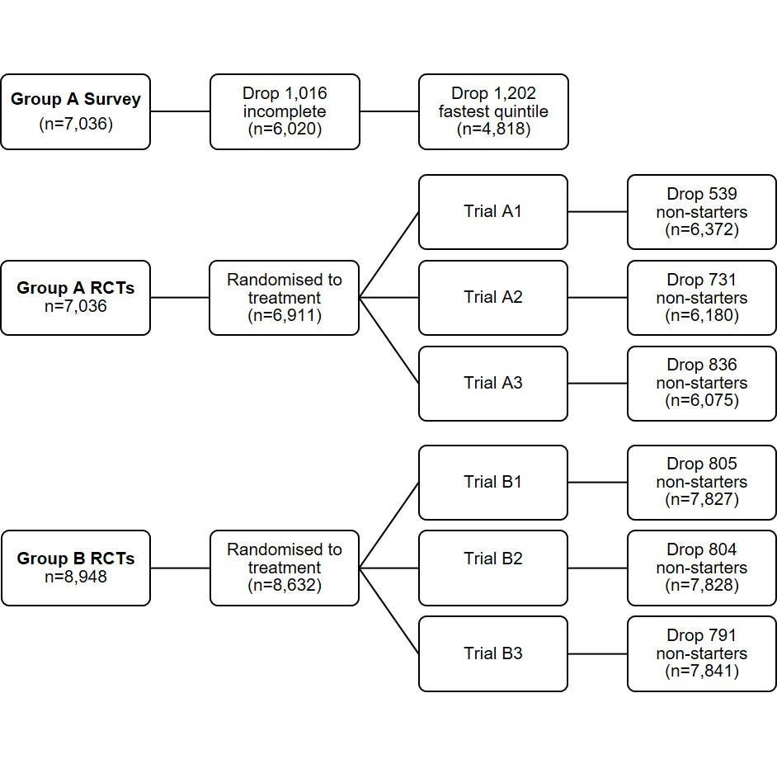
Figure 1 shows how the sample was reduced to improve data quality through the exclusion of incomplete and ‘speeder’ responses from the survey, and through exclusion of non-starters from the RCTs.

Demographic characteristics
The table below summarises the demographic characteristics for our three samples, and compares them to the overall figures in the National Energy Customer Framework (NECF) jurisdictions: New South Wales, Queensland, South Australia, Tasmania and the ACT. (Where state-by-state breakdowns were not available, we used national-level figures.)

Comparison between samples
There is little difference in the demographic characteristics of full and cleaned Group A samples. Likewise, the Group A and Group B samples are broadly similar, with two exceptions. First, the Group A sample is skewed towards women (55% versus 50% in Group B). Second, the Group A sample is skewed away from NSW and towards the smaller jurisdictions. These differences were both by design: for the Group A sample, we tried to over-sample from smaller jurisdictions to allow for cross-tabulation of the survey results by jurisdiction. However, this meant it took longer to recruit our desired sample and so, to keep within our project timeframe, we decided to relax the gender quota.

Comparison with the NECF population
We collected large and diverse samples through an online survey panel however they were not truly representative of the NECF population. In particular, they only include people who are willing to regularly participate on online surveys.
For both samples the key difference with the NECF population related to the main language spoken at home although this is difficult to quantify exactly. In our surveys, only 3-4% reported that the main language spoken in the household was not English. By contrast, in the 2016 Census, 25.5% of the NECF population said that they speak a language other than English at home. However, some households may speak another language at home even though English is the main language spoken. Nonetheless, our samples clearly had an under-representation of people from culturally and linguistically diverse (CALD) backgrounds, (unsurprisingly, since the survey was conducted in English). As noted in the Final Report, to address this gap, focus groups were held, in language, with Australians from various CALD backgrounds (recruited and run by the Ethnic Communities Council of NSW).
Both samples were skewed in the following ways:
- Age: the samples were younger (55-59% aged under 45 years versus 47% in the NECF population).
- Education: the samples tended to be higher educated, with more having a post-school qualification (63-65% versus 58%) and fewer only having Year 10 or below (11% versus 19%).
- Housing: the samples were more likely to be renting their home (40-43% versus 32%) and less likely to be mortgagees (24% versus 37%).
As noted above, the Group A sample was skewed on gender and jurisdiction due to our decision to over-sample smaller jurisdictions for that sample. Group B also had a skew towards South Australia (16% versus 11% of the NECF population), with fewer from NSW or Queensland.
- Demographic characteristics
 | NECF population | Group A  (full) | Group A (cleaned) | Group B  (full)
Gender
Female | 50.5% | 55.0% (3,499) | 56.1% (2,697) | 50.4% (3,943)
Male | 49.5% | 43.9% (2,790) | 43.1% (2,073) | 48.3% (3,783)
Non-binary / gender diverse | - | 0.8% (48) | 0.6% (28) | 0.8% (61)
Prefer not to say | - | 0.3% (21) | 0.2% (10) | 0.5% (40)
Age
18-24 | 11.5% | 15.6% (988) | 13.1% (629) | 15.5% (1,211)
25-34 | 18.6% | 19.0% (1,209) | 17.0% (818) | 21.2% (1,656)
35-44 | 16.9% | 20.8% (1,323) | 18.2% (876) | 22.5% (1,759)
45-54 | 16.2% | 11.9% (755) | 12.2% (586) | 11.6% (907)
55-64 | 15.2% | 12.1% (771) | 14.4% (696) | 10.8% (841)
65-74 | 12.2% | 14.3% (909) | 17.6% (846) | 13.0% (1,012)
75+ | 9.4% | 6.2% (395) | 7.3% (352) | 5.4% (423)
Jurisdiction
NSW | 50.7% | 32.7% (2,084) | 33.0% (1,592) | 47.1% (3,689)
QLD | 32.3% | 33.0% (2,102) | 33.8% (1,630) | 30.1% (2,359)
SA | 11.0% | 22.3% (1,419) | 21.0% (1,013) | 16.0% (1,254)
TAS | 3.3% | 7.6% (487) | 7.9% (380) | 3.9% (306)
ACT | 2.7% | 4.4% (280) | 4.2% (203) | 2.8% (219)
Education
Year 10 or below | 18.6% | 11.3% (716) | 11.2% (540) | 11.1% (870)
Year 11 or 12 | 23.9% | 25.8% (1,637) | 23.6% (1,136) | 24.3% (1,898)
Post-secondary | 57.5% | 62.9% (3,997) | 65.1% (3,129) | 64.5% (5,038)
Note: The column for the NECF (National Energy Customer Framework) population reflects ABS figures for those jurisdictions (NSW, QLD, SA, TAS and ACT). In all cases, missing responses have been excluded so the totals add to 100%.
Sources: Gender, Age and Jurisdiction – ABS National, State and Territory Population, March 2021 (cat. no. 3101.0). Education – ABS Education and Work, Australia, May 2020 (cat. no. 6227.0).

- Demographic characteristics (continued)
 | NECF population | Group A  (full) | Group A (cleaned) | Group B  (full)
Housing*
Rent | 32.0% | 41.4% (2,630) | 39.4% (1897) | 40.2% (3,137)
Own - outright | 29.5% | 32.0% (2,033) | 33.8% (1,624) | 32.5% (2,539)
Own - mortgage | 36.7% | 23.6% (1,499) | 23.8% (1,143) | 23.7% (1,853)
other | 1.8% | 3.0% (189) | 3.0% (143) | 3.5% (274)
Main language spoken at home
English | … | 96.7% (6,109) | 96.4% (4,623) | 96.2% (7,473)
LOTE | … | 3.3% (211) | 3.6% (172) | 3.8% (293)
Note: The column for the NECF (National Energy Customer Framework) jurisdictions reflects national housing data because jurisdiction-specific data was not available. No data is provided for ‘main language spoken at home’ for the NECF population because the 2016 Census asked a different question about languages spoken at home. See earlier text for a discussion of this point. In all cases, missing responses have been excluded so the totals add to 100%.
Sources: Housing – ABS Housing Occupancy and Costs 2017-18 (cat. no. 4130.0).

3. Survey

Survey overview
In the consumer survey participants were asked a series of questions in relation to energy bills. The survey was designed to help inform various parts of this project, including:
- Prioritising content to be included in bills
- Understanding usage preferences
- Identifying the parts of bills that are contributing to cognitive overload
- Better understanding how consumers access and use their bills, and how they engage with their retailer
All Group A respondents were first asked the consent and demographic questions. They were then randomised to either see the survey before the three RCTs, or the RCTs before the survey.
As noted in Section 2, we cleaned the data set to remove ‘incompletes’ and ‘speeders’. This left a sample size of 4,818 for the cleaned dataset. It is possible that there were still a small number of non-genuine responses remaining in the cleaned dataset. In particular, there may have been some issues with response quality for more complex questions (e.g. a matrix of questions about how respondents use their bills, see questions 4.5, 4.8 and 4.11).
The survey overview is presented in Section B of the Final Report, while the survey results are presented at relevant points throughout the report.

Survey questions
Q1.3 Where do you live?
- New South Wales
- Victoria
- Queensland
- South Australia
- Western Australia
- Tasmania
- Northern Territory
- Australian Capital Territory
- Other territories
Q2.3 What is the postcode where you usually live?
Q2.4 What is your gender?
- Female
- Male
- Non-binary / Gender diverse
- Prefer not to say
Q2.5 Please select your age bracket
- 18 - 24
- 25 - 34
- 35 - 44
- 45 - 54
- 55 - 64
- 65 - 74
- 75+
Q2.6 What is the highest level of education that you have completed?
- Year 10 or below
- Year 11 or equivalent
- Year 12 or equivalent
- A trade, technical certificate or diploma
- A university degree
- Postgraduate qualifications
Q2.7 What is your main language spoken at home?
- English
- Other (please specify)
Q2.8 Do you rent or own the home you live in?
- I pay rent/board
- I own the home outright and do not have a mortgage
- I’m paying a mortgage on the home
- Other (please specify)
Q2.9 In the last 12 months, did any of the following happen to you because of a shortage of money? Please select all that apply.
- Could not pay electricity, gas or telephone bills on time
- Could not pay the mortgage or rent on time
- Pawned or sold something
- Went without meals
- Was unable to heat home
- Asked for financial help from friends or family
- Asked for help from welfare / community organisations
- None of these
Q2.10 Could you access $2,000 now, if an unexpected expense came up?
- Yes
- No
Q3.1 Who is responsible for dealing with energy bills in your household?
- Me
- Someone else
- Shared responsibility
Q3.2 How easy do you find it to understand your energy bills?
- Extremely easy
- Somewhat easy
- Neither easy nor difficult
- Somewhat difficult
- Extremely difficult
Q3.3-Q3.7 Who is your electricity company? (The company that sends you the bill)
- Aurora Energy
- 1st Energy
- Energy Locals
- Future X Power
- Other retailer: ____________
- Don't know
Q3.8 How important is it to you to use less energy?
- Extremely important
- Very important
- Moderately important
- Slightly important
- Not at all important
Q3.9 If you made a decision to use less energy, what would be the main reason?
- To lower the cost of the bill
- Better for the environment
Q4.1 How often do you receive electricity bills?
- Every month
- Every three months
- Other
- Don't know
Q4.2 How do you currently receive your energy bills? Please select all that apply.
- Letter in the mail
- Email
- View in an app
- View on retailer website
- Other (please specify) ______
- Not sure
Q4.3 How do you usually view your energy e-bill?
- View on desktop or laptop computer
- View on smartphone
- I don't open it, I just pay it Direct Debit
- I don't open it because someone else in my household does
- Other _________
- Not sure
Q4.4 Do you usually open the attached bill (the PDF) or just check the total amount in the email?
- I open the PDF attachment
- I just look at the email. I don't open the detailed bill (the PDF)
- Not sure

Q4.5 Which elements of the electricity bill do you read?
 | Always read | Most of the time | Sometimes | Never read | Never noticed it | Doesn't apply
Amount owing
Due date
Electricity usage compared over the last year
Comparison of your electricity usage with the average for other people in your area
Meter read details
Solar exports
Q4.6 Which elements of the electricity bill do you read? (continued)
 | Always read | Most of the time | Sometimes | Never read | Never noticed it | Doesn't apply
Detailed list of charges
Greenhouse emissions
Contact details for services, assistance or complaints
Interpreter services
Electricity usage in the current billing period
Discounts
Q4.7 How do you usually pay your energy bills?
- At the post office
- Send a cheque
- BPAY
- EFT
- Using an energy retailer app or website
- Direct debit of the balance owing
- Phone call
- SMS
- Centrepay
- Other / not sure
Q4.8 Have you ever used your energy bill for the following reasons?
 | Yes, used my bill for this | Used other source for this | Have not needed to do this
Find how much to pay
Find information about my energy plan
Find information about how much energy I use
Find contact details to make a complaint
Find contact details to ask a question
Find contact details for interpreter services
Find out how to report a fault or power outage
Check how my bill was calculated
Seek financial help such as a payment plan
To check the meter read details are correct
Q4.9 Have you ever switched your electricity or gas from one retailer to another?
- Yes
- No
- Don't know / can't remember
Q4.10 In the last 12 months, have you considered switching your electricity or gas to another retailer?
- Yes - have considered
- Yes - already switched
- Yes - I tried to switch but it got too hard
- No
- Not sure
Q4.11 Have you ever looked at your energy bill for more information when doing any of the following things?
 | Have never done this | Did this without looking at my bill | Looked at my bill when doing this but it didn't help | Looked at my bill when doing this and it helped | Not sure / can't recall
Visiting an energy retailer comparison site
Asking for advice from an accountant or financial planner about my energy plan
Doing my own research on energy retailers
Talking to friends or family about which energy retailers are best
Looking into ways to improve energy efficiency
Researching new technologies to reduce energy costs (eg. solar, batteries)
Comparing my plan with another energy plan or retailer

Q4.12 Which of the following best describes your approach to choosing an energy plan?
- Choose a retailer I have heard of (or used previously)
- Choose a green option (a retailer with low emissions or pay extra for renewable energy)
- Choose the cheapest plan
- Choose the largest discounts
- Choose the best solar export price
- Choose a plan that suits how much energy I use
- Choose a retailer with good customer service
- Choose an innovative product (wholesale rates, peak demand, excellent digital app or data)
- Don't know
- Other __________________
- Does not apply to me
Q4.13 Do you get information from your energy company in an app or a website?
- Yes - a website
- Yes - an app
- No - my retailer doesn't offer this service
- No - I'm not sure if this is an option
- No - prefer not to
Q4.14 How do you use the app or website? Select all that apply
- To view bills
- To pay bills
- To check on my energy usage
- To edit my details
- To get information on my current plan
- To get information on my solar
- To make a complaint
- To seek help
- Other (please tell us about it) __
Q4.15 Does your current home have any of the following features? Select all that apply
- Smart meter
- Solar panels
- Battery to store solar power
- Controlled load (separate meter for electric hot water system, underfloor heating or swimming pool)
- Home energy power monitor (eg. smart plug or in-home display)
- Other ________________
- None
- Don't know

4. Experimental design & analysis: overview
This section provides an overview of the experimental design and analysis for the 6 RCTs. It covers:
- Pre-registration and deviations from the pre-analysis plans
- Sample size justification and power analysis
- Randomisation
- Method of analysis
- Sensitivity analysis

Pre-registration and deviations from the pre-analysis plans
We pre-registered the RCTs, along with our pre-analysis plans, on the American Economic Association RCT Registry (Group A pre-registration: AEARCTR-0007974; Group B pre-registration: AEARCTR-0007970). We subsequently registered the trial on the BETA website.
Our analysis deviated from our pre-analysis plans in the following ways.
First, we pre-specified that we would include anybody who was randomised into a trial in the analysis, regardless of whether they answered any questions (unanswered questions would be coded as zero). Instead, we removed responses for an individual RCT if that responder had not answered a single question in that particular RCT. We did this because removing these non-responders reduced noise in the dataset for each RCT. As discussed in Section 2 (under ‘Data quality’), this meant that we removed responses from some participants who saw the intervention and elected to discontinue (around 5% of the sample for RCT A1). We re-ran the analysis with these participants included and there was no meaningful change in the results. Furthermore, the non-responses were balanced across treatment arms, suggesting non-respondents were unlikely to be differentially affected by the bill content they saw.
Second, for the Group B trials, we did not conduct separate analysis on subgroups reflecting which trial they completed first. This was due to time constraints however we will release de-identified unit record data so others can conduct this analysis if they wish.
Third, we have not analysed most of the numerous secondary outcomes listed in the pre-analysis plan. Again, this was due to time constraints, and others can conduct this analysis if they wish using the de-identified unit record data.

Sample size justification and power calculations
We performed power calculations using a standard alpha of 5%, and a standard power of 80% for a one-tailed test. Based on these calculations, we decided on an approximate sample size of 1,500 participants per arm.
We estimated that this sample size would give us 80% power to detect:
- For continuous outcomes: a standardised effect of approximately 0.1 SD unit.
- For binary outcomes: a 4.55 percentage point increase over a 50% baseline (a conservative assumption for power analysis).

Randomisation
For both samples, randomisation was undertaken within the Qualtrics survey platform. Prior to randomisation, all participants answered the consent and demographics questions.
The randomisation, sequencing and sample sizes for each of the RCTs in Group A and Group B are shown in Figure 2 below.

Group A sample
The Group A sample completed a survey in addition to 3 trials. All trials were undertaken in the same order (i.e. Trial A1, Trial A2, Trial A3) however the order of the survey and the trials was randomised. Half the respondents answered the survey questions first, and half completed the series of three trials first. This randomisation was implemented using the “Randomly present elements” tool in the Qualtrics platform.
For each trial, all respondents were randomly assigned to one of the 4 treatment arms with a 25% probability of assignment.

Group B sample
The Group B sample completed 3 trials, and the order in which participants undertook these trials was randomised to allow averaging over any order effects. This created 6 possible trial orders. Randomisation of the trial order was also implemented using the “Randomly present elements” tool in the Qualtrics platform.
For each trial, all respondents were randomly assigned to one of the 5 treatment arms with a 20% probability of assignment. The final trial (B3) was a 5x2 factorial design. In this case, the randomisation for the second independent variable had a 50% probability of assignment.
- RCT randomisation, sequencing and sample sizes
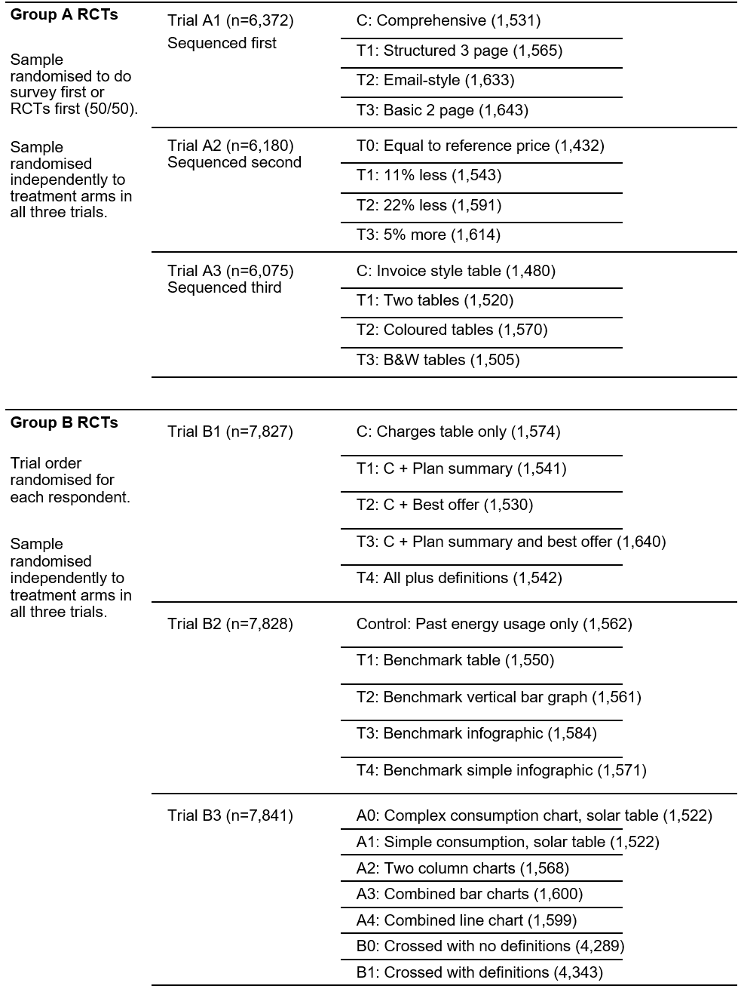

Method of analysis
For all trials, the principal analysis of the effect of the interventions was intent-to-treat (ITT), with the caveat that some data cleaning occurred before we downloaded the data but after randomisation. As noted in Section 2 on data quality, before we received the data, the survey panel provider, Qualtrics, excluded respondents who were classed as: speeding, inattentive, flat-lining, duplicates, IP address not in Australia, giving conflicting answers, or providing nonsensical responses to open-ended questions.
In each trial, our analysis consisted of a covariate-adjusted comparison of our primary outcomes. This estimate, confidence intervals and p-values were derived from an ordinary least squares regression model using robust (HC2) standard errors.
We treated all analysis of secondary outcomes as exploratory.

Group A trials
The following regression model was used for the Group A trials (A1, A2, A3):
$$Y_{i}=β_{0}+ β_{1}Z_{i}+ β_{2}X_{i}+ β_{3}{Z_{i}X}_{i}+ ∈_{i}$$
Where $i$ is an index for each individual in the trial, Y is the primary outcome in question, $β_{0}$ is the intercept, $Z$ is a vector of three treatment assignment indicators, $β_{1}$ is a vector of coefficients representing the average treatment effect, $X$ is a mean-centred indicator of whether trials were conducted before or after the survey, and $ZX$ is the interaction of the treatment indicator vector with the mean-centred trial/survey-order indicator and ∈ is the error term.

Group B trials
The following regression model was used for the Group B trials B1 and B2:
$$Y_{i}=β_{0}+ β_{1}Z_{i}+ β_{2}X_{i}+ β_{3}{Z_{i}X}_{i}+ ∈_{i}$$
Where the terms have the same meaning as above except that $Z$ is a vector of four treatment assignment indicators and $X$ is a vector of mean-centred trial-order indicators to account for the randomised trial order.
For trial B3 (a factorial design) the regression model specification was as follows:
$$Y_{i}=β_{0}+ β_{1}A_{i}+β_{2}B_{i}+{β_{3}X_{i}+β}_{4}{A_{i}X}_{i } {+ β}_{5}{B_{i}X}_{i }{+ ∈}_{i}$$
Where the terms have the same meaning as above except $β_{1}$ (the coefficient on $A$) is a vector of 4 main effects of factor A (i.e. varying the presentation of bills) and $β_{2}$ (the coefficient on $B$) is the main effect of factor B (i.e. including definitions, or not). Both $A$ and $B$ were interacted with $X$ the treatment order indicator. For the factorial design, we did not expect interactions between our independent variables and our design was not powered to detect them.

Subgroups
We investigated variation in our results for 5 subgroups:
- aged 65 or over
- post-school educational attainment
- financial hardship (respondents who selected any one of 7 hardship indicators)
- whether finds bills easy to understand
- home ownership (home owners/mortgagees versus renters/others)
Results from subgroup analyses are summarised in the following sections.

Sensitivity analysis
As described in Section 2 on data quality, despite data cleaning undertaken by Qualtrics, we were concerned that some of the faster completers in both samples were implausibly fast, such that they did not actually engage with the questions. We retained these ‘speeders’ in our primary analysis – consistent with our pre-analysis plan – however we ran a series of sensitivity tests where we: identified the ‘speeders’ (i.e. fastest 20% of completers) for the full data set, removed the non-starters (for that RCT), and then ran the analysis with and without any remaining speeders for key hypotheses in each of the 6 RCTs. The specific results are reported in each individual section below.
Overall, we found that removing fastest completers did not alter our findings and had little impact on the differences between treatment groups. There were modest changes in the marginal means in some trials (e.g. comprehension scores increased), indicating that there may have been a degree of random answering by the ‘speeders’.

Measuring intentions – coding of free-text responses
For several trials (A1, B1, B2, and B3), we wanted to measure respondents’ intentions without asking a leading question. Instead, we asked an open-ended question that asked for suggestions to reduce energy costs or save money on electricity, and then coded the free-text responses to construct a binary outcome variable. We constructed 3 variables based on suggestions to: ‘save energy’, ‘compare or switch plan’, or ‘use solar more efficiently’.
For trial A1 (length and layout), the question asked:
Your good friend, Alice, has had her mail redirected to your address while she travels. Her electricity bill has arrived and she has some questions for you. …
Alice would like to know how she can reduce her energy costs when she returns home next month. What do you suggest?
For trials B1-B3, respondents were asked to imagine they were helping someone understand their electricity bill. They were subsequently asked:
"What would you do to save some money on electricity, if you were in my position?"
(In other words, participants in the Group B sample were asked this question after each of the 3 trials they were shown.)
While these questions were optional we received a large number of responses: 48% for Trial A1 and 47-54% for Trials B1-B3. We coded the free-text responses in two stages.
In the first stage, we identified key terms that could be used in NVIVO to automate the coding process. This involved:
- Blinding: we removed treatment indicators so the coding analyst was blind to treatment
- Identifying key search terms: An analyst reviewed and coded ~200 responses and used them to identify search terms that occurred frequently (and near exclusively) in positively coded responses.
- Automated coding: the search terms were used in NVIVO to produce an initial coding of all free-text responses.
The second stage involved a manual check of the automated coding. A second analyst reviewed all the free-text responses and the codes generated by NVIVO, and changed codes that were judged to be inaccurate. Free-text responses that were difficult to code were reviewed with another team member.

Coding of ‘save energy’
Comments were coded as “advised saving energy” if the response fell into at least one of the following categories.
- Directly state ‘use less energy’ or similar (e.g. ‘use less electricity’, ‘Try conserving electricity’)
- Advice to turn appliances off when not using (e.g. ‘Keep things unplugged when not using’, ‘switch off at wall’)
- Advice to upgrade appliances or globes (e.g. ‘Change all her globes to LEDs’, ‘Sit down and have an audit of her appliances and see if she can cut back on usage. Or even look at the star rating and maybe upgrade.’)
- Advice to review energy consumption (e.g. ‘Get off her backside and investigate why she is consuming more power compared to similar households.’)
- Other specific suggestions to reduce energy usage. For example:
  - ‘have a bbq every now and then’
  - ‘Like Im doing now Im not using a heater nor cooking just microwaving my dinners.’
  - ‘Get rid of aircons’
  - ‘Have timers set on certain electrical devices throughout the day’
  - ‘Hang laundry out on the line instead of using the drier.’
  - ‘. . . Also look at increase the insulation of the house for winter next year’
The following types of comments were not considered advice to save energy.
- ‘defer usage to off peak times if she can’
- ‘Use more electricity off-peak and less during expensive times. Install more solar panels. Investigate cheaper suppliers.’
- ‘Use more solar energy to reduce the electricity bill.’

Coding of ‘compare or switch plans’
Comments were coded as “advised comparing or switching plans” if the response recommended comparing the plan with other plans, looking for a better offer, or switching plans. These included:
- A specific suggestion to switch to the ‘best offer’ plan (e.g. ‘move to energyco super saver plan...’)
- A general suggestion to switch (‘Shop around with other suppliers’, ‘shop around for a better deal’)

Coding of ‘use solar more efficiently’
Comments were coded as “advised using solar more efficiently” if the response fell into at least one of the following categories.
- Use more solar energy generally (e.g. ‘Use more solar.’)
- Run appliances during the day (e.g. ‘use power consuming devices during the day’ or ‘... don’t sell as much power generated back to the grid’)
- Get a battery (e.g. ‘Buying a storage battery to use your excess electricity rather than selling back to the grid at a stupid price’)
- Clean or do maintenance on panels (e.g. ‘getting your solar panels cleaned ...’)
- Upgrade current solar infrastructure (e.g. ‘Increasing her solar import capabilities by updating/upgrading Physical Infrastructure.’)
- Get solar hot water (e.g. ‘solar hot water’)
- Get a better deal for solar feed-in (e.g. ‘Get a better rate to sell it back’)
- Check output/operation of current solar (e.g. ‘review the devices and their efficiency even possible storage of power’)
The following types of suggestions to reduce the bill’s cost were not considered advice to use solar more efficiently:
- get solar panels or buy more panels (e.g. ‘Get solar panels’, ‘Install more solar panels’)
- increase solar exports (e.g. ‘I would export more solar power’)
- use more power at night (e.g. ‘run more at night’).

Structure of remaining sections
Each of the 6 sections below follows the same structure. First, they summarise the additional results from subgroups, and sensitivity analysis. Then they describe the remaining technical details for the trial:
- The treatment groups
- The hypotheses
- Outcome measures
- The intervention designs
- The specific scenario and questions that respondents answered.

5. Bill length and layout (A1)

Overview
The Group A RCT 1 (A1) tested for cognitive overload in full energy bills. Specifically, we investigated how variations in the length and layout of the bill impacted comprehension. We used bills of varying lengths and layouts to determine whether providing additional information detracts from comprehension of the most important information in the bill.

Summary of Results

Primary outcomes
Hypothesis 1 (length and layout). For all 4 bill designs, respondents were about equally likely to find the correct answers to a series of 9 questions that related to: ability to pay, ability to find important details, and understanding of how their bill was calculated. Thus, we recorded a null result on our hypothesis that simplified or structured bills would result in higher bill comprehension than a comprehensive bill.
Hypotheses 2a and 2b (Home Energy Report). Three bills displayed information on energy consumption and solar exports, and two of these bills captured this in a ‘Home Energy Report’ (either included on the bill or provided off-bill via a link). We had a null result on hypothesis 2a, that a separate Home Energy Report would increase comprehension (on 3 questions relating to energy consumption and solar exports) compared with the comprehensive bill. However, we confirmed hypothesis 2b that comprehension would be worse if the Home Energy Report was provided off-bill. Comprehension was substantially lower in this case (23% versus 44-45% for the other 2 bills) and this difference was statistically significant.
See also Section D of the Final Report.

Secondary outcomes
As described in Section 4 (under the heading ‘Measuring intentions – coding of free text responses’), we asked respondents an open-ended question about how to reduce energy costs based on the information in the bill. We used the responses to test the impact of several bill components: the ‘best offer’, benchmarks, and solar exports. The results from these secondary outcomes are discussed under RCT B1, B2 and B3, respectively.

Subgroups
Hypothesis 1 (length and layout). For all subgroups, we continued to find a null result on our main hypothesis (i.e. the general length and layout of the bill did not materially impact the ability of consumers to find key information even for the subgroups we looked at).
Hypotheses 2a and 2b (Home Energy Report). For all subgroups, we continued to find a null result on Hypothesis 2a that providing a separate Home Energy Report would improve comprehension of energy consumption and solar exports relative to a comprehensive bill. For all subgroups, we continued to confirm Hypothesis 2b that putting the Home Energy Report off-bill reduced comprehension.

Sensitivity analysis
We re-ran Hypothesis 1 for this RCT after removing the fastest 20% of completers from the sample and confirmed that this did not change our findings: we continued to get a null result, with only very small differences between the 4 groups. There was, however, a mild increase in the marginal means (i.e. the point estimate for the mean comprehension score) for each treatment group. For example, the control group (Comprehensive bill) increased from 6.0 to 6.4 correct out of 9 (i.e. from 67% to 71%). This implies that the ‘speeders’ were more likely to get more answers incorrect.
In Section D of the Final Report, we noted that the ‘able to pay’ questions (amount of bill, due date, and BPAY biller code) were all fairly simple so it was surprising that the accuracy rate was only 77-79%. It is possible that, despite our efforts to remove ‘non-genuine’ respondents, there remained some respondents who did not seriously attempt to answer the question. One indicator for this is whether respondents correctly answered the question about the amount due, which was displayed prominently on the first page of each bill. In the full sample, 87% answered this correctly, and this increased to 93% once we removed ‘speeders’. This means that, at most, 7% of the remaining sample were still providing non-genuine responses (and less if we assume that a small fraction of respondents were genuinely confused about the amount due).

Treatment groups
This was a four-arm trial with the following groups:
- Control (C) = Comprehensive bill. This bill contains all the elements considered in this research, and puts it in a two-page design, typical of many billers.
- Treatment 1 (T1) = Structured comprehensive bill. The Structured bill contained identical content to the comprehensive bill (control), but it is structured by how you might use it to find the information you need. It is spread out over 3 pages.
- Treatment 2 (T2) = Simple email bill with link to additional information. This bill is styled as an email that contains the information needed to pay (pages 1 & 2 of the Structured bill). By clicking on a link below the email, respondents could see additional “off-bill” information about energy consumption and solar exports (i.e. page 3 of the Structured bill).
- Treatment 3 (T3) = Basic bill with limited content. This bill was a typical paper bill/pdf, but just contains the minimal information you need to pay, critical phone numbers and the detailed charges table (i.e. it excludes information on past energy usage and solar exports, definitions of technical terms, a plan summary, and a ‘best offer’ message).

Hypotheses
A1.H1: Simplified or structured bills (T1, T2, T3) will result in higher bill comprehension than the control condition (C): T1>C, T2>C, T3>C.
This hypothesis was assessed with a series of 3 one-tailed tests. We did not correct for the comparison of multiple arms against the shared control due to the correlation between comparisons.
A1.H2a: The bill with a separate home energy report (T1) will result in higher comprehension of energy consumption and solar exports than the bill containing this information as part of the main bill (C): T1>C.
A1.H2b: Including the home energy report as an attachment instead of in the bill will diminish its impact on the comprehension of energy consumption and solar exports: T2<T1.
Both A1.H2a and A1.H2b were assessed with a one-tailed hypothesis test. We corrected for the two multiple comparisons that comprise this family of tests, by dividing the significance threshold (alpha) by two.

Outcome measures

Primary outcomes
- Bill comprehension - Aggregate of: able to pay, able to find key details, able to understand how your bill was calculated (each scored 0-3). Number of correct answers (0-9).
- Comprehension - Able to understand your energy consumption & solar exports. Number of correct answers (0-3).

Secondary outcomes
- Time taken - Able to pay.
- Time taken - Able to find key details.
- Time taken - Able to understand how your bill was calculated.
- Time taken - Able to understand your energy consumption & solar exports.
- Comprehension - Able to pay. Number of correct answers (0-3).
- Comprehension - Able to find key details. Number of correct answers (0-3).
- Comprehension - Able to understand how your bill was calculated. Number of correct answers (0-3).
- Intention - Free text ‘cost saving advice’- focuses on 1. Energy saving; 2. Switching/comparing plans; 3. Using solar more efficiently. Free text coded to each of these binary outcomes.
- Confidence to find a strategy to reduce energy costs. Binary (Very confident or confident = 1, all other responses = 0).
- Bill is easy to understand. Binary (very or fairly easy = 1, all other responses = 0).
- Easy to find information. Binary (very or fairly easy = 1, all other responses = 0).
- What I liked about this bill (Free text).
- What I disliked about this bill (Free text).

Intervention designs
Control (C) = Comprehensive bill. This bill contains all the elements considered in this research, and puts it in a two-page design, typical of many billers.

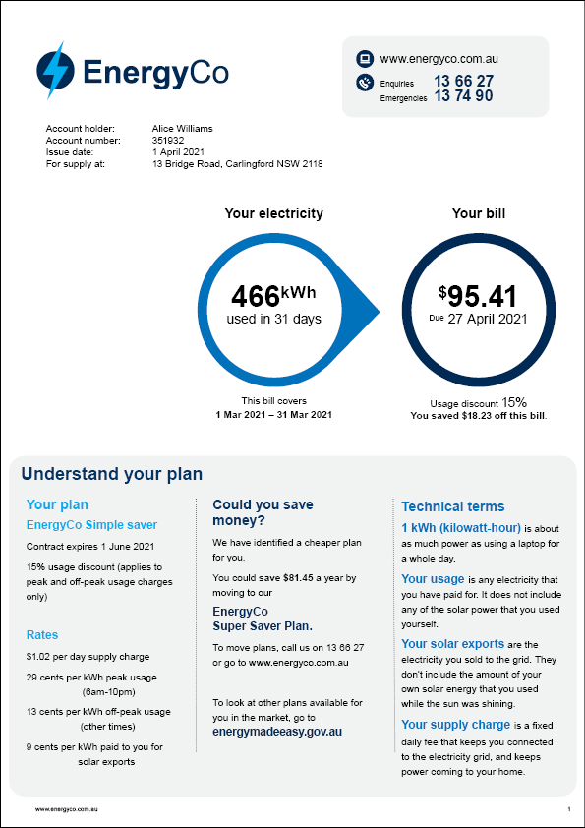

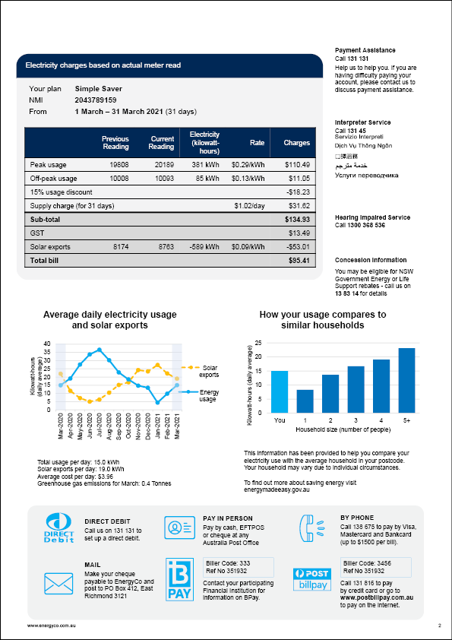

Treatment 1 (T1) = Structured comprehensive bill. The Structured bill contains identical content to the comprehensive bill (control), but it is structured by how you might use it to find the information you need. It is spread out over 3 pages.

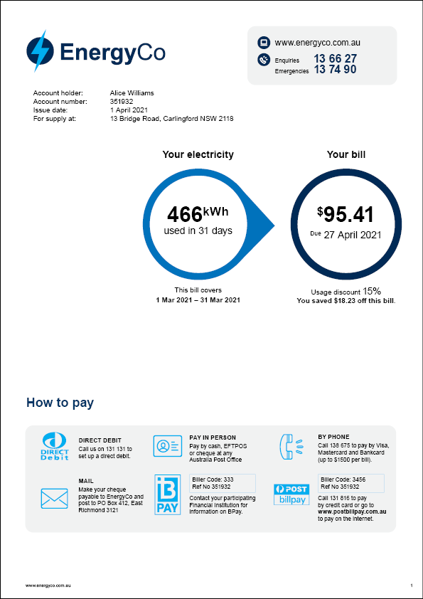
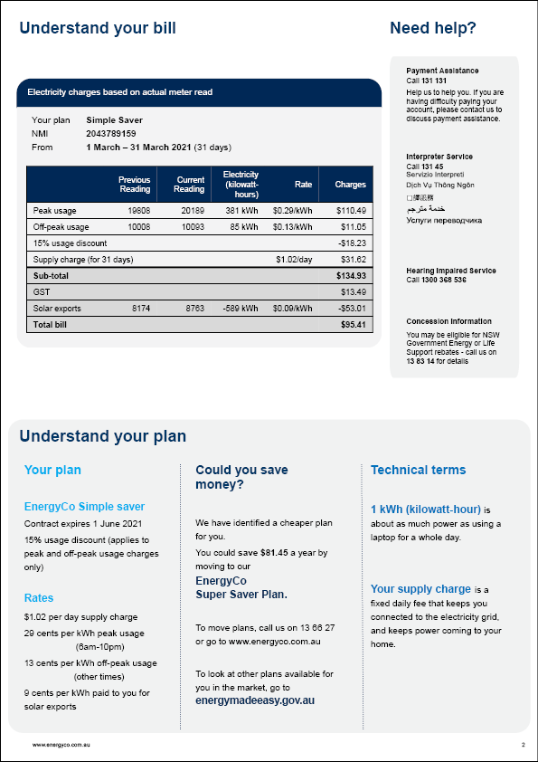
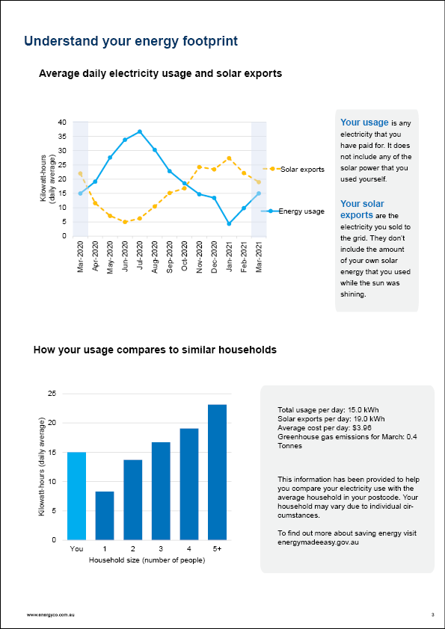

Treatment 2 (T2) = Simple email bill with link to additional information. This bill is styled as an email that contains the information needed to pay (pages 1 & 2 of the Structured bill). By clicking on a link below the email, respondents could see additional “off-bill” information about energy consumption and solar exports (i.e. page 3 of the Structured bill).
Email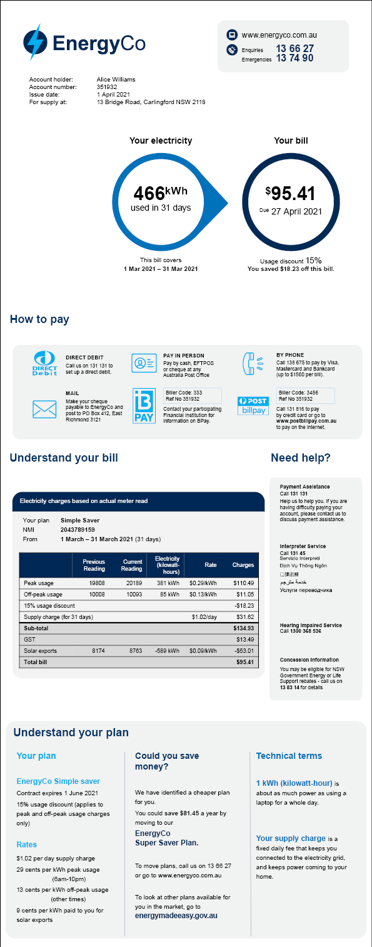
Attachment (accessible via a link)
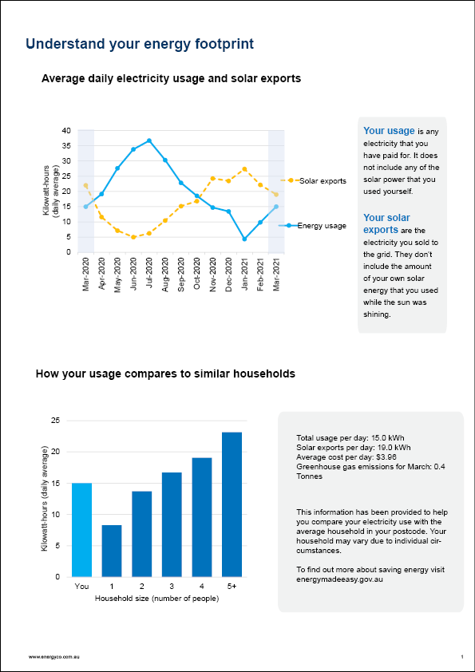

Treatment 3 (T3) = Basic bill with limited content. This bill is a typical bill, but it just contains the minimal information you need to pay, critical phone numbers and the detailed charges table (i.e. it excludes information on past energy usage and solar exports, definitions of technical terms, a plan summary, and a ‘best offer’ message).
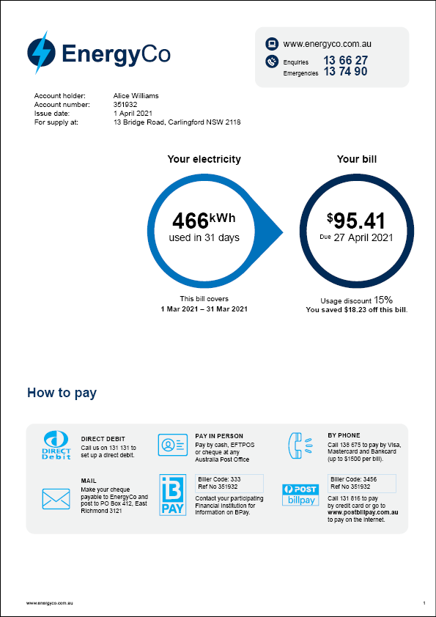

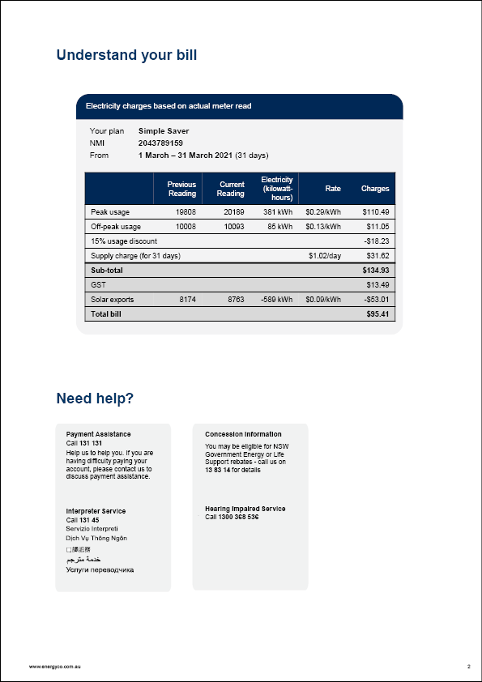

Scenario and questions for RCT A1: Bill length and layout

Scenario
Before seeing a bill, survey respondents read the following text:
“For this part of the study, you will need to use some imagination... Your good friend, Alice, has had her mail redirected to your address while she travels. Her electricity bill has arrived and she has some questions for you. When you click Next, you will see her bill.”
After they had seen the bill, respondents were asked the following questions. They could refer back to the bill as they did so.

Bill comprehension: general
Alice has asked you to send through some details.
"I need to pay..."
- $110.49
- $81.92
- $95.41
- It doesn't say
- Not sure
"Payment is due by..."
- 27 April 2021
- 1 April 2021
- 31 March 2021
- It doesn't say
- Not sure
"To pay using BPAY online, the biller code is..."
- 3456
- 333
- 19808
- It doesn't say
- Not sure
Alice has some more questions about her bill.
"Was a discount applied to the bill?"
- Yes
- No
- It doesn't say
- Not sure
"The number to call if a power line is down is..."
- 13 74 90
- 131 131
- 13 66 27
- It doesn't say
- Not sure
"The NMI or meter number is..."
- 351932
- 2043789159
- 4087226386
- It doesn't say
- Not sure
"How much electricity did I use this bill?"
- 466 kWh
- 589 kWh
- 381 kWh
- It doesn't say
- Not sure
"I get a 15% discount, so it costs less than $1 a day to stay connected to the grid, right? (Like when I'm travelling and using no electricity)"
- Yes
- No
- It doesn't say
- Not sure
"How much does it cost me to use electricity at 8pm?"
- 29 cents per kilowatt-hour
- 13 cents per kilowatt-hour
- 9 cents per kilowatt-hour
- It doesn't say
- Not sure

Comprehension: energy consumption and solar exports
Alice lives alone and has been trying to save energy
"Did I sell more energy than I had to buy in March 2021?"
- Yes
- No
- It doesn't say
- Not sure
"Do I use less energy than similar households?"
- Yes
- No
- It doesn't say
- Not sure
"Is my electricity usage down from this time last year?"
- Yes, it's down
- No, it's up
- About the same
- It doesn't say
- Not sure

Intentions
Alice would like to know how she can reduce her energy costs when she returns home next month. What do you suggest?
- I think Alice should... __________
- I don't know what to suggest

Confidence
How confident do you feel about this advice? (4-point scale: Very confident, Confident, Not very confident, Not at all confident)

Bill is easy to understand
To understand Alice's bill was... (5-point scale: Very easy, Fairly easy, Okay, A bit difficult, Very difficult)

Easy to find information
To find the information I needed on Alice's bill was... (5-point scale: Very easy, Fairly easy, Okay, A bit difficult, Very difficult)

What I liked about this bill
Something I liked about this bill was...

What I disliked about this bill
Something I didn't like about this bill was...

6. Reference price (A2)

Overview
The Group A RCT 2 (A2) tested the inclusion of the ‘reference price’ on the bill, to see whether consumers are sensitive to different reference price levels.

Summary of results

Main outcome
When we asked respondents if they would ‘shop around for a better deal’, 61% said they would do so after they see a plan that was 5% more than the reference price. This fell to 40% for a plan equal to the reference price, then 29% for 11% less than the reference price and 26% for plan 22% below the reference price.
This broadly confirmed our hypothesis that respondents will be more likely to say they would shop around as their plan became higher relative to the reference price. However, the difference between the 2 plans below the reference price (29% versus 26%) should be treated with caution: it had a p-value of 0.047 on a one-tailed test (alpha=0.05 as we did not make any adjustment for multiple comparisons due to the shared variance between comparisons). It is possible, therefore, that how far below the reference price a plan is has little effect on inclinations to shop around.
See also Section F of the Final Report.

Subgroups
In all subgroups, we confirmed our findings in relation to plans above or equal to the reference price. Often, the difference between the 2 plans below the reference price was not statistically significant for the subgroups due to the smaller sample sizes.
In relation to the ‘point estimates’, there were some interesting variations by subgroup. We found that older respondents (aged 65 or more) were more sensitive to a reference price that indicated their current deal was either more than the reference price (68% of older respondents versus 60% of younger respondents) or equal to the reference price (47% versus 38%). We did not conduct a formal test to determine whether these differences were statistically significant.
We found that some other characteristics may influence people’s overall tendency to shop around for a better deal. The following groups were all more likely to shop around for a better deal (in all treatment groups, although again we did not conduct any formal statistical tests):
- People who find energy bills easy to read,
- People with post-school qualifications, and
- Home owners.

Sensitivity analysis
We re-ran the first test for Hypothesis 1 for this RCT after removing the fastest 20% of completers from the sample and confirmed that this did not change our findings. There was a small increase in the marginal mean (i.e. the point estimate of the proportion who said they would shop around) for the plan above the reference price, from 61% to 64%.

Treatment groups
This was a four-arm trial with the following groups:
- Treatment 0 (T0) = Plan is “equal to the reference price”. This treatment showed page 1 of the ‘Structured bill’ and contained additional information about the ‘Simple saver plan’, which in this case was “Equal to” the reference price
- Treatment 1 (T1) = Plan is “11% less than the reference price”. As above, but in this case the plan was “11% less” than the reference price
- Treatment 2 (T2) = Plan is “22% less than the reference price”. As above, but in this case was “22% less” than the reference price
- Treatment 3 (T3) = Plan is “5% more than the reference price”. As above, but in this case was “5% more” than the reference price

Hypotheses
A2.H1: People will be more inclined to ‘shop around for a better deal’ the higher the plan price is relative to the reference price. T0=equal to, T1=11% below, T2=22% below, T3=5% above. T3>T0, T0>T1, T1>T2.
This hypothesis was assessed with a series of 3 one-tailed tests. We did not correct for the comparison of multiple arms given each sequential comparison contains shared variance from the previous comparison.

Outcome measures

Primary outcomes
- Would ‘shop around for a better deal’

Secondary outcome
- Would value having this comparison on my bill (7 point Likert scale). Binary (Any level of agree = 1, all other responses = 0).

Intervention designs

T0: “equal to the reference price”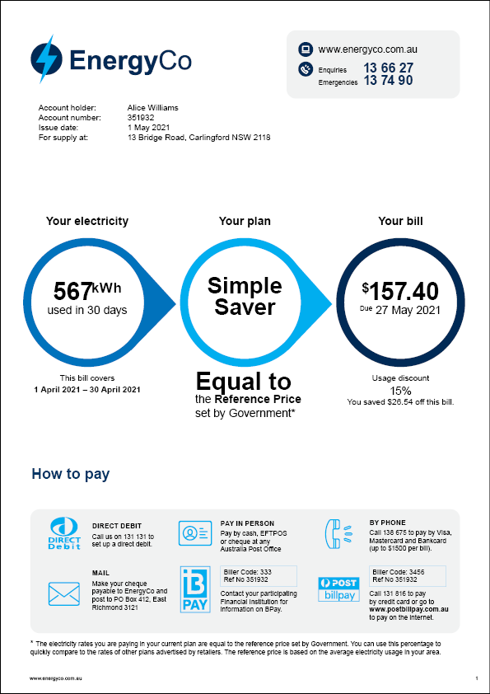
T1: “11% less than the reference price”.
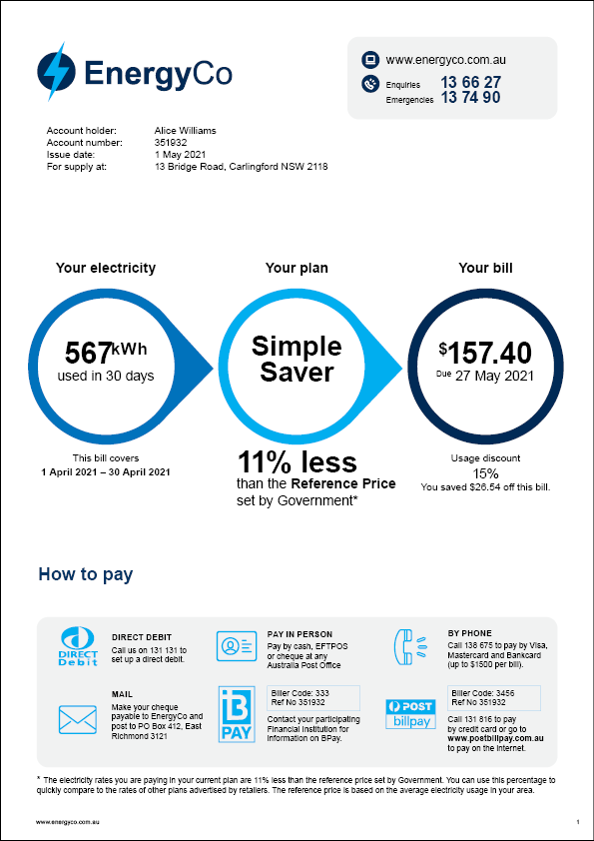

T2: “22% less than the reference price”.
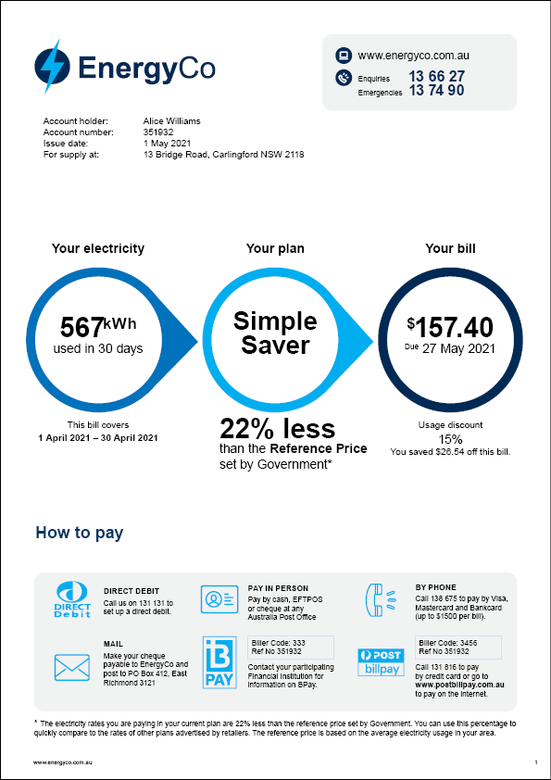
T3: “5% more than the reference price”.
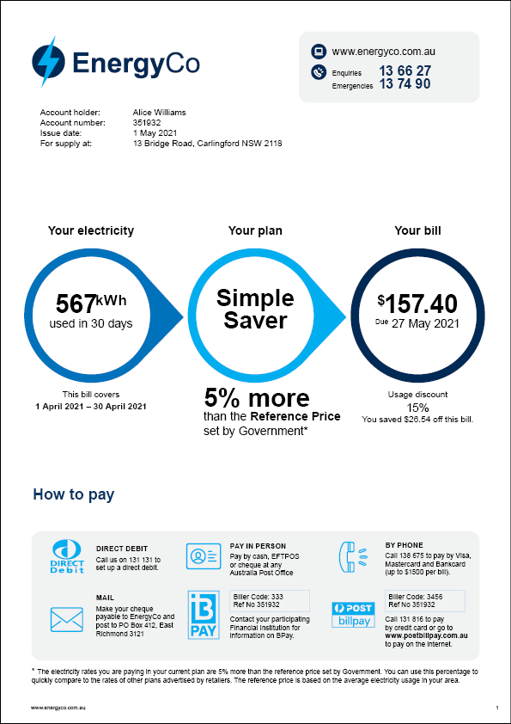

Scenario and questions for RCT A2: Reference price
Scenario
Before seeing a bill, survey respondents read the following text:
“The bill below is a new bill, for the following month. It provides a comparison of Alice's plan to the reference price.
The reference price is a benchmark price for electricity set by the Australian Government based on average electricity use in your area. Electricity companies must use a percentage to show you how their advertised price compares to the reference price.”
After they had seen the bill, respondents were asked the following questions. They could refer back to the bill as they did so.

Shop around for a better deal
If I saw on my bill that the plan was [equal to / 11% less than / 22% less than / 5% more than] the reference price, I would...
- Stay on my current deal
- Shop around for a better deal
- Feel unsure

Value having this on my bill
To what extent do you agree/disagree with the following statement: I would value having this comparison to the reference price on my bill. (7-point scale: Strongly agree, Moderately agree, Slightly agree, Neutral, Slightly disagree, Moderately disagree, Strongly disagree)

7. Detailed charges table (A3)

Overview
The Group A RCT 3 (A3) tested alternative presentations of the detailed charges table to see which most improved comprehension, and which was preferred by customers as easy to understand.

Summary of results

Main outcomes
Hypothesis 1a. We found that the alternative detailed charges tables failed to outperform the familiar ‘invoice style’ table in terms of comprehension. We found null results for all 3 tests of this hypothesis. In terms of the point estimates, the control group (with the traditional table) slightly outperformed all alternative charges tables.
Hypotheses 1b. The alternative detailed charges tables also failed to score better on ‘ease of understanding’ when compared with the traditional table. Once again, we found null results for all 3 tests of this hypothesis. There was little difference in the point estimates.
See also Section E of the Final Report.

Subgroups
There were no interesting variations by subgroup, all of which also produced null results on both hypotheses.

Sensitivity analysis
We re-ran Hypothesis 1a for this RCT after removing the fastest 20% of completers from the sample and confirmed that this did not change our findings. There was a mild increase (3-4 percentage points) in the marginal means (i.e. the point estimate for the mean comprehension score) for all treatment groups. For example, the marginal mean for Treatment 1 (Two tables) increased from 67% correct to 70%. However, the differences between the treatment groups remained essentially the same, consequently we once again had null results on all 3 tests.

Treatment groups
This was a four arm trial with the following groups:
- Control (C) = Traditional table. The control showed a traditional table showing usage and how the bill was calculated.
- Treatment 1 (T1) = Two tables. This treatment showed the usage and meter data in a table on the left and a summary table of the key line items on the right.
- Treatment 1 (T2) = Coloured infographic and two tables. This treatment showed a colourful infographic showing usage, meter data in a table on the left and a summary table of the key line items on the right.
- Treatment 1 (T3) = Black & white infographic and two tables. This treatment showed treatment 2 presented in black and white

Hypotheses
A3.H1a: Behaviourally designed detailed charges tables (T1, T2, T3) will result in higher comprehension than the control condition (C): T1>C, T2>C, T3>C
A3.H1b: Behaviourally designed detailed charges tables (T1, T2, T3) will be rated as easier to understand than the control condition (C): T1>C, T2>C, T3>C
Both of these hypotheses were assessed with a one-tailed hypothesis test. We corrected for the two multiple comparisons that comprise this family of tests, however, we did not correct for the comparison of multiple arms against the shared control.

Outcome measures

Primary outcomes
- Comprehension – Can correctly identify supply charge
- Detailed charges table was easy to comprehend (5 point Likert scale). Binary (very or fairly easy = 1, all other responses = 0)

Intervention designs
Control (C) = Traditional table. The control shows a traditional table showing usage and how the bill was calculated.
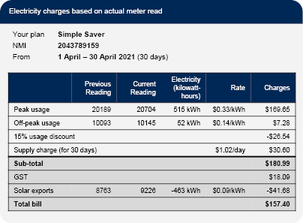
Treatment 1 (T1) = Two tables. This treatment shows the usage and meter data in a table on the left and a summary table of the key line items on the right.
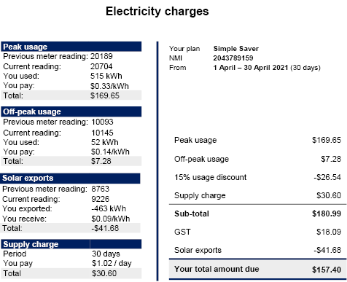
Treatment 2 (T2) = Coloured infographic and two tables. This treatment shows a colourful infographic showing usage, meter data in a table on the left and a summary table of the key line items on the right.
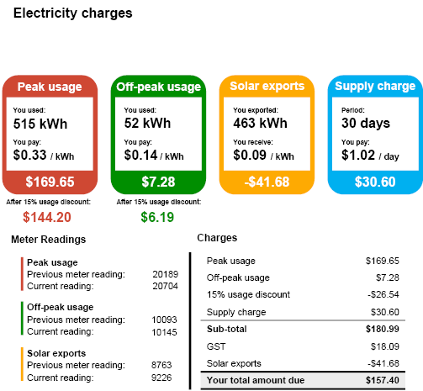
Treatment 3 (T3) = Black & white infographic and two tables. This treatment shows treatment 2 presented in black and white.
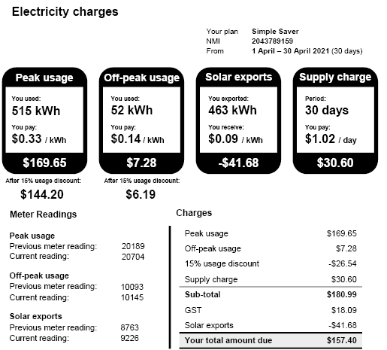

Scenario and questions for RCT A3: Detailed charges table
Scenario
Before seeing a bill, survey respondents read the following text:
“The information below shows how Alice's bill was calculated”
After they had seen the bill, respondents were asked the following questions. They could refer back to the bill as they did so.

Comprehension
How much was the supply charge per day?
- $30.60 per day
- $1.02 per day
- $0.33 per day
- It doesn't say
- Not sure

Detailed charges table
To understand this information was... (5-point scale: Very easy, Fairly easy, Okay, A bit difficult, Very difficult)

8. Plan summaries, best offer, definitions (B1)

Overview
The Group B RCT 1 (B1) tested the impact of a plan summary, a ‘best offer’ message, and adding definitions of key technical terms to see whether each component improved comprehension, and whether they were preferred by customers as easy to understand.

Summary of results

Main outcomes
Hypothesis 1a & 1b (plan summaries). We found that providing a brief summary of plan characteristics helped consumers to better understand how their bill was calculated. Thus we confirmed Hypothesis 1a. The result was statistically significant however the effect size was modest: comprehension on 4 questions increased from 39% to 42%.
We found a null result for Hypothesis 1b, indicating that there was no evidence that the plan summaries assisted people in identifying the best deal. We suspect this is because it was straightforward to identify the best deal even without the plan summary because the Energy Made Easy website prominently displays what the bill would have cost under each plan (see also Final Report, p44).
Hypotheses 2a & 2b (definitions). We found no positive impact of including a box with plain language definitions and so we found a null result for both hypotheses in this family. Indeed, the point estimates for the groups without the definitions were actually slightly higher than for the treatments with the definitions. (We replicated this null result in Trial B3 – see further below.)
Hypotheses 3a, 3b, & 3c (best offer). The presence of a ‘could you save money’ message (also known as a ‘best offer’) on the bill substantially increased the proportion of respondents suggesting the bill recipient should compare their plan or switch to a better one. Around 16% of respondents suggested switching or comparing in the treatment groups, compared to 5% for those who didn’t see the message. This was a large and statistically significant difference, confirming Hypothesis 3a. However, the best offer message did not increase the proportion of respondents who suggested checking a government website, or contacting their provider, leading to a null result for Hypothesis 3b and Hypothesis 3c.
Trial A1 (best offer – intentions). We reached a similar conclusion when we tested the impact of the ‘best offer’ message in a full bill, as part of Trial A1. All three bills that included this message had higher rates of suggestions to switch or compare plans. For the Basic Bill (no ‘best offer’ message), 6.5% of respondents offered such advice. This compared to: 9% for the Comprehensive bill, 11% for the Structured Comprehensive bill, and 15% for the Email-style bill. All of these were statistically significantly different from the Basic Bill (even the smallest difference had p<0.005).
See also Sections E and F of the Final Report.

Subgroups
For Hypothesis 1a (plan summaries) we found that the result was not significant for respondents without post-school qualifications (Year 12 or below). However, this may simply be due to the smaller sample size for this subgroup. Otherwise we found that all subgroups broadly shared the overall results described above.

Sensitivity analysis
We re-ran Hypothesis 1a for this RCT after removing the fastest 20% of completers from the sample and confirmed that this did not change our findings. Indeed, for this test, the results barely changed.

Treatment groups

This was a five-arm trial with the following groups:
- Control (C) = Detailed charges table only
- Treatment 1 (T1) = C + Plan summary
- Treatment 2 (T2) = C + Best offer
- Treatment 3 (T3) = C + Plan summary + Best offer
- Treatment 4 (T4) = C + Plan summary + Best offer + Definitions

Hypotheses

Plan summaries
B1.H1a: Plan summaries will improve plan comprehension: T1 & T3 pooled > C & T2 pooled.
B1.H1b: Plan summaries will result in choosing a cheaper plan: T1 & T3 pooled > C & T2 pooled.
Both of these hypotheses were assessed with a one-tailed hypothesis test. We corrected for the two multiple comparisons that comprise this family of tests, by dividing the significance threshold (alpha) by two.

Plain language definitions
B1.H2a: Bill with definitions box (T4) will result in higher plan comprehension than the equivalent bill without definitions (T3): T4 > T3.
B1.H2b: Bill with definitions box (T4) will result in choosing a cheaper plan than the equivalent bill without definitions (T3): T4>T3.
Both of these hypotheses were assessed with a one-tailed hypothesis test. We corrected for the two multiple comparisons that comprise this family of tests, by dividing the significance threshold (alpha) by two.

Encouragement to switch
B1.H3a: Bill with encouragement to choose a cheaper plan (T2 and T3 and T4 pooled) will result in a higher switching intention than those without encouragement (C and T1 pooled): T2 & T3 & T4 pooled > C & T1 pooled.
B1.H3b: Bill with encouragement to choose a cheaper plan will result in a higher proportion recommending a government comparison website than those without encouragement:
T2 & T3 & T4 pooled > C & T1 pooled.
B1.H3c: Bill with encouragement to choose a cheaper plan will result in a higher proportion recommending contacting your own retailer than those without encouragement:
T2 & T3 & T4 pooled > C & T1 pooled.
We assessed these hypotheses with a one-tailed hypothesis test, using a Bonferroni correction for the three comparisons that comprise this family of tests, by dividing the significance threshold (alpha) by three.

Outcome measures

Primary outcomes
- Comprehension - Able to understand your contract. Number of correct answers (0-4).
- Intention - Advises to switch plans or compare plans. Free text coded as binary.
- Intention - Advises using Energy Made Easy. Binary.
- Intention - Advises contacting own retailer. Binary.
- Comprehension - Able to identify cheapest plan. Score (0-2).

Secondary outcomes
- Time taken - Able to understand your contract.
- Confidence to choose a better plan. Binary (Very confident or confident = 1, all other responses = 0).
- Bill is easy to understand. Binary (very or fairly easy = 1, all other responses = 0).
- Would value having plan summary on their bill. Binary (any agree = 1, all other responses = 0).
- Would value having information about other plans on their bill. Binary (any agree = 1, all other responses = 0).

Intervention designs
Control (C) = Detailed charges table only
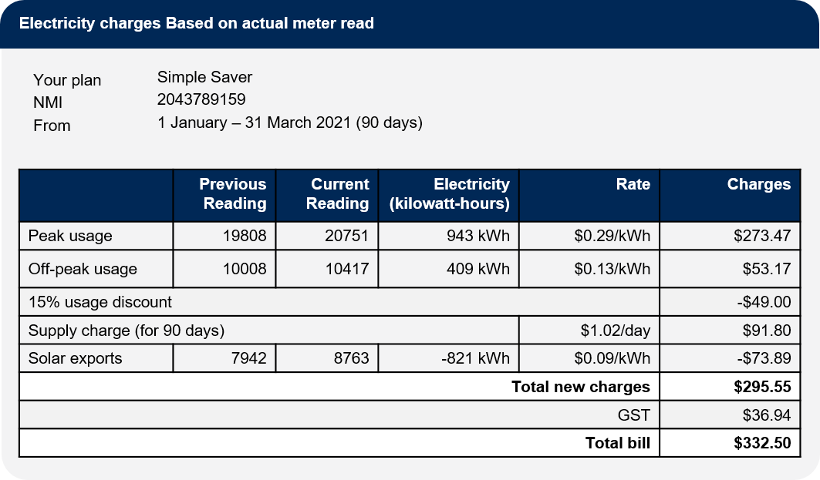
Treatment 1 (T1) = Detailed charges table + Plan summary
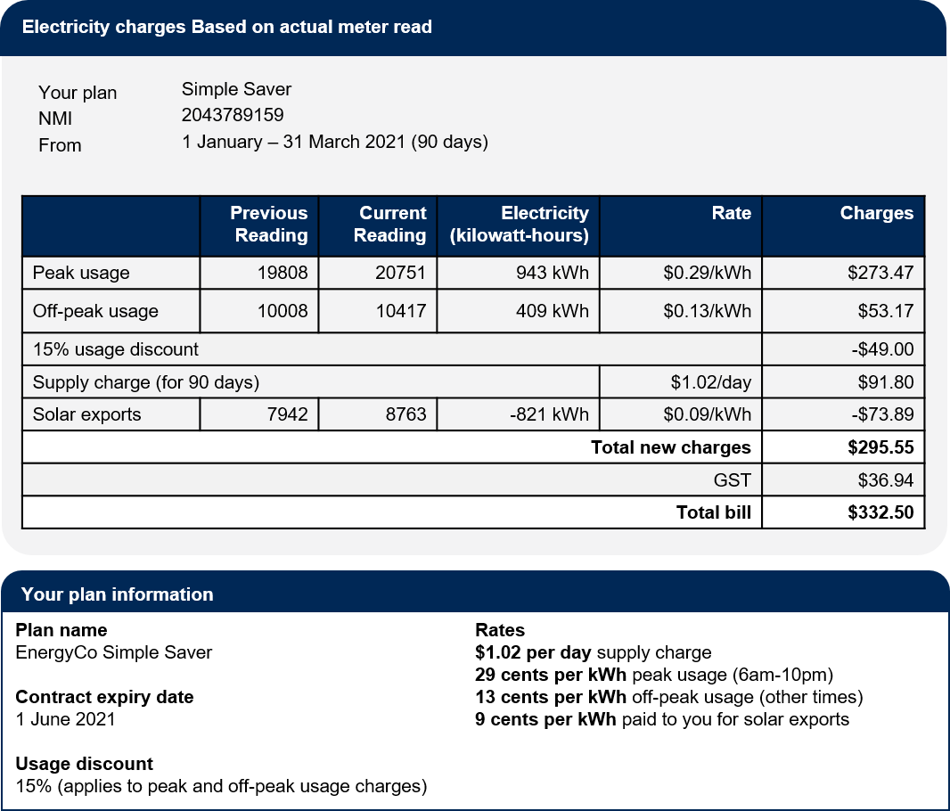
Treatment 2 (T2) = Detailed charges table + Best offer
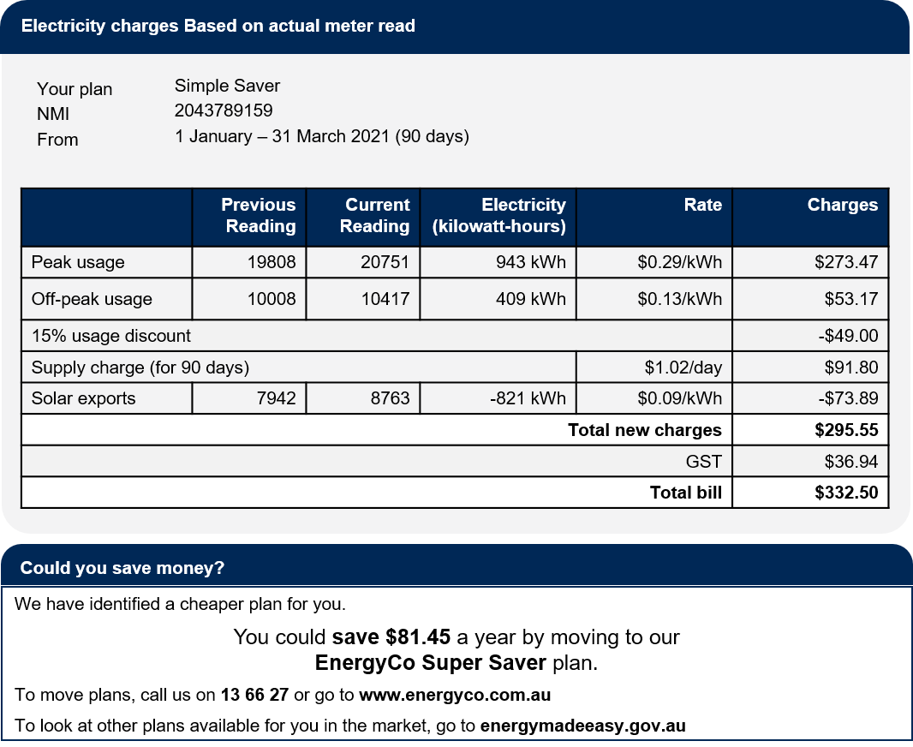
Treatment 3 (T3) = Detailed charges table + Plan summary + Best offer
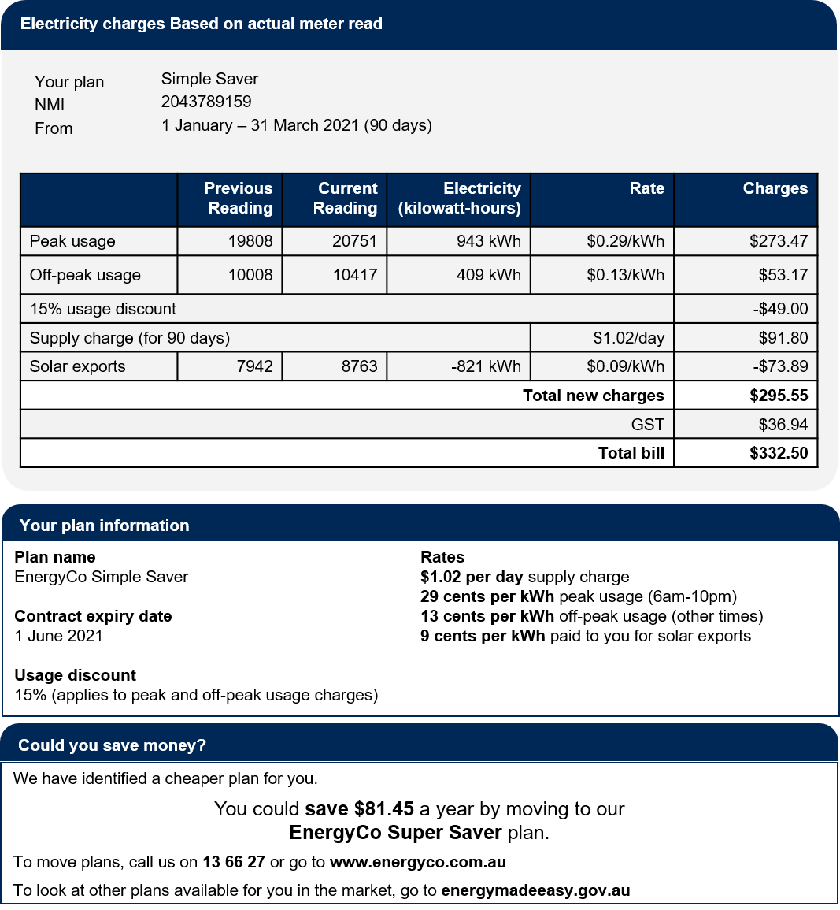

Treatment 4 (T4) = Detailed charges table + Plan summary + Best offer + Definitions
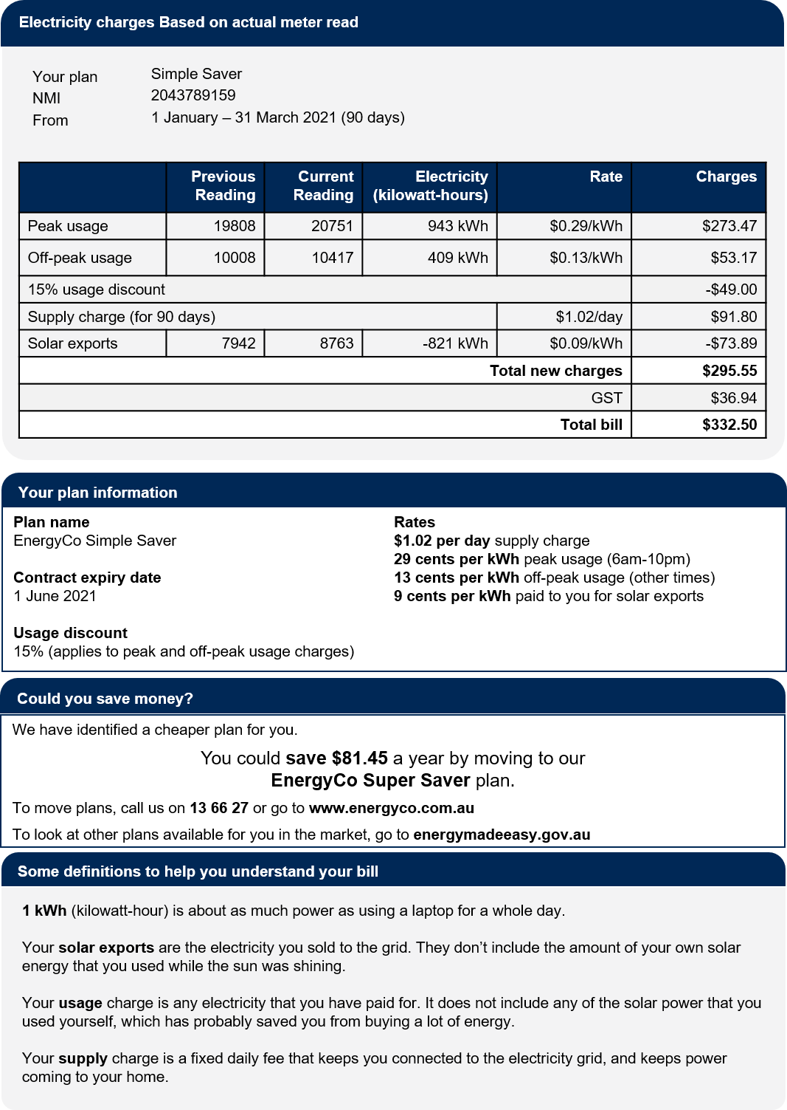

Scenario and questions for RCT B1: Plan summary, Best offer and Definitions
Scenario
Before seeing a bill component, survey respondents read the following text:
“For this part of the study, you will need to use some imagination... Three people are about to ask for your help understanding their electricity.
William's bill is higher than usual and he wants to understand why and what he can do about it. Can you take a look at page 2 of his bill and help him work it out?”
After they had seen the bill component, respondents were asked the following questions. They could refer back to the bill as they did so.

Comprehension
"How much money did my solar panels save me this bill?"
- Less than $75
- More than $75
- It doesn't say
- I'm not sure
"I get a 15% discount, so it costs less than $1 a day just to stay connected to the grid. Is that right?"
- Yes
- No
- It doesn't say
- I'm not sure
"I'm thinking about switching to a plan that charges a flat rate of 18 cents per kilowatt-hour. All the other costs and discounts are the same. Do you think that would that save me money?"
- Yes
- No
- It doesn't say
- I'm not sure
"Could I save money by running my dishwasher at midnight instead of at 8pm?"
- Yes
- No
- It doesn't say
- I'm not sure
William has some more questions for you. He wants your advice.

Advises to switch plans or compare plans.
"What would you do to save some money on electricity, if you were in my position?"
- I suggest... ______________
- I wouldn't know what to do.

Confidence to choose a better plan
"How confident do you feel about this advice?" (4-point scale: Very confident, Confident, Not very confident, Not at all confident)

Intention – Advises using Energy Made Easy website, or advises contacting own retailer.
"I'd like to try to find a cheaper plan. What should I try first?"
- Contact my electricity company and request a cheaper plan
- Visit a government comparison website
- Call a few different electricity companies or check out their websites
- Visit a commercial comparison website
- I don't know

Comprehension – Able to identify cheapest plan.
William decided to look at energymadeeasy.gov.au, a Government comparison website. He has found two plans that he likes the look of and shows them to you together with his own bill.
"Which of these three plans do you think will work out cheapest for me?"
- My current plan (Simple Saver at EnergyCo)
- Dynamic Energy flat rate plan
- Verve Energy Ultra low rate plan
- I don't feel confident to say

Bill is easy to understand
To understand William's bill was... (5-point scale: Very easy, Fairly easy, Okay, A bit difficult, Very difficult)

Would value having plan summary on their bill.
(Respondents randomised to the group that saw the charges table and plan summary were asked the following question.)
The bill below provides information about William’s plan.
To what extent do you agree/disagree with the following statement: I would value having this plan information on my bill. (7-point scale: Strongly agree, Moderately agree, Slightly agree, Neutral, Slightly disagree, Moderately disagree, Strongly disagree)

Would value having information about other plans on their bill.
(Respondents randomised to the group that saw the charges table and best offer message were asked the following question.)
The bill below provides information about other plans on the market.
To what extent do you agree/disagree with the following statement: I would value having this information about other plans on the market on my bill. (7-point scale: Strongly agree, Moderately agree, Slightly agree, Neutral, Slightly disagree, Moderately disagree, Strongly disagree)

9. Benchmarks/peer comparisons (B2)

Overview
The Group B RCT 2 (B2) tested the impact of different benchmark designs on comprehension and intentions to reduce energy usage.

Summary of results

Main outcomes

Hypothesis 1 (impact of benchmarks on comprehension). We found that respondents who saw the benchmarks were more likely to see that energy usage was ‘higher than other people’. We rejected the null for all 4 tests of this hypothesis. The size of the effect was large, with respondents in the four treatment groups offering the correct response 42-45% of the time, as compared to the control group (usage chart only) at 24%.
Hypothesis 2 (impact of graph vs. table benchmark presentation). The graphical presentation of the benchmark did not result in increased understanding of usage. We retained the null for this hypothesis. The point estimate of the graphical presentation treatments was actually slightly lower than when the information was presented in a table (control group).
Hypothesis 3 (impact of benchmarks on intentions). We found that respondents who saw the benchmarks were more likely to suggest energy reductions as a way to save money. Again, we rejected the null for all 4 tests of this hypothesis. In addition, the effect size was material, with 36-40% of people in the treatment groups offering energy saving advice, compared to 32% in the control group (who only saw a historical usage chart).
Trial A1 (impact of benchmarks on intentions). We reached a different conclusion when we tested the impact of a benchmark chart in a full bill, as part of Trial A1. The Basic Bill had no benchmark and yet the proportion in this group who made energy saving suggestions was almost the same as for the Comprehensive and Structured bills (24.5% versus 24.5% and 26.1%, respectively) and these small differences were not statistically significant.
How can the two sets of results be reconciled? One possibility is that benchmarks are effective when respondents focus their attention on them (the Trial B2 result) but lose their effectiveness when seen in the context of a full bill (the Trial A1 result).
Alternatively, when respondents in Trial A1 saw a full bill and were asked for suggestions to reduce energy costs, the full bill suggested other potential avenues for savings (e.g. as implied by the best offer message). Respondents may have felt one answer was sufficient and not looked for further suggestions. If so, our outcome measure may not have been sufficiently sensitive to detect the impact of benchmarks.
This may also help explain why group who saw the Email-style bill were much less likely to suggest using less energy than the group who saw the Basic bill (20.6% versus 24.5%). The Email-style bill group was much more likely to suggest switching plans as a way to reduce energy costs (15% versus 7% for the Basic bill, see results for Trial B1, Hypothesis 3a), perhaps as a result of the prominent position of the best offer message relative to the survey question. Once they made this recommendation, it is possible they did not think it necessary to suggest further ways to reduce costs. That is, suggestions to switch may have crowded out suggestions to reduce energy usage.
See also Section G of the Final Report.

Subgroups
For most subgroups, the results mirrored the main outcomes described above. However, for Hypothesis 3 (impact of benchmarks on intentions), we had a null result for those under financial hardship (i.e. had experienced one or more indicators of financial hardship) and the positive result was confirmed only for respondents who had not reported financial hardship. The size of this effect was stronger than in the overall results, with the benchmarks increasing the energy saving suggestions to 40-46%, as compared to 34% for the group that did not see the benchmark. We are unsure why there would be this difference, and since we did not pre-specify a hypothesis in relation to financial hardship, these results should be treated with caution. (Also, we did not conduct a formal test to determine whether this difference was statistically significant.)

Sensitivity analysis
We re-ran Hypothesis 1 for this RCT after removing the fastest 20% of completers from the sample and confirmed that this did not change our finding. The marginal means (i.e. the point estimate for correctly identifying that usage was above average) for all treatment groups increased by 2-3 percentage points. For example, the marginal mean for Treatment 4 (usage chart + benchmark simple infographic) increased from 45% correct to 48%. However, the differences between the groups were very similar, and they remained statistically significant.

Treatment groups
This was a five-arm trial with the following groups:
- Control (C) = usage chart only
- Treatment 1 (T1) = usage chart + benchmark table
- Treatment 2 (T2) = usage chart + benchmark vertical bar graph
- Treatment 3 (T3) = usage chart + benchmark infographic
- Treatment 4 (T4) = usage chart + benchmark simple infographic

Hypotheses
B2.H1: Any bill showing benchmark data (T1, T2, T3, T4, not pooled) will result in greater understanding of how individual electricity usage compares to average usage than the control condition (C): T1>C, T2>C, T3>C, T4>C.
B2.H2: Any bill showing benchmark data as a chart or infographic (T2, T3 and T4, pooled) will result in greater understanding than the bill which shows benchmark data presented as a table (T1): T2 and T3 and T4 pooled >T1.
B2.H3: Any bill showing benchmark data (T1, T2, T3, T4, not pooled) will result in in higher energy-saving intentions than the control condition (C): T1>C, T2>C, T3>C, T4>C.
The three hypotheses in this trial were assessed using one-tailed hypothesis tests. We used a Bonferroni adjustment to correct for the three main comparisons that comprise this family of tests, by dividing the significance threshold (alpha) by three. We did not correct for the comparison of multiple arms against a shared control group due to correlation between comparisons.

Outcome measures

Primary outcomes
- Comprehension - Able to understand how they compare to benchmark. Binary.
- Intention - Advises to save energy. Free text coded as binary.

Secondary outcomes
- Time taken - Able to respond to comprehension questions.
- Comprehension - Able to understand that benchmark measures usage, not price. Binary.
- Confidence to find a cost-saving strategy. Binary (Very confident or confident = 1, all other responses = 0).
- Bill is easy to understand. Binary (very or fairly easy = 1, all other responses = 0).
- Agrees that benchmarks help their household choose how much energy to use. Binary (any agree = 1, all other responses = 0).
- Would value having benchmark on their bill. Binary (any agree = 1, all other responses = 0).

Intervention designs
Control (C) = past usage chart only
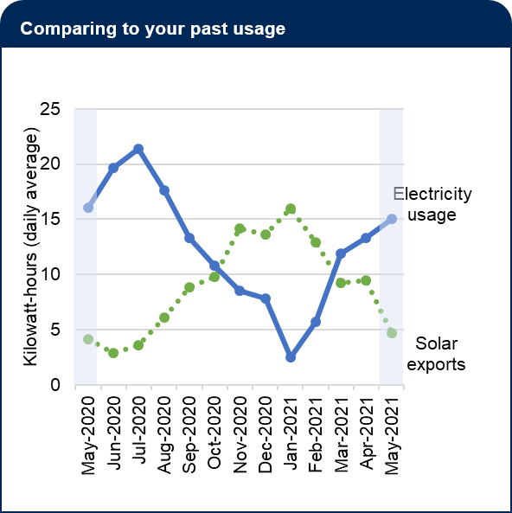

Treatment 1 (T1) = usage chart + benchmark table
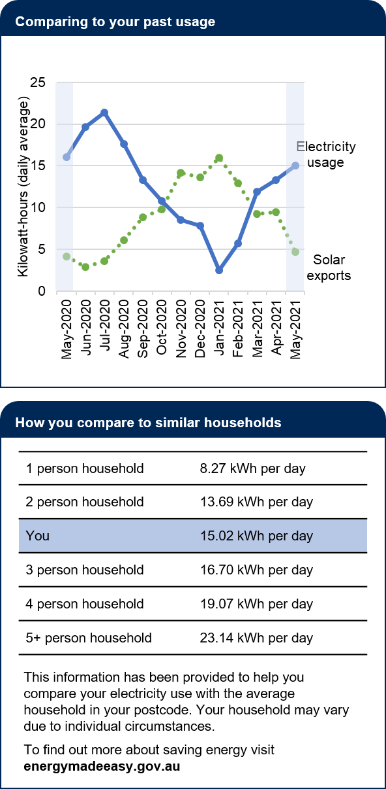
Treatment 2 (T2) = usage chart + benchmark vertical bar graph
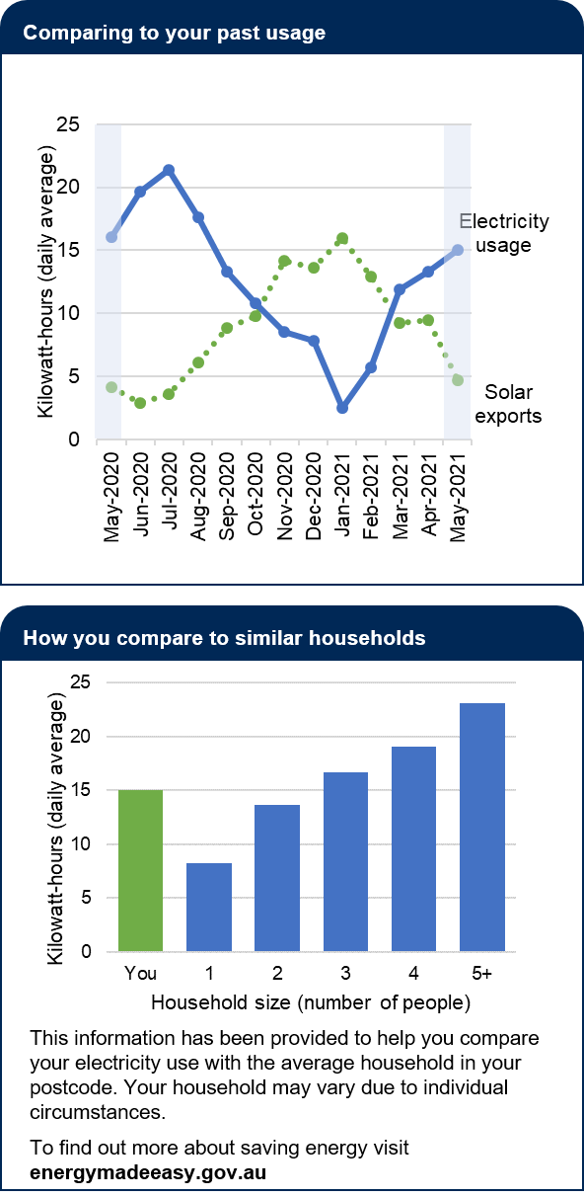

Treatment 3 (T3) = usage chart + benchmark infographic
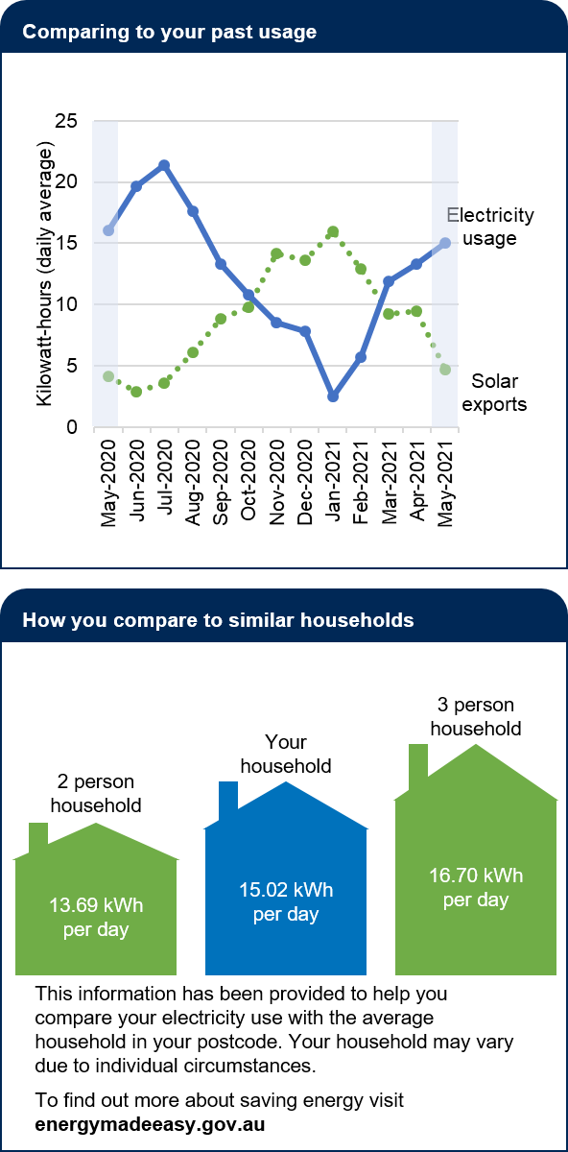
Treatment 4 (T4) = usage chart + benchmark simple infographic
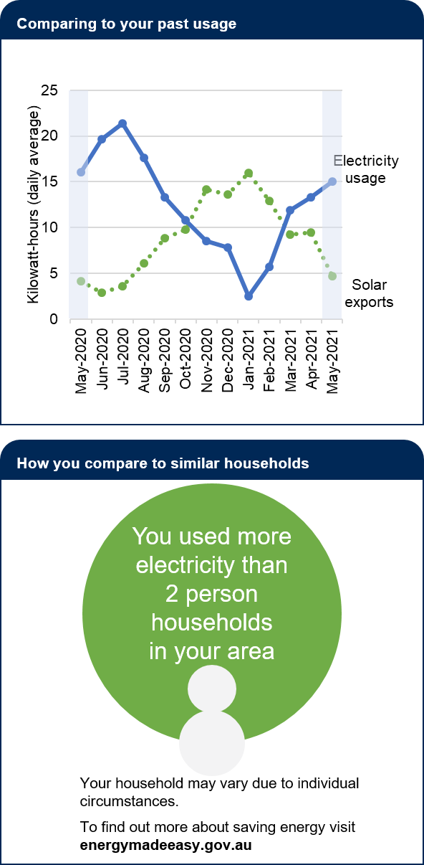

Scenario and questions for RCT B2: benchmarks

Scenario
Before seeing a bill component, survey respondents read the following text:
“Ana lives alone in an apartment, and shows you the home energy report on her bill for May. She wants to check she has understood it, and asks you a few questions.”
After they had seen the bill component, respondents were asked the following questions. They could refer back to the bill as they did so.

Comprehension – Able to understand how they compare to benchmark
"For the month of May, was my electricity usage about average?"
- Higher than other people
- Yes, an average amount
- More efficient than other people
- I couldn't say

Comprehension – Able to understand that benchmark measures usage, not price
"I pay quite a bit more than my neighbour in the apartment next to mine. Why do you think this is?"
- Plan is expensive
- Electricity usage is high
- May have been overcharged
- I couldn't say

Intention – Advises to save energy.
Ana has a few more questions for you. She wants your advice.
"What would you do to save some money on electricity, if you were in my position?"
- I suggest... ______________
- I wouldn't know what to do.

Confidence to find a cost-saving strategy
How confident do you feel about this advice? (4-point scale: Very confident, Confident, Not very confident, Not at all confident)

Bill is easy to understand
To understand Ana's electricity usage information was...
(5-point scale: Very easy, Fairly easy, Okay, A bit difficult, Very difficult)
Like your current bill, Ana's bill provides a comparison of your electricity use to other households in your local area

Agrees that benchmarks help their household choose how much energy to use
To what extent do you agree/disagree with the following statements: This comparison with other households helps my household make a choice about how much electricity to use. (7-point scale: Strongly agree, Moderately agree, Slightly agree, Neutral, Slightly disagree, Moderately disagree, Strongly disagree)

Would value having benchmark on their bill
I would value having this comparison on my bill.
(7-point scale: Strongly agree, Moderately agree, Slightly agree, Neutral, Slightly disagree, Moderately disagree, Strongly disagree)

10. Energy usage & solar exports (B3)

Overview
The Group B RCT 3 (B3) tested the impact of different designs of information regarding past energy usage and solar exports. It also tested the impact of including a definitions of key technical terms.

Summary of results

Main outcomes
Hypothesis 1 (past energy usage). We did not find evidence that the manner of presentation of the chart made a material difference to comprehension. That is, we found null results for all 4 tests of this hypothesis. (The bar chart appeared to perform worse than the others but we are unsure why this could be, and it was not one of our pre-specified hypotheses.)
Hypothesis 2a (solar exports – comprehension). We did not find clear evidence that the manner of presentation of solar exports made a difference for comprehension. There was suggestive evidence in favour of the column or bar chart (42.4% and 42.2%, respectively) relative to the table or line chart (40.5% and 39.7%, respectively). Only the difference between the column chart and the table was statistically significant after adjusting for multiple comparisons (p=0.014, adjusted alpha=0.025) however this was inconsistent with the result for intentions (hypothesis 2b, below) and for the past energy usage chart (hypothesis 1, above). Furthermore, the effect size of 2 percentage points seems small. For these reasons, we are not inclined to draw a positive conclusion in favour of the column chart.
Hypothesis 2b (solar exports – intentions). We found no statistically significant variation in intention to use solar more efficiently based on the presentation of solar export information. Consequently, we found a null result for all 3 tests of this hypothesis. The point estimate for the bar chart was somewhat higher than the other 3 presentations (8.0% versus 6.4-6.6%) however this was not statistically significant when adjusted for multiple comparisons (p=0.029, adjusted alpha=0.025) and not consistent with the results from hypotheses 1 and 2a (in particular, in hypothesis 1, the bar chart appeared to perform worse than the other presentations).
Trial A1 (solar exports – intentions). We also tested the impact of including a solar exports chart in a full bill, as part of Trial A1. In this case, we had a control group – the Basic bill – that did not include the information on solar exports. However, we were unable to draw a clear conclusion about the impact of solar exports on intentions to use solar more efficiently. The proportion making suggestions to use solar more efficiently were similar for three of the bills. While there was a material and statistically significant difference between respondents who saw the Comprehensive bill and the Basic bill (3.7% versus 2.5%, p=0.027, alpha=0.05), it raises the question of why the Structured comprehensive bill did not have a similar impact. Because the proportions who suggested efficient solar use were so small, it was difficult to draw a clear conclusion.
Hypotheses 3a, 3b and 3c (definitions). We found no evidence that adding definitions improved comprehension (3a), understanding of solar exports (3b) or intention to use solar more efficiently (3c). Thus, we found null results for all 3 hypotheses. This mirrored our results on the impact of definitions in Trial B1.

Subgroups
For Hypothesis 2a, Treatments A2 (Two column charts) and A3 (Combined bar chart) led to statistically significant increases in comprehension (when compared to the Table group) for various subgroups. However, the size of this effect was small (1-4pp) and is unlikely to represent any substantial real-world difference. The subgroups for the other hypotheses for this trial broadly matched the overall results described above.

Sensitivity analysis
We re-ran hypotheses 1 for this RCT after removing the fastest 20% of completers from the sample and confirmed that our findings were unchanged. The marginal means (i.e. the point estimate for the usage comprehension score) for all treatment groups increased by small amounts. Nonetheless, we continued to find null results for both hypotheses.

Treatment groups
This was a 5x2 factorial design. Our first independent variable (A) had five levels and varied by energy consumption and solar export charts. Our second independent variable (B) had two levels and tested the impact of providing additional definitions for technical terms. The table below summarises the intervention associated with each factor and defines the individual cells formed by each independent variable.
- Trial B3 factorial design
Chart types | B0 = Without definitions | B1 =With definitions
A0 = Complex consumption chart, solar exports table | A0B0 | A0B1
A1 = Simple consumption column chart, solar exports table | A1B0 | A1B1
A2 = Two column charts | A2B0 | A2B1
A3 = Combined bar chart | A3B0 | A3B1
A4 = Combined line chart | A4B0 | A4B1

Hypotheses

Energy usage patterns
B3.H1: Any simple energy usage chart (A1, A2, A3, A4, not pooled) will result in higher comprehension of energy usage patterns than a complex chart (A0): A1>A0, A2>A0, A3>A0, A4>A0
These hypotheses were assessed with a series of one-sided tests. We did not correct for multiple comparisons due to the shared control group.

Solar exports
B3.H2a: Any bill with a solar chart (A2, A3, A4, not pooled) will result in higher comprehension of solar export patterns over time than a table (A0 and A1 pooled): A2>A0 and A1 pooled, A3> A0 and A1 pooled, A4> A0 and A1 pooled
B3.H2b: Any bill with a solar chart (T2, T3, T4, not pooled) will result in a higher intention to use solar more efficiently (as measured by a higher proportion that advises using solar more efficiently) than those seeing a solar table (T0 and T1 pooled): A2> A0 and A1 pooled, A3> A0 and A1 pooled, A4> A0 and A1 pooled
Both of these hypotheses were assessed with a series of one-tailed hypothesis tests. We corrected for two multiple comparisons for this family of tests (by dividing alpha by two) but did not correct for the multiple comparisons against a shared control group.

Plain language definitions
B3.H3a: Any bill with plain language definitions (B1) will result in higher comprehension of energy usage than a bill without definitions (B0): B1>B0
B3.H3b: Any bill with definitions (B1) will result in higher comprehension of solar energy export patterns over time than a bill without definitions (B0): B1>B0
B3.H3c: Any bill with definitions (B) will result in a higher intention to use solar more efficiently (as measured by a higher proportion that advises using solar more efficiently) than a bill without definitions (A): B1>B0
We assessed these hypotheses with one-tailed hypothesis tests, using a Bonferroni correction for the three comparisons that comprise this family of tests, by dividing alpha by three.

Outcome measures

Primary outcomes
- Comprehension - Able to understand usage chart. Number of correct answers (0-4).
- Comprehension - Able to understand solar export chart. Number of correct answers (0-4).
- Intention - Advises to use solar more efficiently. Free text coded as binary.

Secondary outcomes
- Time taken - Able to respond to understand usage chart.
- Time taken - Able to understand solar export chart.
- Confidence to find a cost-saving strategy. Binary (Very confident or confident = 1, all other responses = 0).
- Bill is easy to understand. Binary (very or fairly easy = 1, all other responses = 0).
- Would value having solar information on their bill. Binary (any agree = 1, all other responses = 0).

Intervention designs
A0 = Complex consumption chart, solar export table
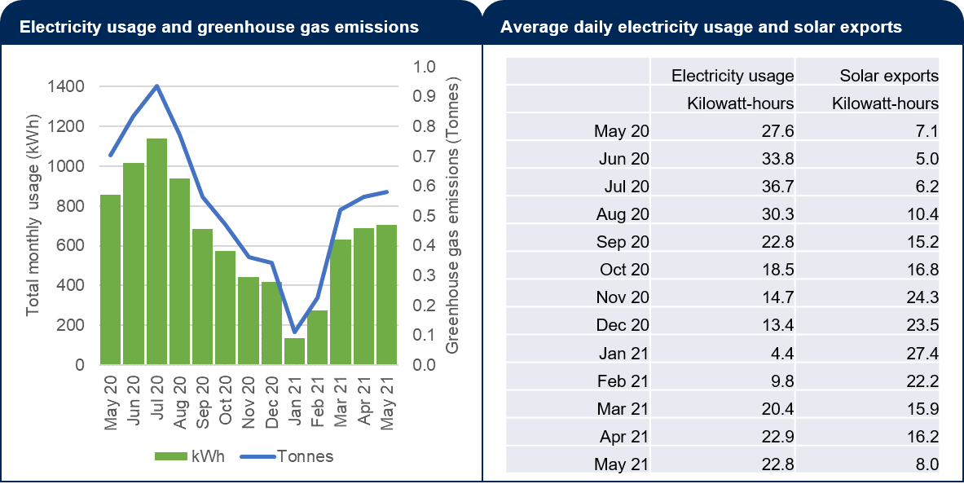
A1 = Simple consumption column chart, solar export table
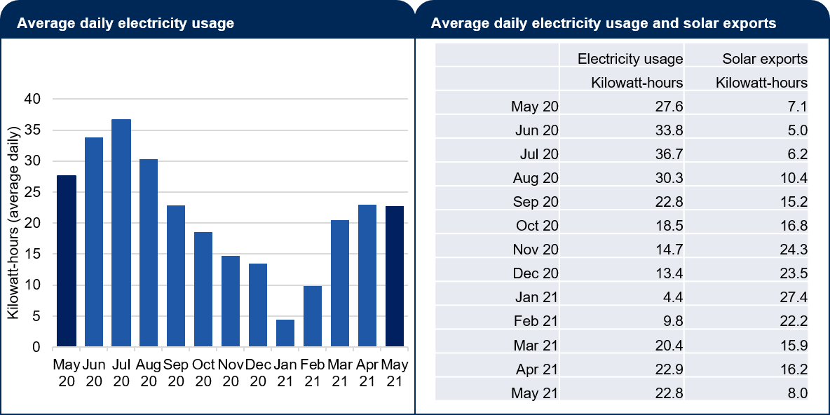
A2 = Two column charts
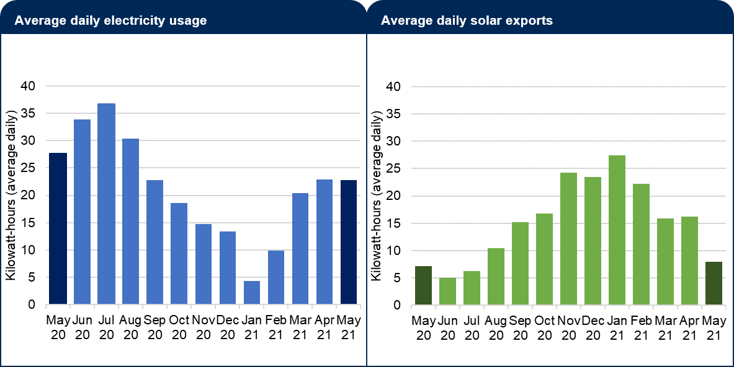
A3 = Combined bar chart
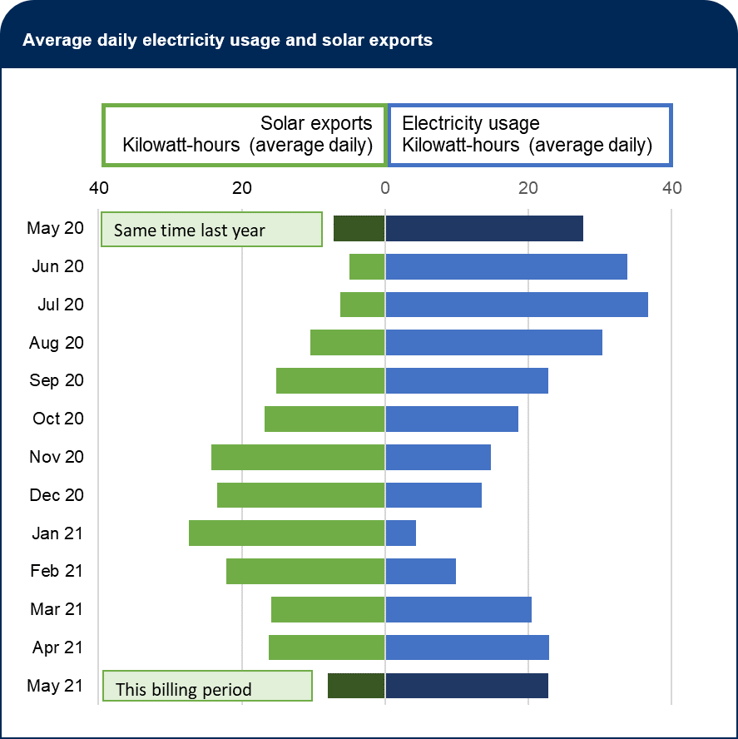
A4 = Combined line chart
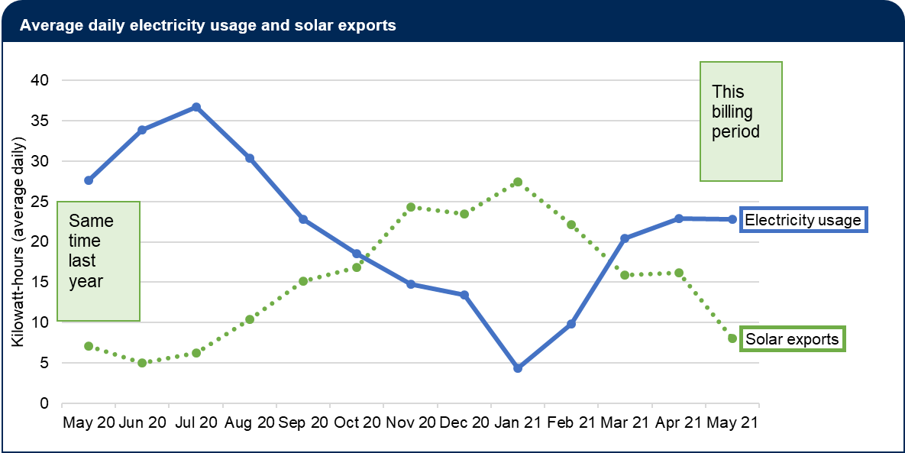
B1 = With definitions (placed beneath A~)
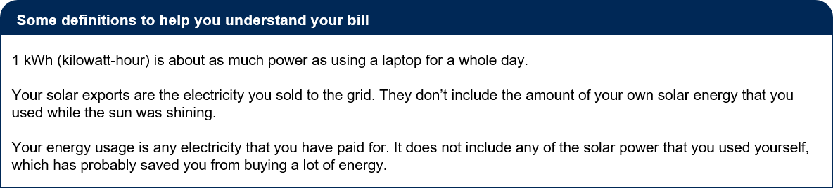

Scenario and questions for RCT B3: Energy usage and solar exports
Scenario
Before seeing a bill component, survey respondents read the following text:
“Isaac has a large family and they use a lot of appliances and devices. He wants to save on his bills and he'd like your help. He shows you the energy information on his bill.”
After they had seen the bill component, respondents were asked the following questions. They could refer back to the bill as they did so.

Comprehension – Able to understand usage chart
“According to this chart, what happened from February to March?"
- Electricity prices went up
- Electricity usage went up
- Electricity prices went down
- Electricity usage went down
- It doesn't say
- I'm not sure
“Is my usage highest in January when the kids turn on the air-conditioner?"
- Yes
- No
- It doesn't say
- I'm not sure
"I was working from home in May this year. How much electricity from the grid did I use?"
- Around 23 kWh a day
- Around 8 kWh a day
- Around 28 kWh a day
- It doesn't say
- I'm not sure
"Did my electricity usage go up compared to the same time last year?"
- Yes, it went up
- No, it came down
- It's virtually the same
- It doesn't say
- I'm not sure

Comprehension – Able to understand solar export chart

Isaac had solar panels installed 18 months ago. He is keen to understand whether they are working for him.

"Why did I earn more money from my solar in January?"
- The price was higher
- I sold more solar electricity to the grid
- I used less electricity
- It doesn't say
- I'm not sure
"How much electricity do you think my solar panels generated in May?"
- Probably less than 10 kWh a day
- Probably more than 10 kWh a day
- It doesn't say
- I'm not sure
"Should I expect my solar exports to be lower this June than they were in May?"
- Yes, this is likely
- No, this is unlikely
- It doesn't say
- I'm not sure
"At any point in the year, did I sell more electricity than I bought?"
- Yes, for about half the year
- Yes, from November to February
- No
- It doesn't say
- I'm not sure

Intention – Advises to use solar more efficiently.
Isaac has some more questions for you. He wants your advice.
"What would you do to save some money on electricity, if you were in my position?"
- I suggest... ____________
- I wouldn't know what to do.

Confidence to find a cost-saving strategy
How confident do you feel about this advice? (4-point scale: Very confident, Confident, Not very confident, Not at all confident)

Bill is easy to understand
To understand Isaac's bill was... (5-point scale: Very easy, Fairly easy, Okay, A bit difficult, Very difficult)

Would value having solar information on their bill
(This question was only presented to people that had indicated in an earlier question that they had solar panels on their property.)
The bill below contains information about solar energy exports over the past year.
To what extent do you agree/disagree with the following statement: I would value having this additional information about solar exports on my bill. (7-point scale: Strongly agree, Moderately agree, Slightly agree, Neutral, Slightly disagree, Moderately disagree, Strongly disagree)

© Commonwealth of Australia 2021
ISBN 978-1-925364-85-9 Improving energy bills: final report

Copyright Notice
With the exception of the Commonwealth Coat of Arms, this work is licensed under a Creative Commons Attribution 4.0 International license (CC BY 4.0) (https://creativecommons.org/licenses/by/4.0/)

Third party copyright
Wherever a third party holds copyright in this material, the copyright remains with that party. Their permission may be required to use the material. Please contact them directly.

Attribution
This publication should be attributed as follows:
© Commonwealth of Australia, Department of the Prime Minister and Cabinet, Improving Energy Bills: final report.

Use of the Coat of Arms
The terms under which the Coat of Arms can be used are detailed on the following website: https://pmc.gov.au/cca

Behavioural Economics Team
of the Australian Government
General enquiries beta@pmc.gov.au
Media enquiries media@pmc.gov.au
Find out more www.pmc.gov.au/beta

Language – ABS Census of Population and Housing: Reflecting Australia - Stories from the Census, 2016 - Cultural (cat. no.2071.0)
This question was tailored to the jurisdiction of the respondent. In each case, it featured a list of 4 or 5 of the largest retailers (by customer share) in that jurisdiction, and names of other retailers could by typed in by the respondent.
Why was the score so high for the Email-style bill? One possibility is that other cost-saving options were only evident for the minority (15%) who clicked on the Home Energy Report. In addition, the ‘best offer’ message may have been unusually prominent since it appeared near the bottom of the Email-style bill, and thus immediately above the survey questions that followed.

