

# Home energy upgrades

**Technical Appendix**

**December 2024**

Contents

Appendix A: Technical details 2

Appendix B: Trial 1 Choice of home 5

Appendix C: Trial 2 Choice of upgrade 12

Appendix D: Trial 3 Decision support 18

Appendix E: Trial 4 Certificate design 25

Appendix F: Trial 5 Prompts 30

Appendix H: Literature Review 32

References 40

## Appendix A: Technical details

### Pre-registration, pre-analysis plan and ethics

This trial was publicly pre-registered on the American Economic Association’s Social Science Registry (13423) and on the BETA website. Both registrations were completed before we commenced data collection and analysis. The ethical aspects of the research were reviewed and approved by the Macquarie University Low Risk Committee (Project ID: 15629).

The analysis of the Randomised Controlled Trial (RCT) data was consistent with the pre-analysis plan. All exploratory analyses are clearly designated.

### Data cleaning

We cleaned and analysed the data using R 4.4.0 (R, Core Team, 2023) and Stata 17.0. As we collected data we did regular checks on quotas, assessments for bots, and checks for randomisation or other errors. We did not analyse the data until after collection was complete.

### Survey design

The population of interest was adults (18 years and over) in Australia, both current and potential homeowners. Our target sample was 13,000 with a final sample of 13,797 survey respondents, achieving a sample consistent with national demographics from the 2021 Census on age, gender, location and home ownership.

Table . Our sample was broadly consistent with national demographics from the 2021 Census

| Category | Value | BETA survey % | 2021 Census % |
| --- | --- | --- | --- |
| Gender | Woman or female | 54 | 51 |
| Gender | Man or male | 46 | 49 |
| Age | 18 - 34 | 29 | 20 (20-34 years) |
| Age | 35 - 64 | 48 | 38 |
| Age | 65+ | 23 | 17 |
| State | Australian Capital Territory | 2 | 2 |
| State | New South Wales | 30 | 32 |
| State | Northern Territory | 0.4 | 1 |
| State | Queensland | 20 | 20 |
| State | South Australia | 9 | 7 |
| State | Tasmania | 3 | 2 |
| State | Victoria | 26 | 26 |
| State | Western Australia | 9 | 10 |
| Location | Capital city | 59 | 67 |
| Location | Another part of the state | 41 | 33 |
| Homeowner | Owned outright | 32 | 30 |
| Homeowner | Owned with mortgage | 32 | 33 |
| Homeowner | Rented | 32 | 30 |

N = 13,797. Percentages may not add up to 100 due to missing responses. Source: Australian Bureau of Statistics, Snapshot of Australia, Census 2021

For full demographics and survey results see Appendix 2 in the Home Energy Upgrades report.

The design (Figure 1) streamed the majority of homeowners with freestanding houses or townhouses to Trial 3, 4 and 5 – in particular, trial 3 asked participants to think about changes they would like to make to their current home. The remaining homeowners and all other groups were streamed to do Trials 1, 2 and 5. Trials 1 and 2 worked as a set. Trial 5 was a single message at the end of all surveys.

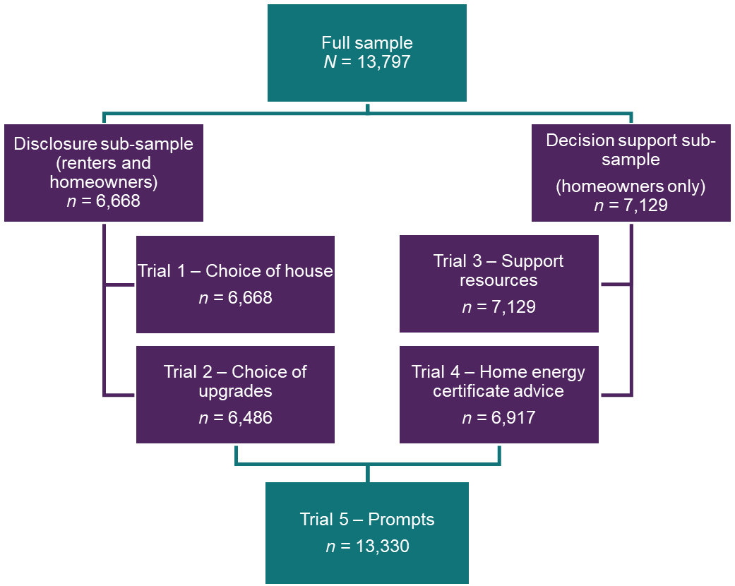

Figure . Survey flow

Randomisation to different arms in each trial was done using inbuilt Qualtrics randomisation functionality. Individuals were assigned a random integer which determined their assignment within each trial. Randomisation for each trial occurred independently, with the exception of trials 1 and 2 – in which respondents were assigned to either a mandatory or voluntary disclosure arm and remained in that arm for both trials.

## Appendix B: Trial 1 Choice of home

### Design

A combined Randomised Controlled Trial (RCT) and Discrete Choice Experiment, participants were invited to view 8 pairs of real estate listings and choose which property to inspect. Participants could see attributes such as price, size, number of bedrooms and bathrooms, internal and external features and Home Energy Ratings. This design tested whether mandatory disclosure of Home Energy Ratings influenced selection of high rated homes more often than voluntary disclosure, in which only highly energy efficient homes “high rated homes” disclosed ratings.

### Sample size and power

This Randomised Controlled Trial (RCT) was designed to observe a minimal detectable effect of 2.2 percentage points. As we did not have a baseline understanding of the proportion of times that survey respondents would pick the high energy rated option, we made the most conservative assumptions for the power calculation. Therefore, we assumed the average proportion for the control was 50%, and thus the treatment group’s average proportion was 52.2%.

We used conventional settings for type I error with alpha at 5% and 80% power. We have chosen these settings because the intervention is low risk. To achieve 80% power to detect an effect size of 2.2 percentage points (Cohen’s *h* = -0.04) we needed to recruit 3250 per arm for a total sample size of 6500. Our final sample achieved was 6,668.

We conducted power calculations in R version 4.4.0 using the ‘pwr’ package version 1.3.2.

### Sample randomisation

For the **RCT component,** survey respondents who were assigned to the disclosure stream were randomised to one of 2 cells. Group 1 was assigned to a Mandatory disclosure group and Group 2 was assigned to a Voluntary disclosure group.

The **Discrete Choice Experiment (DCE) component** of this trial was randomised at the level of features. We specified the following:

* each participant responds to 8 choice sets;
* each choice set contains 2 house options, and a ‘neither of these options’;
* there are 7 features for each house, with varying levels (as described below)
  + *Bed:* 3, 4
  + *Bath:* 1, 2
  + *Block size (m2)*: 500, 550, 600
  + *Indoor Features:* hardwood floors, built-in robes, freshly painted throughout, north facing aspect, new carpet
  + *Outdoor features:* Large veranda, garden shed, close to amenities, established garden, fruit trees and shady lawn
  + *Home Energy Rating:*   
    Mandatory disclosure group: 6 levels, 0/100, 20/100, 40/100, 60/100, 80/100, 100/100 (each level shown a similar number of times).  
    Voluntary disclosure group: 4 levels, Unrated, 60/100, 80/100, 100/100 (around half of homes shown were unrated, the remaining homes were equally distributed among the remaining categories).
  + *Price:* $590k, $610k, $630k, $650k, $670k

Qualtrics then calculated a D-efficient (orthogonal and balanced) experimental design based on these specifications. This means that respondents saw a “random” set of homes, with a “random” set of features. The net effect is that we gain the maximum amount of information about the influence of each feature on respondents’ choices.

### Primary Outcomes

At the individual level the outcome was the proportion of highly efficient houses selected across the 8 choice sets. Individual level outcomes were averaged within treatment groups to give the average proportion of highly efficient homes selected by arm. High rated homes were those at 60/100 or higher (i.e. ratings over 50/100 treated as high efficiency, less than 50/100 treated as low efficiency.) As noted in the report, a home with a score of 60/100 meets the stringency requirements for new homes under the National Construction Code 2022.

### Secondary Outcomes

There were 3 secondary outcomes:

* The importance ranking the participant gives to ‘energy rating’ which is among a selection of 8 options. The survey question ‘Please order these property features from most to least important by dragging them up or down’. Response options are 1 (number of bedrooms), 2 (number of bathrooms), 3 (size of land), 4 (nice interior), 5 (nice garden and landscaping), 6 (Home Energy Rating), 7 (price), 8 (proximity to amenities).
* The average rating respondents choose for homes that don’t display a rating. In the mandatory condition respondents are asked to guess energy rating of an unrated home. (Slider, options are 0-100).
* DCE outcome: for the DCE component the outcome was the option that each individual choses out of the 8 choice sets. Within each choice set an option was coded as ‘1’ if it was selected, and as ‘0’ if it was not. If a participant did not choose any option then both options was coded as ‘0’.

### Hypotheses

H1. Mandatory > Voluntary: Mandatory disclosure will increase the selection of high rated homes relative to voluntary disclosure.

For the secondary outcomes:

H2. Mandatory > Voluntary: Mandatory disclosure will lead to a higher ranking of importance, and a higher proportion of respondents stating energy rating is important, relative to voluntary disclosure.

H3: Mandatory ≠ Voluntary: For the average rating of unrated homes we predict that mandatory and voluntary disclosure arms will differ (direction not specified).

For the DCE we predict that a higher energy rating will increase the likelihood of respondents choosing to inspect a home.

### Method of analysis

The principal analysis of the effect of the intervention is a covariate-adjusted comparison of our primary outcome for our 2 arms. This estimate, confidence intervals and *p-*values were derived from a linear regression model using robust standard errors (HC2) with the following specification:

Equation Y subscript i equals beta subscript 0 plus beta subscript 1 Z subscript i plus beta subscript 2 X subscript i plus beta subscript 3 Z subscript i X subscript i plus epsilon subscript i 

Where *i* is an index for each individual in the trial, *Yi*is the individual’s outcome expressed as 0 or 1, *β0* is the intercept, *Zi* is a treatment assignment indicator, *β1* is the coefficient representing the average treatment effect for the mandatory disclosure arm relative to the voluntary disclosure arm, *Xi* is a vector of the mean-centred covariate and a mean-centred block indicator to account for the stratified randomisation with coefficient *β2*, and *ZjXi*is the interaction of the treatment indicator with the mean-centred covariate/block indicator vector, *β3* is the associated coefficient, and *Ei* is the individual error term.

For the discrete choice experiment we used a linear mixed effects model, with random slopes for the price and energy rating. It had the following specification:

Equation Y subscript i j equals beta subscript 0 plus open paranthesis beta subscript 1 plus v subscript 1 j close parenthesis A subscript 1 i j plus open parenthesis beta subscript 2 plus v subscript 2 j close parenthesis A subscript 2 i j plus elipses plus beta subscript 6 A subscript 6 i j plus epsilon subscript i j 

Where *i* is an index for each individual in the trial, *j* is the index for each choice the individual makes, Y*ij*is whether individual *i* chose choice *j*, A*k* are vectors representing the vectors of different features, B*k* is the coefficient associated with each feature, and the utility gain for no choice *(β0)*, *V1j*and *V2j*are the random effects associated with the price and energy rating label slopes,and *Eij*is the error associated with each choice.

#### Covariates

We will adjust for the following mean-centred covariates in our regression:

* Home ownership (binary, 1 = owner with or without mortgage, 0 = non-owner).
* Home type (binary, 1 = free standing home or townhouse, semi-detached, row or terrace house, 0 = other housing type).
* Block indicator to account for stratified randomisation within each panel provider. Block: categorical variable (binary, 1 = panel A, 0 = panel B).

### Statistical tables

Table . H1: Respondents were more likely to choose a high rated home in the mandatory condition

| **Condition** | **Means (pp)** | **Estimate (pp)** | **Standard error (pp)** | **95% Confidence Interval (pp)** | ***p-*value** |
| --- | --- | --- | --- | --- | --- |
| Voluntary | 51.31 | - | - | - | - |
| Mandatory | 55.53 | 4.22 | 0.01 | (0.03 - Inf) | 0.000 |

n = 6,593

OLS model adjusted for buyer/seller role, recruitment panel and home ownership status with HC2 robust standard errors.

Note on one-sided tests: We tested whether the effect size was greater than zero. The confidence interval is one-sided to describe only the lower bound of the estimate. In this case the lower bound is still greater than zero (0.03) indicating a statistically significant effect.

Table . H2a: Mandatory disclosure led to a higher ranking of importance relative to voluntary disclosure

| **Condition** | **Means (rating)** | **Estimate** | **Standard error (pp)** | **95% Confidence Interval (pp)** | ***p-*value** |
| --- | --- | --- | --- | --- | --- |
| Voluntary | 2.70 | - | - | - | - |
| Mandatory | 3.08 | 0.37 | 0.06 | (0.28 - Inf) | 0.000 |

n = 5,456

OLS model adjusted for buyer/seller role, recruitment panel and home ownership status with HC2 robust standard errors. (Ranking out of 8 factors where 7 = highest ranking and 0 = lowest ranking)

Table . H2b: Mandatory disclosure led to a higher proportion of respondents stating energy rating is important when renting, relative to voluntary disclosure

| **Condition** | **Means (pp)** | **Estimate (pp)** | **Standard error (pp)** | **95% Confidence Interval (pp)** | ***p-*value** |
| --- | --- | --- | --- | --- | --- |
| Voluntary | 73.37 | - | - | - | - |
| Mandatory | 77.44 | 4.07 | 1.07 | (2.31 - Inf) | 0.000 |

n = 6,427

OLS model adjusted for buyer/seller role, recruitment panel and home ownership status with HC2 robust standard errors.

One sided test. How important to you would it be to know the Home Energy Rating of a potential property before you **rent** it? Outcome variable is a binary variable in which 1=Very important or Somewhat important and 0 = Not very important, Not important at all, or Not sure.

Table . H2c: Mandatory disclosure led to a higher proportion of respondents stating energy rating is important when buying, relative to voluntary disclosure

| **Condition** | **Means (pp)** | **Estimate** | **Standard error (pp)** | **95% Confidence Interval (pp)** | ***p-*value** |
| --- | --- | --- | --- | --- | --- |
| Voluntary | 84.86 | - | - | - | - |
| Mandatory | 86.92 | 2.06 | 0.87 | (0.63 - Inf) | 0.009 |

n = 6,414

OLS model adjusted for buyer/seller role, recruitment panel and home ownership status with HC2 robust standard errors. One sided test. How important to you would it be to know the Home Energy Rating of a potential property before you buy it? Outcome variable is a binary variable in which 1=Very important or Somewhat important and 0 = Not very important, Not important at all, or Not sure.

Table . H3: Respondents rate houses differently in both the mandatory and voluntary disclosure conditions

| **Condition** | **Means (rating)** | **Estimate** | **Standard error (pp)** | **95% Confidence Interval (pp)** | ***p-*value** |
| --- | --- | --- | --- | --- | --- |
| Voluntary | 55.28 | - | - | - | - |
| Mandatory | 47.57 | -7.71 | 0.67 | (-9.02 - -6.39) | 0.000 |

n = 3,926

OLS model adjusted for buyer/seller role, recruitment panel and home ownership status with HC2 robust standard errors. Rating out of 100.

Table . Primary analysis DCE voluntary disclosure: Respondents were less likely to inspect homes with lower ratings

| **Home Energy Rating** | **Estimate (pp)** | **Standard error (pp)** | ***t*-value** |
| --- | --- | --- | --- |
| 100/100 | - | - | - |
| 80/100 | -6.47 | 0.01 | -9.031 |
| 60/100 | -14.44 | 0.01 | -19.385 |
| Unrated | -20.44 | 0.01 | -31.128 |

n = 3,339

Linear Mixed Model for voluntary disclosure labels with the energy label treated as a factor (non-linear) variable, using 100 as base. Number of observations = 53,090 (~8 choices per participant with each choice yielding two observations).

Table . Primary analysis DCE mandatory disclosure: Respondents were less likely to choose to inspect homes with lower ratings

| **Home Energy Rating** | **Estimate (pp)** | **Standard error (pp)** | ***t*-value** |
| --- | --- | --- | --- |
| 100/100 | - | - | - |
| 80/100 | -5.37 | 0.01 | -7.472 |
| 60/100 | -12.03 | 0.01 | -16.070 |
| 40/100 | -22.29 | 0.01 | -28.102 |
| 20/100 | -29.53 | 0.01 | -35.865 |
| 0/100 | -36.10 | 0.01 | -42.420 |

n = 3,329

Linear Mixed Model for mandatory disclosure labels with the energy label treated as a factor (non-linear) variable, using 100 as base. Number of observations = 52,944 (~8 choices per participant with each choice yielding two observations).

#### Exploratory analysis

Not all choices in the DCE were between high and low rated homes. Some choices were between two high rated homes or between two low rated homes as all the features were randomised. These were evenly distributed across both mandatory and voluntary conditions in the RCT.

Table . A subset of observations showed respondents making a choice between a high rated home and low rated home

|  | Choice | Voluntary  (n) | Mandatory  (n) |
| --- | --- | --- | --- |
| **1** | Chose high rated home - both homes were high rated | 5,761 | 5,473 |
| **2** | **Chose high rated home over low rated home** | **7,849** | **9,223** |
| **3** | **Chose low rated home over high rated home** | **4,452** | **3,486** |
| **4** | Chose low rated home - both homes low rated or unrated | 5,487 | 5,045 |
| **5** | Chose neither property | 2,996 | 3,245 |
| - | Totals | 26,545 | 26,472 |

n = 6,668, based on 53,017 observations (~ 8 choices per respondent).   
Image description: Table 1 shows the number of respondents choosing high rated and low rated homes in the discrete choice experiment. Respondents could choose 1 of 2 properties or neither. In around half of cases, both properties presented were low rated or high rated. In the main RCT analysis, choices for a high rated home (line 1 or 2) were treated as the numerator, and all other choices (lines 3-5) were included in the denominator.

We found almost 3 in 4 respondents in the mandatory disclosure condition chose the home with a high energy rating when given a choice between a high rated and low rated home. The effect of the mandatory disclosure condition was stronger when we looked only at this subset of choices.

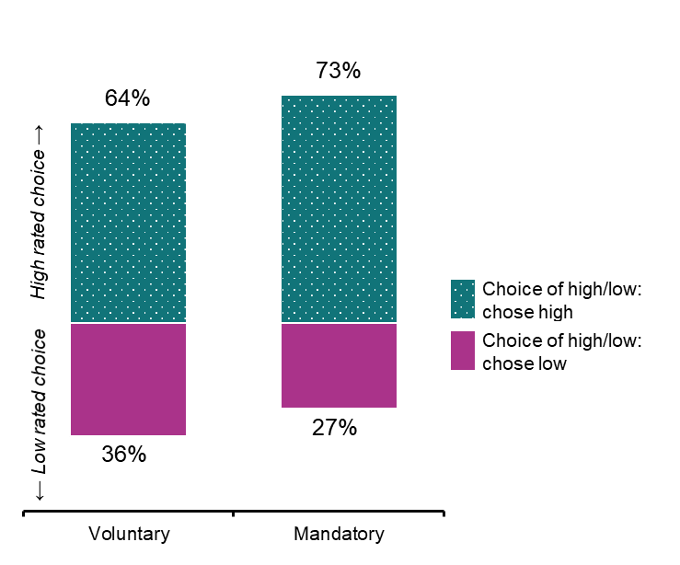

Figure . Respondents were more likely to pick the high rated home in the mandatory disclosure condition compared to the voluntary disclosure condition

n = 6,349, based on 25,010 observations (varying but up to 8 choices per respondent).

## Appendix C: Trial 2 Choice of upgrade

### Design

A 2x2 factorial Randomised Controlled Trial (RCT) in which participants were asked to choose a preferred upgrade (out of 12 options) after being shown a detailed real estate listing. Randomisation to Mandatory and Voluntary disclosure settings was paired with Trial 1, but participants were also randomised to a role – a buyer making upgrades to a home before moving in or a seller, making upgrades prior to sale to realise the best price at auction. This design tested whether ‘buyers’ and ‘sellers’ were more likely to choose ‘energy upgrades’ (4 options of the 12: solar panels, roof insulation, efficient heatpump hot water system or reverse cycle air-conditioning unit) if the Home Energy Rating was required to be disclosed on the real estate listing (Mandatory Disclosure).

### Sample size and power

The target sample for Trial 2 experiments was 6,500 individuals and final sample was 6,486. With this sample size we had approximately 90% power to detect an effect of 4 percentage points for both hypotheses. We expected to be able to detect a 4 percentage point main effect for the voluntary vs mandatory disclosure hypothesis, and a 4 percentage point change in the buyer vs seller. In the event of an interaction between the effects we had 88% power to detect a 5 percentage point main effect, with either an antagonistic or synergistic interaction effect of 2 percentage points. We were not powered to measure the interaction.

We set alpha at 5% and power at 90%. We chose these settings because the intervention is low risk.

We conducted power calculations in R version 4.4.0 using simulation.

### Sample randomisation

Respondents were randomised before Trial 1 at the individual level to 1 of 2 cells (for the voluntary vs mandatory randomisation). Trial 1 and Trial 2 both shared the randomisation to either the mandatory or voluntary disclosure condition, but in Trial 1 all respondents were asked to imagine they were buying a house. In Trial 2, half were asked to imagine they were buying a house, and half were asked to imagine they were selling a house. We then randomised respondents to buyer vs seller with roughly equal probability of assignment across the 2 cells. Prior to undertaking this trial respondents completed some demographics questions (for quotas and baseline covariates) and completed Trial 1.

### Primary Outcomes

At an individual level respondents were asked to choose an upgrade for their home from a list of 12 options. The primary outcome was whether their priority upgrade was an energy upgrade (binary, 1 = energy upgrade, 0 = another upgrade). This was averaged within treatment groups to give the proportion of energy upgrades selected within each arm.

### Secondary Outcomes

There were 2 secondary outcomes.

* At an individual level the outcome was whether the participant thought knowing their home energy rating before choosing home upgrades and renovations was useful (binary, 1 = ‘very useful’ or ‘somewhat useful’, 0 = ‘not very useful’, ‘not at all useful’). This was averaged within treatment groups to give the proportion of respondents who thought the home energy rating is useful within each arm.
* At an individual level the outcome was the number of home energy upgrades selected by the participant when they were asked to select 3 upgrades to make to the property. The range of possible outcomes was 0, 1, 2, or 3 (the list contained 4 energy upgrades and 8 non-energy upgrades sorted randomly). This is averaged within treatment groups to give the mean number of upgrades within each arm.

### Hypotheses

H1. Mandatory > Voluntary: Mandatory disclosure arm will increase the selection of home energy upgrades relative to voluntary disclosure.

H2. Buyer > Sellers: There will be a difference between buyers and sellers in the proportion of home energy upgrades selected (direction not specified).

### Method of analysis

The principal analysis of the effect of the intervention consisted of a covariate-adjusted comparison of our primary outcome for main effects. This estimate, confidence intervals and p-values were derived from a linear regression model using robust (HC2) standard errors with the following specification:

Equation Y subscript i equals beta subscript 0 plus beta subscript 1 A subscrpt i plus beta subscript 2 B subscript i plus beta subscript 3 X subscript i plus beta subscript 4 A subscript i X subscript i plus beta subscript 5 B subscript i X subscript i plus epsilon sbscript i

Where *i* is an index for each individual in the trial, *Yi* is the individual’s outcome expressed as 0 or 1, *β0* the intercept, *Ai* is treatment assignment indicator and *β1* is a vector of coefficients representing the average treatment effect for mandatory disclosure relative to voluntary disclosure, *Bi* is a treatment assignment indicator, *β2* is a coefficient representing the average treatment effect for buyers relative to sellers, *Xi* is a vector of the mean-centred covariates and a mean-centred block indicator to account for the stratified randomisation with coefficient *β3*, and *AiXi* is the interaction of the treatment indicator vector with the mean-centred covariate/block indicator vector for trial A, *β4* is the interaction coefficient for *AiXi, BiXi* is the interaction of the treatment indicator vector with the mean-centred covariate/block indicator vector for trial *β5* is the interaction coefficient for *BiXi*, and *Ei*is the individual error term.

For the exploratory analysis we used the same model but also included an interaction effect between the two treatments (that is include *β6AiBi*).

#### Covariates

We adjusted for the following mean-centred covariates in our regression:

* Home ownership (binary, 1 = homeowner, 0 = not a homeowner).
* Block indicator to account for stratified randomisation within each panel provider. Block: categorical variable (binary, 1 = panel A, 0 = panel B).

#### Exploratory analyses

We also conducted exploratory subgroup analyses by factors such as homeowners and renters and explored differences in types and preferences for upgrades. We also tested the effect of including an interaction between the treatments on the outcome. However, we note that we were not powered to measure the interaction effect.

### Statistical tables

Our primary hypotheses were both confirmed. The mandatory disclosure arm (Table 9) increased the proportion choosing an energy upgrade for the home by 6 percentage points   
(pless than0.000). We also found that buyers were more likely to choose energy upgrades than sellers (Table 10) by 10 percentage points, but here we detected a significant interaction between factors – see exploratory analysis below.

Table . H1: The mandatory disclosure arm increased the proportion of home energy upgrades selected relative to voluntary disclosure

| **Condition** | **Means** | **Estimate** | **Standard error** | **95% Confidence Interval** | ***p-*value** |
| --- | --- | --- | --- | --- | --- |
| Voluntary disclosure | 62% | - | - | - | - |
| Mandatory disclosure | 68% | 6% | 1% | (4% - Inf) | 0.000 |

n = 6,486

OLS model adjusted for buyer/seller role, recruitment panel and home ownership status with HC2 robust standard errors. This model contained all treatment groups. Only relevant groups are reported.

Table . H2: There was a difference between buyers and sellers in the proportion of home energy upgrades selected

| **Condition** | **Means** | **Estimate** | **Standard error** | **95% Confidence Interval** | ***p-*value** |
| --- | --- | --- | --- | --- | --- |
| Seller | 60% | - | - | - | - |
| Buyer | 70% | 10% | 1% | (8% - 12%) | 0.000 |

n = 6,486

OLS model adjusted for voluntary/mandatory disclosure, recruitment panel and home ownership status with HC2 robust standard errors. This model contained all treatment groups. Only relevant groups are reported.

Table . Secondary outcome 1: The mandatory disclosure arm increased the proportion of respondents who think that knowing their Home Energy Rating before choosing home upgrades and renovations is either very useful or somewhat useful

| **Condition** | **Means** | **Estimate** | **Standard error** | **95% Confidence Interval** | ***p-*value** |
| --- | --- | --- | --- | --- | --- |
| Voluntary disclosure | 91% | - | - | - | - |
| Mandatory disclosure | 93% | 1% | 1% | (0.0% - 2.8%) | 0.032 |

n = 6,486

OLS model adjusted for buyer/seller role, recruitment panel and home ownership status with HC2 robust standard errors. This model contained all treatment groups. Only relevant groups are reported.

Table . Secondary outcome 2: The mandatory disclosure arm increased the number of home energy upgrades selected, relative to voluntary disclosure

| **Condition** | **Means (number of upgrades)** | **Estimate** | **Standard error** | **95% Confidence Interval** | ***p-*value** |
| --- | --- | --- | --- | --- | --- |
| Voluntary disclosure | 1.58 | - | - | - | - |
| Mandatory disclosure | 1.75 | 0.17 | 0.02 | (0.12 - 0.21) | 0.000 |

n = 6,486

OLS model adjusted for buyer/seller role, recruitment panel and home ownership status with HC2 robust standard errors. This model contained all treatment groups. Only relevant groups are reported. Number of home upgrades selected minimum = 0, maximum = 3.

#### Exploratory analysis

Exploratory analysis found a significant interaction between the two factors in the experiment (buyer/seller scenario and mandatory/voluntary disclosure condition). ‘Sellers’ were less likely than ‘buyers’ to make energy upgrades, but mandatory disclosure was more likely to impact upgrade decision making if the respondent was assigned the role of seller. Respondents who were assigned to the role of a buyer were more likely to choose energy upgrades regardless of whether they were in the mandatory or voluntary disclosure groups. Assignment to the mandatory disclosure group had a small impact on their decision making, making them slightly more likely to choose an energy upgrade.

Table . We tested the effect of including an interaction between the treatments on the outcome and found a significant interaction

| **Condition** | **Estimate** | **Standard error** | ***p-*value** |
| --- | --- | --- | --- |
| Interaction: Mandatory#Buyer | -9% | 2% | 0.000 |

n = 6,486

OLS model included interaction between Buyer condition and Mandatory disclosure condition and adjusted for recruitment panel and home ownership status with HC2 robust standard errors. This model contained all treatment groups. Only relevant groups are reported.

## Appendix D: Trial 3 Decision support

### Design

A 4-arm Randomised Controlled Trial (RCT) presented to homeowners testing online resources to support home upgrades. This trial tests the impact of a quiz style online decision tool and a landing page for yourhome.gov.au displaying a range of upgrades resources – and the combination of both. This design tested whether awareness of these resources (or direct experience in the case of the decision tool) would increase intention to make an upgrade or confidence to select and plan an upgrade.

### Sample size and power

#### We designed this study for a minimum detectable effect of approximately 5 percentage points based on a target sample size of 6,500. Our final sample was 7,129.

#### We will set alpha at 5% and power at 90%. We have chosen these settings because the intervention is low risk.

We conducted power calculations in R version 4.4.0 using the ‘pwr’ package version 1.3-0.

### Sample randomisation

Respondents were randomised at the individual level to 1 of the 4 arms, with roughly equal probability of assignment across the 4 cells.

### Primary Outcomes

At the individual level the outcome was whether the participant intends to make upgrades on their home this year (binary, 1 = Very likely or likely, 0 = Unlikely or very unlikely). This was recorded within the Qualtrics platform and averaged within treatment groups to give a proportion in each arm.

### Secondary Outcomes

At the individual level the outcome was whether the participant is confident about the upgrades to make. This was constructed from 2 items: ‘How confident are you that you know which energy efficient upgrades to make to your home’ and ’How confident are you in planning energy upgrades for your home’. Each item was scored 0 – 3 with 0 representing not at all confident. The composite outcome measure was a mean of these 2 scores. This was averaged within treatment groups to give a mean in each arm.

### Hypotheses

H1. Decision support tool > control: The decision support tool will increase respondents’ intention to make upgrades (primary) and confidence (secondary) relative to the control.

H2. Web page of resources > control: The web page of resources will increase respondents’ intention to make upgrades (primary) and confidence (secondary) relative to the control.

H3: Decision support tool and web page of resources > control. The combined presentation of the decision support tool and web page of resources will increase respondents’ intention to make upgrades (primary) and confidence (secondary) relative to control.

We used one-tailed tests for all hypotheses.

### Method of analysis

Consistent with the analysis plan, we used ordinary least squares regression with HC2 robust standard errors. We included a mean-centred covariate:

* Block indicator to account for stratified randomisation within each panel provider (binary, 1 = panel A, 0 = panel B)

The treatment groups were entered into the model as 3 vectors of treatment indicators. The covariate was interacted with the treatment groups. Summaries of all pre-specified analyses are included under Statistical tables.

#### Exploratory analysis

We assessed whether the decision support tool increased respondents’ interest in getting a home energy assessment. We used the entire sample and averaged across whether respondents received the web page arm as well.

### Statistical tables

Table . H1-H3: No intervention increased respondents' intention to upgrade relative to control

| Condition | Means (per cent) | Estimate (pp) | Standard error (pp) | 95% Confidence Interval (pp) | p-value |
| --- | --- | --- | --- | --- | --- |
| Control | 52.31 | - | - | - | - |
| Decision tool only | 52.67 | 0.29 | 1.66 | (-2.44 - Inf) | 0.429 |
| Web page only | 50.72 | -1.64 | 1.67 | (-4.38 - Inf) | 0.837 |
| Decision tool and web page | 50.17 | -2.30 | 1.66 | (-5.04 - Inf) | 0.917 |

n = 7,119  
Marginal means derived from OLS model with HC2 robust standard error adjusted for panel provider

Table . H1-H3: The decision tool only increased respondents' confidence in planning upgrades relative to control

| Prioritisation | Means  (Rating) | Estimate (pp) | Standard error (pp) | 95% Confidence Interval (pp) | *p-*value |
| --- | --- | --- | --- | --- | --- |
| Control | 1.87 | - | - | - | - |
| Decision tool only | 1.94 | 0.07 | 0.02 | (0.03 - Inf) | 0.001 |
| Web page only | 1.82 | -0.05 | 0.02 | (-0.09 - Inf) | 0.986 |
| Decision tool and web page | 1.89 | 0.02 | 0.02 | (-0.02 - Inf) | 0.241 |

n = 7,119

Marginal means derived from OLS model with HC2 robust standard error adjusted for panel provider. Rating scale = 0-3 where 0 = not confident at all, 1 = not confident, 2 = confident and 3 = very confident, composite variable derived from ‘How confident are you that you know what energy efficient upgrades to make?’ and ‘How confident are you in planning energy upgrades for your home?’

#### Exploratory analysis

Respondents shown the decision tool (n = 3,536) were asked questions about their current home and appliances to receive a personalised recommendation about upgrades that could be right for them. We looked at their answers which could inform a current state understanding of existing upgrades in Australian homes.

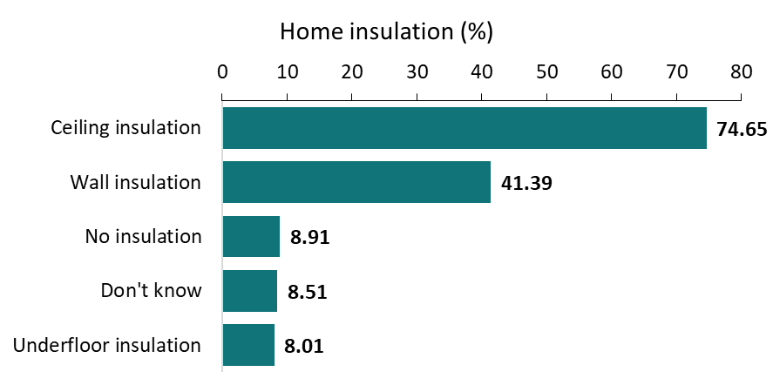

Figure . Does your current home have insulation? (Select all that apply)

Number of observations = 5,001

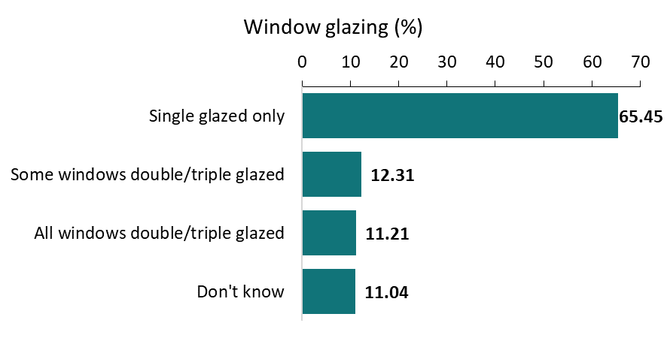

Figure . Do you have double or triple glazed windows?

Number of observations = 3,534

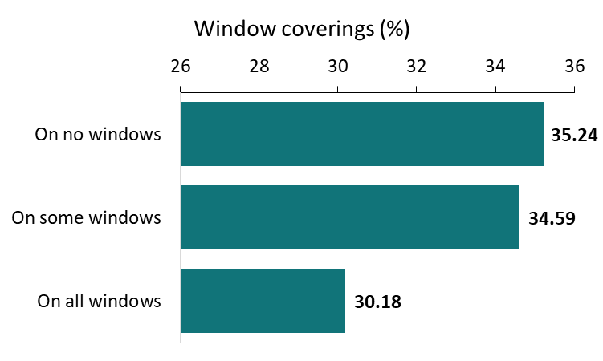

Figure . Do you have insulating blinds or curtains with pelmets on all your windows?

Number of observations = 3,536

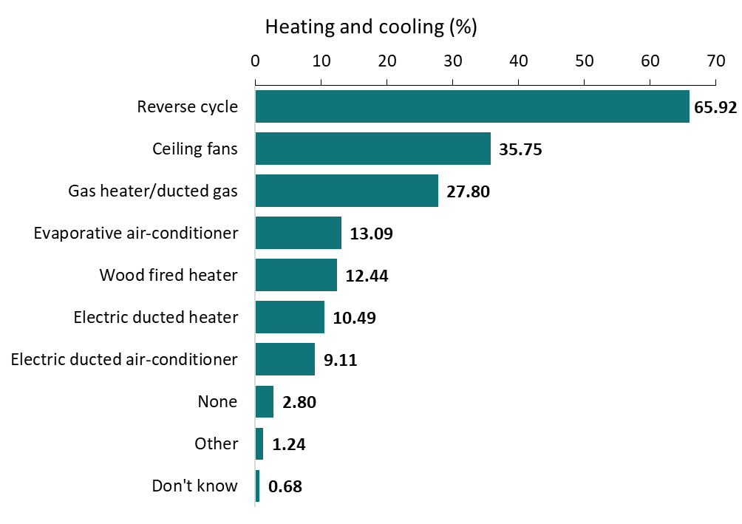

Figure . What type of fixed heating and cooling systems do you have (Select all that apply)

Number of observations = 6,341

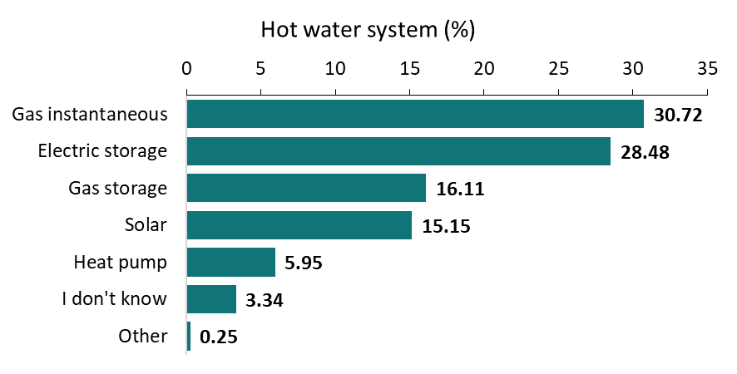

Figure . What kind of hot water heater(s) do you have? If you have more than one, select the main system that heats water for your home.

Number of observations = 3,532

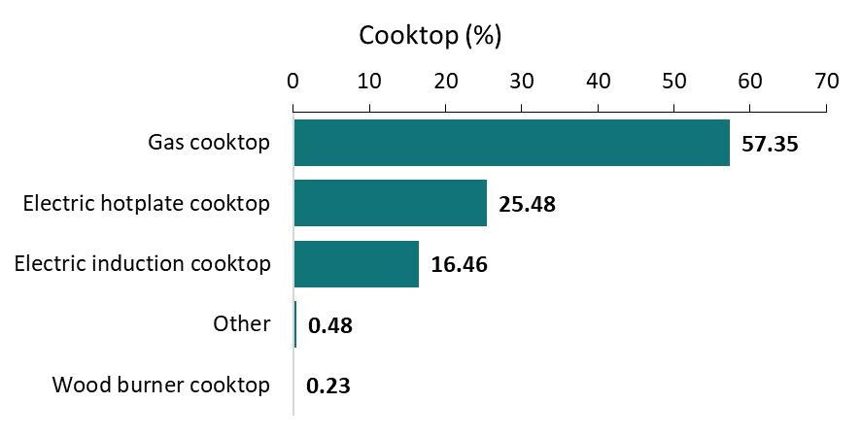

Figure . What kind of cooktop do you have? If you have more than one, select the main cooktop used in your home.

Number of observations = 3,526

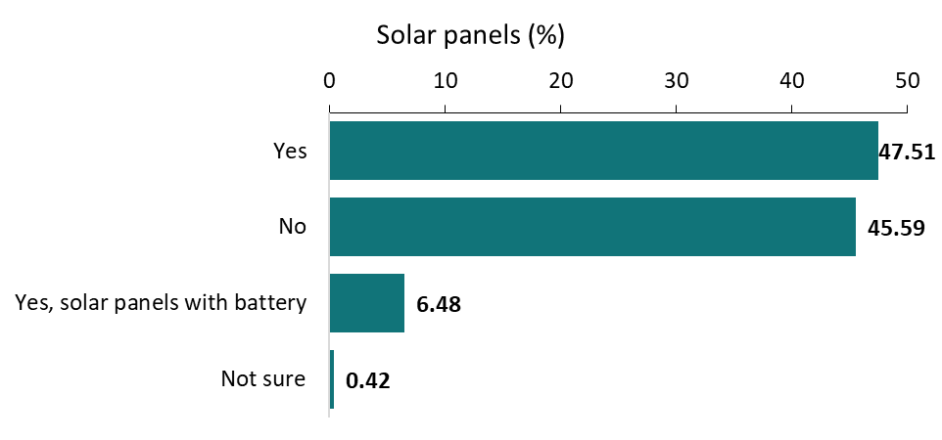

Figure . Do you have solar panels that generate energy on your roof?

Number of observations = 3,536

## Appendix E: Trial 4 Certificate design

### Design

A 4x2 factorial Randomised Controlled Trial (RCT) in which homeowners were invited to imagine that they had just had a Home Energy Rating completed for a home they had recently purchased (described as cold in winter and hot in summer). Upon viewing the certificate and associated advice, they were invited to select from the advice page the option they were most likely to adopt. This design tested whether a small incentive to make a home upgrade (free re-assessment of certificate after 18 months) or the prioritisation of 3 top actions as ‘best value for money’, ‘recommendations from your assessor’, or ‘best to improve your energy rating’ increased the likelihood of people choosing one of the upgrade actions instead of one of the energy efficiency tips.

### Sample size and power

We aimed to recruit approximately 6,500 respondents and achieved 6,917. At this size we had 90% power to detect an effect size of 4.5 percentage points for our primary outcome for the upgrades action and 3 percentage points for the primary outcome for the incentives. We used a conventional alpha level of 5% with 90% power. We chose these settings because the intervention is low risk.

### Sample randomisation

Respondents were randomised at the individual level to one of 4 trial-arms for ‘upgrade action prioritisation’, and one of the 2 ‘incentive’ trial arms (i.e. one of 8 cells) with roughly equal probability of assignment across the groups. The characteristics of each arm is presented in Tables 2 and 3.

### Primary Outcomes

At the individual level the outcome was whether the participant clicked on an upgrade rather than an energy efficiency tip or no action (binary, 1 = clicked on an upgrade, 0 = did not click on an upgrade). This was averaged within treatment groups to give a proportion in each arm.

### Hypotheses

H1. ‘Value for money’ prioritisation > Control: ‘Value for money’ prioritisation will increase participant selection of home upgrades relative to complete list of recommended energy upgrades.

H2 ‘Assessor’s recommendations’ prioritisation > Control: ‘Assessor’s recommendations’ prioritisation will increase participant selection of home upgrades relative to complete list of recommended energy upgrades.

H3. ‘Improve Home Energy Rating’ prioritisation > Control: ‘Improve Home Energy Rating’ prioritisation will increase participant selection of home upgrades relative to complete list of recommended energy upgrades.

H4. Incentive message > No incentive message: An incentive message will increase participant selection of home upgrades relative to no incentive.

Table . Factorial design of Trial 4

| Upgrade action prioritization (A) | Without incentive (B) | With incentive (B) |
| --- | --- | --- |
| Complete list of recommended energy upgrades | A0B0 | A0B1 |
| Value for money | A1B0 | A1B1 |
| Assessor’s recommendations | A2B0 | A2B1 |
| Improve Energy Rating | A3B0 | A3B1 |

### Method of analysis

Consistent with the analysis plan, we used ordinary least squares regression with HC2 robust standard errors. We included 4 mean-centred covariates:

* Whether they intend to make upgrades to their home (outcome in Trial 5) (binary, 1 = Very likely or likely, 0 = Unlikely or very unlikely).
* How often someone is home (binary, 1 = someone is home 50% of the time or more, otherwise 0).
* Can afford some upgrades (binary, 1 = if they can afford $5000 or more, otherwise 0).
* Block indicator to account for stratified randomisation within each panel provider (binary, 1 = panel A, 0 = panel B).

The treatment groups were entered into the model as 2 vectors of treatment indicators. All covariates were interacted with the treatment groups. Summaries of all pre-specified analyses are included under Statistical tables.

### Statistical tables

The outcome was a binary variable indicating whether respondents clicked on a home upgrade presented on the certificate.

Table . H1-H3: No prioritisation message performed better than the control

| Prioritisation | Means (per cent) | Estimate (pp) | Standard error (pp) | 95% Confidence Interval (pp) | *p-*value |
| --- | --- | --- | --- | --- | --- |
| Control | 64.80 | - | - | - | - |
| Assessor | 60.20 | -4.59 | 1.66 | (-7.31 - Inf) | 1.00 |
| Rating | 60.10 | -4.69 | 1.63 | (-7.36 - Inf) | 1.00 |
| Value | 60.90 | -3.88 | 1.63 | (-6.56 - Inf) | 0.99 |

n = 6,917  
OLS model with HC2 robust standard errors adjusted for previous upgrade actions, ability to pay and whether someone is usually home.

Table . H4: The incentive message did not perform better than no message

| Incentive | Means (per cent) | Estimate (pp) | Standard error (pp) | 95% Confidence Interval (pp) | *p-*value |
| --- | --- | --- | --- | --- | --- |
| No message | 61.20 | - | - | - | - |
| Incentive message | 61.70 | 0.46 | 1.17 | (-1.46 - Inf) | 0.35 |

n = 6,917  
OLS model with HC2 robust standard errors adjusted for previous upgrade actions, ability to pay and whether someone is usually home.

#### Exploratory analyses

Subgroups explore whether interventions worked differently for different groups of people. The focus is not whether groups differed on outcomes, but whether exposure to the treatment affected groups differently.

Table . Upgrade selections by subgroup (upgrades priority): those who cannot afford $5000 compared to those who can

| Condition | Interaction effect^ (pp) | Standard error (pp) | 95% Confidence Interval (pp) | *p-*value |
| --- | --- | --- | --- | --- |
| Assessor’s recommendations | -2 | 4 | (-9 – 5) | 0.57 |
| Recommended energy upgrades | 6 | 3 | (-1 – 13) | 0.10 |
| Value for money | 6 | 3 | (-1 – 12) | 0.11 |

n = 6,917  
OLS model with HC2 robust standard errors adjusted for previous upgrade actions, ability to pay and whether someone is usually home.

^Interaction effect between subgroup and condition compared with control

Table . Upgrade selections by subgroup (upgrades priority): someone mostly home compared with someone seldom home

| Condition | Interaction effect^ (pp) | Standard error (pp) | 95% Confidence Interval (pp) | *p-*value |
| --- | --- | --- | --- | --- |
| Assessor’s recommendations | 1 | 4 | (-6 – 9) | 0.77 |
| Recommended energy upgrades | 2 | 4 | (-6 – 9) | 0.68 |
| Value for money | 1 | 4 | (-6 – 8) | 0.79 |

n = 6,917  
OLS model with HC2 robust standard errors adjusted for previous upgrade actions, ability to pay and whether someone is usually home.

^Interaction effect between subgroup and condition compared with control

Table . Upgrade selections by subgroup (incentives)

| Subgroup | Interaction effect^ (pp) | Standard error (pp) | 95% Confidence Interval (pp) | *p-*value |
| --- | --- | --- | --- | --- |
| Those who cannot afford $5,000 compared with those who can | 1 | 2 | (-4 – 6) | 0.64 |
| Someone mostly home compared with someone seldom home | 0 | 3 | (-5 – 5) | 0.98 |

n = 6,917  
OLS model with HC2 robust standard errors adjusted for previous upgrade actions, ability to pay and whether someone is usually home.

^Interaction effect between subgroup and condition compared with no message.

Table . Trial interaction

| Subgroup | Interaction effect^ (pp) | Standard error (pp) | 95% Confidence Interval (pp) | *p-*value |
| --- | --- | --- | --- | --- |
| Assessor’s recommendations and incentive message | -5 | 3 | (-12 – 1) | 0.13 |
| Recommended energy upgrades and incentive message | -6 | 3 | (-13 – 0) | 0.06 |
| Value for money and incentive message | -5 | 3 | (-11 – 2) | 0.15 |

^Interaction effect versus control/no message.

## Appendix F: Trial 5 Prompts

### Design

A 4-arm Randomised Controlled Trial (RCT) in which a brief message at the end of the survey encourages all participants to click through to view yourhome.gov.au. This design tested several behaviourally informed messages, and was designed to measure the actual number of clicks to the website. As this was presented as being optional and respondents were told that the survey was complete, this was a measure of actual behaviour, rather than a hypothetical choice. This design was intended to identify the likely response rate of consumers to a similar style of message appearing on an online government communication such as a rates notice or energy bill.

### Sample size and power

We designed this study for a minimum detectable effect of 0.6 percentage points (a click-through rate of 0.9% in the intervention arms compared with 0.3% in the control arm). These numbers are based on similar work encouraging clicks.

We set alpha at 5% and power at 90%. We have chosen these settings because the intervention is low risk. To achieve 90% power to detect an effect size of 0.6 percentage points (Cohen’s *h* = 0.08) we aimed to recruit 3,250 per arm for a total sample size of 13,000. We achieved a final sample of 13,330.

We conducted power calculations in R version 4.4.0 using the ‘pwr’ package version 1.3-0.

### Sample randomisation

To meet required quotas, respondents completed a number of demographic questions before being assigned to 2 of the other trials. Following completion of those trials, respondents were then randomised with roughly equal allocation to each of the 4 arms.

Table . Sample size for each arm

| Trial arm | Message | *n* | % |
| --- | --- | --- | --- |
| 1 | Simple message (Attention control) | 3,388 | 25 |
| 2 | Future savings | 3,428 | 25 |
| 3 | Trigger event | 3,381 | 25 |
| 4 | Home energy assessment | 3,277 | 24 |

n = 13,474

### Primary Outcomes

At the individual level the outcome was whether the participant clicked on the link to the yourhome.gov.au website (binary, 1 = clicked through, 0 = did not click through), recorded within the Qualtrics platform and averaged within treatment groups to give the proportion of click-throughs within each arm.

### Hypotheses

H1. ‘Future savings’ clicks > Attention control group clicks: The ‘future savings’ message will have more clicks relative to the simple message.

H2. ‘Trigger event’ clicks > Attention control group clicks: The ‘trigger event’ message will have more clicks relative to the simple message.

H3. ‘Home energy assessment’ clicks > Attention control group clicks: The ‘home energy assessment’ message will have more clicks relative to the simple message.

### Method of analysis

Consistent with the analysis plan, we used ordinary least squares regression with HC2 robust standard errors. We included 2 mean-centred covariates:

* Home ownership (binary, 1 = homeowner, 0 = not a homeowner).
* Block indicator to account for stratified randomisation within each panel provider. Block: categorical variable (binary, 1 = panel A, 0 = panel B).

The treatment groups were entered into the model as 2 vectors of treatment indicators. All covariates were interacted with the treatment groups. Summaries of all pre-specified analyses are included under Statistical tables.

### Statistical tables

Table . H1-H3: No message performed better relative to the attention control

| **Condition** | **Means (per cent)** | **Estimate (pp)** | **Standard error (pp)** | **95% Confidence Interval (pp)** | ***p-*value** |
| --- | --- | --- | --- | --- | --- |
| Simple message | 2.90 | - | - | - | - |
| Message emphasising future savings | 2.60 | -0.29 | 0.40 | (-0.94 - Inf) | 0.76 |
| Message about trigger event | 1.90 | -0.96 | 0.37 | (-1.57 - Inf) | 1.00 |
| Message recommending a home energy assessment | 2.40 | -0.48 | 0.39 | (-1.13 - Inf) | 0.89 |

n = 13,474

## Appendix H: Literature Review

**Note:** This literature review was conducted in January 2024 as part of a scoping exercise. This occurred before the design of the interventions and the survey in May 2024.

**What drives the decision to upgrade your current home to be more energy efficient?**

### Introduction

This document explores the question ‘What drives the decision to upgrade your current home to be more energy efficient?’ and is the first deliverable under the Commonwealth Department of Climate Change, Energy, the Environment and Water (DCCEEW) and the Behavioural Economics Team of the Australian Government (BETA) home energy upgrades project agreement.

In this document, BETA draws together and synthesises key findings and insights from the available evidence and literature by applying a behavioural insights (BI) lens to this question.

By drawing from relevant domestic and international BI literature, DCCEEW documents (and other grey literature) and BETA’s net zero survey, we will have a comprehensive picture of the context and will be able to design evidence-based interventions from this.

### Policy context

Residential buildings are responsible for more than 10% of total carbon emissions in Australia ([Residential buildings DCCEEW.gov.au](https://www.dcceew.gov.au/energy/energy-efficiency/buildings/residential-buildings)). Australia has a national plan that sets a trajectory towards zero energy and low carbon buildings for new and existing homes.

Interventions can support homeowners, home buyers, landlords and renters to make decisions about energy performance upgrades to their home.

Energy performance upgrades include fixed appliance purchases, space heating/cooling, hot water systems, solar photovoltaics and battery storage systems, and thermal improvements such as insulation, draught sealing, windows, and shading.

Disclosure of a home’s energy performance (energy costs, energy efficiency ratings and greenhouse gas emissions) at the point of sale or lease can ensure home buyers and renters have relevant information to make a more informed choice.

This information can incentivise improvements by either the seller or the buyer or the landlord.

DCCEEW intends to use behavioural insights to inform the development, and improve the implementation and success, of the Home Energy Ratings Disclosure Framework (Disclosure Framework), Residential Building Disclosure Scheme/s and the Nationwide House Energy Rating Scheme (NatHERS).

This project will feed into the work being done as a part of the Residential Energy Efficiency Disclosure Initiative (REEDI). As such, it will focus on boosting the impacts of the professional home energy assessments that underlie this system. A report prepared for the NSW government (Boulet et al, 2023) conducted a scan of relevant initiatives in Australia. It notes the ‘emphasis on information provision to householders, including self-assessment tools’, and the more limited use of professionals to assist households. It recommends that future efforts focus more on professional assessments rather than trying to encourage do-it-yourself because accredited assessors can influence change in their role as a ‘trusted intermediaries based on their objective assessment of the house and the targeted recommendations they made’.

### Project background

In 2021 DCCEEW undertook the first of 4 phases of an ‘Incentivising behavioural insights’ project. These phases are defined by BETA’s ‘4D’ Framework for behavioural insights projects (see [The 4Ds: A framework for managing behavioural insights projects (pmc.gov.au)](https://behaviouraleconomics.pmc.gov.au/sites/default/files/2021-09/4d-framework-overview.pdf)).

During the ‘Discover’ phase (Phase 1 in 2021), a rapid review was conducted by DCCEEW. DCCEEW then partnered with CSIRO to analyse existing knowledge and data on the decision-making context faced by Australian homeowners and renters to identify the various factors that may explain the motivators and barriers to making energy-efficiency home upgrades.

In future phases of this project, BETA will develop potential interventions that will aim to empower homeowners to choose upgrades that will reduce their emissions.

### Project scope

The scope of this project is to empower homeowners to make upgrades to their home energy performance. The home upgrades the project team are considering include a wide range of high impact modifications that typically stay in place for many years, including:

* Purchasing major fixed appliances such as heaters and air-conditioners, hot water systems, ovens and cooktops – and importantly, preferencing more efficient models and models that use electric, not gas, power sources.
* Making thermal improvements such as adding insulation, draught sealing, double-glazed windows, and shading.
* Installing solar photovoltaics and battery storage systems.

The target population for this project is homeowners – defined broadly as owner-occupiers and owner-investors, but also includes prospective homeowners. The scope is also restricted to existing (not newly built) National Construction Code (NCC) Class 1 dwellings (e.g. freestanding houses and townhouses).

This cohort is the most likely to have the *opportunity* to make and implement an upgrade decision, because they have agency (unlike tenants who would need permission for such decisions), and their homes have the physical characteristics that allow them to make upgrades (e.g. apartments share physical infrastructure like walls, roofs and often hot water systems). They also need to have the *capability* (e.g. awareness and understanding) and the *motivation* to make the decision.

Interventions designed to aid decision-making and behaviour cannot remove legal restrictions. Potential interventions should therefore focus on the other two elements: building capability and stimulating motivation. (This breakdown of behaviour into opportunity, capability and motivation draws on the COM-B model (Michie et. al., 2011) – for examples of COM-B in a home upgrades context see BETA, 2024; Frederiks and Romanach, 2023; The Behavioural Architects, 2021). An environment designed to support informed and low-friction decision-making can empower people to make the choices that will benefit them.

### What makes a home upgrade decision easier or more difficult?

To understand the push and pull factors influencing the home upgrade decision, BETA looked at what can drive people to choose to allocate money and effort to a home upgrade and how people choose which upgrade to go forward with. BETA also explored what can impede the process.

### People are attracted to the full range of benefits.

Awareness that an upgrade could improve energy efficiency may be one of many motivators, it is often not the primary motivator. In BETA’s *Towards Net Zero* survey of nearly 5000 respondents in mid-2023, many Australians said they want to take action on climate change, with 57% reporting they believe it is very important to limit household emissions. However, the financial drivers for using less energy were even stronger reasons for making upgrades than environmental concerns. 93% of respondents wanted to use less energy, but when forced to choose 58% said the main reason would be to lower the cost of the bill, and 35% because it is good for the environment (BETA, 2024).

In reality, there does not have to be a trade-off between environmental considerations and cost savings. A good home upgrade can do both, and more. To the homeowner contemplating an upgrade, the benefits are often *bundled* with comfort and/or convenience to create a much more compelling value proposition than just cost savings alone.

As an example, for the decision to install solar panels, reasons such as environmental sustainability, improved property values, access to power during blackouts and the potential to charge an electric vehicle are becoming increasingly important and sit alongside bill savings as motivating factors (BETA 2024). There are also diverse reasons for undertaking thermal upgrades: they can deliver year-round comfort and noise reduction. New efficient appliances (e.g. induction cooktops) often deliver performance benefits and safety features in addition to improved efficiency. The Residential Efficiency Scorecard Research Pilot Evaluation Report (2019) found that the most common reasons for homeowners having the Scorecard assessment were to improve the comfort of their home, reduce energy use/emissions and reduce energy bills.

People who are home most or all of the time stand to benefit the most from a home upgrade, as they are much more likely to be using heating and cooling throughout the day. This cohort also have flexibility to take advantage of cheaper energy costs in the form of solar generated electricity. BETA (2024) found that 53% of households surveyed currently have someone at home during the day *all or most of the time* and a further 19% have someone home *half of the time*.

There are several compelling reasons to undertake home upgrades, so while it might appear that it should be an easy decision for people with the opportunity and means, BETA survey results indicate there are factors that present barriers to people following through on their intentions. 30% of homeowners in freestanding homes report being able to afford upgrades of $5,000 or more and *already believe* an upgrade would reduce their energy bills (BETA, 2024). This suggests a big intention-action gap and offers an opportunity to improve the choice environment.

### Most people have a limited budget and need to weigh options.

Households face a multitude of ways they could spend their time and money, for example on healthcare, education, entertainment, or travel. They will face many options that offer them a likely net benefit. Within this context, it is quite understandable that people may choose *not* to upgrade their homes, even if doing so might save them money over time. Depending on the desired upgrade, homeowners may need to offset the cost with a green loan or rebate to juggle expenses.

Upfront costs may be more salient than long term savings. Unlike most household expenses, many home upgrades pay for themselves over time through a consistent reduction in energy bills. However, the long-term benefit may still not outweigh the upfront expense in the mind of the homeowner. People tend to place less value on benefits and incentives that are further away in time from the present moment (Frederiks and Romanach, 2023). This *present bias* can be offset to some extent by drawing attention to rebates or tax breaks that could provide an upfront benefit, or green loan schemes that allow households to pay for the upgrade as the advantages of the improved efficiency take effect.

Highlighting the long-term advantages to make home upgrades more salient (such as by giving them a concrete dollar value) can also help people compare the short and long term costs. An example of this can be seen in quotes for solar photovoltaic systems, which draws attention to both the immediate government incentives and charts showing the long-term expected savings. BETA (2024) found that 1 in 3 survey respondents with solar photovoltaic systems mentioned that government subsidies and financial incentives made getting solar easier.

### People are overloaded by complex, difficult, tasks.

People can only manage so much in their lives at any one point in time. This may lead them to postpone tasks that involve difficult and unfamiliar decisions. In the context of deciding to progress a home energy upgrade, this could involve learning technical terms, comparing multiple options, coordinating quotes, contractors and access (and potential disruption) to their home, and researching available rebates/assistance schemes. The results from BETA’s recent survey support this point, with some people responding to open-ended questions that they needed to find the mental space to plan the upgrade (BETA, 2024). Interventions that simplify the process, or offer low effort options, can benefit people experiencing cognitive overload. Not only can the process be complicated, but so can the language and the subject matter.

The Behavioural Architects found that ‘information about energy use is overly complex and feedback on consumption is too infrequent’ (2021). BETA (2024) found that many home upgrade decisions are difficult and contain many steps. People responding to the survey who were planning to install solar, described many tasks as difficult. More than 50% of this group found it difficult to choose the system that was right for them, choose an installer, work out how much money to spend, learn the technical jargon, and work out how big a system they would need. Among respondents who had previously installed solar, BETA found that the task they most frequently rated as difficult was learning the technical jargon.

### Much of the problem is invisible.

For many Australian homes, energy consumption can be significantly reduced without lifestyle compromises or changes to everyday habits, but most people do not know where to start. Some respondents in the BETA survey did not know important details about their home infrastructure. For example, 18% did not know if their home had any insulation, while 14% did not know if their home had double- or triple-glazed windows (BETA, 2024). People often don’t know which elements offer the greatest potential to improve their home energy performance, as they lack a feedback mechanism (Frederiks and Romanach, 2023). If you have wood-fired heating you can see and measure the rate at which the wood pile decreases, but an electricity bill every few months offers few clues to the performance of different appliances (BETA, 2021). The Behavioural Architects note that ‘energy use is intangible, consumption largely occurs on autopilot’ (2021).

Comparing different home upgrade options requires technical expertise that takes into account the climate, aspect, age and materials of the house, and the performance of existing fixed appliances. A home energy assessment can deliver that comparison, but ultimately the way in which the property is used and the available budget, will also influence the homeowner’s decision.

The information gaps are exacerbated for prospective buyers or tenants as a quick inspection of the property typically doesn’t reveal the type of insulation or the efficiency rating of the appliances. One exception is the ACT, where home energy assessment ratings must be disclosed to prospective buyers (Frederiks and Romanach, 2023; BETA 2024).

The Office of Energy and Climate Change (2023) surveyed households before and after a Scorecard assessment of their apartment’s energy efficiency. Awareness of the benefits of energy efficient air conditioners, hot water systems and draught proofing were all very low (20-27%) before the assessment. After the Scorecard assessment, awareness of the benefits effectively tripled. The Residential Efficiency Scorecard Research Pilot Evaluation Report (2019) specifically found that respondents suggested prioritisation of improvement options to identify ‘quick wins’, indicating that this type of information would really help people compare between options.

### Uncertainty can lead to inaction, so how do we build confidence?

BETA (2024) found that respondents’ confidence about which upgrade actions were best suited to their household was low. Over 60% of the sample thought that a renovation or upgrade would likely reduce their energy bills. Of this group, only 20% were *very confident* they could choose the right renovation or upgrade (BETA, 2024). BETA found people who thought it was important to limit emissions were more knowledgeable about which upgrades to choose to limit emissions, but were no more likely to make the upgrades. However, people who were confident to choose the right upgrade *were* more likely to make the home upgrades. Future work could involve testing methods of building confidence to see which are effective at driving action.

By contrast, the status quo requires no decisions, research or planning, and so it is unsurprising that the tendency to stick to the status quo is such a substantial barrier to action. Frederiks and Romanach (2023) also note that inaction is seen as the norm or default. The Residential Efficiency Scorecard Research Pilot Evaluation Report (2019) found one of the most common household reasons for not undertaking an upgrade was being ‘comfortable with the status quo’. Given the low general awareness people have of the energy ‘leaks’ in their homes, households are likely to be missing out on easy and cost-effective improvements, given they have no strong reason to initiate change.

When replacing existing appliances or fittings that have deteriorated, broken down or suffered damage, it is likely to be even harder to shift the default. BETA (2024) found that conflicting environmental narratives can make it difficult for people to know which choice to make. For example, messages encouraging people to reduce waste and to repair what they already own may be the right message for an old dining table, however, the wrong message for an old fridge. Not just householders, but insurance companies also try to repair first or alternatively replace ‘like for like’, missing a key opportunity to prompt an upgrade to a more efficient option. Similarly, owner-investors can claim the cost of replacing an old appliance with a comparable appliance as *repairs and maintenance* but if they upgrade it to a better one it is classified as a capital improve, so is not immediately tax deductable (only over the life of the investment). This is another disincentive to upgrade. Interventions that slow down the transaction so homeowners test whether repair is a good idea in each instance, and if not, compare the performance of replacement options before making a decision, could help to challenge the status quo.

### People are more open to change during key trigger points.

A trigger point could be a major life event like moving house, expecting a child or undertaking a renovation, and could also be a minor event like a sharp rise in an energy bill (Frederiks and Romanach, 2023). Behaviour change interventions can be more effective when delivered after a major life event (Verplanken and Roy, 2016). Most people don’t retain information needed for complex decisions or tasks that occur infrequently – they discard it as soon as the task is complete. Triggers present an opportunity to make interventions both timely and targeted so they actually fill an information gap at a critical decision juncture.

There are several triggers for financing a home renovation or upgrade. The literature views these as opportunities to support decision-making and encourage homeowners to consider the value proposition of an energy performance upgrade (various examples in Frederiks and Romanach, 2023). These activities or triggers include:

1. **Planning upgrades specifically to improve home energy performance.** Homeowners may already be motivated to limit their carbon footprint, to improve the comfort of their home or to reduce their energy bills. If so, they are likely to be searching for the right information already but that doesn’t mean the information is easy to find and comprehend. This group can still become confused or bogged down by complexities in the decision or the process. They need help so that they don’t give up. Professional help can also make it easier to choose the best upgrades for their circumstances and environment.
2. **Planning other kinds of renovations (e.g. to improve functionality, appearance or comfort)**. In this scenario, arranging finance, choosing contractors and selecting from various options are tasks the homeowner is already engaged in, so an energy upgrade can be considered with minimal extra effort. Energy efficiency can be considered along with factors like appearance, performance, comfort and cost. This group risks locking in poor energy performance decisions if energy efficiency isn’t considered early. People looking at undertaking other types of renovations, repairs or upgrades are currently unlikely to find energy performance advice unless they look for it or receive timely and salient advice from a tradesperson.
3. **Making emergency repairs.** Major appliances sometimes break unexpectedly or accidental damage to the building (e.g. a branch falling on a section of roof) spur instant action. A tendency to default to the status-quo (a repair or like-for-like replacement) could result in a missed opportunity to upgrade. However, for someone receiving timely information, the motivation and the need to make a choice is very high, so it is a key time to offer guidance.
4. **Selling or leasing.** A seller or owner-investor may make upgrades with the goal of increasing the sale price or rental price of the property. A prospective buyer may pay a premium for energy efficiency (often correlated with thermal comfort, high performance and new/reliable appliances). In the ACT, where it is mandatory to disclose home energy ratings, Donnelly and Mercer (2011) found almost a third of sellers made their dwelling more energy efficient in order to make it more saleable. In a controlled discrete choice experiment Sussman and colleagues (2022) reported that energy labels on rental listings changed renters’ property preferences and found that renters were prepared to pay a higher price premium for energy score increases, especially in the hottest and coolest climates. The Residential Efficiency Scorecard Research Pilot Evaluation Report (2019) found that ‘householders with houses rating 5 or 6 stars and above found it beneficial to advertise the rating. They did not wish to advertise ratings at 4 stars or below. With relevant and mandatory disclosure, selling or leasing has the potential to become a key trigger for action.

These four triggers present excellent opportunities for timely intervention, but there is a fifth opportunity to consider which doesn’t have a clear trigger:

1. **Unhappy with energy consumption but disempowered to make a change.** Advances in technology, government subsidies, and opportunities for green finance all change over time. There are likely to be homeowners who are currently disengaged, however they might become interested if they were presented with fresh information clearly articulating the benefits – for example, a previous BETA framed field experiment (RCT) showed that telling people they were eligible for cheaper energy plans made them much more likely to consider engaging with the market (BETA, 2021). Some homeowners may have investigated home upgrade options previously and ruled these out. Others may be simply unaware of the benefits of a home upgrade. Some upgrades are expensive, complex and time-consuming, however not all are. People living in homes that are too hot or too cold, or struggling with high energy bills, may be quite open to suggestions that empower them to solve those problems. The Residential Efficiency Scorecard Tropical Pilot Evaluation Report (2020) found that most respondents who provided feedback indicated the reason they participated in the pilot was their curiosity in their home’s energy performance. Simple curiosity about this topic is likely to be quite strong, as it relates to personal comfort, quality of life, climate change and financial wellbeing. Just because people aren’t actively looking for this information doesn’t mean that won’t be receptive or welcoming of it if delivered in a clear way.

### Next steps

The next step in this project is to draw from the insights in this review to form a clear hypothesis of behaviour change. This will consider the results of scoping workshops with key stakeholders and outline draft intervention ideas. The draft intervention ideas will focus on reducing frictions and leveraging opportunities that have been identified in this first draft report:

* **People are attracted to the full range of benefits.**   
  There is no single pull-factor. Interventions should convey all benefits from any given energy upgrade decision: including financial, environmental, comfort, and performance. The biggest reduction in bills may be less important than reduction in noise pollution to an individual.
* **Most people have a limited budget and need to weigh options.**  
  Interventions should prioritise the impact of different upgrade options and offer higher and lower cost choices. People may need to plan upgrades over time as each choice carries an opportunity cost. Interventions should make it clear whether a given upgrade will ‘pay for itself’ and ideally offer options to reduce the upfront expense.
* **People are overloaded by complex, difficult, tasks.**  
  Interventions should consider individual appetite to put time and energy into an upgrade decision. People who are already overloaded are more likely to take advantage of options that are supported or relatively easy to implement.
* **Much of the problem is invisible.**  
  Interventions should focus on high impact actions and should assume low base rates of awareness. Decision tools, home energy assessments, efficiency labelling and robust rules of thumb could all help build awareness and confidence.
* **Uncertainty can lead to inaction, so how do we build confidence?**  
  Interventions should test ways to build confidence to see which lead to action and leverage defaults to motivate behaviour change instead of letting defaults reinforce the status quo (e.g. mandatory disclosure at key decision points).
* **People are more open to change during key trigger points.**Interventions should be timely and attach to existing triggers for home purchases, renovations, repairs, and appliance replacements. Not only are people more open to change, energy performance considerations can be embedded in the larger decision.

## References

BETA, Department of the Prime Minister and Cabinet, Commonwealth of Australia, (2021), *Improving energy bills: final report.* [Improving energy billing (pmc.gov.au)](https://behaviouraleconomics.pmc.gov.au/sites/default/files/projects/final-report-improving-energy-bills.pdf)

BETA, Department of the Prime Minister and Cabinet, Commonwealth of Australia, (2024), *Towards Net Zero: Navigating complex choices towards low emission homes.*

Boulet, M., Hatty, M., and Lauren, N. (2023). *Intervention report: Encouraging householders to include energy efficiency upgrades in retrofits.* Prepared for the NSW Office of Energy and Climate Change. BehaviourWorks Australia, Monash Sustainable Development Institute, Monash University, Australia

Commonwealth of Australia (2019), *Residential Efficiency Scorecard Research Pilot.* COAG Energy Council

Donnelly, D., and Mercer, R., (2011) *Impact of Residential Mandatory Disclosures Schemes Market Research Report.* Prepared for the Department of Climate Change and Energy Efficiency. Instinct and Reason, Australia.

Frederiks, E. R. and Romanach, L. M. (2023) *Residential energy efficiency disclosure: Key insights from the international literature to incentivise behaviour change*. CSIRO, Australia.

Michie, S., van Stralen, M. M., and West, R. (2011). *The behaviour change wheel: a new method for characterising and designing behaviour change interventions*. Implement Sci, 6(42). doi:10.1186/1748-5908-6-42

Office of Energy and Climate Change, NSW Treasury (2023), *Energy efficiency in apartments: Pilot report.*

R Core Team (2024) *R: a language and environment for statistical computing*, R Foundation for Statistical Computing; Vienna, Austria; <https://www.R-project.org>

Sussman, R., H. Bastian, S. Conrad, E. Cooper, E. Tong, A. Sherpa, and S. Pourfalatoun. 2022. *Energy Labels Affect Behavior on Rental Listings Websites: A Controlled Experiment.* Washington, DC: American Council for an Energy-Efficient Economy.

Sussman, R., C. Kormos, C. Park, and E. Cooper. 2020. *Energy Efficiency in Real Estate Listings: A Controlled Experiment*. Washington, DC: American Council for an Energy Efficient Economy. aceee.org/research-report/b2002.

The Behavioural Architects and NSW Government Department of Planning Industry and Environment, (2021) *Behaviour change strategies and interventions to improve energy efficiency in homes*

Verplanken, B. and Roy, D. (2016) *Empowering interventions to promote sustainable lifestyles: Testing the habit discontinuity hypothesis in a field experiment*. *Journal of Environmental Psychology*, 45(127-134, doi:10.1016/j.jenvp.2015.11.008.

**© Commonwealth of Australia 2024**

ISBN 978-1-925365-68-9 Home Energy Upgrades: Technical appendix

**Copyright Notice**

With the exception of the Commonwealth Coat of Arms, this work is licensed under a Creative Commons Attribution 4.0 International license (CC BY 4.0) (<https://creativecommons.org/licenses/by/4.0/>)



**Third party copyright**

Wherever a third party holds copyright in this material, the copyright remains with that party. Their permission may be required to use the material. Please contact them directly.

**Attribution**

This publication should be attributed as follows:

© Commonwealth of Australia, Department of the Prime Minister and Cabinet, *Home Energy Upgrades: Technical appendix*

**Use of the Coat of Arms**

The terms under which the Coat of Arms can be used are detailed on the following website: <https://pmc.gov.au/cca>



Behavioural Economics Team   
of the Australian Government

General enquiries [beta@pmc.gov.au](mailto:beta@pmc.gov.au)

Media enquiries [media@pmc.gov.au](mailto:media@pmc.gov.au)

Find out more [www.pmc.gov.au/beta](http://www.pmc.gov.au/beta)

Tell us how you’re using this report

