— Supporting Retirees in Retirement Income Planning | A
BETA
BEHAVIOURAL ECONOMICS TEAM OF THE AUSTRALIAN GOVERNMENT

Supporting retirees in retirement income planning
October, 2017

Authors: Professor Michael Hiscox, Dr Elizabeth Hobman,
Mr Michael Daffey and Dr Andrew Reeson
© Commonwealth of Australia 2017
978-1-925362-40-4 Supporting retirees in retirement income planning (DOCX)
978-1-925362-39-8 Supporting retirees in retirement income planning (PDF)
Copyright Notice
With the exception of the Commonwealth Coat of Arms, this work is licensed under a Creative Commons Attribution 4.0 International licence (CC BY 4.0) (http://creativecommons.org/licenses/by/4.0/deed.en).
Third party copyright
Wherever a third party holds copyright in this material, the copyright remains with that party. Their permission may be required to use the material. Please contact them directly.
Attribution
This publication should be attributed as follows: Commonwealth of Australia, Department of the Prime Minister and Cabinet, Supporting retirees in retirement income planning.
First published in May 2017 by the Commonwealth of Australia, Department of Prime Minister and Cabinet.
This version is a revised edition, published in October 2017 by the Commonwealth of Australia, Department of Prime Minister and Cabinet.
BETA
BEHAVIOURAL ECONOMICS TEAM
OF THE AUSTRALIAN GOVERNMENT

Supporting retirees in retirement income planning
Results of a survey experiment conducted by the Behavioural Economics Team of the Australian Government (BETA) in partnership with Treasury

Use of the Coat of Arms
The terms under which the Coat of Arms can be used are detailed on the following website: http://www.itsanhonour.gov.au/coat-arms/.

Other uses
Enquiries regarding this licence and any other use of this document are welcome at:
Managing Director
Behavioural Economics Team of Australia
Department of the Prime Minister and Cabinet
Barton ACT 2600
Email: beta@pmc.gov.au
The views expressed in this paper are those of the authors and do not necessarily reflect those of the Department of the Prime Minister and Cabinet or the Australian Government.

Acknowledgments
Special thanks to the five superannuation funds (BT, UniSuper, Mine Wealth+Wellbeing, QSuper and AustralianSuper) and their members who participated in the study. Thanks also to BETA’s Policy Advisors, Mr Nitin Srivastava and Ms Heather Cotching for assistance in the reporting process, and BETA’s Managing Director, Ms Tara Oliver for assistance at all stages of the project. We also would like to thank our partner agency, the Treasury, for collaborating with us on the project.
Dr Andrew Reeson is a Principal Research Scientist in Data61 at the Commonwealth Scientific and Industrial Research Organisation (CSIRO).
The trial was pre-registered on the BETA website and the American Economic Association registry:
AEARCTR-0001795. https://www.socialscienceregistry.org/trials/1795/history/12237

Who We Are
We are the Behavioural Economics Team of the Australian Government, or BETA.
We are the Australian Government’s first central unit applying behavioural economics to improve public policy, programs and processes. Rather than expecting people to redesign their lives around government, our work encourages people-centred design, which means: simpler, clearer and faster public services.
We use behavioural economics, science and psychology to improve policy outcomes.
Our mission is to build behavioural economics capability across the public service and drive its use in policy design by testing what works, where and in what context.

Contents
Foreword 5
Summary 6
Why was it important to conduct this study? 8
What interventions were tested? 11
How were the interventions tested? 13
Results of the study 16
Limitations of the study 25
Policy lessons 26
Appendix 29
Endnotes 38

Foreword
It is my pleasure to share the findings from our BETA study examining alternative ways to help inform people about a new Comprehensive Income Product for Retirement (CIPR). A CIPR is a composite retirement income product, intended to provide a balance of income and access to savings while managing longevity risk. It has been recommended as an alternative to a more standard account-based pension that is often the “default” choice for superannuation fund members when they transition into retirement and start converting their savings into income. The aim of our study was to test ways to help people compare the two options and make a choice that best suits their preferences. The testing focussed on different ways of presenting the features of retirement income products – income, flexibility, and risk management – as simply and clearly as possible using a range of behavioural principles, and we measured effects in terms of improved understanding of the options.
What we found is that all of the simplified presentations of information about the products increased comprehension levels among superannuation fund members and also increased the likelihood that they would choose the CIPR. Text tables comparing the key features of the plans in words were consistently more effective in improving comprehension, especially among women and younger individuals, than tables and graphs showing numerical estimates. Overall, the results suggest that relatively brief presentations of additional information can substantially improve comprehension of retirement income plans and help align choices with preferences.
We believe these findings are instructive for future discussions of the policy framework relating to retirement income. When individuals reach retirement they face a complex decision about what to do with their accumulated superannuation balance and if and how to convert these savings into an income stream. To make the decision individuals must take into account uncertainties about how long they will live, returns on investments, and the need for ready access to funds, along with their preferences for income and bequests. An obvious challenge for the design of this framework is how trustees can present information to their members to enable them to understand their options. Many people are likely to make their decisions about their retirement income plan using only the immediately available information at the time. Our study provides initial insights into how information can be presented in ways that improve comprehension and help people make choices that best suit their needs. More testing along these lines can help to optimize the design of the framework in the future.
Professor Michael J.
Hiscox Director, BETA

Summary
This study examined how people respond to a new income plan for retirement, known as a Comprehensive Income Product for Retirement (CIPR). A CIPR is a composite retirement income product which is intended to provide a balance of income, risk management (for example, longevity risk management) and flexibility to retirees. In response to a Financial System Inquiry¹ recommendation, the Government has agreed to facilitate superannuation trustees pre-selecting a CIPR for their members at retirement. This study is a first step in building an evidence base to inform decisions about how best to present CIPRs to superannuation members in order to maximize comprehension, assist informed decision-making and alleviate cognitive load. Using insights from behavioural economics, we designed and tested a series of alternative presentations of information using a survey experiment based on a hypothetical CIPR.
Over 3,600 pre-retirement members across five industry and retail superannuation funds participated in the study. Members were asked to review information which compared a CIPR and an Account-Based Pension (ABP) (which is how most retirees currently manage their superannuation in retirement). Members were randomly assigned to view information about the two plans in one of eight conditions – minimal text descriptions (control); graphs showing estimates of income and assets over time; number tables showing numerical estimates of income and assets; text tables with text-based comparisons of income and assets; text tables with star ratings assigned to the plans and text-based comparisons of income and assets; and alternative versions of the text and number tables in which comparisons of income under each plan were highlighted in bold.
The results show that presenting key information in a relatively simple manner helped people to make the decision (as measured by comprehension, perceived clarity, decision-making ease and confidence), and made them more likely to choose the CIPR. Compared with the control group who viewed minimal text descriptions of the two plans, members who received any of the alternative information presentations, on average, exhibited much higher comprehension scores (3.71 compared to 2.67 out of 5 – a 39% improvement), reported greater perceived clarity (3.74 vs 3.50 – a 6.9% improvement), decision-making ease (3.54 vs 3.42 – a 3.5% improvement), and decision confidence (3.50 vs 3.40 – a 2.9% improvement), they also were more likely to choose the CIPR (52.01% vs 47.56%- a 9.4% improvement).
When comparing different types of presentations, text tables comparing the key features in words, rather than numbers alone, were consistently most effective. Tables showing numerical estimates appear to be least effective in general. Including star ratings or highlighting income comparisons across the plans had no impact on decision- making. If we were to declare an overall “winner”, there was only one approach, the text table (with income highlighted), that led to significantly improved outcomes across the board – with improvements in comprehension, perceived clarity, decision-making ease, decision making confidence, and willingness to choose the CIPR. The greater effectiveness of text tables (versus graphs and number tables) was especially clear among women and younger (aged 45-54) individuals.
Members responded positively to the proposed new plan – on average, members were around 50% willing to choose the CIPR if it were offered to them in the future. Given the lack of product diversity (94% of retirement assets in Australia are currently allocated to ABPs) and the fact that CIPRs are a new product, this level of interest is encouraging and suggests CIPRs may do well (in terms of customer take-up) in the market.
Comprehension and willingness to choose the CIPR varied across segments. On average, males had slightly higher comprehension scores than females (3.63 vs. 3.51 out of 5 – a 3.4% difference), and members who had consulted a financial planner had higher scores than those who had not (3.66 vs. 3.52 – a 4.0% difference). Consistent with a bequest motive, members without children were more willing to choose the CIPR than were members with children (55.77% vs. 50.28%). Additionally, members who held an average or longer than average life expectancy also were more willing (51.43% and 53.03%, respectively) to choose the CIPR as compared to members who held a shorter than average life expectancy (47.72%).
Individuals generally made their choice about the CIPR in a way that aligned with their pre-stated preferences regarding what was most important for them. Members who prioritised income (‘I want to get the highest level of income in retirement, based on my superannuation balance’) or managing longevity risk (‘I want my superannuation to last my entire lifetime’), and deprioritised flexibility (‘I want to be able to access and use all of my superannuation when I want…’) were 18.9 to 28.83 percentage points (respectively) more likely to choose the CIPR than those who prioritised flexibility (expressing a contrasting preference profile).
The findings of this survey are intended to contribute to the broader public consultation process that the Government is currently undertaking on the CIPRs framework². In particular, as our study specifically focussed on how to present information about CIPRs, the results might inform the regulatory framework governing how superannuation trustees may be required to present CIPRs to their members. We note however, that this study is just a first step in building an evidence base for this. As the CIPRs framework is being developed, there is opportunity to further test and fine-tune different approaches (informed by behavioural science) to support retirees in making well-informed decisions about how to best manage their retirement income.

Why was it important to conduct this study?

Policy context

Many individuals pay little heed to superannuation until they reach retirement. In part this is due to the way in which the system itself has been designed. For example, most people (about 80%) accept the default fund provided by their employer rather than actively choosing a superannuation fund; similarly, most also stick to the default investment options offered by their fund3. Yet when people retire they have to decide what to do with their accumulated savings. For example, they could choose to ‘do nothing’ (i.e., leave it in accumulation phase), withdraw it as a lump sum, or convert it into a flexible account-based pension (ABP) and/or into a lifetime income stream (e.g., through buying an annuity). This is a complex decision in which individuals must account for uncertainties such as how long they will live for and future investment returns as well as their preferences for income and flexibility (including bequests).
As the population ages and more people reach retirement with significant superannuation savings a growing number of Australians will face this decision4, 5. Even though there is currently no recognised default option for retirement income only a minority of people seek financial advice. The importance and complexity of these decisions also is likely to rise as the average superannuation balance increases over time (in line with the maturity of the superannuation system) and the assortment of retirement income products from which to choose, increases in both size and diversity.
Currently, most people who retire with relatively low balances withdraw their money as a lump sum, while those with larger balances typically choose to convert it to an account-based pension (ABP - see Box 1)5. An account-based pension offers maximum flexibility, but requires individuals to decide how much to withdraw each year (above the minimum drawdown rates) and means people risk running out of superannuation before they die. The data show that most retirees draw down from an account-based pension very conservatively, withdrawing at or near the minimum rates mandated by Government. This mitigates the risk of running out of money before death (known as longevity risk) but means that most will die with significant amounts unspent6, money which might have supported a higher standard of living during retirement.

BOX 1: WHAT IS AN ACCOUNT-BASED PENSION?
Account-based pensions (ABP) convert superannuation into an accessible account, from which retirees decide how much to withdraw during retirement (at or above the minimum drawdown rate prescribed by Government). The annual minimum drawdown rate aims to ensure that ABPs are used to provide income in retirement and that funds are withdrawn from the tax-free environment over time. The amount of income is finite and not guaranteed for life – that is, income only continues for as long as there is money available in the accessible account.

In an effort to better support retirees in retirement income planning and improve the efficiency of the superannuation system, the Government has accepted the Financial System Inquiry’s (FSI)¹ recommendation that superannuation trustees should pre-select and offer to members a new class of retirement income product – known as “Comprehensive Income Products for Retirement”(CIPRs - see Box 2). CIPRs are a combination of retirement income products and are principally designed to provide protection against longevity risk. By pooling longevity risk, it is thought that CIPRs should significantly increase private incomes and associated living standards for Australians in retirement¹.

BOX 2: WHAT IS A COMPREHENSIVE INCOME PRODUCT FOR RETIREMENT?
Comprehensive income products for retirement (CIPRs) convert superannuation balance into a regular income stream. CIPRs will comprise a combination of retirement income products (for example, an annuity or a group self-annuitisation product, and an account-based pension) and are designed to provide longevity risk protection, a higher income stream (than if the same account balance was placed in an account-based pension and drawn down at the minimum prescribed rates), and some flexibility for access to lump sums. Thus, the primary difference between CIPRs and the ABP is the inclusion of an underlying product that provides longevity risk management; that is, income for life.
Following implementation of a framework for CIPRs, superannuation trustees will be able to pre-select and offer a CIPR to their members. Members will be able to accept the offer and take up a CIPR, or take their retirement income benefits in another way. It is therefore important that a CIPR is presented in a way that enables members to understand its features and how it compares to the current predominant retirement income product (an ABP) so they can make the choice that best fits their needs. Note that, as part of the CIPRs framework, information would be provided to members not only at the point of retirement but early on, while they are still working and accumulating superannuation (e.g., from age 35). For this reason, Treasury is partnering with BETA to help build an evidence base of how to improve consumer understanding of CIPRs. The results of this research are intended to help inform the Government on the best way to communicate CIPRs to superannuation members.

Prior research on financial decision-making and retirement income planning
Decision-making in uncertain, unfamiliar and high-stakes situations is cognitively demanding and stressful for most people. Making choices around retirement income requires people to wrestle with uncertainty (over how long one will live and unknown investment returns) and make a high-stakes decision where the consequences will not be felt until some (unknown) point in the future. There also is no accumulated knowledge or practical experience to draw upon, given the once in-a-lifetime nature of this decision.
Previous research shows that when it comes to financial decisions in general, and superannuation in particular, many people are not making optimal choices. High rates of default plan enrolment, a large number of ‘lost’ or multiple superannuation accounts, and low rates of active switching between funds and investment allocation changes post-enrolment, indicate that many people are not making conscious, optimizing choices⁷⁻¹¹. Instead, people seem prone to inertia and procrastination (preferring not to make a choice if they don’t have to) and tend to rely on particular decision-making short-cuts to help guide their decision-making (e.g., use starting points to anchor their decisions; accept the default offering; evenly splitting investment allocations between options)^{8, 12-16}. Meanwhile, seemingly innocuous changes in the language (or ‘framing’) used to describe retirement income products can have a major impact on retirement income plan choices¹⁷⁻²⁰.

The current study
By drawing on such behavioural insights, it is possible to design elements of the decision-making environment in ways which enhance the likelihood of people making optimal choices. While a rule mandating that a CIPR be set as the default retirement income product (from which people would need to ‘opt out’) would almost certainly lead to high uptake rates for CIPRs, this setting is not being pursued as CIPRs may not be appropriate for all retirees. Rather, the Government has agreed that a pre-selected CIPR should be presented to individuals by superannuation fund trustees, and members would be required to take a positive action to take-up the product. The disclosure framework will govern how information about CIPRs is provided to individuals during the accumulation phase and upon retirement. It is critical that the disclosure framework ensures that information provided to consumers is sufficiently detailed to enable individuals to discern whether the CIPR would be suitable for them, but not so complex that it overwhelms individuals and leads to disengagement or sub-optimal choices (such as sticking with the pre-selected offer by default). Given that the CIPR is intended to be offered to members as a ‘soft’ default (thereby acting as an ‘anchor’ or ‘reference’ point for decision-making) and noting that the CIPR may not suit all members, it is critical that the disclosure framework facilitates informed decision-making. Otherwise, people may take up a CIPR without completely understanding the product’s features and benefits, or whether it would suit their needs.
In the current study, we focussed specifically on the architecture of information presentation itself – that is, how information about CIPRs could be presented to improve understanding and alleviate cognitive load. The behavioural economics literature has shown that providing individuals with more choice options and more information about choices does not necessarily lead to better choices; instead it may create higher cognitive load, greater reliance on “short-cuts” and poorer decisions. Thus, in the current study we sought to simplify information in an effort to reduce complexity and ease cognitive load.
Simplification of information about choices is commonly used to assist people when making financial decisions. However, perhaps because there are many different ways of simplifying informational materials, the evidence supporting the positive impact of simplification is mixed. Some studies have observed rather inconsequential effects of simplifying material (such as summarising lengthy information about products and options)^{13, 21}. Other research, however, has shown that summarising information in tabular form, as well as other techniques such as reducing the number of options, pre-selecting options, using standardised metrics, increasing the distinctiveness of options, and presenting single figures in a more salient manner can improve superannuation choices²²⁻²⁶.
In this study, we sought to develop and test alternative approaches that the Government could realistically deploy in its regulatory (disclosure) framework. In particular, we tested whether it is better to present numerical information about a CIPR in graphs or in tables of numbers, and whether summarizing features of alternative plans in text is better than providing detailed numerical information about those features. All presentations were designed to be as simple as possible, taking into account the fact that many people are likely to engage with such materials only briefly.

What interventions were tested?

This study implemented a survey experiment to assess member comprehension, perceived clarity, decision-making ease, decision confidence, and willingness to choose a CIPR under alternative presentations of core information comparing a CIPR to an ABP.
The control presentation provided basic text descriptions of the CIPR (labelled as ‘Plan A’) and an ABP (labelled as ‘Plan B’). All members received this information.
In the seven “treatment” conditions, additional information was provided to members on how the CIPR compared to an ABP for a representative retiree across features deemed important for the decision (see Appendix A). In each case, the information was introduced in the following way:
Now please take your time to carefully review the tables [charts] below and answer the question that follows. These tables [charts] provide information on how Plan A compares to Plan B according to those factors previously described.
Please note for the purposes of this example, the calculations are based on an accumulated superannuation balance of $400,000 for a 65-year-old, and exclude the Government Age Pension. For the full set of assumptions, please click on this file – Assumptions – to open a short document.
If the member clicked on the “Assumptions” link, they could read through the assumptions used for the estimates presented (see Appendix B). The seven treatment presentations compared the plans in terms of: (1) the amount of income, (2) protection from running out of money, (3) amount of money available for lump sum withdrawals or bequests, and (4) protection from fluctuations in income. The interventions focussed on presenting the core features of retirement income products – income, flexibility, and risk – as simply and clearly as possible, but using different approaches.
The experiment allowed us to assess different ways of providing information about the CIPR (in comparison to an ABP) according to presentation format (e.g. graphs versus tables of numbers), the inclusion of star ratings to aid comparisons, and highlighting income comparisons across the plans. Since some of these factors could not be combined with all other factors (e.g., it was difficult to highlight income comparisons when presenting information in graphs), an incomplete factorial design was used (see Figure 1). This allowed us to test the overall impact of providing additional, simplified information about CIPRs along with the specific effects of presentation format (text tables versus graphs versus tables of numbers), star ratings (star ratings versus no star ratings in text tables) and the salience or emphasis given to income comparisons (income comparisons highlighted with a border or not).

Prior research has suggested that information on retirement income products should be more graphical or image-based to help support the area of the brain responsible for calculations²⁷. Yet empirical evidence on whether visual or graphical displays actually facilitate decision-making is mixed^{12, 24, 28, 29}. Graphs, as well as information formatted in tables appear to naturally draw people’s attention¹² but need to be carefully designed to facilitate direct comparisons²⁴. Meanwhile, research also has suggested that visual quality scales (such as star ratings) could be used to facilitate standardised comparisons, enabling members to evaluate the comparative performance of plans²⁷. While star ratings have been used in energy-efficiency, food/health and retail to help inform customers about product attributes, this is the first study (to our knowledge) that has examined the impact of star ratings on retirement income planning decisions. Finally, we tested a visual attention cue (a bold border) that aimed to make the comparison of income under the two plans more salient. Prior research has revealed that preference for an annuity is higher when it is presented using language that emphasises income for spending rather than language that emphasises the investment worth and return^{18, 19}. Thus, we anticipated that a cue to emphasize income comparisons may help improve comprehension of CIPRs along with people’s willingness to choose a CIPR over an ABP.

Figure 1: Summary of the Experimental Design

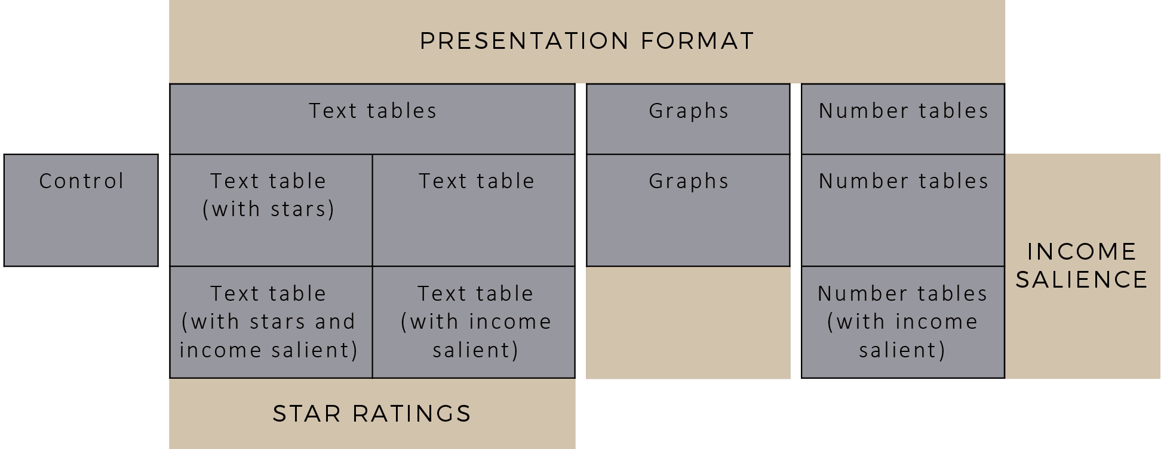

How were the interventions tested?

The trial was an individually randomised controlled trial – more precisely, a “framed field experiment”³⁰ – in which subjects are drawn from the population of interest and invited to take part in an exercise in a natural (“field”) setting for research purposes (see Box 3). In this case, a sample of 121,415 members aged 45 and over from five superannuation funds were invited to participate in an online survey about a possible new type of income plan for retirement. The five superannuation funds were BT, UniSuper, Mine Wealth+Wellbeing, QSuper and AustralianSuper.
Eligible members received an email invitation from their superannuation fund explaining that the fund had partnered with the Government to conduct the survey. In the survey, they were asked to contemplate two retirement income plans and to express their willingness to choose the CIPR (the new ‘Plan A’). Members were aware that it was a hypothetical exercise – they were not making a real life choice to allocate their superannuation balance to a retirement income plan.

BOX 3: WHAT IS A FRAMED FIELD EXPERIMENT?
A framed field experiment is an experiment performed with a sample of participants drawn from the population of interest, whereby they consent to participate in an activity in a natural setting for research purposes. Framed field experiments are designed to mimic features of naturally occurring settings in a controlled environment in order to better understand how people respond to different types of stimuli. Unlike lab experiments, which typically recruit small samples of subjects to perform tasks in an artificial setting, framed field experiments are designed to recruit large samples of subjects that are representative of the populations of interest and ask them to make choices in settings that approximate how they would make decisions in real life (e.g., sitting in front of their own computer in their own office or home).
In the ideal field experiment, researchers observe subjects making real decisions in natural settings without being aware that they have been randomly assigned to some treatment or intervention and their behaviour is being scrutinized. The framed field experiment is an attractive alternative when examining high-stakes, one-time decisions (like the choice of a retirement income plan), as ethical concerns would prohibit conduct of an experiment affecting real choices (certainly without informed consent of subjects).
A total of 3,806 members completed the survey (response rate = 3.13%). We then reviewed the demographic profile of the sample and excluded members aged 65 and over (n = 159), on the grounds that these members did not form our population of interest. Thus, the end sample size for analysis was 3,647. Appendix C provides a summary of the sample in terms of socio-demographic characteristics. There was a fairly even gender split in the sample, and most respondents were 59 years of age or under (~75%), in a relationship (~69%) and had children (~68%). The majority of members (~82%) held at least a certificate or higher level of education. Household annual income tended to cluster within the $50,000 to $150,000 range (~50%). Superannuation balance (with that one superannuation fund) also was distributed across a few wealth categories, with around one-third of the sample holding a balance less than $100,000 and about 46% with a balance between $100,000 and $500,000. Fewer members held over $500,000 (~15%). Around two-fifths (~39%) of the sample reported that they had consulted a financial planner in the last 5 years, and consistent with Australian Tax Office data, a fairly large proportion (~34%) held another superannuation account with another superannuation fund.
The sample is similar to the total population of superannuation fund members in Australia in the same 45 and over age brackets, in terms of the distribution by age and gender (see Appendix D). Note that, in the analysis, we apply population weights (on age and gender) to allow for appropriate generalizations to population of fund members. For 187 respondents, information on age and gender was not available so we have excluded these respondents from the statistical tests involving population weighting. The impact of organizational differences was also controlled for. In all statistical tests, a conventional statistical significance (alpha) level of 0.05 was used. A statistically significant difference means that the observed difference is unlikely to be due to chance (we would expect to see the difference less than 5% of the time).
In the survey experiment, members were first asked to rank order their preferences for using their superannuation in retirement. They were then asked to review information about the CIPR and an ABP, to rate their willingness to choose the CIPR if it were offered to them in the future, and to answer five true/false questions about the CIPR. People’s choices and reflections on the information provided, along with socio-demographic information was collected (see Box 4 for a summary of key outcome measures). Members were randomly assigned to one of eight different information conditions: the control group that received the basic text descriptions or one of the seven groups that received additional information presented in different ways (a summary of this randomised allocation is provided in Figure 2).

BOX 4: WHAT OUTCOMES WERE ExAMINED?
In this trial we examined five key outcomes:
- Comprehension: understanding of the CIPR assessed by 5 questions (0-5 scale)
- Perceived clarity: how clear members perceived the information to be (1-5 scale)
- Decision ease: how easy members felt it was to make the decision (1-5 scale)
- Decision confidence: how confident members felt in the decision (1-5 scale)
- Willingness to choose the CIPR: how likely they were to choose the CIPR (0-100%)
We also examined qualitative responses to an open-ended question asking members to explain the reasons behind the choice they made, and we explored ranked preferences for using one’s superannuation in retirement.

Figure 2: Experimental Groups
Minimal information
(control)
(n = 480, 13.16%)
Text table
(+stars)
(n = 429, 11.76%)
Text table
(+stars, +income)
(n = 457, 12.53%)
Text table
(n = 473, 12.97%)
Eligible members
N=121,415 invited N=3,647 completed
Text table
(+income)
(n = 458, 12.56%)
Graphs
(n = 463, 12.70%)
Number tables
(n = 446, 12.23%)
Number tables
(+income)
(n = 439, 12.04%)

Results of the Study

Comprehension of the CIPR
Table 1 provides a summary of results for the analysis of comprehension. Average comprehension was 3.57 (SD=1.40) on a scale from 0 to 5 with higher scores reflecting greater understanding of the features of the CIPR. In general, men had higher comprehension scores than women (3.63 vs. 3.52, p=0.000), and members who had consulted a financial planner had higher comprehension scores than those who had not (3.67 vs. 3.52, p=0.003).

Table 1: Comprehension of Alternative Presentations, By Sex And Age
 | MEAN COMPREHENSION
 | Overall  (N=3, 357) | Males  (N=1,728) | Females  (N=1,629) | Younger  (45-54)  (N=1,585) | Older  (55-64)  (N=1,772)
Control | 2.67 | 2.76 | 2.59 | 2.60 | 2.74
Text table  (+stars) | 3.82***  better than  graphs* and  number tables*** | 3.84*** | 3.80***  better than  graphs*, number tables** | 3.90***  better than  number tables*** | 3.76***  better than  graphs*
Text table  (+stars, +income) | 3.74***  better than  number tables** | 3.82*** | 3.67***  better than  number tables* | 3.77***  better than  number tables** | 3.72***
Text table | 3.80***  better than  graphs* and  number tables*** | 3.71*** | 3.91***  better than  graphs**, number tables*** | 3.77***  better than  number tables** | 3.83***  better than text  table (+income)*,  graphs**
Text table  (+income) | 3.73***  better than  number tables** | 3.76*** | 3.69***  better than  number tables* | 3.90***  better than  graphs*, number tables*** | 3.59***
Graphs | 3.58*** | 3.69*** | 3.49*** | 3.67*** better than number tables* | 3.50***
Number tables | 3.52*** | 3.65*** | 3.39*** | 3.33*** | 3.70***
Number tables (+income) | 3.74***  better than  number tables* | 3.77*** | 3.72*** | 3.70***  better than  number tables* | 3.79***  better than  graphs*
Overall: | 3.57 | 3.63 | 3.52 | 3.57 | 3.58
Note. *p<0.05. **p<0.01. ***p<0.001. The statistical tests are in comparison to the control condition unless otherwise stated, and include organisation as a covariate. Population weights for age and gender also were applied in the statistical tests. The average scores listed are based on raw data.

One immediate finding is clear: the additional information provided to the treatment groups did not confuse members. Compared with the control group, members who received any of the alternative more-detailed presentations of information exhibited much higher comprehension scores (3.71 compared to 2.67 out of 5; p=0.000) indicating that, in general, the simplified presentations worked.
In terms of relative impacts among the alternative presentation formats, the text tables achieved higher comprehension than the graphs (3.77 vs. 3.58, p=0.010) or the number tables (3.77 vs. 3.63, p=0.001), but the comprehension of graphs was no different to that achieved with number tables (p=0.869). There was no significant difference between the text tables with and without stars (3.78 vs. 3.77, p=0.969), or between the presentations with and without the emphasis on income (3.74 vs. 3.71, p=0.422) – indicating that the addition of star ratings or making income salient did not aid understanding.
As shown in Table 1, at the individual treatment level, all presentations were superior to the control. Among the presentations, both of the text tables without income salient achieved higher comprehension than the graphs or the number tables without income salient (hereafter labelled the ‘simple number tables’). Also, both of the text tables with income salient, and the number tables with income salient were superior to the simple number tables.
We also examined treatment effects broken down by age and sex. There were clearer differences between the effects of specific treatments for younger (age 45-54) members and females. Both younger members and females were much better able to comprehend the text tables as compared to the simple number tables. The text tables (without income salient) also appeared to be easier to understand than the graphs among females. Fewer differences between treatments were observed for males and older members, who tended to achieve higher comprehension in general. However, for older members the text tables (without income salient) were easier to understand than the graphs.

Clarity of the information about the CIPR
Table 2 shows the results of the analysis of members’ perceived clarity of the information presented about the two plans. The average level of information clarity was 3.71 (SD=1.04), on a scale from 1 to 5, with higher scores indicating greater clarity. In general, perceived clarity was higher among women than men (3.77 vs. 3.67, p=0.029).
It is clear that the additional information provided in the various ways to the treatment groups was beneficial in terms of perceived clarity. Compared with the control group, members who received any of the alternative more-detailed presentations overall reported significantly higher perceived clarity (3.74 compared to 3.50; p=0.000). All of the individual presentations, with the exception of the simple number tables, raised perceptions of clarity above control levels.

Table 2: Perceived Clarity of Alternative Presentations, By Sex and Age
 | MEAN PERCEIVED CLARITY
 | Overall  (N=3,378) | Males  (N=1,722) | Females  (N=1,632) | Younger  (45-54)  (N=1,585) | Older  (55-64)  (N=1,769)
Control | 3.50 | 3.42 | 3.59 | 3.47 | 3.54
Text table  (+stars) | 3.77*** | 3.78*** | 3.77 | 3.71* | 3.83**
Text table  (+stars, +income) | 3.74** | 3.63* | 3.87**  better than  number tables* | 3.77** | 3.73
Text table | 3.79***  better than  number tables**,  and number tables (+income)* | 3.74*** | 3.87**  better than  number tables* | 3.93***  better than text  table (+stars)*,  number tables***, number tables (+income)* | 3.70
Text table  (+income) | 3.80***  better than  number tables* | 3.76*** | 3.86**  better than  number tables* | 3.87***  better than  number tables** | 3.76*
Graphs | 3.72*** | 3.70** | 3.77 | 3.78** | 3.70
Number tables | 3.67 | 3.63* | 3.71 | 3.62 | 3.71
Number tables (+income) | 3.68* | 3.66* | 3.72 | 3.69* | 3.68
Overall: | 3.71 | 3.67 | 3.77 | 3.73 | 3.71
Note. *p<0.05. **p<0.01. ***p<0.001. The statistical tests are in comparison to the control condition unless otherwise stated, and include organisation as a covariate. Population weights for age and gender also were applied in the statistical tests. The average scores listed are based on raw data.
Among the presentation formats, the text tables were superior to the number tables (3.78 vs. 3.67, p=0.005), but no different to the graphs (3.78 vs. 3.72, p=0.428). There was no significant difference between the text tables with and without stars (3.76 vs. 3.80, p=0.132), or between the presentations with and without the emphasis on income (3.74 vs. 3.75, p=0.935). Both of the text tables without stars were significantly clearer than the simple number tables, and the text table without stars and without income salient (hereafter labelled the ‘simple text table’) was significantly clearer than the number tables with income salient.

Again, as with comprehension, the differences between the effects of specific treatments were more marked among women and among younger (age 45-54) members than among men and older members.

Ease of making the decision
Table 3 provides a summary of the results of the analysis for the ease with which one made the decision. Overall, the average level of decision ease was 3.53 (SD=1.15) on a scale from 1 to 5 with higher scores representing greater ease. No significant differences were observed between males and females, or on any other key socio demographic variables.

Table 3: Decision-Making Ease for Alternative Presentations, By Sex and Age
 | MEAN DECISION-MAKING EASE
 | Overall  (N=3,349) | Males  (N=1,719) | Females  (N=1,630) | Younger  (45-54)  (N=1,582) | Older  (55-64)  (N=1,767)
Control | 3.42 | 3.43 | 3.41 | 3.34 | 3.50
Text table  (+stars) | 3.57 | 3.63 | 3.52 | 3.54 | 3.60
Text table  (+stars, +income) | 3.53 | 3.44 | 3.62 | 3.54 | 3.52
Text table | 3.54 | 3.61 | 3.45 | 3.60 | 3.50
Text table  (+income) | 3.58* | 3.64 | 3.53 | 3.55 | 3.61
Graphs | 3.55 | 3.57 | 3.53 | 3.60* | 3.50
Number tables | 3.52 | 3.51 | 3.52 | 3.52 | 3.52
Number tables (+income) | 3.50 | 3.49 | 3.50 | 3.56 | 3.43
Overall: | 3.53 | 3.54 | 3.51 | 3.53 | 3.52
Note. *p<0.05. **p<0.01. ***p<0.001. The statistical tests are in comparison to the control condition unless otherwise stated, and include organisation as a covariate. Population weights for age and gender also were applied in the statistical tests. The average scores listed are based on raw data.
Again, the additional information in the presentations made a significant positive difference, increasing the ease of the decision for individuals. Compared with the control group, members who received any of the alternative more- detailed presentations reported higher decision-making ease (3.54 compared to 3.42; p=0.035). However, when we probed further, it was only the text table without stars, but with income salient that achieved a statistically significant higher level of decision ease compared to the control. All other presentations were on par with the control, and each other. There was no significant difference between the text tables with and without stars (3.55 vs. 3.56, p=0.831), or between the presentations with and without income salient (3.54 vs. 3.54, p=0.835). The only significant difference for age or gender cohorts was that graphs increased the ease of decision for younger members, compared with the control.

Confidence in the decision
Table 4 provides a summary of the results of the analysis for confidence in the decision. Overall, the average level of decision confidence was 3.49 (SD=1.17) on a scale from 1 to 5 with higher scores reflecting greater confidence.
Once again, the additional information was helpful for people, leading to a greater sense of confidence in the decision between plans. Compared with the control group, members who received any of the alternative more- detailed presentations reported significantly more confidence in their decision (3.50 compared to 3.40; p=0.042). The text table without stars but with income salient improved confidence the most overall and this was the only condition in which the improvement in confidence versus the control group was statistically significant. While the other treatments led to no significant improvements in decision confidence (above that of the control) across the full sample, the text table (+stars, +income) did improve decision confidence from control levels, for females and younger (age 45-54) members.
Comparisons among the presentation formats showed that the text tables were not significantly different to the graphs (3.52 vs. 3.44, p=0.222) or number tables (3.52 vs. 3.50, p=0.443). There was no significant difference between the text tables with and without stars (3.50 vs. 3.54, p=0.506), or between the presentations with and without income salient (3.53 vs. 3.49, p=0.308).

Table 4: Decision Confidence for Alternative Presentations, By Sex and Age
 | MEAN DECISION CONFIDENCE
 | Overall  (N=3,349) | Males  (N=1,719) | Females  (N=1,630) | Younger  (45-54)  (N=1,984) | Older  (55-64)  (N=1,565)
Control | 3.40 | 3.46 | 3.34 | 3.22 | 3.57
Text table  (+stars) | 3.50 | 3.66 | 3.32 | 3.50* | 3.49
Text table  (+stars, +income) | 3.50 | 3.40 | 3.59*  better than  graphs* | 3.47* | 3.52
Text table | 3.49 | 3.46 | 3.54 | 3.53* | 3.46
Text table  (+income) | 3.58** | 3.65  better than text  table (+stars, + income)* | 3.49 | 3.65*** | 3.53
Graphs | 3.44 | 3.55 | 3.34 | 3.47 | 3.41
Number tables | 3.48 | 3.56 | 3.41 | 3.45 | 3.52
Number tables (+income) | 3.51 | 3.51 | 3.51 | 3.55* | 3.47
Overall: | 3.49 | 3.53 | 3.44 | 3.48 | 3.50
Note. *p<0.05. **p<0.01. ***p<0.001. The statistical tests are in comparison to the control condition unless otherwise stated, and include organisation as a covariate. Population weights for age and gender also were applied in the statistical tests. The average scores listed are based on raw data.

Willingness to choose the CIPR
Table 5 provides a summary of the results of the analysis for willingness to choose the CIPR. Average willingness to choose the CIPR was 51.45% (SD=29.50%) on a scale from 0% (no chance at all I’d choose this) to 100% (I’d definitely choose this). In general, members without children were more willing than those who had children (55.83% vs. 50.31%, p=0.000).

Table 5: Willingness to Choose The CIPR Based On Alternative Presentations, By Sex and Age
 | MEAN WILLINGNESS TO CHOOSE THE CIPR
 | Overall  (N=3,458) | Males  (N=1,773) | Females  (N=1,685) | Younger  (45-54)  (N=1,633) | Older  (55-64)  (N=1,825)
Control | 47.56% | 47.96% | 47.16% | 48.82% | 46.31%
Text table  (+stars) | 51.59% | 51.29% | 51.91% | 51.44% | 51.70%*
Text table  (+stars, +income) | 53.62%**  better than  graphs* | 50.90% | 56.25%***  better than  graphs** and  number tables* | 53.68% | 53.56%**
Text table | 52.26%** | 50.56% | 54.35%* | 54.47%* | 50.45%
Text table  (+income) | 54.77%***  better than  text table (+stars)* graphs* | 50.79% | 59.32%***  better than text table (+stars)*, graphs***, number tables**, and number tables (+income)** | 56.81%**  better than  graphs* | 53.11%**
Graphs | 50.01% | 50.93% | 49.19% | 49.54% | 50.49%
Number tables | 51.38% | 51.89% | 50.87% | 51.05% | 51.67%*
Number tables (+income) | 50.46% | 49.49% | 51.61% | 51.91% | 49.00%
Overall: | 51.45% | 50.47% | 52.47% | 52.12% | 50.84%
Note. *p<0.05. **p<0.01. ***p<0.001. The statistical tests are in comparison to the control condition unless otherwise stated, and include organisation as a covariate. Population weights for age and gender also were applied in the statistical tests. The average scores listed are based on raw data.
The additional information provided in the various ways to the treatment groups significantly increased willingness to choose the CIPR. Compared with the control group, members who received any of the alternative more-detailed presentations were overall, more likely to choose the CIPR (52.01% compared to 47.56%; p=0.003). Willingness for the text tables (overall) was no different compared to the graphs (53.07% vs. 50.01%, p=0.052) or the number tables (53.07% vs. 50.%, p=0.131). Willingness to choose was similar between the graphs and number tables (50.01% vs. 50.92%, p=0.546).
Three of the text tables had a significant positive impact on the willingness of members to choose the CIPR. Both text tables with income salient were superior to the graphs. The text table with only income salient was also superior to the text table with only stars. The number tables and graphs did not significantly increase willingness to choose the CIPR above control levels .There was no significant difference between the text tables with and without stars (52.63% vs. 53.49%, p=0.187), or between the presentations with and without the emphasis on income (52.97% vs. 51.75%, p=0.276). Again, the findings suggest that the addition of more-detailed information, at least in text tables, had the largest effects for females and for younger members.

How was willingness to choose the CIPR related to comprehension and preferences for using superannuation?
We examined the relationship between willingness to choose the CIPR and comprehension to ascertain whether people who had an improved understanding of the CIPR were also more willing to choose it. As discussed above, the simple presentations of additional information about the CIPR increased both comprehension of the CIPR and willingness to choose the CIPR. Overall, in addition, it is clear that comprehension was significantly higher among members who indicated equal to, or greater than the overall mean willingness to choose the CIPR (comprehension=3.79) compared to members who indicated less than the overall mean willingness to choose the CIPR (comprehension=3.36) (p=0.000). These results indicate that willingness to choose the CIPR may have been higher in the treatment groups because members understood the CIPR more when provided additional information in simplified form. (Note that we will provide more sophisticated statistical analysis of the causal pathway, and the effects of the treatments, using an “intent-to-treat” design, in a forthcoming publication: The Nest Egg Problem: Testing ways to improve understanding of retirement income options).
We also examined how willingness to choose the CIPR was related to members’ pre-stated preferences for how they would like to use their superannuation in retirement. At the start of the survey, members were asked to think about what is important for them in deciding how to use their superannuation and to rank in order (of most to least important) the following priorities:
- I want my superannuation to last my entire lifetime
- I want to get the highest level of income in retirement, based on my superannuation balance
I want to be able to access and use all of my superannuation when I want (which might include leaving a bequest to my child/ren, spouse, and/or charity)
The frequencies of the six possible combinations of rank order profiles, and their corresponding willingness to choose the CIPR mean scores are presented in Table 6.

Table 6: Preferences for Using Superannuation in Retirement and Mean Willingness to Choose the CIPR
 | RANKING ORDER
 | Rank Order Profile #1 (N=636) | Rank Order Profile #2 (N=290) | Rank Order Profile #3 (N=538) | Rank Order Profile #4 (N=336) | Rank Order Profile #5 (N=362) | Rank Order Profile #6 (N=636)
I want my superannuation to last my entire lifetime | Rank 1 | Rank 1 | Rank 2 | Rank 2 | Rank 3 | Rank 3
I want to get the highest level of income in retirement, based on my superannuation balance | Rank 2 | Rank 3 | Rank 1 | Rank 3 | Rank 1 | Rank 2
I want to be able to access and use all my superannuation when I want (which might include leaving a bequest to my child/ren, spouse, and/or charity) | Rank 3 | Rank 2 | Rank 3 | Rank 1 | Rank 2 | Rank 1
Willingness to choose the CIPR: | 64.91% | 56.82% | 60.64% | 41.74% | 48.79% | 36.08%
Note. 662 members did not answer the ranking question. The scores for willingness to choose Plan A are based on raw data.
While we are cautious about this analysis, because of the large amount of missing data (n=662, 19.13% failed to answer this question), it does appear that willingness to choose the CIPR was aligned with pre-stated preferences. Overall, among those members who ranked longevity risk (“superannuation to last my entire lifetime”) as the first priority and accessibility to superannuation as the last priority, willingness to choose the CIPR was far higher than among those who ranked accessibility to funds first and longevity risk last (64.91% vs. 36.08%, p=0.000). A similar difference was observed when comparing members who ranked the highest level of income as the first priority and accessibility to superannuation as the last priority with members who ranked accessibility to funds first and highest level of income last (60.64% vs. 41.74%, p=0.000).

What were the reasons members gave for their choices?
To provide additional insights into members’ decision-making, we explored responses to the following open-ended question in the survey:
Before we continue, is there anything else you would like to tell us, to explain why you made that choice?
A good proportion of members (n=1,498, 41.07%) provided a response, many mentioning multiple reasons for their choices. A total of 1,999 reasons were coded. We classified the various reasons according to which were generally negative/positive regarding the CIPR, and which fell somewhere in between as ‘undecided’ or not definitive. (Note that we will provide more detailed analysis of the qualitative data in a forthcoming publication: The Nest Egg Problem: Testing ways to improve understanding of retirement income options).

A brief review of the more common (>10% of all responses) qualitative comments revealed that many members appreciated the financial security and longevity risk protection offered through the CIPR (n=344 comments, 17.21% of all comments). Some examples included
- security of income is important
- as I watch my parents getting older, I think it is better to have a guaranteed income without having to think too much about it
- I want my superannuation to last my entire lifetime
A steady stream of income and being able to budget is important to me. I don’t want to run out of money and have to sell my house
However, there was an even greater frequency of comments about wanting to retain personal choice, control and flexible access to superannuation funds (n=691, 34.57% of all comments) as reasons against choosing the CIPR. Some people also explicitly described how they would require access to lump sums of money for planned or unplanned purchases throughout retirement. Examples included:
- I like to have some control over my income and investments
- Plan A provides little control and locks you in
- Plan B allows you to manipulate your funds at your own discretion
There could be unexpected costs when I retire such as education and wedding costs for my children, a final mortgage payment or a need to buy a small reliable car that will last me throughout my retirement
These results indicate that while many members were attracted to the financial security afforded by the CIPR, there were also many members who did not want to give up control of their funds entirely, and expressed a desire for a combination (“mixture”) plan. This finding is illuminating as CIPRS are intended to offer flexibility in exactly this way – access to a portion of funds but also an income stream for life, so explaining this feature of CIPRs more clearly in the future may be valuable.
The commentary about control of access to fund also was sometimes coupled with statements that conveyed negativity, distrust or suspicion – either directed towards the Government, superannuation funds or the CIPR itself (n=250, 12.51% of all comments). Examples included:
- …I think that annuities will be priced conservatively and I will get a very bad deal if I chose A
- I want my funds in my control, I have zero faith in the government
- Conversion to an annuity…allows insurance companies to profit from the process.
I don’t believe Plan A would not be tinkered with by successive governments
It is possible that some members believed that the new plan would be managed by the Government, perhaps in part because the survey was initiated by the Government.

Limitations of the Study

As discussed above, the trial was a framed field experiment. Members were presented with information about a retirement income plan, and asked how likely they would be to choose it. The trial aimed to mimic the naturally occurring choice situation in which superannuation funds might offer a choice of retirement income plans to members. Unlike a lab experiment, or user-experience (and focus-group) testing, which typically rely upon small samples of subjects performing tasks in highly artificial settings, the trial is based on a large and representative sample of subjects who make choices in settings similar to how they would make decisions in real life (e.g., in front of their own computer in their own home). But unlike an ideal field experiment, in our trial individuals are making an entirely hypothetical decision. While the decision itself is certainly relevant to most members in our sample – those approaching the age of retirement (over 1,000 members were in the 55-59 age group; over 2,000 members were in the 50-59 cohort) – it is possible that some members exerted less cognitive effort and attention to the task simply because it was hypothetical, and thus, may have responded differently compared with how they would in real life.
Further, a real life choice on how to manage superannuation in retirement is inherently more complex than the hypothetical choice presented in this study. Individuals making the choice in real life should take into account their income and assets outside of superannuation, as well as their eligibility (both now and into the future) for the means-tested Age Pension. To standardise and simplify the decision making task, these factors were not included in the current study. Notably, members were not encouraged to factor in other savings (outside of their superannuation) and the estimates used to compare income under the two plans did not include income from the Government Age Pension. The experimental design ensures that, statistically the treatment and control groups are identical, on average, in terms of their voluntary savings rates and eligibility for the pension, so these issues are not potential confounding factors for estimating treatment effects. However, individuals may have responded differently if the choice was presented with these additional components and added complexity.
Finally, we should note again that participation in this study was voluntary for individual fund members, and participation was also voluntary for superannuation fund managers (we conducted the study with five superannuation funds who had a strong interest in the research). It is likely that the study attracted participation by members who were more interested and engaged in the topic of retirement income planning than the average member across all superannuation funds throughout Australia (even those in the about-to-retire cohorts). This potential response bias, in terms of participation in the study, means that we could see different results if the same experiment could be conducted among the broader population. Further testing would be required to explore how a broader sample of superannuation members respond to presentations of information about CIPRs in a real-life setting.

Policy Lessons

The results above indicate that alternative presentations of information can significantly improve comprehension, clarity, decision-making ease and decision confidence among individuals contemplating the choice between a CIPR and an account-based pension. These presentations also increase willingness to choose the CIPR. Overall, the tables with simple text-based descriptions of the key features of alternative plans were the most consistently effective, while tables showing numerical estimates were the least effective. Neither the addition of star ratings, nor visual cues emphasizing income comparisons made a difference to outcomes. In general, these differences were larger for younger members and women than for older members and men – suggesting that communication efforts could be tailored to specific demographic segments.
People tended to make choices that were aligned with their pre-stated preferences about what was most important to them in thinking about their retirement income – that is, individuals who prioritised high income and making their money last their lifetime (versus having access to money) tended to display greater willingness to choose the CIPR. Qualitative responses to the survey also indicated that many members were attracted to the financial security afforded by the CIPR, but many members did not want to give up control of their funds entirely. Since CIPRS are intended to offer flexibility in exactly this way – access to a portion of funds but also an income stream for life – a clearer explanation of this feature of CIPRs might be highly effective. Some individuals also expressed a concern that the CIPR would be directly managed by the Government, so this misperception could be corrected.
The findings suggest a high level of support for the CIPR, overall, with more interest in CIPRs among those receiving the additional information and those demonstrating higher levels of comprehension. It is particularly encouraging that those who better understood the CIPR indicated they would be more likely to choose one. This suggests that as CIPRs become better known over time they are likely to become more popular. Effective communication of CIPRs by the industry and Government can only help people to make informed choices.

What is the best way to present the CIPR?
If we were to declare an overall “winner”, there was only one approach, the text table (with income highlighted), that led to significantly improved outcomes across the board – improvements in comprehension, perceived clarity, decision-making ease, decision making confidence, and willingness to choose the CIPR. This text table generally achieved significantly improved outcomes when compared with the control condition and also when compared with the presentation of number tables and graphs.
The relatively poor performance of the number tables and graphs in terms of improving comprehension might be explained, in part, by the fact that there was minimal text explaining the numerical estimates that were provided, and the estimates themselves were based on a hypothetical example. Thus, members were required to interpret and compare a set of hypothetical numbers (which may be different to their own circumstances) to make an assessment of the relative performance of the plans and the implications for themselves. In comparison, the text tables provided standardized information about the performance of the plan (e.g., ‘this plan provides a medium-to-high amount of income’). It is possible that the addition of these statements helped members quickly understand the relative standing of the plan across the various features.

Do certain presentations work better for certain people/at different points in time?
Findings from this survey provide initial insights into how information about a CIPR should be presented to members to facilitate decision-making and choices. It is important to note however, that there are many different ways, places and times to introduce information on CIPRs to individuals. Our test was confined to a static presentation of comparative information to gauge people’s understanding and first impressions of the CIPR – something that might be presented to people many years out from retirement. Certainly, the fact that the benefits of additional information tended to be more frequent for younger members (age 45-54) than older members suggests that the text tables may be a good way to introduce CIPRs to younger members.
However, as the retirement income decision draws closer – as is the case for older aged members – it would appear, on the basis of the results from our survey, that the way in which information is presented matters less. Indeed, older members seemed to tackle the decision task just as well across all alternative presentations. We can hypothesise that the lack of differential impacts is due to older members already having some exposure to, and experience with, retirement income planning. It also is possible that they thought more about the decision as it was more relevant (and perhaps even interesting!) to them.
The differential pattern of results based on age also was apparent for females versus males. Females tended to be more responsive to the additional information presented than were males, moving from a lower level of comprehension and decision confidence (in the control condition) compared with men, to similar levels (in the treatment conditions). Prior research on gender differences in financial decision-making has shown that females, on average, are more risk averse and less financially literate than men – characteristics which have been used to help explain why women tend to invest in less risky assets like annuities²⁰. The differences observed in the current study might also be partly explained by differences in appetite for risk and financial literacy between males and females. Whatever the underlying mechanism, on the basis of survey results, and as observed for younger members, it appears that text tables may be the preferred way to present information on CIPRs to females. However, great care should be taken before applying a one-size-fits-all approach even with a particular demographic as the observed effects are only averages and there will be many females who respond better to numbers than text.

Other implications for the design of the CIPR framework
It is clear from qualitative feedback in the survey that many members want to maintain control over and flexible access to their superannuation funds during retirement. Thus, it will be important that the relevant features of the CIPR framework (i.e., the ability to choose how much of one’s superannuation balance to allocate to the CIPR, and whether to dial up/down the underlying allocations to the longevity component and flexibility component) are made clear to members. In the current study, these particular aspects were not explicitly communicated to members. But based on the comments, it is clear that these are top-of-mind concerns for many members and should therefore be addressed proactively in any CIPR communication efforts. Prior research on pension plan choices suggests that individual plan attributes – such as the degree of personal control over investment decisions – are critical determinants of choices, even overshadowing the influence of expected returns from the plans themselves³¹.
Finally, it is possible that as members approach the decision of how to use their superannuation balance at retirement, that such information would need to be tailored to the individual’s personal circumstances (as indeed, some members requested in the current study). Providing customized information that is based on each member’s real situation, accounting for other non-superannuation assets and eligibility for the Government Age Pension is likely to be more personally meaningful and useful. Automated systems (e.g., robo-advice) that provide personalised income projections based on user inputs are already available and could help members make informed decisions without incurring the cost of a (human) financial advisor. How such information is best presented to pre-retirees is something that further testing could reveal. While the current survey would suggest text tables as ideal, in the context of delivering real, personalised income projections, it is possible that members may respond differently and require alternatively-presented information.

Where to next?
As the Productivity Commission has noted, there is currently a limited evidence base for understanding the choices of superannuation members⁴. We believe the current study provides new evidence to help inform the design of the regulatory framework for implementing CIPRs. In particular, it provides insights on how CIPRs might be communicated to members to support optimal decision-making.
Australia’s three pillar retirement income system, particularly the mandated superannuation guarantee has been founded on the principles of behavioural economics. The system provides a strong foundation for the accumulation of retirement savings, in order to support retirees by providing income for retirement. However, as noted by the Financial Systems Inquiry and the Productivity Commission4, there are significant opportunities for government to now use behavioural economics in the decumulation phase of retirement, by designing strategies to support optimal decision making without restricting choices.
The Government is currently undertaking a public consultation process on the CIPR framework, as initiated by the discussion paper Development of the framework for Comprehensive Income Products for Retirement². The feedback gained from this process, along with the results of the current study, will inform the Government’s development of the regulatory framework governing CIPRs. We expect that the results of the current study will be most relevant to issues surrounding the presentation of CIPRs.

Appendix

Appendix A: the Alternative Presentations

Figure 3: Control Condition – Basic Text Descriptions of The Plans
Under Plan A:
your superannuation balance would be converted into an income stream for life.
you would receive a regular amount of money every fortnight (like a salary) for the rest of your life.
the income would generally keep pace with the cost of living.

Under Plan B:
your superannuation balance would be converted into an assessible account.
you would decide how much money to withdraw from this account during your retirement.
if you decided to withdraw the minimum amount prescribed by the Government, your money would last until you are aged in your 90s.

Figure 4: Text Table (With Star Ratings)
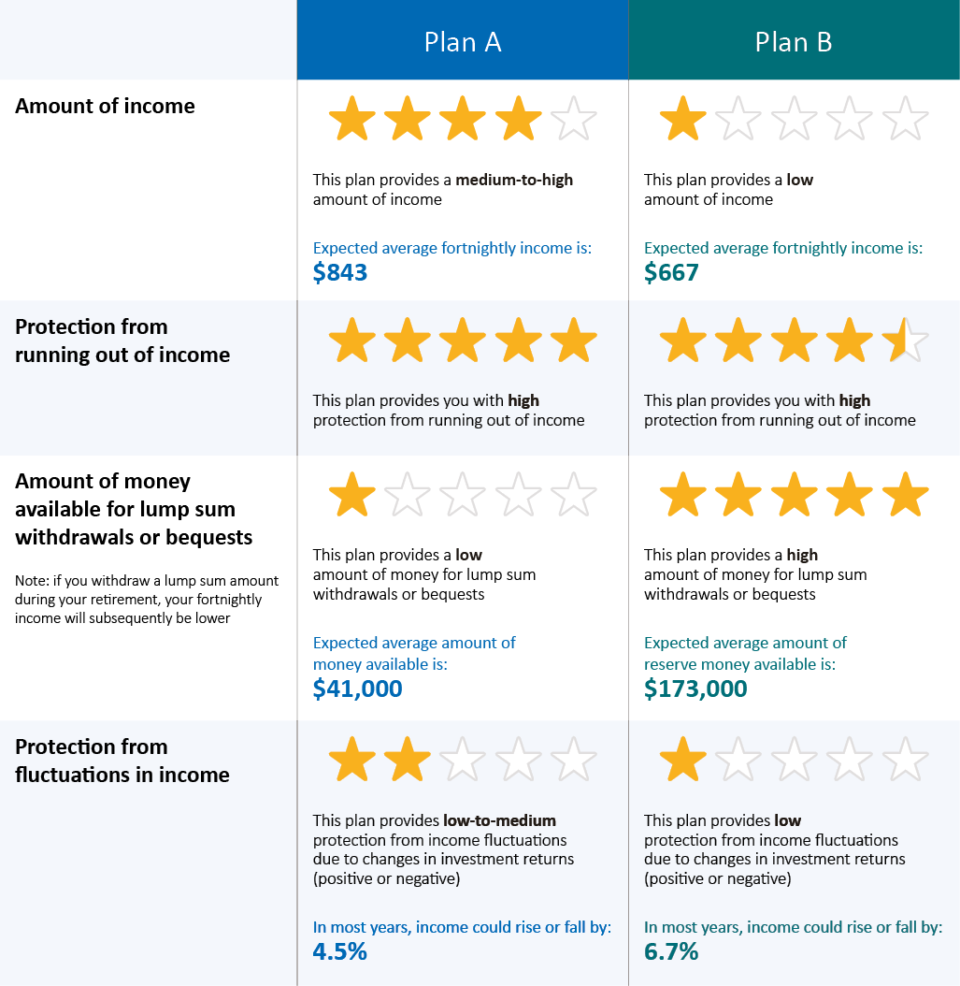

Figure 5: TeXT TAbLe (WiTH STAr rATiNgS AND
iNCOMe MADe SALieNT WiTH A bOrDer)
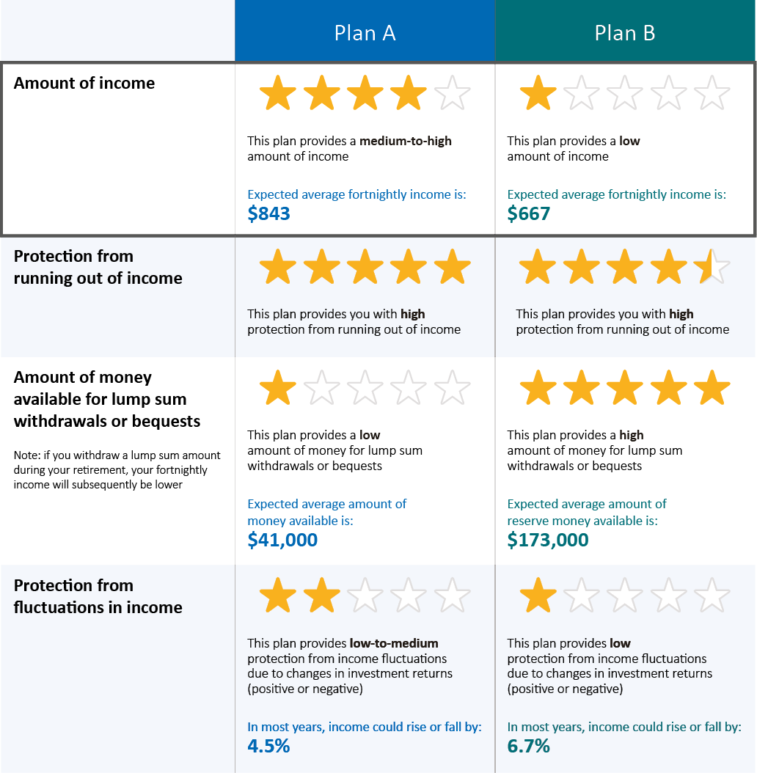

Figure 6: TeXT TAbLe
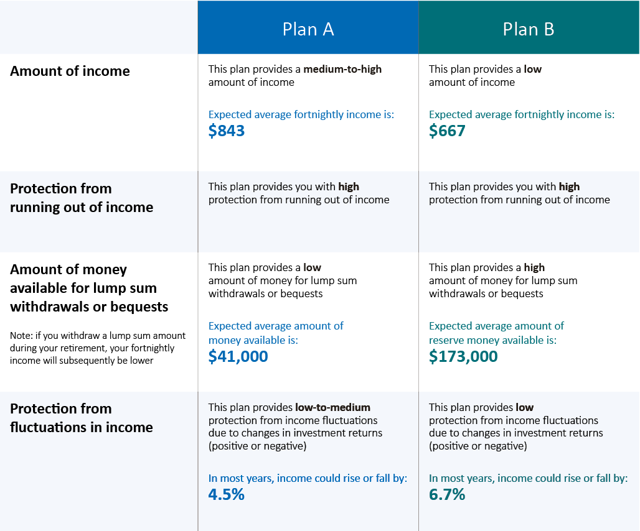

Figure 7: TeXT TAbLe
(WITH INCOME MADE SALIENT WITH A BORDER)
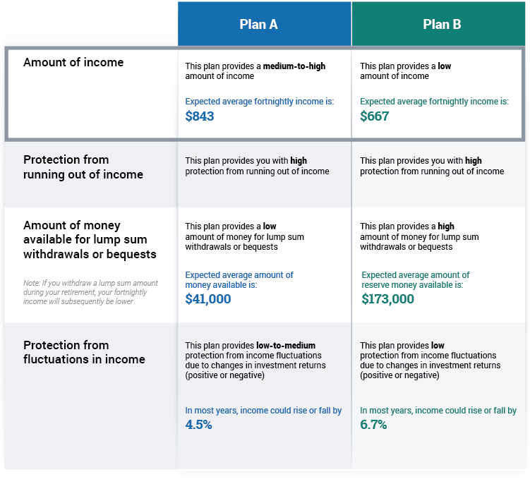

Figure 8: Graphs

Expected average fortnightly income
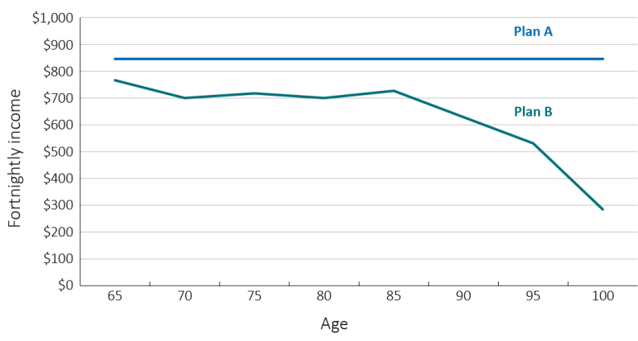

Expected amount of money available for lump sum withdrawals or bequests
Note: If you withdraw a lump sum amount during your retirement,
your fortnightly income will subsequently be lower
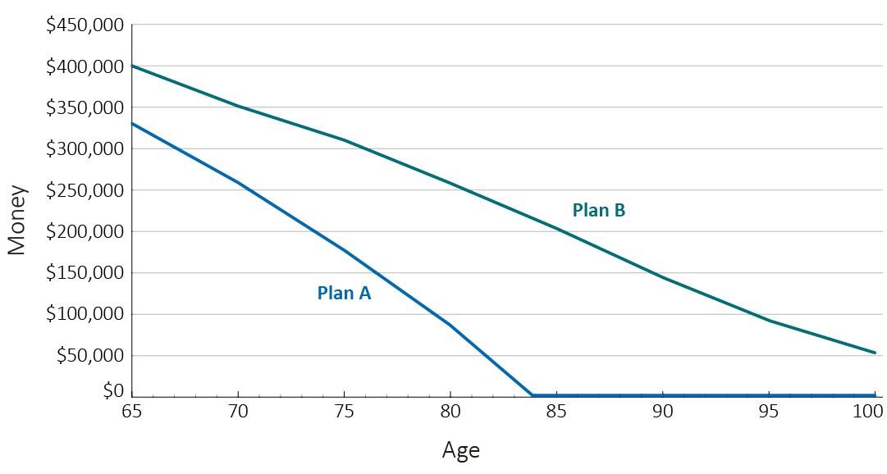

Expected fluctuations in income throughout retirement
Note: In most years, income could rise or fall within this range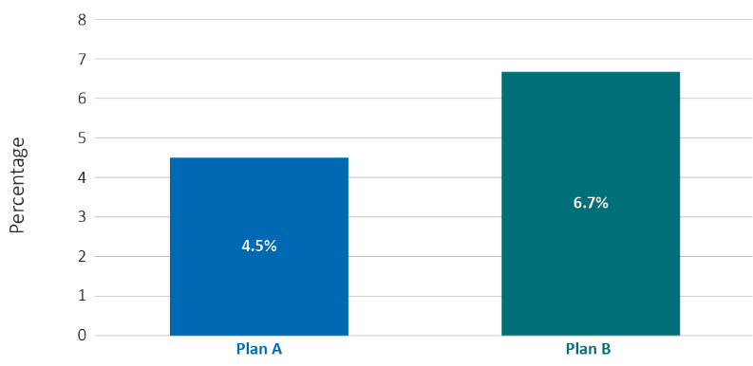

Figure 9: NUMBER TABLES
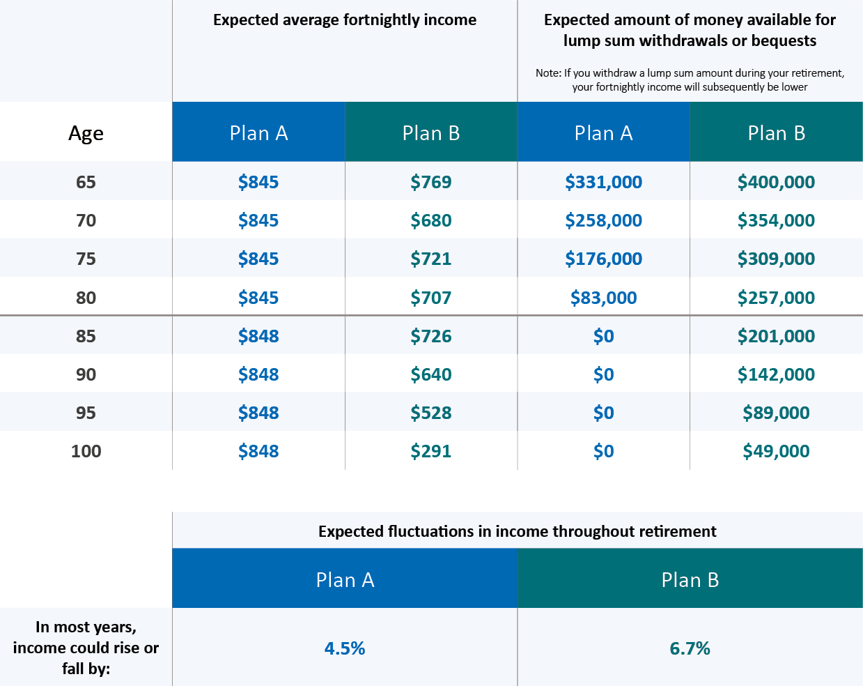

Figure 10: NUMBER TABLES
(WITH INCOME MADE SALIENT WITH A BORDER)
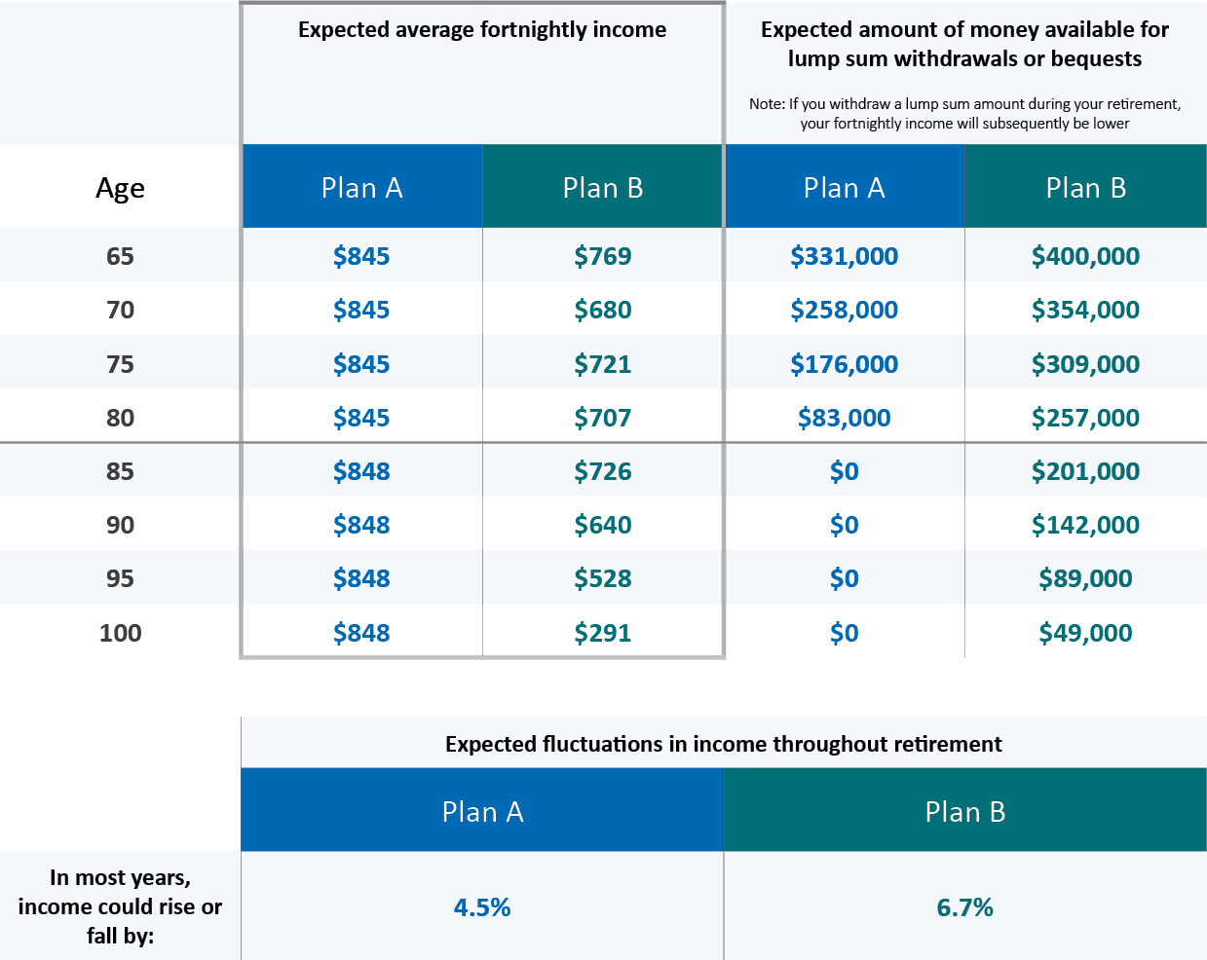

Appendix B: Assumptions Text in the Survey

Box 5: Assumptions
Plan A comprises 84% in an accessible account (commonly known as an account-based pension), which is drawn down faster than the minimum draw down rates and the balance is exhausted at age 85. A further 16% is in a deferred group self-annuitisation product, from which income starts at age 85 and continues for as long as you live. These elements together are expected to deliver broadly constant income until death.
Plan B assumes 100% of income is drawn down from an accessible account (or account-based pension) at the minimum government-prescribed rates. Fortnightly income is expected to decline beyond age 85.
Income is the weighted average of expected fortnightly income, from age 65 years onwards, with a $400,000 accumulated superannuation balance; income is averaged over the lifetime for males and females, and adjusted for an inflation rate of 2.5%. It excludes income that a person may be entitled to under the Government Age Pension.
Income is rounded to the nearest dollar, and is in today’s dollars. Amount of money available for lump sum withdrawals or bequests is rounded to the nearest thousand dollars, and is in today’s dollars.

Appendix C: Socio-Demographic Profile of the Sample
DEMOGRAPHIC VARIABLE | FREQUENCY | PERCENTAGE
Sex
Male | 1,776 | 48.70
Female | 1,688 | 46.28
No response | 183 | 5.02
Age
45-49 | 678 | 18.59
50-54 | 957 | 26.24
55-59 | 1,115 | 30.57
60-64 | 714 | 19.58
No response | 183 | 5.02
Relationship status
Single | 794 | 21.77
Married/ de facto/ couple | 2,531 | 69.40
No response | 322 | 8.83
Children
No | 827 | 22.68
Yes | 2,497 | 68.47
No response | 323 | 8.86
Education
Did not finish school | 38 | 1.04
School education | 302 | 8.28
Certificate | 426 | 11.68
Advanced diploma/diploma | 499 | 13.68
Bachelor degree | 580 | 15.90
Graduate diploma/graduate certificate | 327 | 8.97
Postgraduate degree | 1,155 | 31.67
No response | 320 | 8.77
Household income (per year)
Less than $20,000 | 65 | 1.78
$20,000 to $50,000 | 249 | 6.83
$50,000 to $100,000 | 928 | 25.45
$100,000 to $150,000 | 891 | 24.43
$150,000 to $200,000 | 548 | 15.03
$200,000 to $250,000 | 273 | 7.49
$250,000 to $300,000 | 127 | 3.48
$300,000 or more | 137 | 3.76
No response | 429 | 11.76

DEMOGRAPHIC VARIABLE | FREQUENCY | PERCENTAGE
Superannuation balance
Less than $100,000 | 1,110 | 30.44
$100,000 to $250,000 | 885 | 24.27
$250,000 to $500,000 | 791 | 21.69
Over $500,000 | 534 | 14.64
Don’t know/prefer not to say | 130 | 3.56
No response | 197 | 5.40
Consulted financial planner in last 5 years
No | 1,902 | 52.15
Yes | 1,431 | 39.24
No response | 314 | 8.61
Holds another superannuation account
No | 2,034 | 55.77
Yes | 1,258 | 34.49
I don’t know | 38 | 1.04
No response | 317 | 8.69

Note. The data for age, sex and superannuation balance was derived from a combination of both super-fund and self-reported information. For example, actual superannuation balance information was available for 2,164 members; for the remaining 1,568 members, self-report superannuation balance was used. Of the 2,164 members for whom actual data was available, 338 members self-reported a different category of superannuation balance, 1,506 reported the same category, and 157 indicated that they did not know or preferred not to say, and 163 did not answer the question. 8 members from three of the superannuation funds, self-reported their age as <45 years of age – these members were included in the 45-49 age category bracket.

Appendix D: The Number of Superannuants in the Population and in the Study Sample, By Age and Sex
 | COL. A | COL. B
 | Number of individuals in the population, participating in the super system but excluding individuals who have drawn down/are drawing down on super (%) | Study Sample n (%) | Stratum Weight (pweight)  Col. A / Col. B
Age 45-49, Male | 560,000 (16%) | 327 (9%) | 1712.54
Age 45-49, Female | 545,000 (15%) | 349 (10%) | 1561.60
Age 50-54, Male | 546,000 (15%) | 473 (14%) | 1154.33
Age 50-54, Female | 541,000 (15%) | 484 (14%) | 1117.77
Age 55-59, Male | 438,000 (12%) | 592 (17%) | 739.86
Age 55-59, Female | 433,000 (12%) | 522 (15%) | 829.50
Age 60-64, Male | 275,000 (8%) | 382 (11%) | 719.90
Age 60-64, Female | 262,000 (7%) | 331 (10%) | 791.54
Total | 3,600,000 | 3,460

Note. This data is based on information from Member Contribution Statements for 2014-15. Individuals included in the analysis have a positive balance and were contributing in 2014-15. The analysis excludes individuals with assets in the pension phase (and those with lump sum withdrawals) in 2014-15, although they may have withdrawn superannuation in previous years. The population figures are rounded to the nearest 500. Members who self-reported that they were in the ‘under 45’ age category were included in the 45-49 age category.

Appendix E: Summary of Raw Descriptive Statistics on Outcomes of Interest
 | N | COMPREHENSION  (0 TO 5) | CLARITY  (1 TO 5) | DECISION-MAKING EASE  (1 TO 5) | DECISION  CONFIDENCE  (1 TO 5) | WILLING TO CHOOSE  THE CIPR  (0 TO 100%)
Overall | 3.55 | 3.71 | 3.52 | 3.48 | 51.01 | 3.55
Preference Rank Profile 1 | 3.78 | 3.81 | 3.52 | 3.48 | 64.47 | 3.78
Preference Rank Profile 2 | 3.58 | 3.68 | 3.32 | 3.36 | 56.57 | 3.58
Preference Rank Profile 3 | 3.78 | 3.79 | 3.48 | 3.53 | 59.76 | 3.78
Preference Rank Profile 4 | 3.44 | 3.58 | 3.53 | 3.45 | 41.69 | 3.44
Preference Rank Profile 5 | 3.50 | 3.70 | 3.45 | 3.40 | 48.51 | 3.50
Preference Rank Profile 6 | 3.37 | 3.67 | 3.70 | 3.59 | 35.67 | 3.37
Control | 2.64 | 3.50 | 3.41 | 3.39 | 47.21 | 2.64
Text table (+stars) | 3.81 | 3.77 | 3.57 | 3.49 | 51.41 | 3.81
Text table (+stars, +income) | 3.72 | 3.74 | 3.53 | 3.51 | 52.93 | 3.72
Text table | 3.77 | 3.79 | 3.53 | 3.49 | 52.08 | 3.77
Text table (+income) | 3.70 | 3.80 | 3.58 | 3.58 | 54.43 | 3.70
Graphs | 3.56 | 3.72 | 3.56 | 3.43 | 49.81 | 3.56
Number tables | 3.50 | 3.67 | 3.53 | 3.48 | 50.38 | 3.50
Number tables (+income) | 3.74 | 3.68 | 3.49 | 3.50 | 49.97 | 3.74
Male | 3.63 | 3.67 | 3.54 | 3.53 | 50.47 | 3.63
Female | 3.51 | 3.77 | 3.51 | 3.44 | 52.47 | 3.51
45-49 | 3.68 | 3.80 | 3.58 | 3.54 | 52.20 | 3.68
50-54 | 3.49 | 3.68 | 3.50 | 3.43 | 51.94 | 3.49
55-59 | 3.62 | 3.73 | 3.54 | 3.50 | 51.25 | 3.62
60-64 | 3.51 | 3.68 | 3.50 | 3.50 | 50.17 | 3.51
Single | 3.43 | 3.75 | 3.59 | 3.48 | 52.55 | 3.43
Couple | 3.63 | 3.71 | 3.51 | 3.49 | 51.28 | 3.63
No children | 3.56 | 3.70 | 3.53 | 3.45 | 55.77 | 3.56
With children | 3.59 | 3.72 | 3.53 | 3.49 | 50.28 | 3.59
Did not finish school | 3.29 | 3.55 | 3.35 | 3.38 | 48.76 | 3.29
School education | 3.24 | 3.75 | 3.68 | 3.61 | 54.28 | 3.24
Certificate | 3.16 | 3.61 | 3.57 | 3.38 | 46.02 | 3.16
Advanced diploma/diploma | 3.34 | 3.62 | 3.56 | 3.48 | 50.35 | 3.34
Bachelor degree | 3.61 | 3.69 | 3.48 | 3.48 | 51.60 | 3.61
Graduate diploma/graduate certificate | 3.66 | 3.77 | 3.40 | 3.44 | 53.72 | 3.66
Postgraduate degree | 3.94 | 3.79 | 3.51 | 3.51 | 53.40 | 3.94
Income- less than $20,000 | 2.65 | 3.66 | 3.69 | 3.69 | 47.98 | 2.65
Income- $20,000 to $50,000 | 2.86 | 3.60 | 3.57 | 3.40 | 47.36 | 2.86
Income- $50,000 to $100,000 | 3.35 | 3.68 | 3.50 | 3.44 | 51.38 | 3.35
Income- $100,000 to $150,000 | 3.68 | 3.74 | 3.46 | 3.46 | 53.42 | 3.68
Income- $150,000 to $200,000 | 3.85 | 3.74 | 3.59 | 3.50 | 53.36 | 3.85
Income- $200,000 to $250,000 | 3.89 | 3.75 | 3.60 | 3.49 | 53.09 | 3.89
Income- $250,000 to $300,000 | 4.20 | 3.83 | 3.54 | 3.72 | 49.24 | 4.20
Income- $300,000 or more | 4.16 | 3.95 | 3.70 | 3.77 | 51.16 | 4.16

 | N | COMPREHENSION  (0 TO 5) | CLARITY  (1 TO 5) | DECISION-MAKING EASE  (1 TO 5) | DECISION  CONFIDENCE  (1 TO 5) | WILLING TO CHOOSE  THE CIPR  (0 TO 100%)
Super balance - Less than $100,000 (base) | 3.43 | 3.75 | 3.55 | 3.53 | 53.05 | 3.43
Super balance - $100,000 to $250,000 | 3.56 | 3.69 | 3.49 | 3.48 | 51.01 | 3.56
Super balance - $250,000 to $500,000 | 3.69 | 3.72 | 3.52 | 3.45 | 52.40 | 3.69
Super balance - Over $500,000 | 3.85 | 3.72 | 3.53 | 3.50 | 49.92 | 3.85
Super balance – Don’t know/prefer not to say | 3.14 | 3.55 | 3.49 | 3.33 | 43.56 | 3.14
Have not consulted financial planner | 3.52 | 3.70 | 3.51 | 3.45 | 51.85 | 3.52
Have consulted financial planner | 3.66 | 3.73 | 3.54 | 3.53 | 51.40 | 3.66
No other super account | 3.52 | 3.72 | 3.52 | 3.46 | 51.11 | 3.52
Have another super account | 3.72 | 3.72 | 3.53 | 3.53 | 52.91 | 3.72
Do not know if have another super account | 2.61 | 3.30 | 3.41 | 3.22 | 46.39 | 2.61
Poor health | 2.83 | 3.46 | 3.37 | 3.37 | 50.50 | 2.83
Fair health | 3.31 | 3.56 | 3.34 | 3.22 | 50.16 | 3.31
Good health | 3.51 | 3.70 | 3.50 | 3.47 | 52.75 | 3.51
Very good health | 3.70 | 3.73 | 3.52 | 3.51 | 52.24 | 3.70
Excellent health | 3.78 | 3.85 | 3.72 | 3.64 | 49.36 | 3.78
Shorter than average life expectancy | 3.26 | 3.55 | 3.35 | 3.35 | 47.72 | 3.26
Same as average life expectancy | 3.53 | 3.69 | 3.50 | 3.48 | 51.43 | 3.53
Longer than average life expectancy | 3.74 | 3.80 | 3.59 | 3.52 | 53.03 | 3.74
Less confident in making financial decisions (<=3, on a scale from 1 to 5) | 3.34 | 3.39 | 3.05 | 3.04 | 54.93 | 3.34
More confident in making financial decisions (>3, on a scale from 1 to 5) | 3.64 | 3.79 | 3.64 | 3.59 | 50.66 | 3.64

Endnotes

- Commonwealth of Australia. Financial System Inquiry Final Report. 2014.
- The Treasury. Development of the framework for comprehensive income products for retirement. Discussion Paper. 2016.
- Commonwealth of Australia. Super System Review Final Report. Chapter 1 MySuper and Choice Architecture. 2010.
- Productivity Commission. How to assess the competitiveness and efficiency of the superannuation system. Draft Report. 2016.
- Productivity Commission. Superannuation Policy for Post-Retirement. Productivity Commission Research Paper. 2015.
- Sneddon T, Reeson A, Zhu Z, Stephenson A, Hobman EV, Toscas P. Superannuation Drawdown Behaviour. JASSA. 2016;2:42-53.
- Ameriks J, Zeldes SP. How do household portfolio shares vary with age? Working paper: 2004.
- Choi JJ, Laibson D, Madrian BC, Metrick A. For better or for worse: Default effects and 401(k) savings behavior. National Bureau of Economic Research. 2004;0-226-90305-2.
- Madrian BC, Shea DF. The power of suggestion: Inertia in 401(k) participation and savings behavior. The Quarterly Journal of Economics. 2001;CXVI(4):1149-87.
- Gerrans P. Retirement savings investment choices in response to the global financial crisis: Australian evidence. Australian Journal of Management. 2012;37(3):415-39.
- Bateman H. Retirement income provision in Australia- outstanding design issues in a mature system. 2009.
- Bateman H, Dobrescu LI, Newell BR, Ortmann A, Thorp S. As easy as pie: How retirement savers use prescribed investment disclosures. Journal of Economic Behavior & Organization. 2016;121:60-76.
- Choi JJ, Laibson D, Madrian BC. Why does the law of one price fail? An experiment on index mutual funds. Review of Financial Studies. 2010;32(4):1405-32.
- Benartzi S, Thaler RH. Naive diversification strategies in defined contribution savings plans. American Economic Review. 2001;91:71-99.
- Bateman H, Eckert C, Ishakov F, Louviere J, Satchell S, Thorp S. Default and 1/N heuristics in annuity choice. Working paper: 2013.
- Brown JR, Kapteyn A, Luttmer EFP, Mitchell OS. Cognitive constraints on valuing annuities. Working Paper: 2015.
- Beshears J, Choi JJ, Laibson D, Madrian BC, Zeldes SP. What makes annuitization more appealing? Journal of Public Economics. 2013;116:2-16.
- Brown JR, Kling JR, Mullainathan S, Wrobel MV. Framing lifetime income. The Journal of Retirement. 2013;1(1):27-37.

- UK Financial Conduct Authority. Does the framing of retirement income options matter? A behavioural experiment. 2014.
- Agnew JR, Anderson LR, Gerlach JR, Szykman LR. Who chooses annuities? An experimental investigation of the role of gender, framing, and defaults. American Economic Review: Papers & Proceedings. 2008;98(2):418-22.
- Beshears J, Choi JJ, Laibson D, Madrian BC. How does simplified disclosure affect individuals’ mutual fund choices. In: Wise DA, editor. Explorations in the Economics of Aging. Chicago: University of Chicago Press; 2010. p. 75-96.
- Agnew JR, Szykman LR. Asset allocation and information overload: The influence of information display, asset choice, and investor experience. The Journal of Behavioral Finance. 2005;6(2):57-70.
- Tse A, Friesen L, Kalayci K. Complexity and asset legitimacy in retirement investment. Journal of Behavioral and Experimental Economics. 2016;60:35-48.
- Bateman H, Dobrescu LI, Newell BR, Ortmann A, Thorp S. Flicking the switch: How fee and return disclosures drive retirement plan choice. Working paper: 2016.
- Beshears J, Choi JJ, Laibson D, Madrian BC. Simplification and saving. Journal of Economic Behavior & Organization. 2013;95:130-45.
- Choi JJ, Laibson D, Madrian BC. Reducing the complexity costs of 401(k) participation: The case of quick enrolment. In: Wise DA, editor. Developments in the Economics of Aging. Chicago: University of Chicago; 2009. p. 57-82.
- Kasten GW, Kasten MW. The impact of aging on retirement income decision making. Journal of Financial Planning. 2011; June:60-9.
- de Goeij P, Hogendoorn T, Van Campenhout G. Pictures are worth a thousand words: Graphical information and investment decision making. Working paper: 2014.
- Kaufmann C, Weber M, Haisley E. The role of experience sampling and graphical displays on one’s investment risk appetite. Management Science. 2013;59(2):323-40.
- Harrison GW, List JA. Field experiments. Journal of Economic Literature. 2004;42(4):1009-55.
- Brown JR, Weisbenner SJ. Why do individuals choose defined contribution plans? Evidence from participants in a large public plan. Journal of Public Economics. 2014;116:35-46.

