Subtracting fees to subtract confusion
Using behavioural insights to improve International Money Transfer calculators
June 2024

Other uses
Enquiries regarding this license and any other use of this document are welcome at:
Managing Director
Behavioural Economics Team of the Australian Government
Department of the Prime Minister and Cabinet
1 National Circuit
Barton ACT 2600
Email: beta@pmc.gov.au
The views expressed in this paper are those of the authors and do not necessarily reflect those of the Department of the Prime Minister and Cabinet or the Australian Government.

Research team
Bethany Jones was the principal investigator for this project. Other (current and former) staff who contributed to the report were: Scott Copley and Hanne M Watkins.

Acknowledgments
Thank you to the Australian Competition and Consumer Commission and the Competition Enforcement & Financial Services Team for their support and valuable contribution in making this project happen.
The trial was pre-registered on the BETA website and the American Economic Association registry:
https://behaviouraleconomics.pmc.gov.au/projects/increasing-transparency-online-foreign-exchange-calculators
https://www.socialscienceregistry.org/trials/11462

About BETA
Who are we?
We are the Behavioural Economics Team of the Australian Government, or BETA. We are the Australian Government’s first central unit applying behavioural economics to improve public policy, programs and processes.
We use behavioural economics, science and psychology to improve policy outcomes. Our mission is to advance the wellbeing of Australians through the application and rigorous evaluation of behavioural insights to public policy and administration.
What is behavioural economics?
Economics has traditionally assumed people always make decisions in their best interests. Behavioural economics challenges this view by providing a more realistic model of human behaviour. It recognises we are systematically biased (for example, we tend to satisfy our present self rather than planning for the future) and can make decisions that conflict with our own interests.
What are behavioural insights and how are they useful for policy design?
Behavioural insights apply behavioural economics concepts to the real world by drawing on empirically-tested results. These new tools can inform the design of government interventions to improve the welfare of citizens.
Rather than expect citizens to be optimal decision makers, drawing on behavioural insights ensures policy makers will design policies that go with the grain of human behaviour. For example, citizens may struggle to make choices in their own best interests, such as saving more money. Policy makers can apply behavioural insights that preserve freedom, but encourage a different choice – by helping citizens to set a plan to save regularly.

Contents
Executive summary 4
Introduction 5
What we did 8
What we found 14
Discussion and conclusion 20
References 22

Executive summary
Every year, Australians transfer an estimated $21 billion to family and friends overseas, making use of international money transfer (IMT) services (ACCC 2019). However, IMT pricing is complex and often not transparent for consumers. To assist businesses supplying IMT services, the Australian Competition and Consumer Commission issued best practice guidance, aimed at improving how IMT offers are presented to consumers. As a result, businesses now provide IMT calculators to allow consumers to better understand the costs associated with the transaction, and ultimately get better value for their transfer.
However, while IMT calculators can help, there is still room for improvement. Calculators differ from provider to provider, which means that comparing offers across different calculators is challenging. In particular, when a calculator adds fees (rather than subtracting them) it is harder to compare offers; no-fee transfers can ‘hide’ the cost of the transaction in a high foreign exchange rate (FX) margin; and the total cost of the transaction to the customer is often hard to determine directly.
BETA worked with the ACCC to design and test changes to online IMT calculators that could help consumers choose better value offers. We first designed seven new calculators to address the three key problems outlined above. We then ran online survey experiments with 5,673 Australians to test which type of calculator best helped consumers choose the best value offer. We found:
Consistently subtracting fees made it easy to compare offers and choose the best deal. When fees are consistently subtracted, the cost to the customer remains the same across providers and people can therefore rely on the amount received by the recipient – a common heuristic – to accurately guide them to the highest value offer. Consistently subtracting fees also made people more confident in their choices.
Providing ‘comparison rate prompts’ also improved people’s ability to choose the best deal. These prompts summarised the total cost of the transaction as a dollar value or per cent. Further, the prompts were also the most impactful when people were asked to judge the value from a single calculator (without a comparison). We found no evidence of ‘cognitive overload’ or other downsides when combining elements in a single calculator; e.g. adding prompts, FX margins, and consistently subtracting fees.
Based on these findings, subtracting fees and adding a comparison prompt would result in the highest performance both when consumers are considering a single offer, and when they are comparing offers. These results demonstrate the potential for improvements to IMT calculators further helping consumers choose the best deal when making international money transfers. Further research in the field – such as partnering with an IMT provider and evaluating the impact of calculators on real choices made by actual consumers – could be considered to test how the current findings translate to a real-world context.

Introduction
Getting a ‘good value deal’ when sending money overseas is complex.
Every year, Australians transfer an estimated $21 billion to family and friends overseas, making use of international money transfer (IMT) services (World Bank 2017, cited in ACCC 2019). However, when the Australian Competition and Consumer Commission (ACCC) conducted an inquiry into foreign currency conversion – including IMT services – they found that IMT pricing was complex and often not transparent for consumers (ACCC 2019). For example, fees are often charged by the provider of the IMT service, as well as by the correspondent bank (the bank receiving the funds). Some providers have ‘fee-free’ services which have no transfer fee, but include a high retail margin on the exchange rate. In combination, these complex fee structures can be confusing for consumers and make it hard to compare one offering to another.
IMT calculators can help, but there is still room for improvement.
In response to these complexities, the ACCC issued best practice guidance (ACCC, 2019) to assist businesses supplying IMT services. The guidance aimed to improve how IMT offers are presented to consumers, and triggered the development of online IMT calculators. IMT calculators are provided by the businesses providing IMT services. When well designed, they should allow consumers to better understand the fees and charges associated with a transaction, and ultimately get better value for their transfer.
While calculators can improve the user experience of online IMT services, research conducted by the ACCC indicated that there could be further improvements. In particular, many participants in their research still found it difficult to choose the cheapest supplier when comparing suppliers.
A typical calculator currently available online has three key problems.
Because the online IMT calculators are provided by the different IMT service providers, the way they present information varies from calculator to calculator. This means some calculators could be better than others at helping consumers find a good value offer – but it also means that comparing offers across different calculators is challenging. The question a consumer should be asking is “For every Australian dollar I spend, what is the amount of foreign currency the recipient actually gets?” Or conversely, “For a given amount of foreign currency the recipient actually receives, how many Australia dollars am I spending?”
Adding versus subtracting fees makes it harder to compare offers.
Currently, IMT calculators for some suppliers add a fee to the amount a consumer wishes to transfer, whereas other suppliers may subtract it, before applying the exchange rate. When the fees are subtracted, the amount received by the recipient is always indicative of the value of the offer. However, when the fees are added, the cost of the transaction changes, and it therefore becomes harder to select the best value offer. A worked example is provided in Box 1 (below).
While it is generally easier to compare offers when fees are subtracted (than when they are added), it remains especially challenging to compare offers across different calculators if they use a mix of methodologies – i.e. some suppliers’ calculators subtract and some add the fees. For example, as at 24 April this year, 6 major suppliers added fees, whereas 4 suppliers subtracted them. Furthermore, research by the ACCC found that approximately one third of people who regularly use IMT providers preferred fees added, and one third preferred fees subtracted. For this reason, in the present project we aimed to assess empirically which fee methodology would be most useful in helping participants choose the best value offer.

Box 1: Worked example of the impact of fee methodologies
When fees are subtracted, the cost to the sender remains the same across providers
When the fees are consistently subtracted, the amount received by the recipient is always indicative of value. This is because the cost of the transaction to the sender remains the same across providers. For example, if someone wished to send $250 to the USA they might compare two providers with different fees and different exchange rates. One might have a fee of $2 and deliver 163USD, while another might have a fee of $6 and deliver 173USD. When fees are always subtracted, the cost of the transaction to the sender is always $250. This means that regardless of fees or exchange rate, the highest amount received by the recipient is always the best value. Thus, the second provider is offering the better deal, despite having higher fees.
When fees are added, the cost and the amount received vary across providers
When the fees are added it becomes harder to pick the best value offer, as the amount sent is not comparable across providers because the cost of the transaction changes. For example, if someone again wished to send $250 to the USA, one provider might charge $6 and deliver $173USD, and another might charge $20 and deliver $184USD. While the second option delivers more money to the recipient, it does so at higher cost to the sender.
In order to determine which of these offerings presents better value, the sender would need to compare the total cost ($256 and $270 in these examples) and the total amount received. Because both numbers vary it is necessary to convert these numbers to a ratio to make them directly comparable. In this example, for every Australian dollar spent, the first provider provides 0.676USD, and the second 0.681USD, making the second option better value overall. However, a sender who just wanted to avoid the big fee might end up choosing the lower value provider.

Some are less transparent about their pricing, relying on higher exchange rate margins to charge more.
Some IMT providers offer low-fee or no-fee transfers, while still representing poor value for consumers. How? By ‘hiding’ the cost in the foreign exchange rate (FX) margin. The FX margin is the difference between the applied exchange rate and the mid-market rate. The FX margin is an influential part of the pricing mechanism for IMTs. Some consumers are very familiar with the market rates, and the FX margin enables them to compare value, particularly where a provider might have a large retail FX margin and a small or possibly zero-fee service (ACCC 2024). However, for less experienced consumers it may be confusing or unhelpful. We therefore aimed to test the impact this would have on participants’ ability to choose the best value offer.
The total cost of the transaction – including the fee and the exchange rate margin – is often hard to determine directly.
Both the above – varied fee methodology and FX margins – are aspects of IMT calculators that make it harder for consumers to determine the total cost of the transaction to them, and therefore to choose the best value transfer. The total cost of a transaction can be calculated as the difference between a theoretical no-fee transfer at the mid-market exchange rate, compared to the proposed transfer (with fees and a retail margin on the exchange rate). Including this information on IMT calculators would allow consumers to compare different providers even when the fee methodology and FX margin differs, by explicitly listing the total cost of the transaction. In the present project, we also aim to test the impact such a ‘comparison rate’ would have on participants’ ability to choose the best value offer.
BETA worked with the ACCC to design and test changes to online IMT calculators that could help consumers choose better value offers.
Based on previous research, the ACCC identified a number of potential changes to their best practice guidance for online calculators that could be tested empirically. These involved changes such as introducing consistent methodologies for adding or subtracting fees from the amount to transfer, and providing extra information about total costs. The ACCC commissioned BETA to test these potential changes in a survey experiment. The aim of the research was to determine which elements of online IMT calculators – including fee methodologies, FX margins, and a comparison rate – help consumers choose the best value offer. Further, since some of these changes involve adding information to the calculators (and potentially making them more overwhelming), we tested whether combining multiple (individually helpful) elements could nonetheless present a barrier for consumers in choosing the best value offer.

What we did

New calculator designs
We designed new calculators to address the three key problems. Based on earlier qualitative research, the ACCC identified three key aspects of IMT calculators that may reduce their usefulness for consumers: mixed fee methodology, undisclosed FX margins, and (as a result) the total cost to consumers being hidden or hard to calculate (see above).
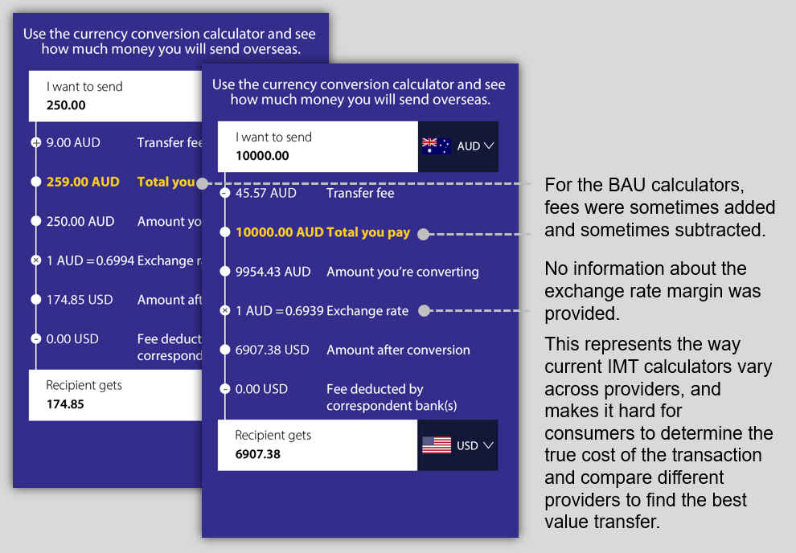
In collaboration with ACCC, BETA therefore designed seven new calculators, which were compared to a ‘business-as-usual’ calculator (BAU). The BAU calculator was based on the way IMT calculators currently vary across providers. For this calculator, fees were sometimes added and sometimes subtracted, and it provided no comparison rate prompt and no information about the FX margin (see Figure 1). The new calculator design changes fell into three overall categories, each addressing one of these three issues.
Figure 1. Example BAU calculators, illustrating the varied fee methodology and exchange rate, and lack of information about the total cost of the transaction to the customer.

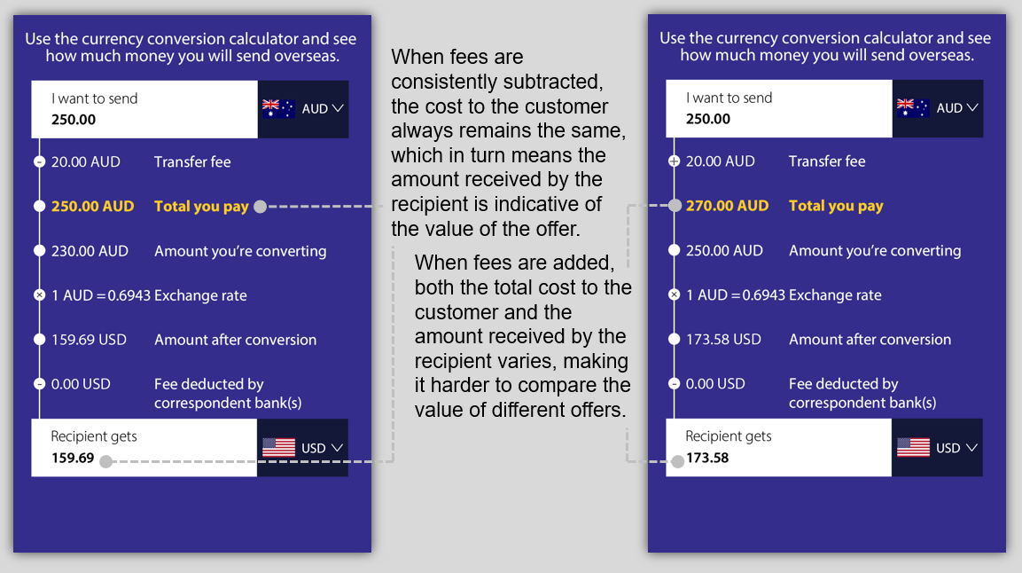
For two of our seven new calculators, we varied whether the transfer fees were either consistently subtracted from or added to the amount sent (Figure 2). For another of our calculators, we added a line indicating the exchange rate margin (Figure 3). As mentioned, this margin indicates the difference between the exchange rate applied by the IMT provider, and the mid-market rate. It allows users to more easily compare value across different calculators and providers.
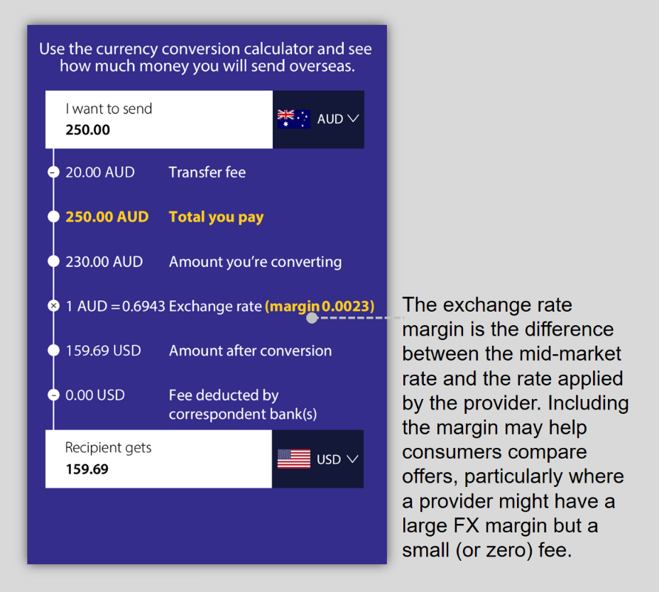
Figure 2. Example ‘fee subtracted’ and ‘fee added’ calculators. Further details are provided in Box 1.
Figure 3. Example FX margin calculator.

For another two calculators, we added a comparison rate prompt at the bottom of the calculator. As mentioned, the comparison rate for the new calculators was the difference between a theoretical no-fee transfer at the mid-market rate, and the proposed transfer with fees and a retail margin on the exchange rate. In these conditions, the fee methodology varied – the fee was sometimes subtracted, and sometimes added. The comparison rate prompt was included at the bottom of the calculator, either as a dollar amount or as a percentage of the entire transaction (Figure 4). As the comparison rate summarises the total cost of the transaction to the consumer, it makes it easier to compare calculators and choose the best value offer.
Finally, we designed two calculators which combined elements described above (Figure 5). The first included both a comparison rate prompt presented in dollar format and the FX margin. We have labelled this calculator the ‘combination’ calculator. The second included both the prompt dollar and the FX margin, and also consistently subtracted fees. We labelled this calculator ‘fee subtracted combination’. The combinations allowed us to test whether some interventions work better in combination, or whether more information can overwhelm people and interfere with their ability to choose the best value offer.
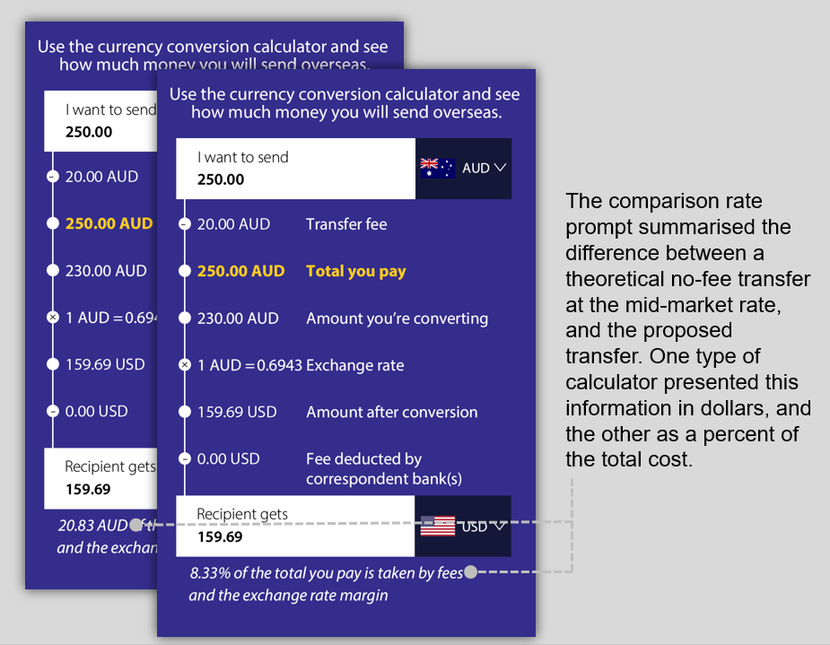
Figure 4. Example calculators including the comparison rate prompts (dollar and percent).

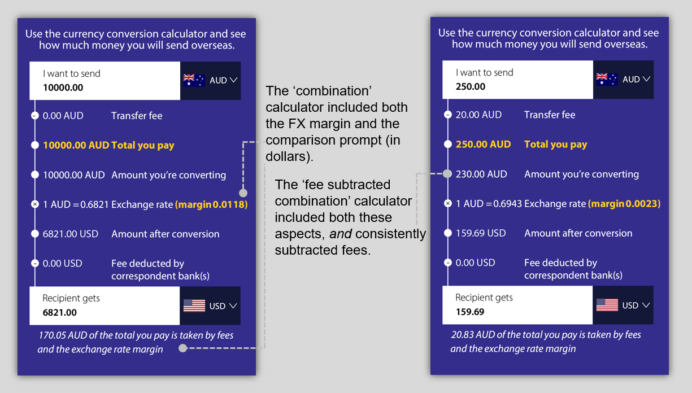
Figure 5. Example ‘combination’ and ‘fee subtracted combination’ calculators.

Survey experiments
We ran survey experiments to test changes to online international money transfer (IMT) calculators. A survey experiment is a type of randomised controlled trial (RCT; see Box 2) which is embedded into an online survey. The purpose of the main survey experiment was to determine which type of IMT calculator allowed consumers to identify the best value offering when comparing calculators. We asked participants in the experiment to view several sets of calculators, and choose the one that provided the best value offer.

Box 2: What is a Randomised Controlled Trial (RCT)?
Well-designed randomised controlled trials are the best available method for determining whether policies, programs or services have a specific intended impact. RCTs work by separating people into two or more groups randomly, in a manner similar to flipping a coin. People in the ‘treatment’ groups are assigned to receive an intervention while people in the ‘control’ group are not. The control group receives either the business as usual experience or nothing. On average, the difference in outcomes between people in the groups reflects the effect caused by the intervention.
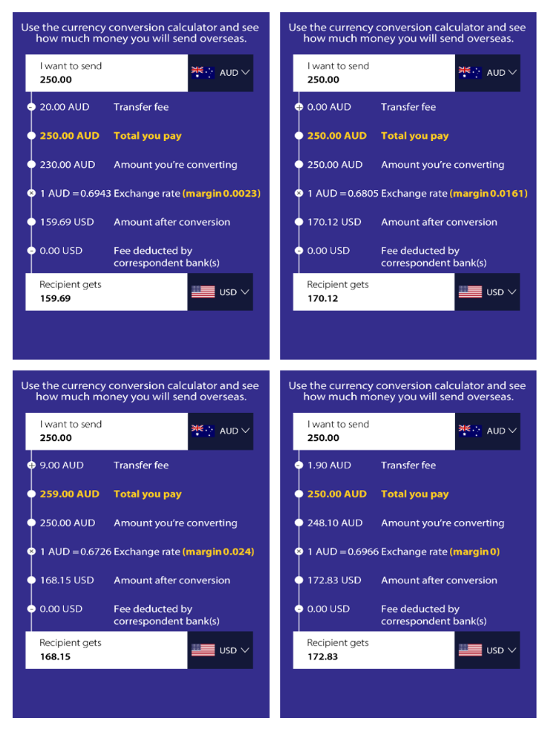
A third-party provider recruited 5,673 Australian adults to participate in the survey experiment. Recruitment was targeted to ensure the sample had an even mix of previous experience using IMTs: One third of our participants had not used IMTs in the past 2 years, one third had used IMTs infrequently, and one third used it frequently. After completing initial demographic questions, survey participants were then randomly assigned to separate groups, and each group completed 5 comparison tasks using one of the 8 types of calculators summarised above (one of 7 new calculators, or ‘business-as-usual’).In each task, participants were shown four calculators of the same type, and asked to select the one that represented the best value (see Figure 6). As there was a correct answer for each task, every participant was given a score out of 5, expressed as a proportion. We then compared the average scores in each group, to determine which calculator type resulted in participants choosing the best offer.
Figure 6. Example set of calculators in the comparison task. Participants were asked to select the calculator that provided the best value offer (or respond ‘don’t know’). This example includes the FX margin and mixed fee methodology. The best offer is provided by the bottom right calculator: for every dollar spent by the sender, the recipient gets $0.69.

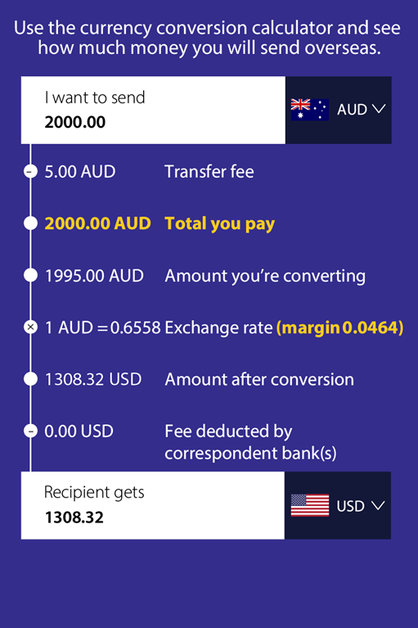
We also ran a secondary survey experiment to assess the impact of the different types of calculators on consumers’ perceptions of value, and their intentions to compare offers across multiple providers. In this secondary survey experiment, we showed participants a single calculator with a hypothetical transfer of $2000 from AUD to USD (Figure 7). The offer that the calculator presented was designed to be very poor value.
Figure 7. The very poor value offer used in the secondary survey experiment. The elements of the calculator (e.g., fee methodology, exchange rate margin, comparison prompt) depended on which group the participant was assigned to.
Participants were asked if they thought that the offer represented good or poor value, and whether they would seek another provider with which to compare. We also asked participants for their confidence in their judgement of value, and which aspects of the calculators participants found useful, and which aspects were confusing. For each of the questions, we compared the groups to determine which type of calculator resulted in the most correct answers, the highest likelihood of comparing offers, and the highest confidence.

What we found

In short…
Consistently subtracting fees increased participants’ ability to choose the best value when comparing offers. This was not affected by whether the calculator also included the FX margin or a comparison prompt. When only a single offer was presented, participants who saw a comparison prompt were able to more accurately identify a poor deal. Based on these findings, subtracting fees and adding a comparison prompt would result in the highest performance both when consumers are considering a single offer, and when they are comparing offers.

Primary outcome: comparison task
Consistently subtracting fees made the comparison task easy.
Participants were asked to complete 5 comparison tasks, each with 4 calculators (see Figure 6). They were asked to select the calculator that represented the best value in each task, and were given a score out of 5. In this section, we present ‘accuracy’ as the percentage of correct answers among the group randomised to see a given calculator.
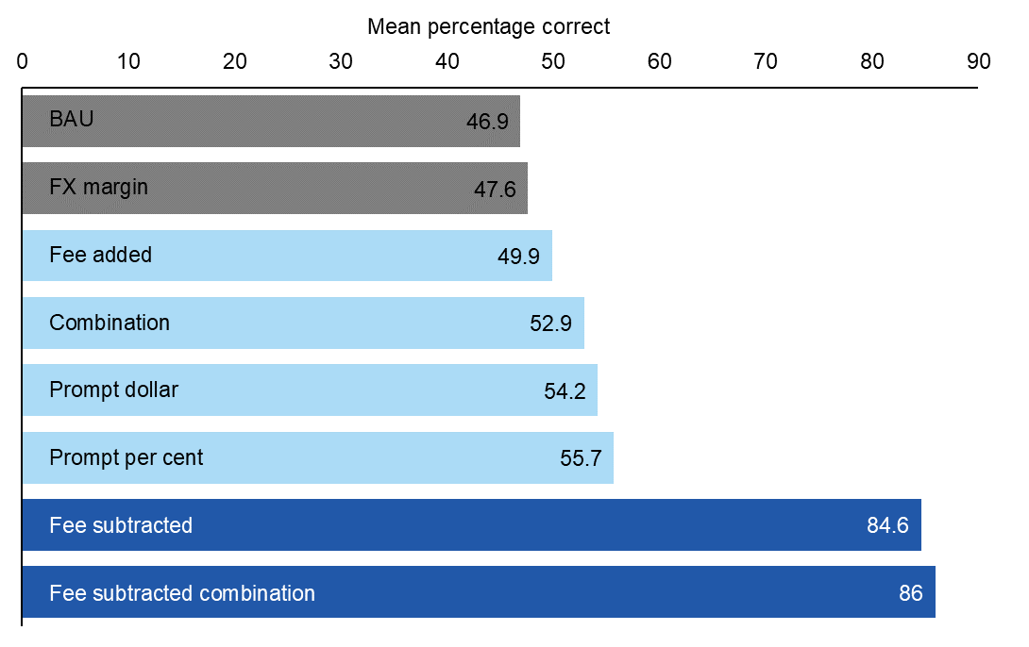
Figure 8. Participants in the ‘fee subtracted’ and ‘fee subtracted combination’ groups were most easily able to select the best value offer in the comparison task.
When asked to select the best deal, the group that saw the business as usual (BAU) calculator had the lowest accuracy of any group (46.9%; Figure 8). In contrast to the BAU group, accuracy was very high among the group that saw calculators with fees consistently subtracted (84.6%). This difference of 37.67 percentage points was statically significant. The accuracy among those who saw calculators with fees consistently added was also higher than the BAU group, however, adding fees did not improve accuracy as much as subtracting fees. Accuracy was also higher in the fee subtracted group when compared to the prompt per cent, prompt dollar, and FX margin groups. All of these comparisons were statistically significant. The only calculator that did not improve accuracy compared to the BAU calculator was the calculator with the FX margin added (47.6% vs 46.9%, which was not statistically significant).
When fees are consistently subtracted, a common heuristic accurately guides people to the best value offer.
To understand how people were interpreting the calculators and making judgments about the offers, we looked more broadly at the pattern of participants’ responses to the comparison task. In all groups, the most frequently selected calculators were those that had the highest amount in the ‘recipient gets’ box. They were likely using the heuristic that ‘the best value offer is the one where the recipient gets the most money.’ Because this heuristic fails to consider the cost of the transaction to the sender, it can lead to incorrect judgments of value (see Box 1 for an example). However, in this study, when fees were consistently subtracted, the best offer calculator (i.e., the correct answer) was the one where the recipient got the highest amount. This helps explain why the fee subtracted groups performed so well: The common heuristic for good value aligned with what is actually good value under those conditions.
Providing prompts also improved accuracy, but combining interventions had no additional impact.
The groups that saw a comparison rate prompt presented as a percentage or as a dollar value were also more accurate than the BAU group. However, there was no difference between presenting the prompt as a percentage or presenting it as a dollar value (54.2% vs 55.7%, not statistically significant). Nor did the combined approaches cause gains in accuracy over-and-above the best performing constituent group: The fee subtracted combination group performed substantially better than the FX margin and the prompt dollar conditions, but only one percentage point better than the group that saw the calculators with only the fee subtracted (no additional prompt or FX margin), and this difference was not statistically significant. Similarly, the group that combined the FX margin and prompt dollar did not outperform the prompt dollar alone (52.9% vs 54.2%, not statistically significant). While the combinations did not increase accuracy, nor did we observe any decreases in accuracy in these groups. This means that while extra information did not improve accuracy, neither did adding this information cause overload.

Secondary outcomes: comparison task
Consistently subtracting fees also made people more confident.
The two groups with fees subtracted both had higher ratings of confidence than other groups. By consistently subtracting fees we increased the proportion of people who rated themselves as ‘very confident’ in their judgements by about 10 percentage points compared to BAU (Figure 9). This confidence appears well calibrated, as these two groups were also the most accurate at selecting the best value offer (see Figure 8).
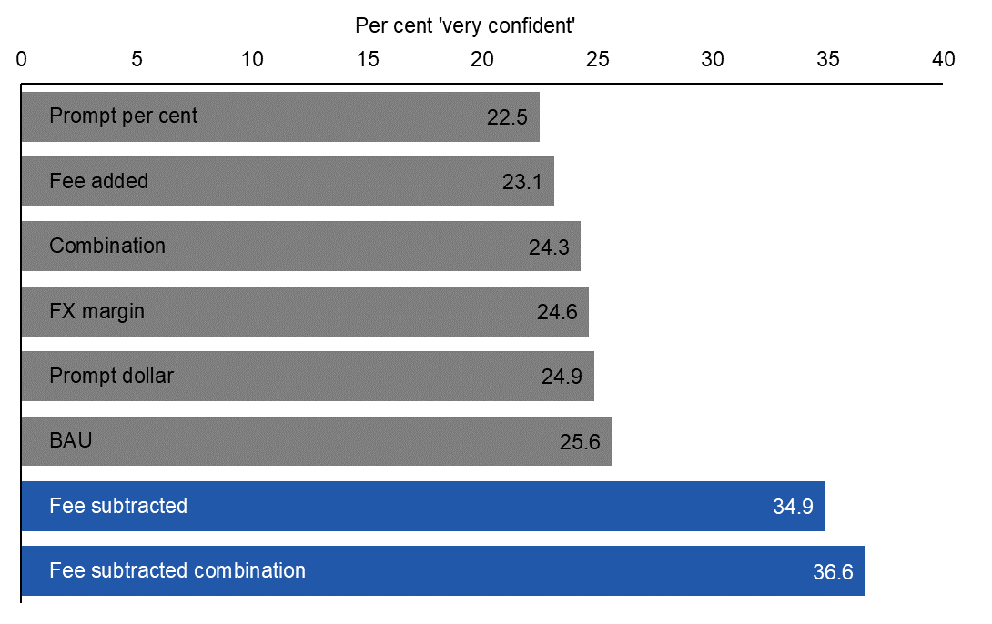
Figure 9. Participants in the ‘fee subtracted’ and ‘fee subtracted combination’ groups were more likely to rate themselves as ‘very confident’ in choosing the best value offer.

Single-judgment task
Results were different in the single-judgment task.
In a secondary survey experiment, we showed participants a single calculator, then asked them whether it represented good value and whether they would search for other providers to compare the offer. The type of calculator they saw (i.e. fee methodology, presence/absence of FX margin) depended on which group they were in, but the ‘correct’ responses were always that the calculator was poor value and that they should seek more information. For this task, all calculators except the fee added and fee subtracted calculators enabled participants to better identify the poor value deal, as compared with BAU (Figure 10). Instead, when judging value from a single calculator, including a prompt caused the biggest improvement in accuracy. All four groups with prompts were the best performing on this measure, including in particular the combination groups (Figure 10).
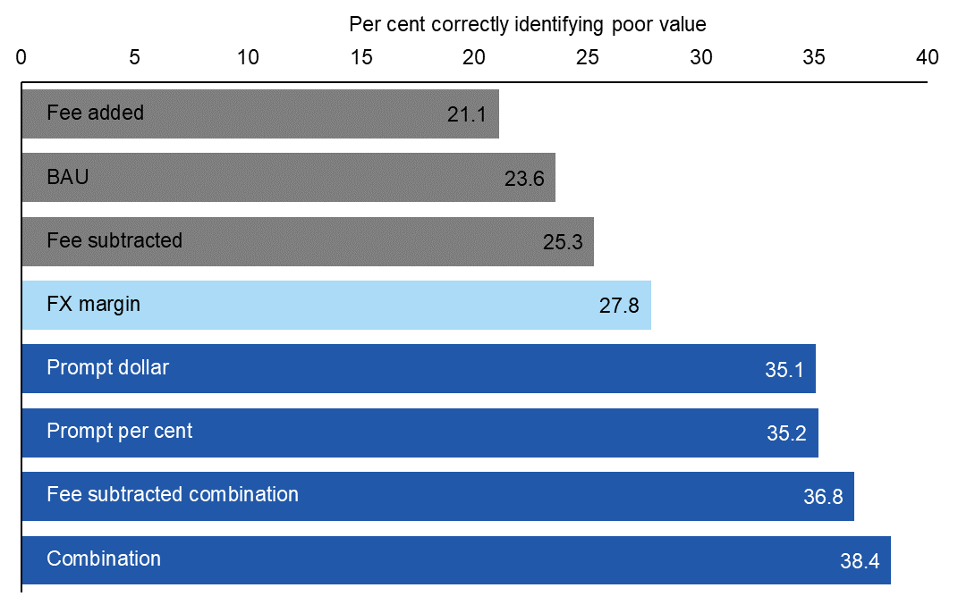
Figure 10. Participants in the combination groups were best able to identify a poor value offer, presented in a single calculator (rather than a comparison task).
However, while these calculators provided more information to participants and increased their accuracy in making a single judgment of poor value, it is important to note that accuracy was still low overall. Judging value in the absence of a comparison was a difficult task for participants, with the highest score being 38.4% overall (i.e., 61.6% incorrect or don’t know responses).
Adding fees can give an illusion of clarity.
People in the fee added group were the least likely to say they would compare the offer with another (Figure 11). While the percentage of respondents in the fee added group who said they would compare the offer is still high (73.3%), it is 6.26 percentage points lower than those in the BAU group (79.50%). In their earlier research, ACCC found that roughly one third of people preferred fees added as they felt it was clearer. However, the performance of this group when comparing calculators indicates that even though some felt it was clearer, adding fees didn’t actually help people choose the best value offer in a single judgment task (see Figure 10), and only lead to a small improvement in the comparison task (Figure 8).
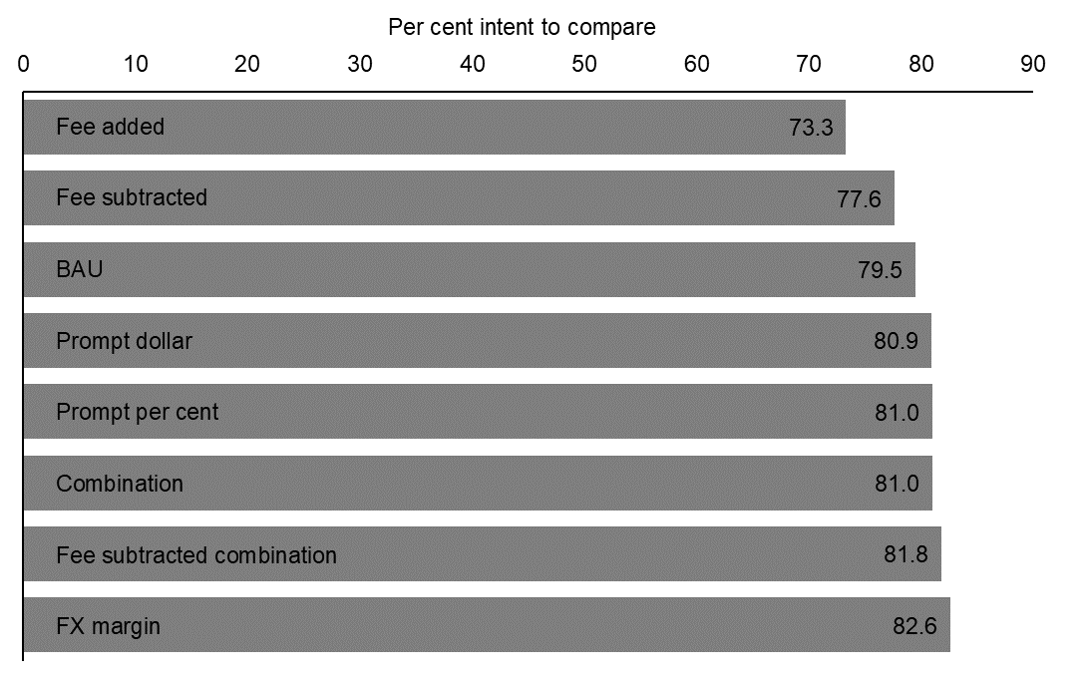
Figure 11. People in the fee added group were least likely to say they would compare offers.

User experience findings
Participants generally found key information helpful, and technical information confusing.
After the experiment, we showed participants a single calculator from the previous comparison task and asked them to click on areas that were helpful and areas that were confusing when making comparisons. Overall, people tended to indicate that they found key information helpful. For example, in the fee added, BAU, and FX margin groups participants needed to use the ‘Total you pay’ field and ‘Recipient gets’ box to pick the best value calculator. In all of these groups the two most endorsed fields were ‘Total you pay’ and ‘Recipient gets’. Participants who were highly accurate on the comparison task (scoring 4 or 5 out of 5) were particularly likely to select these areas as helpful, indicating that they were paying attention to the regions on the calculator most predictive of value. By contrast, people who scored 3 or fewer correct were more likely to overlook critical information in favour of fields such as fees and exchange rates.
Information such as the FX margin was often confusing overall as well: the FX margin information was most frequently rated as confusing in all three groups in which it appeared, which may explain why the FX margin group did not perform better than BAU on the comparison tasks. Finally, the comparison prompts were polarising for participants: In the prompt per cent and prompt dollar groups, the prompt messages were frequently rated as confusing, whereas in the combination groups they were often rated as helpful.

Box 3: Spotlight on frequent users of IMTs
We did not see overall better performance on the comparison tasks for frequent users of IMTs. We can use the responses to the user experience item to explore how frequent users of IMTs interacted with the task.
In most groups that had a comparison prompt, people who were frequent users of IMTs were less likely to rate that information as useful – but overlooking this key information in fact makes it harder to accurately compare offers. In these groups, frequent users of IMTs were more likely to rate sections such as the exchange rate or transfer fees as useful. These sections do not allow you to directly compare calculators. Compared to infrequent or non-users of IMTs, frequent users were also less likely to endorse the ‘recipient gets’ box as useful in many groups. This is a key field to make direct comparisons between calculators, although it was often insufficient on its own.
Overall, it appears that frequent users of IMTs may have been slower to shift their strategies to incorporate new information such as the comparison prompts and total costs.

Discussion and conclusion
Some aspects of IMT calculators are more impactful than others in helping consumers choose the best value offer.
Consistently subtracting fees made it easy to compare offers and choose the best deal. When fees are consistently subtracted, the cost to the customer remains the same across providers and people can therefore rely on the amount received by the recipient – a common heuristic – to accurately guide them to the highest value offer. Consistently subtracting fees also made people more confident in their choices. Providing ‘comparison rate prompts’ also improved people’s ability to choose the best deal. These prompts summarised the total cost of the transaction as a dollar value or per cent. We found no evidence of ‘cognitive overload’ or other downsides when combining elements in a single calculator; e.g. adding prompts, FX margins, and consistently subtracting fees.
Identifying a poor value offer is hard without making comparisons.
In the secondary survey experiment, we showed participants a calculator providing a poor value offer, and asked them to judge its value. While the type of calculator they saw (i.e. fee methodology, presence/absence of FX margin) depended on which group they were in, the ‘correct’ responses were always that the calculator was poor value and that they should seek more information. For this task, including a comparison rate prompt caused the biggest improvement in accuracy. However, it is important to note that accuracy was still low overall. Judging value in the absence of a comparison was a difficult task for participants, with only 38.4% correctly rejecting the poor value offer.
Our study also provides insight into how people use the information presented in IMT calculators.
In order to judge the best value offer, consumers have to pay attention to, and use, key information presented on the calculators. After the survey experiment tasks, we asked participants to indicate which parts of the calculators they found most helpful and most confusing. Overall, areas people said were helpful matched the areas that in fact contained the key information (e.g. ‘total you pay’, ‘recipient gets’ areas). This was especially true for participants who were highly accurate (i.e. good at selecting the best value offer). These participants, who scored 4 or 5 out of 5, were more likely to identify the key information in each calculator, regardless of which type of calculator they saw. In contrast, people who scored 3 or fewer correct were more likely to overlook critical information in favour of fields such as fees and exchange rates.
Ongoing testing will help shed light on how IMT calculators perform in the real world.
Our approach allowed us to test many different calculators in challenging comparison and judgment tasks, using a randomised controlled trial embedded in a survey with a large Australian sample. We are confident the findings from our studies support updates to online IMT calculators – in particular, subtracting fees and adding a comparison prompt – to improve consumer decision-making when transferring money overseas. However, while participants in our study were asked to choose the best value offer – similarly to the choice they face when making actual transfers – we didn’t test the calculators with real transfers in the real world. As ACCC’s Best Practice Guide is updated and rolled out, IMT providers’ and customers’ experiences are likely to provide useful lessons which could be drawn on in further iterating and improving on the calculator design. Looking further ahead, research in the field – such as partnering with an IMT provider and evaluating the impact of calculators on real choices made by actual consumers – could also be considered to test how the current findings translate to a real-world context.

References
Australian Consumer and Competition Commission (2019) Foreign currency conversion services inquiry: Final report. Published September 2019. Accessed June 2024 from https://www.accc.gov.au/inquiries-and-consultations/finalised-inquiries/foreign-currency-conversion-services-inquiry-2018-19

© Commonwealth of Australia 2024
ISBN 978-1-925365-49-8
Subtracting fees to subtract confusion: Using behavioural insights to improve International Money Transfer Calculators
Copyright Notice
With the exception of the Commonwealth Coat of Arms, this work is licensed under a Creative Commons Attribution 4.0 International license (CC BY 4.0) (https://creativecommons.org/licenses/by/4.0/)
Third party copyright
Wherever a third party holds copyright in this material, the copyright remains with that party. Their permission may be required to use the material. Please contact them directly.
Attribution
This publication should be attributed as follows:
© Commonwealth of Australia, Department of the Prime Minister and Cabinet, Subtracting fees to subtract confusion: Using behavioural insights to improve International Money Transfer Calculators.
Use of the Coat of Arms
The terms under which the Coat of Arms can be used are detailed on the following website: https://pmc.gov.au/cca

Behavioural Economics Team
of the Australian Government
General enquiries beta@pmc.gov.au
Media enquiries media@pmc.gov.au
Find out more behaviouraleconomics.pmc.gov.au

Another 4 suppliers did not charge fees. In all cases, the amount to be transferred was $250 and considered various currencies.
The mid-market rate is the midpoint between the buying price and the selling price for a given currency at a point in time.
See the Technical Appendix for more information on our sample.
They could also select ‘don’t know’. This was coded as an incorrect response. As the rate of ‘don’t know’ responses did not differ across groups, we do not discuss it further in this report.
Within each comparison task the amount to send was always the same, but the fees and exchange rate varied. In the BAU group, and other groups with variable fee methodology, some of the calculators had fees added, and some were subtracted. However, in the fee subtracted and fee subtracted combination groups the fees were always subtracted, and in the fee added group the fees were always added. See technical appendix for full details of the survey experiments.
These differences were statistically significant (p < .001), with sample sizes around 1,400 for each pair-wise comparison. We have a high degree of confidence in these results due to the large effects, large sample size, and small p-value, coupled with a pre-registered design. See the Technical Appendix for information on BETA’s approach to statistical significance, and full statistical tables.
Details from this item are available in the Technical Appendix. The results of these analyses are exploratory, and intended to shed light on possible interpretations of the main findings.

