Subtracting fees to subtract confusion
Technical appendix
June 2024

Contents
Appendix A: Technical details 2
Appendix B: Statistical tables 9
Appendix C: Full survey text 30
References 35

Appendix A: Technical details

Pre-registration, pre-analysis plan, and ethics
The trial was publicly pre-registered on the American Economic Association’s Social Science Registry (AEARCTR-0011462) and on the BETA website. Both registrations were completed after we commenced data collection, but prior to analysing the data. The ethical aspects of the research were reviewed and approved by Macquarie University Low Risk Committee (15504).
The analyses of the RCT data was consistent with the pre-analysis plan. All exploratory analyses are clearly designated. The pre-analysis plan is available on the BETA website.

Population and sampling
The population of interest was adults in Australia who use IMT services. However, we were also interested in the effect of different calculators for a naïve audience. We included a quota to ensure we had approximately even numbers of people who were not users of IMT, who were infrequent users of IMT and who were frequent users of IMTs. To determine level of use, we asked people about their use of IMTs in the previous 2 years. Users who indicated that they had not used IMTs in that time were designated non-users. Those who responded ‘Once’, ‘A few times’ or ‘I don’t know’ to the question of frequency of use in the last two years were designated infrequent users. Those who responded ‘Every couple of months’, ‘Monthly’ or ‘Every week or two’ were designated frequent users.
We also monitored age, gender, state or territory of residence and CALD status. For this project a participant was classified as CALD if they either mainly spoke a language other than English at home, or were born overseas (or both). Askable attempted to recruit participants to keep these characteristics of the sample largely consistent with national demographics from the 2021 Census.
The target sample size was 5,600 (700 per arm). The final sample size was 5,784. We removed 23 people who did not agree to the privacy terms, and a further 88 who dropped out prior to randomisation, leaving a total of 5,673 people who were randomised. The composition of the sample is listed in Table 1. Due to the large sample size, the limitations of Askable’s panel and requirements for IMT use there are significant deviations from the national statistics. Recruitment of men was below the national level, and older people are under-represented. This does not impact the results or interpretation of the RCT, but could have implications for the generalisability of the user experience findings.

Table 1. Sample characteristics
Category | Value | Count (per cent)
Gender | Man or male | 1802 (31.8)
Gender | Woman or female | 3797 (66.9)
Gender | Other | 74 (1.3)
Age | Younger (18 - 39) | 4040 (71.2)
Age | Middle (40 - 59) | 1333 (23.5)
Age | Older (60+) | 295 (5.2)
Location | Victoria | 1657 (29.2)
Location | New South Wales | 1738 (30.6)
Location | Queensland | 1263 (22.3)
Location | Australian Capital Territory | 124 (2.2)
Location | South Australia | 420 (7.4)
Location | Western Australia | 382 (6.7)
Location | Tasmania | 65 (1.1)
Location | Northern Territory | 21 (0.4)
Location | Other | 3 (0.1)
Language | English | 5006 (88.2)
Language | Other | 661 (11.7)
Country of birth | Australia | 3544 (62.5)
Country of birth | Other | 2116 (37.3)
Education | No tertiary education | 2162 (38.1)
Education | Tertiary education | 3511 (61.9)
IMT use | None | 1902 (33.5)
IMT use | Infrequent | 1894 (33.4)
IMT use | Frequent | 1877 (33.1)
Household income | $0 - $24,999 | 216 (3.8)
Household income | $25,000 - $49,999 | 530 (9.3)
Household income | $50,000 - $99,999 | 1546 (27.3)
Household income | $100,000 - $149,999 | 1460 (25.7)
Household income | $150,000 - $249,999 | 1264 (22.3)
Household income | $250,000+ | 426 (7.5)
N = 5,673. Percentages may not add up to 100 due to missing responses

Randomisation
Participants were randomised within the survey using the Qualtrics platform. Participants initially had an equal probability of being assigned to each treatment group, but Qualtrics applied an adjustment (increasing the likelihood of assignment to the group with the lowest sample size) to ensure the group numbers didn’t become too uneven. Following this procedure, the sample size of each group ranged from 704 to 711 participants. The characteristics of the sample in each group are summarised in Table 2.

Sample size and power
We aimed to recruit approximately 700 participants per group. At this sample size we had 95 per cent power to detect an effect size of five percentage points (Cohen’s d ~ 0.18) for our primary outcome. We used a conventional alpha level of 5% with 95% power. These values entailed type I and type II error rates of 5%. We chose these settings because the intervention is low risk and it would be as bad to reject a possible real effect as accept a possibly spurious one.

Table 2. Sample characteristics by treatment group: count (per cent)
Condition | Value | BAU | Fee subtract | Fee added | FX margin | Prompt dollar | Prompt per cent | Combination | Fee subtracted combination
Overall | Number of people | 704 | 711 | 707 | 709 | 711 | 710 | 711 | 710
Gender | Male | 226 (32.1) | 227 (31.9) | 221 (31.3) | 223 (31.5) | 228 (32.1) | 231 (32.5) | 231 (32.5) | 215 (30.3)
Gender | Female | 467 (66.3) | 473 (66.5) | 475 (67.2) | 472 (66.6) | 480 (67.5) | 473 (66.6) | 474 (66.7) | 483 (68)
Gender | Other | 11 (1.6) | 11 (1.5) | 11 (1.6) | 14 (2) | 3 (0.4) | 6 (0.8) | 6 (0.8) | 12 (1.7)
Age | Younger (18-39) | 504 (71.6) | 484 (68.1) | 499 (70.6) | 518 (73.1) | 518 (72.9) | 490 (69) | 508 (71.4) | 519 (73.1)
Age | Middle (40-59) | 166 (23.6) | 186 (26.2) | 167 (23.6) | 161 (22.7) | 160 (22.5) | 181 (25.5) | 160 (22.5) | 152 (21.4)
Age | Older (60+) | 33 (4.7) | 40 (5.6) | 41 (5.8) | 29 (4.1) | 33 (4.6) | 39 (5.5) | 42 (5.9) | 38 (5.4)
Location | Victoria | 210 (29.8) | 201 (28.3) | 197 (27.9) | 207 (29.2) | 212 (29.8) | 216 (30.4) | 212 (29.8) | 202 (28.5)
Location | New South Wales | 211 (30) | 219 (30.8) | 236 (33.4) | 211 (29.8) | 224 (31.5) | 208 (29.3) | 207 (29.1) | 222 (31.3)
Location | Queensland | 144 (20.5) | 177 (24.9) | 149 (21.1) | 164 (23.1) | 153 (21.5) | 164 (23.1) | 157 (22.1) | 155 (21.8)
Location | Australian Capital Territory | 24 (3.4) | 18 (2.5) | 15 (2.1) | 15 (2.1) | 13 (1.8) | 13 (1.8) | 17 (2.4) | 9 (1.3)
Location | South Australia | 54 (7.7) | 51 (7.2) | 48 (6.8) | 52 (7.3) | 59 (8.3) | 55 (7.7) | 48 (6.8) | 53 (7.5)
Location | Western Australia | 49 (7) | 36 (5.1) | 49 (6.9) | 47 (6.6) | 41 (5.8) | 43 (6.1) | 60 (8.4) | 57 (8)
Location | Tasmania | 8 (1.1) | 6 (0.8) | 10 (1.4) | 11 (1.6) | 4 (0.6) | 11 (1.5) | 6 (0.8) | 9 (1.3)
Location | Northern Territory | 2 (0.3) | 3 (0.4) | 2 (0.3) | 2 (0.3) | 5 (0.7) | 0 | 4 (0.6) | 3 (0.4)
Location | Other | 2 (0.3) | 0 | 1 (0.1) | 0 | 0 | 0 | 0 | 0
Language | English | 612 (86.9) | 628 (88.3) | 624 (88.3) | 645 (91) | 610 (85.8) | 631 (88.9) | 633 (89) | 623 (87.7)
Language | Other | 90 (12.8) | 83 (11.7) | 82 (11.6) | 63 (8.9) | 100 (14.1) | 78 (11) | 78 (11) | 87 (12.3)
Country of birth | Australia | 437 (62.1) | 460 (64.7) | 437 (61.8) | 442 (62.3) | 437 (61.5) | 439 (61.8) | 456 (64.1) | 436 (61.4)
Country of birth | Other | 266 (37.8) | 249 (35) | 267 (37.8) | 265 (37.4) | 273 (38.4) | 269 (37.9) | 255 (35.9) | 272 (38.3)
Education | No tertiary education | 262 (37.2) | 290 (40.8) | 270 (38.2) | 290 (40.9) | 259 (36.4) | 271 (38.2) | 255 (35.9) | 265 (37.3)
Education | Tertiary education | 442 (62.8) | 421 (59.2) | 437 (61.8) | 419 (59.1) | 452 (63.6) | 439 (61.8) | 456 (64.1) | 445 (62.7)
IMT use | None | 250 (35.5) | 252 (35.4) | 216 (30.6) | 241 (34) | 236 (33.2) | 236 (33.2) | 247 (34.7) | 224 (31.5)
IMT use | Infrequent | 228 (32.4) | 218 (30.7) | 254 (35.9) | 232 (32.7) | 230 (32.3) | 264 (37.2) | 236 (33.2) | 232 (32.7)
IMT use | Frequent | 226 (32.1) | 241 (33.9) | 237 (33.5) | 236 (33.3) | 245 (34.5) | 210 (29.6) | 228 (32.1) | 254 (35.8)
Household income | $0 - $24,999 | 29 (4.1) | 24 (3.4) | 38 (5.4) | 20 (2.8) | 25 (3.5) | 29 (4.1) | 33 (4.6) | 18 (2.5)
Household income | $25,000 - $49,999 | 71 (10.1) | 74 (10.4) | 67 (9.5) | 61 (8.6) | 76 (10.7) | 63 (8.9) | 57 (8) | 61 (8.6)
Household income | $50,000 - $99,999 | 185 (26.3) | 203 (28.6) | 193 (27.3) | 204 (28.8) | 168 (23.6) | 210 (29.6) | 178 (25) | 205 (28.9)
Household income | $100,000 - $149,999 | 177 (25.1) | 172 (24.2) | 174 (24.6) | 185 (26.1) | 199 (28) | 162 (22.8) | 202 (28.4) | 189 (26.6)
Household income | $150,000 - $249,999 | 155 (22) | 161 (22.6) | 144 (20.4) | 164 (23.1) | 165 (23.2) | 155 (21.8) | 160 (22.5) | 160 (22.5)
Household income | $250,000+ | 54 (7.7) | 43 (6) | 65 (9.2) | 48 (6.8) | 49 (6.9) | 56 (7.9) | 56 (7.9) | 55 (7.7)
N = 5673. Percentages may not add up to 100 due to missing responses

Outcome measures

Primary outcome
At an individual level, the primary outcome was the proportion of correct responses given across the five comparison tasks. A correct response occurred when the participant selected the ‘best deal’ out of the four IMT calculators presented in a task.
The ‘best deal’ was defined by the calculator that represents the highest ratio of converted dollars to total cost. For example a calculator that delivers 6907.38USD at a cost of 10,000.00AUD has a ratio of 0.69074. This is better value than one that delivers 6925.00USD at a cost of 10,045.00AUD with a ratio of 0.6894.
Individual level outcomes were averaged within treatment groups, to give the average proportion of correct responses by group.

Secondary outcomes
For our comparison experiment we includes a ‘don’t know’ response option for each comparison task. When calculating our primary outcome, ‘don’t know’ responses were treated as a wrong answer. However, we also assessed ‘don’t know’ responses by treatment group, presenting this data as a proportion.
We measured confidence using a single survey item after the experiment. Participants were asked to rate how confident they were that they could pick the calculator with the best value. It was measured with a three-level single-sided response frame (not at all confident; somewhat confident; very confident). We examined the distribution of individuals answering each of the three categories across treatment groups.
Our secondary judgement experiment had two outcomes based on two separate survey items. The first measured the proportion of individuals that were likely to seek more information, and the second the proportion that identified that the presented calculator was poor value. These proportions were compared across treatment groups.

Hypotheses
In this trial we had 12 pre-specified primary hypotheses. We reported the results relevant to all these hypotheses in the main report, and the full regression outputs are in Tables 3-14 in Appendix 2: Statistical Tables.

Hypotheses 1 to 7 (treatment/BAU group comparisons)
The 7 individual treatments (fee subtracted, fee added, prompt per cent, prompt dollar, FX margin, combination, and Fee subtracted combination) will increase the proportion of correct responses relative to the BAU group (Treatment > BAU).

Hypotheses 8 and 9 (treatment category comparisons)
Our next two hypotheses compared the two interventions that comprise the fee methodology and comparison rate prompt categories:
H8. The fee subtracted group will be superior to the fee added group. This is a one tail test as we expect subtracting fees will be easier for participants to compare, since out of pocket cost is consistent (Fee subtracted > Fee added).
H9. We had no specific hypotheses about which of the two comparison rate prompt interventions will be superior, so we specified a two tailed test (prompt per cent ≠ prompt dollar).

Hypotheses 10 to 12 (conjunction tests)
In the next three hypotheses, we used conjunction testing to test hypotheses that comprise multiple tests. In these cases we rejected the null for the joint hypothesis if we rejected the null for all constituent hypotheses. As this procedure does not inflate Type I error we did not correct for multiple comparisons.
H10. The fee subtracted intervention will be the best performing individual intervention in the trial. (Fee subtracted > Fee added AND prompt per cent AND prompt dollar AND FX margin).
H11. FX margin and prompt dollar (Combination) delivered as a single intervention will outperform both the individual constituent interventions (Combination > FX margin AND prompt dollar).
H12. FX margin, prompt dollar and fee subtracted (Fee subtracted combination) delivered together will outperform the three individual constituent interventions (Fee subtracted combination > FX margin AND prompt dollar AND fee subtracted.

Method of analysis
We cleaned and analysed the data using R 4.2.2 (R Core Team, 2022). As we collected data we did regular checks on quotas, assessments for bots, and checks for randomisation or other errors. We did not analyse the data until after collection was complete.
Consistent with the analysis plan, we used ordinary least squares regression with HC2 robust standard errors. We included two covariates – tertiary education and frequency of IMT use. Tertiary education was a binary flag that was mean-centred. IMT use was a three-level factor. No IMT use was the reference group and the dummy variables for infrequent and frequent use were mean-centred. The treatment group was entered into the model as a vector of treatment indicators. Summaries of all pre-specified analyses are included in Appendix B.

Appendix B: Statistical tables

RCT 1: primary outcome
For the main experiment we asked participants to compare four calculators and select the one that represented the best value. The outcome for this trial is the mean proportion correct for each group. Tables 3-8 are regression tables for each of our main 12 hypotheses.

Table 3. Hypotheses 1-7: Each treatment group will have a higher percentage correct than the BAU group
Condition | Means (per cent) | Estimate (pp) | Standard error (pp) | 95% Confidence Interval (pp) | p-value
BAU | 46.90 | n/a | n/a | n/a | n/a
Fee subtracted | 84.60 | 37.67 | 1.22 | (35.67 – Inf) | 0.00
Prompt dollar | 54.20 | 7.25 | 1.23 | (5.23 – Inf) | 0.00
FX margin | 47.60 | 0.69 | 1.14 | (-1.18 – Inf) | 0.27
Fee subtracted combination | 86.00 | 39.08 | 1.18 | (37.14 – Inf) | 0.00
Prompt per cent | 55.70 | 8.82 | 1.24 | (6.78 – Inf) | 0.00
Fee added | 49.90 | 2.98 | 1.21 | (0.99 – Inf) | 0.01
Combination | 52.90 | 5.95 | 1.22 | (3.94 – Inf) | 0.00
OLS model adjusted for tertiary education and IMT use with HC2 robust standard errors. N = 5,673

Table 4. Hypothesis 8: The fee subtracted group will have a higher percentage correct than the fee added group
Condition | Means (per cent) | Estimate (pp) | Standard error (pp) | 95% Confidence Interval (pp) | p-value
Fee added | 49.90 | n/a | n/a | n/a | n/a
Fee subtracted | 84.60 | 34.69 | 1.33 | (32.51 – Inf) | 0.00
OLS model adjusted for tertiary education and IMT use with HC2 robust standard errors. N = 5,673. This model contained all treatment groups. Only relevant groups are reported.

Table 5. Hypothesis 9: There will be a difference in percentage correct responses between the prompt in dollars and the prompt as a percentage.
Condition | Means (per cent) | Estimate (pp) | Standard error (pp) | 95% Confidence Interval (pp) | p-value
Prompt per cent | 55.70 | n/a | n/a | n/a | n/a
Prompt dollar | 54.20 | -1.57 | 1.37 | (-4.25 - 1.11) | 0.25
OLS model adjusted for tertiary education and IMT use with HC2 robust standard errors. N = 5,673. This model contained all treatment groups. Only relevant groups are reported.

For each of the conjunction tests (Tables 6-8) we report only the p-value of each constituent test. This is the comparison between the hypothesised superior condition and its comparison groups. A p-value of less than 0.05 means that we have rejected the null hypothesis. We only rejected the joint hypothesis if all constituent hypotheses are statistically significant.

Table 6. Hypothesis 10: The fee subtracted group will have a higher percentage correct than the fee added group, the prompt groups and the FX margin group.
Condition | p-value
Fee added | 0.00
Prompt per cent | 0.00
Prompt dollar | 0.00
FX margin | 0.00
OLS models adjusted for tertiary education and IMT use with HC2 robust standard errors. N = 5,673

Table 7. Hypothesis 11: The combination group will have a higher percentage correct than the FX margin group and the prompt dollar group
Condition | p-value
FX margin | 0.00
Prompt dollar | 0.83
OLS models adjusted for tertiary education and IMT use with HC2 robust standard errors. N = 5,673

Table 8. Hypothesis 12: The fee subtracted group will have a higher percentage correct than the FX margin group, the prompt dollar group and the fee subtracted group.
Condition | p-value
FX margin | 0.00
Prompt dollar | 0.00
Fee subtracted | 0.14
OLS models adjusted for tertiary education and IMT use with HC2 robust standard errors. N = 5,673

RCT 1: secondary outcomes
We tested the proportion of ‘don’t know’ responses using a one-sided test to determine if the treatments reduced uncertainty for participants (Table 9). The combination conditions had lower proportions of ‘don’t know’ responses, but these levels are low across all groups and therefore this is not likely to influence recommendations for implementation.

Table 9. Proportion of ‘don’t know’ responses by arm
Condition | Means (per cent) | Estimate (pp) | Standard error (pp) | 95% Confidence Interval (pp) | p-value
BAU | 2.00 | n/a | n/a | n/a | n/a
Fee subtracted | 1.50 | -0.52 | 0.53 | (-Inf – 0.36) | 0.17
Prompt dollar | 1.80 | -0.23 | 0.55 | (-Inf – 0.68) | 0.34
Fx margin | 1.60 | -0.43 | 0.53 | (-Inf – 0.44) | 0.21
Fee subtracted combination | 0.90 | -1.11 | 0.47 | (-Inf – -0.33) | 0.01
Prompt per cent | 1.80 | -0.23 | 0.57 | (-Inf – 0.7) | 0.34
Fee added | 1.90 | -0.10 | 0.56 | (-Inf – 0.82) | 0.43
Combination 2 | 1.10 | -0.91 | 0.49 | (-Inf – -0.11) | 0.03
OLS model adjusted for tertiary education and IMT use with HC2 robust standard errors. N = 5,673

Table 10. Confidence in rating (numeric scale 0 - 2)
Condition | Mean confidence | Estimate | Standard error | 95% Confidence Interval | p-value
BAU | 1.15 | n/a | n/a | n/a | n/a
Fee subtracted | 1.29 | 0.14 | 0.03 | (0.09 – Inf) | 0.00
Prompt dollar | 1.13 | -0.02 | 0.03 | (-0.07 – Inf) | 0.78
FX margin | 1.15 | 0.00 | 0.03 | (-0.05 – Inf) | 0.52
Fee subtracted combination | 1.30 | 0.15 | 0.03 | (0.1 – Inf) | 0.00
Prompt per cent | 1.13 | -0.02 | 0.03 | (-0.07 – Inf) | 0.76
Fee added | 1.11 | -0.04 | 0.03 | (-0.09 – Inf) | 0.92
Combination 2 | 1.13 | -0.02 | 0.03 | (-0.07 – Inf) | 0.73
OLS model adjusted for tertiary education and IMT use with HC2 robust standard errors. N = 5,673

RCT 2: outcomes
The second RCT was an experiment aimed at assessing judgements of value (Tables 11 and 12) and behavioural intention to compare (Tables 13 and 14) based on the presentation of a single calculator.

Table 11. Proportion who correctly identified the poor value offering
Condition | Mean correct (per cent) | Estimate (pp) | Standard error (pp) | 95% Confidence Interval (pp) | p-value
BAU | 23.60 | n/a | n/a | n/a | n/a
Fee subtracted | 25.30 | 1.69 | 2.29 | (-2.08 – Inf) | 0.23
Prompt dollar | 35.10 | 11.47 | 2.41 | (7.5 – Inf) | 0.00
FX margin | 27.80 | 4.16 | 2.33 | (0.33 – Inf) | 0.04
Fee subtracted combination | 36.80 | 13.20 | 2.42 | (9.21 – Inf) | 0.00
Prompt per cent | 35.20 | 11.53 | 2.42 | (7.54 – Inf) | 0.00
Fee added | 21.10 | -2.57 | 2.23 | (-6.24 – Inf) | 0.88
Combination 2 | 38.40 | 14.75 | 2.44 | (10.74 – Inf) | 0.00
OLS model adjusted for tertiary education and IMT use with HC2 robust standard errors. N = 5,673

There were some small differences in the proportions of respondents who answered “don’t know” to the question on whether the single calculator presented poor value (Table 12). Overall, the fee subtracted and combination conditions slightly reduced uncertainty. However, there is little consistency to these results and they could be the result of chance.

Table 12. Proportion who responded ‘don’t know’ to the poor value offering
Condition | Means (per cent) | Estimate (pp) | Standard error (pp) | 95% Confidence Interval (pp) | p-value
BAU | 28.80 | n/a | n/a | n/a | n/a
Fee subtracted | 24.60 | -4.26 | 2.35 | (-Inf – -0.4) | 0.04
Prompt dollar | 25.30 | -3.52 | 2.34 | (-Inf – 0.32) | 0.07
Fx margin | 26.30 | -2.51 | 2.36 | (-Inf – 1.37) | 0.14
Fee subtracted combination | 24.80 | -3.96 | 2.35 | (-Inf – -0.1) | 0.05
Prompt per cent | 26.50 | -2.29 | 2.36 | (-Inf – 1.59) | 0.16
Fee added | 25.00 | -3.86 | 2.35 | (-Inf – 0) | 0.05
Combination 2 | 23.20 | -5.62 | 2.30 | (-Inf – -1.84) | 0.01
OLS model adjusted for tertiary education and IMT use with HC2 robust standard errors. N = 5,673

Table 13. Proportion who reported that they would seek to compare
Condition | Means (per cent) | Estimate (pp) | Standard error (pp) | 95% Confidence Interval (pp) | p-value
BAU | 79.50 | n/a | n/a | n/a | n/a
Fee subtracted | 77.60 | -1.94 | 2.17 | (-5.51 – Inf) | 0.81
Prompt dollar | 80.90 | 1.37 | 2.13 | (-2.12 – Inf) | 0.26
FX margin | 82.60 | 3.13 | 2.08 | (-0.29 – Inf) | 0.07
Fee subtracted combination | 81.80 | 2.32 | 2.10 | (-1.14 – Inf) | 0.14
Prompt per cent | 81.00 | 1.47 | 2.12 | (-2.02 – Inf) | 0.24
Fee added | 73.30 | -6.26 | 2.25 | (-9.97 – Inf) | 1.00
Combination 2 | 81.00 | 1.44 | 2.13 | (-2.06 – Inf) | 0.25
OLS model adjusted for tertiary education and IMT use with HC2 robust standard errors. N = 5,673

When asked if they would seek a comparison when presented with a single calculator, there were no differences between treatment groups on the ‘don’t know’ responses (Table 14).

Table 14. Proportion who responded ‘don’t know’ when asked if they would compare
Condition | Means (per cent) | Estimate (pp) | Standard error (pp) | 95% Confidence Interval (pp) | p-value
BAU | 4.50 | n/a | n/a | n/a | n/a
Fee subtracted | 5.60 | 1.03 | 1.14 | (-Inf – 2.91) | 0.82
Prompt dollar | 5.60 | 1.04 | 1.16 | (-Inf – 2.96) | 0.81
Fx margin | 3.00 | -1.49 | 1.00 | (-Inf – 0.16) | 0.07
Fee subtracted combination | 5.60 | 1.05 | 1.16 | (-Inf – 2.97) | 0.82
Prompt per cent | 5.60 | 1.07 | 1.15 | (-Inf – 2.96) | 0.82
Fee added | 4.90 | 0.35 | 1.12 | (-Inf – 2.19) | 0.62
Combination 2 | 5.40 | 0.87 | 1.15 | (-Inf – 2.76) | 0.78
OLS model adjusted for tertiary education and IMT use with HC2 robust standard errors. N = 5,673

User experience
As part of the ‘user experience’ component of the survey, we asked participants to click on regions of the calculators that they found confusing or helpful. Below we present the results, showing two images for each treatment arm: one summarising the percentage of participants that found a region confusing, and a second summarising the percentage of participants who found it helpful. We have colour-coded regions depending on the valence (green for helpful, pink for confusing) and the percentage of respondents who clicked on a region. Regions highlighted in grey are those that less than 10% of respondents clicked on. Regions that 11-25% of respondents clicked on were designated very light green or very light pink. Regions that 26-50% of respondents clicked on were designated light green or light pink and regions that more than 50% of respondents clicked on where in dark green or dark pink. Information the Figures is also replicated in the Tables immediately afterwards.

BAU (Figure 1 and Table 15)
In this group participants needed to compare both the ‘total you pay’ and ‘recipient gets’ regions to determine which calculator was the best value. Therefore it is not surprising that participants in this group found the ‘total you pay’ (50%) and ‘recipient gets’ (58%) boxes most helpful. Generally people did not find this calculators confusing, but around 14% of respondents rated ‘amount you’re converting’ and ‘correspondent bank fee’ confusing.
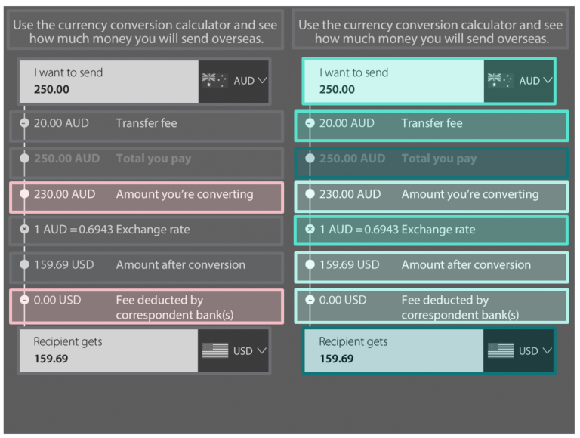

Figure 1. Confusing and helpful regions in the BAU calculator

Table 15. Confusing and helpful regions in the BAU conditions (per cent)
Region | Confusing % | Helpful %
Header | 0.14 | 0.85
Send | 1.56 | 29.97
Recipient gets | 1.85 | 58.10
Total you pay | 5.26 | 50.43
Transfer fee | 6.53 | 35.23
Amount converted | 8.81 | 21.59
Exchange rate | 9.94 | 35.65
Correspondent bank fee | 14.35 | 17.47
Amount you’re converting | 14.49 | 20.60

Fee subtracted (Figure 2 and Table 16)
To compare value in this group respondents needed only to compare the numbers in the ‘recipient gets’ box. Given the very high accuracy in this group, it is not surprising that 63% of people found the ‘recipient gets’ box helpful.
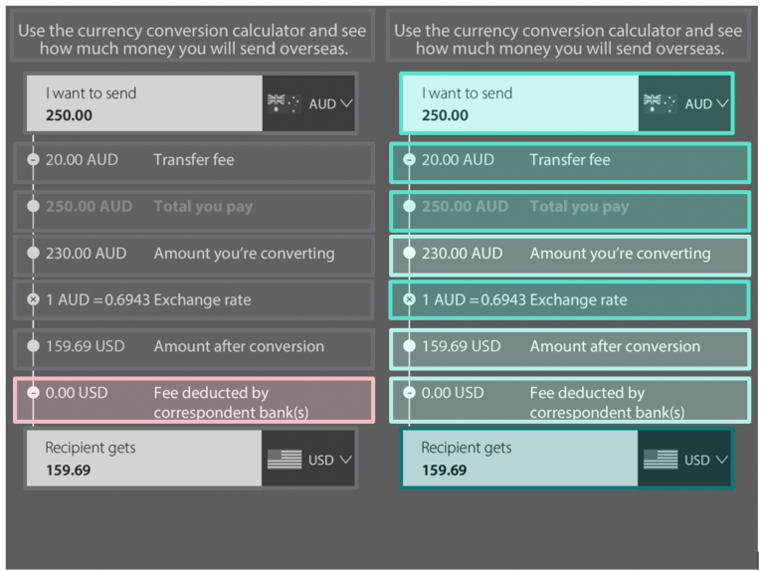

Figure 2. Confusing and helpful regions in the fee subtracted calculators

Table 16. Confusing and helpful regions in the fee subtracted calculators (per cent)
Region | Confusing % | Helpful %
Header | 0.28 | 0.56
Recipient gets | 0.84 | 62.73
Send | 1.27 | 32.35
Transfer fee | 5.20 | 36.57
Amount converted | 6.61 | 23.07
Total you pay | 6.75 | 34.04
Exchange rate | 9.00 | 39.10
Amount you’re converting | 9.70 | 19.97
Correspondent bank fee | 12.10 | 19.83

Fee added (Figure 3 and Table 17)
As with the BAU group, participants in this group needed both the ‘total you pay’ and ‘recipient gets’ regions to compare value. Similar to that group, 53% found the ‘recipient gets’ box helpful and 57% found the ‘total you pay’ region helpful. There were few regions that people found confusing, with low rates across all regions of the calculator.
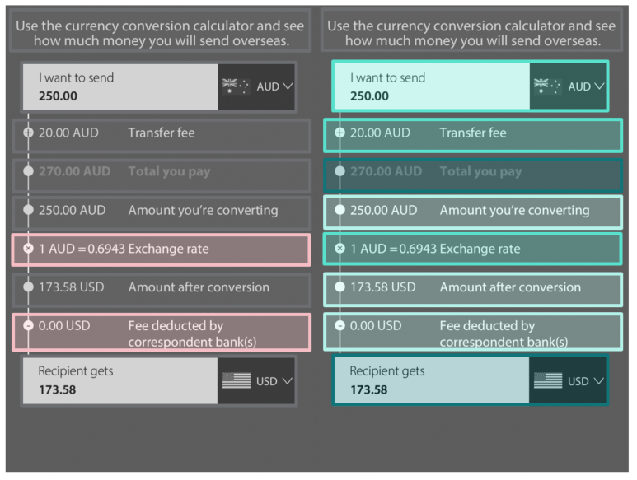

Figure 3. Confusing and helpful regions in the fee added calculators

Table 17. Confusing and helpful regions in the fee added calculators (per cent)
Region | Confusing % | Helpful %
Header | 0.28 | 0.71
Send | 0.99 | 30.55
Recipient gets | 2.83 | 53.47
Transfer fee | 3.25 | 36.63
Total you pay | 4.24 | 56.72
Amount converted | 8.49 | 17.96
Amount you’re converting | 8.49 | 15.28
Correspondent bank fee | 14.29 | 17.96
Exchange rate | 14.99 | 32.67

FX margin (Figure 4 and Table 18)
This group also needed both the ‘total you pay’ and ‘recipient gets’ regions to compare value. The FX margin provided extra information to participants, but could not be used in isolation to compare value. Thirty-one per cent of participants in this group rated the ‘FX margin’ box as confusing. Conversely, only 16% rated it as helpful. As with other groups, 50% of respondents rated the ‘Total you pay’ region as helpful and 59 % rated the ‘Recipient gets’ box as helpful.
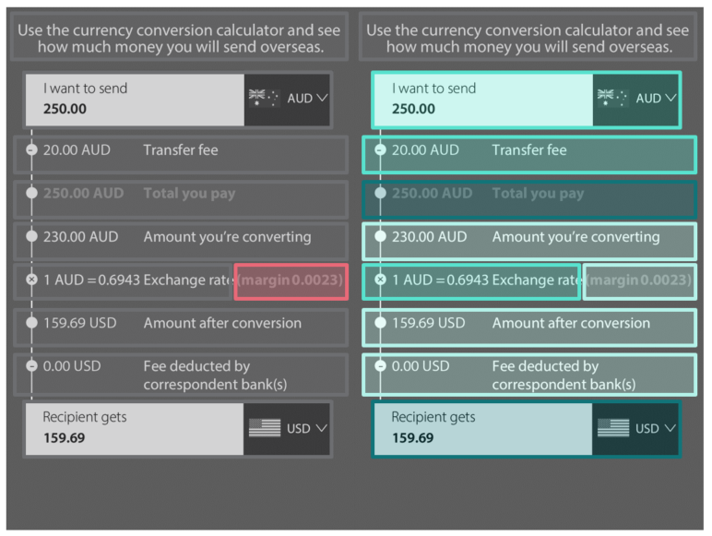

Figure 4. Confusing and helpful regions in the FX margin calculators

Table 18. Confusing and helpful regions in the FX margin calculators (per cent)
Region | Confusing % | Helpful %
Header | 0 | 0.42
Send | 0.99 | 31.31
Recipient gets | 1.55 | 59.24
Transfer fee | 2.26 | 35.68
Total you pay | 3.81 | 50.49
Amount converted | 4.51 | 20.59
Amount you’re converting | 6.49 | 20.31
Correspondent bank fee | 7.62 | 17.35
Exchange rate | 9.31 | 26.09
FX margin | 31.45 | 16.36

Prompt dollar (Figure 5 and Table 19)
In this group participants needed only the prompt to compare value between calculators. Sixteen per cent of respondents rated the dollar prompt as confusing, and 28% rated it as helpful. The most frequently endorsed useful region was the ‘recipient gets’ field (56%) however, in this condition the prompt was the information that would allow participants to select the calculator representing the best value.
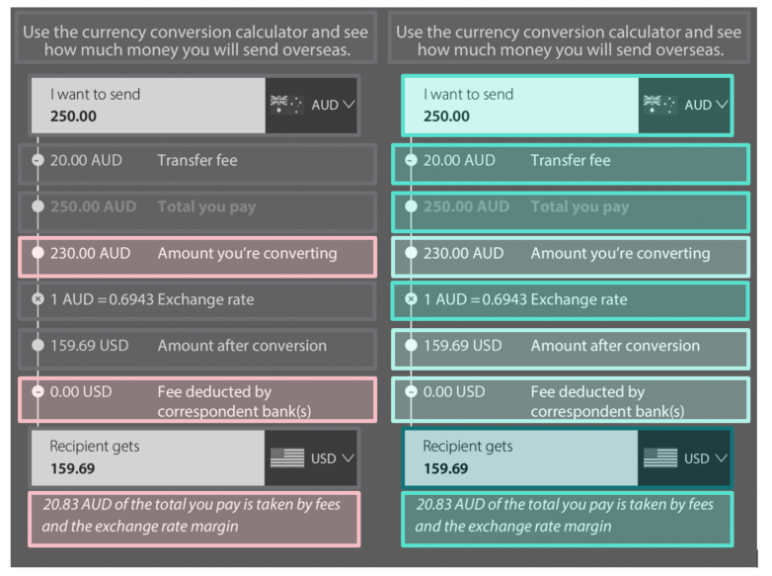

Figure 5. Confusing and helpful regions in the prompt dollar calculators

Table 19. Confusing and helpful regions in the prompt dollar calculators (per cent)
Region | Confusing % | Helpful %
Header | 0.28 | 0.70
Send | 0.84 | 31.22
Recipient gets | 2.67 | 55.98
Transfer fee | 5.06 | 31.50
Total you pay | 5.20 | 48.66
Amount converted | 8.72 | 21.24
Exchange rate | 9.14 | 31.65
Correspondent bank fee | 11.53 | 16.03
Amount you’re converting | 12.66 | 17.30
Dollar prompt | 15.89 | 27.57

Prompt per cent (Figure 6 and Table 20)
As with the dollar prompt, participants in this group needed only the prompt to compare value. This group had similar responses to the prompt dollar arm, with 17% rating the prompt as confusing and 28% rating it as helpful. Again, the ‘recipient gets’ box was the most highly rated with 52% of respondents nominating it helpful.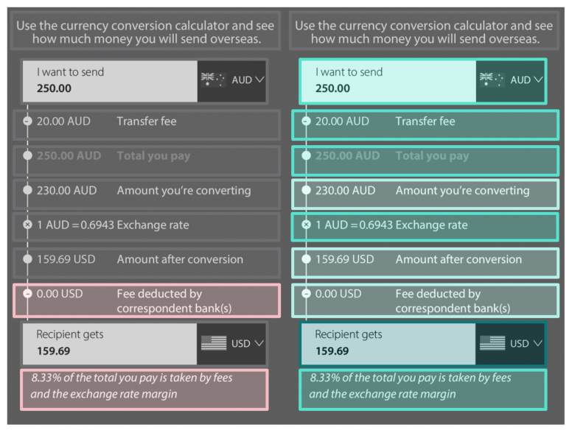

Figure 6. Confusing and helpful regions in the prompt per cent calculators

Table 20. Confusing and helpful regions in the prompt per cent calculators (per cent)
Region | Confusing % | Helpful %
Header | 0.14 | 0.99
Send | 1.69 | 27.18
Recipient gets | 1.83 | 52.25
Total you pay | 4.93 | 43.24
Transfer fee | 5.21 | 29.44
Amount converted | 6.76 | 17.75
Exchange rate | 8.73 | 31.13
Amount you’re converting | 10.00 | 17.46
Correspondent bank fee | 10.42 | 14.37
Per cent prompt | 16.76 | 28.31

Combination (Figure 7 and Table 21)
This group had fees sometimes added and sometimes subtracted so even though this calculator has a lot of information, only the prompt allows for direct comparison between calculators. In this group 28% of respondents found the FX margin confusing. Similarly to the dollar prompt group, about 29% of respondents found the prompt helpful, whereas 57% found the ‘recipient gets’ box helpful.
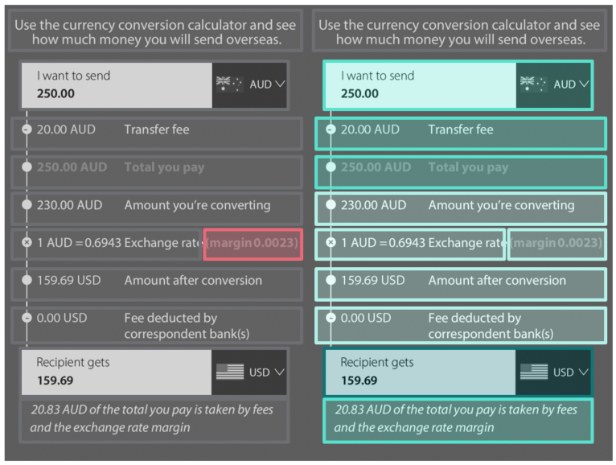

Figure 7. Confusing and helpful regions in the combination calculators

Table 21. Confusing and helpful regions in the combination calculators (per cent)
Region | Confusing % | Helpful %
Header | 0 | 0.56
Send | 0.98 | 27.00
Recipient gets | 1.41 | 56.54
Transfer fee | 3.23 | 27.71
Total you pay | 4.92 | 42.48
Amount converted | 5.34 | 15.61
Correspondent bank fee | 5.91 | 12.38
Amount you’re converting | 7.03 | 15.75
Dollar prompt | 9.00 | 28.97
Exchange rate | 9.42 | 22.64
FX margin | 27.99 | 16.46

Fee subtracted combination (Figure 8 and Table 22)
In this group participants could have used either the ‘recipient gets’ box or the prompt to directly compare calculators to find the one with the best value. Again, the FX margin was the region most frequently rated as confusing (32%). In this group the prompt had a slightly higher rate of endorsement as helpful (35%) as compared with the combination group.
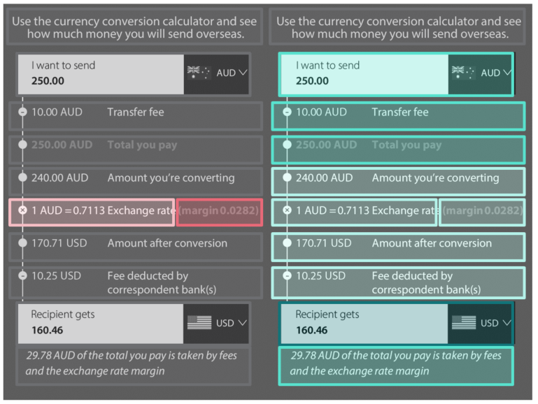

Figure 8. Confusing and helpful regions in the fee subtracted combination calculators

Table 22. Confusing and helpful regions in the fee subtracted combination calculators (per cent)
Region | Confusing % | Helpful %
Send | 0.28 | 31.41
Header | 0.42 | 1.13
Recipient gets | 0.70 | 64.23
Total you pay | 3.38 | 31.41
Transfer fee | 3.94 | 31.13
Amount converted | 4.79 | 20.56
Dollar prompt | 5.49 | 34.51
Correspondent bank fee | 6.34 | 17.04
Amount you’re converting | 6.90 | 17.18
Exchange rate | 10.14 | 24.79
FX margin | 31.55 | 13.10

Subgroup analyses
Initially, we wished to determine whether our subgroups of interest differed overall in their accuracy on the comparison tasks. We found that while frequency of IMT use and CALD status was not associated with accuracy, people with tertiary education were slightly more accurate than those without (Table 23).

Table 23. Accuracy by subgroup
Group | Means (per cent) | Estimate (pp) | Standard error (pp) | 95% Confidence Interval (pp) | p-value
Non-CALD | 46.5 | n/a | n/a | n/a | n/a
CALD | 47.6 | 1 | 2 | (-3 – 4) | 0.74
Not tertiary educated | 44.8 | n/a | n/a | n/a | n/a
Tertiary educated | 48.2 | 4 | 2 | (0 – 7) | 0.03
Frequent IMT use | 46.5 | n/a | n/a | n/a | n/a
Infrequent IMT use | 47.0 | 1 | 2 | (-3 – 4) | 0.75
No IMT use | 47.2 | 1 | 2 | (-2 – 5) | 0.48
However, to assess whether the different calculators affected groups of people differently, we need to evaluate the interaction between the treatment and the group of people. In Tables 24-27 below, we present the results of such interactions. While we did not have power to detect small differences here, there were no statistically significant differences or systematic trends, so we can conclude that there were no differences in the ways in which the calculators affected different groups of people.

Table 24. Subgroups responses to the treatment: CALD respondents compared with non-CALD respondents
Condition | Interaction effect between condition and BAU (95% CI) | p-value
Fee subtracted | 4 (-1 – 9) | 0.13
Prompt dollar | -1 (-6 – 5) | 0.80
FX margin | 3 (-2 – 8) | 0.24
Fee subtracted combination | 2 (-3 – 7) | 0.40
Prompt per cent | 0 (-6 – 5) | 0.96
Fee added | 2 (-3 – 8) | 0.41
Combination | -4 (-9 – 2) | 0.18

Table 25. Subgroups responses to the treatment: Tertiary educated respondents compared with those without tertiary education
Condition | Interaction effect between condition and BAU (95% CI) | p-value
Fee subtracted | 1 (-4 – 6) | 0.61
Prompt dollar | 0 (-5 – 5) | 0.88
FX margin | 0 (-5 – 4) | 0.89
Fee subtracted combination | 3 (-2 – 8) | 0.29
Prompt per cent | 4 (-1 – 9) | 0.09
Fee added | 0 (-4 – 5) | 0.85
Combination | 2 (-4 – 7) | 0.55

Table 26. Subgroups responses to the treatment: Infrequent IMT users compared with frequent IMT users
Condition | Interaction effect between condition and BAU (95% CI) | p-value
Fee subtracted | 0 (-6 – 6) | 0.99
Prompt dollar | 3 (-3 – 9) | 0.37
FX margin | 0 (-5 – 6) | 0.89
Fee subtracted combination | 0 (-6 – 6) | 0.96
Prompt per cent | 4 (-2 – 10) | 0.19
Fee added | 2 (-4 – 8) | 0.48
Combination | -4 (-9 – 2) | 0.24

Table 27. Subgroups responses to the treatment: IMT non-users compared with frequent IMT users
Condition | Interaction effect between condition and BAU (95% CI) | p-value
Fee subtracted | 2 (-4 – 8) | 0.51
Prompt dollar | 2 (-4 – 8) | 0.55
FX margin | 0 (-6 – 5) | 0.91
Fee subtracted combination | 1 (-5 – 6) | 0.83
Prompt per cent | 4 (-2 – 10) | 0.18
Fee added | 2 (-4 – 8) | 0.42
Combination | 0 (-6 – 6) | 0.99

Appendix C: Full survey text

Consent form
Foreign Exchange Calculator Best Practice Guide
Project title: Foreign Exchange Calculator Best Practice Guide
Who is doing the research and why?
This research project is being conducted by the Behavioural Economics Team of the Australian Government (BETA) in the Department of the Prime Minister and Cabinet, in collaboration with the Australian Competition and Consumer Commission (ACCC).
Your responses in this study will help with the development of the Best Practice Guide by the ACCC. These guidelines will detail the standards of providers of international money transfers.
How long will the study take?
This study will take about 15 minutes to complete, and can be done on a computer, smart phone or tablet.
Are there any risks to participating?
Participating in this study is very unlikely to have any negative consequences for you. This study has been subject to an ethics review and was assessed as ‘low risk’.
What are the benefits to me?
The research may help to improve current foreign exchange calculators to make it clearer to users which providers have the best value for users. You may not directly benefit from this research. You will be compensated for your time. When you complete the survey you will be redirected back to Askable and receive $5.00 for your participation.
What if I don’t want to participate?
Your participation in the study is voluntary, and you can stop at any time. If you stop (by closing the browser or navigating away), the responses you have already provided will be recorded and may be used in subsequent analysis and reporting.
What will happen to my information?
The information you provide will be used to inform the ACCC’s development of the Best Practice Guide. Aggregated results—where your responses will be grouped with the responses of other participants—will be included in a public report. However this report will only include general themes and findings. Information will be de-identified, that is, it won’t talk specifically about you or identify you.
For the same purpose, BETA may provide this de-identified information to relevant Government agencies, academic institutions and other researchers to inform other work on this or related topics. You will not be directly identifiable in any shared data.
Contact details
If you have any further questions about this project, you can contact the BETA research team by emailing beta@pmc.gov.au.
The Department of the Prime Minister and Cabinet’s Privacy Policy explains how we handle and protect the information provided by you. Our Privacy Policy also explains how you can request access to or correct the personal information we hold about you, and who to contact if you have a privacy enquiry or complaint (the Privacy Officer at privacy@pmc.gov.au.)
The ethical aspects of this study have been approved by the Macquarie University Human Research Ethics Committee. If you have any complaints or reservations about any ethical aspect of your participation in this research, you may contact the Committee through the Director, Research Ethics and Integrity (telephone (02) 9850 7854; email ethics@mq.edu.au). Any complaint you make will be treated in confidence and investigated, and you will be informed of the outcome.
If you agree to participate and consent to the collection of your information, please proceed with the survey by clicking ‘I agree’ below. This will start the survey.
- I agree
- I do not agree
[Skip To: End of Survey if participant does not agree]

Demographics/eligibility questions
First, some quick questions about you to see if you are eligible for the study.
How do you describe your gender?
- Man or male
- Woman or female
- Non-binary
- I use a different term (please specify)(_______________________)
- Prefer not to answer
What is your age?
- Under 18
- 18-29
- 30-39
- 40-49
- 50-59
- 60-69
- 70 or older
Which state or territory do you live in?
- Australian Capital Territory
- New South Wales
- Northern Territory
- Queensland
- South Australia
- Tasmania
- Victoria
- Western Australia
- Prefer not to say
Which language do you mainly speak at home?
- English
- Other language
- Prefer not to say
In which country were you born?
- Australia
- Other
- Prefer not to say
Which of the following best describes the highest level of education that you personally have reached?
- Primary school
- Secondary school
- Certificate
- Diploma/Advanced diploma
- Undergraduate degree
- Postgraduate degree/qualification
- Other
Have you used International Money Transfer services in the last two years?
International Money Transfer (IMT) services are where a consumer visits an in-store branch or website to transfer money to an overseas account or for cash pick up. Examples of IMT suppliers include Western Union, Wise and the major banks. It does not include where a consumer purchases goods online and makes a payment, such as through Paypal, Visa or Mastercard.
- Yes
- No
[If participant answered ‘Yes’ to above]
How often have you used IMT services in the last two years?
- Once
- A few times
- Every couple of months
- Monthly
- Every week or two
- I don't know
What is your household annual income from all sources before tax? Please include all wages, salaries, pensions and other income. If you are unsure, your best guess will be fine.
- $0 - $24,999
- $25,000 - $49,999
- $50,000 - $99,999
- $100,000 - $149,999
- $150,000 - $249,999
- $250,000 or more
- Prefer not to say
[If participant under 18 or filled quota]
Thank you for your interest in this study. Unfortunately you are not eligible. Please click next to be taken back to Askable.
---------------------------------------------------------------------------------------------------------------------------

RCT tasks
Thank you for your answers. You are eligible to complete this study.
The next section will present you with a series of questions using mock online calculators for International Money Transfer. These calculators provide information similar to the information you would receive if you were making an actual money transfer, but the information in them is fictional. That is, the exchange rate presented does not match the current exchange rate.
[Participants were randomised to one of eight arms at this point. The questions in the next section (included below) were identical in each arm, but the details of the calculators varied depending on the arm]

Single-calculator judgments of value
Imagine you are intending to send $2000 to your friend in the USA. Your normal provider is not able to process your transaction so you have to search for a new provider. The first provider you see gives you the following estimate in their rate calculator. The next two questions will relate to this offer.
<Participants saw a calculator consistent with the group to which they were randomised>
From looking at this estimate alone would you search for other providers to compare?
- Yes
- No
- I don't know
From looking at this estimate alone do you think the offer presented is good value?
- Yes
- No
- I don't know

Calculator comparison task
On the next screen, you will see four examples of a foreign exchange calculator like the one you just saw.
Again, these calculators provide information similar to the information you would receive if you were making an actual money transfer, but the information in them is fictional. That is, the exchange rate presented does not match the current exchange rate.
Please look at the information provided by the calculators, and select the one that provides the best value for money. In these examples, 'value for money' means the most money transferred overseas at the least cost to you.
We'll ask you to do this comparison five times, displaying different calculators each time.
Please pay careful attention to each comparison! At the end, we have a few additional questions, and you'll be given an opportunity to let us know what you thought about the task.
Please select the option that provides the best value.
<Participants saw four calculators consistent with the group to which they were randomised. There was also an option to select ‘don’t know’. The order of the calculators was randomised. Each participant completed this task 5 times The order of the 5 tasks was also randomised.>
Thank you for completing the comparison tasks. You've almost completed the study!

User experience questions
Now we would like to ask you some questions about your choices. There are no right or wrong answers, please just answer as honestly as you can.
When comparing calculators, how confident are you that you were able to pick the calculator with the best value?
- Not at all confident
- Somewhat confident
- Very confident
Now please look again at the calculator below, and click or tap on areas that were useful or confusing.
- Click/tap once on areas that were useful
- Click/tap twice on areas that were confusing
- To unselect – click/tap three times
Please select at least one area that was useful, and one area that was confusing.
<Participants saw a calculator consistent with the group to which they were randomised>
If you have any other thoughts you would like to share about this study, please write them below.
________________________________________________________________
________________________________________________________________
________________________________________________________________
________________________________________________________________
Thank you for completing this study! Please click next to submit your answers.

References
ACCC (2019a) Foreign currency conversion services inquiry: Final report. ACCC 07/19_1550 [online document], Australian Competition and Consumer Commission, accessed 31 May 2023.
ACCC (2019b) Transparent pricing of foreign currency conversion services. ACCC 12/19_1651 [online document], Australian Competition and Consumer Commission, accessed 31 May 2023.
R Core Team (2022). R: A language and environment for statistical computing. R Foundation for Statistical Computing, Vienna, Austria.

© Commonwealth of Australia 2024
ISBN 978-1-925365-49-8
Subtracting fees to subtract confusion: Using behavioural insights to improve International Money Transfer Calculators – Technical Appendix

Copyright Notice
With the exception of the Commonwealth Coat of Arms, this work is licensed under a Creative Commons Attribution 4.0 International license (CC BY 4.0) (https://creativecommons.org/licenses/by/4.0/)

Third party copyright
Wherever a third party holds copyright in this material, the copyright remains with that party. Their permission may be required to use the material. Please contact them directly.

Attribution
This publication should be attributed as follows: © Commonwealth of Australia, Department of the Prime Minister and Cabinet, Technical Appendix to ‘Subtracting fees to subtract confusion: Using behavioural insights to improve International Money Transfer Calculators’

Use of the Coat of Arms
The terms under which the Coat of Arms can be used are detailed on the following website: https://pmc.gov.au/cca

Behavioural Economics Team
of the Australian Government
General enquiries beta@pmc.gov.au
Media enquiries media@pmc.gov.au
Find out more www.behaviouraleconomics.pmc.gov.au

Subgroup analyses were performed using a linear regression model adjusted for previous education, CALD status and IMT use (when these were not the subject of the subgroup analysis) with HC2 robust standard errors. The difference across levels was tested by interacting an indicator for subgroup membership with an indicator for treatment. The difference and CI are expressed in percentage points.
Participants who selected this option were not eligible to participate and the survey was ended.

