Return to work resources for Managers

First three months
EMAIL SUBJECT: Checking in – How is [EMPLOYEE]’s return going?
EMAIL BODY:
Hi [MANAGER]
I just wanted to check in and see how [EMPLOYEE]’s recovery and return to work is going. Continuing to support [EMPLOYEE] now that s/he’s back can reduce the chance of another absence from work and help make his/her return as sustainable as possible. I encourage you to check in regularly with [EMPLOYEE] to see how s/he is going and what supports s/he may need.
That’s why I’ve set up two monthly-placeholders to chat with [EMPLOYEE]. Feel free to move them around, they’re just meant to be simple reminder prompts.
Thanks
[CASE MANAGER SIGNATURE BLOCK]

After the employee returns: Conversation starter
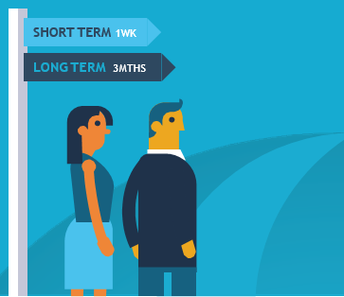
This tool aims to assist you in your conversations with your injured/ill employee.

Within the first week of return
- Be positive: Start out by mentioning that you are happy to have them back.
- Actively listen and flag that the important thing is making sure their return to work is sustainable.
- Mention that you are there to support them in their recovery at work.
- Chat with them about any important information or activities that might have happened while they were away.
- Be careful not to suggest their absence was a big burden on the team.
- Talk about some goals you can set for a sustainable return to work.
- Remind them of the possibility of a gradual return to work.
- Think about how you will measure progress, but acknowledge that it will not necessarily be linear.

Within three months of return
- Stay positive: think about ways that the employee has adapted to their new working arrangements.
- Highlight your commitment to a flexible approach: health and what your employee can do will change over time. Plans and support set up in the first week may not be what they need after a few weeks or months.
- Talk about progress towards sustainable return to work goals.
- Ask whether the workplace accommodations and suitable duties arrangements have been helpful.

