Return to work resources for Managers

On return / first week
EMAIL SUBJECT: Thanks for helping [EMPLOYEE] return to work
EMAIL BODY:
Hi [MANAGER]
Thanks for helping [EMPLOYEE] return to work.
I encourage you to continue working with [EMPLOYEE] to support him/her return to work. This includes reviewing his/her return to work plan. As [EMPLOYEE]’s health and circumstances improve, what he/she can do will also change, so the early plans you’ve made may not be what he/she needs after a few weeks or months back at work.
To have a good conversation about this, here’s a
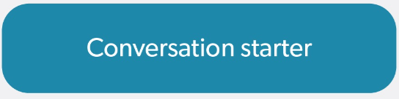
And, in case you haven’t seen it, here is a suitable duties fact sheet
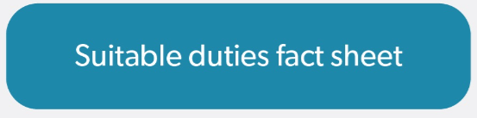
I’m here to help you make [EMPLOYEE]’s recovery and return to work as stable and sustainable as it can be.
If you would like any further support or have any questions please don’t hesitate to contact me.
Kind regards
[CASE MANAGER SIGNATURE BLOCK]

After the employee returns: Conversation starter
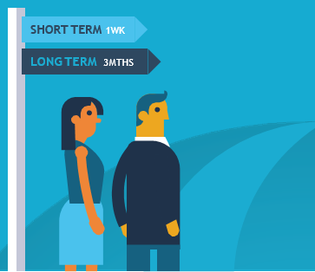
This tool aims to assist you in your conversations with your injured/ill employee.

Within the first week of return
- Be positive: Start out by mentioning that you are happy to have them back.
- Actively listen and flag that the important thing is making sure their return to work is sustainable.
- Mention that you are there to support them in their recovery at work.
- Chat with them about any important information or activities that might have happened while they were away.
- Be careful not to suggest their absence was a big burden on the team.
- Talk about some goals you can set for a sustainable return to work.
- Remind them of the possibility of a gradual return to work.
- Think about how you will measure progress, but acknowledge that it will not necessarily be linear.

Within three months of return
- Stay positive: think about ways that the employee has adapted to their new working arrangements.
- Highlight your commitment to a flexible approach: health and what your employee can do will change over time. Plans and support set up in the first week may not be what they need after a few weeks or months.
- Talk about progress towards sustainable return to work goals.
- Ask whether the workplace accommodations and suitable duties arrangements have been helpful.

Suitable duties and reasonable adjustments
This short guide helps you get the best from your employee returning from an injury/illness.

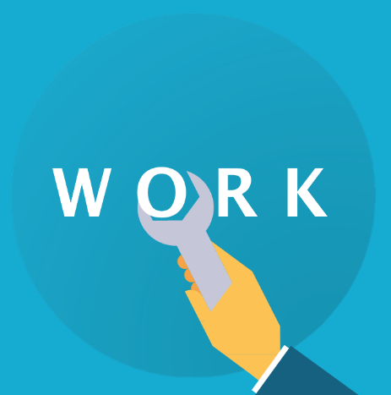
What are suitable duties and reasonable adjustments?
Suitable duties and reasonable adjustments are any changes to a job/workplace that help your returning employee contribute to your team as much as they can following an injury/illness. This could include:
- Changes to work methods – e.g. temporary or permanent task reallocation within your team, new training opportunities and additional support like mentoring.
- Changes to work arrangements – e.g. temporary or permanent adjustments to work hours, support for working remotely/flexibly and modifications to the workplace/work station to make it more accessible.

Key tip
Research shows that supportive managers who share good tasks among their employees have healthy, engaged and productive teams.

Key tip
Be positive – focus on what your employee can do.

Key tip
Providing suitable duties that work for your team as a whole can make a big difference to the sustainability of an injured employee’s recovery and return to work.

How do I start thinking about good suitable duties?
There are no hard and fast rules, but these are some common steps:
- Identify the core requirements of the employee’s job – think about what work needs to be delivered, why the work needs to be delivered, when it needs to be delivered by and how it can be delivered.
- Consider the employee’s skills and abilities – think about what the employee can do. Draw on available medical advice usually outlined in the Comcare Certificate of Capacity, Rehabilitation Plan or rehabilitation case manager notes.
- Identify reasonable adjustments – consider what changes can be made to reduce or remove barriers to work. Speak with the team about modified duties where appropriate so that everyone is on the same page and also about how they can support the adjustments.
- Check that the employee can still meet the core requirements of their job following adjustments ‒ if not, consider whether other parts of the organisation could provide alternative duties that are more suitable.

Key tip
Be flexible and creative – finding the right balance as your team dynamic changes can be hard, but doing it right pays off over time!

Key tip
Keeping the employee involved in this process is key to making sure the adjustments will work. Encourage the employee to chat to their healthcare provider about things they can do, even if they’re not directly related to their job, as they may help identify suitable duties.

Top tips for employees recovering from musculoskeletal disorders

Neck or back pain, sprains or strains, occupational overuse syndrome
There are a few key things to keep in mind for employees recovering from musculoskeletal disorders:
- The process is often gradual – this means it can be helpful for the employee to return in partial capacity and slowly build up capacity (without necessarily returning to the same capacity as before).
  - This requires consistent communication and planning with the employee about the aspects of their job that they are ready to restart with or without modification.
- The physical work environment may need to change – particularly if aspects of the environment were affecting the disorder. This could include office layout, workstation adjustments and tools for more accessible computer use.
- The physical workload may need to change – this could include less physically demanding tasks, short breaks or allowing working from home to relieve physical symptoms.

Top tips for employees recovering from mental illnesses

Depression/mood disorders, anxiety disorders, PTSD
There are a few keys things to keep in mind for employees managing or recovering from mental illnesses:
- Mental illness and medications can affect different people in different ways. Making assumptions is dangerous. Instead, ask the employee ‘what does that mean for you?’
- Focus on the outcomes, goals and deliverables, not the location and time that work gets done.
- Take the time to understand the support they need.
  - Often employees recovering from a mental illness are offered flexible work arrangements and reduced hours , but in many cases modified tasks and training opportunities can also be helpful.
- Finding the right tasks takes time, but communicating clearly that you care about getting it right can make a big difference to the returning employee. Some ideas are:
  - For anxiety disorders, consider reducing exposure (at least initially) to stressful situations like large risky projects and outward-facing contact (e.g. meeting with stakeholders, clients and senior executives) and other potential triggers.
  - For depression, consider how to break the job down into clearly defined tasks (that are still meaningful) and look for opportunities to provide positive feedback.
- Discuss with the employee what information they would like to share with the team, if any. The lack of physical symptoms can lead to stigma and skepticism about mental illnesses. This makes it even more important that you have the support of your team for the adjustments made to the duties of the returning employee.

Going deeper

Musculoskeletal disorders
Questions to think about:
- Are there repetitive tasks that need to be eliminated or reduced?
- How often and for how long might your employee need breaks from manual tasks to allow sufficient physical recovery?
- Does your employee need a longer time to perform certain tasks?

Mental illnesses
Questions to think about:
- How long can your employee concentrate for at a time? Do they need discrete tasks one at a time, or are they better off taking breaks?
- Does your employee find it easier getting instructions and tasks verbally, written or both?
- Would your employee like you to check in with them throughout the day, and how often? Or would they find that intrusive?
- Would the employee find it helpful to have a buddy when first returning to work?
- How many people can the employee be around? Is the level of noise in the workplace making things harder?
- Are there any impacts on relationships?

