Return to work resources for Managers

Preparing to return
EMAIL SUBJECT: Reminder – Prepare for [EMPLOYEE]’s return
EMAIL BODY:
Hi [MANAGER]
Now could be a good time to start talking more about [EMPLOYEE]’s return to work and how you and the workplace can support him/her in recovering at work. This may include discussing a return to work plan, if you haven’t done so already. Research shows that injured/ill workers really value efforts by their managers to discuss workplace accommodations and suitable duties for their return.
There is no one-size-fits-all approach to this type of conversation, but this conversation starter and suitable duties fact sheet may help
If you would like to know more, feel free to give me a call or check out this Comcare resource:
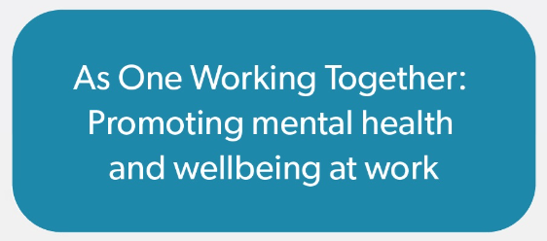

Kind regards
[CASE MANAGER SIGNATURE BLOCK]

Preparing for the employee’s return: Conversation starter
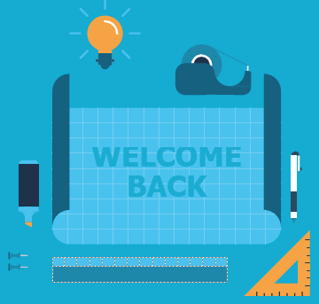
This tool aims to assist you in your conversations with your injured/ill employee.

When the injured employee is improving and is nearing RTW
- Tell them you are looking forward to welcoming them back and they have been missed.
- Begin discussing ways that you can start to adapt the work environment and ideas for suitable roles for the employee on their return (see suitable duties guide).
  - Discuss recommendations from treating practitioner or rehabilitation provider about modified duties where appropriate.
  - Focus on what they can do, not what they can’t do.
  - Ask if any specific factors make the employee’s condition worse and discuss plans to address them (i.e. addressing work health and safety hazards).
  - Listen and reflect back. Focus on the future, not the past.
- Ask what you can do to make their first day easier and what they need you to do to make them feel supported while they are adjusting to being back at work.
- Ask what they would like you to tell their co-employees about their return.

Musculoskeletal disorders
- If you haven’t already, highlight your willingness to help with a graduated return to work, where the employee returns in partial capacity and builds from there.

Mental illnesses
- Keep asking open questions that encourage listening and highlight your genuine interest in the employee’s mental health.
- Reassure the employee that progress is not necessarily linear and that it is okay if some weeks they are feeling worse not better.
- Mention that lots of people find their first day back challenging. Be sympathetic without being patronising – for instance, meeting with them on the first day or suggesting you go for lunch together if they’d like.

Suitable duties and reasonable adjustments
This short guide helps you get the best from your employee returning from an injury/illness.

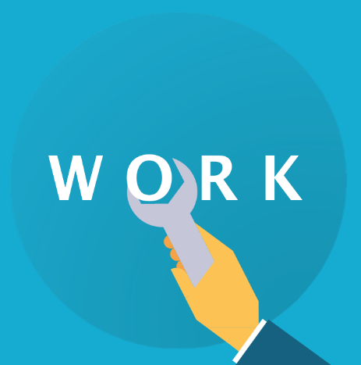
What are suitable duties and reasonable adjustments?
Suitable duties and reasonable adjustments are any changes to a job/workplace that help your returning employee contribute to your team as much as they can following an injury/illness. This could include:
- Changes to work methods – e.g. temporary or permanent task reallocation within your team, new training opportunities and additional support like mentoring.
- Changes to work arrangements – e.g. temporary or permanent adjustments to work hours, support for working remotely/flexibly and modifications to the workplace/work station to make it more accessible.

Key tip
Research shows that supportive managers who share good tasks among their employees have healthy, engaged and productive teams.

Key tip
Be positive – focus on what your employee can do.

Key tip
Providing suitable duties that work for your team as a whole can make a big difference to the sustainability of an injured employee’s recovery and return to work.

How do I start thinking about good suitable duties?
There are no hard and fast rules, but these are some common steps:
- Identify the core requirements of the employee’s job – think about what work needs to be delivered, why the work needs to be delivered, when it needs to be delivered by and how it can be delivered.
- Consider the employee’s skills and abilities – think about what the employee can do. Draw on available medical advice usually outlined in the Comcare Certificate of Capacity, Rehabilitation Plan or rehabilitation case manager notes.
- Identify reasonable adjustments – consider what changes can be made to reduce or remove barriers to work. Speak with the team about modified duties where appropriate so that everyone is on the same page and also about how they can support the adjustments.
- Check that the employee can still meet the core requirements of their job following adjustments ‒ if not, consider whether other parts of the organisation could provide alternative duties that are more suitable.

Key tip
Be flexible and creative – finding the right balance as your team dynamic changes can be hard, but doing it right pays off over time!

Key tip
Keeping the employee involved in this process is key to making sure the adjustments will work. Encourage the employee to chat to their healthcare provider about things they can do, even if they’re not directly related to their job, as they may help identify suitable duties.

Top tips for employees recovering from musculoskeletal disorders

Neck or back pain, sprains or strains, occupational overuse syndrome
There are a few key things to keep in mind for employees recovering from musculoskeletal disorders:
- The process is often gradual – this means it can be helpful for the employee to return in partial capacity and slowly build up capacity (without necessarily returning to the same capacity as before).
  - This requires consistent communication and planning with the employee about the aspects of their job that they are ready to restart with or without modification.
- The physical work environment may need to change – particularly if aspects of the environment were affecting the disorder. This could include office layout, workstation adjustments and tools for more accessible computer use.
- The physical workload may need to change – this could include less physically demanding tasks, short breaks or allowing working from home to relieve physical symptoms.

Top tips for employees recovering from mental illnesses

Depression/mood disorders, anxiety disorders, PTSD
There are a few keys things to keep in mind for employees managing or recovering from mental illnesses:
- Mental illness and medications can affect different people in different ways. Making assumptions is dangerous. Instead, ask the employee ‘what does that mean for you?’
- Focus on the outcomes, goals and deliverables, not the location and time that work gets done.
- Take the time to understand the support they need.
  - Often employees recovering from a mental illness are offered flexible work arrangements and reduced hours, but in many cases modified tasks and training opportunities can also be helpful.
- Finding the right tasks takes time, but communicating clearly that you care about getting it right can make a big difference to the returning employee. Some ideas are:
  - For anxiety disorders, consider reducing exposure (at least initially) to stressful situations like large risky projects and outward-facing contact (e.g. meeting with stakeholders, clients and senior executives) and other potential triggers.
  - For depression, consider how to break the job down into clearly defined tasks (that are still meaningful) and look for opportunities to provide positive feedback.
- Discuss with the employee what information they would like to share with the team, if any. The lack of physical symptoms can lead to stigma and skepticism about mental illnesses. This makes it even more important that you have the support of your team for the adjustments made to the duties of the returning employee.

Going deeper

Musculoskeletal disorders
Questions to think about:
- Are there repetitive tasks that need to be eliminated or reduced?
- How often and for how long might your employee need breaks from manual tasks to allow sufficient physical recovery?
- Does your employee need a longer time to perform certain tasks?

Mental illnesses
Questions to think about:
- How long can your employee concentrate for at a time? Do they need discrete tasks one at a time, or are they better off taking breaks?
- Does your employee find it easier getting instructions and tasks verbally, written or both?
- Would your employee like you to check in with them throughout the day, and how often? Or would they find that intrusive?
- Would the employee find it helpful to have a buddy when first returning to work?
- How many people can the employee be around? Is the level of noise in the workplace making things harder?
- Are there any impacts on relationships?

