BETA
BEHAVIOURAL ECONOMICS TEAM
OF THE AUSTRALIAN GOVERNMENT
Effective use of SMS: timely reminders to report on time
December,2017
© Commonwealth of Australia 2017
978-1-925362-99-2 Effective use of SMS: timely reminders to report on time (DOCX)
978-1-925362-98-5 Effective use of SMS: timely reminders to report on time (PDF)
Copyright Notice
With the exception of the Commonwealth Coat of Arms, this work is licensed under a Creative Commons Attribution 4.0 International license (CC BY 4.0) (http://creativecommons.org/licenses/by/4.0/deed.en).
Third party copyright
Wherever a third party holds copyright in this material, the copyright remains with that party. Their permission may be required to use the material. Please contact them directly.
Attribution
This publication should be attributed as follows: Commonwealth of Australia, Department of the Prime Minister and Cabinet, Effective use of SMS: timely reminders to report on time.
Use of the Coat of Arms
The terms under which the Coat of Arms can be used are detailed on the following website:
http://www.itsanhonour.gov.au/coat-arms
BETA
BEHAVIOURAL ECONOMICS TEAM
OF THE AUSTRALIAN GOVERNMENT
Effective use of SMS: timely reminders to report on time
Outcomes of a trial conducted by the Behavioural Economics Team of the Australian Government (BETA) in partnership with the Australian Government Department of Human Services
Other uses
Enquiries regarding this license and any other use of this document are welcome at:
Managing Director
Behavioural Economics Team of the Australian Government
Department of the Prime Minister and Cabinet
Barton ACT 2600
Email: beta@pmc.gov.au
The views expressed in this paper are those of the authors and do not necessarily reflect those of the Department of the Prime Minister and Cabinet or the Australian Government.
Research team
Professor Michael J. Hiscox was the principal investigator for this project. Other (current and former) staff who contributed to the report were: Scott Copley, Jacqui Brewer, Andrei Turenko, and
James Wilson.
Acknowledgments
Thank you to the Australian Government Department of Human Services’ Behavioural Insights Team and Electronic Messaging Team for their support and valuable contribution in making this project happen. In particular, special thanks to Pam Spurr, Denise Blayden, Rachel Evans, Melinda Smith, Afroditi Cook, Kim Seagrim, Kim Verduyn Lunel, Nicole White, and Jude Planitz for their work on this project.
The trial was registered on the BETA website and the American Economic Association registry:
https://www.pmc.gov.au/domestic-policy/behavioural-economics/effective-use-sms-encourage-timely-reporting-behaviour-using-digital-channels
https://www.socialscienceregistry.org/trials/2210/history/17503

CONTENTS
Executive summary 6
Why was it important to run this trial? 7
What we did 8
Results 11
Discussion and conclusion 17
Appendices 18
References 32

Executive summary
BETA joined forces with the Australian Government Department of Human Services to help job seekers report on time and receive their income support payments on time.
For Australians looking for work, Newstart Allowance and Youth Allowance (other) are the main payments provided by the Australian Government. In 2016, these payments totalled $10.95 billion. People who receive these payments must report their income every fortnight to ensure they receive the correct payment. In any given fortnight over 80,000 people (or 9 per cent) are late reporting their income and approximately 3,100 people are so late their payments are cancelled.
Drawing on behavioural insights, we designed a trial to test if a simple and timely reminder could make a difference. Australians live increasingly busy lives and make hundreds of decisions a day.
It can be easy to get distracted, or procrastinate and forget even the smallest and simplest of tasks. Reminders have been shown to work in a range of contexts including healthcare, education, financial management, and family welfare, and are often used by the private sector to prompt
on-time payment of bills, and renewals of products and services.
Because we know people can respond differently depending on how a message is framed, we also tested whether different reminder messages worked better than others. We designed three types of SMS reminders sent the day before the income report was due: a short and simple reminder (short group); a reminder emphasising the costs of not reporting (loss frame); and a reminder making the benefits of reporting on time more salient (gain frame). We also sent each message
in a personalised and non-personalised version.
We tracked and measured the effect these messages had on income reporting and then compared these results with people who did not receive a reminder. We found sending any SMS reminder had a big impact, increasing the number of people who reported on time by 13.5 percentage points, with those who received an SMS reminder reporting sooner than those who did not. Some reminders also resulted in fewer payment cancellations (down by 1.7 percentage points).
The findings of our trial are clear: small, simple changes in service delivery make a big difference. Introducing a simple reminder helps those looking for work to receive the income they need, when they need it. These changes also help other Australians. By improving the efficiency of services, resourcing can be redirected to helping others in need. In the context of the Department’s
200 million interactions with Australians each year, these small improvements matter and support better outcomes for more Australians.

why was it important to run this Trial?

Policy context
The Australian Government provides many programs and services to support Australians who find themselves in difficult financial circumstances. For those requiring income support while seeking employment, the two key programs are Newstart Allowance for those aged 22 years and over, and Youth Allowance (other) for young people aged 16 to 21 years. In March 2017, approximately 850,000 Australians received these payments (Department of Social Services, 2017). To receive the right amount, most people who receive these payments are required to report their income to the Department of Human Services fortnightly.

The problem
Many people report their income late: in any given fortnight, approximately 80,000
(or 9 per cent) of eligible people miss the deadline. Late reporters have their payments delayed, and after 14 days payments can be cancelled entirely, leading to a financial gap
for these Australians and their families.
Late reporting and cancellations also increase workload and costs for the Department and for eligible Australians, both from the effort required to restore payments once the report has been made, and from increased engagement with the Department when payments are delayed or cancelled. There are approximately 3,100 cancellations each fortnight, or 81,500 per year.

What we did
BETA and the Department of Human Services’ Behavioural Insights Team developed this trial to test whether people in receipt of income support would benefit from prompts to report on time. SMS communication provides a quick and cost effective way to achieve this goal. Text messages are increasingly becoming one of the major modes of interaction between the Government and Australians for a range of services. The Department alone sends in excess of 29 million text messages every year (Department of Human Services, 2016), however, there are no income reporting reminder messages currently in use.
The aim of the trial was to examine whether targeted, timely and behaviourally informed prompts about reporting income, via SMS, increases the number of people who report on time.

The design of SMS messages for this study
Behavioural insights tell us people are susceptible to biases. We can procrastinate and forget everyday tasks we mean to complete. Tasks related to financial issues (calculating and reporting income) may be particularly difficult for some people, making it more likely they delay as long as possible (and often delay for too long). For people facing financial stress, these tendencies may be exacerbated by the high cognitive load (or reduced cognitive bandwidth) associated with living in conditions of scarcity (see Mullainathan & Shafir, 2013). Further key biases which may contribute to late income reporting are set out in Box 1 (see also Samson, 2017).

BOX 1: COMMON BIASES influencing late reporting
Cognitive overload occurs when a person is overwhelmed with the amount or context of information provided to them. It may lead people to forget things and delay decisions, due to having too many competing tasks, which may occur when people are job seeking/studying.
Procrastination can occur because people are short-sighted and often put off decisions or behaviours, even those in their best interests.
Optimism bias and overconfidence refers to our tendency to be unrealistically optimistic even when the stakes are high. This may lead to people being overconfident about their ability to report on time.
To address these biases, we looked at recent behavioural science literature (see Appendix 1) and designed three different reminder messages to test. The first type (short group) was a short, simple reminder the income report was due. The second type (loss frame group) emphasised the cost of not reporting on time. The final type (gain frame group) made the benefits of reporting on time more salient. See Figure 1 for more detail on messages.
Trials in other contexts have shown how personalised messaging, such as using a person’s first name, have proven to be effective in encouraging specific behaviours (Behavioural Insights Team, 2012; Castleman & Page, 2013). To test whether personalisation makes a difference, we created two versions of each type of message described above (short, loss frame, and gain frame): one addressed the message recipient by their preferred first name, and the other did not. This resulted in a total of six unique messages to test in our trial.

The trial
To test whether the SMS reminders encouraged people to report on time, we conducted a randomised controlled trial (RCT). Our trial involved 14,994 people receiving Newstart Allowance or Youth Allowance (other) who were late reporting their income in the fortnight immediately before the trial. These people were randomly assigned to one of the six different SMS reminder groups (treatment groups) or the no reminder group (control group).
More detail on the trial and the randomisation method is in Appendix 2 (Technical details).

BOX 2: WHAT IS A RANDOMISED CONTROLLED TRIAL (RCT)?
A randomised controlled trial (RCT) is the best way of telling if a policy is working.
RCTs work by randomly assigning people (or other units) into different groups – usually one or more ‘treatment’ groups participate in the new intervention, and a ‘control’ group does not.
The differences in outcomes across the groups are then compared. RCTs are considered the ‘gold standard’ for assessing causal impacts because a RCT determines the impact of an intervention or treatment compared to if nothing was changed.

Figure 1: Treatment groups and SMS messages sent in the trial
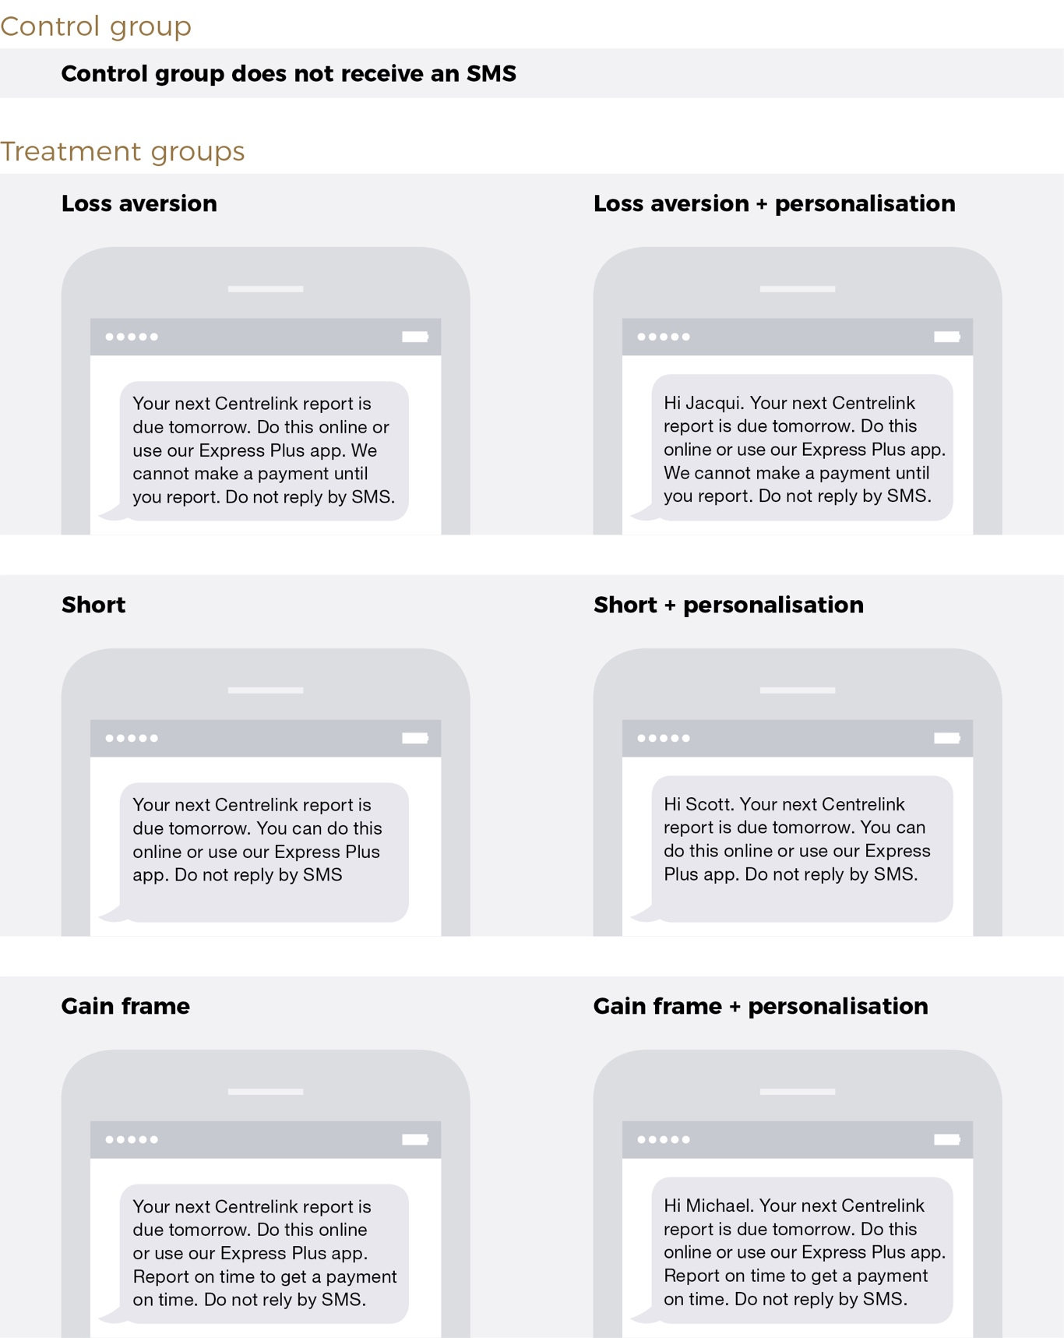
Figure 1 provides an overview of the SMS reminders sent to the treatment and control groups in this trial. The control group did not receive an SMS. For treatment groups, three types of SMS were sent: the ‘Loss Aversion’ type which read “Your next Centrelink report is due tomorrow. Do this online or use our Express Plus app. We cannot make a payment until you report. Do not reply by SMS.”; the ‘Short’ type which read “Your next Centrelink report is due tomorrow. You can do this online or use our Express Plus app. Do not reply by SMS”; and the ‘Gain frame’ type which read “Your next Centrelink report is due tomorrow. Do this online or use our Express Plus app. Report on time to get a payment on time. Do not reply by SMS.”. Each of these three SMS types had a personalised version which included a greeting ‘Hi’ followed by recipient’s first name. In total there were six different SMS messages.

Results

Do SMS reminders improve on-time reporting?
We found sending any SMS reminder led to big improvements in on-time reporting. Of those who received any reminder, 66.6 per cent of people reported on time, compared to
53.1 per cent for those who did not receive a reminder (Figure 2), an increase in on-time reporting of 13.5 percentage points. This difference was estimated with considerable precision given our large sample size.
Figure 2: Impact of sending an SMS reminder ON ON-TIME REPORTING
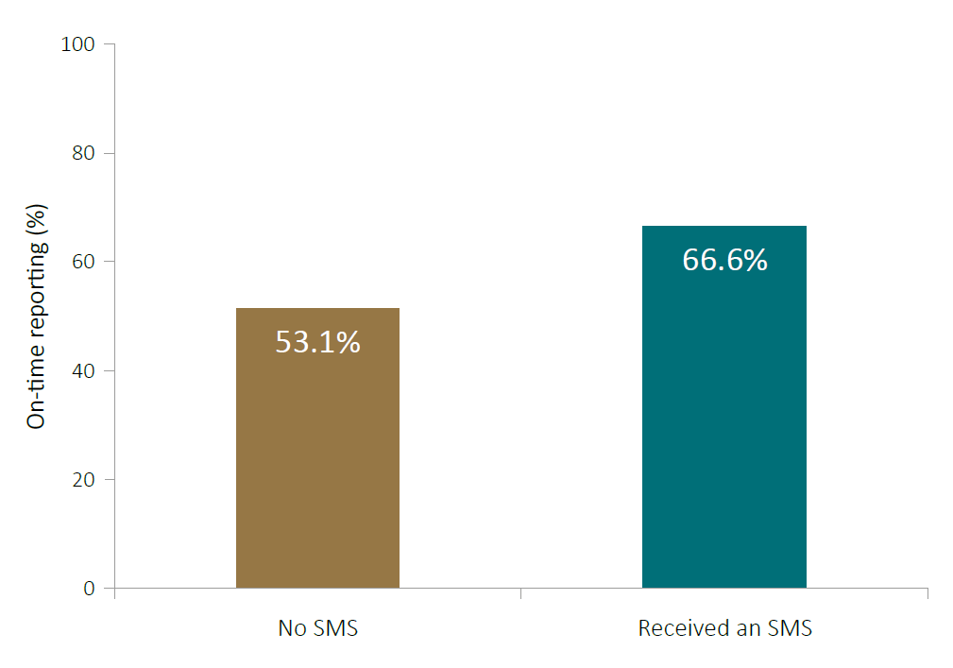
Sending an SMS the afternoon before a person was due to report their income caused an increase in on-time reporting of 13.5 percentage points (from 53.1 per cent to 66.6 per cent).
If SMS reminders were sent to everyone reporting late in these two programs, this would shift approximately 10,800 people from reporting late to being on-time, ensuring they receive their payment in due time (see Table A.6 in Appendix 4).

Do behaviourally informed SMS messages further improve on-time reporting?
We also compared each of the SMS reminder groups to the group that did not receive a reminder. This tells us which message was most effective in encouraging on-time reporting.
We found all SMS messages increased on-time reporting compared to not receiving an SMS, with the increase ranging from 13.0 to 14.2 percentage points. We saw the biggest effects for people receiving the gain frame message, but the difference compared to other messages was small.
Personalised messages were no more effective than impersonal versions (Figure 3).
Figure 3: Impact of sms reminder types ON ON-TIME REPORTING
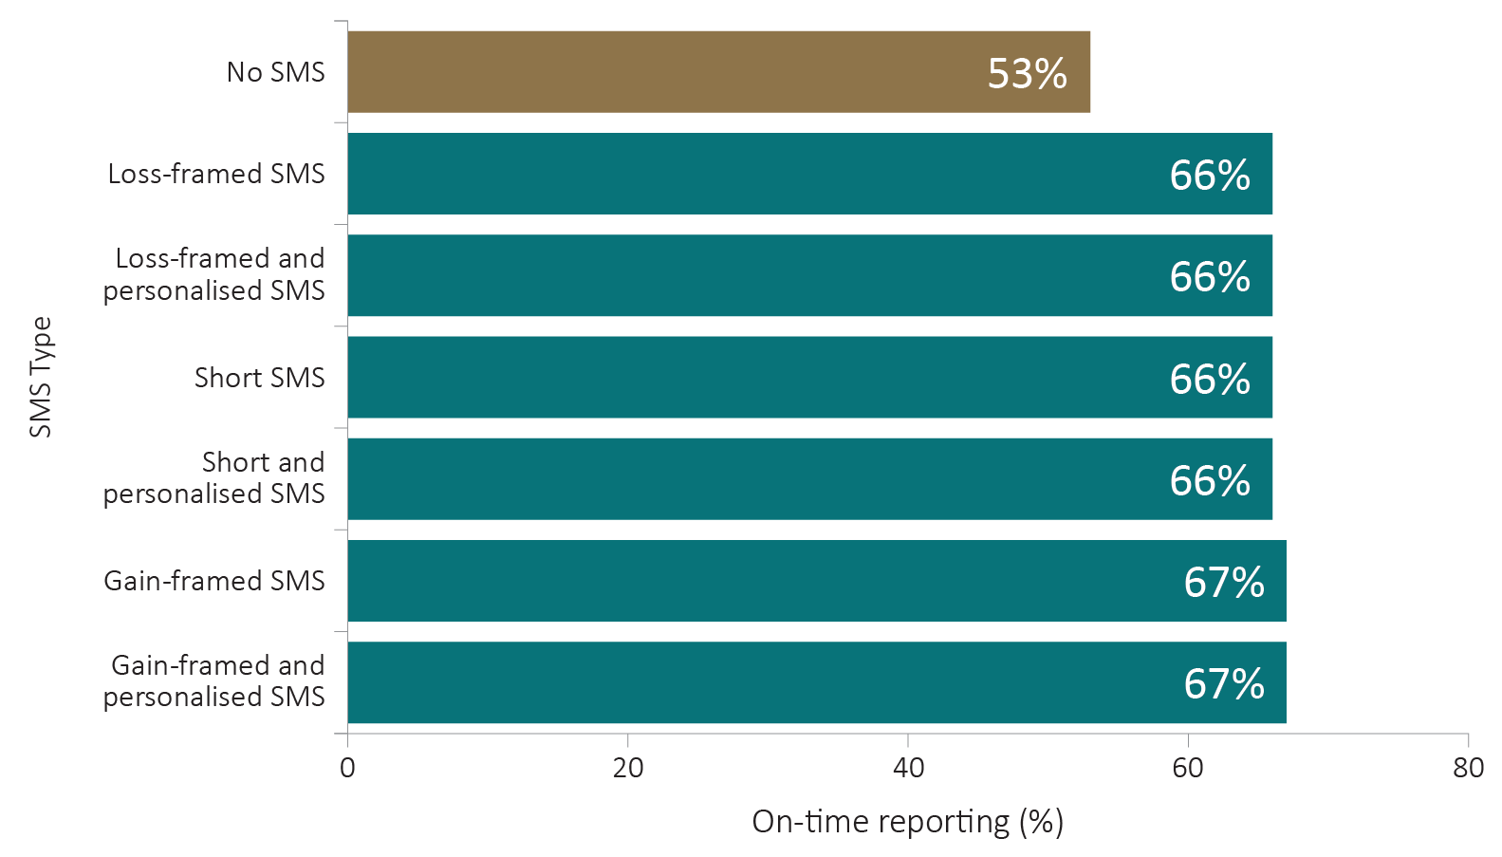
All SMS variations increased on-time reporting above the no SMS (control) group by 13 to 14.2 percentage points (from 53 per cent to 66-67 per cent). There was no significant difference when comparing SMS variations.
One reason for the small differences in impact across the various SMS messages could be due to the way the message was viewed. Many smartphones display the sender’s name at the beginning of a message in the main page of the messaging application (and in any pop-up notifications) when an SMS is received. If people did not open the full message, they would not have been exposed to the small difference in messaging. Some of the key differences between the messages we tested – in particular, those between loss and gain framing – would not be obvious to people who did not view the full text of the message.

By how much do SMS reminders reduce lateness?
Looking at whether people report on time is useful, but does not tell us the full story. We were also interested in how late individuals were. Reporting late has real implications for people receiving Newstart Allowance and Youth Allowance (other) payments, as no payment is made until a report is submitted to the Department.
Those who did not receive an SMS reminder were, on average, 1.9 days late. Sending any SMS reminder reduced the average number of days late by 0.65 days to 1.2 days (Figure 4).
There are two ways by which SMS reminders may reduce the average number of days a person is late. Firstly, by causing individuals to report on-time and secondly, by causing shorter delays among those who missed their deadline.
We found no differences in effectiveness between the different types and versions of messages (for further detail, see the Statistical Tables in Appendix 3).
Figure 4: Impact of SMS reminder on AVERAGE DAYS LATE
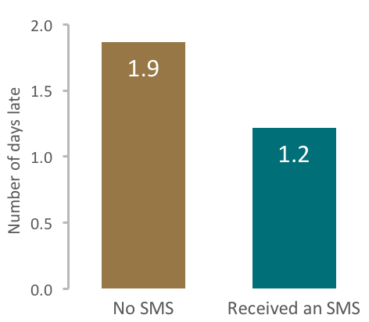
Sending an SMS reminder reduced the average number of days people were late reporting their income by 0.65 days (from 1.9 days to 1.2 days).

Do SMS reminders reduce the number of payment cancellations?
We also wanted to understand if simple timely reminders reduced the number of cancelled payments. When people are 14 or more days late reporting their income, their payment is cancelled. They must then contact Human Services in person or over the phone, and go through a formal process to have their payment restored.
All six messages reduced cancellations relative to those who did not receive a reminder. The non-personalised gain-framed message led to the biggest reduction in cancellations compared with those who did not receive an SMS message (a 1.7 percentage point reduction from 3.9 per cent to 2.2 per cent).
Figure 5: impact of sms reminderS on payment cancellations
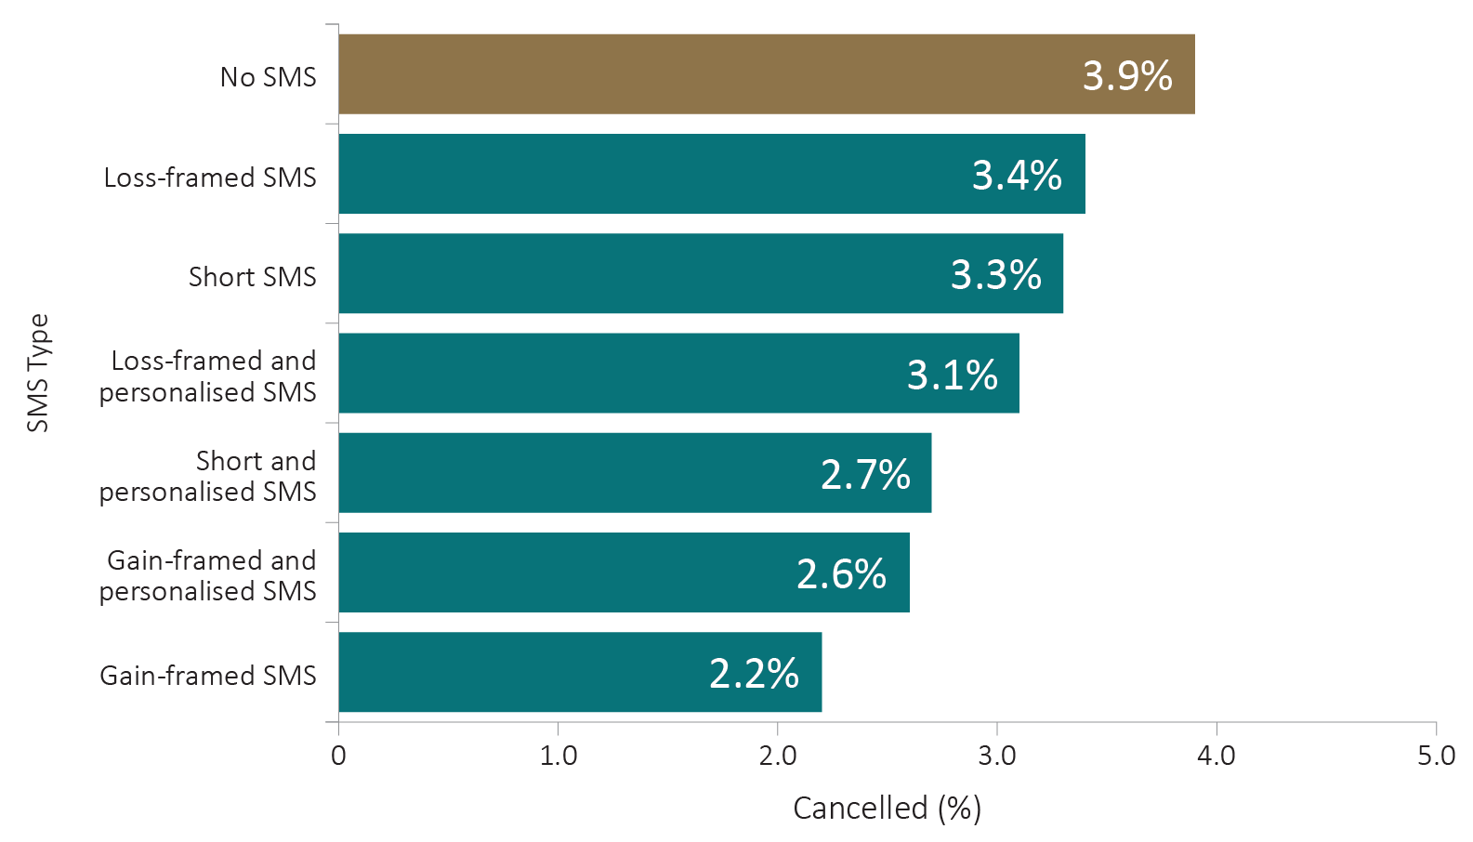
Sending a personalised short, gain-framed or personalised gain-framed SMS reduced cancellations between 1.2 and 1.7 percentage points.
Exploring this further, we used the result for the best performing message (‘Gain’) to estimate the amount of staff time saved if this message was rolled out to everyone who was late reporting in the previous fortnight. Based on an average of 10.5 minutes to restore a cancelled payment, and an average fortnightly late reporting population of 80,400, sending the gain-framed SMS reminder message would save 240 hours of staff time per fortnight (Table A.7 in Appendix 4). These 240 hours could be re-allocated to assist others in need, improving overall service delivery for Australians.

Did the improvement in on-time reporting persist?
Next, we wanted to explore whether sending a single SMS had a lasting impact on a person’s ongoing income reporting behaviour. People involved in our trial received a single, one-off SMS the day before they were due to report. No further reminders were sent for subsequent reporting periods. Looking at their income reporting behaviour over the following fortnights, we concluded the one-time SMS reminders had no lasting effect on ongoing reporting.
Figure 6 shows there was no persistent effect beyond the initial trial fortnight. This indicates the reminders do function in the expected way, helping people recall and attend to an immediate deadline for an otherwise forgotten or postponed task.

Figure 6: impact of sms reminder on subsequent reporting dates
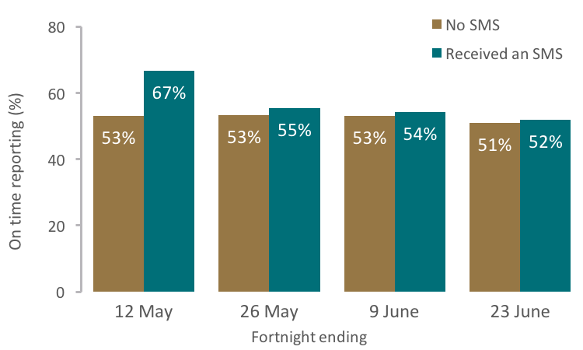
While sending an SMS reminder improved on-time reporting for the next reporting due date, it did not have a persistent effect across later fortnights.
Future trials could examine whether repeated messaging improves ongoing on-time reporting. More frequent reminders may result in better habit formation, helping recipients to become regular on-time reporters. Alternatively, we could see people effectively outsource the habit, becoming reliant on the reminder.

Do SMS reminders work differently with different groups of people?
We found no evidence the effects of the reminder messages for on-time reporting varied across major sub-groups, such as by program (Newstart or Youth Allowance (other)), age, gender, location (remote or non-remote), or reporting days (Tuesday, Wednesday, Thursday or Friday).
The findings do show very clearly the reminder messages were most effective among people who had a history of late reporting. Among those who were late only once previously, receiving any SMS increased on-time reporting by 11 percentage points. Among those who had been late reporting to Human Services twice, or three or more times previously, any SMS reminder increased on-time reporting by 17 and 16 percentage points respectively (Figure 7). The results suggest SMS reminders work best among those who tend to report late, perhaps because these individuals have a greater tendency to forget their reporting obligations.
Figure 7: impact of the sms reminder BY history of late reporting
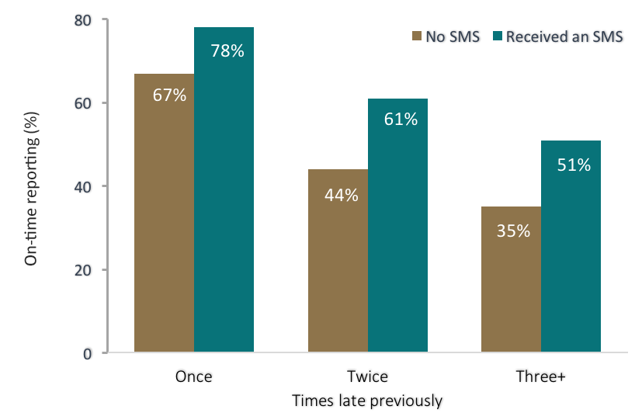
Sending an SMS to people the afternoon before they were due to report their income caused a larger increase in on-time reporting among those who had been late reporting their income in previous fortnights.
Further results relating to reporting methods can be found in Appendix 5.

Discussion and Conclusion
Our findings show simple, timely reminders are a powerful tool to assist people receiving Newstart and Youth Allowance (other) payments to meet their reporting obligations. Overall, we saw big improvements in on-time reporting and fewer payment cancellations.
Interestingly, variations in the specific content and the framing of the message did not show clear differences for on-time reporting: the simple reminder is what mattered. There may be a number of explanations. Late reporting may occur simply due to forgetfulness, and receiving any kind of reminder may remedy this. Alternatively, the wording of our messages may not have been different enough to elicit varying responses in reporting behaviour.
Some SMS messages reduced the number of cancellations resulting from late reporting. Personalised short form messages and the gain-framed messages produced the biggest reduction in cancellation rates compared to the no-SMS group. This result suggests personalised and positively worded messages remained more salient with late reporters during the 14-day period than other types of SMS.
Additionally, people who are habitually late reporters were more responsive to SMS prompts. Habitually late reporters may simply be prone to forgetting their reporting obligations or may face circumstances that make it especially difficult to manage their affairs.
The outcomes of this trial show how simple cost-effective SMS reminders (the average cost of an SMS was 9 cents) can have a two-fold benefit for Australians and the Department. From a person’s point of view, the reduced likelihood of their income support payment being delayed or cancelled is both financially and cognitively beneficial. For the Department, applying our results to the full late reporting population, our trial showed 10,800 more people would report on time, and approximately 240 hours of work could be saved every fortnight. These saved resources could be moved to other areas of the Department. The associated reduction in contact with the Department would also lower the burden on telephone services, making it faster and easier for others to get through.
Given the trial was conducted throughout Australia on a representative cohort of previously late reporters, we consider the lessons learnt to be generalisable to other similar programs run by the Department, as well as wider initiatives undertaken by the Commonwealth, State, Territory, and local governments. This trial demonstrates the value of simple behavioural interventions in administrative processes where timely behavior is required.

Appendices

Appendix 1: Prior research on effective SMS communication
Simple reminder messages can help people remember to complete tasks on time by overcoming common problems of cognitive overload, procrastination and imperfect memory. There are many ways to deliver reminders, but SMS offers an effective, cheap, fast and customisable communication option.
Timely and targeted SMS have been effective in helping people in a broad range of circumstances, including in chronic disease management (Franklin et al., 2006), weight loss (Patrick et al., 2009), financial management (Cadena, 2011; Karlan et al., 2016), education (Castleman & Page, 2013; Naismith, 2007), and encouraging child support payments
(Baird et al., 2015).
The low-cost and widespread use of SMS messaging makes it ideal for large scale communication. In certain cases, SMS has proven to be more effective than traditional modes of communication. In comparing telephone and SMS hospital reminders, both methods were found to be similarly effective, but SMS reminders were much cheaper to administer (Chen et al., 2008). Similarly, SMS was used to reduce missed hospital appointments at the Royal Children’s Hospital in Melbourne (Downer et al., 2006). SMS was also shown to be more effective than posted letters in encouraging completion of surveys (Virtanen, 2007).
In the private sector, companies rely on SMS to engage with customers, to remind them to make an upcoming payment, check a balance or bill, check-in for an upcoming flight, or be ready for an upcoming appointment, visit, or delivery. These types of reminder messages are typically introduced as features of service, rather than a marketing channel. Reminders help customers get desired outcomes and this generates improved customer satisfaction and loyalty.
While there is a large body of research highlighting the success of SMS messaging in
helping people engage with various programs, studies examining the effects of altering
the specific wording and tone of the message are more limited. Only a handful of studies have tested whether small changes in the wording of an SMS can alter its effectiveness (Haynes et al., 2013; Hallsworth et al., 2015; Hallsworth et al., 2017).
A number of studies attempted to emphasise the cost incurred if a recipient fails to act
in time, thus tapping into their “loss avoidance” bias. Experiments have shown the desire
to avoid loss seems to be a stronger than the desire to capture a gain of equal amount (Kahneman & Tversky 1984). For example, the NSW Behavioural Insights Unit (2015) found patients attended more appointments when they received an SMS highlighting the avoidable costs of missing their appointments.
Previous research has also focused on how to attract the attention of individuals by personalising messages. The UK’s Behavioural Insights Team (2012) included the individual’s first name in SMS and saw an increase in the likelihood of a court fine repayment. Conversely, two meta-analyses of studies examining SMS use in primary healthcare found no difference between personalised text messages compared with standard messages (Orr & King, 2015; Spohr et al., 2015).

Appendix 2: The technical details

Power calculations
We conducted power analyses to determine how many people we would need in the trial to detect an effect of the SMS interventions. Of the 80,382 individuals who were late reporting in the fortnight ending 17 February 2017, 35,329 (43 per cent) were late reporting again over the next month. From this base, we calculated a sample size of 1,550 per group would provide 80 per cent power at a 5 per cent significance level to detect a 5 percentage point decrease in the late reporting rate (from 43 per cent to 38 per cent). With a larger control group (no SMS) and six treatment groups it was determined a total sample of more than 12,300 would be required.

The sample frame
The intervention took place over the period Monday 1 May 2017 to Thursday 4 May 2017 over all States and Territories of Australia. Eligible participants were adults aged 16 and over receiving Newstart or Youth Allowance (other) payments due to report on Tuesday, Wednesday, Thursday or Friday of the week starting 1 May 2017. Participants in postcodes 3175, 3977, 3975 were excluded due to advice another trial was running in these locations. Exclusion criteria were: a positive vulnerability indicator; currently in receipt of parenting payments; missing data on one of the stratification variables (report day, not previously reported late in the past two months, type of payment missing, or SMS communication not listed as preferred contact method); or unreliable entries for a participant’s mobile number or first name. This resulted in a final eligible sample of 27,307 people.
Because of resource limitations a final sample of approximately 15,000 participants was randomly sampled from the full eligible population. Due to a coding error within the data extraction, 173 recipients were identified who were outside the designated reporting dates for this trial. These 173 individuals should have been excluded from receiving an SMS.

Randomisation
The trial was an individually randomised controlled trial. Participants were stratified and randomly assigned to groups using a custom script in R that made use of the ‘sample’ command in R Version 3.3. A formal multivariate balance check, in which a treatment variable that indicates assignment to one of the seven experimental groups was regressed on the full set of covariates and showed that none of the variables were significant and together they were jointly insignificant. Overall this suggests randomisation occurred without error and we can therefore attribute differences in the outcomes to the effect of the treatment.
Participants were randomly assigned to the control condition and six treatment conditions, with an allocation ratio of 3:1:1:1:1:1:1 (with most participants in the control – no SMS condition), and were stratified by report day (Tuesday, Wednesday, Thursday, Friday), times late previously (1,2,3+), and by type of payment (Newstart or Youth Allowance (other)), this also acts as a proxy for age).

Analysis
For all outcomes, ordinary least squares (OLS) regression was used. This included a binary outcome (late yes/no) and a count outcome (days late). We also analysed our binary and count outcomes using binary logistic regression and negative binomial regression respectively. In both instances, calculating marginal effects revealed estimates and standard errors very close to those produced using OLS.
Although our randomisation was stratified, we found little difference in our results when adjusting for these blocks in our estimating equations, therefore we report unadjusted estimates for all primary and secondary analyses.

Appendix 3: Key statistical tables
This appendix shows the full statistical tables which underlie the results section.

Table A.1: Baseline characteristics of income support recipients randomised INTO THE TRIAL
 |  | Control | Loss | Loss  and personalised | Short | Short  and personalised | Gain | Gain  and personalised
 | N (no.) | 4998 | 1666 | 1666 | 1666 | 1666 | 1666 | 1666
Demographics | Female (%) | 49.8 | 49.8 | 49.8 | 49.8 | 49.8 | 49.8 | 49.8
 | Age (Mean ± SD ) | 37.7  ± 13.7 | 37.7  ± 13.8 | 37.6  ± 13.6 | 37.5  ± 13.4 | 37.6  ± 13.5 | 37.4  ± 13.4 | 37.4  ± 13.5
Late on previous reports | Once (%) | 50.2 | 50.2 | 50.2 | 50.2 | 50.2 | 50.2 | 50.2
 | Twice (%) | 21.8 | 21.8 | 21.8 | 21.8 | 21.8 | 21.8 | 21.8
 | Three or more (%) | 28 | 28 | 28 | 28 | 28 | 28 | 28
Times late previously | (Mean  ± SD) | 2.9  ± 2.4 | 3.0  ± 2.5 | 2.9  ± 2.4 | 2.9  ± 2.4 | 2.9  ± 2.4 | 2.9  ± 2.4 | 3.0  ± 2.4
Payment type | Newstart (%) | 85.7 | 85.7 | 85.7 | 85.7 | 85.7 | 85.7 | 85.7
 | Youth Allowance (%) | 14.3 | 14.3 | 14.3 | 14.3 | 14.3 | 14.3 | 14.3
Report date | Tuesday (%) | 28.9 | 28.9 | 28.9 | 28.9 | 28.9 | 28.9 | 28.9
 | Wednesday (%) | 29.1 | 29.1 | 29.1 | 29.1 | 29.1 | 29.1 | 29.1
 | Thursday (%) | 22.1 | 22.1 | 22.1 | 22.1 | 22.1 | 22.1 | 22.1
 | Friday (%) | 19.9 | 19.9 | 19.9 | 19.9 | 19.9 | 19.9 | 19.9

Table A.2: Summary statistics and regression results for on-time reporting.
 | N | On-time reporting % (no.) | Difference from Control (95% confidence interval) | p-value | Difference from Loss frame (95% confidence interval) | p-value
No SMS | 4998 | 53.1 (2654)
Received an SMS (pooled) | 9996 | 66.6 (6654) | 13.5  (11.8 to 15.1) | < 0.001
Loss | 1666 | 66.2 (1103) | 13.1  (10.4 to 15.8) | < 0.001
Loss + personalised | 1666 | 66.4 (1106) | 13.3  (10.6 to 16.0) | < 0.001 | 0.2  (-3 to 3.4) | 0.91
Short | 1666 | 66.3 (1104) | 13.2  (10.5 to 15.8) | < 0.001 | 0.1  (-3.1 to 3.3) | 0.97
Short + personalised | 1666 | 66.1 (1101) | 13.0  (10.3 to 15.7) | < 0.001 | -0.1  (-3.3 to 3.1) | 0.94
Gain | 1666 | 67.1 (1118) | 14.0  (11.3 to 16.7) | < 0.001 | 0.9  (-2.3 to 4.1) | 0.58
Gain + personalised | 1666 | 67.4 (1122) | 14.2  (11.6 to 16.9) | < 0.001 | 1.1  (-2.1 to 4.3) | 0.49
Note: Treatment effects and p-values are from linear models. All groups were compared to control (columns 4 & 5) and then all groups (except the control) were compared to the loss frame group (columns 6 & 7). This analysis was also run as a logistic regression with the same results.

Table A.3: Summary statistics and regression results for average number of days late.
 | N | Average days late mean (SD) | Difference from Control (95% confidence interval) | p-value | Difference from Loss frame (95% confidence interval) | p-value
No SMS | 4779 | 1.9 (3.3)
Received an SMS (pooled) | 9642 | 1.2 (2.8) | -0.6  (-0.7 to -0.5) | < 0.001
Loss | 1606 | 1.3 (2.9) | -0.6  (-0.8 to -0.4) | < 0.001
Loss + personalised | 1607 | 1.3 (2.9) | -0.6  (-0.8 to -0.4) | < 0.001 | 0.0  (-0.2 to 0.2) | 0.91
Short | 1600 | 1.3 (3.0) | -0.6  (-0.8 to -0.4) | < 0.001 | 0.0  (-0.2 to 0.2) | 0.87
Short + personalised | 1613 | 1.2 (2.8) | -0.6  (-0.8 to -0.4) | < 0.001 | 0.0  (-0.2 to 0.2) | 0.91
Gain | 1614 | 1.1 (2.6) | -0.8  (-0.9 to -0.6) | < 0.001 | -0.2  (-0.4 to 0.0) | 0.11
Gain + personalised | 1602 | 1.2 (2.8) | -0.7  (-0.9 to -0.5) | < 0.001 | -0.1  (-0.3 to 0.1) | 0.37
Note: Treatment effects and p-values are from linear models. All groups were compared to control (columns 4 & 5) and then all groups (except the control) were compared to the loss frame group (columns 6 & 7).

Table A.4: Summary statistics and regression results for cancellations.
 | N | Cancelled % (no.) | Difference from Control (95% confidence interval) | p-value | Difference from Loss frame (95% confidence interval) | p-value
No SMS | 4779 | 3.9 (188)
Received an SMS (pooled) | 9642 | 2.9 (278) | -1.1  (-1.7 to -0.4) | 0.0007
Loss | 1606 | 3.4 (54) | -0.6  (-1.6 to 0.4) | 0.26
Loss + personalised | 1607 | 3.1 (50) | -0.8  (-1.8 to 0.2) | 0.10 | -0.3  (-1.4 to 0.9) | 0.67
Short | 1600 | 3.3 (52) | -0.7  (-1.7 to 0.3) | 0.18 | -0.1  (-1.3 to 1) | 0.85
Short + personalised | 1613 | 2.7 (44) | -1.2  (-2.2 to -0.2) | 0.018 | -0.6  (-1.8 to 0.5) | 0.28
Gain | 1614 | 2.2 (36) | -1.7  (-2.7 to -0.7) | 0.001 | -1.1  (-2.3 to 0.002) | 0.055
Gain + personalised | 1602 | 2.6 (42) | -1.3  (-2.3 to -0.3) | 0.010 | -0.7  (-1.9 to 0.4) | 0.21
Note: Treatment effects and p-values are from linear models. All groups were compared to control (columns 4 & 5) and then all groups (except the control) were compared to the loss frame group (columns 6 & 7). This analysis was also run as a logistic regression with the same results.

Table A.5: Summary statistics AND REGRESSION RESULTS for on-time reporting subgroup analyses
Subgroup | Level | On-time reporting  Control  % (n/N) | On-time reporting Treatment  % (n/N) | Control – Treatment difference  (95% CI) | P-value | Difference across subgroup levels (95% CI) | P-value
Times late | 1 | 67.4  (1691/2508) | 78.1  (3917/5016) | 10.7  (8.6 to 12.7) | < 0.0001 | Ref
 | 2 | 43.5  (475/1092) | 60.7  (1325/2184) | 17.2  (13.6 to 20.7) | < 0.0001 | 6.5  (2.5 to 10.5) | 0.0015
 | 3+ | 34.9  (488/1398) | 50.5  (1412 /2796) | 15.6  (12.4 to 18.8) | < 0.0001 | 4.9  (1.2 to 8.6) | 0.0092
Payment type | NSA | 52.9  (2266/4284) | 66.3  (5679/8568) | 13.4  (11.6 to 15.2) | < 0.0001 | Ref
 | YAL | 54.3  (388/714) | 68.3  (975/1428) | 13.9  (9.7 to 18.2) | < 0.0001 | 0.5  (-4.1 to 5.2) | 0.81
EPED | Tuesday | 55.9  (808/1446) | 68.9  (1992/2892) | 13  (10 to 16) | < 0.0001 | Ref
 | Wednesday | 53.1  (771/1452) | 67.7  (1966/2904) | 14.6  (11.6 to 17.6) | < 0.0001 | 1.6  (-2.7 to 5.9) | 0.46
 | Thursday | 56.5  (624/1104) | 71.0  (1568/2208) | 14.5  (11.1 to 17.9) | < 0.0001 | 1.5  (-3.1 to 6.1) | 0.52
 | Friday | 45.3  (451/996) | 56.6  (1128/1992) | 11.3  (7.6 to 15.1) | < 0.0001 | -1.7  (-6.4 to 3.1) | 0.49
Channel | Other | 61.3  (995/1623) | 71.9  (2393/3329) | 10.6  (7.8 to 13.3) | < 0.0001 | Ref
 | Web | 49.2  (1659/3375) | 63.9  (4261/6667) | 14.8  (12.7 to 16.8) | < 0.0001 | 4.2  (0.7 to 7.6) | 0.018
Remote- ness | Non-remote | 52.9  (2553/4828) | 66.5  (6396/9612) | 13.7  (12 to 15.3) | < 0.0001 | Ref
 | Remote | 62.1  (90/145) | 69.4  (231/333) | 7.3  (-1.9 to 16.5) | 0.12 | -6.4  (-15.9 to 3.2) | 0.19
Note: The six treatment groups were pooled for these analyses. Columns 3 & 4 show treatment effects and p-values within each subgroup level. Columns 5 & 6 show the difference in treatment effects between each level of the subgroup. Only the Times late and Channel subgroups had significant differences between subgroup levels. Ref = reference group for subgroup level comparisons.
Appendix 4: Extrapolation tables

table A.6: Extrapolating on-time reporting results to full fortnightly late population
Results within trial |  | Extrapolated to full fortnightly late population
 | Increase in on-time reporting  (in percentage points) | Number of people moved from late to on-time reporting
Upper bound estimate | 15.1 | 12,100
Mid-point estimate | 13.5 | 10,800
Lower bound estimate | 11.8 | 9,500
This table uses the estimated increase in on-time reporting (13.5 percentage points) and extrapolates this to the full late reporting population to calculate the estimated number of individuals who would move from reporting late to on-time if they received an SMS. The table uses the 95 per cent confidence interval (11.8 to 15.1 percentage points) to calculate an upper and lower bound.

table A.7: Extrapolating cancellations results to full fortnightly late population
Within trial |  | Extrapolated to full fortnightly late population
 | Decrease in cancellations (in percentage points) | Number of cancellations prevented per fortnight | Hours of staff time saved per fortnight
Upper bound | 2.7 | 1,900 | 380
Mid-point estimate | 1.7 | 1,200 | 240
Lower bound | 0.7 | 500 | 100
Sending a gain-framed SMS to recipients before their due date reduced cancellations. This table uses the estimated reduction in cancellations in the gain frame SMS group (1.7 percentage points) and extrapolates this to the full late reporting population to calculate the number of cancellations prevented and staff time saved. The table uses the 95 per cent confidence interval around the gain frame estimate (0.7 to 2.7 percentage points) to calculate an upper and lower bound.

Appendix 5: Supplementary Results

preferred Channel of reporting
Australians who receive Newstart Allowance and Youth Allowance (other) payments have the option of reporting their income in person, via phone or online through a website or phone app. As an additional analysis, we wanted to see if there was a different pattern of results for different reporting channels. We did not see a shift in reporting channel as a result of any of our treatments (80.8 per cent reported online in the control versus 81.1 per cent in the combined treatment groups).
There was a difference in the effectiveness of the SMS reminder messages between those individuals who reported to Human Services in person or by phone and those who reported online. Among those who reported in person or by phone, sending an SMS message (of any type) increased on-time reporting by 11 percentage points. For those who reported online, an SMS reminder increased on-time reporting by 15 percentage points (Figure A.1). This may be due to the relative ease of using an online channel (via smartphone) to respond immediately to the SMS reminder when it appears on the device.

Figure A.1: impact of the sms reminder BY reporting channel
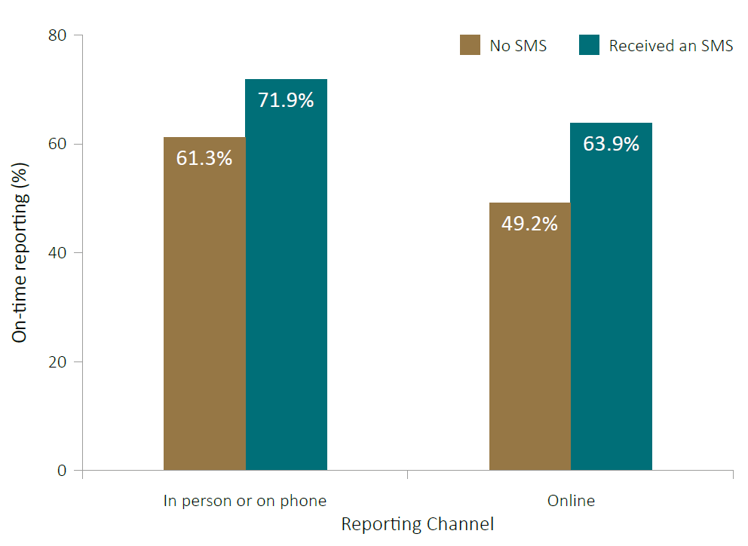
Sending an SMS to income support recipients the afternoon before they were due to report their income caused a larger increase in on-time reporting among those who reported online compared with those who reported in person or by phone.
Those already using online or digital reporting methods may be more comfortable with receiving electronic communication from the Department and it may be easier for them to report once reminded.

Appendix 6: Accessible graph data

Figure 2: Impact of sending an SMS reminder ON ON-TIME REPORTING
 | On-time reporting (%)
No SMS | 53.1
Received an SMS | 66.6

Figure 3: Impact of sms reminder types ON ON-TIME REPORTING
SMS Type | On-time reporting (%)
No SMS | 53
Loss-framed SMS | 66
Loss-framed and personalised SMS | 66
Short SMS | 66
Short and personalised SMS | 66
Gain-framed SMS | 67
Gain-framed and personalised SMS | 67

Figure 4: Impact of SMS reminder on AVERAGE DAYS LATE
 | Number of days late
No SMS | 1.9
Received an SMS | 1.2

Figure 5: impact of sms reminderS on payment cancellations
SMS Type | Cancelled (%)
No SMS | 3.9
Loss-framed SMS | 3.4
Short SMS | 3.3
Loss-framed and personalised SMS | 3.1
Short and personalised SMS | 2.7
Gain-framed and personalised SMS | 2.6
Gain-framed SMS | 2.2

Figure 6: impact of sms reminder on subsequent reporting dates
Fortnight ending | On-time reporting (%)
 | No SMS | Received an SMS
12 May | 53 | 67
26 May | 53 | 55
9 June | 53 | 54
23 June | 51 | 52

Figure 7: impact of the sms reminder BY history of late reporting
Times previously late | On-time reporting (%)
 | No SMS | Received an SMS
Once | 67 | 78
Twice | 44 | 61
Three + | 35 | 51

Figure A.1: impact of the sms reminder BY reporting channel
Reporting Channel | On-time reporting (%)
 | No SMS | Received an SMS
In person or on phone | 61.3 | 71.9
Online | 49.2 | 63.9

References
Baird, P., Reardon, L., Cullinan, D., McDermott, D., & Landers, P. 2015. Reminders to pay: using behavioral economics to increase child support payments. OPRE Report 2015-20. Washington, DC: Office of Planning, Research and Evaluation, Administration for Children and Families, U.S. Department of Health and Human Services. Available at SSRN: https://ssrn.com/abstract=2666567.
BEHAVIOURAL INSIGHTS TEAM. 2012. Test, learn, adapt: developing public policy with randomised controlled trials. Cabinet Office Behavioural Insights Team.
CADENA, X. & SCHOAR, A. 2011. Remembering to pay? Reminders vs. financial incentives for loan payments. National Bureau of Economic Research.
CASTLEMAN, B. L. & PAGE, L. C. 2013. Summer nudging: Can personalized text messages and peer mentor outreach increase college going among low-income high school graduates. Center for Education Policy and Workforce Competitiveness Working Paper, 9.
CHEN, Z.W., FANG, L.Z., CHEN, L.Y. & DAI, H.L. 2008. Comparison of an SMS text messaging and phone reminder to improve attendance at a health promotion center: a randomized controlled trial. Journal of Zhejiang University-Science B, 9, 34-38.
DEPARTMENT OF HUMAN SERVICES. 2016. Department of Human Services 2015-16 Annual Report. [online] available at https://www.humanservices.gov.au/sites/default/files/8802-1610-annualreport2015-16.pdf [accessed at 20/09/2017].
DEPARTMENT OF SOCIAL SERVICES. 2017. DSS Payment Demographic March 2017. Data.gov.au. [online] available at: https://data.gov.au/dataset/dss-payment-demographic-data [accessed 06/09/2017].
Downer, S. R., Meara, J.G., Da Costa, A.C., Sethuraman, K. 2006. SMS text messaging improves outpatient attendance. Australian Health Review, 30, 389-396.
FRANKLIN, V. L., WALLER, A., PAGLIARI, C. & GREENE, S. A. 2006. A randomized controlled trial of Sweet Talk, a text‐messaging system to support young people with diabetes. Diabetic Medicine, 23, 1332-1338.
HALLSWORTH, M., BERRY, D., SANDERS, M., SALLIS, A., KING, D., VLAEV, I. & DARZI, A. 2015. Stating appointment costs in SMS reminders reduces missed hospital appointments: findings from Two randomised controlled trials. PloS one, 10, e0137306.
HALLSWORTH, M., LIST, J. A., METCALFE, R. D. & VLAEV, I. 2017. The behavioralist as tax collector: Using natural field experiments to enhance tax compliance. Journal of Public Economics, 148, 14-31.
HAYNES, L. C., GREEN, D. P., GALLAGHER, R., JOHN, P. & TORGERSON, D. J. 2013. Collection of delinquent fines: An adaptive randomized trial to assess the effectiveness of alternative text messages. Journal of Policy Analysis and Management, 32, 718-730.
KARLAN, D., MCCONNELL, M., MULLAINATHAN, S. & ZINMAN, J. 2016. Getting to the top of mind: How reminders increase saving. Management Science, 62, 3393-3411.
KAHNEMAN, D., & TVERSKY, A. 1984. Choices, values, and frames. American Psychologist, 39(4), 341-350. http://dx.doi.org/10.1037/0003-066X.39.4.341
NSW BEHAVIOURAL INSIGHTS UNIT AT PREMIER & CABINET. 2015. Spotlight on Health Results: Behavioural Insight Short Report. NSW Government
MULLAINATHAN, S., & SHAFIR, E. 2013. Scarcity: Why having too little means so much. Macmillan.
NAISMITH, L. 2007. Using text messaging to support administrative communication in higher education. Active Learning in Higher Education, 8, 155-171.
ORR, J. A. & KING, R. J. 2015. Mobile phone SMS messages can enhance healthy behaviour: a meta-analysis of randomised controlled trials. Health psychology review, 9, 397-416.
PATRICK, K., RAAB, F., ADAMS, M. A., DILLON, L., ZABINSKI, M., ROCK, C. L., GRISWOLD, W. G. & NORMAN, G. J. 2009. A text message–based intervention for weight loss: randomized controlled trial. Journal of medical Internet research, 11.
R CORE TEAM (2016). R: A language and environment for statistical computing. R Foundation for Statistical Computing, Vienna, Austria. URL https://www.R-project.org/.
SAMSON, A. 2017. The Behavioral Economics Guide 2017. Retrieved from http://www.behavioraleconomics.com.
SPOHR, S. A., NANDY, R., GANDHIRAJ, D., VEMULAPALLI, A., ANNE, S. & WALTERS, S. T. 2015. Efficacy of SMS text message interventions for smoking cessation: a meta-analysis. Journal of Substance Abuse Treatment, 56, 1-10.
VIRTANEN, V., SIRKIÄ, T. & JOKIRANTA, V. 2007. Reducing nonresponse by SMS reminders in mail surveys. Social Science Computer Review, 25, 384-395.

The effect is statistically significant at p < 0.001; see Appendix 3 for the results of statistical tests.
To provide evidence for this we looked at the average number of days late among only those who missed their deadline and found a reduction of 0.3 days (95% CI: 0.07 to 0.5, p = 0.009) from 4.1 days in the control group to 3.8 days in the treatment group. This result should be treated as suggestive, as it is calculated using a subset of the sample defined after randomisation.

