Slowing down to add it up
using behavioural insights to support decisions about
add-on insurance
March 2021

Other uses
Enquiries regarding this license and any other use of this document are welcome at:
Managing Director
Behavioural Economics Team of the Australian Government
Department of the Prime Minister and Cabinet
1 National Circuit
Barton ACT 2600
Email: beta@pmc.gov.au
The views expressed in this paper are those of the authors and do not necessarily reflect those of the Department of the Prime Minister and Cabinet or the Australian Government.

Research team
Current and former staff who contributed to the report were: Hanne M Watkins, Ashley Breckenridge, Vathany McCormick, Andrea Willis, and Scott Copley.

Acknowledgments
Thank you to the Australian Securities and Investments Commission (ASIC) for their valuable contribution to this project. In particular, special thanks to Nicholas Simoes da Silva, Natalie Elkins, Christian Mikula, and the rest of the design team for their support, insight, enthusiasm, and advice.
The trial was pre-registered on the BETA website and the American Economic Association registry:
AEARCTR-0006236
https://www.socialscienceregistry.org/trials/6236

Who?

Who are we?
We are the Behavioural Economics Team of the Australian Government, or BETA. We are the Australian Government’s first central unit applying behavioural economics to improve public policy, programs, and processes.
We use behavioural economics, science, and psychology to improve policy outcomes. Our mission is to advance the wellbeing of Australians through the application and rigorous evaluation of behavioural insights to public policy and administration.

What is behavioural economics?
Economics has traditionally assumed people always make decisions in their best interests. Behavioural economics challenges this view by providing a more realistic model of human behaviour. It recognises we are systematically biased (for example, we tend to satisfy our present self rather than planning for the future) and can make decisions that conflict with our own interests.

What are behavioural insights and how are they useful for policy design?
Behavioural insights apply behavioural economics concepts to the real world by drawing on empirically-tested results. These new tools can inform the design of government interventions to improve the welfare of citizens.
Rather than expect citizens to be optimal decision makers, drawing on behavioural insights ensures policy makers will design policies that go with the grain of human behaviour. For example, citizens may struggle to make choices in their own best interests, such as buying insurance that represents value for them and provides cover they actually need. Policymakers can apply behavioural insights that preserve freedom, but encourage a different choice – by building in time and space away from high-pressure sales environments and giving people the chance to adequately review and consider add-on insurance products.

Contents
Executive summary 4
Why? 5
What we did 9
What we found 15
Discussion & conclusion 21
References 23

Executive summary
Add-on insurance is insurance offered to consumers as an add-on when they buy a primary product (the main item consumers buy). Examples include travel insurance when buying a flight and extended warranties on items like phones, laptops, or whitegoods. Numerous reviews have found consumers often receive poor value for money, experience pressure to buy, and have low levels of understanding of and engagement with the add-on insurance market (Australian Securities and Investments Commission [ASIC], 2016a, 2016b, 2016c, 2019; Productivity Commission, 2018; Royal Commission into Misconduct in the Banking, Superannuation and Financial Services Industry, 2019; Treasury, 2019).
A number of behavioural biases and heuristics come into play when people consider insurance generally, including loss, risk, and regret aversion. By tacking an offer onto the end of the primary purchase, the sales environment for add-on insurance heightens these and other barriers such as sunk cost bias and anchoring to the price of the main product. These are further exacerbated during in-person sales, where the rapport a sales person builds during the consumer’s purchase of the primary product may make it harder for the consumer to say ‘no’.
The Government has agreed to address these concerns through a deferred sales model, with ASIC to be given power to mandate the content of an information statement at the start of the deferral period. BETA partnered with ASIC to design and test an information statement to address some of these barriers and help consumers make more informed decisions by intervening in the sales process and providing an opt-out mechanism. In particular, the intervention sought to highlight the fact add-on insurance is not compulsory, prompt consumers to consider the value of the insurance and their personal circumstances, and encourage them to shop around. We also tested devices such as colour, icons, the government crest, and an Australian dollar coin to engage people in the content of the statement. We tested the effect of seeing an information statement, as well as variations of different statement designs, using a framed field experiment with a nationally representative sample of 6,243 people.
We found being given any information statement substantially decreased sales of add-on insurance in our experiment. Of people who were given an information statement, 29 per cent bought add-on insurance compared to 38 per cent of people who were not given an information statement. This is a 24 per cent reduction: a large and statistically significant difference. The impact was similar across all statement designs.
Our findings support the use of timely, clear, targeted and engaging prompts to better inform consumers and help slow down the decision-making process. They also suggest the information statement gave people ‘permission’ to turn down the offer by reminding them they weren’t legally required to buy add-on insurance. Looking ahead, research in real-world settings can help determine the long term impact of an information statement on demand for add-on insurance in Australia. Regardless of the final design, an information statement can act as an effective intervention to help create a buffer between the main sale and add-on sale, giving consumers space to make a decision.

Why?

The add-on insurance market isn’t delivering value-for-money to consumers
A review by ASIC found consumers can expect to receive an average of just nine cents in claims per dollar of the premiums they pay for some types of add-on insurance sold with a motor vehicle. This is substantially less than what consumers receive from better-value insurance, such as comprehensive car insurance policies, which pay out at least 50 cents per dollar or more (ASIC, 2016a). Another ASIC review found the high-pressure sales environment for car yard add-on insurance affects people’s understanding and decision-making, which helps sustain sales of low-value add-on insurance (ASIC, 2016b).
Reviews by the Productivity Commission and the Royal Commission into Misconduct in the Banking, Superannuation, and Financial Services Industry (the Royal Commission) have also identified a number of issues with car yard add-on insurance and the way it is sold. In addition to the high number of poor value add-on insurance products, the reviews found evidence of commission-driven conduct including salespeople pressuring consumers to buy add-on insurance; insurers paying more in commissions to salespeople than to consumers in claims; and low levels of consumer understanding and engagement (Productivity Commission, 2018; Royal Commission into Misconduct in the Banking, Superannuation and Financial Services Industry, 2019).

The sales environment for add-on insurance limits consumers’ ability to make optimal choices
Information on insurance is often complex, ambiguous, and difficult for consumers to compare (ASIC and Dutch Authority for the Financial Markets, 2019; Kunreather, Pauly, & McMorrow, 2013). Important pieces of information consumers need to make informed choices about insurance tend to be buried in product disclosure statements, financial services guides, or key fact statements, which most consumers don’t read (Insurance Council of Australia, 2017).
This problem is heightened for add-on insurance. Consumers are typically focused on the main item they are buying, and have given little or no thought to an add-on they may be offered at the close of the sale. Time and fatigue can also hamper consumers’ ability to make informed choices (Treasury, 2019).

Government is creating space for consumers to consider add-on products without the end-of-sale pressure or fatigue
Based on recommendations from the Productivity Commission and the Royal Commission, the government will introduce an industry-wide deferred sales model (DSM) to build a buffer between the sale of the main item or product and the sale of any add-on insurance. Specifically, sellers will need to wait at least four days before they can sell add-on insurance to a consumer who buys a primary product or service. Separating the sale of add-on insurance from the main purchase will allow consumers time to consider whether they need the add-on insurance without the high-pressure sales environment add-on insurance is currently sold in.
Consumers will also be given a short information statement about add-on insurance. The statement will allow consumers to opt-out of receiving any further follow-up about add-on insurance related to the main product or service they buy (Financial Sector Reform (Hayne Royal Commission Response - Protecting Consumers (2020 Measures)) Bill, 2020). The information statement will also highlight the important characteristics of add-on insurance consumers should take into account when considering the purchase of add-on insurance. The design and evaluation of prototype information statements is the subject of this report.
As well as improving consumers’ ability to identify and reject lower-value insurance products, the combination of these interventions may have the added benefit of reducing sales of poor-value add-on insurance products and ultimately increase the quality of add-on insurance and competition in the market. Empowering consumers to reject poor-value products should place competitive pressure on insurers to improve the design, price, and value of their products.

Behavioural insights can help highlight some important issues with the sale of add-on insurance to consumers

The risk of loss can loom disproportionately large for many consumers
People tend to have distorted risk perceptions, leading us to be more inclined to buy add-on insurance and pay more for it than we should. It is rational to weigh up costs and risks, and we often do this well – but sometimes cognitive biases and heuristics mean we overweigh the likelihood of an event and favour avoiding loss more highly than making a gain. As a result, we may buy overpriced or poor-value insurance when we could have got a better deal elsewhere, or buy insurance we may not have needed in the first place.
One of these distortions is loss aversion, the tendency to favour avoiding losses more than making gains of the same amount (Tversky & Kahneman, 1991). People are typically also risk averse and will seek to minimise their risk exposure even if the probability or potential impact of the risk is low. One reason these distortions are more problematic when considering add-on insurance is the circumstance in which add-on insurance is sold. Tacked onto the purchase of a main (and bigger) purchase, the possibility of missing out on the benefits of the main purchase (because of loss or damage, cancellation, or some other change of circumstances) is especially heightened, making the add-on insurance product seem more relevant and necessary than it may actually be.
In particular, when considering risks in isolation rather than part of the broader circumstances in which we are likely to need insurance coverage, many of us consider the risk much greater than it often is (Rabin & Thaler, 2001). It would be rational to buy insurance costing at most as much as an expected loss, but risk and loss aversion tend to increase our willingness to pay and the price we are willing to accept (Johnson, Hershey, Meszaros, & Kunreather, 1993). This may explain, in part, why many overpriced add-on insurance products have persisted in the market.
Regret aversion is also a factor, and may lead people to buy insurance to hedge their bets and provide ‘peace of mind’. This can be heightened by the availability heuristic, our tendency to draw too heavily on recent or memorable events or stories, leading us to over- or underestimate the likelihood of something happening rather than drawing on facts. These factors can be exacerbated in an add-on insurance sale, where a salesperson or company is likely to place particular emphasis on what could go wrong (even if it is very unlikely), prompting potential consumers to imagine future regret rather than consider the possibility of a loss actually taking place (Baker & Siegelman, 2013).

The decision to buy an add-on insurance product may be affected by the cost of the primary product, rather than other, more relevant indicators
The cost of the primary product may be seen as both a sunk cost and a reference point or anchor, leading the add-on product to seem cheap in comparison, particularly relative to the loss, risk, and regret people seek to avoid (Baker & Siegelman, 2013; Tversky & Kahneman, 1974). Sunk cost bias is the tendency to spend more than we otherwise would have (be it money, time, or effort) because of how much we have already spent (Arkes & Blumer, 1985). When considered on the whole, sunk cost bias leads us to think of additional costs differently to the main sale, and can lead costs to outweigh benefits in the long term.
This is related to mental accounting, the tendency to set up mental ‘accounts’ for different items or activities (Thaler, 1980; 1985). For example, people may split their money into different mental accounts for groceries, rent, or petrol. Although this is often a useful budgeting strategy, mental accounting can sometimes lead us to spend more than we need to or view savings or unexpected gains differently than we would if they came from a different source. In the case of add-on insurance, if the primary product is cheaper than expected, the offer of add-on insurance may be more attractive to spend these ‘bonus’ savings on. Rather than considering savings as funds to be kept or spent elsewhere, some consumers may buy add-on insurance because they have already mentally allocated a certain amount of money to spend on the primary purchase.

Consumers may buy add-on insurance because it is convenient, and are less likely to scrutinise it when they are overloaded or fatigued
Because add-on insurance exists inherently as an addendum to the primary purchase, consumers rarely scrutinise the value of add-on insurance in the same way they might a primary purchase or compulsory insurance (Treasury, 2019). The convenience of being offered the insurance immediately may also lead more consumers to proceed with the add-on product on offer rather than search for other options, minimising the friction costs associated with further research (Kunreather, Pauly, & McMorrow, 2013).
Even for consumers who intend to read the fine print or research the add-on insurance, the process of buying the primary product can leave them overloaded with information and mentally fatigued. This is a particular issue in car yards or other in-person sales, where consumers may have spent hours considering a large amount of information and making numerous decisions relating to the primary product, let alone doing the same for an add-on insurance offered at the end of the sale process (ASIC, 2016b).
It can also be particularly difficult to decline the offer of add-on insurance from a salesperson with whom the consumer may have spent a lot of time, and who they may like and trust. In some cases, consumers may even be more inclined to buy a product when the salesperson has disclosed they will make a commission or could benefit from the sale, because this disclosure makes the salesperson appear more trustworthy (ASIC, 2016b).

Box 1: Behavioural insights concepts
Anchoring is the effect a number (whether relevant to later decisions or not) can have on subsequent judgements or estimations (Tversky & Kahneman, 1974).
Availability heuristic is the tendency to over or underestimate the likelihood of an event or risk based on memorable, recent or ‘available’ information, rather than more relevant or holistic information (Tversky & Kahneman, 1974).
Decision fatigue describes the effect long periods of decision-making can have on choices made later in the period (Vohs, et al., 2008).
Information overload is the effect of having too much material or detail, often creating too many choices or decisions about which information is most important or relevant. Provided with too many options, people can often make sub-optimal decisions (Simon & Stedry, 1969).
Loss aversion is the tendency for people to behave differently when facing a loss compared to a gain of the same amount; people much prefer avoiding losses than making gains (Tversky & Kahneman, 1991).
Mental accounting describes peoples’ tendency to set up mental accounts for outcomes that are psychologically separate (Thaler, 1980; 1985).
Regret aversion is the effect anticipated regret has on our decision-making. Fear of missing out, changing one’s mind, or looking back in hindsight can impact intentions and behaviour more than other types of negative emotions or assessments of risk (Brewer, DeFrank, & Gilkey, 2016).
Risk aversion is the tendency to avoid or hesitate in making risky decisions, even ones where the stakes are low and even when there is a potential gain to be made (Rabin & Thaler, 2001).
Sunk cost bias or the sunk cost fallacy describes instances when people continue a behaviour or action, even when the costs of doing so outweigh the benefits, because of time, money, or effort already spent (Arkes & Blumer, 1985).

What we did

We designed an information statement aimed at helping consumers quickly and easily gauge value for money, and prompt them to consider their need for add-on insurance
Some consumers may be unaware add-on insurance is not compulsory, unlike other insurance they may have bought in the past or even in relation to the primary product or service (for example, third party car insurance is compulsory, but tyre and rim insurance is not). To make this point salient, we capitalised the phrase ‘not compulsory’ and bolded ‘you do not legally need to buy it’, and put these at the top of the information statement, making them the first things consumers read (see Figure 1).
To counter some of the behavioural factors which contribute to consumers buying poor-value add-on insurance, we also included three key questions to prompt consumers to consider their need for the add-on insurance:
- Is the product on offer a good deal for me?
- Could I get a better deal from a different provider?
- Do I need and understand this insurance?
In doing so, we aimed to make it easy for consumers to breakdown the complex concept of insurance and risk into three succinct topics. Even if consumers cannot answer them right away, the questions may prompt them to pause and scrutinise the add-on insurance more closely, potentially delaying or deferring the purchase until they have time to consider the insurance and their circumstances more carefully.
One key metric of value for money for insurance is the claims ratio (see Box 2). The claims ratio is a complex financial metric, and one consumers are not currently shown when buying insurance. Improving the claims ratios of add-on insurance has long been a focus for ASIC. In their report, A market that is failing consumers: The sale of add-on insurance through car dealers (ASIC, 2016a), ASIC indicated insurers need to increase low claims ratios or potentially face mandatory disclosure of their claims ratio to customers (p. 9).
To test whether this type of information is useful in helping consumers assess the value of add-on insurance, we added a claims ratio to some of the information statements. We attempted to make the claims ratio as easy to interpret as possible by using a natural frequency figure ($X/$100). Although different from a true ratio, we know most people are better at interpreting absolute numbers than ratios or percentages (Burson, Larrick, & Lynch Jr, 2009; Kirkpatrick & Epstein, 1992). We also provided a written explanation (for example: ‘this means for every $100 paid in premiums by consumers, $60 is kept by the insurer and others, and $40 is paid out to consumers who successfully claim’) and added the line ‘a higher claims ratio is better’ to provide some guidance to the consumer in assessing the value.

Box 2: What is a claims ratio?
The claims ratio represents the average amount paid out to consumers in claims, per dollar paid in premiums. It is an objective measure of the average value of an insurance product to consumers holding the product; a higher claims ratio indicates better value. For example, insurance with a claims ratio of $40/$100 means for every $100 paid in premiums by consumers, $40 is paid out to consumers who successfully make a claim and $60 is kept by the insurer (e.g., to pay for the cost of administering claims and for profit) and others (e.g. those who make a commission selling the insurance).

We used colour, icons, and the images of the government crest and an Australian dollar coin to catch people’s attention
We added a government crest to signify authority and distinguish the information statement from marketing material. To further prompt people to pause, we used the colour red to signify ‘stop’. We also used an exclamation point and triangle (a universal symbol for warning) to draw the eye to key prompts in the statement. To compare a bolder and stronger warning theme to something more neutral, we also designed a statement with a blue colour and more subtle symbols (question marks).
Acknowledging some consumers may benefit from a visual explanation of the claims ratio, or may spend less time reading the text explanation, we designed an alternative, visual display of the claims ratio. Using a pie chart to show the different ‘wedges’ consumers can expect to get, compared to what the insurance provider and others keep, we aimed to make salient how little consumers stand to gain compared to those who profit from add-on insurance. We also used a dollar coin to represent the whole pie, linking the value for money to something monetary, familiar, and tangible (see Figures 1 and 2).

We designed and tested variations of an information statement using red or blue, and varying claims ratios (or no claims ratio)
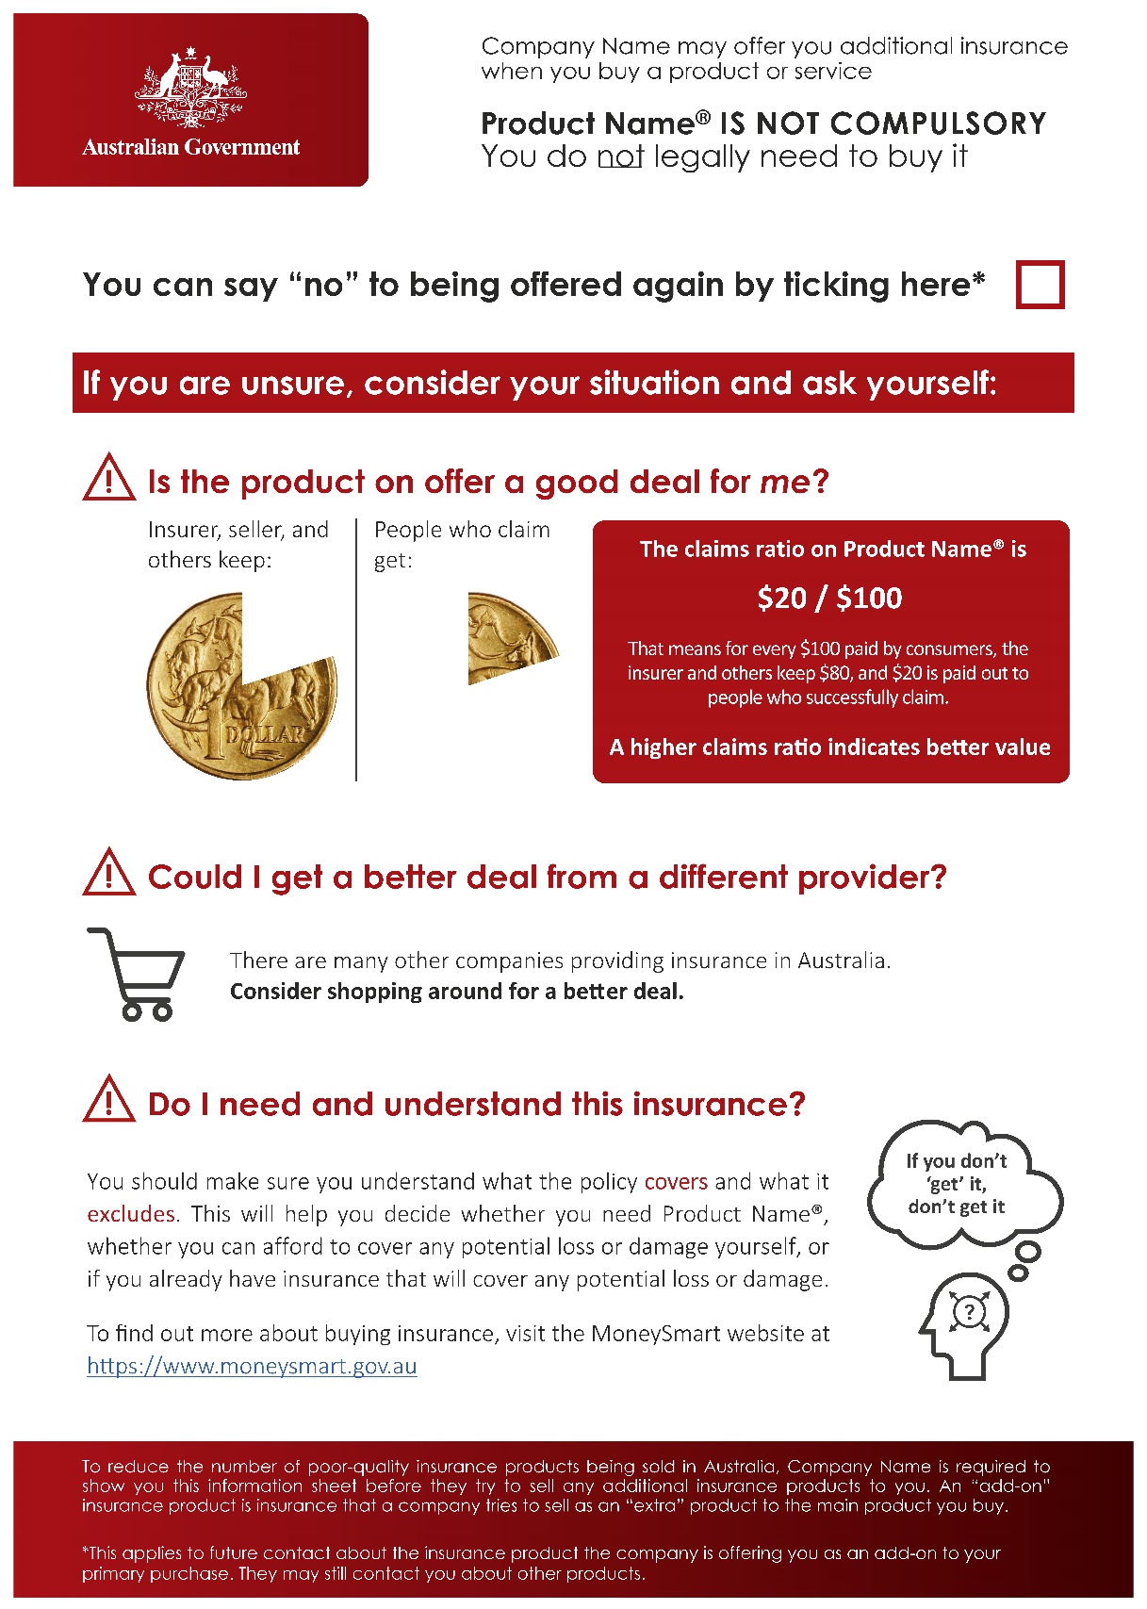
- Design of the information statements
Blue | Different claims ratios | No claims ratio
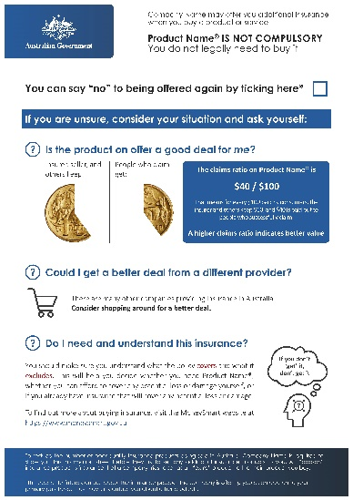 | 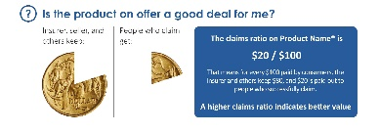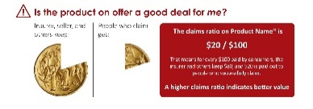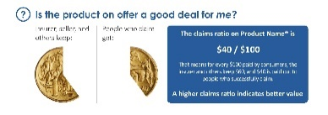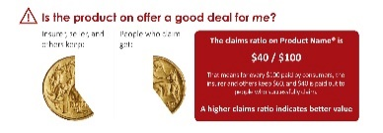 | 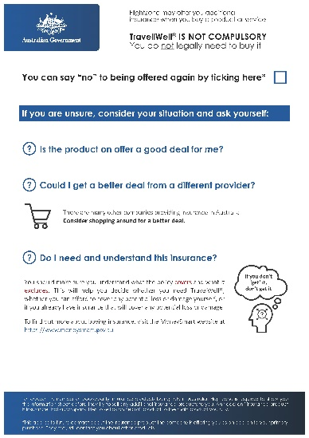
- Variations of the information statements

We tested six information statement designs using a framed field experiment
We conducted a framed field experiment with a nationally representative sample of 6,243 Australian adults. In addition to closely matching population demographics on age, gender, and location, we also recruited participants from a full range of socioeconomic backgrounds. A person’s financial circumstances and socioeconomic background can affect their decision-making, and those in less advantaged circumstances may especially benefit from being alerted to the (poor) value of add-on insurance (Anand & Lea, 2011; Sheehy-Skeffington, 2020).

Box 3: What is a framed field experiment?
A framed field experiment is a type of evaluation conducted with a sample of people drawn from the population of interest (in this case, all Australians), in which participants make choices in settings which approximate how they make decisions in real life (for example, sitting in front of their own computer in their own home, buying flights). Importantly, in a framed field experiment, people are randomly separated into two or more groups, in a manner similar to flipping a coin. People in a ‘treatment’ group receive an intervention (in this case, an information statement) while people in the ‘control’ group receive the business-as-usual experience (in this case, no information statement). On average, the difference in outcomes between people in a treatment group and in the control group reflects the causal impact of the interventions. Because of this randomisation, framed field experiments are a powerful empirical method for estimating a policy’s quantifiable impacts. It’s important to note, however, participants’ decisions in a framed field experiment (e.g., to buy or not buy add-on insurance) do not have the same consequences as ‘real world.’

Add-on insurance takes many forms, and is sold across a wide variety of industries both online and in-person. Acknowledging this, we included three different shopping scenarios in order to assess the effectiveness of the information statements across a range of contexts. We conducted the experiment via a survey, which had two parts. In the first part, participants completed one of three hypothetical shopping scenarios: buying a phone, buying flights, or getting a loan. In each shopping scenario, participants were given options to choose between (for example, different destinations to fly to) which were used to customise their scenario and make it more realistic.
After participants made a decision about the primary purchase, they were shown an advertisement for add-on insurance, as they often would in a real shopping experience. For those in the phone scenario, participants were offered an extended warranty; for flights, travel insurance; and in the loan scenario, participants were offered consumer credit insurance. The add-on insurance was presented on a colourful, attractive flyer, using a number of marketing tactics to mimic how add-on insurance is sold in the real world (see Figure 3).
After participants had considered the insurance, they were randomly assigned to see either one of six information statements (in the intervention conditions), or to simply proceed to the next page (the control condition, reflecting what consumers currently experience when offered add-on insurance). For those who saw an information statement, they were asked to read and interact with it as they would in real life (e.g., by clicking the opt-out box or hyperlinks) before continuing to the next page.
They were then offered the add-on insurance at the ‘checkout’ and asked whether they wanted to add it to their purchase. Once the ‘sale’ was complete, the shopping scenario (and experimental) section of the survey finished. In the second part of the study, we then asked a range of questions to gauge participants’ engagement with, and understanding of, different parts of the information statement.

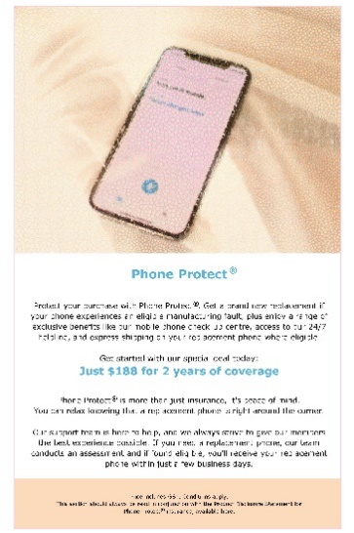
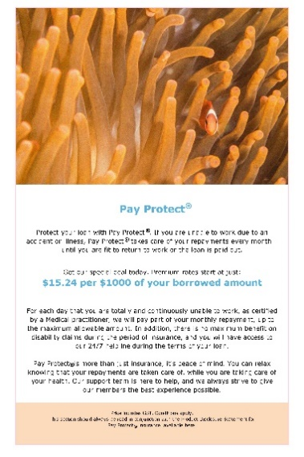
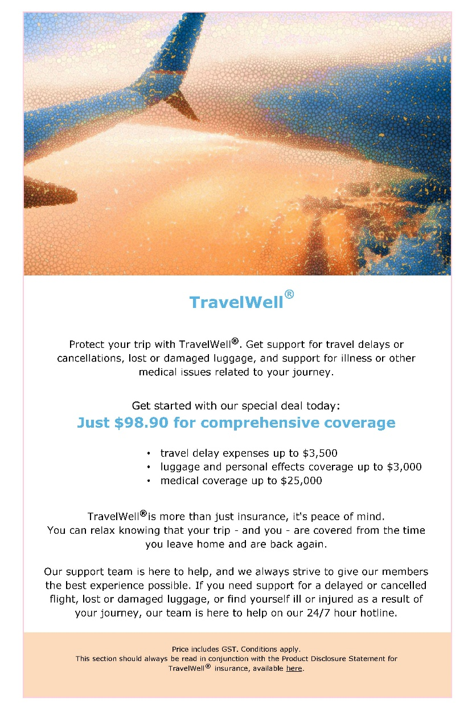
- Add-on insurance advertisements for travel insurance (flight scenario), extended warranty insurance (phone scenario), and consumer credit insurance (loan scenario)

What we found

In short
- People who saw an information statement were 24 per cent less likely to purchase add-on insurance. If we apply this to a figure of 2,263,136 add-on insurance sales for one year, this is a reduction of over half a million sales.
- The information statement helped slow down the decision to buy add-on insurance. In particular, the ‘insurance is not compulsory’ statement and opt-out section drew people’s attention, and may have helped give consumers ‘permission’ to say no to add-on insurance.
- There was no difference in the effects of red versus blue information statements.
- The claims ratio did not help people make purchasing decisions – it was not well-understood and may have confused and distracted people.
- Most attention was paid to elements in the top half of all information statements.

We found the information statements decreased sales of add-on insurance
Information statements had a large impact on reducing sales of add-on insurance in our experiment. On average, 29 per cent of people who saw an information statement bought add-on insurance, compared to 38 per cent of people who did not see an information statement. This represents a 24 per cent reduction in purchases of add-on insurance overall (see Figure 4).

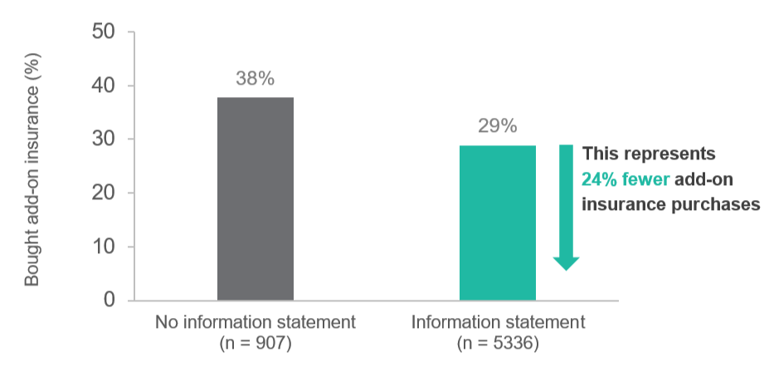
- Information statements reduce purchases of add-on insurance

Additional analyses highlighted some differences between scenarios
We also conducted some additional exploratory analyses which indicated the proportion of people who bought add-on insurance varied across the three shopping scenarios, but the information statement was effective in each (see Figure 5). Importantly, purchasing behaviour in each scenario was reflective of what we expect for the different primary products. For example, people were more likely to buy travel insurance (38 per cent overall) than loan insurance (28 per cent overall), which is consistent with travel insurance being the most common type of add-on insurance sold in Australia (General Insurance Code Governance Committee, 2018). These results suggest people were paying attention to the scenarios and treating the decision to buy add-on insurance as they would in ‘real’ life.
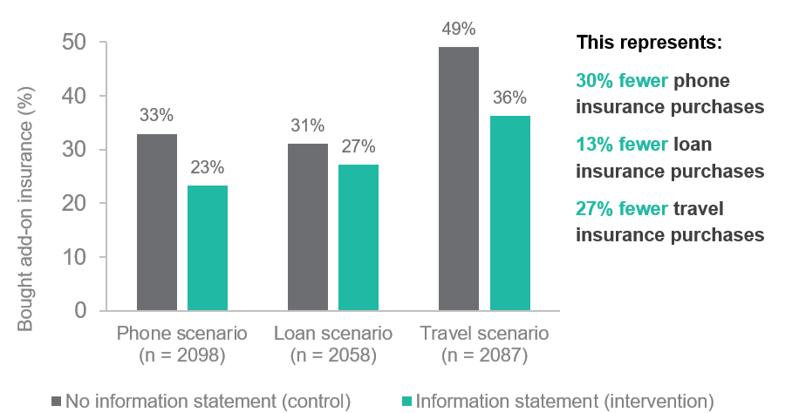
- Percent add-on insurance purchases across the three scenarios

We found no evidence to suggest either colour is more effective than the other: both are good options
Both red and blue information statements had similar effects on purchases of add-on insurance. Slightly fewer people who saw a red information statement bought add-on insurance (28 per cent) compared to those who saw a blue information statement (29 per cent). However, more people who saw blue information statements clicked the opt-out box: 23 per cent, compared to 20 per cent of people who saw red information statements. On balance, these findings do not suggest one colour is more effective than the other, and either is likely to be a good option for a final design.

We found no evidence to suggest the claims ratio helped people recognise or reject low-value add-on insurance
Those who saw an information statement with a claims ratio were less likely to purchase add-on insurance (28 per cent) overall compared to those who saw a statement without a claims ratio (30 per cent). However, this difference was small, not statistically significant, and masks evidence suggesting the claims ratio was a source of confusion.
For example, 29 per cent of people bought add-on insurance when their information statement showed them a lower (worse) claims ratio ($20/$100), compared to those who were offered a moderate (better) claims ratio ($40/$100) (30 per cent). If the claims ratio helps consumers make an informed decision about add-on insurance, we should see more people rejecting insurance with a lower claims ratio than a moderate one.
Additionally, including a claims ratio section reduced the number of people who opted out of follow-up. Among those who saw a claims ratio, 20 per cent of people opted out of follow-up, compared to 24 per cent among those who did not see a claims ratio.

Further analyses: survey results

The claims ratio was polarising and poorly understood by many
In the second component of the study, the survey, we asked people which regions of the information statement drew their attention first (see Figure 6). We also asked people which regions they liked or disliked. Whereas the sections with “this insurance is not compulsory” and the opt-out box were consistently well-liked, the claims ratio coin ‘pie chart’ and explanatory textbox were both liked by some (23 and 28 per cent respectively) and disliked by others (12 and 17 per cent respectively).
More concerning, those who selected the claims ratio (textbox or coin) as their favourite part of the information statement were much more likely to buy add-on insurance overall (38 per cent) than those who selected it as their least favourite part (14 per cent). They were also more likely to say the claims ratio section influenced their decision to buy add-on insurance (81 per cent saying it influenced them ‘a lot’ or ‘a bit’, compared to 55 per cent who disliked it).
We also found evidence to suggest the people who liked the claims ratio were less likely to understand it. In response to two comprehension questions about the claims ratio, those who said they liked it the most were also less likely to get both questions right (37 per cent) than the whole sample (44 per cent). Those who got both claims ratio questions wrong were also more likely to be financially insecure (30 per cent) compared to those who got both questions right (18 per cent), suggesting those who most need help to make informed decisions about add-on insurance may be most confused by the claims ratio.
When combined with the heat map results showing what caught people’s attention, these findings suggest the claims ratio section was poorly understood, may have misled some, and may have detracted from other parts of the statement – grabbing, but sapping, people’s attention (see Figures 6 and 7). This suggests this section of the information statement should be excluded from final designs in its current design and format.

Any claims ratio
No claims ratio

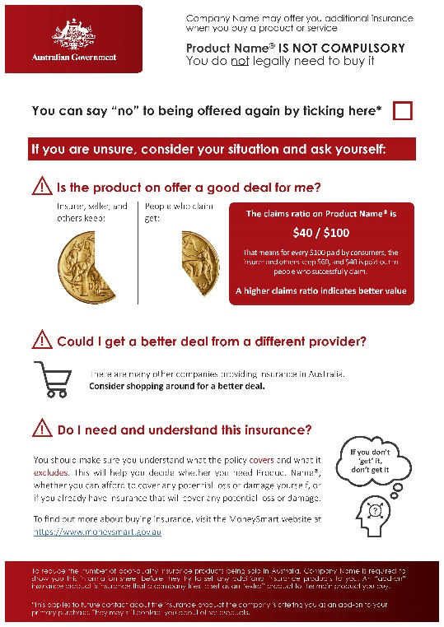
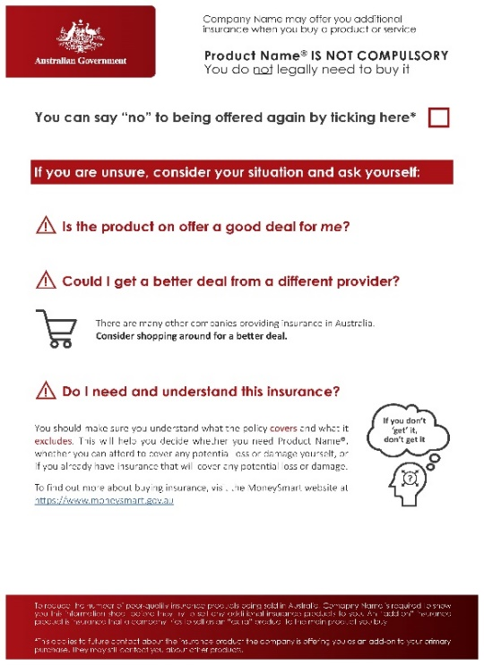
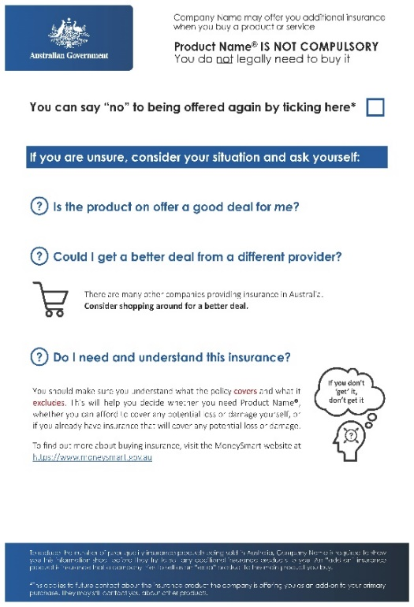
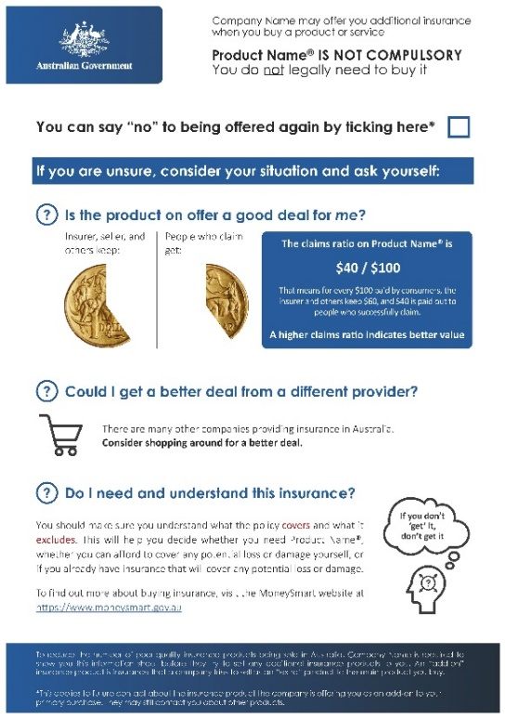
- Heat maps of areas grabbing people’s attention
Participants who saw an information statement were asked to click what drew their attention first on the information statement. The colours in the heatmap represent concentration of clicks – the darker the pink area, the more clicks. Green signifies fewer clicks; white signifies no clicks.

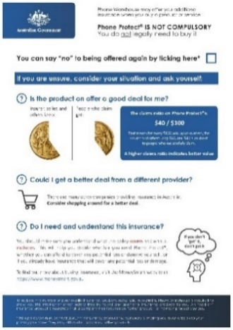
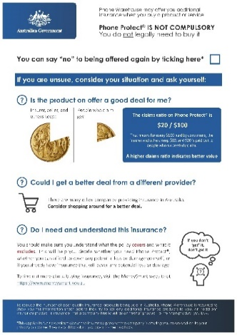
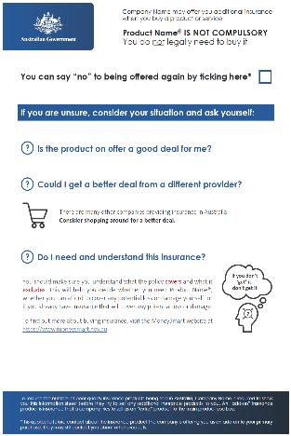
- Comparison of claims ratio and white space
The information statement without the claims ratio had more white space. Our findings suggest less is more: the claims ratio section detracted from other parts of the statement, in particular the opt-out box, which fewer people ticked when a claims ratio was present.

The ‘this insurance is not compulsory’ statement and opt-out regions influenced people’s buying decisions
In follow-up analyses we found across all statements, the ‘this insurance is not compulsory’, and ’you can say no‘ statements drew people’s attention the most. These were also the most liked, with 32 per cent and 31 per cent of responses selecting these respectively (they were rated as ‘neutral’ by around 65 per cent of the sample, and disliked by around 4 per cent).
Further, when we asked people why they chose not to buy the add-on insurance, those who saw an information statement were more likely to say it was because the insurance was not compulsory (30 per cent), compared to those who saw no statement (25 per cent). More people (25 per cent) also said they would shop around, another key message from the information statement, compared to those who saw no statement (19 per cent). Combined, this suggests the information statement acted as an effective reminder or notification about the fact add-on insurance is not compulsory, and prompted people to consider their options to opt-out of follow-up and shop around for different deals.

Discussion & conclusion

Our findings suggest an information statement presented to consumers before the sale of add-on insurance can help slow down the decision to buy
We found information statements reduced the number of people who bought add-on insurance in our experiment. Those who saw an information statement and didn’t buy add-on insurance were more likely to cite the fact it wasn’t compulsory and to say they would shop around as their reasons for declining the offer (compared to those who didn’t see a statement). This suggests the information statement slowed down the decision-making process and gave consumers permission to say no to add-on insurance.
Overall, either colour works well: People responded similarly to information statements in either red or blue. We also found people liked and were drawn to things at the beginning of the page, and tended to focus most on the first half. This supports putting the most important information for consumers in the top section of the statement.

More needs to be done to understand the impact of the claims ratio
We didn’t find evidence to suggest the claims ratio helped consumers decline poor-value add-on insurance. This is consistent with ASIC’s conclusions in the ‘Disclosure: Why it shouldn’t be the default’ report, which suggests complex financial information alone is often insufficient to help consumers make optimal decisions, and can even have harmful backfire effects (ASIC and Dutch Authority for the Financial Markets, 2019). We found the presentation of the claims ratio information was both unclear to those who understood the concept of the claims ratio, and may have given false confidence to those who didn’t understand it. Additionally, our research suggests the claims ratio section may detract from the opt-out box, an important mechanism for protecting consumers from further follow up about add-on insurance. For these reasons, further research into the most effective display of the claims ratio is warranted, as well as careful consideration of the merits of including the claims ratio information relative to other aspects of the information statement.

Ongoing testing will help shed light on how the information statement (in conjunction with the deferred sales model) performs in the real world
Our survey experiment allowed us to test different information statements across multiple shopping scenarios, using a randomised controlled trial in a framed field experiment with a large and nationally representative sample. We are confident the findings from this study support the use of timely, clear, and engaging prompts to help slow down the decision-making process, remind consumers add-on insurance is not compulsory, and provide them with an easy mechanism for opting out of any follow-up.
Our study was a framed field experiment that simulated shopping scenarios and purchasing conditions as closely as possible; we did not test actual add-on insurance purchasing. Further research with consumers in real-world settings will help determine the long term impact of the information statement (and associated deferred sales period) on sales and quality of add-on insurance in Australia.

References
Anand, P., & Lea, S. (2011). The psychology and behavioural economics of poverty. Journal of Economic Psychology, 32(2), 284-293.
Arkes, H. R., & Blumer, C. (1985). The psychology of sunk costs. Organizational Behavior and Human Decision Processes, 35, 124-140.
ASIC. (2016a). A market that is failing consumers: The sale of add-on insurance through car dealers (Report 492). Author.
ASIC. (2016b). Buying add-on insurance in car yards: Why it can be hard to say no (Report 470). Author.
ASIC. (2016c). The sale of life insurance through car dealers: Taking consumers for a ride (Report 471). Author.
ASIC. (2019). Consumer credit insurance: Poor value products and harmful sales practices (Report 622). Author.
ASIC and Dutch Authority for the Financial Markets. (2019). Disclosure: Why it shouldn't be the default (Report 632). Author.
Baker, T., & Siegelman, P. (2013). "You want insurance with that?" Using behavioral economics to protect consumers from add-on insurance products. Connecticut Insurance Law Journal, 20, 1-60.
Brewer, N. T., DeFrank, J. T., & Gilkey, M. B. (2016). Anticipated regret and health behavior: A meta-analysis. Health Psychology, 35(11), 1264.
Burson, K. A., Larrick, R. P., & Lynch Jr, J. G. (2009). Six of one, half dozen of the other: Expanding and contracting numerical dimensions produces preference reversals. Psychological Science, 20(9), 1074-1078.
Financial Sector Reform (Hayne Royal Commission Response - Protecting Consumers (2020 Measures)) Bill. (2020). Deferred sales model for add-on insurance. Author. Retrieved from https://treasury.gov.au/sites/default/files/2020-01/c2020-48919d-explanatory-memorandum.pdf
Finity Consulting. (2019). Add-on insurance products and the deferred sales model. Author.
Gabaix, X., & Laibson, D. (2006). Shrouded attributes, consumer myopia, and information suppression in competitive markets. The Quarterly Journal of Economics, 121(2), 505-540.
General Insurance Code Governance Committee. (2018). Who is selling insurance? 2014 General Insurance Code of Practice Own Motion Inquiry. Author.
Hogarth, R. M., & Kunreuther, H. (1995). Decision making under ignorance: Arguing with yourself. Journal of Risk and Uncertainty, 10, 15-36.
Insurance Council of Australia. (2017). Consumer research on general insurance product disclosures. Author.
Johnson, E. J., Hershey, J., Meszaros, J., & Kunreather, H. (1993). Framing, probability distortions, and insurance decisions. Journal of Risk and Uncertainty, 7, 35-51.
Kirkpatrick, L. A., & Epstein, S. (1992). Cognitive-experiential self-theory and subjective probability: Further evidence for two conceptual systems. Journal of Personality and Social Psychology, 63(4), 534.
Kunreather, H. C., Pauly, M. V., & McMorrow, S. (2013). Insurance and behavioral economics: Improving decisions in the most misunderstood industry. New York: Cambridge University Press.
Productivity Commission. (2018). Competition in the Australian Financial System Inquiry Report . Author.
Rabin, M., & Thaler, R. H. (2001). Anomalies: Risk aversion. Journal of Economic Perspectives, 15(1), 219-232.
Royal Commission into Misconduct in the Banking, Superannuation and Financial Services Industry. (2019). Final report. Commonwealth of Australia.
Sheehy-Skeffington, J. (2020). The effects of low socioeconomic status on decision-making processes. Current Opinion in Psychology, 33, 183-188.
Simon, H. A., & Stedry, A. C. (1969). Psychology and economics. The Handbook of Social Psychology, 5, 269-314.
Thaler, R. (1980). Toward a positive theory of consumer choice. Journal of Economic Behavior & Organization, 1(1), 39-60.
Thaler, R. (1985). Mental accounting and consumer choice. Marketing Science, 4(3), 199-214.
Treasury. (2019). Reforms to the sale of add-on insurance products: Proposal paper. Commonwealth of Australia.
Tversky, A., & Kahneman, D. (1974). Judgment under uncertainty: Heuristics and biases. Science, 185(2157), 1124-1131.
Tversky, A., & Kahneman, D. (1991). Loss aversion in riskless choice: A reference-dependent model. The Quarterly Journal of Economics, 106(4), 1039-1061.
Vohs, K. D., Baumeister, R. F., Schmeichel, B. J., Twenge, J. M., Nelson, N. M., & Tice, D. M. (2008). Making choices impairs subsequent self-control: A limited-resource account of decision making, self-regulation, and active initiative. Journal of Personality and Social Psychology, 94(5), 883-898.
Zajonc, R. B. (1968). Attitudinal effects of mere exposure. Journal of Personality and Social Psychology, 9(2), 1.

© Commonwealth of Australia 2020
ISBN: 978-1-925364-34-7
Using behavioural insights to improve decision-making about add-on insurance (Online)

Copyright Notice
With the exception of the Commonwealth Coat of Arms, this work is licensed under a Creative Commons Attribution 4.0 International license (CC BY 4.0) http://creativecommons.org/licenses/by/4.0

Third party copyright
Wherever a third party holds copyright in this material, the copyright remains with that party. Their permission may be required to use the material. Please contact them directly.

Attribution
This publication should be attributed as follows: Commonwealth of Australia, Department of the Prime Minister and Cabinet, Slowing down to add it up: Using behavioural insights to improve decision-making about add-on insurance.

Use of the Coat of Arms
The terms under which the Coat of Arms can be used are detailed on the following website: http://www.itsanhonour.gov.au/coat-arms

Behavioural Economics Team
of the Australian Government
General enquiries beta@pmc.gov.au
Media enquiries media@pmc.gov.au
Find out more www.behaviouraleconomics.pmc.gov.au

Full demographic details of the sample are included in the Technical Appendix.
For a copy of the full study (experiment and follow-up survey) see Appendix 3.
This figure is taken from the ‘Who is selling insurance’ report, which cited 565,784 add-on insurance sales during the July-September 2017 quarter (General Insurance Code Governance Committee, 2018).
This difference is statistically significant (p < .001) with a sample size of 6,243. We have a high degree of confidence in this result due to the large effect, large sample size, and small p-value, coupled with a rigorous pre-registered design. See Appendix 1 for information on BETA’s approach to statistical significance. Full statistical tables are included in Appendix 2.
The difference between the information statement and control conditions was not statistically significant in the consumer credit scenario, percentage point difference -3.7%, p = .190, n = 2058.
This difference was statistically significant, p = .037, n = 5,336. The rate of opt-out was pre-registered as a secondary outcome measure (the primary outcome measure was purchasing decision). The analysis comparing red and blue was also pre-registered.
This difference was statistically significant (p < .001) with a sample size of 5,336. We have a medium degree of confidence in this result due to the small effect, large sample size, and small p-value. This outcome measure (rate of opt-out) was pre-registered as a secondary outcome measure, and the analyses were pre-registered as well.
‘Financially insecure’ participants were those who would not be able to come up with $2,000 at short notice. 30 per cent of those who got both claims ratio questions wrong were in this cohort. We also asked whether participants had faced a range of shortages in the past 12 months, as an additional measure of financial insecurity. 49 per cent of those who got both claims ratio questions wrong said they had faced ‘none’ of the shortages; whereas 76 per cent of those who got both claims ratio questions right gave this answer.
Participants could select more than one reason for not buying insurance. The most common reasons for not buying insurance overall were “I don’t think I will need it’ (40%), and ‘The insurance was too expensive’ (38%), regardless of whether participants saw the information statement or not.

