Department of the Prime Minister and CabinetAustralian Government

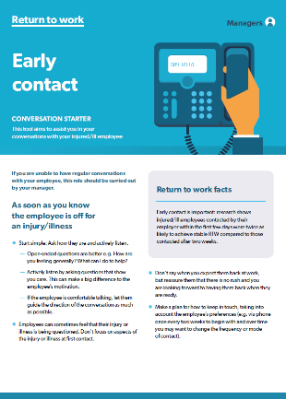**Returning to work after**

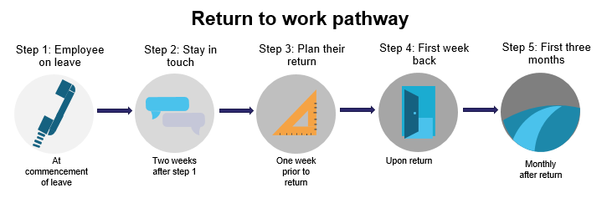**illness or injury is easier with supervisor support**

*Conversation starters provide tips for making contact with workers (the example for step 1 is shown above).*

The materials were delivered to supervisors in a five-step return to work process matching key points in the return to work journey:

**We drew on expert advice and behavioural science to design materials to help supervisors provide timely, tailored and ongoing support for workers.**

We tested the materials with theassistance of case managers from two APS agencies.

**Returning to work following an illness or injury is a complex challenge for people and workplaces across Australia. Supervisors play a critical role in supporting workers to return to work, but may have limited time, knowledge or confidence.**

**Supervisors and case managers reported the materials were useful**

*“Overall, I think the content is really good. [The Checklist] is great! The mental health content and language is great [in the suitable duties guide]” (HR, ATO)”*



**Tailored support materials provided at key points in the return to work**

**journey can help supervisors to provide timely and appropriate support**

**to injured or ill workers.**

Behavioural Economics Team of the Australian Government **pmc.gov.au/beta**