Returning to work after illness or injury
November 2020

Other uses
Enquiries regarding this license and any other use of this document are welcome at:
Managing Director
Behavioural Economics Team of the Australian Government
Department of the Prime Minister and Cabinet
Barton ACT 2600
Email: beta@pmc.gov.au
The views expressed in this paper are those of the authors and do not necessarily reflect those of the Department of the Prime Minister and Cabinet or the Australian Government.

Research team
Current and former staff who contributed to the report were: Su Mon Kyaw-Myint, Katrina Anderson, Linda Ma, Elizabeth Shaw, Harry Greenwell and Roxarne Armstrong.

Acknowledgments
Thank you to the (then) Department of Employment’s Applied and Behavioural Economics Section and the Attorney-General’s Department Workplace Compensation section for their support and valuable contribution in making this project happen. In particular, special thanks to Bruce Cunningham, Eve Wheeler, Tran Ngo, Megan O’Riordan, Jim Gilchrist, Alan Piira and Henry Jones for their work on this project.
We also extend our deep thanks to the staff members of the implementing partner agencies who ensured we were able to test our trial in the field.
The evaluation plan was pre-registered on the BETA website and the Australia New Zealand Clinical Trials Registry:
https://behaviouraleconomics.pmc.gov.au/projects/supporting-supervisors-improve-return-work-outcomes-injured-or-ill-workers https://www.anzctr.org.au/Trial/Registration/TrialReview.aspx?ACTRN=12619000166178

Who?

Who are we?
We are the Behavioural Economics Team of the Australian Government, or BETA. We are the Australian Government’s first central unit applying behavioural economics to improve public policy, programs and processes.
We use behavioural economics, science and psychology to improve policy outcomes. Our mission is to advance the wellbeing of Australians through the application and rigorous evaluation of behavioural insights to public policy and administration.

What is behavioural economics?
Economics has traditionally assumed people always make decisions in their best interests. Behavioural economics challenges this view by providing a more realistic model of human behaviour. It recognises we are systematically biased (for example, we tend to satisfy our present self rather than planning for the future) and can make decisions that conflict with our own interests.

What are behavioural insights and how are they useful for policy design?
Behavioural insights apply behavioural economics concepts to the real world by drawing on empirically-tested results. These new tools can inform the design of government interventions to improve the welfare of people.
Rather than expect people to be optimal decision makers, drawing on behavioural insights ensures policy makers will design policies that go with the grain of human behaviour. For example, people may struggle to make choices in their own best interests, such as saving more money. Policy makers can apply behavioural insights that preserve freedom, but encourage a different choice – by helping people to set a plan to save regularly.

Contents
Executive summary 4
Why? 5
What we did 7
What we found 19
Discussion and conclusion 22
Appendices 24
Appendix A – Study participants 24
Appendix B – List of outcome measures and data sources 25
Appendix C – Worker survey 26
Appendix D – Supervisor survey 34
Appendix E – Additional tables and figures 44
Appendix F – Additional information on implementation 53
Appendix G – Case manager survey 57
Appendix H – List of data variables to integrate with existing HR systems 61
Appendix I – Workers’ return to work experience before the intervention 62
References 64

Executive summary
Supporting a worker to return to work after illness or injury can be challenging for supervisors. Providing simple reference materials to supervisors at key points in the return to work journey can help.
Returning to work following an illness or injury is a complex challenge for people and workplaces across Australia. While compensation claims for work-related illness and injury has decreased over the last two decades, return to work rates have remained stable. As well as impacting on productivity, work-related injuries and illnesses have adverse financial, social and health consequences for workers and their families.
Many factors influence return to work success for a worker, including the supervisor–worker relationship. While supervisors play a critical role in supporting workers to return to work, supervisors may be apprehensive and have limited experience or competing priorities. Support materials are often complex, leading to cognitive overload and decision fatigue, and some supervisors may disengage when they are overwhelmed.
BETA and the (then) Department of Employment developed behaviourally informed reference materials for supervisors to support workers in their return to work. The materials provide guidance for supervisors to have informed conversations with workers at specific points in the return to work pathway. Materials were tailored to both psychological and physical conditions.
We partnered with the Department of Human Services (DHS) and the Australian Taxation Office (ATO) to pilot the materials. We trained 240 case managers to deliver the materials, and conducted surveys and interviews with supervisors, case managers and workers. Supervisors responded positively to the reference materials. Most remembered seeing the materials and the majority had read them. The majority of supervisors who read the materials considered these useful (78 per cent) and would recommend these to others (81 per cent). A small sample size meant we were unable to assess the impact of the materials on sustained return to work rates.
Through this report, the reference materials have been made available for use across the Australian Public Service (APS) and more broadly to assist supervisors and improve sustainable return to work rates. Testing of the materials in other settings could also be valuable.

Why?

Policy context
The APS has legislated obligations to support workers to achieve sustainable return to work following injury or illness. The National Return to Work Strategy 2020‒2030 (the Strategy) was developed to inform consistent policy across private and public workplaces (Safe Work Australia, 2019). The Strategy sets out five action areas to improve return to work outcomes and address common challenges across workers’ compensation schemes. The action areas are:
- supporting workers to be involved actively in their recovery and return to work
- building positive workplace culture and leadership to reduce stigma and promote positive relationships and behaviours
- supporting employers to effectively support workers in their recovery and return to work
- supporting other stakeholders to support workers
- building and translating evidence to make better use of data and research
This report contributes to these action areas, in particular supporting workers and employers.

The problem
Claims from work-related injuries and illnesses have declined over time, but return to work rates have remained stable and time off has increased, especially for psychological injury (Safe Work Australia, 2019; Wyatt, Cotton, & Lane, 2017). There are major consequences for the employer and worker when return to work processes fail or are less effective.
For the injured worker, being unable to return to work leads to adverse health, social and financial outcomes. Consequences for the employer include costs of recruiting new staff, costs associated with managing workers’ compensation claims (if work-related) and productivity losses. The overall costs to the Australian economy, health system and society have been estimated at $61.8 billion per year (Safe Work Australia, 2019).
Multiple factors affect the return to work process, with the supervisor–worker relationship being an integral component. Evidence suggests timely, tailored and ongoing support for workers is key to supporting a sustainable return to work (Wyatt & Lane, 2017). However, supervisors may face multiple challenges including:
- lack of confidence or knowledge on how and when to communicate with workers
- limited cognitive capacity to provide timely and early advice
- limited access to easy-to-understand information about what is a complex process
- limited time and availability

Box 1: Key terms used in this report
Term | Description
Worker | The term worker is used to refer to anyone who worked for an organisation, regardless of employment relationship (e.g. permanent, contract, casual, through labour hire companies).
Employee | The term employee is used to refer to those who have are employed on a permanent or a contract basis. In the surveys and reference materials, the agencies preferred the term ‘employee’ to ‘worker’ so we have used that term to accommodate their preference. All our materials are applicable to the broader definition (i.e., worker above).
Manager | Manager is the term used to refer to the direct supervisor of the injured worker in our materials and survey. The two agencies preferred the term ‘manager’ to ‘supervisor’ so we used ‘manager’ in these materials.
Supervisor | Supervisor is the same as manager. We use the term supervisor throughout the report as it is a more widely used term and consistent with the literature.
Case Manager | Human Resource staff in agencies involved with assisting supervisors and workers in the return to work process. Many are rehabilitation professionals.
Psychological injury | Mental disorder/illness. It is a term used in workers’ compensation legislation.
Recover at work | This term is used to describe workers returning to work before they are completely recovered and may involve a graduated return to work to pre-injury duties. Research shows benefits of work in recovery from illness and injury if appropriate support and workplace adjustments are provided.
Return to work | When a worker returns to work after absence due to illness or injury. Workers may resume pre-injury duties or modified duties.
Sustainable return to work | Sustainable return to work is achieved when a worker is back at work for three months or longer (short term absences such as to attend appointments or from a cold or flu are not included).
Active cases | Active cases are defined as cases that are open or ongoing during the data collection period for this study. Active cases include cases where injury or illness commenced before the data collection period and cases where injury or illness occurred during the data collection period.
New/incident cases | New or incident cases are defined as cases where injury or illness occurred during data collection periods for the comparison and the treatment groups. This means leave commencement data for new cases occurs within the data collection period. New cases are a subset of active cases.

What we did

We identified the supervisor–worker relationship as a key factor in return to work success
We conducted a literature review, user research and consulted with a diverse range of experts, staff and employers to investigate barriers and enablers to achieving a sustainable return to work. This evidence suggests workers are more likely to recover at work when the supervisor has early and regular contact with the worker and support is tailored and flexible.

Early and regular contact is important
Early and proactive communication along with day-to-day management of the return to work process leads to earlier and sustained return to work (Andersen, Nielsen, & Brinkmann, 2012). When workers are contacted early they perceive greater supervisor support and fairer treatment than those contacted later. These employees are more likely to return to work than those who did not have early workplace support and contact (Safe Work Australia, 2014). Other research has shown employees who were contacted by the workplace within three days of their injury or illness had a return to work rate approximately 20 percentage points higher than those who had no contact (Wyatt & Lane, 2017).
But supervisors do not always find it easy to make early and sustained contact. We undertook user research in the APS with 31 injured workers who had returned to work and 29 supervisors who had managed injured workers between July and September 2017. Workers reported early contact by an immediate supervisor created a sense of connection to the workplace. Supervisors reported competing work demands and discomfort with contacting absent employees as two important barriers to making regular contact. The latter may be due to uncertainty with how to manage a return to work process.

Supervisors need clear guidance on the return to work process
Supervisors are busy and return to work processes can be complex and time-consuming. Supervisors involved in our user research reported they found the return to work process difficult due to the administrative burden and lack of clarity surrounding roles and responsibilities. In other research, supervisors reported challenges such as not having capacity to engage with case managers, rehabilitation officers or workers, a lack of confidence in dealing with financial issues and concern about meeting legal requirements of the return to work process (Blackman & Chiveralls, 2011). This suggests clear resources and information about supervisor role and responsibilities, as well as better communication between all parties involved in the process, may lead to increased engagement and better return to work outcomes.

Supervisors need clear guidance on the allocation of suitable duties
Our user research identified a lack of supervisor knowledge in devising suitable duties. Supervisors’ willingness and ability to design suitable duties varied. Some supervisors found designing suitable work duties challenging, especially if they had limited time or if medical practitioners made non-specific recommendations.
Managing return to work for workers with psychological conditions is particularly complex. Return to work rates are typically lower, absences are longer and sustained return is less likely compared with workers with physical (musculoskeletal) conditions (Prang, Bohensky, Smith, & Collie, 2016; Smith, Black, Keegel, & Collie, 2014; Wyatt & Lane, 2017). Both Australian and international research indicates the lower return to work rate for employees with psychological conditions is due to the difficulty in determining when it is possible to return to work and the complexity in determining workplace accommodations compared to for those with physical conditions (Hogan, Kyaw-Myint, Harris, & Denronden, 2012; Smith et al., 2014; Zwerling et al., 2003).
In the user research, workers reported a lack of empathy and a lack of understanding of illnesses from supervisors, especially for mental health issues. This research also identified the following as being part of a successful return to work plan:
- collaboration and early design
- meaningful work and realistic goals
- regular review
- consideration of secondary illnesses (e.g. pain management, stress/anxiety).
These findings suggest managers may need additional help in identifying suitable duties and workplace accommodations, especially for employees with psychological claims.

How behavioural insights can help
Our user research indicates status quo bias may prevent supervisors from providing the necessary return to work support beyond their usual management responsibilities. This is likely particularly when workers are out of sight and supervisors no longer receive natural prompts to check in with them. Instead, supervisors may be focusing on their day-to-day work, even though an occasional check-in with their absent worker could be a valuable use of their time. This could be preventing the early and regular contact needed for return to work success.
Cognitive overload and decision fatigue also affect supervisors. Supervisors have challenging workloads, often navigating sensitive issues. Getting supervisors to engage with any additional process is challenging and the more difficult the process is, the more likely they will become fatigued and stop fully engaging. Cognitive overload can impede supervisors’ ability to understand roles and responsibilities and gain new knowledge on how to develop suitable duties.
Providing easy to understand guidance for supervisors at the right time may make it easier. This will be particularly important for supervisors who are navigating the return to work process for the first time.

Table 1. Biases/heuristics that may affect the supervisor–worker relationship
Bias/Heuristic | Definition
Status quo bias | The tendency to stick with our current course of action, even if we intend to or would benefit from change.
Cognitive overload and decision fatigue | Following complex procedures and having to make too many decisions requires a lot of mental effort and can reduce the quality of decision-making.

We developed behaviourally informed reference materials for supervisors to better support workers in their return to work
Supervisors have specific responsibilities in the return to work process and are the primary point of contact for the workplace. Supervisors know the worker and the work context well. However, supervisors are busy, return to work information may be complex and managing injured or ill workers can be time-consuming. We developed easy to use reference materials to be provided to supervisors at five specific points in the return to work pathway. The reference materials were designed to:
  - Make absent workers front of mind for supervisors at key times in the return to work process.
- Make return to work processes as easy as possible for supervisors.
The materials aim to improve supervisor support for injured or ill workers and evidence suggests this leads to earlier and sustained return to work. The materials are meant for all workers, including workers who may be considered vulnerable.
Figure 1 outlines the pathway map of the five return to work steps. Each step includes an email to the supervisor along with a conversation starter and other supporting materials. We used behavioural science principles to design the emails and materials. For example, each email is personalised and includes an action-oriented message to grab attention. The email is sent by the HR team, making use of the messenger effect, where behaviours are more likely to be influenced by messengers who are credible experts. This means supervisors are more likely to give weight to messages from HR who have specialist knowledge of the return to work process. Also, conversation starters guide supervisors to ask questions and provide information to the worker as appropriate for each step in the return to work pathway. More detail on each step is provided below.
- Return to Work Pathway Map
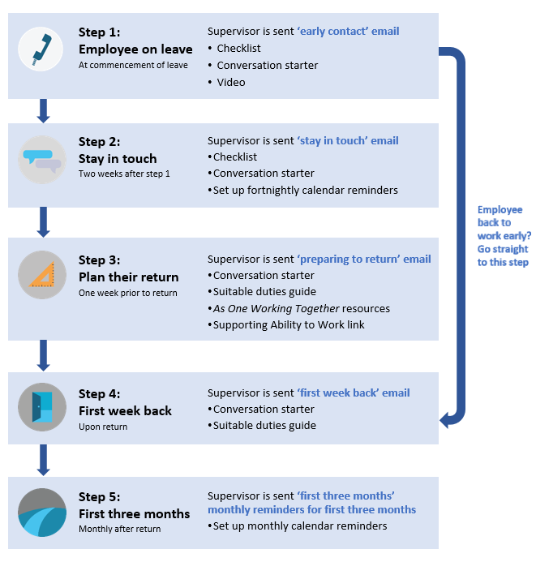

Step 1: Early contact – employee goes on leave
When a worker first goes on leave an early contact email is sent to the supervisor to encourage them to make first contact. The email outlines how making early contact helps and a reminder this is part of the agency’s return to work policy. This makes expectations of supervisor support salient and potential outcomes of their support more tangible. A checklist and video provide an overview of the process to reinforce expectations and guide supervisor behaviours throughout the five steps. A brief conversation starter provides supervisors with guidance on what to talk about with the injured/ill worker when first on leave.

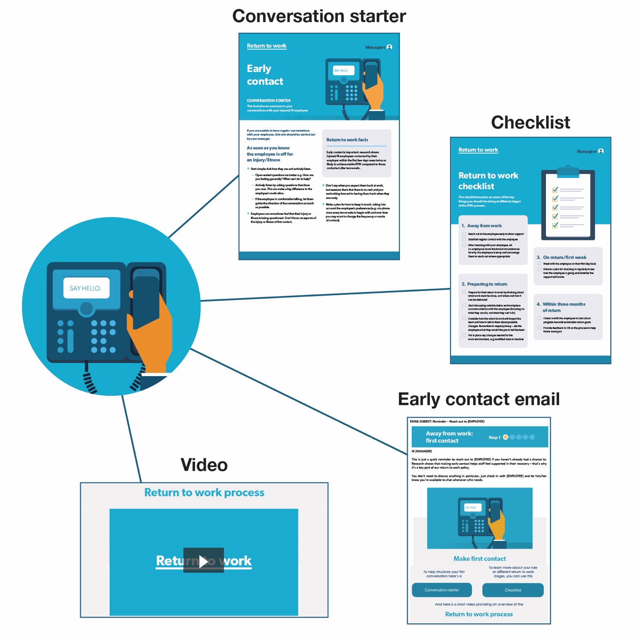

Step 2: Stay in touch – two weeks after Step 1
A second email is sent to the supervisor two weeks after Step 1, including links to the checklist, a tailored conversation starter, and a fortnightly calendar placeholder for regular contact between the supervisor and worker. The conversation starter provides guidance for talking about musculoskeletal disorders and mental illnesses separately, to account for different worker needs.
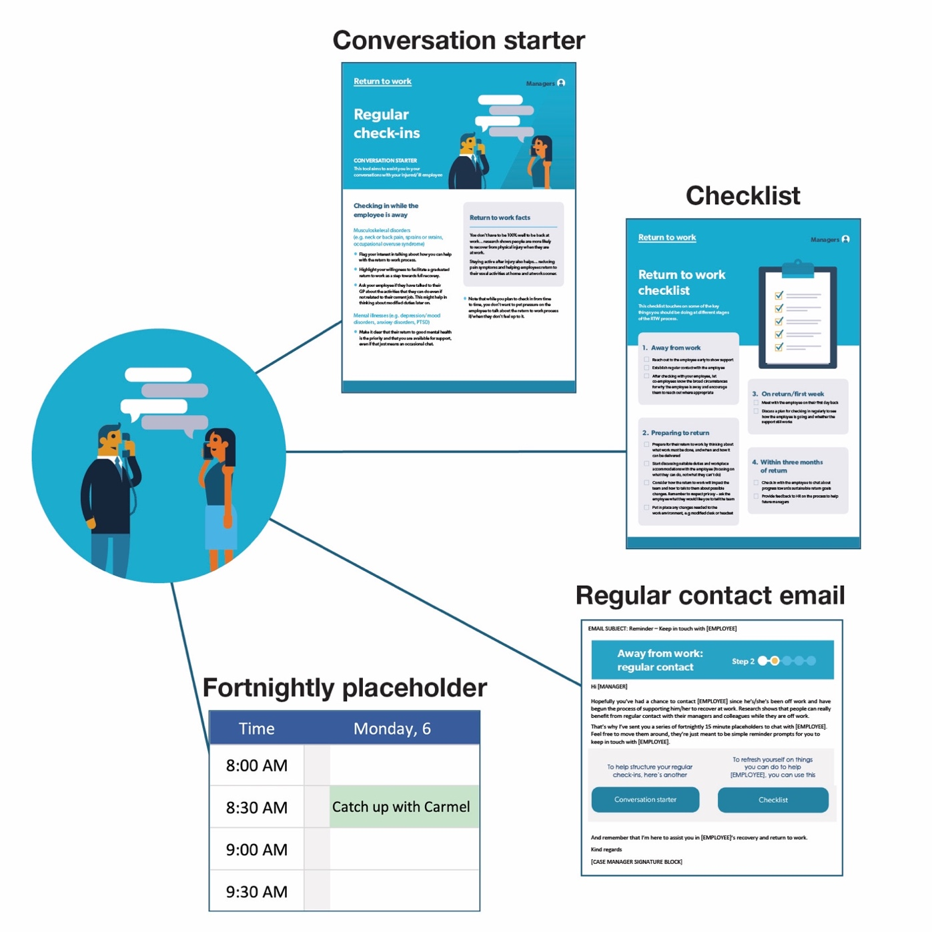

Step 3: Plan their return – one week before return
One week before the workers’ planned return the supervisor is sent a preparing to return email. A conversation starter, suitable duties guide and other resources are provided to assist the supervisor in supporting the worker to develop a return to work plan with adjusted duties if necessary. The suitable duties and reasonable adjustments guide is tailored to musculoskeletal and mental disorders separately. This easy to read booklet gives a summary of existing resources in an accessible format.

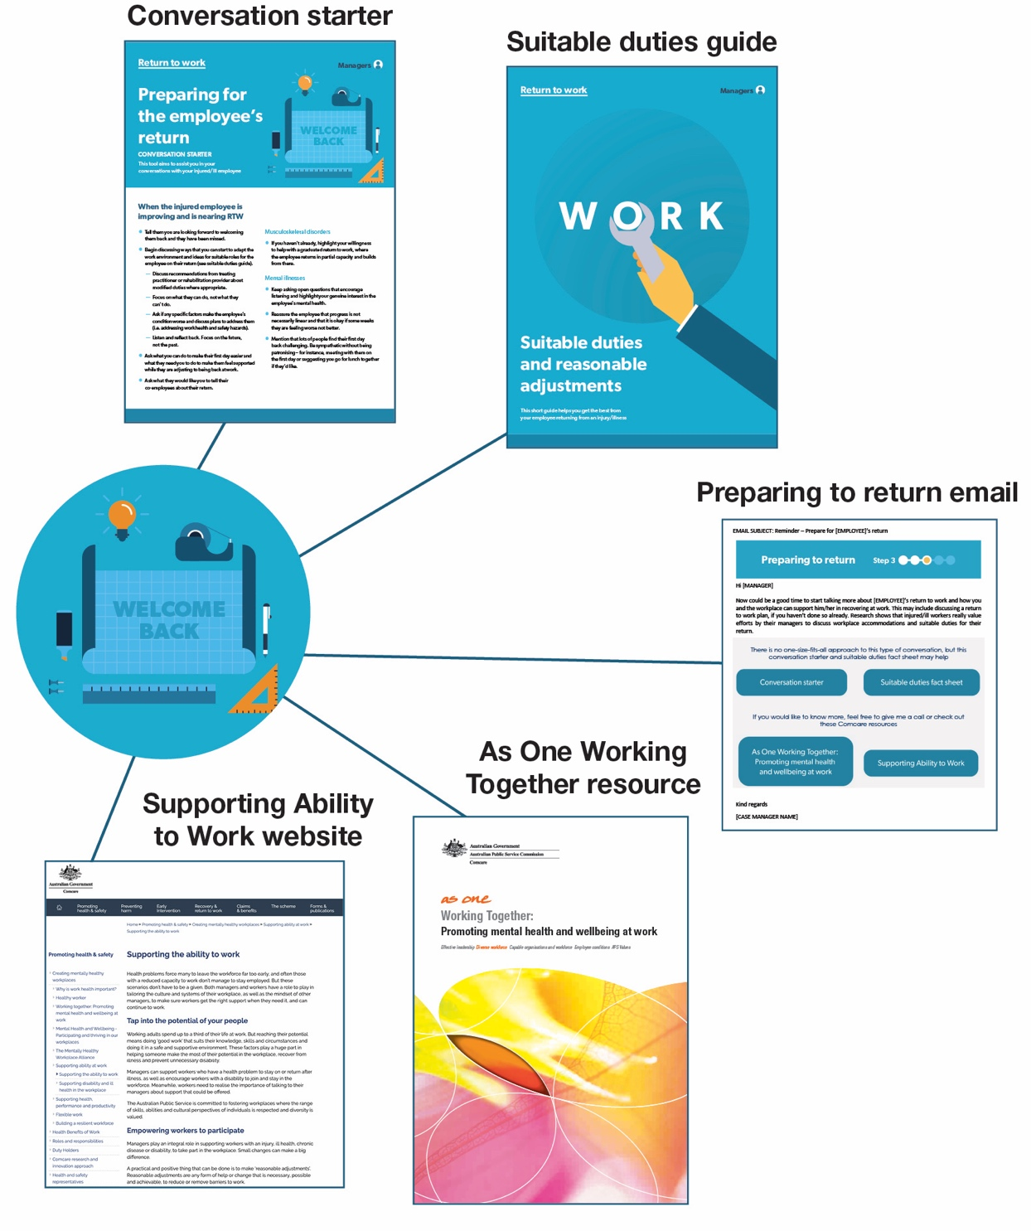

Step 4: First week back – upon return
The supervisor is sent an email upon the worker’s return as a reminder of the ongoing need to review the worker’s situation and needs. A conversation starter provides guidance for talking about current and future worker needs and work requirements. The suitable duties and reasonable adjustments guide is sent again as a reminder.

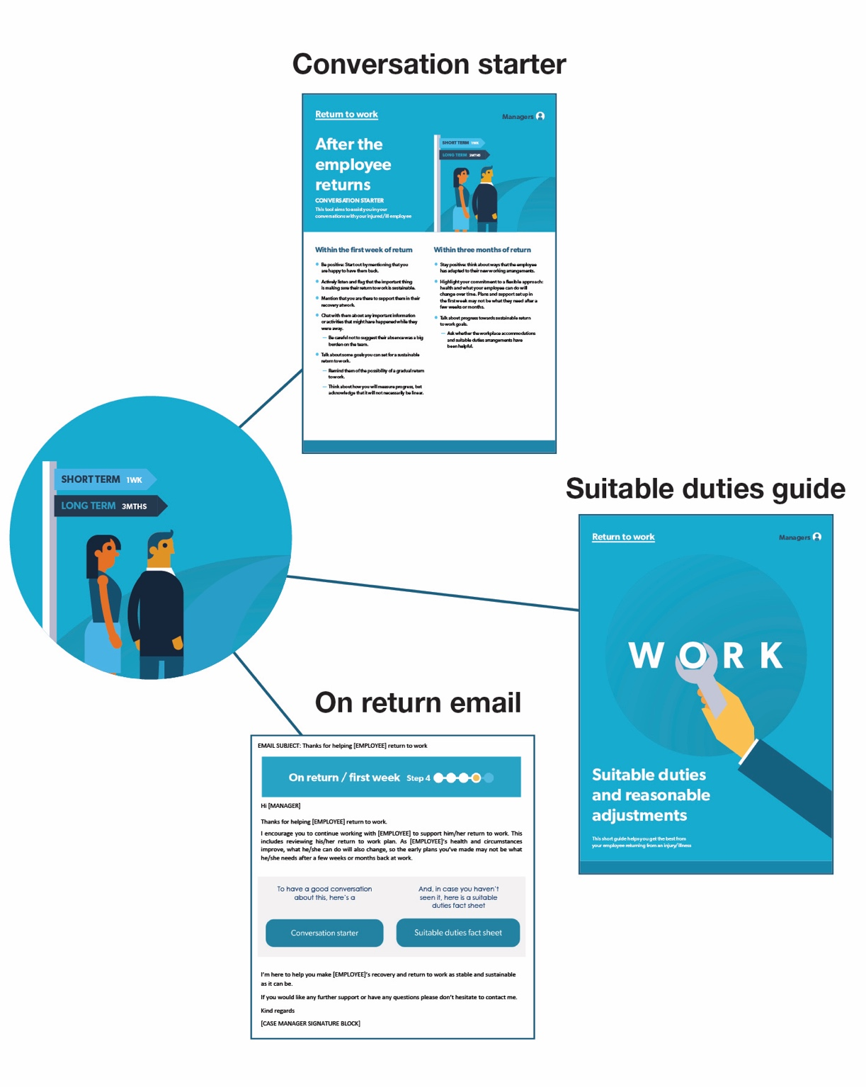

Step 5: First three months – one month after return, then every month
After the worker has been back for one month the supervisor is sent an email along with a conversation guide. Two calendar placeholders are sent for the following two months to remind the supervisor to check in with the worker.

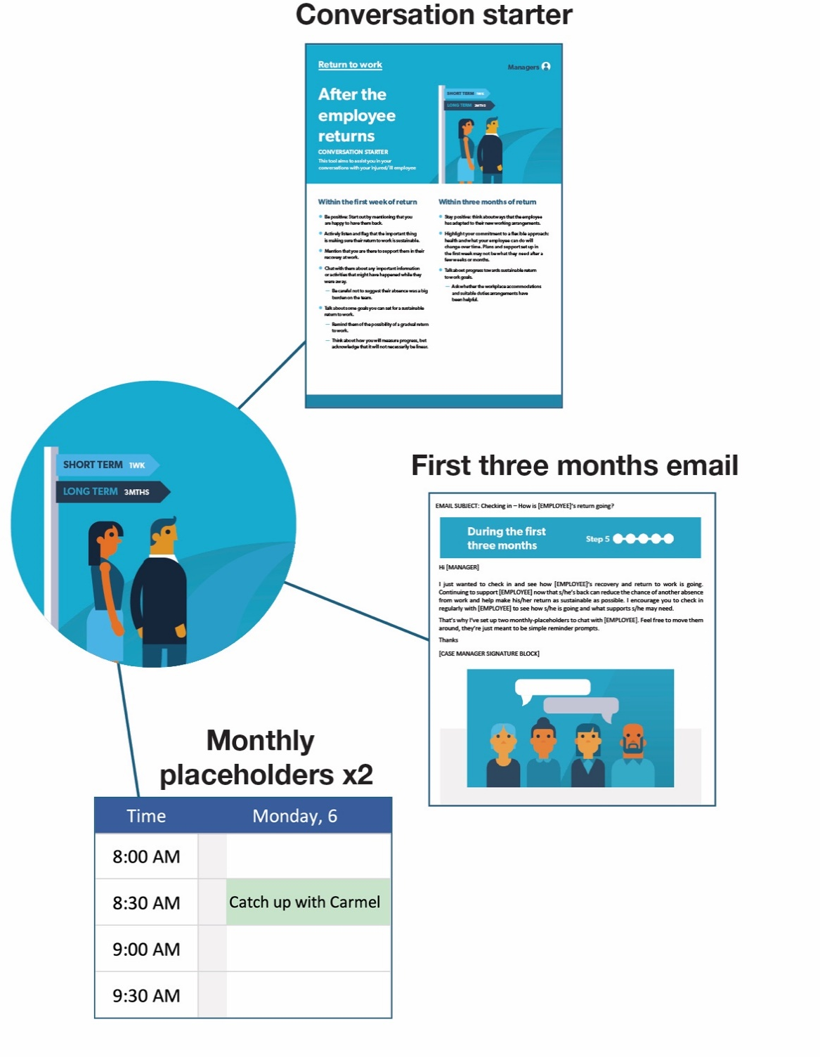

We received positive feedback from relevant HR staff and case managers during the development of the materials
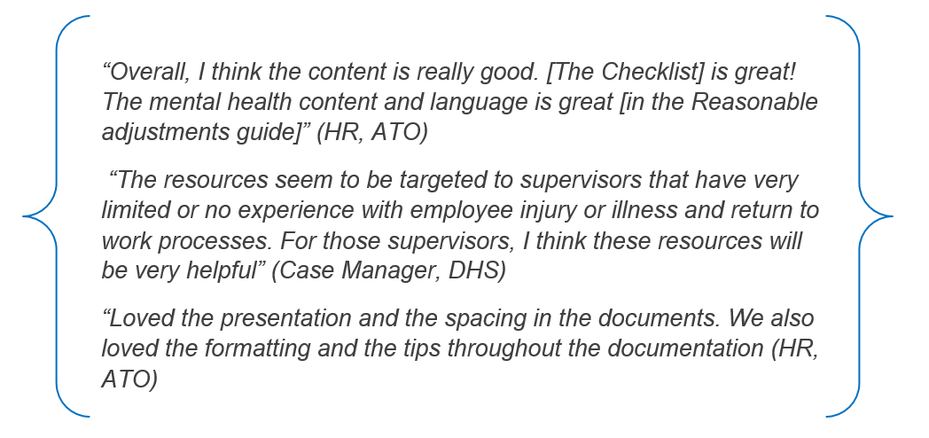

We worked with case managers to deliver the reference materials
We partnered with the ATO and DHS to pilot the five step delivery of the reference materials. Agency case managers played a key intermediary role in the delivery of the reference materials given their existing relationships with supervisors and workers and experience of the return to work process. We trained approximately 240 case managers and provided supporting materials on the agencies’ intranet sites, including:
- information sheets for case managers, supervisors and workers
- Frequently Asked Questions for project implementation
- a project journey map
- roles and responsibilities for implementation.
Project Steering Committees were established in each agency to champion the project and act as a contact point.

We conducted a mixed-methods evaluation
The evaluation design changed at several points in the project. We initially planned to conduct a randomised controlled trial (RCT) but the sample size was too small. This led us to develop and pre-register a mixed-methods design. This design meant both quantitative and qualitative data were collected. Rather than quantitative data informing the qualitative phase of the study (or vice versa), we collected similar information in both phases.
Our mixed-methods evaluation design included a before and after comparison of quantitative return to work outcomes for two worker groups: those whose supervisor experienced the standard return to work approach (the comparison group) and those where supervisors experienced the standard return to work approach and received the reference materials (the treatment group).
Although our intended mix-methods evaluation design was robust, we were unable to conduct before and after comparisons as planned. The two groups (comparison group and treatment group) needed to be similar on key baseline characteristics to make meaningful comparisons, for example, all new cases of injury or illness during the data collection period.
Instead we focused on descriptive comparisons and qualitative findings, noting the data limitations. This means we were still able to assess supervisors’ reactions to the materials and gain valuable insights into how the materials might be implemented more broadly across organisations in the APS as well as in private enterprise.
We gathered data through surveys and interviews of workers and managers, and a survey of case managers (Figure 2). We also set up an administrative data collection tool for case managers. The administrative data for the comparison group contained active and incident/new cases. The administrative data for the treatment group contained only incident/new cases. Data from the comparison group was collected during July to December 2018 and data for the treatment group during February to June 2019 (Appendix A).
To evaluate the materials we measured: the worker’s experience with the return to work process, the frequency and quality of support from supervisors, the worker’s work status at the end of study period, and the time taken to return to work (Appendix B). We also asked supervisors about the usefulness of the reference materials and their confidence with managing a returning to work case. Finally, we gathered data on how the intervention was implemented. Copies of worker and supervisor surveys are at Appendix C and D respectively. For further information on sample size and survey response rates, please see Table 1, Appendix E.

- Data gathered during this study
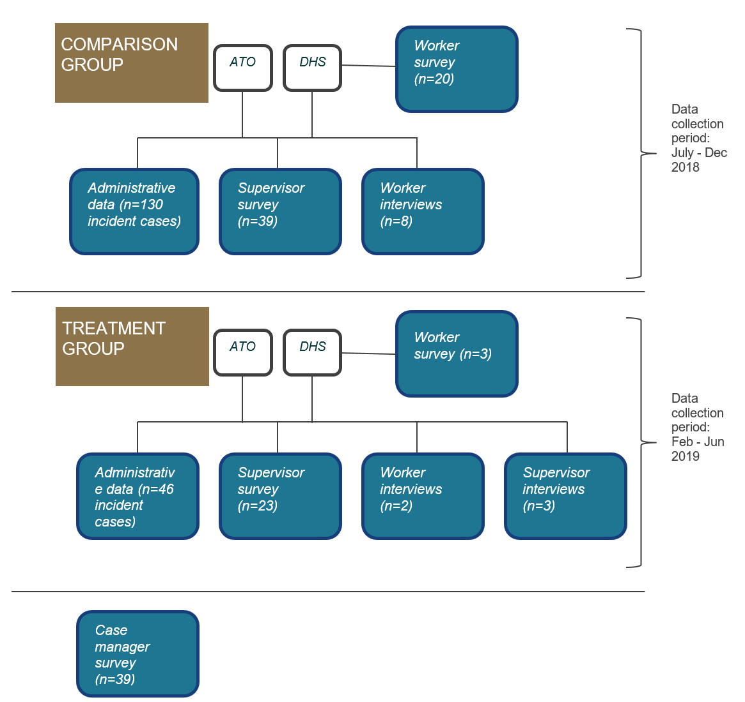
Note: Sample sizes presented in this figure for surveys are the number of respondents, not the number of people who received a survey invitation. For comparison group administrative data, we have only presented the sample size for incident cases. The comparison group administrative data also contains cases where injury or illness occurred before the study data collection period but the case was still active due to the worker still on leave or on graduated return to work. If such cases were included, the number of cases (i.e. active cases) in the comparison group database was 183. For definition of active and incident cases see Box 1.

What we found

Summary of findings
- For workers, we were unable to draw any conclusions about impact of the reference materials on their return to work.
- Supervisors responded positively to the reference materials. Most remembered seeing the materials and the majority had read them. Supervisors who read the materials considered these useful and would recommend the materials to others.
- Case managers were mostly positive about the reference materials although some did not feel these were relevant to their cases.

Workers’ experience
While our mixed-methods evaluation sought to compare workers’ outcomes before and after the materials were introduced, in practice this proved difficult. Beforehand, the return to work rate at the two agencies was 52 per cent. Afterwards, it was 74 per cent, however it is likely the ‘treatment group’ had different characteristics from the earlier ‘comparison group’ (see previous section for details). As a result, we do not know whether the difference in the return to work rate is due to the reference materials, differences between the two groups, or a combination of the two.

Supervisors’ access to and perception of the materials
We surveyed supervisors who received the materials in July 2019, with a response rate of 56 per cent (23 supervisors responded out of 41). While this is an acceptable response rate, survey responses may not be representative of all supervisors of return to work workers. We also interviewed three supervisors. For the majority of supervisor respondents (60 per cent), it was the first time they had managed someone through a return to work process. A copy of the survey is at Appendix D.
Supervisor respondents could remember receiving the reference materials and the vast majority (90 per cent) reported they received reminder emails. For those supervisors who were included in the intervention, the intervention emails were largely delivered as per the five step delivery guidelines. Most supervisors were sent three to four emails (see
Appendix F). While the materials were structured around five steps in the return to work process, it was always not appropriate to send five emails, and sometimes the ‘stay in touch’ email could be sent more than once.
The majority of respondents reported they had accessed the materials included in the intervention emails. More survey respondents reported reading the return to work checklist compared to the reasonable adjustments guide (Figure 3). Supervisors might not have accessed specific materials such as the reasonable adjustments guide unless they were needed. In addition, differences in the access rate of specific intervention materials likely reflect the design of intervention delivery.
- Proportion of supervisors who read reference materials
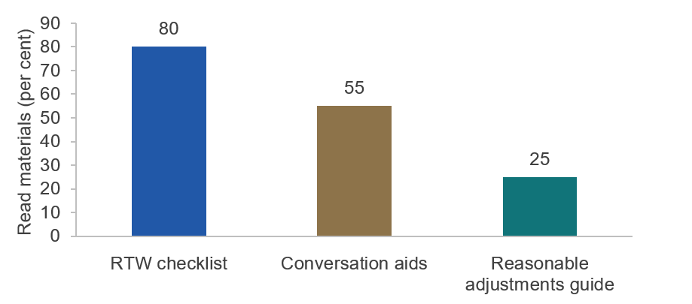
Note: n =21; Question: Which of these return to work materials have you seen or are familiar with? Participants were shown a screen shot of each of the materials. The response categories for each resource were ‘Yes I have seen it but have not read it’, ‘Yes I have read it before’ and ‘No I have never seen it before’. The percentages in the graph represent those who reported ‘Yes, I have read it before’.
Even when specific materials were not accessed, the emails served as reminders for the majority of supervisors:
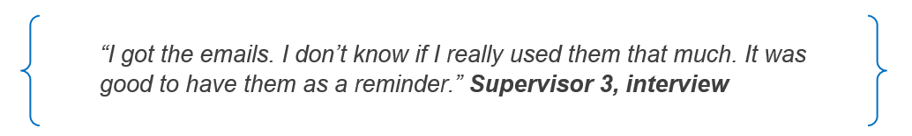
Supervisors were positive about the usefulness of materials they read, with 78 to 81 per cent agreeing they found the information valuable or useful (Figure 4). The majority of supervisors reported the conversations aids made it easier for them to have a conversation with their worker and were easy to understand (see Table 9, Appendix E for more details).
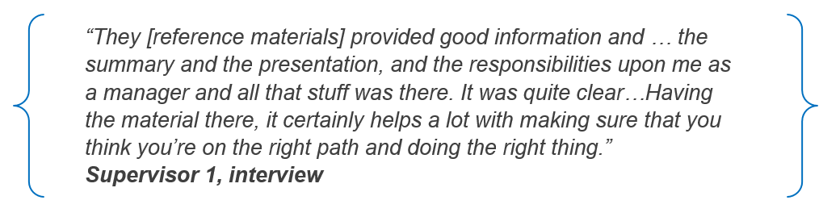
- Supervisor’s perception of reference materials
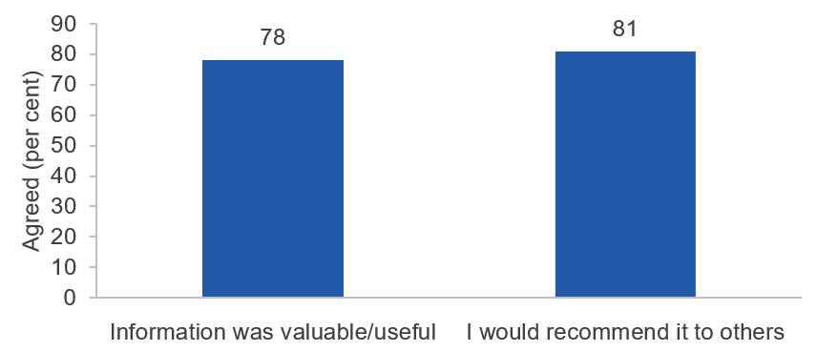
Note: This graph only includes supervisors who had read reference materials (n=32), Responses to specific intervention materials (e.g. RTW check-list and reasonable adjustment guide) have been combined. Response categories are on a 5-point scale from strongly agree to strongly disagree. The percentage presented in this graph are the proportion who agreed or strongly agreed to the statements. Please see Appendix D, Q21 for a list of the statements.

Case managers’ perceptions of the materials
We evaluated the implementation of reference materials in the two agencies to inform how the intervention would work in a real world setting. For information on sample size and response rates, see Table 1, Appendix E. A copy of the survey is at Appendix G.
Case managers commented positively during user testing on the content, checklist, formatting and presentation of the materials. This was consistent with case managers’ survey findings — around 75 per cent of respondents agreed the materials helped them explain to supervisors what was expected of them in supporting injured/ill workers. A similar proportion agreed the reference materials are appropriate for supervisors with a wide range of return to work experiences. While most case managers were positive about the reference materials, only a little over half of case managers who responded to the survey indicated they sent out reference materials. Reasons for not delivering the intervention were ‘materials being not appropriate for their cases’, ‘not having enough time’ and ‘moving into a different role’.
Some evidence suggests attitudes toward change and adoption of new processes can influence the use of the materials. Some case managers indicated they already knew all the information covered in the materials, the materials were too basic for experienced supervisors, or it caused further administrative burden and workload for case managers.
It is possible resource constraints contributed to lower participation by case managers in delivering the materials. Case managers reported intervention delivery and administrative data entry as additional tasks on top of their usual workload, and unnecessarily time-consuming (see Appendix F). While we tried to address status quo bias for supervisors by making it easy to access and read materials to support workers, it appears case managers may have been reluctant to adopt new processes.

Discussion and conclusion

Regular reminders with tailored and easy-to-understand information could help supervisors better support injured/ill workers return to work

Behaviourally informed reference materials could improve the return to work process
We designed timely reminders with succinct, specific information for supervisors about how to manage workers with an illness or injury through the return to work process. The aim was to improve stable return to work for workers with an illness/injury by supporting the supervisor–worker relationship.
We were unable to say whether the reference materials made a difference to return to work outcomes due to possible differences in the characteristics of the treatment and comparison groups, which impeded reliable comparisons between them. However, the materials were developed from a robust evidence-base, using insights from behavioural science, return to work experts and staff on the ground. Feedback from relevant staff suggests the materials fill an existing gap in supporting supervisors to manage staff returning to work.
BETA has provided all the reference materials developed for this study for consideration by organisations interested in improving the return to work process (see separate downloadable files on the BETA website).

Supervisor training is also needed
Well-designed reference materials on their own are unlikely to be enough to deliver significant improvements in the return to work process. Familiarising supervisors with reference materials regularly and through multiple channels would make relevant information front of mind when supervisors are required to manage an injured/ill worker. Training could be included as part of induction, performance agreement and manager training processes. It would also be beneficial to include case managers and human resource helpline staff in training.

Automated and targeted delivery of reference materials could increase impact
Automated systems incorporated into existing HR systems would enable reliable and targeted delivery of materials. This integrated system should include multiple pathways for case identification and automated reminders for supervisors. Appendix H provides a recommended list of data fields to integrate into existing HR systems.

More work is needed to address worker and case manager cognitive biases
There are multiple interacting factors affecting return to work outcomes. Our study only dealt with one aspect of the process. In addition to supervisor support reference materials, behaviourally informed interventions targeting workers and case managers could strengthen approaches to improve stable return to work rates.

Further evaluation and testing will help refine supervisor reference materials
This study highlighted the challenges in delivering and evaluating interventions on return to work. Given the complex nature of returning to work, the long follow-up period required and small sample sizes, a randomised controlled trial on return to work interventions would be very challenging but is much needed.

Appendices

Appendix A – Study participants
Case managers sent invitations to participate in surveys, along with the survey link, to both comparison and treatment groups. The surveys also invited participants to take part in a face to face or telephone interview for qualitative research.
For both the comparison and treatment groups, surveys were sent to injured/ill workers who had returned to work at the end of the data collection period. However, supervisors were eligible to participate in the survey even if their worker had not returned to work.

Inclusion criteria
The study population was injured/ill employees and their supervisors who have data recorded in the administrative case management databases held by DHS and ATO. The comparison group were employees and supervisors who had recent experience of the standard return to work process prior to intervention launch (July 2018 – December 2018), and the treatment group were those who had undertaken a return to work process during the intervention period (February 2019 – June 2019). This means the comparison group included both active and incident cases whereas the treatment group only consisted of workers (and their supervisors) whose absence commenced during the data collection period (i.e. incident cases). Active cases would have leave commencement date prior to the start of the data collection period for the comparison group.

Exclusion criteria
The following potential participants were excluded from the study: workers who were unable to give informed consent; workers in extreme physical or mental distress as determined by themselves or their supervisor/case manager; and those who the case manager deemed to be in a potentially stressful relationship with their supervisor.

Appendix B – List of outcome measures and data sources
Outcome | Data source(s)
Return to work status: Whether or not has returned to work | Case administrative data
Time to return to work: Median and average number of days taken to return to work | Case administrative data
Supervisor confidence and behaviour in relation to return to work | Survey data, Qualitative research
Supervisors’ assessment of usefulness of reference materials | Survey data, Qualitative research
Worker’s satisfaction with contact by supervisor | Survey data, Qualitative research
Perception of supervisor support | Survey data, Qualitative research
Intervention implementation and monitoring | Administrative data, Survey data

Appendix C – Worker survey

Survey development
The majority of questions in the worker survey were sourced from two existing questionnaires on return to work (RTW): the 2018 National Return to work Survey and the Monash Longitudinal Study of workers on workers’ compensation. We also included supervisor behaviour questions from a UK RTW study (Munir, Yarker, Hicks, & Donaldson-Feilder, 2012) and a Swedish RTW (Selander, Tjulin, Müssener, & Ekberg, 2015) and the K-6 mental health screening questions (Kessler et al., 2010).

Survey questions
Q1 You have been identified as someone who has experienced a recent injury or illness, requiring time off from work. In order to find out if you are eligible to participate in this survey, we need to ask you a few questions.
How long ago was your leave due to injury or illness?
- Less than one month ago (1)
- One to three months ago (2)
- Three to six months ago (3)
- More than six months ago (4)
Q2 How long were you/ have you been absent from work because of this injury or illness? Estimates are fine.
- Less than 10 days (1)
- Two weeks to a month (2)
- One to two months (3)
- Two to three months (4)
- Three months or more (5)

Q3 Below are a list of reactions your direct supervisor or manager may have had at the time you first notified them of your injury or illness. Please select as many as that apply.
- Blamed you for your injury/illness (1)
- Was supportive and helpful (2)
- Was angry that you would be off work (3)
- Did not believe that anything was wrong with you (4)
- Was eager for you to return to work (5)
- Has had no reaction (6)
- Reacted in another way (specify) (7)
Q4
Thinking about the role of your direct supervisor or manager following your injury or illness, do you agree or disagree with the following statements?
 | Strongly disagree (1) | Disagree (2) | Neither agree nor disagree (3) | Agree (4) | Strongly agree (5)
Your manager or direct supervisor did what they could to support you
Your manager or direct supervisor provided enough information on your rights and responsibilities
Your manager or direct supervisor made an effort to find suitable employment for you
Your manager or direct supervisor treated you fairly

Q5 Are you satisfied with the amount of contact by your manager or direct supervisor during your absence from work?
- Yes
- No, too little contact
- No, too much contact

Q6 Do you agree or disagree with the following statements regarding contact with your supervisor during your absence from work?
 | Strongly disagree (1) | Disagree (2) | Neither agree nor disagree (3) | Agree (4) | Strongly agree (5)
Contact from your manager or direct supervisor was helpful
You feel supported by your manager or direct supervisor

Q7 During my absence from work, my manager or direct supervisor discussed with me about how to stay in touch, taking into account my preferences.
- Yes
- No
- Not applicable (please explain) ________________________________________________

Q8 During my absence from work, my manager or direct supervisor explained the return to work process/procedures to me.
- Yes
- No
- Not applicable (please explain) ________________________________________________

Q9 Have you returned to work at any time since your injury or illness? (Note: this can include return to work at a different section, branch or employer).
- Yes
- No
- Don't know/ Prefer not to say
If Yes: go to Q10
If No: go to Q19
Q10 When you went back to work, was this with the same direct supervisor or manager as at the time of your recent injury or illness?
- Yes, same supervisor/manager
- No, changed supervisor/manager
Q11 When you FIRST went back to work, were the hours you returned to the same, more or less than what you were doing at the time of your recent injury or illness?
- Same
- More
- Less
Q12 When you FIRST went back to work, were the duties you returned to the same, slightly different or completely different to what you were doing at the time of your work-related injury or illness. NOTE: ‘slightly different’ includes ‘restricted’, or ‘alternate’ duties
- Same duties
- Slightly different (modified/ light duties
- Completely different duties
If slightly different or completely different go to Q13
Q13 Did you feel that these different duties were meaningful?
- Yes
- No
- Don't know/ Can't say
Q14 Did these duties match your physical capabilities?
- Yes
- No
Q15 Did these duties match your psychological capabilities?
- Yes
- No
Q16 In your opinion, has returning to work helped, hindered or not affected your recovery from your injury/ illness?
- Helped
- Hindered (delayed)
- Not affected
- Don't know/ Can't say
Q17 Thinking about your current situation, do you agree or disagree with the following statements?
 | Strongly agree (1) | Agree (2) | Neither agree nor disagree (3) | Disagree (4) | Strongly disagree (5) | Don't know (6)
I am able to perform/ complete my work tasks.
I can deal with the physical demands of my work.
I am able to cope with work pressure.
I have no energy left to do anything.
I am able to handle potential problems if they arose.
Q18 Thinking about your current situation do you feel motivated and involved in your work?
- To a very large extent
- To a large extent
- Somewhat
- To a small extent
- To a very small extent
- Don't know
Q19 Do you have a Return to Work (RTW) plan?
- Yes
- No
- Don't know
If Yes: Go to Q20
Q20 My return to work plan is fair and adequate.
- Strongly agree
- Agree
- Neither agree nor disagree
- Disagree
- Strongly disagree
Q21 Overall, is your injury/illness better or worse than you expected it to be at this point?
- Much better
- Somewhat better
- What you expected
- Somewhat worse
- Much worse
If Q9 = No:
Q22 How likely do you think it is that you will return to work (at all)?
- Very likely
- Somewhat likely
- Not at all likely
- Don't know/ can't say

Q23 How would you rate your ability to cope at the moment with your injury or illness? Would you say...
- Very poor (ability to cope
- Poor
- Moderate
- Good
- Very good (ability to cope)
Q24 In the last four weeks how often did you feel...
 | All of the time (1) | Most of the time (2) | Some of the time (3) | A little of the time (4) | None of the time (5) | Don't know (6)
nervous
hopeless
restless or fidgety
so depressed that nothing could cheer you up
that everything was an effort
worthless

Q25 Pre-injury/illness questions
The next questions are about your relationship with your direct supervisor or manager in general, before your injury or illness.
In general, how often...
 | Always (1) | Often (2) | Sometimes (3) | Seldom (4) | Never/hardly ever (5) | Don't know (6)
was your manager or direct supervisor willing to listen to your problems at work?
did you get help or support from your manager or direct supervisor?
did your manager or direct supervisor talk with you about how well you carried out your work?
Q26 Before your injury/illness to what extent did you feel motivated and involved in your work?
- To a very large extent
- To a large extent
- Somewhat
- To a small extent
- To a very small extent
Q27 About you
These last few questions are about you. Could you please tell us your gender?
- Female
- Male
- Other
- Prefer not to say

Q28 What is your age?
- 18-24 years
- 25-34 years
- 35-44 years
- 45-54 years
- 55-64 years
- 65 and older
- Prefer not to say
Q29 What is your substantive (or acting) APS level?
- APS 1-4
- APS 5-6
- EL1-EL2
- SES
- Prefer not to say
Q30 Do you have any further comments about your return to work process that you would like to mention?
________________________________________________________________

Appendix D – Supervisor survey

Survey development
The majority of questions in the supervisor survey were developed by BETA. Questionnaire development involved:
- drafting and reviewing of the questions by BETA staff
- cognitive interviews with four managers who have had experience in managing a worker on RTW (two from BETA and two from ATO) in October 2018
- piloting the supervisor survey with 43 managers who had had RTW experience in the Department of Employment, Small and Family Business in November 2018
- finalising the survey and testing it on the Qualtrics platform.
The questions on return to work behaviours were adapted from Munir and colleagues ((Munir et al., 2012).

Survey questions
Q1 Do you directly supervise or manage staff in your role?
- Yes
- No
If No: go to end
Q2 Are any of the employees you manage or directly supervise away on long-term sick leave due to an injury or illness? Note: Long-term sick leave is defined as consecutive sickness absence of at least ten days. An injury or illness does not have to be a workers' compensation case. Examples include surgery, cancer, depression or back pain.
- Yes
- No
Q3 In the last six months, have you managed or directly supervised an employee who has returned to work from a long-term injury or illness?
- Yes
- No
Q4 Is this your first time managing or directly supervising an employee through a RTW process? Note: The return to work process is different for everyone. Its goal is about helping the employee to remain or recover at work. For some employees, this may involve first returning to work at partial capacity. They may then gradually build up to their pre-injury hours or job.
- Yes
- No
The next set of questions are about the most recent experience you have had in managing and supporting an employee through a return to work (RTW) process.
Note: If you have supervised multiple employees on RTW, please answer the questions for your most recent experience.
Q5 About the injured employee
Talking about your most recent experience, were you their direct supervisor or manager before they became injured or ill?
- Yes
- No

Q7 Has this employee returned to work at any time since their injury or illness? Note: this can include return to work at a different section or branch in any capacity, even for a brief period of time and have had to go back on leave). Please do not answer Yes if they had only been back at work for a visit.
- Yes
- No
If Yes go to Q8
If No go to Q10
Q8 How long was this employee off work in total due to their injury or illness? Note: If the employee is still away, please put the length of absence to date. Estimates are fine.
- Less than two weeks
- >2 weeks to less than a month
- One month to two months
- Three months to five months
- Six months to less than a year
- More than one year
- Other (please specify) ________________________________________________
Q9 When they returned to work, did they have you as their manager or direct supervisor?
- Yes
- No
Q10 When they return to work, will they have you as their manager or direct supervisor?
- Yes
- No
- Don't know/Can't say
Q11 How confident are you about...
 | Not at all confident (1) | Slightly confident (2) | Moderately confident (3) | Highly confident (4) | Completely confident (5)
Supporting an employee on long-term sickness absence
Managing an employee on return to work
Identifying suitable duties and reasonable adjustments
Finding information you need on your responsibilities as a supervisor

Q12 Note: Some of the questions may not be applicable to your particular situation and there are no right or wrong answers. For example, if your employee was only absent for a short period of time, or was proactive in contacting you, you may not need to discuss a plan to stay in touch or check-in with them regularly. To help us understand the individual nature of each case and how communication and support needs to be tailored in each case, please provide a short explanation when you select not applicable to the following questions. During the employee's absence, I
... discussed with them about how to stay in touch, taking into account their preferences
- Yes
- No
- Not applicable (explain why) ________________________________________________
... checked in with them regularly
- Yes
- No
- Not applicable (explain why) ________________________________________________
... consulted with HR and other relevant professionals involved in employee’s RTW process
- Yes
- No
- Not applicable (explain why)____________________________________________
... was quick to respond to them via email, text or telephone
- Yes
- No
- Not applicable (explain why) ________________________________________________
... explained the return to work process /procedures to the employee before they returned
- Yes
- No
- Not applicable (explain why) ________________________________________________

If returned to work:
Q13 When the employee returned to work, I ...
... discussed any changes to their role, responsibilities and work practices
- Yes
- No
- Not applicable (explain why) ________________________________________________
... gave them lighter duties/ modified duties during their initial return to work
- Yes
- No
- Not applicable (explain why) ________________________________________________
... discussed reasonable adjustments/modified duties
- Yes
- No
- Not applicable (explain why) ________________________________________________
... met them on their first day back
- Yes
- No
- Not applicable (explain why) ________________________________________________
Q14 Again thinking about your most recent experience managing or directly supervising an employee with a long-term injury or illness, did you have contact with a case manager? Note: A case manager is someone within your organisation, usually from HR. They assist employees with long-term health issues and also support supervisors of these employees.
- Yes
- No
Q15 Please rate your level of agreement to the following statements.
 | Strongly disagree (1) | Disagree (2) | Neither agree nor disagree (3) | Agree (4) | Strongly agree (5)
The support provided by the case manager was helpful.
The information provided by the case manager was useful.

Q16 Reference materials (NOTE: this section is for treatment group managers only)
During your employee's absence, did you receive reminder emails (example below) about keeping in touch with your employee?
- Yes
- No
- Can't remember
Q17 Please rate your level of agreement to the following statement.
The reminder emails helped me to stay in touch with my employee.
- Strongly disagree
- Disagree
- Neither agree nor disagree
- Agree
- Strongly agree
Q18 In addition to reminders about stay in touch, did you receive resources about how to support your employee?
- Yes
- No
- Can't remember
Q19 Have you accessed any of the RTW materials attached to the reminder emails?
- Yes
- No
- Can't remember
Q20 Which of these RTW materials have you seen or are familiar with?
 | Yes, I have seen it but have not read it (1) | Yes, I have read it before (2) | No, I have never seen it before (3)
Checklist
Conversation guide
Reasonable adjustments guide
Q21 Please rate each of the statements below on the RTW checklist to show the extent to which you agree or disagree with the statement.
 | Strongly disagree (1) | Disagree (2) | Neither agree nor disagree (3) | Agree (4) | Strongly agree (5)
I found the information valuable
The checklist made it easy for me to keep track of things
I would recommend the checklist to others
Please rate each of the statements below on the RTW conversation aid(s) to show the extent to which you agree or disagree with the statement.
 | Strongly disagree (1) | Disagree (2) | Neither agree nor disagree (3) | Agree (4) | Strongly agree (5)
Makes it easier to have conversations with my employee
Is easy to understand and follow
I would recommend it to others
Please rate each of the statements below on the RTW suitable duties guide to show the extent to which you agree or disagree with the statement.
 | Strongly disagree (1) | Disagree (2) | Neither agree nor disagree (3) | Agree (4) | Strongly agree (5)
Helps me to identify suitable duties for my employee
I will refer to it again if needed
I would recommend it to others
Q22 About you
Thanks for taking time to respond to our survey. Our last few questions are about you.
How long have you been managing or directly supervising staff?
- Less than one year
- One to three years
- Three to five years
- More than five years
Q23 Could you please tell us your gender?
- Female
- Male
- Other
- Prefer not to say
Q24 What is your age?
- 15-24 years
- 25-34 years
- 35-44 years
- 45-54 years
- 55-64 years
- 65 and older
- Prefer not to say
Q25 What is your substantive (or acting) APS level?
- APS 1-4
- APS 5-6
- EL1-EL2
- SES
- Prefer not to say
Q26 Is there anything you would like to share with us about your experience in managing an employee on RTW?
________________________________________________________________

Appendix E – Additional tables and figures
This appendix presents descriptive findings on case implementation, characteristics of workers in the study, workers’ perceptions of supervisor support, modified duties provided to workers, supervisors’ level of confidence about managing workers on RTW, and supervisors’ and case managers’ feedback on the RTW reference materials.
Where results are presented in tables for both the comparison and treatment groups, we caution using these results to draw conclusions about differences between the two groups. This is because selection bias and small sample size issues — discussed earlier in the report — mean the groups may not be directly comparable. Instead, results should be taken as qualitative, descriptive summaries.
Active cases are defined as cases that are active/open during the data collection period for the comparison group. Active cases would have a leave commencement date prior to the start of the data collection period for the comparison group. New/incident cases are defined as cases that commenced during the data collection period for the comparison group. This means leave commencement data for new cases occur within the data collection period. New cases are a subset of Active cases.
Figure five shows the distribution of cases between the treatment group and the comparison group over the five months of the study. Comparison group cases peaked in month two, with 47 cases while the treatment group declined slowly over the five months, from 15 cases in month one to two cases in month five.
- Distribution of cases by month during the two phases of the study
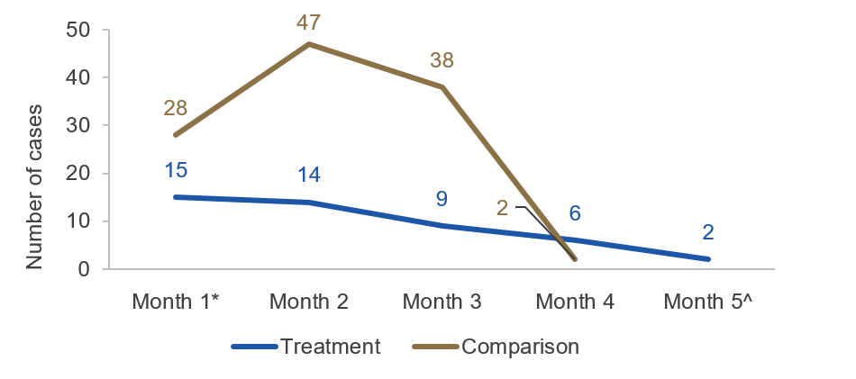
Notes: For the comparison group, months 1 to 4 represent Sep-Dec 2018. For the treatment group, months 1 to 5 represent Feb-Jun 2019.
* Month 1 represents the first month where both agencies were collecting data (September). In the comparison group, one agency started data collection 1.5 months before the second agency (these earlier data are not shown).
^ There are no data for month 5 for the comparison group as data collection in both agencies ended after month 4 (December).

Table 1 Sample sizes and response rates
 | Comparison Group 1  (Active cases) | Treatment Group  (New cases)
Cases in the administrative database (n) | 183 | 46
Worker Survey (DHS only)
Eligible for the worker survey (n) | 104 | 7
Invited to participate in the worker survey (n) | 47 | 7
Responded to the worker survey (n) | 24 | 3
Worker survey response rate (per cent) | 51.1 | 42.9
Supervisor Survey (both agencies)
Eligible for the supervisor survey (n) | 150 | 46
Invited to participate in the supervisor survey (n) | Not known | 41
Responded to the supervisor survey (n) | 33 | 23
Supervisor survey response rate (per cent) | - | 56.1
Case Manager Survey
Invited to the case manager survey (n) | 91
Responded to the case manager survey (n) | 29
Case manager survey response rate (per cent) | 31.9

Table 2 Characteristics of injured/ill workers (administrative data, both agencies)
Characteristics | Comparison Group 1  (Active cases) | Comparison Group 2  (New cases) | Treatment Group  (New cases)
Total n | 183 | 130 | 46
Age | (n=176) | (n=107) | (n=39)
Less than 40 | 26.1% (46) | 29.9% (32) | 15.4% (6)
40–49 | 33.5% (59) | 25.2% (27) | 30.8% (12)
50 and over | 40.3% (71) | 44.9% (48) | 53.8% (21)
Gender | (n=182) | (n=129) | (n=45)
Female | 68.1% (124) | 64.6% (84) | 68.9% (31)
Male | 31.9% (58) | 34.6% (45) | 31.1% (14)
Type of injury | (n=183) | (n=123) | (n=45)
Both | 12.0% (23) | 13.0% (16) | 8.9% (4)
Physical | 47.5% (87) | 50.4% (62) | 60.0% (27)
Psychological | 39.9% (73) | 36.6% (45) | 31.1% (14)
Level | (n=183) | (n=128) | (n=40)
APS 1‒6 | 85.8% (157) | 85.2% (109) | 85.0% (34)
EL1‒2 | 14.2% (26) | 14.8% (19) | 15.0% (6)
Notes: We have missing data on age, gender, type of injury and APS level due to non-response to survey. Some numbers may not add to 100.0% due to rounding. ‘Active cases’ refer to all cases still active within the period whereas ‘new cases’ only refers to cases that commenced during the period. ‘New cases are a subset of active cases’.

Table 3 Return to work statistics (administrative data, both agencies)
 | Comparison Group 2  (New cases, n=130) | Treatment Group  (New cases, n=46)
Return to work rate  (per cent) | 52.3 | 73.9
Median days on leave  (number of days) | 31.5 | 31.0
Notes: We discourage direct comparison between the Treatment and Comparison Groups because of possible differences in how these groups were selected. See introduction to this appendix for further details. We present statistics for new comparison group cases rather than active cases as the two groups are more alike than comparing with active comparison cases.

Table 4 Modified duties provided to injured/ill workers (administrative data, both agencies)
 | Comparison Group 1  (Active cases, n=145) | Treatment Group  (New cases, n=15)
Reduced hours | 49.0% (71) | 66.7% (10)
Flexible work schedule | 18.6% (27) | 20.0% (3)
Lighter or easier job | 10.3% (15) | 6.7% (1)
Modification of work tasks | 46.9% (68) | 20.0% (3)
Changes to layout or equipment | 10.3% (15) | 0.0% (0)
Special training | 5.5% (8) | 6.7% (1)
No modified duties required | 19.3% (28) | 26.7% (4)
Had one or more modified duties | 80.7% (117) | 73.3% (11)
Notes: We discourage direct comparison between the Treatment and Comparison Groups because of possible differences in how these groups were selected. See introduction to this appendix for further details. The percentages may add up to more than 100% because more than one modified duty can be provided to each worker. The total sample size is much less than total cases in the study groups because we did not have modified duty data from everyone (n=38 missing for comparison group 1, n=55 missing for comparison group 2, and n=31 missing for the treatment group). ‘New cases are a subset of active cases’ therefore all cases are shown in this table.

Table 5 Supervisor reaction to injury or illness (worker survey, DHS only)
 | Comparison Group 1 (Active cases, n=20) | Treatment Group  (New cases, n=3)
 | Per cent (n) | Per cent (n)
Blamed you for your injury/illness | 5.0% (1) | 0.0% (0)
Was supportive and helpful | 75.0% (15) | 67.0% (2)
Was angry that you would be off work | 5.0% (1) | 0.0% (0)
Did not believe that anything was wrong with you | 10.0% (2) | 0.0% (0)
Was eager for you to return to work | 45.0% (9) | 0.0% (0)
Reacted in another way (specify) | 20.0% (4) | 33.0% (1)
Supervisor has had no reaction | 0.0% (0) | 0.0% (0)
Note: We discourage direct comparison between the Treatment and Comparison Groups because of possible differences in how these groups were selected. See introduction to this appendix for further details. The percentages may add up to more than 100% because this was a multiple response question.

Table 6 Supervisor support and contact (worker survey, DHS only)
Per cent agreed/strongly agreed | Comparison Group 1 (Active cases, n=18-19) | Treatment Group  (New cases, n=3)
Your manager or direct supervisor did what they could to support you | 84.2% (16/19) | 100.0% (3/3)
Your manager or direct supervisor provided enough information on your rights and responsibilities | 73.7% (14/19) | 66.7% (2/3)
Your manager or direct supervisor made an effort to find suitable employment for you | 72.2% (13/18) | 100.0% (3/3)
Your manager or direct supervisor treated you fairly | 84.2% (16/19) | 100.0% (3/3)
Contact from your manager or direct supervisor was helpful | 77.8% (14/18) | 66.7% (2/3)
You feel supported by your manager or direct supervisor | 77.8% (14/18) | 66.7% (2/3)
Note: We discourage direct comparison between the Treatment and Comparison Groups because of possible differences in how these groups were selected. See introduction to this appendix for further details. The percentages are based on those who answered the question. N for the comparison group for each item varied from 18 to 19.

Table 7 Supervisor confidence (supervisor survey, both agencies)
Per cent highly/completely confident | Comparison group 1 (Active cases, n=35) | Treatment group  (New cases, n=21)
Supporting an employee on long-term sickness absence | 62.9% (22) | 52.4% (11)
Managing an employee on return to work | 68.6% (24) | 61.9% (13)
Identifying suitable duties and reasonable adjustments | 57.1% (20) | 61.9% (13)
Finding information you need on your responsibilities as a supervisor | 65.7% (23) | 66.7% (14)
Note: We discourage direct comparison between the Treatment and Comparison Groups because of possible differences in how these groups were selected. See introduction to this appendix for further details. The percentages are based on those who answered the question.

Table 8 Supervisor confidence by return to work experience (supervisor survey, both agencies, treatment group only)
Per cent highly/completely confident | First time (n=8) | Experienced (n=13)
Supporting an employee on long-term sickness absence | 37.5% (3) | 61.5% (8)
Managing an employee on return to work | 62.5% (5) | 61.5% (8)
Identifying suitable duties and reasonable adjustments | 62.5% (5) | 61.5% (8)
Finding information you need on your responsibilities as a supervisor | 62.5% (5) | 69.2% (9)
Note: The percentages are based on those who answered the question.

Table 9 Rating of reference materials among those who read the materials (supervisor survey, both agencies
Per cent agreed/strongly agreed | Per cent (n)
Read the return to work checklist (n=16)
I found the information valuable | 81.3% (13)
The checklist made it easy for me to keep track of things | 68.8% (11)
I would recommend the checklist to others | 81.3% (13)
Read the Conversation aid (n=11)
Makes it easier to have conversations with my employee | 72.7% (8)
Is easy to understand and follow | 90.9% (10)
I would recommend it to others | 81.8% (9)
Read the Reasonable Adjustments Guide (n=5)
Helps me to identify suitable duties for my employee | 80.0% (4)
I will refer to it again if needed | 80.0% (4)
I would recommend it to others | 80.0% (4)
Note: The percentages are based on those who answered the question.

Table 10 Case manager feedback on reference materials (case manager survey, both agencies)
Per cent agreed/strongly agreed
These materials helped me to do my job | 59.4% (19/32)
helped me explain to managers what was expected of them in supporting the injured/ill employee | 75.0% (24/32)
Contain information that is new for my organisation in managing return to work processes | 33.3% (11/33)
are appropriate for managers (supervisors) with a wide range of return to work experiences | 75.8% (25/33)
were suitable for my Department's return to work cases | 67.7% (22/32)
Note: The percentages are based on those who answered the question.

Appendix F – Additional information on implementation
We evaluated the implementation of intervention materials in the two agencies to inform how the intervention will work in a real world setting.

Intervention delivery and dosage
A total of 145 emails and calendar invites were sent to supervisors in the two agencies in relation to 46 return to work cases. The most common number of emails sent to supervisors was three emails (Figure 6).
- Intervention (dose) received
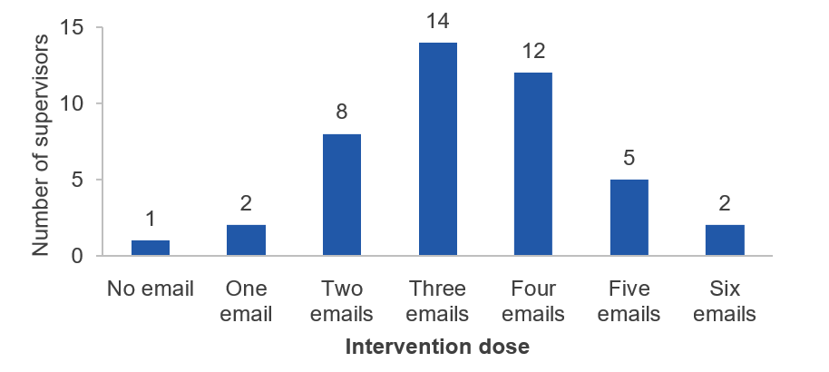
Note: supervisors n=46 but missing case administrative data for 2 supervisors

Assessment of dose delivered by return to work steps
Figure 7 presents the number of intervention emails sent by return to work steps. Most supervisors received the right email at the right time.
- Intervention delivery by return to work steps
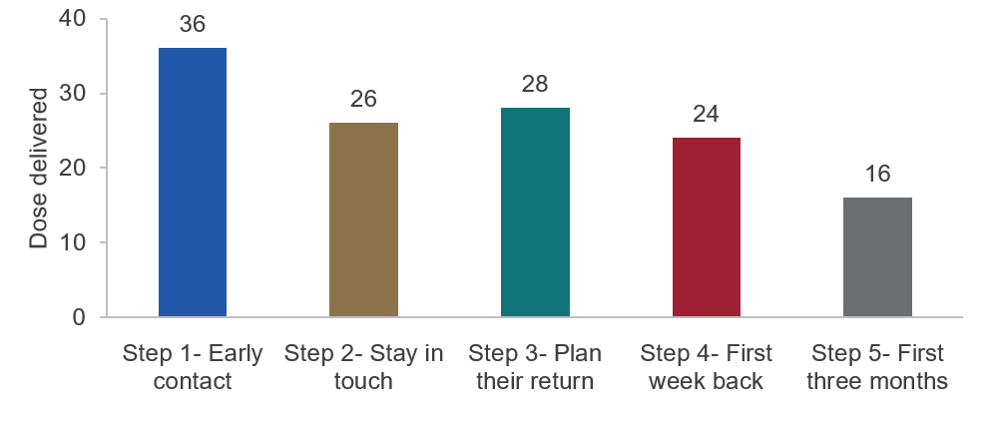
Note: supervisors n=46, case administrative data, the numbers do not add up to 145 because there were missing data on which specific emails were delivered to supervisors in case administrative data
The Step 1 email was about the importance of establishing early contact with the injured/ill worker. It was to be sent to the supervisor as soon as the worker went on leave. The Step 1 email could only be delivered if HR was notified or aware of workers’ absence. In some cases HR may not be aware of these cases until much later or after the worker has returned to work. In addition to prompting the supervisor to get in touch, the Step 1 email contained the first contact conversation guide, return to work checklist and a short video about the steps in the return to work process.

Most supervisors received the Step 1 email. Thirty-six Step 1 emails were sent to supervisors (out of 46 cases or 78 per cent). Reasons for not sending Step 1 emails included:
- other communications sent by the case manager covered points in Step 1 email
- worker was not absent from the workplace, and
- supervisor had already reached out to worker prior to HR becoming aware of the case.
The Step 2 email was about keeping in touch while the worker was absent from work. It prompted supervisors to stay in regular contact with their injured/ill worker. This email contained a conversation guide for regular contact and the return to work checklist. At the same time, case managers had to send fortnightly calendar invites to supervisors to remind the supervisor to stay in regular contact with their injured/ill worker.
Over half of supervisors in the treatment group received the Step 2 intervention email (56 per cent). Supervisors of workers who were absent for a short period (e.g. less than two weeks) would not have received Step 2 email. This step was meant for longer term absences. Reasons for not sending Step 2 emails included:
- supervisors moving onto a different role
- some case managers combining emails for several steps (e.g. Steps 2 and 3)
- worker had already returned to work before Step 2 email was due to be sent out
- worker was about to return to work so Step 3 email was sent instead of Step 2
- late notification of leave period, and
- supervisor had been in regular contact with worker so case manager felt Step 2 email was not necessary.
The Step 3 email was about preparing and getting things ready for the worker’s return to work. This email was to be sent to the supervisor close to the expected return to work date. In cases where the worker was absent only for a short time or where the case manager only learned afterwards the worker has returned to work, this email would not have been sent. The Step 3 email included suitable duties guide, conversation guide for preparing for return to work and two APS wide links on promoting mental health and wellbeing at work and promoting ability at work.
Twenty-eight supervisors were sent the Step 3 intervention email (61 per cent). Reasons for not sending Step 3 emails included:
- short leave period between leave notification and return to work
- worker retired or resigned, and
- only finding out after the worker has returned to work they are back at work so it was too late to send Step 3 email.
The Step 4 email was about the first week back at work. It included a conversation guide for after return to work and prompted supervisors to continue to provide support and regularly review the return to work plan.
The majority of supervisors who should have received Step 4 email received it. While overall just over half of the supervisors (52 per cent) received Step 4 emails, this figure rose to 70 per cent among supervisors whose worker had returned to work, the appropriate return to work stage for Step 4 emails.
The Step 5 email was intended to be sent one to three months after the injured/ill worker had returned to work. This served as a final check-in and also encouraged feedback from supervisors about the return to work process. Sixteen supervisors received the Step 5 email.

Case manager participation and feedback
In August 2019, we surveyed all 94 case managers involved in the study (from the comparison group data collection to the treatment group data collection). Overall, 39 case managers responded (a 41 per cent response rate): from the ATO, 13 out of 22 (59 per cent) and from DHS, 26 out of 72 (36 per cent).
The majority (85 per cent) reported they had seen the supervisor support materials. A little over half of the respondents were involved in intervention delivery (i.e. they sent out reference materials). Among those who did not deliver the intervention, the most common reason provided was the materials were not appropriate for their cases. Other reasons included not having enough time and moving into a different role.
Thirteen case managers (or 68 per cent of those who answered the question) reported there were cases where supervisor support materials were not appropriate even though they met the inclusion criteria for the study. The examples of such cases provided by case managers include:
- cases where the employee was retired or resigned
- cases that met the criteria but arose too late during the intervention phase
- where supervisors had multiple staff on return to work so it would mean sending them duplicate information
- cases with ongoing attendance concerns
- when case managers were not aware of employee’s absence until they were due back at work, making the steps irrelevant, and
- supervisors who knew the process well or materials being considered a little too basic for some supervisors.
Just under half of case managers agreed the process of sending out emails was confusing. At the same time, 55 per cent agreed this process would be easy to do in an ongoing basis. Three in four case managers agreed ‘it was easy for them to determine when they needed to send out the emails with supervisor support materials’. Part of this ease in delivery timing may be due to the approach taken where cases were tracked each week and relevant case managers contacted to remind them of the next intervention step. However, we note the monitoring and reminder role was resource intensive.
Not surprisingly, there were a few negative comments from case managers about intervention delivery. One case manager provided possible reasons for negative reactions from some of their colleagues.
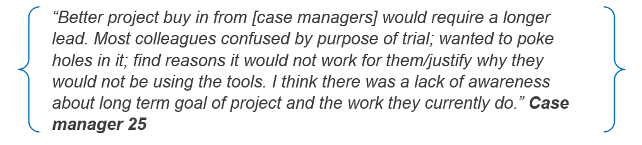
Some case managers would prefer if the administrative database and emails were linked to existing systems to avoid duplication of efforts.
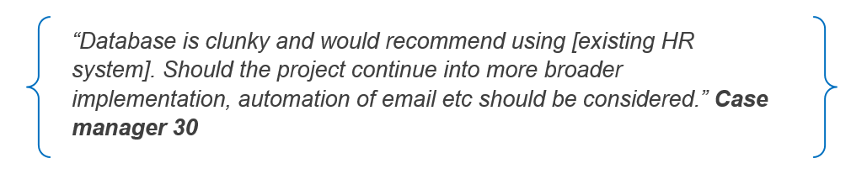
Several case managers did not understand the purpose of the research project despite the training and information provided by BETA. Even though the project was about supporting supervisors, some thought with their level of knowledge and experience, they did not need to use them.
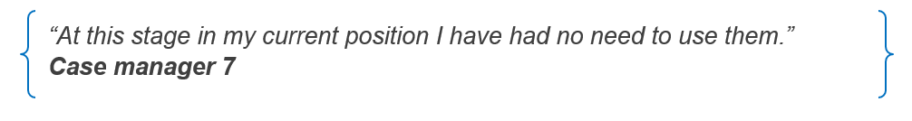
However, some case managers saw the intervention process as beneficial despite the time and resource intensity of the intervention delivery.
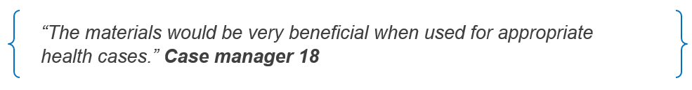

Appendix G – Case manager survey
Q1 Which People Delivery Centre/People Branch are you located in?
________________________________________________
Q2 Have you seen manager support materials for the Return to Work project?
The manager support materials look like this.
- Yes
- No
- Don't know
Q3 Did you send out emails with manager support materials as part of the Return to Work project? The manager support materials look like this.
- Yes
- No
- Don't know
If no, go to Q4
If yes, go to Q5
Q4 What were the main reasons you did not send out manager support materials for the Return to Work project?
- I didn't hear about the project
- The materials were not appropriate for the cases that I manage
- I did not want to participate in this project
- I did not have enough time
- Other (please specify) ________________________________________________

Q5 Please rate your level of agreement with the content of the materials to support managers with the return to work process.
These materials:
 | Strongly disagree (1) | Somewhat disagree (2) | Neither agree nor disagree (3) | Somewhat agree (4) | Strongly agree (5) | Not Applicable (6)
helped me to do my job
helped me explain to managers what was expected of them in supporting the injured/ill employee
Contain information that is new for my organisation in managing return to work processes
are appropriate for managers with a wide range of return to work experiences
were suitable for my Department's return to work cases

Q6 Were there cases where manager support materials were NOT appropriate even though they met the guidelines provided (see below)?
- Yes
- No
- Don't know
If Yes, go to Q7
Q7 What would be examples of cases where these manager support materials were not appropriate? Please do not include any identifying information. ________________________________________________________________
Q8 The next two statements are about the process of sending out emails with manager support materials.
Please rate your level of agreement with these statements.
 | Strongly disagree (1) | Somewhat disagree (2) | Neither agree nor disagree (3) | Somewhat agree (4) | Strongly agree (5)
The process of sending reminder emails and materials was confusing.
This process would be easy to do on an ongoing basis.
Q9 It was easy for me to determine when I needed to send out the emails with manager support materials for the Return to Work project.
- Strongly disagree
- Somewhat disagree
- Neither agree nor disagree
- Somewhat agree
- Strongly agree

Q10 Do you have any other comments about the process of sending out emails with manager support materials? ________________________________________________________________
Q12 Did you receive training on the process for sending out emails with support materials to managers for the Return to Work project?
- Yes
- No
- Don't know
Q13 Who did you receive training from?
- Other case managers/ staff
- My direct supervisor
- BETA
- Don't know
Q14 The training gave me a clear idea of my role in the Return to Work project.
- Strongly disagree
- Somewhat disagree
- Neither agree nor disagree
- Somewhat agree
- Strongly agree
Q15 Did you use any of the supporting documents provided on the intranet to assist you with your role in the Return to Work Project? The materials may look like this.
- Yes
- No
- Don't know
Q16 Do you have any other comments about the project materials, the process or any other aspects of the Return to Work project?
________________________________________________________________

Appendix H – List of data variables to integrate with existing HR systems
Variable | Response type/categories
Case name | Taken from HR system
Case number | Manual entry
Case manager identifier | Manual entry
Injury | Physical injury; psychological injury, both
Leave start date | Taken from HR/leave system
Claim lodged? | Yes; No; Don't know
Involve RTW? | Yes; No; Don't know
Expected RTW date | Taken from leave system
Date RTW | Taken from HR/leave system
Modified duties | Allow multiple selections  Reduced hours; flexible work schedule; a lighter or easier job; modification of work tasks; change to layout or equipment; special training; no modified duties required
Any additional time off since RTW? | Taken from HR/leave system
Total days on leave | Automatic calculation – from leave system

Appendix I – Workers’ return to work experience before the intervention
We collected administrative data on return to work outcomes at both agencies before the reference materials were introduced. We also surveyed and interviewed DHS workers. Here we describe the experience of 183 injured or ill workers who were absent from work during July to December 2018. About half had a physical injury or illness and 40 per cent had a psychological injury (see Table 4, Appendix E). The remainder had both physical and psychological injuries/illness. A quarter of these workers had lodged a workers’ compensation claim.
Note the data presented below are for active cases.

Multiple return to work attempts and duration of absence
Just over half of those workers who had returned to work subsequently needed additional time off suggesting they may need multiple attempts to return to work. According to leave data, the median length of absence was 34 days. It was noticeably higher for psychological injuries (43 days) than for physical injuries (32 days).

Modified duties upon return to work
The majority of workers in both agencies received modified duties upon returning to work. The most common modifications were reduced hours (49 per cent), modification of work tasks (47per cent) and flexible work arrangements (19 per cent) (See Table 4, Appendix E). One common practice was to remove staff from public-facing, client engagement work, which might deepen issues for workers who had psychological disorders.
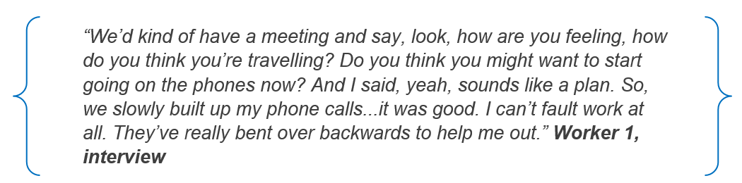

Returning to work and recovery
We examined the impact of returning to work on workers’ recovery and their ability to cope with work. Half of survey respondents thought returning to work had helped their recovery. Three in four reported they were able to cope with work pressure after returning to work and the vast majority could perform their work tasks.

Supervisor support at DHS
The majority of survey respondents at DHS viewed their supervisor as supportive throughout, from the start of their injury or illness to when they are back at work (see Table 5 and 6, appendix E). Most workers were contacted by their supervisors while they were absent. All were satisfied with the amount of contact they received and the majority (78 per cent) indicated the contact was helpful. The majority (84 per cent) of workers reported their supervisor did all they could to support them, suggesting the level of supervisor support before intervention roll out at DHS was already high. A large proportion (72 per cent) reported their supervisor made an effort to find suitable employment for them.
Interviews with DHS workers confirmed these survey findings. Workers provided positive feedback about their return to work experiences, and were positive about their managers’ level of knowledge and ability to support them.
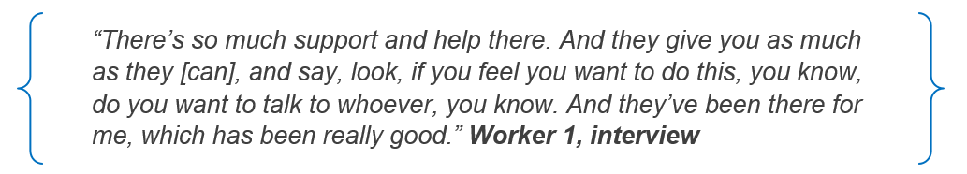
These impressions of supervisor support were generally more positive than emerged from other research or our earlier user research. This may mean supervisor support at DHS was better at the time of the survey. However, it is likely our survey results were from a biased sample and those with better experience were more likely to be included the survey. While the survey response rate was 51 per cent among those who were invited to participate in the survey, case manager discretion was used to determine who on the survey sample list should receive the survey invitation. This led to a coverage error which is a common type of survey error affecting the reliability and generalisability of survey results (Dillman, Smyth, & Christian, 2014).

References

Andersen, M. F., Nielsen, K. M., & Brinkmann, S. (2012). Meta-synthesis of qualitative research on return to work among employees with common mental disorders. Scandinavian journal of work, environment & health, 38(2), 93-104.
Blackman, I., & Chiveralls, K. (2011). Factors Influencing Workplace Supervisor Readiness to Engage in Workplace-Based Vocational Rehabilitation. Journal of occupational rehabilitation, 21(4), 537-546. doi: 10.1007/s10926-011-9297-1
Dillman, D. A., Smyth, J. D., & Christian, L. M. (2014). Internet, phone, mail, and mixed-mode surveys: The tailored design method (Fourth ed.): John Wiley & Sons.
Hogan, A., Kyaw-Myint, S. M., Harris, D., & Denronden, H. (2012). Workforce participation barriers for people with disability. International Journal of Disability Management, 7, 1-9.
Kessler, R. C., Green, J. G., Gruber, M. J., Sampson, N. A., Bromet, E., Cuitan, M., . . . Hu, C. Y. (2010). Screening for serious mental illness in the general population with the K6 screening scale: results from the WHO World Mental Health (WMH) survey initiative. International journal of methods in psychiatric research, 19(S1), 4-22.
Munir, F., Yarker, J., Hicks, B., & Donaldson-Feilder, E. (2012). Returning employees back to work: developing a measure for supervisors to support return to work (SSRW). Journal of occupational rehabilitation, 22(2), 196-208.
Prang, K.-H., Bohensky, M., Smith, P., & Collie, A. (2016). Return to work outcomes for workers with mental health conditions: a retrospective cohort study. Injury, 47(1), 257-265.
Safe Work Australia. (2014). The National Return to Work Survey: The Role of the Employer and Workplace Australia and New Zealand 2013. Canberra: Safe Work Australia.
Safe Work Australia. (2019). National Return to Work Strategy 2020-2030. Canberra: Safe Work Australia.
Selander, J., Tjulin, Å., Müssener, U., & Ekberg, K. (2015). Contact with the workplace during long-term sickness absence and worker expectations of return to work. International Journal of Disability Management, 10.
Smith, P. M., Black, O., Keegel, T., & Collie, A. (2014). Are the predictors of work absence following a work-related injury similar for musculoskeletal and mental health claims? Journal of occupational rehabilitation, 24(1), 79-88.
Wyatt, M., Cotton, P., & Lane, T. (2017). Return to work in psychological injury claims: Analysis of the Return to Work Survey Results. Canberra: Safe Work Australia.
Wyatt, M., & Lane, T. (2017). Return to work: A comparison of psychological and physical injury claims. Canberra: Safe Work Australia.
Zwerling, C., Whitten, P. S., Sprince, N. L., Davis, C. S., Wallace, R. B., Peter Blanck, J., & Heeringa, S. G. (2003). Workplace accommodations for people with disabilities: National health interview survey disability supplement, 1994–1995. Journal of Occupational and Environmental Medicine, 45(5), 517-525.

© Commonwealth of Australia 2020
ISBN 978-1-925364-39-2 Returning to work after illness or injury (Online) (DOCX)
ISBN 978-1-925364-39-2 Returning to work after illness or injury (Online) (PDF)
Copyright Notice
With the exception of the Commonwealth Coat of Arms, this work is licensed under a Creative Commons Attribution 4.0 International license (CC BY 4.0) (https://creativecommons.org/licenses/by/4.0/)
Third party copyright
Wherever a third party holds copyright in this material, the copyright remains with that party. Their permission may be required to use the material. Please contact them directly.
Attribution
This publication should be attributed as follows:
© Commonwealth of Australia, Department of the Prime Minister and Cabinet, Returning to work after illness or injury.
Use of the Coat of Arms
The terms under which the Coat of Arms can be used are detailed on the following website:
https://pmc.gov.au/cca

Behavioural Economics Team
of the Australian Government

General enquiries beta@pmc.gov.au
Media enquiries media@pmc.gov.au
Find out more www.pmc.gov.au/beta

Department of Jobs and Business. 2017 (unpublished report). Return to Work Behavioural Economics Project: User research report.
Claims and rehabilitation | Comcare (as at February 2020) and Comcare’s Return to Work easy reference guide.
Please see glossary for definitions of active and incident cases.
We are unable to generalise these findings to all supervisors of RTW cases as we are uncertain about the representativeness of the supervisor sample.
Note This sample included a broader sample of workers than presented in the worker section of the report, termed active cases. This sample represented active cases during July–December 2018 rather than new cases during the same period.

