Return to work email templates

EMAIL SUBJECT: Reminder – Reach out to [EMPLOYEE]
Hi [MANAGER]

This is just a quick reminder to reach out to [EMPLOYEE] if you haven’t already had a chance to. Research shows that making early contact helps staff feel supported in their recovery – that’s why it’s a key part of our return to work policy.

You don’t need to discuss anything in particular, just check in with [EMPLOYEE] and let him/her know you’re available to chat whenever s/he needs.

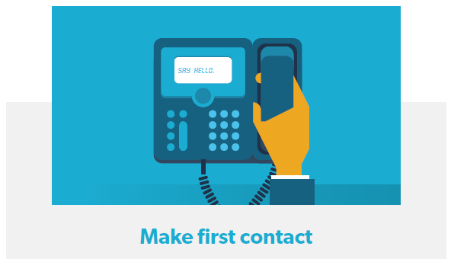
To help structure your first conversation here’s a | To learn more about your role at different return to work stages, you can use this
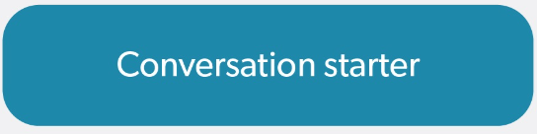
And here is a short video providing an overview of the

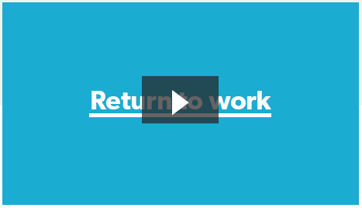
I will be back in touch in a couple of weeks. In the meantime, feel free to get in touch with me anytime to chat about how you can support [EMPLOYEE]’s recovery back to work.
Kind regards
[CASE MANAGER SIGNATURE BLOCK]

Hi [MANAGER]

Hopefully you’ve had a chance to contact [EMPLOYEE] since he’s/she’s been off work and have begun the process of supporting him/her to recover at work. Research shows that people can really benefit from regular contact with their managers and colleagues while they are off work.
That’s why I’ve sent you a series of fortnightly 15 minute placeholders to chat with [EMPLOYEE]. Feel free to move them around, they’re just meant to be simple reminder prompts for you to keep in touch with [EMPLOYEE].
To help structure your regular check-ins, here’s another |  | To refresh yourself on things you can do to help [EMPLOYEE], you can use this
And remember that I’m here to assist you in [EMPLOYEE]’s recovery and return to work.
Kind regards
[CASE MANAGER SIGNATURE BLOCK]

EMAIL SUBJECT: Reminder – Keep in touch with [EMPLOYEE]

EMAIL SUBJECT: Reminder – Prepare for [EMPLOYEE]’s return
Hi [MANAGER]

Now could be a good time to start talking more about [EMPLOYEE]’s return to work and how you and the workplace can support him/her in recovering at work. This may include discussing a return to work plan, if you haven’t done so already. Research shows that injured/ill workers really value efforts by their managers to discuss workplace accommodations and suitable duties for their return.
There is no one-size-fits-all approach to this type of conversation, but this conversation starter and suitable duties fact sheet may help

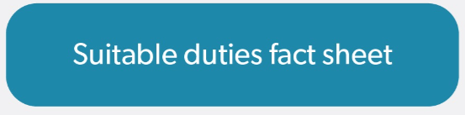
If you would like to know more, feel free to give me a call or check out this Comcare resource
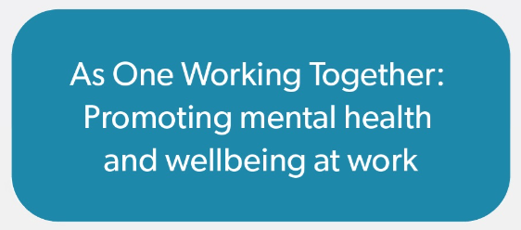
Kind regards
[CASE MANAGER NAME]

EMAIL SUBJECT: Thanks for helping [EMPLOYEE] return to work
Hi [MANAGER]

Thanks for helping [EMPLOYEE] return to work.
I encourage you to continue working with [EMPLOYEE] to support him/her return to work. This includes reviewing his/her return to work plan. As [EMPLOYEE]’s health and circumstances improve, what he/she can do will also change, so the early plans you’ve made may not be what he/she needs after a few weeks or months back at work.

To have a good conversation about this, here’s a | And, in case you haven’t seen it, here is a suitable duties fact sheet
I’m here to help you make [EMPLOYEE]’s recovery and return to work as stable and sustainable as it can be.
If you would like any further support or have any questions please don’t hesitate to contact me.
Kind regards
[CASE MANAGER SIGNATURE BLOCK]

EMAIL SUBJECT: Checking in – How is [EMPLOYEE]’s return going?
Hi [MANAGER]

I just wanted to check in and see how [EMPLOYEE]’s recovery and return to work is going. Continuing to support [EMPLOYEE] now that s/he’s back can reduce the chance of another absence from work and help make his/her return as sustainable as possible. I encourage you to check in regularly with [EMPLOYEE] to see how s/he is going and what supports s/he may need.
That’s why I’ve set up two monthly-placeholders to chat with [EMPLOYEE]. Feel free to move them around, they’re just meant to be simple reminder prompts.
Thanks
[CASE MANAGER SIGNATURE BLOCK]

