Step 1: Away from work - first contact
EMAIL SUBJECT: Reminder – Reach out to [EMPLOYEE]
EMAIL BODY:
Hi [MANAGER]
This is just a quick reminder to reach out to [EMPLOYEE] if you haven’t already had a chance to. Research shows that making early contact helps staff feel supported in their recovery – that’s why it’s a key part of our return to work policy.
You don’t need to discuss anything in particular, just check in with [EMPLOYEE] and let them know you’re available to chat whenever they need.

Make first contact
To help structure your first conversation here’s a
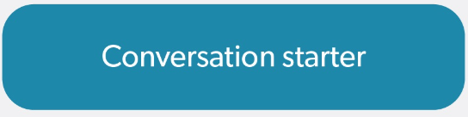
To learn more about your role at different return to work stages, you can use this

Return to work process
And here is a short video providing an overview of the return to work process:
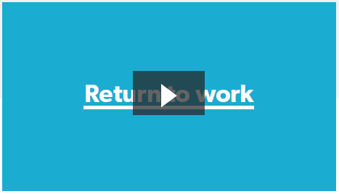
I will be back in touch soon. In the meantime, feel free to get in touch with me anytime to chat about how you can support [EMPLOYEE]’s recovery back to work.
Kind regards
[CASE MANAGER SIGNATURE BLOCK]

Step 2: Away from work - regular contact
EMAIL SUBJECT: Reminder – Keep in touch with [EMPLOYEE]
EMAIL BODY:
Hi [MANAGER]
Hopefully you’ve had a chance to contact [EMPLOYEE] since they’ve been off work and have spoken about how you can assist their recovery and return to work. Research shows that people can really benefit from regular contact with their managers and colleagues while they are off work.
That’s why I’ve sent you a series of fortnightly 15 minute placeholders to chat with [EMPLOYEE]. Feel free to move them around, they’re just meant to be simple reminder prompts for you to keep in touch with [EMPLOYEE].
To help structure your regular check-ins, here’s another:
To refresh yourself on things you can do to help [EMPLOYEE], you can use this:
And remember that I’m here to assist you in [EMPLOYEE]’s recovery and return to work.
Kind regards
[CASE MANAGER SIGNATURE BLOCK]

Step 3: Preparing to return
EMAIL SUBJECT: Reminder – Prepare for [EMPLOYEE]’s return
EMAIL BODY:
Hi [MANAGER]
Now could be a good time to start talking more about [EMPLOYEE]’s return to work and how you and the workplace can support their recovery at work. I will organise a meeting shortly with you, [EMPLOYEE] and I to discuss a return to work plan. Research shows that injured/ill workers really value efforts by their managers to discuss workplace accommodations and suitable duties for their return.
There is no one-size-fits-all approach to this type of conversation, but this conversation starter and suitable duties fact sheet may help
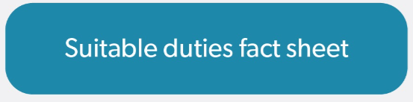
If you would like to know more, feel free to give me a call or check out these Comcare resources
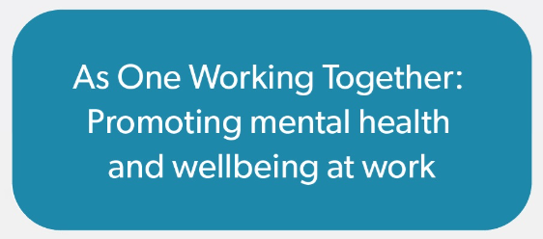
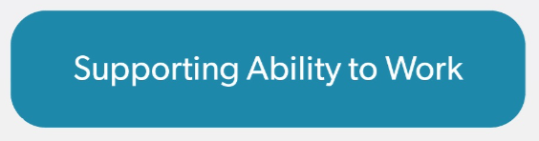
Kind regards
[CASE MANAGER SIGNATURE BLOCK]

Step 4: On return / first week
EMAIL SUBJECT: Thanks for helping [EMPLOYEE] return to work
EMAIL BODY:
Hi [MANAGER]
Thanks for helping [EMPLOYEE] return to work.
I encourage you to continue working with [EMPLOYEE] to support their return to work. This includes us all working together to review the return to work plan. As [EMPLOYEE]’s health and circumstances improve, what they can do will also change, so the early plans we’ve made may not be what they need after a few weeks or months back at work.
To have a good conversation about this, here’s a
And, in case you haven’t seen it, here is a suitable duties fact sheet
I’m here to help you make [EMPLOYEE]’s recovery and return to work as stable and sustainable as it can be.
If you would like any further support or have any questions please don’t hesitate to contact me.
Kind regards
[CASE MANAGER SIGNATURE BLOCK]

Step 5: First three months
EMAIL SUBJECT: Checking in – How is [EMPLOYEE]’s return going?
EMAIL BODY:
Hi [MANAGER]
I just wanted to check in and see how you are going in providing support for [EMPLOYEE]’s recovery and return to work. Continuing to support [EMPLOYEE] now that s/he’s back can reduce the chance of another absence from work and help make his/her return as sustainable as possible. I encourage you to check in regularly with [EMPLOYEE] to see how s/he is going and what supports s/he may need.
That’s why I’ve set up two monthly-placeholders to chat with [EMPLOYEE]. Feel free to move them around, they’re just meant to be simple reminder prompts. I’ll continue to organise meetings for you, [EMPLOYEE] and I to discuss progress and any further support needed.
Thanks
[CASE MANAGER SIGNATURE BLOCK]

