Retirement planning, saving and attitudes: survey report
November 2020
pmc.gov.au/beta

Other uses
Enquiries regarding this license and any other use of this document are welcome at:
Managing Director
Behavioural Economics Team of the Australian Government
Department of the Prime Minister and Cabinet
Barton ACT 2600
Email: beta@pmc.gov.au
The views expressed in this paper are those of the authors and do not necessarily reflect those of the Department of the Prime Minister and Cabinet or the Australian Government.
Research team
Current and former employees who contributed to the report were: Harry Greenwell, Michael Ridgway, Anne-Line Giudicelli, and Jack Hodge.
Acknowledgments
Thank you to the Department of the Treasury for their support and valuable contribution in making this project happen. In particular, special thanks to members of the Retirement Income Review team, Rebecca McCallum, Cate Le Mesurier and Luke Dorahy for their work on this project.

Who?

Who are we?
We are the Behavioural Economics Team of the Australian Government, or BETA. We are the Australian Government’s first central unit applying behavioural economics to improve public policy, programs and processes.
We use behavioural economics, science and psychology to improve policy outcomes. Our mission is to advance the wellbeing of Australians through the application and rigorous evaluation of behavioural insights to public policy and administration.

What is behavioural economics?
Economics has traditionally assumed people always make decisions in their best interests. Behavioural economics challenges this view by providing a more realistic model of human behaviour. It recognises we are systematically biased (for example, we tend to satisfy our present self rather than planning for the future) and can make decisions that conflict with our own interests.

What are behavioural insights and how are they useful for policy design?
Behavioural insights apply behavioural economics concepts to the real world by drawing on empirically-tested results. These new tools can inform the design of government interventions to improve the welfare of citizens.
Rather than expect citizens to be optimal decision makers, drawing on behavioural insights ensures policy makers will design policies that go with the grain of human behaviour. For example, citizens may struggle to make choices in their own best interests, such as saving more money. Policy makers can apply behavioural insights that preserve freedom, but encourage a different choice – by helping citizens to set a plan to save regularly.

Contents
Introduction 4
Results: Summary 6
Demographics 14
Survey results 22
Attitudes and expectations 22
Planning and saving 27
Voluntary contributions 36
Financial advice 54
Appendices 56
Appendix 1 - Technical details 56
References 61

Introduction
The Retirement Income Review was commissioned to ‘establish a fact base of the current retirement income system’ to improve the outcomes it delivers for Australians. This report contributed to the work of the Review by presenting results from an online survey about retirement planning, saving and attitudes. Specifically, the survey sought to answer questions under four broad themes:
- Retirement expectations, and attitudes towards the ‘retirement income system’: When do people expect to retire? Do they expect to have a better lifestyle in retirement than their parents? Do they expect the Age Pension will still be available when they retire? If so, do they expect the Age Pension will maintain its current value?
- Retirement planning and saving: How much do people plan for retirement generally? If they do, what factors do they consider regarding how much they will need, how much to save, and where to invest?
- Voluntary superannuation contributions: How many people make voluntary contributions? How much do they contribute? And why? In particular, why don’t more people make more voluntary contributions? Are they aware of tax concessions? And how much do tax concessions influence decisions to make voluntary contributions?
- Financial advice: Where do people get their advice? How does advice influence retirement saving decisions?
The survey was conducted through the Qualtrics online survey panel, with a sample size of 1,580 respondents. We received responses between 6 and 11 March 2020, which was a period of significant decline in world stock markets. Where this may have affected responses to some questions, it is noted in the results.
The survey sample was restricted to our population of interest. Accordingly, it was confined to Australian residents who are currently working and have not yet retired. Further, we over-sampled the self-employed since they are not subject to the Superannuation Guarantee. The results presented in this report are unweighted. We also reweighted the analysis to address over-sampling and the results were largely unchanged (see Appendix for details).
Within these constraints, Qualtrics constructed a sample broadly matching our population of interest for gender, age, and State or Territory (although the female cohort skews younger, and our male cohort older, see the Demographics section for further details). Our sample was also roughly representative in terms of employee’s income. Participants from any online survey panel are unusual because they have chosen to regularly complete online surveys in return for small payments. Nonetheless, we consider the results from this survey give useful insights in relation to the research questions listed above.

Results: Summary

Expectations for retirement, and attitudes toward the retirement system
Survey respondents had mixed expectations about their prospects for retirement. Most respondents (72%) intend to retire after the age of 60. Another 13% intend to keep working as long as they are able.
Expectations about lifestyle in retirement varied: 42% expect to be better off in retirement than their parents, 33% expect about the same but 25% of respondents expect to be worse off (Figure 1). There was a gender gap in these lifestyle expectations, which was partly due to female respondents being more pessimistic, and partly due to greater pessimism amongst younger cohorts (which skewed female).
- Expected lifestyle in retirement, compared to one’s parents
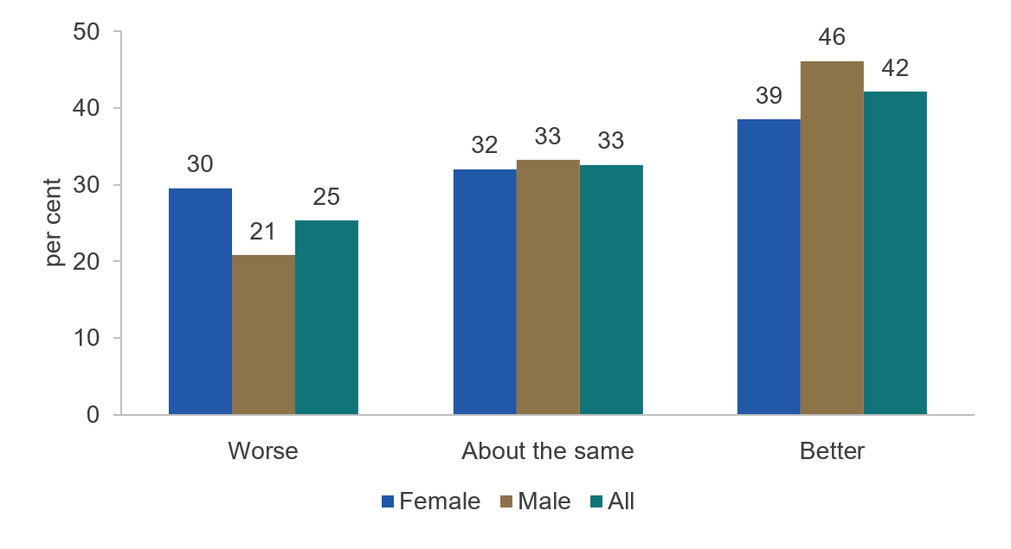
Do you believe that you’ll have the same standard of living in retirement as your parents? n=1,580. Note: some answer categories (Certainly better/Likely better and Likely worse/Certainly worse) were combined.
Most respondents saw superannuation as a stable investment. More than half of respondents (53%) agreed superannuation is a stable investment for retirement, only 17% disagreed. However, two-thirds were concerned about how financial markets will affect their superannuation. The timing of the survey may be important, since it occurred during a period of significant decline in world stock markets resulting from the global COVID-19 pandemic.
Survey respondents were generally pessimistic about the Age Pension and changes to the ‘retirement income system’. On the Age Pension, less than half of respondents (48%) thought it likely the pension will still exist when they reach retirement. This was even lower for people aged below 55 years (37%). Similarly, only 37.5% thought it likely the Age Pension will still have a similar value when they reach retirement (Figure 2). Again, this was driven by those under 55 years, only 28% of whom thought it likely. Finally, a considerable majority (60%) agreed the superannuation and Age Pension rules change too much.
- Expectations for the Age Pension
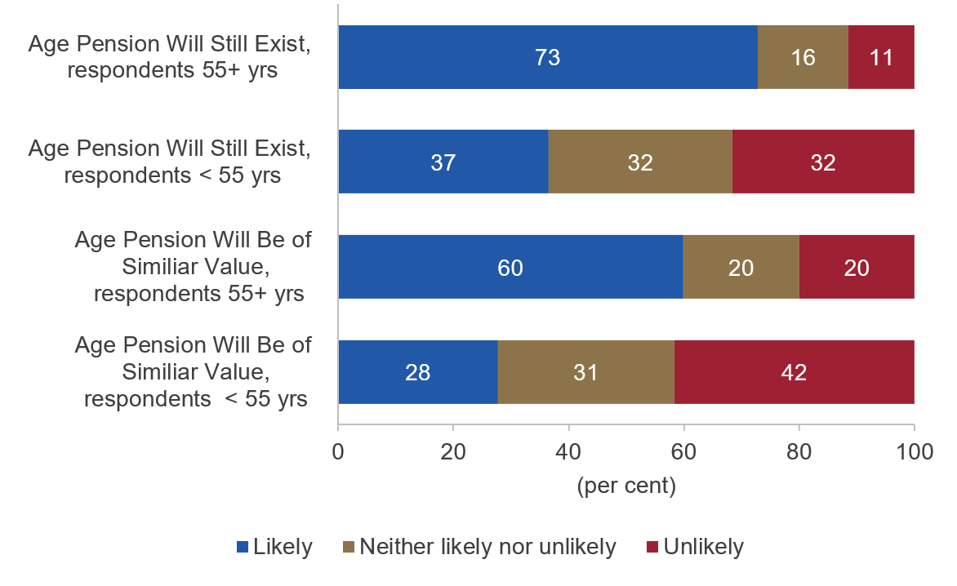
Please assess the likelihood of the following statements: (1) The Age Pension will still exist when I reach retirement age. (2) The Age Pension will still be of a similar value when I reach retirement age. n=1,580. Note: some answer categories (Very Likely/Likely and Unlikely/Very unlikely) were combined.

Retirement planning and saving
Few respondents had thought about how much they would need in retirement. Over two-thirds (68%) of survey respondents said they had never estimated how much they would need for retirement (Figure 3). The most cited reasons for this were: ‘retirement is a long way off’ (46%), and ‘I want to but haven’t got around to it’ (20%). Female respondents were less likely to estimated their retirement needs.
For some people, there appears to be a connection between reflecting on their retirement needs, and making voluntary super contributions. Of those respondents not making voluntary contributions, 22% reported they have not thought much about retirement.
- Have calculated a retirement saving aim, by age and gender
By age | By gender
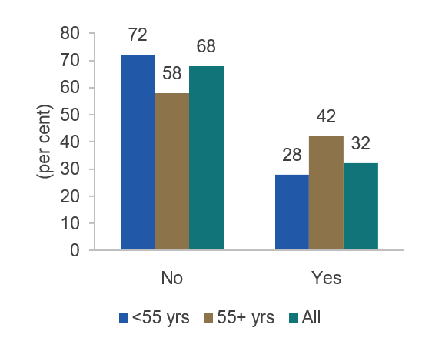 | 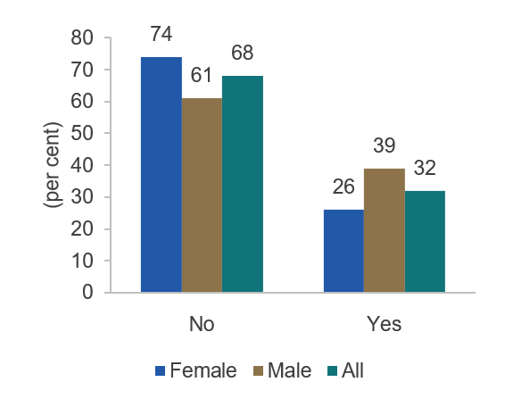
Have you (or your financial adviser) ever estimated how much money you will need for your retirement? (n=1,580)
Most respondents who had a retirement goal had adjusted their saving behaviour accordingly. Only one-third (32%) of respondents had estimated a retirement savings goal. However, of these, a large majority (80%) had some idea of the amount they needed to save each year to reach their goal. Furthermore, 60% had changed their savings behaviour as a result of calculating how much they needed for retirement.
Retirement saving goals seemed low but only half of respondents expected to achieve their goals. For singles, almost half (49%) were aiming for less than $400,000 in retirement savings (excluding the family home), while for couples over half (56%) were aiming for less than $600,000. These amounts seem low given the implied retirement income for a typical retirement duration. Only 52% thought it likely they could save the amount they were aiming for, with female respondents more pessimistic than males (Figure 4). Most respondents (61%) thought they would need a retirement income between $30,000 and $90,000 per year (in today’s dollars).
- Likelihood of achieving retirement savings aims, by age and gender
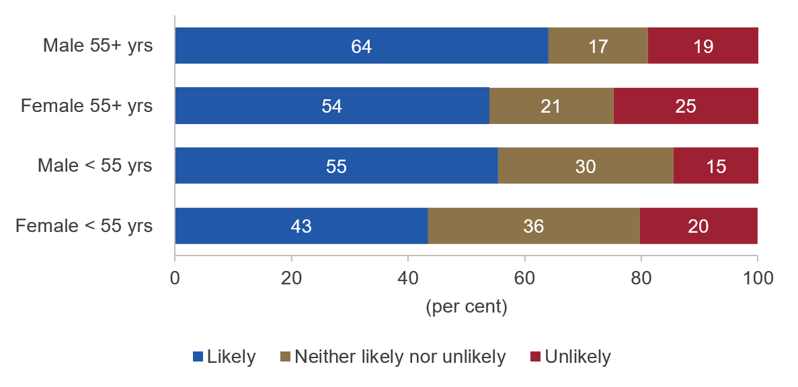
Do you think that you will achieve the amount of money you estimated you will need for your retirement. (n=1,580) Note: some answer categories (Very Likely/Likely and Unlikely/Very unlikely) were combined.
The family home and super were seen as the main retirement assets. Most respondents expected their largest asset in retirement would either be their super (44%) or their family home (39%).
Most expect to own their home by retirement, although much less so for singles. Around two-thirds (67%) already own their home or expect to do so by retirement. The remainder were evenly split between those who expect to still have a mortgage by retirement and those who doubt they will be able to afford their own home. Almost a quarter of single respondents (23%) said they do not expect to ever be able to afford own their own home (compared with just 8% of couples). Single, female respondents were noticeably more likely than single males to hold this view (Figure 5).
- Home ownership expectations, by gender and family type
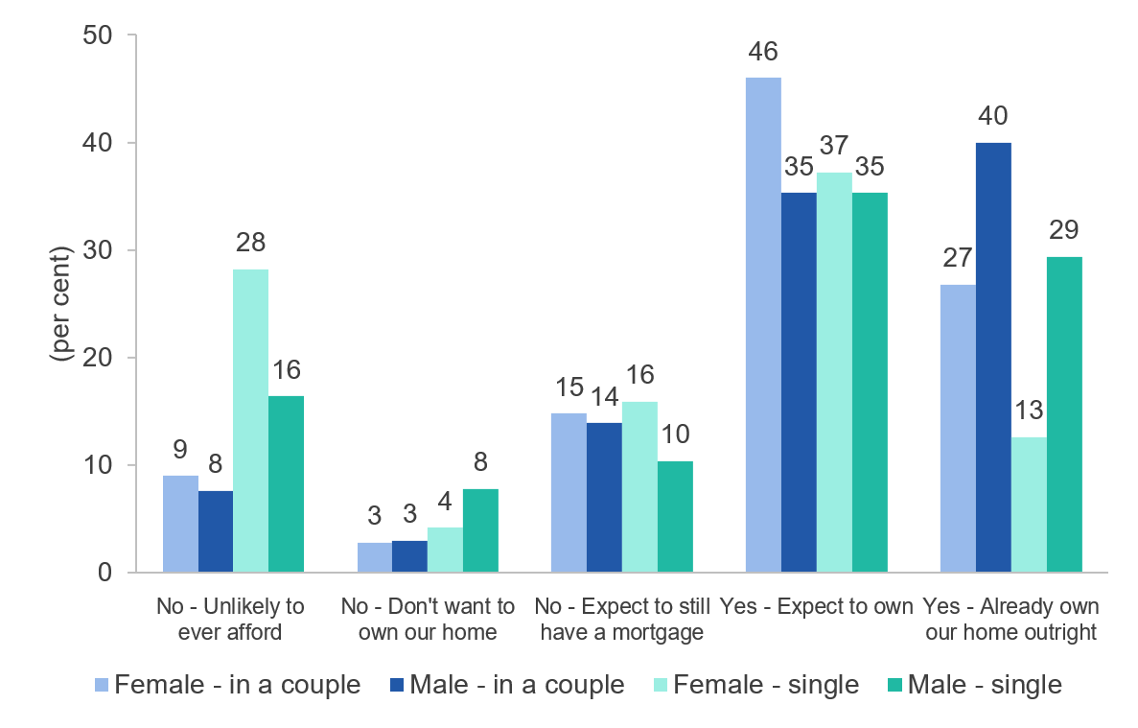
Results from two questions: What is your home ownership status? And (if they did not already own their home outright): Do you think you will own your own home outright before retirement? (n=1,580)

Voluntary super contributions
Voluntary contribution rates may have increased over the past decade. Past evidence from the ABS’ Survey of Employment Arrangements, Retirement and Superannuation (SEARs) suggested voluntary contribution rates were low. In 2007, about 28% of employees were making voluntary contributions. And even amongst the self-employed, who are not subject to the Superannuation Guarantee, the proportion making contributions only rose to around 36%.
More than a decade later, we found higher contribution rates: 46% of employee respondents reported making voluntary contributions, and 56% of the self-employed reported making superannuation contributions (Figure 6). This suggests voluntary superannuation contribution rates have increased—perhaps substantially—between 2007 and 2020, since the differences between the SEARS results and our own seem too large to be solely due to sample selection or survey method. Female respondents were less likely to be making voluntary contributions.
- Voluntary super contributions, by employment type and gender
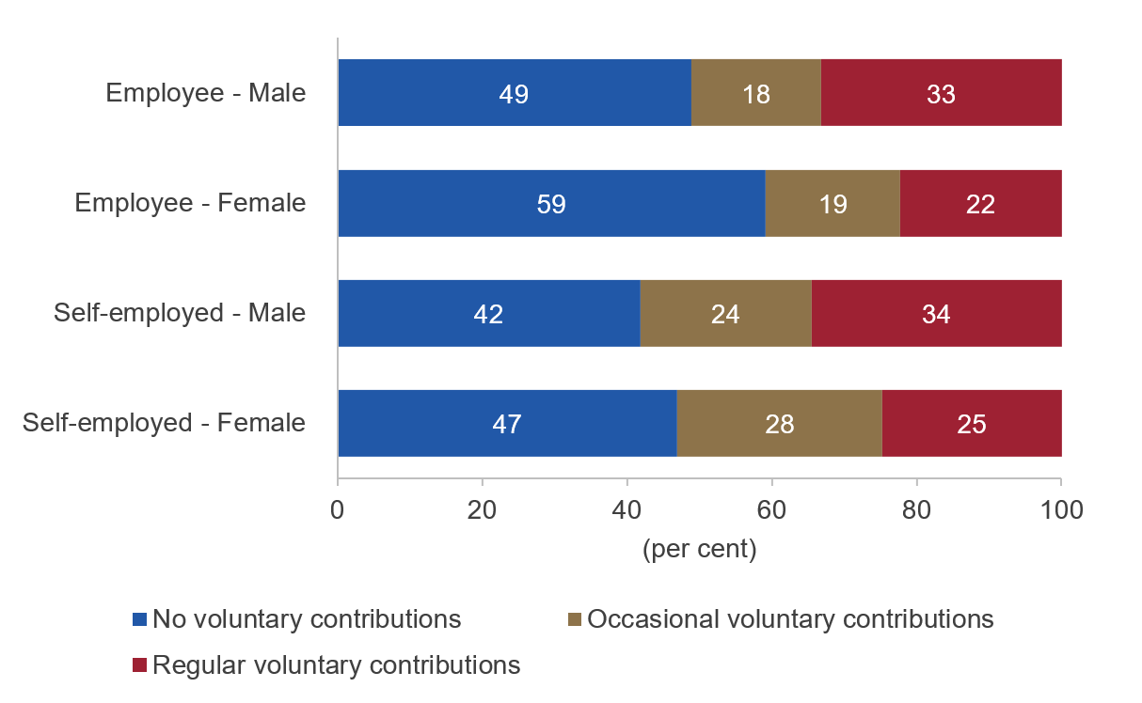
Self-employed: Do you make contributions to your superannuation? Employees: Do you currently make voluntary super contributions (that is contributions beyond the amount that employer is required to provide)? (n=1,580)
Self-employed workers comprised around 17% of the working population in 2019 (Department of Employment 2019, p4). Our results suggest a large minority (44%) were not contributing to superannuation. It is possible they were saving by other means. For example, an analysis of the 2015-16 Survey of Income and Housing found:
the self-employed tend to accumulate more of their non-housing wealth outside of the superannuation system, including in cash, shares and investment properties [and] … business assets are also substantial contributors to non-housing wealth. (Craston 2018, p24).
Most of the non-contributing self-employed (86%) had lower incomes (earning less than $80,000 before tax). Within this group, about half (52%) cited financial constraints as the main reason for not contributing. Many lower-income self-employed seem likely to depend on the Age Pension in retirement.
There was mixed awareness of superannuation tax concessions. Roughly similar proportions of the self-employed (52%) and employees (43%) stated they were aware of the tax concessions available for super contributions and had a good sense of what they were (Figure 7). Female respondents reported lower awareness and understanding.
For those who did not make voluntary contributions, few (33%) reported they were aware of super tax concessions. However, close to half of those not making contributions (45%) said they lacked the income to save for the longer term: in such cases, a lack of awareness of tax concessions may be understandable. By contrast, for many of those who did make voluntary super contributions (46%), the tax benefits were an important factor in their decision to do so.
- Awareness of tax concessions
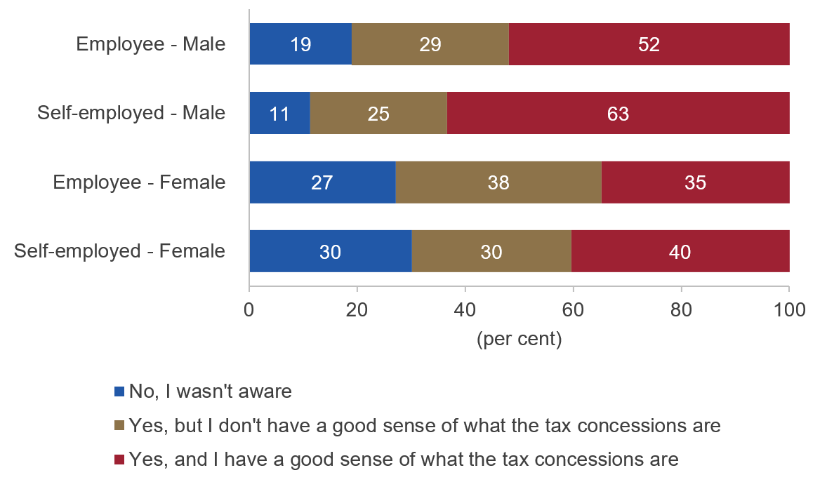
Were you aware of that you can receive tax concessions when you make (voluntary) contributions to your superannuation? (n=1,580)

Financial advice
Only a minority reported financial advice was important for their superannuation decisions. Less than half (40%) of respondents had ever received financial advice. Of those, about half (53%) first received advice before they were 35 years old (Figure 8). In relation to superannuation contributions, financial advice was important for a minority of respondents. One-third of all respondents who made voluntary contributions said the advice from a financial adviser was very or extremely important in their decision to make contributions. Around one-quarter said it was important in deciding how much to contribute. By contrast, only 3% said financial advice was a reason why they did not make super contributions.
- Age at which respondents first sought financial advice
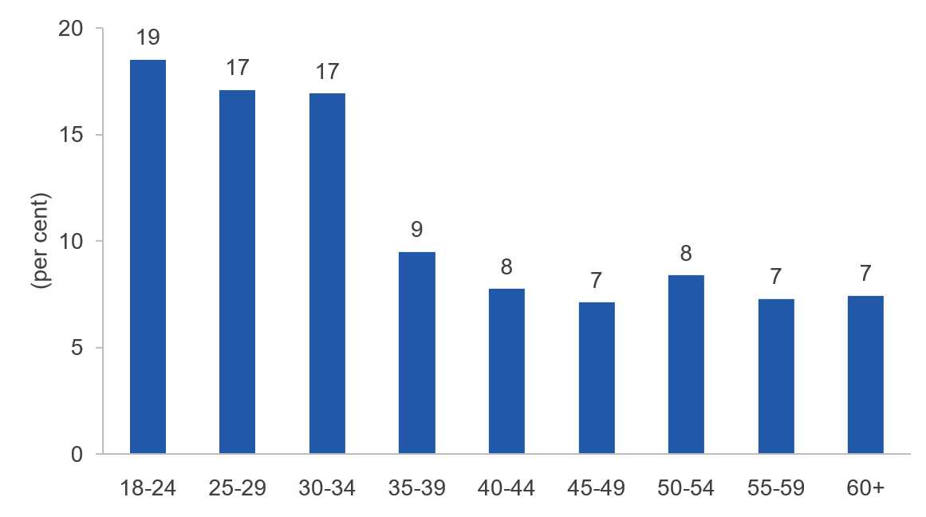
Roughly what age were you when you first received professional financial advice? (‘60 – 64’, and ‘65 or older’ categories have been collapsed into ‘60+’.) (n=632)

Differences in responses by gender
Gender differences should be interpreted with caution as female respondents tended to be younger than male respondents. Despite the sample population matching national characteristics for age and gender, younger age groups skewed female and older age groups skewed male. For example, 41% of female respondents were below 35 years compared to 25% of male respondents. Conversely, 41% of males versus 21% of females were aged 55 years or older. This complicates comparisons by gender: a difference could be due to gender itself, or it could be due to the younger age profile of female respondents. Where possible, we have attempted to clarify the likely source of any apparent gender gaps.
Female respondents appear to have less engagement with and knowledge of the retirement savings system. In particular, even when we allow for the age skew noted above, female respondents were less likely than males to:
- have calculated their retirement savings needs (26% versus 39%);
- have seen a financial advisor (35% versus 45%); and
- have knowledge of key elements of the retirement savings system (for example, awareness of superannuation tax concessions: 72% versus 83%).
Female respondents were more likely to cite income constraints in regards to their retirement savings decisions (which accords with their lower earnings). They were also more pessimistic about their expected lifestyle in retirement, and found superannuation to be a less stable investment than males.

Demographics
Demographic characteristics:
- Key demographic characteristics – gender, age, family type, State or Territory – are broadly representative of the Australian adult population.
- There is, however, a skew in the demographic characteristics: younger age groups skewed female, and the older age groups skewed male. Likewise (and related), female respondents tended to have lower incomes than male respondents.
- Home ownership varied by family status, as expected. Most singles (57%) were renting (36%) or living with friends or family (21%) whereas most couples (69%) either had had a mortgage or owned their own home.
Employment status and duration:
- The survey was restricted to the employed. Most respondents (78%) were employees; the remainder were self-employed. Similarly, most respondents (77%) held permanent or fixed term positions and most of the remainder (19%) were in casual roles.
- Respondents typically had a lengthy duration of employment in their current role: 47% of employees and 58% of the self-employed had been with their current organisation or business for more than five years.
Income and financial situation:
- Overall, respondents’ incomes were roughly representative of Australian employees’ incomes. See the appendix for more details.
- Male respondents were more likely (41%) to earn $80,000+ per annum, as compared to female respondents (22%). This mostly reflected a differential between male and female respondents in similar age groups however the younger age profile of female respondents also influenced this result.
- Almost half (45%) of respondents self-reported their financial situation as ‘just getting along’ or worse.

Demographic characteristics

Table 1: Gender Q2.12
Gender | All
Female | 50.6% (800)
Male | 48.8% (771)
X (Indeterminate/Interex/Unspecified) | 0.4% (6)
Prefer not to say | 0.2% (3)
Total | 100% (1580)

Table 2: Age by gender Q2.13
Age | Female | Male | All
18 - 24 | 18.5% (148) | 8.9% (69) | 13.9% (219)
25 - 34 | 22.0% (176) | 15.8% (122) | 19.1% (301)
35 - 44 | 22.1% (177) | 17.5% (135) | 19.9% (314)
45 - 54 | 16.2% (130) | 17.3% (133) | 16.8% (265)
55 - 64 | 9.6% (77) | 21.0% (162) | 15.1% (239)
65 - 74 | 10.5% (84) | 17.0% (131) | 13.6% (215)
75 - 84 | 1.0% (8) | 2.3% (18) | 1.6% (26)
85 or older | 0.0% (0) | 0.1% (1) | 0.1% (1)
Total | 100.0% (800) | 100.0% (771) | 100.0% (1580)

Table 3: Family characteristics Q2.14
Please describe your family | Female | Male | All
Couple, no dependent children | 28.7% (230) | 32.7% (252) | 30.8% (486)
Couple, with dependent children | 29.6% (237) | 32.4% (250) | 30.9% (488)
Single, no dependent children | 33.1% (265) | 30.7% (237) | 32.0% (505)
Single, with dependent children | 8.5% (68) | 4.2% (32) | 6.4% (101)
Total | 100.0% (800) | 100.0% (771) | 100.0% (1580)
Note: a ‘dependent child’ refers to any child under 15 years, and dependent students aged 15-24 years and studying full-time.

Table 4: State or Territory Q2.4
What State or Territory do you currently reside in? | Female | Male | All
NSW | 29.4% (235) | 32.6% (251) | 30.8% (486)
Victoria | 25.4% (203) | 26.6% (205) | 26.1% (413)
Queensland | 22.8% (182) | 19.1% (147) | 20.9% (330)
WA | 10.8% (86) | 8.7% (67) | 9.7% (154)
SA | 7.1% (57) | 8.4% (65) | 7.8% (123)
Tasmania | 3.0% (24) | 3.1% (24) | 3.0% (48)
ACT | 1.2% (10) | 1.6% (12) | 1.5% (23)
NT | 0.4% (3) | 0.0% (0) | 0.2% (3)
Total | 100.0% (800) | 100.0% (771) | 100.0% (1580)

Table 5: Home ownership status Q2.17 & Q2.18

Couples
What is the home ownership status for you and/or your partner? | Female | Male | All
We are living in social or public housing | 1.1% (5) | 0.6% (3) | 0.8% (8)
We are living with family or friends | 4.7% (22) | 2.4% (12) | 3.5% (34)
We are paying off the mortgage on our home | 36.2% (169) | 35.3% (177) | 35.5% (346)
We are renting privately | 31.0% (145) | 21.3% (107) | 26.3% (256)
We own our home outright | 26.8% (125) | 40.0% (201) | 33.6% (327)
Other (please specify) | 0.2% (1) | 0.4% (2) | 0.3% (3)
Total | 100.0% (467) | 100.0% (502) | 100.0% (974)

Singles
What is the home ownership status for you and/or your partner? | Female | Male | All
I am living in social or public housing | 2.7% (9) | 1.9% (5) | 2.3% (14)
I am living with family or friends | 24.0% (80) | 16.0% (43) | 20.6% (125)
I am paying off the mortgage on my home | 21.3% (71) | 17.8% (48) | 19.6% (119)
I am renting privately | 38.1% (127) | 34.2% (92) | 36.1% (219)
I own my home outright | 12.6% (42) | 29.4% (79) | 20.3% (123)
Other (please specify) | 1.2% (4) | 0.7% (2) | 1.0% (6)
Total | 100.0% (333) | 100.0% (269) | 100.0% (606)

Employment

Table 6: Employment type – employed by an organisation or self-employed Q2.6
Employment type | Female | Male | All
Employed by an organisation | 79.2% (634) | 77.0% (594) | 78.2% (1235)
Self-employed | 20.8% (166) | 23.0% (177) | 21.8 (345)
Total | 100.0% (800) | 100.0% (771) | 100.0% (1580)

Table 7: Length of time employed by organisation – employed Q2.8
How long have you worked for your current employer? | Female | Male | All
Less than 1 year | 15.8% (100) | 11.1% (66) | 13.6% (168)
1 year to less than 2 years | 17.4% (110) | 12.5% (74) | 15.1% (186)
2 years to less than 5 years | 27.3% (173) | 21.5% (128) | 24.5% (303)
5 years or more | 39.6% (251) | 54.9% (326) | 46.8% (578)
Total | 100.0% (634) | 100.0% (594) | 100.0% (1235)

Table 8: Length of time in current business – self-employed Q2.9
How long have you worked in your current business? | Female | Male | All
Less than 1 year | 21.1% (35) | 7.3% (13) | 14.2% (49)
1 year to less than 2 years | 19.9% (33) | 10.2% (18) | 14.8% (51)
2 years to less than 5 years | 16.9% (28) | 9.0% (16) | 12.8% (44)
5 years or more | 42.2% (70) | 73.4% (130) | 58.3% (201)
Total | 100.0% (166) | 100.0% (177) | 100.0% (345)

Table 9: Industry Q2.7
For your main job, please indicate the industry you work in. | Female | Male | All
Accommodation and Food Services | 5.1% (41) | 3.5% (27) | 4.3% (68)
Administrative and Support Services | 5.1% (41) | 2.3% (18) | 3.7% (59)
Agriculture, Forestry and Fishing | 3.0% (24) | 3.2% (25) | 3.1% (49)
Arts and Recreation Services | 2.9% (23) | 2.9% (22) | 2.8% (45)
Construction | 1.5% (12) | 9.2% (71) | 5.3% (83)
Education and Training | 10.6% (85) | 6.9% (53) | 8.7% (138)
Electricity, Gas, Water and Waste Services | 0.8% (6) | 1.6% (12) | 1.2% (19)
Financial and Insurance Services | 4.9% (39) | 5.7% (44) | 5.3% (83)
Health Care and Social Assistance | 14.5% (116) | 7.0% (54) | 10.8% (171)
Information Media and Telecommunications | 2.8% (22) | 3.1% (24) | 3.0% (47)
Manufacturing | 4.4% (35) | 7.1% (55) | 5.7% (90)
Mining | 0.6% (5) | 2.6% (20) | 1.6% (25)
Other Services | 14.9% (119) | 11.5% (89) | 13.2% (208)
Professional, Scientific and Technical Services | 5.6% (45) | 9.2% (71) | 7.4% (117)
Public Administration and Safety | 3.4% (27) | 3.6% (28) | 3.5% (55)
Rental, Hiring and Real Estate Services | 1.1% (9) | 1.4% (11) | 1.3% (20)
Retail Trade | 14.8% (118) | 11.5% (89) | 13.4% (212)
Transport, Postal and Warehousing | 2.0% (16) | 4.3% (33) | 3.1% (49)
Wholesale Trade | 2.1% (17) | 3.2% (25) | 2.7% (42)
Total | 100.0% (800) | 100.0% (771) | 100.0% (1580)

Table 10: Employment type Q2.10
For your main job, what type is your employment? | Female | Male | All
Apprentice or trainee | 0.9% (6) | 1.2% (7) | 1.1% (13)
Casual | 22.6% (143) | 14.5% (86) | 18.9% (233)
Contractor or sub-contractor | 1.3% (8) | 2.5% (15) | 1.9% (23)
Labour hire | 0.8% (5) | 1.0% (6) | 0.9% (11)
Permanent or fixed term | 74.1% (470) | 80.1% (476) | 76.8% (949)
Other (please specify) | 0.3% (2) | 0.7% (4) | 0.5% (6)
All | 100.0 | 100.0 | 100.0

Income and financial situation

Table 11: Financial situation Q2.15
Given your current needs and financial responsibilities, would you say that you and your family are… | Female | Male | All
Very poor | 3.4% (27) | 2.7% (21) | 3.1% (49)
Poor | 5.5% (44) | 4.7% (36) | 5.1% (81)
Just getting along | 39.5% (316) | 33.9% (261) | 36.8% (582)
Reasonably comfortable | 41.0% (328) | 44.4% (342) | 42.4% (670)
Very comfortable | 9.2% (74) | 13.0% (100) | 11.1% (176)
Prosperous | 1.4% (11) | 1.4% (11) | 1.4% (22)
Total | 100.0% (800) | 100.0% (771) | 100.0% (1580)

Table 12: Annual gross income Q2.11
Current annual income from all sources, before tax or other deductions are taken out? Please just give your income, excluding other members of your household. | Female | Male | All
Less than $20,000 | 13.4% (107) | 6.1% (47) | 9.9% (156)
$20,000 to $29,999 | 10.4% (83) | 6.4% (49) | 8.4% (132)
$30,000 to $39,999 | 11.2% (90) | 7.5% (58) | 9.4% (149)
$40,000 to $49,999 | 12.0% (96) | 8.9% (69) | 10.4% (165)
$50,000 to $59,999 | 14.8% (118) | 11.3% (87) | 13.1% (207)
$60,000 to $69,999 | 10.5% (84) | 10.2% (79) | 10.4% (164)
$70,000 to $79,999 | 6.0% (48) | 8.8% (68) | 7.4% (117)
$80,000 to $89,999 | 4.8% (38) | 6.4% (49) | 5.5% (87)
$90,000 to $99,999 | 4.1% (33) | 9.2% (71) | 6.6% (105)
$100,000 to $119,999 | 5.0% (40) | 9.7% (75) | 7.3% (115)
$120,000 to $139,999 | 2.6% (21) | 4.3% (33) | 3.5% (55)
$140,000 to $159,999 | 1.6% (13) | 4.5% (35) | 3.0% (48)
$160,000 to $179,999 | 0.9% (7) | 1.7% (13) | 1.3% (20)
$180,000 or more | 2.8% (22) | 4.9% (38) | 3.8% (60)
Total | 100.0% (800) | 100.0% (771) | 100.0% (1580)

Survey results

Attitudes and expectations

Retirement expectations
- Most respondents (over 70%) expect to retire when they are 60 or older.
- One-quarter expect to have a worse lifestyle in retirement than their parents while around one-third expect it to be about the same and around 40% who expect it to be better.
  - Female respondents had a more pessimistic view (30% expected to be worse off, versus 21% for males). This partly reflects the younger age profile of female respondents. That is, younger people were also generally more pessimistic in their answers to this question.

Superannuation as an investment
- More than half of respondents agreed superannuation is a stable investment for retirement. (More males than females agreed: 59% versus 48%.) Overall, only 17% disagreed.
- However, two-thirds agreed they are concerned about how financial markets will affect their superannuation.

The Age Pension and the superannuation system
- Many respondents (60%) agreed the rules of superannuation and Age Pension change too much.
- One-quarter of respondents thought it unlikely the Age Pension will still exist when they reach retirement age. And more than one-third felt it was unlikely the Age Pension will still be of a similar value.
  - Female respondents tended to be more pessimistic about the Age Pension than males, both the likelihood it will still exist at retirement (42% versus 53%), and the likelihood that it will have a similar value to today (34% versus 42%).

Retirement expectations

Table 13: Expected retirement age Q2.16
At what age do you expect to retire (in the sense that you no longer need to work)? | Female | Male | All
45 – 49 | 2.1% (17) | 1.8% (14) | 2.0% (31)
50 - 54 | 2.8% (22) | 1.8% (14) | 2.3% (36)
55 - 59 | 5.5% (44) | 6.6% (51) | 6.0% (95)
60 - 64 | 18.6% (149) | 16.7% (129) | 17.6% (278)
65 - 69 | 28.2% (226) | 30.2% (233) | 29.2% (461)
70 - 74 | 17.1% (137) | 18.3% (141) | 17.7% (279)
75 or more | 7.1% (57) | 8.3% (64) | 7.8% (123)
I don’t expect to be able to afford to stop working | 5.0% (40) | 3.2% (25) | 4.2% (67)
I intend to keep working as long as I’m able to | 13.5% (108) | 13.0% (100) | 13.3% (210)
Total | 100.0% (800) | 100.0% (771) | 100.0% (1580)

Table 14: Do you believe that you’ll have the same standard of living in retirement as your parents? Q7.10
Do you believe that you’ll have the same standard of living in retirement as your parents? | Female | Male | All
Certainly worse | 7.6% (61) | 4.2% (32) | 5.9% (94)
Likely worse | 21.9% (175) | 16.6% (128) | 19.4% (306)
About the same | 32.0% (256) | 33.2% (256) | 32.6% (515)
Likely better | 27.1% (217) | 30.0% (231) | 28.4% (449)
Certainly better | 11.4% (91) | 16.1% (124) | 13.7% (216)
Total | 100.0% (800) | 100.0% (771) | 100.0% (1580)

Superannuation as an investment

Table 15: Superannuation is a stable investment for retirement Q7.11(b)
Level of agreement | Female | Male | All
Strongly agree | 10.2% (82) | 15.8% (122) | 12.9% (204)
Agree | 37.5% (300) | 43.6% (336) | 40.4% (638)
Neither agree nor disagree | 33.0% (264) | 26.8% (207) | 30.1% (475)
Disagree | 15.8% (126) | 8.9% (69) | 12.5% (198)
Strongly disagree | 3.5% (28) | 4.8% (37) | 4.1% (65)
Total | 100.0% (800) | 100.0% (771) | 100.0% (1580)

Table 16: I am concerned about how financial markets will affect my superannuation Q7.11(c)
Level of agreement | Female | Male | All
Strongly agree | 26.2% (210) | 28.3% (218) | 27.2% (429)
Agree | 39.6% (317) | 40.5% (312) | 40.1% (633)
Neither agree nor disagree | 26.8% (214) | 22.6% (174) | 24.8% (392)
Disagree | 5.9% (47) | 6.7% (52) | 6.3% (99)
Strongly disagree | 1.5% (12) | 1.9% (15) | 1.7% (27)
Total | 100.0% (800) | 100.0% (771) | 100.0% (1580)

The Age Pension and the superannuation system

Table 17: The rules of superannuation and Age Pension change too much Q7.11(a)
Level of agreement | Female | Male | All
Strongly agree | 20.2% (162) | 24.1% (186) | 22.3% (352)
Agree | 39.4% (315) | 35.9% (277) | 37.6% (594)
Neither agree nor disagree | 33.6% (269) | 31.3% (241) | 32.5% (513)
Disagree | 6.1% (49) | 7.4% (57) | 6.7% (106)
Strongly disagree | 0.6% (5) | 1.3% (10) | 0.9% (15)
Total | 100.0% (800) | 100.0% (771) | 100.0% (1580)

Table 18: The Age Pension will still exist when I reach retirement age Q7.12(a)
Likelihood | Female | Male | All
Very Likely | 12.8% (102) | 21.4% (165) | 17.0% (268)
Likely | 29.6% (237) | 31.9% (246) | 30.6% (484)
Neither likely nor unlikely | 31.0% (248) | 22.6% (174) | 26.9% (425)
Unlikely | 16.5% (132) | 15.0% (116) | 15.9% (252)
Very unlikely | 10.1% (81) | 9.1% (70) | 9.6% (151)
Total | 100.0% (800) | 100.0% (771) | 100.0% (1580)

Table 19: The Age Pension will still be of a similar value when I reach retirement age Q7.12(b)
Likelihood | Female | Male | All
Very Likely | 8.4% (67) | 14.7% (113) | 11.4% (180)
Likely | 25.4% (203) | 27.1% (209) | 26.1% (413)
Neither likely nor unlikely | 29.4% (235) | 25.2% (194) | 27.4% (433)
Unlikely | 22.5% (180) | 22.7% (175) | 22.5% (356)
Very unlikely | 14.4% (115) | 10.4% (80) | 12.5% (198)
Total | 100.0% (800) | 100.0% (771) | 100.0% (1580)

Planning and saving

Retirement planning
- Over two-thirds of respondents said they had never estimated how much they would need for retirement.
  - Of those who hadn’t made an estimate, the main reasons were: ‘retirement is a long way off’ (46%) and ‘I don’t have enough money to save generally’ (26%)
  - Female respondents were more likely to have never estimated their retirement savings needs (74% of females versus 61% of males). This gap is only partly due to the younger age profile of female respondents.
- Of those who had made an estimate, most (80%) had worked out how much they save each year — either a specific amount or a rough estimate — to reach their retirement savings goal.
- Of those who had made an estimate, the majority (60%) changed either their super contributions or other savings.

Retirement savings – aims and expectations
- Many respondents had relatively low aims for their retirement savings (excluding the family home).
  - For singles, almost half (49%) were aiming for less than $400,000 and most (81%) said less than $1 million.
  - For couples, over half (56%) were aiming for less than $600,000 and 86% said less than $1.2 million.
- Furthermore, only just over half of respondents (52%) thought it likely they would achieve the amount they were aiming for.
  - A larger share of males thought that it was likely that they would achieve their aim, noticeably more than the share of females respondents (59% versus 46%).
- Most respondents (61%) thought they would need a retirement income between $30,000 and $90,000 per year (in today’s dollars).
- Most respondents expected their largest asset in retirement would either be their super (44%) or their family home (39%).
- Most respondents already own their own home or expected to do so before retirement—74% of couples and 56% of singles—however:
  - A minority expected to still have a mortgage in retirement (13-14%), and
  - Almost a quarter of single respondents (23%) said they don’t expect to ever be able to afford own their own home, compared with just 8% of couples.

Retirement planning

Table 20: Have you ever estimated how much you will need for retirement? Q7.1
Have you (or your financial adviser) ever estimated how much money you will need for your retirement? | Female | Male | All
No | 74.0% (592) | 61.2% (472) | 67.8% (1071)
Yes | 26.0% (208) | 38.8% (299) | 32.2% (509)
Total | 100.0% (800) | 100.0% (771) | 100.0% (1580)

Table 21: Why haven't you worked out how much you need to retire on? Q7.2
Why haven't you worked out how much you need to retire on? (Please select all that apply.) | Female | Male | All
Retirement is long way off | 47% (278) | 43% (203) | 45.6% (488)
I meant to, but haven't gotten around to it | 19.6% (116) | 19.9% (94) | 19.6% (210)
I think the Age Pension will be enough | 6.1% (36) | 5.9% (28) | 6.0% (64)
I don’t have enough income to save generally – for super or otherwise | 28.4% (168) | 22.2% (105) | 25.6% (274)
I am confident that I will have enough to retire on | 10.0% (59) | 16.3% (77) | 12.7% (136)
Other | 2.9% (17) | 4.4% (21) | 3.6% (39)
Total | _ (592) | _ (472) | _ (1071)
Note: totals sum to more than 100% because multiple options were allowed.

Table 22 Have you worked out how much you need to save each year to reach your retirement goal? Q7.5
Have you worked out how much you need to save each year to reach your retirement savings goal? | Female | Male | All
No | 24.0% (50) | 17.4% (52) | 20.0% (102)
Yes, I have worked out a rough estimate of what I need to save each year | 40.9% (85) | 42.5% (127) | 41.7% (212)
Yes, I have worked out a specific amount I need to save each year | 35.1% (73) | 40.1% (120) | 38.3% (195)
Total | 100.0% (208) | 100.0% (299) | 100.0% (509)

Table 23: Did you change how much you are contributing to super as a result of calculating how much money you need for retirement? Q7.6

Employed
Did you change how much you are contributing to super as a result of calculating how much money you need for retirement? | Female | Male | All
No, but I changed my savings elsewhere | 33.1% (55) | 26.6% (59) | 29.7% (116)
No, I am already saving enough so I didn't make any changes to my savings | 30.7% (51) | 38.7% (86) | 35.1% (137)
Yes, I decreased my voluntary contributions | 12.0% (20) | 10.8% (24) | 11.3% (44)
Yes, I increased my voluntary contributions | 21.1% (35) | 20.3% (45) | 20.5% (80)
Other (please specify) | 3.0% (5) | 3.6% (8) | 3.3% (13)
Total | 100.0% (166) | 100.0% (222) | 100.0% (390)

Self employed
Did you change how much you are contributing to super as a result of calculating how much money you need for retirement? | Female | Male | All
No, but I changed my savings elsewhere | 33.3% (14) | 20.8% (16) | 25.2% (30)
No, I am already saving enough so I didn't make any changes to my savings | 31.0% (13) | 44.2% (34) | 39.5% (47)
Yes, I decreased my super contributions | 11.9% (5) | 6.5% (5) | 8.4% (10)
Yes, I increased my super contributions | 19.0% (8) | 23.4% (18) | 21.8% (26)
Other (please specify) | 4.8% (2) | 5.2% (4) | 5.0% (6)
Total | 100.0% (42) | 100.0% (77) | 100.0% (119)

Retirement savings – aims and expectations

Table 24: How much in savings do you aim to enter retirement with (excluding family home)? Q7.3
Excluding the family home, approximately how much in superannuation and other savings do you aim to enter retirement with? | Couples | Singles
Less than $100,000 | 9.3% (80) | 16.1% (84)
$100,000 to $199,999 | 8.8% (76) | 11.9% (62)
$200,000 to $299,999 | 8.7% (75) | 12.3% (64)
$300,000 to $399,999 | 8.3% (71) | 8.4% (44)
$400,000 to $499,999 | 8.8% (76) | 9% (47)
$500,000 to $599,999 | 12.1% (104) | 9.4% (49)
$600,000 to $799,999 | 7.9% (68) | 7.1% (37)
$800,000 to $999,999 | 8.4% (72) | 6.5% (34)
$1 million to less than $1.2 million | 13.8% (119) | 8.4% (44)
$1.2 million to less than $1.4 million | 3.1% (27) | 2.3% (12)
$1.4 million to less than $1.6 million | 3% (26) | 2.3% (12)
$1.6 million or more | 7.7% (66) | 6.3% (33)
Total | 100% (860) | 100% (522)
Not sure | _ (114) | _ (84)
Note: The total excludes those who answered ‘not sure’. There is no sum across couples and singles since they are not directly comparable: couples were asked to provide a combined amount for both.

Table 25: Do you think that you will achieve this amount? Q7.4
Do you think that you will achieve this amount? | Female | Male | All
Very likely | 14.6% (117) | 21.1% (163) | 17.8% (281)
Likely | 31.0% (248) | 37.7% (291) | 34.2% (541)
Neither likely nor unlikely | 33.1% (265) | 24.8% (191) | 29.1% (460)
Unlikely | 14.1% (113) | 10.0% (77) | 12.1% (191)
Very unlikely | 7.1% (57) | 6.4% (49) | 6.8% (107)
Total | 100.0% (800) | 100.0% (771) | 100.0% (1580)

Table 26: What level of annual income do you think you will need for retirement? Q7.8
In today’s dollars, approximately what level of annual income do you think you will need for retirement? | Female | Male | All
Less than $20,000 | 2.6% (21) | 1.9% (15) | 2.3% (37)
$20,000 to $29,999 | 5.2% (42) | 4.9% (38) | 5.1% (80)
$30,000 to $39,999 | 8.8% (70) | 8.6% (66) | 8.6% (136)
$40,000 to $49,999 | 9.0% (72) | 10.6% (82) | 9.9% (157)
$50,000 to $59,999 | 14.1% (113) | 15.6% (120) | 14.8% (234)
$60,000 to $69,999 | 11.1% (89) | 11.4% (88) | 11.2% (177)
$70,000 to $79,999 | 7.1% (57) | 10.2% (79) | 8.7% (138)
$80,000 to $89,999 | 6.9% (55) | 8.6% (66) | 7.7% (122)
$90,000 to $99,999 | 4.4% (35) | 3.6% (28) | 4.0% (63)
$100,000 to $119,999 | 7.8% (62) | 6.9% (53) | 7.3% (115)
$120,000 to $139,999 | 2.8% (22) | 3.1% (24) | 2.9% (46)
$140,000 to $159,999 | 2.6% (21) | 2.6% (20) | 2.6% (41)
$160,000 to $179,999 | 2.2% (18) | 1.9% (15) | 2.2% (34)
$180,000 or more | 15.4% (123) | 10.0% (77) | 12.7% (200)
Total | 100.0% (800) | 100.0% (771) | 100.0% (1580)

Table 27: Home ownership expectations Q2.19 & Q2.20

Couples
Do you think you will own your own home outright before retirement? | Female | Male | All
We own our home outright | 26.8% (125) | 40% (201) | 33.6% (327)
No, I don't think we will ever be able to afford to buy our own home | 9% (42) | 7.6% (38) | 8.4% (82)
No, we don't want to own our home | 2.8% (13) | 3% (15) | 2.9% (28)
No, we will still have a mortgage | 14.8% (69) | 13.9% (70) | 14.4% (140)
Yes | 46% (215) | 35.3% (177) | 40.3% (393)
Other (please specify) | 0.6% (3) | 0.2% (1) | 0.4% (4)
Total | 100% (467) | 100% (502) | 100% (974)

Singles
Do you think you will own your own home outright before retirement? | Female | Male | All
I own my home outright | 12.6% (42) | 29.4% (79) | 20.3% (123)
No, I don't think I will ever be able to afford to buy my own home | 28.2% (94) | 16.4% (44) | 23.1% (140)
No, I don't want to own my home | 4.2% (14) | 7.8% (21) | 5.8% (35)
No, I will still have a mortgage | 15.9% (53) | 10.4% (28) | 13.4% (81)
Yes | 37.2% (124) | 35.3% (95) | 36.1% (219)
Other (please specify) | 1.8% (6) | 0.7% (2) | 1.3% (8)
Total | 100% (333) | 100% (269) | 100% (606)
Note: The responses to ‘We/I own my home outright’ came earlier questions about current home ownership status (Q2.17 and Q2.18).

Table 28: Which form of investment do you expect to have the largest value when you retire? Q7.9
Which form of investment do you expect to have the largest value when you retire? Please rank the following options | Female | Male | All
Super | 41.8% (320) | 45.9% (337) | 43.7% (659)
Family home | 42.6% (326) | 35.6% (262) | 39.1% (590)
Shares or property portfolio | 7.8% (60) | 8.7% (64) | 8.3% (125)
Own business | 5.2% (40) | 6.8% (50) | 6.2% (93)
Other (please specify) | 2.6% (20) | 3.0% (22) | 2.8% (42)
Total | 100% (766) | 100% (735) | 100% (1509)
Note: Unlike other questions, respondents were not forced to respond to this question. 71 people chose not to do so.

Voluntary contributions

Awareness of tax concessions for superannuation
- Half of the self-employed (52%) but a smaller proportion of employees (43%) stated they were aware of the tax concessions available for super contributions and had a good sense what they are.
- Around 21-23% said they were unaware of the tax concessions and the remainder (28-34%) were aware but without a good sense of what they are.
  - Females were substantially less likely to be aware of the tax concessions both for the self-employed (30% unaware versus 11%) and the employed (27% versus 19%).
  - Females were also less likely to feel they have a good sense of the tax concessions. The younger age profile of female respondents only plays a minor role in this result.

Superannuation Guarantee and employer contributions
- Female respondents were much less likely to agree ‘the government mandated employer contribution to superannuation of 9.5% was chosen to ‘give people enough to retire on’ (41% versus 53%). They were also more likely to be unaware of the Superannuation Guarantee (11% versus 4%).
- Female respondents were less likely to know what rate of superannuation they are paid by their employer. This was especially the case for those not making voluntary contributions (37% versus 23%).

How many make superannuation contributions?
- As expected, the proportion making super contributions varies between employees, who receive the Super Guarantee, and the self-employed.
- Amongst employees, 54% make no voluntary contributions whereas over a quarter (28%) make regular voluntary contributions and 18% make occasional contributions.
  - Female respondents were noticeably less likely to make voluntary contributions than males, both for self-employed (47% of females versus 42% of males) and those employed by an organisation (59% of females versus 49% of males). This only partly reflects the younger age profile of female respondents.
- Amongst the self-employed, a large minority (44%) make no contribution. This is largely driven by those on lower incomes, who are a larger share of survey respondents than the Australian population.

Respondents who make superannuation contributions
- For those making contributions, employees and the self-employed had very similar views about the most important factors in the decision to make contributions, and also the decision about how much to contribute.
- For the decision to make contributions, the most important factors (rated as very or extremely important) were:
  - ‘reaching your retirement savings target’ (65-66%)
- tax benefits (46-47%)
- the fact that super is locked away until retirement (42-47%)
- In terms of deciding how much to contribute, the most important factors were:
  - ‘my own careful calculation’ (41-43%; female respondents were less likely to cite this reason)
  - ‘I just put in what I can afford’ (31%)
  - accountant or financial advisor (30% self-employed / 23% employees)
  - tax concessions (22-24%)
- Setting contributions as a fixed percentage of income would allow contributions to increase with wages however relatively few respondents do this: 29% of employees and just 18% of the self-employed.

Respondents not making superannuation contributions
- Of those respondents not making voluntary contributions, many (45-47%) said they lacked the income to save for the longer term.
  - Female respondents were over-represented amongst those lacking income to save for the longer term both for the self-employed (51% versus 42%) and employees (50% versus 39%).
- Most of the remainder said they invest their savings in vehicles other than super (35% of the self-employed and 26% of employees).
  - For this group, there were various reasons for choosing non-super options including: they could achieve better returns elsewhere, they preferred a more stable investment, they didn’t like having their money locked away, or they hadn’t gotten around to it.

Voluntary contributions – self-employed

Table 29: Awareness of tax concessions for superannuation contributions [self-employed] Q3.1
Were you aware of that you can receive tax concessions when you make contributions to your superannuation? | Female | Male | All
No, I wasn't aware | 30.1% (50) | 11.3% (20) | 20.6% (71)
Yes, and I have a good sense of what the tax concessions are | 40.4% (67) | 63.3% (112) | 51.9% (179)
Yes, but I don't have a good sense of what the tax concessions are | 29.5% (49) | 25.4% (45) | 27.5% (95)
Total | 100.0% (166) | 100.0% (177) | 100.0% (345)

Table 30: Do you make contributions to your superannuation? [self-employed] Q3.2
Do you make contributions to your superannuation? | Female | Male | All
No | 47.0% (78) | 41.8% (74) | 44.3% (153)
Yes, I make occasional contributions | 28.3% (47) | 23.7% (42) | 25.8% (89)
Yes, I make regular contributions | 24.7% (41) | 34.5% (61) | 29.9% (103)
Total | 100.0% (166) | 100.0% (177) | 100.0% (345)

Table 31: Retirement savings behaviour [self-employed not making regular contributions] Q3.3
Which of the following best represents your retirement savings behaviour? | Female | Male | All
I could save more for the longer-term, but I don't feel I need to | 1.3% (1) | 4.1% (3) | 2.6% (4)
I don’t have enough income to save for the longer-term | 51.3% (40) | 41.9% (31) | 47.1% (72)
I haven't thought much about saving for retirement | 17.9% (14) | 12.2% (9) | 15.0% (23)
I invest my savings in other ways than super (eg shares, extra mortgage payments, savings account, invest in my business, etc) | 29.5% (23) | 41.9% (31) | 35.3% (54)
Total | 100.0% (78) | 100.0% (74) | 100.0% (153)

Table 32: Superannuation contribution behaviour [self-employed who make voluntary contributions] Q3.4
Are your superannuation contributions … | Female | Male | All
A fixed dollar amount each period | 35.2% (31) | 25.2% (26) | 30.2% (58)
A fixed percentage of your income each period | 11.4% (10) | 24.3% (25) | 18.2% (35)
A varying amount each period (that is, neither a fixed dollar nor a fixed percentage) | 14.8% (13) | 24.3% (25) | 19.8% (38)
Occasional contributions when you can afford it | 26.1% (23) | 25.2% (26) | 25.5% (49)
Not sure | 12.5% (11) | 1.0% (1) | 6.2% (12)
Total | 100.0% (88) | 100.0% (103) | 100.0% (192)

Table 33: Importance in deciding to make voluntary contributions [self-employed who make voluntary contributions] Q3.5(a)
Everybody else has super, so I figured I needed some too | Female | Male | All
Not at all important | 26.1% (23) | 29.1% (30) | 27.6% (53)
Slightly important | 15.9% (14) | 13.6% (14) | 14.6% (28)
Moderately important | 31.8% (28) | 29.1% (30) | 30.7% (59)
Very important | 15.9% (14) | 9.7% (10) | 12.5% (24)
Extremely important | 10.2% (9) | 18.4% (19) | 14.6% (28)
Total | 100.0% (88) | 100.0% (103) | 100.0% (192)

Table 34: Importance in deciding to make voluntary contributions [self-employed who make voluntary contributions] Q3.5(b)
Reaching your retirement savings target | Female | Male | All
Not at all important | 5.7% (5) | 6.8% (7) | 6.2% (12)
Slightly important | 9.1% (8) | 9.7% (10) | 9.4% (18)
Moderately important | 20.5% (18) | 18.4% (19) | 19.3% (37)
Very important | 44.3% (39) | 26.2% (27) | 34.9% (67)
Extremely important | 20.5% (18) | 38.8% (40) | 30.2% (58)
Total | 100.0% (88) | 100.0% (103) | 100.0% (192)

Table 35: Importance in deciding to make voluntary contributions [self-employed who make voluntary contributions] Q3.5(c)
The tax benefits | Female | Male | All
Not at all important | 9.1% (8) | 6.8% (7) | 8.3% (16)
Slightly important | 11.4% (10) | 14.6% (15) | 13.0% (25)
Moderately important | 38.6% (34) | 26.2% (27) | 31.8% (61)
Very important | 26.1% (23) | 31.1% (32) | 28.6% (55)
Extremely important | 14.8% (13) | 21.4% (22) | 18.2% (35)
Total | 100.0% (88) | 100.0% (103) | 100.0% (192)

Table 36: Importance in deciding to make voluntary contributions [self-employed who make voluntary contributions] Q3.5(d)
Advice from a financial adviser | Female | Male | All
Not at all important | 23.9% (21) | 22.3% (23) | 23.4% (45)
Slightly important | 20.5% (18) | 18.4% (19) | 19.3% (37)
Moderately important | 26.1% (23) | 22.3% (23) | 24.0% (46)
Very important | 20.5% (18) | 20.4% (21) | 20.3% (39)
Extremely important | 9.1% (8) | 16.5% (17) | 13.0% (25)
Total | 100.0% (88) | 100.0% (103) | 100.0% (192)

Table 37: Importance in deciding to make voluntary contributions [self-employed who make voluntary contributions] Q3.5(e)
It stops me spending the money now - super is locked away until retirement | Female | Male | All
Not at all important | 12.5% (11) | 21.4% (22) | 17.2% (33)
Slightly important | 14.8% (13) | 12.6% (13) | 14.1% (27)
Moderately important | 22.7% (20) | 30.1% (31) | 26.6% (51)
Very important | 35.2% (31) | 15.5% (16) | 24.5% (47)
Extremely important | 14.8% (13) | 20.4% (21) | 17.7% (34)
Total | 100.0% (88) | 100.0% (103) | 100.0% (192)

Table 38: How people decide how much their superannuation contributions would be? [self-employed] Q3.6
Which of the following were important factors in deciding how much your periodic superannuation contributions would be? (Select all that apply) | Female | Male | All
The help of my accountant or financial advisor | 28.4% (25) | 31.1% (32) | 29.7% (57)
My own careful calculation | 33.0% (29) | 46.6% (48) | 40.6% (78)
Saving too much superannuation means I miss out on the Age Pension | 2.3% (2) | 8.7% (9) | 5.7% (11)
I think I will get better returns on other investments | 9.1% (8) | 12.6% (13) | 10.9% (21)
I prefer to save in a more stable investment than superannuation | 8.0% (7) | 6.8% (7) | 7.3% (14)
The tax concessions for superannuation contributions | 17.0% (15) | 26.2% (27) | 21.9% (42)
I followed what a friend or family member suggested | 12.5% (11) | 3.9% (4) | 7.8% (15)
I just put in what I can afford | 44.3% (39) | 19.4% (20) | 30.7% (59)
I use the 9.5% standard that employees receive | 5.7% (5) | 11.7% (12) | 8.9% (17)
Other (please specify) | 1.1% (1) | 1.9% (2) | 1.6% (3)
All | _ (88) | _ (103) | _ (192)
Note: totals sum to more than 100% because multiple options were allowed.

Table 39: How much of their earnings do people contribute to superannuation? [self-employed] Q3.7
Approximately how much of your earnings do you contribute to superannuation? | Female | Male | All
Less than 3% | 33.8% (24) | 15.5% (15) | 23.7% (40)
3% to less than 6% | 22.5% (16) | 19.6% (19) | 20.7% (35)
6% to less than 9.5% | 15.5% (11) | 18.6% (18) | 17.2% (29)
9.5% - the same as employers have to pay to staff | 7.0% (5) | 19.6% (19) | 14.2% (24)
More than 9.5% but less than 12% | 9.9% (7) | 14.4% (14) | 12.4% (21)
More than 12% | 11.3% (8) | 12.4% (12) | 11.8% (20)
Total | 100.0% (71) | 100.0% (97) | 100.0% (169)

Table 40: Why people don’t make voluntary contributions [self-employed who do not make voluntary contributions] Q3.8
Which of the following describes why you don't make super contributions? (Please select all that apply.) | Female | Male | All
I want to make voluntary contributions to my super, but have never gotten around to it. | 16.7% (13) | 5.4% (4) | 11.1% (17)
I don't like having my money locked away until retirement | 11.5% (9) | 14.9% (11) | 13.1% (20)
I don’t have enough income to save generally – for super or otherwise | 48.7% (38) | 36.5% (27) | 43.1% (66)
I think I can achieve better investment returns elsewhere | 9.0% (7) | 29.7% (22) | 19.0% (29)
I prefer to save in a more stable investment than superannuation | 10.3% (8) | 14.9% (11) | 12.4% (19)
Based on financial advice I received | 1.3% (1) | 5.4% (4) | 3.3% (5)
I didn't know that I could | 9.0% (7) | 6.8% (5) | 7.8% (12)
Other (please specify) | 6.4% (5) | 8.1% (6) | 7.2% (11)
All | _ (78) | _ (74) | _ (153)
Note: totals sum to more than 100% because multiple options were allowed.

Voluntary contributions – employed

Table 41: Awareness of tax concessions for voluntary contributions [employed] Q4.1
Were you aware of that you can receive tax concessions when you make contributions to your superannuation? | Female | Male | All
No, I wasn't aware | 27.1% (172) | 19.0% (113) | 23.4% (289)
Yes, and I have a good sense of what the tax concessions are | 34.7% (220) | 51.9% (308) | 42.9% (530)
Yes, but I don't have a good sense of what the tax concessions are | 38.2% (242) | 29.1% (173) | 33.7% (416)
Total | 100.0% (634) | 100.0% (594) | 100.0% (1235)

Table 42: Perception of government mandated employer contribution [employed] Q4.2
The government mandated employer contribution to superannuation of 9.5% was chosen to give people enough to retire on | Female | Male | All
I wasn't aware of the mandated 9.5% superannuation | 11.0% (70) | 4.4% (26) | 7.8% (96)
Strongly agree | 9.1% (58) | 13.5% (80) | 11.3% (139)
Agree | 31.5% (200) | 39.1% (232) | 35.1% (433)
Neutral | 28.4% (180) | 25.9% (154) | 27.4% (338)
Disagree | 15.0% (95) | 11.1% (66) | 13.1% (162)
Strongly disagree | 4.9% (31) | 6.1% (36) | 5.4% (67)
Total | 100.0% (634) | 100.0% (594) | 100.0% (1235)

Table 43: Do people currently make contributions? [employed] Q4.3
Do you currently make voluntary super contributions (that is contributions beyond the amount that employer is required to provide)? | Female | Male | All
No | 59.1% (375) | 48.8% (290) | 54.2% (669)
Yes, I make occasional voluntary contributions | 18.6% (118) | 18.0% (107) | 18.2% (225)
Yes, I make regular voluntary contributions | 22.2% (141) | 33.2% (197) | 27.6% (341)
Total | 100.0% (634) | 100.0% (594) | 100.0% (1235)

Table 44: For people who don’t make voluntary contributions, which of the following best represents your retirement savings behaviour [employed] Q5.1
Which of the following best represents your retirement savings behaviour? | Female | Male | All
I could save more for the longer-term, but I don't feel I need to | 2.9% (11) | 9.3% (27) | 5.7% (38)
I don’t have enough income to save for the longer-term | 50.1% (188) | 39.0% (113) | 45.1% (302)
I haven't though much about saving for retirement | 23.2% (87) | 23.1% (67) | 23.3% (156)
I invest my savings in other ways than super (eg shares, extra mortgage payments, savings account, invest in my business, etc) | 23.7% (89) | 28.6% (83) | 25.9% (173)
Total | 100.0% (375) | 100.0% (290) | 100.0% (669)

Table 45: For people who invest savings in ways other than super, why don’t they make voluntary super contributions? [employed] Q5.2
Which of the following describes why you don't make voluntary super contributions? (Please select all that apply.) | Female | Male | All
I want to make voluntary contributions to my super, but have never gotten around to it. | 19.1% (17) | 12.0% (10) | 15.6% (27)
I don't like having my money locked away until retirement. | 33.7% (30) | 34.9% (29) | 34.1% (59)
I don’t have enough income to save generally – for super or otherwise | 19.1% (17) | 20.5% (17) | 19.7% (34)
Saving too much super means I might miss out on the Age Pension. | 3.4% (3) | 4.8% (4) | 4.0% (7)
I think I can achieve better investment returns elsewhere | 36% (32) | 26.5% (22) | 31.2% (54)
I prefer to save in a more stable investment than superannuation | 22.5% (20) | 12% (10) | 17.3% (30)
Based on financial advice I received | 4.5% (4) | 1.2% (1) | 2.9% (5)
I didn't know that I could | 5.6% (5) | 1.2% (1) | 3.5% (6)
Other (please specify) | 5.6% (5) | 9.6% (8) | 8.1% (14)
All | _ (89) | _ (83) | _ (173)
Note: totals sum to more than 100% because multiple options were allowed.

Table 46: What rate of super do employers pay? [employed] Q5.3
What rate of super does your employer pay? | Female | Male | All
9.5% | 56.3% (211) | 67.2% (195) | 60.8% (407)
More than 9.5% but less than 15% | 5.1% (19) | 7.2% (21) | 6.1% (41)
15% or more | 2.1% (8) | 2.1% (6) | 2.1% (14)
Not sure | 36.5% (137) | 23.4% (68) | 30.9% (207)
Total | 100.0% (375) | 100.0% (290) | 100.0% (669)

Table 47: Are voluntary contributions made before-tax or after-tax? [employed] Q6.1
Are these contributions made from your before-tax or after-tax wage? | Female | Male | All
After-tax | 37.1% (96) | 31.6% (96) | 34.3% (194)
Before-tax | 43.6% (113) | 51.0% (155) | 47.5% (269)
From both before-tax and after-tax wage | 8.9% (23) | 11.2% (34) | 10.1% (57)
Not sure | 10.4% (27) | 6.2% (19) | 8.1% (46)
Total | 100.0% (259) | 100.0% (304) | 100.0% (566)

Table 48: Voluntary contributions [employed by org] Q6.2
Are your voluntary contributions . . . | Female | Male | All
A fixed dollar amount each period | 37.5% (97) | 42.1% (128) | 40.1% (227)
A fixed percentage of your income each period | 28.2% (73) | 29.6% (90) | 29.0% (164)
A varying amount each period (that is, neither a fixed dollar nor a fixed percentage) | 15.4% (40) | 13.5% (41) | 14.3% (81)
Occasional contributions when you can afford it | 17.4% (45) | 14.8% (45) | 15.9% (90)
Other | 1.5% (4) | 0.0% (0) | 0.7% (4)

Table 49: What factors were important in deciding how much people’s voluntary superannuation contributions were [employed] Q6.3
Which of the following were important factors in deciding how much your voluntarily superannuation contributions would be? (Please select all that apply.) | Female | Male | All
The help of my accountant or financial advisor | 19.7% (51) | 25.3% (77) | 23.0% (130)
My own careful calculation | 32.8% (85) | 51.6% (157) | 42.9% (243)
Saving too much superannuation means I miss out on the Age Pension | 9.7% (25) | 7.6% (23) | 8.5% (48)
The tax concessions for superannuation contributions | 22.8% (59) | 25.3% (77) | 24.0% (136)
I prefer to save in a more stable investment than superannuation | 13.5% (35) | 11.5% (35) | 12.4% (70)
I followed what a friend or family member suggested | 11.2% (29) | 7.9% (24) | 9.4% (53)
I just put in what I can afford | 34.0% (88) | 28.0% (85) | 30.6% (173)
Other (please specify) | 1.5% (4) | 1.6% (5) | 1.6% (9)
All | _ (259) | _ (304) | _ (566)
Note: totals sum to more than 100% because multiple options were allowed.

Table 50: How important were the following factors in peoples’ decision to make voluntary super contributions? [employed] Q6.4(a)
The tax benefits | Female | Male | All
Not at all important | 10.8% (28) | 8.2% (25) | 9.5% (54)
Slightly important | 19.7% (51) | 15.1% (46) | 17.1% (97)
Moderate importance | 29.0% (75) | 26.0% (79) | 27.4% (155)
Very important | 24.7% (64) | 31.2% (95) | 28.3% (160)
Extremely important | 15.8% (41) | 19.4% (59) | 17.7% (100)
Total | 100.0% (259) | 100.0% (304) | 100.0% (566)

Table 51: How important were the following factors in peoples’ decision to make voluntary super contributions? [employed] Q6.4(b)
Reaching your retirement savings target | Female | Male | All
Not at all important | 3.1% (8) | 2.3% (7) | 2.7% (15)
Slightly important | 8.1% (21) | 9.5% (29) | 9.0% (51)
Moderate importance | 27.4% (71) | 18.4% (56) | 22.4% (127)
Very important | 36.7% (95) | 41.1% (125) | 39.2% (222)
Extremely important | 24.7% (64) | 28.6% (87) | 26.7% (151)
Total | 100.0% (259) | 100.0% (304) | 100.0% (566)

Table 52: How important were the following factors in peoples’ decision to make voluntary super contributions? [employed] Q6.4(c)
Advice from a financial adviser | Female | Male | All
Not at all important | 17.4% (45) | 22.7% (69) | 20.1% (114)
Slightly important | 18.1% (47) | 13.8% (42) | 15.9% (90)
Moderate importance | 35.5% (92) | 27.6% (84) | 31.4% (178)
Very important | 17.4% (45) | 23.7% (72) | 20.7% (117)
Extremely important | 11.6% (30) | 12.2% (37) | 11.8% (67)
Total | 100.0% (259) | 100.0% (304) | 100.0% (566)

Table 53: How important were the following factors in peoples’ decision to make voluntary super contributions? [employed] Q6.4(d)
It stops me spending the money now - super is locked away until retirement | Female | Male | All
Not at all important | 11.6% (30) | 14.8% (45) | 13.3% (75)
Slightly important | 10.8% (28) | 9.9% (30) | 10.4% (59)
Moderate importance | 28.6% (74) | 30.3% (92) | 29.3% (166)
Very important | 32.4% (84) | 28.6% (87) | 30.4% (172)
Extremely important | 16.6% (43) | 16.4% (50) | 16.6% (94)
Total | 100.0% (259) | 100.0% (304) | 100.0% (566)

Table 54: Which of the following best describe your voluntary contributions? [employed] Q6.5
Which of the following best describes your voluntary superannuation contributions | Female | Male | All
I make before-tax contributions of less than $25,000 per year, and I also make post-tax contributions | 30.1% (78) | 27.3% (83) | 28.6% (162)
I make before-tax contributions of less than $25,000 per year, and I do not make post-tax contributions | 40.5% (105) | 47.0% (143) | 44.0% (249)
I make before-tax contributions of roughly $25,000 per year, and I also make after-tax contributions | 12.0% (31) | 11.8% (36) | 12.0% (68)
I make before-tax contributions of roughly $25,000 per year, and I do not make post-tax contributions | 10.4% (27) | 11.5% (35) | 11.0% (62)
Other (please specify) | 6.6% (17) | 2.3% (7) | 4.2% (24)

Table 55: What rate of superannuation are people paid by employers? [employed] Q6.6
What rate of superannuation does your employer pay you? | Female | Male | All
9.50% | 59.8% (155) | 63.8% (194) | 61.8% (350)
More than 9.5% but less than 15% | 24.3% (63) | 22.0% (67) | 23.1% (131)
15% or more | 4.2% (11) | 5.6% (17) | 4.9% (28)
Not sure | 11.6% (30) | 8.6% (26) | 10.1% (57)
Total | 100.0% (259) | 100.0% (304) | 100.0% (566)

Table 56: What percentage of your pay are your voluntary contributions? [employed] Q6.7
Approximately how much of your pay do you estimate that your voluntary contributions represent? | Female | Male | All
Less than 2% | 23.9% (62) | 17.4% (53) | 20.3% (115)
2% to less than 5% | 31.3% (81) | 39.1% (119) | 35.5% (201)
5% to less than 10% | 21.2% (55) | 20.1% (61) | 20.8% (118)
More than 10% | 9.3% (24) | 11.8% (36) | 10.6% (60)
Not sure | 14.3% (37) | 11.5% (35) | 12.7% (72)
Total | 100.0% (259) | 100.0% (304) | 100.0% (566)

Financial advice
- Less than half (40%) of respondents had ever received financial advice. Of those, about half (53%) first received advice before they were 35 years old.
  - Female respondents were less likely to have received financial advice than males (35% versus 45%). However, this appears to be mostly due to the younger age profile of our female respondents.
- Financial advice was important for a minority of respondents who make superannuation contributions (from tables in earlier sections):
  - One-third of all respondents rated the advice from a financial adviser as very or extremely important in deciding to make contributions and 23-30% said it was important in deciding how much to contribute.
  - By contrast, only 3% said financial advice was a reason why they did not make super contributions.

Table 57: Financial advice Q2.21
Have you ever received professional financial advice? | Female | Male | All
No | 64.9% (519) | 54.9% (423) | 60.0% (948)
Yes | 35.1% (281) | 45.1% (348) | 40.0% (632)
Total | 100.0% (800) | 100.0% (771) | 100.0% (1580)

Table 58: Age when first received professional advice Q2.22
Roughly, what age were you when you first received professional financial advice? | Female | Male | All
18 - 24 | 21.7% (61) | 15.8% (55) | 18.5% (117)
25 - 29 | 19.9% (56) | 14.7% (51) | 17.1% (108)
30 - 34 | 16.0% (45) | 17.5% (61) | 16.9% (107)
35 - 39 | 9.6% (27) | 9.5% (33) | 9.5% (60)
40 - 44 | 7.8% (22) | 7.8% (27) | 7.8% (49)
45 - 49 | 5.0% (14) | 8.9% (31) | 7.1% (45)
50 - 54 | 5.0% (14) | 11.2% (39) | 8.4% (53)
55 - 59 | 6.8% (19) | 7.8% (27) | 7.3% (46)
60 - 64 | 7.1% (20) | 6.0% (21) | 6.5% (41)
65 or older | 1.1% (3) | 0.9% (3) | 0.9% (6)
Total | 100.0% (281) | 100.0% (348) | 100.0% (632)

Appendices
- Technical details

Survey details
Survey participants were sourced from the Qualtrics online panel. Participants were invited to participate in research via email and were compensated upon completion (once the data has been assessed). The survey ran between 6 and 11 March 2020.
The following groups were excluded from participating:
- people who were neither Australian citizens nor permanent residents,
- retirees, and
- people who were unemployed or not in the labour force (that is, they did not ‘do any work at all in the last month’).
Overall, we received 1,580 responses, all of which were used in the analysis presented in this report. The make-up of the survey participants approximated the make-up of Australian population across key demographic indicators with one exception—we included a higher proportion of self-employed people than we would typically expect to find in the general population. Balance checks on nationally representative quotas ensured people were evenly spread across gender, age and locality indicators (table 59).

Table 59: Survey balance constraints and actual survey distribution
Age | Balance constraints | Survey
18-24 | 15.7% | 13.9%
25-34 | 17.7% | 19.1%
35-44 | 16.5% | 19.9%
45-54 | 16.3% | 16.8%
55-64 | 14.5% | 15.1%
65+ | 19.3% | 15.3%
Total | 100% | 100%

State | Balance constraints | Survey
NSW | 32% | 30.8%
VIC | 25% | 26.1%
QLD | 20% | 20.9%
SA | 7% | 7.8%
WA | 11% | 9.7%
TAS, ACT, NT | 5% | 4.7%
Total | 100% | 100%

Table 59 (continued): Survey balance constraints and actual survey distribution
Gender | Balance constraints | Survey
Female | 51% | 50.6%
Male | 49% | 48.8%
Total | 100% | 100%
Note: The total in the actual survey includes 0.6% for respondents who did not identify as female or male.
We specified the following balance constraints in advance however we were unable to attain the 19.3 per cent quota for the 65+ age bracket. This is likely because many 65+ people had already retired and hence were excluded from the survey. See table 59.
As noted earlier, people completing our survey opted-in to participate in research and were compensated for their time. Qualtrics provides the following general advice about this compensation:
Respondents will receive an incentive based on the length of the survey, their specific panellist profile, and target acquisition difficulty, amongst other factors. The specific type of rewards vary and may include cash, airline miles, gift cards, redeemable points, charitable donations, sweepstakes entrance, and vouchers. (Qualtrics 2019, p4)
We estimate the value of the average incentive payment for this survey was no more than five dollars.
These incentives may mean survey respondents slightly differ from the broader Australian population of interest. For example, people who do opt in to participate in research may have fewer constraints on their time. People who completed the survey also did so during the time of the Coronavirus (COVID-19) pandemic. As a result, people may have exhibited more pessimistic views associated with the economy and long-term planning.
We compared the income distribution in our survey with ABS data. Specifically, we compared ABS figures on employee earnings from employment with incomes reported by employee respondents in our survey. As our income data was in bands, we matched these as closely as possible to the income thresholds for each decile in the ABS data, and then compared the percentage of survey respondents below that threshold with the relevant decile (see table 60). The income definitions are similar but not a perfect match: the ABS asked about total cash earnings whereas our survey asked for income from all sources, so the incomes of our survey respondents should be higher than the corresponding earnings reported to the ABS.
Overall, we consider there was a reasonable correspondence between the two income distributions, suggesting our sample was roughly representative of the population of interest in terms of income. The main difference was that we had fewer on low incomes. For example, while 20% of employees in the ABS data reported earnings up to $30,400, only 15% of our survey respondents fell below this threshold. This may be due to the difference in income definitions (that is, survey respondents included non-earnings income in their answers) or it could be due to a moderate skew away from low-income employees in our sample.

Table 60: Income distribution, comparison of survey respondents to ABS figures on worker earnings
ABS: total cash earnings for employees |  | Survey: income from all sources (employees only)
Decile | Annual income | Percentage | Annual income
10% make less than | $16,930 | 7.0% | Less than $20,000
20% make less than | $30,387 | 15.3% | Less than $29,999
30% make less than | $42,379 | 24.6% | Less than $39,999
40% make less than | $51,767 | 35.7% | Less than $49,999
50% make less than | $60,232 | 49.2% | Less than $59,999
60% make less than | $70,325 | 60.6% | Less than $69,999
70% make less than | $83,456 | 68.4% | Less than $79,999
80% make less than | $101,743 | 81.2% | Less than $99,999
90% make less than | $128,440 | 88.9% | Less than $119,999
Note: The original ABS figures were for weekly total (that is, before tax) cash earnings for employees in May 2018. These figures were converted into annual amounts and inflated using the change in the wage price index between June 2018 and March 2020 (4.1%). The survey figures reflect ‘current annual income from all sources, before tax or other deductions’ for employees only (n=1,235).
Source: ABS Employee Earnings and Hours, Australia, May 2018 (cat. no. 6306.0).

Reweighted results to correct for oversampling of the self-employed
We deliberately oversampled the self-employed as we were interested in understanding their decisions about superannuation contributions. To assess the impact of this oversampling, we re-ran the raw results reported above after reweighting to match the general population. This reweighting effectively reduced the proportion of the survey respondents who were self-employed from 21.8% (the actual proportion in our sample) to 17% (the proportion of the working population who are self-employed; Department of Employment, 2019).
Based on an assessment of several key metrics, the reweighting does not change our conclusions, as illustrated in the table below. Gender differences also remain largely the same after reweighting.

Table 61: Comparison of raw and reweighted results for a selection of key metrics
Key results | Raw data | Reweighted data
Lifestyle in retirement, compared to one’s parents – expect worse | 25.3% (400) | 25.4% (401)
Female | 29.5% (236) | 29.4% (236)
Male | 20.8% (160) | 21.0% (161)
Have not estimated retirement savings needs. | 67.8% (1071) | 67.9% (1073)
Female | 74.0% (592) | 73.9% (593)
Male | 61.2% (472) | 61.2% (473)
Aware of superannuation tax concessions and have a good sense of what they are | 44.9% (709) | 44.4% (702)
Female | 35.9% (287) | 35.5% (285)
Male | 54.5% (420) | 53.9% (414)
Make voluntary contributions | 46.8% (740) | 47.5% (750)
Female | 43.4% (347) | 42.9% (344)
Male | 50.7% (391) | 52.6% (404)
Have received professional financial advice | 40.0% (632) | 39.5% (624)
Female | 35.1% (281) | 34.8% (279)
Male | 45.1% (348) | 44.4% (341)

Voluntary contributions of the self-employed: estimates from SEARs 2007
The ABS’ Survey of Employment Arrangements, Retirement and Superannuation (SEARs) includes estimates of voluntary superannuation contributions. However, estimates of voluntary contributions for the self-employed (‘owner managers of unincorporated enterprises’) are complicated by ambiguities in the response options. The superannuation coverage figures for the self-employed are shown in Table 61.

Table 62: Superannuation coverage for the self-employed
Superannuation coverage | %
Voluntary contributions
1. Pre-tax contributions only
a. With salary sacrifice | 3.0
b. No salary sacrifice | 12.0
2. Pre- and post-tax contributions
a. With salary sacrifice | 1.7
b. No salary sacrifice | 2.0
3. Post-tax contributions only | 17.2
Sub-total: voluntary contributions | 35.9
Other coverage status
4. No current contributions | 33.0
5. Drawing on superannuation | 5.2
6. Previously had coverage | 4.4
7. Never had coverage | 23.7
Sub-total: other coverage status | 66.3
Note: The total sums to more than 100 per cent because 417,300 persons were both contributing to superannuation accounts and drawing from superannuation.
Source: ABS 2007 Employment Arrangements, Retirement and Superannuation Cat. No. 6361.0 (Table 21, pp67-68)
The ambiguity arises in how to interpret the ‘with salary sacrifice’ responses (1a and 2a in the table above) since, by definition, the self-employed cannot pay themselves a ‘salary’. The ABS discusses this anomaly and offers three possible explanations:
In some cases owner managers of unincorporated enterprises reported making salary sacrificed contributions to superannuation, which, as they are not legally obliged to make superannuation contributions and do not pay themselves a wage or salary, could be seen to be incorrect.
[i] These contributions may be pre-tax contributions made by the business.
[ii] Alternatively, while a respondent was an owner manager of an unincorporated enterprise in the week preceding the interview in 2007, their reported superannuation contributions were typically in respect of 2005-2006 when they may have been working for an employer and making salary sacrificed contributions.
[iii] Another possibility is that while the respondent was an owner manager of an unincorporated enterprise in their main job, they may have had a second job from which they were making salary sacrificed contributions.
(ABS 2007, Appendix 2, p117; numbering added)
The first and third possibilities both accurately reflect voluntary contributions by the self-employed (even if some of those contributions are coming from a second, salaried job). However, under scenario (ii), it is possible the salary sacrifice amounts reflect voluntary contributions made while the person was still an employee and before s/he became self-employed. To this extent, the total ‘voluntary contributions’ for the self-employed (35.9%) may be a small overestimate.

References
Australian Bureau of Statistics (ABS) 2007 Employment Arrangements, Retirement and Superannuation Cat. No. 6361.0 https://www.abs.gov.au/ausstats/abs@.nsf/mf/6361.0

Australian Bureau of Statistics (ABS) May 2018 Employee Earnings and Hours, Australia, Cat. No. 6306.0 https://www.abs.gov.au/ausstats/abs@.nsf/mf/6306.0/

Department of Employment 2019, Australian Jobs 2019, https://docs.employment.gov.au/system/files/doc/other/australianjobs2019.pdf
Craston, A 2018 ‘Superannuation balances of the self-employed’, ASFA Research and Resource Centre. https://www.superannuation.asn.au/policy/reports
Feng, J, Gerrans, P and Clark, G 2014 ‘Understanding superannuation contribution decisions: Theory and evidence’, CSIRO-Monash Superannuation Research Cluster (Project 3: Better Superannuation Outcomes). https://www.monash.edu/__data/assets/pdf_file/0014/2052131/WP2014-01.pdf
Qualtrics 2019 ‘ESOMAR 28: 28 Questions to help buyers of online samples’ Updated 30 April. Available at: https://www.iup.edu/arl/qualtrics/
Ralston, D and Feng, J, 2017 ‘Towards a self-funded retirement: will superannuation substitute for the Age Pension?’ Austl. Tax F.,32, p.607. https://papers.ssrn.com/sol3/papers.cfm?abstract_id=3054900

© Commonwealth of Australia 2020
978-1-925364-33-0 Retirement planning, saving and attitudes: survey report (DOCX)
978-1-925364-33-0 Retirement planning, saving and attitudes: survey report (PDF)
Copyright Notice
With the exception of the Commonwealth Coat of Arms, this work is licensed under a Creative Commons Attribution 4.0 International license (CC BY 4.0) http://creativecommons.org/licensesby/4.0/deed.en
Third party copyright
Wherever a third party holds copyright in this material, the copyright remains with that party. Their permission may be required to use the material. Please contact them directly.
Attribution
This publication should be attributed as follows: Commonwealth of Australia, Department of the Prime Minister and Cabinet, Retirement planning, saving and attitudes.
Use of the Coat of Arms
The terms under which the Coat of Arms can be used are detailed on the following website: http://www.itsanhonour.gov.au/coat-arms

Behavioural Economics Team
of the Australian Government
General enquiries beta@pmc.gov.au
Media enquiries media@pmc.gov.au
Find out more www.pmc.gov.au/beta

The superannuation contribution figures are calculated from ABS (2007, Table 21), where ‘self-employed’ refers to an ‘owner manager of an unincorporated enterprise’. There is some ambiguity in the measure of voluntary contributions by the self-employed: see the Appendix for further discussion, and also Feng, Gerrans and Clark (2016, pp4, 15-16) and Ralston and Feng (2017, p620).
These figures are derived from the following questions: Q3.5, Q3.6, Q3.8, Q5.2, Q6.3, Q6.4

