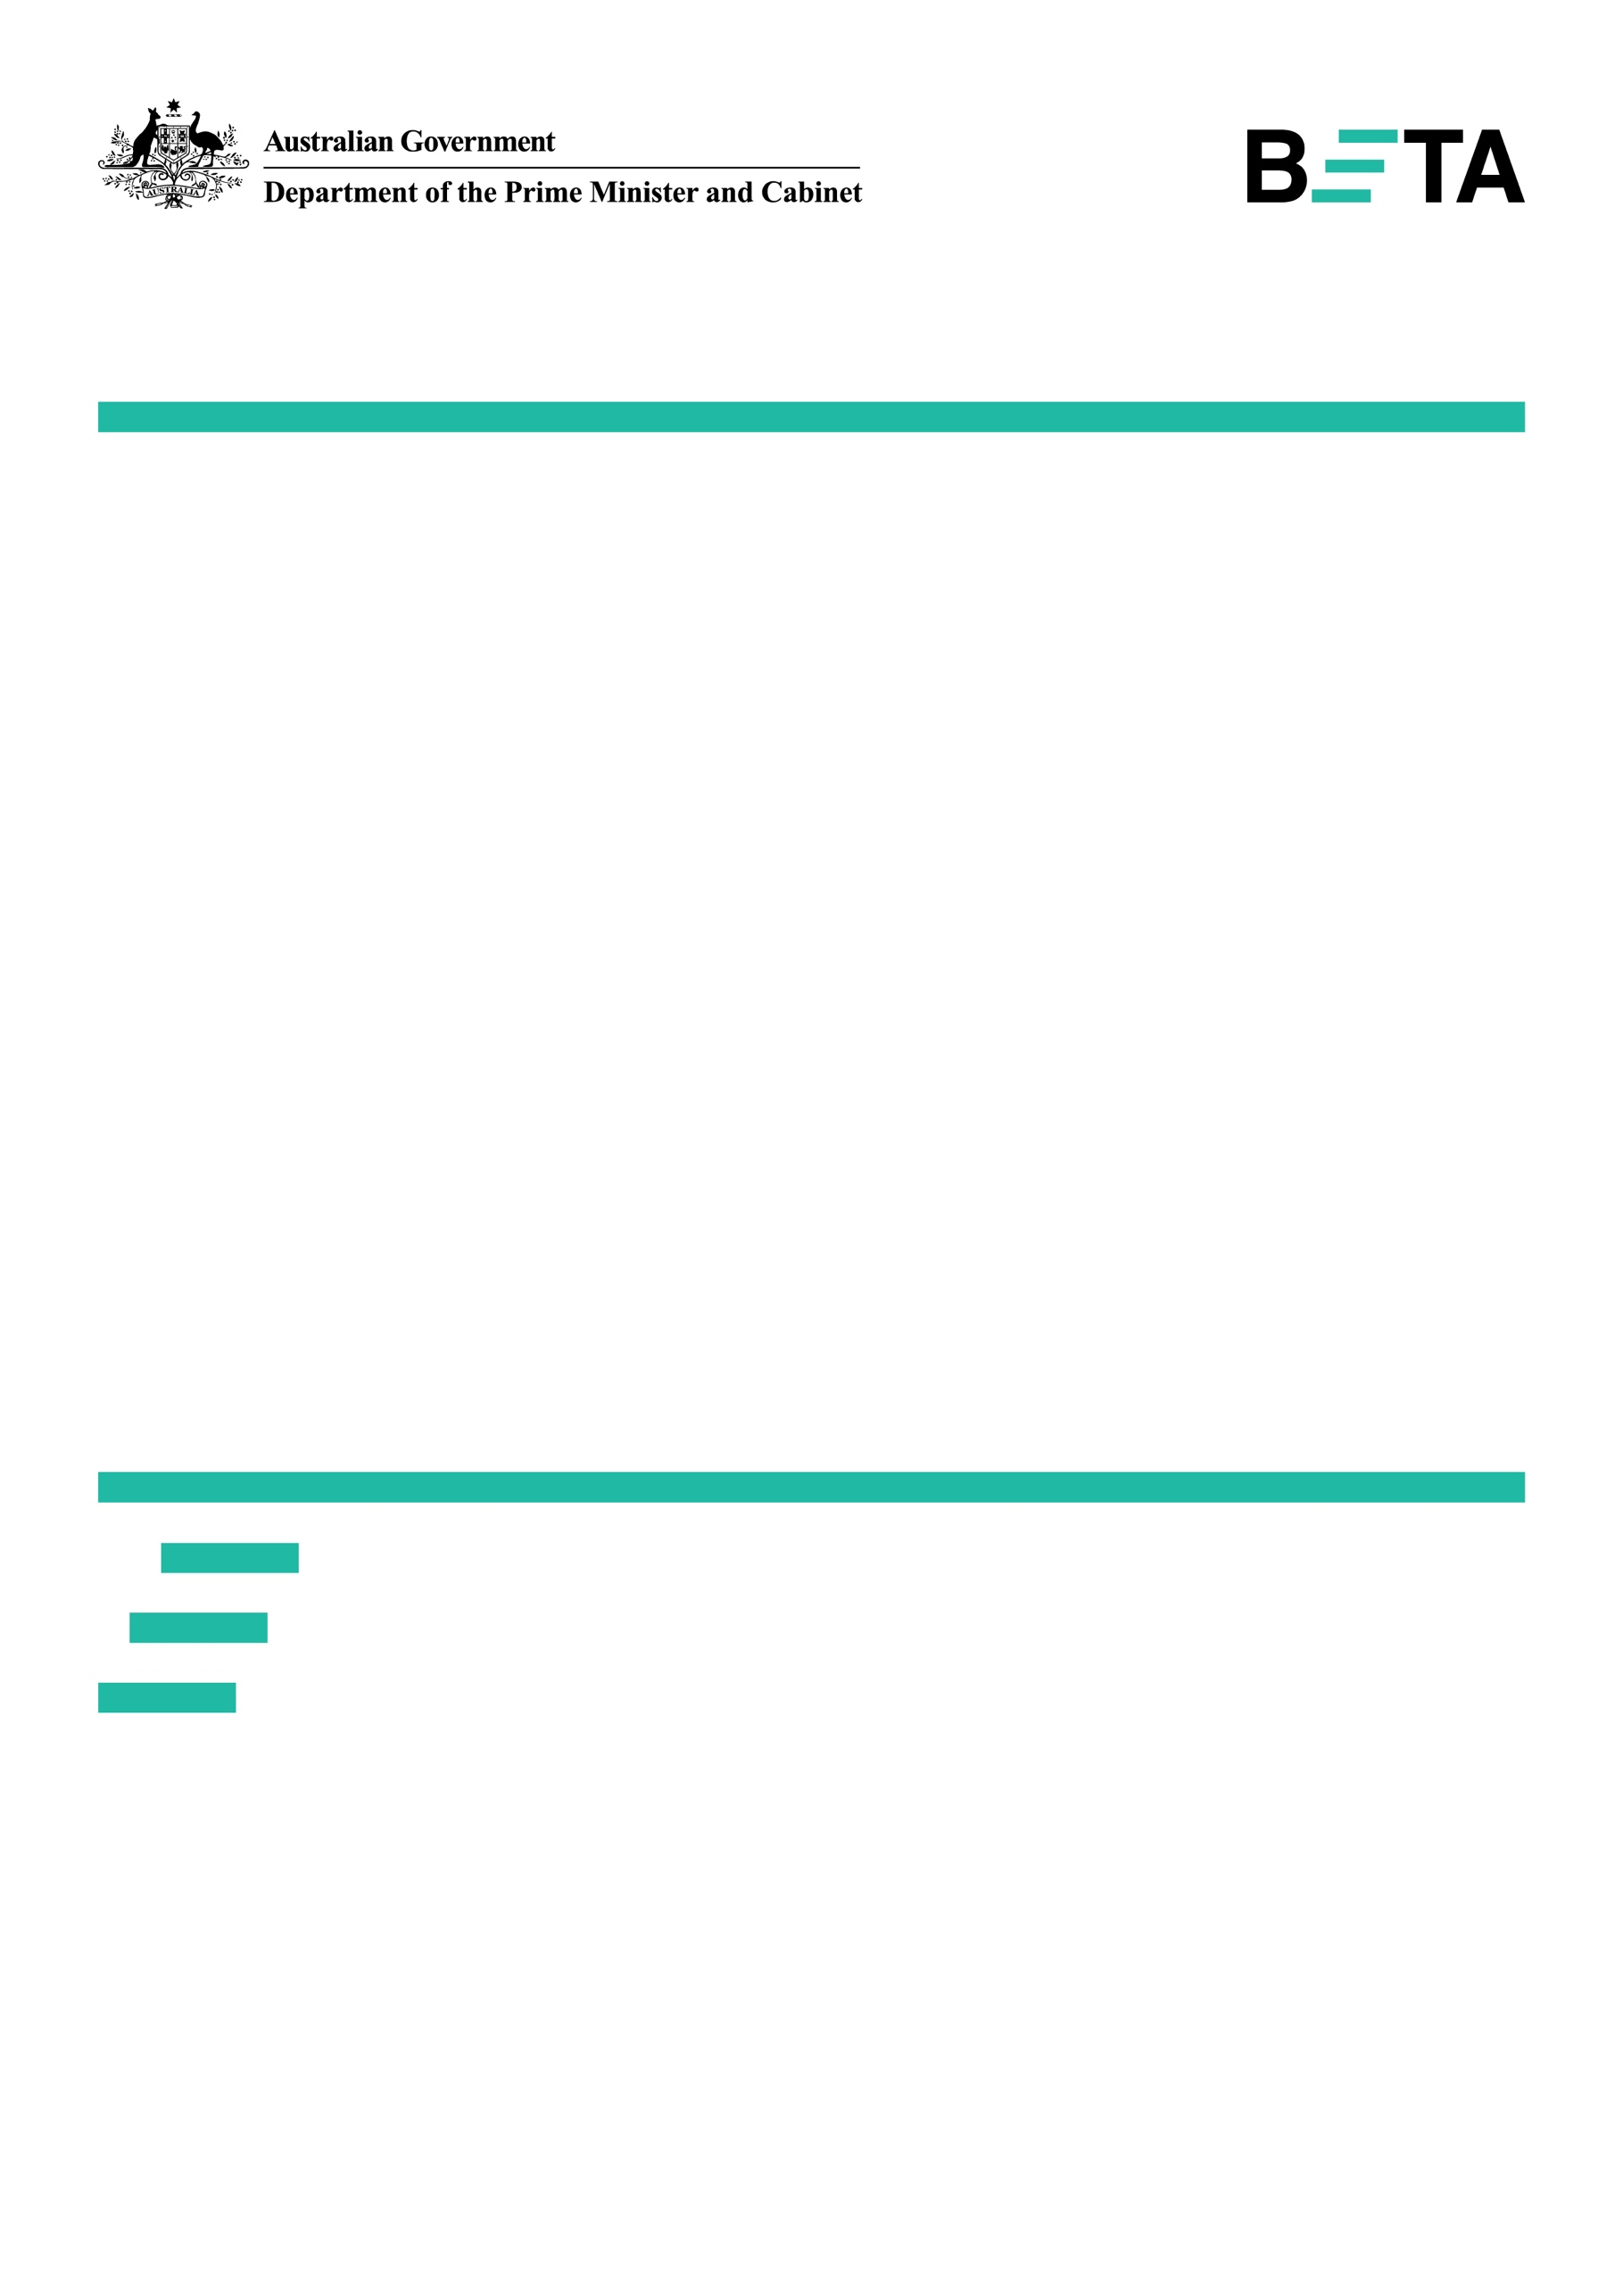

# Increasing workplace giving: What works at work?

**Evidence from three mixed-method studies applying behavioural insights**

**March 2022**

**Other uses**

Enquiries regarding this license and any other use of this document are welcome at:

Managing Director

Behavioural Economics Team of the Australian Government

Department of the Prime Minister and Cabinet

Barton ACT 2600

Email: beta@pmc.gov.au

The views expressed in this paper are those of the authors and do not necessarily reflect those of the Department of Social Services, the Department of the Prime Minister and Cabinet or the Australian Government.

**Research Team**

Current and former BETA employees who contributed to the report were: Amy Fulham; Scott Copley; Michael Ridgway; Shea Houlihan; Ashley Breckenridge; Annie Truong; Swee Hoon Chuah; Eileen Chu; Roxarne Armstrong and Loren Willis.

**Acknowledgments**

Special thanks to the Prime Minister’s Community Business Partnership, Workplace Giving Australia and Philanthropy Australia for their contributions to the scoping of ideas for this project.

The Department of Social Services commissioned this research to assist the work of the Prime Minister’s Community Business Partnership. Thank you to the Department of the Prime Minister and Cabinet and the Department of Social Services for collaborating with us on this project.

Thank you to members of BETA’s Academic Panel for advising on the project, in particular special thanks to Professor Robert Slonim.

The studies were pre-registered on the BETA website and the American Economic Association Registry.

## Who?

### Who are we?

We are the Behavioural Economics Team of the Australian Government, or BETA. We are the Australian Government’s first central unit applying behavioural economics to improve public policy, programs and processes.

We use behavioural economics, science and psychology to improve policy outcomes. Our mission is to advance the wellbeing of Australians through the application and rigorous evaluation of behavioural insights to public policy and administration.

### What is behavioural economics?

Economics has traditionally assumed people always make decisions in their best interests. Behavioural economics challenges this view by providing a more realistic model of human behaviour. It recognises we are systematically biased (for example, we tend to satisfy our present self rather than planning for the future) and can make decisions in conflict with our own interests.

### What are behavioural insights and how are they useful for policy design?

Behavioural insights apply behavioural economics concepts to the real world by drawing on empirically-tested results. These new tools can inform the design of government interventions to improve the welfare of people.

Rather than expect people to be optimal decision makers, drawing on behavioural insights ensures policy makers will design policies to go with the grain of human behaviour. For example, people may struggle to make choices in their own best interests, such as saving more money. Policy makers can apply behavioural insights to preserve freedom, but encourage a different choice – by helping people to set a plan to save regularly.

## **Contents**

Executive summary 6

Why? 7

What we did: APS trials (PM&C & DSS) 8

Results: APS trial (PM&C) 16

Results: APS trial (DSS) 18

Results: APS Survey (PM&C & DSS) 20

Limitations: APS trials (PM&C & DSS) 21

What we did: Corporate partner 22

Results: Corporate partner 27

Limitations: Corporate partner 29

Discussion and Conclusion 30

Appendix 1: Intervention designs 32

Appendix 2: Technical details for APS trials 37

Appendix 3: Statistical tables (PM&C) 43

Appendix 4: Statistical tables (DSS) 46

Appendix 5: Statistical tables (Corporate partner) 50

References 53

## Executive summary

Behaviourally informed emails from a senior manager and easier sign-up can increase charitable workplace giving.

Planned giving, including workplace giving through payroll, is important to charities and not‑for‑profit organisations as it provides a regular source of income. Although more Australian employers are offering workplace giving, employee participation is usually low.

On behalf of the Prime Minister’s Community Business Partnership and in collaboration with the Department of Social Services (DSS), BETA tested ways to increase workplace giving across three separate behavioural trials, in two Australian Public Service (APS) departments and with one corporate partner. The trials were conducted between 2018 – 2021.

For trial one, we applied behavioural insights to the design of an email from a senior manager in the Department of the Prime Minister and Cabinet (PM&C) and tested the impact through a randomised controlled trial (RCT). At another PM&C site, we conducted a before/after comparison of the email in combination with a small gift. We found the behaviourally informed email increased workplace giving participation from 2.0% to 3.3%. Behaviourally informed emails outperformed basic information emails. The gift in combination with the email increased workplace giving but was not more effective than the behaviourally informed email alone.

For trial two, we built on these results in DSS. We tested variations of the behaviourally informed email with two different messengers (emails from a senior manager and a peer messenger), alongside an easier sign‑up process. The best‑performing intervention came from a senior manager, combined with the simpler sign‑up process. This resulted in a workplace giving rate of 3.8%, compared with 1.4% for an email from a peer messenger using the existing sign‑up process.

For trial three, we tested a behaviourally informed email in a corporate setting using an RCT. We tested whether asking people to ‘give later’, with a time delay between committing to give and monetary donations, would result in higher workplace giving sign-ups than asking people to ‘give now’. The overall sign-up rate was very low, possibly due to environmental factors relating to COVID-19. No significant differences were found between the two groups.

Our studies in two APS departments show sending employees emails with information about their workplace giving program can increase participation. Behaviourally informed emails from a senior manager can have an even bigger impact. Testing in different organisational settings is important as we found the behaviourally informed emails did not increase workplace giving sign-ups in a corporate environment. Making the sign‑up process as easy as possible is important and alternative mediums to email should be considered if email communication is already heavily relied upon in the workplace. Applying these small, low-cost changes can increase charitable workplace giving.

## Why?

Planned giving is an important source of income for the not‑for-profit sector. While more employers are offering workplace giving programs, participation is low.

Planned giving is important for the not for profit sector as it can provide them with a reliable source of income, helping them plan their activities. Planned giving is also financially beneficial for charities, reducing processing costs by receiving lump sum payments, providing access to new donors and decreasing the need for expensive fundraisers.

Research on giving trends in Australia found respondents who planned their donations reported giving six times more than those who identified as spontaneous givers (McGregor-Lowndes et al, 2017). Planned giving can include once-off donations like bequests, and regular payments such as workplace giving.

Workplace giving allows employees to donate some of their pre-tax salary to charity directly through payroll at work. The employee can benefit from an immediate tax deduction without the need to keep receipts and the convenience of automatic donations.

In recent years, workplace giving represented around one per cent of total gifts or donations (ATO, 2019a). The amount donated through workplace giving in Australia increased from $23 million in 2009-10 to $43 million in 2018-19 (Workplace Giving Australia, 2020).

The total number of employers in Australia offering workplace giving programs has increased from 2,809 in 2009-10 to 5,382 in 2018-19, with 33% of working Australians having access (Workplace Giving Australia, 2020). But the proportion of employees enrolled in these programs remained at around 5% over this period, leaving room for improvement (Workplace Giving Australia, 2020). If 10% of working Australians donated $5 a week through workplace giving, an additional $338 million would be available to the community each year[1].

Different organisational factors, such as governance structures, salary and perceptions of corporate social responsibility can impact giving behaviour (Shaker & Christensen, 2019). Workplace giving is known to vary significantly by industry (Osili et al. 2011) and organisation size (Haski-Leventhal, 2013).

Past research has found employees of for-profit organisations gave at higher rates than the public sector (Witty & Urla, 1989; Haski-Leventhal, 2013). Of the private sector organisations in Australia offering workplace giving, the most up-to-date publically available data shows 5.9% of employees participate (ATO, 2016). Of the APS agencies offering workplace giving, 1.8% of employees participate, each donating on average around $375 per annum over the year in 2017-18 (ATO, 2019b).

## What we did: APS trials

BETA reviewed behavioural insights literature to identify the motives and barriers associated with giving

### Motives for giving

There are a range of motives for giving, and some are particularly relevant to workplace giving.

**Pure altruism** is the act of giving through compassion, where a need is identified. Employees may be motivated to give by pure altruism if they can see positive impacts on beneficiaries or causes. Conversely, employees driven by pure altruism may reduce or cease giving if they believe others’ donations sufficiently address the need.

**Warm glow, or ‘impure altruism’,** is giving motivated by the satisfaction a person feels when making a sacrifice (Andreoni, 1989). Employees may be driven by warm glow when reminded of their personal efforts to give to a cause. Employees giving out of self-satisfaction are less likely to be affected by the donations of others or the measurable impacts of their giving.

**Social norms** mean people take their cues of how to behave from the behaviour of people around them. In the workplace, employees may be encouraged to take up workplace giving if they see it as the social norm. Equally, employees could be discouraged if workplace giving rates are very low.

**Reciprocity** is our desire to give back based on the treatment we receive. Giving employees a small gift can be a powerful way to motivate potential donors to sign up to workplace giving (Garbarino et al., 2013; The Behavioural Insights Team, 2013).

### Barriers preventing giving

A range of behavioural factors may present barriers to workplace giving. **Moral wiggle room** means a person may find a reason to justify behaving with self-interest. For instance, if employees have trouble signing up, or the benefits of workplace giving are unclear, this may give them moral ‘wiggle room’ to justify not following through on their intention to give.

Employees could suffer **choice overload** if presented with a long list of charities, or **cognitive overload** if given too much information about the workplace giving program. These may result in employees donating less than intended; choosing a charity inconsistent with their preferences, or most likely, not making a change at all (**status quo bias**).

Informational and structural barriers can create **friction costs** and exacerbate existing behavioural biases. To participate in their organisation’s workplace giving program, employees need to be informed of the program; its benefits, and the steps to sign up. Poor program design, including: having to follow many website links; filling in detailed information; printing and scanning a form; and choosing from a long list of charities, may also reduce participation rates.

### BETA applied the EAST framework to overcome the barriers inhibiting current workplace giving

The EAST framework—‘make it Easy, Attractive, Social and Timely’ (The Behavioural Insights Team, 2014) provides four simple principles to help employees overcome some of these informational, structural and behavioural barriers. Box 1 shows how these principles can be applied to encourage workplace giving based on our studies.

**Box 1. Applying EAST principles to encourage workplace giving**

Easy navigation**Make it easy:** If signing up to workplace giving is hard, consider providing a direct link to a simple online sign up page. If there is a long list of charities for employees to choose from, consider reducing the list or grouping charities e.g. by theme).

Attractive **Make it attractive:** Messages need to attract an employee’s attention to ‘cut through the noise’ of the many communications employees receive every day. Use eye-catching images and catchy messaging. Encourage reciprocity with small gifts employees will value.

Social**Make it social:** Share personal stories of current donors to make workplace giving visible and relatable. Involve respected senior managers as lead messengers to signal to would be donors the value of their involvement (messenger effect)

Timely**Make it timely:** Invite employees to give a time associated with giving or use a themed day linked to the organisation’s culture for greater social inclusion. Send communications when employees are less busy or less likely to have other communications competing for their attention.

BETA tested ways to increase workplace giving in two Australian Public Service departments, PM&C and DSS.

### Trial 1: PM&C

#### We designed behaviourally informed emails to encourage employees to sign up to workplace giving

We designed the email to be sent from a senior manager in PM&C. The emails were informed by a range of behavioural insights, including pure altruism, warm glow, and social norms, while emphasising the benefits, impact, and ease of workplace giving to prospective donors. The emails included a direct link to the sign-up page to make it easy to join. 3Behaviourally informed email showing how:

-Mentioning benefits to charities, a concrete fact and "donations of any size" appealed to warm glow and pure altruism
-Catchy language, imagery and a photo made the email attractive
-Convenience of pre-tax payments and the link to sign up made it easy
-A lead messenger increased the chance of the email being opened and read
-Mentioning Harmony Day made it social and timely

1. Behaviourally informed email

#### We also gave a small gift

To test reciprocity, employees were given a recipe card, together with a fork as a useful and durable item. We used recipes from around the world to make the link with diversity and inclusion on Harmony Day; chosen as a day we thought would inspire giving. A photo of the meal helped make the card attractive. The card included a message drawing on several behavioural insights, similar to the email. We made it social by providing different recipe cards to spark conversation among employees.



Note: See Appendix 1 for more detailed images of all interventions used in the PM&C and DSS studies.

1. Gift (recipe card designs and fork)

#### We tested these interventions using a randomised controlled trial and a before/after comparison

We randomly assigned 1,315 PM&C employees in PM&C’s Woden and regional network offices across Australia into three groups to receive either the behaviourally informed email, a basic information email, or no email. We used the basic information email to test whether the behaviourally informed email would be effective over simply providing information about workplace giving.

We distributed behaviourally informed emails to PM&C employees in combination with the gifts to 687 employees in PM&C’s Barton office. Employees received the gift on the morning of Harmony Day and the simple attractive email in the afternoon as a prompt to sign up. We measured workplace giving outcomes before and after employees received the gifts and emails.

We measured the impact of our interventions on workplace giving rates in the fortnight immediately after the email. We expected the highest rate for the gift‑and‑email combination, followed by the behaviourally informed email, the information‑only email, and those who received no email.

**Box 2. What is a Randomised Controlled Trial (RCT)?**

Well-designed RCTs are the best available method for determining the impact of policies or programs. RCTs work by separating people into two or more groups randomly, in a manner similar to flipping a coin. People in the ‘treatment’ groups are assigned to receive an intervention while people in the ‘control’ group are not. The control group receive either the business-as-usual experience or nothing. On average, the difference in outcomes between people in the groups reflects the effect of the intervention.

Level 1. Eligible PM&C employees (n = 2,002)
Level 2a. Individual level RCT (n = 1315)
Spilt into i) No email (n=263) ii) Basic information email (n=526) and iii) Behaviourally-informed email (n=526) 
Level 2b. Before/after comparison (n=687) recieved the email + gift. 

1. PM&C randomised controlled trial and before/after comparison

### Trial 2: DSS

#### We designed emails from different messengers and with simple sign-up links

We designed emails from a lead messenger (a senior manager) and a peer messenger (fellow employee already donating via workplace giving). Peer messengers have also been shown to increase workplace giving (The Behavioural Insights Team, 2013).

To attribute any difference in outcomes to the messenger, emails were as similar as possible (see Figures 5 and 6).

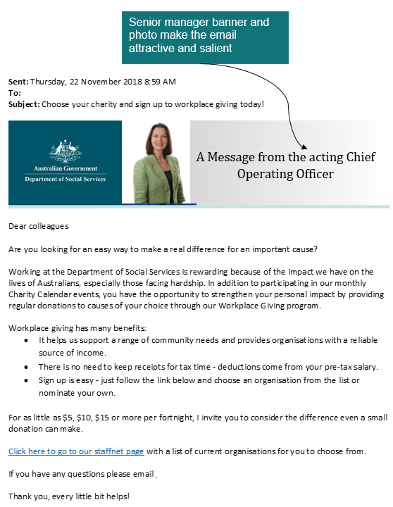

Figure 5: Senior manager email[2]

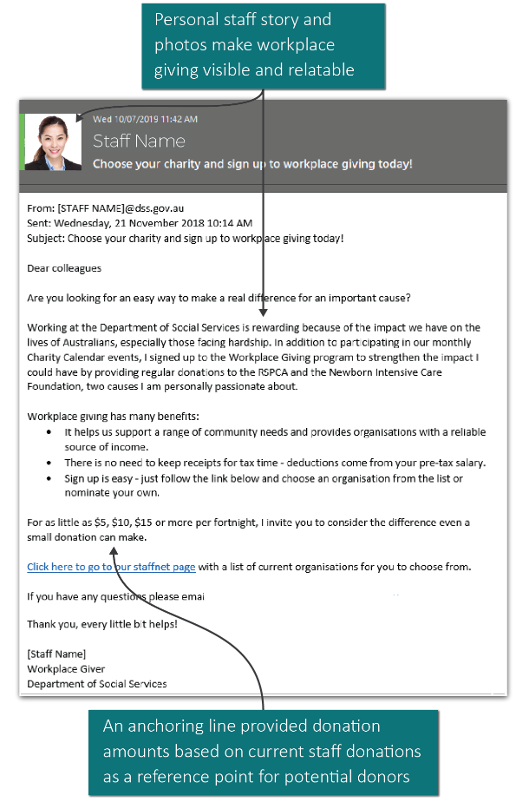

Figure 6: Peer messenger email

#### We also designed an online form to simplify sign-up

We also designed a simplified online sign-up form to test whether making sign-up easier than the current process of printing and scanning forms would have added impact.

The simple online form incorporated:

* clear explanation of the benefits of workplace giving; a drop down list of charities to choose from;
* links and prompts to help employees access required information.

The sign up form had a short description of what workplace giving was and outlined the criteria for eligible charities. The sign up asked for the following details: 
- Full name
- AGS number 
- Deduction amount
- Charity name 
- Start deduction from pay day date 

Figure 7: Simplified sign-up form

#### We tested the emails using a randomised controlled trial and a before/after comparison

We randomly divided 2,436 DSS employees into four treatment groups to receive the different possible variations of the email. Employees received an email with either a link to the existing sign-up process or the simplified online form. Depending on which of the four groups they were in the email came from a senior manager or a peer messenger (see Appendix 1).

We hypothesised the emails would increase workplace giving rates and the simplified sign‑up process would lead to a further increase. We wanted to test which messenger would be more effective as there are studies showing both senior and peer messengers can increase workplace giving (Karlan & List 2020; The Behavioural Insights Team, 2013).

This figure shows how the treatment groups received variations of the email- emails included links to either the existing sign up process or the simplified online form and came from either the senior manager or a peer messenger.The treatment groups were as followed: 
- Treatment group 1: Senior manager messenger and current sign-up process
- Treatment group 2: Peer messenger and current sign-up process
- Treatment group 3: Senior manager and simplified sign-up process
- Treatment group 4: Peer messenger and simplifed sign-up process 

Figure 8: DSS trial email treatment groups

#### Further details

For more details on the trial design and evaluation methods, see Appendix 2.

## Results: APS trials

### Trial 1: PM&C

Behaviourally informed emails increased workplace giving participation from 2.0% to 3.3%. Behaviourally informed emails outperformed basic information emails but including a gift did not lead to additional sign-ups.

#### Behaviourally informed emails can boost workplace giving

Among employees who did not receive an email, 2.0% were enrolled in workplace giving. A basic information email increased workplace giving enrolment to 2.4%. Behaviourally informed emails caused a further increase in enrolment to 3.3%, a 68% increase compared to the no-email group (Figure 9).[3]

Note: Adjusted percentages, n = 1,315. For full analysis, including p‑values and confidence intervals, see Appendix 2.

Figure 9: Percentage of employees enrolled in workplace giving

#### Adding a gift was no more effective than just sending an email

At a second PM&C site, we gave employees a small gift (a recipe card and fork) along with the behaviourally informed email. The gift‑and‑email combination increased workplace giving from 1.7% (12 employees) in the fortnight beforehand to 2.6% (18 employees) in the fortnight afterwards, a 50% increase in the giving rate (Figure 10).[4] The gift‑and‑email combination appears to be less effective for employees at the Barton office than the email alone was for employees in Woden and the Regional Network. See Appendix 2 for further discussion.

Note: Before/after comparison. Unadjusted percentages, n = 687. For full analysis, including p‑values and confidence intervals, see Appendix 2.

Figure 10: Percentage of employees enrolled in workplace giving before and after receiving a gift

Combining all of our treatments, including the gift, we increased participation by 15 employees (from 38 to 53). These employees gave an average of $48 per fortnight[5], with total fortnightly donations increased by $724.[6] This is equivalent to around $19,000 if employees maintained their donations for a year.

### Trial 2: DSS

Behaviourally informed emails from a senior manager, combined with a simplified sign-up process, were the most effective.

#### Behaviourally informed emails increase workplace giving

In this trial, we tested varying the email messenger — either a peer or a senior manager (lead messenger) — and moving from a sign-up system requiring employees to print and scan forms to a simple online form. This gave us a total of four groups. Overall, in the four groups combined, our emails increased employee participation in workplace giving from 1.4% to 2.4%, a 65% increase.[7]

Note: Before/after comparison. Unadjusted percentages, n = 2,436. For full analysis, including p‑values and confidence intervals, see Appendix 2.

Figure 11: Overall effect of emails on workplace giving enrolment

#### Simplified sign-up and a senior messenger worked best

Of the four groups, the group receiving an email from a senior manager with the link to the simplified sign-up online form had the highest percentage of workplace giving participants (3.8%, compared to 1.4% among the peer messenger with standard sign-up group, see Figure 12).[8]

Note: Adjusted percentages, n = 2,436. For full analysis, including p‑values and confidence intervals, see Appendix 2.

Figure 12: Percentage of employees enrolled in workplace giving by email group

#### Giving amounts remained about the same

Combining the four groups, our intervention increased participation by 23 people (from 35 to 58). They gave on average about $17 per fortnight each, and fortnightly donations increased by $387. This is equivalent to around $10,000 if individuals maintained their donations for a year. There was no meaningful difference in average donations between the four treatment groups.

### APS Survey (PM&C and DSS)

In both departments, we surveyed all employees who participated in the studies to ask about their views on workplace giving. Survey response rates were 16.1% (PM&C) and 13.9 per cent (DSS). We present results for both departments combined.

#### Motivations for giving

We asked current or previous workplace givers what attracted them to this style of giving. Of the 136 employees who answered, the most common responses were[9]:

* Providing charities with a reliable source of funding (55%).
* Wanting to make a difference (53%).
* Not having to keep track of donations for tax time (48%).
* A good feeling donating to charity (47%).

Very few employees reported social reasons for signing up, such as being motivated by existing givers (1.5%) or wanting to feel part of the workplace culture (2.2%).

#### Reasons for not signing up

We also asked those who didn’t sign up why workplace giving was not their preferred method of donating to charity. Among the 344 responses to this question, common reasons were:

* They already donate to charity outside the workplace (60%).
* They prefer to donate to one-off events rather than make ongoing deductions (39%).

#### There is room for further improvement

Across both departments, 130 respondents who were not enrolled in workplace giving indicated they were interested in signing up. This suggests our interventions did not fully bridge the gap between intention and action.

#### Workplace giving is likely to increase overall giving

It is possible those who signed up reduced donations they made by other means, so there was no net increase in giving. To check this, we asked employees who had signed up to workplace giving (either during the trial or in the past) if they reduced other giving. Across the two agencies, 73 employees responded to the question with 89% saying they gave the same or more to other charities. This suggests our trial resulted in an overall increase in giving.

## Limitations: APS trials

### We used a mixed‑methods approach to evaluation

In this report, we present the results of two RCTs supplemented with non‑randomised before/after comparisons. Although before/after comparisons may result in biased estimates in some circumstances, due to the impact of unmeasured variables, in this case we judge they produced accurate estimates. See Appendix 2 for further discussion.

### Employees may have discussed the emails

In both RCTs, it is possible employees discussed the email they received with others. This may have led to contamination across treatment groups (for example, employees who did not receive an email may have heard about it from others who did and consequently signed up to workplace giving). The lack of sign-ups in the control group of the PM&C trial suggests if contamination did occur it was not enough to affect giving rates.

### We measured changes in short-term giving rates

The trial only looks at workplace giving participation in the weeks following the intervention, so we do not know if individuals will continue giving. Data on previous givers in PM&C shows most people who sign up continue to give, with the average tenure being two years. It is reasonable to assume most of our new sign-ups will continue to give.

## What we did: Corporate partner

BETA tested whether introducing a time delay between sign-up and payroll donations increased giving in a corporate setting

Past research suggests people are more likely to donate money when there is delay between the initial commitment to give and the start of payroll donations (Breman, 2006; 2011). Delaying the transaction between commitment and donation by a week can increase the proportion of people who give by 50% compared to when the donation is taken immediately (Andreoni & Serra-Garcia, 2021). Even longer delays, such as three months, can increase the proportion of employees willing to have regular deductions from their pay (Thaler & Benartzi, 2004).

Other research suggests the option of delayed giving leads to higher amounts being donated compared to regular giving. Adding a delay between pledging a donation and paying for the donation can more than double the amount donated, but the proportion of people willing to donate can remain constant (Powell et al., 2018). For people already signed up to planned giving, a two month delay between the commitment and donation can increase the average amount donated by 32% (Breman, 2006).

Two main behavioural insights explain why a time delay can encourage people to follow through on their giving intentions:

* + - 1. **Warm glow:** As mentioned previously, warm glow is the sense of happiness a person feels when they give to others. A time delay can enhance the feelings of warm glow associated with signing up to donate, as people don’t incur an immediate monetary loss and the amount of time it takes to complete the good deed is lengthened.
      2. **Present bias:** We place greater importance on events happening now compared to events happening in the future. We also tend to value todays money more than we value it tomorrow, meaning losses in the present are more ‘painful’ than potential losses sometime in the future. This bias might be minimised when there is a delay in donations, as people are more willing to commit and part with ‘future’ money.

### We designed behaviourally informed emails to test the effectiveness of a giving time delay

BETA designed two different emails encouraging workplace giving sign-up; 1) a ‘**give now**’ email with no time delay between sign-up and donation, or 2) a ‘**give later**’ email with approximately a two month time delay between sign-up and donation. As with the previous trials, we applied the EAST framework to design the trial emails. We made it:

* **Easy** by simplifying the sign-up process. The emails included a direct link to the sign-up page so participants could join easily. Minimal personal information was needed so people could sign-up in under two minutes. We also suggested three charities recommended by the corporate partner on the sign-up page to reduce choice overload, although the full list of registered charities was still available.
* **Attractive** by including attention-grabbing images within the email and highlighting the individual benefits of planned workplace giving. We used the corporate partner’s email template to make the email look credible and consistent with corporate branding.
* **Social** by evoking a sense of community and national identity with links to common experiences, such as the Australian bushfires and COVID-19.
* **Timely** by sending the email around a recognised time for giving when donating behaviour is salient (Remembrance Day). We also sent the email in a month with few other events scheduled in the corporate partner’s annual giving calendar, to increase the novelty of the email and minimise confusion. The ‘give later’ group started deductions from the first payroll of the new year (2021), as New Year is known as a time to make positive behavioural changes. A reminder email acted as a timely prompt to encourage action.

### We used a randomised controlled trial to evaluate the emails

The trial was evaluated in a two-arm RCT with 981 individual staff employed at the corporate partner in Melbourne, Australia. Eligible staff included everyone employed at the organisation at the time of the trial, except for staff already registered for the workplace giving program and staff who were involved in the implementation of the trial.

There were two randomly assigned treatment groups, Group A and Group B[10]:

* **Group A**: At the start of the trial Group A received the ‘**give now**’ email encouraging them to register now to start donating straight away. Eleven days after, Group A received a sequenced ‘**give later**’ email. The email acknowledged it might not be a good time for them to start giving, but gave the option of registering now to start donating from the first pay of the new year.
* **Group B**: At the start of the trial Group B received the ‘**give later**’ email encouraging them to register now to start donating from the first pay of the new year (two month time delay). Eleven days later, Group B received a simple **reminder email** about registering now to start giving later in the new year.

Behaviourally informed email for the Give Now Group A group. The email used behavioural insights by: 
- Making salient the reasons why donating to charity now is important for the community.
- Using language such as urgent, now and today to create a sense of urgency 
- Including a memorable, eye-catching image to create interest
- Making it clear the sign up is easy and donation start straight away 
- Removing barriers by including a direct link to the sign up form. 

Figure 13. Give Now Email Template for Group A[11]

Behaviourally informed email for the Give Later Group B group. The email used behavioural insights by: 
- Emphasising the reasons why donating to charity in the future is important for the community
- Anchoring the start of a new behaviour (donating money) to the New Year
- Making the program attractive by highlighting the tax benefit sand ease of automatic donations
- Making it clear donations do not start for a couple of months, as there is a time delay
- Simplifying the sign-up process to take only 1-2 minutes


Figure 14. Initial Give Later Email Template for Group B

Group A: (n=490). Group A recieved the Give Now email on the 26th of October (Day 1 of the trial). The first data collection occured, then they recieved the Give Later email on the 5th of November (Day 11 of the trial). The trial ended on the 10th of November (Day 16 of the trial) and the second data collection point occured. The post-trial survey was sent on the 21st of January. 

Group B: (n=491). Group B recieved the Give Later email on the 26th of October (Day 1 of the trial). The first data collection occured, then they recieved the Give Later reminder email on the 5th of November (Day 11 of the trial). The trial ended on the 10th of November (Day 16 of the trial) and the second data collection point occured. The post-trial survey was sent on the 21st of January.

Figure 15. Trial 3 RCT design

The number of people who signed up for workplace giving was recorded eleven days after the start of the trial, immediately before the second email was sent. Signups were also recorded 16 days after the start of the trial. Sign-ups after this second collection point were not recorded.

We evaluated the impact of the intervention on two outcomes. The primary outcome was the number of people who registered for the workplace giving program via the email link. The secondary outcome was the average dollar amount donated by each new donor.

We hypothesised that at eleven days, staff who receive the ‘give later’ email (Group B) will be more likely to register for workplace giving compared to staff who receive the ‘give now’ email (Group A). We believed the give later option (Group B) may also lead to higher amounts donated compared to the give now email (Group A). We expected having a time delay between registering for the workplace giving program and the first donation would be appealing to staff and result in higher donation amounts.

At the second data collection point (16 days after the first email) we investigated whether the sequenced ‘give later’ email (Group A) had a different sign-up rate to those who received the upfront ‘give later’ email (Group B). This is interesting from a practical perspective as if both groups have similar giving rates, the sequenced ‘give later’ (Group A) would be preferred by charities, as there would be less delay receiving initial donations.

## Results: Corporate partner

New sign-ups for workplace giving in both groups were low

### We found no significant difference between the treatment groups on the number of people who signed up or donation amounts

There were six (0.6% of trial participants) new sign-ups during the trial across both Group A and Group B, and we were not able to detect a significant result. The sign-up rate was much lower than we had expected based on our previous trials. We do not know if this is due to the email content, environment factors like COVID-19 or elements of the corporate setting.

All sign-ups were in response to a ‘give later’ message, suggesting delayed giving may be worth trialling in a different setting and context. The reminder email prompted a small boost in sign-ups.

Table 1. Sign-ups during the trial*

| Group | n | Data collection point 1 | Data collection point 2 |
| --- | --- | --- | --- |
| Group A | 490 | Give Now 0 (0.0%) | Give Later 3 (0.6%) |
| Group B | 491 | Give Later 1 (0.2%) | Give Later 3 (0.6%) |
| **Total for overall trial** | **981** | **1 (0.1%)** | **6 (0.6%)** |

*Sign-ups are cumulative across data collection points

The results showed the average donation amount of the ‘give later’ (Group B) and the ‘give now’ (Group A) groups were not significantly different, as the amount of donations overall was too small to detect an effect[12].

We also collected data late in March 2021, to see whether staff who registered during the trial were still giving after approximately 5 months. All six new donors were still giving in March, with no difference between treatment groups.

### We conducted a post-trial survey to understand why the sign-up rate was low

Eighty-five staff (9% of staff included in the trial) completed the post-trial survey, of whom **27 (32%) recall receiving the workplace giving email**. Fifty-eight staff (68%) did not recall receiving the trial email and 10 (17%) were not aware their organisation offered workplace giving. Staff who do not remember seeing the trial email believe this is due to:

* 21 staff (36%) having more urgent work priorities
* 17 staff (29%) having a lot of other email communication at the time
* 5 staff (9%) already being signed up to the workplace giving program

Of the staff who remember the trial email, 25 (93%) were aware of the workplace giving program offered by the corporate partner prior to receiving the email and three (11%) signed up as a result of the email. The main reasons why staff who remember the email did not sign-up to workplace giving include:

* 14 staff (52%) already donate to charity
* 7 staff (26%) do not like the idea of automatic donations from their pay
* 5 staff (19%) do not like the idea of regular donations to the same charity

About 78% of the staff who completed the post-trial survey did not think the pandemic affected their desire to sign-up to workplace giving in 2020. Nine staff (11%) believed COVID-19 increased their desire to sign-up, mainly because they felt the community need was so much greater than normal. For the nine staff (11%) who believed COVID-19 decreased their desire to sign-up, seven were worried about the recession and economy overall.

## Limitations: Corporate partner

### The trial was launched during the COVID-19 pandemic, limiting the generalisability of the results

The trial launch was initially planned for April 2020, but was postponed when COVID-19 was declared a global pandemic. BETA and the corporate partner decided to launch the trial in October 2020, agreeing the research was still warranted and demand for charitable donations increased, with many charities struggling to support themselves during the pandemic (Charities Aid Foundation, 2020). It was also clear COVID-19 would continue to have a long-term impact on the Australian community and the not-for-profit sector.

It is possible the sign-up rate was affected by COVID-19, with the economic crisis decreasing monetary donations across Australia (Our Community, 2020). An unforeseen coincidence was the first email of the trial was sent on the same day as the government announcement ending the 112 day lockdown in Melbourne (BBC News, 2020), meaning the trial email might have been overshadowed. Comparisons between the trial results and pre-COVID-19 trials should be limited.

### The corporate partner already had high levels of communication about the workplace giving program prior to the trial

The existing level of awareness and registration for the workplace giving program may have meant the corporate partner was close to saturation. The partner’s rate of registration was around the national average at 5.7% in September 2019. The partner already had a dedicated workplace giving team and a targeted campaign calendar to encourage sign-up.

It is possible the majority of the sample did not intend to sign-up, having been given many prior opportunities with widespread corporate communication about the workplace giving program. Charities were also heavily relying on email communication during COVID-19 (CharityComms, 2020), meaning staff could have already been contacted and donated outside of the workplace.

In the original trial design, staff who were already registered to the workplace giving program were to be ineligible for the trial and removed from the mailing list. Answers from the post-trial survey indicate this screening process was not implemented, meaning staff who were not our target were inadvertently included in the trial, decreasing the possible pool of people who could have signed up.

### Employees could be aware of both emails

As with trial 1 and 2 in the current report, it is possible employees discussed the email they received with others. As most people don’t remember seeing the email, we do not expect there was much spill over between groups.

## Discussion and conclusion

### Key points from two APS trials

* **Behaviourally informed emails have been shown to encourage more employees in APS agencies to sign up to workplace giving**
* **The email is likely to have the greatest effect when it comes from a senior manager as a respected lead messenger**
* **Simplifying sign-up should also be considered if the current process is difficult**

Our APS studies show emails from a senior manager informed by a range of behavioural insights, including warm glow and pure altruism, can increase workplace giving. We also found it is important to make sure the sign-up process is as easy as possible.

Starting from a low baseline of workplace giving in two APS departments, we found the interventions caused an increase in the number of employees giving. Because the behaviourally informed email showed an impact across two studies, we have a high degree of confidence in this finding. These studies took place in two different APS departments, suggesting similar findings could be expected in other agencies.

In the PM&C trial we found behaviourally informed emails outperformed basic information emails, but adding a gift to induce reciprocity had no greater impact than the behaviourally informed emails alone. We built on this result in the DSS trial by testing variations of the behaviourally informed email and found the best performing email combined a senior manager messenger with a simpler sign-up process.

The results from the DSS trial highlight the importance of testing assumptions and changes to policy and programs before implementing them. While we were expecting simplifying sign-up would increase giving, we were not expecting the difference between the senior manager and peer messengers to be so large. If DSS had sent the best‑performing email to all employees we estimate this would have added about 60 givers (while the combination of the peer and current sign-up would have only added about four). This would translate to about $26,500 extra per year donated to charity over and above the $1,500 per year with no intervention. Small differences really do matter.[13]

Based on our overall results, if a similar behaviourally informed email were sent by all APS agencies it would result in more than 1,000 new workplace giving participants and about $500,000 in additional annual donations[14]. These proposed changes can help employees who are interested in workplace giving follow through with their intentions.

### Key points from a corporate trial

* **The sign-up rate was low, making it difficult to draw conclusions about time delayed giving**
* **APS and corporate organisations might have different operating contexts**
* **Alternative mediums to email might be better at attracting attention in the corporate setting**

BETA tested whether behaviourally informed emails, focusing on time delayed donations, increased workplace giving sign-ups. The expectation was including a delay between commitment and donation would encourage more sign-ups and increase donation amounts.

Overall, the small sign-up sample meant no significant differences were found between the groups. All the sign-ups during the trial were from ‘Give Later’ emails with time delay, indicating it is worth testing the theory again under different circumstances. For example, in the same email an individual could be given the choice of starting donations now or later, making the time delay more salient.

Five of the six registrations during the corporate trial were prompted by the reminder email. Although the results are not statistically significant, they suggest it is always preferable to send multiple emails rather than rely on one. Reminders can be an inexpensive and effective way to trigger behaviour.

Testing workplace giving trials in different organisational settings is important, as the trial effectiveness might differ based on organisational factors. For example, the corporate partner had a much higher baseline rate for workplace giving than the APS departments in trials 1 and 2. A higher baseline might have meant increasing the sign-up rate required a more hands on approach than sending an email.

As most staff did not remember seeing the trial emails, alternative mediums should be considered if email communication is already heavily relied upon in the workplace. Particularly during the COVID-19 pandemic, when internal email communication increased (DeFilippis et al., 2020), other mechanisms, such as in-person presentations, induction packs or text messages might have been more novel and successful at increasing sign-ups.

Further research focusing on innovative ways to increase workplace giving is important. Charitable organisations are financially struggling after the impact of the pandemic (Charities Aid Foundation, 2020) and workplace giving can increase stable donations and support the not-for-profit sector during this period and beyond.

## Appendices

### Appendix 1: Intervention designs

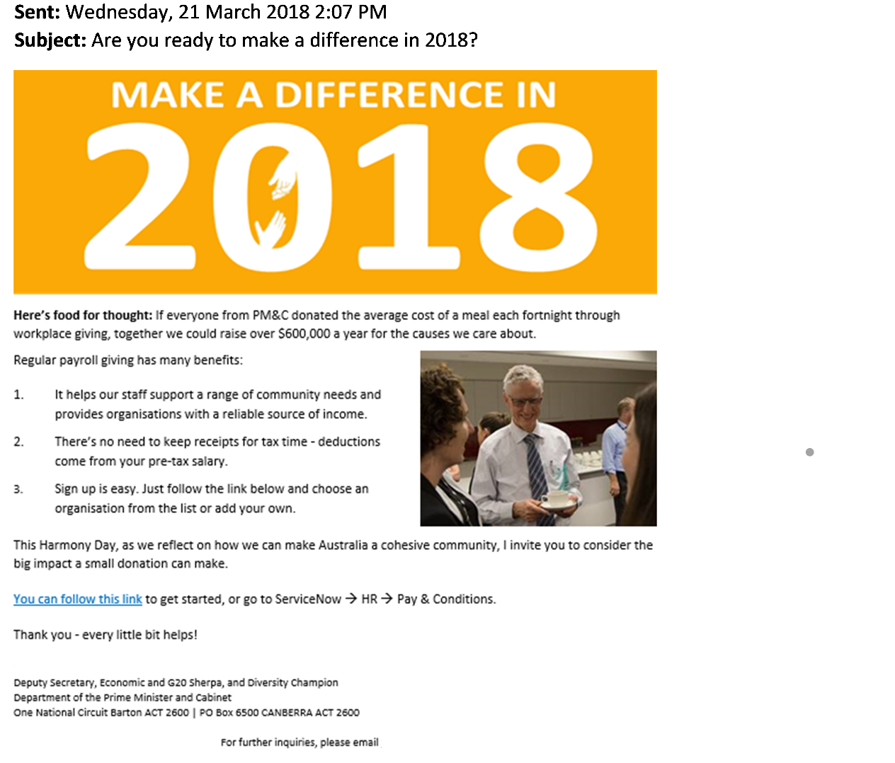Figure 16: Behaviourally informed email, PM&C trial

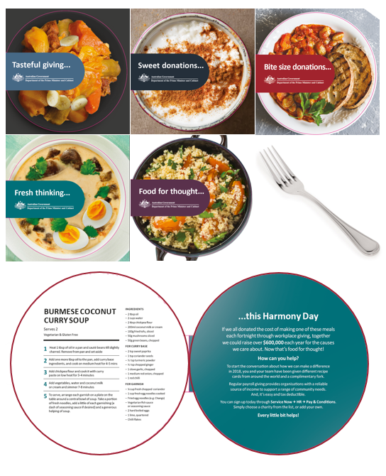

Figure 17: Gift, PM&C trial

Main messages in the email: 
-subject line 'Choose your charity and sign up to workplace giving today'
- 'Are you looking for an easy way to make a real difference for an important cause?' 
-'Working at the DSS is rewarding because of the impact we have on the lives of Australians, especially those facing hardship. In addition to participating in our monthly Charity Calender events, you have the opportunity to strengthn your personal impact by providing regular donations to causes of your choise through our Workplact Giving program. 
- Workplace giving has many benefits, with examples such as 'there is no need to keep receipts for tax time' 

Figure 18: Senior manager email, DSS trial

Image of the full text of the email from the peer messenger in the DSS study (de-identified) with the subject line 'Choose your charity and sign up to workplace giving today'. Main parts of the email:
- 'Are you looking for an easy way to make a real difference for an important cause?' 
-'Working at the DSS is rewarding because of the impact we have on the lives of Australians, especially those facing hardship. In addition to participating in our monthly Charity Calender events, I signed up to the Workplace Giving program to strengthn the impact I could have by providing regular donations.
- Workplace giving has many benefits, with examples such as 'there is no need to keep receipts for tax time' 


Figure 19: Peer messenger email, DSS trial (de-identified)

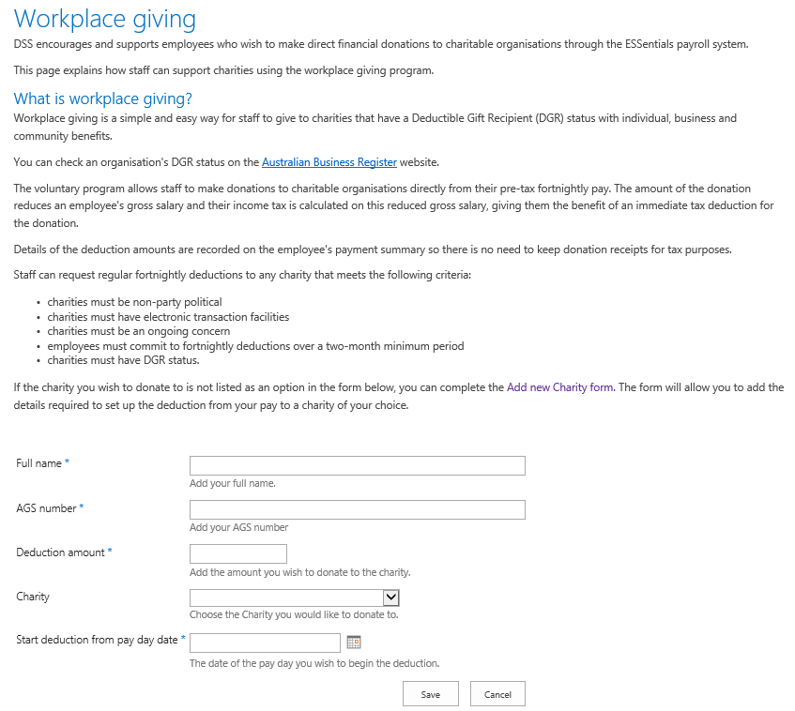

Figure 20: Simplified sign-up page, DSS trial

Image of the full text of the initial email from the corporate partner (trial 3) sent to the Group A. Main parts of the email:
Now is a compelling time to donate to charity. Many people in our community need urgent help to recover from the impacts of COVID-19, the bushfires, and the drought. Why not choose a cause close to your heart and start helping today! 

XX’s workplace giving program allows you to donate to charities of your choice by making regular donations from your pre-tax salary. This means you get the tax benefits up front, and your donations are automatically included in your annual payment summary. 

Click the ‘Sign me up!’ button below to register – quickly and easily – to start your ongoing donations from your next pay.  
Figure 21. Give Now Initial Email Template for Group A: Corporate partner trial

Image of the full text of the sequenced email from the corporate partner (trial 3) sent to Group A. Main parts of the email:
We understand this year has been a bit…unusual. Now may not be a great time for you to start donating to charity. But maybe starting in the New Year would suit you better?

The importance of charity to Australian society will only grow in 2021. Many people in our community will need help in the New Year to recover from the ongoing impacts of the COVID-19 pandemic, the bushfires, and the drought. 

XX’s workplace giving program allows you to donate to charities of your choice by making regular donations from your pre-tax salary. This means you get the tax benefits up front and your donations are automatically included in your annual payment summary. 

Click the ‘Sign me up for 2021’ button below to register  – quickly and easily – to start your ongoing donations from January 2021. 


Figure 22: Give Later Sequenced Email Template for Group A: Corporate partner trial

Image of the full text of the initial email from the corporate partner (trial 3) sent to Group B. Main parts of the email:

The New Year marks new opportunities for positive change and is a great time to start donating to charity. Why not choose a cause close to your heart and start helping! 

The importance of charity to Australian society will only grow in 2021. Many people in our community will need help in the New Year to recover from the ongoing impacts the of COVID-19 pandemic, the bushfires, and the drought. 

XX’s workplace giving program allows you to donate to charities of your choice by making regular donations from your pre-tax salary. This means you get the tax benefits up front, and your donations are automatically included in your annual payment summary. 

Click the ‘Sign me up for 2021!’ button below to register – quickly and easily – to start your ongoing donations from January 2021.


Figure 23. Give Later Initial Email Template for Group B : Corporate partner trial

Image of the full text of the reminder email from the corporate partner (trial 3) sent to Group B. Main parts of the email:

Just a quick reminder to start supporting a charity of your choice in the New Year, by signing up for XX’s workplace giving program. 

It’s not too late to help. If you’ve been meaning to donate, take the step today.

Click the ‘Sign me up for 2021’ button below to register  – quickly and easily – to start your ongoing donations from January 2021.


Figure 24. Give Later Reminder Email Template for Group B:Corporate partner trial

### Appendix 2: Technical details for APS trials

#### Overview

We conducted two RCTs, one with the Department of the Prime Minister and Cabinet (PM&C), and one with the Department of Social Services (DSS). The unit of randomisation for both trials was the individual employee. We randomly assigned employees to receive varying email messages, and in the case of DSS, also varying sign-up processes. We also ran a pre-post observational trial at PM&C, separate from the RCT.

The PM&C trial was launched on 21 March 2018 and the DSS trial was launched on 21 November 2018. Employees’ sign-up to workplace giving was measured two weeks following the interventions.

#### Pre-registration and ethics

We pre-registered these trials on both the [BETA website](https://behaviouraleconomics.pmc.gov.au/projects/increasing-workplace-giving) and the American Economic Association RCT Registry

* PM&C trial - ID no. [AEARCTR-0002790](https://www.socialscienceregistry.org/trials/2790)
* DSS trial - ID no. [AEARCTR-0003833](https://www.socialscienceregistry.org/trials/3833)

We pre-registered the PM&C trial before the intervention and trial had commenced. We pre‑registered the DSS trial after the trial had commenced but prior to BETA receiving or analysing any data on outcomes. Detailed pre-analysis plans containing details for our proposed analysis, including our research hypotheses, were included in the pre-registration documentation.

#### Outcomes

Our primary outcome was the participation in workplace giving among employees in the respective departments. Specifically, we took the ratio of the number of employees enrolled in workplace giving at the relevant payroll date two weeks after the intervention over the total employees at the time of the intervention. Our secondary outcome was the average amount given per person per fortnight.

#### Population and sampling

For PM&C, all employees were included in the trial except for personnel involved in trial delivery from areas such as BETA, HR, IT, and Security. This left a total of 2,002 employees in the trial.

* 1,315 employees working in the Woden office and the PM&C Regional Network (spread across Australia) were included in the individually RCT.
* 687 employees working in the Barton office were included in the before/after observational trial

For the DSS trial, all permanent ongoing and non-ongoing employees with tenure of six months or longer, regardless of their location, were eligible for inclusion. Employees involved in the design and implementation of the trial, along with employees at the Deputy Secretary and Secretary level, were excluded from the trial. This resulted in 2,436 DSS employees included in the trial.

#### Trial design

The PM&C RCT had three treatment groups

* **the control condition** received no email
* **the basic email group** received a basic information attention control email
* **the BI email group** received a behaviourally informed email

In the PM&C observational trial all participants received both a gift and the behaviourally informed email.

The DSS trial was a 2x2 factorial design, as seen in Figure 8. There were two independent variables (the messenger and the sign-up system) each with two ‘levels’:

* **Messenger** - The email was sent from either a member of the DSS Senior Executive Service (SES) or a non-SES employee (peer).
* **Sign-up system -** Emails included a link to either the current sign-up information page (current) or a simplified sign-up form (simplified).

#### Power calculations and sample size

We estimated the sample for the PM&C RCT would be 1,283 employees. At an alpha of 5%, this gave us 80% power to detect a 1.55 percentage point increase in the rate of participation.

We estimated the sample for the pre-post observational trial to be 687 total employees. With this sample size, the trial could detect an effect size of 0.23 percentage point increase in workplace giving participation.

For DSS we estimated there would be 2,250 individual employees in the trial. We performed power calculations using simulation for our two main effects making use of the regression specification outlined below. At an alpha of 5%, we would have 80% power to detect a standardised effect of 0.11. This is equivalent to a change in workplace giving participation from 1.4% to 3.1%. These calculations assumed no interaction between the impact of the messenger and the impact of the sign-up system.

#### Stratification and randomisation

We randomly assigned individual employees in the PM&C trial to the behaviourally informed email, basic information email, or no email condition with a 2:2:1 assignment ratio (40% treatment, 40% attention-control, and 20% pure control).

The DSS randomisation was also at the level of individual employees. We randomised in blocks, defined by the following pre‑treatment covariates:

* Baseline workplace giving status (yes/no)
* Income level (below median/above median)

We randomly assigned individuals within each block to four treatment groups using complete random assignment.[15] Assignment was balanced to the extent possible given strata sizes.

#### Method of analysis

For both RCTs, the primary analysis of the effect of the intervention was a covariate-adjusted comparison of our primary outcome across groups. Estimates, along with confidence intervals (CI) and p-values were calculated using ordinary least squares (OLS) regression. All analyses were intent-to-treat. Where possible, we performed robustness checks using logistic regression with average marginal effect calculations.

We used robust standard errors with interacted mean‑centred covariates (including, where relevant, block indicators) for our main outcome regressions. We conducted our analyses using R, version 3.5.3.

*PM&C trial*

For the PM&C trial, our regression had the following specification:

$$y= α+τT+β_{1}x+ β_{2}xT+β_{3}z+ϵ$$

Where $T$ is a vector of treatment indictors for which the coefficients give the effect of the BI email and the attention‑control email, and $x$ is a vector of mean‑centred covariates (gender, salary) and $xT$ is the interaction of these covariates with treatment. Finally, $z$ is a covariate for baseline workplace giving status. As explained in the *Deviations from our pre‑analysis plan* section below, we were unable to interact baseline workplace giving status with treatment.

For the PM&C observational trial, we performed a non-experimental before/after comparison, equivalent to a paired t-test. We did not adjust for covariates for this analysis.

*DSS trial*

We had planned for the primary analysis of the DSS RCT to be a covariate‑adjusted comparison of our primary outcome for our two main effects (simplified sign-up system and senior manager messenger). We ran this analysis using a linear regression model with the following specification:

$y= α+τ_{1}A+τ_{2}B+γ_{1}xA+ γ_{2}xB+ϵ$

The coefficient on $A$ is the main effect of changing the email messenger, the coefficient on $B$ is the main effect of changing the sign-up system and $x$ is a vector of mean‑centred covariates – age, gender, location (national office or elsewhere) – as well as block indicators (baseline workplace giving status, income level).

We formally tested for interaction between our two interventions by running a similar model to the above but including an interaction term for $AB$. While our trial was underpowered to detect an interaction effect (and we did not expect to find one), point estimates suggested a positive interaction between simplified sign-up and the senior manager messenger. Accordingly, we followed the contingency in our pre-analysis plan and switched to ‘simple effects’ or individual groups analysis as our principal analysis. This analysis compares the means of the four treatment groups.

We ran the ‘simple effects’ analysis using a linear regression model with the following specification:

$$y= α+τ_{1}T+γ_{1}xT+ϵ$$

The vector $T$ represents the four treatment groups and $x$ is a vector of the same mean‑centred covariates and block indicators as listed above.

We also performed a non-experimental unadjusted before/after comparison to estimate the effect of sending any email.

**Deviations from our pre-analysis plan**

Our analysis of the two studies included several minor deviations from our pre‑analysis plans. We do not believe any of these deviations altered our conclusions but we report each of them below. The first four deviations relate to the PM&C trial, the final two relate to the DSS trial.

*We interpreted ‘total amount given each fortnight’ as referring to the mean amount, and treated it as a secondary outcome.*

The pre‑analysis plan stated ‘total amount given each fortnight’ would be one of our primary outcomes but the term ‘total’ could be taken to mean the total amount given across an entire experimental condition. This is not what was intended as the analysis plan referred to analysis of individual‑level – rather than group‑level – variables. We instead used the *mean* amount given each fortnight. Both the total and mean amounts are reported in Appendix 3.

We changed this measure to be a secondary outcome because the trials aimed to increase participation in workplace giving rather than the amount given per person. The impact on the amount given is important but ultimately secondary to the intervention’s main objective.

*We did not stratify on baseline workplace giving status and we did not interact this covariate with the treatment dummy variables.*

Contrary to the pre‑analysis plan, we did not stratify on baseline workplace giving status, we still included it as a covariate in our analysis. We encountered difficulties when we attempted to interact this covariate with the treatment dummies because no one in the control group signed up to workplace giving during the trial. This meant it was not possible to generate estimates from a linear regression model. We avoided this problem by including baseline workplace giving status as a covariate but withoutinteracting it with treatment dummies.

*We were unable to measure some secondary outcome variables.*

The secondary outcomes specified in the pre-analysis plan included the number of email read receipts, and the number of click-throughs from the email to the workplace giving sign-up page. It did not prove feasible to measure either of these.

*We did not conduct exploratory subgroup analysis.*

We intended to conduct exploratory subgroup analysis to potentially inform future work. Given the modest treatment effects, we opted not to do subgroup analyses out of concern they could be more misleading than informative.

*In the DSS trial, we did not include covariates in the pre‑post analysis regression.*

Contrary to the pre-analysis plan, we did not include covariates in the pre-post regression. Covariate adjustment had no impact on our estimates.

*In the DSS trial, we analysed ‘age’ as a categorical (rather than continuous) variable.*

As the DSS data we received included the age range for each participant rather than their actual age, we were unable to include age as a continuous variable in the regressions. Instead the age range was used as a categorical variable.

#### Limitations: further discussion

This section expands on some of the more technical points raised in the Limitations section of the report, and discusses some further, more minor limitations of the studies.

*Drawing conclusions about the gift‑and‑email combination in the PM&C trial*

The gift‑and‑email trial conducted in PM&C’s Barton office produced a smaller increase in workplace giving than the email‑only trial conducted in PM&C’s Woden office and regional network. Consequently, we concluded the addition of a small gift was ineffective. There are potential risks in comparing the two studies because they were conducted at different workplaces. We think it is likely the two workplaces are sufficiently similar and we can attribute most or all of Barton’s increased giving to the email alone.

*Before/after comparisons*

Before/after comparisons can give misleading impact estimates if they are influenced by unmeasured variables such as other, concurrent changes also encouraged workplace giving. In this case, we think these comparisons give accurate impact estimates due to these departments having historically low workplace giving sign-up rates. Communications occurred during the trial period were unlikely to have increased sign-up rates, so it is reasonable to attribute the changes seen in workplace giving to our emails.

*Not everyone received their assigned treatment*

In both RCTs, not everyone who was sent an email actually read it. In the PM&C trial for example, 12% of emails delivered were met with an ‘out-of-office’ response. Our results are best thought of as the impact of sending emails rather than actually reading them and reflect the real-world practicalities of delivering this kind of campaign. Similarly, the gift was not delivered to all participants for the pre‑post comparison as there were parts of the building we were unable to access. The accompanying behaviourally informed emails were nonetheless delivered to these employees and we included them in analysis.

### Appendix 3: Technical details for the corporate trial

#### Overview

In this trial we extended the findings of the two Australia Public Service based trials into a corporate setting while also examining the impact of encouraging people to sign up to WPG with a delayed start to giving.

#### Pre-registration and ethics

We pre-registered this trial on the American Economic Association RCT Registry (ID no. AEARCTR-0006662). Pre-registration occurred prior to BETA receiving or analysing any outcome data. A detailed pre-analysis plan containing details for our proposed analysis, including our research hypotheses was included in the pre-registration documentation.

This project was approved through BETA’s ethics approval process, with risk assessed in accordance with the guidelines outlined in the National Statement on Ethical conduct in Human Research.

#### Outcomes

As with the two APS trials, the primary outcome for this trial was the proportion of staff signed up to WPG. Specifically, this was calculated as the ratio of the number of employees enrolled in WPG at the relevant data collection point over the total number of employees enrolled in the trial at the time of randomisation. This was measured using data from our corporate partner’s administrative systems, and operationalised as a binary variable where registering to donate was recorded as 1 and otherwise 0.

We also assessed the average amount (in dollars) given by WPG participants as a secondary outcome.

#### Population and sampling

All staff employed by our corporate partner were eligible for participation in the trial excluding those already registered for workplace giving and those involved in the implementation of the trial. This resulted in a total of 981 staff enrolled in the trial.

#### Trial design

The trial had two treatment groups, both groups received two emails with the first sent on day one of the trial, and the second on day 11.

Group A (give now): staff were sent an email encouraging them to start donating through WPG. This was followed by a second email acknowledging that now may not be a good time for them to start giving, but maybe they would like to register to start giving in the New Year.

Group B (give later): staff were sent an email encouraging them to sign up now, but with donations starting in the New Year (2-3 months in the future). This was followed by a reminder email about registering now to start WPG in the New Year.

#### Data collection

Data was collected at three points. The first data collection point occurred immediately before the second email was sent on day 11 (so signups that occurred between the first and second email were attributed to the impact of the first email). The second data collection point was on day 16, which was 5 days after the second email was sent. Any signups that occurred after this point were not included in our analysis.

The third data collection point occurred in March 2021, approximately five months after the trial ended. The aim was to asses if those that registered to give later actually started (and continued) giving.

#### Power calculations and sample size

We estimated that for H1, given a fixed sample size of 981, and an alpha of 5% we would have 80% power to detect a standardised effect of 0.16. With the assumption that, post-intervention, group A (give now) would have a giving rate of 1% (based on the results of our previous WPG trials), this would be equivalent to a 3.2 percentage point increase in the giving rate due to the give later (group B) intervention.

#### Randomisation

Randomisation was at the level of individual staff members. Participants were assigned to either Group A or Group B using complete random assignment. Assignment was balanced to the extent that the final participant numbers allowed with 490 individuals assigned to Group A and 491 assigned to Group B. Randomisation was implemented via an R script.

#### Hypotheses

H1. The WPG signup rate will be higher in the Give Later group compared to the Give Now group after the initial email: Give Later (group B) > Give Now (group A). This hypothesis was assessed using the first data collection point.

H2. The rate of those who are giving ~5 months after the trial will be higher in the Give Later group compared to the Give Now group: Give Later (group B) > Give Now (Group A). This is based on the third data collection point, and only includes those that signed-up before the first data collection point.

H3. For signup rates after the second email: Sequenced Give Later (Group A) ≠ Up front Give Later (Group B). Based on second data collection point.

Hypothesis 1 and 2 are both one sided-hypotheses and were assessed with one tailed tests. We did not adjust for multiple hypothesis testing.

#### Method of analysis

The principal analysis of the effect of the intervention was intent-to-treat consisting of a covariate-adjusted comparison of our primary outcome across the two arms. Estimates, confidence intervals and p-values were derived from a linear regression model with the following specification:

$$y= α+τA+δX+γXA+ϵ$$

Where the coefficient on A is the effect of the Give Later message, $X$ is a mean centered covariate indicating individuals wage and $XA$ is the interaction of the treatment indicator and mean centered covariate. Hypothesis tests for H1 and H2 were one tailed, H3 was a two tailed test. The method of analysis was similar for H3, where we compare the impact of the sequenced give later message vs the upfront give later message. In this case the coefficient on A was the impact of the upfront give later email.

All participants that signed up during the trail commenced giving and then continued giving until data collection point 3. Because of this, the analysis and results of H2 were identical to H1. Thus, we have not reported these separately in the main body of the report.

As a secondary analysis, we used the same regression specification to estimate the effect of the give later email at data collection point 1 on the average amount donated.

We used robust (HC2) standard errors for all linear models. Because our primary outcome was binary, we also ran robustness checks using an equivalent logistic regression specification calculating average marginal effects.

### Appendix 4: Statistical tables (PM&C)

Table 2 summarises pre-treatment characteristics of each group in the PM&C trial. It demonstrates our randomisation procedure resulted in reasonable balance across a range of factors.

Table 2. PM&C trial – participant characteristics and balance

| Characteristic |  | No email | Basic email | BI email | Before / after comparison |
| --- | --- | --- | --- | --- | --- |
| Sample size | N | 263 | 526 | 526 | 687 |
| Age | mean ± SD (years) | 43.5 ± 12.1 | 44.6 ± 11.2 | 43.7 ± 11.3 | 38.2 ± 10.2 |
| Gender | Female | 177 (67.3%) | 336 (63.9%) | 358 (68.1%) | 442 (64.3%) |
| Employment type | Ongoing | 240 (91.3%) | 489 (93.0%) | 502 (95.4%) | 634 (92.3%) |
| Attendance type | Full-time | 226 (85.9%) | 441 (83.8%) | 445 (84.6%) | 601 (87.5%) |
| Classification | APS levels | 135 (51.3%) | 298 (56.7%) | 260 (49.4%) | 302 (44.0%) |
| EL1 and above | 128 (48.7%) | 228 (43.3%) | 266 (50.6%) | 385 (56.0%) |
| Salary | mean ± SD  (dollars) | 94,303 ± 29,290 | 93,299 ± 28,507 | 95,644 ±  28,688 | 107,350 ± 50,440 |

Note: N is the group sample size, SD=standard deviation. The before/after comparison group was not randomly allocated, it consists of the majority of employees in the PM&C Barton office, balance on pre-treatment characteristics was not expected for this group.

Table 3 summarises the descriptive statistics for both the PM&C RCT and the before/after comparison. It includes the number of employees in each treatment group, as well as the number of employees who were participating in workplace giving both immediately before the trial began and two weeks after interventions were delivered.

Table 3. PM&C trial – descriptive statistics

| Group | n | Givers – pre-trial | Givers – after emails |
| --- | --- | --- | --- |
| RCT - No email | 263 | 4 (1.5%) | 4 (1.5%) |
| RCT - Basic email | 526 | 10 (1.9%) | 12 (2.3%) |
| RCT - BI email | 526 | 12 (2.3%) | 19 (3.6%) |
| **RCT - all groups combined** | **1315** | **26 (2.0%)** | **35 (2.7%)** |
| Before / after comparison | 687 | 12 (1.7%) | 18 (2.6%) |
| **Total for overall trial** | **2002** | **38 (1.9%)** | **53 (2.6%)** |

Note: n is the group sample size. Givers is the number of employees participating in workplace giving.

Table 4 summarises the results of our primary analysis for the PM&C RCT (as described in the *Method of analysis* and *Deviations from our pre-analysis plan* sections of Appendix 2). “Comparison against `No email’ group” refers to the regression run with the ‘No email’ group (pure control) as the baseline, while “Comparison against `Basic email’ group” uses the basic email (attention control) as the baseline.

Table 4. PM&C trial – RCT primary analysis

| Experimental Condition | n | % giving (adjusted) | Effect (95% CI) | p-value |
| --- | --- | --- | --- | --- |
| **Comparison against ‘No email’ group** | | | | |
| No email | 263 | 1.98 | REF | REF |
| Basic email | 526 | 2.37 | 0.39 (0.36 to 2.36) | 0.077 |
| BI email | 526 | 3.33 | 1.35 (-0.15 to 0.94) | 0.004 |
| **Comparison against ‘Basic email’ group** | | | | |
| Basic email | 526 | 2.37 | REF | REF |
| BI email | 526 | 3.33 | 0.96 (-0.12 to 2.1) | 0.048 |

Note: n is the group sample size. All statistics are derived from covariate‑adjusted linear regression models. The ‘effect’ column presents percentage point differences from the reference group. p-values are from one tailed hypothesis tests. REF = reference category.

Table 5 summarises the results of the PM&C before / after comparison. The comparison estimates the effect of the combination of a small gift-and-email delivered to the Barton office of PM&C. This comparison is not based on randomised groups.

Table 5. PM&C trial – estimating the effect of a letter + gift, before and after comparison

| Experimental Condition | n | % giving before | % giving after | Effect (95% CI) | p-value |
| --- | --- | --- | --- | --- | --- |
| Barton office | 687 | 1.75 | 2.62 | 0.87 (0.18 to 1.57) | 0.0071 |

Note: n is the group sample size. All statistics are derived from an unadjusted linear regression model. The ‘effect’ column presents the percentage point change in giving from pre-intervention. p-values are from a one tailed hypothesis test.

### Appendix 5: Statistical tables (DSS)

Table 6 summarises pre-treatment characteristics of each group in the DSS trial. It demonstrates our randomisation procedure resulted in reasonable balance across a range of factors.

Table 6. DSS trial – participant characteristics and balance

| Characteristic |  | Current sign up + Senior | Current sign up + Peer | Simplified + Senior | Simplified + Peer |
| --- | --- | --- | --- | --- | --- |
| Sample size | n | 608 | 610 | 609 | 609 |
| Prior workplace giver | Yes | 1.3% (8) | 1.5% (9) | 1.5% (9) | 1.5% (9) |
| No | 98.7% (600) | 98.5% (601) | 98.5% (600) | 98.5% (600) |
| Age | 15-29 | 15.8% (96) | 11.6% (71) | 14.9% (91) | 14.3% (87) |
| 30-39 | 24.3% (148) | 29.3% (179) | 27.6% (168) | 27.1% (165) |
| 40-49 | 29.4% (179) | 25.2% (154) | 28.4% (173) | 29.2% (178) |
| 50-59 | 25.0% (152) | 25.9% (158) | 24.1% (147) | 23.6% (144) |
| 60+ | 5.4% (33) | 7.9% (48) | 4.9% (30) | 5.7% (3 5) |
| Sex | Female | 63.8% (388) | 70.5% (430) | 71.8% (437) | 68.3% (416) |
| Male | 36.2 (220) | 29.5% (180) | 28.2% (172) | 31.7% (193) |
| Income | Lower 50% | 45.2% (275) | 45.2% (276) | 45.3% (276) | 45.3% (276) |
| Upper 50% | 54.8% (333) | 54.8% (334) | 54.7% (333) | 54.7% (333) |
| Location | National Office | 76.0% (462) | 72.5% (442) | 74.5% (454) | 72.9% (444) |
| Network | 24.0% (146) | 27.5% (168) | 25.5% (155) | 27.1% (165) |
| Attrition during the trial | | 0.8% (5) | 1.3% (8) | 0.7% (4) | 1.6% (10) |

Note: n is the group sample size.

Tables 7 and 8 summarise the changes in workplace giving participation by treatment group over the course of the DSS trial. This includes the number of employees participating in workplace giving (Table 7) and total and average giving amounts (Table 8), both immediately before the trial began and two weeks after interventions were delivered.

Table 7. DSS trial – descriptive statistics (number of givers)

| Group | n | Givers – pre-trial | Givers – after emails |
| --- | --- | --- | --- |
| **T1** Current sign-up + Senior | 608 | 8 (1.3%) | 11 (1.8%) |
| **T2** Current sign-up + Peer | 610 | 9 (1.5%) | 9 (1.5%) |
| **T3** Simplified sign-up + Senior | 609 | 9 (1.5%) | 24 (3.9%) |
| **T4** Simplified sign-up + Peer | 609 | 9 (1.5%) | 14 (2.3%) |
| **Total** | 2436 | 35 (1.4%) | 58 (2.4%) |

Table 8. DSS trial – descriptive statistics (total and average giving amounts)

| Group | Pre-trial total ($) | After emails total ($) | Pre-trial average ($) | After emails average ($) |
| --- | --- | --- | --- | --- |
| **T1** Current sign-up + Senior | $150 | $200 | $18.8 | $18.2 |
| **T2** Current sign-up + Peer | $335 | $320 | $37.2 | $35.6 |
| **T3** Simplified sign-up + Senior | $154 | $416 | $17.1 | $17.3 |
| **T4** Simplified sign-up + Peer | $210 | $300 | $23.3 | $21.4 |
| **Total** | $849 | $1236 | $24.2 | $21.3 |

Averages are *for those who participated in workplace giving*, not the average for all employees in each group. There were two employees who donated considerably more than average in T2 and T4. The total giving amount in T2 went down after treatment, as one individual stopped giving. Another individual then signed up in T2 but they gave a smaller amount.

Table 9 summarises the results for individual group comparisons in the DSS trial using the ‘current sign-up + peer messenger’ group as the base. We committed in our pre-analysis plan to run individual group comparisons if we found evidence of an interaction effect, as main effects can be biased when an interaction is present and there does appear to be an interaction between sign-up and messenger. The means reported in the table correspond to figures used in the main body of the document, for example in Figure 5.

Table 9. DSS trial – individual group effects (primary analysis)

| Experimental Condition | n | % giving (adjusted) | Effect (95% CI) | p-value |
| --- | --- | --- | --- | --- |
| **T1** current sign-up + senior | 608 | 1.95 | 0.51 (-0.25 to 1.28) | 0.1897 |
| **T2** current sign-up + peer | 610 | 1.44 | REF | REF |
| **T3** simplified sign-up + senior | 609 | 3.82 | 2.38 (1.09 to 3.68) | 0.0003 |
| **T4** simplified sign-up + peer | 609 | 2.27 | 0.83 (-0.05 to 1.70) | 0.0643 |

Note: n is the group sample size. All statistics are derived from covariate‑adjusted linear regression models. Treatment 2 was used as the baseline as it reflected the base case (ie, a peer messenger with current sign-up). REF = reference category.

Table 10 summarises the results of the supplementary analysis for the DSS trial, as detailed in the *Method of analysis* section in Appendix 2. It shows the results of the ‘main effects’ analysis, exploiting the RCT’s factorial design to estimate separately the impact of (a) a change in the sign-up system or (b) a change in the messenger. It also shows the result of running a regression to test for interaction effects.

Table 10. DSS trial – main effects and interaction

| Experimental Condition | n | % giving (adjusted) | Effect (95% CI) | | p-value |
| --- | --- | --- | --- | --- | --- |
| **Main effect – sign-up system** | | | | | |
| Current system | 1218 | 1.65 | REF |  | REF |
| Simplified system | 1218 | 3.04 | 1.39 (0.58 to 2.21) | | 0.0004 |
| **Main effect – messenger** | | | | | |
| Peer messenger | 1219 | 1.82 | REF |  | REF |
| Senior manager | 1217 | 2.88 | 1.06 (0.27 to 1.86) | | 0.0089 |
| **Interaction** |  |  |  |  |  |
| Sign-up * Messenger | 2436 |  | 1.04 (-0.55 to 2.64) | | 0.1992 |

Note: n is the group sample size. All statistics are derived from covariate‑adjusted linear regression models. For the regressions, including the interaction regressions, the treatment dummies were as follows: sign-up (simplified = 1), and messenger (peer = 1).

Table 11 summarises the results of comparing giving rates before and after the intervention in four treatment groups combined. It estimates the effect of receiving any email, and relates to Figure 11 (and surrounding text) in the results section.

Table 11. DSS trial – before and after comparison

| Experimental Condition | n | % giving before | % giving after | Effect (95% CI) | p-value |
| --- | --- | --- | --- | --- | --- |
| All Treatment groups | 2436 | 1.44 | 2.38 | 0.94 (0.54 to 1.34) | 0.000004 |

Note: n is the group sample size. All statistics are derived from an unadjusted linear regression model. The ‘effect’ column presents the percentage point change in giving from pre-intervention. p-values are from a one tailed hypothesis test.

### Appendix 6: Statistical tables – Corporate partner

Table 12. Participant characteristics and balance

| Characteristic |  | Give Now (Group A) | Give Later (Group B) |
| --- | --- | --- | --- |
| Sample size | n | 490 | 491 |
| Age | <30 | 6.5% (32) | 8.1% (40) |
| 30-39 | 32.0% (157) | 33.0% (162) |
| 40-49 | 35.7% (175) | 35.6% (175) |
| 50-59 | 14.9% (73) | 11.2% (55) |
| 60+ | 5.7% (28) | 5.7% (28) |
| N/A | 5.1% (25) | 6.3% (31) |
| Sex | Female | 40.8% (200) | 38.5% (189) |
| Male | 58.4% (286) | 60.9% (299) |
| N/A | 0.8% (4) | 0.6% (3) |
| Income | $40,000 - $80,000 | 28.4% (139) | 28.1% (138) |
| $80,001 - $120,000 | 36.9% (181) | 34.8% (171) |
| $120,001 - $160,000 | 18.0% (88) | 21.4% (105) |
| $160,001 + | 11.6% (57) | 9.4% (46) |
| N/A | 5.1% (25) | 6.3% (31) |
| Tenure | Less than 4yrs | 54.7% (268) | 57.6% (283) |
| 4yrs or more | 45.3% (222) | 42.4% (208) |

Table 13. Descriptive trial statistics

| Group | n | Data collection point 1 | Data collection point 2 |
| --- | --- | --- | --- |
| Give Now (Group A) | 490 | 0 (0.0%) | 3 (0.6%) |
| Give Later (Group B) | 491 | 1 (0.2%) | 3 (0.6%) |
| Total | **981** | **1 (0.1%)** | **6 (0.6%)** |

Note: n is the group sample size. Givers is the number of employees participating in workplace giving.

Table 14. Total and average giving amounts

| Group | total ($) | Average ($) | Pre-trial average ($) |
| --- | --- | --- | --- |
| Give Now (Group A) | $35 | $11.67 | - |
| Give Later (Group B) | $120 | $40 | - |
| Total | $155 | $25.83 | $33.35 |

Note: Averages are *for those who participated in workplace giving*, not the average for all employees in each group.

Table 15. RCT primary analysis

| Experimental Condition | n | Effect (adjusted) | Effect (95% CI) | p-value | |
| --- | --- | --- | --- | --- | --- |
| **1st data collection point** | | | | |
| H1: (comparison against ‘Give now’ group) | | | | | |
| Give now | 490 | 0.000 | REF | REF | |
| Give later | 491 | 0.002 | 0.002 (-0.002 to 0.007) | 0.159 | |
| H2: (comparison against ‘Give now’ group) | | |  |  | |
| Give now | 490 | 0.000 | REF | REF | |
| Give later | 491 | 0.002 | 0.002 (-0.002 to 0.007) | 0.159 | |
| **2nd data collection point** | | | | |
| H3: (comparison against ‘Give later sequenced’ group) | | | | | |
| Give later sequenced | 490 | 0.006 | REF | REF | |
| Give later up front | 491 | 0.006 | 0.000 (-0.010 to 0.010) | 0.997 | |

Note: n is the group sample size. Effects and 95% CIs are given as proportions and should be multiplied by 100 to match reporting in the main body of the text. All statistics are derived from covariate‑adjusted linear regression models. ‘Give now’ was used as the baseline as it reflected the base case (ie, people are typically encouraged to sign-up for work-place giving immediately). REF = reference category.

## References

Andreoni J (1989) ‘Giving with impure altruism: Applications to charity and Ricardian Equivalence’, *Journal of Political Economy*, 97(6):1447-1458. Retrieved from: <https://www.jstor.org/stable/1833247>

Andreoni J and Serra-Garcia M (2021) ‘Time-Inconsistent charitable giving’, *Journal of Public Economics*, 198.

ATO (Australian Taxation Office) (2016) National workplace giving data, 2009-10 to 2015-16.

ATO (Australian Taxation Office) (2019a) Taxation statistics 2017-18, gifts or donations data, 2017‑18.

ATO (Australian Taxation Office) (2019b) Taxation statistics 2017-18, workplace giving data, 2009-10 to 2017-18.

Breman A (2006) ‘Give more tomorrow: A field experiment on intertemporal choice in charitable giving, *Job Market Paper*.

Breman A (2011) ‘Give more tomorrow: Two field experiments on altruism and intertemporal choice’, *Journal of Public Economics*, 95(11):1349-1357.

The Behavioural Insights Team (2013) *Applying behavioural insights to charitable giving*. Retrieved from: <https://www.bi.team/publications/applying-behavioural-insights-to-charitable-giving/>

The Behavioural Insights Team (2014) *EAST Four simple ways to apply behavioural insights*. Retrieved from: [https:/www.bi.team/publications/east-four-simple-ways-to-apply-behavioural-insights/](https://www.bi.team/publications/east-four-simple-ways-to-apply-behavioural-insights/)

BBC News (The British Broadcasting Corporation) (2020) *Covid in Australia: Melbourne to exit 112-day lockdown*. Retrieved from: <https://www.bbc.com/news/world-australia-54686812>

Charities Aid Foundation (2020) *Future-proofing Nonprofits for the Post-pandemic World: The Voice of Charities Facing COVID-19 Series,* 6: 1-12. Retrieved from: <https://www.cafonline.org/charities/adaptability/charity-landscape>

CharityComms (CharityComms and Media Trust) (2020) *Impact of COVID-19 on Charity Communications*. Retrieved from: <https://www.charitycomms.org.uk/reports-and-guides>

DeFilippis E, Impink SM, Singell M, Polzer JT and Sadun R (2020) *Collaborating during coronavirus: The impact of COVID-19 on the nature of work* (No. w27612), National Bureau of Economic Research.

Garbarino, E., Slonim, R., & Wang, C. 2013. The multidimensional effects of a small gift: Evidence from a natural field experiment. *Economics Letters, 120*(1): 83-86. doi: 10.1016/j.econlet.2013.03.031.

Haski‐Leventhal D (2013) ‘Employee engagement in CSR: The case of payroll giving in Australia’, *Corporate Social Responsibility and Environmental Management*, 20(2):113-128.

Karlan D and List JA (2020) ‘How can Bill and Melinda Gates increase other people's donations to fund public goods?’, *Journal of Public Economics*, *191:*104296.

Labour Market Information Portal. 2021. Industry Information. Last modified 14 April, 2021. Retrieved from: <https://lmip.gov.au/default.aspx?LMIP/GainInsights/IndustryInformation>

McGregor-Lowndes M, Crittall M, Conroy D, Keast R, Baker C, Barraket J and Scaife W (2017) *Giving Australia 2016: Individual giving and volunteering*. The Australian Centre for Philanthropy and Nonprofit Studies, QUT, Centre for Social Impact Swinburne University of Technology & The Centre for Corporate Public Affairs. Australia 2016 report series commissioned by the Australian Government Department of Social Services. Brisbane, Queensland

Osili UO, Hirt DE and Raghavan S (2011) ‘Charitable giving inside and outside the workplace: The role of individual and firm characteristics’, *International Journal of Nonprofit and Voluntary Sector Marketing*, 16(4):393-408.

Our Community (2020) *COVID-19: Community Sector Impact Survey*. Retrieved from: <https://www.ourcommunity.com.au/search/?q=covod+19+community+survey>

Powell E, Jung M, Peer E and Vosgerau V (2018) ‘I don’t care when I’ll give, but I’ll give more later: Adding time delays increases donation amounts, but not willingness to donate’, *E -European Advances in Consumer Research*, 11: 265-266. Retrieved from: <https://www.acrwebsite.org/volumes/1700235/volumes/v11e/E-11>

Shaker GG and Christensen RK (2019) ‘I give at the office: A review of workplace giving research, theory, and practice’, *International Journal of Nonprofit and Voluntary Sector Marketing*, 24(1):e1628

Thaler RH, and Benartzi S (2004) ‘Save more tomorrow™: Using behavioral economics to increase employee saving’, *Journal of political Economy* 112(1):164-S187.

Witty CJ and Urla J (1989) ‘Workplace Giving: Employee Attitudes, Perceptions and Behavior’. Working paper (University of San Francisco. Institute for Nonprofit Organization Management); no. 9. San Francisco, CA: Institute for Nonprofit Organization Management, College of Professional Studies, University of San Francisco.

Workplace Giving Australia (2020) *FY2019 ATO Data and Giving Research* Retrieved from: [FY19 ATO Data and Giving Research | Workplace Giving Australia Public Library](https://library.workplacegivingaustralia.org.au/fy19-ato-data-and-giving-research/)

© Commonwealth of Australia 2019

978-1-925363-89-0 Increasing workplace giving: What works at work? (online)

Copyright Notice

With the exception of the Commonwealth Coat of Arms, this work is licensed under a Creative Commons Attribution 4.0 International license (CC BY 4.0) <http://creativecommons.org/licensesby/4.0/deed.en>



Third party copyright

Wherever a third party holds copyright in this material, the copyright remains with that party. Their permission may be required to use the material. Please contact them directly.

Attribution

This publication should be attributed as follows: Commonwealth of Australia, Department of the Prime Minister and Cabinet, Increasing workplace giving in the Australian Public Service.

Use of the Coat of Arms

The terms under which the Coat of Arms can be used are detailed on the following website:

<https://www.pmc.gov.au/government/commonwealth-coat-arms>

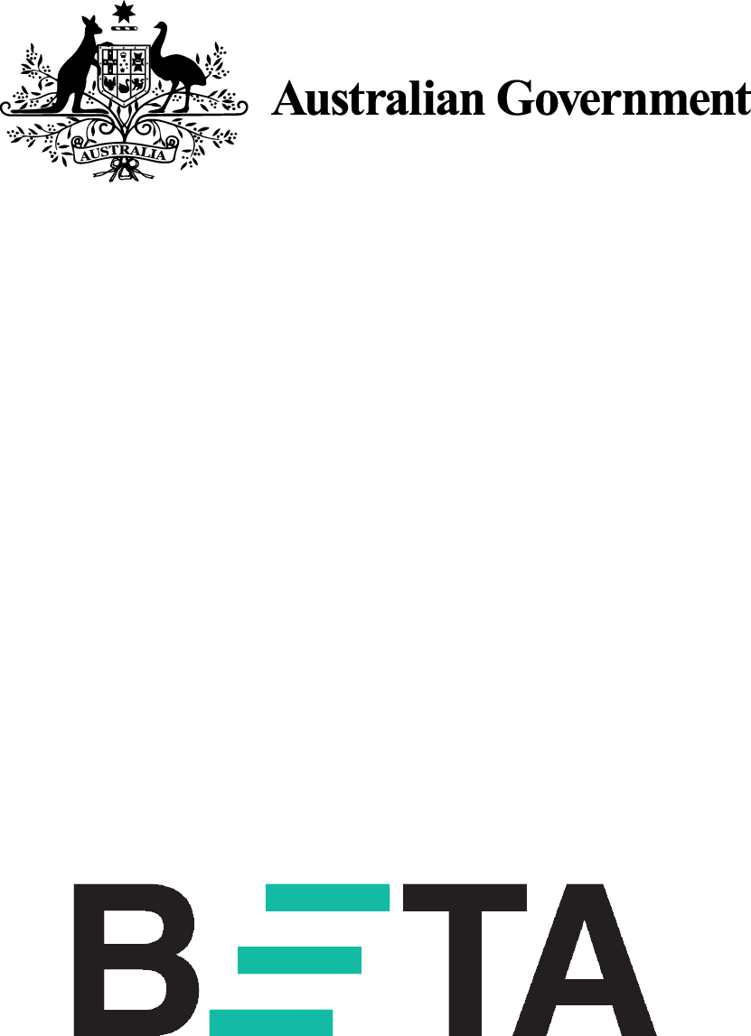

Behavioural Economics Team   
of the Australian Government

General enquiries [beta@pmc.gov.au](mailto:beta@pmc.gov.au)

Media enquiries [media@pmc.gov.au](mailto:media@pmc.gov.au)

Find out more [www.pmc.gov.au/beta](http://www.pmc.gov.au/beta)

1. There are approximately 13 million working Australians (Labour Market Information Portal, 2021); 13 million multiplied by 0.1 (10% of the workforce), multiplied by $260 ($5 multiplied by 52 weeks of the year) equals $338 million.
2. The acting Chief Operating Officer’s name, contact information and picture have been removed from the templates. For the peer messenger template, the staff member’s name, contact information and picture have also been removed to preserve the anonymity of the individual.
3. The difference between the no‑email group and the behaviourally informed email group was statistically significant at p = 0.004 and the difference between the basic information email and behaviourally informed email was significant at p = 0.048. Employee numbers and approach are outlined in Appendix 2.
4. We discuss the use of before/after comparisons in the Limitations section and Appendix 2.
5. This relatively high average giving amount was driven by two particularly generous givers. If they are excluded from the calculation the average is around $18, very similar to the average amount in the DSS trial.
6. This figure is the total fortnightly donations after the trial minus total fortnightly donations before the trial.
7. p < 0.00001. This result compared the number of givers across all groups before and after the emails were sent and was not part of the RCT. See the Limitations section and Appendix 2 for a discussion on the use of before/after estimates. Employee numbers and approach are outlined in Appendix 2.
8. p = 0.00032 (two‑sided test).
9. Respondents could select multiple reasons, meaning percentages do not sum to 100%.
10. There was no control group in this trial, as the previous trial showed people rarely spontaneously register for workplace giving. People tend to sign-up when prompted, such as at giving drives.
11. The corporate partner logo, name and contact information have been removed from the templates to preserve the anonymity of the partner.
12. The total donation amount from the ‘give now’ (Group A) email was $35 with an average donation of $11.67. The total donation amount from the ‘give later’ (Group B) email was $120 with an average donation of $40. The large apparent difference between the two groups is misleading, as it is skewed by a single generous donor in the ‘give later’ Group B, who pledged $100 a fortnight.
13. This is the increase for the simplified/senior manager messenger email multiplied by four. The increase in the amount given is the average donation per fortnight in that same arm multiplied by the estimated number of additional givers ($17 per fortnight from 60 givers is $26,500 per year).
14. This is a conservative estimate assuming new participants give $15 each fortnight. We applied this to total employee numbers in the APS (around 150,000 individuals) using an average effect of the behavioural email (sent by a senior executive) from both of our studies.
15. We implemented this via an R script using the ‘block_ra’ command from the ‘randomizr’ package