Prompting accuracy
Using behavioural insights to support accurate registrations
March 2022

Other uses
Enquiries regarding this license and any other use of this document are welcome at:
Managing Director
Behavioural Economics Team of the Australian Government
Department of the Prime Minister and Cabinet
1 National Circuit
Barton ACT 2600
Email: beta@pmc.gov.au
The views expressed in this paper are those of the authors and do not necessarily reflect those of the Department of the Prime Minister and Cabinet or the Australian Government.

Research team
Andrei Turenko was the principal investigator for this project. Other (current and former) staff who contributed to the report were: Belinda Xie, Andrew Bromwich, Angela McGregor and Andrea Willis.

Acknowledgments
Thank you to AFSA for their support and valuable contribution in making this project happen.
In particular, special thanks to Genene Bageas, River Paul, Rebecca Mitchell, Kenneth Beaton, David Adams, Andrew Marshall, Leilani Mordaunt, Diminee Robinson, Michael Piotrowicz, and Associate Professor David Brown for their continuous support and work on this project.

Who?

Who are we?
We are the Behavioural Economics Team of the Australian Government, or BETA. We are the Australian Government’s first central unit applying behavioural economics to improve public policy, programs and processes.
We use behavioural economics, science and psychology to improve policy outcomes. Our mission is to advance the wellbeing of Australians through the application and rigorous evaluation of behavioural insights to public policy and administration.

What is behavioural economics?
Economics has traditionally assumed people always make decisions in their best interests. Behavioural economics challenges this view by providing a more realistic model of human behaviour. It recognises we are systematically biased (for example, we tend to satisfy our present self rather than planning for the future) and can make decisions that conflict with our own interests.

What are behavioural insights and how are they useful for policy design?
Behavioural insights apply behavioural economics concepts to the real world by drawing on empirically-tested results. These new tools can inform the design of government interventions to improve the welfare of citizens.
Rather than expect citizens to be optimal decision makers, drawing on behavioural insights ensures policy makers will design policies that go with the grain of human behaviour. For example, citizens may struggle to make choices in their own best interests, such as saving more money. Policy makers can apply behavioural insights that preserve freedom, but encourage a different choice – by helping citizens to set a plan to save regularly.

Contents
Executive summary 4
Why? 5
Part 1: A new review screen 9
Part 2: Prompts and an intuitive layout 13
Conclusion 18
Appendix 1: Technical Details 19
Appendix 2: Statistical Tables 23
Appendix 3: Accuracy Logic 24
References 28

Executive summary
The Personal Property Securities Register (PPSR) supports the growth of Australia’s economy. The PPSR makes it easy for businesses to safeguard their security interests (money owed to them or other obligations), helps them make informed purchasing decisions, and facilitates secured lending. Businesses (and other entity types) register on the PPSR by completing an online form hosted by the Australian Financial Security Authority (AFSA).
For a registration to be effective, businesses must provide details about themselves, the assets they are registering, and the other party in the transaction (known as the Grantor). Our previous research indicates some less frequent PPSR users get some of these details incorrect - in particular, details relating to the other party.
In response to BETA’s recommendations from our previous research (BETA 2020), AFSA implemented enhancements to the PPSR system, processes and supporting information. These enhancements focused on improving the experience for infrequent users. Two of these recommendations were evaluated using randomised controlled trials (RCTs):
- A redesigned review screen
To prevent users from rushing through the registration process and to highlight the importance of registering correctly, we redesigned the review screen. A new pop-up alerted users that incorrectly completed registrations may not be valid. Users were also required to confirm details about themselves, details of what they were registering and details of the Grantor. We found these new additions to the review screen did not result in any improvement in the accuracy of registrations.
- New layout of the Grantor page and error-warning prompts
We introduced a more intuitive way of asking users to identify the Grantor. We also added five customised prompts that appeared when a mistake relating to a Grantor was made. These changes almost halved the number of incorrect transactions: 22.3% of PPSR transactions made by users who completed the business-as-usual registration form were incorrect, compared to only 12.8% of transactions made by those who saw the redesigned page.
These evaluations shed light on ways government agencies can help less frequent users navigate complex registration processes. AFSA is planning to adopt the prompts as its business-as-usual practice, and is considering how to adopt the new Grantor page layout across the different user cohorts. Given the review screen did not decrease incorrect transactions, AFSA have opted to maintain their current review screen.

Why?

The Personal Property Securities Register (PPSR) allows Australian businesses to make informed commercial decisions
The PPSR acts as a noticeboard for registering and searching for financial interests in assets. The PPSR allows businesses to:
- safeguard their security interests (money owed to them),
- make informed purchasing decisions by determining whether assets they are purchasing have outstanding financial obligations, and
- facilitate secure lending.
Businesses can register on the PPSR by completing an online form hosted by the Australian Financial Security Authority (AFSA). In the 2021 financial year alone, around 1.7 million PPSR registrations were created (AFSA 2021).

Box 1: The PPSR registration process at a glance
Every security agreement requires at least two parties: the ‘secured party’ and the ‘grantor’. The secured party may be a financier, lender or a retention-of-title supplier, although other arrangements may also be captured. When the secured party enters into a financial arrangement with the grantor (for example by lending funds, selling goods on payment terms, or leasing goods), they can protect the priority of their claim against other creditors by creating a PPSR registration.
The PPSR registration records the secured party’s claim over the personal property the grantor used as collateral.
- Overview of the PPSR registration process
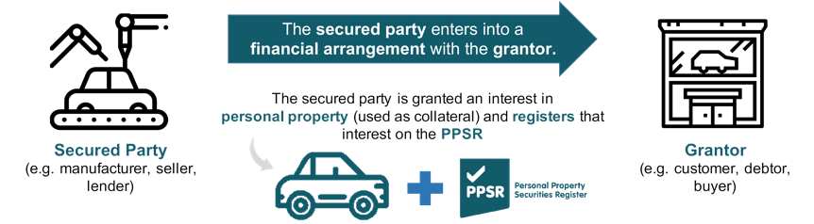
When making a registration, the secured party selects a broad category under which the personal property falls. This is known as the ‘collateral class’. Depending on the collateral class selected, the secured party may need to provide additional information about their security interest in the personal property.
In most circumstances, the secured party must also provide information about the other party in the transaction (the grantor).
Businesses can complete the registration via the PPSR website or via a private portal. Most self-lodging businesses we spoke to always register via the PPSR website. PPSR advisers, lawyers and those handling large volumes of registrations use their own or third party portals to create their registrations, but still use the PPSR portal to complete ad hoc registrations.

Improving the accuracy of registrations will reduce costs to business and increase the effectiveness of the PPSR
Businesses need to get key elements of the registration right. Even a small mistake may render the registration invalid and expose a business to greater financial risk. Accurate registrations are also the cornerstone of a well-functioning PPSR. They ensure the financial interests of registrants are protected and other parties (such as banks, financiers or someone purchasing valuable second-hand property) can make informed decisions. All this leads to a system that supports and facilitates commercial activity.

The registration process is sometimes challenging and can lead to mistakes
AFSA previously commissioned BETA to understand why businesses create inaccurate registrations. We analysed 2.7 million PPSR transactions and interviewed PPSR advisers, lawyers and users (BETA 2020). Our research showed that while many businesses saw the benefits of PPSR, some less frequent users found the registration process challenging and were prone to making mistakes. The key issues we identified were:
- Technical language: many self-lodging businesses and PPSR advisers found it hard to interpret technical language used in the form and on the PPSR website.
- Comprehension and relevance: new registrants were confused about what information they need to provide and how the questions on the registration form relate to their circumstances.
- Help tools: registrants felt the form’s ‘help’ function needed improvement. Some were frustrated the ‘help’ definitions were written in terms just as technical as the questions themselves. Accessing embedded help tools also proved to be a burden to some registrants.
- Register layout: the process of completing the entire registration — from creating a PPSR.gov.au account, to creating a secured party group, selecting a collateral class and selecting the grantor — did not seem intuitive to some users.

Infrequent registrants may be subject to a number of behavioural biases that contribute to erroneous registrations
Our previous research into the user experience of the PPSR form suggested behavioural biases may impact PPSR registrations for some users (BETA 2020). The PPSR form is technical, requires a high level of accuracy and can be particularly difficult for users who lack prior experience using the PPSR. As a result, users may be impacted by cognitive or choice overload, or have a false sense of confidence about their ability to complete the form correctly. These behavioural biases may contribute to incorrect registrations. Box 2 outlines relevant behavioural biases.

Box 2: Behavioural biases affecting registrants
Cognitive overload
When presented with an overwhelming amount of information, competing priorities, or situations where mistakes can incur significant consequences, people can experience cognitive overload (Kirsh 2000).
PPSR users may experience cognitive overload if they find the concepts in the form complex and confusing. This may be more likely for PPSR users who use the system infrequently or are unable to get help. As a result, even if they want to register correctly, users may disengage from the registration process, persevere despite a poor understanding, or rely on shortcuts to complete the registration.
Choice overload
When too many choices are available, people aim to simply end the choice-making ordeal, by finding a merely satisfactory choice, rather than the optimal choice (Iyengar and Lepper 2000; Mick et al. 2004; Reutskaja and Hogarth 2009).
In the PPSR, users are presented with numerous (and sometimes confusing) options. Users might respond to this choice overload by prioritising progressing through the form over making optimal choices, leading to errors.
Optimism bias and overconfidence
People tend to overestimate the likelihood of positive events and underestimate the likelihood of negative events. This is known as optimism bias (Sharot 2011). Coupled with overconfidence, or overestimating one’s ability (Moore and Healy 2008), PPSR users may persevere with a poorly-completed registration form. In our earlier research, we found most businesses were confident they always completed their registrations correctly.

We implemented and evaluated two recommendations that aimed to simplify the registration process and reduce mistakes
In 2021, AFSA made substantial effort to address BETA’s previous recommendations (BETA 2020) including:
- a review of the PPSR website with a focus on simplifying language and providing examples where possible
- implementation of a welcome email to provide an overview, explain key terms and set expectations for the user
- implementation of a ‘Before you start’ section on the ‘create a registration’ landing page, including a visual depiction of the registration process and a checklist detailing key registration requirements.
As part of AFSA’s commitment to continuous improvement, BETA was asked to evaluate two additional changes. These evaluations were intended to inform the decision on whether to implement these changes permanently. BETA worked with AFSA to evaluate the impact of:
- changes to the design of the review screen to highlight the importance of accuracy
- automatic prompts to alert the registrants of a mistake, and a more intuitive layout of the Grantor page.
Both evaluations were randomised controlled trials (RCTs) and involved a sample of relatively infrequent PPSR users.
This report is divided into two parts, corresponding to the two trials. The conclusion section summarises the implications from both trials.

Box 3: What is an RCT?
RCTs randomly assign individuals into different groups – usually, a ‘treatment’ group that is exposed to a new intervention and a ‘control’ group that is not. We then compare outcomes across the groups to determine the causal impact of the intervention.
For this project, PPSR account holders were randomised to either see a new, revised PPSR registration form or the unchanged business-as-usual form. We then compared key outcomes between these two groups.

Part 1: A new review screen

What we did

We introduced a new review screen to confirm the most important details and to highlight the importance of getting the registration right
Our advisory report found some new registrants did not understand the importance of correctly identifying the Secured Party, the collateral class and the Grantor information. Some AFSA Service Centre staff believed users were speeding through the application process. We recommended strengthening the ‘review’ section of the form to encourage users to slow down and carefully review the information they provided.
We introduced two key changes to the review screen:
- Screenshot of the review pop-up
- A pop-up that appeared prior to the review screen (Figure 2). We know timely prompts and reminders are effective in changing behaviour (Behavioural Insights Team 2014). The pop-up we introduced explained that inputting incorrect details may render the registration invalid. We expected users would take greater care after seeing the pop-up.
- We required users to confirm that each of the Secured Party, Grantor, and collateral details they entered into the form were correct (Figure 3). Previously only one confirmation, located at the bottom of the page, was required.
People are often impacted by small inconveniences or extra tasks, commonly known as friction costs. Under certain conditions, these friction costs can cause people to pause and pay more attention (Benartzi and Lehrer 2015). For example, some ride-sharing companies ask their customers to manually enter the surcharge multiplier amount before they are allowed to book their ride. This is designed to ‘slow down’ the customer and make sure they understand additional charges they will incur. Our intervention was designed to have a similar impact on behaviour.
- The new review screen requiring users to confirm that the Secured Party, Grantor and collateral information they entered was correct
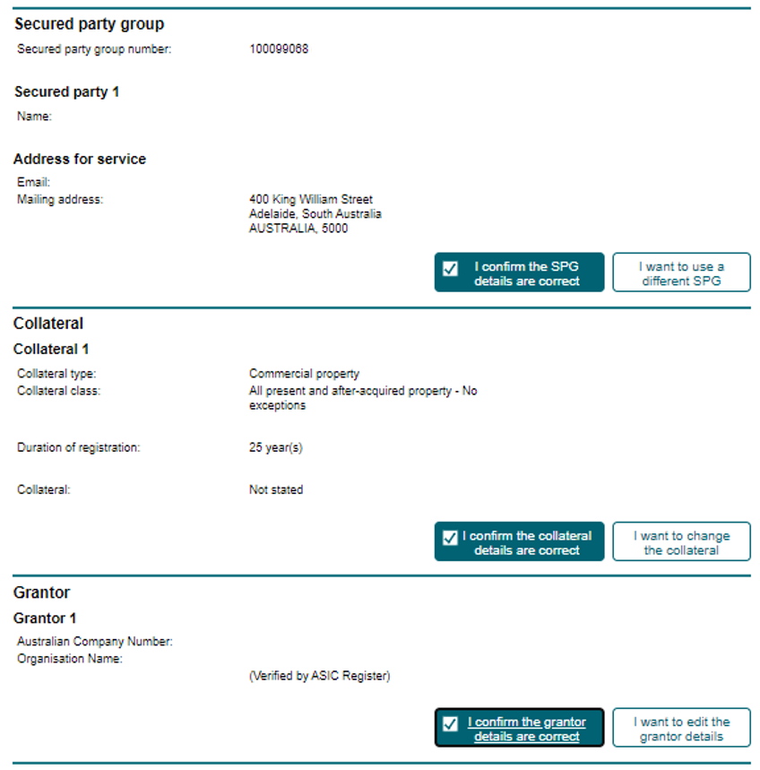

We measured whether these changes improved accuracy or caused inconvenience
To measure whether users selected the most appropriate identifier, we developed an algorithm to cross-reference numeric identifiers with the Australian Business Register (ABR) and the Australian Securities and Investment Commission (ASIC) databases. Based on the identifier hierarchy outlined in PPSR regulations, we then determined whether a given identifier was the most appropriate one to use. All non-numeric identifiers (names) were cross referenced manually by AFSA specialist staff. The logic behind the algorithm is outlined in Appendix 3.
We also inserted a short optional survey at the end of the registration process to better understand users’ experience. The optional survey was completed by 8% of users. This sample is unlikely to be representative of the broader sample of PPSR users, however, it still allows us to make comparisons between the two randomised groups (i.e. business-as-usual, new review screen). One of the survey questions asked how easy or difficult users found the registration process – this is how we measured ease of use.

What we found

The review screen did not reduce the rate of incorrect registrations
We analysed 3,631 transactions made by 1,013 PPSR account holders. The rate of incorrect registrations was similar regardless of whether users saw the business-as-usual review screen (19.1%), or the new review screen (19.0%) (see Figure 4).
- Percentage of incorrect transactions in the business-as-usual and new review screen groups.
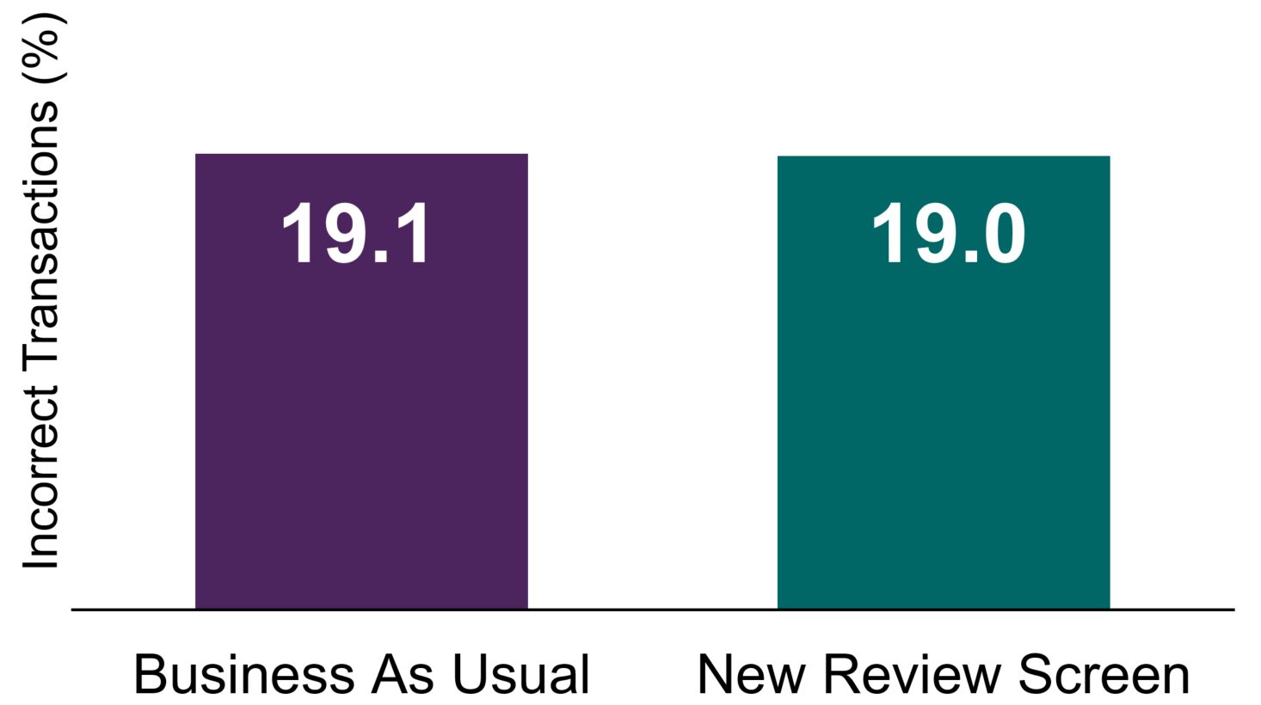
Note: N = 3,631. Percentage of incorrect transactions did not differ significantly across the two conditions (p = 0.50. The relevant statistical table is in Appendix 2, Table A2.
The new review screen had little impact on the self-reported ease-of-use (Figure 5). Most surveyed users found the form ‘fairly easy’ to ‘very easy’ regardless of whether they saw the new or the business-as-usual review screen (n = 281 accounts). We did not measure completion rates in this trial.
- Average self-reported ease-of-use
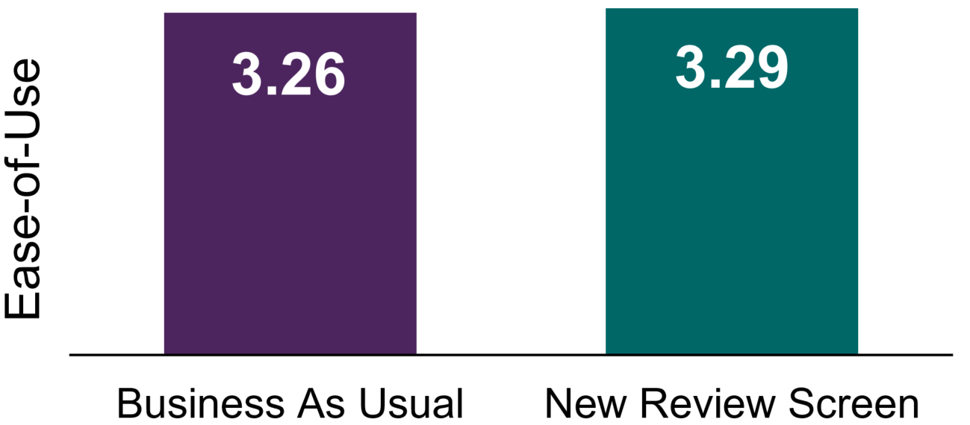
Note: N = 281 accounts. Ease-of-use was recorded on a four-point scale, where 1 = Very Difficult, 2 = Fairly Difficult, 3 = Fairly Easy and 4 = Very Easy. Mean ease-of-use scores did not differ significantly across the two conditions (p = 0.86). The relevant statistical table is in Appendix 2, Table A4.

Discussion
Highlighting the importance of getting the key details of the registration right and requiring additional confirmations did not improve registration accuracy. We suspect this is because users who made incorrect registrations did not realise they were incorrect – and so asking them to confirm the accuracy of their registration had no effect. PPSR users we previously interviewed for our advisory report expressed high confidence in their ability to register correctly.
While self-reported ease-of-use did not suffer as the result of introducing the new review screen, the new process required the user to complete extra steps for little apparent benefit. Requiring the user to exert additional effort could be justified if we saw a decrease in incorrect transactions, however, the lack of meaningful improvement means the new review screen is likely to lead to unnecessary administrative burden.
The results of this trial suggest errors need to be made more explicit to users, as incorrect registrations appear to be due to a lack of knowledge, rather than a lack of care and attention. AFSA’s ongoing efforts to educate their user base, make guidance materials more accessible, and introduce more explicit prompts are likely to drive greater positive behavioural change, leading to more accurate registrations.

Part 2: Prompts and an intuitive layout

What we did

We introduced an intuitive layout and error prompts into the Grantor screen
PPSR registrations involve at least two parties: a Secured Party (for instance a supplier, financier, or a lender), and a Grantor (a customer, debtor or a buyer). Most commonly the secured party is the person making the registration, and they must identify who the Grantor is, and must do so in a specific way. Failure to correctly identify the Grantor can make the registration invalid.

PPSR Regulations provide guidance on what ‘identifier’ to use. Our earlier research, however, found some less frequent users do not know which identifier is most appropriate, and others default to using a familiar identifier (such as an ABN) regardless of who the Grantor is.
We redesigned the Grantor page to make Grantor identification easier in the following ways:
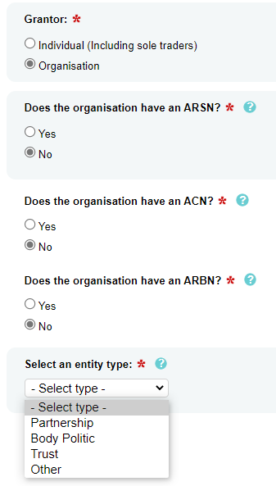
- Business-as-usual Grantor page
- A more intuitive way of asking for Grantor identifiers.
Some less frequent users noted the business-as-usual grantor page is too technical and does not provide sufficient guidance or explanation on how to complete it (see Figure 6). The page also uses terms which may not be familiar to the user (for instance, ARSN or ARBN). Our qualitative research also revealed users look for familiar identifiers (such as an ABN) and just complete that field, even when they should have chosen a different identifier.

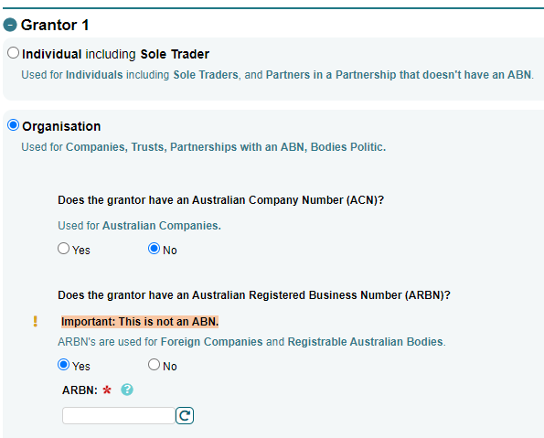
- New grantor page design, expanded
The new layout asks the user a series of questions about the Grantor (whether the grantor is an organisation, a sole trader, etc.), guiding them to the right identifier. The new layout then provides additional guidance about technical terms used on the page (see Figure 7).
All questions are conditional, meaning users cannot ‘skip ahead’ to an identifier further down the hierarchy.
- Introduction of prompts alerting users they selected an incorrect Grantor identifier. Prompts appeared on the Grantor page and on the review page. Most prompts offered the user a choice on how to proceed and highlighted the ‘correct’ identifier to use. To make prompts more relevant and user-friendly, they automatically incorporated details inputted by the user (e.g. by referring to the ABN the user inputted). Details about the prompts are outlined in Table 1.
To measure transaction accuracy, we used the same algorithm described in Part 1.
Between July and October 2021, 1,567 PPSR account holders participated in the trial. These account holders made 4,940 transactions.
- Reason for the prompt, and text of the prompt
Reason | Example of prompt text
User entered an incorrect identifier type into the registration form | You have entered an Australian Business Number (ABN): 47 005 199 920, to identify Jane & John’s Baked Goods Pty Ltd as a grantor.  The entity is registered as an Australian Public Company on the Australian Business Register.  Companies should be registered by their Australian Company Number (ACN).  To proceed, please select:  ○ Change to ACN 005 199 920  ○ Continue with ABN 47 005 199 920
User entered an ABN to identify a sole trader | You have entered an Australian Business Number (ABN): 48 662 782 914, to identify Jenny Ann Thomas as a grantor.  This entity is registered as a sole trader on the Australian Business Register.  Sole traders should be registered by their name and date of birth.  To proceed, please select:  ○ Change to name and date of birth  ○ Continue with ABN 47 005 199 920
User registered against themselves | You have entered the same details for both the secured party and the Grantor.  The Secured Party and the Grantor of a security agreement should not be the same.  There are serious consequences for registering incorrectly, please review your registration.  For more information visit the PPSR Website.
User entered an identifier that is no longer active | A search of ABR indicates Australian Business Number (ABN): 48 662 782 914 is not active.  For example, it may be showing a status of de-registered or cancelled.  Please review your application.
User entered a correct identifier into the wrong field | It appears you have recorded the Grantor’s identifier in the wrong field.  You have entered an Australian Business Number (ABN) in the Australian Company Number (ACN) field.  Please review your application.

What we found

The new layout and prompts almost halved the number of incorrect registrations
Incorrect registrations, as seen in Figure 2, were less common among users who saw the new layout and prompts (12.8%), compared to users who saw the business-as-usual form (22.3%). The difference between the two groups was statistically significant (p = .012).
- Percentage of incorrect transactions in the business-as-usual and new Grantor page conditions
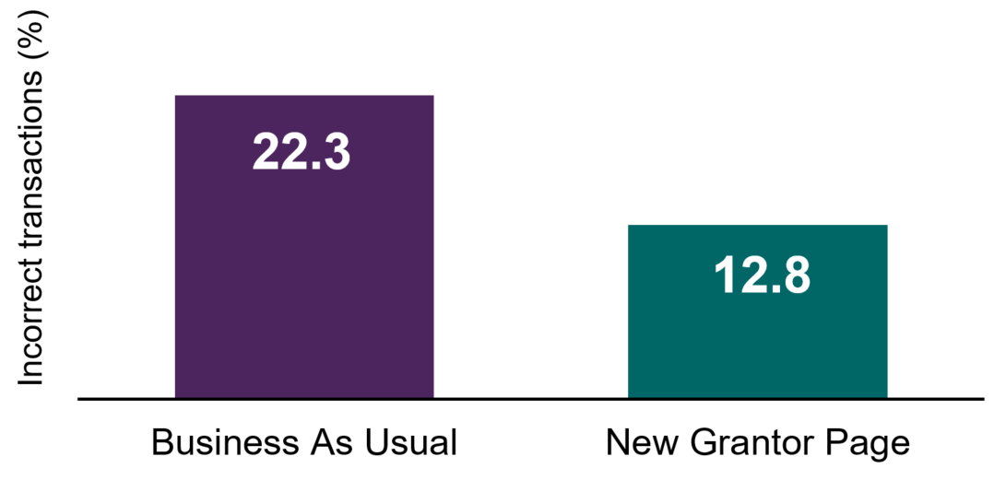
Note: N = 4,940. Percentage of incorrect transactions was significantly different between the two conditions; p = 0.012. The relevant statistical table is in Appendix 2, Table A5.

The most common error was caused by the Secured Party registering against itself
There is no good reason for the Secured Party to register against itself (i.e. listing the same party as both the Secured Party and the Grantor) and ideally it should never do so. However, this was the most common error, comprising 48% of all errors in this trial (n = 420). The new layout and prompts reduced this error, but did not totally eliminate it. This particular error made up 57% of all errors in the business-as-usual condition (n = 327) but only 30% of all errors in the new Grantor page condition (n = 93).
The next most common errors were caused by using an incorrect Grantor name (25% of all errors) and using an ABN when a different identifier should have been used (18% of all errors). Relatively few transactions were incorrect because users used an ABN or ACN that does not exist (<3% of all errors).

Ease of use and the completion rate did not suffer with the new layout and prompts
Self-reported ease-of-use was similar whether users saw the new Grantor page or the business-as-usual page (Figure 9).
We relied on Google Analytics data to measure completion rates. Some users blocked Google Analytics data collection. This meant we could not track the completion of all users who participated in the trial. As a result, we have a small sample (515 accounts) for completion rates, making these results less reliable. However, completion rates did not appear to be affected by the new Grantor page (Figure 10) – the difference between conditions was not statistically significant.

- Average self-reported ease of use
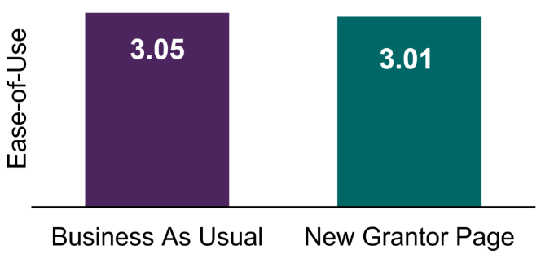
Note: N = 120 accounts. Ease-of-use was recorded on a four-point scale, where 1 = Very Difficult, 2 = Fairly Difficult, 3 = Fairly Easy and 4 = Very Easy. Mean ease-of-use scores did not differ significantly across the two conditions (p = 0.70). The relevant statistical table is in Appendix 2, Table A6.
- Completion rates between groups
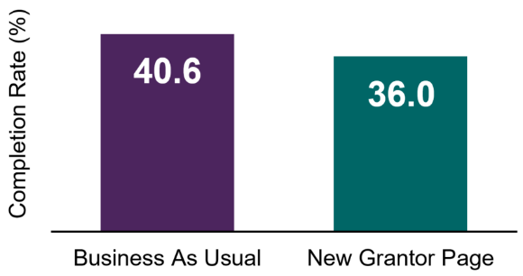
Note: N = 515 accounts. Completion rate was measured as the number of views of the final ‘Confirmation’ page in the registration process, as a percentage of the number of views of the ‘Grantor’ page. The difference in completion rates was not statistically significant (p = 0.28). The relevant statistical table is in Appendix 2, Table A7.

Discussion
Stepping users through the identifier hierarchy and presenting them with error-specific and customised prompts led to a significant drop in incorrect registrations. While we cannot discern which of these two interventions had the bigger impact on users’ behaviour, we suspect prompts were the more powerful intervention over the new layout. The prompts explained to users how the identifier they used was incorrect, acting as an educational tool. The prompts provided simple - and limited - next steps options (for example, “Change to name and date of birth" or “Continue with ABN”).
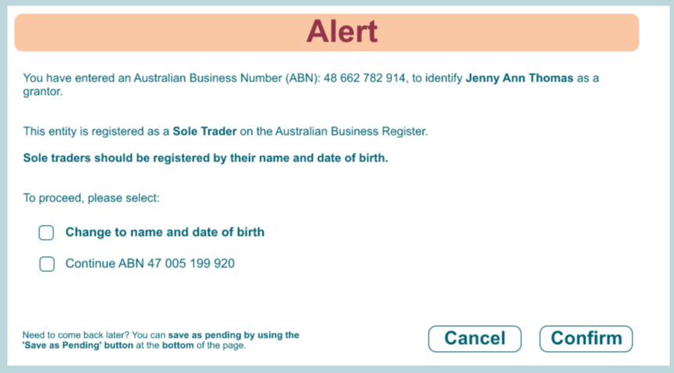
- An example pop-up.
As seen in Figure 11, most prompts were ‘choice preserving’, meaning users could elect to not follow the warning’s advice and proceed with their original (incorrect) choice. Only the prompt relating to Secured Party being the same as the Grantor was definitive in its phrasing. It read ‘the Secured Party and the Grantor of a security agreement should not be the same’ and did not allow the user to continue with their original choice.
To proceed with the incorrect identifier, the user needed to exit the prompt and then resubmit the Grantor page. Even with such a direct prompt, we saw 93 transactions in the new Grantor page condition containing the ‘SPG same as Grantor’ error. It is possible a small section of the PPSR community are misguided about the purpose of the PPSR or are intentionally using the PPSR for purposes other than what it is intended for, such as registration of ownership. Further research is required to better understand this behaviour and how it could be addressed.

Conclusion

Direct and timely advice helps users register correctly
Some less frequent users find the PPSR registration process challenging. To help them, we introduced a number of changes into the process. We found providing direct advice, via customised prompts and a new page layout, improved registration accuracy dramatically. However, drawing attention to the importance of the process and adding additional steps to the process, without providing educational support or feedback, did not improve registration accuracy.

Some mistakes appear to be purposeful
In our trials, many users changed their behaviour when advised they were making a mistake. However, some people ignored this advice and proceeded to make incorrect registrations. It is difficult to conclude with certainty why a user would ignore such advice. We speculate this may be because some users misunderstand the purpose of the PPSR or are mimicking actions of their peers. Stopping users from continuing to make these errors may require further research to better understand their motivations, greater educational efforts, or use of more direct language.

Small changes to the system do not appear to impact user experience
Although only a small number of users completed the optional survey, on average, these users self-reported that the registration process was ‘fairly easy’. This assessment did not change when we introduced the new layout, prompts or the new review screen.
Continuous marginal improvements will contribute to the integrity of the PPSR and have broader implications for the delivery of Government services. To ensure any changes to the register had the desired effect, AFSA rigorously evaluated proposals using RCTs. These evaluations allowed AFSA to make evidence-based decisions, minimising the possibility of negative and unintended outcomes and ensuring its users benefited from the changes. AFSA is planning to adopt the prompts as its business-as-usual practice, and is considering how to adopt the new grantor page layout across the different user cohorts. Given the review screen did not decrease incorrect transactions, AFSA have opted to maintain their current review screen.
More broadly, the results from these projects provide useful information on how public service organisations may communicate with their clients to minimise errors.

Appendix 1: Technical Details
This section describes the technical details for both Trial 1 and 2.

Pre-registration, pre-analysis plan, and ethics
Both trials were publicly pre-registered on the AEA registry. For Trial 1 the record number is AEARCTR-0006971 and for Trial 2 it is AEARCTR-0008355. For both trials, registration took place before we analysed the data.
Trial 1 was in the field from 17 December 2020 to 10 March 2021. Trial 2 was in the field from 29 July 2021 to 20 October 2021.
For both trials, our analyses were consistent with our pre-analysis plan, besides the exclusion of one primary outcome in Trial 1 due to data issues (see Outcome measures below). Pre-analysis plans for both trials are published on the BETA website as a supplement to the report. Full statistical tables are also available in Excel format on the BETA website.
Both trials were approved through BETA’s ethics approval process, with risk assessed by Macquarie University in accordance with the guidelines outlined in the National Statement on Ethical Conduct in Human Research.

Population and sampling
For both trials, our population of interest was PPSR account holders that did not regularly create registrations. Accordingly, our sample comprised PPSR account holders that created a registration during our trial period. We excluded particularly experienced PPSR account holders who had ever created more than 10 registrations within a single month. All registrations made by new accounts were included.
For Trial 1, in the fourteen weeks available for the trial, we obtained 3,631 transactions made by 1,013 PPSR account holders.
For Trial 2, in twelve weeks, we obtained 1,567 PPSR account holders that made 4,940 transactions.

Randomisation
For both trials, randomisation to the control (business-as-usual) or treatment (new review screen for Trial 1, new grantor page for Trial 2) conditions was conducted on a rolling basis by AFSA as registrations were created. Randomisation occurred at an account level. This meant that all users of a PPSR account (e.g. a business) viewed the same registration form.

Sample size and power calculations
These power calculations were originally reported in our pre-analysis plans. Estimates for both trials assume conventional power of 0.8, but deviate from convention to an alpha of 0.1. We opted to increase alpha because the practical risks associated with making a Type I error (a false positive) with these treatments were small.

Trial 1
Based on an intra-cluster correlation (ICC) estimate of 0.2, we estimated that with a sample size of around 1,400 account holders making 4,970 transactions, this trial had power to detect an increase in accuracy (see Outcome measures) of 3.5 percentage points, from a base accuracy rate of 60%.
Our final sample was smaller than the estimated sample size used in these power calculations with 1,013 accounts making 3,631 transactions. In addition, accuracy was relatively consistent within accounts, resulting in a higher ICC than predicted (0.85 for the first new review screen trial).

Trial 2
Based on an ICC of 0.85 from the first trial, we estimated that with a sample size of around 1,500 account holders making 5,370 transactions, this trial had power to detect an increase in accuracy of 4.5 percentage points, from a base accuracy rate of 80%.
Our final sample for this trial was 1,567 account holders and 4,940 transactions. The ICC estimated from the final data in this trial was 0.80.

Outcome measures

Trial 1
Our primary outcome was transaction accuracy. Although randomisation occurred at an account level, accuracy was measured at the transaction level. Accounts could make multiple transactions during the trial period and transactions could include multiple registrations (e.g. registering multiple assets). For a transaction to be deemed correct, all registrations making up that transaction needed to be correct.
Transaction accuracy was estimated by checking whether the identifier hierarchy was correctly applied. We did this by cross-referencing information inputted into the Grantor page with the Australian Business Register (ABR) and the Australian Securities Investment Commission (ASIC) databases. If cross-referencing the submitted identifier with ABR and ASIC databases showed that the wrong identifier was used, the registration was classed as incorrect.
Additionally, if the same identifier was used for both the grantor and the secured party, the registration was classed as incorrect, even if the data entered correctly matched the ABR/ASIC databases. This is a common and known error – it is not possible for a valid registration to contain the same Grantor and secured party.
When we were unable to use the Grantor Identifier to explicitly determine whether the registration is correct, we assumed it was correct. Further detail about the logic used to determine transaction accuracy is provided in Appendix 3.
In our pre-analysis plan, we registered a second primary outcome - changes made after review point. However, we were not able to capture the required data for this outcome and have not included it in our analyses.
The secondary outcome measure was ease of use. This was intended to be measured in three ways: survey questions, time taken, and navigation back and forth. Once again, we were not able to capture time taken and navigation back and forth metrics. Only the survey questions were used for this outcome measure. The optional three-question survey was presented to participants after submitting their registrations. We only assessed answers to the first question, “How easy or difficult was the registration process overall?”, to which participants could respond “Very easy”, “Fairly easy”, “Somewhat difficult”, or “Very difficult”. This was treated as a continuous variable.

Trial 2
The primary outcome measure was transaction accuracy, as described for Trial 1 above.
There were two secondary outcome measures. The first secondary outcome measure was perceived ease of use, as described for Trial 1.
Our second secondary outcome, which was not included in Trial 1, was registered as drop-out rates, which we ultimately reported as completion rates (the inverse of drop-out rates). We used Google Analytics data to calculate the number of views of the “Confirmation” page, as a proportion of the number of views of the “Grantor” page. The Grantor page was the point where the intervention was introduced (about halfway through the registration form), while the Confirmation page was the last stage in the registration form.

Hypotheses

Trial 1
In our pre-analysis plan, we specified two hypotheses in relation to our two primary outcomes and two hypotheses in relation to our secondary outcomes. Here, we have excluded hypotheses that were not tested due to data issues (see Outcome Measures above).
Primary: In registrations where users will see the new review process, registrations will have lower error rates in the grantor identifier section, than those in the control group (one-tailed).
Secondary (a): There will be a difference in the self-reported ease of use of the review screen, when compared to the control group (two-tailed).
Secondary (b): There will be a difference in the self-reported ease of use of the registration process as a whole, when compared to the control group (two-tailed).

Trial 2
In our pre-analysis plan, we specified one hypothesis in relation to our primary outcomes and two hypotheses in relation to our secondary outcomes. All pre-registered hypotheses were tested in the analysis of this trial.
Primary: Transactions completed via the new grantor page form will have lower error rates (i.e. higher transaction accuracy) in the Grantor Identifier section than transactions completed via the business-as-usual form (one-tailed).
Secondary (a): Participants who viewed the new grantor page form will self-report a different ease-of-use score than participants who completed the business-as-usual form (two-tailed).
Secondary (b): Drop-out rates (as measured by the proportion of “Confirmation” page views) will be different for transactions completed via the new grantor page form, compared to those completed via the business-as-usual form (two-tailed).

Method of analysis
All data processing and analysis was performed using R (version 4.0.3, R Core Team, 2020) in R Studio (RStudio Team, 2020).
All analyses used ordinary least squares regression with CR2 cluster robust standard errors. We used the ‘estimatr’ package from the DeclareDesign suite (version 0.24.0, Blair, Cooper, Coppock & Humphreys 2019). For all hypotheses, effect estimates, confidence intervals and p-values were derived from the following model:
$$Y_{ij}=α+τT_{i}+ βx_{i}+γx_{i}T_{i}+v_{j}+ ω_{ij}$$
Where Y is one of our pre-registered primary or secondary outcomes, $α$ is the intercept, $T_{i}$ is an indicator for treatment group membership, $x_{i}$ is a mean-centred covariate, however, this was not included in Trial 2 analyses (see below), $x_{i}T_{i}$is the interaction between the treatment indicator and the mean-centred covariate, $v$ is the error for each cluster (account) j, and $ω$ is the registration level error term.

Covariates
All models from Trial 1 included a binary covariate which provides a proxy for the experience level of that account holder. Each account was categorised as less experienced (<11 registrations created previously) or more experienced (≥11 registrations created previously). This covariate was interacted with the treatment indicator as per Lin (2013). We anticipated that more experienced accounts would be less likely to make a mistake. However, including the covariate did not significantly affect the results. In addition, accounts that create many registrations might do so for ‘incorrect’ reasons (e.g. some users who are not sure which grantor identifier is correct, may create duplicate registrations, using a different grantor identifier each time; BETA 2020). As a result, previous experience was not used as a covariate in models for Trial 2.

Missing Data
Registrations with critical information not entered will be treated as missing, however, we do not expect this to be widespread in registry entries. The survey is optional, so we expect to have at least some missing data in our dataset.
Registrations that are incomplete by the time the trial is closed will be treated as missing. Where data is missing for a specific outcome we will exclude that record for the corresponding analysis.

Appendix 2:
Statistical Tables
Statistical tables are available in the Excel spreadsheet published alongside this report.

Appendix 3: Accuracy Logic
As noted in Appendix 1, registration accuracy was the primary outcome in both trials. This section describes the logic underpinning our evaluation of registration accuracy.

Background
In most PPSR registrations there is a:
- Secured Party Group (SPG) – the party making the registration, and
- Grantor – the party that ‘grants’ the interest in the security.
The SPG identifies itself and the grantor by entering an ‘identifier’ (e.g. ABN, ACN, name). PPSR regulations prescribe which identifiers the SPG must use. An SPG can be made up by multiple entities and there may be multiple grantors nominated in a single registration.
To measure whether our interventions helped registrants choose the correct identifiers, we cross-referenced identifiers used in the PPSR forms with the Australian Business Register (ABR) and the Australian Securities Investment Commission (ASIC) databases.
Based on rules outlined bellow, we decided whether the identifier (and by extension the registration) is correct.

The hierarchy of identifiers
Depending on the SPG and the Grantors’ corporate structure, Personal Property Securities Regulations 2010 prescribe which identifiers must be used and in what order.

Body corporates:
- Australian Registered Scheme Number (ARSN).
- Otherwise, the Australian Company Number (ACN).
- Otherwise, the Australian Registered Body Number (ARBN).
- For any other body corporates, use the name of the body corporate as it appears on its constitution.

Trusts and their trustees:
- Trustee’s ARSN.
- If trustee does not have an ARSN, and the Trust has an ABN, the Trust’s ABN should be used.
- If the Trustee is a body corporate and the Trust does not have an ABN then the registration should be lodged against the body corporate’s details as outlined above.
- If the Trustee is an individual and the Trust does not have an ABN, then registrations should be against the individual’s details as outlined in the next sub-section.

Individuals (inc. sole traders):
- Surname, given names and date of birth as known to the secured party because of the operation of the Anti-Money Laundering and Counter-Terrorism Financing Act 2006.
- Otherwise, surname, given names and date of birth as it appears on the individual’s current driver’s licence.
- Otherwise, surname, given names and date of birth as recorded on the individual’s proof of identity or proof or age card issued by a State or Territory body.
- Otherwise, surname, given names and date of birth as recorded on the individual’s current Australian passport.
- Otherwise, surname, given names and date of birth as recorded on the individual’s current Australian visa.
- Otherwise, surname, given names and date of birth as recorded on the individual’s current passport issued by the jurisdiction in which the individual ordinarily resides.
- Otherwise, surname, given names and date of birth as recorded on the individual’s birth certificate.

Body politic:
- Body politic’s ABN (if it has one).
- If the body politic has an interest in collateral, other than in the course of, or for, an enterprise that has been allocated an ABN then register against the name of body politic, in accordance with the constitution of body politic.

Partnership:
- Partnership's ABN.
- Otherwise, if partner is an individual, details of individual partner.
- Otherwise, if partner is a body corporate, details of body corporate.
Please note, for all these categories, the first identifiers that should be used are the SPG/Grantor names as they appear on a ‘Transitional register’ (a register set up in 2012 to accommodate the merge of State and Territory based registers). In practice, these identifiers are very rarely used. As such, they will be omitted from our hierarchy of identifiers

External to AFSA datasets used

ASIC’s Datasets
Hosted on data.gov.au (data dictionary), the ASIC Company Dataset contains select data from ASIC’s company register. We also purchased a custom dataset from ASIC that contained ARSN details. For trial 1, ASIC dataset was extracted on 14 March 2021 (then updated on 21 March 2021). For trial 2, ASIC dataset was extracted on 25 October 2021.

ABR database
ABR Dataset, extracted via a bulk download, specifically the ‘agency file’ (data dictionary). For trial 1, the agency file was extracted on 14 March 2021. For trial 2, the agency file was extracted on 29 October 2021.

Identifier accuracy process
Checking identifier accuracy is a two-step process.
- Step one is to check whether any SPG within the registration is the same entity as the grantor. SPG should not be the same as the grantor. Given there may be multiple parties in an SPG and multiple grantors, if any single SPG member is the same entity as the grantor, than the transaction/registration is deemed to be incorrect.
- Step two is to check the numeric identifier used in the registration to identify the SPG member or the grantor. If at least one SPG member or at least one grantor from a given transaction is incorrect, the whole transaction/registration is incorrect.
We applied a slightly different verification process based on the identifier used in the process:

ARBN
Compare ARSN used in the PPSR form with the custom ASIC database. If the ARSN exists in the custom ASIC dataset, we deem the identifier to be correct. If it does not appear in the custom ASIC dataset, we deem it to be incorrect.

ACN or ARBN
Compare ACN or ARBN used in the PPSR form the ASIC Company Dataset. If ACN or ARBN exists in the ASIC Company Dataset, we deem the identifier to be correct. If it does not appear in the ASIC Company Dataset, we deem it to be incorrect.

ABN
Compare ABN used in the PPSR form the ABR database. If the ABN does not exists in the ABR database, we deem the identifier to be incorrect. If it does appear in the ABR database, we then check what entity ‘type’ of the party being registered.
- If the entity type of the party being registered relates to trust/trustee, partnership or body politic, we deem the identifier to be correct.
- If it does not relate to trust/trustee, partnership or body politic, we deem the identifier to be incorrect.

Names
AFSA’s subject matter experts assessed whether the names used to identify the SPGs and grantors was the most appropriate identifier to use.

References
AFSA (Australian Financial Securities Authority) (2021) ‘Registrations activity monthly time series’ [data set], AFSA, Australian Government, accessed 5 December 2021.
Behavioural Insights Team (2014). ‘EAST: Four simple ways to apply behavioural insights’. Behavioural Insight Team, accessed 25 October 2021.
Benartzi S and Lehrer J (2015) ‘The Smarter Screen: What Your Business Can Learn from the Way Consumers Think Online’, Hachette UK.
BETA (Behavioural Economics Team of the Australian Government) (2020) ‘Applying behavioural insights to the Personal Property Securities Register’, Department of the Prime Minister and Cabinet, Australian Government, accessed 10 November 2021.
Iyengar SS and Lepper MR (2000) ‘When choice is demotivating: Can one desire too much of a good thing?’, Journal of Personality and Social Psychology, 79(6):995-1006. doi:10.1037//0022-3514.79.6.995.
Kirsh D (2000) ‘A Few Thoughts on Cognitive Overload’, Intellectica, 1(30):19-51.
Mick D, Broniarczyk S and Haidt, J (2004). ‘Choose, choose, choose, choose, choose, choose, choose: Emerging and prospective research on the deleterious effects of living in consumer hyperchoice’, Journal of Business Ethics, 52(2):207-211. doi:10.1023/B:BUSI.0000035906.74034.d4.
Moore DA and Healy PJ (2008) ‘The trouble with overconfidence’, Psychological Review, 115(2):502-517. doi:10.1037/0033-295X.115.2.502.
Reutskaja E and Hogarth RM (2009) ‘Satisfaction in choice as a function of the number of alternatives: When “goods satiate”’, Psychology & Marketing, 26(3):197-203. doi:10.1002/mar.20268.
Sharot T (2011) ‘The optimism bias’, Current Biology, 21(23):R941-R945. doi:10.1016/j.cub.2011.10.030.

© Commonwealth of Australia 2021
ISBN 978-1-925365-03-0 Prompting accuracy: Using behavioural insights to support accurate registrations

Copyright Notice
With the exception of the Commonwealth Coat of Arms, this work is licensed under a Creative Commons Attribution 4.0 International license (CC BY 4.0) (https://creativecommons.org/licenses/by/4.0/)

Third party copyright
Wherever a third party holds copyright in this material, the copyright remains with that party. Their permission may be required to use the material. Please contact them directly.

Attribution
This publication should be attributed as follows:
© Commonwealth of Australia, Department of the Prime Minister and Cabinet, Prompting accuracy: Using behavioural insights to support accurate registrations.

Use of the Coat of Arms
The terms under which the Coat of Arms can be used are detailed on the following website: https://pmc.gov.au/cca

Behavioural Economics Team
of the Australian Government
General enquiries beta@pmc.gov.au
Media enquiries media@pmc.gov.au
Find out more www.pmc.gov.au/beta

Or via another form of transaction which raises a debt obligation.
Personal property is defined as any sort of property that is not land, buildings or fixtures. Examples include goods, motor vehicles, planes, boats, intellectual property and bank accounts.
Some collateral classes with universal serial numbers, such as automobiles, do not require the grantor to be identified.
Some frequent PPSR users create and manage their own private PPSR portals. There are also businesses that use their portals to provide PPSR registration services to their clients.
Only PPSR accounts that completed fewer than 10 registrations in any given month, or new PPSR accounts, were included in the trials.
Grantor(s) do not need to be identified when the SPG registers a serial numbered property, such as a car.
Registrations made against serial-numbered goods do not require for a grantor to be nominated.

