Pre-Analysis Plan

Part 2: Prompts and an intuitive layout

Policy problem
The Personal Property Securities Register (PPSR) serves several purposes: it allows businesses to safeguard their security interests (money owed to them); helps businesses make informed purchasing decisions by letting them know whether the asset they are purchasing has outstanding financial obligations tied to it; and facilitates secure lending to businesses by financiers.
Businesses can register on the PPSR by completing an online form hosted by the Australian Financial Security Authority (AFSA). Businesses need to get key elements of the registration exactly right. Even a small mistake may render the registration invalid, exposing the business to greater financial risk.
Previously, BETA made several recommendations that aim to reduce the error rates of submitted PPSR forms. This evaluation project will test some of these recommendations.

Trial aim
This trial aims to reduce errors in the ‘Grantor Identifier’ section of the registration form. This trial will add pop-up prompts alerting users of possible errors and introduce an alternative layout of the online form.
This trial will be a two-arm clustered randomised field trial, in which users will complete the ‘business-as-usual’ registration form, or the ‘treatment’ registration form with additional prompts and an alternative layout. The unit of randomisation will be PPSR accounts (rather than individual registration forms).
We will test whether the treatment form;
- Increases transaction accuracy,
- Increases or decreases the perceived difficulty of the registration process,
- Increases or decreases drop-out (non-completion) rates, compared to the business-as-usual form.

Interventions

Treatment Form
The intervention is a new version of the PPSR form. It differs from the business-as-usual form by including both of the following changes:
- Prompts alerting users if an incorrect identifier (e.g. Australian Company Number, Australian Business Number) was used when identifying the grantor (the other party in the transaction they are registering). All prompts used can be found in Appendix A.
- A more intuitive way of laying out the information and asking questions. A screenshot is shown in Appendix B.

Outcome measures

Primary Outcome Measure – Transaction Accuracy
We will measure transaction accuracy using a proxy. We will cross-reference key information used to identify the ‘grantor’ with the Australian Business Register (ABR) and the Australian Securities Investment Commission (ASIC) databases. This is a binary measure; a registration will be either ‘correct’ or ‘incorrect’.
In most cases, the Secured Party Group (SPG; the party making the registration) must provide information about the other party – the Grantor. Information that ‘identifies’ the grantor is referred to as an ‘identifier’. This identifier can be an Australian Business Number (ABN), Australian Company Number (ACN), or another available identifier. The registrant must follow a specific hierarchy of correct identifiers. For example, if an organisation has multiple identifiers, such as an ABN and an ACN, the registrant should use the ACN and not the ABN.
If cross-referencing the submitted identifier with ABR and ASIC databases shows that the wrong identifier was used, the registration will be classed as ‘incorrect’. A single registration can include multiple grantors, so all grantor information must be correct in order for the registration to be classed as ‘correct’. In addition, multiple registrations can be grouped under a single transaction - for instance, a person may register multiple assets (hence creating multiple registrations) in a single transaction. For a transaction to be deemed correct, all registrations making up the transactions must be correct.
If the Grantor is the same as the registered Secured Party Group (SPG), the registration will be classed as ‘incorrect’, even if the data entered correctly matches the ABR/ASIC data. This is a common and known error - it is not possible for a valid registration to contain the same Grantor and SPG.
When we cannot use the Grantor Identifier to explicitly determine whether the registration is correct, we will assume it is correct.

Secondary Outcome Measures

Perceived Ease of Use
After participants submit their registration, they will be presented with a three-question survey. We will only assess answers to the first question, “How easy or difficult was the registration process overall?”, to which participants can respond “Very easy”, “Fairly easy”, “Somewhat difficult” or “Very difficult”. This will be treated as a continuous variable.
The second question in the survey asks whether certain elements of the registration form were helpful or not helpful, while the final question is an open-ended question (“What could we improve?”). Responses to these two questions will be used by AFSA to monitor user feedback.

Drop-Out Rates
We will measure drop-out rates as the number of views of the “Confirmation” page, as a proportion of the number of views of the “Grantor” page. The Grantor page is the point where the intervention is introduced (about halfway through the registration form), while the Confirmation page is the last stage in the registration form. This is why views of the Confirmation page will be used as a proxy for completes.
Due to technical constraints, there is a chance we will not have an accurate count of “Confirmation” page views. If AFSA is unable to provide this data, then we will instead use administrative data to determine the number of completed registrations for each condition.
Drop-out rates will be compared between the treatment and business-as-usual forms.

Population and sample selection
Our population of interest is PPSR account holders, particularly account holders who do not regularly create registrations. Accordingly, trial participants will be PPSR account holders who create a registration during our trial period. We will exclude PPSR account holders that have ever created more than 10 registrations within a single month. All registrations made by new account holders will be included.
The trial will remain in the field for up to eighteen weeks or until at least 1,500 eligible registrations have been completed (750 business-as-usual, 750 treatment). At the conclusion of the trial, forms will be complete (submitted) or pending (not submitted, but saved by users and partially complete). Pending forms will not be included in our analyses.

Hypotheses

Primary Hypothesis
H1. Transactions completed via the ‘treatment’ form will have lower error rates (i.e. higher transaction accuracy) in the Grantor Identifier section than transactions completed via the ‘business-as-usual’ form (one-tailed).

Secondary Hypotheses
H2. Participants who viewed the ‘treatment’ form will self-report a different ease-of-use score than participants who completed the ‘business-as-usual’ form (two-tailed).
H3. Drop-out rates (as measured by the proportion of “Confirmation” page views) will be different for transactions completed via the ‘treatment’ form, compared to those completed via the ‘business-as-usual’ form (two-tailed).

Randomisation
Randomisation will be conducted on a rolling basis by AFSA as registrations are created. Individual PPSR account holders can create more than one registration, and therefore the trial will be randomised (clustered) at the account level. Accounts will be assigned to ‘business-as-usual’ or ‘treatment’ forms in a 1:1 ratio.

Sample size and power calculations
Based on a historical ICC of 0.85, a sample size of around 1,500 users would allow for a minimum detectable effect size of about 4.5 percentage point change at a base accuracy rate of approximately 80%.
The above calculation assumes conventional power of 0.8, but deviates from convention to an alpha of 0.1. We believe the practical risks associated with making a Type I error are small, therefore we have opted to increase alpha in order to achieve a reasonable level of statistical power.

Method of analysis

Primary and secondary analysis
We will use ordinary least squares (OLS) regression to estimate the effects of our intervention. For all hypotheses, effect estimates, confidence intervals and p-values will be derived from the following model:
$$Y_{ij}=α+τT_{i}+ +v_{j}+ ω_{ij}$$
Where Y is one of our pre-registered primary or secondary outcomes, $α$ is the intercept, $T_{i}$ is an indicator for treatment group membership, $v$ is the error for each cluster (account) j, and $ω$ is the registration level error term.
Standard errors will be CR2 cluster robust with a degrees of freedom adjustment (Pustejovsky and Tipton, 2018).

Missing Data
Registrations with critical information not entered will be treated as missing, however, we do not expect this to be widespread in registry entries. The survey is optional, so we expect to have at least some missing data in our dataset.
Registrations that are incomplete by the time the trial is closed will be treated as missing. Where data is missing for a specific outcome we will exclude that record for the corresponding analysis.

Additional Bayesian Analysis
In addition to the OLS regression described above, we will also use Bayesian regression to estimate the strength of the evidence in favour of the intervention’s effects.
The results of the Bayesian regression will primarily serve as a robustness check and will aid the interpretation of p-values.

Pre-analysis plan commitments
We have two standard commitments:
- ‘No trial data have been collected/no analysis has been undertaken prior to the completion of this pre-analysis plan.’
- ‘We will be transparent about, and provide justification for, any deviations (additions or omissions) from this plan.’

Appendix A: Prompts
Prompt 1. Appears if the user enters an incorrect identifier type into the registration form.
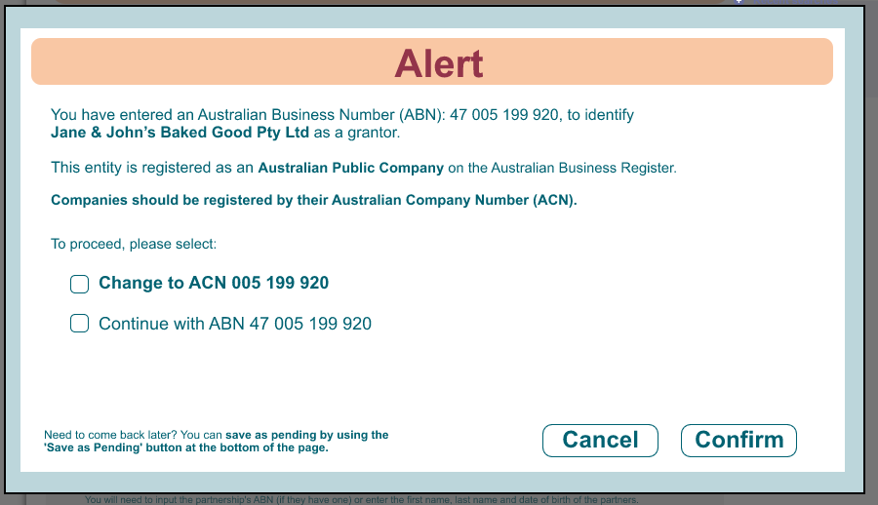

Prompt 2. Appears if the user enters ABN to identify a sole trader.
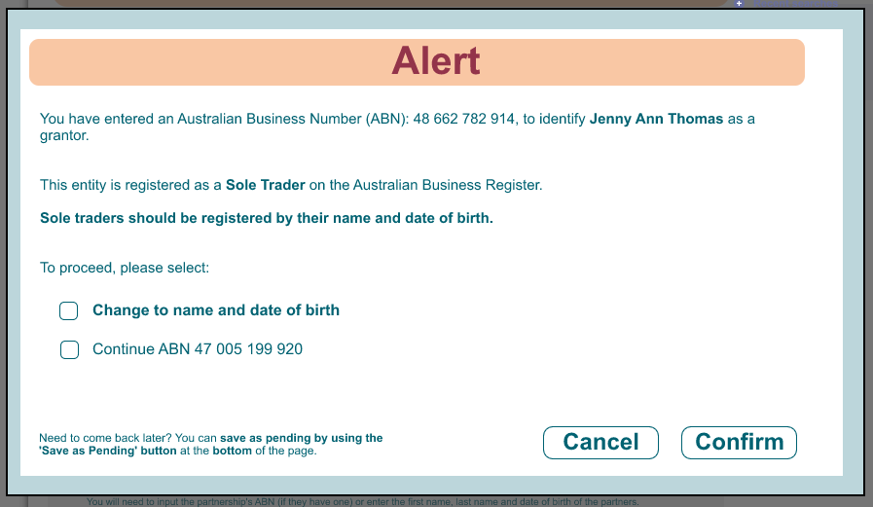

Prompt 3: Appears if the user tries to register against themselves (SPG=Grantor). 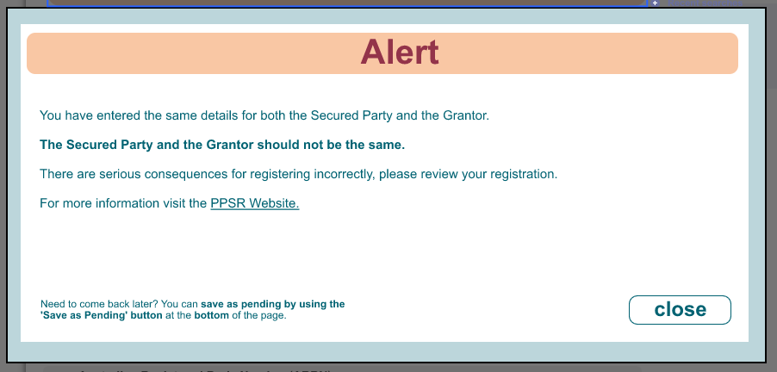

Prompt 4: Appears if the identifier used is no longer active.
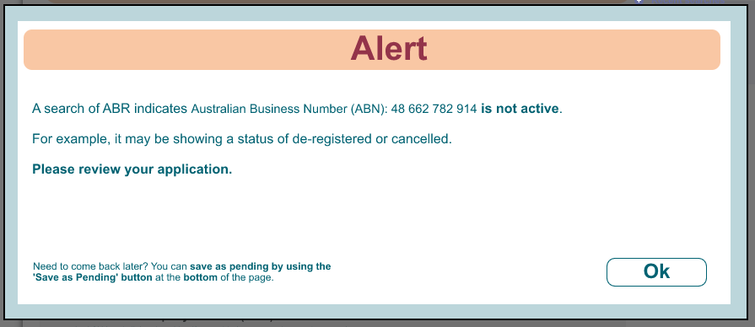

Prompt 5: Appears if the user input a correct identifier into the wrong field on the form
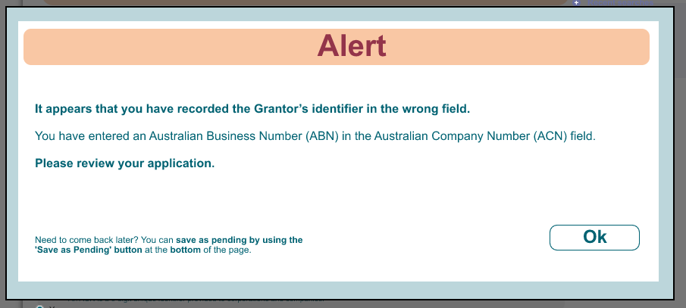

Appendix B: New layout
Screenshot 1: An example of the new Grantor page with expanded options.
