# Family and Domestic Violence Leave Survey Experiment

**Technical Report**

**August 2024**

Contents

Technical details 2

Results and discussion 11

Appendix 1: Statistical tables 15

Appendix 2: Survey materials 19

References 24

## Technical details

### Study aim

To explore whether the new legislation regarding the paid family and domestic violence (FDV) leave entitlement has the potential to reduce stigma and discrimination experienced in the workplace by victim-survivors.

### Policy context

The Safety Net Branch in the Department of Employment and Workplace Relations asked BETA to conduct research to understand the impacts of the new paid FDV leave entitlement that became available to Australian employees in 2023. The results of this research will contribute to an independent review of the paid FDV leave legislation.

### Scope of this report

This report provides technical detail on only a single experiment included in a suite of research activities to explore the impact of the paid leave entitlement.

In the experiment, we asked respondents to provide their rationale for some of their responses. This was collected via an open-text response box. The qualitative thematic analysis of these responses is not covered in this report.

### Rationale

Previous research has indicated that the act of introducing legislation can alter community attitudes (e.g. Colombotos 1969; Werner et al 1995; Bilz and Nadler 2014). This may be because citizens view the legal system as a legitimate and reliable source of morality that reflects commonly held views (Kuran 1995). Essentially, citizens assume others are complying not because they must, but because they want to – and this perception contributes to a shift in social norms.

Specifically, legislation may be able to reduce stigma and discrimination against employees who take leave from work. For example, in an experimental study, Albiston and Correll (2023) found that anti-discrimination legislation significantly reduced stigmatising and discriminatory evaluations of fictional employees who accessed leave to care for their sick child. Moreover, they found that legislative provisions were far more powerful at reducing stigma and discrimination than organisational policies alone. Using an experimental methodology similar to Albiston and Correll (2023), we tested whether the paid FDV leave entitlement has a similar potential.

### Experiment design

We conducted a two-arm online survey experiment which was part of a broader online survey of the general Australian workforce. The two arms differed only in how the survey questions were ordered.

Half the participants in our survey were randomly allocated to our **treatment condition.** In the treatment condition, participants first received information about the legislation through educational feedback following their responses to a quiz designed to measure their comprehension of the leave entitlement (see Appendix 2). Then they responded to a vignette that required them to evaluate the work performance and behaviour of a fictional employee who had taken leave from work due to experiencing FDV. Participants also answered general attitudinal questions about FDV (see Appendix 2). The other half of our participants were allocated to the **control condition** where they learnt about the legislative requirements *after* they evaluated the fictional employee and indicated their general attitudes towards FDV.

The experiment design pre-empted that members of the general Australian workforce were probably unfamiliar with the provisions of the paid FDV leave entitlement, which had only been available to Australian employees for a short time (11 months for large business employees and 5 months for small business). In support of this assumption, we found that our participants displayed quite poor knowledge of the legislation. Participants scored an average of 4.52 out of 10 on the quiz designed to measure their comprehension of the leave provisions.

Participants were recruited through a research participant panel. The recruitment flow, eligibility, and exclusion criteria for the survey experiment is outlined in Figure 1. Hard and soft quotas were used to ensure similar cell sizes to the general Australian workforce.

Figure 1. Survey flow and eligibility criteria

Figure 1. Survey flow and eligability criteria. This figure demonstrates the survey flow for demonstrating the eligibility criteria of participants. The first box reads 'Survey panel members invite: "This 15 to 30 minute survey is about work and family and domestic violence (FDV)."' There is then an arrow pointing to the second box. The second box contains the screener questions and says 'Screener questions. Panel members were eligible for the survey experiment if they: were aged between 18 years and 70 years old, lived in Australia, were currently in paid work, had been in paid work and experienced FDV before 2018. For our sample to be representative of the Australian  workforce, we aimed for the following quotas: Gender (51% female), Age (39% 18 to 34 years, 43% 35 to 54 years, 18% aged above 55 years), State/ Territory (26% Victoria, 30% NSW, 20% QLD, and 23% from the remaining). The survey was closed after we had 3,008 respondents.' This box then has an arrow pointed to the third box. The third box is called 'informed consent'. There is then an arrow pointing to the next box, which is the fourth box. The fourth box is called 'Demographic and covariate questionnaire.' This fourth box then has two arrows to point to two different pathways, to demonstrate the split between the treatment group and the control group. The first pathway has the first box called 'Treatment group (1,470 respondents). It has one arrow pointing to the next box in the treatment group pathway, which is called 'Section B: Immediate educational feedback to a comprehension quiz about the paid FDVL entitlement'. This box then has one final arrow pointing to the next box in the treatment pathway called 'Section A: Evaluation of a fictional employee plus attitudes questionnaire." For the second pathway, the first box is titled 'Control group (1,538 respondents)'. This box has an arrow going to the next box of the control group pathway called 'Section A: Evaluation of a fictional employee plus attitudes questionnaire'. This box then has another arrow pointing from it to the last box of the pathway called "Section B: Immediate educational feedback to a comprehension quiz about the paid FDVL entitlement". 

### Randomisation

Randomisation occurred at the individual level. Participants who were eligible to take part in the survey experiment were randomised into two arms within the Qualtrics survey platform, using the inbuilt randomisation functionality, with roughly equal probability of assignment across the two groups. There were 1,470 respondents in the treatment group and 1,538 respondents in the control group.

### Outcome measures

There were two sets of outcome measures. The first set was measured in response to a vignette. The vignette described an employee who took leave from work to deal with FDV. These outcome measures relate directly to perception of the employee. The second set of outcome measures included general attitudinal outcomes towards those who experience FDV and general attitudes towards gender equality.

A copy of relevant survey questions is provided in Appendix 2.

#### Primary outcomes

**Discrimination outcome measures**

Bonus (numeric). In the vignette, participants were informed that employees may receive a bonus between $0 and $1000. Participants were asked what bonus is appropriate for the fictional victim-survivor in whole dollars between 0 and 1000. There were 297 missing responses for this outcome measure.

Management (binary). In the vignette, participants were asked whether the fictional victim-survivor should be assessed for a management position in the next year (1 = yes, 0 = not yes). There were 297 missing responses for this outcome measure.

We undertook missing value analyses and those are described later in this report.

#### Secondary outcomes

**Stigma outcome measure: Vignette**

Competence of the fictional victim-survivor was measured using a 6-item scale, each with a 6-point sliding response scale. The outcome was constructed as the mean of these responses. There were 297 complete missing responses but no partial missing responses, so we used all available data. The Cronbach’s alpha of the competence scale was 0.83, indicating good internal consistency.

**Stigma outcome measure: Endorsement of general stigmatising attitudes**

We asked participants to indicate their level of agreement with a set of stigma-related statements that we had adapted from the Australia’s National Research Organisation for Women’s Safety (ANROWS) Gender Inequality Scale (AGIS) and the Attitudes towards Violence Against Women Scale (AVAWS) (Keel et al. 2023).

These two attitudinal scales are not related to the vignette and evaluation (Section A of the survey experiment in Figure 1). They form part of Section B of the survey experiment.

We used the AGIS (adapted) to measure stigmatising attitudes towards gender equality. The AGIS (adapted) contained five statements to which participants responded on a 4-point sliding scale (‘Disagree’ = 0, ‘Slightly agree’ = 1, ‘Agree’ = 2, ‘Strongly agree’ = 3). The outcome was constructed by calculating the mean of responses. None of the respondents had partial missing data on these items. 297 respondents who did not answer any of the five items were excluded from analysis. The alpha for this scale was 0.82, indicating good reliability.

We used the AVAWS (adapted) to measure stigmatising attitudes towards domestic violence. This scale contained 12 stigmatising statements for which participants responded on a 4‑point sliding scale (‘Disagree’ = 0, ‘Slightly agree’ = 1, ‘Agree’ = 2, ‘Strongly agree’ = 3). The outcome was constructed by calculating the mean of responses. None of the respondents had partial missing data on these items. 297 respondents who did not answer any of the five items were excluded from analysis, leaving 2711 respondents with complete data. The alpha for this scale was 0.97, indicating good reliability and that some items could be dropped if needed in future use of this scale.

### Hypotheses

#### Primary

H1: Mean bonus amount will be higher in the treatment arm as compared with the control arm (treatment Greater than control).

H2: There will be a higher proportion of people recommending assessment for management for the fictional employee in the treatment arm as compared with the control arm (treatment Greater than control).

#### Secondary

H1: Mean competence scores will be higher in the treatment arm as compared with the control arm (treatment Greater than control).

H2: Mean AVAWS scores will be lower in the treatment arm as compared with the control arm (treatment Less than control).

H3: Mean AGIS scores will be lower in the treatment arm as compared with the control arm (treatment Less than control).

### Power and sample size

With 1,320 participants per arm, we estimated 90% power to detect an effect of:

* $25 higher in the mean recommended bonus in treatment compared to the control group
* 5 percentage point higher in proportion recommending fictitious person for management (for example, from 50% to 55%) in the treatment group compared to the control group.

We used alpha level of 10% and 90% power. We chose these settings because the intervention is extremely low risk and it would be worse to reject a possible real effect than to accept a possibly spurious one.

### Pre-registration and ethics

This survey experiment was publicly pre-registered on the American Economic Association’s Social Science Registry ([AEARCTR-0013173](https://www.socialscienceregistry.org/trials/13173)). The pre-registration was completed before we commenced data collection for the survey experiment and prior to analysing the data. The ethical aspects of the research were reviewed and approved by Macquarie University’s Human Research Ethics Committee, Humanities & Social Sciences Committee (520241682255308) on 16 February 2024.

The analyses of the experiment data were as per the pre-analysis plan. However, we did not collect information on whether respondents worked for private or public sector, therefore we could not undertake subgroup analyses by private/public sector.

### Final sample size

There were 3,008 respondents in the survey experiment. This was larger than the sample size of 2,640 we used for power calculations in the pre-analysis plan.

There were 1,470 respondents in the treatment group and 1,538 respondents in the control group. All eligible participants except those who did not consent to participating in the study were included in our analyses, including partial responders. There were 297 (9.3%)participants who had missing outcome data.

The demographics of the final sample are presented in Table 1.

**Table 1. Sample characteristics by treatment and control groups**

| Characteristics | Total  Count (per cent) | Treatment group  Count (per cent) | Control group  Count (per cent) |
| --- | --- | --- | --- |
| Male | 1470 (48.9) | 741 (50.4) | 729 (47.4) |
| Not male• | 1538 (51.1) | 729 (49.6) | 809 (52.6) |
| CALD | 256 (8.5) | 118 (8.0) | 138 (9.0) |
| Not CALD | 2752 (91.5) | 1352 (92) | 1400 (91) |
| English is main language | 2695 (89.6) | 1325 (90.1) | 1370 (89.1) |
| English is not main language | 313 (10.4) | 145 (9.9) | 168 (10.9) |
| Born in Australia | 2315 (77.0) | 1148 (78.1) | 1167 (75.9) |
| Not born in Australia | 693 (23.0) | 322 (21.9) | 371 (24.1) |
| 18-29 years old | 651 (21.6) | 307 (20.9) | 344 (22.4) |
| 30-39 years old | 906 (30.1) | 434 (29.5) | 472 (30.7) |
| 40-49 years old | 604 (20.1) | 301 (20.5) | 303 (19.7) |
| 50-59 years old | 489 (16.3) | 239 (16.3) | 250 (16.3) |
| 60-69 years old | 348 (11.6) | 183 (12.4) | 165 (10.7) |
| 70 or older | 9 (0.3) | 5 (0.3) | 4 (0.3) |
| Has a university education | 1520 (50.5) | 735 (50.0) | 785 (51.0) |
| Does not have a university education | 1488 (49.5) | 735 (50.0) | 753 (49.0) |
| Aboriginal and/or Torres Strait Islander | 55(1.8) | 27(1.9) | 28(1.9) |
| Not Aboriginal nor Torres Strait Islander | 2929 (97.4) | 1431 (97.3) | 1498 (97.4) |

•Not male group includes females, non-binary and third gender.

### Missing data analysis

Based on our missing data analysis decision tree in the pre-analysis plan, we conducted complete case analyses. Overall 279 (9.3%) of respondents had missing data. This was below the 10% threshold stated in the pre-analysis plan. Data on both primary outcomes was missing for 154 (10%) respondents in the control condition and 125 (8.5%) of respondents in the treatment condition. There was no evidence for differential attrition between the treatment and control groups (Chi-square statistic 1.9, p = 0.17), indicating that complete case analysis was appropriate.

We note that those with non-university level education were more likely to have missing primary outcome data, compared to those with university level education. There were also age differences. Older respondents were more likely to have missing primary outcome data. The mean age for those with no missing data was 40.7 compared to 43.1 among those with missing data.

### Method of data analysis

The principal analysis of the effect of the intervention consisted of a covariate-adjusted comparison of our primary outcomes. This estimate, confidence intervals and p-values were derived from a linear regression model using robust (HC2) standard errors and with the following specification:

Y subscript i equals beta zero (intercept) plus beta one z subscript i plus beta two x subscript i plus beta three Z subscript i X subscript i plus epsilon, which is the error term

Where:

* i  is an index for each individual in the experiment
* Y is the individual’s score on the outcome measure
* Beta zero is the intercept
* Z is a treatment assignment indicator
* Beta one is a coefficient representing the average treatment effect for the intervention relative to control
* X is a vector of four mean centred covariates (see Covariates section below)
* Zee X  is the interaction of the treatment indicator vector with the mean-centred covariate indicator vector
* epsilon is the individual error term.

All outcomes have directional hypotheses so we undertook a one-sided test for all hypotheses. As there were two primary outcomes, we adjusted the p-values using the Holm method to maintain a family-wise error rate of 0.1 (Rubin 2021). This involves ordering *m* p-values lowest to highest and evaluating them in a stepwise way. The first is multiplied by *m* and if *adjusted* *p-value* Less than *alpha* then no further comparisons are made. The second p-value is multiplied by *m-1* and if *adjusted* *p-value* Less than *alpha* then no further comparisons are made. This continues until the last p-value is multiplied by 1. We chose to multiply p rather than divide alpha for simplicity of reporting.

#### Subgroup analyses

We undertook subgroup analysis by gendered industry (male-dominated, female-dominated and mixed). The classification of industry by gender segregation was conducted using data from a 2019 report on gender segregation in the workforce, published by the Workplace Gender Equality Agency (WGEA):

* Male dominated industries = ‘Agriculture, Forestry and Fishing’, ‘Manufacturing’, ‘Electricity, Gas, Water’, ‘Construction’, ‘Wholesale Trade’, Mining’, ‘Transport, Postal and Warehousing’
* Female dominated industries = ‘Health Care and Social Assistance’, Education and Training’
* Mixed industries = ‘Retail Trade’, Accommodation and Food Services’, Administrative and Supportive Services’, ‘Public Administration and Safety’, ‘Rental, Hiring and Real Estate Services’, ‘Financial and Insurance Services’, ‘Arts and Recreation Services’, ‘Other Services’, ‘Professional, Scientific and Technical Services’, ‘Information, Media and Telecommunications’

Results of subgroup analyses are provided in Tables 6 to 9 in Appendix 1.

#### Covariates

We adjusted for the following pre-randomisation variables (collected prior to randomisation) in our regression:

* Male (binary variable, 1 = male, 0 = not male (that is, female, binary and third gender)
* Education (binary variable, 1 = has tertiary education, 0 = does not have tertiary education)
* CALD (binary variable, 1 = born outside Australia AND home language was a language other than English, 0 = born in Australia OR home language was English)
* Prior awareness of the new paid leave entitlement (binary variable, 1 = did NOT identify that there was a leave that casuals could access (NOT aware), 0 = identified that there was a leave that casuals could access (AWARE).

## Results and discussion

### Discrimination outcomes

#### Bonus

Our first primary hypothesis was that the mean bonus amount given to the victim-survivor in the vignette (Section B in Figure 1) would be higher in the treatment group compared to the control group. Respondents could choose any amount from $0 to $1,000.

This hypothesis was confirmed in the survey experiment. The mean bonus amount was significantly higher in the treatment group ($477.2) compared to the mean bonus amount in the control group ($457.1, see Figure 2). The effect size of the awareness and understanding intervention on this bonus outcome measure was $20.10.

Figure 2. Mean bonus amount ($) provided to the fictional victim-survivor by respondents in the treatment and control group

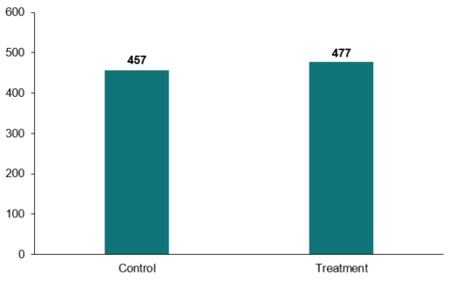

N= 2720, p=0.03 (Holm adjustment carried out)

#### Recommend for management

Our second primary hypothesis was that there would be a higher proportion of people recommending a management position for the fictional victim-survivor in the treatment group compared to the control group.

This hypothesis was also confirmed in the survey experiment. The proportion of respondents recommending the victim-survivor in the vignette for a managerial position was significantly higher in the treatment group (44.3%) compared to the control group (34.8%) (Figure 3). The effect size of the awareness and understanding intervention on this outcome measure was 9.5%.

Figure 3. Percentage of respondents recommending the fictional victim-survivor for a managerial position by treatment and control group

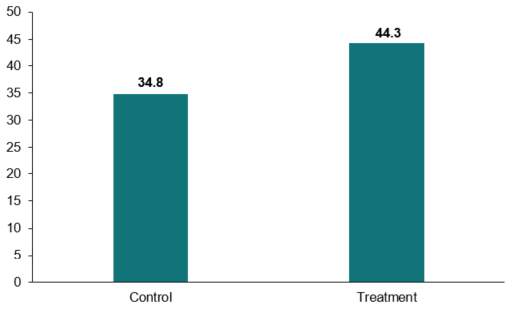

N= 2720, p=0.00 (Holm adjustment carried out)

Based on the findings above, we conclude that raising awareness and understanding of FDV leave legislation and provisions resulted in more favourable workplace evaluations of a victim-survivor of FDV.

#### Competence

The competence scale asked respondents to rate the victim-survivor on 6 characteristics (such as ‘capable’) on a six-point Likert scale (not at all [1] to extremely [6]). Higher scores indicate higher competence.

We hypothesised that the mean competence score would be higher in the treatment group compared to the control group. This hypothesis was confirmed. As shown in Figure 4, the mean competence score was significantly higher in the treatment group (4.13) compared to the control group (4.06), a difference of 0.07 points.

Figure 4. Mean competence rating of the fictional victim-survivor by respondents in the treatment and control groups

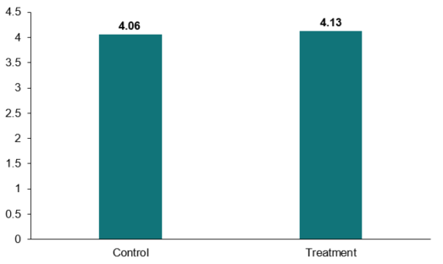

N= 2720, p=0.02

### Attitude outcomes

#### Attitudes towards domestic violence (AVAWS scale)

This scale contains 12 statements on domestic violence and respondents were asked to rate their level of agreement on a four-point scale (‘Strongly disagree’ [1] to ‘Strongly agree’ [4]). For this scale, higher scores represent attitudes that condone, excuse or dismiss domestic violence.

We hypothesised that mean AVAWS score would be lower in the treatment group compared to the control group (that is, there would be an improvement in attitudes towards domestic violence in the treatment group). This hypothesis was not confirmed. The mean score in the treatment group (1.70) was not significantly lower than the mean score in the control group (1.63, p = 1.00).

#### Attitudes towards gender equality (AGIS scale)

The scale contains five statements on gender equality and respondents were asked to rate their level of agreement to these statements on a four-point scale (‘Strongly disagree’ [1] to ‘Strongly agree’ [4]). Higher scores indicate misogynistic attitudes.

We hypothesised that the mean AGIS score would be lower in the treatment group compared to the control group (that is, there would be a better attitude towards gender equality in the treatment group). This hypothesis was not confirmed. The mean AGIS score in the treatment group (1.82) was not significantly lower than the mean AGIS score in the control group (1.79, p = 0.87).

### Exploratory analyses

#### Employment in gender-dominated industries

There were no significant main effects on any of the primary outcome measures based on whether respondents were employed in either male-dominated, female-dominated, or mixed-gendered industries. Neither were there any significant interaction effects with treatment condition. See Appendix 1 for more detail on these analyses.

### Discussion and conclusion

We found that raising awareness of the legislation resulted in more favourable workplace evaluations of a fictional FDV victim-survivor but did not reduce more generalised stigmatising beliefs as measured by the AVAWS or AGIS questions. Given that prior research has revealed that many FDV victim-survivors perceive or experience negative effects of stigma and discrimination in the workplace (e.g. Fitz-Gibbon et al 2023; Smith and Orchiston 2012), our findings suggest that the paid FDV leave may function as a potential mechanism to reduce stigma and discrimination within the workplace.

### Limitations

The experiment artificially increased knowledge of the relevant legislation and its provisions. In a field setting it would be extremely difficult to achieve this level of engagement. However, the aim was to assess whether there could be a reduction in stigmatising attitudes over time, as knowledge of the provisions in the legislation become more widely known. This experiment does not provide direct evidence for the magnitude of such a reduction due to its artificial setting.

## Appendix 1: Statistical tables

### Primary outcomes

The two primary outcomes were the mean amount of bonus recommended for the fictional employee and percentage recommending the fictional employee for a managerial position.

Table 2. Hypothesis 1: Mean bonus amount will be higher in the treatment group as compared with the control group

| **Condition** | **Means (per cent)** | **Estimate (pp)** | **Standard error (pp)** | **95% Confidence Interval (pp)** | **p-value** | **Holm-adjusted p-value** |
| --- | --- | --- | --- | --- | --- | --- |
| Control group | 457.10 | n/a | n/a | n/a | n/a | n/a |
| Treatment group | 477.20 | 20.10 | 10.45 | (2.91 - Inf) | 0.03 | 0.03 |

OLS model adjusted for gender, education, CALD status and awareness of FDVL legislation with HC2 robust standard errors. N = 2720.

Table 3. Hypothesis 2: There will be a higher proportion of people recommending assessment for management for the fictional employee in the treatment group as compared with the control group

| **Condition** | **Means (per cent)** | **Estimate (pp)** | **Standard error (pp)** | **95% Confidence Interval (pp)** | **p-value** | **Holm-adjusted p-value** |
| --- | --- | --- | --- | --- | --- | --- |
| Control group | 34.80 | n/a | n/a | n/a | n/a | n/a |
| Treatment group | 44.30 | 9.49 | 1.86 | (6.44 - Inf) | 0.00 | 0.00 |

OLS model adjusted for gender, education, CALD status and awareness of FDVL legislation with HC2 robust standard errors. N = 2720.

### Secondary outcomes

Table 4. Mean competence scores will be higher in the treatment group as compared with the control group

| **Condition** | **Means (per cent)** | **Estimate (pp)** | **Standard error (pp)** | **95% Confidence Interval (pp)** | **p-value** |
| --- | --- | --- | --- | --- | --- |
| Control group | 4.06 | n/a | n/a | n/a | n/a |
| Treatment group | 4.13 | 0.07 | 0.03 | (0.02 - Inf) | 0.02 |

OLS model adjusted for gender, education, CALD status and awareness of FDVL legislation with HC2 robust standard errors. N = 2720

Table 5. Mean AVAWS (attitude towards domestic violence) scores will be lower in the treatment group as compared with the control group

| **Condition** | **Means (per cent)** | **Estimate (pp)** | **Standard error (pp)** | **95% Confidence Interval (pp)** | **p-value** |
| --- | --- | --- | --- | --- | --- |
| Control group | 1.63 | n/a | n/a | n/a | n/a |
| Treatment group | 1.71 | 0.08 | 0.02 | (-Inf - 0.11) | 1.00 |

OLS model adjusted for gender, education, CALD status and awareness of FDVL legislation with HC2 robust standard errors. N = 2702

Table 6. Mean AGIS (attitude towards gender equality) scores will be lower in the treatment group as compared with the control group

| **Condition** | **Means (per cent)** | **Estimate (pp)** | **Standard error (pp)** | **95% Confidence Interval (pp)** | **p-value** |
| --- | --- | --- | --- | --- | --- |
| Control group | 1.79 | n/a | n/a | n/a | n/a |
| Treatment group | 1.82 | 0.03 | 0.02 | (-Inf - 0.06) | 0.87 |

OLS model adjusted for gender, education, CALD status and awareness of FDVL legislation with HC2 robust standard errors. N = 2702

### Subgroup analyses

We examined whether there were differences in bonus amount and recommendation for a managerial position by whether the industry type was female dominated, male dominated or mixed gender. Respondents’ industry type was classified in accordance with classifications set out by the Workplace Gender Equality Agency (2019).

There were no interaction effects observed but the experiment was not powered to detect an interaction effect.

Table 7. Bonus outcome by industry type

| **Condition** | **Means (per cent)** | **Estimate (pp)** | **Standard error (pp)** | **95% Confidence Interval (pp)** | **p-value** |
| --- | --- | --- | --- | --- | --- |
| Female-dominated industry | 476.36 | n/a | n/a | n/a | n/a |
| Male-dominated industry | 469.05 | 5.19 | 22.35 | (-38.64-49.02) | 0.82 |
| Mixed industry | 462.08 | 3.28 | 17.50 | (-31.03-37.60) | 0.85 |

OLS model adjusted for gender, education, CALD status and awareness of FDVL legislation with HC2 robust standard errors. N = 2705

Table 8. Manager outcome by industry type

| **Condition** | **Means (per cent)** | **Estimate (pp)** | **Standard error (pp)** | **95% Confidence Interval (pp)** | **p-value** |
| --- | --- | --- | --- | --- | --- |
| Female-dominated industry | 42.2 | n/a | n/a | n/a | n/a |
| Male-dominated industry | 41.4 | -0.02 | 0.04 | (-0.10-0.06) | 0.61 |
| Mixed industry | 37.9 | -0.03 | 0.03 | (-0.09-0.03) | 0.30 |

OLS model adjusted for gender, education, CALD status and awareness of FDVL legislation with HC2 robust standard errors. N = 2705

To determine if the intervention worked differently for different industry types, we examined the interaction of the interventions with industry of participants (that is, if the effect of increased knowledge was the same for different industries). These results are reported below.

Table 9. Subgroup responses to the treatment for bonus outcome

| **Subgroup analysis by Condition** | **Interaction effect between condition and industry type (95% CI)** | **p-value** |
| --- | --- | --- |
| Female-dominated industry compared to Male-dominated industry:  Treatment group | -25.59 (-93.43-42.25) | 0.46 |
| Female-dominated industry compared to Mixed industry:  Treatment group | -35.97 (-87.26-15.31) | 0.17 |

OLS model adjusted for condition, industry type, interaction between condition and industry type, gender, education, CALD status, awareness of FDVL legislation with HC2 robust standard errors. N = 2705

Table 10. Subgroup responses to the treatment for manager outcome

| **Subgroup analysis by Condition** | **Interaction effect between condition and industry type (95% CI)** | **p-value** |
| --- | --- | --- |
| Female-dominated industry compared to Male-dominated industry:  Treatment group | 0.03 (-0.09-0.14) | 0.66 |
| Female-dominated industry compared to Mixed industry:  Treatment group | -0.02 (-0.11-0.07) | 0.64 |

OLS model adjusted for condition, industry type, interaction between condition and industry type, gender, education, CALD status, awareness of FDVL legislation with HC2 robust standard errors. N = 2705

## Appendix 2: Survey materials

### Vignette and related survey questions (Section A)

#### Vignette

Q63: Below is a scenario. Please read this carefully. After 30 seconds, questions about the scenario will appear at the bottom of the page.

Imagine that you are a manager at a recruitment company called QStat. You manage a team of 20 recruiters. They help businesses find candidates to hire. To encourage maximum performance, every quarter QStat managers – like you – provide all recruiters with a bonus, ranging from $0 to $1,000, with an average bonus of $250. The size of each recruiter’s bonus depends on their manager’s judgement of their work performance, behaviour, and commitment to their work over each quarter. In addition, you have been asked to identify whether or not each recruiter should be assessed for potential promotion to manager within the next year.

Recruiters have an ambitious target of placing 2 candidates per day, and 110 per quarter. The average performance of recruiters for the last quarter was 1.4 candidates placed per day (the highest = 1.6, lowest = 0.9), with an average total of 77 candidates placed per quarter (highest = 100, lowest = 61). This average per quarter accounts for recruiters taking an average of 5 days leave.

You are reviewing a recruiter named Emily. In the last quarter, Emily placed a daily average of 1.5 candidates, with a total of 68 candidates placed (she had 5 days sick leave and also 10 days of leave to relocate and to attend support services due to experiencing domestic violence).

Emily prefers not to work with male candidates, as her long-term on and off again boyfriend gets jealous. Emily gets most of her work done independently and on time. She communicates well with you, and is well liked by her clients and candidates who describe her as ‘efficient’, ‘to the point’ and ‘diligent’. Emily has been frequently up to 45mins late to work and arrives stressed and flustered, informing you that her boyfriend who insists on driving her to and from work was in “another one of his moods again”. She often works through her lunch break, which she says is because she wants to make up for being late. She makes meaningful contributions in meetings, though occasionally appears distracted. She is courteous to her co-workers but does not engage in any social activities.

#### Vignette-related survey questions

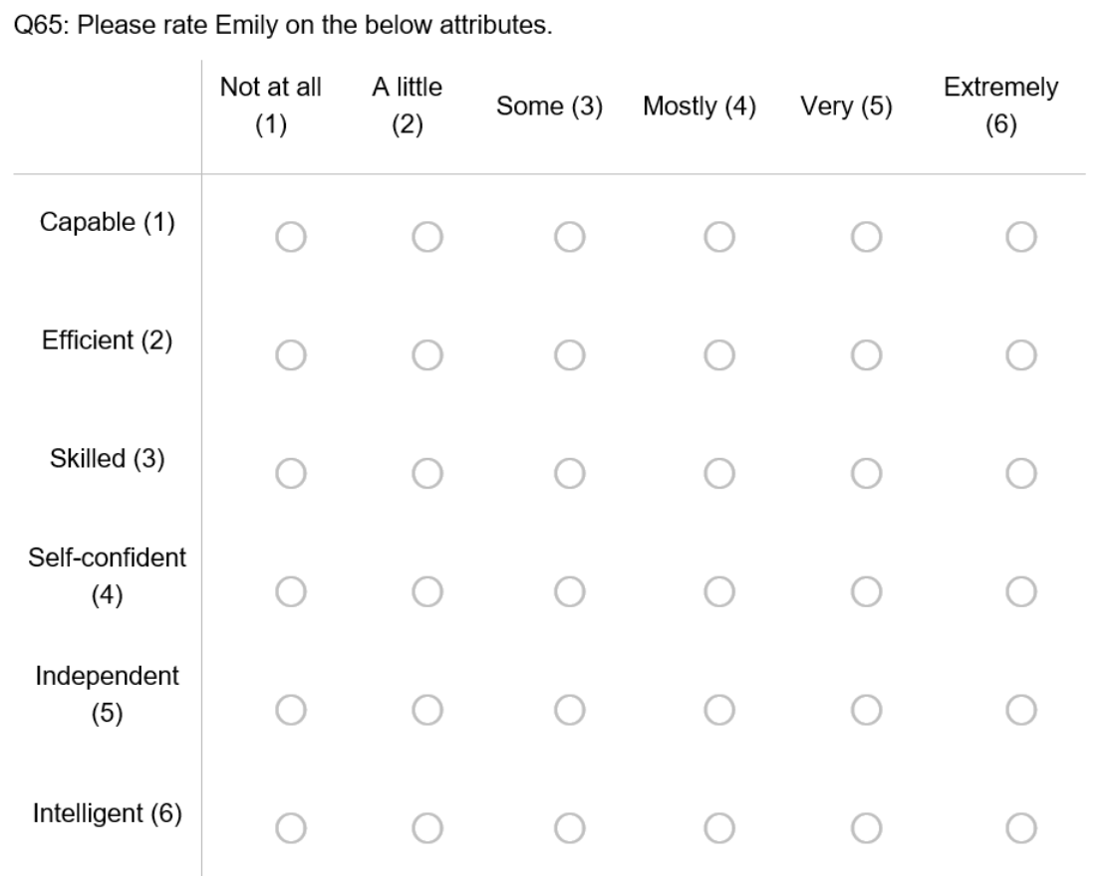

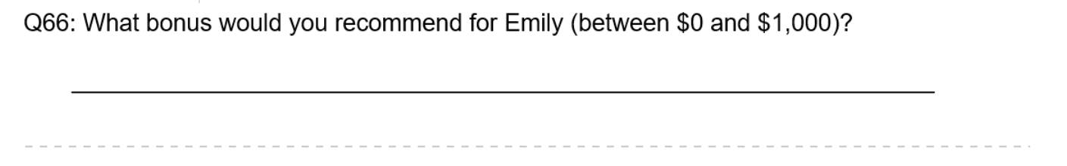

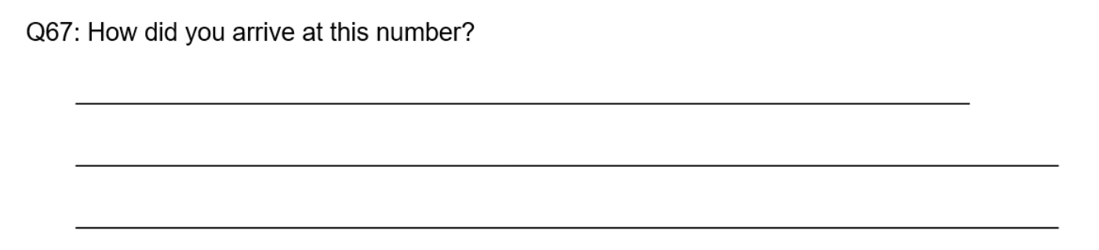

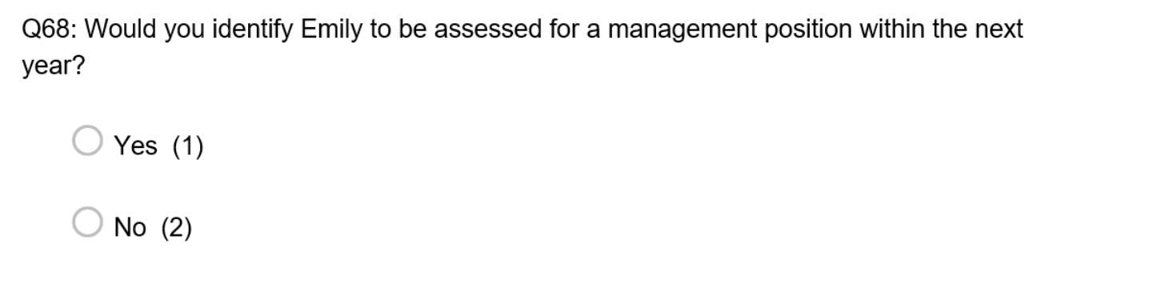

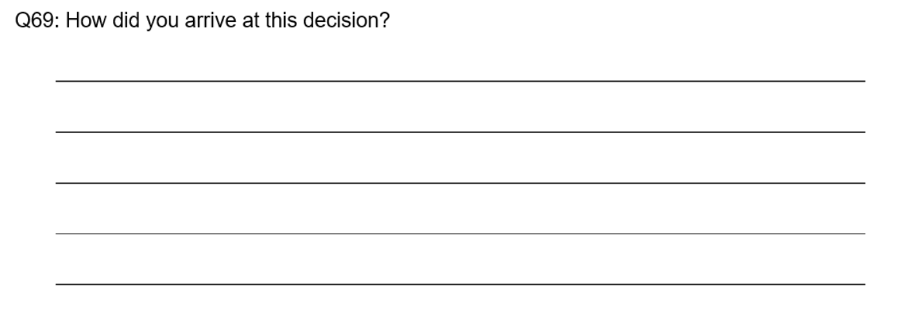

### Attitudinal questions (Section B)

#### Attitudes towards gender equality (AGIS scale)

#### This question shows five statements and asks participants to indicate their level of agreement with each individual statement. The first statement is 'If a woman earns more than her male partner, it is not good for the relationship (13)'. The second statement is 'On the whole, men make better political leaders than women (14)'. The third statement is 'In the workplace, victims of family or domestic violence make less capable bosses (15)'. The fourth statement is 'People experiencing family or domestic violence should not hold positions of responsibility in the community (16)'. The fifth and final statement is 'Women experiencing family or domestic violence are less capable of thinking logically (17)'. Participants are asked to rank each of these statements individually with a 'strongly agree (1)', 'disagree (2)', 'agree (3)' or a 'Strongly agree (4)'.

#### This image has twelve statements that participants were asked if they strongly disagree (1), disagree (2), agree (3) or strongly agree (4) with. The first statement is 'It is acceptable to give lower priority to family or domestic violence issues if they have arisen many times before (1). The second statement is 'A victim who does not leave an abusive partner is partly responsible for the abuse continuing (2)'. The third statement is 'Family and domestic violence is a private matter that should NOT be handled in the workplace (3)'. The fourth statement is 'A lot of what is called family or domestic violence is really just a normal reaction to day-to-day stress and frustration (4)'. The fifth statement is 'Women OFTEN make up or exaggerate claims of family or domestic violence to gain something (5)'. The sixth statement is 'Sometimes a woman can make a man so angry that he hits her when he didn't mean to (6)'. The seventh statement is 'Victims should keep quiet about their experience of family or domestic violence to protect their reputation (7)'. The eighth statement is 'If someone keeps going back to their abusive partner then the violence can't be very serious (8)'. The ninth statement is 'Women who flirt all the time are somewhat to blame if their partner gets jealous and hits them (9)'. The tenth statement is 'Those who STAY in abusive relationships deserve less help from counselling and support services than those who leave their abusive partner (10)'. The eleventh statement is 'Family and domestic violence can be excused if it results from people getting so angry they temporarily lose control (11)'. The twelfth and final statement is 'It's easy for a woman to leave an abusive relationship (12)'. Attitude towards domestic violence scale (AVAWS)

## References

Albiston C and Correll S (2023) ‘Law’s Normative Influence on Gender Schemas: An Experimental Study on Counteracting Workplace Bias against Mothers and Caregivers’, *Law & Social Inquiry*, 1-39, doi:10.1017/lsi.2022.102

Bilz K and Nadler J (2014) ‘Law, moral attitudes, and behavioral change’, in *The Oxford handbook of behavioral economics and the law*, 241-267, Oxford University Press, Oxford.

Colombotos J (1969) ‘Physicians and Medicare: A before-after study of the effects of legislation on attitudes’, *American Sociological Review*, 34(3):318-334.

Fitz-Gibbon K, Pfitzner N and McNicol E (2023) ‘Domestic and family violence leave across Australian workplaces: Examining victim-survivor experiences of workplace supports and the importance of cultural change’, *Journal of Criminology*, *56*(2-3): 294-312.

Kuran T (1998) *Private truths, public lies: The social consequences of preference falsification*, Harvard University Press.

Keel C, Wickes R, Cherkesly I, Segrave M and Tan SJ (2023) ‘[Technical report for migrant and refugee women in Australia: A study of sexual harassment in the workplace’](https://www.anrows.org.au/publication/migrant-and-refugee-women-in-australia-a-study-of-sexual-harassment-in-the-workplace/), *ANROWS Insights 03/2023*, ANROWS.

Rubin M (2021) ‘When to adjust alpha during multiple testing: A consideration of disjunction, conjunction, and individual testing’, *Synthese*, doi: 10.1007/s11229-021-03276-4

Smith BM and Orchiston T (2012) ‘Domestic violence victims at work: A role for anti-discrimination law? *Australian Journal of Labour Law, 25(3): 209-236.* Sydney Law School Research Paper No. 12/46, Available at SSRN: https://ssrn.com/abstract=2105150

Werner CM, Turner J, Shipman K, Twitchell FS, Dickson BR, Bruschke G.V and von Bismarck WB (1995) ‘Commitment, behavior, and attitude change: An analysis of voluntary recycling’, *Journal of Environmental Psychology*, 15(3):197–208, doi: 10.1016/0272-4944(95)90003-9

Workplace Gender Equality Agency (2019) [*Gender segregation in Australia’s workforce*](https://www.wgea.gov.au/publications/gender-segregation-in-australias-workforce), WGEA, accessed on 2 May 2024.

**© Commonwealth of Australia 2024**

ISBN 978-1-925365-57-3: Family and Domestic Violence Leave Survey Experiment – Technical Report

**Copyright Notice**

With the exception of the Commonwealth Coat of Arms, this work is licensed under a Creative Commons Attribution 4.0 International license (CC BY 4.0) (<https://creativecommons.org/licenses/by/4.0/>)



**Third party copyright**

Wherever a third party holds copyright in this material, the copyright remains with that party. Their permission may be required to use the material. Please contact them directly.

**Attribution**

This publication should be attributed as follows:

© Commonwealth of Australia, Department of the Prime Minister and Cabinet, *Family and Domestic Violence Leave Survey Experiment: Technical Report*.

**Use of the Coat of Arms**

The terms under which the Coat of Arms can be used are detailed on the following website: <https://pmc.gov.au/cca>

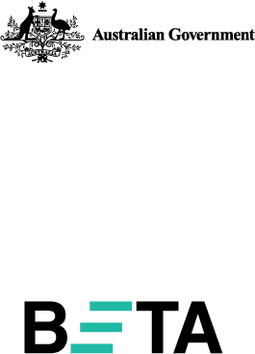

Behavioural Economics Team   
of the Australian Government

General enquiries [beta@pmc.gov.au](mailto:beta@pmc.gov.au)

Media enquiries [media@pmc.gov.au](mailto:media@pmc.gov.au)

Find out more [www.pmc.gov.au/beta](http://www.pmc.gov.au/beta)