# Family and domestic

# violence leave

**Research findings for the Independent Review of the Fair Work Amendment (Paid Family and Domestic Violence Leave) Act 2022**

**August 2024**

Other uses

Enquiries regarding this license and any other use of this document are welcome at:

Managing Director

Behavioural Economics Team of the Australian Government

Department of the Prime Minister and Cabinet

1 National Circuit

Barton ACT 2600

Email: [beta@pmc.gov.au](mailto:beta@pmc.gov.au)

The views expressed in this paper are those of the authors and do not necessarily reflect those of the Department of the Prime Minister and Cabinet or the Australian Government.

Research team

Current and former staff who contributed to the report were: Luke Rogers, Dr Annalese Bolton, Dr Angela Bender, Dr Aurore Chow, Rachelle Damm, Dr Su Mon Kyaw-Myint, Kimiko Rathbone and Amelia Johnston.

Acknowledgments

Thank you to the Safety Net Branch in the Department of Employment and Workplace Relations for their support and valuable contribution in making this project happen. In particular, special thanks to Cassie Di Maria, Chanan Crompton, Katelyn Tsipiras and Michael Radzevicius for their work on this project.

Support

This report includes information that may be distressing for some readers. It outlines some of the tragic impacts of family and domestic violence. The Government respectfully acknowledges and regrets the loss of those who have died, and the harm caused to those who are affected by violence.

Help is available. If you, or someone you know, is experiencing family or domestic violence, you can contact 1800RESPECT (1800 737 732) or visit [1800respect.org.au](https://1800respect.org.au/) for support. Lifeline provides 24-hour support in Australia for those experiencing a personal crisis and can be contacted by calling 13 11 14 or visiting [lifeline.org.au](https://www.lifeline.org.au/).

Who?

### Who are we?

We are the Behavioural Economics Team of the Australian Government, or BETA. We are the Australian Government’s first central unit applying behavioural economics to improve public policy, programs and processes.

We use behavioural economics, science and psychology to improve policy outcomes. Our mission is to advance the wellbeing of Australians through the application and rigorous evaluation of behavioural insights to public policy and administration.

### What is behavioural economics?

Economics has traditionally assumed people always make decisions in their best interests. Behavioural economics challenges this view by providing a more realistic model of human behaviour. It recognises we are systematically biased (for example, we tend to satisfy our present self rather than planning for the future) and can make decisions that conflict with our own interests.

### What are behavioural insights and how are they useful for policy design?

Behavioural insights apply behavioural economics concepts to the real world by drawing on empirically-tested results. These new tools can inform the design of government interventions to improve the welfare of citizens.

Rather than expect citizens to be optimal decision makers, drawing on behavioural insights ensures policy makers will design policies that go with the grain of human behaviour. For example, citizens may struggle to make choices in their own best interests, such as saving more money. Policy makers can apply behavioural insights that preserve freedom, but encourage a different choice – by helping citizens to set a plan to save regularly.

Contents

Executive summary 4

Policy context 6

What we did 8

Attitudes and awareness 11

Uptake 16

Barriers and challenges 20

Impacts 31

Understanding and views of leave parameters 44

Other supports 50

Discussion: Maximising impact 53

Appendix: Methodology and samples 58

References 75

## Executive summary

Between December 2023 and April 2024, the Behavioural Economics Team of the Australian Government (BETA) conducted research in partnership with the Department of Employment and Workplace Relations (DEWR) to inform the independent statutory review of the operation of the *Fair Work Amendment (Paid Family and Domestic Violence Leave) Act 2022*.

Our goal was to understand the impact of a new entitlement to 10 days of paid family and domestic violence (FDV) leave for all national system employees. To answer this question, we conducted 5 primary research activities: a survey of 594 victim-survivors, interviews with 22 victim-survivors, a survey of 1,437 employers, interviews with 15 employers and a survey (including a randomised experiment) of 3,008 Australian workers.

BETA found the leave entitlement was performing as intended, delivering significant benefits to those accessing it. In addition, the leave entitlement was remarkably well-supported by victim-survivors and employers alike. BETA also found that uptake of the FDV leave was low, noting that it has only been in place for a short time and the full effects may not yet be clear.

Our research revealed the following key findings:

1. **Overall, employers and employees agree the new paid FDV leave entitlement is a positive step for Australia.** More than three quarters (77%) of employers surveyed were supportive of the new legislation. Around 4 in 5 victim-survivors surveyed (79% of males and 90% of females) agreed that requiring employers to offer paid leave for family and domestic violence was a positive step toward supporting those who experience abuse.
2. **The paid leave is being used for its intended purposes.** The 46 paid FDV leave users in our survey primarily used the leave to make arrangements for their safety (41%) or their children’s safety (43%). Some also used FDV leave to access services like police (39%), medical (22%) and legal (24%).
3. **For those accessing the leave, it appears to be meeting its objectives of promoting employment security and preserving income for victim-survivors.** Ninety one percent (91%) of the 46 surveyed leave users reported paid FDV leave helped them maintain their income and 89% said it helped them maintain employment.
4. **The new paid leave entitlement has the potential to reduce stigma surrounding the workplace impacts of FDV**. In our survey experiment with Australian workers, respondents were randomly selected to receive information about the paid FDV leave legislation either before or after completing an evaluation of a fictional employee who had taken leave due to FDV. Those who had read the information beforehand rated the employee as more suitable for management and assigned a higher bonus than those who did not receive the information. This suggests raising awareness and making the new legislation salient for employees could assist in reducing workplace stigma and discrimination experienced by victim-survivors.
5. **Lack of awareness of the entitlement and when and how it applies appears to be constraining rates of uptake.** Forty two percent (42%) of businesses and 59% of victim-survivors in our surveys were not aware of the paid FDV leave entitlement. Low levels of awareness were identified by employers as the biggest challenge in providing the leave and by victim-survivors as the key barrier in requesting the leave. Although our research can't provide definitive estimates of national leave uptake, we found low awareness is likely driving low uptake, with only 13% of eligible victim-survivors in our survey using the leave since the legislation came into effect.
6. **Casual staff have lower awareness and uptake of the leave**. Victim-survivors who were casual employees were half as likely to be aware of their entitlement (20%; 13 out of 64 casuals) compared to part-time (38%; 39 out of 102 part-time employees) or full-time employees (42%; 181 out of 427 full-time employees). In our survey, 19 casual respondents experienced FDV in 2023 or 2024 but only one accessed paid FDV leave. Many casual victim-survivors reported instead cancelling shifts due to FDV (34 out of 50 female and 2 out of 13 male casual employees).
7. **The conversation between victim-survivors and employers is a critical step, with privacy and trust remaining key concerns.** Victim-survivors report that the process of telling a manager about their experience of FDV is a key barrier in accessing the leave. Trust was a concern, with around one in three (37% of female, 27% of male) victim-survivors disagreeing with the statement "I was confident my manager could be trusted". Employers also struggled, with 37% of employers who had provided leave saying they felt ill-equipped to have conversations about FDV.
8. **The provision of evidence is a key sticking point, with leave users struggling to gather evidence and employers concerned about potential misuse.** Eight in ten leave users (38 out of 46 leave users) provided evidence to their employer. Of the leave users who provided evidence, just over half (20 out of 38) faced challenges in gathering the evidence. Employers were concerned about misuse, with 17% of the 169 who had received leave requests claiming to have encountered misuse. In our survey, 14% of all employers reported denying FDV leave requests, most commonly due to concerns about misuse.
9. **Small and micro businesses feel the impacts of the leave more than large businesses**. Among the businesses who had granted leave, 28% of the 18 micro businesses (1-4 employees), 30% of the 30 small businesses (5-14 employees) and 14% of the 121 medium and large businesses (more than 15 employees) identified financial costs as a challenge in providing FDV leave. Some small businesses expressed an expectation that the leave should be reimbursed by government.
10. **Employers who had granted FDV leave to staff were looking for more guidance.** Forty percent of the 169 employers who had provided leave reported difficulties in sourcing clear guidance and 24% didn’t understand their obligations. A third (34%) of employers who had provided leave had sought information on the Fair Work Ombudsman website and a quarter (23%) had visited the government-funded 10dayspaidfdvleave.com.au website.

Drawing on behavioural science, BETA identified several opportunities to strengthen the impact of the FDV leave entitlement and increase uptake:

• raise broad awareness of the existence of the leave entitlement (and FDV itself)

• empower casual employees to access the leave

• make it easier for victim-survivors to approach their employer

• reduce the barriers associated with victim-survivors providing evidence

• promote existing employer resources and encourage preparation

• support employers to create safe, trauma-informed, stigma-free workplaces

• consider the needs of victim-survivors who are not eligible for the leave.

## Policy context

### Family and domestic violence is a major issue in Australia

Family and domestic violence (FDV) occurs across all ages and backgrounds, but mainly affects women and children. On average, one woman is killed every nine days in Australia by a current or former partner (Bricknell 2023), and one in four Australian women have experienced FDV (AIHW 2024a). FDV has wide-ranging personal and economic effects on individuals, businesses and society (e.g. ABS 2021-22; ABS 2022; Stanford 2016).

### New paid FDV leave entitlement introduced in 2022

Family and Domestic Violence Leave (FDV leave) entitlements were first implemented in the National Employment Standards on 12 December 2018, allowing employees to take 5 days unpaid FDV leave. However, the *Fair Work Amendment (Paid Family and Domestic Violence Leave) Act 2022* replaced this provision. Under the new provisions, national system employees – including casual workers – can now access 10 days paid FDV leave per year. The definition of FDV was also extended to include the conduct of former intimate partners or other household members.

Paid FDV leave became available to employees of large and medium businesses from 1 February 2023 and to employees of small businesses from 1 August 2023. The entitlement will also extend to non-national system employees and state referral employees in September 2024, 3 months after the International Labor Organization Violence and Harassment Convention 190 comes into effect. These amendments brought the National Employment Standards into alignment with the practice of many Australian employers, who were already providing paid FDV leave through enterprise agreements or workplace policies (Fitz-Gibbon et al. 2023).

### The aim of the paid FDV leave entitlement

The Australian Government introduced the paid FDV leave entitlement as it recognised that FDV was not just a criminal justice or social issue, but also an economic and a workplace issue (Explanatory Memorandum, Fair Work Amendment (Paid Family and Domestic Violence Leave) Bill 2022). Financial issues, such as the likelihood of leaving property or assets behind, are major factors in women’s decisions about leaving or staying in abusive relationships (Cortis and Bullen 2016). But many FDV victim-survivors suffer disrupted or reduced incomes. Approximately one in ten Australian women have taken time off work due to violence from a current partner (ABS 2016). Women with a history of domestic violence have a more disrupted work history, are on lower personal incomes and are more likely to be in casual or part‑time work than women with no experience of violence (Ganley et al. 1998).

Being in employment is a key pathway for women to leave a violent relationship (Patton 2003). Financial security from employment can allow people to escape becoming trapped and isolated in violent and abusive relationships and to maintain, as far as possible, their home and standard of living.

In introducing the paid FDV leave legislation, the Government acknowledged that those affected by FDV are often unable to take steps to leave violent situations without risking unemployment, financial hardship or homelessness (Explanatory Memorandum, Fair Work Amendment (Paid Family and Domestic Violence Leave) Bill 2022). Financial insecurity was identified as a key obstacle to leaving violent relationships, particularly if there are children to provide for.

The Government introduced the paid FDV leave entitlement with the aim of helping employees experiencing FDV to remain in work, maintain their income and access relevant services (Explanatory Memorandum, Fair Work Amendment (Paid Family and Domestic Violence Leave) Bill 2022).

### A statutory review of the paid FDV leave entitlement

The *Fair Work Amendment (Paid Family and Domestic Violence Leave) Act 2022* contains provisions for an independent statutory review of the changes to the FDV leave entitlement to commence as soon as practicable from 1 February 2024. The legislation stipulates the review must consider the operation of the new leave entitlement, including the impact of the amendments on people experiencing family and domestic violence, small business and sole traders, and consider both quantitative and qualitative data.

### BETA conducted research to inform the review

The Safety Net Branch in the Department of Employment and Workplace Relations asked BETA to conduct qualitative and quantitative research to understand the impacts of the new paid FDV leave provisions on employees and employers. Our research findings will be considered by an independent reviewer, Flinders University, to support their assessment of the operation of the amendments.

Our research delivers an evidence base to inform key questions relevant to the review, including:

* **Attitudes and awareness.** Are employees and employers generally supportive of the new entitlement? Do they think it is effective overall? Are employees and employers aware of the new leave provisions? Do they understand their rights and obligations?
* **Uptake.** What level of uptake are victim-survivors and employers reporting? Are some types of employees more or less likely to be taking up FDV leave?
* **Barriers and challenges.** What are the barriers facing victim-survivors in accessing the leave and the challenges facing employers in granting the leave? How do stigma, social attitudes and workplace cultures affect the ability of employees to access FDV leave?
* **Impacts.** What effect is paid FDV leave having on people who experience FDV? What effect is it having on small, medium and large businesses?
* **Understanding and views of leave parameters.** Do victim-survivors and employers understand and support key parameters like eligibility, length of the leave and the potential requirement to supply evidence?
* **Other supports.** What else can employers do to support people experiencing FDV? What other supports do employers need to provide paid FDV leave?

We have structured the findings in this report around these six sets of research questions and conclude with a discussion chapter that outlines opportunities for maximising impact of the legislation and offers a behavioural perspective on solutions, drawing on BETA’s expertise.

## What we did

### Research approach

To explore the impact of the newly introduced paid FDV leave entitlement, we identified the aims of the paid FDV leave entitlement, conducted reviews of academic and other literature, consulted with relevant government stakeholders and undertook our own primary research activities. For our primary research activities, we focused on the impact of the entitlement on three groups, outlined below.

#### Understanding victim-survivors’ experience of the leave

In line with the National Plan to End Violence against Women and Children, our research heavily centred on understanding the experiences of people within the Australian workforce with recent lived experience of FDV (within the last 5 years). We applied a trauma-informed (see Alessi and Kahn 2023) and positive empowerment (Downes et al. 2014) approach, where we considered how best to safeguard victim-survivors as well as how to maximise their capacity for self-determination and autonomy within all research processes.

Our methodology was informed by research approaches recently used and found acceptable by victim-survivors (e.g. Fitz-Gibbon et al. 2023; Legerski and Bunnell 2010; Jaffe et al. 2015; Dragiewicz et al. 2023) and in consultation with eight FDV support services across Australia and the Victim Survivors’ Advisory Panel, who also supported our recruitment of research participants. Our research methodology was consistent with the lived experience engagement guidelines developed by FDV victim-survivors for use by government workers (Victorian Government 2022).

To explore victim-survivors’ experience of the leave, we conducted two research activities:

* interviews with 22 victim-survivors
* a survey with 594 victim-survivors.

#### Understanding the impact on employers

Our research sought to uncover the impact of the paid FDV leave entitlement on businesses. We sought the perspectives of business owners and managers who are responsible for handling employee leave requests from micro (1-4 employees), small (5-14 employees) and large (15+ employees) businesses. In recruiting businesses to participate in the research, we targeted micro and small businesses to ensure the views of this priority audience were adequately represented.

To explore the impact of the leave entitlement on employers, we conducted 2 research activities:

* interviews with 15 employers
* a survey of 1,437 employers.

#### Understanding attitudes of members of the Australian workforce

We wanted to understand the members of the Australian workforce’s comprehension of, and willingness to use or support others to access the leave. Victim-survivors are more likely to first tell their co-workers about abuse than their supervisors or HR personnel (McFerran 2011). Recipients of disclosures do not always know how to respond and can unintentionally blame the victim-survivor, minimise the abuse, or excuse the actions of the perpetrator (Trotter and Allen 2009). When victim-survivors experience negative responses to disclosures, they are less likely to seek further help and much more likely to remain in abusive relationships (Poicastro and Payne 2013). On the other hand, supportive responses are a strong predictor of victim-survivors leaving abusive relationships (Chang et al. 2010). Therefore, understanding members of the Australian workforce’s attitudes toward paid FDV leave is an important factor for understanding drivers and barriers of victim-survivors’ uptake of the leave.

We also wanted to explore if the paid FDV leave legislation has the potential to reduce stigma and discrimination against victim-survivors among members of the Australian workforce. Evidence in other contexts suggests that the mere act of introducing legislation can sometimes alter attitudes (e.g. Colombotos 1969; Werner et al. 1995; Bilz and Nadler 2014). Legislation is believed to be able to alter community attitudes because citizens view the legal system as a legitimate and reliable source of morality that reflects commonly held views (that is, social norms).

There is specific evidence that legislation can reduce stigma surrounding staff who take leave for protected reasons. A recent experimental study by Albiston and Correll (2023) found that anti‑discrimination legislation for carers who take leave to care for a sick child significantly reduced stigmatising and discriminatory evaluations of fictional employees who accessed the leave. Moreover, legislative provisions were far more powerful at reducing stigma and discrimination than organisational policy alone. In the survey experiment outlined below, we examined whether the paid FDV leave entitlement has a similar potential for FDV victim-survivors.

To understand the attitudes of members of the Australian workforce and the potential impact of the legislation on stigma in the workplace, we conducted one research activity:

* a survey (including a randomised experiment) of 3,008 members of the Australian workforce.

See Appendix A for further methodology and sample information on our research activities.

### Considerations and limitations

The limitations of the research are laid out in the Appendix. In summary, they are:

* We could not generate a population-wide estimate of uptake given the short time the legislation has been in effect and the consequent limitations of our sample.
* We could not measure all potential impacts of the leave entitlement, including whether it reduced further violence by helping victim-survivors engage with services, or if the leave had second-order workplace impacts such as reduced absenteeism or turnover.
* We did not consider the impact of the legislation on sole traders because they are not eligible under the Fair Work Act to grant or use the leave. Sole traders are taken to mean those who operate a business without any employees. These sole traders were not surveyed or interviewed because we did not include anyone who was not eligible under the Fair Work Act to grant or use the leave. The paid FDV leave provisions in the Fair Work Act only apply to eligible employees with an employer.
* Consistent with common survey practice, we used online survey panels to procure most of our research participants. While these panels are large and diverse, they only include individuals who are digitally literate, read and write fluent English and are willing to participate in online research.
* We had unexpectedly high rates of male respondents in our victim-survivor survey (54%). While both men and women can be victim-survivors and perpetrators of FDV, the majority of FDV is perpetrated by men against women (ABS 2021-22; ABS 2022). We recruited research participants for our victim-survivor research activities based on their self-identification as a person who had experienced family or domestic violence since 2018 while also being in the paid workforce. To gather perspectives from as many victim-survivors as possible, we did not impose any other requirements or quotas.
  + A key reason our sample contained so many males was our requirement for participants to be in paid employment when they experienced FDV, which filtered out many more females than males. Specifically, we found that, while 68% of the males who experienced FDV were employed at the time, only 55% of the females were employed. Applying this filter changed our sample from female-dominated to male-dominated.
  + We nonetheless expect that male victim-survivors may be overrepresented in our sample of employed victim-survivors. To ensure the crucial perspective of female victim-survivors is clearly represented, we have disaggregated all victim-survivor data according to gender in this report.
  + We note that, given the short period of time the entitlement has been in effect and low uptake in our sample, it is too early to draw conclusions about the gender and other demographic characteristics of FDV leave users. Once the entitlement has been in effect for a longer period, further research would help policymakers understand who is accessing the leave.
* We did not specifically target vulnerable populations such as First Nations, culturally and linguistically diverse communities or people with a disability. To understand and evaluate the impact of FDV leave on these audiences, more in-depth and customised research is required.

### A note on the terminology used in this report

This report has used a variety of terms and abbreviations to refer to different populations and research activities. Below is a list of terms used and their definitions:

* + FDV = family and domestic violence. Family and domestic violence is violent, threatening or other abusive behaviour by certain individuals known to an employee that seeks to coerce or control the employee or causes them harm or fear.
  + Members of the Australian workforce = the part of the Australian population that is currently working
  + Employers = represented by business owners and managers
  + Employees = those employed by a business (including part-time, full-time and casual staff)
  + Victim-survivor = a person who identifies as having experienced family and domestic violence. Please note, we use this shortened term to refer to people who have experienced family and domestic violence. To be included in our research activities, they were also required to be working within the last five years.

The following six chapters outline findings from our research activities.

## Attitudes and awareness

### Attitudes towards paid FDV leave are positive

Overall, victim-survivors, employers and members of the Australian workforce agree that the new paid FDV leave entitlement is a positive step for Australia (Figure 1). The vast majority of victim-survivors surveyed (79% of males and 90% of females) agreed that requiring employers to offer paid FDV leave was a positive step towards supporting those who experience abuse. More than three quarters (77%) of employers surveyed were supportive of the new legislation (despite bearing the cost of the leave entitlement) and 87% of the Australian workforce members agreed that the entitlement is effective at supporting people who have experienced abuse. Moreover, 91% of the members of the Australian workforce indicated that they would recommend others use the leave if they needed it.

In interviews, victim-survivors felt the paid leave was a positive initiative because it supports victim-survivors, raises awareness of FDV in Australia and reduces stigma for victim-survivors.

“I think [the leave] is a positive step, definitely. Because DV is not going away. So anything, *anything* that can be available to help victims make it even a little bit easier, you know?”

- Victim-survivor interview #1, female, did not use the leave, part-time

“So many people who are victims of FDV, they have lost their job because of the situation they are going through, so this [FDV] leave has given us the job security and also given us confidence that despite whatever we are going through as victims, that the government is offering us support.”

- Victim-survivor interview #17, female, used the leave, part-time

Likewise, employers highlighted as potential benefits the promotion of a positive workplace culture that values empathy, inclusivity and respect for employees’ personal well-being, improved staff retention, enhanced employee engagement and work commitment.

“They are employed by us. They spend a lot of time in the workforce and... work is part of their lives. They need to feel that they can be supported at work. I think that by providing the support as an employer, that's one less thing that they've got to worry about, so they can focus more on getting the support that they need to deal with this issue.”

- Employer interview #11, business owner, 14 employees, has provided paid FDV leave before 2023

“I think that we need to care for our people and support them however we can. I think this is a really great support tool for businesses to support their people.”

-Employer interview #5, HR employee, 6000 employees, has provided paid FDV leave before 2023

The high level of support for the paid leave entitlement that we found in our surveys is consistent with research conducted before the legislation came into effect. Prior to commencement of the legislation, victim-survivors were highly supportive of the intended legislation (Fitz-Gibbon et al. 2023) and 88% of business leaders supported the introduction of paid FDV leave in a survey of n=398 (My Business 2022).

Figure 1. Support for the paid FDV leave entitlement (%)

The first heading is Victim-Survivors and it has two bar charts, one for males and one for females, with the statement that participants were responding to; 'Requiring employers to offer paid leave for family and domestic violence was a positive step towards those who have experienced FDV'.  These bar charts are each broken down into those that prefer not to say (3% for female, 6% for male), those that disagree (6% for female and 15% for male), and those who agree (90% for females and 79% for males). 

The next two bar charts are under the heading 'Members of the Australian workforce'.  For the first of the two bar charts, the statement participants responded to was 'the new paid family and domestic violence leave is effective at supporting people who have experienced family and domestic violence', with 6% preferring not to say, 7% disagreeing and 87% agreeing. The second bar graph asked participants to respond to the statement 'I would recommend others to use the leave if they needed it', with 3% preferring not to say, 6% disagreeing and 91% agreeing.

The fifth and final bar graph is under the heading of Employers. The statement participants were asked to respond to is 'Overall, what is your level of support for the new paid family and domestic violence leave entitlement'. The graph is broken down into don't know or prefer not to say (2%), oppose (6%), neutral (14%) and support (77%).

Source: Victim-survivor survey. Q129 (1) – Do you agree or disagree with the following statements: Requiring employers to offer paid leave for family and domestic violence was a positive step towards supporting those who have experienced abuse? All victim-survivors; Unweighted; base n=594.

Source: Australian workforce survey. Q59 (1) Do you agree or disagree with the following statements: - The new paid family and domestic violence leave is effective at supporting people who have experienced family and domestic violence. Q59 (5) - Do you agree or disagree with the following statements: I would recommend others use the leave if they needed it. All Australian workforce respondents; Unweighted; base n = 2,617

Source: Employer survey. Q81 – Overall, what is your level of support for the new paid family and domestic violence leave entitlement? All employers; Unweighted; base n = 1434.

### Victim-survivors’ awareness has developed via media and workplaces

We identified that the primary pathways through which many victim-survivors have found information about the FDV leave has been through the media or their employer (Figure 2). **Around one third of employers in our survey reported that they had told all their employees about the leave entitlement (36%), predominantly through team meetings or organisation-wide email notifications.**

Figure 2. Victim-survivors’ source of FDV leave entitlement awareness (%)

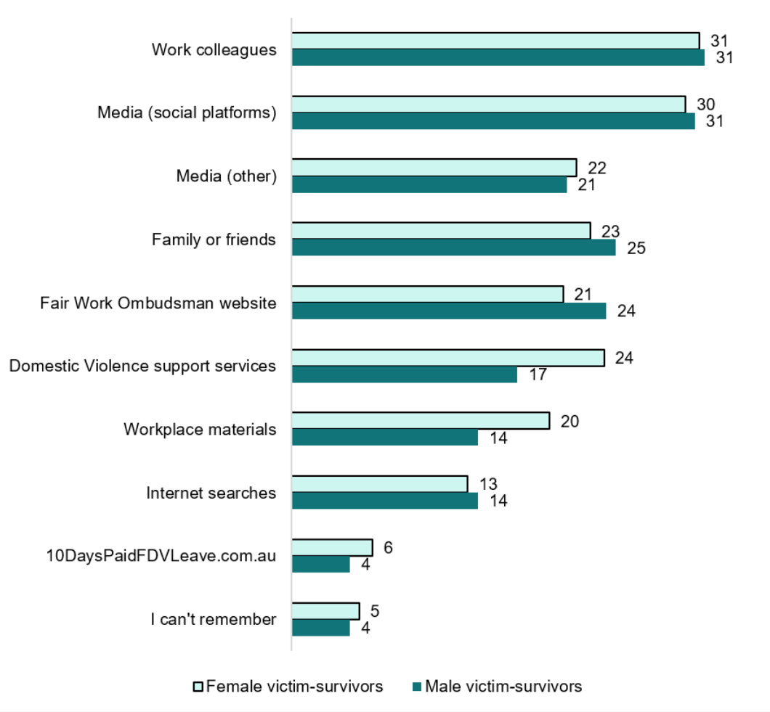

Source: Victim-survivor survey. Q94 – Where did you learn about this leave entitlement (tick all that apply)? (Selected Choice). Victim-survivors aware of FDV leave Unweighted; base n = 233. Note - ‘other’ option has been removed from the figure.

### Awareness could be improved

Awareness of the changes to the paid FDV leave entitlement was relatively low among employers and even lower among victim-survivors. Only **58% of surveyed employers and 39% of surveyed victim-survivors were aware of the new entitlement. At** the time of our surveys, the paid entitlement in the National Employment Standards had been available for 11 months for employees of large businesses and 5 months for employees of small businesses.

**When asked what FDV leave arrangements our surveyed employers offered to staff, only two-thirds of employers (66%) reported that they offered 10 or more days, despite all employers in our sample being subject to the new entitlement. The remaining 34% may still agree to an eligible employee’s request for leave, but this nonetheless indicates that around a third of surveyed employers did not yet see paid FDV leave as an existing leave offering.**

**Lack of awareness that the leave existed was identified by employers as the most significant barrier they face in providing the new FDV leave entitlement to their employees (see Figure 11 on page 26).** O**ur research findings on employers’ awareness were similar to results of surveys conducted before** the introduction of the entitlement, which found that **60% of** businesses were aware of the forthcoming requirement to provide paid FDV leave (My Business 2022). The similarity of these findings suggests awareness levels among employers have not changed significantly over the last two years despite the change to entitlements.

Figure 3. Percentage aware of the paid FDV leave entitlements (%)

This figure displays the levels of awareness of the paid FDV Leave, first by the categories of victim survivor and   employer, and then these categories are further broken down into cohorts within those two categories. 

The first category is victim-survivors. The first cohort of this category is females (36%) and males (42%). The second is by employments type (full-time (42%), part-time (38%) and casual employees (20%)). The third cohort is by the size of the business (micro-business employees (35%), small-business employees (36%), medium-business employees (43%) and large-business employees (39%)). The third and last cohort of the victim survivors category is by education level (University or higher education (49%), trade, certificate or diploma (29%) and secondary or below (32%)). 

The second category is employers. The first cohort of this category is all employers (58%). The second and last cohort of the employers category is size of business (micro businesses (43%), small businesses (54%) and large businesses (67%)).

Source Victim-survivor survey. Q93 – Were you aware of this paid leave entitlement prior to today? All Victim-survivors; Unweighted; base n = 594.

Source: Employer survey. Q13 – Were you aware of any changes to the leave entitlement before participating in this survey? All employers; Unweighted; base n = 1437.

### Lower awareness among casual workers and small businesses

Victim-survivors working on a casual basis were less likely to be aware of the paid FDV leave entitlement than those employed on a full or part-time basis (Figure 3). In fact, only around 2 in 10 victim-survivors employed on a casual basis were aware of the entitlement (13 out of 64 casuals). Victim-survivors without a university degree also had lower levels of awareness (Figure 3).

In interviews, we spoke to five victim-survivors employed on a casual basis, none of whom had taken paid FDV leave. These victim-survivors were surprised to find out the leave existed and applied to them. They assumed that because they did not qualify for other leave entitlements, they would not qualify for this one. Even victim-survivors who had used the leave entitlement as part or full-time staff were sometimes not aware that the leave entitlement was also available to casual staff.

“Oh wow, I didn’t realise it was for casuals, because, obviously, when you think of casuals, you’re not entitled to any of the other leaves.”

- Victim-survivor interview #18, female, used the leave, part-time

Among employers, medium and large **businesses (67%) were more aware of the leave compared to small (54%) or micro (43%) businesses** (Figure 3)**. Additionally, employers with a university degree displayed greater awareness of the entitlement (63%) than those with a trade, certificate or diploma level (52%) or secondary level of education (44%).**

## Uptake

### ****Victim-survivors’ uptake of the leave was low in our sample****

**While our research cannot be used to evaluate population-wide rates of FDV leave use, uptake was low among our sample.** Of the 128 victim-survivors surveyed who had experienced FDV in 2023 or 2024, only 16 (13%) had taken paid FDV leave. Twenty-two (20%) of these victim-survivors took unpaid leave.

The majority (78%) of victim-survivors we surveyed had experienced FDV when the previous legislation was still in effect. Of these victim-survivors, only 6% had accessed paid FDV leave, presumably via enterprise agreements. In contrast, 28% had accessed unpaid leave before the legislation took effect (Figure 4).

Figure 4. Total victim-survivors surveyed, their awareness and uptake of leave across two legislative periods

|  | Experienced FDV in:  2018-22 | Experienced FDV in:  2023-24 |
| --- | --- | --- |
| Number (%) of those aware of paid FDV leave entitlement | N/A | 54 (42%) |
| Number (%) of total surveyed who used paid FDV leave | 30 (6%) | 16 (13%) |
| Percentage of those aware of paid FDV leave entitlement who used it. | N/A | 16 out of 54* (30%) |
| Number (%) of total surveyed who used unpaid FDV leave | 116 (28%) | 22 (20%) |

Source: Victim-survivor survey. Q93 - Were you aware of this paid leave entitlement prior to today? Unweighted; base n = 594. Q95 - Did you take paid family and domestic violence leave? Unweighted; base n = 594. Q120 - Did you take unpaid leave to address FDV? All victim-survivors; Unweighted; base n = 529. *Data derived from Q93 and Q95.

Businesses also reported that uptake of paid FDV leave so far has been modest, with only 12% of employers reporting any staff accessing FDV leave since the new legislation came into effect (Figure 5). Of the large businesses surveyed, 18% reported at least one staff member accessing paid FDV leave. Of the small businesses and micro businesses surveyed, 7% and 5% of businesses respectively reported uptake of paid FDV leave (Figure 5). Six percent of surveyed employers indicated they had more than one staff member take FDV leave. Around two-thirds (68%) of businesses who had granted leave indicated the staff member took all 10 days.

### Lower uptake among casuals in our sample

Casual staff had even lower uptake of paid FDV leave. Of the 19 casual staff respondents in our victim-survivor survey who had experienced FDV in 2023 or 2024, only one had accessed paid FDV leave. In interviews, we spoke to 5 casual employees, none of whom had accessed paid FDV leave.

Lower uptake among casual employees was corroborated by our survey of employers. Of the employers who had granted the leave, only 22% had granted it to casuals, compared with 75% who had granted it to full-time employees and 34% who had granted it to part-time employees.

This may be partly explained by low levels of understanding about the eligibility of casual employees. In our surveys, only 27% of victim-survivors who were working casually (17 out of 64) and 57% of employers believed the entitlement was available to casual employees, compared with 92% of employers believing it was available to full-time employees.

Figure 5. Paid FDV leave uptake reported by employers since legislation change (% of employer type****)****

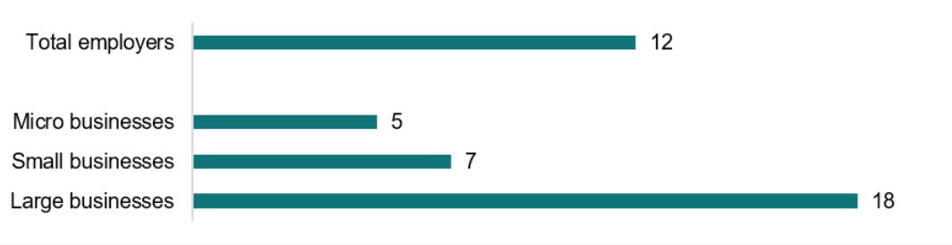

**Source: Employer survey.** **Q63 - Are you aware of any instances where employees at your organisation have taken paid family and domestic violence leave since the legislation changed on [Field-Date]? All employers; Unweighted; base n = 1437. Micro businesses; Unweighted; base n = 328. Small businesses; Unweighted; base n = 438. Large businesses; Unweighted; base n = 671. Note “[Field-Date]” was displayed as the date of legislation change based on the size of the business.**

### Leave users access other supports at higher rates

Uptake of the leave was significantly higher among victim-survivors who were engaged with FDV support services outside of work (76%, or 35 out of the 46 victim-survivors accessing external services) than those not engaged with outside services (43%, or 78 out of 180 victim-survivors not accessing external services). It is unclear whether this is because external FDV support services are performing a significant role in raising awareness of the entitlement among victim-survivors or if leave users are more likely to seek supports outside work. In total, 44% of surveyed victim-survivors said they had received help from services outside of work. This was significantly higher for female victim-survivors (51%) than for male victim-survivors (38%).

### Not all victim-survivors need leave, but many do and aren’t taking it

Not all victim-survivors need or want to take leave from work due to experiencing FDV. Experiences of FDV are diverse, as are victim-survivors’ ways of dealing with violence (Fitz-Gibbon et al. 2023). We would not expect uptake of the leave to be 100% among victim-survivors. In our survey we found 9% of victim-survivors felt their experience of FDV did not impact their work at all and 46% felt it only slightly impacted their work. The primary reason why victim-survivors who were aware of the leave entitlement did not take it was because they felt they did not need it (40%, or 25 of these 62 victim-survivors).

In victim-survivor interviews, one person said they did not need to take any type of leave to deal with their experience of FDV. They indicated they would only need leave if their situation got worse. There were also some interviewed victim-survivors who said they needed to take leave but would never use FDV leave because they would not disclose FDV to their employer and preferred to use other forms of leave.

Nonetheless, our results suggest there are other victim-survivors who need, and would likely benefit from, paid FDV leave but are not accessing it. We call this ‘unmet need’.

Just under half (45%) of the victim-survivors in our survey reported they had taken another form of paid or unpaid leave or cancelled their own shifts to deal with FDV instead of taking paid FDV leave. When combined with victim-survivors who did access paid FDV leave (8%), this suggests approximately 53% of victim-survivors have a need to use the FDV leave entitlement, with 45% of victim-survivors representing ‘unmet need’ for FDV leave.

In interviews, some victim-survivors who needed to take leave told us they would consider accessing FDV leave if they were aware of the leave entitlement, if they felt the process of disclosure was safe and private, and if they did not fear negative repercussions from using the FDV leave.

### Victim-survivors primarily use the leave to establish safety

The leave users in our survey used the leave most commonly to make arrangements for the safety of themselves (19 out of 46 leave users, or 41%) or their children (20 out of 46, or 43%; Figure 6). Victim-survivors also used FDV leave to access police (18 out of 46, or 39%), medical (10 out of 46, or 22%) and legal services (11 out of 46, or 24%).

Figure 6. Key activities undertaken by victim-survivors while using FDV leave (number of people)

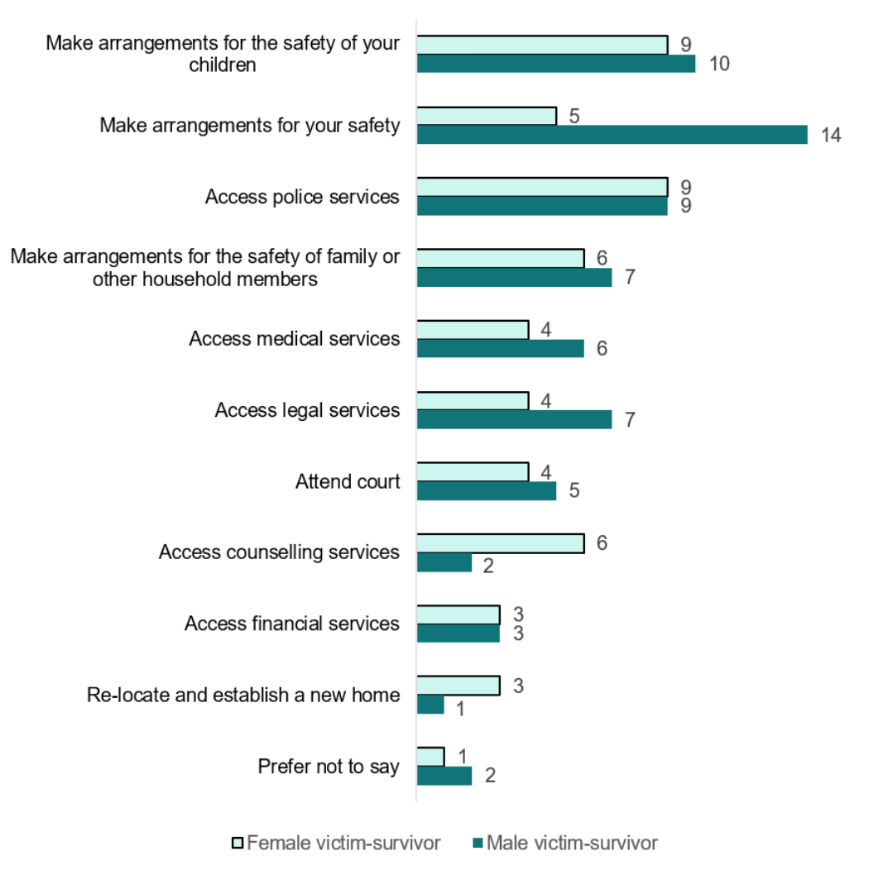

Source: Victim-survivor survey. Q101 - What activities did you use the family and domestic violence leave for (select all that apply)? - Selected Choice. Filter: Taken FDV leave; Unweighted; base n = 46.

**In interviews, victim-survivors described using FDV leave for practical and logistical tasks associated with safety, recovery and moving house. Tasks included real estate inspections, organising utilities services, changing passwords on shared accounts, changing phone numbers, going to court, applying for an intervention order and attending counselling sessions. Both victim-survivors who used and did not use the leave were engaging in these tasks, but those who used the leave were able to better maintain their income and keep their activities secret from the perpetrator.**

**Some victim-survivors wanted to use FDV leave for psychological recovery, by having time off work to emotionally and mentally recover from the effects of FDV. However, they were unclear if it was a valid use** **of the leave under the legislation. To avoid misusing the leave, victim-survivors erred on the side of only using leave for explicitly-approved purposes.**

*****[After reading the leave entitlement summary]* “It just has a quite strong focus on needing the leave to do practical things. So that kind of implies to me that the leave is for going to the police, going to court, moving out of your house, going to hospital. I feel like that’s quite exclusive and doesn’t really take into account of the emotional impact and reason for taking the leave.”****

**- Victim-survivor interview #8, female, did not use the leave, full-time**

## Barriers and challenges

### Victim-survivors face a number of barriers in accessing the leave

In the previous chapter, we discussed our finding that 45% of victim-survivors could have benefitted from taking FDV leave, but did not access their entitlement. Half of these victim-survivors were not aware of the leave entitlement (51%) but others knew of the leave and faced other barriers. Victim-survivors who knew about the leave provided a range of reasons as to why they did not access it (Figure 7).

Figure 7. Top 10 reasons cited by victim-survivors for declining to use FDV leave (number of people)

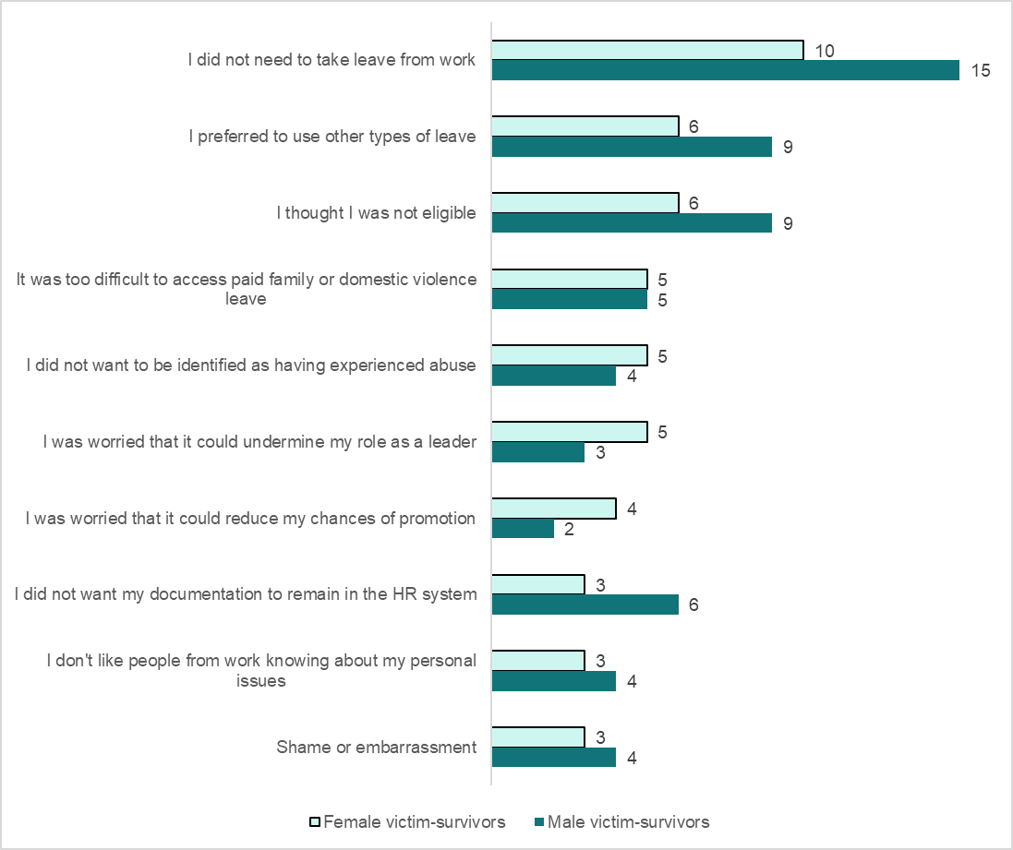

Source: Victim-survivor survey. Q112 - Please indicate why you did not access the paid family and domestic violence leave (select all that apply). Victim-survivors who declined FDV leave; Unweighted; base n = 62 (22 female victim survivors; 40 male victim-survivors).

In our research, victim-survivors perceived that reporting FDV to their employer came with risk: risk to their employment, their reputation, their income and risk that a breach of privacy would exacerbate the FDV. They also felt accessing the leave would impose an administrative burden when they had more pressing administrative tasks, such as legal paperwork or moving to a new residence. Some victim-survivors preferred to use other types of leave such as annual or sick leave (Figure 7).

V**ictim-survivors described a process in which they weighed the risks and benefits of accessing the leave entitlement, describing thresholds for how bad the FDV would need to be to prompt them to ask for FDV leave**. In open-text responses in the victim-survivor survey, participants indicated their situation would need to worsen before they sought the leave. In interviews, victim-survivors described thresholds like being hospitalised or going through a divorce before considering accessing FDV leave.

“What may have to happen [to take the leave] is the situation becomes worse. Maybe we reach a situation where we have to separate, to divorce. And maybe now I need some time off to maybe relocate, or maybe see a doctor, or maybe report a particular incident to the police.”

- Victim-survivor interview #12, male, did not use the leave, full-time

“If I went into hospital for a psych admission, I could possibly tell [the employer about FDV]. But other than having to take a substantial amount of time off, I don’t think I would want to tell them for just missing a few days here and there. […] There would need to be kind of a bigger impact than just lack of motivation to leave the house. It would have to be something bigger than that.”

- Victim-survivor interview #20, female, did not use leave, casual

#### Victim-survivor barrier 1: Awareness and comprehension

A lack of awareness of the existence of the leave and limited understanding of its parameters are the key barriers preventing leave uptake. Nearly 6 in 10 surveyed victim-survivors (59%) were not aware of the existence of paid FDV leave. Among victim-survivors who were casual staff, nearly 8 in 10 (78%) were not aware. See the chapters on ‘Attitudes and awareness’ and ‘Understanding and views of leave parameters’ for further discussion of these issues.

#### Victim-survivor barrier 2: The initial conversation

The conversation between victim-survivor and manager presents a key challenge for victim-survivors to access the leave. One in three victim-survivors in our survey did not tell anyone at their workplace they were going through FDV (33%) and only 38% told their manager (Figure 8).

**The relationship between victim-survivor and manager is a key driver in whether victim-survivors approach their manager to request leave (Fitz-Gibbon et al. 2023). Our survey with victim-survivors found a correlation between victim-survivors’ rating of trust in their manager and uptake of FDV leave. Victim-survivors who had taken FDV leave rated their manager as more trustworthy (Figure 9). It is unclear whether provision of FDV leave increases trust within the employee-employer relationship, or whether victim-survivors are more likely to request the leave if they trust their manager.**

Figure 8. Victim-survivors’ disclosure of their abuse in the workplace (%)

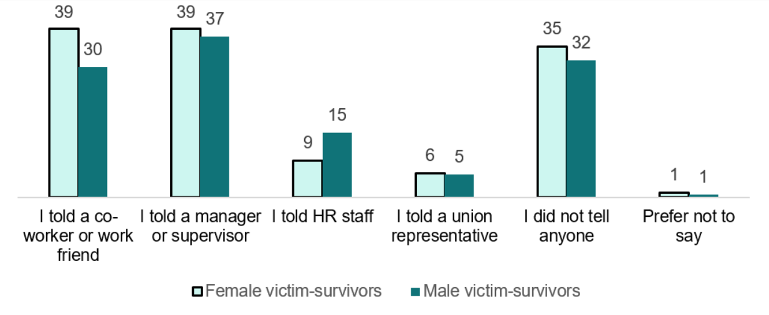

Source: Victim-survivor survey. Q90 – Did you discuss your family or domestic violence experience with anyone at this job (tick all that apply)? All victim-survivors; Unweighted; base n =594.

Figure 9. Average mean score of victim-survivors’ appraisal of their relationships with managers

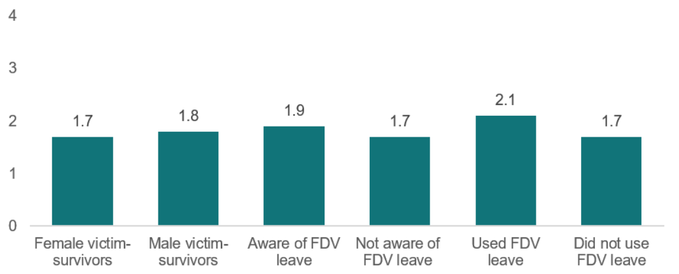

**Source: Victim-survivor survey. Higher scores indicate that the victim-survivor has a greater level of trust in their manager and organisation. All 594 victim-survivors in our survey completed the 15-item multidimensional employee trust in leaders scale (Q89) as developed by Fischer, Walker and Hyder (2023). Victim-survivors rated all items on a scale from 0 = ‘strongly disagree’ to 4 = ‘strongly agree’. A mean score across the 15 items was calculated for each victim-survivor to provide an overall indication of the employee/manager relationship.**

**When this conversation did proceed, we found that a manager’s awareness of the leave made a considerable difference to the outcome. In interviews, some victim-survivors described requesting leave from a manager and discovering the manager was unaware of the leave entitlement. In such circumstances, managers had to research the leave parameters, discuss with others and then make a decision about granting the entitlement. For some victim-survivors, this process took longer than two weeks. That period of uncertainty caused the victim-survivor anxiety, made them feel doubted or suspect, and delayed them from being able to take leave. Our research indicated that leave is often requested during crisis periods, so this delay could expose victim-survivors to a heightened safety risk.**

**Victim-survivors who approached a manager who understood the leave entitlement experienced a sense of relief, felt validated and were able to take leave with less delay.**

“I was telling her I had the move booked and she said, look, I’ve spoken to the Director and I’ve looked into this for you and you’re eligible for it and I’m willing to support your application for it and all you have to do is put it in our leave system and that’s it. You don’t have to provide any supporting evidence or anything and I cried… I just… I’m probably going to cry again now. It was such […] such an enormous relief.”

- Victim-survivor interview #7, female, used the leave, full-time

*[Describing an employer taking two weeks to respond to a request to access the leave]* “In those two weeks, I was quite stressed about what’s gonna happen and feeling paranoid. Who is this information being shared with? […] How many leadership members know about this? It’s a super sensitive topic and I felt really uncomfortable. Especially in that time [waiting for an answer] because I was like, am I gonna have to now battle? Or have to prove and show them documentation of this policy or what?”

- Victim-survivor interview #6, female, used the leave, part-time

#### ****Victim-survivor barrier 3: Gathering evidence****

**Although many victim-survivors indicated they felt it was reasonable for employers to request evidence to access the leave, some experienced or anticipated issues in gathering evidence.**

**A**mong leave users, 8 in 10 provided evidence to their employer to access FDV leave (38 out of 46 **leave users**). Half of all leave users (23 out of 46) reported that this evidence was required by their employer, while a third (15 out of 46) provided the evidence voluntarily (Figure 10).

Among leave takers who provided evidence, half (20 out of 38) faced challenges in gathering this evidence. Some victim-survivors who had not taken the leave also anticipated challenges with gathering evidence, suggesting the potential evidence requirements could discourage some victim-survivors from requesting the leave. These challenges often related to misconceptions about the kind of evidence that would be acceptable. This issue is discussed further in the chapter on ‘Understanding and views of leave parameters’.

“I would have no problem about providing that sort of evidence. I think that’s, that would be fair enough.”

- Victim-survivor interview #21, female, did not use the leave, casual

“I do have copies of DVOs if they needed evidence of it.”

- Victim-survivor interview #22, female, did not use the leave, casual

“I mean, I don’t know how you could begrudge someone that leave. They’re not gonna ask for it for the sake of it. But if you’re a business and you felt there maybe was a trust issue and you really needed someone to support that, they can ask for that [evidence] within the legislation, I also think that’s fair enough.”

- Victim-survivor interview #10, female, did not use the leave, part-time

Figure 10. Victim-survivor’s experiences with providing documentation to access FDV leave (number of people)

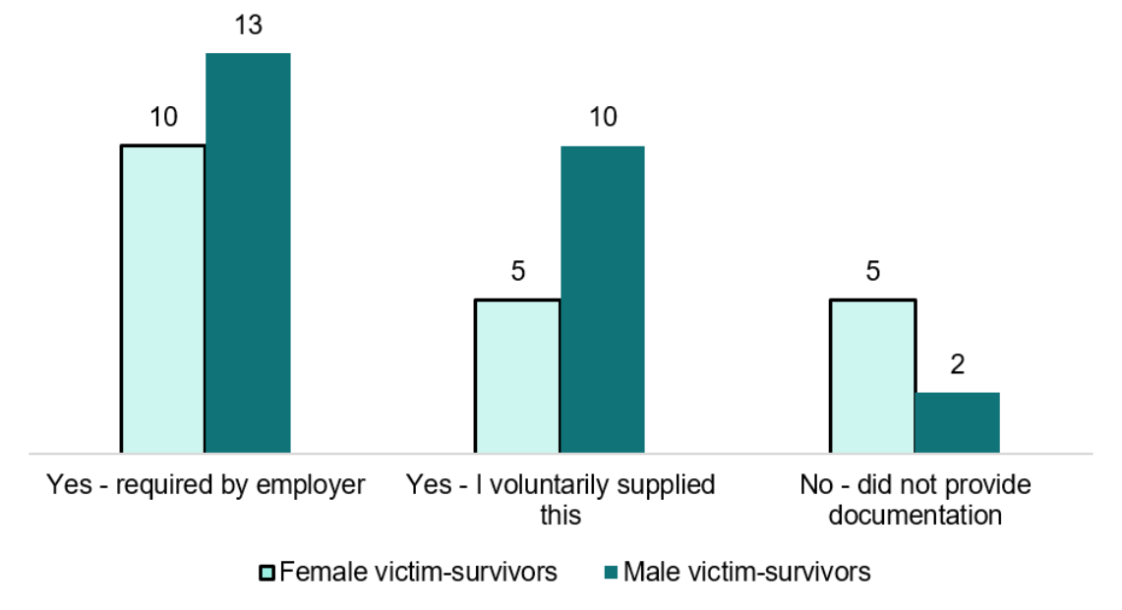

Source: Victim-survivor survey. Q103 - Did you provide documentation to support the leave? Filter: Victim-survivors who have taken paid FDV leave; Unweighted; base n = 46.

Some victim-survivors also raised concerns about the time or capacity they had to collect the evidence.

****“If somebody has like, total control over somebody else’s life, they might not feel like they even have time to get any evidence, which would be a massive concern.”****

**- Victim-survivor interview #15, female, did not use the leave, part-time**

“You have to go out to get these things. So a stat dec, you would have to go to the police station or a pharmacy or somewhere that has the authority to do it. You could have been the night before absolutely bashed and you’re black and blue, do you really want to go out looking like that? To go get a stat dec?”

- Victim-survivor interview #18, female, used the leave, part-time

#### Victim-survivor barrier 4: Concerns about confidentiality

Most leave users in our survey (89%, or 41 out of 46) felt their privacy was protected by their employer throughout the process. However, in interviews, victim-survivors raised confidentiality and privacy as significant barriers when they considered accessing the leave in the future, even among people who had read the rules of the leave. Among the 62 surveyed victim-survivors who chose not to use FDV leave, 9 (15%) did so because they did not want their documentation in the HR system and another 9 (15%) did not want to be identified as having experienced abuse.

While some interviewed victim-survivors felt maintaining privacy about their FDV was not an option because the effects were so obvious or the perpetrator came to the workplace, others did not want anyone in their workplace to know about their FDV. Some did not want to share information at work about their experience of FDV because they felt it helped their mental health to keep FDV separate from work. They wanted their workplace to remain a place where they felt capable and professional. Other victim-survivors did not want anyone to know because they were concerned about the potential negative impacts.

“I think the work keeps, it’s sort of a distraction from whatever I’m experiencing. When I’m at work, it gives me an opportunity to forget about what I’m experiencing at home. If I take some time off, I would think so much about whatever I’m experiencing and maybe I fall into a depression or something like that.”

- Victim-survivor interview #12, male, did not use the leave, full-time

“I’d rather use my own leave. More for privacy issues. […] I suppose I didn’t want to share it. I saw it as a bit of a failing, […] I didn’t want to share because they’re awful gossips. […] It wouldn’t have stopped at my manager, I wouldn’t imagine. […] I don’t think I could ask for the leave without divulging more than I wanted to.”

- Victim-survivor interview #10, female, did not use the leave, part-time

“In my workplace, a narrative can develop around a person. […] I don’t want to be the subject of any of those kinds of narratives. So if accessing the leave means that I have to tell someone about that, I’m not going to do it.”

- Victim-survivor interview #8, female, did not use the leave, full-time

Some victim-survivors were concerned that the perpetrator may find out if they discussed FDV at work**. For example, one interviewed victim-survivor worried that the provision of evidence posed a risk to their safety because it could be leaked to the perpetrator. This fear was borne out for a small number of respondents in the victim-survivor survey, in which two leave users said “the person who abused me found out I shared information with work.”**

“Are you compromising the safety of the person as well by forcing them to have to give that sort of information? Do the people in the organisation know the perpetrator? […] Is the perpetrator going to subpoena those types of documents and the fact that you took leave?”

- Victim-survivor interview #2, female, did not use the leave, part-time

“There’s always that fear that you would be out setting up your new apartment or something and you run into him and he’s like, ‘Why aren’t you at work?’ you know? […] So you have to put things in place to make sure that doesn’t happen. You have to keep it private.”

- Victim-survivor interview #16, female, did not use the leave, casual

**Victim-survivors indicated that increasing the** transparency regarding the administrative process may address some of their concerns about confidentiality. For instance, some victim-survivors told us they didn’t have enough information about the process to make an informed decision about whether or not they would apply the leave. Others felt the process of applying for the leave would need to be simplified or changed before they would access it. For example, some suggested they did not want HR records to be kept permanently, or required more transparency as to where documents would be stored, as well as for how long and who would have access to those documents.

“The thing is, how do I take it? […] I didn’t understand the process and the confidentiality and those things. […] That was in the back of my head, not having transparency about that. […] I just didn’t know how it worked.”

- Victim-survivor interview #2, female, did not use the leave, part-time

“Where are they going to store this stuff?”

- Victim-survivor interview #2, female, did not use the leave, part-time

“I wouldn’t want it on my personal record where if I’m going for another job in the future and they see that I’ve taken leave for this situation and then them just seeing you as that sort of liability.”

- Victim-survivor interview #3, female, did not use the leave, casual

#### Victim-survivor concern 5: Misconceptions about mandatory reporting

Some victim-survivors were hesitant to request the FDV leave because they believed their employer would need to follow up with a police report or formal record of the abuse. This was more common for younger victim-survivors whose initial experience of FDV was as a minor, where any disclosure leads to mandatory reporting. The belief that accessing the leave would require them or their employer to report the abuse to authorities was a deterrent.

“If it [requesting FDV leave] meant that I had to obviously raise it to a point of the authorities and stuff, I probably wouldn’t and just take regular leave.”

- Victim-survivor interview #13, male, did not use the leave, full-time

“I would be worried as well that, like, I would wanna make sure that the information wouldn’t automatically have to go to police or any sort of government thing.”

- Victim-survivor interview #20, female, did not use leave, casual

*[Asked if there was anything that would have encouraged them to take the leave]* “I guess I, if there was a confidentiality thing and that says, if you’re an adult and it’s not really a child endangerment situation […] I think that was the main thing that I was worried that it would somehow get back to him. So some sort of like, oh you cannot have your name published. Just a tick a box that nothing was going to happen.”

- Victim-survivor interview #15, female, did not use the leave, part-time

### Employers report a number of challenges in providing the leave

Surveyed employers identified a range of challenges in providing paid FDV leave to their staff. These differed according to whether the respondent had granted FDV leave or not (Figure 11). Among those who had granted the leave, the most commonly experienced challenges were lack of awareness, a need for guidance and feeling ill-equipped for the conversation with staff.

Some challenges, notably financial costs and staffing shortages, were more prominent among those who had not provided the leave. For example, while 30% of employers who had not provided leave anticipated financial costs as a challenge, only 18% of employers who had provided the leave reported this as a challenge. This suggests that financial costs and staffing shortages may be more significant in anticipation than in reality for some employers.

Figure 11. Employers’ anticipated and experienced challenges in providing FDV leave to staff (%)

This graph has eight categories, each broken down into two columns, one for what employers who have not granted the leave anticipated, and one for employers who had experienced the particular category while granting the leave. The first category is 'Lack of awareness about the existence of the new family and domestic violence leave legislation (33% of employers who have not granted the leave but anticipated, 46% of employers who had experienced the particular category while granting the leave). The second category is 'not able to source clear guidance about how to provide the leave (10% of employers who have not granted the leave but anticipated, 40% of employers who had experienced the particular category while granting the leave). The third category is 'not feeling equipped to have sensitive conversations with staff (18% of employers who have not granted the leave but anticipated, 37% of employers who had experienced the particular category while granting the leave). The fourth category is 'lack of understanding of my obligations under this new paid family and domestic violence leave law (23% of employers who have not granted the leave but anticipated, 24% of employers who had experienced the particular category while granting the leave). The fifth category is 'financial costs' (30% of employers who have not granted the leave but anticipated, 18% of employers who had experienced the particular category while granting the leave). The sixth category is 'misuse by employees' (18% of employers who have not granted the leave but anticipated, 17% of employers who had experienced the particular category while granting the leave). The seventh category is 'staffing shortages' (25% of employers who have not granted the leave but anticipated, 17% of employers who had experienced the particular category while granting the leave). The eighth and last category is 'no barriers expected/ experienced' (28% of employers who have not granted the leave but anticipated, 15% of employers who had experienced the particular category while granting the leave).

Source: Employer survey. Q72 - Based on your experience or observations, please indicate any barriers that your organisation has encountered in offering family and domestic violence leave? Please select all that apply. Filter: Employers who had staff take FDV leave; Unweighted; base n = 169. Q70 - Considering your organisation's situation, please indicate/tick any barriers you believe may affect your organisation's ability to provide paid family and domestic violence leave to staff. Please select all that apply. Filter: Employers who did not have staff take FDV leave; Unweighted; base n = 1268. Note – “other” and “prefer not to say” have been excluded from the figure.

#### ****Employer challenge 1: Low awareness****

**Forty two percent (42%) of surveyed businesses were unaware of the paid FDV leave entitlement. Lack of awareness about the existence of the leave was the most commonly identified challenge for businesses of all sizes and for both businesses who have granted and have not granted the leave. See the chapters on ‘Attitudes and awareness’ and ‘Understanding and views of leave parameters’ for further discussion of these issues.**

#### ****Employer challenge 2: Seeking more practical guidance****

Many employers who had provided paid FDV leave to staff – and were therefore aware of the entitlement – were looking for more guidance about the process. Forty percent (40%) of survey respondents who had granted leave reported difficulties in sourcing clear guidance, and 37% felt ill‑equipped to have difficult conversations. In interviews, some employers expressed frustration over being compelled to provide FDV leave without adequate support or prior consultation.

“I think training and development, peer support and just maybe some more support of HR business partners, my manager as well that I could fall back on, that I could have reached out to… So yes, having more wraparound support at that point in time and the policies and procedures where there was nothing in the policies and procedure, but all the new policies in that practice guide only got developed in June last year.”

- Employer interview 4, HR employee, 9000 employees, has provided paid leave before 2023

One third (34%) of employers who had provided paid FDV leave had sought information on the Fair Work Ombudsman website and just under a quarter (23%) had visited the government-funded 10dayspaidfdvleave.com.au website (Figure 12).

The employers who had visited government websites found them useful. In interviews, participants reported that they found the information highly valuable. Surveyed employers who visited government websites were slightly more likely to feel equipped to support employees experiencing FDV (72%) compared to those who saw information about FDV from other channels (68%) and far more likely than those who were not aware of FDV leave at all (38%).

“I'm not sure that I've heard lots about it in the media, but I think it's fantastic. I'm pretty sure it was the Fair Work website that we got our info from. They’re pretty good. It all looked quite straightforward. I guess, I mean with these things there’s always examples that are given, which is great to help, I think business owners and the individual as well.”

- Employer interview 7, business owner, 11 employees, has provided paid leave before 2023

“I think you need to register the type of business you are on a portal with the government and therefore your registered email address that maybe you have gets sent these things. I think a bit of the onus needs to be on the government to inform businesses *[about FDV leave entitlements]*.”

- Employer interview 15, 2 employees, has provided leave before 2023

Figure 12. Comparison of employers who have and have not provided FDV leave and their sources of information about FDV leave (%)

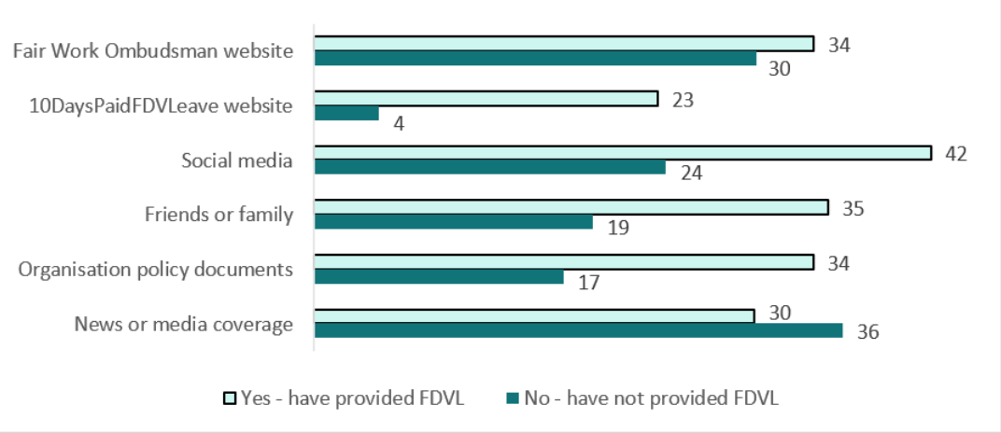

Source: Employer survey. Q14 - Where have you seen information about the change in family and domestic violence leave entitlements? Please select all that apply. Filter: Employers who were aware of changes to FDV leave; Unweighted; base n = 828. Q63 - Are you aware of any instances where employees at your organisation have taken paid family and domestic violence leave since the legislation changed on [Field-Date]? All employers; Unweighted; base n = 1437.

#### Employer challenge 3: Having difficult conversations with staff

In our survey, 37% of employers who had received an FDV leave request felt ill-equipped to have difficult conversations (Figure 11). Our interviews with employers revealed that employers can feel conflicted about balancing trust with the need for verification. Employers expressed discomfort questioning employees on a sensitive subject, but also sometimes held concerns about potential misuse.

“I have no idea because I feel like if someone came to me and said, ‘I’m in a domestic violence situation.’ and then I turn around and go, ‘Well, prove it.’, how awful is that? You need to have compassion and try to help support someone in that situation. But at the same time they can’t just say, ‘I need to access this kind of leave.’ and then not give any information. But at the same time, information about their home life is none of an employer’s business. I don’t know. I’m very confused as to how this works and I feel like a bad person for questioning it.”

- Employer interview #1, business owner, 5 employees, no previous FDV leave experience

“Yes. I think the first thing is I have to see if that is the person who be with us for a long time already or just the new member staff who didn't even pass the probation yet. So I probably ask for the evidence, like, oh, can you get me the certificate if you get any physical abusive or something?”

- Employer interview #3, business owner, 10 employees, no previous FDV leave experience

#### Employer challenge 4: Concerns about potential misuse

Across all surveyed employers, around one in five highlighted staff misuse as a challenge in providing paid FDV leave, with similar rates among those who had (18%) and had not granted leave (17%). Concern about potential misuse by employers who had not granted the leave was more common among employers from larger businesses (22%) than small (17%) and micro businesses (12%).

These concerns are resulting in employers denying requests for FDV leave. 14% of employers in our survey reported denying an FDV leave request since the legislation had come into effect, with larger businesses far more likely to deny a request (21%) than small (11%) and micro (4%) businesses. The most common reasons for denied requests were concerns about misuse (7% of all employers), insufficient documentation (5% of all employers) and operational reasons (5% of all employers).

#### Employer challenge 5: Financial costs and staffing shortages

Although financial cost and staffing shortages were less commonly cited challenges among businesses who had granted the leave, they remain significant concerns for a segment of businesses. For further discussion of this issue, see the chapter on ‘Impacts’.

### Some challenges are shared by victim-survivors and employers

**There are several challenges that were shared by victim-survivors and employers:**

* **low levels of awareness of the existence of the entitlement and limited comprehension of its nuances**
* **concerns about the initial conversation between victim-survivor and employer**
* **discomfort about the evidence requirement, while acknowledging its necessity.**

The first shared challenge, low levels of awareness and limited comprehension, is discussed at length in the chapters on ‘Attitudes and awareness’ and ‘Understanding and views of leave parameters’.

The conversation between victim-survivor and manager was a key concern for both parties, with victim-survivors concerned about trust and privacy, while employers felt ill-equipped to deal with sensitive conversations. Similarly, the evidence requirement was a source of discomfort for both parties, with victim-survivors finding the logistics challenging and employers feeling uncomfortable asking for proof while also harbouring concerns about potential misuse.

## Impacts

### The entitlement has potential to reduce stigma and discrimination

We ran a randomised control trial survey experiment to examine whether Australian workers would evaluate a fictional employee differently depending on whether they saw details about the paid FDV leave legislation *before* (treatment group) or *after* (control group) making their evaluation. In the experiment, the fictional employee had taken leave from work due to FDV.

Compared to the control group, we found that members of the Australian workforce who first saw details about the legislation evaluated the fictional employee as:

* significantly more suitable for a management position (44.3% vs 34.8%; *p < 0.00, holm adjusted p value*) (see Figure 13)
* deserving of a significantly higher bonus (mean bonus of $477.20 and $457.10; *p < 0.03, holm adjusted p value*) (see Figure 13)
* significantly more competent (mean competency ratings of 4.13 vs 4.06; *p < 0.02*).

Figure 13. Recommendation for management positions and mean bonus allocation across experimental conditions

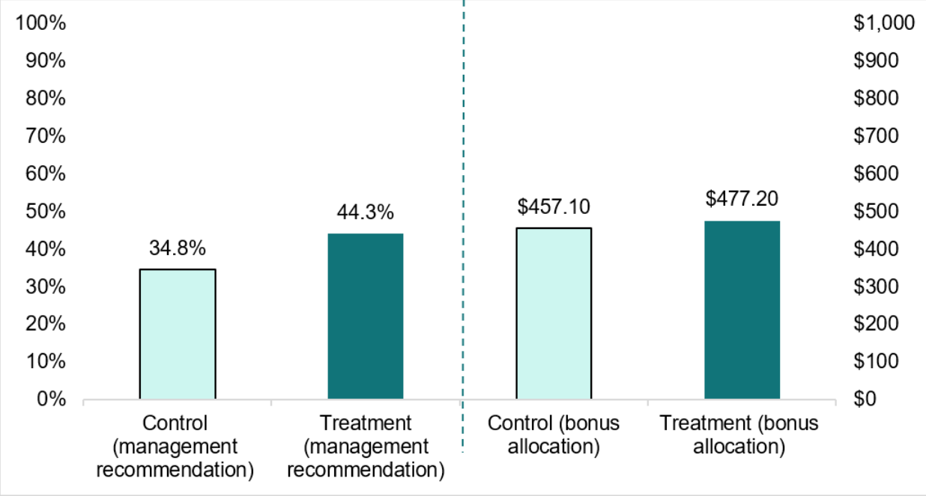

Source: **Members of the Australian workforce survey,** n = 2720. Half of the participants were randomly allocated into the treatment condition, where they saw information about the paid FDV leave legislation before they made evaluations regarding a fictional employee. The other half of participants were allocated to the control condition, where they saw information about the leave legislation after they had made their evaluation of the fictional employee. See Appendix for further details.

Thematic analysis of the reasons provided for participants’ competency evaluations offer insight as to what might be driving the reduction in stigma and discrimination. Those who saw details about the legislative entitlement before their evaluation were more likely to: provide rationales for their evaluation, mention a consultation process with the fictional employee (such as to understand the fictional employee’s thoughts on a managerial position) and mention providing support for the fictional empoyee (such as a counselling referral).

Although the primary reasons for participants’ management recommendation were the employee’s work commitment and performance, the language used to describe their decision-making varied. Participants who first read about the legislation were more likely to suggest the fictional employee’s strong performance was ‘in spite’ of what was happening in their personal life, indicating that they saw this as a strength in assessing management potential. On the other hand, participants who had not read about the legislation were more likely to place caveats on their management recommendation. For example, these participants suggested that, to be a manager, the fictional employee would need to improve their home life or work situation. This suggests they viewed the fictional employee’s experiences of FDV as a weakness in relation to management potential.

We also noted that across both conditions, participants very rarely used the terms FDV or domestic violence. Instead, participants tended to refer to the fictional employee’s 'private life’ or 'personal situation'. It remains unclear what is driving this, but may indicate an overall discomfort in discussing or labelling FDV in work contexts.

### For victim-survivors, the impact of the leave is mixed, but primarily positive

**For interviewed victim-survivors who accessed the leave, it was a relief and an asset to have time to deal with the effects of FDV while maintaining an income.**

#### ****The leave supports victim-survivors to maintain financial security****

**There was strong support and appreciation for the material benefits of taking the leave. Among victim-survivors who accessed FDV leave, nearly all suggested paid FDV leave helped them to:**

* **maintain their income (95% or 19 out of 20 of female victim-survivors and 88% or 22 out of 25 male victim-survivors) (Figure 14)**
* **maintain their employment (85% or 17 out of 20 female victim-survivors and 92% or 23 out of 25 male victim-survivors (Figure 14).**

**Interview participants described the financial security of maintaining an income while managing FDV and supporting financial independence from the perpetrator. They also appreciated that they could save other types of leave for their intended purposes of sickness and respite.**

Figure 14. Victim-survivors’ experiences with FDV leave in helping to maintain income and employment (number of people who said yes, out of 20 females and 25 males)

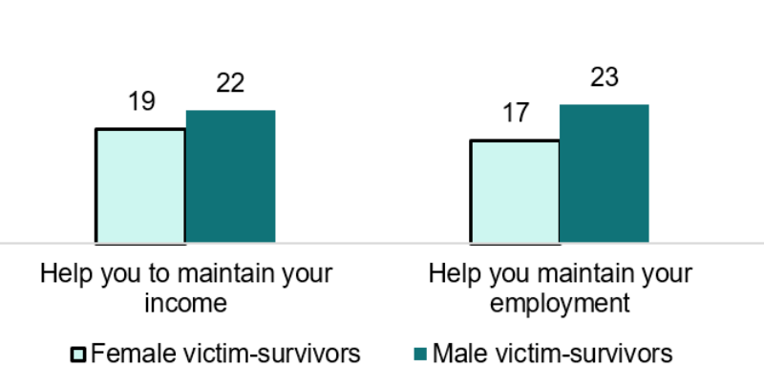

**Source: Victim-survivor survey. Q107 - Did the paid family and domestic violence leave help you to maintain your income? Filter: Taken FDV leave; Unweighted; base n = 46 (20 female and 25 male). Q108 - Did the paid family and domestic violence leave help you to maintain your employment? Filter: Taken FDV leave; Unweighted; base n = 46.**

“The positives is just the financial positives. The fact that you can still get paid and do what you need to do when you are going through this. […] Because a lot of people, including myself, have to struggle with making appointments and organising you know, sessions, time, admin tasks. Then feeling reluctant to take time off if it meant not getting paid or running out of sick leave, so it does reduce that financial burden of taking time off.”

- Victim-survivor interview #6, female, used the leave, part-time

“The benefit for me was definitely not having to use all of my paid leave. […] My health hasn’t been great this year and I’ve been able to take time off. I haven’t had to push myself to work when I hadn’t been capable of it. So that’s a big difference for me.”

- Victim-survivor interview #7, female, used the leave, full-time

“That was really, really helpful not to have to use my TOIL or annual leave to be able to [safely relocate]. Because it wasn’t like being able to do something nice. It wasn’t a holiday or anything.”

- Victim-survivor interview #14, female, used the leave, full-time

#### ****The leave helps victim-survivors to pursue safety plans and deal with FDV effects****

**The leave also helped victim-survivors deal with the effects of FDV and pursue their safety plans. Victim-survivors used the leave to secure their own safety (19 out of 46 leave users), the safety of their children (20 out of 46) or other household members (14 out of 46) (see Figure 6).**

**Victim-survivors described how the leave made it possible for them to complete practical tasks that could not be done outside work hours, such as time consuming tasks associated with seeking legal protection and moving house. They said accessing the leave made it easier to do tasks associated with escape or safety during work hours without the perpetrator knowing.**

“I had to get days off, to get reports, to go to the police, to get court orders, and also for the emotional part, I had to get counselling. […] There are some things I cannot do on the weekend. There is something I cannot do in the afternoon because of the kids. And also the relocating, that was also a positive part for my kids. I needed to relocate for my safety and the safety of my kids. […] So the leave has been beneficial to me.”

- Victim-survivor interview #17, female, used the leave, part-time

“I just needed to be able to pick up my daughter when my parents couldn’t. I couldn’t do meetings around 8:30, 9:00, and I couldn’t do meetings around 3:00-3:30, so my whole calendar had to be rejigged, I guess.”

- Victim-survivor interview #9, female, used the leave, full-time

#### ****The leave contributes to victim-survivors feeling socially and emotionally supported****

**The leave also contributed to a sense of social and emotional support. Around two of every three (30 out of 46) victim-survivors who accessed the leave said their employer’s response to them taking FDV leave made them feel very or extremely supported (see Figure 16).**

**Using FDV leave appears to have prompted employers to make additional accommodations. Nine out of ten (41 out of 46**) leave users said their employer provided support in ways beyond FDV leave, such as moral support, flexible working hours, or referrals to counselling or an Employee Assistance Program.

**Interview participants also described employers being emotionally supportive and providing additional practical supports beyond the FDV leave.**

****“It showed me that they trusted me, you know, and I was just given the time and respite to do what I needed to do.”****

****-** Victim-survivor interview #11, non-binary, used the leave, full-time**

Figure 15. Workplace supports reported by victim-survivors ****(%)****

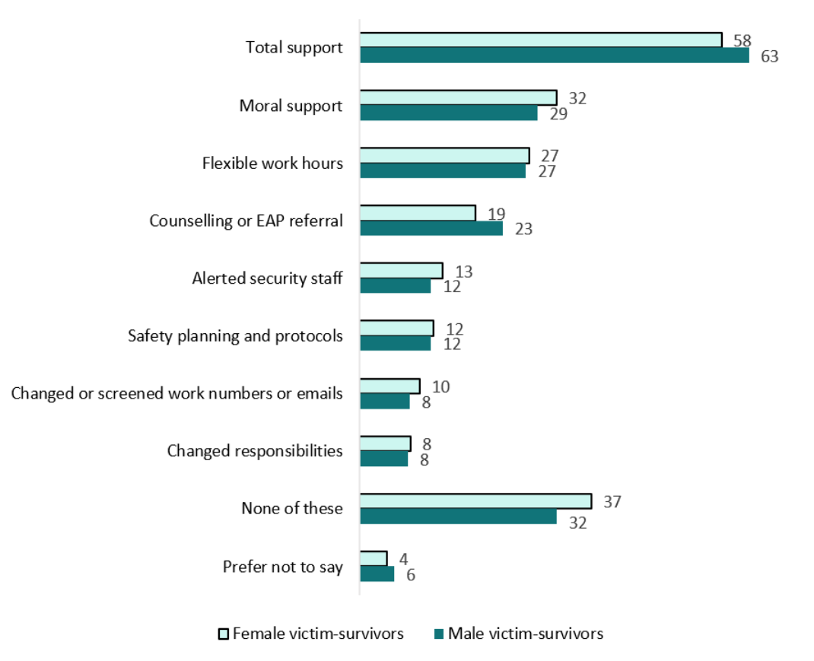

**Source: Victim-survivor survey. Q126 - Did your work help you in the following ways? (Select all that apply) - Selected Choice. All victim-survivors; Unweighted; base n = 594. Note – “Other” has been removed from the figure.**

#### ****But victim-survivors report workplace stigma alongside the support****

**F**or leave users, taking the leave was associated with both positive and negative workplace reactions. Nine out of 10 leave users (42 out of 46) said they felt supported by their workplace, but despite this, many also simultaneously reported feeling judged (33 out of 46) and shamed (31 out of 46; Figure 16). This could indicate the complexity of responses that victim-survivors experience or perceive from colleagues and managers upon their return to work.

Figure 16. Victim-survivors’ feelings regarding how their workplace responded to them taking FDV leave (number of people)

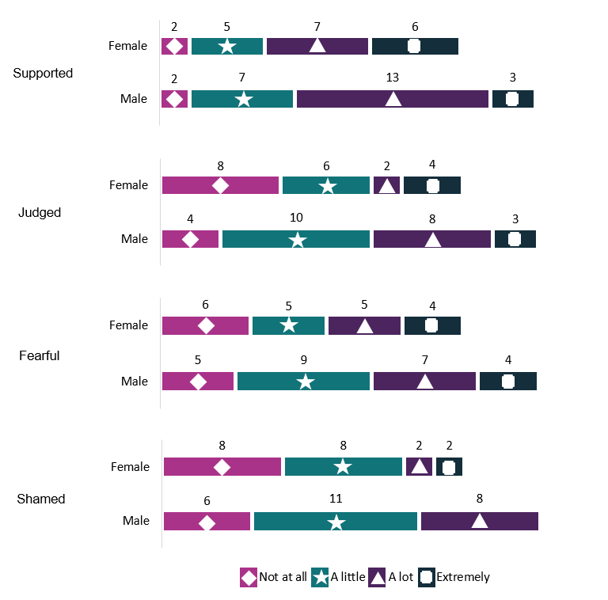

Source: Victim-survivor survey. Q106 - To what extent did your employer’s and or colleagues' responses to you taking family and domestic violence leave make you feel; Filter: Victim-survivors who have taken FDV leave; Unweighted; base n = 46.

#### ****Some victim-survivors experienced negative impacts****

**While many leave users (10 out of 20 females and 7 out of 25 males) suggested they suffered no negative consequences, others did report costs. For example, some leave users were asked to use sick leave or annual leave (9 out of 46 leave users) or unpaid leave (5 out of 46) instead of accessing the paid leave.**

**Some leave users reported that they experienced the concerns often anticipated by victim-survivors when weighing up the risks and benefits of using the leave. Around a quarter of leave users reported that after taking the leave they experienced exclusion (13 out of 46 leave users) or discrimination (11 out of 46), and reduced trust from management (8 out of 46; Figure 17). Some reported negative impacts on their income such as reduced hours and shifts (8 out of 46) or being fired or asked to resign (7 out of 46). While respondents attributed these outcomes to their accessing the leave, we note that victim-survivors often experience challenging periods at work as a result of their abuse, including absenteeism and distraction, which could also contribute to negative impacts like these. As we did not ask similar questions of victim-survivors who did not access the leave, we are not able to distinguish between the effects of taking the leave and the effects of FDV more generally.**

**Leave users appeared to be less aware than those who had not used the leave that they could contact the Fair Work Ombudsman for support if they felt their employer had unreasonably discriminated against them. Of the leave users surveyed, 24 out of 46 (52%) said that if an employer unreasonably denies access to the leave, or discriminates against employees who access the leave, employees should contact the Ombudsman, compared to 136 out of 180 (76%) victim-survivors who had not used the leave.**

**A small proportion of leave users experienced privacy and safety issues. About 1 in 10 (5 out of 46 leave users) said their privacy/confidentiality was not protected and 4 out of 46 said the information they shared with management was misused.**

**Interviewed victim-survivors reported being seen as unreliable, being treated as fragile or being asked questions they felt were intrusive after taking leave. Leave users also reported stress and anxiety about needing to disclose FDV, about requesting the leave, and not knowing how the process would play out.**

****“It wasn’t a comfortable experience to be honest. I was quite stressed going through that.”****

****-** Victim-survivor interview #6, female, used the leave, part-time**

****“I do feel in some ways […] I won’t be asked my reflection on things but my colleagues will. And like, they’ll be given tasks and I’ll be left out of conversations. […] I feel like people are a bit more fragile with me.”****

****-** Victim-survivor interview #14, female, used the leave, full-time**

**While negative experiences were reported by a minority of people who used the leave, several of these negative impacts exert a significant cost on affected individuals. Existing research also suggests that any negative impact could also discourage future help-seeking behaviour (Poicastro and Payne 2013).**

Figure 17. Negative consequences reported in the survey by victim-survivors as a result of taking FDV leave ****(number of people)****

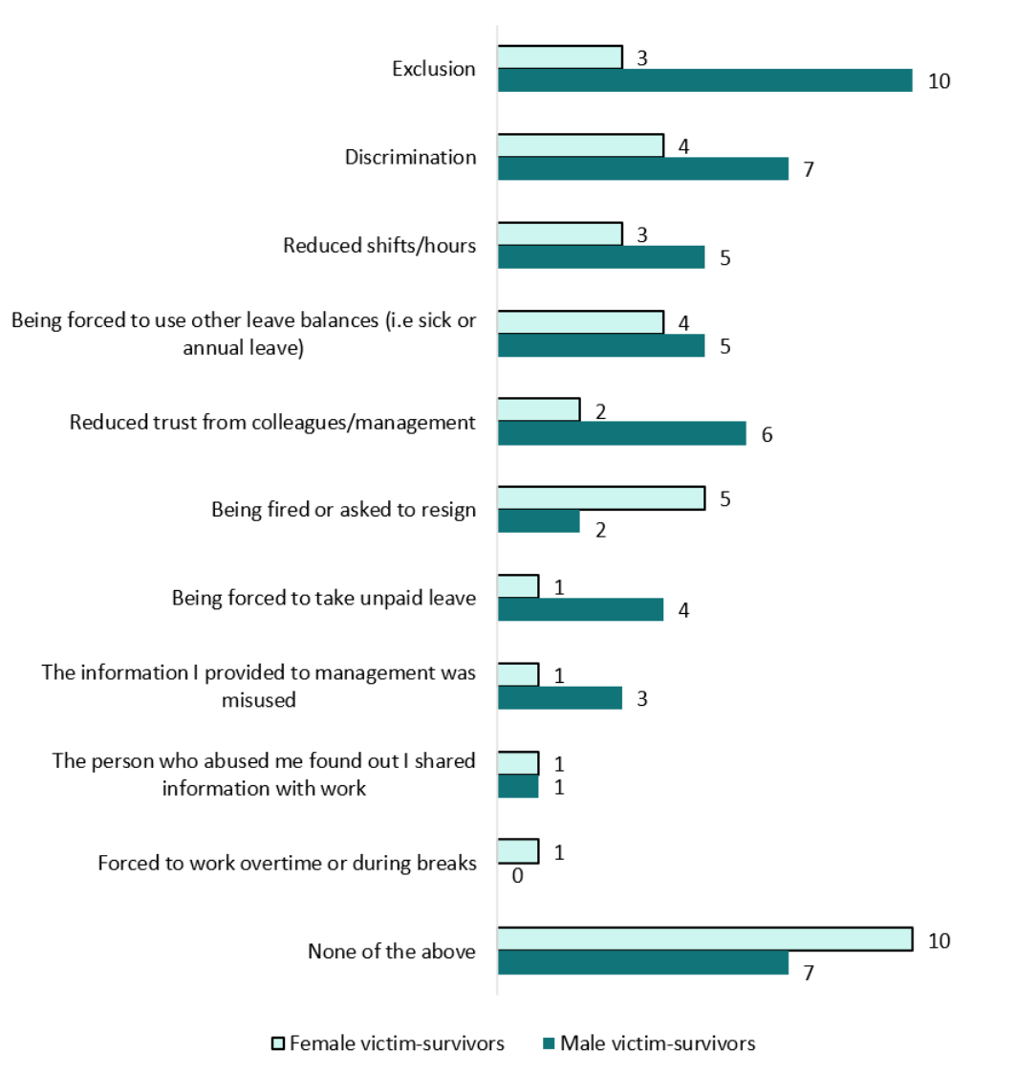

**Source: Victim-survivor survey. Q111 - Were there any negative consequences for you due to taking the leave? - Selected Choice. Filter: Taken FDV leave; Unweighted; base n = 46. Note “other” and “prefer not to say” have been removed from the figure.**

### ****Overall, victim-survivors would recommend the leave, but with caveats****

**The majority of victim-survivors indicated they would recommend the leave to others, and few would caution others against using the leave (Figure 18). Fewer female victim-survivors stated they would caution others (17%) compared to the male victim-survivors (29%).**

**Most of the victim-survivors who had used the leave likewise indicated that they would likely recommend the leave to other victim-survivors (40 out of 46, or 87%). However, leave users were more likely than those who had not used the leave to caution other victim-survivors against using the leave (23 out of 46 leave users, or 50%). While this suggests that some victim-survivors’ experience accessing the FDV leave gave them reason to caution others of the potential negative consequences, their negative experience was not significant enough to prevent them from recommending the leave in general.**

Figure 18. Victim-survivors’ likelihood to advise or caution others regarding FDV leave (%)

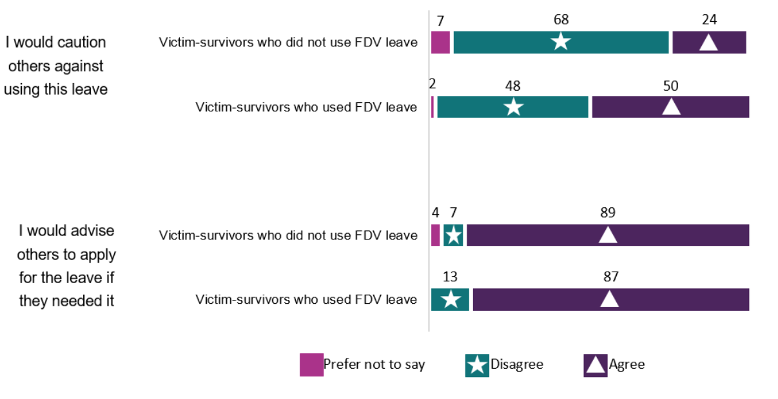

**Source: Victim-survivor survey. Q59 (1) - Do you agree or disagree with the following statements about the paid family and domestic violence leave: - I would advise others to apply for the leave if they needed it. Q59 (6) Do you agree or disagree with the following statements about the paid family and domestic violence leave: - I would caution others against using this leave. All victim-survivors; Unweighted; base n = 594.**

**Victim-survivors were positive overall about the net benefits of the leave entitlement. In the victim-survivor survey, 8 out of 10 victim-survivors (82%) agreed that they would use the leave in the future. There were equal rates of agreement among victim-survivors who had and had not used the leave entitlement.**

“I’m all about like, accessing services if it’s available to you. By all means, use it. But I did step out of my comfort zone to have those conversations and to bring up my entitlement. And although I felt incredibly uncomfortable and anxious about it, I’m glad I did.”

- Victim-survivor interview #6, female, used the leave, part-time

### Employers haven’t yet felt the full impact of the new entitlement

**At this early stage of operation, our research suggests many employers haven’t yet fully incorporated the new entitlement into their processes and policies – particularly those that haven’t yet received a request. This suggests many employers haven’t yet incurred the costs and benefits of operationalising the new entitlement, so the full extent of impacts are yet to be seen.**

**However, we found key impacts on employers include:**

* **the effort in transitioning to the new arrangements**
* **financial costs and staffing implications of staff accessing the leave**
* **positive impacts on staff wellbeing, productivity and workplace culture.**

#### ****Many employers are at early stages of operationalising the entitlement****

**For most businesses, the 2023 commencement of the paid FDV leave entitlement represented a new employment condition. Only just under a quarter of employers in our survey previously offered paid FDV leave (23%) before the legislation came into effect due to enterprise agreements or workplace conditions. Most employers, including those who previously offered paid FDV leave to ongoing staff, needed to contemplate new administrative arrangements to accommodate the eligibility of casual workers.**

****“Yeah, I knew much in advance that this was coming and therefore, I could organise the back end preparation, was good to have the time to prepare all of that and also teach the leaders that this is the new process, in that there's a 10 day paid limit rather than it being ad hoc. Officially, of course, we had the five days unpaid, which was law, but we just tried to support our employees where we could.”****

**- Employer interview #5, HR employee, 6000 employees,** has provided paid FDV leave after the legislative change

“I read it [the email from workplace relationship contractor] and I find it quite stressful having another set of leave as an employer to account for. I understand that there's probably a need for it and there's reasons why it's coming into action, I suppose. But I looked at it, I stressed out and then I closed the email and then I didn't do anything about it.”

- Employer interview #1, business owner, 5 employees, has not yet provided leave

**Our survey suggested many employers are at an early stage of operationalising the entitlement, with only 12% reporting a member of staff accessing paid FDV leave since the legislation came into effect. Just over a third of employers (36%) have communicated the change in entitlement to all of their employees. Of these, less than a third had added FDV leave to employee handbooks or policies (28%) or included it in employee training (29%). While these steps are not required by law, widespread integration of paid FDV leave into employers’ communication and administrative systems could be an important step in ensuring broader access to the leave (see chapter on ‘Discussion: Maximising impact’).**

“I actually didn't realise I was meant to communicate that to my staff that this is now something that you can access.”

- Employer interview #1, business owner, 5 employees, no previous FDV leave experience

“Yeah, on boarding and also if there's, we have our meetings, it can vary, but pretty much any changes discussed in team meetings as such, directly to employees.”

- Employer interview #2, business owner, 10 employees, has provided paid FDV leave before 2023

**Our survey found that the most common challenges identified by employers about the new entitlement are ‘teething’ issues, suggesting employers are experiencing friction or costs in transitioning to new arrangements. Among businesses who had provided the leave, 46% initially encountered a lack of awareness that the leave even existed, 40% encountered issues sourcing clear guidance and 37% felt a key challenge was not feeling equipped to have sensitive conversations with staff (see Figure 11).**

#### Some report substantial financial costs and staffing implications

Among employers who hadn’t yet had a staff member access the paid FDV leave entitlement, financial costs and staffing implications were significant concerns, with 30% of employers highlighting financial costs as a barrier and 25% highlighting staffing shortages. Among employers who had granted the leave, however, only 18% raised financial costs and 17% raised staffing implications. These concerns about financial implications were concentrated among small and micro businesses (30% and 28% respectively) compared with only 14% of larger businesses. Concerns about staffing implications were more evenly shared across business sizes (11% micro, 10% small and 19% medium and large).

For a subset of employers, particularly small businesses, financial costs loomed as the most significant challenge they face in providing paid FDV leave. Even among employers who had granted the leave, 17% of micro businesses, 12% of small business and 7% of larger businesses highlighted financial costs as the largest challenge they faced in providing FDV leave (Figure 19). Some small businesses expressed an expectation that this leave should be reimbursed by the Government.

In contrast, only 4% of employers in our survey who had already had an employee take FDV leave identified staffing implications as their most significant challenge.

**Figure 19. Largest barrier by business size among employers who have had a staff member take FDV leave **(%)****

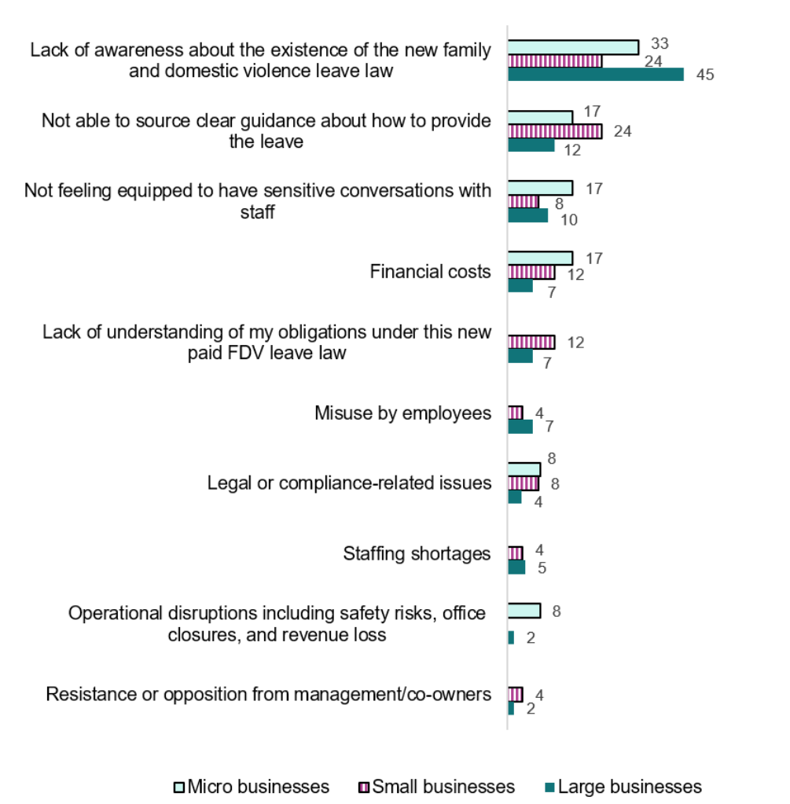

Source: Employer survey. Q73 – And of these barriers, which barrier has had the largest impact? Filter: Employers who have had a staff member access FDV leave; Unweighted; base n = 144.

In our interviews with victim-survivors, several noted the financial impact on their employers, but some argued it was a ‘false economy’ to avoid providing the leave. Victim-survivors argued their work performance and productivity were much improved in the long-run if they were allowed time off to get their lives in order. While this concept was well-understood in interviews with larger businesses, some micro businesses highlighted the stark implications of staff absences, such as losing a day of retail profit.

“It's not the right financial time to be saying, ‘You have to pay this and this and this, and everyone's entitled to this.’ Where my customers aren’t willing to pay an extra two to five bucks on a cookie, I can’t double the price to cover the cost of an extra staff member. It just won’t be... And if I have to do everything without some education, some support and things like that, the time just would mean I probably would shut the business, or I would downscale it back and my employees would not have jobs anymore.”

- Employer interview #15, business owner, 2 employees, has provided paid FDV leave before 2023

“I lose an entire day of profit when that woman, if I can’t replace them, is running a whole market store, that can be nearly a thousand dollars.”

- Employer interview #15, business owner, 2 employees, has provided paid FDV leave before 2023

#### ****Positive impacts include improved staff wellbeing and productivity****

Although in many interviews employers struggled to spontaneously identify benefits to their business from paid FDV leave, surveyed employers selected a range of benefits when prompted. Improved employee well-being emerged as the primary experienced and anticipated benefit of providing paid FDV leave. Those who had experience in providing paid FDV leave also highlighted enhanced workplace safety, increased employee productivity, and a more inclusive and supportive workplace as benefits of providing paid FDV leave.

Figure 20. Employers’ anticipated and experienced positive impacts of the FDV leave entitlement on their organisation (%)

This figure has ten categories, each category broken down into two columns to represent two groups. The columns are labelled 'anticipated by employers who have not granted the leave' and 'experienced by employers who have granted the leave'. The first category is called 'improved employee wellbeing' (71% of participants that were in the 'anticipated by employers who have not granted the leave' selected this and 62% of participants who were in the 'experienced by employers who have granted the leave' selected this). The second category is 'enhanced workplace safety' (44% of participants that were in the 'anticipated by employers who have not granted the leave' selected this and 49% of participants who were in the 'experienced by employers who have granted the leave' selected this). The third category is 'increased employee productivity' (29% of participants that were in the 'anticipated by employers who have not granted the leave' selected this and 40% of participants who were in the 'experienced by employers who have granted the leave' selected this). The fourth category is 'a more supportive and inclusive work environment' (54% of participants that were in the 'anticipated by employers who have not granted the leave' selected this and 37% of participants who were in the 'experienced by employers who have granted the leave' selected this). The fifth category is 'better employee retention' (41% of participants that were in the 'anticipated by employers who have not granted the leave' selected this and 27% of participants who were in the 'experienced by employers who have granted the leave' selected this). The sixth category is 'increased job satisfaction' (30% of participants that were in the 'anticipated by employers who have not granted the leave' selected this and 27% of participants who were in the 'experienced by employers who have granted the leave' selected this). The seventh category is 'positive impact on your organisation's reputation' (34% of participants that were in the 'anticipated by employers who have not granted the leave' selected this and 19% of participants who were in the 'experienced by employers who have granted the leave' selected this). The eighth category is 'promotion of gender equality' (21% of participants that were in the 'anticipated by employers who have not granted the leave' selected this and 18% of participants who were in the 'experienced by employers who have granted the leave' selected this). The ninth category is 'attracted a diverse talent pool' (13% of participants that were in the 'anticipated by employers who have not granted the leave' selected this and 15% of participants who were in the 'experienced by employers who have granted the leave' selected this). The tenth and final category is 'no benefits' (9% of participants that were in the 'anticipated by employers who have not granted the leave' selected this and 5% of participants who were in the 'experienced by employers who have granted the leave' selected this).

Source: Employer survey. Q79 - What positive impacts, if any, have you observed for employees and/or the organisation as a result of paid family and domestic violence leave entitlement? Please select all that apply. Filter: Employers who have had staff take FDV leave; Unweighted; base n = 169.

Employer survey. Q78 - In your opinion, what do you think would be the positive impacts of the new paid family and domestic violence leave entitlement for the organisation? Please select all that apply. Filter: Employers who have not had staff take FDV leave; Unweighted; base n = 1268.

“I think for at the moment our full-time manager, of course they have family and I think it's going to be benefit them if things happen, and I think they will feel trust in our company more because we give this leave to them.”

- Employer interview #3, business owner, 10 employees, no previous FDV leave experience

“Retention, absolutely and seeing really positive change in those individuals by allowing them the time to sort through, wade through, what they’re going through, it's really reflective in their statistics and things when they come back. So giving them that dedicated time to just get what they need to get done on a weekday, when everything's open and available to them, we see a really positive impact on that.”

- Employer interview #5, HR employee, 6000 employees, has provided paid FDV leave before 2023

“Having that transparency is a good thing and I think that it opens up the culture of making staff more willing and feeling more safe to come to you with something that's required if they're having certain issues as well. So I just think it promotes that positive culture as well.”

- Employer interview #2, business owner, 10 employees, has provided paid FDV leave before 2023

#### ****In spite of the costs, employers are overwhelmingly positive****

**Overall, in spite of the financial and administrative costs, employers recognise the need for paid FDV leave entitlements and are overwhelmingly supportive of the legislation. More than three-quarters of surveyed employers (77%) expressed support, with only a small percentage (6%) opposing the legislation and 14% having neutral responses. When asked to explain the reasons for their view, respondents cited consideration for employee wellbeing and FDV’s impact on individuals as key reasons for their support.** Conversely, opponents highlighted concerns about potential misuse and a perceived lack of support from government authorities as the key factors influencing their lack of support.

Figure 21. Top five factors that influence supportive employers’ views of the new FDV leave entitlement (%)

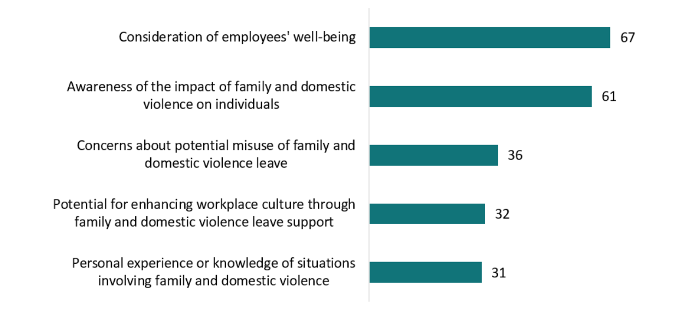

Source: Employer survey. Q82 - **And what factors influence your view of the new paid family and domestic violence leave entitlement? Please select all that apply. By Q81 - Overall, what is your level of support for the new paid family and domestic violence leave entitlement? Filter: Employers who support FDV leave; Unweighted; base n = 1109.**

Figure 22. Top five factors that influence opposing employers’ views of the new FDV leave entitlement (%)

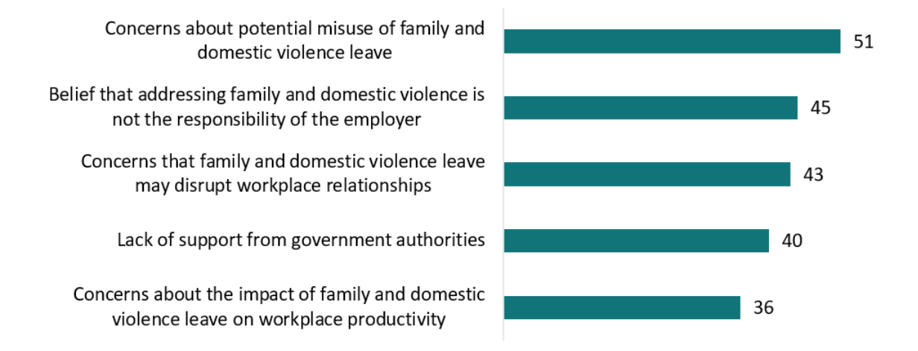

**Source: Employer survey. Q82 - And what factors influence your view of the new paid family and domestic violence leave entitlement? Please select all that apply. By Overall, what is your level of support for the new paid family and domestic violence leave entitlement? Filter: Employers who oppose FDV leave; Unweighted; base n = 92. Note, “other” and “prefer not to say” have been removed from the figure.**

“I think it’s worthwhile, because it’s obviously necessary and it’s one of those topics that generally doesn’t get discussed, may have been sort of pushed under the carpet in the past. So the fact that it’s come about is a good thing. Yes, it’s going to be hard for some people, especially if employees abuse it. And I imagine that would happen more in the larger companies than the smaller ones. There's pros and cons to everything. I think if it’s needed and it's there, then it’s a good thing.”

- Employer interview #8, business owner, 3 employees, no previous FDV leave experience

“They are employed by us. They spend a lot of time in the workforce, and it is part of... work is part of their lives. They need to feel that they can be supported at work. I think that by providing the support as an employer, that's one less thing that they've got to worry about, so they can focus more on getting the support that they need to deal with this issue.”

- Employer interview #11, business owner, 14 employees, female, has provided paid FDV leave before 2023

## Understanding and views of leave parameters

### ****Understanding of the leave parameters is low****

**Unsurprisingly, given the low awareness of the entitlement, we found that victim-survivors, employers and members of the Australian workforce all displayed low knowledge of specific details of the paid FDV leave entitlement provisions.**

**Our surveys included a 10 question quiz on details of the paid FDV leave entitlement, such as on the number of days and types of employees eligible. On average, actual comprehension of the entitlement was low (Figure 23), even amongst victim-survivors who knew about the leave entitlement prior to our survey (mean of 5.19 out of 10 for those aware of the leave compared to 3.65 for those who were not). Employers had the highest level of understanding (mean score of 5.46) followed by members of the Australian workforce (mean score of 4.52) and victim-survivors (mean score of 4.29).**

Figure 23. Average score on FDV leave knowledge survey across victim-survivors, employers and members of the Australian workforce

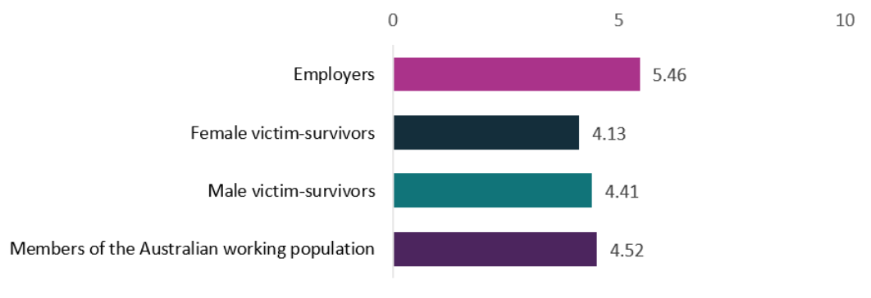

**Source: Employer survey. Aggregate quiz score, out of a possible score of 10. All employers; Unweighted; base n = 1437. Victim-survivor survey. Aggregate quiz score. All victim-survivors; Unweighted; base n = 594. Members of the Australian workforce survey. Aggregate quiz score. All members of the Australian workforce; Unweighted; base n = 2617.**

**In particular, there was confusion about:**

* **the duration of the leave**
* **who qualifies for the leave**
* **the requirement for evidence**
* **activities included in the leave**
* **the definition of FDV.**

### ****Few knew the entitlement was 10 days and views on length were mixed****

Under the *Fair Work Amendment (Paid Family and Domestic Violence Leave) Act 2022*, employees can access up to 10 days of paid family and domestic violence leave each year. The leave renews every year (on the employee’s work anniversary) but doesn’t accumulate.

**One in three victim-survivors in our survey (36%) knew the leave entitlement was for 10 days, while j**ust over half (53%) of employer respondents were aware that the leave entitlement was 10 days. Other employers thought it was 5 days (19%), 3 days (12%) or didn’t know (16%).

**Employers were generally supportive of the leave entitlement and thought the settings broadly appropriate. In interviews, some viewed the 10 days of leave as sufficient and welcomed the positive step forward, anticipating minimal impact on their business. Other employers, however, were concerned about financial implications and suggested 5 days of paid leave would be more feasible, or that the government should provide additional support in conjunction with a shorter paid FDV leave period.**

“I think maybe five days could have been good. Five days paid and five days unpaid.”

- Employer interview #12, HR employee, 30 employees, has provided paid FDV leave in 2023

“I think it [10 days of paid leave] is [adequate], because it gives time to do certain things that they otherwise would not have the time to do as well, or sometimes if they need to leave a residence discreetly or whatever, I think it's sometimes easier when you've got that time where you could process it and do it, whether it's after hours or during business hours, whatever suits. I think it just provides that flexibility to do certain things that have to be done. Yeah. So for a variety, whether it's attending court, whether it's obviously trying to process what's happened or getting that additional support from the way of counselling, I think it's important having that additional time when needed.”

- Employer interview #2, business owner, 10 employees, has provided paid FDV leave before 2023

“I really think that it's been a token gesture of what they've done with the two weeks' leave. I think they really need to implement some support lines, rather than just giving two weeks' leave. It could be that to mean that they... They just can't give away leave like that without really giving any support, and even giving the employers some support lines to say, ‘Look, well, if you've got a person that's got it, this is what you need to do. You've got to give them the access to, I don't know, mentors or police or whatever,’ like it should be.”

- Employer interview #9, business owner, 9 employees, no previous FDV leave experience

**Victim-survivors who had taken paid leave after the 2022 amendments were implemented (which required a minimum of 10 days paid leave be granted) were more satisfied with the number of leave days they were offered than those who had taken paid leave before the amendments were implemented. In our survey, 9 out of 16 (56%) victim-survivors who took paid leave after the 2022 amendments were implemented indicated that the number of days their employer offered them either met or exceeded their need. Whereas 9 out of 30 (30%) who took paid leave before the amendments felt that the number of days their employer offered them either met or exceeded their need.**

In interviews, victim-survivors were generally comfortable with the number of leave days in the legislation. They commented that while the 10 days might not be enough for some people, it was a fair balance between the needs of employees and employers.

“Look, I think in most circumstances it will be enough. You have to draw the line somewhere I guess. Maybe if it was cumulative, like sick leave, will possibly be a better option if that was the case. But in terms of the amount of days per year that you are entitled to, you’ve got to draw the line and, you know, it’s an adequate amount.”

- Victim-survivor interview #19, male, did not use the leave, full-time

“I think… I probably think two weeks is, is adequate. It’s hard to say, isn’t it, because everyone’s situation is different. No two situations are alike.”

- Victim-survivor interview #21, female, did not use the leave, casual

### There is confusion about eligibility, particularly for casuals

Under the *Fair Work Amendment (Paid Family and Domestic Violence Leave) Act 2022,* c**asual, part‑time, and full-time employees are entitled to the leave. The leave is not pro-rated for part-time or casual staff. All employees, including casuals, are entitled to be paid their ‘full rate’, which includes incentive-based payments and bonuses, loadings, monetary allowances, overtime or penalty rates and any other separately identifiable amounts that they would have likely received had they have worked that day. The intention is that employees taking the leave will receive the same remuneration they would have received had they not taken the leave, as far as possible (**Explanatory Memorandum, Fair Work Amendment (Paid Family and Domestic Violence Leave) Bill 2022)**. For casual staff, this means they are to be paid for the hours they were rostered or had accepted with their employer either verbally or in writing, to work in the period they require the FDV leave. Volunteers, sub-contractors and sole traders are not covered by the Act and are therefore not eligible for the paid leave.**

**Both employers and victim-survivors in our survey believed the leave was available for full-time employees (92% and 79% respectively). However, fewer understood that it was available to part-time (80% employers and 65% victim-survivors) and roughly half of each group believed it was available to casual employees (57% employers and 47% victim-survivors). A significant minority of employers erroneously thought that volunteers, sub-contractors and sole traders were also eligible for the leave (19%, 22%, and 23% respectively).**

There is confusion in particular around the eligibility of casual staff. Only half (47%) of victim-survivors were aware that casual staff are eligible for the leave and casual victim-survivors are even less aware of their entitlement, with only 27% aware that casual staff are eligible for paid FDV leave.

“Well, as a casual, any leave is not paid, so then they just probably wouldn't get it paid as such, I'm gathering, because obviously, they get paid more to cover those sort of leave. They just get leave without pay, as such, because there's no guaranteed hours in casual. It's just how it is.”

- Employer interview #9, business owner, 9 employees, no previous FDV leave experience

“I never would’ve thought that it can apply to me [...] Mostly because I’m casual, so I never would think that casuals would be part of the thing.

- Victim-survivor interview #3, female, did not use the leave, casual

“I’ve heard a little bit about it but I hadn’t really looked into it too much and I wasn’t sure if it was relevant for casual staff or not.”

- Victim-survivor interview #20, female, did not use the leave, casual

Additionally, there is confusion around how the logistics of FDV leave work for casual staff. Just under half of victim-survivors believe casual staff are paid pro-rata (42%). Again, casual staff have heightened confusion, with more than a quarter (27%) suggesting they “don’t know” if casual staff are paid pro-rata or not.

### There are common misconceptions about the evidence requirements

Under the *Fair Work Amendment (Paid Family and Domestic Violence Leave) Act 2022,* for an employee to access the leave, the employee only needs to provide evidence to substantiate their claim, if the employer requires it.

**In our survey, one in three (37%) victim-survivors understood that evidence was not mandatory but could be requested by an employer.** Around a quarter of victim-survivors (22%) believed evidence didn’t need to be provided to access FDV leave. Female victim-survivors (23%) were significantly more likely to indicate they “didn’t know” what the evidence requirements for accessing FDV leave were.

Around half of employers understood that employees are only required to provide evidence if requested by the employer (47%). The other half didn’t know (9%) or incorrectly thought leave takers didn’t need to provide evidence in any circumstances (22%) or that they must always provide evidence (22%). These misconceptions were significantly more prevalent in micro businesses, where only 39% correctly understood the evidence requirements.

“I know that they don't have to show any proof of anything. To say it, they can just make that claim, which doesn't really sit well with me. I think they've got to have some case number or something before they could really claim. I'm probably lucky that I'm confident that if it was happening and they put in for that claim, that it would be definitely true, but I know there's a lot of people out there that probably would be very sceptical and say that because we don't... Their people will milk it for what they can, as such.”

- Employer interview #9, business owner, 9 employees, no previous FDV leave experience

Victim-survivors also revealed uncertainty or misconceptions about the type of evidence required. For example, some victim-survivors in interviews reported they **would not be able to generate appropriate evidence to support their application** for the leave because they did not intend to report their abuse to the police**. Such comments are consistent with evidence that indicates only a quarter of women experiencing FDV report their abuse to the police (Duncan et al. 2021). This suggests that victim-survivors who do not have police documents may feel that they cannot access the leave.**

**Even among those who understood that a statutory declaration could be used as evidence, some were unsure of the required content, with many assuming it needed to contain the type of evidence that would be suitable for police or courts, such as** photo or video evidence of the abuse.

“I was a bit curious of what the evidence requirements were. I was worried about if I was going to have to try to get videos. If I was going to have to get audio recordings.”

- Victim-survivor interview #15, female, did not use the leave, part-time

“With a lot of the family violence, you wouldn’t even have this type of evidence. And a statutory declaration – what are you going to write? What detail are they going to need for that? […] A statutory declaration is re-traumatising someone potentially and that’s the only type of evidence that’s going to be constant in all cases. The other stuff would be quite rare. I didn’t have any in my situation. If that’s being insisted on, it’s hugely problematic.”

- Victim-survivor interview #2, female, did not use the leave, part-time

### Victim-survivors lack clarity about what the leave can be used for

Under the *Fair Work Amendment (Paid Family and Domestic Violence Leave) Act 2022,* employees can take paid FDV leave for activities such as arranging for their safety or the safety of a close relative (including relocation), attending court hearings, accessing police services, attending counselling, and attending appointments with medical, financial or legal professionals. Close relatives include a spouse, de facto partner, child, parent, grandparent, grandchild or sibling of the person, or – for First Nations peoples – someone who is related according to kinship rules.

**Victim-survivors displayed low awareness of the type of activities the FDV leave can be used for, with only around half of those we surveyed understanding the leave could be used for relocating (46%), accessing counselling services (52%) or accessing financial services (52%). Female victim-survivors were significantly more likely to believe the leave could be used to re-locate or establish a new home (54%).**

“I honestly didn’t think I would be allowed to use it to move house.”

- Victim-survivor interview #15, female, did not use the leave, part-time

“It wasn’t immediate that [going to court] qualified for it, you know what I mean? In that it was planned and not urgent. So it wasn’t automatic that that was an appropriate use of it.”

- Victim-survivor interview #2, female, did not use the leave, part-time

Surveyed employers had a more accurate understanding of the activities for which the leave can be used. Three quarters understood that the leave could be used for accessing police services (76%), making arrangements for personal safety or the safety of a close relative (75%), accessing medical services (74%) or accessing legal services (74%). Around two thirds understood that the leave could be used for relocating or establishing a home (65%).

### There is confusion about the definition of FDV

Under the *Fair Work Amendment (Paid Family and Domestic Violence Leave) Act 2022,* FDVis defined as **violent, threatening or other abusive behaviour that seeks to coerce or control a victim and causes the victim harm or evokes their fear. For an employee to access paid FDV leave, the FDV can have been perpetrated by either a close relative of the employee, a member of the employee's household, or a current or former intimate partner of the employee.**

**In our interviews, some victim-survivors and employers thought the paid FDV leave was only applicable for some types of abuse. In particular, some thought the leave would only be available for people who experienced violence from a partner (rather than others within the household), or had experienced physical or sexual violence but not financial abuse or coercive control.** This misconception prevented some victim-survivors from accessing paid FDV leave.

“I didn’t think it applied to me. […] Historically it was always very much about physical and sexual violence. I suppose it’s terrible that I thought that – maybe because it’s so much harder to prove? You have to have someone who just takes your word for it and believes you.”

- Victim-survivor interview #7, female, used the leave, full-time

“Because I don't know under what circumstances an employee would use it. I don't understand how they would actually use it. I don't know, do they come to me and go, ‘I'm in a domestic violence situation, I need some time off.’ Do they say, "I need time off because I've ‘been beaten up and I'm in hospital?’ But no, because that would be like sick leave. I don't understand why they need it. That sounds terrible. I'm not articulating it correctly. There's obviously a need for it, but I'm not sure of the actual specifics of when someone would use it.”

- Employer interview #1, business owner, 5 employees, no previous FDV leave experience

## Other supports

This chapter outlines the other supports provided to victim-survivors in the workplace in addition to the statutory requirements, and other supports requested by employers in implementing the entitlement.

### Other supports for victim-survivors

#### Employers offered a range of supports to victim-survivors

Surveyed employers reported offering a range of additional supports for staff experiencing FDV in addition to paid FDV leave (Figure 24). Many of these supports, like employee assistance programs (EAP) and working from home arrangements, are general workplace supports and are not specific to victim-survivors. However, a significant minority of employers did offer specific additional supports, such as additional unpaid FDV leave (25%), safety planning and protocols (14%) and additional paid FDV leave (13%). Larger businesses were more likely to offer additional supports, with 75% of large businesses offering supports, compared with 53% of micro and 65% of small businesses.

Figure 24. Support measures offered by employers in their organisations (%)

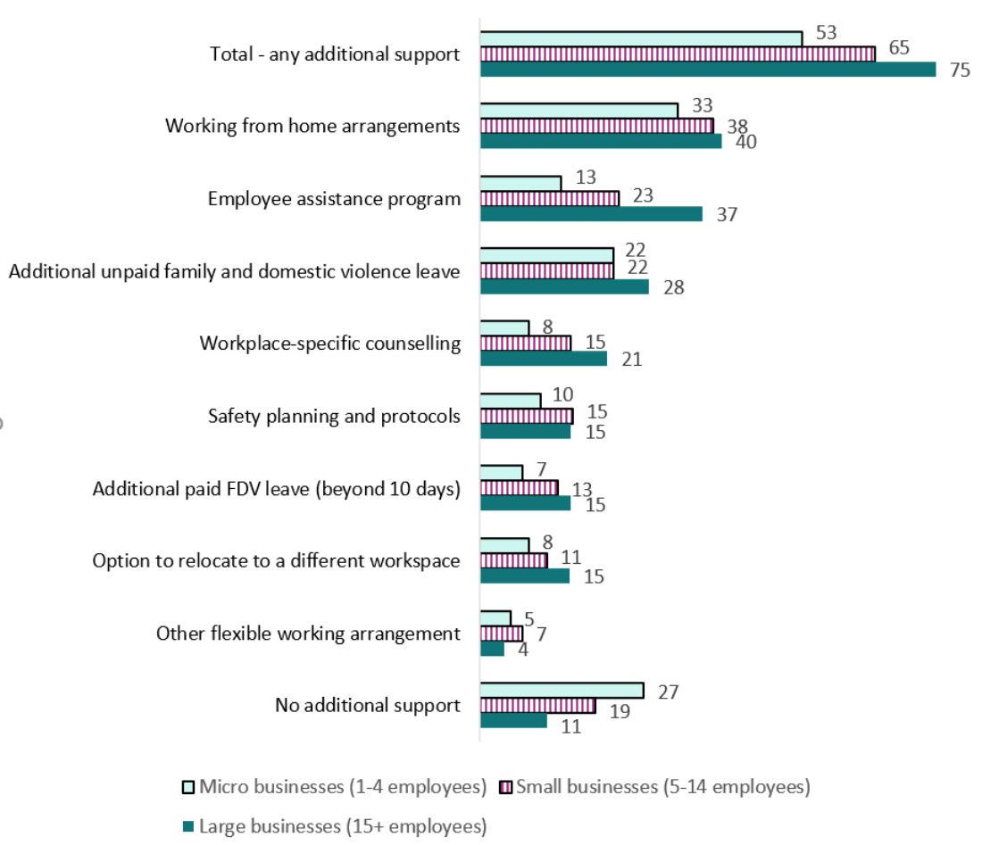

Source: Employer survey. Q68 - Does your organisation offer any of the below supports for staff experiencing family or domestic violence? Please select all that apply. All employers; Unweighted; base n = 1437. The ‘Other’, ‘Prefer not to say’ and ‘Not sure’ options have been removed from the figure.

In our victim-survivors survey, 61% reported that they received additional support from their employer. This was significantly higher for victim-survivors who took FDV leave (41 out of 46 leave users, or 89%). The most common support provided across all victim-survivors surveyed was moral support (30%), followed by flexible working hours (27%) and counselling or EAP referral (21%). A small proportion of victim-survivors reported their workplace took extra security measures such as safety planning and protocols (12%), alerting security staff (12%) or changed or screened work numbers or emails (9%). The only significant difference in types of support received between leave users and other victim-survivors was that leave users were more likely to report that their employer “alerted security staff” (19 out of 46 leave users or 39%).

In interviews, victim-survivors often spoke about the benefit of EAP counselling provisions because they reduced the cost and wait time of accessing counselling services privately. Another common support was additional leave or flexible work. Some victim-survivors talked about employers offering extra leave if the initial leave was not sufficient, offering flexible hours or leave during “blackout” busy periods. Some victim-survivors welcomed their manager working with them to adjust duties to make them more suitable. Victim-survivors’ experience of moral support from managers was variable, with some finding it helpful and others feeling they did not have a close enough relationship to welcome it.

“I know in that job that I had […] I could use the employee assistance scheme to talk to a psychologist, you know privately on a video conference. […] If I did not have that service to avail myself of, I think, I probably would have ended up in a mental health unit myself.”

- Victim-survivor interview #21, female, did not use the leave, casual

“They did write underneath that leave I could have, you know, they said I could have taken off more leave after that, we could sort of work around it and that sort of thing.”

- Victim-survivor interview #11, non-binary, used the leave, full-time

“I think that being able to like, look at a person’s role with them and think ‘what is manageable, what doesn’t’ […] I definitely think it would be good to like, have a conversation to tailor what work feels okay and what work doesn’t.”

- Victim-survivor interview #14, female, used the leave, full-time

A third of victim-survivors surveyed (33%) said they had not told anyone at their work about their experience with FDV. One interviewed victim-survivor felt if she had disclosed her FDV, she would have received more support, but she preferred to keep the FDV experience private.

#### Employers sought subsidies, information and training

After identifying that financial costs were the most significant challenge in providing the leave (see Figure 11), small and micro businesses in our sample emphasised that financial assistance or incentives for business would be a helpful support for them in assisting staff members affected by FDV (Figure 25). Fifty five percent (55%) of micro businesses and 52% of small businesses indicated financial assistance would be a helpful support, and this was the most commonly sought support among these businesses.

Medium and large businesses were more focused on information and training. The most commonly identified helpful supports among these businesses were clearer guidelines for managing FDV situations (40%) and training on identifying signs of FDV in staff (Figure 25). A similar number of medium and large businesses wanted regular updates on obligations (37%) and an awareness campaign to highlight the new entitlement (36%). A third of larger businesses (34%) – a significantly smaller proportion than that of small and micro business – selected financial assistance or incentives as a helpful support.

Figure 25. Extra supports considered helpful by business owners (%)

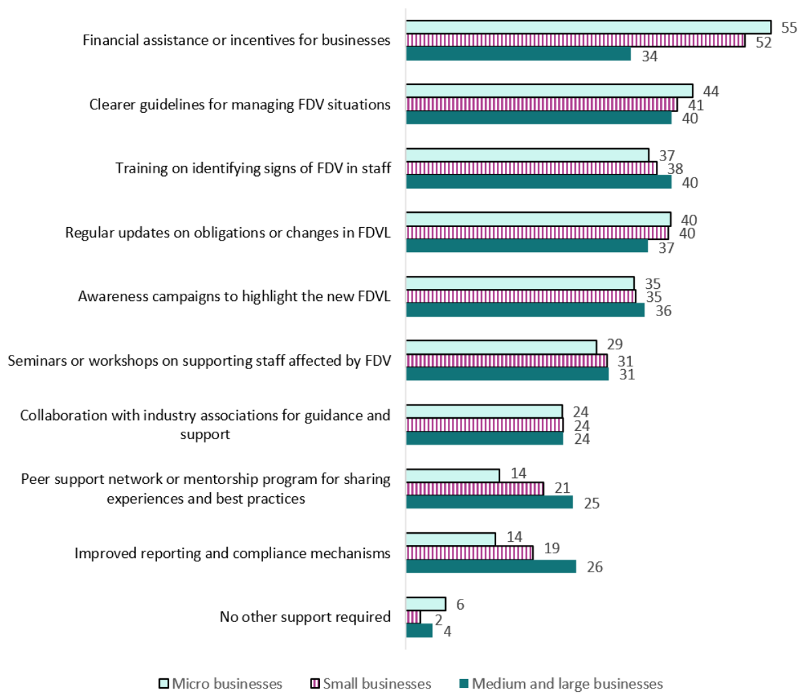

Source: Employer survey. Q84 - What support would be most helpful for you in providing the best assistance for staff members affected by family and domestic violence? Please select all that apply. All employers; Unweighted; base n = 1437.

“A little night session of come and we'll do a talk for two hours at this community centre, an invite to the local businesses, and this is what we're going to talk about. This is what you need to be aware of. Amazing. That's not even offered, is it?”

- Employer interview #1, business owner, 5 employees, has not yet provided FDV leave

“I think you need to register the type of business you are on a portal with the government and therefore your registered email address that maybe you have gets sent these things. I think a bit of the onus needs to be on the government to inform businesses *[about FDV leave entitlements]*.”

- Employer interview #15, 2 employees, has provided FDV leave before 2023

## Discussion: Maximising impact

While the leave entitlement is performing well overall, our research identified a number of challenges in the implementation of the legislation. This chapter summarises these challenges and draws on BETA’s expertise in behavioural science to offer insights relevant to policy solutions.

We identified seven opportunities to strengthen the impact of the leave entitlement:

* raise broad awareness of the existence of the leave entitlement (and FDV itself)
* empower casual employees to access the leave
* make it easier for victim-survivors to approach their employer
* reduce the barriers associated with victim-survivors providing evidence
* promote existing employer resources and encourage preparation
* support employers to create safe, trauma-informed, stigma-free workplaces
* consider the needs of victim-survivors who are not eligible for the leave.

Additionally, monitoring the uptake and impact of the leave entitlement over time – by collecting data from businesses, for example, or through existing national surveys – would help to understand its evolving impact and tailor awareness-raising or support efforts.

### Raise broad awareness of the leave entitlement (and FDV itself)

Our results indicated that low awareness of FDV leave entitlements among both victim-survivors and employers is impeding uptake of the leave by people who need it. We also found in our survey experiment that increased awareness and salience of the leave among members of the Australian workforce would reduce stigma faced by leave users in the workplace. Our research has highlighted the important role played by workplaces as either a supporter or source of stigma for victim-survivors.

Efforts to raise awareness of FDV and relevant workplace protections should be delivered broadly, at an Australian workforce level. Awareness efforts could focus on:

* the likelihood that there are victim-survivors in your workplace
* the existence of the leave entitlement and the eligibility of both permanent and casual staff
* the addition of FDV as a ‘protected attribute’ under the Fair Work Act, meaning that employees are protected from discrimination as a result of being a victim-survivor
* where to get further information.

This would equip people to seek further information if and when they need it. A broad awareness effort would increase the likelihood that a victim-survivor or a confidant is aware of the leave and can advise the victim-survivor at a suitable time, especially for vulnerable victim-survivors not yet connected to FDV support services. We also expect broader awareness of new workplace entitlements would reduce the stigma experienced by victim-survivors in the workplace, as suggested by our survey experiment.

These messages could be conveyed through public messaging, including government FDV campaigns and, potentially, liaison with the media. Government communication campaigns and Australian media articles about FDV currently often mention the 1800RESPECT helpline at the end of stories or advertisements about family and domestic violence or related issues. They could be encouraged to extend this message to mention the support available, including paid FDV leave for all employees and the Australian Government’s ‘Leaving Violence Payment’. This could be particularly effective in raising awareness given the significant media attention currently focused on family and domestic violence.

Another key avenue for victim-survivors to become aware of FDV leave is through their workplace, either through colleagues, a manager or internal communications. Employers are currently required to give every new employee the Fair Work Information Statement, which mentions FDV leave among other protections and entitlements. However, people tend to experience considerable cognitive load at the start of a new job, so we suggest consideration be given to increasing the prominence of FDV leave information in the information sheet. This could be achieved by adding information in text form with a dedicated heading (rather than only in the table of entitlements). Additionally, employers could be encouraged and supported to also advise ongoing staff of the new entitlement through their existing communication channels with employees, such as staff meetings or workplace health and safety discussions.

### Empower casual employees to access the leave

Our results indicate victim-survivors who are employed on a casual basis have lower awareness, uptake and understanding about FDV leave than other victim-survivors. They were also more likely to appraise the relationship with their manager poorly, which is a key determinant in whether victim-survivors consider taking the leave. However, casuals are also an important target audience for this leave – existing research shows casual staff are more likely to experience domestic violence than others in paid work and are more vulnerable to its effects (Loxton, Egan, Townsend and Barnes 2024).

Given casual staff tend to be ineligible for other types of paid leave, they may pay less attention to leave information in information sheets and employer policies. Proactive efforts may be required to raise their awareness. One possibility is to adopt targeted awareness efforts in industries with high rates of casual employees (such as retail, care and hospitality) and consider working with unions and employers in these industries to raise awareness. An explainer about paid FDV leave could also be added to the Casual Employment Information Statement.

### Make it easier for victim-survivors to approach employers

Victim-survivors informed us that the process of telling a manager or workplace about their FDV was a key barrier in accessing the leave due to concerns about privacy and potential career impacts. A positive and trusting relationship between a victim-survivor and their manager appears pivotal in supporting uptake of FDV leave. Unfortunately, our questions about **employee trust in leaders revealed** many victim-survivors had a poor relationship with their manager, preventing many from accessing the leave.

Victim-survivors who do not have a supportive relationship with their workplace or manager may benefit from third-party involvement. In larger employers, victim-survivors would benefit from being able to approach a trained HR representative. To achieve a similar effect in smaller employers, existing support services could be asked to expand their services to approach employers on behalf of victim-survivors when requested.

Victim-survivors who are concerned about privacy may be reassured by information about how their information will be shared and stored. According to the principles of trauma-informed practice (Harris and Fallot 2001; Bloom 2013), transparency of issues related to privacy is highly important for establishing trust with victim-survivors. Proactive communication by employers about the storage and access of information may reduce some of the barriers to accessing leave. This could be facilitated by adding to existing employer support materials to encourage employers to communicate privacy protections to leave applicants.

Information for victim-survivors – such as that in the Fair Work Information Statement – c*o*uld also be expanded to explain the implications of FDV being a protected attribute under the law.

### Reduce the barriers associated with victim-survivors providing evidence

The perceived requirement for leave users to provide onerous evidence of FDV was a key concern for victim-survivors in considering whether to apply for the leave. Although evidence is only required from victim-survivors when requested by employers, we heard that victim-survivors were heavily focused on this possibility. Being asked for evidence helped establish a mentality among victim-survivors that they needed to ‘make a case’ for the leave, rather than simply accessing an entitlement. Although the evidence requirement for paid FDV leave is similar to other leave entitlements, it creates a barrier to accessing the leave because of the sensitivity of the information which forms the evidence and the vulnerable state of mind of many victim-survivors.

There is also confusion among victim-survivors about the types of evidence that are acceptable under the FDV leave legislation. Victim-survivors tended to mistakenly believe the only acceptable evidence would be official police or court documents. However, we know from both our interviews with victim-survivors and a large body of research (Duncan et al. 2021) that many victim-survivors choose not to report their abuse to police. The mistaken perception that only police or court documents are acceptable evidence is preventing some victim-survivors from accessing FDV leave.

One way to address this confusion would be to provide targeted messages to victim-survivors about the leave entitlement. The Fair Work Ombudsman website contains neutral and generic information about FDV leave and the 10dayspaidfdvleave.com.au page provides information predominantly for small businesses. But currently there is no government resource targeted specifically at supporting victim-survivors. This would be a subtle change, but the tone of the information and how it is delivered could make a difference to victim-survivors seeking assistance. The FWO website’s landing page could potentially include a split between “information for people experiencing abuse” and “information for employers”, enabling each audience to seek customised information that is most relevant to them.

An enhanced FWO resource could:

• emphasise to both victim-survivors and employers that paid FDV leave is an entitlement like sick leave and annual leave, and the option to request evidence is simply about providing supporting documentation rather than imposing an onerous approval process.

• ensure victim-survivors are aware that there is no obligation to get a police report for leave purposes if they don’t have one already, and evidence such as letters from counselling or FDV support services, medical certificates or statutory declarations are also valid if their employer requests evidence. It may also be helpful to provide examples of the type of statements to be included in such documents to correct misconceptions that these documents need to lay out evidence that would normally be required to satisfy police or a court.

Some employers also mistakenly believed they could not request evidence from staff who are asking for FDV leave, and this belief seems to be fuelling fears that employees will misuse their FDV leave entitlement. This misconception is addressed in existing resources for employers; further promoting these resources could help resolve this concern (see next section).

### Promote existing employer resources and encourage preparation

Our research found many employers had not yet taken steps to incorporate paid FDV leave into their systems and processes. For leave users who encountered an unprepared manager or workplace, this added significant stress and uncertainty to a traumatic period in their lives. Employers in our sample were also hungry for additional support, such as guides for having difficult conversations, training on the detail of the leave entitlement, and regular updates on changes.

There are a range of high-quality resources available on the FWO and 10dayspaidfdvleave.com.au websites. We heard from employers that they found these sites to be very helpful and practical. However, the majority of employers had either not sought them out or not found them.

Instead, the primary channel through which businesses had discovered the leave entitlement was through media reporting. We note this likely reflected the burst of media coverage when the legislation took effect – coverage may be minimal in the future. Given the relatively low rates of awareness and understanding of the entitlement among employers, there is a case for a renewed push to encourage employers to visit the existing high-quality resources.

One approach could be to use existing highly utilised channels through which governments engage with employers, such as state government business registers, to raise awareness of the leave entitlement and encourage employers to access existing resources on the topic. New business owners are a key target audience moving forward, so the Australian Government’s guide to starting a business (on [business.gov.au](https://business.gov.au/)) could be updated to link to and reference employer obligations regarding FDV leave.

We note that the resource funded by Government to support small business, 10dayspaidfdvleave.com.au, was the 27th result in an internet search using a search term “family and domestic violence leave”. Employer engagement with this site could be improved through an investment in search engine optimisation.

In any promotion activities, a key message should be to encourage businesses to proactively prepare for leave requests, given the significant positive impact this preparation has on victim-survivors. For example, employers could ensure all managers are aware of the entitlement, and update their systems, processes and policies. This would reduce uncertainty and associated stress for both leave applicants and employers.

Employers in our research also proposed other potential supports including subsidies or other financial supports for small and micro businesses.

### Support employers to create safe, trauma-informed, stigma-free workplaces

Consistent with previous research (Fitz-Gibbon et al. 2023; Overstreet and Quinn 2013; Taccini and Mannarini 2023), a strong theme across our research was that stigma of victim-survivors within the workplace and poor relations with their manager were barriers to victim-survivors taking the FDV leave. On the other hand, we found supportive workplace cultures and positive relationships with managers were associated with greater uptake of the leave. It remains unclear whether supportive workplaces were more likely to offer the leave or victim-survivors were more likely to request the leave if they felt safe at work – it’s likely a combination of both. Further, we found that a positive, supportive workplace can offer additional benefits to victim-survivors, such as moral support and encouragement to seek other help. It is worth noting that, based on new protections from 15 December 2023 under the Fair Work Act, it is unlawful for an employer to take adverse action against an employee or potential employee because they have been, or are being, subjected to family and domestic violence. These protections may help promote more supportive workplaces for victim-survivors.

Although many employers in our research prioritised staff wellbeing and were eager to do what they could to support staff experiencing FDV, many victim-survivors still did not feel comfortable to request or use the leave. To translate good intentions into impact, employers who are highly committed may appreciate support to build a trusting, stigma-free and trauma-informed workplace culture with respect to FDV. One option for pursuing this could be to facilitate engagement and dialogue between FDV advocacy groups and business groups to offer advice and support on creating safe, stigma-free and trauma-informed workplaces. Another option could be to ensure training on how to support FDV victim-survivors is included in accredited courses for managers and HR personnel.

### Consider the needs of victim-survivors who are not eligible for leave

While the paid FDV leave entitlement effectively supports victim-survivors in paid work with an employer, it does not support large categories of victim-survivors.

In particular, victim-survivors not in paid work do not benefit from this entitlement, including those who are unemployed, not in the labour force and volunteers. Evidence suggests this encompasses a significant proportion of people (particularly women) experiencing family and domestic violence. In the general population, around 39.5% of working-age women are outside the paid workforce (ABS 2024) and recent evidence indicates this rate is likely significantly higher among women experiencing FDV (Loxton et al. 2024 unpublished). These victim-survivors require additional targeted research and further consideration should be given to alternative mechanisms (other than paid FDV leave) across government to promote financial independence, personal safety and access to support services for these groups. We note there are a range of existing and planned government supports in place for this cohort, including those laid out in the National Plan to End Violence against Women and Children 2022–2032.

Sole traders and self-employed people are also unable to benefit from this leave entitlement when experiencing FDV. Further research could explore whether this presents a barrier to victim-survivors in this group remaining in work, maintaining their income and accessing relevant services.

## Appendix: Methodology and samples

### Methodology

We obtained ethics approval through Macquarie University’s Human Research Ethics Committee for the following 5 research activities.

#### 1. Interviews with FDV victim-survivors

We conducted 22 semi-structured, in-depth interviews with victim-survivors. All participants had experienced FDV while employed during the time the paid FDV leave legislation was in effect. To ensure we captured diverse experiences with the leave, we spoke to victim-survivors who did and did not take the paid FDV leave, who had been employed either as a casual or on a part- or full-time basis, and had been employed in a micro, small or large business. We also selected participants to vary by age, gender, and state or territory. For full details of the sample see Table 1.

Interviews were conducted online on Microsoft Teams, lasted 30 to 60 minutes and participants were paid a $150 reimbursement upon completion of the interview.

#### 2. Survey with FDV victim-survivors

We surveyed 594 people who self-identified as having experienced FDV while in paid employment in Australia within the last 5 years. No quotas were applied to this survey to ensure we maximised the number of victim-survivors included in our research. We recruited participants through an online research panel and also through referral from 8 domestic violence service providers. Participants recruited through the online panel were reimbursed for their time through the online panel’s standard arrangements. Participants referred from domestic violence service partners were reimbursed for their time with a $30 e-gift card. For full details of the sample, see Table 2.

#### 3. Interviews with employers

We conducted 16 semi-structured, in-depth interviews with employers. One participant did not fit the inclusion criteria and was excluded from the analysis. Our final sample of 15 employers included employers from a range of organisational sizes, including 4 micro businesses, 6 small businesses and 5 large businesses. For full details of the sample, see Table 3.

Interviews ran for approximately 60 minutes and were conducted online via Microsoft Teams by BETA moderators. Participants were recruited via an online research panel and were reimbursed approximately $200 for their time.

#### 4. Survey of employers

We surveyed 1,437 business owners and managers. Participants were recruited from an online panel. Our sample consisted of 43% owners or co-owners and 57% managers. All managers surveyed were screened on their responsibility for actioning leave requests within the organisation. Our sample comprised a range of organisational sizes, including 328 micro businesses, 438 small businesses and 671 medium/large businesses. For full details of the sample, see Table 4.

#### 5. Working population experiment and survey

We conducted an online survey experiment with 3,008 participants. Quotas based on Australian Bureau of Statistics data were utilised to ensure the sample was representative of the Australian workforce population as recruited through an online survey panel. For the experiment, participants evaluated the work performance and behaviour of a fictional employee who had taken leave because they had experienced FDV. Respondents assigned the fictional employee a ‘bonus’ from $0 to $1,000 based on the employee’s work outcomes and behaviour, made a decision about whether or not the employee should be recommended for a management position, and rated the employee’s level of competency across 6 characteristics. Respondents were randomly allocated to receive information about the paid FDV leave legislation either *before* they evaluated the fictional employee (treatment group) or *after* (control group).

Respondents received information about the paid FDV leave entitlement in the form of educational feedback immediately following each response they gave to a quiz designed to determine their comprehension. Respondents also indicated how they felt about the legislated entitlement in terms of whether they agreed or disagreed with various statements (such as their willingness to use the leave or recommend it to others in the future if needed).

We hypothesised that if the paid FDV leave legislation has the potential to reduce stigma and discrimination, then respondents who received information about the legislation *before* evaluating the fictional employee would assign a larger bonus, would be more likely to recommend the employee for a management position, and would rate the employee’s competency as higher than those who received information about the legislation afterwards. For more details of the survey experiment, see accompanying Technical Report.

### Considerations and limitations

#### We could not measure all potential impacts

There are number of potentially important impacts and outcomes that were beyond the scope of our research. For instance, although we asked individuals about their experiences and attitudes towards the new leave entitlement, our research was not designed to measure direct causal impacts of the changes on rates of leave uptake or other outcomes.

Although we included uptake of the paid FDV leave entitlement in our surveys with victim-survivors and employers, our results cannot be used to determine overall uptake of the leave entitlement across Australia. This is because our victim-survivor survey sample was small and not nationally representative.

Understanding the impact of the legislation on sole traders, who are not eligible to give or receive the leave entitlement under the Fair Work Act, was not within scope of our research.

We did not explore whether the legislation reduced further violence due to the leave enabling victims to engage effectively with appropriate support services (such as counselling). Future research may wish to explore this potential longer-term impact given it was one of the Australian Government’s expressly stated hopes regarding this legislation (Explanatory Memorandum, Fair Work Amendment (Paid Family and Domestic Violence Leave) Bill 2022).

Our research also did not explore second-order economic impacts such as whether provision of paid FDV leave reduces absenteeism, increases productivity or reduces costs associated with staff turn‑over (Stanford 2016).

#### Sampling approach and limitations

We collected quantitative data through online panel sampling. Online panels are made up of thousands of individuals who have opted in to participate in research and are reimbursed with small payments for their time. Online panel sampling is a commonly used approach in social research as it allows for the affordable collection of a large amount of data. Online panel sampling is non-random and findings from such research cannot be generalised to the Australian population. Although online panels are large and diverse, they only include individuals who are digitally literate, read and write fluent English, and are willing to participate in online research.

#### High rates of male respondents in our victim-survivor survey

The proportion of male respondents in our victim-survey survey was higher than anticipated. While both men and women can be victims and perpetrators of FDV, the majority of FDV is perpetrated by men against women (ABS 2021-22; ABS 2022). However, in our victim-survivor survey, 54% of the 321 victim-survivor respondents were male.

There are a variety of factors that may have contributed to the larger than anticipated proportion of male respondents. First, it may be that women who experience FDV are less likely to be in paid employment than men who have experienced FDV. In support of this hypothesis, we found that, of those who were initially approached to participate in our research, a greater proportion of the women reported they had experienced FDV compared to the men (37% of the women compared to 28% of the men). However, many of the women who had experienced FDV were not eligible to participate in our victim-survivor survey as they were not in paid employment during the period they had experienced FDV. Specifically, we found that while 68% of the men who experienced FDV were employed at the time, only 55% of the women were.

Additionally, our sample may have been affected by selection bias, in that male victim-survivors may have been more motivated to participate as a response to feeling under-represented in FDV research and statistics, or that female victim-survivors may have been less likely to participate due to issues associated with physical or psychological safety.

#### We did not target vulnerable populations

There are vulnerable populations within the Australian population who are more likely to experience FDV or are likely to experience it in a different way. For instance, among First Nations people, 90% of violence against women is undisclosed, with some barriers to disclosure including beliefs that they should look for support from their kin, or that the violence is a private matter (AIHW 2024b). For some CALD communities, domestic violence may be visa abuse or dowry abuse (AIHW 2024c), while for LGBTIQA+ persons it can be threatening to ‘out’ a person’s sexuality, gender or HIV status (AIHW 2024d). To understand and evaluate the impact of FDV leave on these audiences, more in-depth and customised research (such as translation or in-language moderation) is required.

#### Our experiment explores potential, not actual, stigma reduction

The online survey experiment included in our research could only explore the potential for the legislation to reduce stigma and discrimination. Any real-world reduction in stigma will be dependent on the clarity in which the legislative entitlement, including the anti-discriminatory provisions, are communicated to members of the Australian working population.

### Samples

Table 1. Victim-survivor interview demographics (*n* = 22)

| Category | Demographic | *n* |
| --- | --- | --- |
| Gender | Female | 16 |
| Gender | Male | 4 |
| Gender | Non-binary | 2 |
| Type of employment | Casual | 5 |
| Type of employment | Part-time | 7 |
| Type of employment | Full-time | 10 |
| Size of employer | Small | 7 |
| Size of employer | Medium/large | 15 |
| State | New South Wales (NSW) | 7 |
| State | Victoria (VIC) | 7 |
| State | Queensland (QLD) | 5 |
| State | Western Australia (WA) | 2 |
| State | Australian Capital Territory (ACT) | 1 |
| Taken paid FDVL | Yes | 7 |
| Taken paid FDVL | No | 15 |
| Age | 18-24 | 4 |
| Age | 25-34 | 7 |
| Age | 35-44 | 4 |
| Age | 45-54 | 4 |
| Age | 55-64 | 2 |
| Age | 65+ | 1 |

Table 2. Victim-survivor survey demographics (*n* = 594)

| Category | Demographics | *n* |
| --- | --- | --- |
| Gender | Female | 268 |
| Gender | Male | 321 |
| Gender | Non-binary/third gender | 5 |
| State/Territory | New South Wales (NSW) | 176 |
| State/Territory | Victoria (VIC) | 144 |
| State/Territory | Queensland (QLD) | 135 |
| State/Territory | Western Australia (WA) | 49 |
| State/Territory | Australian Capital Territory (ACT) | 19 |
| State/Territory | Tasmania (TAS) | 7 |
| State/Territory | South Australia (SA) | 59 |
| State/Territory | Northern Territory (NT) | 5 |
| Age | 18-34 | 286 |
| Age | 35-54 | 276 |
| Age | 55+ | 32 |
| When was the last time you experienced FDV while also being in the workforce? | Between 2018 and 2022 | 466 |
| When was the last time you experienced FDV while also being in the workforce? | Between 2023 and 2024 | 128 |
| Do you identify as LGBTIQA+? | Yes | 90 |
| Do you identify as LGBTIQA+? | No | 498 |
| Do you identify as LGBTIQA+? | Prefer not to say | 6 |
| Country of birth | Australia | 502 |
| Country of birth | Countries other than Australia | 91 |
| Country of birth | Prefer not to say | 1 |
| Main language spoken at home | English | 545 |
| Main language spoken at home | LOTE | 49 |
| English proficiency | Native speaker | 277 |
| English proficiency | Very good | 58 |
| English proficiency | Good | 21 |
| English proficiency | Okay | 2 |
| Do you identify as Aboriginal and/or Torres Strait Islander? | Yes – Aboriginal | 36 |
| Do you identify as Aboriginal and/or Torres Strait Islander? | Yes – Torres Strait Islander | 2 |
| Do you identify as Aboriginal and/or Torres Strait Islander? | Yes – Aboriginal and Torres Strait Islander | 7 |
| Do you identify as Aboriginal and/or Torres Strait Islander? | No | 543 |
| Do you identify as Aboriginal and/or Torres Strait Islander? | Prefer not to say | 6 |
| What is your highest level of education? | University or higher | 292 |
| What is your highest level of education? | Trade, certificate, or diploma | 205 |
| What is your highest level of education? | Secondary or below | 96 |
| What is your highest level of education? | Prefer not to say | 1 |
| Do you have any children? | Yes | 347 |
| Do you have any children? | No | 246 |
| Do you have any children? | Prefer not to say | 1 |
| What age brackets are your children in? | 0-2 | 73 |
| What age brackets are your children in? | 3-5 | 71 |
| What age brackets are your children in? | 5-7 | 93 |
| What age brackets are your children in? | 8-9 | 71 |
| What age brackets are your children in? | 10-12 | 94 |
| What age brackets are your children in? What age brackets are your children in? | 13-15 | 85 |
| What age brackets are your children in? | 16-18 | 47 |
| What age brackets are your children in? | 18+ | 57 |
| What age brackets are your children in? | Prefer not to say | 1 |
| For the last job you were in when you experienced FDV, what was your employment status? | Employed full-time | 427 |
| For the last job you were in when you experienced FDV, what was your employment status? | Employed part-time | 102 |
| For the last job you were in when you experienced FDV, what was your employment status? | Casual | 64 |
| For the last job you were in when you experienced FDV, what was your employment status? | Prefer not to say | 1 |
| How many employees were in the business you worked for? | 1 to 4 | 26 |
| How many employees were in the business you worked for? | 5 to 14 | 98 |
| How many employees were in the business you worked for? | 15 to 199 | 242 |
| How many employees were in the business you worked for? | 200+ | 209 |
| How many employees were in the business you worked for? | Prefer not to say | 3 |
| How many employees were in the business you worked for? | Don’t know | 16 |
| What industry did you work in? | Female dominated industries | 294 |
| What industry did you work in? | Male dominated industries | 300 |

Table 3. Employer interview demographics (*n* = 15)

| Category | Demographics | *n* |
| --- | --- | --- |
| Gender | Female | 10 |
| Gender | Male | 5 |
| Age | 18-34 | 3 |
| Age | 35-54 | 11 |
| Age | 55+ | 1 |
| State/Territory | New South Wales (NSW) | 5 |
| State/Territory | Victoria (VIC) | 6 |
| State/Territory | Queensland (QLD) | 3 |
| State/Territory | South Australia (SA) | 1 |
| Role | Business owner | 11 |
| Role | HR employee | 4 |
| Number of employees | 1-4 | 3 |
| Number of employees | 5-14 | 7 |
| Number of employees | 15+ | 5 |
| Industry | Health care | 2 |
| Industry | Construction | 3 |
| Industry | Rental | 1 |
| Industry | Not-for-profit | 1 |
| Industry | Admin and support | 1 |
| Industry | Information media | 1 |
| Industry | Food | 1 |
| Industry | Retail/trade | 2 |
| Industry | Manufacturing | 2 |
| Industry | Agriculture | 1 |
| Awareness of new FDVL legislation | Yes | 14 |
| Awareness of new FDVL legislation | No | 1 |
| Previous FDVL experience | Yes | 8 |
| Previous FDVL experience | No | 7 |
| Type of most employees | Full-time | 13 |
| Type of most employees | Part-time | 1 |
| Type of most employees | Casual | 1 |

Table 4. Employer survey demographics (*n* = 1437)

| Category | Demographics | *n* |
| --- | --- | --- |
| Gender | Female | 638 |
| Gender | Male | 795 |
| Gender | Non-binary | 2 |
| Gender | Prefer not to say | 2 |
| Age | 18-34 | 444 |
| Age | 35-54 | 764 |
| Age | 55+ | 229 |
| Which of the following sectors do you work in? | Private sector/business | 1351 |
| Which of the following sectors do you work in? | Not-for-profit sector | 66 |
| Which of the following sectors do you work in? | Other (please specify) | 20 |
| Which of the following best describes your role at work? | Manager/Team Leader | 546 |
| Which of the following best describes your role at work? | Human Resource Representative | 27 |
| Which of the following best describes your role at work? | Department manager/Head of Department | 64 |
| Which of the following best describes your role at work? | Administrative/Operations Manager | 147 |
| Which of the following best describes your role at work? | Finance/Accounting Manager | 83 |
| Which of the following best describes your role at work? | Legal/Compliance Officer | 3 |
| Which of the following best describes your role at work? | Sales Representative | 14 |
| Which of the following best describes your role at work? | IT Representative | 17 |
| Which of the following best describes your role at work? | Other (please specify) | 13 |
| Do you have any of the below responsibilities in your role within your organisation? (Select all that apply) | Processing and/or approving employee leave | 1338 |
| Do you have any of the below responsibilities in your role within your organisation? (Select all that apply) | Managing employee well-being | 1123 |
| Do you have any of the below responsibilities in your role within your organisation? (Select all that apply) | Managing payroll | 974 |
| Do you have any of the below responsibilities in your role within your organisation? (Select all that apply) | Booking travel arrangements | 730 |
| Do you have any of the below responsibilities in your role within your organisation? (Select all that apply) | None of the above | 26 |
| Which of the following best describes the size of your organisation? | 1-4 employees | 328 |
| Which of the following best describes the size of your organisation? | 5-14 employees | 438 |
| Which of the following best describes the size of your organisation? | 15+ employees | 671 |
| Which of the following types of employees does your organisation currently have? | Full-time | 1275 |
| Which of the following types of employees does your organisation currently have? | Part-time | 625 |
| Which of the following types of employees does your organisation currently have? | Casual | 501 |
| Which of the following types of employees does your organisation currently have? | Sub-contractor | 250 |
| In which state or territory is your organisation based? | New South Wales (NSW) | 489 |
| In which state or territory is your organisation based? | Victoria (VIC) | 398 |
| In which state or territory is your organisation based? | Queensland (QLD) | 290 |
| In which state or territory is your organisation based? | South Australia (SA) | 88 |
| In which state or territory is your organisation based? | Western Australia (WA) | 124 |
| In which state or territory is your organisation based? | Tasmania (TAS) | 29 |
| In which state or territory is your organisation based? | Australian Capital Territory (ACT) | 13 |
| Which geographical region in Australia best describes the location of your organisation? | Metropolitan (city or urban area) | 1078 |
| Which geographical region in Australia best describes the location of your organisation? | Rural (town or countryside) | 140 |
| Which geographical region in Australia best describes the location of your organisation? | Regional | 193 |
| Which geographical region in Australia best describes the location of your organisation? | Remote | 16 |
| Which geographical region in Australia best describes the location of your organisation? | Very remote | 3 |
| Which geographical region in Australia best describes the location of your organisation? | Other (please specify) | 1 |
| Which geographical region in Australia best describes the location of your organisation? | Prefer not to say | 6 |
| Do you speak a language other than English at home? | Yes (please specify) | 142 |
| Do you speak a language other than English at home? | No | 1274 |
| Do you speak a language other than English at home? | Prefer not to say | 21 |
| How would you describe your level of proficiency in spoken English? | Native speaker | 1061 |
| How would you describe your level of proficiency in spoken English? | Very good | 293 |
| How would you describe your level of proficiency in spoken English? | Good | 60 |
| How would you describe your level of proficiency in spoken English? | Okay | 14 |
| How would you describe your level of proficiency in spoken English? | Prefer not to say | 9 |
| Were you, or either of your parents, born outside of Australia? | Yes, I was born outside of Australia | 283 |
| Were you, or either of your parents, born outside of Australia? | Yes, one or both of my parents were born outside of Australia | 396 |
| Were you, or either of your parents, born outside of Australia? | No | 842 |
| Were you, or either of your parents, born outside of Australia? | Prefer not to say | 19 |
| Have you had any personal experience with FDV? | Yes | 417 |
| Have you had any personal experience with FDV? | No | 963 |
| Have you had any personal experience with FDV? | Prefer not to say | 57 |
| What is your highest level of education? | University or higher | 828 |
| What is your highest level of education? | Trade, certificate, or diploma | 431 |
| What is your highest level of education? | Secondary or below | 167 |
| What is your highest level of education? | Prefer not to say | 11 |
| Please select the industry that best describes your organisation from the options below | Health care | 126 |
| Please select the industry that best describes your organisation from the options below | Education | 86 |
| Please select the industry that best describes your organisation from the options below | Retail | 193 |
| Please select the industry that best describes your organisation from the options below | Hospitality | 87 |
| Please select the industry that best describes your organisation from the options below | Non-profit and social services | 50 |
| Please select the industry that best describes your organisation from the options below | Information technology | 120 |
| Please select the industry that best describes your organisation from the options below | Finance and banking | 140 |
| Please select the industry that best describes your organisation from the options below | Construction | 157 |
| Please select the industry that best describes your organisation from the options below | Engineering | 37 |
| Please select the industry that best describes your organisation from the options below | Automotive | 32 |
| Please select the industry that best describes your organisation from the options below | Mining | 19 |
| Please select the industry that best describes your organisation from the options below | Manufacturing | 75 |
| Please select the industry that best describes your organisation from the options below | Energy | 6 |
| Please select the industry that best describes your organisation from the options below | Transportation | 38 |
| Please select the industry that best describes your organisation from the options below | Telecommunications | 14 |
| Please select the industry that best describes your organisation from the options below | Other (please specify) | 230 |
| Please select the industry that best describes your organisation from the options below | Prefer not to say | 27 |

Table 5. Working population survey demographics (n=2356)

| Category | Demographics | *n* |
| --- | --- | --- |
| Gender | Female | 1317 |
| Gender | Male | 1294 |
| Gender | Non-binary/third gender | 6 |
| Age | 18-34 | 1033 |
| Age | 35-54 | 1105 |
| Age | 55-70 | 479 |
| State/Territory of residence | New South Wales (NSW) | 768 |
| State/Territory of residence | Victoria (VIC) | 678 |
| State/Territory of residence | Australian Capital Territory (ACT) | 45 |
| State/Territory of residence | Tasmania (TAS) | 63 |
| State/Territory of residence | South Australia (SA) | 231 |
| State/Territory of residence | Western Australia (WA) | 292 |
| State/Territory of residence | Northern Territory (NT) | 8 |
| State/Territory of residence | Queensland (QLD) | 532 |
| Do you Identify as Aboriginal and/or Torres Strait Islander? | Yes – Aboriginal | 36 |
| Do you Identify as Aboriginal and/or Torres Strait Islander? | Yes – Torres Strait Islander | 2 |
| Do you Identify as Aboriginal and/or Torres Strait Islander? | Yes – Aboriginal and Torres Strait Islander | 6 |
| Do you Identify as Aboriginal and/or Torres Strait Islander? | No | 2554 |
| Do you Identify as Aboriginal and/or Torres Strait Islander? | Prefer not to say | 19 |
| Employment status | Business owner or sole trader | 83 |
| Employment status | Casual | 607 |
| Employment status | Employed full-time | 1441 |
| Employment status | Employed part-time | 479 |
| Employment status | Prefer not to say | 3 |
| Employment status | Sub-contractor | 4 |
| Do you own or manage a business? | Yes – business owner | 72 |
| Do you own or manage a business? | Yes – business manager | 67 |
| Do you own or manage a business? | No | 750 |
| Have you ever experienced FDV? | Yes | 598 |
| Have you ever experienced FDV? | No | 1910 |
| Have you ever experienced FDV? | Prefer not to say | 109 |
| And were you in paid employment at the time you experienced FDV? | Yes | 296 |
| And were you in paid employment at the time you experienced FDV? | No | 250 |
| And were you in paid employment at the time you experienced FDV? | Prefer not to say | 9 |
| When was the last time you experienced FDV while also being in the workforce? | Before 2018 | 323 |
| What country were you born in? | Australia | 2027 |
| What country were you born in? | Outside of Australia | 590 |
| Main language spoken at home | English | 2352 |
| Main language spoken at home | LOTE | 259 |
| Main language spoken at home | Prefer not to say | 6 |
| Proficiency in spoken English | Native speaker | 2013 |
| Proficiency in spoken English | Very good | 453 |
| Proficiency in spoken English | Good | 127 |
| Proficiency in spoken English | Okay | 19 |
| Proficiency in spoken English | Bad | 3 |
| Proficiency in spoken English | Very bad | 2 |
| What is your highest level of education? | University or higher | 1364 |
| What is your highest level of education? | Trade, certificate, or diploma | 782 |
| What is your highest level of education? | Secondary or below | 470 |
| What is your highest level of education? | Prefer not to say | 1 |
| What industry do you work in? | Agriculture, forestry and fishing | 40 |
| What industry do you work in? | Mining | 38 |
| What industry do you work in? | Manufacturing | 91 |
| What industry do you work in? | Electricity, gas, water and waste services | 28 |
| What industry do you work in? | Construction | 135 |
| What industry do you work in? | Wholesale trade | 42 |
| What industry do you work in? | Retail trade | 305 |
| What industry do you work in? | Accommodation and food services | 135 |
| What industry do you work in? | Transport, postal and warehousing | 113 |
| What industry do you work in? | Information media and telecommunications | 81 |
| What industry do you work in? | Financial and insurance services | 117 |
| What industry do you work in? | Rental, hiring and real estate services | 34 |
| What industry do you work in? | Professional, scientific and technical services | 236 |
| What industry do you work in? | Administrative and support services | 144 |
| What industry do you work in? | Public administration and safety | 118 |
| What industry do you work in? | Education and training | 299 |
| What industry do you work in? | Health care and social assistance | 359 |
| What industry do you work in? | Arts and recreation services | 68 |
| What industry do you work in? | Other services | 223 |
| What industry do you work in? | Prefer not to say | 11 |
| Roughly how many employees are in the organisation you work for? | 1-4 employees | 203 |
| Roughly how many employees are in the organisation you work for? | 5-14 employees | 320 |
| Roughly how many employees are in the organisation you work for? | 15-199 employees | 851 |
| Roughly how many employees are in the organisation you work for? | 200+ employees | 1093 |
| Roughly how many employees are in the organisation you work for? | Prefer not to say | 3 |
| Roughly how many employees are in the organisation you work for? | Don’t know | 147 |
| To the best of your knowledge, are casual employees eligible to take any type of paid leave as soon as their employment begins? | Yes | 397 |
| To the best of your knowledge, are casual employees eligible to take any type of paid leave as soon as their employment begins? | No | 1515 |
| To the best of your knowledge, are casual employees eligible to take any type of paid leave as soon as their employment begins? | Don’t know | 705 |

## References

ABS (Australian Bureau of Statistics) (2016), [*Personal Safety, Australia*](https://www.abs.gov.au/statistics/people/crime-and-justice/personal-safety-australia/2016), ABS Website, accessed 21 May 2024.

ABS (Australian Bureau of Statistics) (2021-22) [*Personal Safety, Australia*](https://www.abs.gov.au/statistics/people/crime-and-justice/personal-safety-australia/latest-release), ABS Website, accessed 21 May 2024.

ABS (Australian Bureau of Statistics) (2022), [*Recorded Crime - Victims*](https://www.abs.gov.au/statistics/people/crime-and-justice/recorded-crime-victims/latest-release), ABS Website, accessed 21 May 2024.

ABS (Australian Bureau of Statistics) (2024), [*Labour Force April 2024*](https://www.abs.gov.au/statistics/labour/employment-and-unemployment/labour-force-australia/latest-release), ABS Website, accessed 24 May 2024.

AIHW (Australian Institute of Health and Welfare) (2024a)[*Family, domestic and sexual violence; Family and domestic violence*](https://www.aihw.gov.au/family-domestic-and-sexual-violence/types-of-violence/family-domestic-violence#:~:text=Over%201%20in%204%20women&text=FDV%20was%20more%20common%20among,1)%20(ABS%202023).)*,* AIHW website, accessed 30 May 2024.

AIHW (Australian Institute of Health and Welfare) (2024b) [*Family, domestic and sexual violence; Aboriginal and Torres Strait Islander people*](https://www.aihw.gov.au/family-domestic-and-sexual-violence/population-groups/aboriginal-and-torres-strait-islander-people#:~:text=Aboriginal%20and%20Torres%20Strait%20Islander%20(First%20Nations)%20people%20are%20overrepresented,relationships)%20(Cripps%202023).), AIHW website, accessed 22 May 2024.

AIHW (Australian Institute of Health and Welfare) (2024c) [*Family, domestic and sexual violence; People from culturally and linguistically diverse backgrounds*](https://www.aihw.gov.au/family-domestic-and-sexual-violence/population-groups/cald#data), AIHW website, accessed 22 May 2024.

AIHW (Australian Institute of Health and Welfare) (2024d)[*Family, domestic and sexual violence; LGBTIQA+ people*](https://www.aihw.gov.au/family-domestic-and-sexual-violence/population-groups/lgbtiqa-people), AIHW website, accessed 22 May 2024.

Albiston C and Correll S (2023) ‘Law’s Normative Influence on Gender Schemas: An Experimental Study on Counteracting Workplace Bias against Mothers and Caregivers’, *Law & Social Inquiry*, 1-39, doi:10.1017/lsi.2022.102

Alessi EJ and Kahn S (2023) ‘Toward a trauma-informed qualitative research approach: Guidelines for ensuring the safety and promoting the resilience of research participants’, *Qualitative Research in Psychology*, 20(1):121-154, doi: 10.1080/14780887.2022.2107967

Bilz K and Nadler J (2014) ‘Law, moral attitudes, and behavioral change’, The Oxford handbook of behavioral economics and the law, 241-267.

Bloom SL (2013) *Creating sanctuary: Toward the evolution of sane societies*, 1st edn, Routledge, New York.

Bricknell S (2023) [‘Homicide in Australia 2020-21](https://www.aic.gov.au/publications/sr/sr42)’, *Statistical Report number. 42*, Australian Institute of Criminology, accessed 23 May 2024.

Chang JC, Dado D, Hawker L, Cluss PA, Buranosky R, Slagel L, McNeil M and Scholle SH (2010) ‘Understanding turning points in intimate partner violence: factors and circumstances leading women victims toward change’, *Journal of women's health*, 19(2):251-259, doi: 10.1089/jwh.2009.1568

Colombotos J (1969) ‘Physicians and Medicare: A before-after study of the effects of legislation on attitudes’, *American Sociological Review*, 34(3):318-334.

Cortis N and Bullen J (2016) ‘[Domestic violence and women’s economic security: Building Australia’s capacity for prevention and redress: Final Report’](https://www.anrows.org.au/publication/domestic-violence-and-womens-economic-security-building-australias-capacity-for-prevention-and-redress-final-report/), *ANROWS Horizons series 05/2016*, ANROWS

Downes J, Kelly L and Westmarland N (2014) ‘Ethics in violence and abuse research-a positive empowerment approach’, *Sociological Research Online*, 19(1):29-41, doi: 10.5153/sro.3140

Dragiewicz M, Woodlock D, Easton H, Harris B and Salter M (2023) ‘“I’ll be okay”: survivors’ perspectives on participation in domestic violence research’, *Journal of family violence*, 38(6):1139-1150, doi: 10.1007/s10896-023-00518-6

Duncan A, Mavisakalyan A and Twomey C (2021) [Family and domestic violence in Australia: Prevalence, impact and responses](https://bcec.edu.au/assets/2021/12/BCEC-Briefing-Note-2021-2-Family-and-Domestic-Violence-in-Australia-1.pdf)*, Bankwest Curtin Economics Centre Research Briefing Note 21/2,* Bankwest, accessed 9 March 2024.

*Fair Work Amendment (Paid Family and Domestic Violence Leave) Act 2022*

Fischer S, Walker, A and Hyder S (2023) ‘The development and validation of a multidimensional organisational trust measure’, *Frontiers in Psychology*, *14*:1189946, doi:10.3389/fpsyg.2023.1189946

Fitz-Gibbon K, Pfitzner N and McNicol E (2023) ‘Domestic and family violence leave across Australian workplaces: Examining victim-survivor experiences of workplace supports and the importance of cultural change’, *Journal of Criminology*, 56(2-3):294-312, doi: 10.1177/263380762211482

Ganley AL, Fazio J, Hyman A, James L and Ruiz-Contreras A (1998) [*Improving the health care response to domestic violence: A trainer’s Manual for health care*](https://www.futureswithoutviolence.org/userfiles/file/HealthCare/improving_healthcare_healthtrainer.pdf), The Family Violence Prevention Fund, accessed 15 February 2024.

Harris ME and Fallot RD (2001) *Using trauma theory to design service systems*, Jossey-Bass/Wiley, San Francisco.

Jaffe AE, DiLillo D, Hoffman L, Haikalis M and Dykstra RE (2015) ‘Does it hurt to ask? A meta-analysis of participant reactions to trauma research’, *Clinical psychology review*, 40:40-56, doi: 10.1016/j.cpr.2015.05.004

Legerski JP and Bunnell SL (2010) ‘The risks, benefits, and ethics of trauma-focused research participation’, *Ethics & Behavior*, 20(6):429-442, doi: 10.1080/10508422.2010.521443

Loxton D, Egan N, Townsend N and Barnes I (2024 unpublished) *Women, work and domestic violence: Summary unadjusted data from the Australian Longitudinal Study on Women’s Health*, report to the Australian Government Department of the Prime Minister and Cabinet, Women’s Health Australia.

McFerran L (2011) [*Safe at home, safe at work? National domestic violence and the workplace survey 2011*](https://apo.org.au/node/27394), Analysis and Policy Observation, accessed 23 November 2023.

My Business (2022) [*Domestic Violence Survey Report*](https://www.mybusiness.com.au/how-we-help/be-a-better-employer/managing-people/domestic-violence-survey-results)*,* My Business, accessed 22 November 2023.

Overstreet NM and Quinn DM (2013) ‘The intimate partner violence stigmatization model and barriers to help seeking’, *In Social Psychological Perspectives on Stigma*, 1:35(1): 109-122, doi: 10.1080/01973533.2012.746599

Patton S (2003) ‘[*Pathways: How women leave violent men*](https://nla.gov.au/nla.obj-1382075787/view)’ Department of Premier and Cabinet, Government of Tasmania, accessed 25 November 2023.

Policastro C and Payne BK (2013) ‘The blameworthy victim: Domestic violence myths and the criminalization of victimhood’, *Journal of Aggression, Maltreatment & Trauma*, 22(4):329-347, doi: 10.1080/10926771.2013.775985

Rubin M (2021) ‘When to adjust alpha during multiple testing: A consideration of disjunction, conjunction, and individual testing’, *Synthese,* 199(10969-11000), doi: 10.1007/s11229-021-03276-4

Stanford J (2016) [*Economic aspects of paid domestic violence leave provisions*](https://futurework.org.au/wp-content/uploads/sites/2/2022/11/Economic_Aspects_Domestic_Violence_Leave.pdf). Centre for Future Work at the Australia Institute, accessed 24 April 2024.

Taccini F and Mannarini S (2023) ‘An attempt to conceptualize the phenomenon of stigma toward intimate partner violence survivors: a systematic review’ *Behavioral Sciences*, 13(3): 194, doi: 10.3390/bs13030194

The Parliament of the Commonwealth of Australia (2022) [*Fair Work Amendment (Paid Family and Domestic Violence Leave) Bill 2022: Explanatory Memorandum*](https://parlinfo.aph.gov.au/parlInfo/search/display/display.w3p;query=Id%3A%22legislation%2Fems%2Fr6882_ems_805554bf-e778-4e8b-9820-9c463ff038bf%22).

Trotter JL and Allen NE (2009) ‘The good, the bad, and the ugly: Domestic violence survivors’ experiences with their informal social networks’. *American journal of community psychology*, 43:221-231, doi: 10.1007/s10464-009-9232-1

Victorian Government (2022) [*Lived experience engagement guidance for government workers*](https://www.vic.gov.au/lived-experience-engagement-guidance-government-workers#examples-of-the-type-of-government-worker-who-would-benefit-most-from-this-guidance), Victorian Government, accessed 22 November 2023.

Werner CM, Turner J, Shipman K, Twitchell FS, Dickson BR, Bruschke G.V and von Bismarck WB (1995) ‘Commitment, behavior, and attitude change: An analysis of voluntary recycling’, *Journal of Environmental Psychology*, 15(3):197–208, doi: 10.1016/0272-4944(95)90003-9

**© Commonwealth of Australia 2021**

ISBN 978-1-925365-56-6 Family and domestic violence leave: Research findings for the Independent Review

**Copyright Notice**

With the exception of the Commonwealth Coat of Arms, this work is licensed under a Creative Commons Attribution 4.0 International license (CC BY 4.0) (<https://creativecommons.org/licenses/by/4.0/>)



**Third party copyright**

Wherever a third party holds copyright in this material, the copyright remains with that party. Their permission may be required to use the material. Please contact them directly.

**Attribution**

This publication should be attributed as follows:

© Commonwealth of Australia, Department of the Prime Minister and Cabinet, *Family and domestic violence leave: Research findings for the Independent Review*.

**Use of the Coat of Arms**

The terms under which the Coat of Arms can be used are detailed on the following website: https://pmc.gov.au/cca



Behavioural Economics Team   
of the Australian Government

**General enquiries** [**beta@pmc.gov.au**](mailto:beta@pmc.gov.au)

**Media enquiries** [**media@pmc.gov.au**](mailto:media@pmc.gov.au)

**Find out more** [**www.pmc.gov.au/beta**](http://www.pmc.gov.au/beta)