The workplace experience of hospitality apprentices

- The fast food, restaurants and cafes sector sees disproportionately high levels of non-compliance with workplace laws.
- Hospitality apprentices are often young workers and can be more vulnerable to workplace exploitation. This can discourage them from completing their apprenticeship.
- A lack of knowledge about workplace rights and obligations may contribute to poor workplace experiences.

We partnered with the Fair Work Ombudsman to address this challenge. We designed simple, timely education messages and tested the impact. Our messages were:
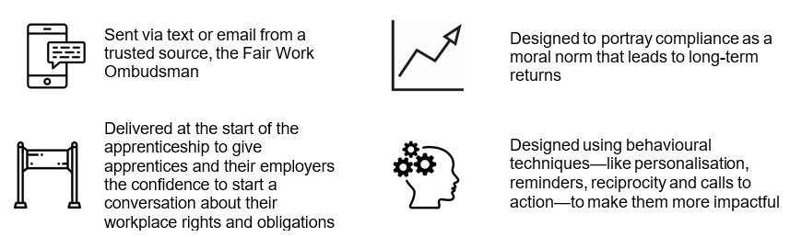

What we found:
