Nudge vs Superbugs: 12 months on

  - June 2020

About this report
This is an update report to Nudge vs Superbugs: A behavioural economics trial to reduce the overprescribing of antibiotics (Australian Government 2018). It builds on the six-month results provided in the initial report and details the continued effect of providing general practitioners (GPs) with peer comparison feedback on reducing antibiotic prescribing over 12 and 15 months.
More detailed information about the trial and initial six-month results is available in the original report.

The problem
Antimicrobial resistance (AMR) is one of the biggest threats to human health today and is an increasing concern in Australia and around the world. A report commissioned by the UK Government estimates, if we fail to act, by 2050 AMR will lead to the death of 10 million people globally every year. But this is not just a problem for the future – it is happening now. It is estimated at least 700,000 people around the world die each year from antibiotic resistant infections.
One of the key drivers of AMR is antibiotic use, which remains high in Australia per capita. It is important we take action to improve stewardship across all sectors where antibiotics are used, including human health, animal health and agriculture.
GPs prescribe more antibiotics than other health professionals, due to the large numbers of patients seen in general practice, and the types of illnesses they treat.
GPs are sometimes caught between patients demanding antibiotics, time pressures and managing uncertainty in diagnosing an infection. This can result in increased antibiotic prescribing. It also means GPs have an important role to play as partners in combating AMR.

What we did
We applied behavioural insights to the design of letters sent by the Australian Government’s Chief Medical Officer (CMO) to high-prescribing GPs. The letters aimed to prompt GPs to reflect on whether they could reduce prescribing when appropriate and safe.
The letters provided GPs with information on how their prescribing compared to their peers, to help inform future prescribing. Simple peer comparison feedback like this can be powerful because as humans we often look to others to guide our own choices.
We undertook a cluster randomised controlled trial (RCT) involving 6,649 GPs whose prescription rates were in the top 30 per cent for their region to test the impact of these letters. Four groups of GPs received different versions of the letter.
In three versions of the letter, we compared GPs’ antibiotic prescription rates with those of other GPs in their region. A fourth letter contained only education messages about AMR and antibiotic prescribing. A fifth group received no letter.

Results over time
Peer comparison letters had a long-term impact, helping GPs reduce antibiotic prescribing by 9.0 per cent over the year and, at their peak, by 13.6 per cent.
Most cases of upper respiratory tract infections in Australia occur during the winter months (June-September). In anticipation of this, we chose to send the letters on 9 June 2017, at the beginning of the cold and flu season. In the year prior to sending the letters, the prescription rates for the five groups were almost identical for the group of eight commonly prescribed antibiotics monitored. Following the letters there was a striking reduction in the monthly prescription rate for each of the three peer comparison groups, which persists over the twelve months of the trial. While the impact of the peer comparison letters decreases over this time, at the start of the next cold and flu season, in June 2018, the effect of the letters shows signs of strengthening (see Figure 1).
Figure 1: Antibiotic prescription rates, June 2016 to September 2018
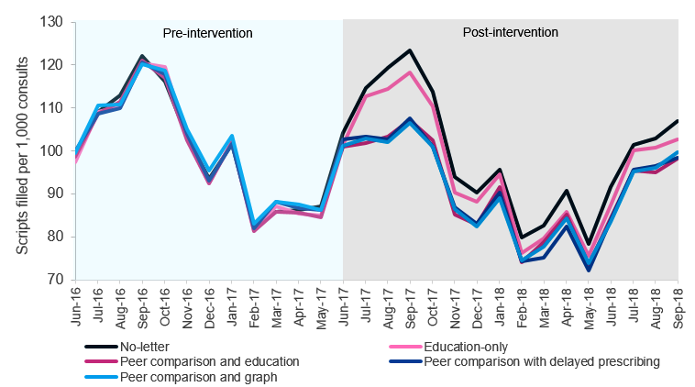
Sample size n=6,649. This chart presents prescription rates for those GPs and the eight commonly prescribed antibiotics in this trial. The prescription rate reflects the number of scripts filled, which reflects patient behaviour as well as GP prescribing decisions.

Cumulative effect over six months
In the initial report, we found high-prescribing GPs who received the peer comparison letters substantially reduced their prescribing over the following six months. Compared to GPs who did not receive a letter, the peer comparison letters caused a 9.3 to 12.4 per cent reduction in antibiotic prescription rates over the six months, with the peer comparison with graph letter performing best. In contrast, sending doctors a letter containing educational material without the peer comparison cut prescriptions by only 2.4 per cent on average over the six months.

Cumulative effect over twelve months
We can now report the peer comparison letters had a persistent effect for a further six months. Over the full twelve months, the average prescription rate in the no-letter group was 98.5 scripts per 1,000 consults. The three peer comparison letters caused an 8.4 to 9.4 per cent average reduction, all of which were statistically significantly different from the control group.
Because the three peer comparison letters had very similar effects over six and twelve months, we now combine the three letters for ease of reporting. Together, the three peer comparison letters reduced prescription rates by 9.0 per cent over the twelve-month period.
Figure 2: Cumulative 12-month effects of intervention by letter group
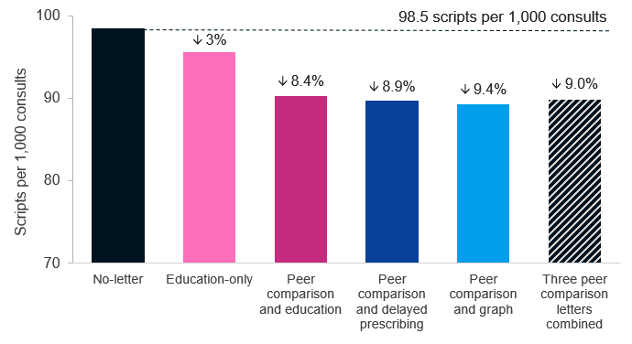
Sample size n=6,608. This chart shows prescription rates and the percentage difference from the no-letter group over 12 months for the education-only letter and the three peer comparison letters both individually and pooled together. GPs in the no-letter control group had 98.5 scripts filled per 1,000 consults whereas this rate fell to 89.8 scripts filled for the combined peer comparison group, a reduction of 9.0 per cent (p<0.000001). See Appendix for the complete table of estimates, p-values and confidence intervals.
Monthly effects
Figure 3 presents the percentage reduction in monthly prescription rates attributable to the three peer comparison letters over time. At their most effective, in August 2017, the peer comparison letters reduced prescriptions by around 13.6 per cent.
Figure 3: Monthly effects of the peer comparison letters compared to the control group
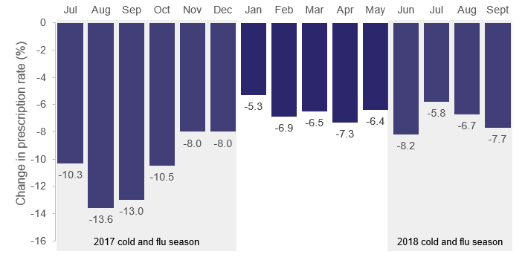
This chart shows the difference in prescription rates (number of scripts filled per 1,000 consults) between the control group and the three peer comparison groups combined. For example, in August 2017, the prescribing rate was 13.6 per cent lower for the peer comparison groups than for the control group (p<0.000001). See Appendix for tables of estimates, p-values and confidence intervals.
At the end of the 2017 cold and flu season, the effectiveness of the peer comparison letters began to decline. This can be seen between October 2017 and January 2018, after which the monthly effect of the letters plateaued at around 5 to 7 per cent. During this period, the difference between all three peer comparison letters and the control remains statistically significant.
At the end of the twelve-month period, the three letters continued to have an impact, with a statistically significant reduction in antibiotic prescription rates of about 6.4 per cent.

Impact on the total number of scripts filled
We estimate the four letters together (the peer comparison letters and the education-only letter) reduced the number of scripts being filled by about 190,000 over the twelve-month period.
If we had sent any of the peer comparison letters to all high-prescribing GPs (including the control group), we estimate we could have helped GPs to prevent about 280,000 prescriptions being filled.

Salience of letters during cold and flu season
As the 2018 cold and flu season began, the effect of the three letters increased to around 8.2 per cent in June 2018.
This suggests, when given peer comparison information, some GPs are able to initiate and sustain a change in antibiotic prescribing habits and these new habits have the most pronounced effect on prescription rates during peak antibiotic prescribing periods.

Discussion and Conclusion
Our trial shows providing high-prescribing Australian GPs with peer comparison information can have a substantial effect on antibiotic prescribing. These results add to a large body of evidence showing peer comparison can be a powerful behavioural tool for policy makers. Providing GPs with peer comparison enabled them to initiate and sustain behavioural change more effectively than just education about AMR. Encouragingly, 15 months after providing the letters to GPs, the impact of providing peer comparison information has been sustained.
Antibiotic prescriptions increase during the winter months, due to the cold and flu season. While antibiotics do not work for colds and flus, more people get sick with both viral and bacterial infections in the winter months and more antibiotics are prescribed. The letters were sent in June 2017 to coincide with the yearly spike in antibiotic use. In general, the 2017 influenza season saw the highest levels of influenza-like illness since 2009, increasing the potential to reduce overprescribing of antibiotics. Comparatively the 2018 flu season saw very low levels of influenza-like illness. In spite of this, the peer comparison letters had a substantial effect across both seasons.
Our trial shows the value of simple peer comparison letters as part of the bigger strategy to combat AMR across all sectors. The results suggest antibiotic stewardship programs can maximise their effects by using peer comparison feedback at the individual-level to assist doctors to reflect on their prescribing practices.

Future directions
These results will help inform future efforts to reduce the risk of AMR caused by the overprescribing of antibiotics. The Department of Health is considering the approach to implementing the peer comparison letters and whether GPs would benefit from receiving this information on an annual or twice-yearly basis.
It may be worth testing whether follow-up letters can have the same impact and how often they should be sent, or whether repeat exposure reduces the effect. Follow-up letters could also test the effect of including feedback on whether the doctor has increased or decreased their prescription rates over time.

Appendix
The details of the letters we sent, the trial design, and trial limitations are set out in the initial report (Australian Government 2018). This Appendix:
- reviews some key points from the trial design,
- details one further limitation that emerged in the re-analysis undertaken for this report, and
- presents the statistical tables underlying the ‘Results over time’ section

Trial design
We conducted a cluster randomised controlled trial. The trial was approved through BETA’s ethics process following guidelines outlined in the National Statement on Ethical Conduct in Human Research and preregistered on BETA’s website and the American Economic Association trial registry.
The units of randomisation (clusters) were clinics containing GPs who were ‘high prescribers’ relative to other GPs in their region. When selecting the trial sample, there was a small number of GPs with prescription rates well above the average prescription rate. To deal with this, we removed the top two per cent of prescribers. After this exclusion, we selected the top 30 per cent of remaining GPs for inclusion in the trial. The GPs in clusters assigned to treatments received individually addressed letters. Letters were sent to GPs on 9 June 2017.
The data used in this report measures the number of antibiotic scripts prescribed by GPs that were taken to a pharmacy and filled. We focused on eight commonly prescribed antibiotics. As the number of consults delivered by GPs varies and affects the number of prescriptions, we report our outcome as the number of antibiotic scripts filled per 1,000 consults for each GP.

Limitations
The six-month results in this report are slightly different from the results presented in the first report. This is due to the dynamic nature of Medicare Benefits Schedule (MBS) and Pharmaceutical Benefits Scheme (PBS) data. As MBS and PBS claims can be submitted and adjusted any time after delivery of the service, there is often a period of delay between the date of service and date of processing and/or date of lodgement. Analysis has shown 98 per cent of claims for MBS and PBS are received within 90 days following the date of service. For completeness of the dataset, analysis should only be conducted three months following the date of service.

Statistical tables
Table 1: Prescription rates pooled over six and twelve months
Pooled over twelve months
 | n | Scripts per 1,000 consults (mean) | Treatment – control effect  (95 per cent CI) | p-value | Percent change from control
Control | 1,335 | 98.5
Education-only | 1,306 | 95.6 | -2.9 (-5.5 to -0.3) | 0.028 | -3.0%
Education with peer comparison | 1,300 | 90.3 | -8.3 (-11 to -5.6) | < 0.000001 | -8.4%
Peer comparison with delayed prescribing | 1,341 | 89.7 | -8.8 (-11.6 to -6.0) | < 0.000001 | -8.9%
Peer comparison with graph | 1,326 | 89.3 | -9.3 (-12.3 to -6.2) | < 0.000001 | -9.4%
Three peer comparison letters combined | 3,967 | 89.8 | -8.8 (-11.1 to -6.5) | < 0.000001 | -9.0%
Note: Means and treatment effects are measured in scripts filled per 1,000 consults. n is the group sample size taking into account exclusions and missing data. Adjusted means, treatment estimates, 95 per cent confidence interval (CI) and p-value are from a linear regression model adjusted for GPs’ previous prescription rate, age and sex. We used robust standard errors (CR2) with a degrees of freedom adjustment.
Pooled over six months
 | n | Scripts per 1,000 consults (mean) | Treatment – control effect  (95 per cent CI) | p-value | Percent change from control
Control | 1,332 | 110.0
Education-only | 1,305 | 107.3 | -2.7 (-5.7 to 0.3) | 0.1 | -2.4%
Education with peer comparison | 1,302 | 99.7 | -10.3 (-13.8 to -6.8) | < 0.000001 | -9.3%
Peer comparison with delayed prescribing | 1,339 | 98.2 | -11.8 (-14.7 to -8.9) | < 0.000001 | -10.7%
Peer comparison with graph | 1,322 | 96.4 | -13.6 (-16.6 to -10.7) | < 0.000001 | -12.4%
Three peer comparison letters combined | 3,963 | 98.1 | -12.0 (-14.5 to -9.4) | < 0.000001 | -10.9%
Note: Means and treatment effects are measured in scripts filled per 1,000 consults. n is the group sample size taking into account exclusions and missing data. Adjusted means, treatment estimates, 95 per cent CI and p-value are from a linear regression model adjusted for GPs’ previous prescription rate, age and sex. We used robust standard errors (CR2) with a degrees of freedom adjustment.

Table 2: Prescription rates by month
 | Control (mean) | Three peer comparison letters combined (mean) | Treatment – control effect  (95 per cent CI) | Treatment – control Percentage difference | p-value
Jul (month 1) | 114.6 | 102.7 | -11.9 (-14.8 to -8.9) | -10.3% | < 0.000001
Aug | 119.0 | 102.8 | -16.2 (-19.1 to -13.2) | -13.6% | < 0.000001
Sep | 123.2 | 107.2 | -16.0 (-19.3 to -12.7) | -13.0% | < 0.000001
Oct | 113.5 | 101.6 | -12.0 (-15.4 to -8.5) | -10.5% | < 0.000001
Nov | 93.8 | 86.3 | -7.5 (-10.1 to -5.0) | -8.0% | < 0.000001
Dec (month 6) | 90.1 | 82.9 | -7.2 (-10.2 to -4.3) | -8.0% | 0.000002
Jan | 95.5 | 90.4 | -5.1 (-8.6 to -1.5) | -5.3% | 0.005
Feb | 79.9 | 74.4 | -5.5 (-8.4 to -2.7) | -6.9% | 0.0002
Mar | 82.6 | 77.3 | -5.3 (-8.1 to -2.5) | -6.5% | 0.0002
Apr | 90.7 | 84.1 | -6.6 (-9.7 to -3.6) | -7.3% | 0.00002
May | 78.3 | 73.3 | -5.0 (-7.9 to -2.0) | -6.4% | 0.001
Jun (month 12) | 91.5 | 84.0 | -7.5 (-11.0 to -4.0) | -8.2% | 0.00003
Jul | 101.4 | 95.4 | -5.9 (-8.9 to -2.9) | -5.8% | 0.00001
Aug | 102.8 | 95.9 | -6.9 (-10.3 to -3.5) | -6.7% | 0.00008
Sep (month 15) | 107.0 | 98.8 | -8.2 (-11.9 to -4.5) | -7.7% | 0.00001
Note: The control and “three peer comparison letters combined” means are adjusted and reported as scripts filled per 1,000 consults. These estimates, 95 per cent CI and p-values are from a linear regression model adjusted for GPs’ previous prescription rate, age and sex. Regressions were estimated individually for each month.
© Commonwealth of Australia 2020
978-1-925363-90-6 Nudge vs Superbugs: 12 months on (online)

Copyright Notice
With the exception of the Commonwealth Coat of Arms, this work is licensed under a Creative Commons Attribution 4.0 International license (CC BY 4.0) https://creativecommons.org/licenses/by/4.0/deed.en

Third party copyright
Wherever a third party holds copyright in this material, the copyright remains with that party. Their permission may be required to use the material. Please contact them directly.

Attribution
This publication should be attributed as follows: Nudge vs Superbugs: 12 months on

Use of the Coat of Arms
The terms under which the Coat of Arms can be used are detailed on the following website: https://www.pmc.gov.au/government/commonwealth-coat-arms

Other uses
Enquiries regarding this license and any other use of this document are welcome at:
Managing Director
Behavioural Economics Team of the Australian Government
Department of the Prime Minister and Cabinet
Barton ACT 2600
Email: beta@pmc.gov.au
The views expressed in this paper are those of the authors and do not necessarily reflect those of the Department of Health, the Department of the Prime Minister and Cabinet or the Australian Government.

Project Team
The trial described in this report was a collaborative effort between the Behavioural Insights and Evaluation Section (Department of Health) and the Behavioural Economics Team of the Australian Government (Department of the Prime Minister and Cabinet).
Behavioural Insights and Evaluation Section  www.health.gov.au/bert  Ms Tiali Goodchild  Mr Robert Kinnell MAPS  Ms Erin Thomas  Ms Lilia Arcos Holzinger  Ms Naomi Armstrong | Behavioural Economics Team of  the Australian Government (BETA)  www.pmc.gov.au/beta  Prof Michael Hiscox  Dr Scott Copley  Dr Jacqui Brewer  Ms Amy Fulham

Acknowledgments
The project team would like to thank Professor Brendan Murphy, Australia’s Chief Medical Officer, Mr Simon Cotterell PSM, First Assistant Secretary of the Provider Benefits Integrity Division and Ms Sharon Appleyard, First Assistant Secretary of the Office of Health Protection. Without their valuable support and assistance this project would not have happened.
Thank you also to:
National Prescribing Service MedicineWise for their assistance, and the use of posters, website material and the Respiratory Tract Infection Action Plan.
The Medical Advisers from Provider Benefits Integrity Division for their advice and assistance, with special thanks to Dr David Rankin.
Mr Scott Pryor from Provider Benefits Integrity Division’s data analytics team.
Our other colleagues in the Department of Health with special thanks to the Office of Health Protection, Health Call Centre staff, and the Technology Assessment and Access Division.
We would also like to acknowledge those organisations we consulted on the project including the Australian Medical Association, Royal Australian College of General Practitioners and the Australian College of Rural and Remote Medicine.

The Review on Antimicrobial Resistance, Antimicrobial Resistance: Tackling a crisis for the health and wealth of nations. 2014
Australian Commission on Safety and Quality in Health Care (ACSQHC). AURA 2017: second Australian report on antimicrobial use and resistance in human health. Sydney: ACSQHC; 2017.
We report results for the twelve-month trial period (July 2017 to June 2018) and the three-month post-trial period (July to September 2018) separately. This reflects our pre-analysis plan, in which we committed to a twelve-month primary analysis. The additional three month post-trial analyses should therefore be considered exploratory.
The six-month results presented here are slightly different from the results presented in the first report. This is because we received an updated dataset and have re-run the analysis on this basis. The overall pattern and qualitative findings of results are the same.
There is ongoing academic debate about how (or whether) to test for statistical significance (Wasserstein and Lazar, 2016). When we state a result is ‘statistically significant’, this means we judge the result to be a real effect, not a chance finding. Our assessment is based on, amongst other things, the ‘p-value’, the effect size, consistency with past evidence and theory, and any deviations from our pre-analysis plan. Wasserstein, R.L. and Lazar, N.A., 2016. The ASA’s statement on p-values: context, process, and purpose. The American Statistician, 70(2), pp.129-133.

