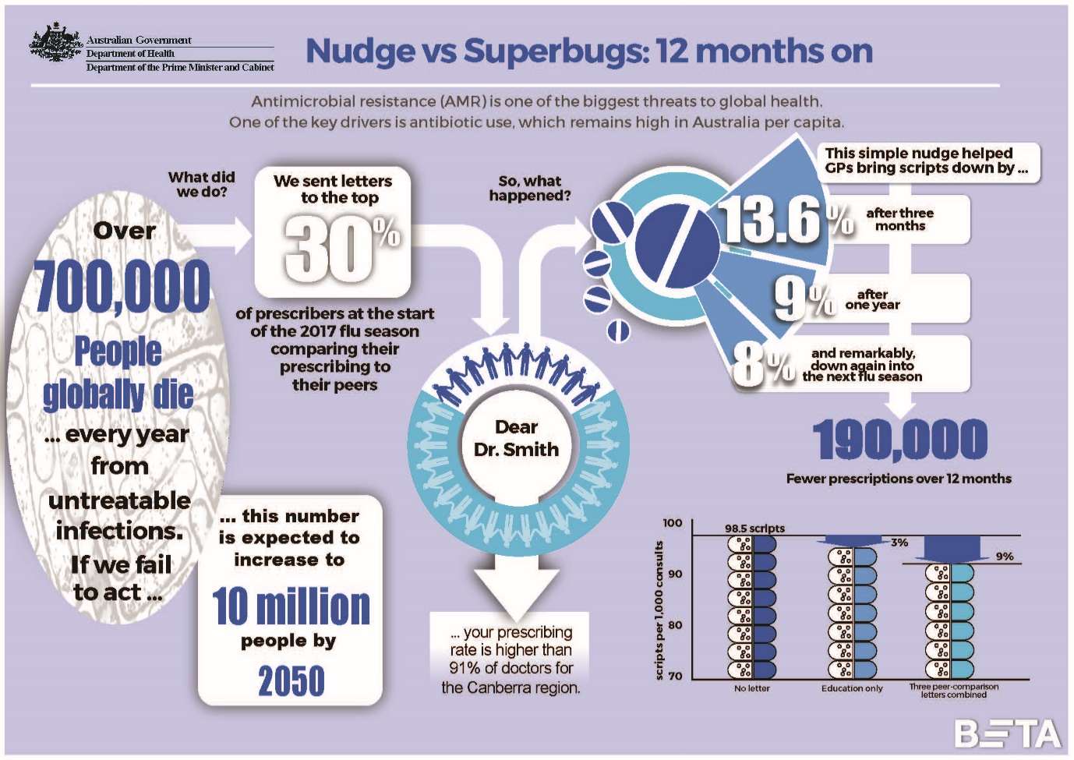

Nudge versus Superbugs: 12 months on infographic text equivalent

Antimicrobial resistance (AMR) is one of the biggest threats to global health. One of the key drivers is antibiotic use, which remains high in Australia per capita.
Over 700,000 people globally die every year from untreatable infections. If we fail to act this number is expected to increase to 10 million people by 2050.

What did we do?
We sent letters to the top 30% of prescribers at the start of the 2017 flu season comparing their prescribing to their peers. The subject heading of the letter read:
“Dear Dr Smith, your prescribing rate is higher than 91% of doctors for the Canberra region.”

So what happened?
This simple nudge helped GPs bring scripts down by …
- 13.6% after three months
- 9% after one year
- And remarkably, down by 8% again into the next flu season
This resulted in 190,000 fewer prescriptions over 12 months.
The chart shows the number of scripts per 1,000 consultations over 12 months.
- Doctors who received no letter had 98.5 scripts per 1,000 consultations.
- For doctors who received the ‘education only’ letter, this fell by 3%.
- And it fell by 9% for doctors who received the any of the three peer-comparison letters.

Australian Government
Department of Health
Behavioural Economics Team of the Australian Government (BETA), Department of the Prime Minister and Cabinet

