Improving tax compliance
Claims for work-related expense deductions are large. $22 billion was claimed in 2015-16. Even small amounts of over-claiming can lead to large revenue impacts.
Eligible work-related expenses include car and travel expenses, clothing, education and more.
We tested the effectiveness of a letter that draws on behavioural insights to notify selected tax agents they had higher than expected work-related expense claims for their clients.

- Social norms: We compared agents making higher than expected claims against other agents.

- Availability bias: We made it clear how infrequently other tax agents make higher than expected claims.

- Saliency: we reminded agents higher than expected claims are likely to attract closer scrutiny by the ATO.

The letter led to more amended claims with reduced work-related expenses and increased tax paid (amended claims compared to the control).

- Agents who received the letter reduced their average client claims by $191.

- Agents who received the letter increased the average tax paid by their clients by $76.

If we had sent the letter to all tax agents in this trial, we expect tax revenue would have increased by about $1.7 million.
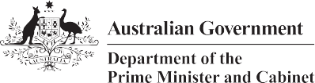
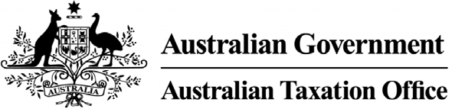
Low-cost, well-targeted and well-designed communications, incorporating behavioural insights, can increase tax compliance and revenue to fund services for Australians.

Social norms

Availability bias

Saliency

