Incentivising excellence
Attracting high-achieving teaching candidates
February 2022

Other uses
Enquiries regarding this license and any other use of this document are welcome at:
Managing Director
Behavioural Economics Team of the Australian Government
Department of the Prime Minister and Cabinet
1 National Circuit
Barton ACT 2600
Email: beta@pmc.gov.au
The views expressed in this paper are those of the authors and do not necessarily reflect those of the Department of the Prime Minister and Cabinet or the Australian Government.

Research team
Andrei Turenko was the principal investigator for this project. Other (current and former) staff who contributed to the report were: Belinda Xie, Dan Carr, Cale Hubble and Andrea Willis.

Acknowledgments
Thank you to the Department of Department of Education, Skills and Employment and the Quality Initial Teacher Education Review Expert Panel for their support and valuable contribution in making this project happen. In particular, special thanks to Anthony Flint, Lisa Paul AO PSM, Malcolm Elliott, Bill Louden AM and Derek Scott for their continuous support and work on this project.

Who?

Who are we?
We are the Behavioural Economics Team of the Australian Government, or BETA. We are the Australian Government’s first central unit applying behavioural economics to improve public policy, programs and processes.
We use behavioural economics, science and psychology to improve policy outcomes. Our mission is to advance the wellbeing of Australians through the application and rigorous evaluation of behavioural insights to public policy and administration.

What is behavioural economics?
Economics has traditionally assumed people always make decisions in their best interests. Behavioural economics challenges this view by providing a more realistic model of human behaviour. It recognises we are systematically biased (for example, we tend to satisfy our present self rather than planning for the future) and can make decisions that conflict with our own interests.

What are behavioural insights and how are they useful for policy design?
Behavioural insights apply behavioural economics concepts to the real world by drawing on empirically-tested results. These new tools can inform the design of government interventions to improve the welfare of citizens.
Rather than expect citizens to be optimal decision makers, drawing on behavioural insights ensures policy makers will design policies that go with the grain of human behaviour. For example, citizens may struggle to make choices in their own best interests, such as saving more money. Policy makers can apply behavioural insights that preserve freedom, but encourage a different choice – by helping citizens to set a plan to save regularly.

Contents
Executive summary 4
Why? 5
What we did 6
Results: Young High-Achievers 8
Results: Mid-Career Professionals 10
Discussion and conclusion 14
References 16

Executive summary
Quality teachers help their students excel. In recent years, however, there has been a decline in high-achieving young adults and university-educated mid-career professionals choosing teaching as their career (QITE Review 2021).
The Behavioural Economics Team of the Australian Government (BETA) assisted the Quality Initial Teacher Education Review (the Review) by exploring what incentives young high-achievers and mid-career professionals find most attractive when considering a career in teaching. We also looked at mid-career professionals with a Science, Technology, Engineering and Mathematics (STEM) background, as STEM teachers are in high demand.
We ran an online survey containing a discrete choice experiment with 501 young high achievers and 1,432 mid-career professionals. We used the discrete choice experiment to quantify the relative importance of various incentives related to work and study, as well as a teacher’s starting and top pay. We also asked respondents about their intentions to become a teacher and expectations of a teacher’s salary.
Young high achievers
A $30,000 scholarship was the most effective work or study incentive, followed by guaranteed ongoing employment in a nearby school (both increased the probability of choosing a teaching job by around 12%). Most study and all work incentives were valued greater than a $15,000 increase to starting or top pay.
Of young high-achievers not studying initial teacher education, 8% plan to become a teacher and 4 in 10 are open to the idea. About half of surveyed young high-achievers underestimated teachers’ starting and top pay.
Mid-career professionals
Paid work throughout study, a $30,000 scholarship, mortgage/rent relief and guaranteed ongoing employment in a nearby school were the most impactful work and study related incentives.
For professionals coming from a STEM background, the $30,000 scholarship was the most attractive study incentive. For younger professionals, rent/mortgage relief was particularly attractive.
Of mid-career professionals not currently studying initial teacher education, 1 in 10 are planning a career change to be a teacher and 3 in 10 are open to the idea.
Attracting high-achieving candidates to the teaching profession requires a careful mix of incentives and remuneration packages. This research contributes to the discussion on how such packages could be constructed. Further research could focus on how to best bridge the gap between perceptions and reality of teaching (for instance, relating to starting and top pay, and qualification requirements) and strategies to bolster retention in the sector.

Why?

Great teachers help students excel
The academic outcomes of Australian students have fallen in recent years, both compared to other nations and in absolute terms (Programme for International Student Assessment 2018). Since teachers are the number one in-school influence on student outcomes (Hattie 2003; Deloitte Access Economics 2017; QITE Review 2021), the Australian Government established the Quality Initial Teacher Education Review (the Review) to identify how to best attract and educate high-achievers into the teaching profession. A high-quality teaching workforce can help lift student performance.
One way to bolster Australia’s teacher workforce is by attracting high-achieving school leavers (typically defined as graduates with an Australian Tertiary Admission Rank (ATAR) of 80 or more). In 2019, 24 percent of undergraduate initial teacher education entrants were admitted on the basis of their secondary education with an ATAR. 39 per cent of these entrants had an ATAR above 80 (QITE Review 2021).
Mid-career professionals – with tertiary education, work experience and practical knowledge – can also transition to being high-achieving teachers. These professionals can help boost teacher supply in certain subject areas. However, postgraduate completions in teacher education have declined since 2014, even though postgraduate completions in general have increased (QITE Review 2021).

Attracting high-achieving candidates can be challenging
There are various reasons for the decline in the number of high achievers pursuing a career in teaching. Some high school students and older adults believe teaching is not a respected career (Stokes and Tyler 2003, Richardson and Watt 2005). Some younger adults think teaching lacks career progression opportunities and is less intellectually challenging than other careers (Goss, Sonnemann and Nolan 2019). Poor pay is also commonly cited as a reason for not considering teaching (Stokes and Tyler 2003; Peter D Hart Research Associates 2008), along with the perception that teaching involves stressful and demanding overtime work (Stokes and Tyler 2003).

BETA explored how to best attract high-achieving candidates into teaching
The Review commissioned BETA to understand which incentives would best attract high achievers to teaching. The Grattan Institute had conducted similar research in 2019 (Goss, Sonnemann and Nolan 2019). It found the best ways to attract young high-achievers were to offer annual $10,000 scholarships and to create new career pathways with higher pay and greater responsibility.
We aimed to build on the Grattan Institute’s research by testing new incentives suggested by the Review Expert Panel. These incentives included higher-value scholarships, paid work during study, and guaranteed ongoing employment. We also surveyed a new cohort – mid-career professionals with a Bachelor’s degree or higher – to understand what might appeal to potential career changers. In the mid-career cohort, we recruited a high proportion of individuals with a STEM background, because STEM teachers are a high priority and often in short supply (DESE 2021, QITE Review 2021).

What we did

We used a discrete choice experiment to understand what would incentivise a career in teaching
We surveyed 501 young high-achievers (18-25 years old, scored an ATAR of 80 or above, and never studied teaching) and 1,432 mid-career professionals (26-60 years old, with a Bachelor’s degree or higher, and never studied teaching or worked as a teacher). The survey included a discrete choice experiment and asked about respondents’ career intentions and their perceptions of teachers’ pay and qualifications.
A discrete choice experiment allows us to quantify the relative importance of teaching-related incentives. The experiment works by presenting people with different incentive packages (Figure 1). By analysing which packages people chose most often, we can estimate how impactful each incentive might be and what trade-offs people make when comparing different incentives.
- A screenshot from the discrete choice experiment, illustrating the teaching packages participants compared. Participants were asked “Which of these packages would make you most likely to consider a career in teaching?”.
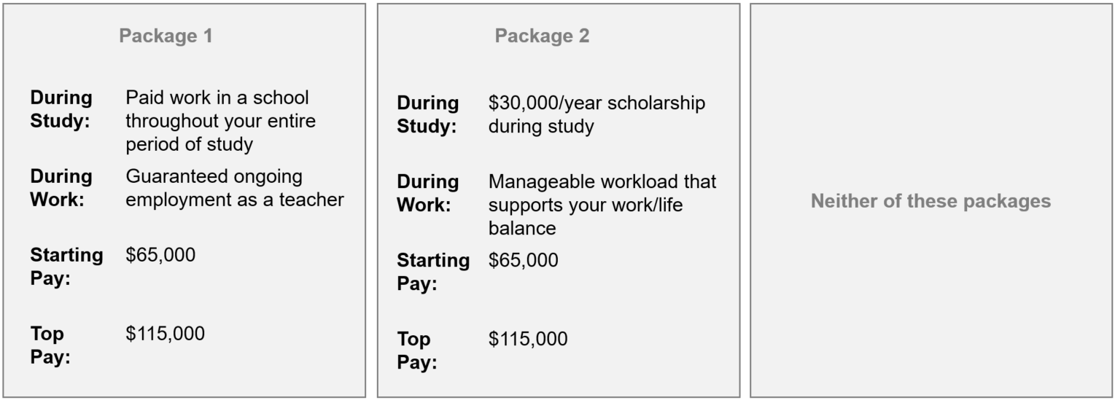
Each respondent compared six to seven incentive packages. The incentives we tested were based on what has been shown to be effective in previous research and also on the back of advice provided by the Review Expert Panel. We tested four types of incentives:

Study Incentives – incentives during the period spent studying:
- $20,000/year scholarship during study
- $30,000/year scholarship during study
- Opportunity to complete a paid 4-week teaching internship before commencing study
- Paid work in a school throughout your period of study
- Paid work in a school in your final year of study
- Studying in a course where all students have an ATAR of 80 or above (young high-achievers only)
- A condensed one-year full-time qualification (mid-career professionals only)
- Mortgage or rent payments covered throughout study (mid-career professionals only).
Work Incentives – incentives related to the teaching workplace:
- Guaranteed ongoing employment as a teacher
- Guaranteed ongoing employment as a teacher in a nearby school
- Manageable workload that supports your work/life balance
- Overtime work is recognised and paid
- Mentoring and support from senior staff
- Additional payment (on top of your starting salary) to recognise your prior experience (mid-career professionals only).
Starting Pay – what the applicant would earn in the first year working as a teacher:
- Between $65,000 and $90,000, increasing in $5,000 increments.
Top Pay – the maximum yearly amount the applicant would earn as a teacher:
- Between $105,000 and $130,000, increasing in $5,000 increments.

Results: Young High-Achievers

Introducing most incentives (except a minimum ATAR requirement) increased the probability of young high-achievers selecting a teaching job
- Impact of incentives on young high-achievers.
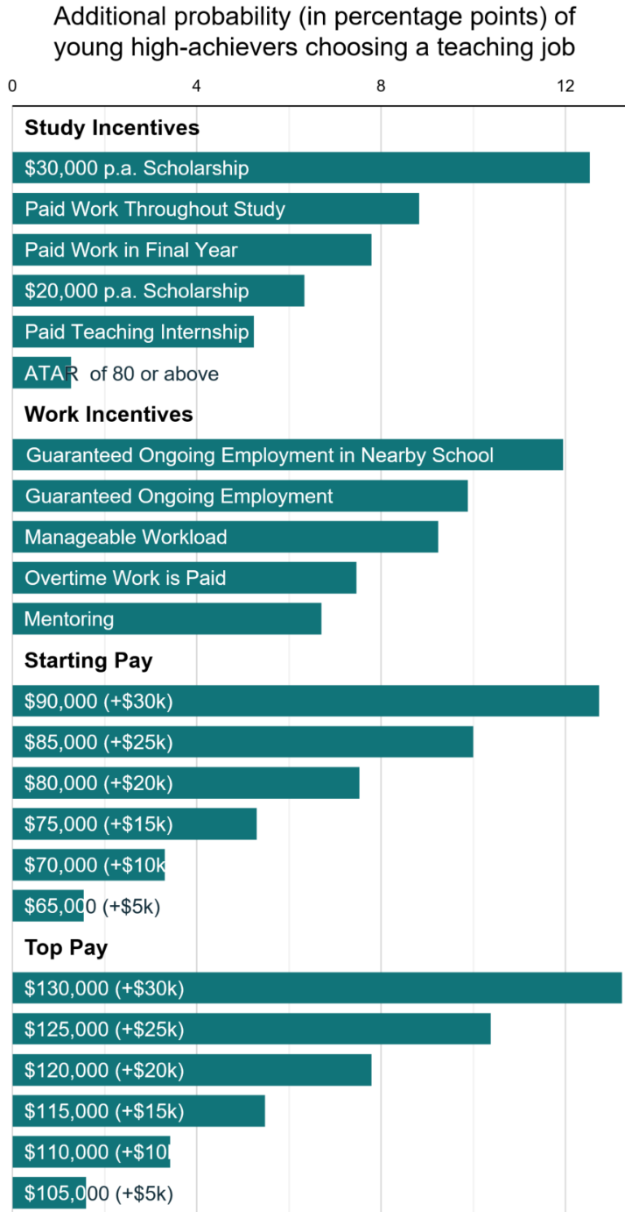
To establish a reference point, we first looked at how many young high-achievers picked a package with no additional incentives, $60,000 starting pay and $100,000 top pay. We saw that about 10% of young high-achievers chose this ‘baseline’ package.
As shown in Figure 2, the $30,000 per annum scholarship was the most attractive study or work incentive on offer, increasing the probability of a young high-achiever choosing a teaching job by more than 12 percentage points over the baseline package. Specifying that guaranteed ongoing employment will take place in a nearby school was the second most attractive study or work incentive.
The minimum ATAR requirement was the only incentive that did not significantly increase the attractiveness of a teaching job.
Large increases in both starting and top pay (+$20,000 and above) were also attractive to young high-achievers. However, smaller increases in pay (around $5,000) were relatively ineffective. Most study and all work incentives were valued greater than a fifteen thousand dollar increase to starting pay or top pay.

While nearly half of the young high-achievers are open to teaching, many underestimate teachers’ salary
Four in 10 (37%) young high-achievers have considered teaching as a career and are still open to the idea. Consistent with prior research, we find 8% are planning to become a teacher (Goss and Sonnemann 2019).
Many young high-achievers underestimated teachers’ starting pay. Figure 3 shows only 37% could correctly identify it was between $60,000 - $79,000, and nearly half (47%) expected it to be $59,000 or less.
- Young high-achievers’ expectations of teachers’ starting pay in teaching and their chosen occupation.
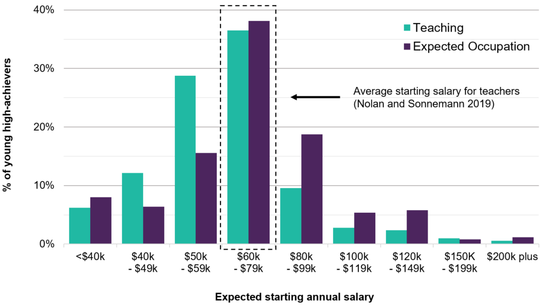
Similarly, half (51%) of the young high-achievers underestimated the top teacher salary (broadly consistent with Goss, Sonnemann and Nolan 2019). However, even if young high-achievers held accurate expectations of teacher’s top salary, 56% still expect to earn more in their chosen career.

Results: Mid-Career Professionals

Mid-career professionals value ongoing financial assistance and guaranteed work
- Impact of incentives on mid-career professionals.
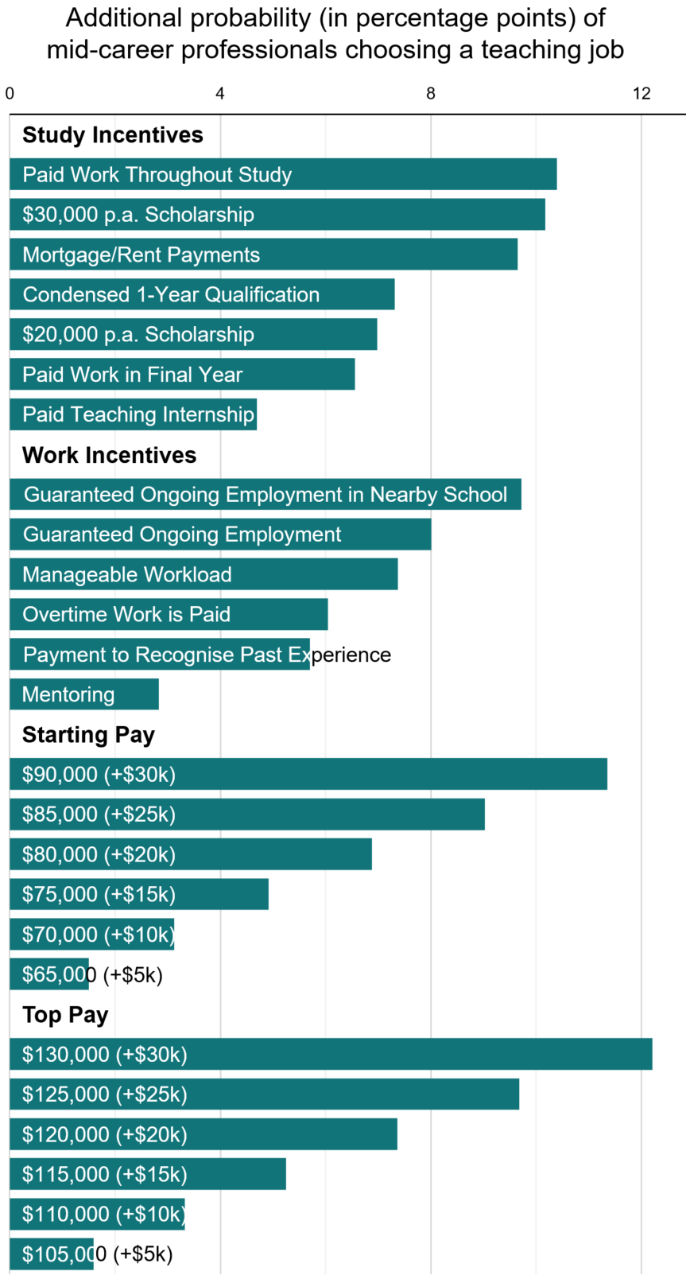
Eleven percent of mid-career professionals chose the baseline teaching job package.
All forms of ongoing financial assistance during study were attractive to mid-career professionals. Paid work throughout study, a $30,000 per annum scholarship and mortgage or rent payments during study were chosen at similarly high rates.
Guaranteed ongoing employment in a nearby school was the most attractive work incentive. This was nearly as impactful as the most generous financial study incentives. Mentoring was the lowest performing work incentive, having even less impact than it did when tested with young high-achievers.
Increasing top pay was more impactful than an equivalent increase in starting pay. This suggests potential earnings throughout a career are more impactful than the initial earnings at the beginning of a teaching career, for mid-career professionals.

Mid-career professionals with a STEM background value higher starting pay as well as the $30,000 scholarship
In our sample, 599 or 42% of mid-career professionals had a STEM background. Figure 5 compares the impact of incentives for STEM and non-STEM mid-career professionals. A $30,000 scholarship was the most attractive study incentive for those with a STEM background. For those without a STEM background, mortgage or rent payments was the most attractive study incentive. If attracting mid-career professionals with a STEM background is a particular priority, then a scholarship is likely to be the more impactful study incentive. Both groups responded similarly to the work incentives on offer.
- Impact of incentives on STEM and non-STEM mid-career professionals.
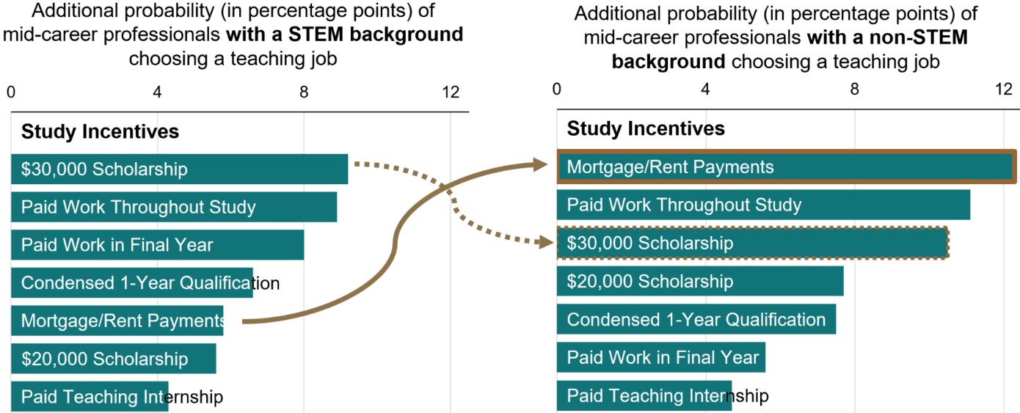
Mid-career professionals with a STEM background were more responsive to pay incentives. A $30,000 increase in starting pay increased the probability of STEM individuals choosing a teaching job by 14 percentage points, but only by 10 percentage points for non-STEM individuals. This may be because STEM professionals in our sample earned slightly more than non-STEM professionals (as they do in the general population; Karmel and Carroll 2017), which could explain this group valuing higher starting pay more than others.

Younger mid-career professionals value mortgage or rent payments and work incentives
Figure 6 compares younger mid-career professionals, aged 26-40 (comprising 52% of the sample), with older mid-career professionals, aged 41-60. Younger mid-career professionals value mortgage or rent payments more than their older counterparts. Paid work throughout study was more appealing to older professionals.
Across the board, work incentives were more attractive to younger professionals than older professionals. For example, guaranteed ongoing employment in a nearby school led to a 10.6 percentage point increase in younger professionals choosing teaching, but only an 8.7 percentage point increase for older professionals.
Higher starting and top pay were equally impactful across the two age cohorts.
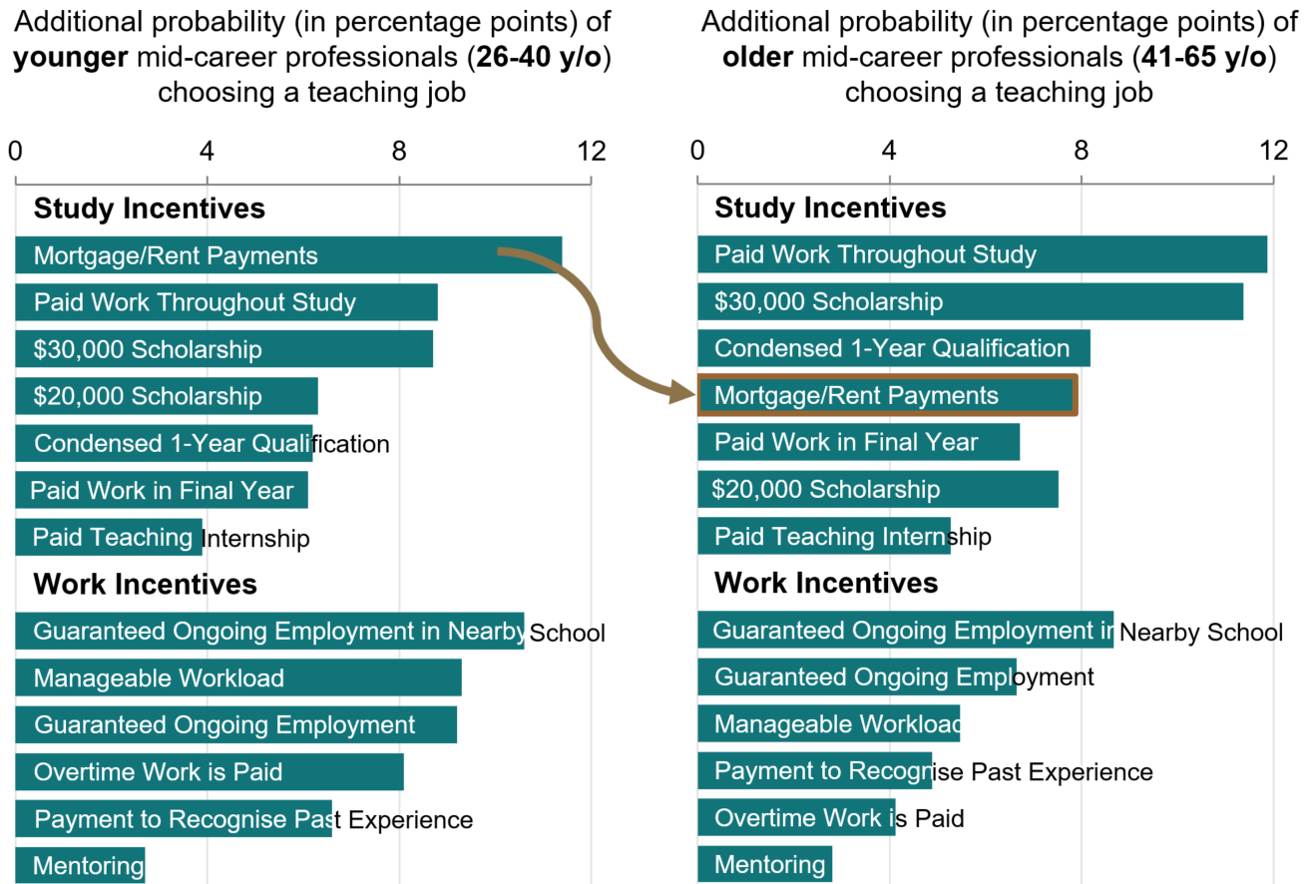
- Impact of incentives on younger and older mid-career professionals.
Work
incentives
Study
incentives

There is interest from mid-career professionals to enter teaching, although most underestimate the length of study required
One in 10 mid-career professionals indicated they plan to become a teacher (10%), and another 29% have considered it and are still open to it. The rest (61%) have either never considered it, or considered it but are no longer open to the idea.
Most mid-career professionals (67%) underestimate the length of study required to become a teacher. Only a third knew that a 2-year Master’s degree is required to become a teacher. Even among the 10% who indicated they were ‘planning to become a teacher’, only 28% knew a 2-year Master’s degree was required. This shows knowledge about postgraduate teaching studies is low, even among those most willing to become a teacher.
Similar to young-high achievers, four in ten mid-career professionals correctly identified a teacher’s starting pay. Figure 7 shows a third (33%) underestimated this pay, and 28% overestimated it.
A quarter of mid-career professionals (23%) currently earn less than a starting teacher would. Although these individuals stand to get a pay rise by becoming a teacher, they are slightly less likely to be open to teaching (34% planning or open to becoming a teacher) than individuals who earn more or the same as a starting teacher (41% planning or open to becoming a teacher).
- Mid-career professionals’ expectations of teacher’s starting pay compared to the income they currently earn.
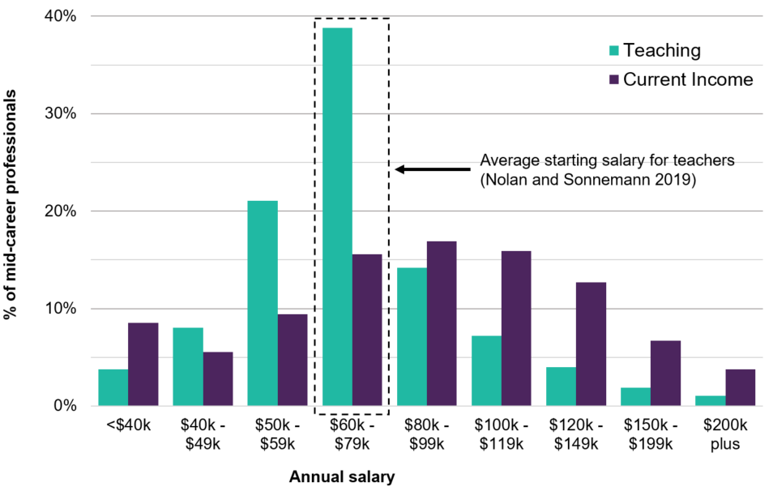

Discussion and conclusion

Guaranteeing ongoing employment, particularly in a nearby school, is attractive for all cohorts
Guaranteed ongoing employment in a nearby school was the top-performing work incentive for young high-achievers and mid-career professionals. This incentive outperformed improvements to workload or additional payments for overtime or past experience. This implies long-term job stability, especially coupled with the convenience of a nearby workplace, is one of the most important considerations. The second most attractive work incentive was the guarantee of ongoing employment, without the condition of being placed in a nearby school.

People value support during study
Across the board, young high-achievers and mid-career professionals were attracted to incentives that offered financial support during the period of study. For young high-achievers, a $30,000 per annum scholarship was the best performing non-pay incentive. For mid-career professionals, such a scholarship was on par with the other top ranking incentives. There was some variability in how study support incentives affected cohorts. Paid work throughout study was more attractive to STEM professionals than non-STEM professionals. The $30,000 scholarship was relatively more attractive to young high-achievers than it was to mid-career professionals.
For some study incentives, further research would help to identify the specific conditions that make them attractive. For example, the study incentive of ‘paid work in a school throughout your two-year qualification’ was somewhat ambiguous: we did not specify the hours of work, level of remuneration, or impact on study time this paid work would involve. Some additional insight into how participants were interpreting this incentive could improve its implementation.

Increasing top pay would likely be more impactful than increasing starting pay
In our discrete choice experiment, increases in top pay led to a greater increase in the probability of choosing a teaching job than an equivalent increase in starting pay. This finding shows the earning potential throughout a career is a more influential consideration than the earning potential at the beginning of a career. In fact, at the beginning of their career, teachers earn a competitive wage compared to other professionals (Nolan and Sonnemann 2019).
Increases in pay should be complimented by efforts to ensure potential candidates’ perceptions of pay align with reality. We found many young high-achievers and mid-career professionals currently underestimate a teacher’s starting and top pay. Correcting these perceptions would make any increases to teachers’ pay more impactful.

Length of study is important for mid-career professionals
There may be value attached to shortening the time required to attain a postgraduate teaching qualification. In our discrete choice experiment, a condensed 1-year course was as attractive as a $20,000 increase in top pay. Mid-career professionals also had a poor understanding of the length of study required to attain a teaching qualification. Most believed it can be done in one year or less. This confusion may be due to one-year teaching Graduate Diplomas being offered, but then discontinued in 2017. Potential teaching candidates may be discouraged once they understand the required time investment to become a teacher.

References
Audit Office of New South Wales (2019) ‘Supply of secondary teachers in STEM-related disciplines’, accessed 25 August 2021.
Deloitte Access Economics (2017) ‘School quality in Australia’, DESE, accessed on 27 October 2021.
Department of Education, Skills and Employment (2021) ‘Support for Science, Technology, Engineering and Mathematics (STEM)’, accessed 20 December 2021.
Goss P, Sonnemann J and Nolan J (2019) ‘Attracting high achievers to teaching’, Grattan Institute, accessed 21 May 2021.
Hattie JAC (2003) ‘Teachers make a difference: What is the research evidence?‘ [conference paper], Australian Council for Educational Research Conference, Melbourne, accessed 21 May 2021.
Karmel T and Carroll D (2017) ‘Do STEM graduates command a premium?’, National Institute of Labour Studies, Adelaide, accessed 3 November 2021.
Nolan J and Sonnemann J (2019) ‘Three charts on teachers’ pay in Australia: it starts out OK, but goes downhill pretty quickly’, The Conversation, accessed 2 July 2021.
Peter D Hart Research Associates (2008) ‘Teaching as a Second Career’, accessed 24 May 2021.
Programme for International Student Assessment (PISA) (2018) ‘Results from PISA 2018. Country Note: Australia’, Organisation for Economic Co-operation and Development, accessed 25 August 2021.
Porter S and Bear K (2014) ‘The role scholarships play in graduate recruitment for Initial Teacher Training’, National College for Teaching and Leadership, accessed 25 August 2021.
QITE Review (Quality Initial Teacher Education Review) (2021) ‘Discussion Paper’ DESE, accessed 1 November 2021.
Richardson PW and Watt HMG (2005) “I’ve decided to become a teacher’: Influences on career change’, Teaching and Teacher Education, 21(5): 475-489. doi: 10.1016/j.tate.2005.03.007
Stokes H and Tyler D (2003) ‘Secondary Students’ Attitudes to Teaching as a Career, Youth Research Centre’, University of Melbourne, accessed 21 May 2021.
Tes Global (2021) NSW teacher salary: What you could be earning, Tes, accessed 22 August 2021.

© Commonwealth of Australia 2021
ISBN 978-1-925364-98-9 Incentivising excellence. Attracting high-achieving teaching candidates (online)

Copyright Notice
With the exception of the Commonwealth Coat of Arms, this work is licensed under a Creative Commons Attribution 4.0 International license (CC BY 4.0) (https://creativecommons.org/licenses/by/4.0/)

Third party copyright
Wherever a third party holds copyright in this material, the copyright remains with that party. Their permission may be required to use the material. Please contact them directly.

Attribution
This publication should be attributed as follows:
© Commonwealth of Australia, Department of the Prime Minister and Cabinet, 978-1-925364-98-9 Incentivising excellence. Attracting high-achieving teaching candidates (online).

Use of the Coat of Arms
The terms under which the Coat of Arms can be used are detailed on the following website: https://pmc.gov.au/cca

Behavioural Economics Team
of the Australian Government
General enquiries beta@pmc.gov.au
Media enquiries media@pmc.gov.au
Find out more www.pmc.gov.au/beta

We defined STEM background as either having studied a STEM subject or currently working in a STEM industry (‘Science and Mathematics’, ‘Computing and Information Systems’, ‘Engineering’, and ‘Agriculture and Environmental Studies’; ABS 2011).
This analysis did not control for people’s patterns of work (full time or part time) and it is possible some people who currently earn less than teacher’s starting pay are working part-time.

