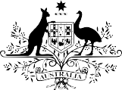

Electricity information to fit the bill
Energy prices in Australia have risen 56 per cent in a decade, putting significant pressure on household budgets.

People can save hundreds of dollars a year by shopping around—but more than half of Australians have not switched plans or providers in the past five years.

Energy bills are the primary tool to inform consumers about their energy plan and usage—but they are dense, inconsistent and hard to read.

We worked with the Department of the Environment and Energy, to design and test new electricity bill designs with around 4,200 Australians.

We focused on:
simplifying the structure and style

drawing attention to key information

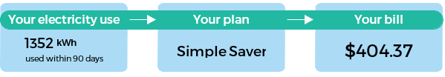

including a ‘ways to save’ box encouraging people to search for a better deal.

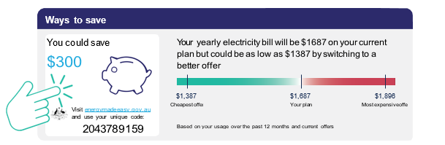

We found a simple design and information about
personalised savings increased confidence in using the
bill to find a better deal by thirteen per cent.
13%

But we found no difference among the bill types with regard to consumers’ stated intention to look for a better deal.
Increasing consumer confidence in a market facing record-low levels of trust is important. For this reason alone, making bills clearer and more accessible for consumers makes sense and should be considered by electricity retailers.

