

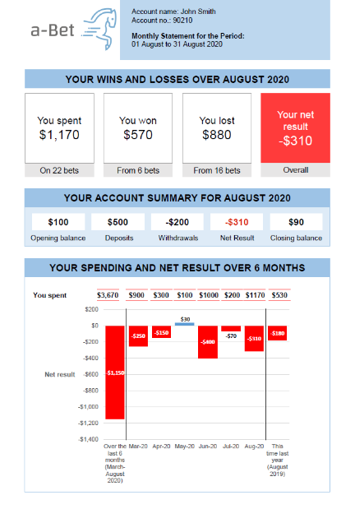**Activity statements can help consumers make decisions about online gambling**

**Online wagering is the fastest growing form of gambling in Australia. Providing consumers with activity statements showing details of their gambling can help track their spending, wins and losses.**

**We used behavioural science to design and test two online wagering activity statements. We targeted cognitive biases known to affect gambling decisions.**

In a study simulating gambling, we showed participants one of the summary activity statements or no statement and measured their gambling behaviours.

*Activity Summary Statement A (above) shows gambling over time using a graph format. Activity Statement B includes a table.*

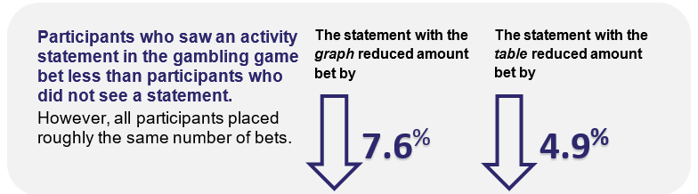

**Participants found the activity statements useful for guiding their gambling behaviours:**

*****“Think this is a good reality check for people as a few dollars here and there mean not much but when you see these big numbers they really stand out and make you question your behaviours.”*

Behavioural Economics Team of the Australian Government **pmc.gov.au/beta**

**Easy to understand activity statements reduced misperceptions about**

**past and future gambling outcomes, and empowered online gamblers**

**to make informed decisions about their bets.**