# decorativeEmpowered to switch

**A partnership to improve the   
*Energy Made Easy* comparison website**

**August 2025**

**Other uses**

Enquiries regarding this license and any other use of this document are welcome at:

Managing Director

Behavioural Economics Team of the Australian Government

Department of the Prime Minister and Cabinet

1 National Circuit

Barton ACT 2600

Email: [beta@pmc.gov.au](mailto:beta@pmc.gov.au)

The views expressed in this paper are those of the authors and do not necessarily reflect those of the Department of the Prime Minister and Cabinet or the Australian Government.

[Tell us how you’re using this report](https://youropinion.au1.qualtrics.com/jfe/form/SV_3KTVLrC3vE1cqp0?document=empowered)

[](https://youropinion.au1.qualtrics.com/jfe/form/SV_3KTVLrC3vE1cqp0?document=empowered)

**Research team**

Laura Bennetts Kneebone was the principal investigator for this project. Other (current and former) staff who contributed to the report were: Michael Ridgway, Martin Brumpton, Parima Vyas, Ruisi Chen, Harry Greenwell and Jacqui Brewer.

**Acknowledgments**

Thank you to Australian Energy Regulator and Pretzel Team for their support and valuable contribution in making this project happen. In particular, special thanks to Jon Milne, Tiger Hu, Victor Cabello, Benita Botha and Peter Sahlani for their work on this project.

The two survey experiments discussed in this report were pre-registered on the American Economic Association registry:

[AEA RCT Registry (socialscienceregistry.org)](https://www.socialscienceregistry.org/trials/9660)

Who?

### Who are we?

We are the Behavioural Economics Team of the Australian Government, or BETA. We are the Australian Government’s first central unit applying behavioural economics to improve public policy, programs and processes.

We use behavioural economics, science and psychology to improve policy outcomes. Our mission is to advance the wellbeing of Australians through the application and rigorous evaluation of behavioural insights to public policy and administration.

### What is behavioural economics?

Economics has traditionally assumed people always make decisions in their best interests. Behavioural economics challenges this view by providing a more realistic model of human behaviour. It recognises we are systematically biased (for example, we tend to satisfy our present self rather than planning for the future) and can make decisions that conflict with our own interests.

### What are behavioural insights and how are they useful for policy design?

Behavioural insights apply behavioural economics concepts to the real world by drawing on empirically-tested results. These new tools can inform the design of government interventions to improve the welfare of citizens.

Rather than expect citizens to be optimal decision makers, drawing on behavioural insights ensures policy makers will design policies that go with the grain of human behaviour. For example, citizens may struggle to make choices in their own best interests, such as saving more money. Policy makers can apply behavioural insights that preserve freedom, but encourage a different choice – by helping citizens to set a plan to save regularly.

Contents

Executive summary 4

Why? 5

What we did 7

What we found 8

Evaluating changes to the website 18

References 26

Appendix A: Methodology 30

Appendix B: Technical details 34

Appendix C: Special offers RCT 36

Appendix D: Retailer comparison RCT 39

## Executive summary

### Energy plans are sticky

For energy retail pricing to be competitive, consumers need to walk away from expensive plans. In reality, many consumers never switch. Time, effort and search costs are amplified by behavioural barriers such as plan complexity, retailer bundling tactics, choice overload and brand loyalty.

*Energy Made Easy* (EME) is a free, independent, government comparison website that allows consumers to see and compare energy plans from all providers, to find the right plan for them.

### We found ways to help consumers switch to better plans

BETA’s research identified improvements which:

* Steer consumers through the search questions and filters.
* Focus attention on critical information, such as the main costs and conditions.
* Build confidence by showing consumers how their current plan compares to other options.

### The implementation of these changes has made switching easier

BETA’s research findings and recommendations informed the 2023 redesign of the EME website by the Australian Energy Regulator (AER).

The redesigned EME website has resulted in more users:

* completing a search and reaching the results page;
* taking a high accuracy pathway to see more precise estimates;
* looking at individual plan details; and
* making a switch to another retailer.

This report is one part of a suite of work done in partnership between BETA and the AER. An earlier unpublished version of this report was provided to the AER in mid-2022 to inform the refresh of the EME website. *This* version includes a new section describing the impact of the website refresh on consumers. BETA’s earlier *Improving Energy Bills (2021)* report informed the development of the *Better Bills Guideline*. The *Better Bills Guideline* made many mandatory changes to energy bills, to make it easier for consumers to engage with the market. These included a plan summary on every bill, and a *Better offer message* every 3 months encouraging consumers to compare plans on *Energy Made Easy.* The *Better Bills Impact Report (2025)* describes the effect of the *Better Bills Guideline* in driving more consumers to visit the refreshed *Energy Made Easy* website.

## Why?

### Policy context

The *Energy Made Easy* (EME) website is an independent and comprehensive interactive resource that helps consumers compare energy plans currently available in the market. The Australian Energy Regulator (AER) engaged BETA to apply behavioural insights to improve the EME website. BETA undertook a scan of relevant behavioural science literature and used primary qualitative and quantitative research to inform the website redesign.

This research was done in partnership with the AER and Pretzel lab, a graphic/web design agency responsible for building the prototype and website. The resulting recommendations and insights were provided iteratively during the design and testing phase.

The aim of the research was to increase the rate of switching to better energy plans. The project also aimed to improve the user journey by identifying and removing barriers to finding a better energy plan using the website.

### The problem

Switching energy plans and providers can lead to substantial savings for Australians, but only 34% of respondents to our survey had ever switched to a different retailer (excluding moving house) (*‘Panel Survey data’* 2022). The EME website, like other price comparison websites, is a tool that can help consumers overcome *switching inertia*, or the tendency to not switch, by allowing them compare their current energy plan with others in the market.

### A behavioural lens

BETA investigated the determinants of switching inertia by reviewing literature from the fields of behavioural economics, marketing and psychology. In addition, we drew from research on online web design and choice architecture (how information and options are presented to consumers) to understand how consumers choose from a set of alternatives:

* The number of options and the order in which they are presented (choice architecture) matters and has a direct influence on how consumers acquire information and then use that information to make choices (Shi, Wedel & Pieters, 2013; Yang, Toubia & de Jong, 2018; Etco, Sénécal & Fredette, 2017).
* The layout of plan attributes and the ability to search and filter non-price attributes can be influential in the decision-making process (Hauser, Urban, Liberali & Braun, 2009; Ariely, 2000).
* There is emerging evidence that commercial price comparison websites do consumers a disservice by only sharing information about plans from a small number of retailers (Mountain, 2019; Antal, 2020). A 2020 study found that the best price offer on EME is on average 4% lower than the best price offers on private third-party price comparators (Centre for Market Design).

Switching inertia presents a formidable barrier, for example:

* There is significant evidence energy consumers do not switch to better-priced plans even when aware of cheaper alternatives (Klemperer, 1995; Salies, 2005; Wilson, 2012; Gamble et al., 2009).
* Much of this inertia can be attributed to behavioural barriers that impact the cost of search such as brand loyalty, choice overload, bundling tactics and lack of attention (Burnett, 2014; Greenstein, 2014; Lee, 2017; Giulietti, 2005; Murakami, 2021; McShane and Böckenholt 2017; Chernev et al. 2015; and Scheilbehenne et al. 2010; Hortaçsu et al. 2018).
* Demographic characteristics are related to switching rates; areas with lower education, lower income and older citizens have lower rates of switching (Carthy, Lunn & Lyons, 2020; Hortaçsu et al. 2018).

## What we did

### Our research program

Our research program included a number of distinct approaches that enabled us to comprehend:

* The population: current and future users of the website, their needs and preferences.
* The status quo: what was and was not working, how consumers were actually using the website.
* Reactions to new designs and prototypes: whether they were solving identified problems, and how they might be further improved.

See Appendix A for full methodology.

### Summary of research methodology

Following a literature scan on consumer switching and comparison websites, BETA built a contemporary understanding of consumer experience. We conducted analysis using existing data to identify barriers and pain points (*‘Call-centre data’* 2021 and *‘Website Google Analytics data’* 2021). Suggestions for improvements were captured using a *Give Feedback* widget on the EME website (*‘Website Feedback data’* 2022).

To inform the website redesign process, EME users were surveyed to better understand why they were on the website (*‘Website Search Pathway Survey data’* 2021) and the drivers and barriers of switching energy plans (*‘Website User Survey Series’* 2022). This was used to develop user personas that informed qualitative user-testing.

Clickable prototypes were designed and iteratively refined across four rounds of user-testing (*‘Website user-testing data’* 2022). The design ideas were then tested with a broadly representative sample of survey participants (*‘Panel Survey data’* 2022). This series of surveys also captured energy market consumer attitudes, awareness, and switching behaviour. Additionally, survey experiments tested the impact of two changes to the EME results page: bumping the retailer’s lowest offer to the top of the results, and including information about discounts against plans where relevant (*‘Panel Survey-Experiment data’* 2022).

## What we found

Summary of key findings

* Asking consumers to use their National Metering Identifier (NMI) data by default reduced friction, as this pathway provided the quickest and most accurate results. A skip option was designed to direct consumers to the ‘no bill or no meter data’ pathway. This recommendation was implemented on the EME website.
* Price was the most important factor to the majority of users, therefore the results page needed to reflect the main pricing structure of a plan, rather than minor or infrequent fees. This was implemented on the EME website.
* Special offer messages on the results page drew attention to those plans, even if they did not present the best value to the consumer. BETA recommended removing or de-emphasising special offers on the results page and only presenting discount information on the individual plan page with detailed eligibility information. This was not implemented on the EME website.
* Bumping a consumer’s current retailer’s lowest offer to the top of the list of results and stating how much more it cost than the most competitive plan overall made the consumer more likely to switch plans. This was implemented on the EME website.

### Consumers needed help to get personalised and accurate results

To see a personalised list of plans, EME users had to answer a set of questions about their location and energy usage. This ‘funnel’ on the original website contained pain points that made it difficult for consumers to answer accurately.

The original website offered users a choice of 4 alternative pathways. 3 of these provided a personalised result, the 4th allowed consumers to continue without sharing usage data (Figure 1). The presentation of these pathways didn’t tell people how long each one would take, or whether some pathways would produce more accurate results than others.

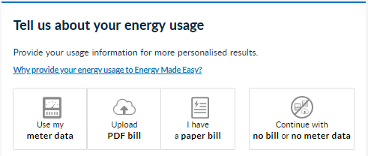

Figure . The original Energy Made Easy website offered consumers four alternate ways to share their data.

**Option 1. Use my meter data**

This was the quickest method and yielded accurate results. This pathway asked consumers to enter their NMI into the EME website, give consent to link to their data held by the Australian Energy Market Operator (AEMO), which included consumption over the past year, meter types, solar exports and controlled load.

When we surveyed EME users about choice of data sharing pathway, only 27% reported choosing the NMI pathway (Figure 2, *‘Website Search Pathway Survey data’* 2021). Users who selected this pathway were attracted to the ease, accuracy and convenience of this method, especially when they understood how to find the NMI and that the linkage was instant. Some misconceptions (*‘Website Search Pathway Survey data’* 2021, *‘Website User-Testing data’* 2022) included concerns that they would need to wait for the meter to be read, or need to walk outside and look at their meter.

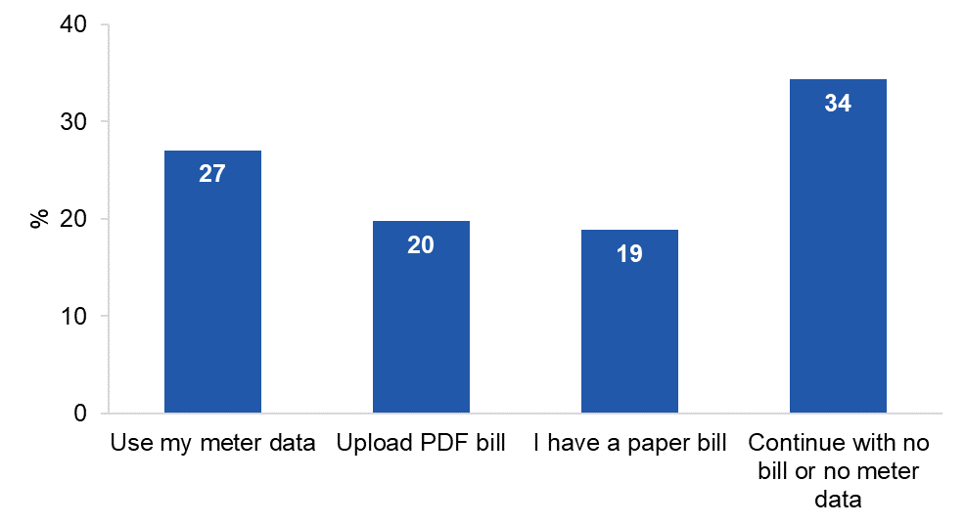

Figure . EME users who completed the pop-up survey in 2021 were most likely to choose not to share any data

‘Website Search Pathway Survey data’ 2021. N=15,306.

General confusion about what the NMI was and where it could be found were larger barriers. In our user-testing, some comments highlighted this lack of awareness, such as, ‘I wouldn’t use the NMI regardless because it just is not what I know’ (*‘Website User-Testing data’* 2022). While this response should not be overstated, it suggests that some consumers might reject this option because it is unfamiliar.

The NMI, once consumers saw what it could do in user-testing, elicited enthusiastic comments: ‘It’s real for me, and shows me how much energy I use and don’t have to go through my usage and work it out, I’m pretty happy that it’s recorded accurately through the meter.’ (‘Website User-Testing data’ 2022).

**Option 2: Upload PDF bill**

The major problem with this option was that the PDF reader often rejected bills as unreadable, so this pathway created a lot of frustration for users.

When it did work, there were mixed responses to the ease and speed of this process. One user thought this would be ‘probably less buttons to click’*.* Another identified this as an option they would prefer: ‘would click on that, find my uploaded bill, that’s drag and drop, that’s even better*.’* Another user was surprised to discover that the PDF reading process was instant: ‘It doesn’t feel like you’re going to get a timely response. It seems someone will get back to me.’ (‘Website User-Testing data’ 2022).

Several users realised that it would not be quite as quick and convenient if you needed to upload multiple bills. One person said: ‘Perfect, I’m happy with that. Oh! Twelve months of bills, that will take more time but I am happy to start with one and then if I need more info I’d take it further and maybe upload two.’

**Option 3: I have a paper bill**

This was the most time-consuming option as users needed to manually enter all their energy usage amounts and solar exports as listed on their bill. If they chose to enter data from multiple bills, they needed to add the various amounts together to complete the form accurately (Figure 3).

In user-testing, we observed users making errors (e.g. omitting digits, entering daily average usage instead of total usage, and confusing off-peak usage and controlled-load usage). So in addition to being demanding, this pathway was error-prone.

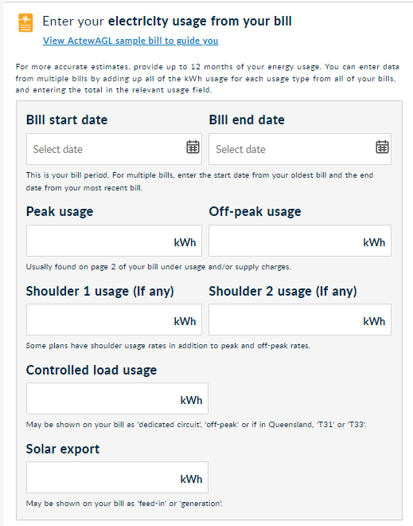

Figure . Consumers selecting the manual entry pathway have to enter their total usage.

The other issue was that the label for this option was misleading. This pathway was called *I have a paper bill*, but consumers with paper bills could have entered their NMI to use their meter data for the search and consumers with an emailed bill could have used this ‘*paper bill’* pathway. We suggested that a more accurate label would be *Enter my usage manually*.

Although the manual entry pathway was more complex, it still had value for some consumers:

* Users could maintain control of the process: one user described it as ‘more physical and straight forward’ (‘Website user-testing’ data 2022).
* Users could keep information private (as opposed to uploading bill or sharing NMI) (*‘Website Search Pathway Survey data’* 2021).
* Convenience: some retailers provided consumers with annualised details to enter (*‘Website Search Pathway Survey data’* 2021).
* As a backup option: some users had tried and failed to upload PDFs or found their meter data request did not work (*‘Website Search Pathway Survey data’* 2021).

**Option 4: Continue with no bill or no meter data.**

This pathway could quickly generate estimates of total cost and was easiest for consumers but provided the least accurate estimates. These estimates were based on community averages (benchmarks) for each household size and climate zone. Diagnostic research on the EME website showed that roughly 34% of users completing the survey selected this ‘no data’ pathway, higher than any other pathway (Figure 2, *‘Website Search Pathway Survey data’* 2021).

In our survey of EME users we found that 16% of consumers initiating a search on EME were looking for a new plan because they were moving house (*‘Website User Survey Series’* 2022). For someone who is moving house, they would have no existing data so this would be the only choice.

Some consumers needed this pathway if they knew their circumstances were about to change, making their current data a poor predictor of future usage (e.g. if they were installing solar panels, batteries, or underfloor heating). This pathway was also likely to be useful for consumers in the exploratory stages of looking, trying to gather a quick impression of the range of available plans and suppliers.

However, as the pathway that would generate the least accurate estimates, it was better to guide people away from it unless they had no choice.

**Testing changes to improve user experience**

Based on these findings from our exploratory research, we had two main goals to improve the user experience and quality of results.

1. Maximise the number of consumers choosing to link their meter data, while still making other choices available. We tested a prototype in which the search flow harnessed the power of defaults to direct most users to enter their meter data, while still allowing them to choose alternatives,
2. Find out which consumers were moving house and redirect them to the *no data* pathway.

To achieve this, we added simple screener questions and re-ordered the question flow. We added explainers on what an NMI is and how to find it, and indicated that it could take less than a minute. Once users had tried it, this option was met with an overwhelmingly positive response.

### Consumers struggled to identify the cheapest plan

When consumers reached the results page, they saw a list of plans tailored to their location and sorted by total estimated cost. This showed summary information about each plan, and consumers needed to click on the plan name to reveal the finer details about the plan.

Existing data told us users complained that the most important information did not appear on the main results page. One comment was that the plans do not tell you much at a glance (*‘Call-centre data’* 2021). A common comment in user-testing was that the results page was overwhelmingand contained a lot of information (*‘Website user-testing’* data 2022).

BETA observed that much of the real estate on each plan result was given over to a *Need to know* section about fees and charges, which were rarely if ever charged, at the expense of information about the plan’s pricing structure and key characteristics. This made the results page more complex for users with little benefit to informing their decision making.

In qualitative user-testing, users spoke positively of discounts and special offers and were attracted to the *Special offers* flag displayed on some results (*‘Website user-testing’* data 2022). Special offers can include guaranteed discounts, pay-on-time discounts, membership discounts and reward points.

Discounts operated in two main ways to benefit retailers:

* Inflated base rates coupled with guaranteed discounts made the offer appear more attractive because users focused on the discount rather than the absolute total and this obscured the actual plan costs.
* Consumers could overestimate the likelihood that they would qualify for conditional discounts (e.g. by paying on time or referring friends).

The *Special Offers* flag was described as *eye catching* (*‘Website user-testing’* data 2022) and was popular among users. However, by drawing attention to such plans, EME would be effectively endorsing plans with special offers rather than keeping user focus on the bottom line (e.g. total estimate and the usage charges).

*Energy Made Easy* wanted to disrupt some of these impacts of *Special Offers* by rolling them into the total estimate, so costs between plans were as clear and comparable as possible. We wanted to know whether users understood this or whether they were effectively ‘double counting’ the discount (applying the discount to the already discounted total).

We showed survey respondents a results page with three plans and asked them to select their preferred plan (Figure 4).

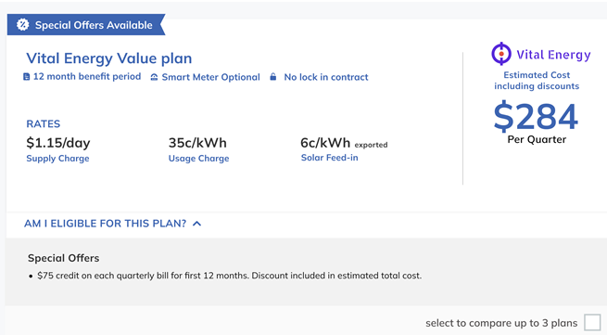

Figure . Example of a plan with Special Offer flag and explanatory note used in testing.

In our scenario, respondents viewing the same three plans chose the absolute cheapest plan in 89% of cases when no *Special Offer* flag was shown. When we showed the *Special Offer* flag, consumers were slightly less likely to choose the cheapest plan (fell to 86%) because they were attracted to the plan with the *Special Offer* instead (Figure 5).

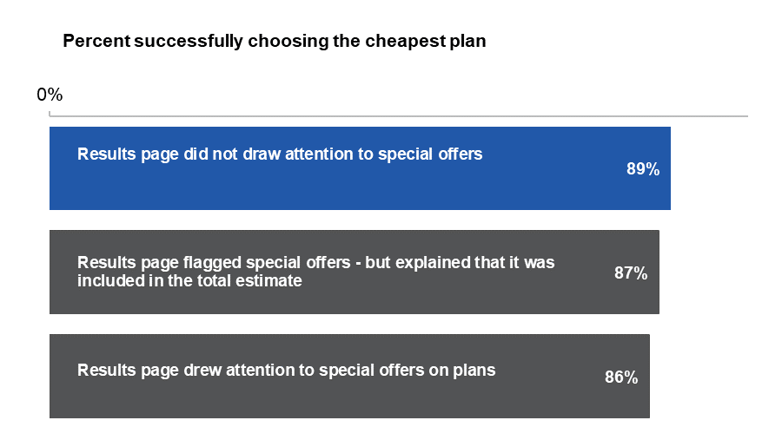

Figure . Drawing attention to special offers on the main results page made consumers a little less likely to choose the cheapest plan from the list.

Adding an explanatory note pointing out that the *Special Offer* (or discount) was already included in the total estimate did not significantly offset the negative effect of the *Special Offer* flag (*‘Panel Survey-Experiment data’* 2022).

These results suggest that caution should be applied before deciding to flag *Special Offers* on the results page.

### Consumers struggled to compare other options to their existing plan

While comparing energy plans on the website was easy, comparing plans on the website to their energy bill was hard. Information on the bill was presented differently to the website. Unlike Energy Made Easy results, bills were not neatly totalled into an estimate for the past year. Supply charges, peak and off-peak rates, pay-on-time discounts, concessions and rebates combined to make it very complex to compare one plan to another (*‘Website user-testing’* data 2022).

When we spoke to energy consumers, we found they wanted to feel really confident before making a choice. In BETA’s previous research into energy bills, our survey asked reasons for *not* switching in the last year. Of those who looked at other plans but did not switch, 40% said they were happy with their current plan and 12% were worried they would end up on a worse plan (BETA 2018, p.58). This means that if, after initiating a plan search, the user still felt uncertain about the best choice, they were more likely to stick with the status quo than take a risk.

In user-testing, consumers looked for their own plan on the website, but old plans from previous years are not shown if they are not available to new consumers (*‘Website user-testing’* data 2022). We thought that drawing attention to their current retailer’s cheapest plan might be a good substitute for their actual plan. It would give them a clue as to whether their retailer is competitive, but also allow them to realise that their own retailer might offer better plans.

We were concerned about a potential backfire: If we pinned their current retailer’s cheapest plan to the top of the results, would this give them an unearned advantage? Would placing it in the most prominent spot cause consumers to choose it, even if it wasn’t a very good deal? We needed to be sure we wouldn’t be nudging consumers to choose an expensive plan.

In order to test this, we used a Randomised Controlled Trial (RCT) so we could show each person one of several possible versions of the website and observe their choices (*‘Panel Survey-Experiment data’* 2022). We embedded this in a survey about energy and switching (Figure 6).

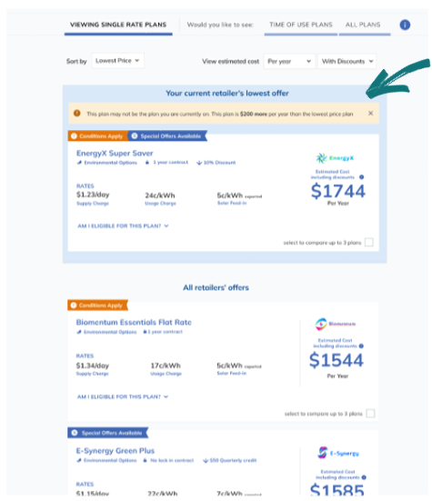

Figure . We highlighted the current retailer’s lowest offer in the survey experiment.

Surprisingly, even in the hypothetical experiment, some consumers were loyal to the fictitious energy retailer we’d assigned to them one minute earlier. Of the group who saw a ‘business as usual’ version of the website, one in ten consumers decided to stick with their current plan, rather than to risk a bad decision. When the cheapest plan from their current retailer was pinned to the top of the search results, consumers were more likely to want to make a switch to a better plan. The number choosing to stick to their old plan dropped by around half, most switched to the even cheaper plan offered by another retailer (Figure 7). That left only 3-6% sticking with their current plan. The example that we tested left little room for confusion, it stated *‘This plan may not be the plan you are currently on. This plan is* ***$X more*** *per year than the lowest price plan’*. We tested an example where the currently retailer’s plan was competitive ($80 more per year) and another where it was much less competitive ($201 more per year). Providing consumers a bit of extra information about their current choice made it easier for them to make a switch.

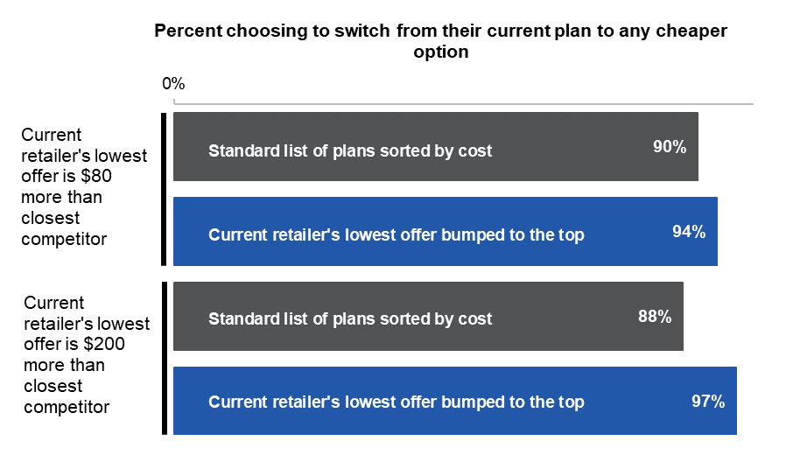

Figure 7. Consumers chose a cheaper plan when their current retailer’s lowest offer was bumped to the top of the list of options.

## Evaluating changes to the website

Summary of key findings:

* Streamlining search function questions resulted in a greater proportion of EME users responding to all questions and reaching the results page (from 70% to 84%).
* A default prompt increased the likelihood users would share their meter data (NMI) (from 39% to 70%), and get the most accurate results.
* By focusing attention on the most critical plan information, users were more likely to persist and view one or more individual plans (from 9% to 28%).
* Showing users their current retailer’s cheapest plan to compare to other available plans, consumers were more likely to switch retailers (from 22% to 26%).

The updated website went live in October 2023. It featured a large number of changes recommended by BETA to make it easier to use the website and to decode complex plans to make the best choices for the individual.

To measure the impact of all these changes, we reviewed Google analytics measures that tell us a bit about the effectiveness of different elements.

### A behaviourally informed user-journey kept consumers engaged

The AER changed the search funnel to default consumers to a request to link their meter data, the quickest method for data sharing delivering the most accurate results (Figure 8), but bypassing all extra data sharing options for consumers who were moving house (Figure 9).

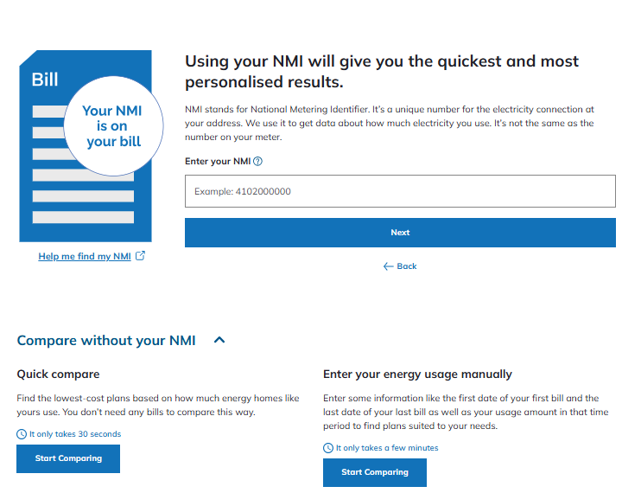

Figure . The redesigned search function defaults consumers to a prompt to enter their National Metering Identifier – the best method for sharing data.

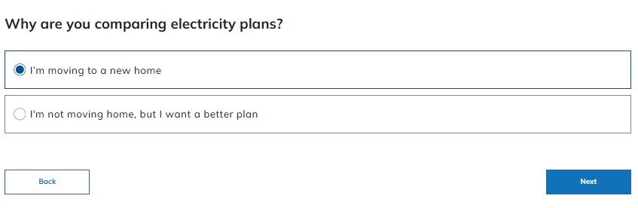

Figure . On the new website, consumers who are moving house bypass all questions around data sharing as it is not applicable.

To measure the impact of these changes, we looked at the percent of consumers who completed the form and reached the results page. Before the website was replaced, 70% of consumers who started a plan search reached the results page. After the new website was introduced, this increased to 84%, a 14 percentage point jump (Figure 10).

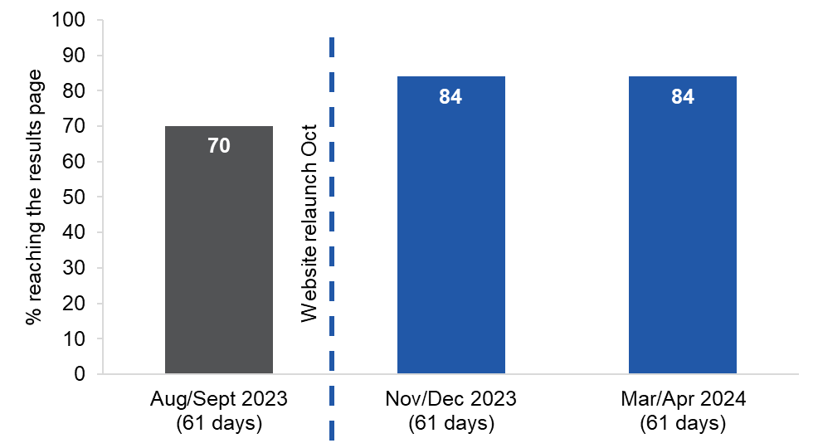

Figure . After the website was redesigned to improve the choice architecture, EME users who started a search journey were more likely to respond to all questions and reach the results page.

‘Website Google Analytics data’, 2024. N=1,627,993 (All EME consumers who started a search journey by entering their postcode).

In addition, 39% of consumers on the old website entered their NMI. The new defaults increased the rates of NMI entry to 64%, a 25 percentage point jump, ensuring many more consumers got the most accurate results (Figure 11).

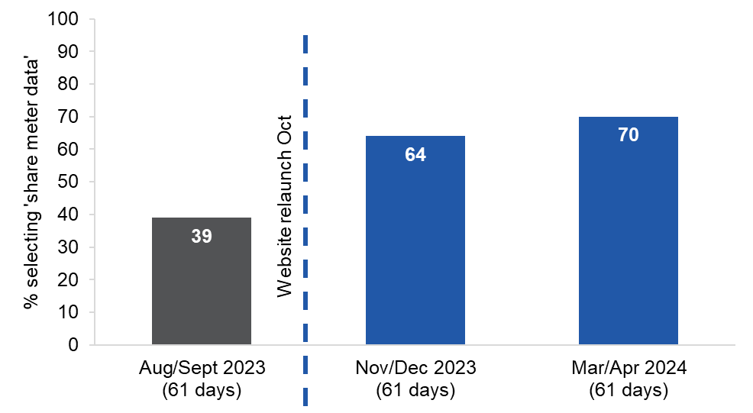

Figure . After the website was redesigned to improve the choice architecture, EME users were more likely to choose to share their meter data (NMI) giving them more accurate search results.

‘Website Google Analytics data’, 2024. N=1,627,993 (All EME consumers who started a search journey by entering their postcode).

### A focus on critical information helped consumers compare plans

The AER changed the plan summary on results page to show critical main usage and supply charges, with special offers carefully caveated (Figure 12).

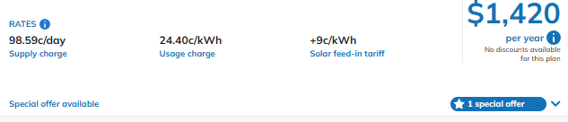

Figure . This example shows the critical information appearing on the main results page, instead of only on the detailed results page.

To measure the impact of these changes, we looked at the percent of consumers who, after viewing the results page, chose to take the next step by viewing the detail on an individual plan. This step is a sign of more serious engagement – similar to trying on a garment after browsing the shelves. Before the website was replaced, 9% of consumers who viewed the results page clicked on and viewed an individual plan. After the new website was introduced, this increased to 26%, an 18 percentage point increase (Figure 13).

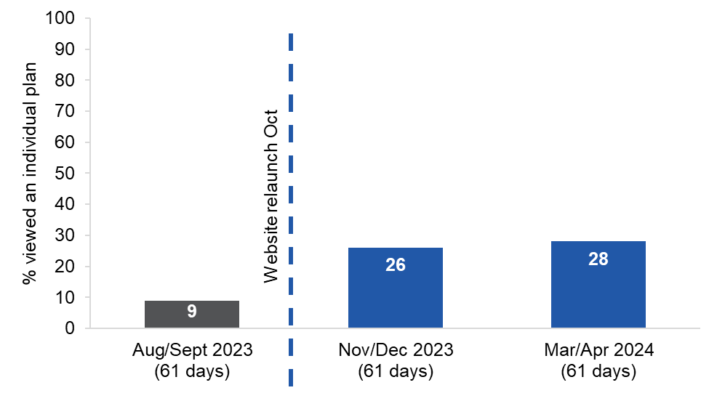

Figure . After the results page was redesigned to focus on critical information, users who viewed the results page were more likely to persist and view one or more individual plans.

‘Website Google Analytics data’, 2024. N=384,829 (All EME consumers who viewed the results page).

### Consumers were more likely to switch after seeing how their own retailer compared

The AER changed the results page to show the current retailer’s best offer at the top, with a line stating how it compared to the cheapest offer overall (Figure 14). Our testing predicted that this would make consumers a little more likely to switch to another retailer than if it was not shown.

The AER only receives reports of actual rates of switching to another retailer if consumers have entered their meter number. In the following month, AEMO provides the AER with a report showing the overall rate of switching of those consumers who shared data.

Example webpage shows search results for user who is with energy Company A. A message at the top says This plan by your current energy company is $620 more than the lowest priced plan we found. Company A's best offer ($2,500 per year) is at the top of the page highlighted in light blue box. 
Under the box is the lowest price plan by a different energy company ($1,880 per year).

Figure . The refreshed website placed the current energy company’s best offer at the top – demonstrating how it compares to other offers sorted by price.

To measure the impact of showing the current retailer’s best offer at the top, this sub-sample provides an excellent data source because all consumers who share meter data have a known current retailer that can be displayed at the top. Importantly, this data only counts switching to a different provider, not switching to a different plan with the same provider.

Before the website was replaced, 22% of consumers who shared their meter data switched to a different retailer. After the new website was introduced this increased to 25% of consumers, an increase of 3 percentage points switching retailers. We had been concerned about a backfire here (fewer people switching retailers), but actually saw a small increase – as predicted by our survey experiment. More than 80,000 consumers per month (on average) started a plan search on Energy Made Easy in this period, so the 3 percentage point increase represented an additional 4,520 households switching energy providers in the Nov/Dec 2023 period compared to Aug/Sept 2023 (Figure 15).

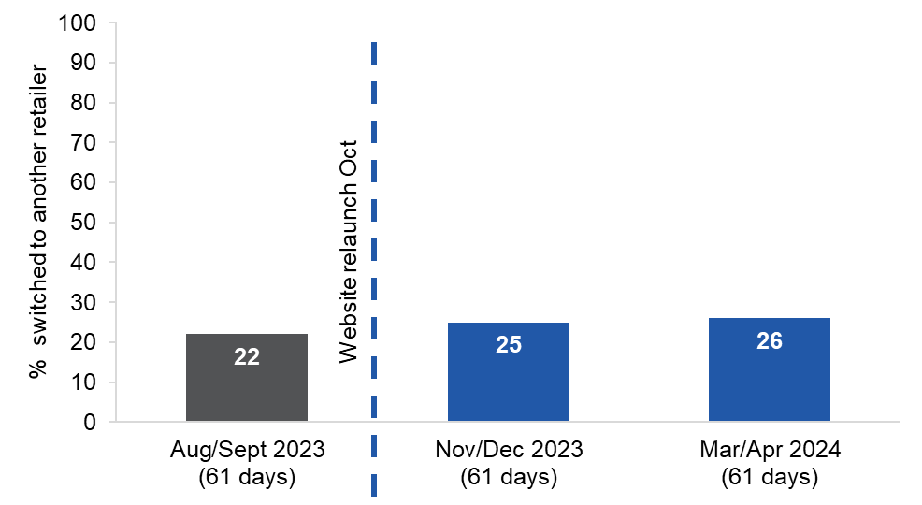

Figure . After the results page was redesigned to show users how their current retailer’s cheapest plan compares to other available plans, consumers were more likely to switch to a different retailer.

AEMO report to AER, 2024. N = 274,278 (Consumers who shared their meter data. Switching information is not available for other consumers).

Implementing the improvements described above does not mean the website is complete and perfectly optimised. Technological advancements and further user-testing can continue to identify both small tweaks and major opportunities to improve the user experience and ultimately to save Australian consumers money.

As an example of this iterative process, the EME Team within the AER conducted a User Experience Review during 2024. As in previous testing, the review found that consumers expected to see their current plan information within the results list. It also found that consumers were perceiving the *pinned* best offer from the current retailer to be *their* current plan. Consumers were skimming past the words *‘This may not be the plan you’re on now’* (Figure 14). Consumers who assume that the plan on EME is therefore incorrect, could potentially lose trust in EME.

To address this, the EME team implemented a change to how this feature works on EME after the data were collected. The wording stating that EME does not show their current plan is now in larger bold font and links to guidance on how to use a bill to compare to the current plan. In addition, the highlighted plan from the current retailer is no longer pinned to the top but is sorted by price.

To continue to align with the core finding of this report, the AER will explore pinning the information about the best offer from the current retailer, without displaying the full plan – to strike a balance between the issue of consumers expecting to see their current plan, while giving them critical information about the value of their current retailer. It is hoped at a later stage, EME will have new capability to show consumers their current plan.

### Evaluation showed strong positive impact on consumer journey

When many changes are rolled out simultaneously in a website redesign, it becomes difficult to distinguish the effects of individual changes. The suite of improvements to the usage input and search function, making critical information more salient, enabling comparison to current retailer, as well as a range of other improvements to the layout, graphic design and functionality are collectively responsible for these higher rates of persistence, engagement and switching. These positive effects are substantial and align closely with the effects predicted by the experimental research. The redesigned Energy Made Easy website is easier to use than before and is empowering more consumers to switch energy plans.

## References

### Citations

ACCC, 2021. *Inquiry into the National Electricity Market: May 2021 Report.* <https://www.accc.gov.au/publications/serial-publications/inquiry-into-the-national-electricity-market-2018-2025/inquiry-into-the-national-electricity-market-may-2021-report>

Behavioural Insights Team, 2022. *Testing the better offer notice on energy bills: Final report from the Behavioural Insights Team,* [BIT - Testing the better offer notice on energy bills - Final report.PDF (aer.gov.au)](https://www.aer.gov.au/system/files/BIT%20-%20Testing%20the%20better%20offer%20notice%20on%20energy%20bills%20-%20Final%20report.pdf)

BETA, Commonwealth of Australia, Department of the Prime Minister and Cabinet, 2018. *Electricity information to fit the bill: Redesigning electricity bills to support consumer engagement.* [BETA: Fit the Bill Report (pmc.gov.au)](https://behaviouraleconomics.pmc.gov.au/sites/default/files/projects/Fit-the-bill-report_0.pdf)

Centre for Market Design, 2020. *Third-party price comparator platforms in the Australian energy market*, Melbourne: University of Melbourne.

Newgate, 2017. Consumer Research for the Australian Energy Market Commission’s 2017 Retail Competition Review. [Newgate Research - AEMC 2017 Retail Competition Review - Consumer Research Report](https://www.aemc.gov.au/sites/default/files/content/62080e52-06d1-4526-8c92-3eadec24876f/Newgate-Research-AEMC-2017-Retail-Competition-Review-Consumer-Research-Report-F.pdf)

### Sources from our literature scan

Ariely, D., 2000. Controlling the information flow: Effects on consumers' decision making and preferences. *Journal of Consumer Research*, *27*(2), pp.233-248.

Antal, M., 2020. A ‘parasite market’: A competitive market of energy price comparison websites reduces consumer welfare. *Energy Policy*, *138*, p.111228.

Ball, C., 1997. A comparison of single-step and multiple-step transition analyses of multiattribute decision strategies. *Organizational Behavior and Human Decision Processes*, *69*(3), pp.195-204.

Bettman, J.R., Luce, M.F. and Payne, J.W., 1998. Constructive consumer choice processes. *Journal of Consumer Research*, *25*(3), pp.187-217.

Brennan, T.J., 2007. Consumer preference not to choose: methodological and policy implications. *Energy Policy*, *35*(3), pp.1616-1627.

Burnett, T., 2014. The impact of service bundling on consumer switching behaviour: evidence from UK communication markets (pp. 1-53). CMPO.

Carthy, P., Lunn, P.D. and Lyons, S., 2020. Demographic variation in active consumer behaviour: On-line search for retail broadband services. *Heliyon*, *6*(7), p.e04478.

Castagnos, S., Jones, N. and Pu, P., 2010, September. Eye-tracking product recommenders' usage. In *Proceedings of the fourth ACM conference on Recommender systems* (pp. 29-36).

Centre for Market Design, 2020. *Third-party price comparator platforms in the Australian energy market*, Melbourne: University of Melbourne.

Chernev, A, Böckenholt, U., and Goodman, J. 2015. ‘Choice overload: A conceptual review and meta-analysis.’ *Journal of Consumer Psychology* 25(2) pp.333-358

Cronqvist, H., & Thaler, R. 2004. Design choices in privatized social security systems: learning from the Swedish experience. *American Economic Review*, 94, 424–428.

Dubé, J. P., Hitsch, G. J., and Rossi, P. E. 2010. State dependence and alternative explanations for consumer inertia. *The RAND Journal of Economics*, 41(3), 417-445.

Dubé, J.P., Hitsch, G.J. and Rossi, P.E. 2009. Do switching costs make markets less competitive?. *Journal of Marketing Research*, Vol. 46 No. 4, pp. 435-445.

Eppler, M. J. & Mengis, J. 2004. The Concept of Information Overload: A Review of Literature from Organization Science, Accounting, Marketing, MIS, and Related Disciplines. *The Information Society: An International Journal.* 20 (5), pp.325–344.

Etco, M., Sénécal, S., Léger, P.M. and Fredette, M., 2017. The influence of online search behavior on consumers’ decision-making heuristics. *Journal of Computer Information Systems*, *57*(4), pp.344-352.

Gamble, A., Juliusson, E.A. and Gärling, T., 2009. Consumer attitudes towards switching supplier in three deregulated markets. *The Journal of Socio-Economics*, *38*(5), pp.814-819.

Giulietti, M., Waterson, M. and Wildenbeest, M., 2014. Estimation of search frictions in the British electricity market. *The Journal of Industrial Economics*, *62*(4), pp.555-590.

Giulietti, M., Price, C.W. and Waterson, M., 2005. Consumer choice and competition policy: a study of UK energy markets. *The Economic Journal*, *115*(506), pp.949-968.

Gray, D.M., D’Alessandro, S., Johnson, L.W. and Carter, L., 2017. Inertia in services: causes and consequences for switching. *Journal of Services Marketing*.

Hauser, J.R., Urban, G.L., Liberali, G. and Braun, M., 2009. Website morphing. *Marketing Science*, *28*(2), pp.202-223.

Hortaçsu, A., Madanizadeh, S.A. and Puller, S.L., 2017. Power to choose? An analysis of consumer inertia in the residential electricity market. *American Economic Journal: Economic Policy*, *9*(4), pp.192-226.

Johnson, E.J., Shu, S.B., Dellaert, B.G., Fox, C., Goldstein, D.G., Häubl, G., Larrick, R.P., Payne, J.W., Peters, E., Schkade, D. and Wansink, B., 2012. Beyond nudges: Tools of a choice architecture. *Marketing Letters*, *23*(2), pp.487-504.

Klemperer, P., 1995. Competition when consumers have switching costs: An overview with applications to industrial organization, macroeconomics, and international trade. *The Review of Economic Studies*, *62*(4), pp.515-539.

Kling, J. R., Mullainathan, S., Shafir, E., Vermeulen, L., & Wrobel, M. V. (2011). Misprediction in choosing Medicare drug plans. Harvard University Press, Cambridge.

Lee, R. and Neale, L., 2012. Interactions and consequences of inertia and switching costs. *Journal of Services Marketing*, 26(5), pp.265-374.

McShane, B., and Böckenholt, U. 2017. ‘Multilevel Multivariate Meta-Analysis with Application to Choice Overload.’ *Psychometrika*

Mols, F., Haslam, S.A., Jetten, J. and Steffens, N.K., 2015. Why a nudge is not enough: A social identity critique of governance by stealth. *European Journal of Political Research*, *54*(1), pp.81-98.

Mountain, B., 2019. New regulations expose energy price gouging through ‘free’ comparison sites. *The Conversation*, 9 January

Murakami, R., 2021. Consumers’ Switching Behavior and Bundling: An Empirical Study of Japanese Energy Retail Markets. *Kindai Working Papers in Economics No. E-46*

Ndebele, T., Marsh, D. and Scarpa, R., 2019. Consumer switching in retail electricity markets: Is price all that matters?. *Energy Economics*, *83*, pp.88-103.

Ofgem 2020. Prompting sustained engagement in energy tariff switching: Learnings from following up customers from Ofgem's Collective Switch trials

Ofgem 2019. Ofgem’s collective switch trials. https://www.ofgem.gov.uk/publications/ofgems-collective-switch-trials

Orquin, J.L. and Loose, S.M., 2013. Attention and choice: A review on eye movements in decision making. *Acta Psychologica*, *144*(1), pp.190-206.

Pomp, M., Shestalova, V. and Rangel, L., 2005. Switch on the competition; causes, consequences and policy implications of consumer switching costs (No. 97). *CPB Netherlands Bureau for Economic Policy Analysis.*

Rutter, R., Chalvatzis, K.J., Roper, S. and Lettice, F., 2018. Branding instead of product innovation: a study on the brand personalities of the UK's electricity market. *European Management Review*, *15*(2), pp.255-272.

Salies, E., 2005. A measure of switching costs in the GB electricity retail market. *MPRA Paper No. 28255.*

Samuelson, W. and Zeckhauser, R., 1988. Status quo bias in decision making. *Journal of Risk and Uncertainty*, *1*(1), pp.7-59.

Scheibehenne, B., Greifeneder, R. and Todd, P.M., 2010. Can there ever be too many options? A meta-analytic review of choice overload. *Journal of Consumer Research*, *37*(3), pp.409-425.

Shi, S.W., Wedel, M. and Pieters, F.G.M., 2013. Information acquisition during online decision making: A model-based exploration using eye-tracking data. *Management Science*, *59*(5), pp.1009-1026.

Shin, K.J. and Managi, S., 2017. Liberalization of a retail electricity market: Consumer satisfaction and household switching behavior in Japan. *Energy Policy*, *110*, pp.675-685.

Simon, H.A., 1955. A behavioral model of rational choice. *The Quarterly Journal of Economics*, *69*(1), pp.99-118.

Simon, H.A., 1971. Designing Organizations for an Information-rich World. Baltimore, MD: Johns Hopkins University Press. pp. 37–52*.*

Strombom, B.A., Buchmueller, T.C. and Feldstein, P.J., 2002. Switching costs, price sensitivity and health plan choice. *Journal of Health Economics*, *21*(1), pp.89-116.

Thaler, R. 1980. Toward a positive theory of consumer choice. *Journal of Economic Behavior and Organization.* (1) pp.39–60

Thaler, R. H., & Sunstein, C. R. 2008. Nudge: improving decisions about health, wealth and happiness. New Haven: Yale University Press.

Uddin, M., Wang, L.C., and Smyth, R. 2021 Do government-initiated energy comparison sites encourage consumer search and lower prices? Evidence from an online randomized controlled experiment in Australia *Journal of Economic Behavior & Organization* 188 pp.167-182

Waterson, M., 2003. The role of consumers in competition and competition policy. *International journal of Industrial Organization*, *21*(2), pp.129-150.

Yang, Y., 2014. Understanding household switching behavior in the retail electricity market. *Energy Policy*, *69*, pp.406-414.

Yang, L., Toubia, O. and de Jong, M.G., 2018. Attention, information processing, and choice in incentive-aligned choice experiments. *Journal of Marketing Research*, *55*(6), pp.783-800.

## Appendix A: Methodology

**Our research program**

Our research program included a number of distinct approaches that enabled us to comprehend:

* The population: current and future users of the website, their needs and preferences.
* The status quo: what was and was not working, how consumers are actually using the website.
* Reactions to new designs and prototypes: whether they were solving identified problems, and how they might be further improved.

**We conducted analysis of existing data sources**

BETA conducted a scan of the literature on consumer switching & comparison websites and reviewed de-identified EME web-form and call centre data to identify existing barriers and pain points (‘Call-centre data’ 2021). In addition, reviewed existing Google Analytics reports on the EME website in December 2021 (‘Website Google Analytics data’ 2021).

**We placed a *Give feedback* widget on the EME website**

Using Hotjar, a behaviour analytics and user feedback service used by EME, a sidebar widget was placed on all pages of the site encouraging users to *Give Feedback* (*‘Website Feedback data’* 2022). Clicking on the sidebar, there was an option for site visitors to rate their overall experience out of five stars and to *Tell us about your overall experience or any suggested improvements*.

**We surveyed EME users about data sharing pathways**

An additional Hotjar short survey was designed to pop-up after a visitor to the EME website had entered their selections and were about to be shown their energy plan results (*‘Website Search Pathway Survey data’* 2021). The survey asked only which data entry pathway had been chosen and why.

Options included:

* enabling data linkage by entering their National Meter Identifier (NMI)
* uploading a PDF bill
* manually entering their usage data
* entering no data, estimates are then based on an average for household size and location.

**Using seven short surveys to understand drivers and barriers to switching plans**

We wanted our survey to test if user personas from previous qualitative research commissioned by the AER was reflective of actual EME users.

The personality traits and preferences described through the personas were captured through survey questions posed on the EME website through a pop-up Hotjar survey (‘Website User Survey Series’ 2022). From 21 to 28 February, we fielded seven short surveys through the EME website, swapping them over on a daily basis. The sample for each survey ranged from 531 to 1,173.

EME visitors completing each survey were a subset of total visitors to the site. The surveys were not compulsory, and were designed to pop up upon completion of a plan search, just before results were revealed. This means that the responding sample is likely to be more representative of visitors who are serious about looking for a new plan, not visitors casually browsing or those following a direct link to the site to view a Basic Plan Information Document. Each survey contained only four questions and the device type used was captured by the Hotjar software. Age was collected in each survey, so only age and device type were captured across all surveys. Across the week, there was an 18% response rate to 35,632 impressions.

**We observed consumers using the website and several prototypes**

Four rounds of qualitative user research were undertaken to test and refine designs, each round with naïve users recruited through a panel process (‘Website user-testing’ data 2022). Each round had a different set of materials to test, based on ideas and content generated collaboratively by the AER, Pretzel and BETA. These included clickable prototypes showing the website landing page, the funnel, the results page and several examples of individual plan pages. It also featured help windows, and pathways for *PDF, NMI*, *Manual entry* and *Quick compare*. In each round, 8-10 participants were invited to participate.

* Round 1: Tested the prototypes built by Pretzel: a household search with several alternative data entry pathways.
* Round 2: Tested the existing live EME website: respondents were asked to undertake a search based on their personal circumstances (postcode, etc.).
* Round 3: Tested prototypes updated based on feedback from Round 1 and Round 2.
* Round 4: Tested prototypes developed for small businesses with small business owners.

BETA provided the interviewer guide, but Hall & Partners was contracted to recruit participants, facilitate the user interviews and provide reports. BETA, Pretzel and AER staff observed interviews and had regular debriefs with Hall & Partners.

**We tested several design options and surveyed Australians about switching preferences**

BETA developed a survey which went out to a panel of participants who were broadly representative of population demographics. A link inviting participants to complete the survey was also posted on the EME website so that EME users could participate. Both samples, over 2,100 respondents, saw the same survey, which included two survey experiments and a series of survey questions. Where results of the survey are presented here (*‘Panel Survey data’* 2022), we use only complete responses from panel participants (n=1,554), as the EME users’ responses numbered only 513 and represented only an extremely interested and unrepresentative subset of EME users.

The survey questions targeted:

* awareness of EME and other energy comparison websites
* design of the EME site
* comprehension of technical jargon in the energy sector
* attitudes to reducing energy usage
* switching, energy bills and household features
* demographic characteristics and financial status.

We conducted survey experiments to test the impact of two changes to the EME results page: bumping the retailer’s lowest offer to the top of the results, and including information about discounts against plans where relevant (*‘Panel Survey-Experiment data’* 2022).

**Summary of research methods**

Our methods included qualitative, quantitative and experimental methods as well as analysis of existing data sources, summarised in Table 1.

**Table 1. Sources of evidence**

| Source of evidence | Sample size | Report reference |
| --- | --- | --- |
| Observations from EME web-form and call centre data | N=1,291 | *‘Call-centre data’* 2021 |
| Google Analytics report on the EME website | - | *‘Website Google Analytics data’* 2021, 2022, 2024 |
| Entries in a widget on all pages of the EME website encouraging users to *Give feedback* | N=133 | *‘Website Feedback data’* 2022 |
| Pop-up survey of EME users about data sharing pathways | N=15,306 | *‘Website Search Pathway Survey data’* 2022 |
| Short pop-up surveys of EME users about drivers and barriers to switching plans | N=6,432  (531-1,173 in each survey) | *‘Website User Survey Series’* 2022 |
| Qualitative user-testing of website and prototypes | N=40  (~10 per round) | *‘Website User-Testing data’* 2022 |
| Survey about switching preferences and use of comparison websites | Panel=1,554, EME=513 | *‘Panel Survey data’* 2022 |
| Survey experiments on discounts and bumping retailer’s lowest offer to the top of the page | N=2,136 | *‘Panel Survey-Experiment data’* 2022 |

## Appendix B: Technical details

### Pre-registration, pre-analysis plan and ethics

The pre‑analysis plan for the RCT was registered on 27 June 2022. This was after the experiment launch on 10 June 2022 but before data collection was completed and before any analysis was undertaken. The ethical aspects of the experimental research were reviewed and approved by the Macquarie University Low Risk Committee (Project ID: 11843), as were the user-testing / interviews (Project ID: 11212). The short pop-up surveys on the Energy Made Easy website were assessed as negligible risk (approved by Macquarie University Ethics Secretariat)

The analysis of the RCT data was consistent with the pre-analysis plan. All exploratory analyses are clearly designated. The pre-analysis plan is available on the BETA website.

### Data cleaning

We cleaned and analysed the data using R. As we collected data we did regular checks on quotas, assessments for bots, and checks for randomisation or other errors. We did not analyse the data until after collection was complete.

### Population and sampling

Our sample was drawn from two sources.

**Online panel**: We aimed for a sample of 1,725 respondents drawn from an online survey panel constructed by the Online Research Unit (the ORU). The ORU’s panel was recruited through a mix of offline and online methods including post, phone, print and online recruitment. Panel members received incentives for participation by post to a physical address. This reduced the risks of fraudulent respondents or panellists that reside outside of Australia.

Participants from the ORU’s panel were restricted to those aged 18 years or above old who live in jurisdictions in the National Energy Market (NSW, QLD, SA, TAS and the ACT), since the EME site only provides comparisons for those jurisdictions. We applied loose quotas for survey participants based on age, gender and location (metro/regional).

**EME website visitors**: The second sample source was via a link from the EME website that displayed during June for approximately 2 weeks. We aimed for at least 1,275 responses – see section below on Sample Size and Power Calculations for further details. We did not impose any restrictions on the age or location of respondents because previous surveys on the EME site suggest almost all users who responded to a survey were 18 years or older (99.9%) and living in NEM jurisdictions (99.6%). Participants who completed the survey via the EME site did not receive any payment or reimbursement for their participation.

**Population of interest**: Our population of interest was prospective visitors to the Energy Made Easy website. In principle, this could extend to all household and small business energy consumers in the National Energy Market. In practice, only a subset of these energy consumers would ever visit the website. Neither of the samples were representative of the population of interest so some caution must be applied in generalising the results of the survey experiments.

After data cleaning, we achieved a final sample of 1,650 respondents through the panel and 620 respondents through the website, making our final sample 2,270 respondents.

### Survey design

The median duration was 8.6 minutes (panel sample) and 10.3 minutes (website sample). While the panel sample was reasonably representative of the population, the web sample was predominantly male (65%) and substantially older (50% over 55). Both surveys contained an almost identical question set and randomisation to treatment was balanced across the samples.

The survey flow ran as follows:

1. Screeners
2. Switching behaviours
3. Randomisation to treatment arms for both experiments
4. Both experiments consecutively, order randomised
5. Energy Made Easy preferences
6. Engagements with the energy market and energy consumption
7. Demographics

Survey questions can be made available on request.

## Appendix C: Special offers RCT

### Design

Several participants in user-testing said they were aware that retailers often offer discounts or special offers, and they said they wanted to see that information on the results page. However, these discounts are already factored into the ‘estimated cost’ of each plan so there is a risk that site visitors effectively double-count the discounts, leading them to mistakenly choose an inferior plan.

Experiment B is a 3-arm individually randomised survey experiment run with the aim of evaluating whether drawing attention to plan discounts increases the percentage who choose the discounted plan (not the cheapest plan), and whether additional information can neutralise the effect of the discount flag. Specifically we want to know whether we can ensure that consumers notice that the total estimated cost already includes the discount or whether they are applying the discount to the discounted price estimate.

### Sample size and power

We performed power calculations for the minimum detectable effect size using an alpha of 5%, and power of 80% for a one‑sided test. This assumed that we would collect a sample size of 3,000 respondents across the 2 samples.

With 3,000 respondents, the experiment would have been powered to detect a minimum effect size of a decrease of 5 percentage points (based on a baseline rate of 90% choosing the cheapest plan (H1)).

### Sample randomisation

Randomisation occurred dynamically in Qualtrics – each respondent was assigned a random number of 1, 2 or 3, determining treatment arm (Table 2).

Table . Sample size for each arm of the trial.

| Trial arm | Message | n | % |
| --- | --- | --- | --- |
| 1 | Special offers not flagged | 694 | 30.91 |
| 2 | Plan shows a special offer flag | 808 | 35.99 |
| 3 | Plan shows special offer flag with explanation that offer is included in the total estimate. | 743 | 33.1 |

n = 2,245

### Outcome measures

Outcome (cheapest plan): choose the cheapest overall plan (binary)

### Hypotheses

H1: When Discount flag is shown (T2), fewer people will choose the cheapest plan than when no Discount information is provided (T1). T2 < T1

H2: When Discount flag is shown but a note explains that Discount is already included in price estimate (T3), more people will choose the cheapest plan than when Discount flag is shown without the note (T2). T3 > T2

### Method of analysis

We derived the estimated treatment effects, confidence intervals and p-values from an ordinary least squares regression model using robust (HC2) standard errors with the following specification:



Where *i* is an index for each individual in the experiment, *Y* is the outcome, *β0* is the intercept, *Z* is the treatment indicator, *β1* is the coefficient on treatment and represents the average treatment effect, *X* is a vector of two mean‑centred covariates (an indicator for which sample the respondent came from (where 1 = EME sample) and an indicator for whether the respondent has switched plans or energy providers previously (where 1 = switching plan/provider other than when moving house), and *ZX* is the interaction of the treatment indicator with the mean‑centred covariates and *E* is the error term.

The treatment indicator *Z* is a vector of 2 treatment assignment indicators where {0,0} = T1, {1,0} = T2 and {0,1} = T3.

### Statistical tables

Table . H1: Fewer people chose the cheapest plan when a discount was flagged on an alternative plan.

| **Condition** | **Mean % choosing the cheapest plan** | **Estimate** | **Standard error** | **95% Confidence Interval** | ***p-*value** |
| --- | --- | --- | --- | --- | --- |
| Discount not flagged | 89.0% | - | - | - | - |
| Discount flagged | 85.9% | -0.03 | 0.02 | (-0.06 – -0.002) | 0.036 |

n = 1,445

One tailed test.

Marginal means derived from OLS model with HC2 robust standard error adjusted for switching history, source of sample and these two covariates interacted with treatment.

Table . H2: Compared to when the discount is flagged, when it was also accompanied by an explanatory note, the small increase in people choosing the cheapest plan was not significant.

| **Condition** | **Mean % choosing the cheapest plan** | **Estimate** | **Standard error** | **95% Confidence Interval** | ***p-*value** |
| --- | --- | --- | --- | --- | --- |
| Discount flagged | 85.9% | - | - | - | - |
| Discount flagged with note | 87.1% | 0.01 | 0.02 | (-0.02 – 0.04) | 0.242 |

n = 1,504

One tailed test.

Marginal means derived from OLS model with HC2 robust standard error adjusted for switching history, source of sample and these two covariates interacted with treatment.

## Appendix D: Retailer comparison RCT

### Design

Several participants in user-testing said that they wanted the results page to show them how their current retailer compares with others. Comparison sites can achieve this by ‘pinning’ the current retailer’s product to the top of the results page before showing a sorted list of other plans. However, the complexities of the energy retail market mean that the EME site cannot always show the visitor’s current plan but it can show the ‘best offer’ from the same retailer. The risk, however, is that pinning this to the top of the results page induces consumers to switch to the retailer’s best offer even though this is inferior to other plans in the market.

This experiment was a 4-arm individually randomised survey experiment run with the aim of increasing the percentage who choose to switch from their current plan to another plan in a hypothetical scenario. Specifically, we tested the effect of pinning the cheapest plan from their current retailer to the top of the search results.

### Sample size and power

We performed power calculations for the minimum detectable effect size using an alpha of 5%, and power of 80% for a one‑sided test. This assumed that we would collect a sample size of 3,000 respondents across the 2 samples.

**Experiment A:** With 3,000 respondents, the experiment was powered to detect a minimum effect size of 5 percentage points (assuming a baseline rate of 80% choosing to switch). We did not know what effect size was feasible and had no information on the probable baseline rates of switching in a hypothetical such as this.

### Sample randomisation

Table . Sample size for each arm of the trial after randomisation.

| Trial arm | Presentation of Retailer’s Best Offer (RBO) on list of plan results | *n* |
| --- | --- | --- |
| T1 | **Pinned RBO; competitive RBO**:  The RBO is pinned to the top of the results summary page, with the rest of the results sorted by estimated cost. The estimated cost of the RBO is $80 more expensive than the best plan available. | 535 |
| T2 | **Pinned RBO; expensive RBO**:  As for T1 except the estimated cost of the RBO is $201 more expensive than the best plan available. | 580 |
| T3 | **No pin; competitive RBO**:  As for T1 except the RBO is not pinned. The RBO appears 3rd in the results based on its estimated cost ($80 more than the best plan). | 595 |
| T4 | **No pin, expensive RBO**:  As for T2 except the RBO is not pinned. The RBO appears 4th in the results based on its estimated cost ($201 more than the best plan). | 535 |

### Outcome measures

**Experiment A (pinned current retailer)**

Outcome 1 (savings from switching): amount saved from switching ($$$, continuous). Note: the implied cost of the current plan is $2,008 so the savings from cheapest plan is $384.

Outcome 2 (any switch): choose to switch from current plan (binary)

Outcome 3 (switch to retailer’s best offer): select the retailer’s best offer (binary)

Outcome 4 (switch to best plans): select either of the top 2 plans in terms of ‘estimated cost’ (binary)

### Hypotheses

Hypothesis 1 (T1 vs T3): A ‘competitive’ RBO, when pinned, will result in higher savings by inducing some non-switchers to switch to the RBO. It is possible that pinning the RBO will induce some ‘switchers’ to choose the RBO instead of one of the best plans but we still hypothesise the net change in savings will be higher overall.

*Primary analysis*: Pinned (competitive) RBO will result in higher level of savings from switching. T1 > T3. Outcome 1 (amount saved).

*Secondary tests*:

* Higher switching overall: T1 > T3. Outcome 2 (switch)
* Higher switching to RBO: T1 > T3. Outcome 3 (switch to RBO)
* Lower switching to best plans: T1 < T3. Outcome 4 (switch to best plans)

Hypothesis 2 (T2 vs T4): An ‘uncompetitive’ RBO, when pinned, may have several effects although all are expected to be small. First, it could induce some non‑switchers to switch to the RBO. Second, it could induce more switches to the best plans. Third, it could backfire and cause some switchers to choose the RBO instead of the best plans. The most important effect for decision‑making is the potential for a backfire effect and consequently it is the subject of the primary analysis.

*Primary analysis*: The pinned (uncompetitive) RBO may lead to more respondents choosing the best plans or it may backfire and lead to fewer respondents choosing the best plans. T2 ≠ T4 (2-sided test). Outcome 4 (switch to best plans).

We are running a 2 sided test because, as noted above, we want to test 2 plausible scenarios. That is, we may be able to reject the null in favour of the claim that (a) pinning the RBO backfires and reduces the proportion switching to best plans or (b) pinning the RBO causes increased switches to the best plans. (However, we anticipate that pinning an uncompetitive RBO will likely only have a small effect size (if any) and consequently we may not have sufficient power to reject the null. In the event of a null result, we will inspect the point estimates and their confidence intervals to make a judgement about whether any possible effect seems small or material.)

*Secondary tests*:

* Higher level of savings from switching. T2 ≠ T4 (2‑sided test). Outcome 1 (amount saved)
* Higher switching overall: T2 > T4. Outcome 2 (switch)
* Higher switching to RBO: T2 > T4. Outcome 3 (switch to RBO)

### Method of analysis

We derived the estimated treatment effects, confidence intervals and p-values from an ordinary least squares regression model using robust (HC2) standard errors with the following specification:



Where *i* is an index for each individual in the experiment, *Y* is the outcome, *β0* is the intercept, *Z* is the treatment indicator, *β1* is the coefficient on treatment and represents the average treatment effect, *X* is a vector of two mean‑centred covariates (an indicator for which sample the respondent came from (where 1 = EME sample) and an indicator for whether the respondent has switched plans or energy providers previously (where 1 = switching plan/provider other than when moving house), and *ZX* is the interaction of the treatment indicator with the mean‑centred covariates and *E* is the error term.

*Z* is a single treatment indicator where 0 = unpinned RBO (T3 or T4) and 1 = pinned RBO (T1 or T2).

### Statistical tables

Table . H1: Pinning current retailer’s best offer to the top increased individual savings. Retailer’s best offer was competitive, only $80 more than the cheapest plan.

| **Condition** | **Mean savings ($)** | **Estimate** | **Standard error** | **95% Confidence Interval** | ***p-*value** |
| --- | --- | --- | --- | --- | --- |
| Control | $392.31 | - | - | - | - |
| RBO pinned ($80 more) | $408.45 | 16.14 | 7.93 | (0.58 – 31.71) | 0.021 |

n = 1,073

One tailed test.

Marginal means derived from OLS model with HC2 robust standard error adjusted for switching history, source of sample and these two covariates interacted with treatment.

Table . H2: Pinning current retailer’s best offer to the top increased individual savings. Retailer’s best offer was not competitive. It was $201 more than the cheapest plan.

| **Condition** | **Mean savings ($)** | **Estimate** | **Standard error** | **95% Confidence Interval** | ***p-*value** |
| --- | --- | --- | --- | --- | --- |
| Control | $378.01 | - | - | - | - |
| RBO pinned ($201 more) | $408.84 | 30.83 | 8.20 | (14.74 – 46.93) | 0.000 |

n = 1,063

Two tailed test.

Marginal means derived from OLS model with HC2 robust standard error adjusted for switching history, source of sample and these two covariates interacted with treatment.

Table . H1: Pinning current retailer’s best offer to the top lead to higher overall switching rates. Retailer’s best offer was competitive, only $80 more than the cheapest plan.

| **Condition** | **Mean % choosing to switch** | **Estimate** | **Standard error** | **95% Confidence Interval** | ***p-*value** |
| --- | --- | --- | --- | --- | --- |
| Control | 90.3% | - | - | - | - |
| RBO pinned ($80 more) | 93.6% | 0.03 | 0.02 | (0.01 – 0.06) | 0.022 |

n = 1,073

One tailed test.

Marginal means derived from OLS model with HC2 robust standard error adjusted for switching history, source of sample and these two covariates interacted with treatment.

Table . H2: Pinning current retailer’s best offer to the top lead to higher switching overall. Retailer’s best offer was not competitive. It was $201 more than the cheapest plan.

| **Condition** | **Mean % choosing to switch** | **Estimate** | **Standard error** | **95% Confidence Interval** | ***p-*value** |
| --- | --- | --- | --- | --- | --- |
| Control | 87.7% | - | - | - | - |
| RBO pinned ($201 more) | 96.9% | 0.09 | 0.02 | (0.06 – 0.12) | 0.000 |

n = 1,063

One tailed test.

Marginal means derived from OLS model with HC2 robust standard error adjusted for switching history, source of sample and these two covariates interacted with treatment.

Table . H1: Pinning current retailer’s best offer to the top lead to higher switching to the retailer’s best offer. Retailer’s best offer was competitive, only $80 more than the cheapest plan.

| **Condition** | **Mean % choosing retailer’s best offer** | **Estimate** | **Standard error** | **95% Confidence Interval** | ***p-*value** |
| --- | --- | --- | --- | --- | --- |
| Control | 5.5% | - | - | - | - |
| RBO pinned ($80 more) | 8.9% | 0.03 | 0.02 | (0.01 – 0.06) | 0.015 |

n = 1,073

One tailed test.

Marginal means derived from OLS model with HC2 robust standard error adjusted for switching history, source of sample and these two covariates interacted with treatment.

Table . H2: Pinning current retailer’s best offer to the top lead to higher switching to the retailer’s best offer. Retailer’s best offer was not competitive. It was $201 more than the cheapest plan.

| **Condition** | **Mean % choosing to switch to retailer’s best offer** | **Estimate** | **Standard error** | **95% Confidence Interval** | ***p-*value** |
| --- | --- | --- | --- | --- | --- |
| Control | 2.2% | - | - | - | - |
| RBO pinned ($201 more) | 7.6% | 0.05 | 0.01 | (0.3 – 0.08) | 0.05 |

n = 1,063

One tailed test.

Marginal means derived from OLS model with HC2 robust standard error adjusted for switching history, source of sample and these two covariates interacted with treatment.

Table . H1: Pinning current retailer’s best offer to the top did not lead to lower switching to cheapest plans. It actually lead to slightly – not significantly – higher switching to cheapest plans. Retailer’s best offer was competitive, only $80 more than the cheapest plan.

| **Condition** | **Mean % choosing the cheapest plans** | **Estimate** | **Standard error** | **95% Confidence Interval** | ***p-*value** |
| --- | --- | --- | --- | --- | --- |
| Control | 82.0% | - | - | - | - |
| RBO pinned ($80 more) | 83.0% | 0.01 | 0.02 | (-0.03 – 0.05) | 0.656 |

n = 1,073

One tailed test.

Marginal means derived from OLS model with HC2 robust standard error adjusted for switching history, source of sample and these two covariates interacted with treatment.

Table . H2: Pinning current retailer’s best offer to the top lead to higher switching to cheapest plans. Retailer’s best offer was not competitive. It was $201 more than the cheapest plan.

| **Condition** | **Mean % choosing the cheapest plans** | **Estimate** | **Standard error** | **95% Confidence Interval** | ***p-*value** |
| --- | --- | --- | --- | --- | --- |
| Control | 78.4% | - | - | - | - |
| RBO pinned ($201 more) | 83.8% | 0.05 | 0.02 | (0.01 – 0.10) | 0.026 |

n = 1,063

Two tailed test.

Marginal means derived from OLS model with HC2 robust standard error adjusted for switching history, source of sample and these two covariates interacted with treatment.

**© Commonwealth of Australia 2025**

ISBN 978-1-925365-74-0 - Empowered to switch: A partnership to improve the Energy Made Easy comparison website (online)

**Copyright Notice**

With the exception of the Commonwealth Coat of Arms, this work is licensed under a Creative Commons Attribution 4.0 International license (CC BY 4.0) (<https://creativecommons.org/licenses/by/4.0/>)



**Third party copyright**

Wherever a third party holds copyright in this material, the copyright remains with that party. Their permission may be required to use the material. Please contact them directly.

**Attribution**

This publication should be attributed as follows:

© Commonwealth of Australia, Department of the Prime Minister and Cabinet, *Empowered to switch.*

**Use of the Coat of Arms**

The terms under which the Coat of Arms can be used are detailed on the following website: <https://pmc.gov.au/cca>

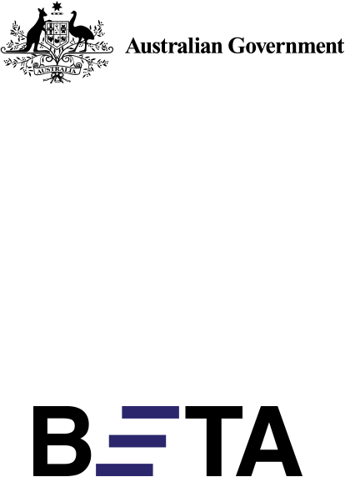

Behavioural Economics Team   
of the Australian Government

General enquiries [beta@pmc.gov.au](mailto:beta@pmc.gov.au)

Media enquiries [media@pmc.gov.au](mailto:media@pmc.gov.au)

Find out more [www.pmc.gov.au/beta](http://www.pmc.gov.au/beta)

[Tell us how you’re using this report](https://youropinion.au1.qualtrics.com/jfe/form/SV_3KTVLrC3vE1cqp0?document=empowered)

[](https://youropinion.au1.qualtrics.com/jfe/form/SV_3KTVLrC3vE1cqp0?document=empowered)