Communication counts: helping small business supervisors support ill and injured workers to return to the workplace
December 2022

Other uses
Enquiries regarding this license and any other use of this document are welcome at:
Managing Director
Behavioural Economics Team of the Australian Government
Department of the Prime Minister and Cabinet
1 National Circuit
Barton ACT 2600
Ngunnawal Country
Email: beta@pmc.gov.au
The views expressed in this paper are those of the authors and do not necessarily reflect those of the Department of the Prime Minister and Cabinet or the Australian Government.

Research team
Current and former staff who contributed to the report were: Hanne M Watkins, Nicholas Hilderson, Andrea Willis, Scott Copley and Katrina Anderson.

Acknowledgments
Thank you to Safe Work Australia for its support and valuable contribution in making this project happen. In particular, special thanks to Safe Work Australia Agency staff, Corey Grandin, Jim Gilchrist and Duncan Cockburn for their work on this project.
We would also like to thank the Strategic Issues Group-Workers’ Compensation, a committee of Safe Work Australia whose membership reflects the broader tripartite Safe Work Australia membership, including representatives from each of the Commonwealth, state and territory governments, and worker and employer representatives. They provided valuable insights, expertise and support of the project.

Who?

Who are we?
We are the Behavioural Economics Team of the Australian Government, or BETA. We are the Australian Government’s first central unit applying behavioural economics to improve public policy, programs and processes.
We use behavioural economics, science and psychology to improve policy outcomes. Our mission is to advance the wellbeing of Australians through the application and rigorous evaluation of behavioural insights to public policy and administration.

What is behavioural economics?
Economics has traditionally assumed people always make decisions in their best interests. Behavioural economics challenges this view by providing a more realistic model of human behaviour. It recognises we are systematically biased (for example, we tend to satisfy our present self rather than planning for the future) and can make decisions that conflict with our own interests.

What are behavioural insights and how are they useful for policy design?
Behavioural insights apply behavioural economics concepts to the real world by drawing on empirically-tested results. These new tools can inform the design of government interventions to improve the welfare of citizens.
Rather than expect citizens to be optimal decision makers, drawing on behavioural insights ensures policy makers will design policies that go with the grain of human behaviour. For example, citizens may struggle to make choices in their own best interests, such as saving more money. Policy makers can apply behavioural insights that preserve freedom, but encourage a different choice – by helping citizens to set a plan to save regularly.

Contents
Executive summary 4
Why? 6
What we did 8
What we found 10
Stakeholder consultation and
literature review 11
Claims data and National RTW survey 17
User testing 22
Final materials 25
Considerations and caveats 28
Conclusion 30
References 31

Executive summary
Every year, more than half a million Australians sustain a work-related injury or illness. For the employee who becomes injured or ill at work, and for their employer, a failed or incomplete return to work can to lead to significant loss of income, loss of productivity, or long term unemployment. Limiting these negative consequences by increasing workers’ timely, safe and durable return to work is a key priority of Safe Work Australia (SWA). Previous research has highlighted a number of factors which contribute to a successful return to work (RTW) process, and the relationship between the worker and their direct supervisor has proven to be critical.
In a previous project, BETA developed guidance materials for the Australian Public Service focused on supporting the supervisor-worker relationship following the illness or injury of a worker. For the present project, BETA collaborated with SWA to adapt these RTW materials for use by supervisors in Small and Medium Enterprises (SMEs). SMEs face unique challenges in supporting an employee to return to work, and addressing barriers to successful return to work in these businesses is a key action identified in the National Return to Work Strategy 2020-2030 (The Strategy, SWA 2019).
To understand the challenges faced by SMEs and adapt the materials for this context, we undertook a literature review, stakeholder consultation and data analysis. Key findings from this diagnostic research informed the first round of revisions to the original RTW guidance materials. Next, we user tested the revised materials with 12 supervisors working in SMEs, and made further changes based on their feedback. See Table 1 at the end of this section for a summary of our findings and corresponding revisions.
Stakeholder consultation, data analysis and user testing also highlighted the variability between SMEs. In particular, data analysis demonstrated that injured or ill workers in small (5-19 employees) and small-medium (20-49 employees) businesses were least likely to report that they were receiving adequate support from their supervisor. In contrast, injured or ill workers in micro (1-4 employees) and medium (50-199 employees) were more likely to feel supported and have positive relationships with their supervisor. As the materials focus on supporting the relationship between workers and supervisors, these findings suggest that they will be most impactful for small and small-medium businesses.
During user testing almost all supervisors indicated that they would find the materials useful; less experienced supervisors in particular thought they would provide helpful guidance. Considering how businesses currently access information about workplace health and safety (WHS) will be key to ensuring materials reach their intended audience. User testing identified possible additional distribution channels including unions and industry bodies, insurers and the Fair Work Ombudsman website. Overall, the results of this project demonstrate supervisors in SMEs are likely to benefit from access to suitable guidance materials helping them navigate the return to work process for an injured or ill worker.

- Summary of findings and corresponding revisions to the materials
Finding | Addressed in revised materials
Relationships matter. A positive relationship between the supervisor and worker can reduce the risk of a failed return to work, while poor relationships present a challenge. Supervisors also highlighted the importance of the rest of the team in a small business. | - Materials retain their focus on the supervisor-worker relationship, and ‘make the case’ to the supervisor for staying in touch with the worker.  - A new section is included, focused solely on tips for talking to the rest of the team (e.g. balancing the need to keep them informed with respect for the privacy of the injured or ill worker).
Timely, specific information is key. Supervisors in SMEs are often time poor, and juggling many roles and responsibilities. They do not always have existing processes in place for dealing with a workplace injury; rather dealing with each incident in an ad hoc manner. | - Materials are streamlined and shortened, including a succinct overview and timeline for easy reference.  - Specific examples and prompts for conversation starters are included at key points during the RTW process.  - An SME’s formal responsibilities (related to workers’ compensation) are also highlighted throughout where relevant.
Mental health is on everyone’s mind. Psychological injuries often result in longer periods of time off and lower chance of successful return to work. They are particularly challenging for supervisors. | - Psychological and physical injury are discussed separately in the revised suitable duties guide (as in the original materials).  - ‘Call-outs’ with mental health tips are included at key points in the RTW process as well, and highlighted in the timeline.
Suitable duties are a challenge for SMEs. Given the smaller number of staff and roles in SMEs, it is harder (than in large businesses) to find alternative work or tasks for the injured or ill workers. | - Materials retain almost all of the original suitable duties guide.  - The suitable duties guide (like the rest of the materials) includes interactive sections to prompt supervisors to think carefully and creatively about changes that could be made to the work or the workplace.

Why?

Increasing workers’ timely, safe and durable return to work is a key priority of Safe Work Australia
Every year more than half a million Australians sustain work-related injury or illness, at an estimated cost of tens of billions per year. This number has been steadily declining since 2000, though the proportion of people who successfully return to work following injury or illness has failed to improve, remaining at around 81-84 per cent (Safe Work Australia 2018). Within the same time period (from 2015 to 2018) the rates of durable return to work declined, evidenced by a significant increase in those who had to take additional time off after returning to work, due to their injury or illness (Safe Work Australia 2018). For the employee who becomes injured or ill at work and for their employer, failed or incomplete return to work has significant negative consequences. Limiting these negative consequences by increasing workers’ timely, safe and durable return to work is a key priority of Safe Work Australia (SWA). The National Return to Work Strategy 2020-2030 (The Strategy) outlines five action areas, with the goal of increasing positive return to work experiences for workers and increasing employers’ ability to prepare for and effectively respond to work-related injury and illness (SWA 2019).

Previous research on the return to work process has highlighted the importance of the supervisor-worker relationship
Previous research has highlighted a number of factors which contribute to a successful return to work (RTW) process (e.g. BETA 2020; SWA 2018). These factors range from the type of injury or illness, to employee or industry characteristics. For example, physical injuries are associated with better return rates than psychological injuries (Prang et al. 2016; Wyatt and Lane 2017), manufacturing and labouring are associated with worse outcomes (Berecki-Gisolf et al. 2012), and the older an injured employee is, the higher the likelihood they do not return to work (Berecki-Gisolf et al. 2012).
While many factors interact in this complex process, the relationship between the worker and their direct supervisor or manager is critical (MacEachen 2006; SWA 2019). In a previous project, BETA developed guidance materials for the Australian Public Service focused on supporting the supervisor-worker relationship following the illness or injury of a worker. The materials facilitated return to the workplace and supported the relationship by giving supervisors key information and guidance, such as conversation prompts and a suitable duties guide, at key points in the RTW process.

Small and Medium Enterprises (SMEs) face unique challenges in supporting an employee to return to work
SMEs are defined by the Australian Bureau of Statistics (ABS) as businesses employing fewer than 200 people, while the Australian Taxation Office (ATO) and the Australian Small Business and Family Enterprise Ombudsman (ASBFEO) define them as businesses with a turnover under $20 million. Over 98% of businesses in Australia are classified as SMEs (by employee count), and together they employ 66% of the business workforce (as at June 2019; ASBFEO 2020) – making them the largest group of employers in Australia. Given the prevalence and significance of SMEs in the workforce, addressing barriers to successful return to work for SMEs is a key action identified in the Strategy (SWA 2019). SMEs differ from larger businesses in a number of ways. For example, supervisors are often juggling many roles and responsibilities, relationships between supervisors and workers tend to be more personal and visible, and decisions are more likely to be made by a single person – making them more vulnerable to behavioural biases. These factors – which we explore in this report – present unique challenges and opportunities for SMEs navigating the RTW process.

BETA collaborated with SWA to adapt the existing return to work materials to the SME context
To understand the challenges faced by SMEs and adapt the materials for this context, we undertook a number of research activities. We first undertook a literature review, stakeholder consultation and data analysis, to learn about the barriers and facilitators of a successful return to work in the specific context of SMEs. We then worked with SWA to revise the original RTW guidance materials (developed by BETA 2020), and user tested the materials with twelve supervisors in SMEs. Findings from each phase of work are outlined in this report, as well as an overview of the final suite of resources published on the SWA website.

Box 1: What the variability of small and medium enterprises means for this report
The characteristics of SMEs vary significantly. For example, a micro business with 3 employees is likely to have very different internal processes and expertise in administrative tasks than a medium business with 100 employees including a Human Resources (HR) department. Throughout this report, when we discuss the specific issues and challenges SMEs face in navigating return to work, we are generally referring to businesses at the smaller end of the spectrum. This is consistent with the focus of our stakeholder consultation, and with the research literature we found on work health and safety in SMEs – which tends to focus on small, rather than medium businesses. Our data analysis also found medium businesses are in many respects more similar to larger businesses than to small. Throughout this report, when our findings refer to businesses of a particular size, we have specified accordingly.

What we did

Review of literature to explore how SMEs manage injuries at work
BETA’s earlier literature review identified a range of factors influencing the RTW process (BETA 2020). For the present project, we reviewed these factors, considering how each would be likely to contribute to successful or unsuccessful return to work in the context of a small and medium enterprise. We also searched academic and grey literature to explore how SMEs manage work health and safety (WHS), and included recent research commissioned by SWA on psychological responses to injury and stigma around injury and illness at work (Brough et al. 2021; Casey et al. 2021). We found most research which focused directly on RTW was conducted with larger businesses. Where relevant, we drew on this RTW literature, as well as broader research on decision-making and WHS practices in SMEs around the world (which, as mentioned in Box 1, tended to focus on the smaller end of the scale). We also relied heavily on stakeholder consultation for insights into specific RTW challenges and opportunities for SMEs.

Consultation with key stakeholders uncovered challenges unique to SMEs
BETA and SWA conducted preliminary stakeholder consultation with eight representatives from the Australian Industry Group, Australian Chamber of Commerce and Industry, WorkSafe Victoria, SafeWork SA, State Insurance Regulatory Authority, Australian Council of Trade Unions, QBE Insurance and PSC Insurance Brokers. The aim of the preliminary stakeholder consultation was to gather views about the experiences of SMEs in managing RTW processes from a cross-section of key stakeholders. We focused particularly on the supervisor-worker relationship, one of the key barriers to returning to work for SMEs, and which sources of information or channels SMEs use to learn about the RTW process. The insights from this consultation are summarised in the next section (alongside findings from the literature review), and informed the revisions of the RTW guidance materials.

Analysis of survey and claims data to explore how the return to work process and outcomes differ for SMEs compared to larger enterprises
To explore how SMEs compare to larger businesses, we analysed the latest available data for both the National Return to Work survey (NRTWS) and the National Dataset for Compensation-based statistics (referred to as ‘claims data’ as it includes administrative data on workers’ compensation claims Australia-wide). These data sets are large national data sets administered by SWA, providing current and relevant insights about businesses’ experience of the RTW process and outcomes. We grouped businesses into six size categories shown in Table 1, using the number of full-time equivalent employees. We use this definition of business size, which is consistent with the ABS definition, rather than turnover (used by the ATO and ASBFEO) to better reflect the number of roles in a business. The number of employees is a more relevant measure for the present project, as it is likely to influence the different relationships in a business – for example, whether a business has a HR department or whether the owner of the business will be managing the entire claim (a factor directly related to number of employees).
- The number of FTE employees in each business size category
Business Size | Number of FTE Employees
Sole Traders | 0
Micro | 1-4
Small | 5-19
Small-Medium | 20-49
Medium | 50-199
Large | 200+
Note: In our analysis we do not consider sole traders.
They are included in this table for completeness.
We explored both datasets using a mix of cross-tabulations and modelling to understand the relationships between variables. The cross-tabulations involved comparing businesses in each size category in terms of how their employees responded to each question in the NRTW Survey. For the statistical modelling we focused on analysing the relationships between business size and key outcomes (RTW rates and the cost of claims) while controlling for other factors. Results presented for the NRTWS use weighted data, for consistency with SWA’s reporting elsewhere. Claims data was unweighted.

User testing with supervisors in SMEs, both with and without experience of the RTW process
To learn how SMEs would respond to the RTW materials, and whether further revisions would be useful, we tested them with supervisors in SMEs. Supervisors came from a range of backgrounds and industries, including construction, hospitality and retail. Almost all the supervisors had at least some experience with managing a return to work process, and the complexity of the cases varied. A number of supervisors had experience managing a worker will a mental illness or psychological injury. During the one-on-one interviews we showed supervisors the revised materials and invited their feedback, particularly on key elements (e.g. mental health, examples of suitable duties, relevance to their context). We also tested whether specific messaging resonated – for example, highlighting potential longer-term financial gains and other benefits from making early contact with the injured worker. Finally, we explored their experiences of RTW, investigated where they get their information from (in relation to WHS), and when/where they would be likely to access the materials. The aim of these final questions were to identify the best conduits for delivery of the materials.

What we found

Summary of findings from literature review, stakeholder consultation, and data analysis
SMEs have lower return to work rates than big businesses. However, SMEs vary substantially: micro and medium businesses face very different challenges, with 1-4 and
20-199 employees, respectively. Overall, the number of staff, the experience of the supervisor, and the diversity in the roles in the business all impact return to work outcomes for SMEs.
In SMEs, owner/supervisors are key in determining the success of the return to work process. Their impact is shaped by:
- How prepared the supervisor is for a workplace injury. Supervisors have to learn about their responsibilities under their workers’ compensation scheme, make a workers’ compensation claim, and manage the injured worker at the same time. Some supervisors can find it difficult to do all three, and only focus on their legal responsibilities.
- Whether the injured worker had a close pre-existing relationship with the supervisor. Close relationships – which are more common in SMEs than in large businesses – can make injured workers feel more supported during the return to work process. On the other hand, a workplace incident can be made much worse when workers and supervisors don’t have a positive relationship.
- The time and resources available to the supervisor. It can be more difficult in small businesses compared with large, for supervisors to pick up and redistribute work left by the injured worker. This can impact how they manage the claim, and their relationship with the injured worker.
A key challenge for SMEs is finding suitable duties for their workers after illness or injury. Small businesses may not have the diversity of roles or overhead to support workers easily with suitable duties. However, some SME supervisors suggested some experienced staff had extensive knowledge of WHS, and these people can act as mentors for other supervisors on the best way to provide suitable duties for their workers.
During user testing, we found supervisors within SMEs generally liked the materials and thought they were useful. However, both in the user testing and in the literature review, we found that information needs to be provided to SME supervisors at the time a worker is injured or falls ill. It also needs to be succinct and easy to refer to at critical times during the RTW process.
We present our findings from the literature review and stakeholder consultation, data analysis, and user testing in the following three sections, followed by a summary of how the materials were adapted to address the challenges we identified.

Stakeholder consultation and literature review
Compared to larger businesses, decision-making in SMEs is more likely to be influenced by a single person. This means the attitudes and beliefs of the key decision-maker (often someone in the role of both owner and supervisor) will have a larger impact on how SMEs are managed, including in relation to the RTW process. Our literature review and stakeholder consultation identified behavioural biases – optimism bias, loss aversion, present bias and cognitive overload – likely to be influencing SMEs at various points during the RTW process. Figure 1 summarises the different stages of the process, and highlights how behavioural biases and other factors influence each stage. The rest of this section is organised around these stages, with each behavioural bias outlined and explained in more detail during the stage where it is likely to be most relevant.
Note that the insights provided by the stakeholders and the literature review relate specifically to the RTW context. They are not intended as claims about how small businesses and large businesses differ from each other in general.
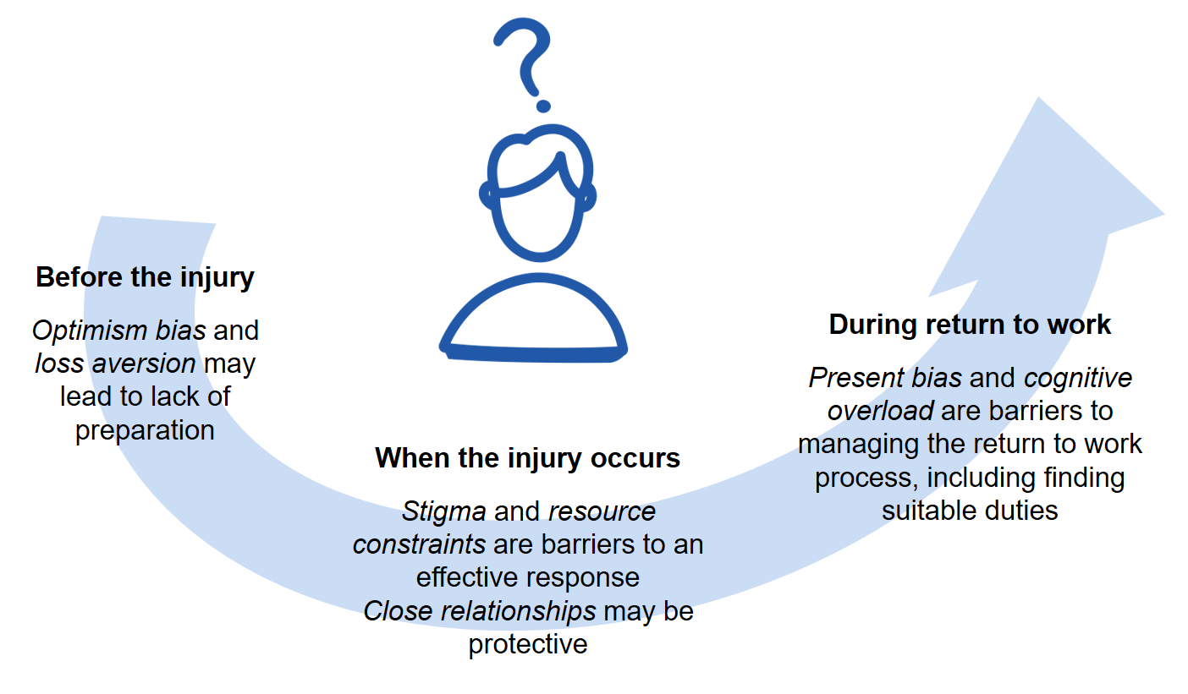
An overview of how behavioural biases and other factors play into SME decision-making at different stages of the return to work process

Before the injury occurs: SMEs may be less likely to be prepared for a workplace injury or illness
Stakeholders perceived that many SMEs were less likely to be prepared for a workplace injury or illness, compared to larger businesses. This is consistent with research from other countries on WHS practices in SMEs, which shows small businesses have less systematic WHS procedures (Landstad et al. 2021), rely on informal agreements and idiosyncratic workplace health practices (Hasle et al. 2012; MacEachen et al. 2010), and take an ad hoc approach to risks – reacting to rather than preparing for incidents (Bluff 2019). While compulsory workers’ compensation insurance mitigates some of the risk with workplace injuries, another theme identified in stakeholder consultation was that many businesses may not understand their roles and responsibilities, and struggle to navigate the complex workers’ compensation system.
Further, a systematic review of WHS processes in small businesses across the world found small business may be more likely to downplay workplace hazards as ‘par for the course’, or ‘not really dangerous’ (MacEachen et al. 2010:189). This was not a major theme in our stakeholder consultation, however some industries (for example, construction, hospitality) were perceived to be more likely to have the attitude of ‘accidents happen’. While experience with accidents in an industry can mean the industry has more experience, and therefore is better prepared for a workplace injury or illness, stakeholders perceived that this was not always the case.
Finally, we identified two behavioural biases which may affect SME supervisors’ decision-making in Australia and contribute to a lack of preparation (see Figure 1). These biases are outlined in Box 2.

Box 2: Behavioural biases contributing to a lack of preparation for workplace injuries
Optimism bias is the tendency for people to underweight the probability of bad events occurring and overweight the probability of good events occurring (Sharot 2011). This bias may lead SME supervisors to believe the risk of an injury is lower than actually is, and that in the event of an injury, it wouldn’t be severe.
Loss aversion is the tendency to weight losses over gains. Research suggests SME owners are loss averse when making investment decisions (Kremer et al. 2013). This may explain why (according to some stakeholders) SMEs are less likely to attend RTW training, even if it is free: the time necessary to understand RTW processes may feel like an avoidable ‘loss’, if they think they may not end up using the training. The ‘return on investment’ of the training and WHS processes may not be the most important factor in their decision-making, if the direct cost is still perceived to be too high (Hasle et al. 2012).

Economic factors also shape how prepared SMEs are for a workplace injury or illness
Small businesses are more vulnerable to the impacts of external events (e.g. a pandemic, economic shocks, or a workplace injury, Falkner et al. 2015) and SMEs face relatively higher fixed costs compared with large businesses when addressing risks and meeting regulatory requirements (Douglas and Pejoska 2017; Lima et al. 2020). For example, the time taken for a small business owner to understand a RTW process has a higher opportunity cost to the business than for a supervisor in a large business. Small businesses are also less likely to have the budget or staff available to support a specialist administrative role for managing WHS or RTW processes. These economic factors all contribute to the challenges for SMEs in preparing adequately for workplace injuries.

Once the injury occurs, a number of behavioural factors continue to influence a supervisor’s decision-making
Previous research and stakeholder consultation has identified that when an injury occurs, a supervisor should take two key steps to make a start on a successful RTW process:
- effectively communicate with and support the worker
- proactively begin the claims process.
To understand the barriers supervisors face to taking these steps, we used the Theory of Planned Behaviour (TPB) to model supervisors’ behavioural intentions (Ajzen 1991; Brosseau and Li 2005). According to the TPB three key factors would influence a supervisor’s behavioural intentions: their attitudes towards the behaviour (and in this case, toward the worker), social norms towards the behaviour, and their perceived behavioural control – the extent to which the supervisors can perform and perceive they can perform the behaviour. Below we use this model as a framework (see Figure 2) to summarise the findings from stakeholder consultation and literature review, and discuss the extent to which each of the factors play a role at this stage of the process: when an injury occurs.
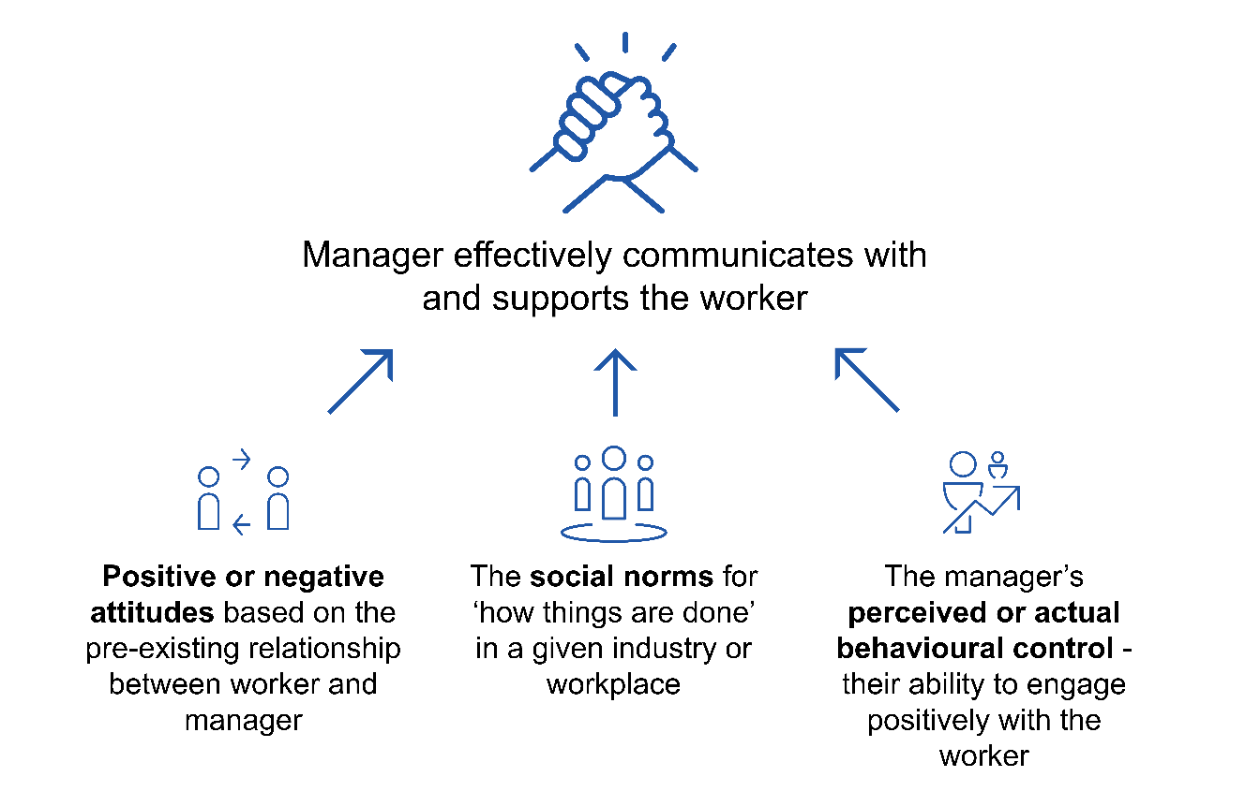
- A framework for understanding the factors influencing a supervisor’s behaviour in communicating with and supporting a worker through the return to work process

A supervisor’s pre-existing relationship with, and positive or negative attitudes towards, the worker will influence how they react to their injury or illness
During consultation, many stakeholders highlighted the importance of the existing relationship and the supervisor’s existing attitudes towards the worker. If the supervisor sees the worker as being of significant ‘value’ to the business they may be more likely to be proactive in helping and supporting the worker. Stakeholders also pointed out that in small businesses, relationships between supervisors and staff are more likely to be personal and visible than in larger organisations. This can influence the RTW process in different ways. On the one hand, it could result in businesses being more willing to help workers, and provide a more accommodating environment. Research also suggests the close relationships and access to social support in SMEs could be a positive for RTW outcomes (Handley et al. 2021). ‘Side-by-side’ working relationships can foster empathy between the supervisor and worker, which in turn can increase the likelihood of sustained return to work in the event of an injury or illness (BETA 2020; Landstad et al. 2021; MacEachen et al. 2010).
On the other hand, supervisors with poor pre-existing relationships with the worker are likely to see the injury as another problem or issue associated with the worker. Stakeholders also suggested the more personal relationships in smaller businesses, may lead to supervisors taking it personally when an employee is injured at work, and feel offended and resentful. Similarly, if the relationship is strained, an injured worker may be more likely to complain of the employer’s focus on the cost of implementing safety issues, and highlight ways in which the employer failed to observe WHS standards (MacEachen et al. 2010:190). By contrast, employers may be more likely to attribute an accident to ‘unforeseeable circumstances’, suggesting they couldn’t have prevented it, or – less commonly – attribute the accident to the injured worker themselves (Hasle 2012).

Social norms, specific to an industry or workplace, influence responses to a worker who is injured or ill, and to the management of the return to work process
Social or cultural norms refers to the shared understanding of ‘how things are done’ among a group of people – for example in a workplace or more broadly, in an industry sector. Norms can therefore be both a barrier and an enabler to the RTW process, in businesses of any size. How an industry in general handles injured workers will shape how an individual business reacts, and how the business has handled workers’ compensation claims in the past will change how they handle future injuries and illnesses. Norms can also relate to the type of injury/illness and whether it is perceived to be legitimate in the work context. For example, stakeholders suggested that a mental health condition in a hospitality setting may be less likely to be considered legitimate than a burn or physical injury, because the latter is expected in that environment. In the case of an injury perceived to be illegitimate, workers can face stigma (discussed further below. See also Casey et al. 2021).

Stakeholders also told us that physical injuries are perceived very differently to mental health conditions. At times the latter may be considered less legitimate because they are not necessarily as concrete, visible, or familiar to supervisors. Mental health injuries with a clearly discernible cause, such as a traumatic event occurring in the workplace, may be more likely to be considered legitimate and be well-supported. By contrast, stress claims – for example due to dysfunctional workplace relationships, high workloads, and/or burnout – are often perceived to be more subjective and more complicated to manage. This is likely to be the case regardless of the size of the business. However, the closer and more personal relationships in SMEs once again present both challenges and opportunities. While stakeholder consultation highlighted the challenges to SMEs in managing mental health issues in the workplace, these strong relationships could also be leveraged, with the right supports, to help supervisors of SMEs engage with their injured or ill staff on issues of mental health – including psychological responses to injury – as well.

In both stakeholder consultation and the literature review, stigma emerged as a significant issue
In businesses of all sizes, injured or ill workers are sometimes labelled negatively or discriminated against by co-workers and employers because of their injury – a process referred to as stigma. Stigma can influence all aspects of the RTW process, and is the focus of a comprehensive report by researchers at Griffith University, commissioned by SWA: Stigma towards injured or ill workers (Casey et al. 2021). The report highlights how and why stigma may occur, and provides recommendations for reducing it. Crucially for the present project, while the report focuses on businesses overall, it also finds that business size can influence a worker’s experience of stigma: for example, ‘…small business employers can feel a self-imposed obligation … to police the legitimacy of injured/ill workers’ compensation claims’ (Eakin et al. 2003, cited by Casey et al. 2021).
Stakeholder consultation supported this observation from the literature. First, stakeholders pointed out that stigma towards workers’ compensation claims influences how supervisors react in the case of a workplace injury or illness. Some supervisors may see an injured worker as someone only attempting to get time off work or to ‘get a payout’, and this may stop them providing support (see also Eakin et al. 2003). Stakeholders highlighted that this attitude would also be more likely to lead to a litigious approach. Second, stigma towards certain types of injuries or illnesses – in particular, mental ill-health – may present a barrier to communication between the worker and supervisor. Stakeholders suggested supervisors in SMEs may be uncertain about how to support workers with mental health conditions and worried about saying the wrong thing. This in turn may lead to avoidance in contacting the worker and compound the effects of the worker’s mental health condition (see also the report on psychological response to injury, commissioned by SWA: Brough et al 2021).

A supervisor’s perceived or actual ability will impact how the supervisor engages with the injured worker and with the claims process
Supervisors in micro and small businesses are often ‘juggling’ many roles and responsibilities, and can lack the time and skills to focus on the injured worker (Blackman and Chiveralls 2011). Stakeholders highlighted this is especially likely when a small business has been established due to the supervisor’s technical skills – e.g. they are an experienced tradesperson setting up their own company. In particular, stakeholders perceived that supervisors may feel like they don’t have the ability to help the injured worker return to work if they have a mental health condition: ‘They [the supervisor] don’t know what to say’. In addition to a lack of skills, many SME supervisors may feel like they don’t have time to deal with the process, or may actually not have the time to deal with it (e.g. Hasle et al. 2012). Furthermore, supervisors may view managing the administration associated with the workplace injury (e.g. submitting a claim, corresponding with the insurer) as their only responsibility (Blackman and Chiveralls 2011, also mentioned in stakeholder consultation). In doing so, they may neglect other tasks critical to a successful return to work, such as maintaining their interpersonal relationship with the injured worker. This can make workers feel isolated, decrease the likelihood of successful return to work (Nieuwenhuijsen et al. 2004), and, according to stakeholders, increase the likelihood of litigation.
In addition to gaps in management skills, supervisors of SMEs may lack specific knowledge about RTW processes, and not know how to act in this circumstance. Several stakeholders commented that small businesses do not actively seek out information, or may resist receiving information on managing RTW processes in their business. This is supported by literature suggesting a culture of ‘self-sufficiency’ or ‘independence’ among SMEs (Eakin 1992; Schulte et al 2018), and a tendency to rely on cultural norms and informal information sharing through networks for information about issues such as return to work (Hedlund et al 2017). However, for SMEs in industries with a low prevalence of injury/illness, there may not be visible standards or norms around what makes good practice RTW processes.

During the return to work process, providing suitable duties is a key strategy often overlooked by SMEs
As the injured worker begins to return to work, the provision of suitable duties is an important factor in determining whether the process is successful. However, many supervisors may find it difficult to provide suitable duties, due to the perceived and actual limited roles in SMEs. From the stakeholder consultation, we found supervisors may not adequately consider the provision of suitable duties for the worker, nor do they appreciate the positive impact this can have on RTW outcomes. Many supervisors prefer to have a worker who is fully recovered before they restart work. This is challenging for injured workers as many injuries take a long time to recover, and it is better for workers if they return to work in a reduced capacity than not at all (Lane et al. 2018). A number of attitudes as well as behavioural biases could be driving the supervisor’s preferences. Supervisors may have inaccurate preconception of what a recovery journey looks like: Our analysis of the NRTWS (see below) indicated that twenty-five per cent of injured workers will have multiple periods on workers’ compensation, however stakeholders reported that most supervisors think once someone is back at work they are ‘healed’. This may be due to people being inherently optimistic about recovery times. Two additional behavioural biases may come into play at this stage, and are summarised in Box 3.

Box 3: Behavioural biases presenting barriers to managing the return to work process
Present bias – the tendency to prefer a smaller current reward over a larger future rewards (O’Donoghue and Rabin 1999) – may also drive decision-making during the RTW process. In a RTW context, present bias can lead supervisors to prioritise immediate tasks over long-term RTW planning. For example, a supervisor may spend their time hiring a new employee (short-term payoff) rather than discussing and planning with their injured the provision of suitable duties (long-term payoff).
Cognitive overload – the lack of mental bandwidth – worsens the effect of other cognitive biases (Mullainathan and Shafir 2013) and may present a further barrier to supervisors successfully supporting the worker once they return to work. For example, supervisors may fail to carve out time in their day to focus on RTW tasks. When they do approach RTW tasks, they may be less thoughtful in their approach, particularly if it is an unfamiliar task, and rely more on cognitive shortcuts – e.g. assuming the RTW pathway will be the same as for a previous injury.

Claims data and National RTW survey
In addition to stakeholder consultation and literature review, we analysed two key sources of data on return to work, the National RTW Survey, and the National Dataset on Compensation Based Statistics (referred to as ‘claims data’ as it includes administrative data on workers’ compensation claims Australia-wide). These data sets focus on return to work and workers’ compensation, and the insights they provide about relationships within a business are therefore specific to this context (i.e. rather than referring to relationships between supervisors and workers in general). Our analysis was exploratory, and compared RTW outcomes and the treatment of injured workers across businesses of differing size.

Small businesses have lower return to work rates than larger businesses
Figure 3 illustrates RTW rates among business sizes over time. The RTW rate is the percentage of injured workers who have returned to work at any time following a workplace injury or illness. Overall, RTW rates have declined somewhat from 2014 to 2021, especially for small businesses (micro and small). While overall the RTW rates declined, between 2018 and 2021 the rates for micro, small and small-medium businesses’ have increased. These differences highlight the importance of analysing different sized SMEs separately. The remainder of this section summarises key findings for micro, small, and medium businesses separately, and concludes with a comparison of external and internal RTW coordinators.

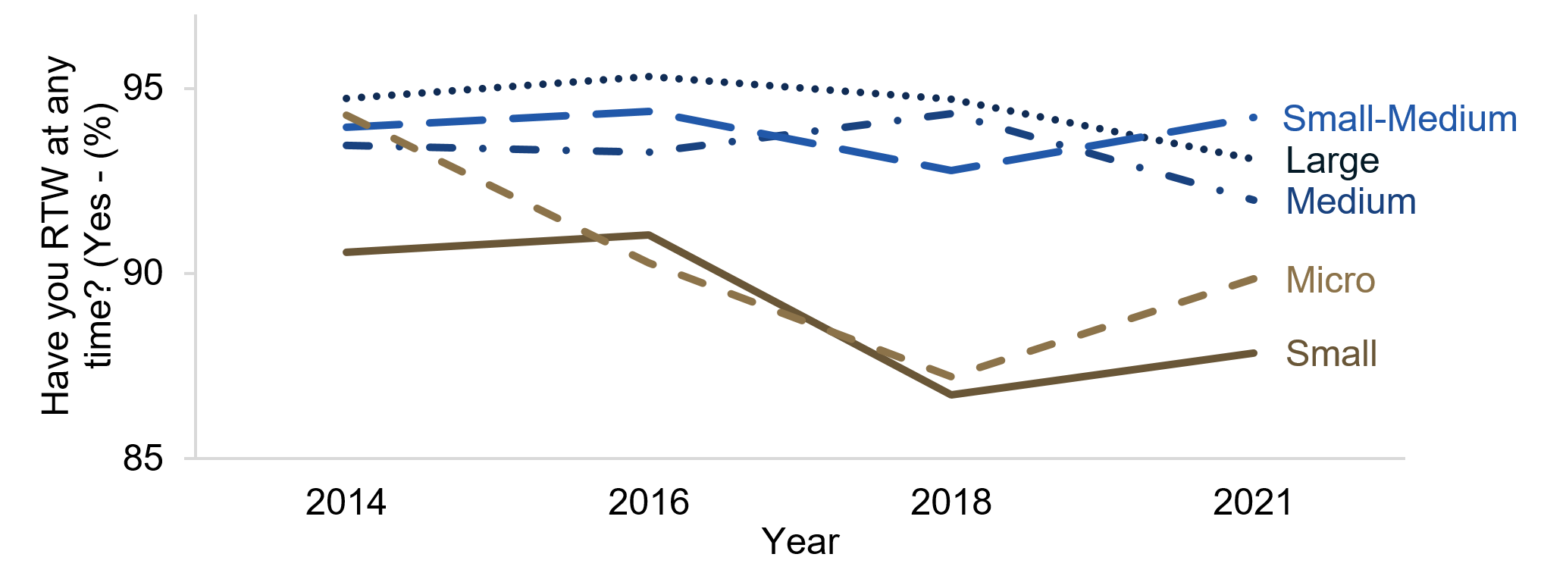
- The percentage of workers who have RTW at any time from 2014-2021, by business size

Micro businesses have strong internal relationships, but their claim costs are higher than other businesses’
Injured workers employed in micro businesses (with 1-4 employees) were generally the most positive about their treatment in the workplace. Injured workers in these businesses were the least likely to feel they would be treated differently in the workplace following an injury (28% compared with 40% of large businesses), and had a higher rate of employees feeling they could easily explain to their supervisor what they can and can’t do (87% compared with 82% for large businesses) and to co-workers (88% compared to 80%).
Despite the positive nature of the relationships and level of communication within micro businesses, claim costs were higher and RTW rates lower in micro than in large businesses. Claims costs were the highest in micro businesses, and were roughly $5,600 higher on average for these businesses compared with large businesses (controlling for a range of factors). The high cost of claims was not reflected in noticeably better outcomes for micro businesses. Controlling for a range of factors, we found that employees of micro businesses were 5 percentage points less likely to return to work at any time compared with employees of large businesses.
Of note was the higher rate of workers needing additional time off in micro businesses (32%) compared with other business sizes (25% overall). This may be driven by several factors, which cannot be directly observed in the data. One possibility is that as micro businesses are more dependent on one staff member, they may encourage the staff member to return before they are ready, causing them to reinjure themselves, and have additional time off work. Alternatively, the close relationships between employees may mean they want to get back to faster, to support their co-workers. If these factors are driving the higher rate of additional time off in these businesses, the RTW materials may help micro businesses to find better suitable duties.

What do these findings mean for engagement with micro businesses?
A key aim of the RTW materials is to support the relationship between a supervisor and an injured worker in a SME. Relationships within micro businesses already appear to be strong in the context of return to work, so there is likely less scope for improving the relationship. When disseminating the materials, this means it may be more impactful to target small businesses with 5+ employees.
However, further research with micro businesses may be warranted to understand why the cost of claims is higher on average for them. One possible explanation, raised in the stakeholder consultation, is that smaller businesses may be less likely to submit small more frequent claims to their insurer, fearing higher premiums, resulting in a single one-off high claim instead.

Small businesses have lower rates of successful return to work and appear less likely to adequately support their workers
Small business have the lowest RTW rates of any business category, with 12% of injured workers not having returned to work in the time between their injury and the survey being conducted. Controlling for a range of factors, employees of small businesses are 8 percentage points less likely to RTW than employees of large businesses. Small businesses also have the third highest average claim cost (around $4,100 more than large businesses).
While the trends in the quality of the relationships (in relation to return to work) within small businesses were not clear, reflecting the diverse nature of these businesses, there were some consistent findings. Small businesses had the highest rate of employees feeling their supervisor thought they were exaggerating their injury (29%). Small businesses were also the somewhat less likely to contact their injured employee about recovering from their injury (60% of workers were contacted, compared with 63% overall). They also had the lowest rate of employees needing additional time off (17%, compared to 32% in micro businesses). It is difficult to say whether the low rate is due to the inability to provide suitable duties (so only fully recovered workers RTW) or whether small businesses are good at accommodating injured workers – ensuring the return to work was a success.

What do these findings mean for engagement with small businesses?
The findings demonstrate a clear case for the materials to be put in the hands of small business. The lower rate of return to work in small businesses compared with other businesses suggest there is space to provide more support to supervisors within small businesses. The lower level of resources in small business may mean the materials may have a larger impact on their processes compared with larger businesses.
The lower rates of supervisors contacting the injured workers about their injury may be due to confusion about who is responsible, or supervisors not feeling they have the ability to discuss sensitive issues like workplace injuries or illnesses. In either case, the materials may have a positive impact, prompting employers to reach out, and providing them with the tools to make contact with their injured employee. The conversation guides will be an important section of the RTW materials to get right, to have an impact on small business practices in relation to the RTW process.

Medium businesses are similar to large businesses, but they differ in the cost of claims, and treatment of employees
We categorised medium businesses into two groups, small-medium (20-49 FTE employees) and medium (50-199 FTE employees), as the internal processes – including expertise in administration and corporate governance – are likely to be quite different for businesses of 20 employees compared to almost 200. As shown in Figure 3, both types of medium businesses differ very little from large businesses in their RTW outcomes. In 2021, small-medium and medium business had RTW rates of 94% and 92%, respectively, compared with large businesses’ rate of 93%. Likewise, the RTW outcomes for small-medium businesses did not differ from large businesses after controlling for a range of factors.
While their RTW rates were similar, the cost of their claims differ. Small-medium businesses’ claim costs were on average $2000 more than large businesses’, while for medium businesses the average claim cost was only around $800 more than large businesses’, accounting for the nature of the injury, age, gender, and industry. The experience of employees in small-medium businesses compared with all other business sizes also appears to be less supportive in a number of ways. Employees of small-medium businesses were the least likely to feel they could explain to their supervisor what they can and can't do (77% compared with 83% overall). They also had had the second lowest rate of offering suitable duties to their employees (55%), while medium businesses offer suitable duties at the highest rate of any business size (64%). Both small-medium and medium businesses had the highest rate of employees feeling they were discouraged from putting in a claim (both at 22%), compared with micro, small, and large businesses (which all had a rate of 16%).

What do these findings mean for engagement with medium businesses?
These findings suggest the materials may be of more assistance to small-medium, rather than medium-sized businesses. Given the relationship between workers and supervisors appears to be less supportive in these businesses compared to other business sizes, providing supervisors with clear guidance on how to work with an injured worker may be beneficial to their relationship. The results also suggest medium businesses are very similar to large businesses with respect to the RTW outcomes. If this is because they also have similar RTW practices and experienced staff managing injuries and RTW, the materials may be less useful for these businesses. Taken together, when disseminating the materials, it may be more impactful to target small-medium businesses with fewer than 50 employees.

Internal return to work coordinators appear to have a more positive effect on outcomes compared to external coordinators
When an injury occurs in the workplace, a RTW coordinator may be appointed, whose role is to implement the organisation’s RTW program. The coordinator can be someone from within the business (internal), or someone from outside the businesses (external). In a micro or small business the coordinator may be the supervisor or owner by default, whereas in a medium-sized business there may be a designated role for an employee in an HR position. Appointing an external RTW coordinator can occur in a business of any size, but is more likely in micro, small, and small-medium businesses.
Across all business sizes, we found injured workers who had an external RTW coordinator were 7 percentage points less likely to return to work than those who had an internal coordinator. This difference held when we accounted for different jurisdictions and industries as well as different types and severities of injury. The relationship between coordinator type and outcomes is correlational, not causal. However, one possible explanation of this finding is the way internal RTW coordinators are embedded in the business, and may therefore be more effective in accommodating an injured worker by (for example) modifying the workplace or tasks. An external RTW coordinator, by contrast, may have less leverage or influence with the business. This interpretation is supported by the finding that workers with external RTW coordinators were 19 percentage points less likely to think their employer did what they could to support them (than workers within an internal coordinator). Similarly, the rate of injured workers saying they agree their employer helped with their recovery was 24 percentage points lower for individuals with an external RTW coordinator.
Overall this suggests employees who had an external coordinator felt less supported by their employer during the RTW process, compared with employees with an internal coordinator. However, the data does not let us assess whether the negative relationship was formed pre- or post-injury. For example, it is possible that if the employer-employee relationship was strained prior to the injury, the employer may be more likely to seek out and assign an external coordinator. On the other hand, having an external coordinator may contribute to a loss of connection with the workplace, which literature has identified as a factor contributing to poor RTW outcomes (White et al. 2019).

What do these findings mean for engagement with SMEs?
These findings – while not unique to SMEs – are especially relevant to the SME context because smaller businesses are more likely than larger businesses to use an external RTW coordinator. This may be due to smaller businesses lacking enough staff for someone to fill the RTW coordinator role. These findings also highlight the way external and internal coordinators face different kinds of challenges. However, in both cases, the relationship between the supervisor and the injured/ill employee remains critical, in order to maintain the connection between the employee and their workplace. Further, the findings suggest that the RTW materials may have a larger impact where a business is using an external RTW, as they will facilitate ongoing support and connection between the employee and their workplace.

User testing

Overall, supervisors found the revised materials to be clear and well organised
The language of the materials was generally described by supervisors as clear and easy to read. One supervisor described it as ‘conversational’: neither too technical nor too colloquial. We tested specific wording (e.g. worker vs employee, psychological injury’) with supervisors, and made some small changes on the basis of their preferences. Even when supervisors had a preference for (for example) ‘employee’ over ‘worker’ (or the other way around), they were able to understand how the materials applied to their context even if the language differed slightly. For example, one supervisor thought the language of some of the suggestions was a bit ‘flowery’, but said they would still be able to translate the general idea to their setting.
Many supervisors appreciated the overview and the timeline sections as providing a condensed summary of the materials. Even supervisors who indicated that the materials were helpful and that they would use them, said they would be likely to focus on the overview and timeline sections as a ‘quick check list’. This reinforces the findings from stakeholder consultation and the literature review that materials targeted at SMEs need to be succinct and clear.

Many supervisors appreciated the distinction between the legal/formal obligations of the business and the ‘nice to have’ suggestions
As uncovered during stakeholder consultation and the literature review, one of the key challenges faced by supervisors in SMEs is that they often have multiple roles within the business and juggle many responsibilities. During user testing, many supervisors raised the point that in the event of a worker becoming injured or ill they would be very concerned with meeting all their legal obligations, and not doing anything ‘wrong’. They appreciated the materials referring to other professionals and processes involved in a workers’ compensation claim (and some said these sections could be highlighted even further), while at the same time focusing specifically on the relationship between the worker and the supervisor. The ‘why use this guide’ section – emphasising the benefits of maintaining a good relationship with an injured or ill worker – resonated with almost all supervisors. The critical feedback from a few supervisors was that it was ‘obvious’, and seemed to assume that they didn’t already have a good relationship with their worker.

Finding suitable duties for the injured or ill worker remains challenging for many supervisors
The suggestions in the ‘suitable duties guide’ section of the materials were well received by supervisors during user testing. However, many highlighted the intrinsic challenge of changing the work or workplace for a single employee. This is consistent with what we heard during stakeholder consultation. There were two experienced supervisors who were able to recount specific challenging incidents, while also reporting on what had helped them in the past. In both cases, the most helpful resource had turned out to be another worker, someone very experienced in WHS issues, who was able to mentor/teach them and think creatively about suitable duties.
He [WHS person on site] was quite experienced, he worked his way up from the ground up, so he was very practical. He was a good sounding board – a new fresh set of eyes is always good – he'd walk in and say, ‘well, hang on he [the injured worker] can be doing this, and he could be doing that.’
– Experienced supervisor, construction
Similarly, other supervisors also highlighted the impact injury and illness has on the whole team. This was framed both as a positive – team members care for each other and can help ‘pick up slack’ – and as a challenge. This challenge comes in different forms:
- Concern for the injured or ill worker, as well as worry about ‘saying the wrong thing’– everyone’s mental health is affected.
- The burden of ‘picking up slack’, working extra for an uncertain amount of time while the worker is away – including potential resentment toward the injured worker for ‘getting time off’.
- Managing the balance between maintaining the worker’s privacy while keeping the team informed – and some co-workers might want to know what’s going on.
- The team may need to continue to support the ill or injured worker, even after they come back.
As a result, we revised the materials to include a new one-page section focusing on how to have conversations with the team. This section highlights the importance of acknowledging the impact on the whole team, and keeping them informed, while also respecting the injured or ill worker’s privacy by not discussing their medical issues with the team without their consent.

Supervisors said they would use the materials to guide their behaviour
Almost all supervisors indicated they would find the materials useful, and would use them when they were published. No supervisors said they would not use the materials. Supervisors with relatively less experience seemed to be more likely to say they would ‘definitely’ use the materials. Those who were more experienced were more likely to say that the materials covered information/provided suggestions about things they already knew or did. More experienced supervisors were also more likely to say they would focus on the overview and timeline, or that others in their business would benefit more from the materials.
I think it's a great way of bringing in a whole bunch of information together. Is it perfect? Probably not, because to make it have everything it’s going to have to be twenty pages long and no one reads it. So I think it's about drawing attention to the fact that yes, this is your starting point. And don't forget though, that it's not your end point.
– Experienced supervisor, health care
In particular, a few of the less experienced supervisors thought the materials provided a helpful prompt to get in touch with ill or injured staff members straight away. The temptation might otherwise be to ‘give it a week, see how they go’, or to avoid what might become a difficult conversation.

Many supervisors use the Fair Work Ombudsman’s website as a key source of information
Many supervisors noted they used the Fair Work Ombudsman’s website (FWO) as a key source of information on their responsibilities as employers. Typically, it was the first website they visited when searching for workers’ compensation related topics, suggesting this channel is likely to be effective in delivering the materials. A subset of supervisors (mainly professionals) also said they used industry bodies, personal networks, and state-based chambers of commerce as a source of information on workers’ compensation. Supervisors from non-professional industries also noted they would typically contact their state-based chamber of commerce for information.
Some supervisors, in particular those who were previously involved with workers’ return to work process, said they received information from their insurer as part of making a workers compensation claim. However, supervisors said this information focused solely on their obligations, and not on managing the injured worker. They noted that if the insurer provided information focused on ‘how you can support your workers to have a better outcome’ they would find it useful as well. Lastly, a few supervisors mentioned they would contact unions for more information on managing an injured worker. However, they were not specific about which union or how they would access the information.

Considering how businesses currently access information will be key to ensuring materials reach the intended audience
When the materials are published, Safe Work Australia is planning a communications strategy to distribute them. During user testing we asked supervisors how they access information and where they would seek information related to an injury or illness at work. Their responses identified – in addition to the usual conduits for reaching SME – three possible distribution channels:
- Making the materials available directly on the Fair Work Ombudsman’s website. Making information available in one place, a place that is already frequently used by supervisors, is likely to have a significant impact.
- Distributing them through industry bodies and unions. This will likely improve the ease with which supervisors and businesses can access the information, at least in some professions and industries.
- Sharing them with insurers; and insurers could be encouraged to on-share the resources with SMEs when they initiate a workers’ compensation claim. As noted above, supervisors already engage with information provided by insurers. However, the provided information could be extended with the RTW materials focused on supporting returning employees.

Final Materials
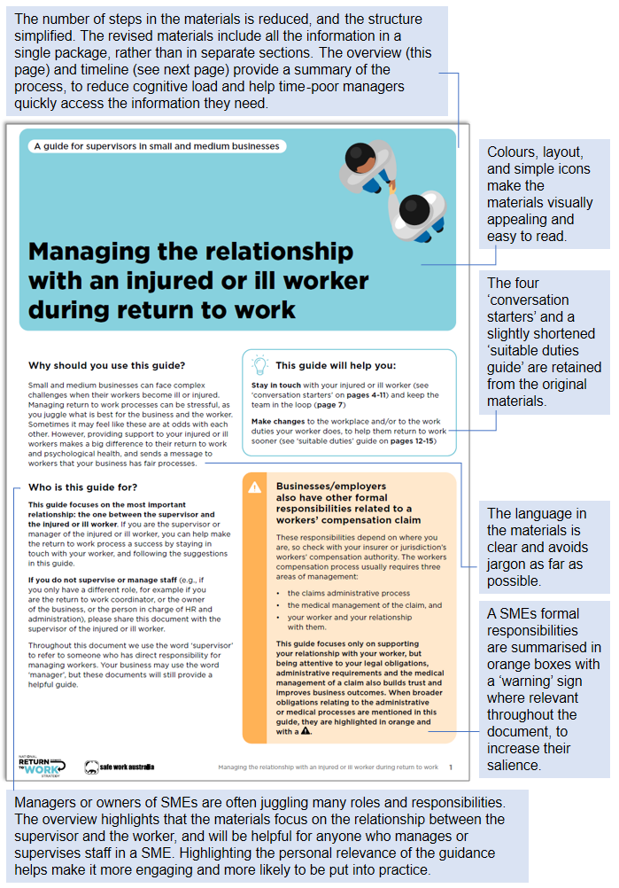
- First page (Overview) of the revised materials

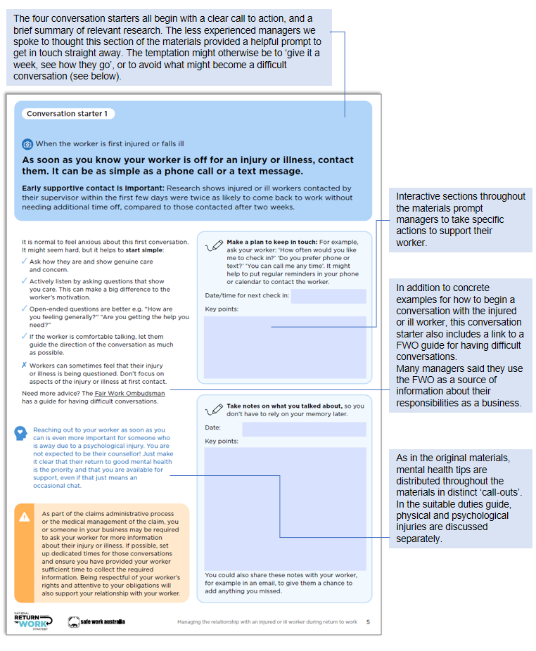
- Conversation starter 1 (of 4)

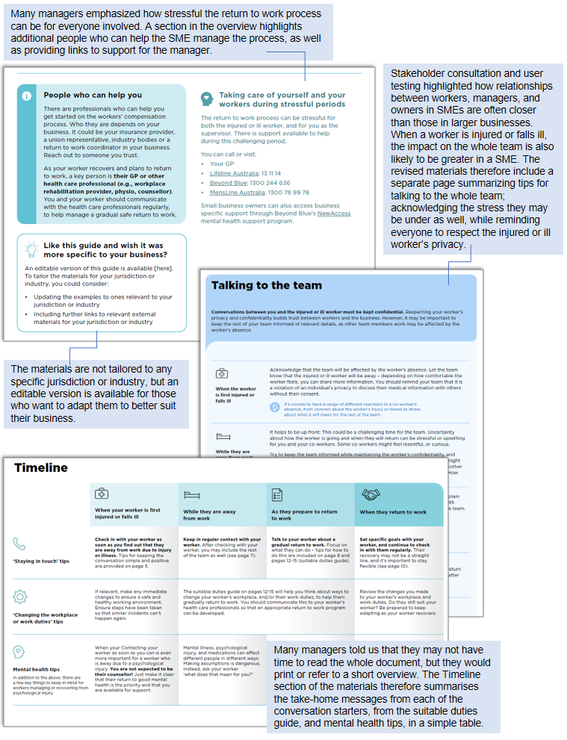
- Additional sections from the materials

Considerations and caveats
This project aimed to investigate the experience of SMEs during the RTW process, with a particular focus on how they differ from larger businesses and which unique challenges and opportunities they face in managing an ill or injured worker. The findings informed revisions to a package of RTW materials, to adapt them to better meet the specific needs of supervisors of SMEs. While the stakeholder consultation, data analysis, and user testing identified opportunities for and value in tailoring the materials for SMEs, it also highlighted some complex issues SMEs face which will likely require more targeted solutions and alternative interventions (which go beyond the scope of this project). In this section we outline some of the key considerations in applying the insights we identified in this research, and note some associated limitations.

Stakeholder consultation highlighted the problem of stigma
During stakeholder consultation we focused particularly on the supervisor-worker relationship and the key barriers to return to work for SMEs. As a result, many of the stories we heard focused on problems, or ‘when things go wrong’. In particular, one recurring theme in stakeholder interviews was the idea that some supervisors may have strongly stigmatised views of workplace injury and the likelihood of successful return to work, believing the injured worker ‘is just trying to get compo’. The extent of these views is not well understood, because stakeholders are likely to emphasise such views as particularly problematic, irrespective of how common they are. Furthermore, stigma was not a theme that emerged during user testing, perhaps because the interviewees self-selected to participate and may have had a particular interest in return to work (and therefore be unlikely to hold stigmatising views of their workers). The adapted materials – while intended to highlight the benefits of close and positive ongoing communication with the injured worker – may be less effective for supervisors with preconceived negative views, as they are tailored for the more general case where there is a baseline of trust in the supervisor-worker relationship. That said, this stigmatised view is worthy of addressing in its own right, and SWA have a separate stream of work focused specifically on this issue.

Data analysis provides specific, cross-sectional, insights about the return to work process in SMEs compared to larger businesses
The claims data and National Return to Work survey (NRTWS) are key sources of information about the RTW process in businesses across Australia, and – crucially – allow for quantitative comparisons between SMEs and larger businesses. However, like all data, these data sets have some limitations. First, the data provide a point-in-time view of workers’ compensation claims and the RTW process. As a result, it allows us to observe associations between (for example) industry or business size and outcomes, but it does not allow us to make claims about cause and effect, or to understand why smaller businesses differ from larger businesses on certain outcomes. Furthermore, when modelling the associations between business size and RTW outcomes, we may be missing key factors that explain this relationship. That is, even if an outcome is different across businesses of different sizes, it does not mean the outcomes are directly caused by business size. Second, with regards to the NRTWS in particular, there is the issue of sampling: the individuals included in the survey are drawn from the group of people who received workers’ compensation for a work-related injury or illness. As a result, whilst there are many workers who experience injuries or illness but do not submit a claim, the NRTWS does not explore their experiences. Further, it seems likely people who complete this kind of survey hold stronger views (both positive and negative) about their experiences with the RTW process, than people who do not complete the survey. As a result, the true effects (for example, the differences between external and internal RTW coordinators) are likely to be less pronounced than those observed here. Lastly, our findings are based on administrative data, which may contain errors that lead to us over- or underestimating the magnitude of some reported findings.
Finally, the data sets analysed for this report naturally focus on return to work and workers’ compensation. Where they provide insights about relationships within a business – for example, how supported a worker feels, and how well a supervisor communicates – these insights relate specifically to the RTW context. The findings should not be taken as claims about how relationships in small businesses in general differ from those in larger businesses, or about whether outcomes other than RTW outcomes will differ for businesses of different sizes.

User testing provided key insights into how the RTW materials could be adapted, but the sample was small
For the user testing we aimed to recruit individuals working in SMEs (currently or in the recent past) in a role where they had responsibility for overseeing workers, from businesses in a range of industries, sizes, and locations. People in BETA’s personal networks who had connections to SMEs were asked to circulate an invitation with a link to a screener questionnaire. The Australian Chamber of Commerce and Industry (ACCI) also forwarded the invitation to their members. Over a period of one month, we were able to get in touch with twelve supervisors. While all business sizes and a range of industries and experiences were represented in the final sample, almost all participants were women, and most were Canberra-based. We note the sample is not representative of all SMEs in Australia, and we cannot generalise more broadly from their experiences. However, the focus of the interviews was soliciting feedback on the materials. Even with the relatively small sample available, the feedback we received was useful, varied, and helped improve the final guidance.

SMEs and workers may face challenges during the return to work process that cannot be directly addressed by our adapted materials
Our research also uncovered a range of systemic or ‘external’ challenges to successful return to work in SMEs. One of these – ingrained negative attitudes – has been discussed above in relation to stigmatised views of compensation claims. Along with stigma, SMEs in certain industries may have embedded cultural norms prescribing workers should endure illness or injury without ‘making a fuss’, contain perceptions of illness or injury as weakness, and are not relationship focused in the support they provide to workers. The RTW materials are less likely to be used by supervisors who hold such views, or where these types of strong cultural norms are present.

Conclusion
SMEs face unique challenges and opportunities in supporting workers to return to work following work-related illness or injury. In this project, we explored the SME context for return to work through stakeholder consultation, a literature review, data analysis and user testing. Overall it is clear that:
- Supervisors in SMEs are often time poor, juggling many roles and responsibilities. The revised materials take this into account by providing succinct overview and timeline sections for easy reference, and supervisors indicated they would find this aspect especially helpful.
I like the document as an education piece. Because it's nice, simple, laid out all the way through (…) it’s a nice checklist to help you work through what you're doing. (…) Once you get to the next iteration, is it possible to get a copy of [the materials]?
– Experienced supervisor, professional services
- Relationships within SMEs are often close and supportive (and data analysis suggests this is particularly true of micro businesses, 1-4 employees), but supervisors may lack experience managing workers who are injured or ill. By providing concrete examples and calls to action supported by brief explanations of research supporting ‘best practice’, the revised materials aim to help supervisors maintain a positive relationship with their worker. They also highlight the importance of involving the whole team (while respecting a worker’s privacy).
- Finding suitable duties was highlighted – in stakeholder consultation, the literature review, and user testing – as a key challenge. While the materials have been shortened and simplified overall, we retained nearly all of the ‘suitable duties guide’ to address this challenge. Like the other sections, this section of the materials includes an interactive section with prompts to help supervisors think carefully and creatively about how to modify the work or workplace for the injured or ill worker.
- Data analysis suggests SMEs overall have worse return to work outcomes than larger businesses, but small businesses in particular (5-19 employees) appear less likely to adequately support their workers. This suggests distributing the materials to these businesses may be most impactful.
The results of this project demonstrate supervisors in SMEs are likely to benefit from access to guidance materials helping them navigate the return to work process for an injured or ill employee. Looking further ahead, supporting supervisors to maintain a positive relationship with their injured or ill workers may facilitate workers’ timely, safe, and durable return to work.

References
Ajzen I (1991) ‘The theory of planned behavior’, Organizational Behavior and Human Decision Processes, 50(2):179-211, doi.org/10.1016/0749-5978(91)90020-T.
Berecki-Gisolf J, Clay FJ, Collie A and McClure RJ (2012), ‘Predictors of sustained return to work after work-related injury or disease: insights from workers’ compensation claims records, Journal of Occupational Rehabilitation, 22(3):283-291, doi: 10.1007/s10926-011-9344-y.
BETA (2020) Returning to work after illness or injury: Research report, Behavioural Economics Team of the Australian Government.
Blackman I and Chiveralls K (2011), ‘Factors influencing workplace supervisor readiness to engage in workplace-based vocational rehabilitation’, Journal of Occupational Rehabilitation, 21(4):537–546, doi:10.1007/s10926-011-9297-1.
Bluff E (2019), ‘How SMEs respond to legal requirements to provide information, training, instruction and supervision to workers about work health and safety matters’, Safety Science, 116:45-57, doi.org/10.1016/j.ssci.2019.02.036.
Brosseau LM and Li SY (2005), ‘Small business owners' health and safety intentions: A cross-sectional survey’, Environmental Health, 4(23):1-9, https://doi.org/10.1186/1476-069X-4-23.
Brough P, Chan C, Wishart D, Spedding J and Raper M (2021) Psychological Response to Injury: research to support workers’ psychological responses to injury and successful return to work, report to Safe Work Australia, Griffith University.
Casey T, Hu X, Lee QY and Carden C (2021) Stigma towards injured or ill workers, report to Safe Work Australia, Griffith University.
Douglas J and Pejoska AL (2017) Regulation and small business, Department of the Treasury, Australian Government.
Eakin JM (1992) ‘Leaving it up to the workers: sociological perspective on the management of health and safety in small workplaces’, International Journal of Health Services, 22(4):689-704, doi:10.2190/dnv0-57vv-fj7k-8ku5.
Eakin JM, MacEachen E and Clarke J (2003) ‘‘Playing it smart’ with return to work: small workplace experience under Ontario’s policy of self-reliance and early return,’ Policy and Practice in Health and Safety, 1(2):19–41, https://doi.org/10.1080/14774003.2003.11667635.
Falkner EM and Hiebl MRW (2015), ‘Risk management in SMEs: a systematic review of available evidence’, Journal of Risk Finance, 16(2):122-144, doi:10.1108/JRF-06-2014-0079.
Fraser S and Greene FJ (2006), ‘The effects of experience on entrepreneurial optimism and uncertainty,’ Economica, 73(290):169–192, doi:10.1111/j.1468-0335.2006.00488.x.
Handley K, Molloy C, and Faulkner L (2021), Crisis in small business: A literature review. Prepared for the State Insurance Regulatory Authority, NSW. Accessed: 2 February 2021
Hasle P, Kvorning LV, Rasmussen CD, Smith LH and Flyvholm MA (2012), ‘A model for design of tailored working environment intervention programmes for small enterprises,’ Safety and Health at Work, 3(3):181-191, doi:10.5491/SHAW.2012.3.3.181
Hedlund M, Landstad BJ and Vinberg S (2017), ‘Tightrope walking: external impact factors on workplace health management in small-scale enterprises,’ Society, Health and Vulnerability, 8, doi:10.1080/20021518.2017.1350551.
Kremer M, Lee J, Robinson J, and Rostapshova O (2013), ‘Behavioral biases and firm behavior: Evidence from Kenyan retail shops,’ American Economic Review, 103(3):362-68: doi: 10.1257/aer.103.3.362
Landstad B, Hedlund M and Vinberg S (2017), ‘How managers of small-scale enterprises can create a health promoting corporate culture,’ International Journal of Workplace Health Management, 10(3):228-248, doi:10.1108/IJWHM-07-2016-0047.
Lane TJ, Lilley R, Hogg-Johnson S, LaMontagne AD, Sim MR and Smith PM (2018), ‘A prospective cohort study of the impact of return-to-work coordinators in getting injured workers back on the job,’ Journal of Occupational Rehabilitation, 28(2):298-306, doi: 10.1007/s10926-017-9719-9.
Lima PF, Crema M and Verbano C (2020), ‘Risk management in SMEs: A systematic literature review and future directions,’ European Management Journal, 38(1):78-94, doi:10.1016/j.emj.2019.06.005.
MacEachen E, Clarke J, Franche RL, Irvin E and Workplace-based Return to Work Literature Review Group (2006), ‘Systematic review of the qualitative literature on return to work after injury,’ Scandinavian Journal of Work, Environment and Health, 257-269.
MacEachen E, Kosny A, Scott-Dixon K, Facey M, Chambers L, Breslin C and Mahood Q (2010). Workplace health understandings and processes in small businesses: a systematic review of the qualitative literature. Journal of Occupational Rehabilitation, 20(2), 180-198.
Mullainathan S and Shafir E (2013), ‘Scarcity,’ Social Policy, 46(2):231-249, doi:10.5271/sjweh.1008.
Nieuwenhuijsen K, Verbeek JH, de Boe AG, Blonk RW, and van Dijk FJ (2004), ‘Supervisory behaviour as a predictor of return to work in employees absent from work due to mental health problems,’ Occupational and Environmental Medicine, 61(10):817–823, doi:10.1136/oem.2003.009688.
O'Donoghue T and Rabin M (1999), ‘Doing it now or later,’ American Economic Review, 89(1):103-124, doi:10.1257/aer.89.1.103.
Prang KH, Bohensky M, Smith P and Collie A (2016), ‘Return to work outcomes for workers with mental health conditions: a retrospective cohort study,’ Injury, 47(1):257-265, doi:10.1016/j.injury.2015.09.011.
Safe Work Australia (2018) National Return to Work Survey 2018: Summary Report, Report to Safe Work Australia, Social Research Centre, ANU, Canberra.
Safe Work Australia (2019) National Return to Work Strategy 2020-2030, Safe Work Australia, Australian Government.
Schulte PA, Cunningham TR, Guerin RJ, Hennigan B and Jacklitsch B (2018), ‘Components of an occupational safety and health communication research strategy for small-and medium-sized enterprises,’ Annals of Work Exposures and Health, 62, S12-S24, doi:10.1093/annweh/wxy054.
Sharot T (2011), ‘The optimism bias,’ Current Biology, 21(23), R941–R945, doi:10.1016/j.cub.2011.10.03
Sparrow J and Bentley P (2000) ‘Decision tendencies of entrepreneurs and small business risk management practices,’ Risk Management, 2(1):17-26, doi: 10.1057/palgrave.rm.8240037.
White C, Green RA, Ferguson S, Anderson SL, Howe C, Sun J and Buys N (2019) ‘The influence of social support and social integration factors on return to work outcomes for individuals with work-related injuries: a systematic review,’ Journal of Occupational Rehabilitation, 29:636-659, doi:10.1007/s10926-018-09826-x
Wyatt M and Lane T (2017) Return to work: A comparison of psychological and physical injury claims, report to Safe Work Australia, Griffith University.

© Commonwealth of Australia 2022
ISBN 978-1-925365-18-4
Supporting supervisors to engage with workers returning after illness or injury (online)
Copyright Notice
With the exception of the Commonwealth Coat of Arms, this work is licensed under a Creative Commons Attribution 4.0 International license (CC BY 4.0) (https://creativecommons.org/licenses/by/4.0/)

Third party copyright
Wherever a third party holds copyright in this material, the copyright remains with that party. Their permission may be required to use the material. Please contact them directly.

Attribution
This publication should be attributed as follows:
© Commonwealth of Australia, Department of the Prime Minister and Cabinet, Supporting supervisors to engage with workers returning after illness or injury.
Use of the Coat of Arms
The terms under which the Coat of Arms can be used are detailed on the following website: https://pmc.gov.au/cca

Behavioural Economics Team
of the Australian Government
General enquiries beta@pmc.gov.au
Media enquiries media@pmc.gov.au
Find out more www.pmc.gov.au/beta

Small business: 0-19 people; Medium business: 20-199 people, as defined by the Australian Bureau of Statistics. In this report we also break down small business further, into sole traders (0 employees), micro businesses (1-4 employees), and small businesses (5-19 employees). See the ‘What we did’ section for further details.
Small business: less than $10 million; Medium business $10-20 million (Australian Small Business and Family Enterprise Ombudsman, 2020).
For this report we analysed the most recent wave of the NRTWS, which includes data collected between 22 June and 30 September 2021, and was finalised December 2021. The claims data includes all claims submitted from 1 January 2017 and 30 June 2019. Further information about the claims data and the NRTW Survey (including full survey text) is available on the SWA website at Explanatory notes: National data set for compensation-based statistics and NRTW Methodological Report.
Information on full-time equivalent employees is not available for all jurisdictions, so SME-specific findings exclude injured workers covered by Comcare, WorkCover Queensland and NT WorkSafe schemes.
For further details about these analyses, including full model specification, please contact BETA directly at beta@pmc.gov.au.
This difference was significant p < 0.001. This result is from a mixed-effects model. We controlled for a range of covariates and included jurisdiction and industry as a random effect.
Significant at p = 0.01. Further details are available by contacting BETA.
The NRTWS is a sample of all injured workers who submitted a claim from 1 February 2019 to 31 January 2021 inclusive. The minimum possible length of time an injured worker was off work is 4 months, the maximum is two years and four months.
The difference in average claim costs was significant p < 0.001.
The overall rate of employees needing additional time off was 25%.
Both average claim costs were significantly more at p < 0.001.
37%, 42%, and 36% of injured workers had external RTW coordinators in micro, small and small-medium businesses, respectively. While only 31% and 29% of medium and large businesses employed an external RTW coordinator, respectively.
We looked at the difference in the number of individuals who agreed with the statement “Your employer helped you with your recovery” by whether they had an internal or external RTW coordinator.
We looked at the difference in the number of individuals who agreed with the statement “Your employer did what they could to support you” by whether they had an internal or external RTW coordinator.
The full materials are available on the SWA website, and on the BETA website alongside this report.

