Better Choices

Enhancing informed decision-making for online wagering consumers
December 2020

Other uses
Enquiries regarding this license and any other use of this document are welcome at:
Managing Director
Behavioural Economics Team of the Australian Government
Department of the Prime Minister and Cabinet
Barton ACT 2600
Email: beta@pmc.gov.au
The views expressed in this paper are those of the authors and do not necessarily reflect those of the Department of the Prime Minister and Cabinet or the Australian Government.
Research team
Current and former staff who contributed to the report were: Katrina Anderson, Charis Anton, Su Mon Kyaw-Myint, Laura Bennetts Kneebone, Roxarne Armstrong, Robert Sale, Amy Fulham, Linda Ma and Chiara Varazzani. Professor Swee-Hoon Chuah played an integral role in the development of the activity statements and experimental design during a secondment to BETA. Professor Robert Slonim and Professor Benjamin Newell provided invaluable advice to the research team throughout the project.
Acknowledgments
Thank you to the Department of Social Services and the Gambling Policy Section for their support and valuable contribution in making this project happen. Thank you also to the participants who contributed valuable time to take part in the research, without whom this study would not have been able to take place.
The trial was pre-registered on the BETA website and the American Economic Association registry:
https://behaviouraleconomics.pmc.gov.au/projects/applying-behavioural-insights-online-wagering
https://www.socialscienceregistry.org/trials/5373

Who?

Who are we?
We are the Behavioural Economics Team of the Australian Government, or BETA. We are the Australian Government’s first central unit applying behavioural economics to improve public policy, programs and processes.
We use behavioural economics, science and psychology to improve policy outcomes. Our mission is to advance the wellbeing of Australians through the application and rigorous evaluation of behavioural insights to public policy and administration.

What is behavioural economics?
Economics has traditionally assumed people always make decisions in their best interests. Behavioural economics challenges this view by providing a more realistic model of human behaviour. It recognises we are systematically biased (for example, we tend to satisfy our present self rather than planning for the future) and can make decisions in conflict with our own interests.

What are behavioural insights and how are they useful for policy design?
Behavioural insights apply behavioural economics concepts to the real world by drawing on empirically-tested results. These new tools can inform the design of government interventions to improve the welfare of people.
Rather than expect people to be optimal decision makers, drawing on behavioural insights ensures policy makers will design policies to go with the grain of human behaviour. For example, people may struggle to make choices in their own best interests, such as saving more money. Policy makers can apply behavioural insights to preserve freedom, but encourage a different choice – by helping people to set a plan to save regularly.

Contents
Executive summary 5
Why? 5
What we did 9
Results 21
Limitations 27
Discussion and conclusion 28
Appendices 31
References 76

Executive summary
We designed activity statements to help gamblers make informed decisions about their online wagering
Online wagering is the fastest growing segment of gambling in Australia, and people who gamble online have been found to experience higher rates of gambling-related harm compared with other forms of gambling (Jenkinson et al. 2019). The Department of Social Services (DSS) commissioned BETA to design and evaluate easy-to-understand activity statements for online wagering consumers. Activity statements provide online wagering consumers with details of their gambling activities, including bets made, wins, losses and other account transactions over a specified time period. Drawing on principles from the National Consumer Protection Framework for Online Wagering - National Policy Statement (National Framework) and insights from behavioural science, BETA developed and tested two activity statement prototypes.
In a behavioural trial (experiment) using a purpose-built simulated gambling platform, we found showing participants an activity statement reduced the amount they bet when compared with participants who did not see a statement (by 7.6 per cent for Statement A and 4.9 per cent for Statement B). This suggests providing online gamblers with regular, clear and useful information about their gambling can strengthen informed decision-making.
We focussed the design and content of the activity statements on correcting several behavioural biases known to affect gambling decisions. These relate to misperceptions about the randomness of events and probabilities (expecting a win after a series of losses), misperceptions about personal attributes and behaviours (beliefs about being a lucky person) and loss aversion (valuing losses more than gains). We found activity statements had a stronger effect for participants who held false gambling beliefs.
We also found viewing activity statements to have a stronger effect on the amount bet for moderate-risk gamblers, and those with lower financial literacy. A significant effect was also found for gamblers with loss-chasing tendencies. Taken together these findings suggest the activity statements are effective for groups at-risk of harm from gambling.
Participants completed a survey at the end of the simulated gambling platform to examine their views on the usefulness and ease-of-understanding of the prototypes. Comprehension was high, and participants overwhelmingly indicated a desire to receive activity statements from their online wagering service provider. Nearly all participants (91 per cent) said they would like to receive the statements in real life; many preferred this to be via email and every month.
The results from this project suggest activity statements have a significant role to play in reducing harm from gambling and providing online wagering consumers with meaningful and accessible information in order to make informed decisions about their gambling. The report sets out the recommended elements and style designs which have been found to achieve the objectives in the National Framework.

Why?
The importance of conducting this trial

Policy context
In November 2018, Commonwealth, state and territory governments agreed the National Consumer Protection Framework for Online Wagering in Australia – National Policy Statement (National Framework), which is designed to:
- Provide consumers with strong, nationally consistent minimum protections, to both prevent and provide support for those experiencing gambling harm.
- Respect consumer choice by empowering consumers to make more informed decisions about their gambling.
This report responds to one of the ten measures outlined in the National Framework: Measure 7: Activity statements. Activity statements are provided to consumers by online wagering service providers, and contain details of previous online wagering activities. The National Framework sets out minimum requirements for the provision of regular, meaningful activity statements, containing details of bets placed, wins and losses, account transactions and net results.
Activity statements are a critical and objective feedback mechanism for the consumer. Without them, it may be difficult to remember and monitor online wagering activities. The National Framework recommends this measure take effect 6 months after trialling and testing this measure, the results of which are provided in this report.

The problem
Online wagering is the fastest growing form of gambling in Australia, growing from 16 per cent to 34 per cent between 2012 and 2018 (Jenkinson et al. 2019). Online wagering reportedly increased during the COVID-19 pandemic, likely because people could only leave home for essential reasons and local clubs and casinos were closed (AlphaBeta 2020). A recent survey found almost 1 in 3 participants had signed up for a new online betting account during COVID-19, and 1 in 20 started gambling online (Jenkinson et al. 2020). However, it is important to note these findings reflect a point in time, and it is too soon to know if these levels will be sustained.
Online wagering is accessible, convenient and anonymous. Online gamblers can place large bets, and the ease and speed of electronic transactions may reduce the impact of spending and losses. This is a concern for policy makers because of the harmful effects associated with online wagering.
Involvement in online wagering poses a risk of harm to gamblers, their families and communities. Harm from gambling includes depression, financial difficulties, relationship difficulties and breakdown, lowered productivity, bankruptcy, job loss, crime and suicide (Productivity Commission 2010). Harm arising from gambling is not limited to problem gamblers (people unable to restrict their gambling); people classified at low- and moderate-risk levels on the Problem Gambling Severity Index (PGSI) are also experiencing harm. This highlights the need for broad uptake of measures to protect all people who engage in online wagering, as proposed in the National Framework.

Prior research
The Australian Institute of Family Studies conducted baseline research prior to the National Framework’s full roll-out and implementation. The research used a mixed methods approach (desktop review, semi-structured interviews and a survey with 5,076 consumers) to explore the views and activities of consumers, service providers and regulators.
The baseline research found about half of online wagering service providers currently provide financial statements (referred to in this report as activity statements) to their customers (16 out of 29 providers). Further, while one-quarter of survey respondents stated they had access to regular activity statements, less than one in ten had used them (Jenkinson et al. 2019).
The baseline research report noted activity statements currently provided to consumers are not always user-friendly, consisting of long lists of transactions. The information provided is also inconsistent across jurisdictions and licensed providers. According to non-industry stakeholders, online gamblers have difficulty understanding the extent of their gambling due to an inability to access easy-to-understand activity statements (DSS 2017). Activity statements which are behaviourally informed can make it easier for online wagering consumers to track and adjust their gambling when it is becoming harmful.
Although only a small number of survey respondents had accessed activity statements, many consumers rate regular statements as the most useful of all account features (as noted in the baseline research report). Of those who had used activity statements, 77 per cent stated they found these statements useful to some extent, mostly for keeping track of their wagering activity. This suggests activity statements may reduce harm from gambling by allowing consumers to monitor (and decrease) spending if it is becoming problematic.

Box 1: Key terms used in this report
Online wagering
Online wagerers can bet on the outcomes of sporting, racing and other events such as elections and reality TV shows, or on contingencies within such events (Productivity Commission 2010). Online wagering refers to bets placed over the internet or via any other telecommunication method (e.g. a telephone). Onshore online wagering service providers are licensed in Australia, whereas offshore providers are based in overseas jurisdictions and are illegal (DSS 2017).
Activity statement
In the online wagering context, activity statements provide online wagering consumers with details of their wagering history, typically over a specific time period. The National Framework sets out principles for the provision of regular, clear and accessible statements which include the outcomes of bets, aggregate wins and losses and deposit information.
Online wagering consumer
People who take part in online wagering activities. To participate in online wagering in Australia, consumers must be over 18 years old and open an account with a licensed service provider.
Online wagering service providers
A licensed operator who is authorised under an Australian state or territory law to conduct an interactive wagering service. Online wagering service providers have legal obligations to implement consumer protections as part of the services they provide. These obligations are set by state/territory and Commonwealth governments, and compliance is monitored by the Australian Communications and Media Authority (ACMA) and state and territory regulators.
Problem gambling
Gambling risk in this report is defined according to the Problem Gambling Severity Index (PGSI). The PGSI is a nine-item measure of gambling behaviours and consequences associated with the risk of problem gambling. A score of 0 indicates no-risk, a score of 1‒2 indicates low-risk, a score of 3‒7 indicates moderate-risk and a score of above 8 indicates high-risk.
A high-risk score indicates problem gambling, which is defined as “gambling behaviour that creates negative consequences for the gambler, others in his or her social network, or for the community” (Ferris and Wynne 2001).
Net result
The overall result at the end of the betting period equating to the difference between wins and losses.
Amount spent
Total amount bet over the specified session.
Amount won/lost
Total amount won or lost over the specified session.
Account balance
The amount of money available to withdraw or bet, usually deposited from the gambler’s bank account.

What we did
BETA conducted a literature review, user research and a framed field experiment to design and test best practice activity statements for online wagering consumers

Overview
We conducted a literature review of relevant behavioural biases and used principles from behavioural science to design and test 6 activity statement prototypes. Through interviews, eye-tracking and a focus group we tested the designs with online wagering consumers to find out which elements were most easy to understand and useful. This culminated in two final prototypes which we evaluated in a simulated online gambling game, by testing the effects of activity statements on in-game gambling behaviours. We compared the gambling behaviours of participants who saw the prototypes to those who did not. We also examined understanding and usefulness ratings through a survey of participants.
Figure 1: Project stages
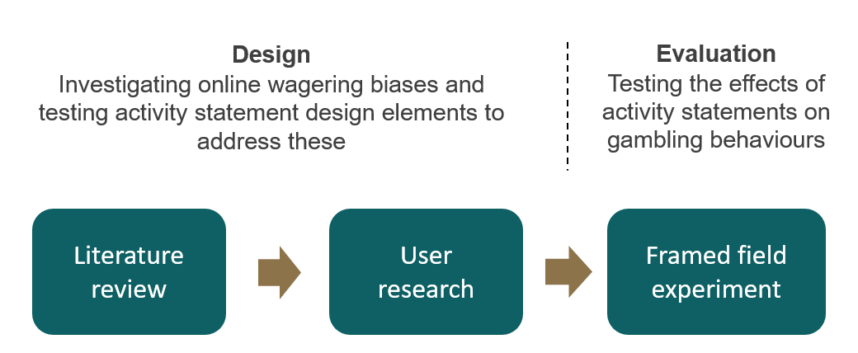
BETA identified behavioural biases which contribute to harm from online wagering

Behavioural biases can help explain gambling choices
Gambling behaviours are complex and occur in the context of multiple social, economic and personal experiences. Behavioural science can provide insights into why people gamble even when continued gambling will inevitably lead to losses.
We identified loss aversion, misperceptions about randomness and probabilities, and misperceptions about the influence of personal attributes and behaviours on gambling outcomes as biases which may be addressed by the regular provision of clear and meaningful information on gambling activities. Behavioural biases linked to harm from gambling are presented in Table 1.
Table 1: Behavioural biases commonly identified as contributors to gambling choices
Bias |  | Definition
Loss aversion |  | People respond more to losses than to gains of the same magnitude. Displaying losses clearly may reduce gambling.
Misperceptions about randomness and probabilities | Gambler’s fallacy | People commonly believe a win is more likely following a series of losses, and vice versa, even when each gamble is random.
 | Availability heuristic | People make judgments about the likelihood of events based on how readily they recall examples of them.
 | Selective recall | The availability heuristic is exacerbated by the tendency of people to recall wins better than they recall losses.
Misperceptions about personal attributes and behaviours | Illusion of control | People tend to overestimate their influence on the outcomes of gambles, particularly when they have some agency (e.g., they choose a horse).
 | Illusory correlation | Some people believe they possess traits (e.g., luck), or can engage in ritual behaviours (e.g., prayer), which will increase their probability of winning.
People respond more to losses than gains of the same amount; this is known as loss aversion (Kahneman and Tversky 1979). Loss aversion may lead to increased gambling due to the desire to win back losses (loss-chasing), or to decreased gambling to avoid future losses (loss avoidance). Whether gamblers chase losses or avoid losses is dependent on multiple factors (Zhang and Clark 2020; Imas 2016). These include individual sensitivity to losses, and whether losses are short or long-term.
Misperceptions about randomness and probabilities can also influence gambling decisions. Gamblers may not understand probabilities or independence of events, for example, gamblers may believe they are more likely to win after a series of losses, or may be more likely to remember wins than losses (Colman 2015; Gilovich 1983; Rickwood et al. 2010). These are known as the gambler’s fallacy and selective recall, respectively. People who have misperceptions about the influence of personal attributes and behaviours may believe they have abilities, skill or luck to be able to overcome random outcomes (Rickwood et al. 2010). Specifically they may have a belief about being able to influence gambling outcomes where they have no apparent control (illusion of control), or may falsely associate one outcome with another such as linking a win to a lucky behaviour (illusory correlation).
In some cases these biases are unconscious so are not able to be corrected simply by drawing attention to the bias. This is evident in studies in which improvements in participants’ statistical understanding of gambling do not lead to any changes in gambling behaviour (Harris and Griffiths 2017; Williams and Connolly 2006). Gambling under pressure or as an escape from external stressors may exacerbate unconscious biases.
Rather than directly correcting biases or educating online gamblers about probabilities and randomness of outcomes, there is opportunity to counter biases by providing online gamblers with regular information about their gambling activities. When this information is clear and easy-to-understand, it may unconsciously correct beliefs and over time lead to more informed decision-making during online wagering.

Activity statements can reduce behavioural biases associated with problem gambling
Activity statements may protect against behavioural biases by correcting misperceptions about randomness, probabilities and luck and by showing losses which may counteract the selective recall of wins. Previous research found participants who received personalised feedback about their gambling behaviour decreased their gambling intensity, spent significantly less time gambling and lost significantly less money than gamblers who did not receive personalised feedback (Auer and Griffiths 2015; 2016). Personalised feedback has been found to have a stronger behavioural effect on no-risk and at-risk gamblers than high-risk gamblers (Wood and Wohl 2015).
Another study showing the link between feedback and spending found gamblers who underestimated their losses lost significantly less money in the 3 months after they received personalised behavioural feedback. These participants were generally unaware of this change in their behaviour, suggesting the impact of feedback can be unconscious (Wohl et al. 2017). Our research builds on the findings of these previous studies by testing the effect of activity statements on gambling behaviour through user research and a simulated online wagering experiment with an Australian cohort.
We developed two activity statement prototypes

BETA designed activity statements using principles from behavioural science
We developed 6 activity statements showing summary gambling information for a 3-month period (a quarter), compared with previous quarters over the year and this time last year. We also developed a detailed list of transactions to attach to each of the summary statements, listing all gambling transactions for the period. To enable comprehension we drew on key design elements from behavioural science (Table 2).

Table 2: Behavioural science elements in the activity statements
Key behaviourally informed elements of the activity statements
Draw out key facts and highlight important elements
Online gamblers are unlikely to spend a long time looking at an activity statement. Focussing on the most important information helps people understand the key points at a glance.
Keep it short and to the point
Online gamblers are unlikely to read text which is long and complex. Presenting information in a clear and precise way will lead to focussed comprehension.
Present information in a standard way (across statements and providers)
Many online gamblers have accounts with multiple providers. Different styles of activity statements across providers can make it hard for consumers to compare their spending and results to get the full picture of the extent of their gambling. Presenting information in a standard way will lead to familiarity with statements and better understanding.
Use a combination of text, diagrams and tables
Many online gamblers find it easier to understand numbers when they are presented visually in graphs and diagrams. Breaking up text using boxes and graphs helps draw attention to important information.
Order information carefully
Online gamblers will pay more attention to the first item on the activity statement. Putting the key information up front will highlight gambling activities.
Use conversational language
Online gamblers find it is easier to engage with everyday language. Using conversational language in an activity statement will lead to better comprehension.
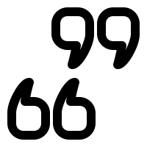 | Use standard terms  Online gamblers are familiar with common gambling terms. Applying the same terms across activity statement providers will enable better understanding with less cognitive effort.

We tested the activity statement prototypes through user research
We tested the 6 summary statements and detailed list of transactions through eye-tracking tasks, interviews and a focus group with 24 no/low-risk gamblers. All participants had gambled at least once in the last 30 days. We also interviewed 6 high-risk gamblers about the prototypes, to explore whether there were different needs for this group.
Participants were asked to view the 6 statements and find, explain and interpret information in them. Participants who took part in the eye-tracking task were recorded using eye-tracking and video analysis software. This tracked the participants’ eyes and showed which parts of the statements they were drawn to and how long they looked at each element.
The figure below shows eye-tracking of a number of participants on an earlier prototype tested during the user research. It shows the gaze of participants is drawn to the use of red and the simple heading, but also shows multiple sweeps across the wins and losses columns (indicating confusion), and less focus on deposits and withdrawals. The coloured balls represent eye-gaze and the larger they are indicates longer participants viewed those areas (note the top right corner out of view contained name and date information for the statement which participants viewed often). This finding led to the development of a prototype with segmented boxes, for easier interpretation.
Figure 2: Eye-tracking results helped us identify confusing design elements
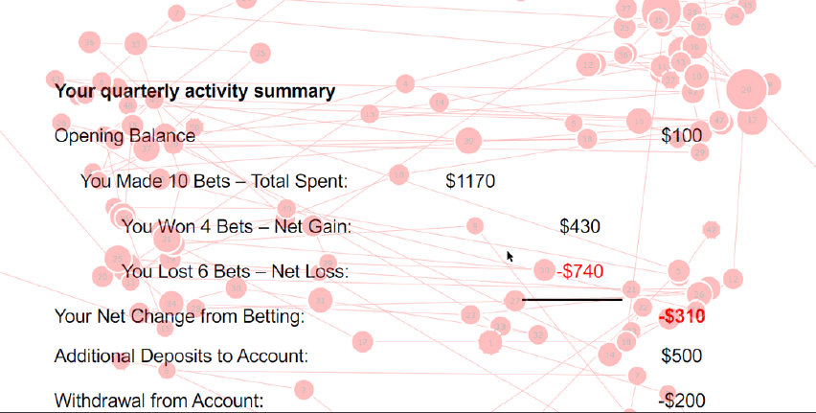

While viewing the statements participants were asked questions about the different elements and whether they understood these elements. For example, if a participant in the eye-tracking task spent a long time viewing a particular element they were asked if they found those elements useful or interesting or if they dwelled on them because they had trouble understanding them. Participants were also asked how they think the statements might affect their future behaviour and their preferred method of receiving activity statements. The feedback from user research provided insights into which elements were easiest to understand and of most value to online wagering consumers (for more details see the Results section and Appendix A).
The two final activity statement prototypes tested in the game are provided in Figures 3, 4 and 5. Both prototypes consist of a summary page and a detailed list of transactions. Summary page A and B differed by the display of a graph or a table. The key design elements of all 3 are highlighted below. These were adapted for the game by showing gambling sessions of 8 bets rather than quarters.
The prototypes align with the National Framework principles for the Activity Statement measure. Activity statements must at a minimum include information about each bet, the account balance, deposits and withdrawals, wins and losses, the net win/loss for the specified period, and the date, time and unique identifier of each transaction. The statements and detailed list of transactions also incorporated feedback from representatives of gambling support agencies, academics and government officials responsible for online wagering policy.
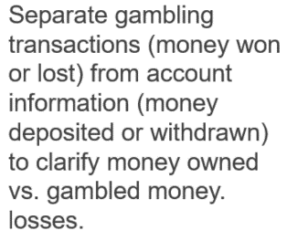
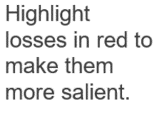
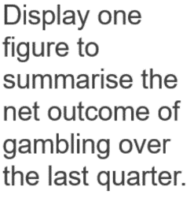
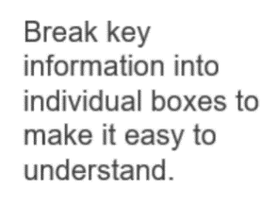
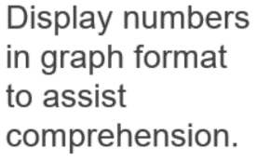
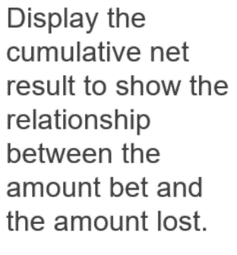
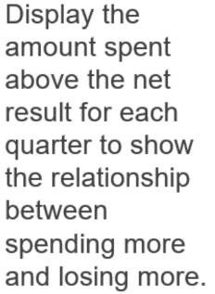
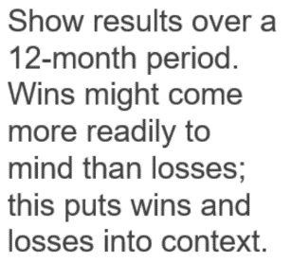
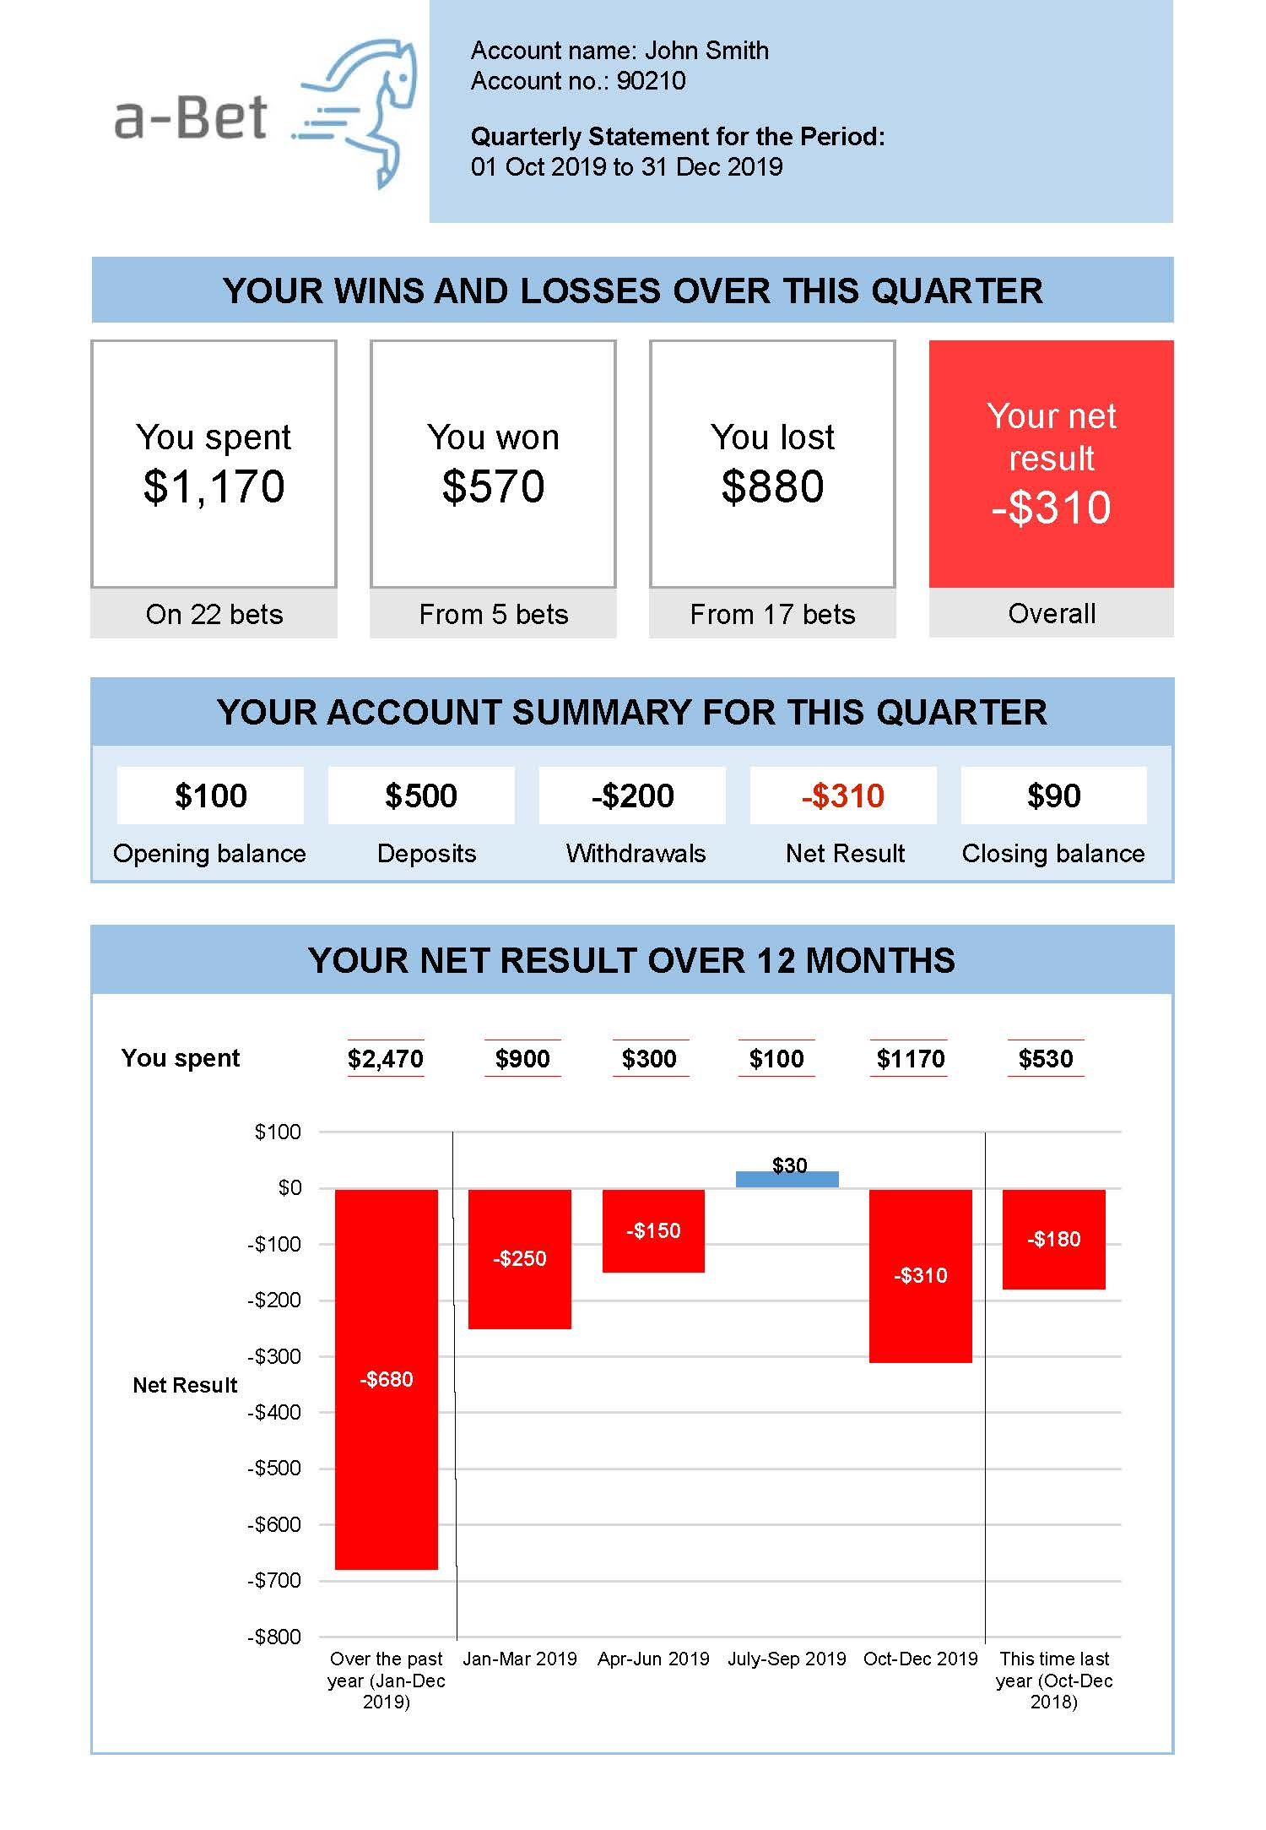
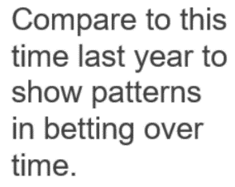
Figure 3: Design elements in Statement A
Figure 4: Design elements in Statement B

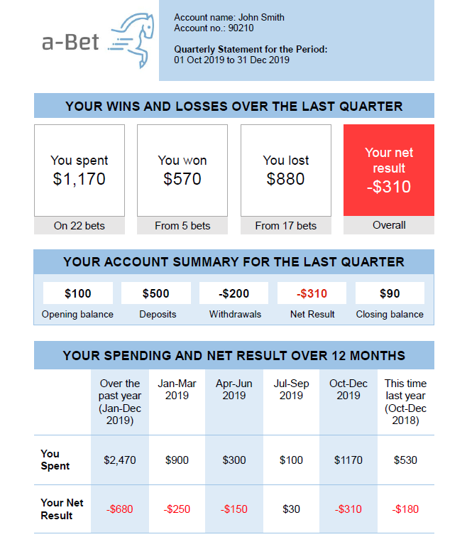

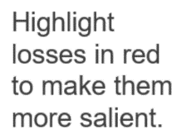
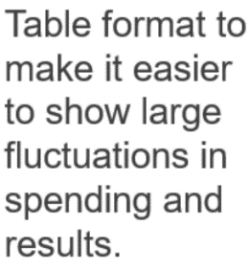
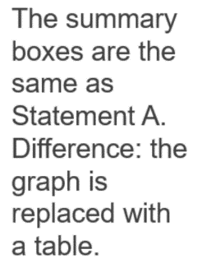
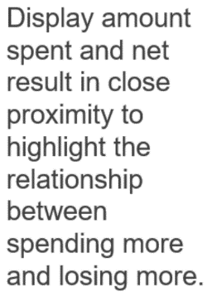

Figure 5: Design elements in the detailed list of transactions

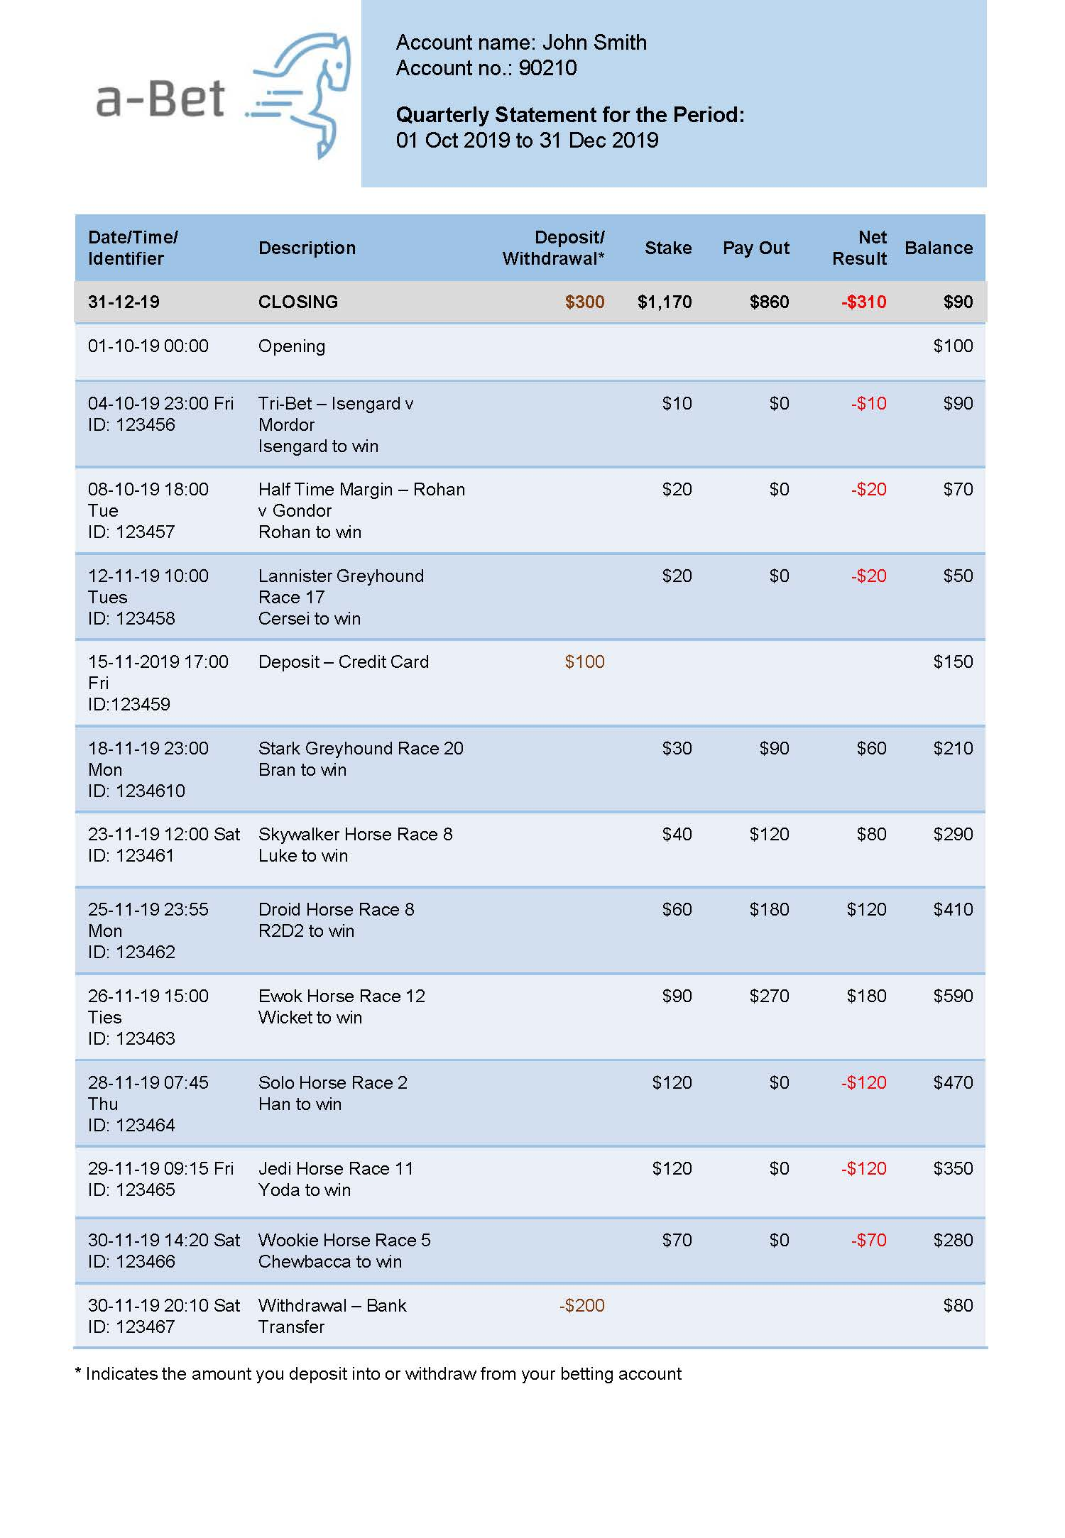
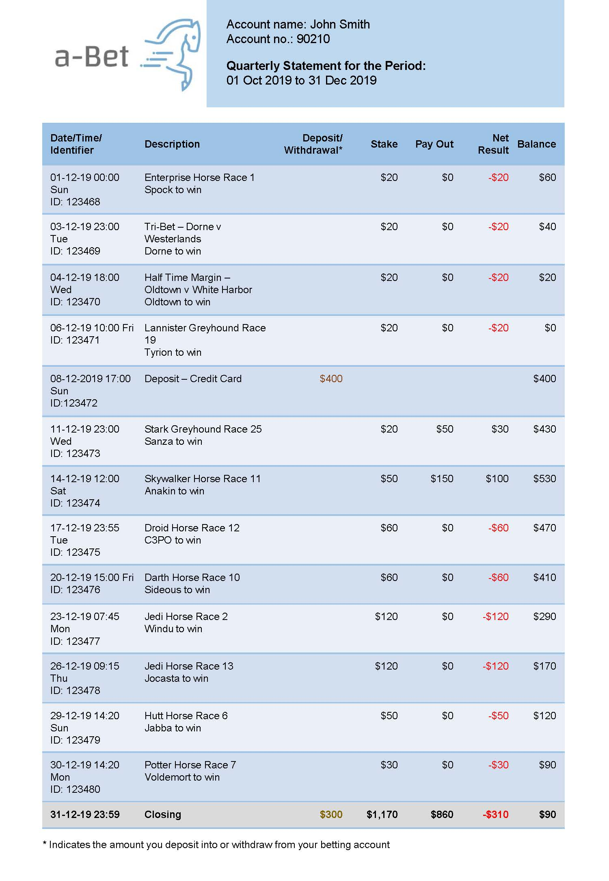
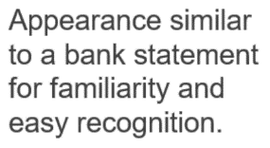
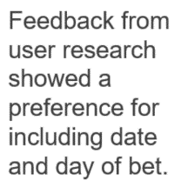

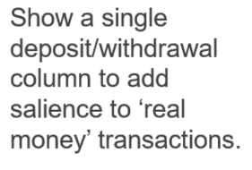

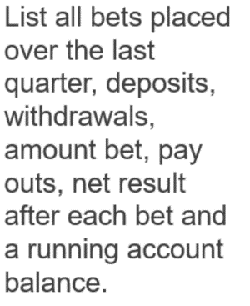

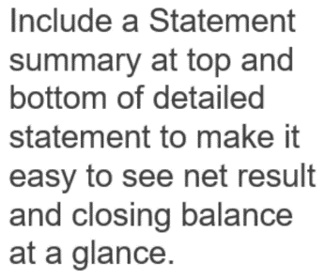

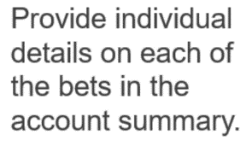

We tested the effects of the final two activity statement prototypes on gambling behaviour through a framed field experiment
We tested whether the activity statements would inform decision-making in a simulated online gambling game. Specifically, we examined whether participants who saw activity statements would bet less money and place a smaller number of bets than those who did not see activity statements during the game. The simulated game was a framed field experiment with participants randomly allocated to one of 3 conditions (see Box 1).
Box 1: What is a framed field experiment?
A framed field experiment is a type of randomised controlled trial conducted with a sample of people drawn from the population of interest (in this case, online gamblers). Framed field experiments are designed to mimic features of naturally occurring settings in a controlled environment to better understand how people respond to different types of stimuli. Framed field experiments generally ask participants to make choices in settings which approximate how they make decisions in real life (for example, sitting in front of their own computer in their own office or home).
Figure 6 shows the experiment flow. After completing a screener survey to check eligibility, participants were randomised into one of the 3 groups: treatment group 1 received Statement A; treatment group 2 received Statement B and the control group did not receive an activity statement. The detailed list of transactions was provided for both treatment groups. Following the online game, participants completed a post-game survey, which collected information on their financial literacy, gambling habits and beliefs, and their comprehension and perceptions of the activity statements (see Appendix D).
Figure 6: Experiment flow diagram
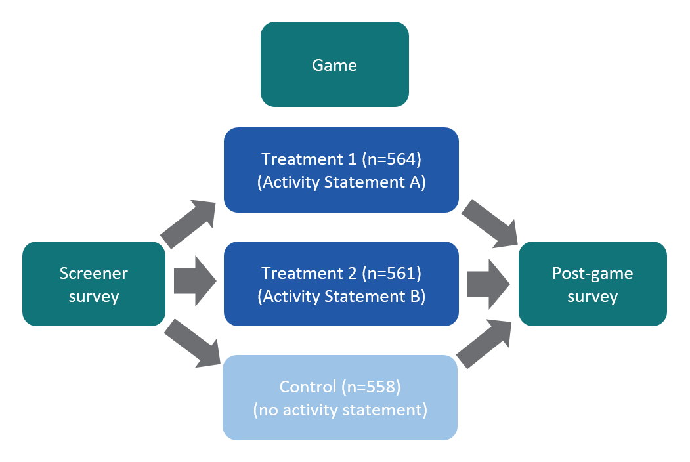
Figure 7 displays the study design for the treatment groups. Participants were invited to place bets on simulated horse races, with 1,000 lab dollars (not real money) provided over the course of the game in $125 instalments every 8 gambles. They could bet between $0 and $15 each gamble. There were 8 sessions of 8 gambles for a total of 64 gambles. Treatment groups 1 and 2 were shown activity statements after each session (8 gambles). Participants in the treatment groups saw an activity statement with details of their gambling activities for a minimum of 10 seconds after every 8 bets. Participants in the control group also had a 10-second enforced pause, to ensure any differences between treatment and control groups were not simply due to providing participants with time to think about their gambling. Figure 8 shows a screenshot of the simulated horse race from the game (see also Appendix C).
Figure 7: Study design
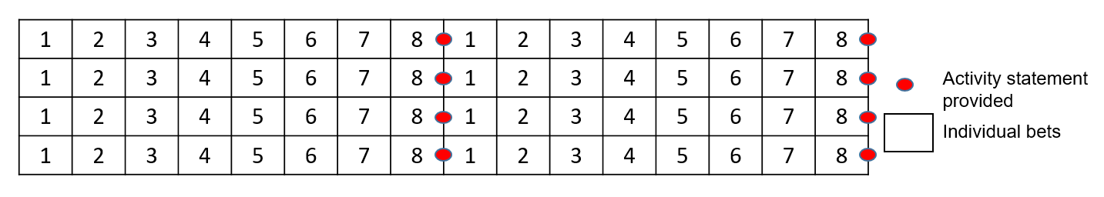
Figure 8: Game screenshot example
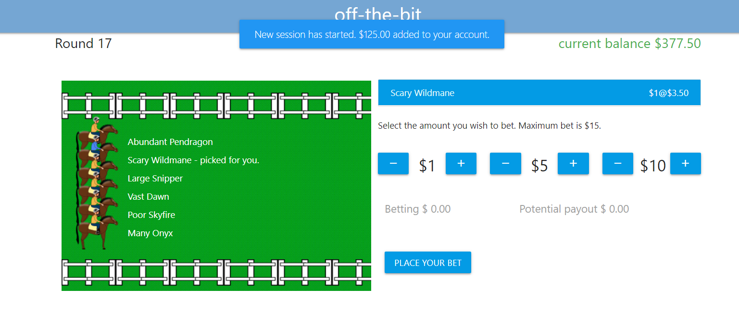
The game was designed to invoke similar feelings of risk and excitement as real-life online wagering. For each race, participants were able to see which horse they had an option to bet on (labelled “picked for you”) and the associated payout odds.
Each participant was compensated for their participation in the research. As a further incentive, 3 participants were randomly selected to receive an e-voucher for their remaining account balance converted into one Australian dollar for every 20 lab dollars. This approach provided the chance to take home “winnings”, intending to evoke the motivation to receive as large a pay-out as possible as per real-life online gambling.
We hypothesised:
- Participants who saw the activity statements would bet less money than the control group who did not see a statement.
- Participants who saw the activity statements would place fewer bets than the control group.
- The amount bet and the number of bets would be different between the two activity statement groups.

Results
What we found

Participants who viewed the activity statements bet less than participants who did not see a statement
There was a meaningful, and statistically significant difference in the amount bet between those who did not see a statement and those who did. On average, those who did not see a statement bet $368 while those who saw Statement A (graph) bet $340, and those who saw Statement B (table) bet $350. This represents a $28 (7.6 per cent) and $18 (4.9 per cent) reduction in amount bet for Statement A (graph) and B (table) respectively.
Those who saw Statement A (graph) bet $10 less than those who saw Statement B (table). This difference was not statistically significant, but does provide some evidence favouring a graph presentation over a table.
Figure 9: Activity statements reduce the amount bet

Note: This graph presents group averages for the total amount bet by each individual over 56 rounds of betting. Participants who saw Statement A (graph) (n=564) bet less on average than those who did not see a statement (n=558; p=.002). Participants who saw Statement B (table) (n=561) also bet less than those who did not see a statement (p=.029).
Figure 10 shows the impact of our activity statements over the 64 individual bets. Relative to the no statement group, betting decreases steadily over time with repeated exposure to the activity statements. This suggests the effect of viewing activity statements on gambling decisions is not only maintained but reinforced over time.
Figure 10: The impact of activity statements increases with repeated exposures

Note: This figure shows a running total of the average amount bet in each group. Relative to control, both Statement A and Statement B steadily reduced the total amount bet over time. This difference over time was statistically significant (p=.003 for Statement A and p=.033 for Statement B, see Table E2 in Appendix E).
We were also interested in whether viewing an activity statement would influence the number of bets made by participants. While participants who saw the statements bet smaller amounts, the number of bets they placed was not meaningfully different to the no statement group (45 bets compared with 46 bets). This suggests the activity statement informs decision-making about amount bet rather than participation in gambling itself.

Activity statements had a bigger effect for some individuals than others
We looked at how our activity statements performed among groups of participants with different characteristics. The findings in this section are suggestive, as the study was not designed to detect differences between sub-groups.

Gambling severity
Our results suggest the impact of our statements, particularly Statement A, was higher among moderate-risk gamblers. Moderate-risk gamblers bet less when they saw Statement A (graph) compared with those who did not see an activity statement (by 11 per cent). Moderate-risk participants who saw Statement B (table) bet less than those who did not see a statement, but this difference was not statistically significant (see Figure 11). This finding indicates a stronger effect of the graph format compared with no statement, especially for moderate-risk gamblers. Participants who were classified as no/low-risk bet less when shown an activity statement but this difference was not statistically significant.
Figure 11: Activity statements reduced amount bet for moderate-risk gamblers

Note: * indicates a statistically significant difference to the no statement group. This graph presents group averages for the total amount bet by each individual over 56 rounds of betting. "No/Low-risk" indicates a PGSI score of 0-2, "moderate-risk" indicates a PGSI score 3-7. Participants in the "moderate-risk" group who saw Statement A (graph) (n=209) bet significantly less than the control group (no statement) (n=221) (p=.010). Those who viewed Statement B (table) (n=222) bet less than the control group (no statement) but this was not significant (p=.235). The differences for those in the no/low-risk groups were not significant, though those who viewed Statement A (n=355) and Statement B (n=339) bet less than those in the control group (no statement) (n=337) (both p=.127).
We found activity statements reduced the amount bet for participants with other characteristics of interest, though it should be noted the study was not designed to detect sub-group effects. Participants with false gambling beliefs, loss-chasing tendencies and lower financial literacy bet substantially less when they saw an activity statement. These results are discussed further in Appendix E.

Participants found most elements of the activity statement prototypes to be useful and easy to understand
After playing the online game, participants were asked questions about their understanding and usefulness of the activity statements. Overall, the majority of participants found elements within the activity statements easy-to-understand, useful and were able to correctly identify amounts shown against each element when asked. This indicates the designs achieved the objectives set out in the National Framework.

Comprehension of activity statement elements was high
To test comprehension, all participants were presented with one of the prototypes and asked to identify amounts shown for key elements. Treatment group 1 and half the control group saw Statement A and treatment group 2 and half of the control group were shown Statement B. Nearly three-quarters of participants (72 per cent) got all of the comprehension questions correct (Figure 12). Comprehension was high for all other elements in the activity statements prototypes.
Figure 12: Most participants answered the comprehension questions correctly

Note: This graph presents the proportion of participants who correctly identified different elements in the activity statement prototypes. Proportions are of all participants who responded to each question.
Similarly, most participants found the elements easy to understand during the game (table 3).

Table 3: Ease of understanding of activity statement elements
Rating of understanding | Amount bet | Amount won | Amount lost | Net result | Amount spent over time | Net result over time | Overall under-standing
Extremely easy | 63.0 | 63.5 | 65.1 | 54.3 | 41.5 | 41.5 | 45.4
Slightly easy | 26.0 | 25.2 | 24.2 | 27.1 | 32.4 | 30.7 | 35.4
Neither easy nor difficult | 6.4 | 6.1 | 6.8 | 10.9 | 16.2 | 16.8 | 12.6
Slightly difficult | 3.4 | 4.0 | 2.9 | 5.8 | 7.8 | 8.7 | 5.1
Extremely difficult | 1.1 | 1.2 | 0.9 | 1.9 | 2.1 | 2.3 | 1.5

Participants rated most of the elements in the activity statement as useful
All of the elements rated highly in relation to usefulness (Figure 13). The comparison to spending and net result in the same quarter last year was reported as useful by the smallest proportion of participants (though still high at 76 per cent). This was likely at least in part due to the lack of relevance of this element in the game.
Figure 13: Elements were rated moderately or very useful by most of the participants

Note: This graph presents the proportion of participants who rated activity statement elements as moderately or very useful during the game. Proportions are of participants who responded to each question (n=1,496).
Participants were also asked to nominate the element in the activity statement they found most useful. The most popular response was net result (39 per cent) (Figure 14). Only 7 per cent of participants selected amount spent over time as the most useful part of the activity statement.
Figure 14: Net result was rated the most useful element

Note: This graph presents the proportion of participants who responded to the question about the most useful element in the activity statement (n=1,496).

Displaying a detailed list of transactions
The detailed list of transactions was designed to provide in-depth information about each gambling transaction including the date/time/identifier, the deposit and withdrawal account information, the bet, payment, net result and balance. It is a tabular layout which includes a summary box of transactions at the top and bottom of the statement, red text to indicate losses and brown text for account transactions. The detailed list was refined during user research and included in the experiment game. We did not ask any specific questions about the list in the framed field experiment, but participants in the user research found this clear and useful.

Preferences for activity statements in real life
The majority of respondents in the experiment (91 per cent) said they would like to receive the activity statements in real life, with 85 per cent indicating they would like to receive them via email. The second most popular delivery method was in-app/browser delivery, which was selected by 54 per cent of respondents. The least preferred method was by post.
The most popular frequency for receiving activity statements in both the experiment and user research was monthly (44 per cent of experiment participants selected this option). The preferred timeframe covered in the activity statements was evenly split between monthly for the past 6 months and monthly for the previous year (25 per cent each).

Real-life uses
Participants in the treatment groups who stated they had read the activity statements during the game were asked how they thought they would use the activity statements in real life. The most common response was to find out how much they had won or lost (see Figure 14). The majority of participants stated they would use the activity statements to decide how much to bet in real life. We expect this will be higher in real-life gambling situations given previous research found the impact of feedback can occur unconsciously (Wohl et al. 2017).
Figure 15: Many participants stated they would use the activity statement in real-life

Note: This graph presents the proportion of participants who stated they would use the different elements of the activity statements most of the time/always in real-life. Proportions are of treatment group participants who saw the statements during the game and answered the question about use in real-life (n=963).
When asked about how they used activity statements in the game, participants were more likely to say they used them to see how much they had won or lost (67 per cent) but not to make decisions about how much or how often to bet (28 per cent). However the results of the experiment suggest people used the activity statements to make decisions about how much to bet in the game, as participants who viewed activity statements bet less money than those who did not see activity statements (though frequency of betting did not change). This aligns with previous research showing people who had underestimated their losses lost less after receiving personalised feedback but were unaware of the change in their behaviour (Wohl et al. 2017). A similar phenomenon may be occurring in this experiment; participants may not realise viewing the statements corrected their beliefs about how much they were winning and resulted in them betting less.

Limitations
Our study was a framed field experiment, conducted in a controlled environment designed to mimic real-life gambling. Extending the findings of the experiment to real-life online wagering environments is limited by this design. First, participants placed bets using lab dollars provided to them at the start of the experiment and refreshed throughout the game. They may have bet differently if they had been using their own money. To encourage them to bet as they would in real-life, the design included the random selection of 3 participants to receive their winnings at the end of the study (at a conversion of $1 Australian dollar to every $20 lab dollars). It is possible in real-life viewing activity statements may have a stronger effect as they show losses accrued by participants using their own money.
Second, we restricted the amount and frequency of bets, focussed on horse racing only and selected the horse for the participant. Participants who viewed the activity statements did so after every 8 bets. In real-life, participants will likely receive activity statements monthly. It is unknown whether the cumulative effect of viewing the activity statements over time will be similar in real-life as there will be more time between each viewing.
Given these factors we cannot extrapolate to say the average gambler will make a saving of a particular amount. We can say the direction of the effects was substantial (within the confines of the activity) and consistent. Some evidence suggests findings can be extrapolated to real-world online wagering. When asked how much the online game felt like their real-life experience of betting online only 14 per cent said the game did not at all feel like their real-life experience.
Figure 16: Most participants rated the game as similar to real life
Note: This graph presents participant responses when asked how much the game resembled real-life gambling. Proportions are of participants who completed the post-game survey (n=1,501).

Discussion and conclusion
Online wagering is the fastest growing form of gambling in Australia and has the potential to lead to social, personal and economic harm. Consumers are able to make multiple bets across several operators and to bet on a wide range of events. Yet online wagering consumers do not currently have access to clear and consistent statements about their gambling activities. The National Framework aims to address this. We designed easy-to-understand and clearly set-out activity statement prototypes to provide consumers with details of their gambling activities. In a behavioural trial we showed viewing these activity statements can lead to more informed choices for online wagering consumers.
Viewing an activity statement significantly impacted wagering amounts, this effect was strongest for moderate-risk gamblers, those with poor financial literacy, participants with a tendency to chase losses and those who hold false gambling beliefs about the likelihood of winning. This suggests activity statements are particularly effective for online gamblers at risk of harm from gambling. It also suggests the design of the activity statements informed by behavioural science were effective in addressing cognitive biases influencing online wagering decisions. Notably, betting amounts were affected but not number of bets, suggesting the activity statements provide critical feedback to adjust but not prevent spending in line with gambling preferences and within spending limits.
Statement A is recommended as the preferred statement for implementation given its performance for at-risk groups. The graph design for gambling over time used in Statement A was a preferred display for user research participants and more positively received by those in the framed field experiment. Statement B was also found to be effective for empowering decision-making in online wagering and is a satisfactory design also. The final recommended prototypes are provided in Appendix B. We specifically recommend the following features be retained by operators, as these are the design and content features most likely to influence online wagering decision-making:
- use of red for showing losses and black to show wins (no use of green)
- segmented information clearly showing monthly information on gambling activities, and account transactions, separately
- display of amount spent against net result, over time for over the last 6 months (cumulative) and this time last year
- chart scale to be adjusted appropriately as amounts won/lost increase and decrease
- detailed transaction list to include a summary box at the top and clearly separated activities as shown in Appendix B
- detailed transaction list to include information on what event was bet on and the type of bet placed
- detailed transaction list to include odds for each bet.
It is recommended operators provide monthly statements for the last 6 months, via email and also available through download. These were the preferences nominated by many of the participants in the user research and experiment.
Further, additional design features recommended through the National Framework and currently being evaluated through other trials include:
- gambling helplines
- safe gambling messaging.
This project provides strong evidence for the provision of clear and accessible statements about gambling activities to online wagering consumers. Findings suggest the prototypes will empower online gamblers to make informed decisions, and to prevent harm from gambling.

Appendices

Appendix A: User research and stakeholder consultation
In late 2019 BETA tested 6 summary statements and the detailed list of transactions with a online gamblers. The objective was to develop final activity statement prototypes for the simulated game, using elements selected as being of most value to online gamblers, and easy-to-understand designs.
Eye tracking and interviews were carried out with 24 no/low-risk gamblers who had gambled at least once in the last 30 days. Overall, the summary components of the prototypes scored high on comprehension, from 7.4 to 8.3 out of 10. This was supported by the eye-tracking research, where few issues with comprehension were identified. Over half of the participants reported their gambling decisions would be influenced if they received an activity statement.
We also explored prototype designs in a focus group with 6 no/low-risk gamblers and 6 face-to-face interviews with high-risk gamblers. Participants showed a positive response to the prototypes, though the high-risk gamblers noted they may avoid looking at activity statements if they show losses or may be compelled to make up losses by betting more. The images below show the activity statement prototypes annotated with findings from the user research.

Figure A1 shows prototype statement 1 from the user research. Participants suggested the term quarterly be added to the Account statement box at the top. Withdrawals and deposits took longer for participants to find than for other statements. There was confusion around the unaligned numbers in three different columns and participants thought the numbers were too far away from the words. This was considered the least useful prototype by participants in the user research.

Figure A1: Prototype statement 1 tested in the user research
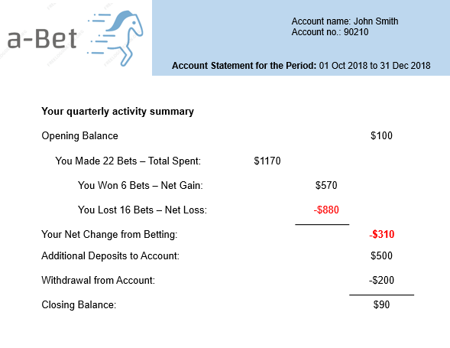

Figure A2 shows prototype statement 2 tested in the user research. Participants reported they found the line graph difficult to understand but the trends over time useful. Participants’ comments on the top half of prototype statement 1 also apply here.

Figure A2: Prototype statement 2 tested in the user research

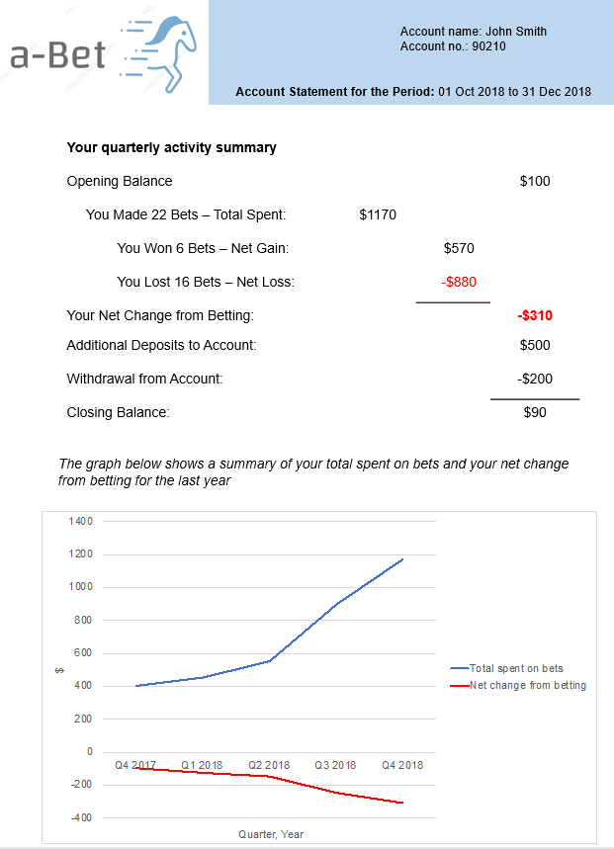
Figure A3 shows prototype statement 3 tested in the user research. Participants found the statement useful overall. Participants found the gauge and the percentage of money lost confusing. However, they reported the segmented boxes, showing gambling information separately to account information, were useful and easy to understand.

Figure A3: Prototype statement 3 tested in the user research
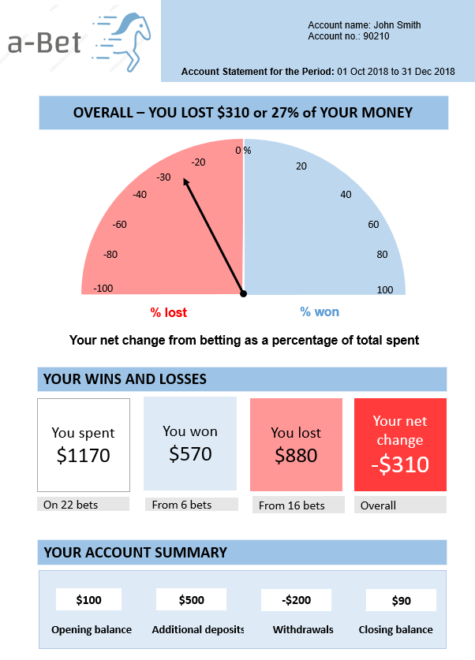
Figure A4 shows prototype statement 4 tested in the user research. Participants’ comments on the top half of prototype statement 1 also apply here. Participants thought there was “too much text” particularly in the middle part of the statement. There was a mixed response to the comparison with low-risk gamblers; some participants reported they did not know why they were being compared with low-risk gamblers. Participants reported they liked the use of colours.

Figure A4: Prototype statement 4 tested in the user research
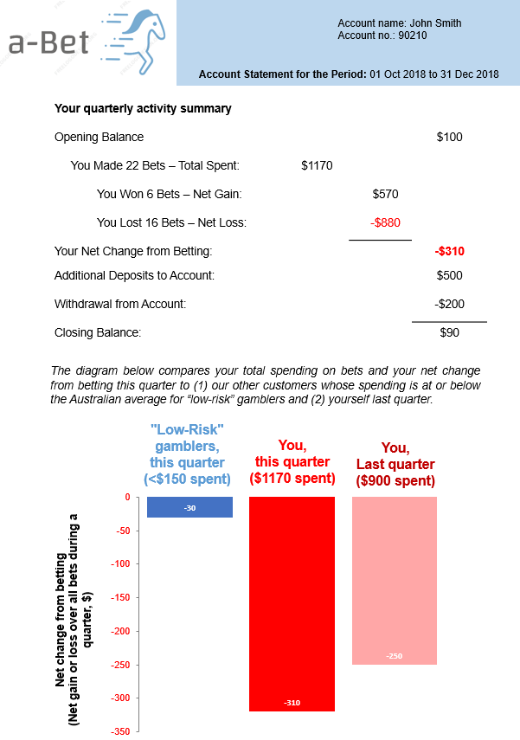
Figure A5 shows prototype statement 5 tested in the user research. Participants’ comments on the top half of prototype statement 1 also apply here. Similarly to prototype 4, participants had mixed views on the comparison with low-risk gamblers. Participants also thought the amount of text was “too much”. Again, participants liked the use of colours in the graph and found the bar titled “you” easy to understand.

Figure A5: Prototype statement 5 tested in the user research
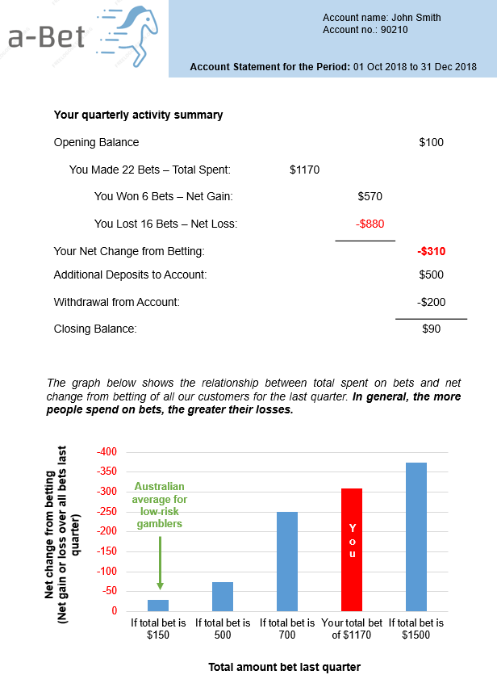
Figure A6 shows prototype statement 6 tested in the user research. Participants liked the graph showing changes in spending over time, as well as the segmented boxes. However, there was a mixed response to the comparison with low-risk gamblers.

Figure A6: Prototype statement 6 tested in the user research
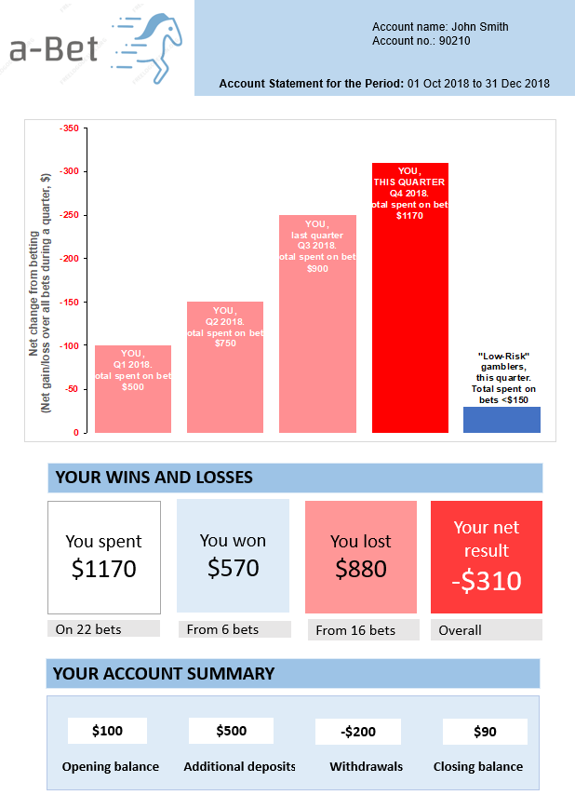

Figures A7 and A8 show the detailed transaction statement tested in the user research. Participants liked the summary box repeated at the top and bottom, recommended the box showing deposits and withdrawals be separated into two boxes and day of the week be included in the left column. Participants found the tabular layout easy for comprehension and liked the use of red for losses. Some participants thought seeing this information over time would be useful for them to make decisions about betting.

Figure A7: Detailed transaction statement tested in the user research (page 1)
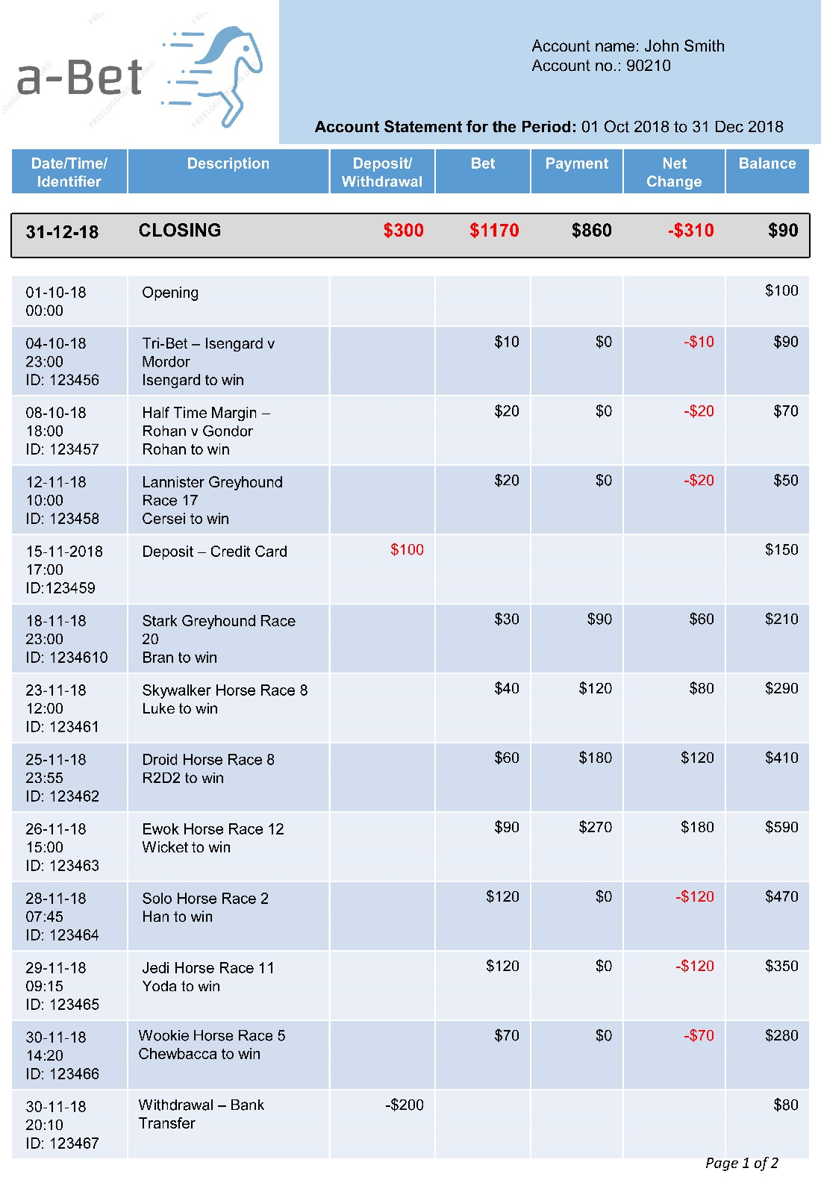

Figure A8: Detailed transaction statement tested in the user research (page 2)
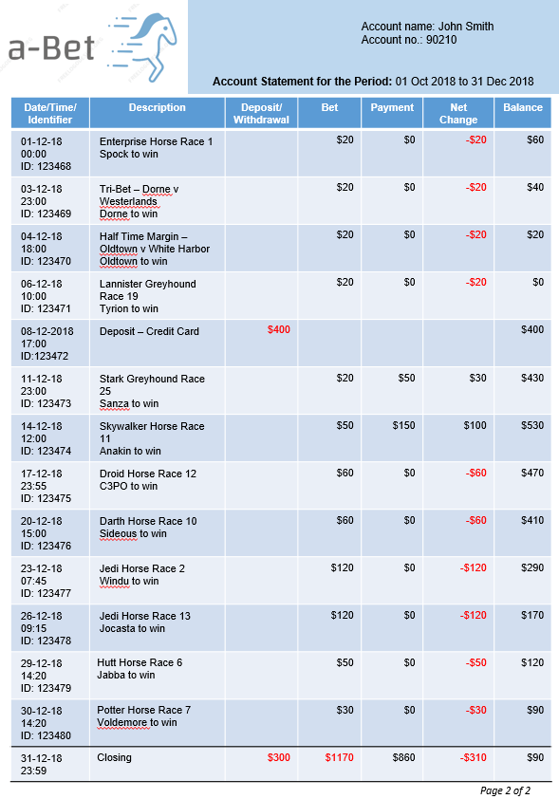

Appendix B: Final recommended prototypes
Final recommended prototypes are below.

Figure B1: Activity Statement A (preferred)
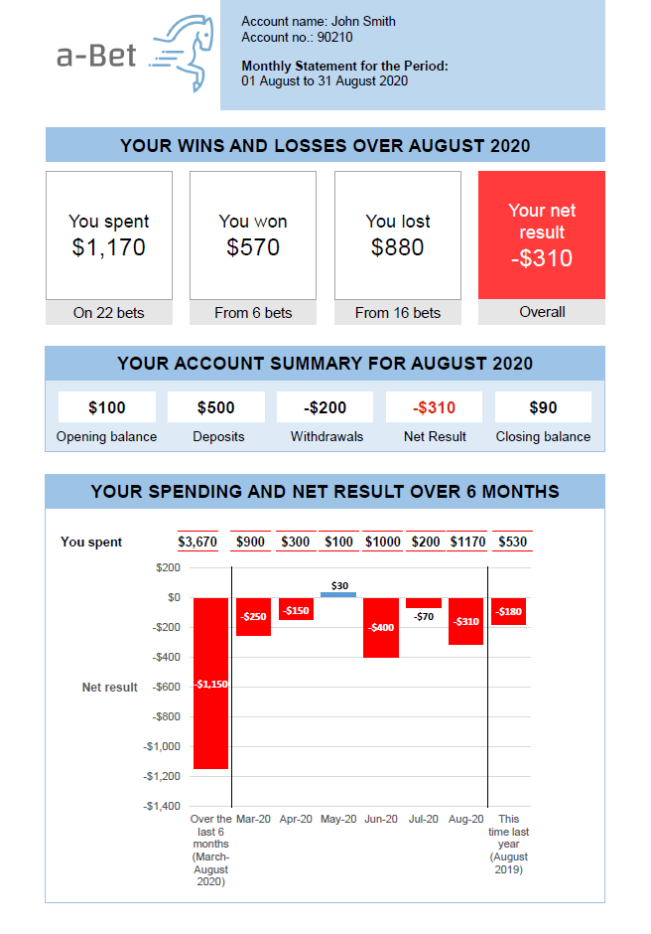

Figure B2: Activity Statement B
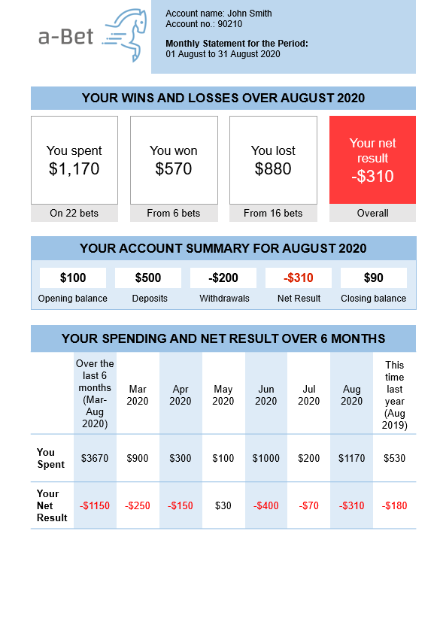

Figure B3: Detailed transaction list (pg 1)
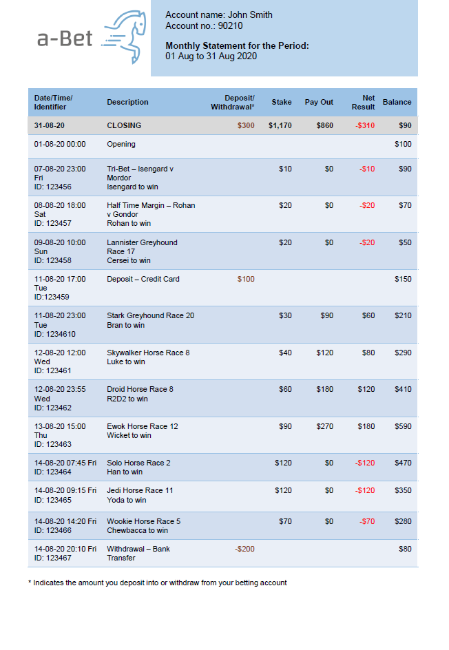

Figure B4: Detailed transaction list (pg 2)
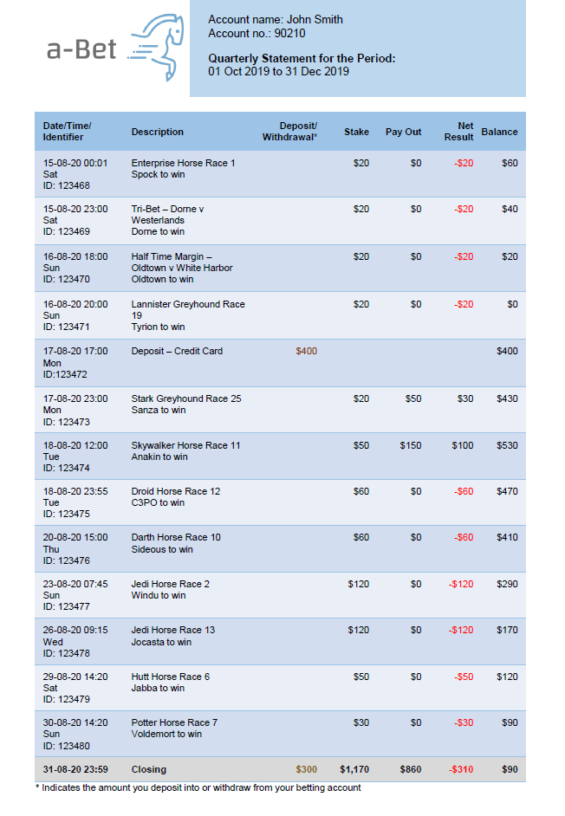

Appendix C: Experiment instructions and screenshots (game)
Following the screener, participants were provided with instructions for the game (see below).
Welcome to the online betting game.
Please read these instructions in full before proceeding.
How does the game work?
This is a virtual horse racing game. The virtual races are dynamic, not fixed, and the odds relate to the probability of winning.
You will bet lab dollars (not your own money) on 64 horse races, with four practice races to start you off. You will start the game with $125 and have an additional $125 deposited into your betting account every 8 races. In July 2020, three randomly chosen participants will have their account balance at the end of the game converted into Australian dollars at a rate of 20:1. If you are selected, you will receive an e-voucher for this amount.
How long will it take? The game will take approximately 25 minutes and will be followed by a survey. The two together will take about 40 minutes to complete. You cannot stop and return so please make sure you have adequate time available to complete the study before commencing. We really want as many individual experiences as possible to inform our research. Please give the study your full attention; we suggest closing other browsers and tabs and reducing background distractions such as the TV or radio. If the game is inactive for 15 minutes you will be timed out.
How to play
To get used to the game you will play four practice bets. The amount that you win or lose during the four practice bets will not be added to or subtracted from your account balance.
Following the four practice bets you will play for 64 races. For each race you won’t get to choose your horse but you do get to choose whether or not you place a bet.
The horse name and payout odds will be shown in a blue box, like the one below. You can bet between $1 and $15 for each race or choose not to bet at all. You can place bets by clicking the $1, $5 and $10 buttons (shown in the image below) to create any combination between $1 and $15 and then selecting the ”place your bet” button.
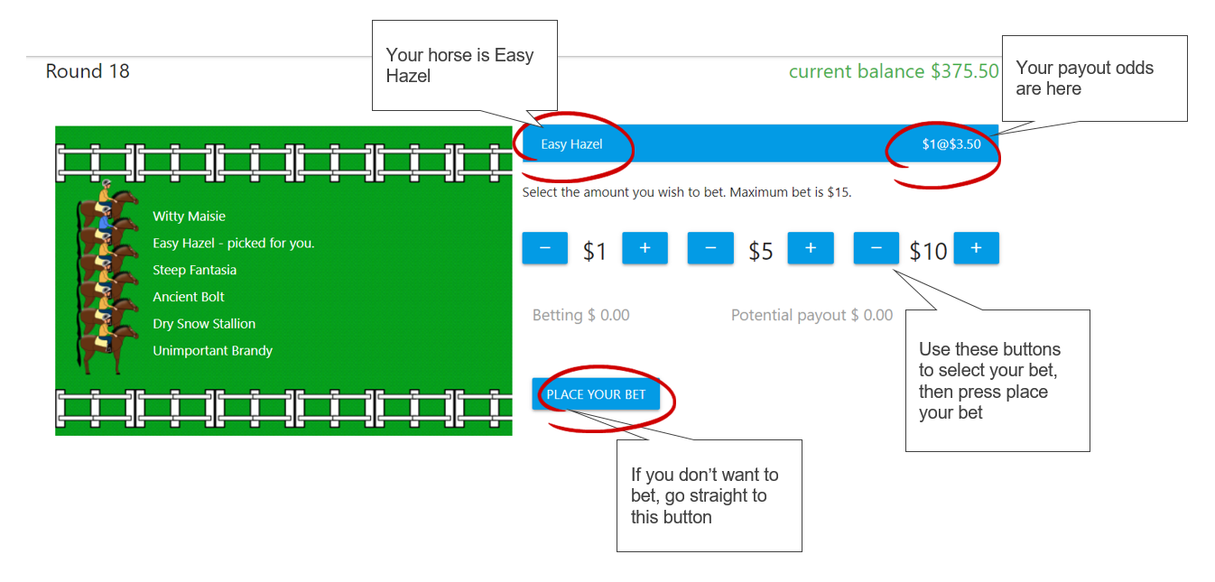
If you do not wish to bet you can select the “place your bet” button without selecting an amount.
The amount that you have selected and the potential payout will be displayed on the screen.
Once you have placed your bet, the virtual horse race will begin. Your jockey is the one in blue.
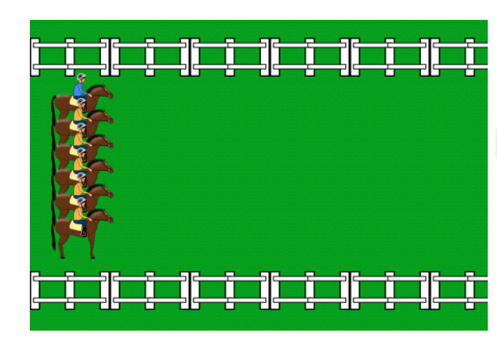
At the end of each race you will see the outcome, the winner will be highlighted in white and your horse will be highlighted in blue. If you win, all of the other horses will be highlighted in grey.
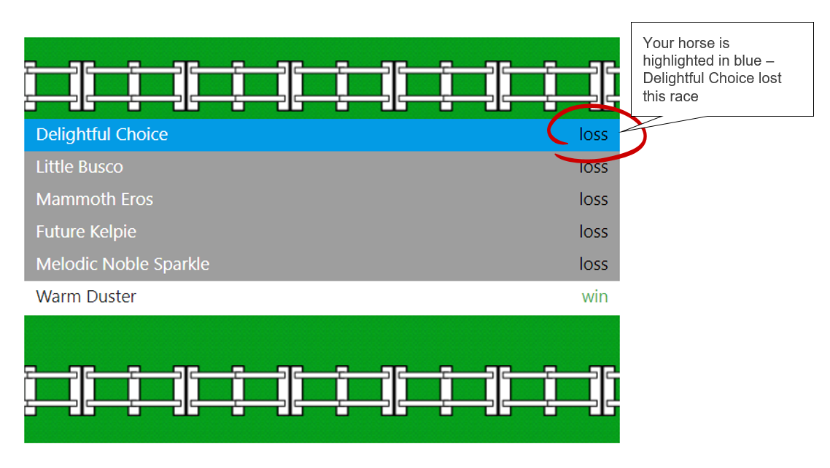
Good luck!
*No pixelated horses were harmed in the making of this game.

Appendix D: Screener and post-game survey

Screener Survey
Thank you for your interest in taking part in this study on decision-making. Below is a short five-minute survey to check your eligibility for taking part in the research.
- Please select your age bracket
1. | 18 - 24
2. | 25 - 34
3. | 35 - 44
4. | 45 - 54
5. | 55 - 64
6. | 65+
- What is your gender?
1. | Female
2. | Male
3. | Non-binary
4. | Prefer not to say
- What is the highest level of education that you have completed?
1. | Year 10 or below
2. | Year 11 or equivalent
3. | Year 12 or equivalent
4. | A trade, technical certificate or diploma
5. | A university or college degree
6. | Postgraduate qualifications
7. | Other, please specify
- In the last 6 months, have you placed any bets online (with money) on sports, racing or other events?
When we refer to online betting, we mean electronically via a mobile/smartphone, computer (e.g. PC, laptop), tablet (e.g. iPad), smart TV, internet telephone or by telephone call.
1. | Yes
2. | No
If no, terminate participation
- Thinking back over the last year, on average, how often do you engage in online wagering? These include activities you undertake betting online such as horse race betting and sports betting. (Single response)
1. | 4 or more a times a week
2. | 2-3 times a week
3. | Once a week
4. | 2-3 times a month
5. | Once a month
6. | A few times a year
7. | Once or twice a year
- Do you usually reside in Australia?
1. | Yes
2. | No
If no, terminate participation
- What state/territory do you reside in most of the time?
1. | Queensland
2. | New South Wales
3. | Australian Capital Territory
4. | Victoria
5. | South Australia
6. | Tasmania
7. | Western Australia
8. | Northern Territory
9. | Other
When you think of the past 12 months, how often...
- Have you bet more than you could really afford to lose?
Never (0) Sometimes (1) Most of the Time (2) Almost Always (3)
- Have you needed to gamble with larger amounts of money to get the same feeling of excitement?
Never (0) Sometimes (1) Most of the Time (2) Almost Always (3)
- Have you gone back another day to try to win back the money you lost?
Never (0) Sometimes (1) Most of the Time (2) Almost Always (3)
- Have you borrowed money or sold anything to get money to gamble?
Never (0) Sometimes (1) Most of the Time (2) Almost Always (3)
- Have you felt that you might have a problem with gambling?
Never (0) Sometimes (1) Most of the Time (2) Almost Always (3)
- Have you felt people criticized your betting or told you that you had a gambling problem, regardless of whether or not you thought it was true?
Never (0) Sometimes (1) Most of the Time (2) Almost Always (3)
- Have you felt guilty about the way you gamble, or what happens when you gamble?
Never (0) Sometimes (1) Most of the Time (2) Almost Always (3)
- Has your gambling caused you any health problems, including a feeling of stress or anxiety?
Never (0) Sometimes (1) Most of the Time (2) Almost Always (3)
- Has your gambling caused any financial problems for you or your household?
Never (0) Sometimes (1) Most of the Time (2) Almost Always (3)
If PGSI score ≥ 8, terminate participation:
Thank you for your interest in participating in this research. Unfortunately you are not eligible for this study.
If completing this questionnaire has brought to mind unpleasant thoughts about losing money or experiencing financial difficulties, support is available 24/7 at:
Lifeline 13 11 14
National Debt Helpline 1800 007 007
Gambling Helpline 1800 858 858
Gambling Help Online

Post-game survey
Thank you for completing the online game. Once you have completed this 15-minute survey you will receive your $25 e-voucher and go into the running to be one of three people to win an e-voucher for the balance left in your account at the end of the experiment, paid out at 20 lab dollars to 1 Australian dollar.
Treatment groups were then asked the following questions about activity statement use during the game
The first set of questions are about the activity statements that were displayed during the online game. These were the summaries provided every 8 bets showing your betting activities during the previous rounds. There were also detailed summaries of each bet.
- Did you read the activity statements that were displayed during the online game?
1. | Yes
2. | No
If no, go to Q8
- What was the net gain/loss in your final activity statement at the end of the 64 gambles? Your best guess is fine if you can’t remember the exact amount $___________
- How easy or difficult was it to understand the following information included in the activity statements?
 | Extremely easy | Slightly easy | Neither easy nor difficult | Slightly difficult | Extremely difficult
How much you spent/bet | 1 | 2 | 3 | 4 | 5
How much you won | 1 | 2 | 3 | 4 | 5
How much you lost | 1 | 2 | 3 | 4 | 5
Your net result | 1 | 2 | 3 | 4 | 5
How much you spent/bet over time | 1 | 2 | 3 | 4 | 5
Your net result over time | 1 | 2 | 3 | 4 | 5
Overall ease of understanding | 1 | 2 | 3 | 4 | 5
- The following questions are about how frequently you used information in the activity statement to make your betting decisions during the online experiment.
I used the activity statement | Not at all | A little | A lot | Always
to make decisions about how much I spent/bet | 1 | 2 | 3 | 4
to make decisions about how often I bet | 1 | 2 | 3 | 4
to find out about my patterns of betting over time | 1 | 2 | 3 | 4
to find out how much I had won or lost | 1 | 2 | 3 | 4
The next two statements are about your response to the activity statements. Please rate how much you agree or disagree according to your experiences during the game.
- The activity statement made me want to keep gambling to make up the losses
1 | Strongly disagree
2 | Disagree
3 | Neither agree nor disagree
4 | Agree
5 | Strongly agree
- The activity statement made me want to stop gambling to avoid further losses
1 | Strongly disagree
2 | Disagree
3 | Neither agree nor disagree
4 | Agree
5 | Strongly agree
- If you were presented with an activity statement in real-life, please rate the extent to which you would use them for the following options.
In real life I think I would use the activity statement | Never | Sometimes | Most of the time | Always
to make decisions about how much I spend on betting | 1 | 2 | 3 | 4
to make decisions about how often I bet | 1 | 2 | 3 | 4
to find out about my most recent betting activities | 1 | 2 | 3 | 4
to find out about my patterns of betting over time | 1 | 2 | 3 | 4
to find out how much I had won or lost | 1 | 2 | 3 | 4
- Did you sit out a bet at any point during the game?
1 | Yes
2 | No
If yes, go to Q9
If no, go to Q10
- What most prompted you to not place a bet?
1 | The odds
2 | I was losing
3 | I was winning
4 | I was trying to make sure I have the most balance left at the end of the game
5 | Other (please specify)
- How much did the online game feel like your real life experiences of betting online?
1 | Not at all
2 | A little
3 | Somewhat
4 | A lot
Control and treatment groups received the rest of the survey
Now you will be shown an example activity statement, which shows a hypothetical person’s betting over the course of a year. Please spend a moment looking at the activity statement and answer the following questions.
You can scroll back up to remind yourself of the activity statement elements while answering the questions.
- Thinking about the design of the activity statements, please rate how useful this information would be to you.
 | Not at all useful | Slightly useful | Moderately useful | Very useful
How much you spent/bet | 1 | 2 | 3 | 4
How much you won | 1 | 2 | 3 | 4
How much you lost | 1 | 2 | 3 | 4
Your net result | 1 | 2 | 3 | 4
How much you spent/bet over time | 1 | 2 | 3 | 4
Your net result over time | 1 | 2 | 3 | 4
The comparison to your spending this time last year | 1 | 2 | 3 | 4
- What do you think is the most useful information in this activity statement?
1. | How much you spent
2. | How much you won
3. | How much you lost
4. | Your net result
5. | How much you spent over time
6. | Your net result over time
7. | The comparison to your spending this time last year
8. | Other, please specify
- Overall, in the last quarter what is the net result in this example activity statement?
1 | Lost money overall
2 | Came out even
3 | Won money overall
- How many bets did this person place in the last quarter?
- How many wins did this person have in the last quarter?
- How much money did this person bet in the last quarter (in dollars)?
- What’s the net result (in dollars)?

- Is there any information about online wagering activities missing from this activity statement that you would like to see in real life?
- Do you have any further comments on the activity statements that you would like to make?
- Would you like the online gambling platforms you use to provide similar activity statements?
1 | Yes
2 | No
If yes, go to Q21
If no, skip to Q24
- How often would you like to receive activity statements?
1 | On request
2 | Yearly
3 | Every 6 months
4 | Quarterly
5 | Monthly
- The activity statements you have been shown today show quarterly information over the past year. What period of time would you like activity statements to show?
1 | Monthly for the past 6 months
2 | Monthly for the previous year
3 | Quarterly for the past 6 months
4 | Quarterly for the previous year
5 | Just the previous month
6 | Just the previous quarter
7 | Just the previous week
- How would you like to receive activity statements? Select all that apply.
1 | By mail
2 | By email
3 | In the app/browser
4 | Other, please specify
Gambling habits
We will now ask you a few questions about real-life gambling scenarios.
- When you engage in online wagering, what devices do you use to gamble? Please select all that apply.
1 | Mobile app/Smartphone
2 | Desktop/PC
3 | Laptop
4 | Tablet
5 | Telephone call
6 | Gaming console
7 | Smart TV
8 | Other ___________
- How many gambling websites or gambling apps are you registered with?
- How long is your typical online wagering session? Your best guess is fine.
1 | Up to 30 mins
2 | 30 mins to one hour
3 | 1 to 2 hours
4 | 2 to 3 hours
5 | 3 to 4 hours
6 | More than 4 hours
- What is your usual reason for ending an online wagering session?
1 | Had something else to do
2 | Lost too much money
3 | Reached a target
4 | Got bored
5 | Got tired
6 | Run out of money
7 | Won a lot of money
8 | Other, please specify
- In a typical month over the last 12 months, when you bet on horse or greyhound races online, roughly how much did you usually bet? Your best estimate is okay.
1 | Enter amount in dollars $
2 | Nothing
3 | Prefer not to say
- In a typical month over the last 12 months, when you bet on sporting events online, roughly how much money did you usually bet? Your best estimate is okay.
1 | Enter amount in dollars $
2 | Nothing
3 | Prefer not to say
Gambling beliefs
- Read each of the statements carefully. Rate to what extent you agree or disagree with each statement
luck /  perseverance | Strongly disagree | Disagree | Somewhat disagree | Neither agree nor disagree | Somewhat agree | Agree | Strongly agree
If I am gambling and losing, I should continue because I don’t want to miss a win. | 1 | 2 | 3 | 4 | 5 | 6 | 7
If I lose money gambling I should try to win it back | 1 | 2 | 3 | 4 | 5 | 6 | 7
I should keep the same bet even when it hasn’t come up lately because it is bound to win. | 1 | 2 | 3 | 4 | 5 | 6 | 7
- A positive attitude or doing good deeds increases your likelihood of winning money when gambling. (Illusion of control)
1 | Disagree
2 | Agree
- A gambler goes to the casino and wins 75% of the time. How many times has he or she likely gone to the casino? (Insensitivity to sample size)
1 | 4 times
2 | 100 times
3 | It is just as likely that he or she has gone either 4 or 100 times
- You go to a casino with $100 hoping to double your money. Which strategy gives you the best chance of doing this? (Base rate neglect)
1 | Betting all your money on a single bet
2 | Betting small amounts of money on several different bets
3 | Either strategy gives you an equal chance of doubling your money
- How lucky are you? If 10 people’s names were put into a hat and one name drawn for a prize, how likely is it that your name would be chosen? (Belief that luck is dispositional)
1 | About the same as everyone else
2 | Less likely than other people
3 | More likely than other people
Financial literacy
- Suppose you had $100 in a savings account and the interest rate was 2% per year. After 5 years, how much do you think you would have in the account if you left the money to grow?
1 | More than $102
2 | Exactly $102
3 | Less than $102
- Imagine that the interest rate on your savings account was 1% per year and inflation was 2% per year. After 1 year, how much would you be able to buy with the money in this account?
1 | More than today
2 | Exactly the same
3 | Less than today
- Please tell me whether this statement is true or false. ‘Buying a single company’s stock usually provides a safer return than a stock mutual fund’.
1 | True
2 | False
END OF SURVEY

Appendix E: Statistical tables
This appendix presents the statistical tables which underlie the results section. It includes detail not included in the main body of the report.

Table E1: Primary analysis – total amount bet from gambles 9 to 64
Total amount bet | N | Mean | Effect | (95% CI) |  | p-value
H1: Total bet from gambles 9–64
Control (reference) | 558 | 368 |  |  |  | (one-sided)
Pooled treatments | 1,125 | 345 | -23.1 | (N.A. to -9.4) |  | 0.003
H1: Total bet from gambles 9–64
Control (reference) | 558 | 368 |  |  |  | (one-sided)
Statement A (graph) | 564 | 340 | -28.3 | (N.A. to -12.2) |  | 0.002
Statement B (table) | 561 | 350 | -18.0 | (N.A. to -2.4) |  | 0.029
H3: Total bet from gambles 9–64
Statement A (reference) | 564 | 337 |  |  |  | (two-sided)
Statement B (table) | 561 | 347 | 10.0 | (-8.7 to 28.7) |  | 0.295
Note: Output from OLS regressions in which the outcome (total $ bet in gambles 9‒64) was regressed on indicators for treatment group membership and a mean-centred covariate (total $ bet in gambles 1‒8). For 95% CIs where a one-sided test was performed, only the tail of interest is reported, with the opposite tail reported as N.A.

Table E2: Treatment effect over time
Cumulative bets | N | Effect | (95% CI) |  | p-value
Control (reference) | 558
Statement A (graph) | 564 | -0.7 | (-1.1 to -0.2) |  | 0.003
Statement B (table) | 561 | -0.5 | (-0.9 to -0.0) |  | 0.033
Note: This table provides evidence the impact of the activity statements increased over subsequent bets. The amount bet (as a running cumulative total) was regressed on the interaction between treatment group membership and time (bet number 9 to 64). A cluster robust standard error was used to adjust standard errors for the correlation in the outcome within individuals over time. The slopes from this regression suggest the magnitude of the treatment-control difference increases by $0.67 and $0.48 (for Statement A and B respectively) for each additional bet.

Table E3: Secondary analysis – total number of bets from gambles 9 to 64
Total number of bets | N | Mean | Effect | (95% CI) |  |  | p-value
H2: Total number of bets from gambles 9–64
Control (reference) | 558 | 45.7 |  |  |  |  | (one-sided)
Pooled treatments | 1,125 | 44.8 | -1.0 | (N.A. to 0.2) |  |  | 0.091
H2: Total number of bets from gambles 9–64
Control (reference) | 558 | 45.7 |  |  |  |  | (one-sided)
Statement A (graph) | 564 | 44.7 | -1.0 | (N.A. to 0.4) |  |  | 0.112
Statement B (table) | 561 | 44.8 | -0.9 | (N.A. to 0.4) |  |  | 0.128
H3: Total number of bets from gambles 9–64
Statement A (reference) | 564 | 44.7 |  |  |  |  | (two-sided)
Statement B (table) | 561 | 44.7 | 0.1 | (-1.6 to 1.6) |  |  | 0.954
Note: Output from OLS regressions in which the outcome (total number of bets greater than $0 placed in gambles 9–64) was regressed on indicators for treatment group membership and a mean-centred covariate (total $ bet in gambles 1‒8). For 95% CIs where a one-sided test was performed, only the tail of interest is reported, with the opposite tail reported as N.A.

Sub-group analysis: false gambling beliefs
Following the game participants were asked questions measuring 4 different gambling beliefs linked to biases identified in Table 1 (Leonard, Williams and Vokey, 2015). Questions about illusion of control, and belief in dispositional luck tested misperceptions about personal attributes and behaviours and questions measuring insensitivity to sample size and base rate neglect tested misperceptions about randomness and probabilities. Participants who held 3 or 4 false gambling beliefs were analysed together and participants who held fewer than 3 false gambling beliefs were analysed together.
Of participants who held more false beliefs, those who viewed the activity statements bet significantly less money than those who did not view activity statements ($43 less for those who viewed Statement A and $32 less for those who viewed Statement B). Participants who held fewer false beliefs bet less when viewing activity statements than those who did not view a statement but not by a significant amount ($18 less for participants who viewed Statement A and $16 less for participants who viewed Statement B) (see Table E4).
These findings suggest the statements may have corrected misperceptions of participants’ “luckiness” or betting skill without participants being consciously aware. This is similar to a previous study which found participants lost less after receiving personalised feedback but were not consciously aware of changing their behaviour (Wohl et al. 2017).

Sub-group analysis: loss-chasing
We were concerned showing participants statements emphasising how much money they had already lost (and most did lose in the majority of sessions) might influence some to bet more to try to win their money back. This is known as loss-chasing, and we measured it with 3 standard questions (Steenbergh et al. 2002). Participants who scored in the top quartile were characterised as loss chasers and the rest were considered to not have a tendency to chase losses.
All participants (loss chasers and non-loss chasers) who saw Statement A bet significantly less than those who did not see statements. Non-loss chasers bet $22 less than non-loss chasers who did not see statements and loss chasers bet $40 less than loss chasers who did not see statements. This suggests even though some gamblers may hold pre-existing beliefs about the need to chase their losses, those who are exposed to activity statements will not chase their losses to the same extent as those who are not shown activity statements. Both loss chasers and non-loss chasers who viewed Statement B bet less than those who did not see a statement but not significantly so (see Table E4).

Sub-group analysis: financial literacy
Following the game, participants were asked 3 standard questions on financial literacy (Lusardi and Mitchell 2011). Those who answered all 3 questions correctly were categorised as having better financial literacy and participants who got one or more questions incorrect were considered to have poorer financial literacy.
Participants with poorer financial literacy who saw Statement A (graph) bet on average $45 less than those who did not see a statement, a statistically significant difference. Similarly, these participants also bet less when they saw Statement B (table) betting $35 less than those who did not see a statement (a difference which was statistically significant).
For participants classified as having better financial literacy, those who saw Statement A (graph) bet, on average, $16 less than those who did not see a statement. Those who saw Statement B (table) bet $9 less, neither of these differences were statistically significant (see Table E4). These findings suggest seeing activity statements reduces amount bet for those with poorer financial literacy.

Table E4: Sub-group analysis– total amount bet from gambles 9 to 64
 |  | Difference between treatment and control |  |  |  | Difference in effect size between sub-groups
 |  |  | Effect | (95% CI) | p-value | Effect | (95% CI) | p-value
Betting behaviour in first session  (pre-intervention) | Statement A | Bets low (<$60) | -16.1 | (-37.4 to 5.3) | 0.140
 |  | Bets high ($60+) | -58.4 | (-96.0 to -20.8) | 0.002 | -44.8 | (-88.2 to -1.5) | 0.043
 | Statement B | Bets low (<$60) | -15.9 | (-37.4 to 5.6) | 0.147
 |  | Bets high ($60+) | -26.1 | (-60.8 to 8.7) | 0.141 | -10.8 | (-51.6 to 30.1) | 0.606
Problem Gambling Severity Index  (PGSI, 9 questions) | Statement A | No/Low risk | -18.3 | (-41.7 to 5.2) | 0.127
 |  | Moderate risk | -43.4 | (-76.3 to -10.5) | 0.010 | -24.1 | (-64.5 to 16.2) | 0.241
 | Statement B | No/Low risk | -18.6 | (-42.4 to 5.3) | 0.127
 |  | Moderate risk | -18.1 | (-48.1 to 11.8) | 0.235 | 1.2 | (-37.0 to 39.4) | 0.951
Loss-chasing behaviour  (3 questions) | Statement A | Not loss-chasing | -21.8 | (-41.6 to -2.0) | 0.031
 |  | Loss-chasing (top quartile) | -40.2 | (-79.8 to -0.5) | 0.047 | -17.5 | (-61.4 to 26.5) | 0.435
 | Statement B | Not loss-chasing | -16.0 | (-36.3 to 4.3) | 0.122
 |  | Loss-chasing (top quartile) | -34.2 | (-70.9 to 2.5) | 0.068 | -18.2 | (-59.9 to 23.6) | 0.394
Note: The columns under “Difference between treatment and control” are the results from OLS regressions ran as per Table E1 within sub-groups. The difference in effect size between sub-groups was tested by interacting an indicator for sub-group membership with an indicator for treatment group membership. These model also includes a mean-centred covariate (total $ bet in gambles 1‒8).

Table E4 (cont’d): Sub-group analysis – total amount bet from gambles 9 to 64
 |  | Difference between treatment and control |  |  |  | Difference in effect size between sub-groups
 |  |  | Effect | (95% CI) | p-value | Effect | (95% CI) | p-value
Device type used | Statement A | PC | -16.5 | (-39.3 to 6.2) | 0.154
 |  | Mobile phone | -40.2 | (-77.1 to -3.4) | 0.032 | -23.3 | (-66.5 to 19.9) | 0.291
 | Statement B | PC | 5.8 | (-16.9 to 28.5) | 0.616
 |  | Mobile phone | -59.7 | (-94.2 to -25.3) | <0.001 | -65.3 | (-106.5 to -24.1) | 0.002
Belief in gambling beliefs  (4 questions) | Statement A | Fewer beliefs (<3) | -18.4 | (-39.9 to 3.1) | 0.094
 |  | More beliefs (3+) | -43.4 | (-75.2 to -11.6) | 0.008 | -24.4 | (-62.6 to 13.9) | 0.212
 | Statement B | Fewer beliefs (<3) | -15.9 | (-37.3 to 5.6) | 0.147
 |  | More beliefs (3+) | -31.9 | (-63.8 to -0.1) | 0.050 | -15.5 | (-53.7 to 22.8) | 0.427
Financial literacy measure  (3 questions) | Statement A | Poorer financial literacy | -44.9 | (-72.6 to -17.1) | 0.002
 |  | Better financial literacy  (all correct) | -16.0 | (-38.9 to 6.9) | 0.170 | 30.2 | (-5.7 to 66.1) | 0.099
 | Statement B | Poorer financial literacy | -35.2 | (-62.3 to -8.2) | 0.011
 |  | Better financial literacy  (all correct) | -9.3 | (-32.7 to 14.2) | 0.438 | 27.0 | (-8.9 to 62.8) | 0.140
Note: The columns under “Difference between treatment and control” are the results from OLS regressions ran as per Table E1 within sub-groups. The difference in effect size between sub-groups was tested by interacting an indicator for sub-group membership with an indicator for treatment group membership. These model also includes a mean-centred covariate (total $ bet in gambles 1‒8).

Comprehension by prototype
To test comprehension participants were presented with a prototype in the post-game survey and asked to identify specific amounts (see Appendix D). The 5 comprehension questions were combined into a binary variable. Participants who got all comprehension questions correct were considered to have perfect comprehension (72 percent of total participants). The table below shows the breakdown between the group shown Activity Statement A (graph) in the post-game survey and the group shown Activity Statement B (table).

Table E5: Comprehension by prototype
Overall statement comprehension between two prototypes  (n=1,477) | Statement A (graph) percentage | Statement B (table) percentage | Combined
Perfect comprehension | 70.0 | 73.1 | 71.6
One or more errors | 30.0 | 26.9 | 28.4
Total | 100 | 100 | 100

Comprehension by Problem Gambling Severity Index (PGSI) score
We compared comprehension of the activity statements across PGSI groups. There were no meaningful differences in comprehension of the activity statements between the no/low-risk group and the moderate-risk group.

Table E6: Comprehension by PGSI risk group
Overall statement comprehension between PGSI risk groups  (n=1,477) | No/low-risk  (percentage) | Moderate-risk  (percentage) | Combined
Perfect comprehension | 72.0 | 70.9 | 71.6
One or more errors | 28.0 | 29.1 | 28.4
Total | 100 | 100 | 100

Differences in usefulness by prototype and by PGSI score
There were no meaningful differences between the two prototypes for ratings of how useful participants found the different elements. Nor were there meaningful differences between no/low-risk participants and moderate-risk participants for how useful they found the different activity statement elements.

Table E7: Usefulness of different elements of activity statements by prototype and by PGSI risk group
Amount spent (n=1,496) | Statement A (graph) percentage | Statement B (table) percentage | No/low-risk percentage | Moderate-risk percentage | Total
Not at all useful | 2.3 | 2.3 | 2.5 | 1.9 | 2.3
Slightly useful | 12.0 | 14.1 | 13.6 | 12.2 | 13.0
Moderately useful | 24.5 | 23.3 | 23.1 | 25.0 | 23.9
Very useful | 61.3 | 60.2 | 60.6 | 61.0 | 60.8
Total | 100 | 100 | 100 | 100 | 100
Amount won (n=1,496) | Statement A (graph) percentage | Statement B (table) percentage | No/low-risk percentage | Moderate-risk percentage | Total
Not at all useful | 2.6 | 2.8 | 3.0 | 2.2 | 2.7
Slightly useful | 9.7 | 11.4 | 10.1 | 11.3 | 10.6
Moderately useful | 26.5 | 27.0 | 25.7 | 28.4 | 26.7
Very useful | 61.3 | 58.8 | 61.3 | 58.1 | 60.0
Total | 100 | 100 | 100 | 100 | 100
Amount lost (n=1,496) | Statement A (graph) percentage | Statement B (table) percentage | No/low-risk percentage | Moderate-risk percentage | Total
Not at all useful | 2.3 | 2.4 | 2.8 | 1.7 | 2.3
Slightly useful | 7.4 | 9.2 | 8.3 | 8.3 | 8.3
Moderately useful | 21.1 | 22.9 | 21.0 | 23.5 | 22.0
Very useful | 69.2 | 65.4 | 67.9 | 66.4 | 67.3
Total | 100 | 100 | 100 | 100 | 100

Net result (n=1,496) | Statement A (graph) percentage | Statement B (table) percentage | No/low-risk percentage | Moderate-risk percentage | Total
Not at all useful | 2.2 | 2.8 | 3.0 | 1.7 | 2.5
Slightly useful | 9.0 | 7.2 | 8.7 | 7.1 | 8.1
Moderately useful | 20.4 | 22.6 | 20.1 | 23.6 | 21.5
Very useful | 68.4 | 67.4 | 68.1 | 67.6 | 67.9
Total | 100 | 100 | 100 | 100 | 100
Amount spent over time (n=1,496) | Statement A (graph) percentage | Statement B (table) percentage | No/low-risk percentage | Moderate-risk percentage | Total
Not at all useful | 3.1 | 3.7 | 4.1 | 2.4 | 3.4
Slightly useful | 13.0 | 12.1 | 12.5 | 12.7 | 12.6
Moderately useful | 27.6 | 29.7 | 27.1 | 30.9 | 28.6
Very useful | 56.2 | 54.5 | 56.2 | 54.1 | 55.3
Total | 100 | 100 | 100 | 100 | 100
Net result over time (n=1,496) | Statement A (graph) percentage | Statement B (table) percentage | No/low-risk percentage | Moderate-risk percentage | Total
Not at all useful | 2.6 | 2.3 | 3.0 | 1.5 | 2.4
Slightly useful | 11.7 | 11.4 | 11.3 | 12.0 | 11.6
Moderately useful | 23.9 | 29.0 | 25.4 | 28.0 | 26.5
Very useful | 61.7 | 57.3 | 60.2 | 58.4 | 59.5
Total | 100 | 100 | 100 | 100 | 100
Comparison to this time last year (n=1,496) | Statement A (graph) percentage | Statement B (table) percentage | No/low-risk percentage | Moderate-risk percentage | Total
Not at all useful | 5.8 | 5.9 | 6.2 | 5.2 | 5.8
Slightly useful | 17.9 | 17.6 | 16.5 | 19.6 | 17.7
Moderately useful | 30.5 | 28.5 | 28.2 | 31.4 | 29.5
Very useful | 45.7 | 48.1 | 49.0 | 43.8 | 46.9
Total | 100 | 100 | 100 | 100 | 100

Participant suggestions for additional elements
After viewing the prototype summary page, participants were asked if there was any additional information they would like included in the activity statements. Twenty-two per cent of participants (324 people) provided a comment about additional information they would like to see. Many of the responses had been considered previously though some are recommended for inclusion along with the findings of this study, such as additional information on types of events in the detailed list of transactions. The most common responses are included in the table below along with recommendations for why they should or should not be included.

Table E8: Participant suggestions for additional elements
Suggestion | Number of participants | Recommendation
Average amount bet and average odds bet on | 43 | This will likely not add much more information than the individual odds and bets and may cause the activity statements to look cluttered.  This does not need to be included in the activity statements.
Types of events/bets | 33 | Providing information on what event was bet on and the type of bet which was placed provides more detailed information on betting habits.  This should be included in the detailed list of transactions.
Odds of each bet | 31 | Including the odds of each bet provides gamblers with more information about their betting habits.  Odds should be included in the detailed list of transactions.
Win/loss ratio | 31 | Presenting the win/loss ratio was trialled in the user research and was not well understood by participants. The number of total bets and number of wins and losses are included in the summary pages allowing consumers to calculate their own win/loss ratio if they wish.  This does not need to be included in the activity statements.
Time spent gambling | 20 | It is not clear time spent on the gambling platform correlates to problem gambling.  This will not be recommended for inclusion in the activity statements given lack of evidence for usefulness.
Responsible gambling messages and helplines | 20 | This will support online gamblers to seek help if they are concerned about the information on the activity statement.  This should be included in the activity statements.

Time spent viewing the activity statements by treatment group
Participants in the treatment groups viewed the activity statement for a minimum of 10 seconds every 8 bets. They could then choose to move to the next bet or continue looking at the activity statements. Activity statements were shown a total of 8 times over 64 bets. Time spent viewing the activity statements was similar for those viewing Statement A and Statement B.

Table E9: Time spent viewing activity statements by prototype
Mean viewing time of activity statements | Statement A viewing time in seconds | Statement B viewing time in seconds | Total
Session 1 | 22.9 | 21.6 | 22.2
Session 2 | 18.5 | 18.5 | 18.5
Session 3 | 17.2 | 17.6 | 17.4
Session 4 | 16.6 | 16.8 | 16.7
Session 5 | 16.7 | 16.8 | 16.7
Session 6 | 16.4 | 16.4 | 16.4
Session 7 | 16.4 | 16.9 | 16.6
Session 8 | 16.6 | 16.6 | 16.6
Combined | 18.0 | 17.7 | 17.9
Note: Activity statements had a minimum viewing time of 10 seconds after which participants could move to the next screen. Means are only calculated for active participants at any given point in the experiment, so some participants who viewed earlier statements are missing from later data points.

Usual gambling habits
Participants were asked 4 questions about their usual gambling habits, including the devices they usually use to gamble, number of providers they are registered with, how long a typical gambling session lasts for them and their usual reasons for ending an online wagering session. Participants’ responses to the 4 questions are presented in the tables below.

Table E10: Usual gambling habits — devices used for gambling, and length of typical online wagering session
Devices used to gamble (multiple responses allowed)  (n=1,495) | Percentage of respondents |  | Length of typical online wagering session  (n=1,495) | Percentage of respondents
Smartphone | 73.3 |  | Up to 30 mins | 50.7
Desktop/PC | 27.8 |  | 30 mins to one hour | 27.6
Laptop | 39.9 |  | 1 to 2 hours | 13.0
Tablet | 13.1 |  | 2 to 3 hours | 3.2
Telephone call | 2.5 |  | 3 to 4 hours | 3.2
Gaming console | 1.5 |  | More than 4 hours | 2.3
Smart TV | 1.5 |  | Total | 100
Other | 0.6

Table E11: Usual gambling habits — reasons for ending a gambling session, and number of websites or gambling apps registered with
Reasons for ending a gambling session (n=1,495) | Percentage of respondents |  | Number of websites or gambling apps registered with (n=1,495) | Percentage of respondents
Had something else to do | 23.3 |  | None | 2.7
Lost too much money | 17.7 |  | One | 46.9
Reached a target | 25.4 |  | Two | 31.8
Got bored | 11.2 |  | Three-four | 15.0
Got tired | 2.3 |  | Five or more | 3.6
Ran out of money | 8.6 |  | Total | 100
Won a lot of money | 0.8
Other, please specify | 10.6
Total | 100

Attrition
Table E12 provides an overview of sample attrition throughout the experiment. Individuals who did not meet the selection criteria were screened out and were not randomised. A total of 350 individuals were randomised but did not complete the experiment. Table E13 shows this attrition does not differ meaningfully across treatment groups.

Table E12: Study eligibility and completion
Response Type | No.
Full completion | 1,501
Started experiment, but incomplete | 182
Eligible but discontinued | 168
Ineligible (screener only) | 4,660
Total | 6,511

Table E13: Attrition by treatment group
Attrition by treatment group
 | No statement | Statement A | Statement B | Total | Total
 | % | % | % | % | No.
Full completion | 89.4 | 88.1 | 90.0 | 89.2 | 1,501
Started experiment, but incomplete | 10.6 | 11.9 | 10.0 | 10.8 | 182
Total | 100 | 100 | 100 | 100 | 1,683

Demographics and balance
We did not perform formal balance checks to check whether randomisation was balanced, however Table E14 shows demographic characteristics by treatment status and provides evidence groups were successfully randomised.

Table E14: Demographics by treatment group
Demographics by treatment group
Age (years) | No statement | Statement A | Statement B | Total | Total
 | % | % | % | % | No.
18‒24 | 17.7 | 18.1 | 19.1 | 18.3 | 308
25‒34 | 25.8 | 23.9 | 25.8 | 25.2 | 424
35‒44 | 22.8 | 21.6 | 19.6 | 21.3 | 359
45‒54 | 13.6 | 13.3 | 14.4 | 13.8 | 232
55‒64 | 9.9 | 12.2 | 10.2 | 10.8 | 181
65+ | 10.2 | 10.8 | 10.9 | 10.6 | 179
Gender | No statement | Statement A | Statement B | Total | Total
 | % | % | % | % | No.
Female | 41.8 | 44.1 | 45.5 | 43.8 | 737
Male | 58.1 | 55.7 | 54.5 | 56.1 | 944

Education | No statement | Statement A | Statement B | Total | Total
 | % | % | % | % | No.
Year 10 or below | 5.6 | 6.0 | 7.3 | 6.3 | 106
Year 11 or equivalent | 2.0 | 1.8 | 2.3 | 2.0 | 34
Year 12 or equivalent | 19.4 | 16.8 | 16.8 | 17.6 | 297
A trade, technical certificate or diploma | 27.6 | 29.4 | 28.0 | 28.3 | 477
A university degree | 31.5 | 31.2 | 32.8 | 31.8 | 536
Postgraduate qualifications | 13.3 | 14.2 | 12.5 | 13.3 | 224
Other, please specify | 0.7 | 0.5 | 0.4 | 0.5 | 9
Frequency of betting online | No statement | Statement A | Statement B | Total | Total
 | % | % | % | % | No.
4 or more a times a week | 9.1 | 7.1 | 8.0 | 8.1 | 136
2‒3 times a week | 16.1 | 15.6 | 16.4 | 16.0 | 270
Once a week | 21.5 | 20.2 | 20.9 | 20.9 | 351
2‒3 times a month | 14.3 | 16.3 | 16.6 | 15.7 | 265
Once a month | 11.8 | 14.0 | 9.8 | 11.9 | 200
A few times a year | 19.9 | 19.0 | 20.0 | 19.6 | 330
Once or twice a year | 7.2 | 7.8 | 8.4 | 7.8 | 131
State of residence | No statement | Statement A | Statement B | Total | Total
 | % | % | % | % | No.
Queensland | 18.6 | 16.7 | 16.2 | 17.2 | 289
New South Wales | 31.0 | 31.2 | 31.2 | 31.1 | 524
Australian Capital Territory | 1.8 | 1.2 | 2.0 | 1.7 | 28
Victoria | 27.8 | 29.6 | 27.8 | 28.4 | 478
South Australia | 7.2 | 7.6 | 7.8 | 7.5 | 127
Tasmania | 2.3 | 3.0 | 3.0 | 2.8 | 47
Western Australia | 10.2 | 9.9 | 11.8 | 10.6 | 179
Northern Territory | 1.1 | 0.5 | 0.2 | 0.6 | 10
PGSI risk level | No statement | Statement A | Statement B | Total | Total
 | % | % | % | % | No.
No/Low-risk | 60.4 | 62.9 | 60.4 | 61.3 | 1,031
Moderate-risk | 39.6 | 37.1 | 39.6 | 38.7 | 652

Appendix F: Technical Appendix

Overview
We conducted a randomised, online framed field experiment. The units of randomisation were adult Australians who had gambled online in the previous 6 months, and classified as being at no-risk, low-risk or moderate-risk according to the Problem Gambling Severity Index (PGSI). High-risk gamblers, and individuals who do not engage in online gambling were screened out.
After completing a short screener survey, eligible participants played an online game which simulated placing a series of 64 bets on horse races. Participants were randomly assigned to receive one of two activity statements which summarised their bets, wins, losses and net result, or to a control group that received no feedback. Those assigned to the activity statement saw the statement for a minimum of 10 seconds after each session of 8 gambles, while the control group saw a statement that said “Take a small break. You can proceed to next round in 10 seconds”. After the experiment, participants were asked to complete a post-game survey.
Pilot data from 30 participants was collected on 24 June 2020. Data collection for the main study took place from 3 July to 16 July 2020. During this period, live attendance at horse races and sporting events, as well as pubs and clubs in Australia was banned due to the COVID-19 pandemic. Other data suggests the number of Australians engaged in online wagering was much higher during this period than normal due to these limitations. This is likely to have affected (expanded) the eligibility pool for the study, so demographic characteristics and gambling habits of study participants may be different when compared to those of participants in studies of online gambling in previous years (AlphaBeta, 2020).

Pre-registration, pre-analysis plan and ethics
We pre-registered this trial on the American Economic Association RCT Registry (AEARCTR-0005373) on 21 February 2020, and uploaded a pre-analysis plan on 3 July 2020, prior to commencing data collection, but after assessment of pilot data. We posted information about the trial on the BETA website on 16 July 2020.
This trial was approved by a Human Research Ethics Committee (HREC) convened by Bellberry Limited on 17 February 2020, application number 2020-01-021-A-3. It was amended twice on 20 March 2020 and 18 June 2020.
Following pilot testing and a number of changes to the design, a range of changes were made to the following sections of the pre-analysis plan: Framed field experiment, Data sources, Interventions, Outcome measures, Hypotheses, Sample size and power calculations, Sample selection, Randomisation, Trial threats, Main analyses, Exploratory and Sub-group Analyses and Pre-analysis plan commitments. These were mainly to reflect alterations to the intervention design, such as reducing the number of gambles in total and the number of gambles per session (it took too long), and increasing the maximum gamble for each horserace.

Interventions
The two interventions we tested are two different designs of online wagering activity statements. The two designs are similar but one contains betting trends over time in a graph format and the other contains similar information in a table format (see Appendix B).
There were 3 experimental arms:
Control: Respondents did not see any activity statements but they got their betting results after each gamble and had an enforced ‘pause’ of 10 seconds every 8 gambles (8 times).
Treatment 1: Respondents saw Activity Statement A for a minimum viewing time of 10 seconds after every 8 gambles (8 times) in addition to seeing their betting results after each gamble.
Treatment 2: Respondents saw Activity Statement B for a minimum viewing time of 10 seconds after every 8 gambles (8 times) in addition to seeing their betting results after each round.

Outcomes
The primary outcome measure was the total amount bet ($) over 56 gambles (gamble 9 to gamble 64) by each individual, averaged within each experimental group.
The secondary outcome measure is the number of bets placed over 56 gambles (gamble 9 to gamble 64) by each individual, averaged within each experimental group.
Data for the primary and secondary outcome measures were collected on the online experimental platform. We also collected additional data using a post-game survey. The data from the survey has been used to answer supplementary research questions and to undertake exploratory analyses.

Hypotheses
We designed the activity statements with the aim of detecting whether they would influence betting behaviour to reduce the size and number of bets. We made the following directional hypotheses about the effect of the activity statements relative to control:
Primary
H1. The amount bet ($) by participants who received activity statements is lower than the control group (no statements).
This was a one-sided hypothesis test and was a comparison of the pooled treatment sample (those seeing Statement A or Statement B) against the control (No statement), and a comparison of each treatment individually against the control.
Secondary
H2. The number of bets placed by participants who received activity statements is lower than the number placed by those in the control group.
This was a one-sided hypothesis test and was a comparison of the pooled treatment sample (Statement A and B) against the control and a comparison of each treatment individually against the control.
H3. The amount bet and the number of bets will be different between the two behaviourally informed activity statements.
This was a comparison of Statement A against Statement B. Since we did not have a directional hypothesis, we used a two-sided test.

Study population, sample size and randomisation
Participants were sourced through the Pureprofile panel and were eligible to be included in the study if they were Australian residents aged 18 years and over who have:
- gambled online at least once in the last 6 months (e.g., sports betting, horse race betting)
- a Problem Gambling Severity Index (PGSI) ≤ 7 (no-risk, low-risk, or-moderate risk).
People identified as high-risk gamblers when completing the PGSI (with a score higher than 7) were excluded from the study. They were provided with Gambling Helpline numbers.
The unit for randomisation was at the individual participant level. Randomisation took place on the online platform once an individual progressed through the screener. The probability of assignment was the same for the 3 treatment groups.

Power calculations
We did not have prior information to inform power calculations. The power calculation given in our pre-analysis plan was for a two-sided hypothesis test. This was an oversight as we pre-registered a one-tailed test for our primary hypothesis. Based on the calculation given in our PAP, however, we aimed to recruit 500 participants per arm, which at an alpha of 5% would give 80% power to detect a standardized effect of d = 0.25).

Method of Analysis
Primary and secondary analyses were performed using a linear regression model as per the equation below:
$$y_{i}= α+τT_{i}+βX_{i}{+ γX_{i}T_{i }+ε}_{i}$$
where $y$ is one of the primary and secondary outcomes (see Outcome Measures above), $α$ is the intercept, $T_{i}$ is a vector of indicators for treatment group membership, and $ε$ is an error term which picks up variance not explainable by other variables in the model. $X_{i}$ is the mean-centred covariate and $X_{i}T_{i}$is an interaction between treatment group indicator and the mean-centred covariate.
The covariate was the total amount bet over the first 8 gambles. Using data from the pilot test, we found this substantially reduced the standard error on the treatment effect.
Robust standard errors were calculated for all regressions.

Use of p-values
There is a lively academic debate about the merits of testing for ‘statistical significance’, the appropriateness of conventional thresholds such as p<0.05 (or any thresholds at all), and even the use of p-values generally. See, in particular, the ‘The American Statistical Association Statement on Statistical Significance and P-Values’ (Wasserstein and Lazar, 2016).
We have made use of p-values to aid the interpretation of our results. However, we also consider the p-value together with effect size, robustness checks and design limitations to assess the strength of a finding.

Missing data
The pre-analysis plan specified an Intention-to-Treat analysis. We had 133 participants drop out after randomisation but before the experiment began. There is no mechanism by which these drop-outs could be related to assignment (participants had not yet seen the intervention) so we excluded them from the analysis.
There were a further 182 participants who dropped out after placing some (or many bets). Those who placed one or more bets, but dropped out before completing the experiment participated in, on average, 31 gambles before dropping out. These individuals were included in our analysis with their outcomes reflecting the total amount bet and the total number of bets placed before they stopped. There is no evidence to suggest drop-out was related to treatment assignment (see Table F1).
For time series analysis, values were set to missing for observations at time points where participants had dropped out.

Table F1: Missing values in experiment data
 | Excluded from analysis |  | Included in analysis
 | Dropped out at landing page | Dropped out during practice rounds | Dropped out during first session | Dropped out after first session (after exposure to treatment) | Mean number of gambles by those who dropped out after placing some bets
No statement | 34 | 13 | 10 | 49 | 29
Statement A | 33 | 9 | 8 | 59 | 32
Statement B | 38 | 6 | 10 | 46 | 31
Total | 105 | 28 | 28 | 154 | 31
Of the 1,683 individuals who participated in the experiment, 1,501 progressed to the post-game survey, and 1,501 completed it. Where survey data is reported, the denominator used reflects the individuals who were still participating at each point.

References
AlphaBeta 2020. COVID19 Economic Impact Real Time Tracking. AlphaBeta website, accessed 1 October 2020.
Auer MM and Griffiths MD (2015). ‘The use of personalized behavioral feedback for online gamblers: an empirical study’, Frontiers in Psychology. 6:1406, doi.org/10.3389/fpsyg.2015.01406.
Auer MM and Griffiths MD (2016). ‘Personalized behavioral feedback for online gamblers: A real world empirical study’, Frontiers in Psychology. 7:1875, doi.org/10.3389/fpsyg.2016.01875
Colman AM (2015). A dictionary of psychology. Oxford University Press, USA.
Department of Social Services (DSS) (2017). A national consumer protection framework for online wagering in Australia: Decision regulation impact statement. Australian Government. Accessed 15 August 2020.
Department of Social Services (DSS) (2018). National Consumer Protection Framework for Online Wagering in Australia – National Policy Statement. Australian Government. Accessed 15 January 2017.
Ferris JA and Wynne HJ (2019). The Canadian problem gambling index, report to Canadian Centre on Substance Abuse (CCSA). Canadian Consortium for Gambling Research.
Gainsbury SM, Russell A, Hing N, Wood R, Lubman D and Blaszczynski A (2015). ‘How the Internet is changing gambling: Findings from an Australian prevalence survey’. Journal of Gambling Studies. 31(1):1‒5, doi.org/10.1007/s10899-013-9404-7.
Gilovich T (1983). ‘Biased evaluation and persistence in gambling’, Journal of Personality and Social Psychology. 44(6):1110‒1126, doi.org/10.1037/0022-3514.44.6.1110.
Harris A and Griffiths MD (2017). ‘A critical review of the harm-minimisation tools available for electronic gambling’, Journal of Gambling Studies. 33(1):187‒221, doi.org/10.1007/s10899-016-9624-8.
Imas A (2016). ‘The realization effect: Risk-taking after realized versus paper losses’, American Economic Review, 106(8):2086-2019, doi.org/10.1257/aer.20140386.
Jenkinson R, Khokhar T, Tajin R, Jatkar U and Deblaquiere J (2019). National Consumer Protection Framework for Online Wagering: Baseline study, Australian Gambling Research Centre, Australian Institute of Family Studies, Australian Government.
Jenkinson R, Sakata K, Khokhar T, Tajin R and Jatkar, U (2020). Gambling in Australia during COVID-19, Australian Gambling Research Centre, Australian Institute of Family Studies, Australian Government.
Kahneman D. and Tversky A (1979). ‘Prospect Theory: An analysis of decision under risk’, Econometrica, 47:263–291, doi.org/10.2307/1914185.
Leonard CA, Williams RJ and Vokey J (2015). ‘Gambling fallacies: what are they and how are they best measured?’, Journal of Research Therapy and Addiction, 6(4): 256, doi.org/10.4172/2155-6015.1000256.
Lusardi A and Mitchell OS (2014). ‘The economic importance of financial literacy: Theory and evidence’, Journal of Economic Literature, 52(1):5‒44, doi.org/10.1257/jel.52.1.5.
Productivity Commission (2010). Gambling, Report no.50. Australian Government.
Rickwood D, Blaszczynski A, Delfabbro P, Dowling N and Heading K (2010). ‘The psychology of gambling’, InPsych, 32(6):11‒21.
Steenbergh TA, Meyers AW, May RK and Whelan JP (2002). ‘Development and validation of the Gamblers' Beliefs Questionnaire’, Psychology of Addictive Behaviors, 16(2):143‒149, doi.org/10.1037/0893-164X.16.2.143.
Wasserstein RL, Lazar NA (2016). ‘The ASA statement on p-values: Context, process, and purpose’, The American Statistician, 70(2): 129‒133, doi.org/10.1080/00031305.2016.1154108.
Williams RJ and Connolly D (2006). ‘Does learning about the mathematics of gambling change gambling behavior?’, Psychology of Addictive Behaviors, 20(1):62‒68, doi.org/10.1037/0893-164X.20.1.62.
Wohl MJ, Davis CG and Hollingshead SJ (2017). ‘How much have you won or lost? Personalized behavioral feedback about gambling expenditures regulates play’, Computers in Human Behavior, 70:437‒445, doi.org/10.1016/j.chb.2017.01.025.
Wood RT and Wohl MJ (2015). ‘Assessing the effectiveness of a responsible gambling behavioural feedback tool for reducing the gambling expenditure of at-risk players’, International Gambling Studies, 15(2):1‒6, doi.org/10.1080/14459795.2015.1049191.
Zhang K and Clark L (2020). ‘Loss-chasing in gambling behaviour: neurocognitive and behavioural economic perspectives’, Current Opinion in Behavioral Sciences, 31:1‒7, doi.org/10.1016/j.cobeha.2019.10.006.

© Commonwealth of Australia 2020
ISBN 978-1-925364-38-5 Better Choices: Enhancing informed decision-making for online wagering consumers (Online) (DOCX)
ISBN 978-1-925364-38-5 Better Choices: Enhancing informed decision-making for online wagering consumers (Online) (PDF)
Copyright Notice
With the exception of the Commonwealth Coat of Arms, this work is licensed under a Creative Commons Attribution 4.0 International license (CC BY 4.0) (https://creativecommons.org/licenses/by/4.0/)
Third party copyright
Wherever a third party holds copyright in this material, the copyright remains with that party. Their permission may be required to use the material. Please contact them directly.
Attribution
This publication should be attributed as follows:
© Commonwealth of Australia, Department of the Prime Minister and Cabinet, Better choices: Enhancing informed decision-making for online wagering consumers.
Use of the Coat of Arms
The terms under which the Coat of Arms can be used are detailed on the following website:
https://pmc.gov.au/cca

Behavioural Economics Team
of the Australian Government

General enquiries beta@pmc.gov.au
Media enquiries media@pmc.gov.au
Find out more www.pmc.gov.au/beta

Note: while bets with net zero return were not tested within the prototypes they may easily be incorporated as per bets with wins or losses.
Both differences were statistically significant (Statement A: p=.002, Statement B: p=.029). See Appendix E for information on BETA’s approach to p-values.
p=.295
Grouping variables were collected post-randomisation and for others we determined group membership criteria based on the observed data rather than as pre-defined groupings. For these reasons sub-group analyses presented here should be interpreted with caution.
Only treatment group participants were asked about how easy to understand they found each of the elements in the game.
Note: participants could nominate more than one preference for receiving activity statements.
Note: gambling activities relating to ‘free bets’ and other inducements offered by online wagering service providers was considered out of scope for this study. The focus here was providing detailed information to online wagerers in relation to their gambling activities with their ‘own money’. One option is for transactions relating to inducements to be contained separately in activity statements.

