

# Better bills impact report

**How the AER’s Better Bills Guideline drives consumer confidence and market engagement**

**August 2025**

**Other uses**

Enquiries regarding this license and any other use of this document are welcome at:

Managing Director

Behavioural Economics Team of the Australian Government

Department of the Prime Minister and Cabinet

1 National Circuit

Barton ACT 2600

Email: [beta@pmc.gov.au](mailto:beta@pmc.gov.au)

The views expressed in this paper are those of the authors and do not necessarily reflect those of the Department of the Prime Minister and Cabinet or the Australian Government.

[**Tell us how you’re using this report**](https://youropinion.au1.qualtrics.com/jfe/form/SV_3KTVLrC3vE1cqp0?document=better%20bills%20impact%20report)



**Research team**

Parima Vyas was the principal investigator for this project. Other (current and former) staff who contributed to the report were: Laura Bennetts Kneebone, Jacqui Brewer, Michael Ridgway, Katie Anderson-Kelly, Ruisi Chen, Harry Greenwell, Bethany Jones and Alex McKenzie.

**Acknowledgments**

Thank you to the Australian Energy Regulator and the Consumer Policy and Consumer Engagement and Insights Teams for their support and valuable contribution in making this project happen. In particular, special thanks to Lois Shedd, Simone Tyson, Nicola Pitt, Luella Charles, Sifan Lu and Sunita Varlos for their work on this project.

Thanks also to energy retailers who voluntarily participated in our research by sharing bill templates.

Who?

### Who are we?

We are the Behavioural Economics Team of the Australian Government, or BETA. We are the Australian Government’s first central unit applying behavioural economics to improve public policy, programs and processes.

We use behavioural economics, science and psychology to improve policy outcomes. Our mission is to advance the wellbeing of Australians through the application and rigorous evaluation of behavioural insights to public policy and administration.

### What is behavioural economics?

Economics has traditionally assumed people always make decisions in their best interests. Behavioural economics challenges this view by providing a more realistic model of human behaviour. It recognises we are systematically biased (for example, we tend to satisfy our present self rather than planning for the future) and can make decisions that conflict with our own interests.

### What are behavioural insights and how are they useful for policy design?

Behavioural insights apply behavioural economics concepts to the real world by drawing on empirically-tested results. These new tools can inform the design of government interventions to improve the welfare of citizens.

Rather than expect citizens to be optimal decision makers, drawing on behavioural insights ensures policy makers will design policies that go with the grain of human behaviour. For example, citizens may struggle to make choices in their own best interests, such as saving more money. Policy makers can apply behavioural insights that preserve freedom, but encourage a different choice – by helping citizens to set a plan to save regularly.

Contents

Executive summary 4

Why? 6

What we did 8

Results 12

Discussion and conclusion 41

Appendices 44

References 51

## Executive summary

### Background

In March 2022, the Australian Energy Regulator (AER) introduced the [Better Bills Guideline](https://www.aer.gov.au/industry/registers/resources/guidelines/better-bills-guideline-version-2), which sets out how energy retailers must design bills for consumers. The Better Bills Guideline recognises that energy bills are a key source of information and communication between energy retailers and consumers, and that consumers expect bills to be simple, clear sources of information about how and when to pay. Bills can also help consumers make informed decisions to confidently engage in the energy market. The Guideline, which was fully implemented from 30 September 2023, requires retailers to follow design principles to ensure bills use simple language and present content logically to prioritise the most important information. Bills are to be set out using a tiered approach and must include a ‘better offer’ message and information about the AER’s Energy Made Easy (EME) comparison website on the first page. There is also a range of other information that must be included in bills to help customers understand and pay their energy bills and make informed decisions about their energy.

### What we did

BETA partnered with the AER to understand the impact of the Guideline on consumers’ comprehension of bill content and their confidence to engage in the energy market. We undertook the following three research activities:

1. **Monitored Energy Made Easy usage**: We embedded a pop up survey on the results page of the EME comparison tool, which asked what brought visitors to EME, including whether they saw it referenced on their bill
2. **Interviewed consumers and collected eye tracking data**: We worked with a provider to conduct interviews and collect eye tracking data of participants who looked at bills from 9 retailers before and after implementation of the Guideline, and responded to questions about how easy they found the bill to navigate, use and make decisions with
3. **Ran an expert review activity**: We invited energy consumer experts to review and rate retailers’ pre- and post-implementation bills on a range of metrics relevant to the goals of the Better Bills Guideline

### What we found

Our research shows that the Better Bills Guideline has been effective in simplifying and clarifying bills to support consumer comprehension. It has also led to increased consumer engagement in the energy market. The Guideline was notably effective in supporting consumers who may not have otherwise compared plans on EME.

Energy bills designed after the Guideline was implemented (post-implementation bills) are generally clearer than bills designed before the Guideline was implemented (pre-implementation bills), and support improved comprehension. Post-implementation bills were rated higher on average on clearer visual design, simpler language and making it easy to know how much, when and how to pay bills.

Post-implementation bills also support consumers to make informed decisions about their energy plans, and to engage in the energy market. A bigger proportion of people compared plans on EME after seeing it mentioned on their bill (23%) compared to before Guideline implementation (7%). More than 60% of people visiting EME after seeing it mentioned on their bill had not previously switched retailers. Consumers also found the post-implementation bill made it easier to compare their current plan to others on the market and to find their plan details (including their National Metering Identifier).

We found that variation in how the Guideline has been implemented across retailers had an impact on how easy bills were for consumers to use, and there is opportunity for some retailers to improve bill design further to better support customers. For example, some bill designs could be enhanced to make it easier for consumers to compare plans. There is also scope to improve bills further to make it easier for consumers to find information about accessing financial assistance or to make bills easier to navigate for people with low English literacy.

## Why?

### Policy context

In March 2022, the Australian Energy Regulator (AER) introduced the Better Bills Guideline. The Guideline sets out how energy retailers must prepare and issue bills to small customers[1] (AER 2022). It recognises that energy bills are a key source of information and communication between energy retailers and consumers, and that consumers expect bills to be simple, clear sources of information about how and when to pay. Bills can also help consumers make informed decisions to confidently engage in the energy market. The deadline for retailers to implement the Guideline was 30 September 2023, when it became enforceable for all retailers.

### The Better Bills Guideline

The Guideline requires retailers to:

1. Follow design principles to ensure bills:
   * Use simple language
   * Are presented in a way that is easy to understand
   * Format and order content logically to prioritise the most important information
2. Set out bills using a tiered approach. Bill content is classified in three categories:
   * Tier 1 (first page or upfront): critical information including customer details, amount due, date due, payment methods key contact information, link to the AER’s Energy Made Easy (EME) website and ‘better offer’ message
   * Tier 2 (second page or after Tier 1): information about the customer’s energy plan, bill charges and contact information for additional supports like interpreter services
   * Additional information (after Tier 1 and 2): any other information the retailer may want to include
3. Include a ‘better offer’ message and EME information in Tier 1:
   * The ‘better offer’ message requires retailers to tell their customers whether they could be paying less if they switched to the best plan their retailer offers.
   * If there is a better plan available, retailers have to include a ‘negative better offer’ message, naming the plan, identifying how much less the plan would cost the customer, and clearly describing how to switch to the better offer.
   * If the customer is on the best plan available from their retailer, retailers must include a ‘positive better offer message’, with clear and simple instructions on how to compare plans from other retailers on EME.

### What we know about consumers’ experiences of energy bills

BETA’s previous research, which informed the AER’s development of the Guideline, generated extensive evidence about how consumers use energy bills, and ways that bills can be better designed to support consumers.

Our literature review (BETA 2021a) identified several well-supported findings. Energy bills often include complex content that can be difficult to understand, and can cause confusion for consumers. Simplifying bills using evidence-based behavioural principles can help reduce the cognitive load that consumers experience, and can make bills easier to understand and use. We found the following principles could guide improved bill design: using simple, conversational language, making bills visually attractive, making key information in bills salient and ordering the information in bills logically.

Our survey experiment, which involved 6 randomised controlled trials with over 14,000 Australians, generated evidence about how consumers interact with and interpret bill content and ways to simplify bills to support consumer comprehension (BETA 2021b).

The AER also commissioned focus groups from a range of suppliers to understand the unique experiences of culturally and linguistically diverse consumers (AER 2021), those aged 65 and over who do not typically engage with their bill online (Hall and Partners 2021a), and small business customers (Hall and Partners 2021b). In addition, the AER undertook behavioural testing on how to present the better offer message (BIT 2022a), as well as consumer research to test example bills designed in line with the Better Bills Guideline (BIT 2022b).

### Understanding impact of the Guideline on consumer comprehension and confidence

Following the Guideline publication, BETA partnered with the AER to conduct research about the impact of the Guideline on consumers’ comprehension of bill content and their confidence to engage in the energy market. Our previous research was valuable in informing the development of the Guideline. In this report, we detail our findings from research into how the Guideline is working in the real world, as implemented by retailers.

## What we did

### Research question

Our research methodology was guided by the following overarching research question, and access to available data sources.

Key research question: to what extent has the AER’s Better Bills Guideline supported consumers to better understand their bills and more confidently engage in the energy market?

### Research activities

We undertook the following three research activities to address the research question:

1. Monitored Energy Made Easy usage
2. Interviewed consumers and collected eye tracking data
3. Ran an expert review activity.

In activities 2 and 3, we included pairs of bills from 9 retailers who voluntarily submitted sample bills for use in our research. The bills in each pair were based on the same content, except the first was from before the retailer implemented the Guideline (‘pre-implementation’) and the second was from after they implemented the Guideline (‘post-implementation’).[2] Research activities ran from June 2023 to July 2024, and focussed on understanding the short-term impacts of the Guideline.

#### Monitored Energy Made Easy usage

The Better Bills Guideline requires retailers to include information about EME on the first page of a bill. They are also required to include a better offer message on the first page of a customer’s bill approximately once a quarter. If it is a ‘positive better offer message’ (a message saying that the customer is on the best plan that retailer can offer them), it must contain clear and simple instructions on how they can compare plans from other retailers on EME. This is a new requirement introduced in the 2022 Better Bills Guideline; prior to this retailers did not typically reference EME on the first page of bills in this way.

We theorised that this new requirement, if implemented effectively by retailers, would prompt consumers to visit EME. We also theorised that more consumers would be directed to EME who may not have previously regularly compared plans and retailers.

To test this we embedded a short pop up survey on EME, asking users what brought them to the site (see Appendix 1 for the full survey). The pop up survey was shown to visitors on the results page of the EME comparison tool. Visitors who reached this page had entered relevant information, and were looking at the cost of various plans offered by retailers in their region. Those who responded to our survey on this page were engaging in the energy market by actively reviewing their options.

Whether or not users went on to switch plans or retailers, by comparing plans and retailers on EME they engaged with some of the available information about the market, becoming more informed and empowered to make choices in that market.

The survey popped up for a random 10% of EME visitors per day for the duration of the monitoring period. The survey was launched in March 2023 and closed in June 2024. Due to technical constraints, we had complete data from early June 2023 to late May 2024. We collected a total sample of 24,036 responses during this time. This gave us sufficient data to see baseline trends in the four months leading up to the full implementation of the Guideline, and the effects of the better offer message approximately eight months following implementation.

We also reviewed EME Google Analytics data to understand general EME usage trends over the evaluation period.

#### Interviewed consumers and collected eye-tracking data

We procured EY Sweeney to conduct interviews with energy consumers, showing them examples of bills designed before and after retailers implemented the Guideline. We sought to understand:

* how well the Guideline supported consumers to comprehend the content of their bills, and
* how consumers interacted with and navigated bills.

The interviews collected two main types of data: the subjective self-reported experience of the respondents and the objective eye-tracking data, which recorded their interaction with energy bills in real time.

EY Sweeney conducted 30–45 minute interviews with 30 participants in-person in Sydney. Each participant was shown two pairs of bills (each pair containing a pre-implementation bill and post-implementation bill from the same retailer). Where relevant, all post-implementation bills used in our research included a negative better offer message. To minimise order effects, bills were shown in a random order across all participants. Participants completed four tasks and answered associated questions. The tasks and questions were designed to explore how consumers interact with and interpret bills, and how this varied across pre- and post-implementation bills. Participants were asked:

1. To take a general look at the bill as they would if they received it at home. This was the first task each participant completed for the first bill they were shown.
2. How they would find information about how the bill was calculated, using the information in the bills.
3. How they would find information about energy usage, using the information in the bills.
4. To imagine they had just received this bill and were unhappy with the cost. They were then asked how they would use the bill to decide how to save money on their bill moving forward.

Eye-tracking data was generated as heat maps and gaze order plots. The heat maps showed what parts of the bill participants looked at within the first 5 seconds of viewing the page, and the gaze order plots showed the order in which they looked at these parts of the bill.

The interview sample was a mixture of gender and age groups. All participants were 18 years or older, and the primary or joint decision-maker on household energy decisions. Participants included 18 people from the general population, 5 people with relatively low English literacy (noting all interviews were conducted in English), 3 people who are digitally excluded[3] and 4 people experiencing financial difficulty.

#### Ran an expert review activity

We designed an exercise that drew on the expertise of consumer representatives from AER’s [Customer Consultative Group](https://www.aer.gov.au/customer-consultative-group) (CCG). The CCG has 11 members with expertise and knowledge in representing the views and perspectives of their constituents. Consumer groups represented by CCG members include: CALD consumers, older Australians, regional and remote consumers, those with disability, renters, consumers experiencing financial hardship and vulnerability, and those who have experienced domestic and family violence.

CCG members were shown a random selection of pairs of energy bills (each pair containing a pre-implementation bill and post-implementation bill from the same retailer). Each member assessed the bills on 9 different measures:

1. **Clarity of language** used in the bill
2. How easily consumers can **find details of their plan**
3. How easily consumers can **determine how their plan compares to others available**
4. How well the bill **supports consumers to make decisions** about their energy plan and usage
5. How well the **visual design** of the bill supports consumer comprehension
6. How well the bill supports consumers with **low English literacy**
7. How well the bill supports decision making for consumers **concerned about the cost** of their bill
8. How easily consumers can **pay the amount due** using information on their bill
9. How easily consumers can find their **National Metering Identifier (NMI) number**, which can be used to generate personalised electricity plan comparisons on EME

These measures were designed to capture key aspects of the intent of the Guideline. The full questionnaire that raters completed for each pair of bills is at Appendix 2.

## Results

We report on the findings in two parts: (1) clarity and comprehension of bill content, and (2) confidence to engage in the energy market. We have consolidated findings from all three research activities.[4]

### Part 1: Clarity and comprehension

* Post-implementation bills were generally clearer than pre-implementation bills, and supported improved comprehension.
* Post-implementation bills were rated higher on average for clear visual design, simple language and making it easy to know how much, when and how to pay bills.
* Post-implementation bills were rated higher on average for supporting consumers with low English literacy than pre-implementation bills, but this was the smallest average increase and some post-implementation bills still rated relatively low on this measure.
* Some retailers could improve bill design further, including to better support consumers with low English literacy.

Figure 1 provides an overview of the overall difference in pre- and post-implementation bills based on average ratings from the expert review task on measures of comprehension.

On a scale of 0 to 10 pre-implementation bill average rating compared with post implementation bill average rating.
Visual design increased by 1.8 from from 4.0 to 5.8
Supports decision increased by 1.7 from 3.5 to 5.2
Clarity of langauge increased by 1.5 from 4.9 to 6.4
Easy to pay amount due increased 1.2 from 6.0 to 7.2 
Support consumers with low English literacy increased 0.8 from 4.0 to 4.8

Figure 1. On average, post-implementation bills were rated higher than pre-implementation bills on factors that support consumer comprehension[5]

#### 1.1 Simple language supports consumer comprehension

**1.1.1 Clarity of bill language**

The Guideline requires retailers to use simple language, with a conversational tone, plain language and basic grammar. Bills are required to avoid jargon, technical or uncommon terminology, abbreviations and acronyms. Our research found that post-implementation bills, on balance, used simpler and clearer language in a way that supports consumer comprehension.

In the expert review task, on average post-implementation bills were rated higher than pre-implementation bills on the ‘language’ measure (Figure 2).

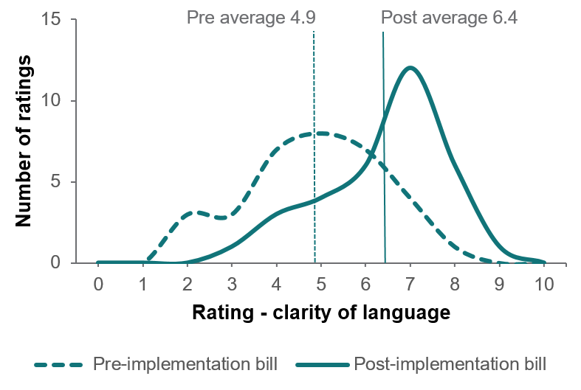

Figure 2. On clarity of language, post-implementation bills were rated higher on average than pre-implementation bills

Raters were asked ‘Based on the language used in this bill, how easy is it to understand the contents? Consider the tone of the language (conversational vs formal) and use of technical vs plain language.’

Raters generally found language on pre-implementation bills confusing, with technical jargon and formal tone. Raters highlighted that pre-implementation bills were denser and more cluttered, contained more text, and had more terminology that required more explanatory notes. Some noted that pre-implementation bill language was passable for English speakers, but inaccessible for those not fluent in English.

“The language is confusing, technical in parts and ambiguous […] in others, it is not framed for the consumer” – Expert rater, Retailer H pre-implementation bill

“It felt cluttered and too much information to absorb, it seemed more confusing especially [for] people who have English as a second language, or already feel overwhelmed due to financial stress.” – Expert rater, Retailer M pre-implementation bill

On the other hand, language on post-implementation bills was generally described as clearer, with more accessible, colloquial language. Raters noted the use of questions as headings made post-implementation bills more relatable and easier to understand (‘need help?’ and ‘how much do I owe?’).

“It seemed cleaner, the concessions message was easier to read and follow, more white space and structure. The Need support section was simple and easy to read” – Expert rater, Retailer M post-implementation bill

In some instances, raters highlighted room for improvement to make post-implementation bills even clearer and easier for consumers to comprehend.

“There is greater use of 'simple/normal' descriptive language, with text generally clearer and more logically presented – though there is still confusing technical terminology and excessive text where simple statements or graphics could be used …” – Expert rater, Retailer E post-implementation bill

This trend was supported in consumer interviews, during which participants were asked to review sample bills and find information to understand how bills were calculated. Participants found pre-implementation bills with complex, technical terms to be less accessible, and that it reflected a lack of transparency about details in the bill, such as the origin of some costs. They valued explanations and definitions of key terms, which were provided more consistently in post- than pre-implementation bills.

“Shoulder period. I hadn’t heard of that term, but the text beneath made it clear what it meant.” – Interview participant, Retailer F post-implementation bill

“They have the definition of each of these down the bottom here explaining what’s peak, off peak and shoulder. I think that’s useful. It shouldn’t be a mystery what these are […]” – Interview participant, Retailer G, post-implementation bill

“Peak and off peak – I’m trying to see if they tell you what that means, but I don’t think they do.” – Expert rater, Retailer F pre-implementation bill

* + 1. **Clarity of language for consumers with low English literacy**

As part of our research, we also looked at the impact of Guideline implementation on clarity of bills for people who are not fluent in English. Our research showed on average there was some improvement in clarity for consumers with low English literacy from pre- to post-implementation bills, however some post-implementation bills still rated relatively low on this measure. This variation in ratings suggests there is room for improvement in this regard.

In the expert review task, post-implementation bills were rated slightly higher on average compared to pre-implementation bills regarding clarity of expression for consumers with low English literacy (Figure 3). This was the smallest average increase across all measures.

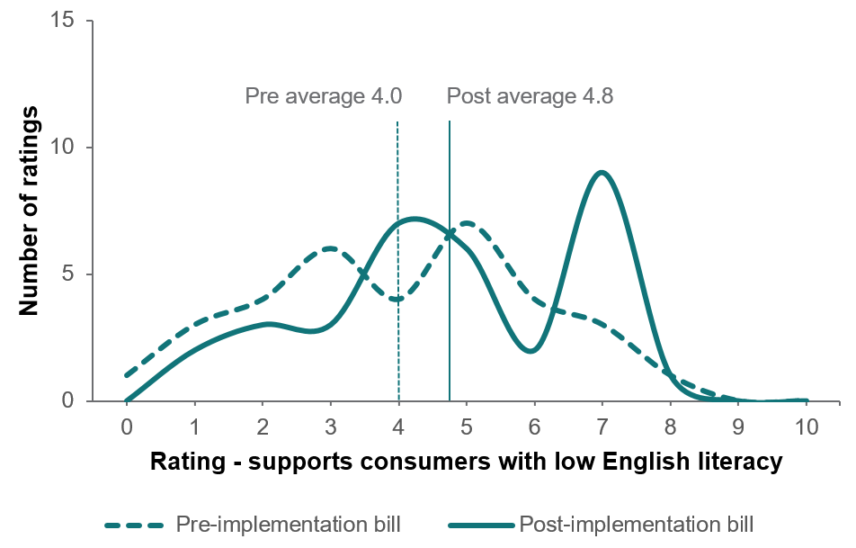

Figure 3. On clarity for consumers with low English literacy, post-implementation bills were rated slightly higher on average than pre-implementation bills

Raters were asked ‘How well does this bill support a customer who does not speak much English, and has questions about their bill? Consider: is it obvious how much to pay, when and how? Is it clear how to find interpreter or translation services?’

The general principle of simplifying language and using a colloquial rather than formal tone made post-implementation bills more accessible for culturally and linguistically diverse consumers. As one rater noted:

“Quite formal language makes bill more challenging than it needs to be. Bills are very difficult for CALD consumers generally and crucial information is lost by being towards the end of the bill.” – Expert rater, Retailer M pre-implementation bill

“Clearer English expression makes this one a little less challenging. Necessary info is early which is good. Bills are challenging for CALD consumers.” – Expert rater, Retailer M post-implementation bill

Importantly, raters noted that most post-implementation bills listed interpreter services after the first page (whereas most pre-implementation bills had these details listed on the first page). This is an artefact of the Guideline’s tiering requirements, whereby interpreter services fall under Tier 2 and cannot appear on the first page of the bill.

Many raters suggested that including interpreter services on the first page of bills would support people with low English literacy. For example, one rater commented:

“This bill is completely inaccessible for someone with lower level of English proficiency, even for the simplest information to do with payment.” – Expert rater, Retailer E pre-implementation bill

“This bill is almost completely inaccessible for someone with lower levels of English proficiency – while payment information is more prominent, information on assistance and interpreter services is hidden on the back page.” – Expert rater, Retailer E post-implementation bill

#### 1.2 Design and tiering principles prioritise most important information

The Guideline requires retailers to priortise consumer comprehension using colour, headings and shading, accessible font and size, white space, and approriate infographics. It also sets out requirements regarding presentation of billing information in three categories:

* Tier 1 (most prominent information, and must be displayed on the first page of bills),
* Tier 2 (next most prominent, and must be displayed after Tier 1 information and not on the first page of bills) and
* Additional information (must be displayed after Tier 1 and 2 information).

**1.2.1 Design**

Our research found that most post-implementation bills generally applied design principles in ways that better supported consumer comprehension than pre-implementation bills. However, we also found opportunities for improvement in the way they were applied.

In the expert review activity, post-implementation bills were rated higher on average on the ‘visual design’ measure than pre-implementation bills (Figure 4).

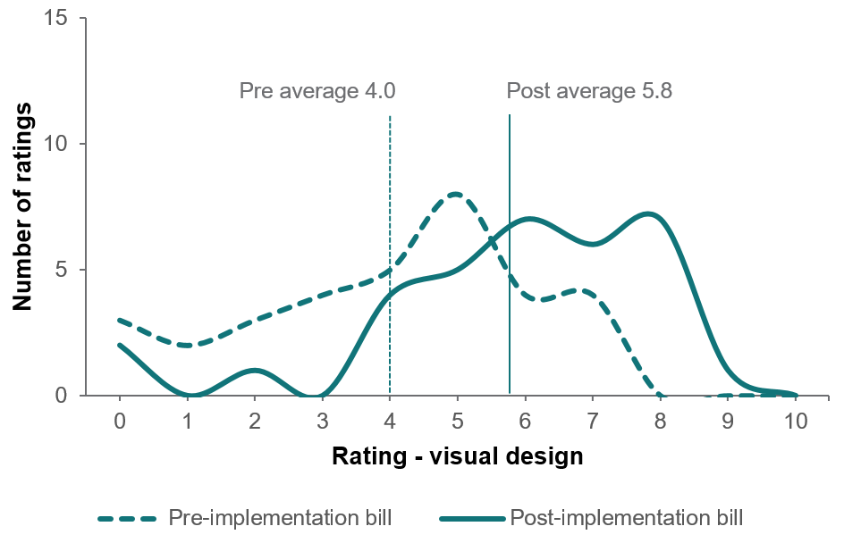

Figure 4. On how well visual designs supports comprehension, post-implementation bills were rated higher on average than pre-implementation bills

Raters were asked ‘Looking at the way this bill is laid out, how easy is it to understand the content? Consider the use of headings, colour, shading and white space. Also consider how information is grouped or positioned, and how the bill uses font size, infographics and charts or tables.’

In general, pre-implementation bills were considered messy and cluttered, and for the most part post-implementation bills (especially the first page) were described as being visually clearer and neater. Raters and consumers alike noted that some pre-implementation bills contained distracting information such as promotional imagery, or content that looked like advertisements.

“Aspects of this bill are relatively easy to understand and consistently presented - but others are confused, poorly positioned, inconsistently shaded, emphasised etc.” – Expert rater, Retailer L pre-implementation bill

“Messy, cluttered, text heavy, lots of mixed information, multiple fonts, italics, with no real pattern” – Expert rater, Retailer M pre-implementation bill

“[Pre-implementation bill] looks cluttered and dense. Challenging to work through the detail.” – Expert rater, Retailer G pre-implementation bill

Similarly, consumer interviews found participants appreciated that post-implementation bills had eliminated content resembling advertisements, which was either distracting or considered wasted space.

Pre-implementation heat map shows that participants gloss over advertising material, and focus on amount payable and other key information. Post-implementation heat map shows that participants focussed on the amount payable, and other key information.


Figure 5. Example of how post-implementation bills have eliminated content that resembles advertisements

Regarding the bills shown in Figure 5 above (modelled off Retailer H’s bills), an interview participant said:

“It looks like an ad, I’m not going to bother looking at it.” – Interview participant, general population

Raters appreciated use of boxes and shading to distinguish separate information in post-implementation bills. However, raters noted that some post-implementation bills, even those that generally rated highly for good use of design principles, used small font which made some information harder to read.

“I found [the] information a lot easier to understand. It’s quite clear … the layout is good, and the [lines] being more spaced out and the different colours. I love the spacing here.” – Interview participant, culturally and linguistically diverse, Retailer M post-implementation bill.

“Clean, calls out key areas in simple language, graphs clear, much more white space – except for [a section in the bill] which is small font, too much text and cluttered.” – Expert rater, Retailer M post-implementation bill

“Information is clearly set out, with my focus on page 1. Good amount of white space [but] font should be larger and with better contrast …” – Expert rater, Retailer N post-implementation bill

“The white space is much better & adds to clarity. [Colour] highlights are effective.” – Expert rater, Retailer G post-implementation bill

As the quotes above show, effective use of white space made post-implementation bills easier to navigate by breaking up information and decluttering bills. Interestingly consumer interviews found that white space needed to be used judiciously to enhance, rather than detract from, improved navigation. Bills where plain white space took up more than a third of the page were not as positively received as those where white space was used strategically to break up information.

Some participants expressed that too much white space felt like wasted space, and they would prefer to see other information displayed there, or existing information to be enlarged or rearranged. Alternatively, retailers should consider shortening their bills altogether, reducing the total number of pages.

“I prefer the other one [Retailer F’s post-implementation bill]. This one has a lot of white space […].” – Interview participant, experiencing financial difficulty, Retailer F pre-implementation bill

“There’s a lot of blank space, they might as well use it.” – Interview participant, general population, Retailer J post-implementation bill

**1.2.2 Tiering**

Consumer interviews revealed that some people only ever look at the first page of their bill, highlighting the importance of making key information prominent on page one of bills using design principles and logical layout. The gaze plot in Figure 6 below shows that Guideline implementation led to increase in the speed of locating key information such as amount and due date. In the pre-implementation bill (left), the participant did not locate the price in the first five seconds, whereas it was one of the first things noticed in the post-implementation bill (right).

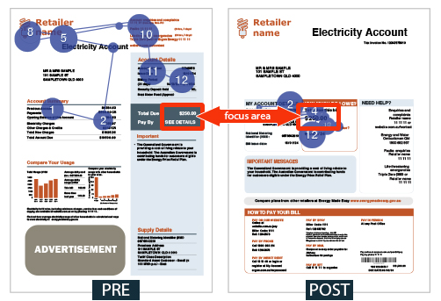

Figure 6. Gaze plots of the first page of Retailer D’s bills shows that design principles effectively drew participant attention

Interviews also found that effective use of colour drew participants’ attention to key information, thereby supporting overall comprehension of the bill. Effective use of colour to highlight key information (Figure 7) and tactical use of large and bold text (Figure 8) made key sections of bills stand out.

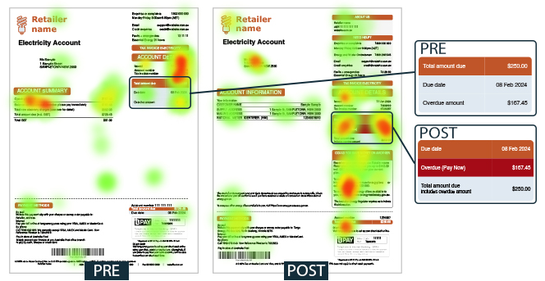

Figure 7. Eye tracking heat maps show judicious use of colour effectively drew participants’ attention to essential information

Regarding Retailer F’s post-implementation bill (Figure 7, right), a participant said:

“I like how the due date, amount due and overdue are in different colours. The overdue in red is a warning so it draws your attention to it.” – Interview participant, experiencing financial difficulty

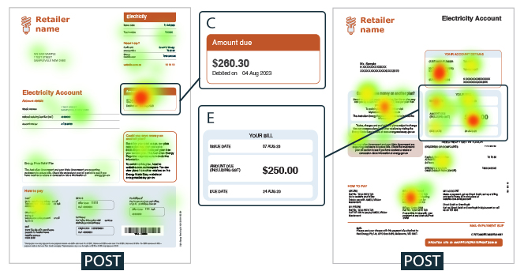

Figure 8. Eye tracking heat maps of post-implementation bills from Retailers C and E show how the use of bolding and large text caught respondents’ attention

Regarding Retailer N’s post-implementation bill (Figure 8, left), a participant said:

“The colour and the box for the amount due [make it easy to find] as you go straight there.” – Interview participant, experiencing financial difficulty

Regarding Retailer E’s post bill (Figure 9, right), another participant said:

“[The amount due] is great. It’s the largest possible font of all three bills I’ve seen.” – Interview participant, general population

Findings from consumer interviews showed that culturally and linguistically diverse participants did not interact with bills in qualitatively different ways compared to general population participants. Specifically, they did not take particular notice of interpreter services.[6]

**1.2.3 Making decisions using bills**

In the expert review task, post-implementation bills were rated higher on average than pre-implementation bills on how easy it is for consumers to make decisions using the bill (Figure 9).

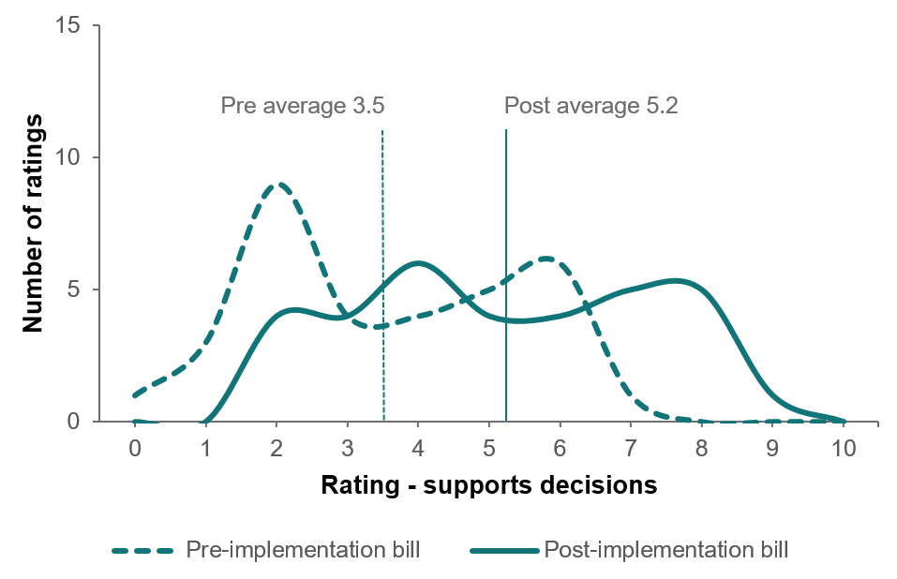

Figure 9. On how easy it is for consumers to make decisions using bills, post-implementation bills were rated higher on average than pre-implementation bills

Raters were asked ‘Looking at this bill, how easy is it for a customer to make decisions about their energy? This could be payment decisions, decisions about the plan they are on, or other decisions about their energy use’

Raters appreciated when payment assistance information was provided earlier, and noticed when it was not provided upfront. Many raters noted the absence in post-implementation bills of household comparison data, which is no longer mandated by the Guideline.

“Payment options and assistance nearer the front of the bill and in clear format.” – Expert rater, Retailer M post-implementation bill

“Information about usage provided in clearer, easier to digest format in terms of table re use. I like having comparison to other local households of x size and that is missing in new bill. Good info re saving on another plan, especially providing an estimate of how much savings on an alternate plan – helps consumer understand benefit of putting time into switching plans. Also appreciate the note re rebate and concessions […] info about hardship supports seem a bit buried to me.” – Expert rater, Retailer E post-implementation bill

Clarity of energy usage tables and graphs was found to be an important factor in supporting consumer comprehension and decision making.

“Payment options are hidden at the end of the bill. Energy use table is very cluttered.” – Expert rater, Retailer G post-implementation bill

“While this bill helps support a 'better offer' decision, its presentation of usage information is confusing and does not make it clear what (if anything) can be done.” – Expert rater, Retailer H post-implementation bill

Consumer interviews found that, on balance, post-implementation bills successfully integrated graphical and tabular presentations of energy usage to cater for different audiences. However, retailers varied in how effectively they visualised usage data to support consumer understanding.

Participants were asked to review bills and answer the following question: ‘Based off the information in this energy bill, how would you find information about your energy usage?’. Where most pre-implementation bills only presented this information in tabular format, most post-implementation bills used graphs as well. Findings showed that some participants preferred to rely on graphs while others preferred graphs when trying to find and understand energy usage information. Bills that presented data in both table and chart format catered to different consumers’ preferences.

Interviews also found that incorporating colour into charts drew participants’ attention and made them easier to understand. Figure 10 below shows that participants engaged more readily with energy usage charts that used colour (Retailer M post-implementation bill) than black and white charts (Retailer M pre-implementation bill).

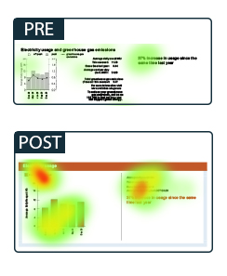

Figure 10. Participants found it easier to focus their attention on important information.

Qualitative discussion and heat map data from interviews also found that while some participants valued the inclusion of additional visual information, others were overwhelmed when bills contained multiple charts. Figure 11 below shows participants utilising all sections of the page to understand their energy usage. Some participants found this helpful, while others felt that monthly usage charts were sufficient and either glazed over other charts or spent a lot of time trying to decipher the different meaning of each chart.

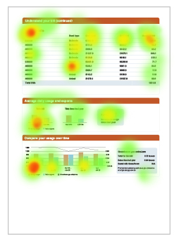

Figure 11. Multiple charts within a single bill can be helpful for some consumers but confusing for others

Interviews supported findings from the expert review task suggesting consumers valued household comparisons.

“The comparison is pretty useful. I always like when they have the comparison in there because I like to see how I’m doing compared to other customers with the same household [composition] because it’s good to see if you’re under or over that. If you’re over, maybe you’re not using your electricity as well as others.” – Interview participant, general population, Retailer G pre-implementation bill

**1.2.4 Understanding how bills are calculated**

Findings from consumer interviews showed that post-implementation bills generally supported participants to understand how their bills are calculated better than pre-implementation bills. Participants were asked ‘Based off the information in this energy bill, how would you find information about how your bill was calculated?’.

Interview findings highlighted the importance of brevity when explaining charges. It can be challenging to strike a balance between providing sufficient details while keeping bills succinct, and this was the case even in some post-implementation bills. Figure 12 below illustrates an instance where line items in the ‘understand your bill’ section appeared superfluous and led to confusion, as seen in the increased fixation in the heat map. Participants were confused by the multiple rows each showing ‘general usage’. They queried the distinction between those rows, and spent time fixating on the contents of the table. Similarly, the difference between ‘daily supply – controlled’ and ‘daily supply’ was unclear, prompting a suggestion to consolidate the rows.

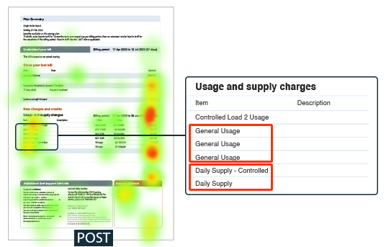

Figure 12. Interview findings highlighted the importance of simplifying table structure and content

Similarly, the ‘meter readings’ section in Figure 13 below caused confusion among participants.

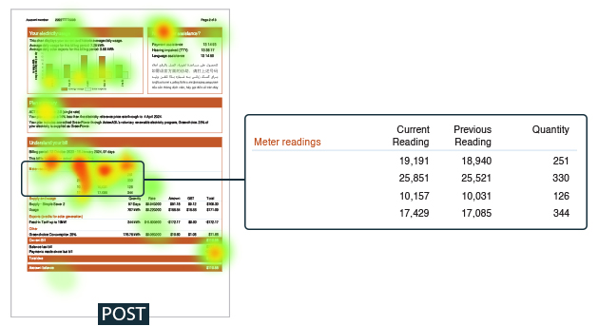

Figure 13. Interview findings highlighted the importance of including the right clarifying information for tables to be meaningful and interpretable

Lack of row labels made it difficult for participants to interpret the difference between each row. The heat map shows participants spent a generous amount of time fixating on this section of the bill, trying to decipher its meaning. The most common suggestion from participants was to remove this information altogether.

“The meter readings are confusing … I just don’t understand and that annoys me because I’d have to call them for them to explain it to me.” – Interview participant, general population, Retailer L, post-implementation bill.

Interview participants expressed a preference for short bills, no longer than two pages, and suggested bill calculation information should be no longer than one page.

“The layout of this bill is understandable and it’s only two pages. You don’t need all this other stuff.” – Interview participant, digitally excluded, Retailer H, post-implementation bill.

Effective use of design principles was found to be critical in clearly communicating bill calculation information. A common theme when participants reviewed pre-implementation bills was that use of black and white was disengaging to the reader. As heat maps in Figure 14 below show, participants were far less engaged with black and white content in the pre-implementation bill. In contrast, the judicious use of colour for headings and shading for subtitles engaged the reader and helped them confidently navigate the information on the page.

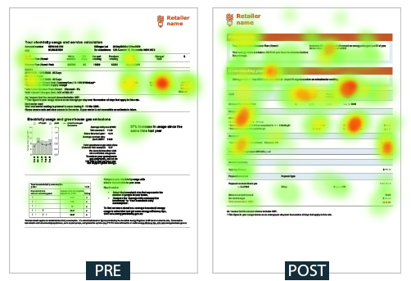

Figure 14. Judicious use of colour helped participants confidently navigate bill information

#### 1.3 Spotlight: making bills easy to pay

One of the key purposes of energy bills as set out in the National Energy Retail Rules is to provide consumers with billing information that enables them to easily understand payment amounts, dates and methods. Unsurprisingly, pre-implementation bills generally did a good job of providing this information clearly to consumers, but Guideline implementation still led to an average improvement in this regard.

In the expert review task, post-implementation bills were rated higher on average than pre-implementation bills on how easy it was to find out how to pay the amount owing (Figure 15). This metric had the smallest change in average ratings from pre- to post-implementation bills compared to all other metrics, and had the highest average rating for pre-implementation bills. This may be because before the current Better Bills Guideline was introduced, one of the main purposes of bills has been to provide payment information.

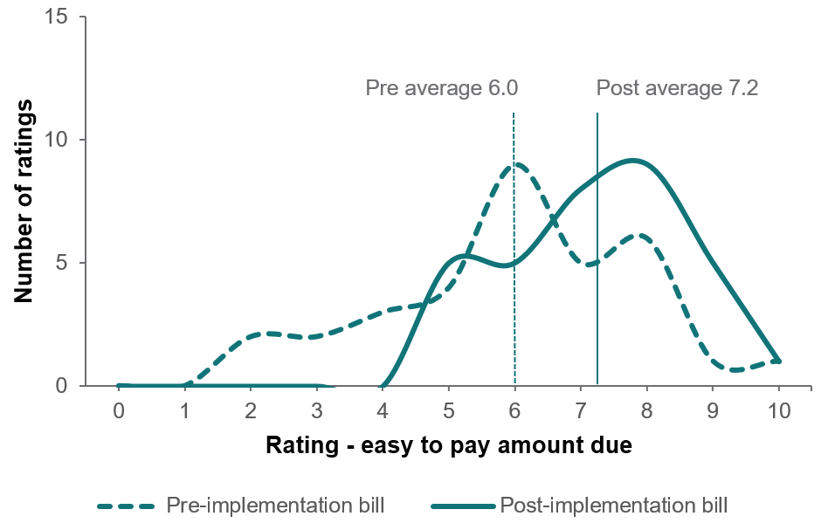

Figure 15. On how easy it was to find key payment information, post-implementation bills were rated higher on average than pre-implementation bills

Raters were asked ‘Looking at this bill, how easy is it for a customer to find out how they can pay the amount owing? Consider the information they would need to pay the bill, including the total amount due, date due, and payment methods.’

Key payment information (amount due, date due and payment methods) was available on all pre- and post-implementation bills. However, with effective use of design principles and the application of tiering requirements, these details were generally easier to find on post-implementation bills.

“Payment method information is on the front page and relatively prominent though poorly presented, the bill is hidden with other less important information and the due date is not apparent at all.” – Expert rater, Retailer E pre-implementation bill

“Information is on the second page, and although presented simply in layout, is presented with confusing language.” – Expert rater, Retailer H pre-implementation bill

“The amount due is the most prominent feature, presented alongside the due date. Payment methods are reasonably prominent on the front page and more clearly presented […]” – Expert rater, Retailer E post-implementation bill

“Information is prominent, clear, simply presented in language and layout and with infographics – this should be the required approach.” – Expert rater, Retailer H post-implementation bill

Consumer interviews showed that consumers consistently expect the amount due and date due to be featured prominently on the right hand side of the first page of bills. Some also indicated that post-implementation bills made payment information clearer.

“The payment and due date is clearer [on the post-implementation bill]. It’s highlighted and it’s a colour and it’s a bigger font size.” – Interview participant, general population, Retailer M post-implementation bill

“The first thing I looked at was the amount […] due and then I would put that straight in my diary.” – Interview participant, digitally excluded, Retailer E post-implementation bill

Interestingly, some participants noted that they would prefer usage information to be included on the first page of bills, instead of payment methods, as they usually use the same method each time and do not need to revisit it frequently.

“I would like it if the cost breakdown was on the front page so I don’t have to scroll down … if you’ve got direct debit you don’t need that [payment methods section’ on the front page].” – Interview participant, general population, Retailer G, post-implementation bill

“I skip the payment methods because I pay quarterly automatically from my credit card by direct debit, so I’d skip that.” – Interview participant, culturally and linguistically diverse, Retailer G, post-implementation bill

### Part 2: Confidence to engage in the energy market

* Post-implementation bills support consumers to make informed decisions about their energy plans, and to engage in the energy market.
* A bigger percentage of EME users compared plans after seeing it mentioned on their bill (23%) than before Guideline implementation (7%).
* Customers found it easier to determine the competitiveness of their plan compared to others on the market when looking at the post-implementation bill. Customers could also find their plan details and NMI more easily.
* Guideline implementation varied across retailers and there is some opportunity to improve bills design further to better support customers, particularly those who would benefit from financial assistance.

Figure 16 provides an overview of the overall difference in pre- and post-implementation bills based on average ratings from the expert review task on measures of consumer confidence.

On a scale of 0 to 10 pre implementation rating compared to post implementation rating. 
Easy to find NMI increased 4.3 from 3.3 to 7.7
Easy to determine plan competitiveness increased 3.0 from 1.9 to 4.9
Easy to find plan details increased 2.5 from 3.0 to 5.3
Supports consumers conserned about cost increased 1.6 from 2.6 to 4.2

Figure 16. On average, post-implementation bills were rated higher than pre-implementation bills on factors that support consumer confidence[7]

One of the most novel requirements of the Guideline compared to the previous requirements is for retailers to include a ‘better offer’ message prominently on the first page of bills approximately once a quarter. In combination with information about the AER’s EME comparison site, the better offer message is designed to encourage consumers to compare and switch energy plans to save money.

#### 2.1 Introduction of the better offer message is empowering consumers to engage in the market

Our primary research question for the pop up survey activity was understanding whether Guideline implementation, and specifically the inclusion of a better offer message, led more visitors to EME. Data from our popup survey on EME (Figure 17) shows that in June 2023, before most retailers had implemented the Guideline, less than 9% of respondents reported visiting EME because it was mentioned on their bill. By November 2023, two months after most retailers implemented the Guideline, this increased to almost 23%.[8] The proportion remained high in the subsequent months of data collection (16–21%). Seeing EME mentioned on energy bills went from the second lowest mentioned reason in June to the second highest by October and remained steadily at number two thereafter. The top reason for visiting EME was ‘I saw it on an internet search (e.g. Google)’.

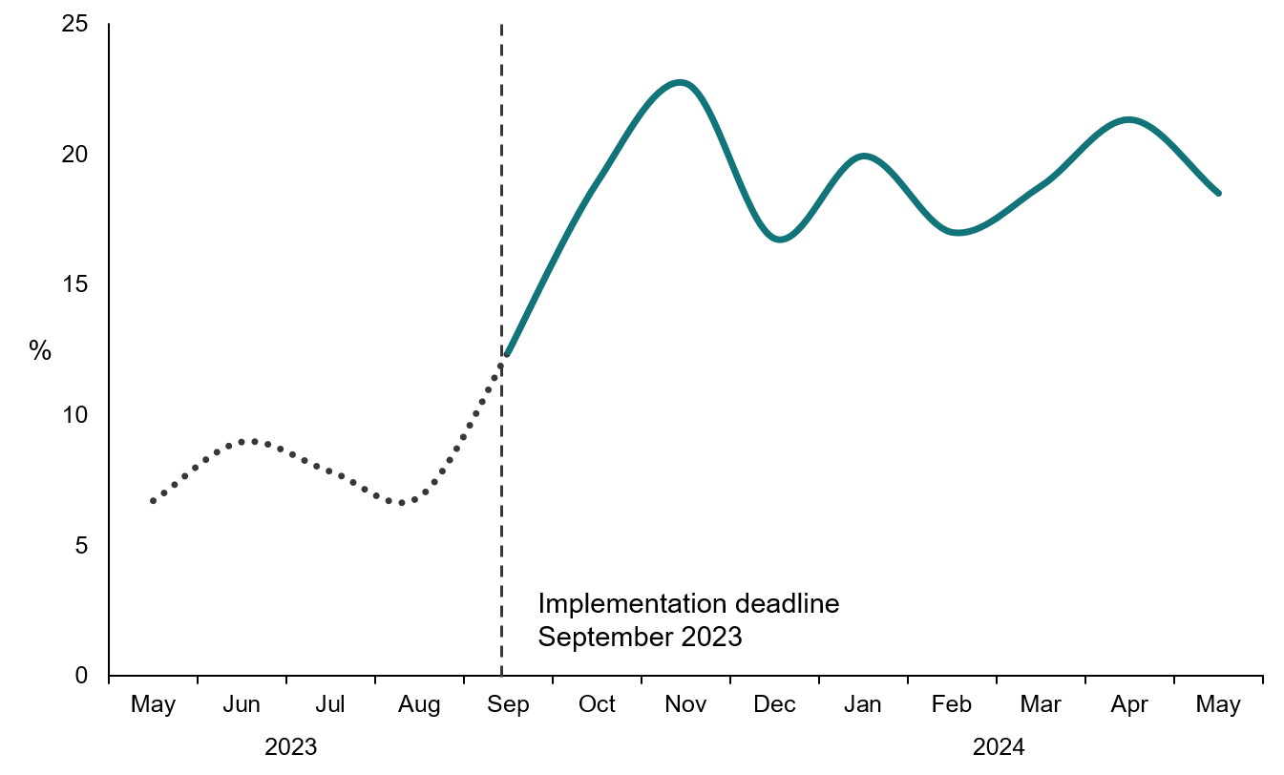

Figure 17. Proportion of respondents brought to EME by their energy bill more than tripled over the course of the implementation period[9]

Participants were asked ‘What brought you to Energy Made Easy today? Select all that apply’. This chart shows the proportion of people who selected ‘Mentioned on my electricity bill or gas bill’

Across the whole monitoring period, only 7% of visitors were brought to EME by their bill when their current retailer had not implemented the Guideline, compared to 19% when their retailer had implemented it.

Some retailers chose to roll out bills with the better offer message prior to the September 2023 deadline. Figure 18 shows the proportion of customers who stated their bill was the reason they visited EME, for three separate retailers. The chart shows a general increase in the proportion of respondents saying their bill brought them to EME following implementation of the Guideline. Variation in rates of increase across retailers could be due to factors such as the number of plans offered by the retailer and the proportion of customers on monthly or quarterly billing (which would determine how many customers saw a positive better offer message on their bill over the research period), or differences in the visual design and presentation of the better offer message on customers’ bills (which would influence the effectiveness of the positive better offer message that customers saw).

Line graph shows proportion of survey respondents who selected 'saw it on my bill' from three retailers. Starting below 10% in June and increasingly rapidly to 15-35% by November and remaining between 9-28% until May.
Retailers implementated changes at different times with Retailer 1 implementing in June and Retailer 2 and 3 implemented in September.

Figure 18. Proportion of survey respondents who selected ‘saw it on my bill’ as the reason they visited EME, by retailer (guideline implementation dates in brackets)

Participants were asked ‘What brought you to Energy Made Easy today? Select all that apply’. This chart shows the proportion of people who selected ‘Mentioned on my electricity bill or gas bill’.

Some consumers might regularly compare plans or ask retailers for their best available offer, while others may be unaware of these options, or be unable or unwilling to take these actions. As Figure 19 shows, we found that the better offer message was an effective prompt particularly for those consumers who would not typically engage in the energy market regularly or habitually. 63% of people who were brought to EME by their bill had never switched retailers with the intention of finding better deal before[10], compared to approximately 50% before Guideline implementation.

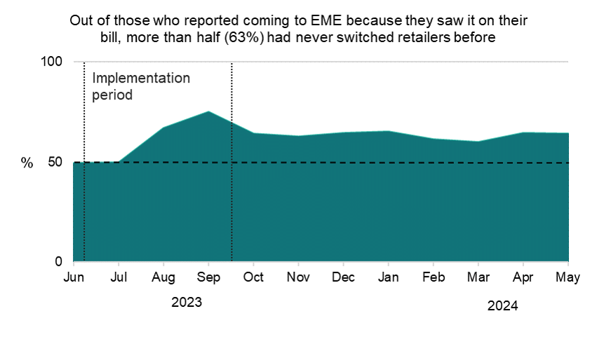

Figure 19. Out of those who reported coming to EME because they saw it on their bill, more than half (63%) had never switched retailers before

In the expert review activity, we found that on average post-implementation bills were rated substantially higher than pre-implementation bills on understanding how their plan compared to others available (Figure 20). This measure was designed as a proxy to understand how well the better offer message and plan summary help consumers actively engage in the energy market. Inclusion of the better offer message was one of the single biggest improvements in bills as rated by the expert panel.

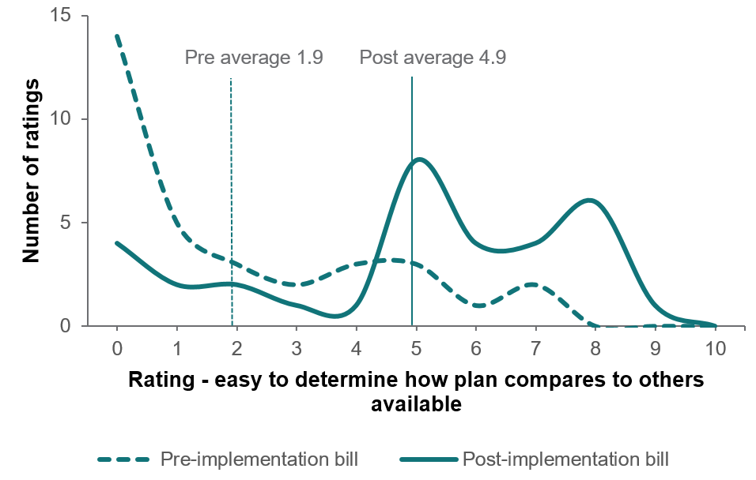

Figure 20. On average, post-implementation bills were rated higher than pre-implementation bills on how easy it is for consumers to understand how their plan compares to others available

Raters were asked ‘Looking at this bill, how easy is it for a customer to understand how their plan compares to others available?’

Raters noted the prominence of the better offer message in post-implementation bills.

“I could not find it. The layout and clutter is so disengaging that it’s not simple to find.” – Expert rater, Retailer M pre-implementation bill

“It [is] on the first page in clean, clear box – could you save money on another plan – easy to understand call to action. Uses simple language, reasonable font size.” – Expert rater, Retailer M post-implementation bill

Some raters suggested including the customer’s current plan name near the better offer message to make it easier to compare and switch plans. Others noted the importance of making the better offer message salient by simplifying surrounding content.

“While a prominent presentation of scope to save on another plan is provided, the existing plan is not provided alongside to help aid further examination” – Expert rater, Retailer M post-implementation bill

“Personalised information about what plan could save the customer more money is helpful. Placement of this information on a chaotic page with multiple groupings may make it harder for the reader to hone in on this information. Information about energy made easy is easier to spot […]” – Expert rater, Retailer G post-implementation bill

Consumer interviews found that the better offer message caught participants’ attention and prompted them to consider switching to a better plan. Participants were given the following task: ‘Imagine you’ve just received this energy bill and you’re not happy with the cost of the bill. How would you use the bill to decide how to save money on your bill moving forward?’.

Interview findings showed that participants who noticed the better offer message on post-implementation bills appreciated its inclusion and expressed an intention to act on it. The heat map in Figure 21 below shows participants fixated on the better offer message. The gaze order plot shows how efficiently the participant located the better offer message on this bill, as it was the first thing they looked at.

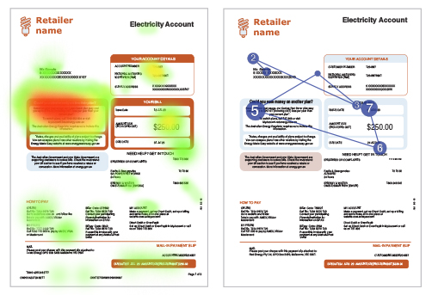

Figure 21. Eye tracking data across different retailer bills shows better offer messages were easy to locate and held participants’ attention

Without a better offer message, participants were less likely to suggest switching plans to reduce costs. Instead, they were more likely to describe actions such as changing their energy usage habits. The heat maps in Figure 22 below show participants focussed on information that explains their usage when answering this question with pre-implementation bills.

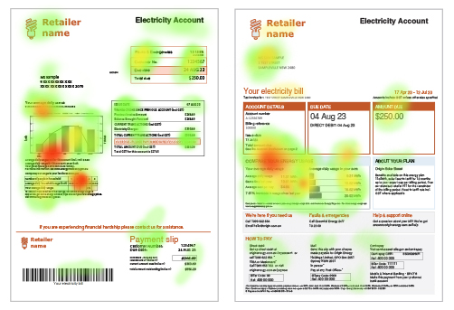

Figure 22. In the absence of a better offer message, participants turned to usage data to find ways to cut energy costs

Participants responded positively to better offer messages that applied effective design principles.

“‘Could you save money on another plan’ – the title jumped out straight away … the positioning [of this section] on the page is the most prominent … it’s next to the total amount payable and heading makes it easy to spot.” – Interview participant, general population, Retailer H post-implementation bill

“I was drawn to this text here [the better offer message], probably because there was writing in there with a clear amount shown.” – Interview participant, experiencing financial difficulty, Retailer L post-implementation bill

Another important way that bills support consumers to make informed decisions about their energy plans is by making current plan details clear. The Guideline requires retailers to prepare and include a plan summary, in order to help consumers easily understand and compare the key features of their plan. This is a key piece of information to enable consumers to engage more confidently in the energy market, especially for consumers who may find it less easy to access and use EME to compare plans.

Our research found that Guideline implementation generally resulted in bills with clearer, more accessible information about plan details. While consumers do not generally look for or benefit from plan details on an everyday basis, this information becomes useful when they are considering switching plans.

In the expert review task, post-implementation bills rated substantially higher on average than pre-implementation bills on how easy it is to find plan details (Figure 23).

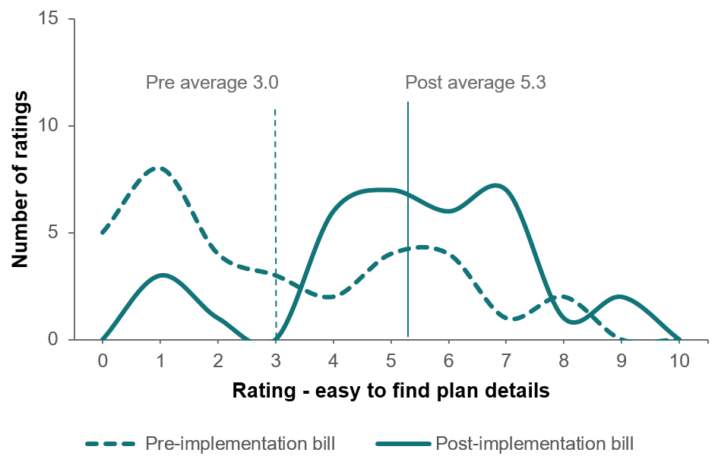

Figure 23. On how easy it is to find plan details, post-implementation bills were rather higher on average than pre-implementation bills

Raters were asked ‘On this bill, how easy is it for a customer to find out details of their plan? Plan details could include the name of the plan, any discounts it includes, and when the discounts expire. They could also include timing for peak and off-peak tariffs, explanations about green energy, or other extras.’

Raters generally found it hard to identify plan details in pre-implementation bills, and in some cases, they could not find plan details at all, or could only find the plan name.

“Couldn’t find it – assume it’s ‘Simple Saver’, but not shared explicitly.” – Expert rater, Retailer L pre-implementation bill

“Information on the current plan exists on the first page but is presented randomly in a way that loses it next to other less practical information […] explanation of what 'single rate means' and its impact is absent – this makes it difficult to know what to do with the information that does exist.” – Expert rater, Retailer L pre-implementation bill

“There is no discernible identifier for the plan, and key information regarding charging structures and timings are complicated and inaccessible – how it is presented and described (use of terms such as peak/off-peak, etc.) is inaccessible. There is very little scope to understand this bill and what information is key, and how [I] can use it.” – Expert rater, Retailer E pre-implementation bill

Meanwhile, raters generally found plan details easier to locate in post-implementation bills. In some instances, use of clearer language and definitions of key terms helped make plan details more accessible.

“Easy to find, clearly identified and details provided.” – Expert rater, Retailer L post-implementation bill

“Included relevant info – for example, the timings associated with peak, off-peak etc. I could also see what plan I was on” – Expert rater, Retailer F post-implementation bill

However, raters noted room for improvement in making bill details even more accessible. Some retailers also have some way to go in making discounts and other benefits clearer.

“While improved, this bill does not resolve many of the key issues, with the plan identifier on the 3rd page (and unclear as to what the name is) key tariff information is presented more clearly, but still uses technical terms instead of description (i.e. use between x.pm and y.pm etc.).” Expert rater, Retailer E post-implementation bill

“The structure is better on this bill however when it lists out the peak, off peak, total shoulder – does anyone know what these things mean – it has the description down the bottom in much smaller font and italics.” – Expert rater, Retailer G post-implementation bill

One rater suggested requiring retailers to indicate to consumers what their current plan name is in or near the better offer message so consumers do not have to separately search for this information elsewhere in the bill.

When consumer interview participants were asked to take a general look at bills as they would if they received it at home, the majority did not notice plan summaries. Of participants who did notice plan summaries (as shown in Figure 24, for example), some found them informative while others found the content wordy and difficult to understand.

“This one is good … I like how it is here the summary of your plan.” – Interview participant, digitally excluded, Retailer H post-implementation bill

“I don’t understand the wording of all that [the plan summary]. It’s information I’m not familiar with … there’s just a lot going on here.” – Interview participant, experiencing financial difficulty, Retailer L post-implementation bill

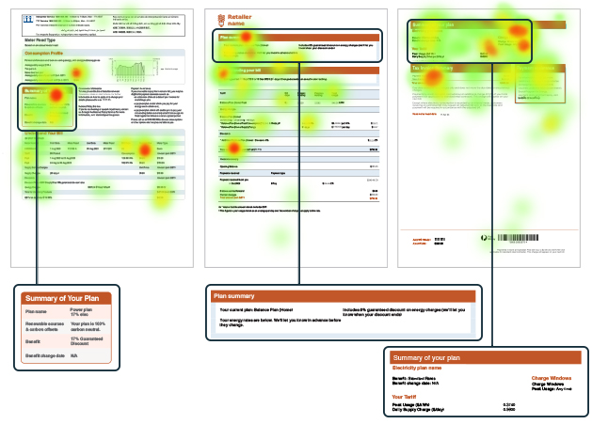

Figure 24. These heat maps highlight examples where participants noticed and fixated on plan summaries in post-implementation bills

**2.1.1 Supporting consumers concerned about high bill cost**

Findings from the expert review task showed that, on average, post-implementation bills were rated higher than pre-implementation bills on how well they support consumers concerned about high energy costs (Figure 25). However, post-implementation bills had room for further improvement in this regard.

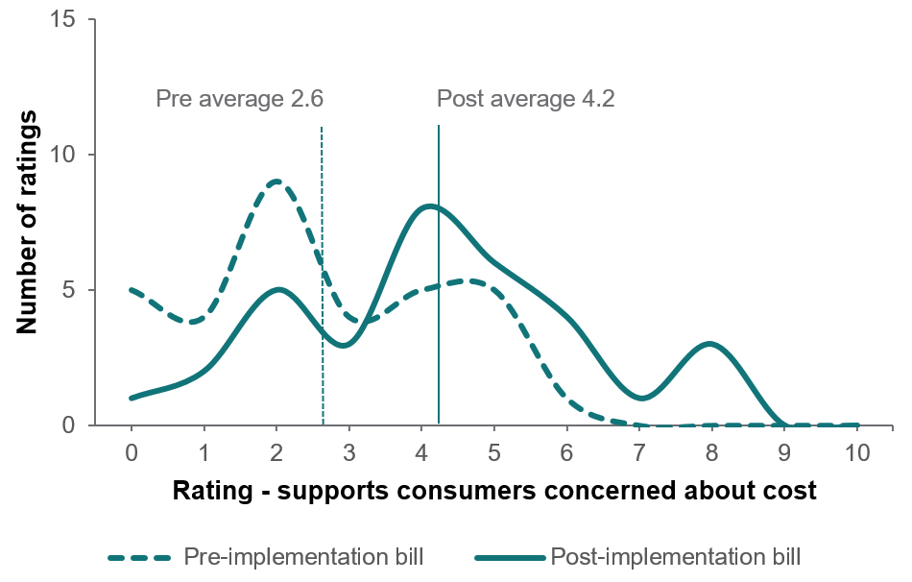

Figure 25. On how well they support consumers concerned about high energy costs, post-implementation bills were rated higher on average compared to pre-implementation bills

Raters were asked ‘How well does this bill support a customer who is worried about how high their bill is, and wants to know what they can do next?’

Some raters noted the presence of the better offer message on post-implementation bills as a way of supporting customers concerned about costs. Some also noted that pre-implementation bills often only referenced the EME site in a footnote that would be easily missed by many consumers.

Many pre-implementation bills were rated low for lack of any (meaningful) payment assistance information. Raters noted some post-implementation bills went some way to addressing this but could do more to support concerned consumers. In particular, raters valued bringing up payment assistance information to the first page (near the amount due or in the ‘Need help?’ section).

“It is not clear to me that someone struggling with their bill would have any useful information to access from this bill” – Expert rater, Retailer L pre-implementation bill

“Financial assistance message doesn't stand out. Ombudsman contact not included.” – Expert rater, Retailer E pre-implementation bill

“While there is some specific 'payment assistance' on the second page and a 'need assistance' on the front page which is prominent and positive – there is not further information anywhere else to explain what assistance is available and for who/why, which may help direct people correctly. This is a 'pass' for simplicity and accessibility but does not address questions of clarity and understanding.” – Expert rater, Retailer L post-implementation bill

“Information on assistance is clearer underneath the key $ information and is presented in a more plain language form with other contacts as well, though it’s not clear that the 'help' referred to is for payment assistance. The rebate assistance information is small and inaccessible and the direct payment assistance contact is presented separately to the other assistance contacts (alongside the interpreter information). This is very difficult to piece together and while an improvement on [the pre-implementation bill] still fails to provide meaningful accessibility.” – Expert rater, Retailer E post-implementation bill

“The Need Help section on page 1 needs to include financial hardship and other bill support measures” – Expert rater, Retailer N post-implementation bill

“Both [pre- and post-implementation] bills seem to list help in this area in small print towards the back of the bill – and it is very high-level and generic. Not good enough.” – Expert rater, Retailer N bills

One rater noted the particular importance of making clear what payment assistance options are available for consumers with low English literacy.

“[There is] very little knowledge within CALD communities about payment assistance measures, and reluctance to seek help outside of relatives/friends.” – Expert rater, general comment

**2.1.2 Finding National Metering Identifier numbers on bills**

National Metering Identifier numbers (NMI) are an example of information consumers may not need regularly but should be able to easily find on their bills when they do need it – for example, when comparing plans on EME. Our expert review findings suggested that Guideline implementation was very effective in supporting consumers to easily find their NMI (Figure 26). On this measure we saw the largest increase in average ratings between pre-implementation and post-implementation bills compared to all other measures.

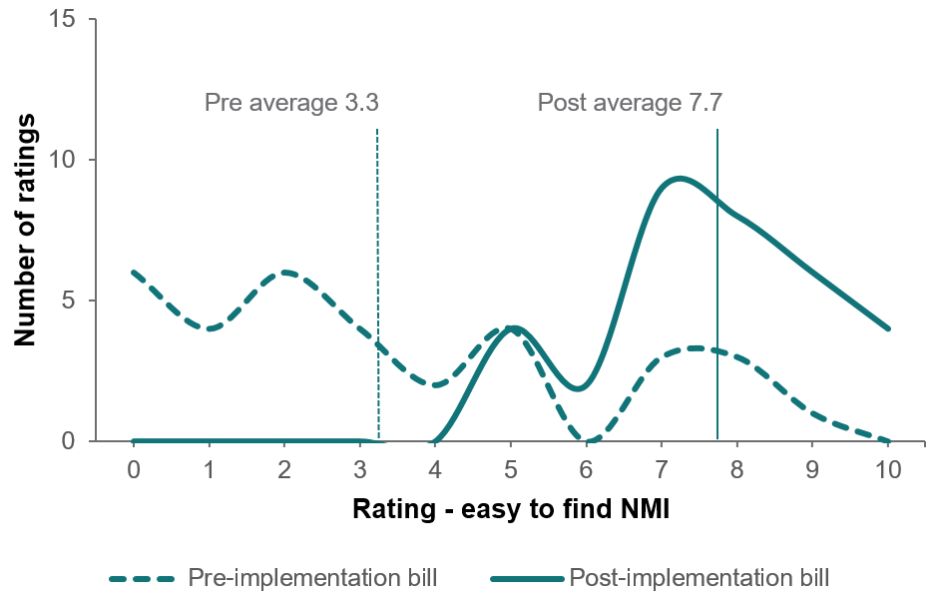

Figure 26. On how easy it was to find the NMI, post-implementation bills were rated substantially higher on average than pre-implementation bills

Raters were asked ‘On this bill, how easy is it for a customer to find their National Metering Identifier number?’

Many raters struggled to find the NMI at all on pre-implementation bills. Where they did find it, they often noted that it was only described as ‘NMI’ and that the full term was not spelled out. In some instances, they were able to find the NMI but it was on last page of the bill. On post-implementation bills, the NMI was consistently easier to find, often on the first page and almost always spelled out in full.

“It is tucked away with an acronym instead of spelling out the word.” – Expert rater, Retailer M pre-implementation bill

“Number is visible at the very top of the first page, in a bold easy to read font.” – Expert rater, Retailer G post-implementation bill

“Good that full wording used as well as acronym, early on bill” – Expert rater, Retailer G post-implementation bill

## Discussion and conclusion

### The Better Bills Guideline supports consumer comprehension, confidence and engagement in the energy market

Our research shows that the Better Bills Guideline has been effective in simplifying and clarifying bills to support consumer comprehension. It has also led to increased consumer engagement in the energy market. A bigger proportion of people compared plans on EME after seeing it mentioned on their bill (23%) compared to before the Guideline was implemented (7%). More than 60% of people visiting EME after seeing it mentioned on their bill had not previously switched retailers, showing that the Guideline is effective in supporting consumers who may not have otherwise compared plans on EME.

Previous research identified that complexity in bills can be a major barrier to consumers engaging with bills and understanding their content (BETA, 2021a). Simplifying bill language and layout can make bills less intimidating to navigate. Guideline implementation has made it easier for consumers to engage with bill content, with post-implementation bills rated higher on average on clearer visual design, simpler language and making it easy to know how much, when and how to pay bills.

Our research suggests that following retailer implementation of the Guideline, consumers are able to more quickly and easily find important information on their bills. This includes information about paying bills, accessing essential services and understanding their current plan.

Highlighting this key information upfront makes it quicker and easier for consumers to understand and action bill content. In particular, the better offer message on the first page of post-implementation bills makes it quick and easy for consumers to understand how their plan compares to others available and to make more informed decisions about switching energy plans. It has led to more people comparing their plans on EME.

In some cases, a reduction of even a few seconds of time spent looking at bills represents a significant reduction in barriers to finding key information. Previous research suggests that on average, consumers spend just 20 seconds reading their bill, and they spend most of this time on the first page (Ofgem 2018). Our eye tracking data showed that consumers generally found information relevant to them more quickly on post-implementation bills than pre-implementation bills.

Another simple but important improvement is how much easier it is to find NMI numbers on post-implementation bills. While consumers may not need to know or find their NMI on a regular basis, it can make their energy plan comparison much quicker and easier when using EME. This improvement, particularly in conjunction with the introduction of the better offer message, can help many consumers follow through on their intentions to search for better plans.

### Considerations

In designing our research to evaluate the Guideline’s impact, we were mindful of some important considerations. Firstly, our research forms one part of the AER’s broader review of the Guideline’s costs and benefits for consumers. We focussed on research activities that would capture the behaviour of consumers in the real world, as they relate to Guideline implementation. Taken together our research activities help build a picture about the ways in which retailers’ bills affect consumers, using pre-implementation and post-implementation bills and data to draw comparisons. However, our methods are not designed to make causal or generalisable claims about the Guideline.

Secondly, there are some important assumptions underlying how well the Guideline achieves its stated aims. For example, the effectiveness of the Guideline depends on retailers interpreting and implementing it accurately and in line with its policy intent. It also assumes that bills are a key mechanism for consumers to make informed decisions about their energy usage, costs and retailer choices, when they could turn to alternative sources of information, such as websites, apps or family and friends. Nevertheless, bills remain an important way for retailers to communicate timely information relevant to their customers’ circumstances, and regulation of bills remains an effective means of protecting consumer rights in the energy market.

Finally, we collected data a few months before and after retailers implemented the Guideline. While this provided us with sufficient and robust pre–post data for our research methods, it only captures the early impacts of the Guideline rollout.

### Future research

We speculate that our findings somewhat underestimate the impact of the Guideline regarding confidence to switch to better plans. Through our EME pop up survey, we only estimated the impact of the better offer message on whether consumers were prompted to explore plans available with retailers other than their own. Findings from consumer interviews and the expert review activity suggest that Guideline implementation likely prompted many customers to switch to better plans within their own retailers. Future research could investigate the impact of the Guideline on within-retailer switching rates.

We anticipate that as retailers continue to issue bills consistently using the requirements stipulated in the Guideline, consumers will become more used to the presentation of bills in this format over time (and across retailers, if they switch). We expect that the positive benefits of Guideline implementation, including being able to quickly and easily review, understand and find relevant information on bills, will increase over time. Our research has likely only captured the early stages of these impacts, but future research could be conducted to determine whether these effects increase or are sustained over time. Alternatively, research may find that some of the impacts are diluted as consumers become desensitised to certain aspects of the Guideline. For example, the better offer message could become more effective over time, as the impact of seeing the message multiple times across many bills has an ‘additive’ effect in prompting consumers to compare or switch plans. On the other hand, it could be the novelty of seeing the message on their bill that prompts consumers to take action, and the message may become less salient as they become accustomed to seeing it.

The Guideline was intentionally developed with an emphasis on principles rather than prescription when it comes to how bills are presented. This has naturally led to variation in how retailers have interpreted and applied the Guideline in designing their bill. We found that the effectiveness of the Guideline varied based on how retailers implemented it, and there is scope for bills to support consumers further. For example, retailers should consider ways to apply design principles to make bills even easier to understand and make it easier for consumers to use their bills to compare features of their current plan to others available on the market. They could also simplify bill content further to make it easier to navigate for people with low English literacy and make it easier for consumers to find information about accessing financial assistance. Some expert raters noted that while post-implementation bills are easier to understand, many are still not designed with low English literacy consumers in mind. The AER could consider working with retailers to identify opportunities to further improve bill design for these consumers, based on evidence about what works to promote consumer comprehension and confidence.

## Appendices

### Appendix 1: EME pop up survey

Can you help us better understand what brought you to EME today? This short survey only has six questions. You can choose to exit any time. If you exit the survey without completing it we may keep your responses. Click next to continue or close the box to exit.

1. What brought you to Energy Made Easy today? *Select all that apply.*

* Mentioned on my electricity bill or gas bill (1)
* Mentioned on a letter/email from my energy company (other than a bill) (2)
* I saw it on an internet search (e.g. Google) (3)
* Mentioned on TV, article, or radio (4)
* Mentioned on social media (5)
* Someone told me about it (6)
* My contract is ending (7)
* Other (please tell us) (8) Have you switched energy (electricity or gas) plans before?  
  *Select all that apply.*
* Yes – switched to a different retailer (1)
* Yes – switched to a better plan with my existing retailer (2)
* Yes – when moving house (3)
* No (4)

1. Who is your electricity company? (The company that sends you the bill)

* ActewAGL (1)
* AGL (2)
* Alinta Energy (3)
* Aurora Energy (4)
* EnergyAustralia (5)
* Ergon Energy (6)
* Origin (7)
* Red Energy (8)
* Simply Energy (9)
* Other (10)
* I don’t have an electricity connection (11)

1. Who is your natural gas company? (The company that sends you the bill)

* ActewAGL (1)
* AGL (2)
* Alinta Energy (3)
* EnergyAustralia (4)
* Red Energy (5)
* Origin (6)
* Other (7)
* I don’t have a natural gas connection (8)

1. Where do you live?

* Western Australia (1)
* New South Wales (2)
* Australian Capital Territory (3)
* Queensland (4)
* South Australia (5)
* Tasmania (6)
* Northern Territory (7)
* Victoria (8)
* Other Territories (9)

1. What is your main language spoken at home?

* English (1)
* Other language – I am also fluent in English (2)
* Other language – it helps to have translations on websites (3)

Thanks!

### Appendix 2: Expert review task

Raters were shown brief instructions on completing the task. They were then asked to use rating sliders (see example below) in response to questions about each pair of bills they reviewed. They were also asked to explain the reason for their rating.

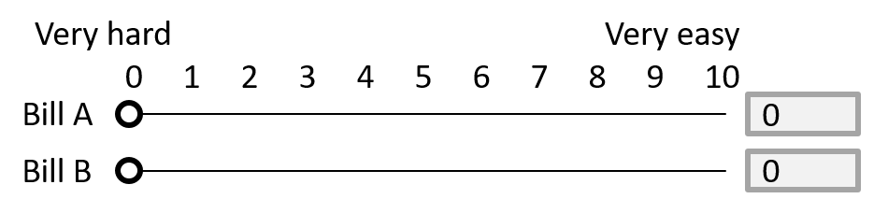

Figure 27. Example rating slider

1. **Based on the language used in this bill, how easy is it to understand the contents?**

*Consider the tone of the language (conversational vs formal) and use of technical vs plain language.*

Bill A

0 (Very hard) --------- 10 (Very easy)

Bill B

0 (Very hard) --------- 10 (Very easy)

In a few words, please explain why you gave this rating for **Bill A**. [free text box]

In a few words, please explain why you gave this rating for **Bill B**. [free text box]

1. **On this bill, how easy is it for a customer to find out details of their plan?**

*Plan details could include the name of the plan, any discounts it includes, and when the discounts expire. They could also include timing for peak and off-peak tariffs, explanations about green energy, or other extras.*

Bill A

0 (Very hard) --------- 10 (Very easy)

Bill B

0 (Very hard) --------- 10 (Very easy)

In a few words, please explain why you gave this rating for **Bill A**. [free text box]

In a few words, please explain why you gave this rating for **Bill B**. [free text box]

1. **Looking at this bill, how easy is it for a customer to understand how their plan compares to others available?**

Bill A

0 (Very hard) --------- 10 (Very easy)

Bill B

0 (Very hard) --------- 10 (Very easy)

In a few words, please explain why you gave this rating for **Bill A**. [free text box]

In a few words, please explain why you gave this rating for **Bill B**. [free text box]

1. **Looking at this bill, how easy is it for a customer to make decisions about their energy?**

*This could be payment decisions, decisions about the plan they are on, or other decisions about their energy use.*

Bill A

0 (Very hard) --------- 10 (Very easy)

Bill B

0 (Very hard) --------- 10 (Very easy)

In a few words, please explain why you gave this rating for **Bill A**. [free text box]

In a few words, please explain why you gave this rating for **Bill B**. [free text box]

1. **Looking at the way this bill is laid out, how easy is it to understand the content?**

*Consider the use of headings, colour, shading and white space. Also consider how information is grouped or positioned, and how the bill uses font size, infographics and charts or tables.*

Bill A

0 (Very hard) --------- 10 (Very easy)

Bill B

0 (Very hard) --------- 10 (Very easy)

In a few words, please explain why you gave this rating for **Bill A**. [free text box]

In a few words, please explain why you gave this rating for **Bill B**. [free text box]

1. **How well does this bill support a customer who does not speak much English, and has questions about their bill?**

*Consider: is it obvious how much to pay, when and how? Is it clear how to find interpreter or translation services?*

Bill A

0 (Not well at all) --------- 10 (Very well)

Bill B

0 (Not well at all) --------- 10 (Very well

In a few words, please explain why you gave this rating for **Bill A**. [free text box]

In a few words, please explain why you gave this rating for **Bill B**. [free text box]

1. **How well does this bill support a customer who is worried about how high their bill is, and wants to know what they can do next?**

Bill A

0 (Not well at all) --------- 10 (Very well)

Bill B

0 (Not well at all) --------- 10 (Very well)

In a few words, please explain why you gave this rating for **Bill A**. [free text box]

In a few words, please explain why you gave this rating for **Bill B**. [free text box]

1. **Looking at this bill, how easy is it for a customer to find out how they can pay the amount owing?**

*Consider the information they would need to pay the bill, including the total amount due, date due, and payment methods.*  
  
Bill A

0 (Very hard) --------- 10 (Very easy)

Bill B

0 (Very hard) --------- 10 (Very easy)

In a few words, please explain why you gave this rating for **Bill A**.[free text box]

In a few words, please explain why you gave this rating for **Bill B**. [free text box]

1. **On this bill, how easy is it for a customer to find their National Metering Identifier number?**

Bill A

0 (Very hard) --------- 10 (Very easy)

Bill B

0 (Very hard) --------- 10 (Very easy)

In a few words, please explain why you gave this rating for **Bill A**. [free text box]

In a few words, please explain why you gave this rating for **Bill B**. [free text box]

1. **Do you have any final comments about either of these bills?** [free text box]

### Appendix 3: Expert review average ratings

Average ratings for pre and post implementation bills on a scale of 0 to 10.
Easy to find NMI 3.3 to 7.7
Easy to determine plan competitiveness 1.9 to 4.9
Easy to find plan details 3.0 to 5.3
Visual design 4.0 t0 5.8
Supports decisions 3.5 to 5.2
Supports consumers concerned about cost 2.6 to 4.2
Clarity of langauge 4.9 to 6.4
Easy to pay amount due 6.0 to 7.2
Supports consumers with low English literacy 4.0 to 4.8

Figure 28. Average ratings for pre- and post-implementation bills across all nine measures

## References

AER (Australian Energy Regulator) (2021) [*Better Bills Guideline Behavioural and Consumer Research – Targeted focus group findings – Culturally and linguistically diverse consumers*](https://www.aer.gov.au/documents/aer-better-bills-guideline-behavioural-and-consumer-research-targeted-focus-group-findings-culturally-and-linguistically-diverse-consumers), AER website, accessed 18 October 2024.

——(2023) [*Better Bills Guideline – Version 2*](https://www.aer.gov.au/industry/registers/resources/guidelines/better-bills-guideline-version-2), AER, accessed 18 October 2024 [see also [Version 1 of the Guideline](https://www.aer.gov.au/industry/registers/resources/guidelines/better-bills-guideline-version-1), which was published in 2021].

BETA (Behavioural Economics Team of the Australian Government) (2021a) [*Literature review – improving energy bills*](https://behaviouraleconomics.pmc.gov.au/projects/improving-energy-bills), BETA website, accessed 16 September 2024.

——(2021b) [*Final report – improving energy bills*](https://behaviouraleconomics.pmc.gov.au/projects/improving-energy-bills), BETA website, accessed 16 September 2024.

BIT (Behavioural Insights Team) (2022a) [*Testing the better offer notice on energy bills – Final report*](https://www.aer.gov.au/documents/bit-testing-better-offer-notice-energy-bills-final-report), AER website, accessed 18 October 2024.

——(2022b) [AER Better Bills research – Final report](https://www.aer.gov.au/documents/bit-aer-better-bills-research-final-report), AER website, accessed 18 October 2024.

Hall and Partners (2021a) [*Bills Guideline Research – Focus Groups – Older/non-digital consumers*](https://www.aer.gov.au/documents/aer-better-bills-guideline-research-focus-groups-oldernon-digital-consumers), AER website, accessed 18 October 2024.

——(2021b) [*Better Bills Guideline Research – Focus groups – Small and Medium Business consumers*](https://www.aer.gov.au/documents/aer-better-bills-guideline-research-focus-groups-small-and-medium-business-consumers-december-2021), AER website, accessed 18 October 2024.

Ofgem (Office of Gas and Electricity Markets) (2018) [*Policy consultation: Domestic supplier-customer communications rulebook reforms*](https://www.ofgem.gov.uk/consultation/statutory-consultation-domestic-supplier-customer-communications-rulebook-reforms), Ofgem website, accessed 25 October 2024.

**© Commonwealth of Australia 2025**

ISBN 978-1-925365-75-7 Better bills impact report: How the AER’s Better Bills Guideline drives consumer confidence and market engagement

**Copyright Notice**

With the exception of the Commonwealth Coat of Arms, this work is licensed under a Creative Commons Attribution 4.0 International license (CC BY 4.0) (<https://creativecommons.org/licenses/by/4.0/>)



**Third party copyright**

Wherever a third party holds copyright in this material, the copyright remains with that party. Their permission may be required to use the material. Please contact them directly.

**Attribution**

This publication should be attributed as follows:

© Commonwealth of Australia, Department of the Prime Minister and Cabinet, *Better bills impact report: How the AER’s Better Bills Guideline drives consumer confidence and market engagement*

**Use of the Coat of Arms**

The terms under which the Coat of Arms can be used are detailed on the following website: <https://pmc.gov.au/cca>

Australian Government. BETA.


Behavioural Economics Team   
of the Australian Government

General enquiries [beta@pmc.gov.au](mailto:beta@pmc.gov.au)

Media enquiries [media@pmc.gov.au](mailto:media@pmc.gov.au)

Find out more [www.pmc.gov.au/beta](http://www.pmc.gov.au/beta)

1. Note on terminology: Small customers include households and some small businesses. Throughout this report we use ‘consumer’ or ‘customer’ to refer to Australians whose bills are subject to the Guideline.
2. To retain retailer anonymity throughout this report, we do not refer to retailers by name. We have also overlaid real eye tracking output on mocked-up bills with identifying features removed.
3. Digitally excluded was defined as people who: opt to receiving hard copy bills; prefer to resolve billing issues over the phone; have not accessed their energy account through online portal or downloaded an app; and (?) have low access to digital services or low digital ability.
4. The Guideline covers electricity and gas bills. The EME monitoring survey asked participants about switching electricity *or* gas plans, and we reported findings related to either type of plan. For simplicity, the consumer interviews and expert review tasks focussed only on electricity bills.
5. See Appendix 3 for average ratings across all nine measures.
6. This finding should be interpreted with caution, as interviews were conducted in English. Even where culturally and linguistically diverse interview participants self-identified as having low English literacy, they may not require interpreter services.
7. See Appendix 3 for average ratings across all nine measures.
8. To understand the context of general EME traffic and usage during the monitoring period, we also examined Google Analytics data. We did not see any trends in the data that meaningfully supplemented our pop up survey data. The survey offers a direct measure and more robust evidence about the impact of the Guideline than Google Analytics data, which is sensitive to general volatility of EME traffic that makes comparison over time difficult.
9. We calculated this using respondents’ reason for visiting EME, their current energy retailer, and separate information about when retailers had fully implemented the Guideline.
10. We included respondents who had previously switched when moving house or switched to a different plan with their existing retailer.