IMPROVING APPLIANCE ENERGY RATING LABELS

RESEARCH PROPOSAL
27 February 2017

Background
Reducing household energy consumption is a key component to boosting Australia’s energy productivity. In Australia, households roughly account for twenty five per cent of domestic electricity demands. Everyday household appliances such as fridges, washing machines and clothes driers contribute substantially to overall household energy consumption. In 2012, the Australian Government projected household appliances and equipment use to account for approximately one-third of household energy use. Household appliances and equipment use was also estimated to account for about 45 per cent of greenhouse gas emissions in the average household.
One of the ways to assist consumers in reducing their energy consumption is to help them make more energy-efficient choices when it comes to purchasing household appliances. Australia’s energy rating label is intended to play an important role to play in promoting the uptake of energy-efficient appliances. This label – first introduced on refrigerators in 1986 in Australia – is designed to provide customers with information on energy-efficiency in an accessible and standardised format, with the aim of making it easier for consumers to make more energy-conscious choices if they so desire. Energy-efficient appliances not only help consumers in terms of reducing their electricity bills, but they could also benefit the environment by reducing harmful greenhouse gas emissions.
A 2014 consumer survey on energy rating label awareness and understanding across a range of appliances, but with a focus on air conditioners, indicated that label recognition was high, with approximately 97 per cent of those surveyed recognising the label. Label understanding and interpretation, however, was much lower, with between 69 to 73 per cent of consumers able to correctly interpret the label to select the most efficient appliance. There was no indication that consumers could infer the implications of different ratings in terms of differences in electricity costs or greenhouse gas emissions.
Similar results have been seen in the United States in relation to vehicle fuel efficiency labelling, with consumers demonstrating a poor understanding of the financial value of fuel efficiency and an inability to calculate underlying cost-effective decisions (Allcott, 2011; Larrick and Sol, 2008). These studies have assessed the role of imperfect information in vehicle fuel economy decisions, providing some evidence that the way in which information is provided in energy-efficiency labels can be instrumental at helping guide people toward accurately interpreting key information and making use of it to align their decisions more closely with their goals.
In short, a growing body of research suggests that the information presented on appliance energy rating labels, and the manner in which that information is presented, influences whether and how consumers consider the labels when they make purchasing decisions. People have cognitive limitations when it comes to understanding and using the ambiguous, unfamiliar and abstract concept of electricity consumption (in kWh) when they purchase household appliances. Making salient information on the unobserved long-term cost-savings of different appliances may help people to make better decisions when they are making purchases. Furthermore, providing individuals with lifetime running cost product information framed as a loss they can avoid may tap into people’s propensity to be loss averse, increasing the willingness of individuals to purchase more efficient appliances with lower lifetime running costs, even if they are potentially more expensive at the outset.

Objectives
The overall objective of the proposed research is to support consumers to purchase products with lower predicted energy consumption (kWh) in a variety of key product categories (fridges, washers, dryers and televisions) via the use of a new energy rating label design using insights from behavioural economics. The results of the research are expected to contribute to the Australian Government’s mission to achieve its climate policy outcomes as it relates to reducing greenhouse gas emissions.
To achieve this objective, the proposed research will test the impact of a new energy rating label, specifically designed to increase customer engagement with, interest in, and purchases of higher energy-efficient appliances. In light of the tendency for individuals to avoid losses, the new energy rating label will clearly communicate information about the losses that a consumer can avoid by purchasing a product that is more efficient relative to a benchmark set by a one star (lowest-rated) product of the same size and capacity. This provides a relative measure, which the consumer can use to identify which product will help them reduce spending the most over the life of the product (e.g. a person could avoid losing $1,200 in lifetime running costs compared to the comparison one star product).
The proposed study will use a randomised controlled trial conducted on a retail website selling appliances. The trial is designed with three experimental arms into which customers visiting the site are randomly assigned. Individuals in the control group will always view the website in its current form, with no energy rating labels associated with products. Individuals in the first treatment group will see the same products with the standard energy rating label (Treatment 1) that is currently mandated for use on those appliances when they are sold in (bricks-and-mortar) retail stores in Australia. Individuals assigned to the second treatment group will see the products with the newly designed energy rating label (Treatment 2). Treatment 1 and Treatment 2 label designs are presented in Appendix A.
Overall, we hypothesise that consumers shown the new energy rating label are more likely to engage with, indicate an intent to purchase, and actually purchase higher energy-efficient products when compared to consumers shown the existing label or no label at all. In addition, we hypothesize that the positive effects of the new label will be larger for higher (vs. lower) rated products, as the dollar amounts that people can avoid in long-term running costs are larger for the higher-rated items.
Customer engagement with test products can be measured by clicks to view more detailed product information on specific items. Customer intent to purchase test products is indicated by clicks to add specific items to the online shopping cart. Customer purchases of test products are recorded by clicks to complete payment for items in the shopping cart.
Our specific hypotheses are the following:
H1: As compared with the standard energy rating label (Treatment 1), the new behaviourally-informed energy rating label (Treatment 2) will lead to higher levels of customer engagement (clicks to view detailed information), purchasing intent (clicks to add to cart) and purchases (clicks to complete payment) for labelled higher energy-efficient products.
H2: As compared with no label (control), the behaviourally informed energy rating label (Treatment 2) will lead to higher levels of customer engagement (clicks to view detailed information), purchasing intent (clicks to add to cart) and purchases (clicks to complete payment) for labelled higher energy-efficient products.
H3: The differences described in H1 and H2, above, will be larger in magnitude for products with higher energy efficiency ratings.

Design

a. Partners and subject pools
The trial will be conducted in partnership with online retailer Appliances Online. The Department of the Environment and Energy are contracting Appliances Online to deliver the trial via Appliances Online’s online platform.
All individuals who visit Appliances Online’s website and visit one of the eight product filter pages (within any of the four product categories) during the trial period, from 28 February 2017 for approximately a 30 day period, will be (unidentified) subjects in the trial. Within a 30 day period, there are approximately 13,000 unique visitors to the website filter pages, providing sufficient statistical power to identify significant differences in outcomes across the three experimental groups.

b. Randomisation of the intervention
The trial will be an individually randomised controlled trial. Each individual visiting one of the experimental pages (either the filter or product page) will be randomly assigned to either a control group or one of two treatment groups. Randomisation will be carried out by Appliances Online using their online testing platform. The control group will see no energy rating labels associated with any of the products. Individuals in the first treatment group will view products with the current standard energy rating label that is mandatory when products are sold in stores (Treatment 1). Individuals in the second treatment group will view the products with the new energy rating label designed to incorporate insights from behavioural economics (Treatment 2). The labels are presented in Appendix A. Randomisation will be linked to the device’s IP address with cookies so that, if a person returns to the site on multiple occasions using the same device, they will be exposed to the same experimental condition.
A limitation of the randomisation process is that individuals may use multiple devices to visit the website, which may lead to a small amount of some “non-compliance” in the form of some individuals appearing more than once as subjects in the trial and in more than one experimental group. This is expected to affect only the precision of the estimates, by adding extraneous noise, but does not bias estimates of the impacts of the labels.
Four product categories will be included in the trial: televisions, fridges, washers and dryers. Within each of the four product categories, labels will be assigned to eight of the most popular products included in the experiment. A complete list of products to be included in the experiment is at Appendix B.
Two types of website pages will be re-designed as part of the experiment. The filter pages for each of the four product categories show pictures and prices for all available products in these categories. Customers can then click on any specific product image to go to product pages showing detailed information about that one specific item.
The filter pages for each of the four product categories will be re-designed to ensure the eight test products are displayed in the top two product rows. The order in which the products are displayed will be consistent across conditions. In Treatment 1, the current energy rating label will be positioned in the top right-hand corner of each product box. In Treatment 2, the new behaviourally-informed energy rating label will be positioned in the top right-hand corner of each product box. (See Figures 1 and 2 for examples of how the filter page for fridges will appear for individuals in Treatments 1 and 2).
In addition, the product pages for each of the eight test products will be re-designed as part of the Treatment 1 and Treatment 2 experimental arms. In Treatment 1, when a customer clicks to see more information about any of the labelled test products, the current energy rating label will be positioned in the top right-hand corner of each page, above the product’s displayed price. In Treatment 2, the new behaviourally-informed energy rating label will be positioned in the top right-hand corner of each page, above the product’s displayed price. (See Figures 3 and 4 for examples of how the product page for a fridge will appear for individuals in Treatments 1 and 2).
Participants in either treatment arm may click on either version of the label at any time on both filter pages and product pages to receive more information about the Australian Government Department of the Environment and Energy’s energy rating calculator, including a link to the Department’s energy rating calculator (see Figure 5 for a picture of the pop-up box and its content). This generic information is will be presented in a pop-up box and will be identical across experimental conditions. Figure 6 shows the schedule for participant progress through the trial as well as data collection.
- Screen shot of upright fridge filter page as per Treatment 1
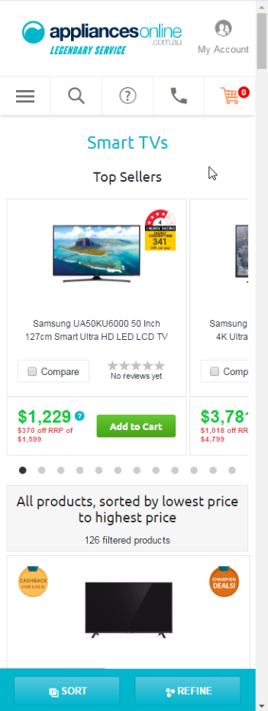

- Screen shot of upright fridge filter page as per Treatment 2
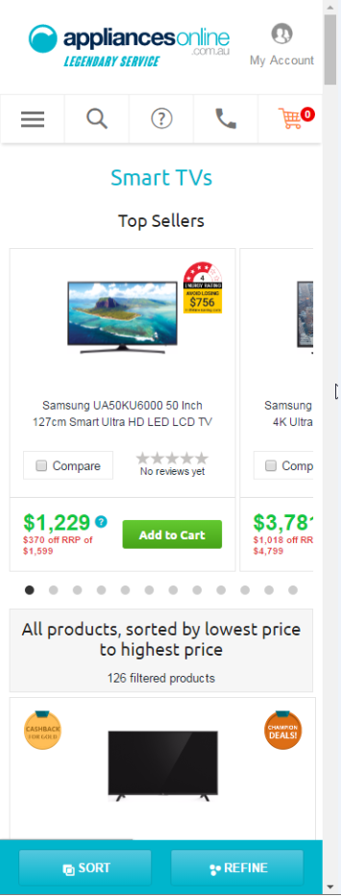

- Screen shot of upright fridge product page as per Treatment 1
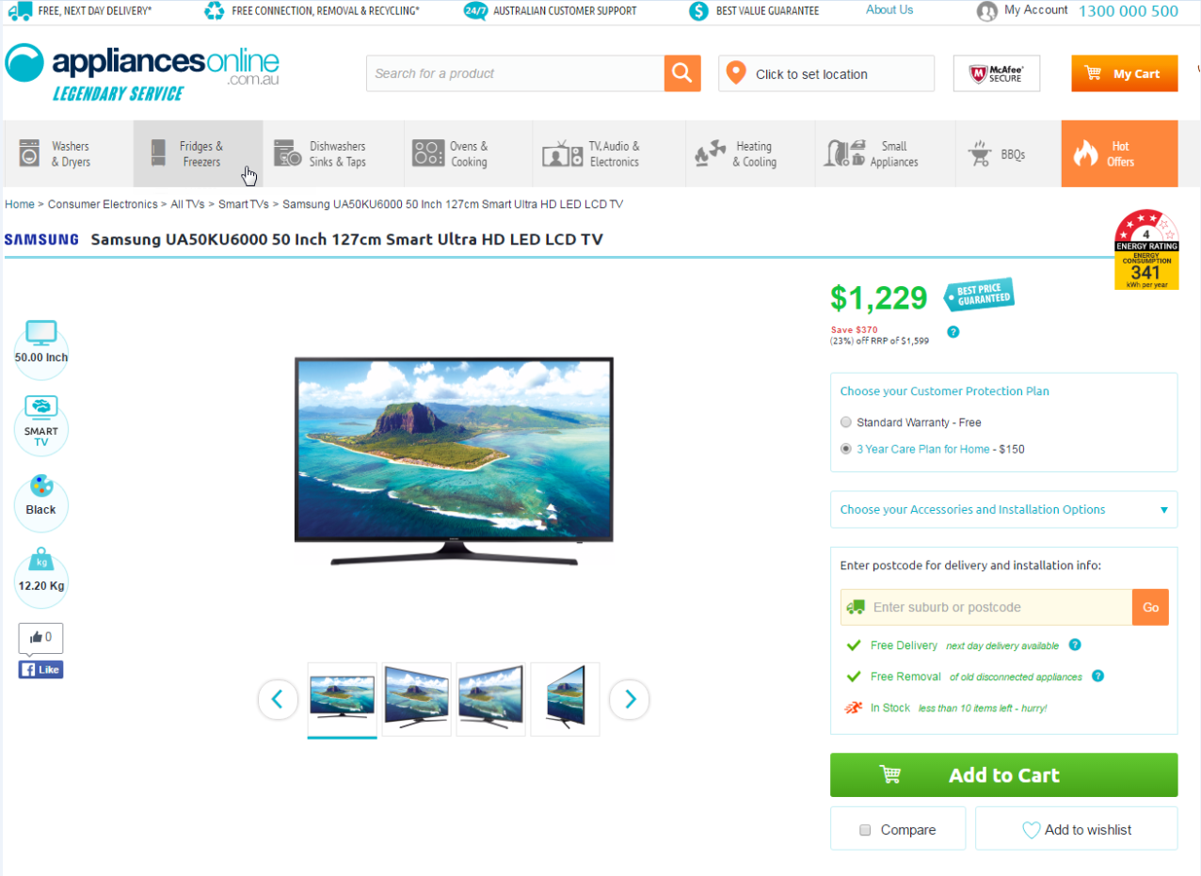
- Screen shot of upright fridge product page as per Treatment 2
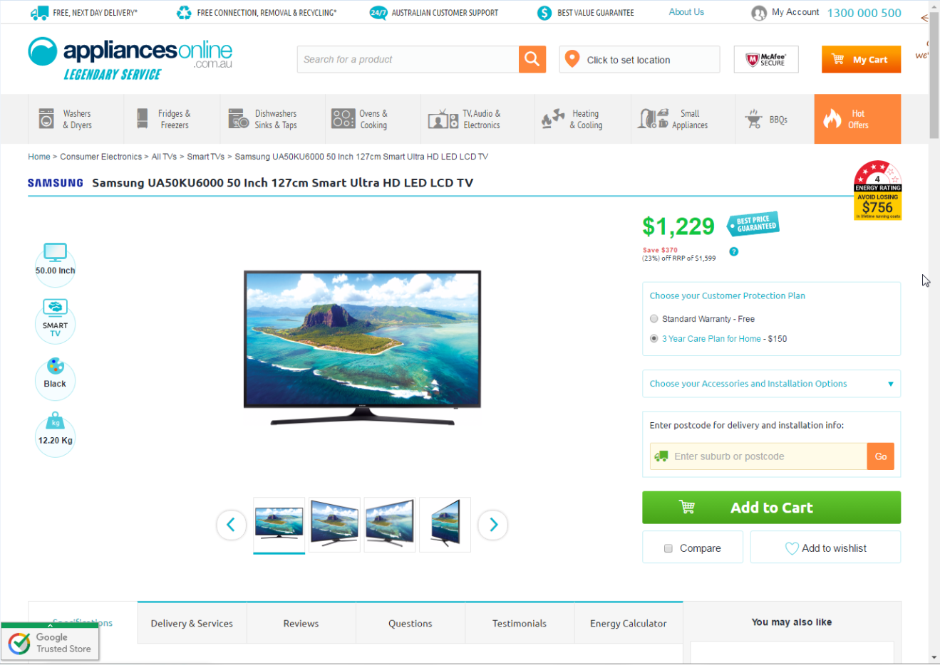

- Screen shot of pop-up box
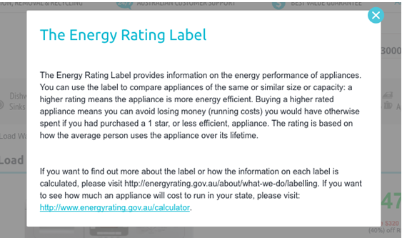

- Participant progress in the trial and schedule for data collection
Data Collection Schedule
Data generated by participants
Pre-trial baseline data from Appliances Online on customer engagement, purchasing intent and purchasing behaviour for each individual product
Post-trial individual level data from Appliances Online customer engagement, purchasing intent and purchasing behaviour for each individual product
Participant Progress in the Trial
Participants randomly assigned to groups
Control group:
View filter and product pages showing no label next to the eight most trafficked products

Treatment group 1:
View filter and product pages displaying current energy star rating label next to the eight most trafficked products

Treatment group 2:
View filter and product pages displaying new behaviourally-informed energy rating label next to the eight most trafficked products

Participants visit Appliances Online website

Conduct online activity

c. Sample Size and Statistical Power
Given the expected traffic to Appliances Online over the trial period, we anticipate having sufficient statistical power to detect a difference of 5 percent on people’s engagement with the energy labels, measured by the rate at which views of the product filter page convert to clicks to view detailed information on product pages of labelled products in each category. A total of approximately 48,000 non-unique visitors to the filter pages over approximately 30 days will provide at least 80% power for two-sided tests (at the 5% significance level) to detect substantial ≥5% differences in conversion rates between the experimental groups.
Table 1: Required sample size to reach 80% power at the 5% significance level
Product Category | Required Sample Size
Clothes Dryers | 1887
Fridges | 3446
Washing Machines | 2621
Total Across All Categories | 7954

While the study has been designed with power only sufficient to detect sizeable impacts of energy ratings labels on customer engagement, we will examine data on differences in purchasing intent and actual purchases of test products in our secondary analysis. As part of our secondary analysis, we will also examine differences across the experimental groups by different energy efficiency categories (e.g. 2-3 energy efficiency stars versus 4-5 energy efficiency stars), product price ranges, products sub-categories (e.g. top load vs. front load washing machines), and type of electronic device used to navigate the website (to measure the impact of the size and legibility of the energy labels on the outcomes of interest). We will also examine the rates at which customers click on ratings labels (the standard label or the new label) to view the pop-up box to find out more about the energy rating calculator.
Based on historical data on conversion rates for the four product categories, we can expect to reach statistical significance for all product categories except for TVs.

d. Data
Key baseline data will include customer engagement, purchasing intent and purchasing behaviour for each of the eight products within each of the four product categories, as well as descriptive data on each of these products (e.g., energy-efficiency rating, electricity consumption, and price).
At the end of the trial implementation period, Appliances Online will collect data on customer engagement, purchasing intent and purchasing behaviour for each of the eight products within each of the four product categories. A complete data set, inclusive of the experimental condition to which the participant was randomly-assigned, will be provided to BETA for analysis immediately following the trial.

e. Measures
The dependent variables to be collected at the product and category levels include:
- Conversion rates to view product pages of test products from filter page (customer engagement)
- Conversion rates to add test products to shopping cart from filter or product pages (customer purchasing intent); and
- Conversion rates to complete purchase of test products (customer purchases).
We will also assess conversion rates for clicks to view the pop-up box providing more information about the energy ratings labels.
The independent variables include: experimental condition and appliance characteristics, including: product category (fridge, washer, drier, television), product model, product type, product size, energy-efficiency star rating, electricity consumption, and price. If possible we would also include in the analysis an indicator for the type of electronic device used to view website (e.g., smartphone, computer).

f. Analysis Plan
The critical research question is whether the behaviourally-informed energy label leads to higher levels of customer engagement, purchasing intent and purchases for higher energy-efficient products compared to no energy label or to the current energy star rating label. The primary analysis will focus on assessing whether customers who viewed products with the new label were more engaged with the test products than customers who viewed the products with the current label or no label at all.
Table 2 shows how the key results will be reported.

Table 2: Summary tables for reporting primary results
Primary Outcome:  Conversion rates to view test products (%) | Control Group mean | Treatment 1 mean (standard energy label) | Difference: Treatment 1 vs Control  (p-value*) | Treatment 2 mean (Behaviourally-informed energy label) |  | Difference: Treatment 2 vs Control  (p-value*) | Difference: Treatment 1 vs Treatment 2  (p-value*)
All categories | %  (n=) | %  (n=) | %  (p=) | %  (n=) | %  (p=) |  |  | %  (p=)
Fridges | %  (n=) | %  (n=) | %  (p=) | %  (n=) | %  (p=) |  |  | %  (p=)
TVs | %  (n=) | %  (n=) | %  (p=) | %  (n=) | %  (p=) |  |  | %  (p=)
Washing machines | %  (n=) | %  (n=) | %  (p=) | %  (n=) | %  (p=) |  |  | %  (p=)
Dryers | %  (n=) | %  (n=) | %  (p=) | %  (n=) | %  (p=) |  |  | %  (p=)

Secondary analysis will examine additional data on purchasing intent, purchases, and clicks to view more information about labels. In these cases, we do not anticipate having enough statistical power to measure plausible effects of labels, but we will examine the evidence available from the trial. As part of the secondary analysis we will also examine differences in label effects across different sub-groups of products defined by energy-efficiency rating, prices, and product sub-categories, and (if available) by whether customers were viewing the website using a smartphone or a computer. Finally, we will consider whether application of the labels to the test products significantly diverts customer attention (measure by conversion to view product pages) away from unlabeled products.

g. Ethics
BETA will conduct an ethical risk assessment of the study proposal. The proposal will be subsequently reviewed by the BETA Ethics Committee of Peers (the Committee) if it is assessed as posing either:
- negligible risk – where the research involves the use of prospectively collected data or records that already contain identifiable data about human participants; or
- low risk – where research does not involve higher-risk groups of individuals (e.g. Indigenous Australians, pregnant mothers, those with cognitive limitations) listed in paragraph 5.1.6 (b) of the National Statement on Ethical Conduct in Human Research 2007.
All information about individual participants in the study will be non-identifiable, and we expect expedited ethics review and approval.

Appendix A. Treatment 1 and Treatment 2 label designs
Treatment 1 (current energy star rating label) | Treatment 2 (new behaviourally-informed energy rating label)
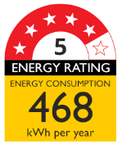

Appendix B. List of products to be included in the experiment
Product and type | Brand | Model
Televisions:  - Smart TVs | TCL | 32P1S
 | TCL | 50E5900US
 | LG | 55UH652T
 | Samsung | UA40KU6000
 | Samsung | UA50KU6000
 | Samsung | UA55KU6000
 | Samsung | UA60KU6000
 | Samsung | UA75JU6400
Refrigerators:  - Bottom Mount  - Multi-door  - Top Mount | Samsung | SRL458ELS
 | Samsung | SRL457MW
 | Westinghouse | WBE5300SARH
 | Samsung | SRF583DLS
 | Fisher & Paykel | RF522ADUSX5
 | Westinghouse | WHE5200SA-D
 | Electrolux | EQE6207SD
 | Samsung | SR318LSTC
 | Samsung | SR254MW
 | Haier | HRF224FW
Washing Machines:  - Front Load  - Top Load | Bosch | WAW28460AU
 | Bosch | WAE22466AU
 | Euromaid | WM7
 | LG | WD1200D
 | Samsung | WW75J4233GW
 | LG | WD12021D6
 | Samsung | WA80F5G4DJW
 | Samsung | WA65F5S2URW
Clothes Dryers:  - Vented | Fisher & Paykel | DE5060M1
 | Fisher & Paykel | DE4060M1
 | Simpson | 39P400M
 | Electrolux | EDV6051
 | Euromaid | DM4KG
 | Fisher & Paykel | DE6060G1
 | Midea | MDV07
 | Simpson | 39S500M

© Commonwealth of Australia 2017

Copyright Notice
With the exception of the Commonwealth Coat of Arms, this work is licensed under a Creative Commons Attribution 4.0 International license (CC BY 4.0) http://creativecommons.org/licensesby/4.0/deed.en
Third party copyright
Wherever a third party holds copyright in this material, the copyright remains with that party. Their permission may be required to use the material. Please contact them directly.
Attribution
This publication should be attributed as follows: Commonwealth of Australia, Department of the Prime Minister and Cabinet, Effective use of SMS: timely reminders to report on time.
Use of the Coat of Arms
The terms under which the Coat of Arms can be used are detailed on the following website: http://www.itsanhonour.gov.au/coat-arms

Behavioural Economics Team
of the Australian Government
General enquiries beta@pmc.gov.au
Media enquiries media@pmc.gov.au
Find out more www.pmc.gov.au/beta

http://www.abs.gov.au/AUSSTATS/abs@.nsf/Lookup/4604.0Main+Features12013-14?OpenDocument
http://www.yourhome.gov.au/energy/appliances
ACIL ALLEN Consulting, Energy Label Rating Review (Report Prepared For The Department Of Industry (On Behalf Of The Equipment Energy Efficiency Committee)). 2014.
United States Environmental Protection Agency, Fuel Economy Label Final Report, 2010; Allcott, H., Social norms and energy conservation, Journal of Public Economics, Vol. 5, Issues 9-10, 2011, pp. 1082-1095; Larrick, R. and Sol, J., The MPG Illusion, Science, Vol. 320, No. 5883, 2008 pp. 1593-1594.
Bull, J., Loads of green washing – can behavioural economics increase willingness-to-pay for efficient washing machines in the UK, 2012; Deutch, M., Life-cycle cost disclosure and consumer behaviour: expectations in the energy policy community versus experimental evidence, in Bermann, D.M. (ed.), Energy Efficiency Research. Happauge: Nova Science, 2009; DECC and the Behavioural Insights Team (UK), Findings from a behavioural trial conducted with John Lewis, 2014, available at: https://www.gov.uk/government/uploads/system/uploads/attachment_data/file/350282/John_Lewis_trial_report_010914FINAL.pdf.
Zhou, H. and Bukenya, O., Information inefficiency and willingness-to-pay for energy-efficient technology: a stated preference approach for China Energy Label, Energy Policy, 2016, pp. 12-21.
Bull, J., Loads of green washing – can behavioural economics increase willingness-to-pay for efficient washing machines in the UK, 2012; Tversky, A and Kahneman, D, Rational Choice and the Framing of Decisions, The Journal of Business, Vol. 59, No. 4, part 2: The Behaviouaral Foundations of Economic Theory, 1986, pp. S251-S278.
‘Higher energy-efficient product’ refers to those products that have a higher than one star energy rating.

