Grow. Gather. Graduate.
Using Behavioural Insights to Help Students Graduate from University
Dropping out of university is associated with a heightened risk of unemployment or long-term welfare dependence.
Supported with funding from the Try, Test and Learn Fund, BETA designed a new behaviourally-informed app called ‘Grok’.
Grok aimed to improve university completion rates by growing student resilience through:
- Reminding students to connect with social groups
- Challenging unhelpful thoughts about setbacks
- Delivering practical wellbeing and study tips

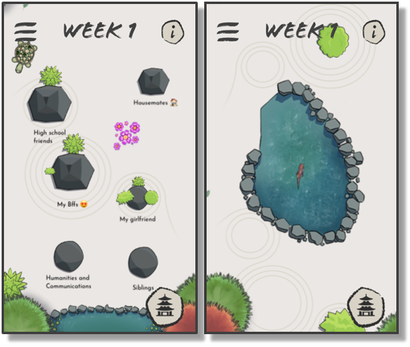

Quote: “Grok was an app worth downloading - it helps you stay motivated, reflect on your self-identity/wellbeing and stay on track when it comes to academics.”
The trial launched in semester one 2020 at two Australian universities.
We evaluated the impact of Grok on academic performance, completion, wellbeing and belonging.
4463 students downloaded Grok. Feedback was largely positive… but overall app usage was low.
We found no significant difference between those who had access to Grok and those who did not.
This could be due to the app content, low usage or impacts of COVID-19.
Mobile apps are highly accessible but maintaining user engagement is a challenge. BETA could make Grok accessible to researchers for further testing to understand its potential impact and broader application.

