Clearer consequences
Helping people understand the outcomes of bankruptcy
July 2021

Other uses
Enquiries regarding this document are welcome at:
Managing Director
Behavioural Economics Team of the Australian Government
Department of the Prime Minister and Cabinet
1 National Circuit
Barton ACT 2600
Email: beta@pmc.gov.au
The views expressed in this paper are those of the authors and do not necessarily reflect those of the Department of the Prime Minister and Cabinet or the Australian Government.

Research team
Current and former BETA staff who contributed to the report were: Andrei Turenko,
Hanne M Watkins, Angela McGregor, Scott Copley, and Andrea Willis.

Acknowledgments
Thank you to the Australian Financial Security Authority for their support and valuable contribution in making this project happen. In particular, special thanks to River Paul, Allan Walsh, Michael Betterton, Jared Cane, Tanya Keays, Helen Armstrong, Daphne Dominique, Bek Kennedy, Richard Datson, and Mark Wicht for their work on this project.
The trial was pre-registered on the BETA website and the American Economic Association registry:
https://behaviouraleconomics.pmc.gov.au/projects/helping-australians-navigate-bankruptcy-process
https://www.socialscienceregistry.org/trials/6534
https://www.socialscienceregistry.org/trials/7302

Who?

Who are we?
We are the Behavioural Economics Team of the Australian Government, or BETA. We are the Australian Government’s first central unit applying behavioural economics to improve public policy, programs and processes.
We use behavioural economics, science and psychology to improve policy outcomes. Our mission is to advance the wellbeing of Australians through the application and rigorous evaluation of behavioural insights to public policy and administration.

What is behavioural economics?
Economics has traditionally assumed people always make decisions in their best interests. Behavioural economics challenges this view by providing a more realistic model of human behaviour. It recognises we are systematically biased (for example, we tend to satisfy our present self rather than planning for the future) and can make decisions that conflict with our own interests.

What are behavioural insights and how are they useful for policy design?
Behavioural insights apply behavioural economics concepts to the real world by drawing on empirically-tested results. These new tools can inform the design of government interventions to improve the welfare of citizens.
Rather than expect citizens to be optimal decision makers, drawing on behavioural insights ensures policy makers will design policies that go with the grain of human behaviour. For example, citizens may struggle to make choices in their own best interests, such as saving more money. Policy makers can apply behavioural insights that preserve freedom, but encourage a different choice – by helping citizens to set a plan to save regularly.

Contents
Who? 2
Executive summary 5
Why? 6
Part 1: Consequences tool and Prescribed Information 9
Part 2: Prompts in the online bankruptcy form 17
Conclusion 23
Technical Appendix 24
References 66

Executive summary
For people in financial difficulties, applying for bankruptcy is a major life decision. Bankruptcy releases people from most types of debt, giving them a fresh start. There are, however, additional consequences to applying for bankruptcy – and deciding whether the benefits outweigh these consequences can be challenging.
Applicants may experience cognitive overload due to new, complex and unfamiliar information – making it harder to make the optimal decision. Some applicants may be overly optimistic in their ability to deal with bankruptcy consequences and fail to consider them in full, or they may simply not wish to engage with distressing information.
The Australian Financial Security Authority (AFSA) oversees personal insolvencies (including bankruptcy) in Australia. In 2020, AFSA streamlined the bankruptcy application process by moving it online, and worked to ensure applicants understand the consequences of going bankrupt before they apply.
BETA and AFSA worked together to develop several approaches to informing people about the consequences of bankruptcy, giving them the required information to make an appropriate decision for their circumstances. We ran two evaluation projects:
- Increasing understanding of the consequences of bankruptcy
Most bankruptcy applicants need to complete an educational tool (known as the ‘consequences tool’) before they can apply for bankruptcy. In an online experiment with the general public, we tested six versions of the consequences tool. We measured people’s understanding of the consequences of bankruptcy by asking them a set of questions after they had completed one of the consequences tools.
People who did not see any consequences tool had a relatively low understanding of bankruptcy. They were able to correctly identify fewer than half of the consequences. The current consequences tool and the ‘Prescribed Information’ (information presented to all applicants at the start of the bankruptcy application form) improved people’s understanding of the consequences. Two further educational tools, a video and a pop-up quiz, performed the best in improving people’s understanding and confidence.
- Testing the impact of tailored and timely prompts within the application form
In a randomised controlled trial with bankruptcy applicants, we evaluated the effect of five prompts within the online bankruptcy application form. These prompts provided timely and tailored information on the consequences of bankruptcy. For the most part, including the prompts did not influence applicants’ reporting behaviour (completion rate, value and count of assets, income declared), and did not have any unintended side-effects.
The findings of these projects have broader implications for how the Government communicates with citizens. Across many services, the Government often needs to ensure people understand and apply complex information. This research contributes to our understanding of how this is best achieved.

Why?

Bankruptcy involves a number of serious consequences
Every year, around 16,000 people become bankrupt in Australia (AFSA, 2020). Bankruptcy releases applicants from most types of debts and provides relief from creditors, allowing people to make a fresh start. However, bankruptcy entails a number of serious consequences – such as the sale of applicant’s property and restrictions to credit and travel (see Box 1).
The Australian Financial Security Authority (AFSA) is responsible for overseeing personal insolvencies, including bankruptcy, in Australia. In October 2020, AFSA launched an online bankruptcy application form. The online form aimed to make it easier to apply and introduced new ways of informing applicants about the consequences of bankruptcy.

Box 1: What is bankruptcy, and what are its consequences?
Personal bankruptcy is a legal process where an individual is declared unable to pay their debts. Bankruptcy covers most types of debts, but some still need to be repaid. When a bankruptcy application is accepted a trustee is appointed to manage the bankruptcy. The trustee is able to take and sell certain assets, including real estate, to pay creditors. The trustee can also take a percentage from the person’s income if they earn over a certain amount.
Bankruptcy in Australia generally lasts for 3 years and 1 day. During this period, the person who is bankrupt has a number of obligations. For example, they must tell their trustee if they receive any money through tax refunds, lottery winnings, or inheritances, and they are not able to travel overseas without their trustee’s permission. The name of the person who is bankrupt is also permanently recorded on the National Personal Insolvency Index (NPII).

The decision to enter bankruptcy should be made carefully
Applying for bankruptcy is a significant and challenging decision. Applicants need to understand their own financial situation - their assets, income and debts - and weigh these factors against the benefits and consequences of becoming bankrupt.
For people in financial distress, making optimal decisions is often difficult due to high cognitive load (or reduced cognitive bandwidth) associated with living in conditions of scarcity (see Mullainathan & Shafir, 2013). People typically don’t readily engage with information they find challenging or distressing (see Box 2 for further discussion). To support informed decision-making, we partnered with AFSA to develop and test ways of informing applicants about the consequences of bankruptcy.

Box 2: Behavioural factors influencing bankruptcy applicants
- Cognitive overload occurs when a person is overwhelmed with the amount or context of information presented to them (Kirsh, 2000). This is particularly relevant as the information presented to bankruptcy applicants may be complex, confronting and unfamiliar. Cognitive overload may lead applicants to forget things, disengage or selectively omit information.
- Optimism bias and overconfidence refers to our tendency to be unrealistically optimistic even when the stakes are high, possibly causing bankruptcy applicants to overestimate their knowledge of the bankruptcy process and its consequences (Sharot, 2011) (Pallier, et al., 2002). This may lead some applicants to pay less attention to the negative consequences of bankruptcy presented for their consideration.
- The ostrich effect is people’s self-protective tendency to not engage with information they find uncomfortable or distressing (Karlsson, Loewenstein, & Seppi, 2009). Bankruptcy applicants may not engage with learning about the consequences of bankruptcy as this information may be worrisome.
- Uncertainty avoidance refers to people’s preference for known over the unknown (Hancıoğlu, BikeDoğan, & Yıldırım, 2014). If applicants do not understand the consequences of bankruptcy, they may delay their decision to apply, possibly worsening their financial situation.

AFSA informs applicants about the consequences of bankruptcy at key stages of the online application process
To help applicants decide if bankruptcy is right for them, AFSA highlights key consequences of bankruptcy at three steps in the application process:

Step 1: Complete the consequences tool
Most people applying for bankruptcy must complete the consequences tool before creating an account and proceeding to the application portal. The tool provides personalised information on how the most common bankruptcy consequences may apply to the applicant. For example, the tool asks if the applicant owns a house, and if they answer ‘yes’, the tool notes the house may be sold.

Step 2: Review Prescribed Information
The bankruptcy application form includes a page-long statement (the ‘Prescribed Information’) describing in detail the consequences of, and alternatives to, bankruptcy. Applicants must acknowledge they have read and understood this information before submitting their application.

Step 3: Prompts in the online form
The online form contains five prompts regarding the consequences of bankruptcy. Some prompts are conditional and appear only if the user enters certain information. For example, if the applicant indicates they have a Higher Education Contribution Scheme (HECS) debt, a prompt advises this type of debt is not covered by bankruptcy and they should reconsider applying if this debt is the main cause of their insolvency.

Across two projects, we applied behavioural science to help inform applicants about the consequences of bankruptcy
BETA and AFSA worked together to find the best approaches to communicating the consequences of bankruptcy across two related projects:
- In an online experiment, we tested how effective the consequences tool (step 1) and the Prescribed Information (step 2) are at explaining the consequences of bankruptcy.
We also designed and tested four new ways of communicating the consequences of bankruptcy and compared their effectiveness to the current Prescribed Information and consequences tool.
- We designed and evaluated the effect of five prompts within the online bankruptcy application form (step 3).
This report is divided into two parts, corresponding to the two projects. The conclusion section summarises the findings from both parts.

Part 1:
Consequences tool and Prescribed Information

Before applying for bankruptcy online, most people must complete what is known as the ‘consequences tool’. The tool informs applicants about the consequences of bankruptcy.
The current version of the tool asks applicants seven questions and – based on the answers provided – explains how bankruptcy may impact the applicant. After completing the tool, the applicant decides whether to proceed with their bankruptcy application or discontinue the process.
If the applicant proceeds, they are able to create an account and provide their identity online. They must then review the Prescribed Information. This is a page-long summary appearing at the start of the bankruptcy form. As can be seen in Figure 1 on the next page, the Prescribed Information is a text-based document, in a simple layout, and contains nine sections outlining the consequences and alternatives to bankruptcy. Applicants must acknowledge they have read and understood this information, before they proceed to the application form.

We designed four new educational tools, and tested them alongside the consequences tool and Prescribed Information in an online experiment
To see how well the consequences tool and the Prescribed Information aid understanding, and if alternative, behaviourally informed ways of presenting the information are more effective, we ran an online experiment. We tested:
- the current consequences tool,
- the Prescribed Information,
- and four alternative approaches to presenting bankruptcy information.
We refer to the alternative approaches collectively as “educational tools”. Each tool provided the same important information about the consequences of bankruptcy, but varied in format and presentation style, incorporating different elements which research has shown can aid understanding of and engagement with complex materials.

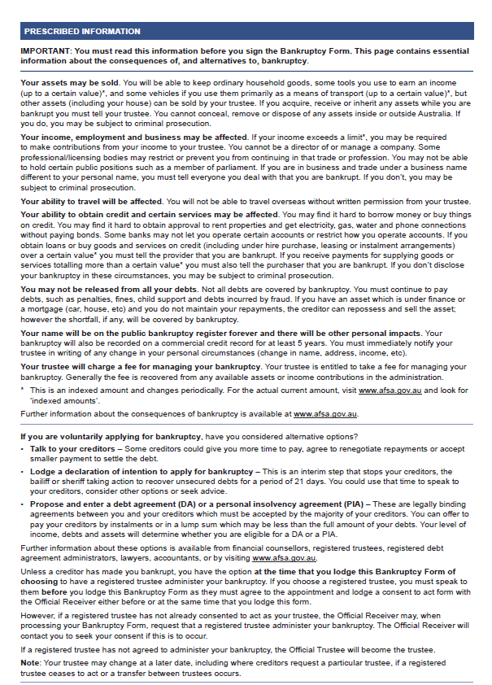
- Screenshot of the Prescribed Information
currently provided to applicants to inform them of
the consequences of bankruptcy. This screenshot demonstrates the text-heavy nature of the Prescribed Information. The educational
tools we designed provided the same information,
but in different formats (see below).

The tools we tested included personalised and interactive elements, as well as imagery and audio, which aid understanding and engagement
AFSA’s current consequences tool uses a behaviourally informed element called personalisation to aid understanding. The tool works by asking the applicant questions, and based on the applicant’s responses, provides tailored information about the consequences of bankruptcy. Research has shown that personalisation aids memory and understanding because it links key information to something the individual knows well – themselves and their circumstances (Symons & Johnson, 1997).
Three of the new educational tools we developed, the ‘pop-quiz’, the ‘roadmap’ and the ‘personalised profile’, also contained elements of personalisation (see Table 1 for further details on these tools), but presented personalised and tailored information in slightly different ways. We also made the ‘pop-quiz’ and the ‘roadmap’ interactive. These tools required active engagement from the user (e.g., answer questions, select options) in order to receive immediate feedback, which has been shown to increase engagement and understanding (Sailer & Homner, 2020).
We also included imagery in three of our educational tools; and the ‘video’ included audio as well. Presenting information in many different ways can help engage people by catering to their different preferences for learning (Adesope & Nesbit, 2012). The educational tools we tested are outlined in Table 1, along with a summary of the behaviourally informed elements they included. Figures 2 and 3 provide screenshots of two of the educational tools.

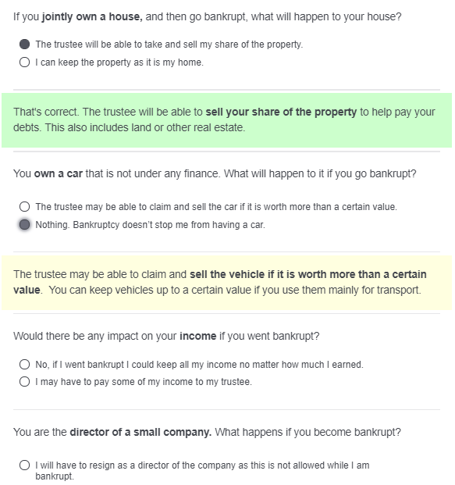
- Screen-shot of the pop-quiz. For this educational tool, as soon as the individual selected a response, a feedback-box appeared. If they answered correctly, the box was green. If they answered incorrectly, the box was yellow. In both cases, the tool also provided more information about the specific consequence.

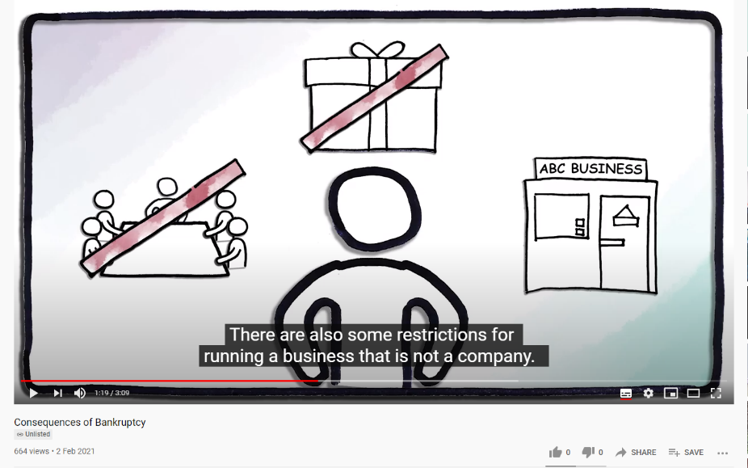

- Screenshot of the video. For this educational tool, a voice-over described the consequences
of bankruptcy, accompanied by simple animations and subtitles.

- Summary of all educational tools tested in the online experiment. This table provides an overview of the tools, including which behaviourally informed elements each tool included.
Educational tool | Description | Elements
Prescribed Information | A page-long text describing consequences of bankruptcy in plain language. | None
Current consequences  tool | The tool asks seven questions about the applicant’s circumstances, providing immediate and tailored feedback about the consequences of bankruptcy. | Personalisation, interactivity
Personalised  profile | The tool asks the applicant several questions about their circumstances, providing a tailored summary about how bankruptcy might impact their life. The summary is accompanied by icons. | Personalisation, interactivity, imagery
Roadmap | Information about the consequences of bankruptcy organised into sections with subheadings and icons, in a vertical timeline. Clicking on each section expands it, and provides further detail. | Interactivity, imagery
Pop-quiz | Eight factual questions about the consequences of bankruptcy are presented to the applicant. Each question includes a correct and an incorrect response option.  The tool provides immediate feedback about whether the applicant answered correctly, and further details about the correct answer. | Interactivity
Video | A 3-minute video summarising the consequences using simple imagery and animations, along with a voice-over. The voice-over is transcribed in closed captions on the screen. | Imagery (and animation), sound

We recruited over 6,500 Australians to complete one of the six educational tools, and assessed their understanding of bankruptcy
We ran an online experiment with over 6,500 people recruited from the general public to test the effectiveness of each educational tool. Each person was randomly assigned to receive one of the six tools. They then answered a set of multiple-choice questions about the consequences of bankruptcy. One group of people (the ‘no information group’) received no information about bankruptcy and were simply asked to answer the multiple-choice questions. The results from this group were used as a baseline for our evaluation.

What we found

The video and the pop-quiz were most effective at increasing people’s understanding of the consequences of bankruptcy
The current consequences tool and the Prescribed Information were both effective at informing people about the consequences of bankruptcy. These tools improved people’s understanding by 12 to 15 percentage points above the no information group. The video and pop-quiz improved people’s score even further, both raising scores by on average 14 percentage points above the consequences tool and Prescribed Information (see Figure 4), and 27 percentage points above the no information group.

- Average scores (% correct) in each group.
We also asked participants – before they commenced the trial – how much they felt they knew about bankruptcy. Most people indicated they knew “Nothing” or “A little” (64% of the sample). All educational tools appeared to help these participants the most. If actual bankruptcy applicants have a similar level of self-assessed knowledge, this result is encouraging: it suggests all these tools will be effective at raising the baseline understanding of bankruptcy.

The pop-quiz and video improved people’s confidence in their own understanding
The increases in understanding were also reflected in increases in people’s confidence. On a scale from 1 (not at all confident) to 6 (completely confident), the pop-quiz and the video gave people the most confidence about understanding the consequences of bankruptcy (see
Figure 5).

- Average confidence score (on a scale from 1 (not at all confident) to 6 (completely confident), in each group.

People’s understanding of bankruptcy is (on average) low
People who received no information about bankruptcy during the trial answered 37% of the multiple-choice questions correctly. This result indicates the average level of knowledge about bankruptcy in the general public is fairly low. The multiple-choice questions covered different aspects of bankruptcy, and – as can be seen in Figure 6 – some aspects were better understood than others.
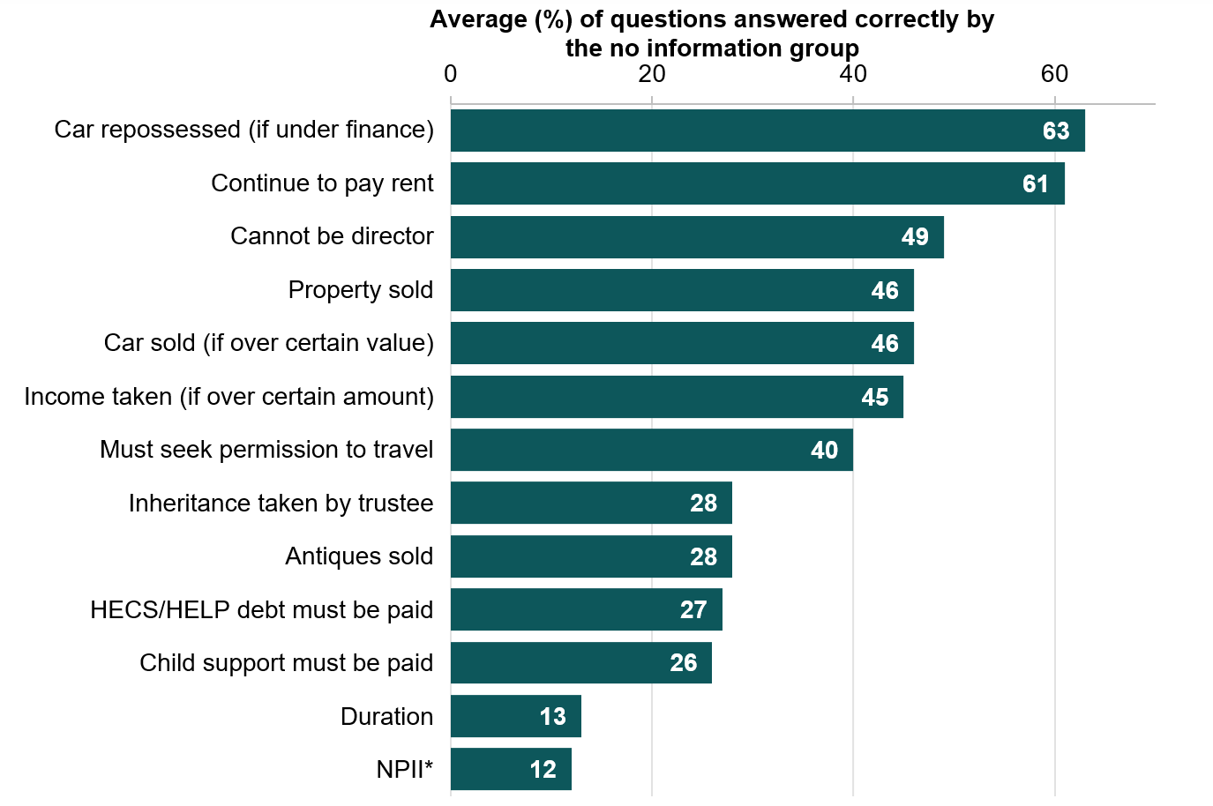
- Average scores (% correct) per question in the multiple-choice questionnaire, for the group of participants who received no information about bankruptcy. *NPII: A bankrupt person’s name is registered on the National Personal Insolvency Index forever.

People answered questions about secured debts (e.g., mortgages, cars under finance) correctly more often than questions about the duration of bankruptcy or about debts not extinguished by bankruptcy (e.g., HECS debt or child support payments). See Figure 6 for the complete list of consequences we asked participants about, and the corresponding proportions of people who answered each question correctly. This finding reveals where the general public’s knowledge regarding consequences of bankruptcy may be lacking and highlights where further educational materials could be targeted.

Discussion
The two educational tools yielding the best outcomes, the video and pop-quiz, are quite different in style and presentation format.
The video was ‘passive’ by design and did not require any action from the viewer. We suspect this approach was effective because it delivered information via different modes – with audio, imagery, text, and animations (Adesope & Nesbit, 2012) – making it more engaging and better suiting people’s varying preferences for learning. Clocking in at over three minutes in length, the video was one of the most time-intensive approaches we tested – potentially contributing to a somewhat higher drop-out rate for this tool.
Meanwhile, the pop-quiz was more ‘active’ and required relatively high levels of interaction from the user. It involved the user making their ‘best guess’ about a series of unfamiliar questions about bankruptcy, before they were provided with the correct information. The educational psychology literature (Rowland, 2014) suggests the pop-up quiz may have been effective because the effort people had to expend to come up with an initial answer made them realise they did not know much about the bankruptcy process, thus motivating them to fill gaps in their knowledge.
Overall, both the video and the pop-quiz are good approaches for teaching people about the consequences of bankruptcy. These could be incorporated into the required steps an applicant should take before applying for bankruptcy, or as educational tools on AFSA’s website.
For this trial we recruited a large sample of people from the general public, providing confidence in the robustness of these results. It also makes our findings relevant to how the Government can use a variety of approaches to inform citizens about important (and at times difficult) processes more generally.
Actual bankruptcy applicants may differ from the general public (participants in our trial) in a number of ways. For example, they may be more motivated to learn about the consequences of bankruptcy; have more pre-existing knowledge through independent research; be more stressed or overwhelmed by their financial circumstances; or have personal experience with alternative insolvency options.
While we believe this population will also benefit from information presented in video or pop-quiz formats, all these factors could influence how bankruptcy applicants engage with information about bankruptcy and the alternatives available to them. Our second project explored this by focussing on actual bankruptcy applicants, and how they responded to prompts about the consequences of bankruptcy, embedded in the bankruptcy application form itself.

Part 2:
Prompts in the online bankruptcy form

We worked with AFSA to design and implement prompts to help bankruptcy applicants complete the online bankruptcy form
Moving the bankruptcy application form online gave AFSA the opportunity to introduce timely prompts and ‘help’ text to assist people applying for bankruptcy. We worked with AFSA to design and implement 19 prompts.
The overarching aim of these prompts was to ensure applicants submitted error-free forms and understood the consequences of applying for bankruptcy. In designing the prompts, we:
- Used simple language. People applying for bankruptcy come from diverse backgrounds, and are likely to have varying levels of education and financial literacy. As much as possible, we designed prompts to be readily understood by all applicants (Bhatia, 1983; Widdowson, 1979).
- Made prompts salient. We paired prompts with attention-grabbing icons and colour-contrasting banners. This was done to minimise instances of ‘banner blindness’, where applicants gloss over the content of the prompt without engaging (Castelo, et al., 2015).
- Made prompts timely. We scheduled the prompts to appear next to a relevant question at a time when the applicant is most likely to be in need of advice (Behavioural Insights Team, 2014).
Of the 19 new prompts we introduced, 15 were ‘help’ type prompts. These prompts provided applicants with guidance on answering specific questions, or with additional information relevant to their circumstances. For example, if the applicant indicates they are over 100 years old, a prompt appears asking them to double-check their birth date.

Five ‘consequence’ prompts described what will happen to the applicant’s income, assets and liabilities after they declare bankruptcy
We also introduced five timely prompts that describe the consequences of bankruptcy. Two of the prompts were static and always visible to the applicant, while three prompts were conditional – only appearing if the applicant enters a particular value or makes a certain selection within the form. Table 2 provides a summary of these prompts.

- Consequences prompts used in the trial. This table lists questions, related prompts and prompt’s conditionality.
Question | Prompt
Give details of your unsecured debts in Australia and overseas | This prompt appears if the applicant selects a type of debt not covered by bankruptcy.  This debt may not be covered by bankruptcy and you may still have to continue to make payments to the creditor. We recommend you contact the creditor to determine if the debt will be covered by bankruptcy. (…). If these debts make up the majority of your debts please reconsider bankruptcy (…)  This prompt appears if the applicant indicates a motor vehicle accident is the source of their debt.  This debt is not covered by bankruptcy unless the money you owe has been set (for example, by court order or issued letter of demand).
Do you own any vehicles including cars, motorbikes, trailers, caravans, camper vans, boars or other means of transport? | This prompt is always visible.  During bankruptcy your trustee may sell your assets, including your vehicle. You can keep a vehicle to be used mainly for transport up to a set amount. Once the value of the vehicle exceeds this amount your trustee may claim and sell it. (…)
Do you have any interest in real estate (e.g. a house, a unit, a commercial property, block of land) whether you a registered owner or not? | This prompt is always visible.  When you become bankrupt your trustee becomes the custodian of your share of any house or property that you own. Your trustee will have control over the property and can sell it. (…)
Give details of the income you have received and expect to receive, from Australia and overseas. | The prompt appears if the applicant’s future (next 12 months) income is above $78,000.  You may be required to contribute some of your income if you are earning above the set income threshold. (…).

It is important to understanding the impact of the consequence prompts on reporting behaviour and completion rates
While prompts seem like a sensible addition to an online form, it is ultimately not clear exactly how they will influence behaviour. We expected the five consequences prompts might influence people’s behaviour in two ways:
- The prompts may encourage applicants to reconsider their need to apply for bankruptcy. For instance, one of the prompts explains how certain types of debt (e.g., HECS/HELP debt) will still need to be repaid, even after declaring bankruptcy. There may be applicants who are declaring bankruptcy largely due to these types of debt, in which case seeing this prompt may lead them to reconsider their application.
- Even if the applicants proceed with their application, their reporting behaviour may change as the result of seeing the prompts. For instance, the prompts may signal the importance of the question to the applicant, causing them to be more careful in their reporting. Alternatively, if the applicants are repeatedly reminded of adverse impacts of applying for bankruptcy the prompts could lead people to be less forthcoming in their disclosure of assets or income.
Therefore, to determine if these prompts influenced people’s decision to proceed with the application, or whether they influenced what applicants entered into the form, we ran an evaluation project.

We ran a randomised controlled trial to evaluate the impact of the five prompts on applicants’ completion rates and reporting behaviour
People applying for bankruptcy were randomly assigned to either see an application form with the five prompts (prompt group), or a version without these prompts (no-prompt group). In total our trial included 2,339 applicants who commenced the online bankruptcy application form from the day it was launched (1 October, 2020) until 8 February 2021.
To determine whether applicants reconsidered their need to apply, we measured the number of submitted forms in each group and compared the rate of completion across the two groups.
To check if applicant’s reporting behaviour was influenced by the consequence prompts, we also tracked applicants’ answers to specific questions:
- Number of vehicle and real estate assets
- Value of vehicle and real estate assets
- Income reported (for past 12 months and next 12 months).

Box 3: What is a randomised controlled trial (RCT)?

A randomised controlled trial (RCT) is the best way of telling if a policy is working.

RCTs work by randomly assigning people into different groups – usually one or more ‘treatment’ groups participate in the new intervention, and a ‘control’ group does not.

The differences in outcomes across the groups are then compared. RCTs are considered the ‘gold standard’ for assessing causal impacts because a RCT determines the impact of an intervention or treatment compared to if nothing was changed.

What we found

Additional prompts did not influence completion rates
Applicants were equally likely to complete their application form, regardless of the version of the form they saw. The completion rate was about 68% in both groups (see Figure 7), with a total of 1,606 forms completed (out of 2,339 commenced) overall in our trial.

- Completion rates in each group. Statistical analysis of completion rates excluded individuals who had been made bankrupt by the court (as these individuals do not have the option of dropping out of the process).

Conditional prompts did not influence reporting of car ownership and real estate assets
The rate of car ownership did not differ between applicants who saw the additional prompts and those who did not. Across both groups, around 850 applicants reported owning at least one vehicle (around 410 in the prompt group, around 440 in the no-prompt group). The value of the vehicles reported (around $7,000) did not differ across the groups.
Prompts did not appear to influence the number of real estate assets declared. Across both groups, 111 applicants reported owning real estate (6.5% of the submitted forms). In the prompt group, 62 people reported owning real estate, while in the no-prompt group, 49 people reported owning real estate. This difference was not statistically significant (p = 0.21), but given the overall number of people declaring any real estate assets in our trial was small, follow-up research may be warranted.

Prompts increased the amount of income reported
Prompts increased the amount of past income reported by on average around $4,000 (p = 0.03), and also increased the amount of future income reported by on average around $3,700 (p = 0.02). As we discuss in the next section, we believe these results should be interpreted with caution.

- Average amount of income reported in each group, for the past and next 12 months

Discussion
Overall, prompts highlighting the consequences of bankruptcy did not influence applicants’ reporting behaviour or discourage applicants from proceeding with their application. Based on the metrics we assessed, there is little downside to introducing these prompts. However, there were some metrics we could not assess - for example, applicants’ increased understanding of the bankruptcy process or their annoyance with seeing additional prompts. If applicants are better informed by seeing these prompts, this is likely to outweigh the negative effects (e.g., annoyance), resulting in a net positive outcome for the applicant.
It is possible prompts did not influence behaviour because applicants decide what to put into the form (or whether they should proceed with the application) before commencing the bankruptcy process. By the time they are completing the form, applicants are likely to have already made up their mind about bankruptcy being the right pathway. This finding highlights the importance of the ‘consequences tool’ in the bankruptcy application process. As the tool must be completed before the application form, it is likely to be a more timely and effective method of informing applicants about the consequences of bankruptcy.
Applicants who saw the prompts appeared to report higher levels of future and past income. This may be because the prompt made the question stand out more and appear more important, or because it raised awareness and a sense of responsibility for ensuring income estimates are as precise as possible. Given we performed a number of statistical tests without adjusting for multiple comparisons, this finding should be interpreted with caution. It does, however, confirm there was no backfire effect.

Conclusion

Most everyday Australians have limited knowledge about bankruptcy
Applying for bankruptcy is a major life decision. It is important for bankruptcy applicants to understand what the consequences of bankruptcy are, and to determine if bankruptcy is the right choice for them. We found the people we surveyed from the general public lacked critical knowledge about bankruptcy – especially about the duration, which debts are extinguished by bankruptcy and which still need to be repaid.

AFSA’s current approach to informing people about bankruptcy – using a ‘consequences tool’ and Prescribed Information – is effective
Our online experiment (with a sample drawn from the general public) tested different versions of an educational tool completed by applicants before they apply for bankruptcy. The consequences tool and Prescribed information improved people’s understanding of bankruptcy by 12 to 15 percentage points above the group receiving no educational materials.

Alternative approaches further increased people’s understanding and confidence
Two additional approaches we developed and tested in our online experiment, a video and a pop-quiz, were particularly effective in informing about the consequences of bankruptcy. AFSA already has a range of educational materials on its website (including a video) and may want to consider whether findings of the present research could inform these tools.

The best time to inform people about the consequences of bankruptcy is likely to be before they attempt the application form
Based on results from our second project – a randomised controlled trial (RCT) with bankruptcy applicants – using prompts to embed advice in the form itself does not make people reconsider their need to apply, and does not generally influence their reporting behaviour. However, there may be other benefits to including prompts, such as improving understanding, which we did not capture in this evaluation.

Given the lack of adverse findings, there is little downside to including prompts within the application form
Despite the finding from our RCT where prompts did not influence applicants’ reporting behaviour or completion rate, there was no evidence of backfire effects and prompts may provide value to the applicant. If income and real estate assets are of continued interest, AFSA may wish to continue tracking these metrics.

These findings have broader implications for delivery of Government services
More broadly, the results from these projects, in particular those from the consequences tool trial, provide useful information on how public service organisations may communicate with their clients to maximise understanding.

Technical Appendix
Clearer consequences
July 2021

Contents
Appendix 1: Part 1 Technical Details 25
Appendix 2: Part 1 Statistical Tables 31
Appendix 3: Part 1 Survey Instrument 44
Appendix 4: Part 2 Technical Details 59
Appendix 5: Part 2 Statistical Tables 63
References 66

Appendix 1:
Part 1 Technical Details

Pre-registration, pre-analysis plan, and ethics
This trial was publicly pre-registered on the AEA registry, record number AEARCTR-007302. The pre-registration plan was also documented on the BETA website. Registration took place before we launched the trial or analysed the data. Our analyses were consistent with our pre-analysis plan. The pre-analysis plan is published on the BETA website as a supplement to the report.
The project was approved through BETA’s ethics approval process, with risk assessed by Macquarie University in accordance with the guidelines outlined in the National Statement on Ethical Conduct in Human Research.

Population and sampling
Our population of interest was all Australian adults. We did not define our population as those at risk of or going through bankruptcy as the tool was designed to communicate the consequences of bankruptcy to anyone. We recruited participants who were aged 18+ and below 65. These were the only inclusion criteria. There is no age limit on going bankrupt, but we required participants to be older than 18 so they could consent to participate in the study.
Our sample was recruited by Dynata, who incentivised participants. Dynata describe their incentivisation process as follows: ‘Panellists are rewarded for taking part in surveys according to a structured incentive scheme, with the incentive amount offered for a survey determined by the length and content of the survey, the type of data being collected, the nature of the task and sample characteristics. (…) All incentives are awarded only once the survey has been completed. The incentive options allow panellists to redeem from a large range of gift cards, points programs, charitable contributions, and partner products or services.’
We recruited with interlocking quotas on age (18-34, 35-49, and 50-64) and gender, in order to have a broadly nationally representative sample on these dimensions. We also aimed to match national proportions for locations (metropolitan vs regional) and employment status (employed vs unemployed). We administered the quotas in-house using the online Qualtrics survey platform.
Our target was a sample of 6,600 participants. We obtained 7,612 participants, and after exclusions and drop-outs our final sample size was 6,566. (See ‘Drop outs’ section below for discussion of drop-outs.) The sample was close to nationally representative on our quota variables. Demographics of the sample are included in Table 3.

- Sample characteristics
Category |  | Number (%)
Gender | Women | 3232 (49)
 | Men | 3288 (50)
Age | Younger (18-34 years) | 2547 (39)
 | Middle (35-49 years) | 2142 (33)
 | Older (50-64 years) | 1858 (28)
Location | Australian Capital Territory | 154 (2)
 | New South Wales | 2115 (32)
 | Northern Territory | 41 (1)
 | Queensland | 1258 (19)
 | South Australia | 510 (8)
 | Tasmania | 182 (3)
 | Victoria | 1695 (26)
 | Western Australia | 581 (9)
Income | Low (under $10,000) or prefer not to say | 270 (4)
 | Below median ($10,000-$49,999) | 1668 (25)
 | Median and above ($49,000 or more) | 3617 (55)
Employment status | Full-time | 3624 (55)
 | Part-time | 1261 (19)
 | Self-employed | 415 (6)
 | Casual | 419 (6)
 | Home duties | 165 (3)
 | Retired | 142 (2)
 | Not employed or other | 699 (11)
Note: Proportions do not all sum to 100% as not all individuals responded to all questions, and a number of “other” and “prefer not to say” responses are excluded from this table. N = 6,566

Randomisation and balance checks
Using the Qualtrics survey platform we randomly allocated participants to one of the seven cells in the experiment (pure control, active control, business-as-usual, and four new intervention conditions – see Table 4). Participants initially had equal probability of being assigned to each cell, but Qualtrics increased the probability of assignment to the cell with the lowest sample size to ensure even cell sizes.
Randomisation was stratified by the device participants used to access the survey. If participants were not on a mobile device, they were randomised as described above. Because the “roadmap” intervention would not function as intended on a mobile device, those accessing the survey on a mobile device were assigned to one of six cells (excluding the roadmap condition).
The final sample size of each cell except the roadmap condition ranged from 922 to 1073 participants. The roadmap intervention had a final sample size of 465. The characteristics of the sample in each cell are summarised in Table 4.

Sample size and power calculations
These power calculations were originally reported in our pre-analysis plan. We estimated that with 940 participants per cell, this trial had power to detect a minimum effect size of 0.14 (Cohen’s d) in our primary analyses (H1), assuming 90% power and alpha = .05. Our realised sample came close or exceeded this sample size estimate for all experimental arms besides the roadmap arm. For H2 and H3 we conducted sensitivity analyses for a range of power values (80%-95%). See pre-analysis plan for further details.

Outcome measures
The primary outcome measure was comprehension of the consequences of bankruptcy, assessed using a 13-question multiple-choice questionnaire administered after the intervention. We calculated the percentage correct as our primary outcome measure.
Our pre-analysis plan did not specify how we would treat skipped items on the primary outcome measure. The method of calculation (of percent correct) given in the pre-analysis plan implied that skipped items would be treated as incorrect. This is what we did. Overall, there were very few skipped items.
The secondary outcome measure was participants’ confidence that they understand the consequences of bankruptcy (6-point scale from 0 = not at all confident, to 5 = completely confident).
See pre-analysis plan for further details on outcome construction.

Pilot
Prior to the main trial, we conducted a small pilot (n = 450) with three trial arms: pure control, current consequences tool, and Prescribed Information. Participants were also randomly assigned to have an “I don’t know” option, or not, in the outcome measure questionnaire. The purpose of the pilot was to pre-test the outcome measure for length and difficulty, to examine the impact of including an “I don’t know” option, to gather preliminary data on the impact of the Prescribed Information (informing whether we would include it in the main study) and to check for any problems with other aspects of the survey (including length, and subjective measures). Participants were recruited by Dynata, as for the full trial. On the basis of the pilot results, we decided to retain all 13 questions in the outcome measure, to give all participants an “I don’t know” option, and to include the Prescribed Information, in the full trial. We did not make any other changes on the basis of the pilot. People who participated in the pilot were not able to complete the full trial, and we did not include these participants in the main analyses.
- Sample characteristics by treatment condition
 | Condition | Control | Current tool | Prescribed Information | Video | Pop-quiz | Personal-ised profile | Roadmap
 | N | 1073 | 1016 | 1020 | 922 | 1048 | 1022 | 465
Gender | Men | 524  (49%) | 495  (49%) | 510  (50%) | 469 (51%) | 519 (50%) | 509  (50%) | 262  (56%)
 | Women | 542  (51%) | 510  (50%) | 500  (49%) | 451 (49%) | 522 (50%) | 506  (50%) | 201  (43%)
Age | Younger | 414  (39%) | 423  (42%) | 401  (39%) | 345 (37%) | 434 (41%) | 389  (38%) | 141  (30%)
 | Middle | 347  (32%) | 326  (32%) | 327  (32%) | 313 (34%) | 315 (30%) | 343  (34%) | 171  (37%)
 | Older | 308  (29%) | 261  (26%) | 288  (28%) | 263 (29%) | 298 (28%) | 289  (28%) | 151  (32%)
Location | VIC | 269  (25%) | 286  (28%) | 271  (27%) | 230 (25%) | 244 (23%) | 271  (27%) | 124  (27%)
 | NSW | 347  (32%) | 316  (31%) | 318  (31%) | 312 (34%) | 367 (35%) | 297  (29%) | 158  (34%)
 | QLD | 215  (20%) | 187  (18%) | 187  (18%) | 175 (19%) | 208 (20%) | 196  (19%) | 90  (19%)
 | Other | 236  (22%) | 223  (22%) | 238  (23%) | 200 (22%) | 225 (21%) | 253  (25%) | 93  (20%)
Personal income | <$10,000/pre-fer not to say | 44  (4%) | 42  (4%) | 46  (5%) | 38  (4%) | 38  (4%) | 52  (5%) | 10  (2%)
 | Below median (<$49,999) | 255  (24%) | 259  (25%) | 268  (26%) | 242 (26%) | 280 (28%) | 251  (25%) | 113  (24%)
 | Median and above ($49,000+) | 600  (56%) | 561  (55%) | 527  (52%) | 510 (55%) | 569 (54%) | 573  (56%) | 277  (60%)
Device | Mobile | 475  (44%) | 448  (44%) | 440  (43%) | 375 (41%) | 461 (44%) | 444  (43%) | -
 | Non-mobile | 579  (54%) | 549  (54%) | 562  (55%) | 535 (58%) | 569 (54%) | 559  (55%) | 462  (100%)
Knowledge | Nothing | 244  (23%) | 233  (23%) | 255  (25%) | 190 (21%) | 243 (23%) | 234  (23%) | 86  (18%)
 | A little bit | 450  (42%) | 415  (41%) | 395  (39%) | 392 (43%) | 428 (41%) | 425  (42%) | 199  (43%)
 | A medium amount | 214  (20%) | 226  (22%) | 222  (22%) | 195 (21%) | 225 (21%) | 213  (21%) | 104  (22%)
 | A lot | 124  (12%) | 113  (11%) | 125  (12%) | 112 (12%) | 135 (13%) | 122  (12%) | 63  (14%)
 | Everything there is to know | 39  (4%) | 29  (3%) | 22  (2%) | 31  (4%) | 17  (2%) | 26  (3%) | 13  (3%)

Hypotheses
In our pre-analysis plan, we specified three hypotheses in relation to our primary outcome. These hypotheses related to comparisons between different trial arms. We report the results relevant to all these hypotheses in the main report, and the full regression outputs in Tables 5-15 in Appendix 2: Statistical Tables.
H1: Comprehension scores in the active control (prescribed information) and BAU (current tool) conditions will be higher than the score in the pure control group. (Compared separately.)
H2: Comprehension scores will differ between the current consequences tool (BAU) group compared to the current prescribed information (active control) group. Scores will also differ between the individual intervention groups compared to the current prescribed information group. (Compared separately.)
H3: Scores will differ between individual intervention groups compared to the current consequences tool. (Compared separately.)

Method of analysis
All data processing and analysis was performed using R (version 4.0.3, R Core Team, 2020) with the dplyr package (version 1.0.3; Wickham, François, Henry & Müller n.d.) in R Studio (RStudio Team, 2020).
As stated in our pre-analysis plan, all analyses used ordinary least squares regression with HC2 robust standard errors, using the ‘estimatr’ package from the DeclareDesign suite (version 0.24.0, Blair, Cooper, Coppock & Humphreys 2019). We estimated the following
$$Y_{i}=β_{0}+ β_{1}Z_{i}+ β_{2}X_{i}+ β_{3}{Z_{i}X}_{i}+ ∈_{i}$$
Where $i$ is an index for each individual in the trial, $Y$ is the percentage of correct answers by individual $i$ on the comprehension test,$β_{0}$ is the intercept, $Z$ is the treatment indicator (where 0 is the reference group and 1 is the group being contrasted),$β_{1}$ is the coefficient on treatment and represents the average treatment effect for a given contrast, $X$ is a vector of mean centred variables that includes an ordinal (but treated as continuous in this model) covariate of baseline self-reported bankruptcy knowledge and a block indicator for mobile device vs non-mobile device, $ZX$ is the interaction of this vector with the treatment indicator, and $∈$ is the error term.
For the primary outcome measure we conducted 11 comparisons (two for H1, five for H2, four for H3). All comparisons used the model specified above. We fitted this model to data from the relevant subset of participants for each comparison. For the two comparisons involving the roadmap condition (vs prescribed information, and vs current consequences tool), we only analysed the subset of participants who completed the study on non-mobile devices, and did not include the binary block indicator in the model. Full results are provided in Tables 5-11 in Appendix 2: Part 1 Statistical Tables.
As per our pre-analysis plan, we did not adjust for multiple comparisons. However, we did take multiple comparisons into account when interpreting our findings.
We performed randomisation checks after launch (n = ~100); and closer to completion (n = ~5000) we also checked the data quality. This revealed approximately 100 free-text responses that suggested bots were completing the study. We alerted Dynata, and they replaced these respondents. We did not analyse the outcome measures until after the data collection was completed. We conducted robustness checks by analysing the data both with and without these respondents. The results reported in the main report include these strange responses, as we did not pre-register any exclusions. The results are robust to removing these responses.

Use of p-values
We have made use of p-values to aid the interpretation of our results. However, we also consider the p-value together with effect size, robustness checks and design limitations to assess the strength of a finding.

Drop-out rates
We anticipated that we would have higher drop-out rates from the roadmap condition than the others (due to the set-up, see Appendix 3: Part 1 Survey instrument). Indeed, this is what we found. The drop-out rate on average across all conditions was 9.1%, but this was quite unevenly distributed. In addition to high drop-out rates in the roadmap condition (22.5%), we had a relatively large number of people dropping out of the video condition (15.1%). The control condition (3.7%) and the pop-quiz condition (5.4%) had the lowest drop-out rates.

Appendix 2:
Part 1 Statistical Tables
The following statistical tables provide the full set of results underpinning the findings presented in the main body of the report.

Primary outcome measure
The primary outcome measure was comprehension of the consequences of bankruptcy (operationalised as per cent correct on a 13-question multiple-choice questionnaire).
Table 5 shows the percentage correct in each condition. These means (and standard deviations, SD) are unadjusted, adjusted means are provided in Tables 6-11 below.
- Percent correct in each intervention condition
 | Condition | N | Percent correct (SD)
New interventions | Video | 922 | 63.7 (26.0)
 | Pop-quiz | 1048 | 63.9 (26.0)
 | Personalised profile | 1022 | 50.2 (26.6)
 | Roadmap | 465 | 51.5 (27.3)
Business-as-usual | Current consequences tool | 1016 | 52.4 (27.3)
Active control | Prescribed information | 1020 | 49.2 (23.6)
Pure control | - | 1073 | 37.3 (21.0)

For each comparison of interest, we subsetted the sample to the two relevant intervention arms, and fitted an OLS model with robust standard errors (see Appendix 1 Method of Analysis for details). The results are summarised in Tables 6-11 below. The sample sizes reported below are slightly smaller than in Table 5 above, because if there were missing values on the covariates (device type and knowledge), these cases were dropped from the analyses.
Unless otherwise specified, p-values are two-tailed. For one-tailed p-values we only report one side of the confidence interval.

Comparing prescribed information and current consequences tool to pure control
Our first hypothesis involved comparing the prescribed information (active control) and the current consequences tool (business as usual) to pure control. This hypothesis was directional and accordingly we used one-tailed tests. Results are summarised in Table 6 below.
- Effect of prescribed information and consequences tool (compared to control) on comprehension; H1
Group | N | Percent correct | Difference from control (95% CI) | p-value  (one-tailed)
Control | 1052 | 37.3 | - | -
Prescribed Information | 1001 | 48.8 | 11.6 (9.6 – INF) | <.0000001
Current consequences tool | 997 | 52.2 | 14.8 (12.7 – INF) | <.0000001

Comparing prescribed information to current consequences tool
Our second comparison was between the current consequences tool and the prescribed information. This comparison is summarised in Table 7.
- Effect of prescribed information (compared to current consequences tool) on comprehension; H2a
Group | N | Percent correct | Difference from reference (95% CI) | p-value
Current consequences tool | 997 | 52.2 | - | -
Prescribed Information | 1001 | 48.8 | -3.3 (-5.6 – -1.1) | .004

Other interventions
In the tables below, we compare each of the new interventions to the prescribed information (Table 8) and to the current consequences tool (Table 9). For the new Roadmap intervention, the reference group is smaller (non-mobile devices only); this intervention is therefore presented in a separate table (Table 10 compared to prescribed information, Table 11 compared to current tool). As noted in the report, the video and the pop-quiz had the biggest impact on understanding.
- Effect on comprehension of three new interventions (video, pop-quiz, personalised profile) compared to prescribed information, H2b
Group | N | Percent correct | Difference from reference  (95% CI) | p-value
Prescribed Information | 1001 | 48.8 | - | -
Video | 908 | 63.8 | 15.0 (12.7 – 17.2) | <.0000001
Pop-quiz | 1030 | 63.9 | 15.1 (12.9 – 17.2) | <.0000001
Personalised profile | 1001 | 50.1 | 1.3 (-1.0 – 3.5) | .269

- Effect on comprehension of three new interventions (video, pop-quiz, personalised profile) compared to current consequences tool, H3
Group | N | Percent correct | Difference from reference  (95% CI) | p-value
Current consequences tool | 997 | 52.2 | - | -
Video | 908 | 63.7 | 11.5 (9.1 – 13.9) | <.0000001
Pop-quiz | 1030 | 63.9 | 11.7 (9.4 – 14.0) | <.0000001
Personalised profile | 1001 | 50.1 | -2.1 (-4.5 – 0.3) | .087

Roadmap
The roadmap intervention could only be accessed on non-mobile devices. Therefore, the results in the roadmap condition are only compared to results on non-mobile devices in other conditions. This changes the adjusted marginal means compared to earlier whole of sample comparisons, and reduces the sample size substantially for these analyses.
- Effect of roadmap (compared to prescribed information) on comprehension
Group | N | Percent correct | Difference from reference (95% CI) | p-value
Prescribed Information | 561 | 48.2 | - | -
Roadmap | 462 | 51.2 | 3.0 (-0.1 – 6.2) | .061
- Effect of roadmap (compared to current consequences tool) on comprehension
Group | N | Percent correct | Difference from reference (95% CI) | p-value
Current consequences tool | 549 | 53.6 | - | -
Roadmap | 462 | 51.2 | -2.4 (-5.8 – 1.0) | .165

Picking a winner
We also preregistered that we would “pick a winner” by comparing the new interventions to each other. Given the point estimates above, we decided not to do this, because it was clear enough that the video and the pop-quiz performed the best (on the primary outcome measure).

Secondary outcome measure
Our secondary outcome measure was self-reported confidence (on 6-point scale): “How confident are you that you understand the consequences of bankruptcy?”
We conducted the same analyses for this measure as for the primary outcome measure. Results are summarised in Tables 12-18 below.
- Mean confidence (unadjusted) in each condition
 | Condition | N | Mean (SD)
New interventions | Video | 922 | 4.5 (1.1)
 | Pop-quiz | 1048 | 4.5 (1.1)
 | Personalised profile | 1022 | 4.0 (1.3)
 | Roadmap | 465 | 4.2 (1.3)
Business-as-usual | Current consequences tool | 1016 | 4.1 (1.3)
Active control | Prescribed information | 1020 | 3.9 (1.3)
Pure control | - | 1073 | 3.3 (1.6)
- Effect of prescribed information and current consequences tool (compared to control) on confidence
Group | N | Confidence | Difference from control (95% CI) | p-value  (one-tailed)
Control | 1052 | 3.25 | - | -
Prescribed Information | 1000 | 3.94 | 0.69 (0.58 – INF) | < .00001
Current consequences tool | 996 | 4.05 | 0.79 (0.69 – INF) | < .00001
- Effect of prescribed information (compared to current consequences tool) on confidence
Group | N | Confidence | Difference  from reference  (95% CI) | p-value
Current consequences tool | 996 | 4.05 | - | -
Prescribed Information | 1000 | 3.94 | -0.11 (-0.21 – -0.01) | .036

- Effect on confidence of three new interventions (video, pop-quiz, personalised profile) compared to prescribed information
Group | N | Confidence | Difference  from reference  (95% CI) | p-value
Prescribed Information | 1000 | 3.95 | - | -
Video | 908 | 4.46 | 0.50 (0.40 – 0.60) | < .00001
Pop-quiz | 1030 | 4.51 | 0.58 (0.48 – 0.67) | < .00001
Personalised profile | 1000 | 3.97 | 0.03 (-0.07 – 0.13) | .574
- Effect on confidence of three new interventions (video, pop-quiz, personalised profile) compared to current consequences tool
Group | N | Confidence | Difference  from reference  (95% CI) | p-value
Current consequences tool | 996 | 4.07 | - | -
Video | 908 | 4.46 | 0.39 (0.30 – 0.49) | < .00001
Pop-quiz | 1030 | 4.52 | 0.47 (0.37 – 0.56) | < .00001
Personalised profile | 1000 | 3.97 | -0.08 (-0.18 – 0.03) | .137
- Effect of roadmap (compared to prescribed information) on confidence
Group | N | Confidence | Difference  from reference  (95% CI) | p-value
Prescribed Information | 561 | 4.09 | - | -
Roadmap | 462 | 4.13 | 0.04 (-0.11 – 0.18) | .622
- Effect of roadmap (compared to current consequences tool) on confidence
Group | N | Confidence | Difference  from reference  (95% CI) | p-value
Current consequences tool | 549 | 4.20 | - | -
Roadmap | 462 | 4.14 | -0.06 (-0.21 – 0.08) | .392

Exploratory analyses

Additional confidence measures
We collected two additional confidence measures: confidence in knowing where to find more information, and confidence in general (financial decisions). We did not pre-register any analyses of these measures, but the results are similar to those for confidence in understanding the consequences (compare Table 19 to Table 12). It’s interesting to note that confidence in where to find more information was relatively high in the roadmap condition – perhaps because people in this intervention condition were taken to a website with an AFSA heading (see Appendix 3 for details).
- Mean confidence in where to find more information, and general financial matters.
 | Condition | N | Mean ‘where’ confidence (SD) | Mean general confidence (SD)
New interventions | Video | 922 | 4.7 (1.1) | 4.6 (1.1)
 | Pop-quiz | 1048 | 4.4 (1.2) | 4.5 (1.1)
 | Personalised profile | 1022 | 4.2 (1.3) | 4.3 (1.2)
 | Roadmap | 465 | 4.6 (1.1) | 4.5 (1.2)
Business-as-usual | Current consequences tool | 1016 | 4.3 (1.2) | 4.3 (1.3)
Active control | Prescribed information | 1020 | 4.2 (1.3) | 4.2 (1.2)
Pure control | - | 1073 | 3.6 (1.6) | 4.1 (1.3)

Ratings
We also asked participants to rate the tool/information presented to them on a set of five bipolar scales:
- Easy-difficult
- Interesting-boring
- Reassuring-distressing
- New-nothing new
- Clear-confusing
The rating scale was from 1-6, with lower numbers being more positive.
We have not compared the interventions statistically, because the overall ratings looked so descriptively similar. The ratings are summarised in Table 20 below, and the general pattern – prescribed information performing worst, video and pop-quiz best – appears to hold. (Participants in the pure control condition did not complete these measures.)

- Ratings of the interventions, in each intervention condition. Lower numbers are more positive.
Rating | Easy-difficult | Interesting-boring | Reassuring-distressing | New- nothing new | Clear-confusing
Condition | Mean (SD) | Mean (SD) | Mean (SD) | Mean (SD) | Mean (SD)
Current consequences tool | 2.4 (1.4) | 2.6 (1.4) | 2.9 (1.3) | 2.4 (1.4) | 2.4 (1.4)
Prescribed information | 2.6 (1.4) | 2.8 (1.5) | 3.1 (1.3) | 2.5 (1.5) | 2.5 (1.4)
Personalised Profile | 2.5 (1.4) | 2.6 (1.4) | 3.0 (1.3) | 2.4 (1.4) | 2.5 (1.4)
Pop-quiz | 2.2 (1.4) | 2.4 (1.4) | 2.8 (1.3) | 2.3 (1.4) | 2.2 (1.4)
Roadmap | 2.6 (1.5) | 2.6 (1.4) | 3.0 (1.3) | 2.5 (1.4) | 2.6 (1.5)
Video | 2.3 (1.4) | 2.5 (1.4) | 2.8 (1.4) | 2.2 (1.4) | 2.4 (1.4)

Timing
In Table 21 below we summarise the time taken on the study, and, within each condition, the correlation between the time taken (in seconds) and the participants’ percentage correct. Note that people who spent longer than 30 minutes on the study are excluded from these analyses (making the means slightly lower than they otherwise would be, and potentially inflating the correlation somewhat). In general, people who spent longer on the study also did better on the outcome measure; all correlations were statistically significant. Note, however, that that this relationship isn’t necessarily causal. People who took longer and scored better may have been more conscientious or financially literate in general.
- Time taken (in minutes) by intervention condition, and the correlation between time taken and per cent correct on the outcome measure. All correlations were significant at p < .05.
Condition | Mean (SD) | Correlation
Control | 5.40 (3.8) | 0.12
Current consequences tool | 7.73 (4.8) | 0.37
Prescribed information | 7.78 (4.9) | 0.34
Personalised Profile | 8.16 (4.6) | 0.30
Pop-quiz | 8.07 (4.6) | 0.35
Roadmap | 9.28 (5.8) | 0.28
Video | 9.94 (3.9) | 0.19

Analysis by item
The outcome measures contained 13 multiple-choice questions. Some of these questions were more difficult than others. Table 22 summarises percentage correct for each item, split by condition, in the full trial. The table is organised from hardest (in pure control condition) to easiest. Generally, the hardest items improved the most when an intervention was received.
- Per cent correct for each item in the outcome measure questionnaire, by intervention condition.
Condition | Control | Pre-scribed infor-mation | Current consequ-ences tool | Road-map | Person-alised Profile | Video | Quiz
Questions | Per cent correct | Per cent correct | Per cent correct | Per cent correct | Per cent correct | Per cent correct | Per cent correct
Sam goes bankrupt. For how long will Sam's name be registered and publicly available on the National Personal Insolvency Index (NPII)? | 12 | 33 | 33 | 35 | 30 | 59 | 40
Alex is thinking of applying for bankruptcy. She has been told bankruptcy lasts for 5 years and 1 day. Is this correct? | 13 | 11 | 37 | 41 | 40 | 59 | 54
Brad is divorced. He makes child support payments to his wife, who looks after his two young children. If Brad goes bankrupt, will he still have to pay child support? | 26 | 43 | 43 | 41 | 38 | 56 | 61
Matt is considering applying for bankruptcy. He has a HECS/HELP debt from when he did an undergraduate degree. What will happen to Matt’s HECS/HELP debt if he goes bankrupt? | 27 | 33 | 35 | 44 | 42 | 60 | 58
Ingrid has been bankrupt for 6 months. Her mother has just passed away and left her $30,000 in her will. What does Ingrid have to do? | 28 | 46 | 48 | 46 | 47 | 67 | 58
Michael lives in a rented apartment, but owns his fridge, washing machine, TV, and an antique dresser worth $20,000. If Michael goes bankrupt, what will happen to his belongings? | 28 | 48 | 48 | 39 | 50 | 45 | 39
Ashley went bankrupt 2 years ago, and now wants to travel to New Zealand to visit friends. What will Ashley need to do before traveling? | 40 | 58 | 59 | 59 | 54 | 73 | 78
Ali goes bankrupt. A few months later he finds a part-time job. Ali has a 5-year old child. What will happen to his income? | 45 | 60 | 59 | 57 | 54 | 69 | 66
Karen owns a house. There is no mortgage. Then she goes bankrupt. What will happen to her house? | 46 | 62 | 61 | 60 | 53 | 69 | 74
Phil bought a car just before he went bankrupt. He paid for the car outright. What will happen to his car? | 46 | 50 | 62 | 54 | 58 | 52 | 78
Seamus is a director of a plumbing company. Will he be able to continue as a director if he becomes bankrupt? | 49 | 59 | 56 | 60 | 59 | 69 | 74
Eleanor is renting her apartment. Then she goes bankrupt. Does she still have to pay rent? | 61 | 64 | 67 | 62 | 61 | 69 | 70
Sarah goes bankrupt. She still owes money on her car. Does she have to keep paying the finance company? | 63 | 67 | 68 | 67 | 63 | 76 | 78

Free text
At the end of the study we also asked participants a number of open-ended questions, to gain additional information about their opinions and attitudes. We undertook an informal analysis of responses to these questions, summarised below.

Where, or from whom, do you normally seek advice on financial matters? [free text response]
We asked people from where they got their financial advice. There were around 5,300 interpretable responses to this question. The most common source of financial advice was some sort of finance professional (including financial advisor, bank, broker, tax agent, superannuation fund, and undefined professionals or experts) or legal professional – with a total of around 2,200 people giving this response.
Another 1,300 people (approximately) indicated that they spoke to friends, family, or colleagues, and around 750 people mentioned websites (including google), social media, podcast, books, or other publications. Government sources (including websites) were only mentioned specifically by around 100 people.
It seems this question was interpreted by some respondents as referring to more official sources, as around 800 people said they rely on their own knowledge, do their own research, or don’t seek advice.
We have not conducted any formal analyses of these responses, and where respondents gave more than one answer, we only counted the first.

Please tell us what you [liked/disliked] the most about the way information was presented in Part 2 of this study.
These were open-ended questions and many people skipped them, or entered random characters. Despite this, some consistencies could be observed, summarised below. We have not categorised and counted precisely which comments were most common; this summary should be treated as exploratory.
Regardless of intervention arm, the things people said they liked were that the tools were clear, concise, easy to understand, informative, and simple to use. There were some minor qualitative differences between the interventions, and below we’ve highlighted the unique positives that appeared to be associated with each intervention:
- Prescribed information: The positive comments in this condition focused on the clear language, that it was well-written, and that there was good use of bullet points and bolding.
- Consequences tool: In addition to finding it clear, short, and easy to understand, many respondents commented on the way the tool provided relevant, relatable, or tailored feedback.
- Video: Many respondents commented on and appreciated the visual and auditory aspects of the video. They said the voice-over was clear, and that the animations were good and appropriately simple (not overwhelming). A number of respondents were also impressed by how much information was covered, in a short amount of time.
- Pop-quiz: For this intervention, the positive comments that stood out was that respondents found it “kind of fun” and “engaging”. They appreciated that it provided immediate feedback, and clear explanations of the answers. A number of respondents also said it “made them think”.
- Roadmap: Fewer people responded to this question in the roadmap intervention, and some had technical difficulties accessing it. Those who were able to access it as intended, said that they liked the headings and layout, and the way it was set out in “chunks”.
- Personalised profile: Many respondents commented that they liked the way this intervention was tailored to the answers they had provided, and that the information was related to their individual circumstances. A number of people also commented on the pictures and graphics, and found it interesting and informative overall.
Roughly, the same number of people provided a response to what they disliked as what they liked. The things people disliked about the interventions were on the whole the opposite to the things people liked. They said that the tools were confusing, too long, dense, or hard to read/use. In all interventions except the video, some respondents said they would have liked images, animation, or audio to support the text/tools. In all interventions except the pop-quiz, many respondents requested more examples. Finally, a number of people in each intervention also commented that the main thing they disliked was the subject matter – they found it sad, confronting, or anxiety provoking to read about bankruptcy. Below we’ve again highlighted the unique drawbacks identified in each intervention:
- Prescribed information: A specific complaint about this intervention was the excessive use of the word “may.” (Note: Only three people mentioned this, but it stood out.) As expected, it was also seen as dense, boring, and dry, and suggestions for improvement included defining key terms, and breaking it over multiple pages.
- Consequences tool: Some people found this intervention to be boring, and wanted more information. We didn’t uncover any particular dislikes that were unique to this presentation format.
- Video: Respondents generally liked the video, but some found the voice too fast, the video too long, and wanted to take it at their own pace. (However, one person noted that they could pause the video whenever they needed time to think.) Four people also expressed some concern that the animations were too “childish” for such a serious topic.
- Pop-quiz: The things people disliked about the pop-quiz were how the information was a bit “random”, “almost too simple”, and “not in depth enough”. One person mentioned that they “didn’t feel fulfilled”. They also thought it was repetitive. This could be because of the (relative) lack of structure to the (short) set of pop-quiz questions.
- Roadmap: A common complaint in this intervention was that respondents wanted more information, but found the webpage unresponsive. This is likely to be a limitation of the study design, rather than of the tool itself (i.e., as it would be implemented on an AFSA webpage). Many respondents also thought specific examples would be useful.
- Personalised profile: Complaints about this intervention were mostly to do with the layout, colour, and a perceived lack of detail. A few people said they found it repetitive, and one person said “I don’t like it when uncertain terms like “probably” are used”.

Is there anything else you would like to know about bankruptcy? If so, please tell us below!
The additional things people said they would like to know about bankruptcy were similar across all conditions (and only a small proportion of the respondents gave an answer to this question). The things people said they would like to know were mostly outside the scope of the consequences tool.
The additional information requested can be grouped as follows:
- The benefits to bankruptcy, or why would someone choose this option: Are there circumstances where it’s a good thing? When should you consider voluntary bankruptcy? Is there a benefit? Why do people do it? “It must be viable for some and is there a kind of formula for working out if it is/isn’t the right thing for you?” One person asked what the minimum debt would be, for bankruptcy to be an option.
- What are the alternatives, or how to avoid bankruptcy: “Bankruptcy as I understand it would be a last resort, what are the steps people should take to get help and to understand the implications before bankruptcy?” What are the alternatives? How to avoid bankruptcy? How to prevent it?
- Where to get help, how to apply: Pragmatic step-by-steps (“how do you apply”), as well as where to get help with the mental health impacts.
- What are the impacts on family: Does debt go to your family? What happens if you die? Are your children liable for your debts? How does it affect children of bankruptees? Does it affect your partner’s financial situation?
- What are the impacts on the (family) home: Can the trustee sell your live in home, and not just investments? How can you keep the family home if you do go bankrupt? Will you get help finding affordable housing if your home is sold?
- What happens afterwards? In particular, impact on availability of credit, and on belongings. Why is your name listed forever? How many times can you declare bankruptcy? What is the impact on future home ownership.
- Specifics: Impact on Superannuation; life stories of people who become bankrupt; who is the trustee; the rights of creditors; costs involved; what happens if you don’t tell the trustee; is your passport taken away?

Appendix 3: Part 1 Survey Instrument
The survey instrument consisted of three parts:
- Part 1: the screener, containing background information (consent form), a few demographic question, and randomisation
- Part 2: the intervention, which differed depending on condition; and those in pure control condition skipped this
- Part 3: the outcome measures
Parts 1 and 3 are reproduced verbatim below. We’ve also provided screenshots of the different interventions (for Part 2), to give an impression of how the interventions differed.

Part 1: Screener
The full text of the screener is included below. Where response options were quite verbose, we have summarised the options in square brackets.
Page 1
This study has three parts:
- A few questions about you, to find out if you are eligible to participate
- Learning about the consequences of bankruptcy
- Answering questions about the consequences of bankruptcy
The whole study should take around 15 minutes.
Thank you for participating!
If reading or thinking about bankruptcy causes distress or discomfort, please remember that you do not need to participate, and you can exit the study at any time.
Page 2
What is your age?
[Response options were Under 18, 18-24, then five-year spans until 60-64, then 65+. We also included the option “prefer not to say”]
What is your gender?
- Male (1)
- Female (2)
- Non-binary / third gender (3)
- Prefer not to say (4)

Which of the following best describes your current employment status?
- Working full time (1)
- Working part time (2)
- Working casually (3)
- Self-employed / Business owner (4)
- Not currently working / unemployed (5)
- Student (6)
- Retired (7)
- Home duties including caring for others (8)
- Unable to work due to illness, disability or impairment (9)
- Other (please specify) (10) [open text box]

What is your personal annual income from all sources (before tax)? If you are unsure, your best guess will be fine.
[Response options were “Under $6,000” “$6,000-$9,999,” then increased by $5,000 increments until $50,000. After that, each response option increased by $10,000 increments until $100,000, then by $20,000 increments until “$150,000 or more.”]
Where do you live?
- Greater Melbourne (1)
- Elsewhere in Victoria (2)
- Greater Sydney (3)
- Elsewhere in NSW (4)
- Greater Brisbane (5)
- Elsewhere in Queensland (6)
- Greater Hobart (7)
- Elsewhere in Tasmania (8)
- Greater Perth (9)
- Elsewhere in Western Australia (10)
- Greater Adelaide (11)
- Elsewhere in South Australia (12)
- Greater Darwin (13)
- Elsewhere in Northern Territory (14)
- Australian Capital Territory (15)
[These response options were recommended by Dynata, to create metro-regional soft quotas]
How much do you currently know about the consequences of bankruptcy?
- Nothing (1)
- A little bit (2)
- A medium amount (3)
- A lot (4)
- Everything there is to know (5)

Please click next to continue. If you are eligible, you will be automatically directed to Part 2 of the study.

Page 3
[The following paragraph prepared participants for what they would be asked to do in Part 2. As it was presented to participants after they had been randomised to a condition, the word “tool” in the following paragraph was replaced with “website”, “text”, or “video”, as appropriate for a given condition. The text provided to those in the pure control is in the next paragraph.]
You are about to start the second, most important, part of the study.
In Part 2, you will learn about the consequences of bankruptcy. When you click 'next', you will be redirected to a "tool" that explains the consequences of bankruptcy. Please use the tool to learn as much as you can about the consequences of bankruptcy. You will be asked questions about this information later.
The tool is designed for people who are considering going bankrupt. It may not be directly relevant to your life, but try to imagine what it might be like to face financial difficulty and consider bankruptcy. You should spend around 3 minutes on this section.

[The text provided to those in the pure control condition was as follows:]
Thank you, you have completed Part 1. You are eligible to participate.
You have been randomly selected to skip straight to Part 3. Please click 'next' to continue.

Part 2: Intervention
The specific information provided to participants (about the consequences of bankruptcy) was the same in each intervention condition. However, the styles/formatting varied substantially. Below we have provided screenshots of each intervention, with a brief explanation (in figure captions) of the unique features of each intervention.

Prescribed Information
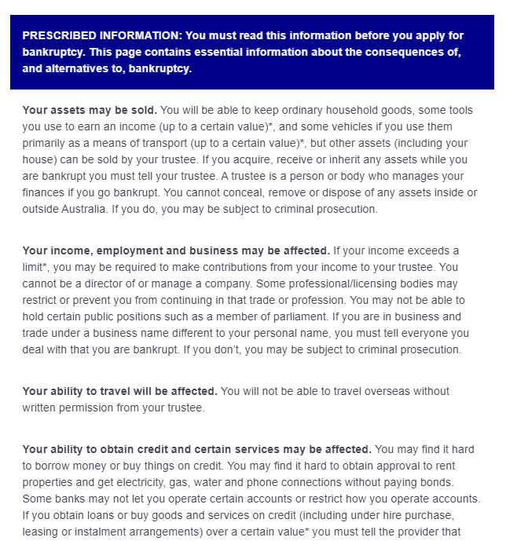
- Screenshot of the Prescribed Information as implemented in this trial. Information about the consequences of bankruptcy was provided in plain text, with bolding and bullet points, similar to how it is provided in the online bankruptcy application portal and on the pdf application form.

Current consequences tool
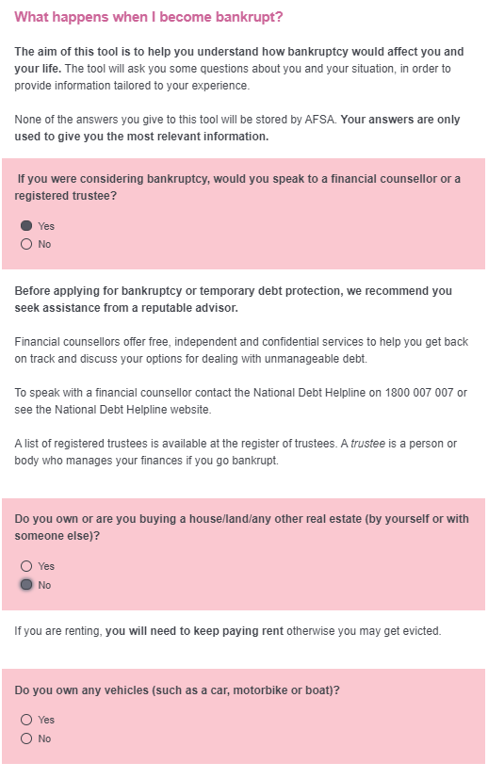
- Screenshot of the current ‘consequences tool’, as implemented in this trial. One question was displayed on the screen at a time. As soon as the respondent answered the question by selecting ‘yes’ or ‘no’, further details appeared (tailored to their response), and the next question also appeared below the information. After answering 7 questions, the respondent clicked next, and all the consequences were displayed on a single screen, for their review.

Pop-quiz
- Screen-shot of the pop-quiz. The pop-quiz started with a brief summary of the consequences of bankruptcy. On the next screen, eight quiz-questions were displayed, with two response-options each. As soon as the individual selected a response, a feedback-box appeared. If they answered correctly, the box was green, and said “That’s correct” followed by further details about the consequences relevant to that question. If they answered incorrectly, the box was yellow, and contained the same details about the consequences, but did not say “That’s correct”.

Personalised profile
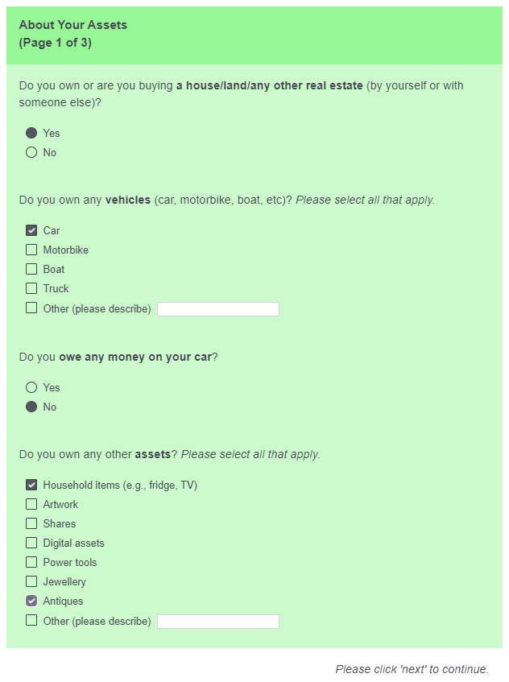
- Screenshot of the first part of the personalised profile. Respondent answered a series of questions about themselves and their circumstances, separated across three pages. Some of the questions were conditional (that is, they only appeared if the respondent had given a particular answer to a previous question).

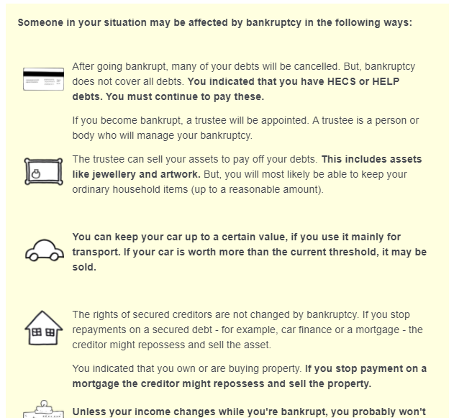
- Screenshot of the summary page of the personalised profile. After completing the three pages of questions, the respondent received a summary of how bankruptcy might affect them. The summary was tailored to the answers the respondent provided. Each section – e.g. about debts, assets, cars, and property – was also accompanied by an image.

Roadmap
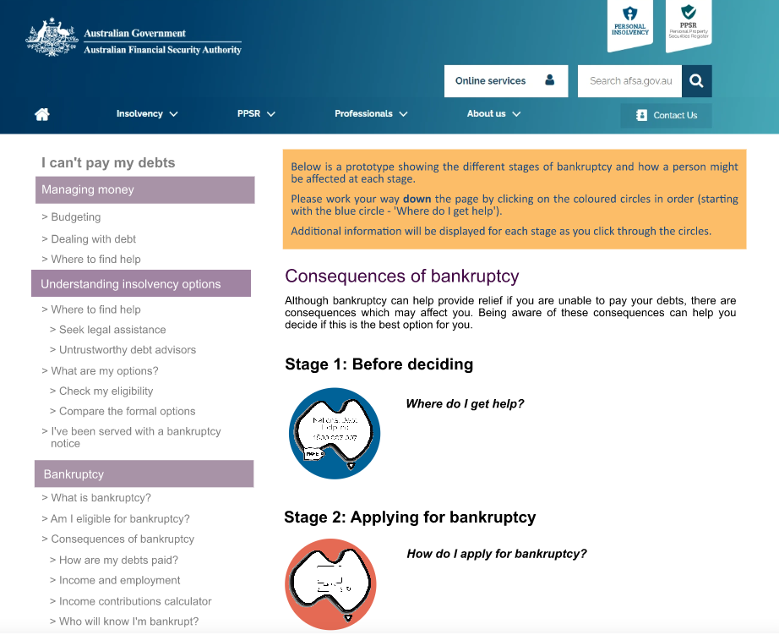
- Screenshot of part of the ‘roadmap’ tool. We used wireframing software to mock up an interactive AFSA website. Participants followed a link from the Qualtrics survey to this page (which opened in a new tab or window). On this page they were asked to click through the “Stages” of bankruptcy. Each stage was displayed with a heading, image, and question, and when participants clicked on each stage it expanded to provide more information. If participants clicked on other parts of the page (e.g., side bar or search box) the site did not react. After working their way through all the stages, participants were asked to return to the Qualtrics survey. Because of the way this tool required participants to navigate away from the Qualtrics survey (and then come back), we had a relatively high number of drop-outs from this arm of the trial.

Video

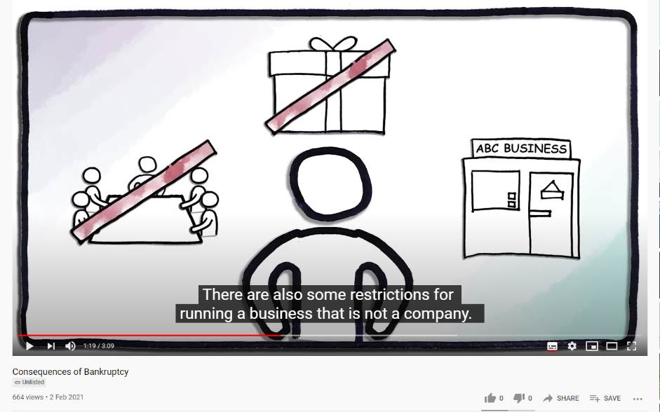
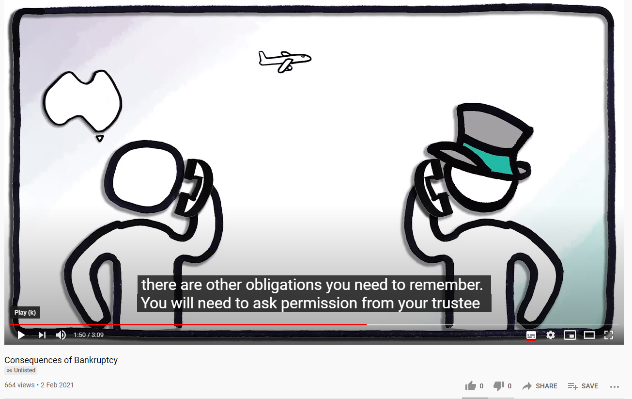
- Two screen shots of the video intervention. The video was embedded in the survey software. It was three minutes long, and included voice-over and subtitles, accompanied by simple icons and animations.

Part 3: Outcome measures
Part 3 of the survey contained the outcome measures. Part 3 is reproduced verbatim below, with commentary in square brackets.
Page 1
[Part 3 began with a short introductory paragraph, included below. In the pure control group, we told people we were “interested in how much you know about” the consequences of bankruptcy. We also left out the last sentence, referring to Part 2. Those in the pure control condition did not see a part 2, and were not asked these questions.]
This is Part 3 of the study. Thank you for your attention so far!
In this part, we are interested in how much you picked up about the consequences of bankruptcy, in the previous parts. First, you will be asked 13 short questions about bankruptcy. Please answer these questions as best you can. If you are unsure, please select “I don’t know”. There are no penalties for providing the wrong answer! We will then ask some quick questions about you. Feel free to skip any questions you don't feel comfortable answering. Finally, we'll ask for some feedback on how the information in Part 2 was presented.

Pages 2-4
[Outcome measures were presented in a random order, distributed over 3 pages. Correct answers are indicated with a star below. The three response options were also listed in a random order for each participant. The “I don’t know” response option always appeared at the bottom.]
Karen owns a house. There is no mortgage. Then she goes bankrupt. What will happen to her house?
- * The trustee may sell the house.
- Karen may be able to keep the house because there is no mortgage.
- Anyone Karen owes money to may be able to take possession of the house.
- I don’t know.
Phil bought a car just before he went bankrupt. He paid for the car outright. What will happen to his car?
- * The trustee may sell the car if it is worth over a certain amount.
- If he needs it for work, he can keep it regardless of its value.
- Regardless of what the car is worth, Phil will be able to keep the car
- I don’t know.
Ali goes bankrupt. A few months later he finds a part-time job. Ali has a 5-year old child. What will happen to Ali’s income?
- * If he earns over a certain amount, some of Ali’s income may go to his trustee to pay Ali’s debts.
- Nothing. Income is irrelevant to bankruptcy.
- Some of Ali’s income may be held by the trustee for Ali’s future dependants.
- I don’t know.
Sam goes bankrupt. For how long will Sam’s name be registered and publicly available on the National Personal Insolvency Index (NPII)?
- * Forever.
- For 5 years and 1 day.
- Until their debts are paid off.
- I don’t know.
Ashley went bankrupt 2 years ago, and now wants to travel to New Zealand to visit friends. What will Ashley need to do before traveling?
- * Ashley will need to ask the trustee for permission to travel.
- Nothing. Ashley is permitted to travel, because it’s more than 1 year since the bankruptcy started.
- Ashley will not be permitted to travel.
- I don’t know.
Matt is considering applying for bankruptcy. He has university education debts (HECS/HELP debt) from when he did an undergraduate degree. What will happen to Matt’s HECS/HELP debt if he goes bankrupt?
- * Nothing. Matt will still need to repay his HECS/HELP debt.
- Matt may be released from his HECS/HELP debt when his bankruptcy application is approved.
- Matt will only need to repay his HECS/HELP debt after the bankruptcy period ends.
- I don’t know.
Alex is thinking of applying for bankruptcy. She has been told bankruptcy lasts for 5 years and 1 day. Is this correct?
- * No. Bankruptcy lasts for 3 years and 1 day.
- Yes.
- No. Bankruptcy will continue until all Alex’s debts are paid.
- I don’t know.
Seamus is a director of a plumbing company. Will he be able to continue as a director if he does become bankrupt?
- Yes. Bankruptcy has no impact on the ability to be a director of a company.
- Yes, as long as there is at least one other director.
- * No, he cannot be a director of a company while bankrupt.
- I don’t know
Ingrid has been bankrupt for 6 months. Her mother has just passed away and left her $30,000 in her will. What does Ingrid have to do?
- Nothing, bankruptcy has no impact on money received after the date of bankruptcy.
- * She must tell her trustee and the trustee will take the funds.
- She must tell her trustee, but she will be able to keep the money because it is an inheritance.
- I don’t know
Michael lives in a rented apartment, but owns his fridge, washing machine, TV, and an antique dresser worth $20,000. If Michael goes bankrupt, what will happen to his belongings?
- * The trustee will sell the antique dresser, but Michael will most likely be able to keep his other household items.
- The trustee will sell all of Michael’s belongings to pay off his debts.
- Nothing. Michael can keep all of these belongings.
- I don't know.
Sarah goes bankrupt. She still owes money on her car. Does she have to keep paying the finance company?
- * Yes. If Sarah stops making repayments, the car finance people can repossess her car.
- No. By becoming bankrupt she no longer has to make the repayments and can keep the car.
- Not if she mainly uses the car for work.
- I don't know.
Brad is divorced. He makes child support payments to his ex-wife, who looks after his two young children. If Brad goes bankrupt, will he still have to pay child support?
- Yes, but only if he earns over a certain amount.
- No, but after the bankruptcy period ends he will have to pay it again if his children are still under 18 years old.
- * Yes, he will still have to pay child support while bankrupt.
- I don't know.
Eleanor is renting her apartment. Then she goes bankrupt. Does she still have to pay rent?
- * Yes. If she does not pay rent she may get evicted.
- No. Bankruptcy releases her from her rent obligations.
- Yes, but only once she earns over a certain amount.
- I don't know.

Page 5
Thank you for your attention so far! Now we just have a few questions about you.
[The following 3 questions were responded to on a scale from “not at all confident” to “completely confident”, coded from 1 to 6]
How confident are you that you understand the consequences of bankruptcy?
How confident are you that you know where to find more information about the consequences of bankruptcy?
In general, how confident are you when making decisions about financial matters (e.g., superannuation, mortgages, any investments)?
Where, or from whom, do you normally seek advice on financial matters? [free text response]
Page 6
[Those in the pure control condition were not asked the following questions.]
In Part 2 of this study, you were given some information about bankruptcy. Now we have some questions about how we presented this information.
Please rate how you felt about the information you read, and how it was presented, in Part 2 of this study.
[The following response options were presented on 6-point bipolar scales]
- It was easy to use – it was difficult to use
- It provided relief – it was distressing
- The information was clear – the information was confusing
- The information taught me something new – the information didn’t teach me anything
- It was interesting or engaging – it was boring
[The following 4 questions were free-text responses]
Please tell us what you liked the most about the way information was presented in Part 2 of this study.
Please tell us what you disliked the most about the way information was presented in Part 2 of this study.
Is there anything else you would like to know about bankruptcy? If so, please tell us below!
[All participants (including those in the pure control condition) were asked the following question before completing the study.]
If you encountered any issues (e.g., technological problems, questions not working) while doing this study, please let us know below.
Please click next to finish this study.

Appendix 4:
Part 2 Technical Details

Pre-registration, pre-analysis plan, and ethics
This trial was publically pre-registered on the AEA, record number AEARCTR-006534. The pre-registration plan was also documented on the BETA website. Both registrations took place before we analysed the data (but after the trial was launched). Our analyses were consistent with our pre-analysis plan (though see note about “joint filing” cases under Method of Analysis). The pre-analysis plan is published on the BETA website as a supplement to the report.
The project was approved through BETA’s ethics approval process, with risk assessed in accordance with the guidelines outlined in the National Statement on Ethical Conduct in Human Research.

Population and sampling
Our population of interest was bankruptcy applicants completing the application through AFSA’s new online portal. We had no exclusion criteria, although people who had been court-ordered to apply for bankruptcy were excluded from analysis of one of our outcome measures (completion rates), because these applicants do not have the option of dropping out of the process.
Our trial began on 1 October 2020, when the form went live online. Any applicant who started the online form from this point onwards was included in the trial.
Our target was a sample of 1,400 submitted forms – at least 700 in each trial arm. We reached this sample on Friday 22 January, 2021, and closed the trial on Sunday 24 January. At this point, the 14-day waiting period (specified in the pre-analysis plan) began. We included this waiting period because one of our outcome measures was completion rates versus drop-outs. We had defined drop-outs (“abandoned forms”) as forms that had been inactive for at least 14 consecutive days. On 22 January, in addition to the ~1400 submitted forms, there were around 250 pending forms, that is, forms that had been commenced since 1 October, but not yet completed. The waiting period provided an opportunity for these people to either submit or abandon their form.
During the waiting period, an additional ~200 people submitted their forms, and were included in our data set, for a total of 1606 submitted forms. At the end of this waiting period, the data set also contained 699 abandoned forms. Finally, there were 34 pending forms (neither abandoned nor submitted). These were also included in the final data set. The final data set thus contained 2,339 cases, and we received the data from AFSA on Monday 8 February 2021. Characteristics of submitted applications are included in Table 23 below.

- Characteristics of submitted applications (n = 1606)
Category |  | Number (%)
Gender | Women | 701 (43.6)
 | Men | 899 (56.0)
Age | Younger (up to 35 years) | 492 (30.6)
 | Middle (35-55 years) | 797 (49.6)
 | Older (55 years and above) | 316 (19.7)
Note: Proportions do not all sum to 100% as not all individuals responded to all questions on the web form, and a small number of “other” and “prefer not to say” responses are excluded from this table.

Randomisation and balance checks
AFSA randomised applicants to either the “prompts” or the “no prompts” version of the form when the applicant created an account and began the process of applying for bankruptcy. Each applicant had a 0.5 probability of being assigned to either form. The “prompt” form included the five key prompts, the “no prompt” form did not. (All forms also included 14 ‘help’ text prompts that we did not evaluate.) Twenty-seven applicants deleted their form, but only two re-started the process, and were re-randomised. All cases (i.e., with two re-randomised applicants) are included in the analysis of completion rates, but not in the analysis of any other outcome measures (as they did not submit their application form). Table 24 describes the sample, by form. We only received demographic information from applicants who had completed and submitted their form.
- Characteristics of each group (treatment vs control)
 | Condition: | Prompts | No prompts
 | N | 1177 | 1162
Gender | Men | 440 | 459
 | Women | 360 | 341
Age | Younger | 247 | 245
 | Middle | 406 | 391
 | Older | 149 | 167

Sample size and power calculations
With a planned sample of at least 700 submitted forms per trial arm, this trial had power to detect a minimum effect size of 0.15 (Cohen’s d and Cohen’s h) in our primary analyses (H1, H2, H4), assuming 80% power and alpha = .05. See pre-analysis plan for further details.
H3 concerned the effect of the prompts on the value (in dollars) of vehicle and real estate assets. It could therefore only be conducted for cases where applicants reported at least 1 vehicle or real estate asset. As we noted in the pre-analysis plan: “The power (or minimum detectable effect size) will be lower for H3, because we are only analysing the value of real-estate assets and vehicle assets for people who report at least 1 asset. That is, we will exclude from these analyses anyone who responds that they have 0 real-estate or vehicle assets (for H3a and H3b respectively), which means our effective sample size will be smaller.”
Only 111 applicants reported any real estate assets, severely limiting our ability to detect any effect of the prompts on the value of real estate assets.
Just over half the applicants reported any vehicle assets (n = 859). Based on a post hoc sensitivity analysis we had between 65 and 90 per cent power (alpha = .05) to detect effect sizes in the range of 0.16 to 0.22 respectively (Cohen’s d) for the effect of prompts on the value of vehicle assets.

Outcome measures
Our outcome measures were:
- Whether people completed the form. For our primary analysis, we coded completed forms as 1, and all other forms as 0. This included all drop-outs, and 34 pending forms.
- The number of assets reported in the bankruptcy form:
  - Real estate assets was coded as a binary variable, none (0) versus any (1).
  - Vehicle assets coded as a count variable (0-10; values > 10 truncated to 10). Note: none of the applicants in our data set reported more than 10 vehicle assets.
- The average monetary value (in $) per assets (real estate and vehicle assets separately) reported in the bankruptcy form. For analyses of this outcome measure, we excluded respondents who reported 0 vehicle or 0 real estate assets.
- Total self-reported income (in $) for the past 12 months and next 12 months.

Hypotheses
In our pre-analysis plan, we specified 4 hypotheses in relation to our outcomes. We report the results relevant to all these hypotheses in the main report, and the full regression outputs are in Tables 25-32 in Appendix 5: Part 2 Statistical Tables.
H1: Completion rates will be lower in the prompt group (PG) than the no-prompt group (NG). PG < NG (completion rate).
We used a one-tailed hypothesis test to evaluate this hypothesis. We also evaluated – as a secondary analysis – whether the drop-out rates were higher in the prompt group than the no-prompt group.
H2: The number of assets reported by the prompt group will be different to the number of assets reported by the no-prompt group. PG ≠ NG (count of assets).
H3: The mean value per asset reported by the prompt group will be different to the value of assets reported by the no-prompt group. PG ≠ NG (value of assets).
Analyses for H2 and H3 were conducted separately for real estate assets (H2a/H3a) and vehicle assets (H2b/H3b).
H4: The amount of income reported (for current year, H4a; for next year, H4b) by the prompt group will be different to the amount of income reported by the no-prompt group. PG ≠ NG (income declared).
We used two-tailed hypothesis tests to evaluate the evidence for hypotheses H2-H4.

Method of analyses
All data processing and analysis was performed using R (version 4.0.3, R Core Team, 2020) with the dplyr package (version 1.0.3; Wickham, François, Henry & Müller n.d.) in R Studio (RStudio Team, 2020). We did not analyse the outcome measures until after the data collection was completed.
As stated in our pre-analysis plan, all analyses used ordinary least squares regression with HC2 robust standard errors, using the ‘estimatr’ package from the DeclareDesign suite (version 0.24.0), Blair, Cooper, Coppock & Humphreys 2019). We estimated the following:
$$Y_{i}=β_{0}+ β_{1}Z_{i}+ ∈_{i}$$
Where $i$ is an index for each individual (form) in the trial, $Y$ is one of the four outcomes listed in the Outcome section above,$β_{0}$ is the intercept, $Z$ is the treatment indicator (where 0 is the prompts group and 1 is the no-prompts group),$β_{1}$ is the coefficient on treatment and represents the average effect of being assigned to the prompt group, and $∈$ is the error term. We fitted this model to data from the relevant subset of participants for each comparison. Full results are provided in Tables 25-32 in Appendix 5: Part 2 Statistical Tables.
One unexpected element of the data was the number of joint submissions. We pre-registered that we would attempt to recover individual data, but if unsuccessful (i.e. with data already combined) we would analyse them as is. We received over 70 joint submissions (i.e., for over 140 cases total), and could not recover individual data. As pre-registered, we analysed them as is, however as a robustness check we also removed the joint cases from the overall sample (robustness check 1), and selected a single random case from each of the joint cases (robustness check 2). The results are robust to these alterations.
As per our pre-analysis plan, we did not adjust for multiple comparisons. This should be taken into account when interpreting the results, especially the effect of prompts on income reported in the past 12 months (p = .03) and in the next 12 months (p = .02).

Use of p-values
See the corresponding section in Appendix 1: Part 1 Technical Details.

Appendix 5:
Part 2 Statistical Tables
The following statistical tables provide the full set of results underpinning the findings presented in the main body of the report. Unless otherwise specified, p-values are two-tailed.

Primary outcome measure

Completion rates and drop-out rates
Our first primary outcome measure was completion rates of the bankruptcy application form. For these analyses we excluded those who were court-ordered to apply for bankruptcy. The primary analysis coded forms as completed = 1, abandoned or pending = 0 (Table 25), and the secondary analysis coded forms as abandoned = 1, completed or pending = 0 (Table 26).
These analyses are almost identical because there were only 34 pending forms in total.
- H1 analysis, completion rates
Group | Completed forms (no.) | Completed forms (%) | Difference (95% CI) | p-value  (one-tailed)
Prompts | 772 | 67.3 | NA | -
No prompts | 774 | 68.4 | 1.1% (-2.7 – 4.8) | 0.29

- H1 analysis, drop-out rates
Group | Drop-out forms (no.) | Drop-out forms (%) | Difference (95% CI) | p-value  (one-tailed)
Prompts | 358 | 31.2 | NA | -
No prompts | 341 | 30.1 | -1.1% (-4.8 – 2.7) | 0.29

Count and value of assets
We tracked the reported number and value of real-estate and vehicle assets. Results of these analyses are included in Tables 27-30 below. Note the smaller sample sizes for analyses of the value of assets. As these analyses could only be undertaken for the cases where at least 1 asset was reported, the sample size is n = 111 for the value of real estate assets and n = 859 for the value of vehicle assets.
- H2a analysis, number of real estate assets (0 = none, 1 = any)
Group | Real estate reported (no.) | Real estate (%) | Difference (95% CI) | p-value
Prompts | 49 | 6.1 | NA | -
No prompts | 62 | 7.7 | 1.6 (-1.0 – 4.1) | 0.21

- H2b analysis, number of vehicle assets (count)
Group | Vehicle assets (mean) | Difference (95% CI) | p-value
Prompts | 0.61 | NA | -
No prompts | 0.65 | 0.04 (-0.03 – 0.11) | 0.28

- H3a analysis, value of real estate assets (note: n = 111)
Group | Mean real  estate value ($) | Difference (95% CI) | p-value
Prompts | 382,356 | NA | -
No prompts | 335,059 | -47,297 (-159,621 – 65,028) | 0.41

- H3b analysis, value of vehicle assets (n = 859)
Group | Mean vehicle value ($) | Difference (95% CI) | p-value
Prompts | 7033 | NA | -
No prompts | 7000 | -32 (-1,153 – 1,219) | 0.96

Income reported for the past 12 months and next 12 months
Our final outcome measure was the amount of income reported by the applicant. We tracked the amount of income reported for the past 12 months, as well as income estimated for the following 12 months.
- H4a analysis, income reported for past 12 months
 | Mean income reported ($) | Difference (95% CI) | p-value
Prompts | 32,655 | NA | -
No prompts | 28,537 | -4,118 (-7,884 – -351) | 0.03

- H4b analysis, income reported for next 12 months
Group | Mean income reported ($) | Difference (95% CI) | p-value
Prompts | 26,050 | NA | -
No prompts | 22,238 | -3,723 (-6,877 –568) | 0.02

As noted in the report: Applicants who saw the prompts appeared to report higher levels of future and past income. This may be because the prompt made the question stand out more and appear more important, or because it raised awareness and a sense of responsibility for ensuring income estimates are as precise as possible. Given we performed a number of statistical tests without adjusting for multiple comparisons, this finding should be interpreted with caution. It does, however, confirm there was no backfire effect.

References
Adesope, OO and Nesbit AC (2012). ‘Verbal redundancy in multimedia learning environments: A meta-analysis’, Journal of Educational Psychology, 104(1):250-263.
Behavioural Insights Team (2014). EAST: Four simple ways to apply behavioural insights. Behavioural Insight Team, London.
Bhatia, V. K. (1983). Simplification v. Easification—The Case of Legal Texts. Applied linguistics, 4(1), 42-54.
Castelo, N, Hardy, E, House, J, Mazar, N, Tsai, C, and Zhao, M. (2015). ‘Moving citizens online: Using salience & message framing to motivate behavior change’, Behavioral Science & Policy, 1(2):57-68.
Hancıoğlu, Y, Doğan, ÜB and Yıldırım, ŞS (2014). ‘Relationship between uncertainty avoidance culture, entrepreneurial activity and economic development’, Procedia-Social and Behavioral Sciences, 150:908-916.
Karlsson, N, Loewenstein, G, and Seppi, D (2009). ‘The ostrich effect: Selective attention to information’, Journal of Risk and Uncertainty, 38(2):95-115.
Kirsh, D (2000). ‘A few thoughts on cognitive overload,’ Intellectica, 1(30):19-51.
Mullainathan, S., & Shafir, E. (2013). Scarcity: Why having too little means so much. Macmillan.
Pallier, G et al., (2002). ‘The role of individual differences in the accuracy of confidence judgments’, The Journal of General Psychology, 129(3):257-299.
Rowland, CA (2014). ‘The effect of testing versus restudy on retention: A meta-analytic review of the testing effect’, Psychological Bulletin, 140(6):1432-1464.
Sailer, M and Homner, L (2020). ‘The gamification of learning: A meta-analysis’, Educational Psychology Review, 32:77-112.
Sharot, T (2011). ‘The optimism bias’, Current Biology, 21(23):941-945.
Symons, CS and Johnson, BT (1997). ‘The self-reference effect in memory: a meta-analysis. Psychological Bulletin, 132(3):371-355.

© Commonwealth of Australia 2021
ISBN 978-1-925364-62-0
Clearer consequences: Helping people understand the outcomes of bankruptcy.

Copyright Notice
With the exception of the Commonwealth Coat of Arms, this work is licensed under a Creative Commons Attribution 4.0 International license (CC BY 4.0) (https://creativecommons.org/licenses/by/4.0/)

Third party copyright
Wherever a third party holds copyright in this material, the copyright remains with that party. Their permission may be required to use the material. Please contact them directly.

Attribution
This publication should be attributed as follows:
© Commonwealth of Australia, Department of the Prime Minister and Cabinet, (2021) Clearer consequences: Helping people understand the outcomes of bankruptcy.

Use of the Coat of Arms
The terms under which the Coat of Arms can be used are detailed on the following website: https://pmc.gov.au/cca

Behavioural Economics Team
of the Australian Government
General enquiries beta@pmc.gov.au
Media enquiries media@pmc.gov.au
Find out more www.behaviouraleconomics.pmc.gov.au/

Average of total bankruptcies per year declared between 2016 and 2020 financial years.
People who are made involuntarily bankrupt by a court order or who voluntarily apply for bankruptcy using a paper form do not complete the consequences tool. For the sake of simplicity, we refer to all individuals completing the online bankruptcy form as “applicants”, although people who are made bankrupt under a sequestration order are not technically “applying” for bankruptcy.
See Technical Appendix for the design of the current consequences tool and other tools we tested.
The exact designs of all tools are provided in the Technical Appendix.
Full demographic details of the sample are included in the Technical Appendix.
These differences are statistically significant (p < .001) with sample sizes around 2000 for each pair-wise comparison. We have a high degree of confidence in this result due to the large effect, large sample size, and small p-value, coupled with a pre-registered design. See the Technical Appendix for information on BETA’s approach to statistical significance, and full statistical tables.

