Attracting a diverse cyber security workforce
Lessons from an analysis of Australian job ads
November 2023

Other uses
Enquiries regarding this license and any other use of this document are welcome at:
Managing Director
Behavioural Economics Team of the Australian Government
Department of the Prime Minister and Cabinet
1 National Circuit
Barton ACT 2600
Email: beta@pmc.gov.au
The views expressed in this paper are those of the authors and do not necessarily reflect those of the Department of the Prime Minister and Cabinet or the Australian Government.

Research team
Current and former staff who contributed to the report were: Nicholas Hilderson, Hanne M Watkins, Scott Copley, and Andrea Willis.

Acknowledgments
Thank you to the Department of Industry, Science and Resources and the Cyber Security Industry Policy Section for their support and valuable contribution in making this project happen. In particular, special thanks to Cameron Stack and David Charlton for their work on this project.
We would also like to acknowledge and thank the staff at Jobs and Skills Australia, with special thanks to Natasha Yemm, Mohammad Seyani, Athos Nicolaou, Alicia Gransden, Victor Gomez and Nitin Kumar. This project would not have been possible without your advice, knowledge and support.

Who?

Who are we?
We are the Behavioural Economics Team of the Australian Government, or BETA. We are the Australian Government’s first central unit applying behavioural economics to improve public policy, programs and processes.
We use behavioural economics, science and psychology to improve policy outcomes. Our mission is to advance the wellbeing of Australians through the application and rigorous evaluation of behavioural insights to public policy and administration.

What is behavioural economics?
Economics has traditionally assumed people always make decisions in their best interests. Behavioural economics challenges this view by providing a more realistic model of human behaviour. It recognises we are systematically biased (for example, we tend to satisfy our present self rather than planning for the future) and can make decisions that conflict with our own interests.

What are behavioural insights and how are they useful for policy design?
Behavioural insights apply behavioural economics concepts to the real world by drawing on empirically-tested results. These new tools can inform the design of government interventions to improve the welfare of citizens.
Rather than expect citizens to be optimal decision makers, drawing on behavioural insights ensures policy makers will design policies that go with the grain of human behaviour. For example, citizens may struggle to make choices in their own best interests, such as saving more money. Policy makers can apply behavioural insights that preserve freedom, but encourage a different choice – by helping citizens to set a plan to save regularly.

Contents
Executive summary 4
Policy Context 5
What we did 6
Literature Review 7
Data analysis: Method 13
Data analysis: Results 16
Limitations 28
Discussion and Conclusion 31
Appendices 33
References 49

Executive summary
With cyber threats an increasing risk for both business and government, the Australian workforce needs to keep up with a growing need for cyber security professionals. Australia is currently facing a skills shortage in cyber security and there is a need to increase the pool of potential applicants for cyber security jobs. As only 17% of the cyber security workforce are women, and a lower proportion of women (than men) with relevant qualifications work in cyber security, women represent an untapped potential workforce.
This analysis examines the way Australian cyber security job ads are written and whether this could be discouraging women from applying to these jobs. Job ads represent a low cost intervention point for business and are the starting point in the recruitment process. .
We conducted a literature review to identify aspects of job ads that encourage and discourage women from applying, including whether businesses are offering flexible working conditions, requiring a long list of skills, and using masculine language in their job ads. Following this, in partnership with Jobs and Skills Australia (JSA), we used the Lightcast database of job ads to measure the current state of Australian jobs. We used a mixture of machine learning, dictionaries, and variables provided by Lightcast to measure these different aspects of job ads.
We found:
  - Only 0.1% of job ads in cyber security explicitly offered part time positions in 2022. While this rate was low across all sectors, it was especially low in both cyber security and Information Communications Technology (ICT) sectors. This partly reflects the very low number of people working part time hours in these sectors.
  - Both cyber security and ICT job ads specify many more skills than other job ads, including job ads for technical roles in occupations that require a similar level of qualification (e.g. engineering). Cyber security and ICT job ads listed around 11 skills on average, compared with 8 skills listed in job ads for other sectors.
  - Cyber security uses the most stereotypically masculine language of any occupation across a number of stereotypes, including ‘lead/leadership’, ‘analysis’, ‘being in control’ and ‘problem solving’. While women clearly also possess these qualities, this language is stereotypically or subconsciously associated with men and may therefore discourage women from applying to job ads that rely on these stereotypes.
  - Despite greater representation of women in the workforce and in leadership roles, the use of masculine language in job ads overall has remained stable over the past decade.
Our findings suggest cyber security and technology sector job ads in Australia are biased towards men, which may be reducing the number of female applicants. Organisations may attract more female job applicants to cyber security and ICT roles by reducing the amount of masculine language, offering flexible working conditions, and reducing the number of advertised skills in their job ads.

Policy Context
As the 2022 Optus and Medibank data breaches demonstrate, cyber security threats to individuals’ and businesses’ information are on the rise (Australian Cyber Security Centre 2022). Australians are increasingly reliant on the internet and internet-connected devices, and protecting their information through cyber security is critical to Australia’s wellbeing and economy (Department of Home Affairs 2020). Building and maintaining a skilled cyber security workforce is an essential component to achieving this.

Australia is facing a skills shortage in cyber security
AustCyber estimates by 2026 the Australian cyber security workforce shortage will grow to 3,000 (AustCyber 2022), while the Global Cybersecurity Workforce Study 2021 (which uses a broader definition of cyber security) estimates the shortage in Australia at 25,000 employees ((ISC)² 2021). The ratio of current workers to job openings is lower in cyber security than the national average (ABS 2022a; AuCyberExplorer 2022), and the competitive demand for skills increases costs for employers, encourages shorter tenures for skilled employees, and reduces the cyber resilience of Australian businesses.

Attracting more women to cyber security could be an effective way of increasing the pool of potential applicants
New cyber security-specific ANZSCO codes enable a clearer picture of the cyber industry in Australia – and reveal only 17% of cyber security workers in Australia are female (ABS 2022a). This is consistent with a recent analysis by RMIT which estimated that women make up 16% of the cyber security sector. This study also reported ‘the positive news is that women’s numbers is now growing at a slightly faster pace than men’ (AWSN 2022): over the past five years (from 2016 to 2021), the number of women in ICT Security Specialist roles grew fourfold, while men’s grew threefold (Risse et al 2023). Given the cyber security sector is growing fast and well paid (YourCareer 2023), lowering barriers to women joining this sector would also support the Australian Government’s broader agenda to improve women’s economic security.

BETA’s previous exploratory research outlined career pathways of the current cyber security workforce
In 2021, BETA was commissioned by the then Department of Industry, Science, Energy and Resources to conduct research on mid-career transitions to cyber security. This qualitative research built a rich picture of the motivators, prompts and barriers to people (particularly women) transitioning to cyber security from another career (BETA 2022). It also identified a range of potential intervention points for addressing the issues faced by women and other underrepresented groups considering a career in cyber security, including addressing stereotypes in the general population, enabling upskilling within the business, and improving job ads to attract a larger, more diverse range of applicants.

What we did

Job ads play an important role in shaping who enters the workforce
Job ads are a key mechanism for engaging potential employees, and often present the first opportunity for a candidate to self-assess their suitability for a role and organisation. A range of factors – from how the role and organisation is described, and the mandatory and desired skills and qualifications listed, through to the specific words used to describe the job – can drive or deter candidates from applying.
For this study, BETA collaborated with the Department of Industry, Science and Resources to explore how job ads can be leveraged to increase workplace diversity and address workforce shortages in cyber security. We first reviewed the existing research literature to identify a set of factors within job ads that make a position more attractive to diverse applicants (especially women). We then analysed a large dataset of Australian job ads to assess the current and historic state of cyber security job ads, and to compare cyber security job ads to job ads in other sectors.

We first reviewed the existing literature to explore how job ads can be written to encourage more women to apply to cyber security roles
Job ads are a focus in broader academic literature on increasing workplace diversity and inclusion, as they play an important role in shaping who enters the workforce. Reviewing existing literature enabled us to identify a set of factors within job ads that are associated with recruitment of more diverse staff. In particular, our literature review focused on exploring how job ads could be written to encourage women to apply: if the aim is to attract more female applicants, what is the best evidence available for what a ‘best practice’ job ad looks like?

We analysed the Lightcast database to see how Australian cyber security job ads are ‘measuring up’ to best practice
The literature review identified a number of factors which make a job ad more attractive to women. These include avoiding stereotypically masculine language (including the ‘hackers in hoodies’ stereotype), including options for flexible work, and avoiding long ‘laundry lists’ of required skills. We then collaborated with Jobs and Skills Australia (JSA) to analyse the Lightcast dataset, a comprehensive data set of over 12 million Australian job ads. This allowed us to determine:
- The current state of job ads in the cyber security sector (both private and public sectors), with respect to ‘best practice’ factors
- The extent to which job ads in cyber security are changing over time
- How cyber security job ads compare to job ads in other sectors

Literature Review

Take-home messages from literature review
- Changes to gendered language – specifically, reducing the amount of stereotypically masculine language – in job ads could have a modest but meaningful impact on encouraging women to apply.
- Going beyond individual ‘masculine’ or ‘feminine’ words to address broader stereotypes – e.g. challenging norms that cyber security professionals are ‘hackers in hoodies’ – suggests a promising but untested avenue for further improvement to cyber security job ads specifically.
- Ensuring job ads highlight flexible and family-friendly policies could encourage a greater number of applicants, including women, to apply.
- Listing a smaller number of required qualifications, or listing requirements as specific behaviours (rather than general traits), could encourage more women to apply, although the evidence for this factor is mixed.
- According to the best available evidence, a ‘best practice’ job ad avoids gendered language (including language associated with the ‘hackers in hoodies’ stereotype), highlights flexibility, and keeps the list of skills and qualifications short.

An individual’s decision to apply for a particular job is influenced by a number of factors
An individual’s decision to apply to a job is influenced by a range of factors: from characteristics of the job (e.g. type of work, compensation), to characteristics of the organisation (e.g. size, leave policies, reputation) and characteristics of the potential applicant (e.g. gender, personal interests; Chapman et al. 2005). Some of these factors – for example the size of the company, or the personal interests of the applicant – are unlikely to be directly influenced by a job ad. However, two strong predictors of job pursuit intentions are the perceived person-organisation fit and characteristics of the job itself (Chapman et al. 2005).
Person-organisation fit can be further subdivided into supplementary and complementary fit, as summarised in Box 1. The way these factors are communicated through a job ad can therefore potentially influence who applies for the job, and these factors are the focus of this report.

Box 1: The person-organisation fit framework
The concept of person-organisation fit helps explain an applicant’s attraction to an employer and decision to apply for a position, and provided the organising principle for our literature review (Highhouse et al. 2007, Morley 2007).
In job ads, employers intentionally or unintentionally send signals about their characteristics, what they can supply, and what they need. According to the person-organisation fit framework, in deciding whether to click on an ad, or to invest time in actually applying, a potential applicant consciously or unconsciously assesses the alignment between the employer and what they understand about themselves.
- Supplementary fit refers to a person and organisation sharing similar fundamental characteristics (e.g. having common values and norms).
- Complementary fit refers to each entity supplying what the other needs – for example, when there is a match between the salary expectations of the applicant, and the pay and conditions offered by the organisation; or when the applicant has expertise and skills in an area the organisation is lacking.
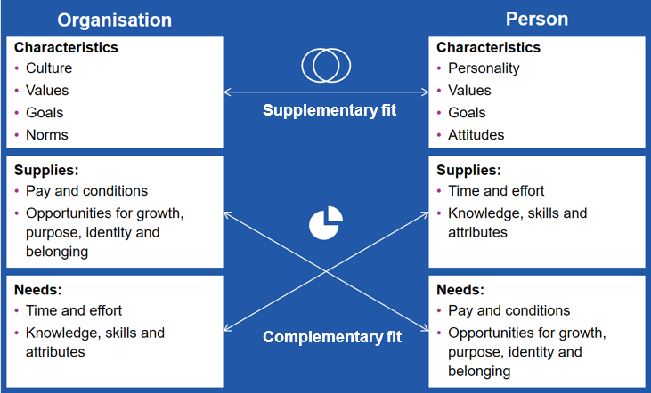

Language associated with gender stereotypes can implicitly signal employer preferences
While job ads are no longer allowed to contain explicit references to a person’s gender, age, or ethnic group, language within job ads can still subtly appeal to a specific group in society (Menegatti and Rubini 2017). This ‘implicit’ appeal to a particular group is driven by how language is stereotypically associated with specific groups or cohorts. For example, the male stereotype is ‘assertive’, ‘independent’, ‘analytical’, while the female stereotype is ‘patient’, ‘relational’, ‘collaborative’ (Cheryan and Markus 2020, see also Charlesworth et al. 2021). The specific stereotypical associations appear to be changing over time (Eagly et al 2020), and it is important to note this should not be interpreted to mean women are actually more relational and collaborative than men. However, the stereotypical associations persist, and this ‘gendered language’ has been a particular focus in research on job ads. Job ads including these gendered terms may consciously or unconsciously signal an employer’s interest in employing male versus female candidates.

Masculine language in a job ad can reduce women’s intention to apply
In the last two decades, several survey-based studies have explored the effect of gendered language on how attractive job ads are to women (Gaucher et al. 2011; Horvath and Sczesny 2016; LinkedIn 2019a; Oldford and Fiset 2021; Tang et al. 2017). In these studies, participants are generally presented with job ads that contain stereotypically ‘masculine’ or ‘feminine’ language (assigned at random), and asked how likely they would be to apply for the role (see Footnote 1 for more on outcome measures). Masculine language in this case includes words that are associated with the masculine stereotype, as outlined above (e.g. assertive, independent).
Many of these studies have been conducted with hypothetical jobs and/or undergraduate students as research participants, and it is not clear how well the findings would generalise to real jobs and actual applicants. Nonetheless, we estimate using masculine language in a job ad may reduce women’s intention to apply by around 6-11% (Gaucher et al. 2011; Tang et al. 2017; Oldford and Fiset 2021). In other words, the impact of masculine language does not appear to be large – but given the number of job ads circulated each year, it may be cumulatively significant.

It’s not just about specific, gendered, words – stereotypes matter too
Stereotypes – including about ‘hackers in hoodies’ and gendered stereotypes – are often communicated in phrases and sentences, not just in individual words. For example, Burn et al. (2022) examined the impact of ageist stereotypes in job ads by focusing on phrases such as ‘energetic person’, ‘digital native’, ‘up-to-date with industry jargon’ and ‘dynamic workforce’ – all of which are associated with a younger cohort. They then posted fake job ads with and without these ageist stereotypes to a noticeboard, to assess the impact on applications: For the ageist version of the ad, the share of applicants who were over 40 years old was 12 percentage points lower.
This demonstrates the importance of not just counting individual words in job ads to attract or deter particular applicants – ‘digital’ and ‘native’ in isolation do not exclude older applicants – but rather trying to understand how stereotypes are communicated in phrases and sentences. In our data analysis, we were able to use machine learning techniques to analyse the use of language associated with gendered stereotypes in job ads. To the best of our knowledge this more holistic analysis – going beyond individual words – has not previously been attempted for gendered stereotypes in job ads, and represents an important next step in understanding how the language in job ads could influence applicants’ choices.

The ‘hackers in hoodies’ stereotype may deter women from seeking a career in cyber security
Much of the research on gendered language in job ads examines job ads from a range of industries. With regard to cyber security specifically, it may not be just gendered stereotypes that contributes to the perception of fit between the job and the potential applicant. A common stereotype of people who work in cyber security is they are ‘hackers in hoodies’ (Foley 2022, Poster 2018). Job ads can reflect this stereotype by using words that are strongly associated with hacking, as well as the defence industry or military. For example, words such as ‘attacks’, ‘threats’, and ‘cyber warriors’ are often used when discussing the sector – even if a cyber security job itself may require skills in governance and risk management (Foley 2022). The impact of this specific stereotype on applicant decisions has not been directly studied. However, it may be a factor in discouraging women from applying to cyber security jobs. We therefore examined its prevalence in cyber security job ads in the next section (see Data Analysis: Results).

Flexible work arrangements attract more applicants, including women
Offering flexible work arrangements (e.g. part-time, job share arrangements) in job ads can increase the number of applicants to a role overall by around 20%, and may increase the proportion of female applicants (BIT, 2021, see also Bharati et al. 2022). Offering flexibility up front can also increase the number of women who apply to senior roles by 19 to 35% (BIT, 2020), and advertising supportive work-family policies can increase the number of applicants, irrespective of their family status (Casper et al. 2013). According to SEEK data, women in ICT are more likely than men to rate paid parental leave, flexible working hours, and ability to work part time as a ‘must-haves’ when considering a role. However, in the studies summarised above (which are not specific to cyber security or ICT), highlighting flexibility did not only increase the number of women. Rather, it appears to be a promising way to increase the pool of applicants overall. For sectors in which flexible and remote work is already common, highlighting this option in the job ads is a low-cost intervention.

The number of qualifications has been highlighted as a problem in cyber security job ads
According to one frequently cited statistic, ‘men apply for a job when they meet only 60% of the qualifications, but women apply on if they meet 100%’. While this specific statistic could not be substantiated (Rice 2014), a recent report by LinkedIn found women tend to apply to fewer jobs than men (LinkedIn 2019b).The Behavioural Insights Team (in the UK) found on average, men applied (to a hypothetical role) when they met 52% of the qualifications, while women applied when they met 56% of the qualifications (BIT 2022). Across a range of job types, lower qualified men were also more likely to apply for a job ad than lower qualified women, while better qualified men and women applied at equal rates (BIT 2022). These studies are consistent with broader research showing that men are more likely to overestimate their capabilities in stereotypically masculine domains (BIT 2022, see also Coffman et al. 2021, and Kay and Shipman 2014).
If cyber security job ads list a large number of qualifications and specific technical requirements, these ads may be more likely to attract male applicants. However, prior to our study (see next section), the only evidence about the number of skills listed in cyber security job ads was anecdotal. In our data analysis, we took the first step to investigating this question by examining the number of skills listed in cyber security and ICT job ads, compared to job ads in other sectors.

How required skills and attributes are listed may also influence whether women apply
There is some evidence that if skills are presented as innate traits of the applicants (e.g. “you are a natural leader”), compared with presenting skills as a specific ability or experience (e.g. “you have leadership experience”) women and underrepresented groups may be less likely to apply (Willie and Derous 2017, 2018). On the other hand, a 2022 survey experiment of 10,000 individuals did not find a significant difference between the number of men and women who intended apply for a role when they varied whether the requirement was presented in a specific versus generic/broad way (BIT 2022, and see Born and Taris 2010).
Men may also be more likely than women to apply for jobs that have a more ambiguous qualification requirement – but if the requirement (‘the bar’) is made clear, women who pass the bar are more likely to apply (Coffman et al. 2021). One survey (summarised in the Harvard Business Review, Mohr 2014,) also found women are more likely than men to say they’ll follow the guidelines about who should apply, further suggesting job ads should aim to be clear about the required qualification and who they would like to apply.
Lastly, making it possible to list experience in terms of the number of years, rather than dates, may be less discriminatory to women who are returning to work after caring for children (BIT 2022). However, others argue that years of experience shouldn’t be requested in job ads at all; rather the focus should be on skill sets (Adler 2015), as this is more likely to increase diversity.

Data analysis: Method
Our literature review revealed four aspects of job ads which may influence the number and proportion of women (and other underrepresented groups) who apply to a given job ad. The aim of the data analysis was to determine the extent to which Australian cyber security job ads already include these aspects. We took a quantitative approach to analysing cyber security job ads, in collaboration with the Department of Industry, Science and Resources (DISR) and Jobs and Skills Australia, who facilitated access to the Lightcast database. Lightcast is the most comprehensive source of job ads data in Australia. It contains most job ads, and associated metadata, posted online since 2012.

We first developed a definition of ‘cyber security’, to allow us to compare cyber security ads to the full set of ads
Based on an inter-departmental workshop BETA conducted with the Department of Home Affairs, DISR, and the ABS, we took a task-based approach to defining cyber security, focusing on technical tasks such as penetration tester, security analyst, or cyber security testing specialist. We also agreed we would only include job ads for roles where cyber security related tasks made up the majority of the job description. For example, we would not include a systems administrator role where the job involves keeping systems up to date, but we would include a security consultant role where the core function is to conduct assessments of a business’s IT security. We also supplemented a solely task-based approach by including relevant skills and qualifications related to cyber security (e.g. ISO27001; Certified Information Security Manager/CISM). Due to the specific nature of qualifications related to cyber security, this helped further refine our sample of job ads for analysis. Through this process we selected a total of 38,234 cyber security job ads for inclusion in our main sample, advertised in Australia between 2012 and 2023. We compared this sample of cyber security job ads to all other job ads combined, and to job ads for specific occupations (see Data Analysis: Results).

We developed several metrics to assess different aspects of the language used in job ads
We developed four metrics, identified through the literature review, to assess different aspects of the language in job ads. These were: the number of requirements listed, the availability of flexible work, stereotypically masculine language, and the ‘hackers in hoodies’ stereotype. To measure the extent to which each of these factors is present in cyber security job ads in Australia, we used a range of different metrics – some tailor-made, some based on pre-existing research:
- Skills and qualifications were assessed using Lightcast’s inbuilt variables. These variables are created using an algorithm that matches job ad text to a known list of skills.
- Whether the job ad offered flexible work arrangements was assessed using a pre-existing list of ‘flexible terms’. Previous work by JSA has examined the rate at which job ads mention flexible work, and we built on their work. For the present analysis we focused on three metrics: 1) the proportion of job ads which included no flexible terms, and the proportion of jobs ads which specifically mention the availability of 2) ‘work from home’ and 3) ‘part time’ arrangements.
- Masculine language was assessed using established dictionaries of around 40 ‘masculine’ words (Gaucher et al., 2011) for consistency with previous research. The exact words and details of the validation process are listed in Appendix D.2.
- Stereotypical language – including gendered stereotypes and the stereotype of ‘hackers in hoodies’ – were analysed using machine learning (ML) techniques. ML techniques allow us to assess how similar the language in a job ad is to a given stereotype, and to assign to each job ad a ‘similarity score’ for each stereotype. As an example of what the similarity score is measuring, consider the cyber security job ad in Box 2 (taken from the APS Jobs website). This job ad has a similarity score of 49 for the stereotype ‘hackers in hoodies’, which is relatively high. If we add a sentence to the ad that further emphasises this stereotype – ‘we want a hacker skilled in the latest cyber security practices, who knows ten programming languages, and hacks in their free time’ – the similarity score increases to 51. Further details on the ML techniques and the similarity score is provided in Appendix D.3.
We compared cyber security job ads to job ads in other industries, and to all job ads overall, on each of these metrics. We also examined how job ads have changed over time.

Box 2: Example Job Ad Text
Job Title: Manager, Cyber Monitoring Services
The EL1 Manager, Cyber Monitoring Services is accountable under broad direction to perform very complex work to lead the Cyber Security team in identification, protection, detection, response and recovery from cyber security events.
The key duties of the position include:
The Manager, Cyber Monitoring Services will work alongside the Cyber Intelligence Manager and support the Director, Cyber Security Operations in supporting the security of all Agency systems. The Cyber Security Team performs monitoring, analysis and response to security events and threats. As a member of the Security Operations Team, the Manager Cyber Monitoring is required to work collaboratively develop sufficient understanding of all roles within the team to provide assistance to other functions as required. The position requires high level specialist skills in cyber security and networking, with the demonstrated ability to communicate effectively with internal and external stakeholders at a wide range of levels.
The position description can be viewed here.
Eligibility
- Australian Citizenship
- Ability to obtain and maintain a Neg Vet 1 security clearance, with the ability to obtain and maintain a higher clearance if required by the Agency.
- Ability to obtain and maintain national police check.
Notes
Digital Health is committed to diversity and inclusion. We welcome applications from Aboriginal and Torres Strait Islander peoples, women, people with disability, people from culturally and linguistically diverse backgrounds, those who identify as LGBTIQ+, mature aged employees and carers. To support our diverse workforce, the Agency is pleased to offer flexible working options to our team members which include opportunities for an agreed amount of work performed at home and varied work hours.
Depending on the Agency's operational requirements, successful applicants may be employed either under the Public Service Act or pursuant to s64(3) of the Public Governance Performance and Accountability (Establishing the Australian Digital Health Agency) Rule 2016.
Pool of Merit: Applicants rated as suitable will be placed in a pool of merit that may be used to fill similar positions throughout the Agency for up to 18 months.
The position may be filled in Brisbane, Sydney, or Canberra. To apply please submit your resume and a cover letter of no more than 2 pages addressing how your skills and experience align with the requirements of this position via the relevant link below.

Data analysis: Results
This section covers three sets of analyses we performed on cyber security job ads to assess for factors known to influence the likelihood of women applying for these jobs:
- Analyses of skills and qualifications
- Analyses of flexible and remote work
- Analyses of masculine language and stereotypes

Analyses of skills and qualifications

Take home messages from the analysis of skills and qualifications
- Cyber job ads list more skills on average than job ads overall.
- The skills in cyber job ads are more likely to be categorised as ‘specialised’ or ‘software’ skills.
- Key cyber skills may be missing from the data set, and further research is required to determine exactly which specialised and/or cyber-specific skills are included in job ads.

Cyber security job ads list more skills on average than job ads overall
The average number of skills listed in an Australian job ad (in the last six months of 2022) was 7.84. This appears to have remained fairly stable over time, increasing only slightly in the last three years (see Figure 1 on the next page). For cyber security job ads, on the other hand, the average number of skills listed was 11.15. Other occupations which on average list a high number of skills include ICT Professionals (mean = 11.78), Business, Human Resource and Marketing Professionals (10.65), and Design, Engineering, Science and Transport Professionals (10.39). Cyber security and ICT job ads are consistently among those listing the highest number of skills across time.
The number of skills and qualifications required in job ads is not correlated with the actual skills needed, particularly for female dominated occupations. For example, job ads for Health Professionals and Education Professionals listed 8 and 6 skills on average, respectively, a much lower average than male dominated occupations. This could be explained by the stricter qualifications to work in health and education, which in turn makes it easier for employers to determine who is suitable for a job. However, job ads for Design, Engineering, Science and Transport Professionals listed the fourth highest number of skills, despite also requiring specific qualifications. This suggests there is a relationship between male-dominated occupations and the number of skills listed in a job ad, independent of the specific skills actually required to work in an occupation.
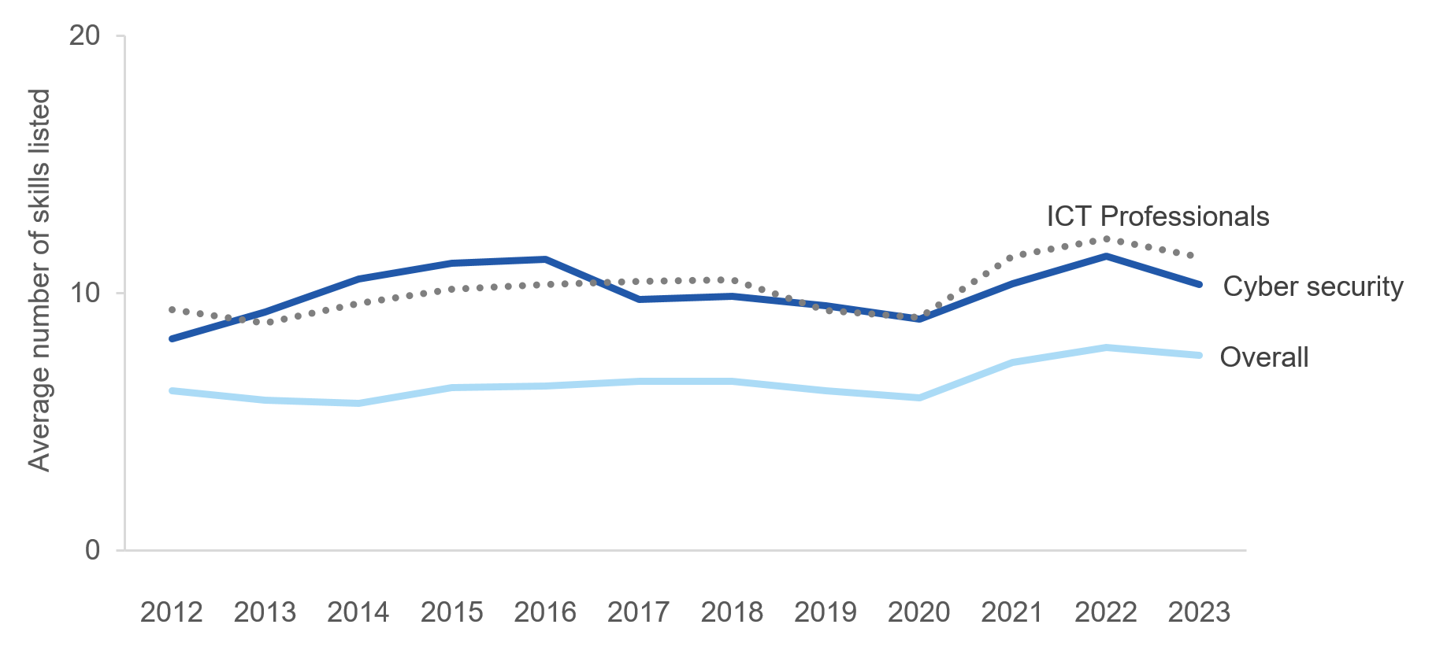
- The average number of skills listed in job ads in the Lightcast data set from 2012 until 2023

The skills in cyber job ads are more likely to be categorised as ‘specialised’ skills
The Lightcast data set categorises each skill listed in a job ad as ‘baseline’ or ‘specialised’. Specialised skills in cyber security include, for example, computer forensics, information security, and anomaly detection. Across all job ads, specialised skills were somewhat more likely to be listed than baseline skills: the average number of specialised skills in a job ad was 5.53, while the average number of baseline skills was 3.28 (in the last six months of 2022). For cyber security job ads, this difference was heightened: an average cyber security job ad listed 8.78 specialised and 3.23 baseline skills.

The skills in cyber job ads are slightly more likely to be categorised as ‘software’ skills, however key cyber skills may be missing from the data set
The skills in the Lightcast data set are also categorised as ‘software’ or ‘non-software’. Overall, non-software skills are much more likely to be listed than software skills: the average number of non-software skills listed in job ads was 7.13, whereas the average number of software skills was 2.76. This is true also in cyber security job ads, which on average listed 9.40 non-software skills and 3.29 software skills.
However, a closer look at the types of skills classified by Lightcast suggests that some technical cyber software skills may be missing or misclassified. Skills classified as ‘cyber security skills’ appeared on average 1.19 times in non-cyber security job ads, and only 1.70 times in cyber security job ads.

Further research would be required to determine the exact type of skills listed in cyber security job ads
Overall, the data supports the anecdotal observation cyber security job ads tend to list a high number of skills and qualifications: in our analysis, the number of specialised and software skills listed in cyber job ads was higher than average. Given we deliberately selected technical cyber security job ads for inclusion in our analysis, this finding is not surprising, and is consistent with previous research (Fortinet 2018). However, further research is required to determine exactly how technical and cyber-specific the skills are. In any case, reducing the number of required skills listed in job ads may be one way to increase the pool of potential candidates for cyber security jobs, including the number of women and other underrepresented groups.

Analyses of flexible and remote work

Take home messages from the analysis of flexible and remote work
- Only a small proportion of job ads advertise the availability of flexible work, even in sectors where the rate of flexible work arrangements among workers is high.
- ICT and cyber security offer flexible work arrangements at a much lower rate than other sectors on average (ABS 2022b, see Figure 2).
- By contrast, cyber security and ICT both offer work from home arrangements at a much higher rate than other sectors.

Few job ads mention the availability of flexible work overall
In 2022, only 1% of cyber security job ads included any of the ‘flexible terms’ developed by the JSA as part of an earlier project (e.g. ‘part time’, ‘contract’, ‘flexible hours’). While this number fluctuated slightly over the past ten years (from a high of 5% in 2013), it has been consistently low. However, this remarkably low number should be interpreted in the context of other job ads: on average across all job ads, in 2022 only 5% included any flexible terms.

On the availability of flexible work, job ads do not align with reality
The occupations most likely to include flexible terms in their job ads (in 2022) were Sales Assistants and Salespersons (15%), Hospitality Workers (13%), and Cleaners and Laundry Workers (12%); however, around 66% of people working in these occupations work part time hours (ABS 2022b; see Figure 2). Overall, in 2022, 32% of workers worked part time hours and 18% considered their job to be casual (ABS 2022b). This demonstrates that the number of flexible terms in a job ad doesn’t directly reflect the actual availability of flexible work. However, with only 10% of ICT Professionals working part time hours (ABS 2022a), there is clearly room for improvement in this and related sectors’ job ads.
- ICT Professionals have the lowest rate of part time hours and offering part time positions in job ads in the economy.

Cyber security job ads are much less likely to mention ‘part time’ work
We also looked at the number of job ads specifying ‘part time’ work in the ad text. This rate was very low in cyber security compared to other sectors, with only 0.1% of job ads in cyber security specifically mentioning part time work. This rate was much lower than in female-dominated occupations, with Education and Health Professionals’ job ads mentioning ‘part time’ 3% and 2% of the time, respectively. Due to limitations in the data, we don’t know the rate of part time hours for cyber security. We can estimate it however, by calculating the ratio of ‘part time’ mentions in job ads to the proportion of part time hours worked for ICT Professionals job ads. If we apply this ratio to cyber security job ads, we would expect approximately 6% of workers to be working part time hours in this sector.

Cyber security job ads are more likely to mention the availability of remote work
Looking specifically at working from home (WFH) arrangements paints a different picture. In 2022, 8% of cyber security job ads mentioned WFH. This puts cyber security in the top 5 occupations for WFH in 2022, with Numerical Clerks (12%) and Arts and Media Professionals (9%) ranking higher, and Business, Human Resource, and Marketing Professionals (8%), and Design, Engineering, Science, and Transport Professionals (8%) mentioning WFH at a similar rate. Job ads for ICT Professionals mention WFH arrangements 7% of the time.

The impact of the pandemic on WFH arrangements can be seen in the data
Up until 2020, less than 1% of all job ads mentioned WFH arrangements. In 2020, the number rose to 2%, then 3% in 2021 and 5% in 2022. Figure 3 shows the increase in WFH arrangements has been much more rapid in cyber security and broader ICT than the overall economy. Interestingly, it looks like the rate is increasing in cyber security at a greater rate than broader ICT Professionals.
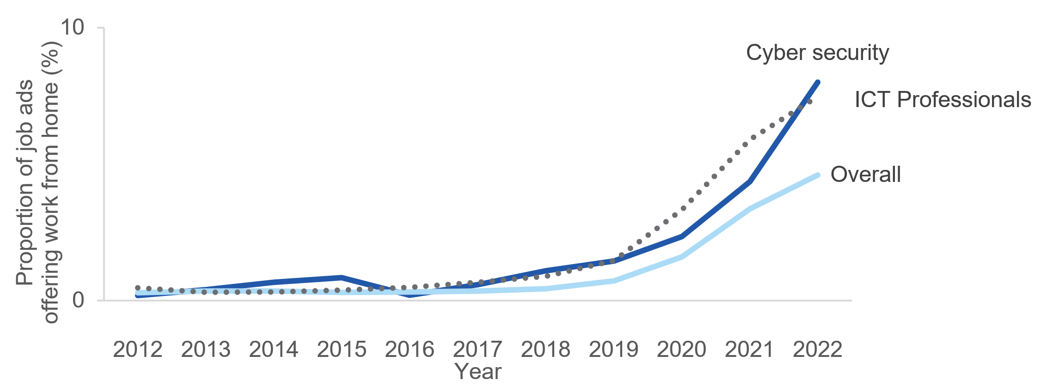
- The proportion of job ads offering work from home has greatly increased since the pandemic.

Masculine language and stereotypes

Take home messages from the analysis of masculine language and stereotypes
- The use of masculine language in job ads has not declined over the past 10 years.
- Cyber security job ads were the 4th highest user of masculine language of any occupation according to the dictionary analysis.
- Cyber security job ads used the most stereotypical language of any occupation for 5 out of 8 masculine stereotypes.
- Language associated with the ‘hackers in hoodies’ stereotype was widespread in cyber security job ads.

Masculine language in job ads is not declining over time
The amount of masculine language in job ads has remained stable since approximately 2014 (Figure 4). Roughly 1% of the ad text – or about 3 words per job ad – were masculine coded, according to the dictionary approach of Gaucher et al. (2011). Similarly, the use of masculine stereotypes in job ads has also remained stable overall – except for a few stereotypes (e.g. ‘leadership ability’, ‘problem solving’), which have seen a slight increase. As can be seen in Figure 4, the amount of masculine language in job ads has remained stable in job ads overall, as well as in the key sectors of interest: cyber security and ICT Professionals. 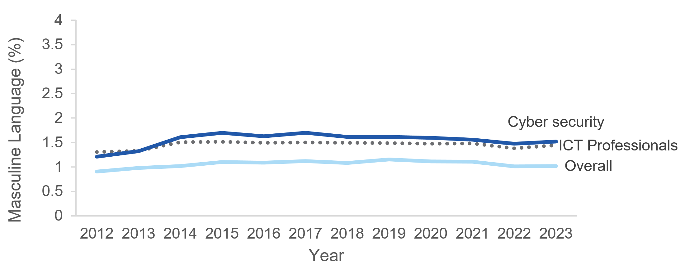
- The proportion of masculine language present in job ads between 2012 and 2023 has not changed over time.¹⁸

Cyber security is the third highest user of masculine language in job ads out of any occupation
To look at how cyber security job ads currently use language, we analysed job ads posted in the last 6 months of 2022. These relatively recent cyber security job ads use more masculine language than most other occupations, ranking 3rd out of 44 occupations (see Figure 5). Cyber security job ads on average contain 1.4% masculine language (as defined by Gaucher et al. 2011). This is roughly 43% more masculine language (or 2.5 more masculine words) than job ads for all other occupations on average. This rate is marginally higher than ICT job ads (by 0.1%), and has been consistently higher than all occupations combined over time (see Figure 5 on the next page).
As seen in Figure 5, there are three categories of job ads that use more masculine language than cyber security. These include job ads for Chief Executives and General Managers, for Business, Human Resource and Marketing Professionals, and Professionals (not further defined). This indicates management-related occupations use more masculine language in describing their roles. This could be due to the focus on leadership for these roles: While women are increasingly taking up leadership positions, they remain underrepresented (Workplace Gender Equality Agency 2022, WGEA), and the job ads for management positions continue to reflect masculine stereotypes.
Furthermore, when considering how all occupations’ job ads compare to cyber security, we found a roughly 72% difference between the proportion of masculine language used in cyber security job ads and the lowest scoring occupations, Hospitality Workers and Food Preparation Assistants. The ads for these occupations use on average less than 0.5% masculine language, or roughly 1 masculine word per job ad.
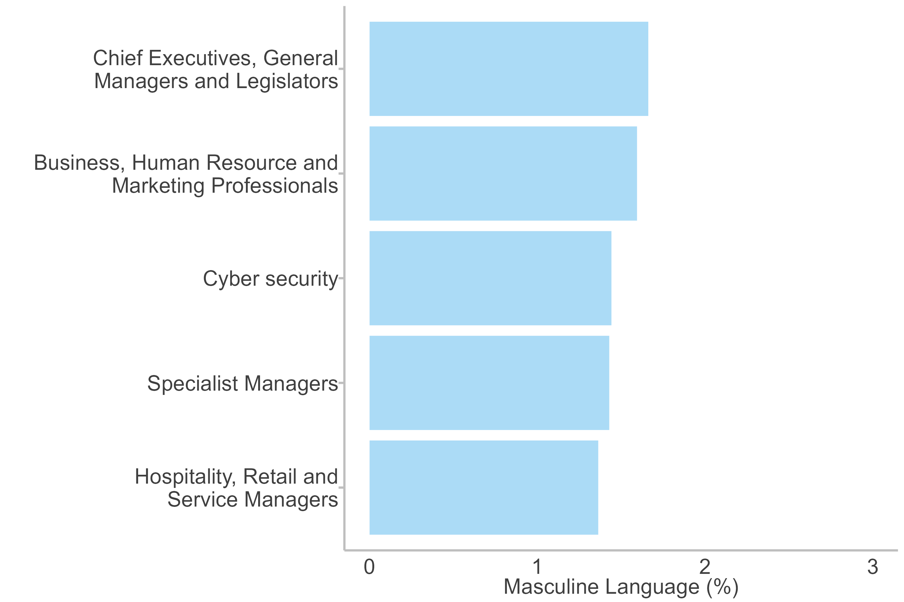
- Masculine language is used more in professional occupations’ job ads – including cyber security – than in low skill occupations.¹⁹

Cyber security job ads use different masculine words than other occupations
Across all job ads, the most common masculine dictionary words were those that started with lead* (e.g. leadership, leader, etc.) and compet* (e.g. competitive, competent, etc.). Like the use of masculine language overall, the use of specific masculine words has been fairly stable over time. However, cyber security job ads used more words that start with lead*, analy*, and challeng* than other occupations (see Figure 6 on the next page). In fact, if the word analy* was removed from the analysis, the amount of masculine language in cyber job ads would be similar to the ICT sector as a whole, and job ads overall. It is not surprising cyber security uses analy* significantly more than all other job ads, as the job title ‘cyber security analyst’ was used to define a cyber security job ad. However, the greater focus on challeng* (e.g. phrases like a ‘challenging environment’), and principle* suggests some of the language used in cyber security job ads could be contributing to fewer women applying to jobs in the sector. 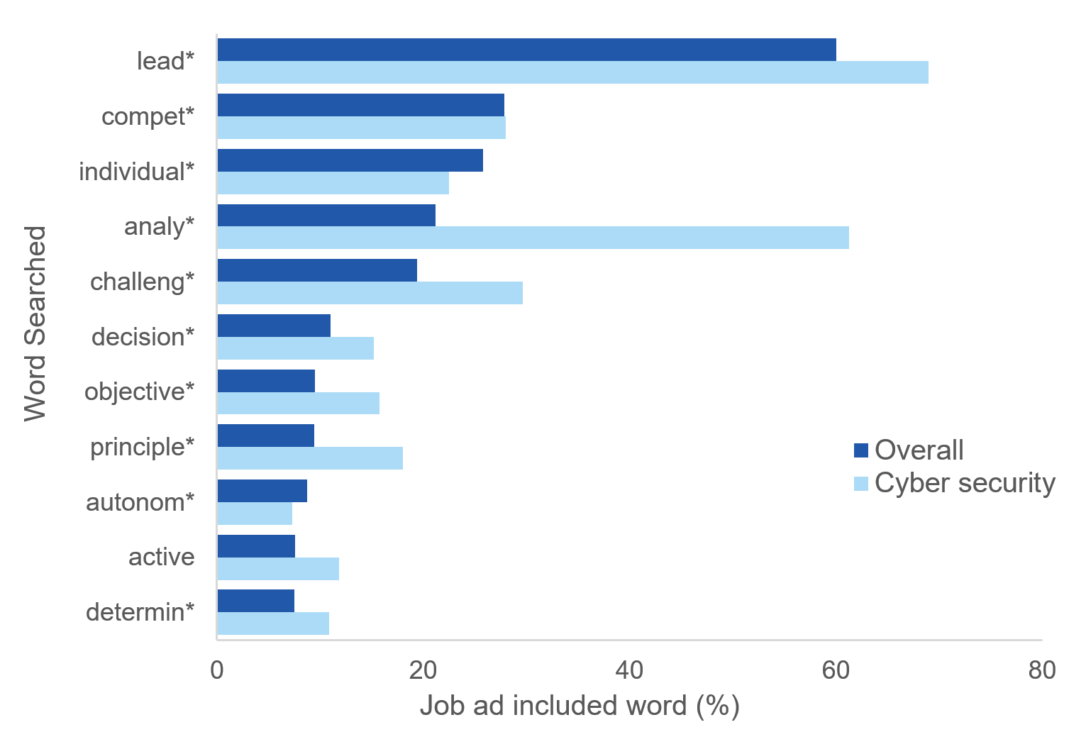
- Lead* is the most commonly used masculine word in job ads on average, while cyber security uses analy* at a much higher rate than other job ads. * indicates that we count all the words that start with these letters.

Cyber security job ads also used the most stereotypical language for several masculine stereotypes
Cyber security job ads had the highest similarity score for 5 out of the 8 masculine stereotypes we analysed using machine learning, which means the language in these job ads was more similar to these stereotypes than the language in any other occupation’s job ads. In particular, cyber security job ads used the most language associated with masculine stereotypes of ‘being in control’, ‘problem solving’, ‘understanding problems’, ‘individual task performance’, and ‘leadership ability’.
While these phrases are different to the individual words captured by the dictionary analyses, they all paint a similar picture of cyber security job ads using highly masculine language:
- With a score of 44, cyber security job ads had the highest average similarity score for the ‘being in control’ stereotype of any occupation. ICT Professionals job ads and all job ads on average had similarity scores of 42 and 41, respectively. The lowest ranking occupations were those that were predominately female-dominated or ‘low skill’ occupations. There wasn’t, however, a large difference in the similarity scores for ‘being in control’ for the top and bottom occupations, suggesting language associated with this stereotype are fairly consistent across occupations’ job ads.
- The technology sector was the most likely to use language associated with ‘problem solving’ and ‘understanding problems’ in their job ads. Cyber security and ICT Professionals job ads had the highest scores for the ‘problem solving’ stereotype, both with an average similarity score of 44. This was 4 points higher than all job ads on average, and 2 points higher than job ads for the next highest occupation, Business, Human Resource and Marketing Professionals. The ‘understanding problems’ stereotype had a very similar pattern of results, and the similarity scores for ‘understanding problems’ and ‘problem solving’ were highly correlated.
- Cyber security job ads had the highest similarity scores for the ‘individual task performance’ (with a score of 45) and ‘leadership ability’ (score of 50) stereotypes, which was slightly higher than the scores for ICT Professionals job ads and all job ads on average. However, for these two stereotypes, there was no relationship between the use of these stereotypes in an occupation’s job ads, and the proportion of men (or women) working in that occupation (see Figure 8 below). Over time, there has also been a slight increase language associated with ‘leadership ability’ and ‘individual task performance’ in job ads, with overall a 2 point increase in the similarity score for both.
Overall, for these masculine stereotypes, cyber security job ads (and often ICT job ads) tended to score 2 to 4 points higher than all job ads on average. This is equivalent to adding one or two sentences using stereotypically masculine phrases, and suggests there is room for improvement in how cyber security job ads are written.

Language associated with the ‘hackers in hoodies’ stereotype is also more pervasive in cyber security
Foley et al (2022) pointed to the ‘hackers in hoodies’ stereotype as one of the reasons women might not think they could work in cyber security, suggesting if the language in job ads reinforce this stereotype, women reading these jobs ads may be less likely to apply.
Cyber security job ads used the most language associated with the ‘hackers in hoodies’ stereotype of any occupation, with a similarity score of 33 on average (Figure 7 on the next page). This score was 5.4 points – or 20% – higher than the average for all job ads combined. Furthermore, the use of language associated with the hackers in hoodies stereotype has not changed over time, in cyber security job ads or across all job ads on average. When we looked how all occupations compare to cyber security, we found a 34% difference between the job ads for the lowest scoring occupation, Farm, Forestry and Garden Workers compared to cyber security job ads. To put these differences in perspective, an increase in this score by this amount is the equivalent of adding 4 or 5 sentences of stereotypical language to a job ad. (See the section on metrics, p.14 for further details.) 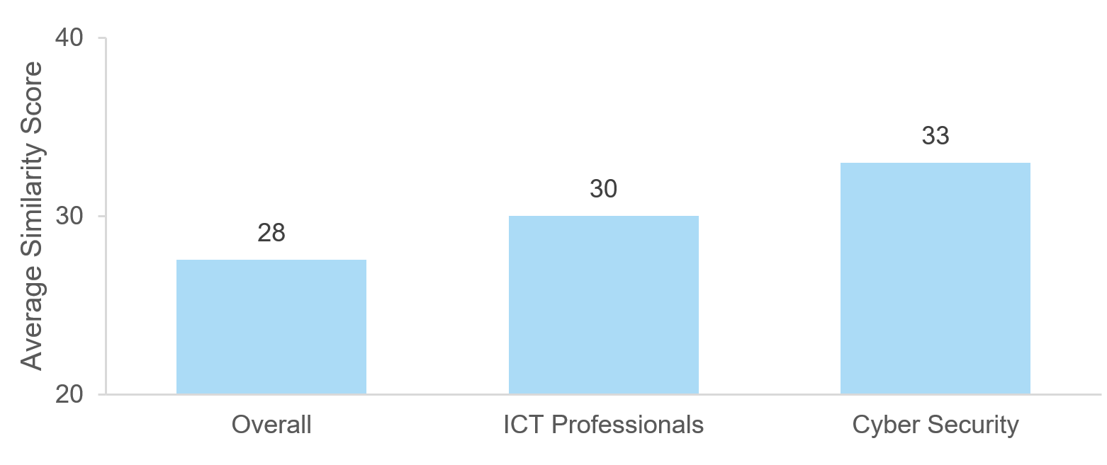
- Cyber security job ads have the highest average semantically similarity score for the ‘hackers in hoodies’ stereotype.

Not all types of masculine language in an occupation’s job ads is associated with a higher proportion of men in that occupation
Like the original research on the masculine dictionaries (Gaucher et al., 2011), we found that a higher proportion of masculine words in a job ad was associated with a higher proportion of men working in that occupation: if the proportion of masculine words increased by 1 percentage point, then the proportion of men in the occupation increased by 1.34 percentage points (see Figure 8 on the next page).
Looking at the association between the proportion of men in an occupation, and the 8 stereotypes we analysed using machine learning, the results were mixed. The strongest positive associations were with the ‘being in control’ and ‘problem solving’ phrases. As can be seen in Figure 8, for example, a one point increase in the similarity score for ‘hackers in hoodies’ was associated with a 1.1 percentage point increase in the proportion of men in an occupation. In other words, male-dominated occupations (including cyber security, as discussed above) are more likely to use language associated with ‘hackers in hoodies’ – as well as ‘being in control’ and ‘problem solving’ – in their job ads.
However, the increased use of phrases ‘taking charge’ and ‘achievement orientated’ in job ads was associated with a lower proportion of men in an occupation (see the negative associations illustrated in Figure 8). This was surprising, and suggests the results for these stereotypes should be interpreted with caution. Attitudes towards these stereotypes may have shifted since they were first described by the literature (c.f. Eagly et al 2020), or they may not be as associated with masculine stereotypes any more.
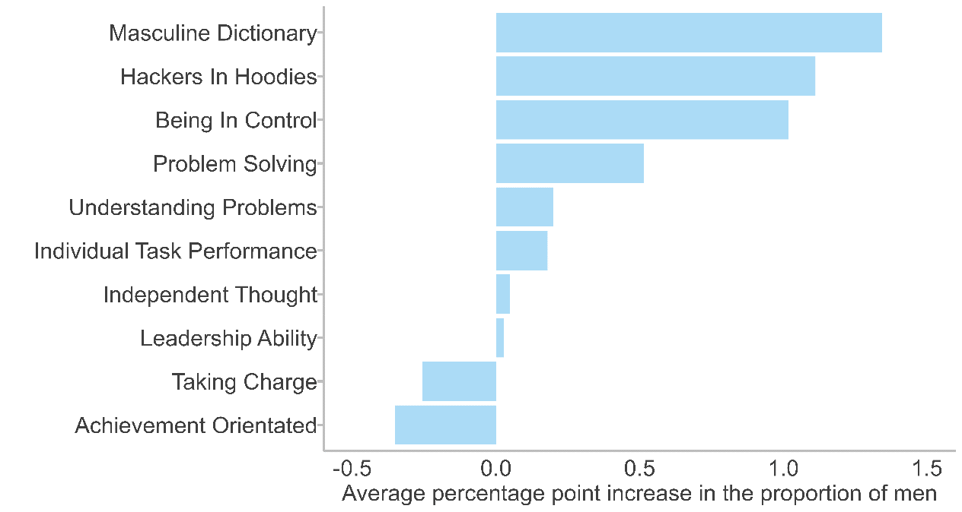
- The proportion of masculine language in an occupation’s job ads, as assessed by the dictionary analyses, had the strongest association with the proportion of men in that occupation.²⁵

Some masculine stereotypes were less common in cyber security job ads
The stereotypes of ‘taking charge’ and ‘achievement orientated’ were not as commonly used in cyber security job ads, nor was ‘independent thought’. The pattern of results for these phrases differ from the ones summarised above:
- For ‘taking charge’, the highest similarity scores were in job ads for workers (e.g. Protective Service Workers) whereas the lowest scores were in job ads for professionals. Cyber security job ads had a similarity score which was the same as all job ads on average (30). While both ‘taking charge’ and ‘being in control’ (on which cyber security scored highest) are associated with the idea of assertiveness, we see a very different pattern of results. This suggests there may different aspects of the language associated with being ‘assertive’, and that it differs across occupations.
- The ‘independent thought’ stereotype had the smallest variation across occupations of any stereotype, with only a 2 point different between the job ads for the top occupation (Education Professionals), and the lowest (Road and Rail Drivers). The low variation across industry, and generally low score probably represent that looking for language associated with ‘independent thought’ is either not a good measure of an agentic trait, isn’t used very often in job ads, and/or is used in a similar way across all job ads. Finally, the stereotype ‘achievement orientated’ had a different pattern of results from others. Education Professionals job ads had the highest similarity score for this stereotype, with a score 36. Cyber security and ICT Professionals job ads both scored higher (with a score of 33) than all job ads on average (32). Overall, use of this stereotype in job ads was associated with more women (fewer men) in an occupation, which we did not expect (see Figure 8).

These analyses show that reducing the amount of specific types of masculine language in cyber security job ads could encourage more women to apply
These results overall suggest some of the stereotypically masculine language used in cyber security job ads could be contributing to fewer women applying for jobs in the sector. Reducing the amount of specific types of masculine language could help attract more female candidates to the sector. This may involve reframing what a position involves, or the skills needed, in order for the job ad to be more gender neutral. In particular, the focus on ‘problems’, ‘analysis’, and ‘hacking’ in cyber security and ICT Professionals job ads could be areas where employers could decrease the use of masculine language. Given other occupations which also have problem solving and analysis as key components of the job – for example engineering and health care – don’t emphasise it in their job ads, it may be possible for cyber security employers to de-emphasise this language in their job ads to avoid discouraging women from applying to these roles.

Limitations

The impact of language in job ads may be small relative to other changes to the cyber security sector
This project was undertaken to understand how job ads are written in cyber security in Australia, how this has changed over time, and how it compares to other sectors. Based on our literature review, we suggest reducing the amount of masculine language, including flexible work, and reducing the number of skills listed in cyber job ads may encourage more women to apply to these jobs. The data analysis demonstrated, with respect to these factors, there is ‘room for improvement’ in Australian job ads – both in cyber security and the technology sector more broadly.
However, between 2016 and 2021 there was a fourfold increase in the number of women working in cyber security in Australia (AWSN, 2022) – while the amount of masculine language in job ads remained constant over the same time period. It is possible if masculine language in job ads had been reduced, the increase in the number of women in cyber security would have be even higher. But other changes to the cyber landscape – for example increased demand, increased awareness of the sector, direct efforts by firms to increase diversity, or mentoring programs – may have larger impacts overall.

We deliberately focused on a narrow subset of cyber security job ads
Our focus for this analysis was specifically on job ads for a more technical subset of cyber security jobs, as this is where the largest gender imbalance is found, and where the greatest workforce shortages are. There are two potential ‘gaps’ in the set of job ads we analysed. First, because our focus was on the most technical cyber security jobs, our definition of cyber security job ads was deliberately narrow. There is always a trade-off between only including the job ads we are interested in, and our ability to include all the job ads we’re interested in. It’s therefore possible we missed some technical cyber security jobs while intentionally ruling out all the non-technical cyber security jobs. Second, although Lightcast is a comprehensive source of online job ads in Australia, it does not include job ads that are listed on SEEK, Australia’s largest job posting website. Similarly, some vacancies may not be advertised online, or may only be ‘circulated’ through word of mouth or through networks. This is not a limitation of our analyses as such, but it may mean we are underestimating the number of cyber security job ads posted in Australia (when looking at the counts of job ads).

Dictionary analyses count individual words, which may miss some aspects of gendered stereotypes reflected in the language of job ads
To analyse the amount of masculine language in cyber security job ads, we initially relied on word-lists (‘dictionaries’) developed and validated by Gaucher and colleagues in 2011. These dictionaries are limited to a relatively small number of specific words, and the analysis involves determining whether these words are present or absent in a given job ad – that is, each word gets a binary yes/no score, rather than a more nuanced score of the degree of gendered language. Furthermore, the dictionaries may be incomplete, and may – given that they were developed over a decade ago – not reflect changes in language use over time. For example, a more recent analysis of gendered language suggests the words ‘responsible’ and ‘honest’ are somewhat more associated with men than with women (Charlesworth 2021) – however, these words were included in the Gaucher dictionary as ‘feminine’ words. As ‘respons*’ was one of the words used more often by cyber security job ads than overall job ads (and we counted it as a feminine word), we may be underestimating how much more masculine the language in cyber job ads are relative to other jobs.

Machine learning analyses address some – but not all – of the limitations of analyses based on masculine and feminine dictionaries
Many of the limitations of the dictionary analysis were addressed by our follow-up analyses of stereotypes using machine learning techniques, and the results were generally consistent between the two analyses. However, one limitation remains: our process of selecting stereotypes for machine learning analysis was similar to Gaucher et al’s process for selecting words for the dictionary, in that both involved reviewing the existing literature on masculine and feminine traits and stereotypes. While we attempted to only use stereotypes that had been included in a number of sources, and to cover many elements of the masculine and feminine stereotypes, selecting the exact phrases is a somewhat subjective process and there may still be gaps in our selection.

Alternative interventions aim to grow the pool of female applicants, and to retain women in cyber security
In Australia, more men than women have technical qualifications related to cyber security (ABS 2019). Growing the pool of applicants by increasing the number of women studying relevant subjects is therefore the focus of other (government and industry) initiatives, for example the CyberCX Academy announcing an all-women cohort (CyberCX n.d.). However, among women who do have qualifications relevant to cyber security, many are currently in a job where they are not using those qualifications (ABS 2019). For example, among women who studied computer science, as many as 25% believe their degree is not relevant to their current job.
This mismatch could be interpreted in at least two ways. On the one hand, it suggests there is a cohort of Australian women with relevant qualifications who have not yet been enticed into cyber security careers – and these women might be reached by carefully written and targeted job ads. On the other hand, these women might have initially had a job in the security/tech sector job, but then left the sector (e.g. due to cultural issues in the industry, Foley et al. 2017). This would suggest a different intervention would be required to retain women in cyber security. Such broader interventions focused on retention, or on increasing the number of women studying cyber security, are outside the scope of this report.

Discussion and Conclusion

Job ads in cyber security use more masculine language than most other occupations in Australia, suggesting opportunities for improvement
Results of both dictionary and machine learning analyses show that cyber security and ICT job ads use a high amount of stereotypically masculine language. In particular, cyber security job ads use more language associated with problem solving, being in control, individual task performance, analysis, and leadership than other occupations. While women clearly also possess these qualities, our literature review suggests that this language is stereotypically associated with men, and that including this language in job ads makes women less likely to apply to the role (Gaucher et al 2011). In other words, if job ads in cyber security (and the technology sector more broadly) focused less on masculine stereotypes, this could encourage more women and people from other underrepresented groups to apply to jobs in this sector. In particular, anyone writing cyber security job ads could reconsider the language used around leadership, control, and analysis. Furthermore, cyber security job ads could focus less on language associated with the ‘hacker in hoodies’ stereotype, as this language may further perpetuate the masculine stereotype associated with cyber security (Foley et al 2022).

Job ads in Australia, particularly in ICT and cyber security, could advertise part-time positions at a higher rate
In Australia, around two thirds of people working part-time hours are women (ABS 2022a), and BIT (2022) found including mention of part time work in a job ad increased the number of women applying. However, our analysis shows that very few job ads in Australia mention the availability of flexible work, including part time hours. This is true across all job ads, although cyber security and ICT job ads include part time hours in their job ads even less than the average. Failing to advertise the availability of flexible work may discourage women from applying to jobs in these sectors. However, the rate of people working part time hours in ICT is also much lower than average. Therefore, changing job ads alone is not sufficient without a broader change in the availability of flexible working conditions in this sector.

Reducing the number of skills listed in cyber security and ICT job ads may increase the overall pool of applicants
In our analysis, cyber security job ads listed more skills – and more specialised skills – than average job ads, consistent with anecdotal observations that job ads in cyber security include ‘laundry lists’ of skills. Previous research suggests reducing the number of skills listed in job ads might increase the overall pool of applicants (BIT 2022), and could therefore increase the number of women applying as well. However, listing fewer skills could also lead to more under-qualified men applying for roles, as men are more likely to overestimate their capabilities in stereotypically masculine domains (BIT 2022, see also Coffman et al. 2021, and Kay and Shipman 2014). A standardised skills framework (for example like CYNAPSE, the program launched in the ACT in April 2023) may support this approach by making it less necessary to list individual skills in a job ad.

Cyber security organisations seeking to improve their hiring practices and attract more female applicants could take a number of steps
To attract more women to apply to cyber security and ICT roles, companies and organisations – both public and private – could:
- Put in place flexible and part time work policies, and advertise these in their job ads
- Carefully consider which critical skills need to be listed in the job ad, and try to reduce the overall number listed in job ads
- Reduce the amount of stereotypically masculine language used in their job ads.
The last point can be achieved using existing tools (available online) which provide an analysis of the gendered language in a given text, or by developing updated tools to achieve the same purpose. More ambitiously, HR professionals could be trained to avoid gendered language, and to use specific gender-neutral language instead.

Government can lead the way by adopting best practice
The government is simultaneously a key employer of cyber security personnel, an industry stakeholder, and a credible source of information. As such, APS agencies could lead by example, and revise their approach to writing job ads in line with the findings from this report. The government could also encourage employers to adopt best practices through the publication of a ‘best practice guide’, and work with industry bodies to disseminate such a guide. Whatever the approach, we recommend it be evaluated (ideally using a randomised controlled trial) and tested alongside other initiatives, to learn more about ‘what works’ for encouraging women to apply to cyber security roles.
Finally, in this project we kept our focus relatively narrow, analysing cyber security and ICT job ads which are just one part of the pipeline from education to employment. More targeted initiatives from Governments (for example to boost the supply of STEM and digital workers throughout this pipeline) could consider adopting an approach similar to the one we have taken here. Analysing the language in communication materials or the flexibility available in learning pathways could provide a fruitful avenue for identifying additional ways to increase the appeal of broader technology-focused career paths to women and other underrepresented groups.

Appendices

Appendix A: Additional details from the literature review
In the main body of the report we summarise findings from the literature on gendered language, flexible work, and skills listed in job ads. These aspects of job ads were then the focus of the data analysis. However, as part of the literature review we also found some research on other aspects of job ads, including diversity statements and other ways of directly addressing diversity and inclusion. We did not follow up these aspects in the data analysis – partly because the evidence for the impact of these factors is less compelling, and partly because they are harder to assess using the data we had available. However, here we summarise a few additional studies on how to potentially attract more women and other underrepresented groups to apply to a job ad.

Directly addressing diversity in job ads may demonstrate opportunities for growth and belonging
In a field study on recruitment to a financial services company in the U.S., Flory et al (2011) including a direct call-out for diverse candidates: The message included an emphasis on how inclusion and diversity are ‘key to [the company’s] success’, and increased the rate at which underrepresented ethnic groups applied. However, this study did not find an impact of diversity-messaging on the proportion of female applicants.
On the other hand, directly addressing identity and belonging through including a role model has been found to increase the number of qualified female applicants. Del Carpio and Guadalupe (2021) showed that including a female role model in information about a female-only software-coding course, significantly increased the total number of applicants (compared to when no role model was included). These studies thus provide suggestions for approaches that could be explored in the future, especially when aiming to recruit other underrepresented groups in addition to women.

Diversity statements may signal an organisation’s commitment to diversity and inclusion
Diversity statements are intended to signal an organisation’s commitment to diversity – and they may send this signal to a broad audience, not just too potential applicants. For example, one study from New Zealand found that if a job ad included an Equal Employment Opportunity statement, women were more likely to rate the organisation positively (McNab and Johnston 2002). However, once again it is not clear that including diversity statements in job ads increase women’s likelihood of applying to the job (Windscheid et al. 2016) – although they might be somewhat more effective for attracting ethnic minorities, BIT 2022).

Evidence used in this review
The ‘literature review’ section of this report summarises studies on the impact of the language, content, or structure of job ads on the number and proportion of women and other underrepresented groups who apply. While we focused primarily on the technology sector, we included several studies conducted in other sectors to better understand ‘what works’ for making a job ad attractive to a diverse pool of potential applicants. Furthermore, we included studies from countries other than Australia, and studies that were conducted in hypothetical settings, and with self-reported outcomes (e.g. ‘how likely would you be to apply for this job?’), not just real job ads and behavioural outcomes (e.g. an individual actually applies for the job). We also expanded our search beyond the peer-reviewed academic literature, and reviewed unpublished studies and reports.
Even with such broad inclusion criteria, rigorous studies on the impact of (changes to) job ads, conducted in the field, are unfortunately scarce. Our overall judgment of whether a particular factor has an impact or not, and the likely size of that impact, is therefore based on a holistic assessment of the available research.

Appendix B: Analysis of feminine language
In the main body of this report we focused on masculine language because the existing literature suggests masculine language in job ads can have an impact on who applies for the role; whereas the evidence that feminine language has a similar impact is scant. We also aimed to keep the main body of the report shorter. However, we analysed feminine language as well – both through the dictionary approach and machine learning – and here we summarise these results.

Take-home messages
- The use of feminine language in job ads has increased over time.
- The increase in feminine language in job ads is driven by specific words and stereotypes being used more.
- Cyber security job ads used the most stereotypical language – compared to other occupations – for 2 out of 5 feminine stereotypes, which was unexpected.
- Language associated with the ‘caring’ stereotype in job ads was the most strongly associated with the proportion of women working in an occupation.

The use of feminine language in job ads is increasing over time
Across all job ads, the proportion of feminine language (as defined by the Gaucher et al dictionaries) is increasing (Figure 1). Compared to the original Gaucher et al. (2011) findings, the proportion of feminine language used in Australian job ads has been consistently higher. The original paper found the language in job ads was roughly 0.6% feminine, while Australian job ads have had roughly double that proportion since 2012. Similarly, the use of feminine stereotypes in job ads (as assessed using machine learning techniques) has generally been increasing, with similarity scores increasing between 2 and 5 points since 2023, for the 4 feminine stereotypes we assessed. 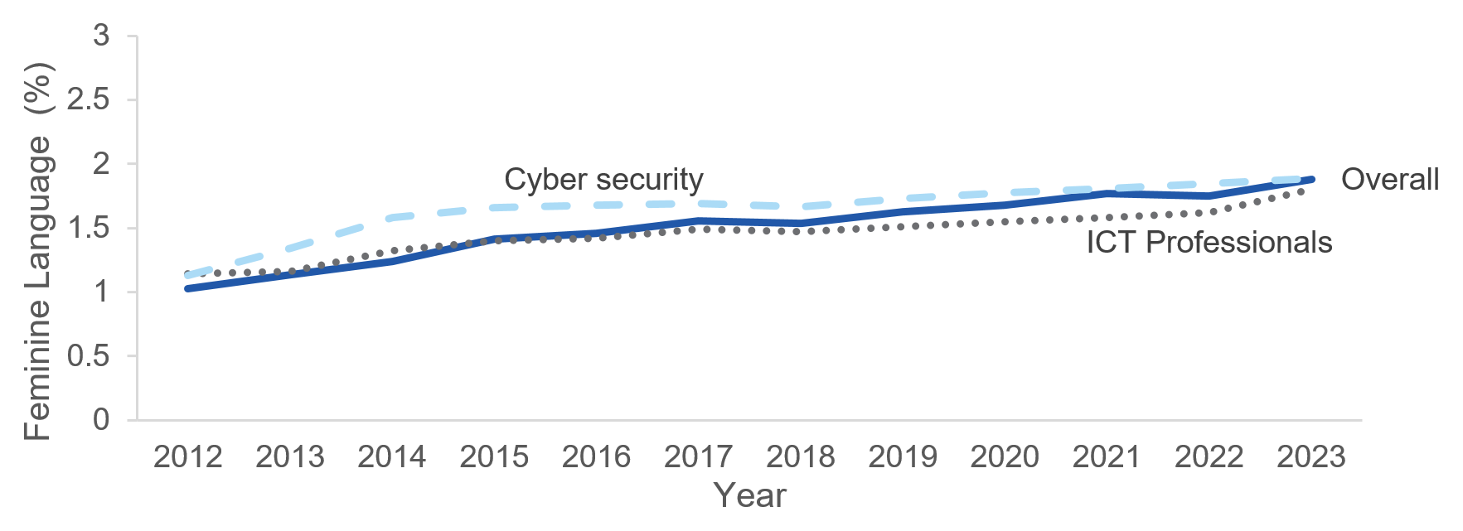
- The use of feminine language has increased in Australian job ads overall.
Because of this increase, in the last few years job ads have on average included a higher proportion of feminine than masculine language. This is consistent with a study by Kanji and colleagues (2022), who collected 6,000 software engineering and IT jobs ads posted to SEEK in Australia between September and November 2020. Using an online gender bias detection tool, these researchers demonstrated these job ads used more feminine than masculine language overall, including a preponderance of words such as ‘supporting’, ‘understanding, and ‘inclusive’ (see further detail on these words below). Similarly, a 2020 study conducted in the US found that language in job ads for ‘cyber security analyst’, ‘programmer analyst’ and ‘systems analysis’ used more feminine than masculine words (Breese et al. 2020). Neither of these studies included a comparison set of ads – for example to other industries. Our analysis suggests this trend of including more feminine words over time (and thus eventually a higher proportion of feminine than masculine words) is not unique to cyber security job ads, but reflects a broader change in how job ads are written.

The increase in feminine language is due to a change in the prevalence of specific words
As can be seen in Figure 2, since 2020 there has been a large increase in the use of specific feminine words in job ads. The largest has been the increase in the word commit*: the proportion of ads including this group of words has increased by roughly 25 percentage points since 2012. This could reflect an increase in the use of diversity statements in job ads – for example the phrase ‘we are committed to being an equal opportunity employer’. However, more broadly we see a general increase in words associated with the feminine stereotype, with roughly 70% of all job ads including words that start with ‘support*’. 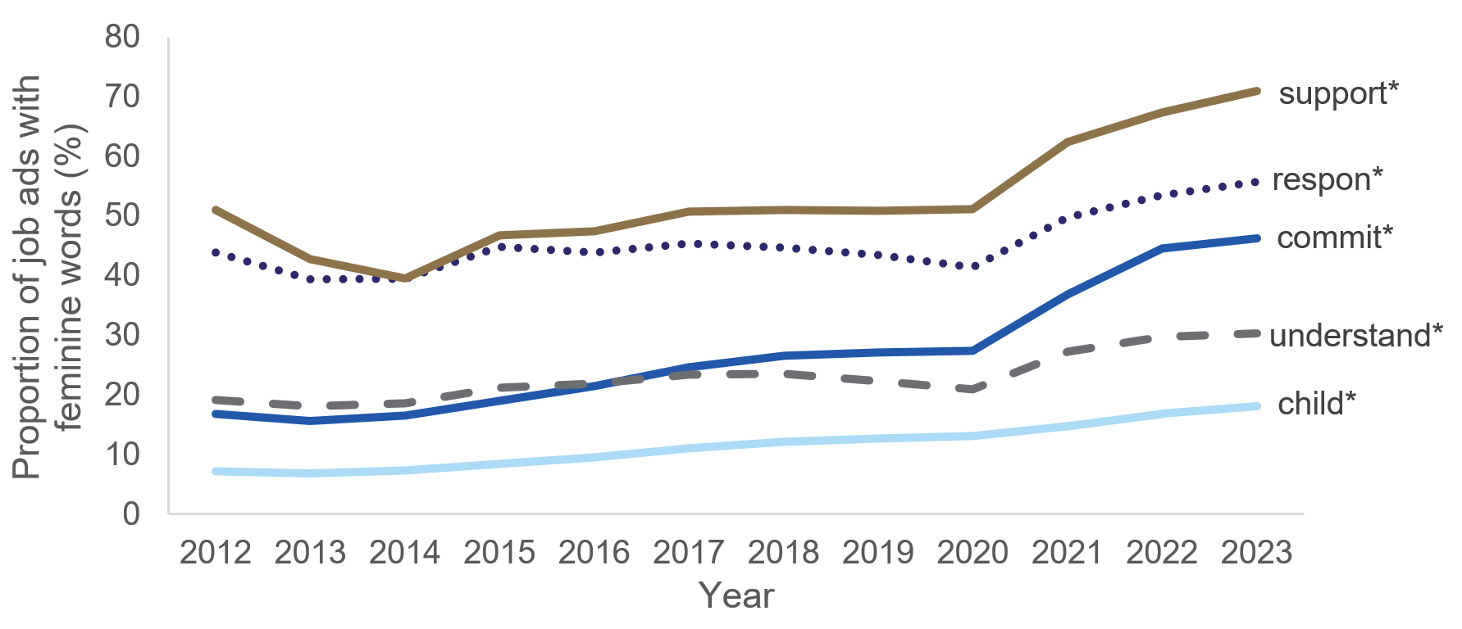
- Certain feminine words have been increasingly used in job ads.
*indicates that we count all words that start with these letters.

Analysed using machine learning, the average similarity score for ‘caring’ has also increased over time: both in job ads overall, and in job ads specific to ICT Professionals and cyber security. This recreates the findings from the dictionary analysis, and suggests employers are increasingly focusing on feminine traits in their job ads.

The difference between cyber security and other job ads depends on the specific types of feminine language
According to the dictionary analyses, cyber security job ads use roughly an equal amount of feminine language as the average of all other job ads – 1.8% for both. Cyber security ranks 11th out of the 44 occupations, so like other professional areas, it uses more feminine dictionary words than non-professional occupations.
However, comparing specific words in cyber security job ads to overall job ads, reveals some differences. Cyber security jobs are less likely to use the word child*, and more likely to use the words respon*, understand* and trust* (Figure 3). ‘Trust’ is likely to be highlighted especially often in a role that involves security, and the higher use of ‘understand’ could reflect cyber security jobs requiring knowledge of several technologies. It is also consistent with the finding (reported in the main body) that language associated with ‘understanding problems’ is especially common in technology sector job ads. 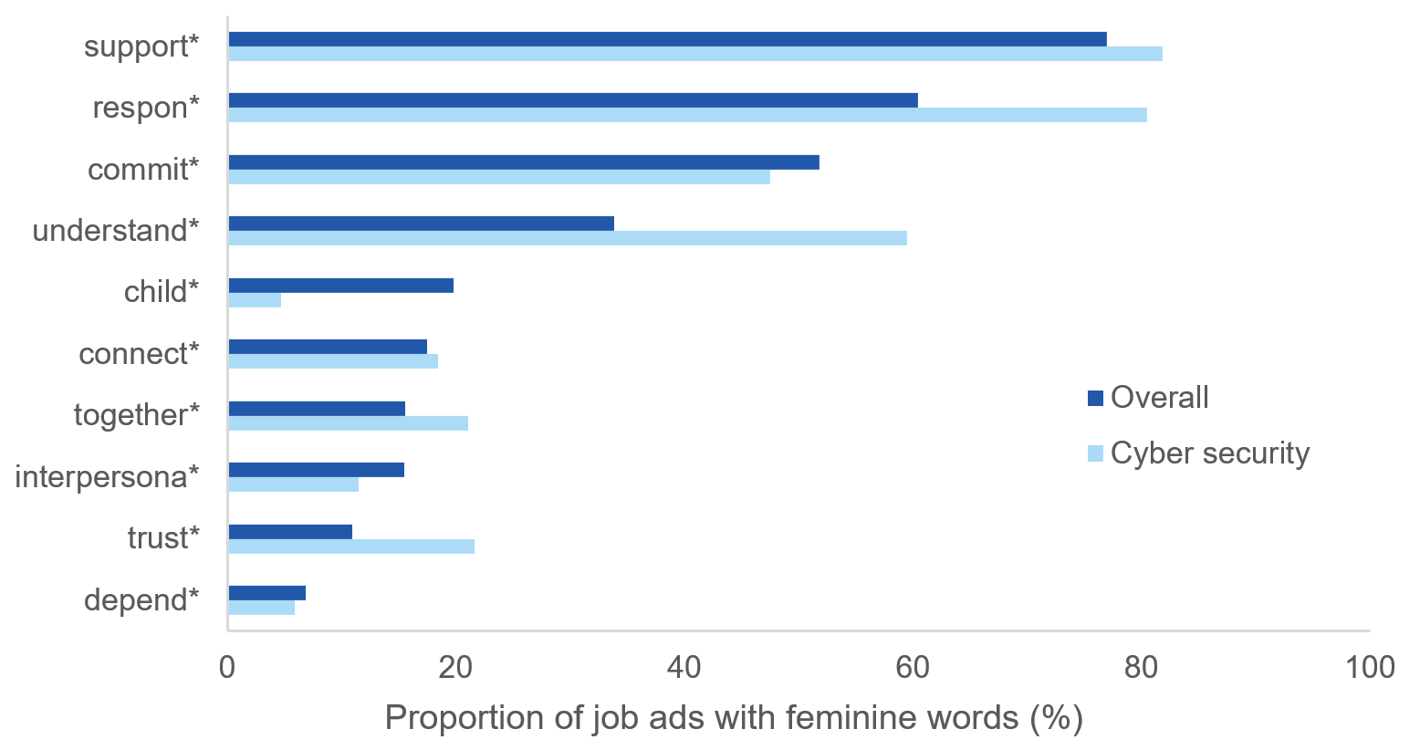
- Cyber security job ads uses the word understand* and respon* at a much higher rate than job ads overall.
The results from our analysis of stereotypes using machine learning were also mixed:
- ICT and cyber security job ads used less language associated with the ‘caring’ stereotype than other occupations, and this has not changed over time. For this stereotype, ICT and cyber security job ads had similarity scores of 29 and 30 respectively (compared to all job ads on average, which scored 32). Unsurprisingly, female-dominated occupations like Carers and Aids and Health and Welfare Support Workers had the highest similarity scores for this stereotype (41 and 39, respectively), while male-dominated occupations had the lowest. This stereotype also had the strongest relationship with the proportion of women in an occupation: a 1 point increase in the similarity score for ‘caring’ in an occupation’s job ad was associated with a 1.2 percentage point increase in the proportion of women in that occupation (see more below).
- By contrast, language associated with ‘understanding people’ was highly likely to be used in both cyber security job ads, and job ads for female-dominated occupations (see Figure 4). Cyber security job ads ranked 4th out of job ads for 44 occupations with a similarity score of 49 – which was both higher than job ads for ICT Professionals, and all job ads on average (which had scores of 47 and 48, respectively). This finding is also consistent with the dictionary analyses showing cyber security job ads were especially likely to use the word ‘understand*’ (see Figure 3 above). 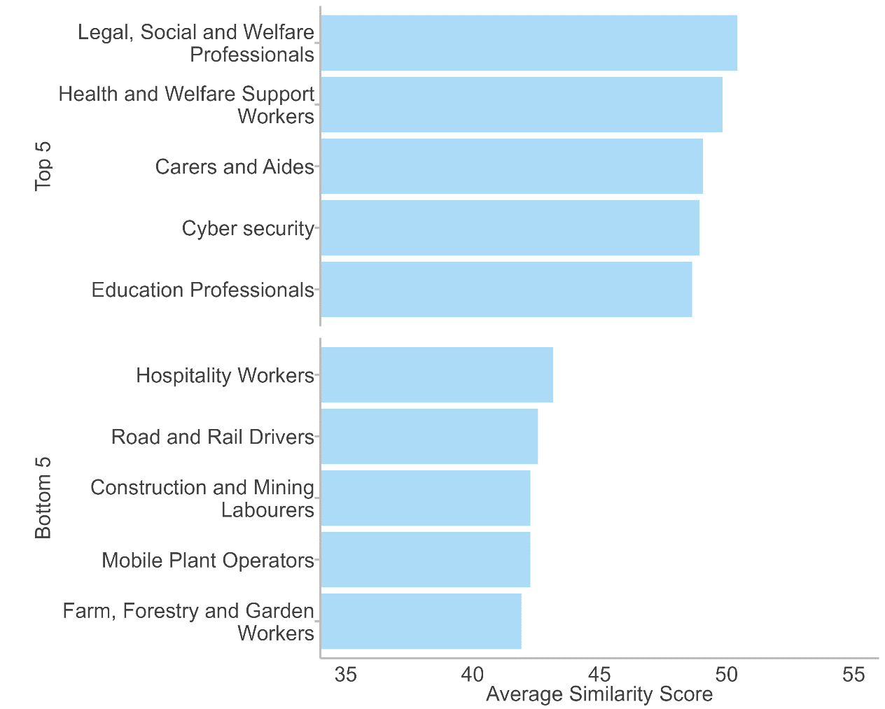
- Cyber security job ads are in the top 5 occupations for use of language associated with the ‘understand people’ stereotype.

- Cyber security job ads were ranked 5th for the ‘relationships orientated’ stereotype, with a similarity score of 33. Occupations that require face-to-face interactions used the most language associated with this stereotype in their job ads (e.g. Legal, Social and Welfare Professionals, Health and Welfare Support Workers) – however, this was also true for the technology sector, as job ads for ICT Professionals also had a similarity score of 33.
- Cyber security job ads also used a surprising amount of language associated with the stereotypes ‘emotional sensitivity’ and ‘concern for others’ (and the two stereotypes were highly correlated). Cyber security job ads had the highest similarity score for any occupation for these two stereotypes, with scores of 45 and 47: compared to all job ads on average, which had scores of 43 and 44. In general, job ads for male-dominated occupations tended to have the lowest similarity scores for these stereotypes, so it is surprising cyber security scored so highly.
Taken together, these findings suggests many employers are increasingly prioritising ‘empathic skills’ (working with others, and seeing multiple perspectives). The high similarity scores for cyber security and ICT Professionals job ads may reflect that technology employers select for people who can maintain good relationships with others. This is potentially to counteract other stereotypes of their occupations (for example, technology workers are blunt or lack communication skills) or because some ICT and cyber security jobs also involve a degree of customer service.

Female-dominated occupations use significantly more feminine language than male-dominated occupations
Unlike the original Gaucher et al. (2011) paper, we generally found a strong relationship between the use of feminine language in job ads, and the proportion of women in the occupation: a 1 percentage point increase in the proportion of feminine language was associated with a 3.5 percentage point increase in the percentage of women in that occupation. This suggests job ads in female-dominated occupations in Australia focus on the feminine traits when advertising for jobs. The reverse effect was not as strong: for example, construction is one of the most male-dominated industries, but it does not use a correspondingly high amount of masculine language in job ads.
On the other hand, the machine learning analysis also shows the relationship between feminine language in job ads and proportion of women in an occupation does not hold for all feminine stereotypes. For example, job ads for ICT professionals and cyber security scored high on the stereotypes ‘concern for others’ and ‘understanding people’, whereas job ads for masculine occupations such as Construction Trades Workers or Construction and Mining Labourers scored low. In other words, stereotypically ‘nerdy’ occupations include in their job ads more stereotypically feminine language in their job ads than do traditionally ‘blokey’ occupations (such as mining and construction), despite both types of occupations being male-dominated.
Given this difference with the Gaucher et al. (2011) result, it may be interesting to better understand the effect of feminine language in job ads, on the attractiveness of the job to (female) applicants, in Australia.

A note on an inconsistency between our finding that masculine language has remained stable, and a previous study
An analysis from 2017 of all English language job ads posted on LinkedIn over the past decade (Tang et al., 2017) found a trend away from the use of gendered language in job ads over this time period, including in the technology sector. This finding is inconsistent with our findings (reported in the main body of the report) that masculine language has remained stable. However, the inconsistency could be due to a couple of reasons. First, our analysis included only Australian job ads. The masculine language in other countries’ job ads might have changed more than the language in Australian job ads. Second, Tang and colleagues calculated the amount of ‘gendered language’ by combining measures of both masculine and feminine language. This means that a decrease in ‘gendered language’ in their analysis could reflect a decrease in masculine language or an increase in feminine language (or both). We analysed masculine and feminine language separately. Our analysis of feminine language (reported above) shows that feminine language in Australian job ads has increased over the past decade. If we had combined our analysis of masculine and feminine language, therefore, our results would have been consistent with those of Tang et al (2017).

Appendix C: ABS Analysis of Technical Qualifications
As mentioned in the Executive summary, more men than women have technical qualifications related to cyber security in Australia. We also noted that among women who do have qualifications relevant to cyber security, many are currently in a job where they are not using those qualifications. These findings were drawn from the ABS data set ‘Qualification and Work’, and are summarised in full in Table 5 below.
The table lists a range of qualifications in the left-most column (highlighted qualifications are most relevant to cyber security). The next two columns indicate these are also qualifications which men are more likely to hold (e.g. 76% of ‘Computer Science’ degree holders are male, while 24% are female). The two columns on the right indicate whether these men and women (who have a given qualification) feel their qualification is relevant to their current job. For example, 26% of women with a Comp. Sci. degree say their degree is not relevant to their current job. For most qualifications related to cyber security, the proportion of women saying their degree is irrelevant to their current job is higher than the proportion of men who say the same (e.g. 31% vs 3% for ‘Economics and Econometrics’.)
- In the technology sector, women are less likely than men to be working a job that is relevant to their highest level of education
Field of highest qualification | Men (%) | Women (%) | Proportion of men not working in relevant field (%) | Proportion of women not working in relevant field (%)
Electrical and Electronic Engineering and Technology^ | 93 | 7 | 13 | 46
Computer Science^ | 76 | 24 | 11 | 26
Information Technology n.f.d.^ | 76 | 24 | 17 | 21
Mathematical Sciences^ | 66 | 34 | 20 | 0
Economics and Econometrics | 60 | 40 | 3 | 31
Other Society and Culture | 57 | 43 | 15 | 30
Information Systems^ | 57 | 43 | 34 | 31
Banking Finance and Related Fields | 56 | 44 | 14 | 11
Political Science and Policy Studies | 56 | 44 | 48 | 31
Management and Commerce | 46 | 54 | 16 | 8
Law | 43 | 57 | 8 | 4
Accounting | 42 | 58 | 17 | 12
Studies in Human Society | 41 | 59 | 30 | 37
Behavioural Science | 24 | 76 | 31 | 19
Teacher Education | 23 | 77 | 11 | 8
Nursing | 10 | 90 | 7 | 8
Total | 45 | 55 | 15 | 12
Note: ABS 2019: Qualifications and Work.
^ These degrees are related to cyber security.

Appendix D: Data analysis methods

Defining ‘cyber security’ in order to select Lightcast job ads for analysis
We selected a cyber security job ad for inclusion in our analysis if:
- The job title matched an Australian and New Zealand Standard Classification of Occupations (ANZSCO) cyber security job title OR matched a Lightcast canonical job title, AND had at least two cyber security key words in the job ad text.
OR
- The job ad contained 4 or more cyber security key words in the job ad text.
This process selected a total of 38,234 cyber security job ads for inclusion in our main sample, spanning from 2012 to early 2023. The list of ANZSCO job titles and cyber security key words are listed in the boxes below.

Key words used to define the cyber security sector
- Cyber/cybersecurity/cyber security
- IT Security/ICT Security/Information Security
- Hacker
- Vulnerabilit*
- Penetration Test*
- Threat
- Malware
- Security Architect/Security Assessment/Security Testing/Security Review
- Incident Responder
- Intelligence Analysis
- CCS/Certified Cloud Security Professional
- Escalate Privilege
- Steal Credential
- Splunk
- Phising
- SIEM
- Keylogger
- AZ-500
- Security+
- CEH
- Certified Ethical Hacker
- CISM/Certified Information Security Manager
- CISSP/Certified Information Systems Security Professional
- TOGAF/The Open Group Architecture Framework
- Arcsight
- ISO27001/ISO27000/ISO27002/ISO27001/ISO27000/ISO27002
- Backdoor
- GIAC/Global Information Assurance Certification
- IRAP/Infosec Registered Assessors Program

ANZSCO job titles used to define the cyber security sector
- Cyber Security Developer
- Cyber Security Engineer
- IT/ICT Security Engineer/ Information Security Engineer
- Ethical Hacker
- ICT Vulnerability Tester
- Penetration Tester
- White Hat
- Security Administrator
- Cyber Compliance
- Cyber Risk
- Cyber Governance
- Cyber Governance Risk Compliance
- Cyber Security Assessment
- Cyber Security Adviser
- Cyber Security Consultant
- IT/ICT Security Adviser/ Security Adviser
- IT/ICT Security Officer
- IT/ICT Security Consultant
- Cyber Security Analyst
- Vulnerability Researcher
- Cyber Security Researcher
- Cyber Security Vulnerability
- Cyber Threat Analyst
- IT/ICT Security Analyst/ Information Security Analyst
- Malware Analyst
- Cyber Security Architect
- Enterprise Security Architect
- IT/ICT Security Architect
- Cyber Security Incident
- Cyber Security Operations

2. List of ANZSCO codes used in the report
We used ANZSCO sub-major (level 2) codes to analyse different occupations, with an additional code for cyber security. We relied on Lightcast’s coding of job ads into their respective sub-major occupation code. Differences between the current addition and our analysis are due to Lightcast’s coding. The full list is provided on the next page.

ANZSCO sub-major code
- Arts and Media Professionals
- Automotive and Engineering Trades Workers
- Business, Human Resource and Marketing Professionals
- Carers and Aides
- Chief Executives, General Managers and Legislators
- Cleaners and Laundry Workers
- Clerical and Office Support Workers
- Construction and Mining Labourers
- Construction Trades Workers
- Cyber security – our definition
- Design, Engineering, Science and Transport Professionals
- Education Professionals
- Electrotechnology and Telecommunications Trades Workers
- Engineering, ICT and Science Technicians
- Factory Process Workers
- Farm, Forestry and Garden Workers
- Farmers and Farm Managers
- Food Preparation Assistants
- Food Trades Workers
- General Clerical Workers
- Health and Welfare Support Workers
- Health Professionals
- Hospitality Workers
- Hospitality, Retail and Service Managers
- ICT Professionals
- Inquiry Clerks and Receptionists
- Legal, Social and Welfare Professionals
- Machine and Stationary Plant Operators
- Mobile Plant Operators
- Numerical Clerks
- Office Managers and Program Administrators
- Other Clerical and Administrative Workers
- Other Labourers
- Other Technicians and Trades Workers
- Personal Assistants and Secretaries
- Protective Service Workers
- Road and Rail Drivers
- Sales Assistants and Salespersons
- Sales Representatives and Agents
- Sales Support Workers
- Skilled Animal and Horticultural Workers
- Specialist Managers
- Sports and Personal Service Workers
- Storepersons

Assessing gendered language through the ‘dictionary’ approach – further detail
Previous research on job ads has used ‘dictionaries’ of masculine and feminine words to measure how gendered the language is. The most established dictionaries were developed by Gaucher and colleagues (2011). Based on previous research on masculine and feminine traits, and agentic and communal language, these researchers collected a list of around 40 words which are associated with men, and around 40 that are associated with women. The full lists are provided on the next pages. They then validated their dictionaries by demonstrating that:
- job ads for male-dominated occupations (e.g. plumber, computer programmer) on average contained more masculine words than jobs ads for female-dominated occupations (e.g. registered nurse, early childhood educator)
- job ads for positions in male-dominated university faculties (e.g. engineering, maths and computer science) on average contain more masculine words than job ads for female-dominated university faculties (e.g. health studies, arts)
- when a job ad contained more masculine language, research participants estimated on average fewer women would work in that occupation, than when the same ad contained more feminine language (regardless of whether the occupation overall tends to be male or female dominated)
- when a job ad contained more masculine language, female research participants found them less appealing than the same ad containing more feminine language (regardless of whether the occupation overall tended to be male or female dominated)
Additional studies have used similar approaches, and also found job ads containing more masculine language are less appealing to women (than the same ad containing more feminine language (Born and Taris 2010, Oldford and Fiset 2021)).
We used the Gaucher et al. (2011) dictionaries for consistency with previous research. As an additional ‘validation’, we checked their wordlist against a more recent analysis of gender stereotypes in natural language (Charlesworth et al. 2021). Not all of Gaucher’s dictionary words were available in the Charlesworth analysis, but on average, Gaucher’s masculine dictionary words were more associated with men (less with women) than their feminine dictionary words, which were on average more associated with women.

Masculine words (* indicates that we count all words beginning with these letters)
- Active
- Adventurous
- Aggress*
- Ambitio*
- Analy*
- Assert*
- Athlet*
- Autonom*
- Boast*
- Challeng*
- Compet*
- Confident
- Courag*
- Decide
- Decisive
- Decision*
- Determin*
- Dominant
- Domina*
- Force*
- Greedy
- Headstrong
- Hierarch*
- Hostil*
- Impulsive
- Independen*
- Individual*
- Intellect*
- Lead*
- Logic*
- Masculine
- Objective
- Opinion
- Outspoken
- Persist*
- Principle*
- Reckless
- Stubborn
- Superior
- Self-confiden*
- Self-sufficien*
- Self-relian*

Feminine words (* indicates that we count all the words beginning with these letters)
- Affectionate
- Child*
- Cheer*
- Commit*
- Communal
- Compassion*
- Connect*
- Considerate
- Cooperat*
- Depend*
- Emotiona*
- Empath*
- Feminine
- Flatterable
- Gentle
- Honest
- Interdependen*
- Interpersona*
- Kind
- Kinship
- Loyal*
- Modest*
- Nag*
- Nurtur*
- Pleasant*
- Polite
- Quiet*
- Respon*
- Sensitiv*
- Submissive
- Support*
- Sympath*
- Tender*
- Together*
- Trust*
- Understand*
- Warm*
- Whin*
- Yield*

Assessing stereotypes using machine learning techniques – further detail
Machine learning techniques can analyse stereotypically gendered phrases (e.g. the masculine ‘taking charge’ and ‘problem solving’), rather than just individual words, and thus provide a more nuanced look at gendered language than the dictionary analyses.
- Stereotypes included in the machine learning analysis
Stereotype | Stereotypical Phrase | Source
Masculine | 'taking charge'  'being in control'  'individual task performance'  'independent thought'  'achievement orientated'  'leadership ability'  'problem solving'  'understanding problems' | Hentschel, Heilman and Peus (2019)  Heilman (2012)
Feminine | 'concern for others'  'relationship-orientated'  'emotional sensitivity'  'caring'  'understanding people' | Hentschel, Heilman and Peus (2019)  Heilman (2012)
Others considered | ‘hackers in hoodies’ | Foley et al (2017)
Our machine learning analyses of stereotypes in job ads involved four steps, following the approach by Burn et al (2022):
- First, we trained a model on a large amount of natural language. We trained a Word2vec model (Mikolov et al. 2013a, 2013b) on the 2023 version of English Wikipedia. When trained, the model had a vocabulary of roughly 2.2 million words, which accounts for roughly all words in the English language. ‘Training’ a model means asking it to ‘review’ every sentence in a dataset of sentences (in this case, every sentence in the 2023 version of English Wikipedia), and try to guess at how likely any given word is to appear in each sentence. In this way, the model eventually ‘learns’ the meaning of words, because it is able to predict which words are used in which context. For example, the model learns the meaning of ‘bus’ and ‘taxi’ by learning that the words will likely fill the gap in ‘I caught a ____ to work.’ The model ‘learns’ each word by converting them to a numeric representations, which can then be used to tell us how similar they are to each other.
- Second, we compiled a list of stereotypical phrases. Phrases contain more information than a single word, which is one reason the machine learning approach adds more nuance than the dictionary approach. For example, we can combine the words ‘taking’ and ‘charge’ to get the phrase ‘taking charge’ (which has a different meaning than the two words in isolation). We selected a range of masculine and feminine stereotypes from a number of research papers (Heilman 2012, Hentschel, Heilman and Peus 2019). We were also interested in additional phrase ‘hackers in hoodies’. The full list of stereotypes is provided in Table 1.
- Third, we compared each phrase in the job ads to each stereotypical phrase. In contrast to dictionary approaches (which give each word in a job ad a score of 1 or 0), using the Word2vec model allows us to compare each phrase in a job ad to each stereotypical phrase. Each phrase in the job ad then receives a score from -1 to 1 in terms of how semantically similar it is to the stereotypical phrase. A higher score indicates a phrase is more closely aligned with a stereotype, whereas a lower, negative score indicates it is dissimilar. For example, ‘coding in a basement’ has a semantic similarity score of 0.58 (which is quite a high score) when compared to the phrase ‘hackers in hoodies’.
- Finally, we summarised the semantic similarity score by reporting the 95th percentile score. To combine all the phrases and summarise the overall ‘stereotypicalness’ of the language in a given job ad, we report the 95th percentile semantic similarity score for each job ad. While this score in theory could range from -1 to 1, in practice it tended to range from [.17 to 0.53] in our analyses. We multiplied it by 100 for ease of interpretation, and call it the similarity score.

References
ABS (Australian Bureau of Statistic) (2019) Qualifications and Work, 2018-2019, ABS TableBuilder, accessed November 2022.
ABS (Australian Bureau of Statistic) (2022a) 2021 Census – employment, income and education, ABS TableBuilder, accessed March 2023.
ABS (Australian Bureau of Statistic) (2022b) Labour Force Australia, October 2022 release, ABS website, accessed 24 November 2022.
ACSC (Australian Cyber Security Centre) (2022) Annual Cyber Threat Report July 2021 – June 2022. ACSC, accessed 24 November 2022.
Adler L (2015) Performance-based hiring is your best bet for diverse hiring [opinion]. Linkedin, accessed 28 November 2022.
AuCyber Explorer (2022) Supply & Demand Maps. AustCyber website, accessed 24 November 2022.
AustCyber (2022) Australia’s Cyber Security Sector Competitiveness Plan 2022. AustCyber, accessed 24 November 2022.
AWSN (Australian Women in Security Network) (2022) Women’s employment in the Cyber Security industry is growing [news item], AWSN, accessed 24 November 2022.
Bharati T, Banerjee R, Fakir AMS, Qian Y (2022) Does greater flexibility of online labor markets encourage female participation? Evidence from an online freelancing platform. Working paper, shared by the authors 29 November 2022.
BETA (2022) Career transitions into cyber security: Qualitative research report. [Unpublished research report.]
The Behavioural Insights Team (BIT) (2020) Changing the default: a field trial with Zurich Insurance to advertise all jobs as part time [research report] BIT for Government Equalities Office, UK, accessed 25 November 2022.
BIT (2021) Flexibility by default: Increasing the advertisement of part-time or job-share options [research report] BIT for Government Equalities Office, UK, accessed 25 November 2022.
BIT (2021) How to improve gender equality in the workplace: Evidence-based actions for employers [research report] BIT London, accessed 6 September 2023.
BIT (2022) Gender differences in response to requirements in job adverts [research report] BIT for Government Equalities Office, UK, accessed 25 November 2022.
Breese JL, Conforti M and Peslak A (2020). An exploration of gender bias in information technology job advertisements. Issues in Information Systems, 21(3).
Born MP and Taris TW (2010). The impact of the wording of employment advertisements on students’ inclination to apply for a job. Journal of Social Psychology, 150:485–502.
Burn I, Firoozi D, Ladd, D and Neumark D (2022). Help Really Wanted? The Impact of Age Stereotypes in Job Ads on Applications from Older Workers, National Bureau of Economic Research Working Paper Series, No. 30287. https://doi.org/10.3386/w30287
Casper WJ, Wayne JH and Manegold JG (2013). Who will we recruit? Targeting deep- and surface-level diversity with human resource policy advertising, Human Resource Management, 52:311-332. https://doi.org/10.1002/hrm.21530
Chapman DS, Uggerslev KL, Carroll SA, Piasentin KA and Jones DA (2005) Applicant attraction to organizations and job choice: a meta-analytic review of the correlates of recruiting outcomes, Journal of Applied Psychology, 90(5).
Charlesworth TE, Yang V, Mann TC, Kurdi B and Banaji MR (2021) Gender stereotypes in natural language: Word embeddings show robust consistency across child and adult language corpora of more than 65 million words, Psychological Science, 32(2):218-240. https://doi.org/10.1177/0956797620963619
Cheryan S and Markus HR (2020) Masculine defaults: Identifying and mitigating hidden cultural biases, Psychological Review, 127(6). http://dx.doi.org/10.1037/rev0000209
Coffman KB, Collis M and Kulkarni (2021) Whether to Apply. Harvard Business School Working Paper, No. 20-062, November 2019. (Revised June 2021.)
CyberCX (n.d.) Ground-breaking all women cohort announced for CyberCX Academy [media release]. Accessed on 6 September 2023.
Del Carpio L and Guadalupe M (2021) More Women in Tech? Evidence from a Field Experiment Addressing Social Identity, Management Science, 68(5):3196-3218.
Department of Home Affairs (2020) Australia’s Cyber Security Strategy 2020. Retrieved from https://www.homeaffairs.gov.au/about-us/our-portfolios/cyber-security/strategy/australias-cyber-security-strategy-2020, November 2022.
Eagly AH, Nater C, Miller DI, Kaufmann M and Sczesny S (2020) Gender stereotypes have changed: A cross-temporal meta-analysis of US public opinion polls from 1946 to 2018, American Psychologist, 75(3):301.
Evans T (n.d.) Tackling the gender gap in the technology sector [news item], SEEK, accessed 25 November 2022.
Flory JA, Leibbrandt A, Rott C and Stoddard O (2021). Increasing Workplace Diversity Evidence from a Recruiting Experiment at a Fortune 500 Company, Journal of Human Resources, 56(1):73-92.
Foley M (2022) As the Russia threat rises, male domination of cybersecurity is a risk [opinion]. Sydney Morning Herald, accessed 25 November 2022.
Foley M, Cooper R, and Mosseri S (2019) Gender equitable recruitment and promotion: Leading practice guide, WGEA Commissioned Research Paper, The Australian Women’s Working Futures (AWWF) Project, University of Sydney, Sydney, Australia.
Foley M, Dewey L, Williamson S, Blackman D, Creagh A, Davidson L, Zhu M and Slay J (2017) Women in Cyber Security Literature Review, Department of the Prime Minister and Cabinet Public Service Research Group and Australian Centre for Cyber Security on behalf of UNSW Canberra for the Women in Cyber Security Careers Project.
Fortinet (2018) Understanding the cybersecurity skills shortage: An Analysis of Employer and Jobseeker Skills and Occupational Demographics. [report] Fortinet, accessed 25 November 2022.
Gaucher D, Friesen J, and Kay AC (2011) Evidence that gendered wording in job advertisements exists and sustains gender inequality. Journal of Personality and Social Psychology, 101(1):109-28. https://doi.org/10.1037/a0022530
Highhouse S, Thornbury EE and Little IS (2007) Social-identity functions of attraction to organizations, Organizational Behavior and Human Decision Processes, 103(1):134-46.
Horvath, L. K., & Sczesny, S. (2016). Reducing women’s lack of fit with leadership positions? Effects of the wording of job advertisements. European Journal of Work and Organizational Psychology, 25(2):316-328.
(ISC)² (2021). A Resilient Cybersecurity Profession Charts the Path Forward: (ISC)² Cybersecurity Workforce Study, 2021. Retrieved from: https://www.isc2.org/-/media/ISC2/Research/2021/ISC2-Cybersecurity-Workforce-Study-2021.ashx, November 2022.
Kanij T, Grundy J, McIntosh, J., Liu, C., & Inthiralingam, T. (2022) Enhancing Understanding and Addressing Gender Bias Init/Se Job Advertisements. PREPRINT
Kay K and Shipman C (2014) The confidence gap, The Atlantic, accessed 25 November 2022.
Linkedin (2019a) Language matters: How words impact men and women in the workplace [report]. Linkedin, accessed 25 November 2022.
Linkedin (2019b) Gender insights report: How women find jobs differently [report]. Linkedin, accessed 25 November 2022.
McNab SM and Johnston L (2002). The impact of equal employment opportunity statements in job advertisements on applicants' perceptions of organisations. Australian Journal of Psychology, 54(2):105-109.
Menegatti M and Rubini M (2017). Gender bias and sexism in language. In Oxford Research Encyclopedia of Communication.
Mohr TS (25 August 2014) Why Women Don’t Apply for Jobs Unless They’re 100% Qualified, Harvard Business Review, accessed 25 November 2022.
Morley MJ (2007) Person‐organization fit, Journal of Managerial Psychology, 22(2):109-117.
Oldford E and Fiset J (2021) Decoding bias: Gendered language in finance internship job postings. Journal of Behavioral and Experimental Finance, 31.
Poster WR (26 March 2018) Cybersecurity needs women [comment]. Nature, accessed 25 November 2022.
Rice C (24 April 2014) How McKinsey's Story Became Sheryl Sandberg's Statistic - and Why It Didn't Deserve To. Huffpost, accessed 25 November 2022.
Risse L, Beamond M, Hall J, Wang Y, Warren MJ, Barua B and Kondylas, V (2023) Gender Dimensions of the Australian Cyber Security Sector Report, RMIT University Centre for Cyber Security Research and Innovation.[report]
SEEK (2022) Laws of Attraction [dashboard]. SEEK, accessed 28 November 2022.
Tang S, Zhang X, Cryan J, Metzger MJ, Zheng H, and Zhao BY (2017) Gender bias in the job market: A longitudinal analysis. Proceedings of the ACM on Human-Computer Interaction, 1(CSCW), 1-19.
Wille L and Derous E (2017) Getting the words right: When wording of job ads affects ethnic minorities’ application decisions, Management Communication Quarterly, 31(4):533-558.
Wille L and Derous E (2018) When job ads turn you down: how requirements in job ads may stop instead of attract highly qualified women, Sex Roles, 79(7):464-475.
Windscheid L, Bowes-Sperry L, Kidder DL, Cheung HK, Morner M and Lievens F (2016). Actions speak louder than words: Outsiders’ perceptions of diversity mixed messages, Journal of Applied Psychology, 101(9):1329–1341. https://doi.org/10.1037/apl0000107
WGEA (2022) Australia’s gender equality scorecard: Key results from the Workplace Gender Equality Agency’s 2020-21 employer census. [report]
YourCareer (n.d.) Occupations Explorer [Australian Government website] https://www.yourcareer.gov.au/occupations Accessed 7 September 2023.

© Commonwealth of Australia 2023
ISBN 978-1-925365-33-7 Attracting a diverse cyber security workforce: Lessons from an analysis of Australian job ads (PDF)

Copyright Notice
With the exception of the Commonwealth Coat of Arms, this work is licensed under a Creative Commons Attribution 4.0 International license (CC BY 4.0) (https://creativecommons.org/licenses/by/4.0/)

Third party copyright
Wherever a third party holds copyright in this material, the copyright remains with that party. Their permission may be required to use the material. Please contact them directly.

Attribution
This publication should be attributed as follows:
© Commonwealth of Australia, Department of the Prime Minister and Cabinet, Attracting a diverse cyber security workforce: Lessons from an analysis of Australian job ads.

Use of the Coat of Arms
The terms under which the Coat of Arms can be used are detailed on the following website: https://pmc.gov.au/cca

Behavioural Economics Team
of the Australian Government
General enquiries beta@pmc.gov.au
Media enquiries media@pmc.gov.au
Find out more www.pmc.gov.au/beta

We also explored additional factors, including whether the job ad included a role model and/or a specific call-out to underrepresented groups, and whether it included diversity statements. As we did not follow up on these factors in the subsequent data analysis, the findings from the literature review in relations to these factors are included in Appendix A.
The primary outcome of interest for this review is whether or not an individual applies for a given job, and what proportion of the applicants are women vs men. However, in the research literature on job ads and application decisions, the actual behaviour – completing an application or not – is rarely measured. Instead, a range of self-reported proxies are used, ranging from a specific assessment of whether the individual would (or would want to, or intend to) apply for a given to job, to more general measures of how attractive they find the job or the organisation (e.g. ‘How much would you like to work for this company?’ Chapman et al. 2005). For the purposes of this review, we do not generally distinguish between different specific measures of job pursuit intentions when summarising the literature.
This is illegal under the Sex Discrimination Act (1984)
There is less evidence for the possibility that ‘feminine’ language in job ads reduces the rate at which men apply. However, one study found that men’s attraction to a job was reduced if the ad used feminine language (Gaucher et al. 2011). In the main report - here and in the data analysis - we therefore focus on masculine language because its impact on female application rates is better established. However we also analysed the use of feminine language in job ads (and how this has changed over time), and these results are included in Appendix B.
SEEK asked candidates to rate aspects of a role on a four-point scale: ‘must have’, ‘delighted-if’, ‘not-bothered, and ‘put-off’. The percent of women and men rating each aspect as ‘must have’ was as follows: paid parental leave: 38% women, 29% men; flexible working hours: 36% women, 27% men; ability to work part time: 10% women, 3% men. The percent of women who rated ability to work part time as a ‘delighted if’ was 59%, compared to 34% of men. For many other aspects of compensation and family friendly policies (e.g. paid overtime, onsite childcare, ability to buy annual leave) differences between women and men were much smaller (SEEK, 2022).
On the other hand, one unpublished study conducted by SEEK Hackathon participants (briefly summarised in a SEEK news article, Evans n.d.) found that ‘job ads with up to five listed skills received on average 53% more female applicants’ – while no further details were provided, the implication was that if more than five skills were listed, fewer women applied. It is not clear from the article what impact the number of skills had on application rates for male applicants.
Specifically, we selected a cyber security job ad for inclusion in our analysis if: 1) The job title matched an Australian and New Zealand Standard Classification of Occupations (ANZSCO) cyber security job title OR matched a Lightcast canonical job title, AND had at least two cyber security key words in the job ad text, or 2) The job ad contained 4 or more cyber security key words in the job ad text. We tested our ‘cyber security’ selection criteria using a training dataset of 250 manually classified job ads. We tested whether our definition was generalizable to all ads by testing another 100 job ads. The list of key words is included in Appendix D.1.
The algorithm used to calculate the skills/and qualifications variables is proprietary, and we do not have access to the methodology. Using these pre-existing variables allowed us to make comparisons across industries in terms of how many skills and qualifications are listed in their job ads, as well as examine how this has changed over time. However, we were not able to conduct a more detailed analysis of more specific types of skills (see further details under Results, Part 1).
We also assessed feminine language. The results of these analyses are included in Appendix B.
In our data, the minimum and maximum similarity scores were -27 and 88, but most scores fell between 18 and 53. (In theory, similarity scores could range from -100 to 100, but in practice very low and high scores are very unlikely.)
We use the mean to assess average the number of skills. However, there appear to be some outliers in the data set (e.g. the maximum number of skills listed in a job ad is 735), suggesting there may be data quality issues. We have therefore created a cut-off of 50 skills.
Note: each average did not count job ads that did only had one of the skills types – i.e. the specialised count did not include job ads that only had baseline skills.
In the last 6 months of 2022, 29% of cyber security job ads listed a Bachelors Degree as a required degree. (The most commonly specified degrees were a Bachelor of Computer Science and Bachelor of Information Technology, listed by 4% and 3% of job ads respectively.) No data was available on 70% of job ads in the same period, and we do not have a comparison to other sectors, which makes this statistic hard to interpret. However, overall 32% of Australians have a Bachelor Degree (which jumps to 45% for the under 45 age group), suggesting this threshold is reflecting the general economy.
Part time hours are defined by the ABS as working less than 35 hours in a week (ABS 2021).
The rate of part time hours is much higher in education and health professional occupations, at 38% and 40%, respectively.
The ratio of mentions of part time hours in jobs ads to the rate of part time hours worked for ICT Professionals was 1 to 72.
We used Lightcast’s in-built variable to measure the rate of job ads offering work from home.
We modelled this relationship using a linear regression, controlling for the variation in number of words in the job ad text over time (because ad length is correlated with the proportion of masculine language, and ad length varies significantly over time). The variation in ad length possibly reflects trends in recruitment practices.
We used the ANZSCO sub-major codes to define the 43 comparison occupations’ job ads (see Appendix D for a full list), and compared them to our own definition of the cyber security occupation job ads. This analysis included ads posted from 1 July 2022 to 31 December 2022. We compared occupations using a multiple linear regression, controlling for ad length. We controlled for ad length because of the relationship with the proportion of masculine language, and because ad length varies across each occupation. We don’t report standard errors or p-values for this analysis as Lightcast is close to all job ads in Australia (the population). While there may be other errors in the data (measurement errors, classification errors etc.), inferential statistics such as p-values don't account for these sources of error.
This analysis included job ads collected from 1 July 2022 to 31 December 2022.
When we refer to the average similarity score, we are referring to the mean similarity score.
The similarity scores for the stereotypes ‘problem solving’ and ‘understanding problems’ had a correlation coefficient of 0.84.
The occupation Farm, Forestry and Garden Workers had a similarity score of 25.
We show the average similarity scores for all job ads (overall), ICT professionals (ANZSCO definition), and cyber security job ads posted from 1 July 2022 to 31 December 2022.
We modelled this relationship using a binary linear regression. We used 2021 Census data to determine the proportion of men in each ANZSCO sub-major (2 level) code (ABS, 2022a). We used job ads posted one year before the census date (10 September 2020 – 10 September 2021).
Education Professionals and Road and Rail Drivers had average similarity scores of 27 and 25, respectively.
See Appendix A for further considerations specific to the evidence reviewed in the first part of this report.
Another implication of the Charlesworth et al (2021) analysis is that while some words appear to be associated more with men or women, their analysis also demonstrates that most words are not strongly male or female: In their statistical analysis of 170 trait words, there were only 5 words that were significantly more masculine than feminine, and 44 words that were significantly more feminine than masculine.
For men who studied computer science, only 11% believe their degree is irrelevant to their current job. This discrepancy applies generally across the technology sector. For comparison, among men and women who studied law or nursing, only around 8% believe their degree is irrelevant to their current job. See the Appendix C for further details.
Suggested further reading on potential interventions beyond the job ad include Gender equitable recruitment and promotion (Foley et al 2019), How to improve gender equality in the workplace – evidence-based actions for employers (BIT 2021). Women in Cyber Security Literature Review (Foley et al. 2017), and Gender Dimensions of the Australian Cyber Security Sector (Risse et al 2023)
The Cyber National Assessment Program for Skills and Employment (CYNAPSE) is an ACT program backed by the Federal Government and led by FifthDomain. It aims to standardise cyber skills assessments to supplement traditional recruitment techniques and improve recruitment.
For example, the Gender Decoder (https://gender-decoder.katmatfield.com/) assesses free text in relation to the Gaucher et al. 2011 dictionary.
Randomised controlled trials can be challenging to set up and run, and trials on job ads also require significant stakeholder buy-in. See the evaluation document for more details on how to run a trial.
See also How to improve gender equality in the workplace – evidence-based actions for employers (BIT 2021).
Especially, African-American applicants. Florey et al (2021) also showed that including ‘facts’ (e.g. a quote from the CEO about their commitment to diversity) had no effect on the number of applicants from different groups.
Like masculine language, we modelled this relationship using a linear regression, controlling for the variation in number of words in the job ad text over time. We do this as ad length is correlated with the proportion of feminine language (as defined by the Gaucher dictionary), and because ad length varies significantly over time.
The proportion of job ads collected from 1 July 2022 to 31 September 2022 that contain the 10 most common feminine word stems, comparing cyber security to overall job ads.
The figure presents the average similarity scores for the top and bottom 5 ANZSCO occupations from job ads collected from 1 July 2022 to 31 September 2022
The similarity scores for ‘emotional sensitivity’ and ‘concern for others’ had a Pearsons correlation coefficient of 0.70.
We modelled this relationship using a binary linear regression. We do not report standard errors or p-values, see Footnote 7 for details
Although the technology sector still lagged behind other sectors (Tang et al, 2017).
These scores represent the mean 95th percentile score for the different stereotypes analysed (see the full list in Table 1). The minimum and maximum in our data set are -0.33 and 0.98.

