To translate or not to translate
Increasing participation in the Adult Migrant English Program
November 2022

Other uses
Enquiries regarding this license and any other use of this document are welcome at:
Managing Director
Behavioural Economics Team of the Australian Government
Department of the Prime Minister and Cabinet
1 National Circuit
Barton ACT 2600
Email: beta@pmc.gov.au
The views expressed in this paper are those of the authors and do not necessarily reflect those of the Department of the Prime Minister and Cabinet or the Australian Government.

Research team
Charis Anton was the principal investigator for this project. Other (current and former) staff who contributed to the project were: Bethany Jones, Katrina Anderson, Rebecca Vaartjes, Roxarne Armstrong and Scott Copley.

Acknowledgments
Thank you to the Department of Home Affairs, LWA who recruited user research participants, AMEP Service Providers and AMEP students for their support and valuable contribution in making this project happen. In particular, special thanks to Kim Lisle, Peta Shepherd, Cheryl Irish, Brian Myers, Catherine Barrett, Lisa Tudehope, Caroline Whittaker, Sophie Mayhew, Vivienne Haynes, Albertina Tenge, David Tan, Jess Del Rio, and Ali Mond for their work on this project.
The trial was pre-registered on the BETA website, OECD registry and the American Economic Association registry:
https://behaviouraleconomics.pmc.gov.au/projects/increasing-participation-adult-migrant-english-program-amep
https://www.socialscienceregistry.org/trials/8681
https://oecd-opsi.org/bi-projects/increasing-participation-in-the-adult-migrant-english-program-amep/

Who?

Who are we?
We are the Behavioural Economics Team of the Australian Government, or BETA. We are the Australian Government’s first central unit applying behavioural economics to improve public policy, programs and processes.
We use behavioural economics, science and psychology to improve policy outcomes. Our mission is to advance the wellbeing of Australians through the application and rigorous evaluation of behavioural insights to public policy and administration.

What is behavioural economics?
Economics has traditionally assumed people always make decisions in their best interests. Behavioural economics challenges this view by providing a more realistic model of human behaviour. It recognises we are systematically biased (for example, we tend to satisfy our present self rather than planning for the future) and can make decisions that conflict with our own interests.

What are behavioural insights and how are they useful for policy design?
Behavioural insights apply behavioural economics concepts to the real world by drawing on empirically-tested results. These new tools can inform the design of government interventions to improve the welfare of citizens.
Rather than expect citizens to be optimal decision makers, drawing on behavioural insights ensures policy makers will design policies that go with the grain of human behaviour. For example, citizens may struggle to make choices in their own best interests, such as saving more money. Policy makers can apply behavioural insights that preserve freedom, but encourage a different choice – by helping citizens to set a plan to save regularly.

Contents
Executive summary 4
Why? 5
What we did 6
Results 19
Discussion and conclusion 23
Appendices 26
References 36

Executive summary
Understanding English helps new migrants settle in Australia and participate socially, economically and politically. The Adult Migrant English Program (AMEP) provides free English language tuition to migrants with less than a vocational level of English. Not all migrants who are eligible for the AMEP currently enrol in it and those that do often disengage before exhausting their eligibility.
BETA partnered with the Department of Home Affairs to conduct two trials to increase participation in the AMEP. We tested whether sending people translated information about the program would increase participation above the current practice of providing information in English.
In the first trial we tested a letter and email in English and a letter and email in participants’ home languages. We sent this material to 16,990 people with eligible visas who arrived in Australia between 1 July 2017 and 31 December 2020 who had not previously enrolled in the AMEP.
In the second trial, we tested a text message in either English or in the participants’ home languages coming from either Home Affairs or their former AMEP provider. We sent the message to 26,113 AMEP students who had disengaged between 1 July 2017 and 30 September 2021.
Across the two trials 985 participants (re-)engaged with the AMEP. We found no difference in engagement with the AMEP between the groups who received the communication material in English and those who received it in their home languages across both trials. We also found no difference in engagement between those who received the text message from Home Affairs and those who received it from their provider.
We embedded links to the AMEP website in the emails and text messages. We found that people who received the translated text message were significantly more likely to click the link than those who received the English text message. Similarly, participants who received the text message from Home Affairs were more likely to click the link than those who received the message from their former AMEP provider.
The two trials suggest short, electronic communication to migrants about enrolling in the AMEP can be sent in English. However, for longer documents, hard-copy documents and documents that require deeper processing and analytical thinking, we recommend translating them into people’s home languages to ensure they are fully understood. Similarly, if the aim is to drive traffic to a website, we recommend translating text messages into people’s home languages.

Why?

Policy context
The Adult Migrant English Program (AMEP) was established in 1948. The government’s post-World War II immigration policy saw migrants from across Europe making a new home in Australia. Many of these migrants did not speak English, so the AMEP was created to teach English and provide education about life in Australia. As migration to Australia increased, the AMEP grew. Currently over 20,000 people a year newly enrol in the program, with 50,000 to 60,000 migrants enrolled at any one time (Department of Home Affairs, 2021). The AMEP is government-funded, making it free for attendees. The Department of Home Affairs is responsible for administering the AMEP through contracted service providers in each state and territory. Service providers offer face-to-face, online and distance education options.
There are many benefits of migrants learning English, including better employment outcomes, increased social connectedness and the ability to access services without the use of an interpreter. In addition to these individual benefits, the Australian community benefits from more migrants having the ability to speak English and participate in Australia’s social, economic, and political life.
The AMEP has undergone many reforms in the past 74 years, most recently in April 2021. New legislation changed the timeframes in which migrants needed to enrol and complete tuition in the AMEP. Previously, new migrants had to enrol within 6 months of arrival in Australia, begin classes within 12 months and complete AMEP tuition within five years (with extensions available up to ten years). These timeframes were removed for migrants in Australia on or before 1 October 2020, providing migrants who did not enrol when they first arrived in Australia, or had previously enrolled but not reached the proficiency eligibility threshold, a second chance to join the AMEP and learn English. The legislation also removed the previous cap that limited tuition to 510 hours, to provide unlimited hours of tuition. The legislation also increased the eligibility threshold from functional English to vocational English (defined as Australian Core Skills Framework Level 3).

The issue
Many migrants may be eligible for the AMEP but do not participate. Furthermore, half of those who do participate leave the program within a year and three quarters leave within 2 years. BETA partnered with the Department of Home Affairs to conduct two trials testing ways to increase the participation of eligible migrants who have never participated in the AMEP and those who disengaged early.
The largest language groups in the AMEP are Arabic, Mandarin, Vietnamese and Chinese (which includes Mandarin, Cantonese and other Chinese languages and dialects). The two trials focused on these language groups as the most represented in the AMEP.

What we did
We conducted a literature review, designed and user-tested communication material and ran two randomised controlled trials to test the effect of translating the material on participation in the AMEP

Overview
We reviewed AMEP client satisfaction surveys and reports and held a workshop with Home Affairs staff, service providers and BETA staff to understand the motivators and barriers for joining the AMEP. We then designed 2 letters/emails and text messages and conducted focus groups with current AMEP students to test their content and find out what elements were easy to understand, what aspects resonated the most and what aspects should be changed. Following these focus groups we designed the final letter/email and text message and designed two randomised controlled trials (RCTs) to test them in the field.
- Project stages

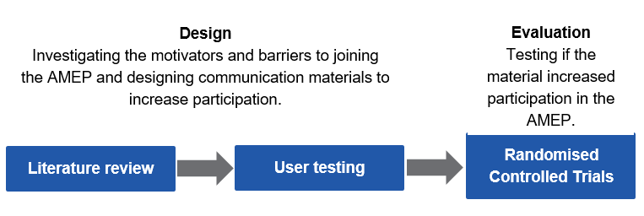

Literature review and workshop
To understand the motivators and barriers for joining the AMEP and design interventions to increase participation in the program we reviewed client satisfaction surveys and third-party reviews of the program, read case studies and interviews with students and conducted a workshop with AMEP policy, operations and communication staff from the Department of Home Affairs and service providers from Queensland, New South Wales and Victoria.
The barriers and motivators identified through the research and workshop are presented in Box 1.

Box 1: Motivators and barriers to participating in the AMEP
Motivators
AMEP course content
- Relevant and contextual learning materials and environment
- Flexibility with class times
Social connection
- Making friends in class
- Involvement in hobbies such as sporting clubs where you need to know English to talk to teammates
- Involving family members in literacy activities
Community engagement
- Conversing about your children's education progress with school staff
- Independently accessing services for important medical, social, legal or administrative help without the use of an interpreter
Psychological
- Seeing the success of others similar to you
- Self-efficacy – feeling you’re capable of learning English
Employment
- Employment opportunities from learning English
Barriers
Biases, heuristics and group processes (lend themselves to a behavioural intervention)
- Prioritising providing for family by working rather than being in class (present bias)
- Psychological barriers to learning (e.g. fear, low self-esteem, negative attitudes or experiences with education)
- Social norms of the role of women as home-makers and carers
- Older family members may be more likely to rely on younger family members for translations and not feel the need to learn English
- Low awareness of the program, especially among family visa holders
- The program being free might contribute to people putting if off or devaluing it
Personal (would require individual-level intervention)
- Traumatic experiences which impacts your ability to learn, for example due to mental ill-health such as post-traumatic stress disorder
- Some people on skilled visas may believe their partners don’t need to learn English
- Limited literacy in your first language
- Poor Wi-Fi and having children at home affecting ability to study at home
- Cultural shame about not being able to communicate
Structural (would require broader system-level change)
- Attendance in class can compete with requirements of jobactive (now Workforce Australia)
- Employment conflicting with class times and study
- Transport to class is expensive or not easily accessible
- Classes with a mix of first language literacy levels
- Homelessness
There are clearly many barriers to participating in the AMEP. There is a complex environment of competing priorities which would be difficult for any person to navigate, let alone a person who does not speak English and is in a new country. Many of the identified barriers do not lend themselves to a behavioural intervention. However, there were a few behavioural biases, heuristics and group processes uncovered which may be relevant to increasing participation in the AMEP.

Present bias
Present bias is the tendency to discount long-term gains such as learning to speak English proficiently for the short-term gains of finding immediate work (O’Donoghue and Rabin 2015). For example, people may prioritise finding work, as they need the income, over attending English classes, despite speaking English increasing their chances of getting a better-paid job in the long term. Communicating about some of the more immediate benefits of participation in AMEP, which may not always be apparent, may help counteract present bias and increase participation to help people achieve their long-term goal of speaking English.

Self-efficacy
Another behavioural factor which appears to impact participation in the AMEP is perceived self-efficacy. Self-efficacy is your belief in your ability to achieve something (Bandura 1977). The workshop and literature review revealed some AMEP participants have low self-esteem and/or have negative prior experiences of education. This might affect their belief in their ability to learn English, resulting in them not beginning classes or disengaging from the program. Increasing feelings of self-efficacy by setting small achievable goals may help to retain students in the AMEP. Communicating to people that they are capable of learning English, and there are classes to suit different circumstances may increase participation by encouraging people to begin classes who otherwise would not have.

Norms
Another barrier identified was social and cultural norms. A previous review of the AMEP reported that for certain cohorts there is the expectation women should focus on raising children and the person earning the primary household income should focus on learning English. The review also reported older people relying on younger family members for translations. Advertising the benefits of partners and older family members learning English, such as more autonomy, being able to engage independently with government and medical services and increased social connection, may help influence people to encourage partners and older family members to participate in the AMEP.

Perceived value
One service provider suggested potential participants in the AMEP may think a free product lacks value and as a result they do not make it a priority to attend classes. Research in marketing and consumer psychology has found consumers can see price as an indicator of quality, however, other factors such as reputation also signal quality (Zeithaml 1988). There is limited research on the effect of course cost on perceptions of value in the education sector.
If service providers are concerned potential AMEP participants will not value the program because it is free, then using a reciprocity frame could be an alternative to advertising the AMEP as free English classes. For example, advertisements could highlight what opportunities new arrivals are receiving by relocating to Australia to encourage them to want to give back by learning English and becoming integrated into society.

Prior efforts to increase participation in the AMEP
Letters, emails, text messages, phone calls and advertisements have been used previously to attempt to increase participation and re-engage former students. These communications are generally written in English. In April 2020, service providers sent letters in English to relevant visa holders regardless of which country they had come from (including English-speaking countries), 0-1% of people who received the letters enrolled in the program. Emails to disengaged students in New South Wales and phone calls and text messages to disengaged students in Victoria yielded more successful results with a 7% and 11% conversion rate respectively. Since the reforms came into effect in April 2021 there have been concerted efforts to increase advertising around the AMEP, in traditional and social media, to encourage disengaged participants and previously unenrolled migrants to engage in the program.

User testing

Choosing a delivery mode
We designed communication material for two different groups:
1) students who had disengaged from the program (disengaged students)
2) people with relevant visas who had never enrolled in the AMEP (potential students)
Disengaged students had already been part of the program so were familiar with the AMEP and didn’t need a lot of background information about the program. For this reason, we decided to send disengaged students text messages which are useful for sending short, simple information and are more likely to be opened than emails (Muench and Baumel 2017).
Potential students may never have heard of the AMEP before and would need information about the program and why they should join. Providing information to these students needs to balance the requirement for detailed information against the need for a message that is easy to engage with. Emails tend to be stored for longer than text messages and are more easily searchable, allowing recipients to go back and look up the information in them at a later date (Muench and Baumel 2017). Despite these positive aspects of emails, people often receive many emails a day and we didn’t want the information to be lost among all the other emails people receive. People send and receive less physical mail these days (Macau and Jie 2020) and can display a letter in a prominent place, such as on the refrigerator, which can act as a reminder to sign-up for classes. For these reasons, we decided to send potential students both emails and physical letters.

Designing intervention materials
We designed two versions of each communication type (text message and email/letter) to counter some of the behavioural biases identified in the literature review and workshop. One emphasised learning English would increase your job opportunities, and one emphasised learning English will increase your social connections by helping you make friends.
The materials were translated into Arabic, Cantonese (Traditional Chinese), Mandarin (Simplified Chinese) and Vietnamese and tested with current AMEP students in the four language groups through focus groups held in November 2020. Box 2 highlights the behavioural elements used in the materials.

Box 2: Behavioural elements in the communication materials
Agency – we included how to contact a service provider, creating a sense that people can guide their own actions, this is known as agency (Bandura 2018)
Call to action – we told people the next steps to take, this is known as a call to action, effective calls to action are concrete and achievable (Neimand et al 2020)
Messenger effect – we tested two different messengers, we are heavily influenced by who communicates information (Dolan et al 2010), this is known as the messenger effect
Personalisation – we provided contact details for the provider where participants live, personalising messages and emails increases behavioural outcomes (BIT 2014)
Present bias – we included immediate benefits of learning English as we have a preference for immediate rewards over future rewards (Hardisty et al 2013), known as present bias
Saliency – we included a colourful photo of students in class as we are attracted to things that draw our attention by being ‘novel, simple and accessible’ (BIT 2014), known as saliency
Social norms – we told people that other students had returned to the AMEP to invoke a social norm, which is a belief about what is common and approved of in a given group (Legros and Cislaghi 2020)
Timeliness – we mentioned coronavirus to create a sense of timeliness, behaviour is easier to change when habits have been disrupted by major life events (BIT 2014)
Figures 2, 3 and 4 show the text messages and letters/emails which were user tested.
- Text messages used in the user testing
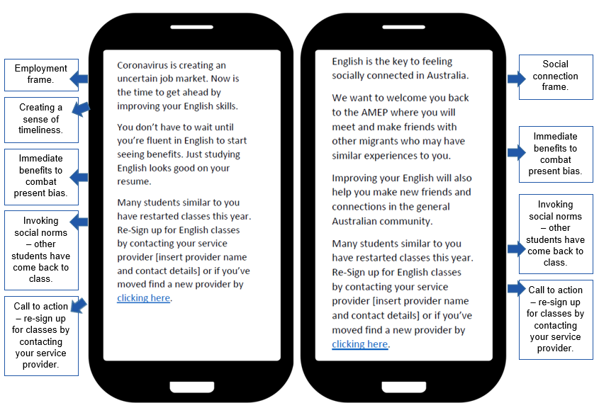

- Employment-focused letter used in the user testing
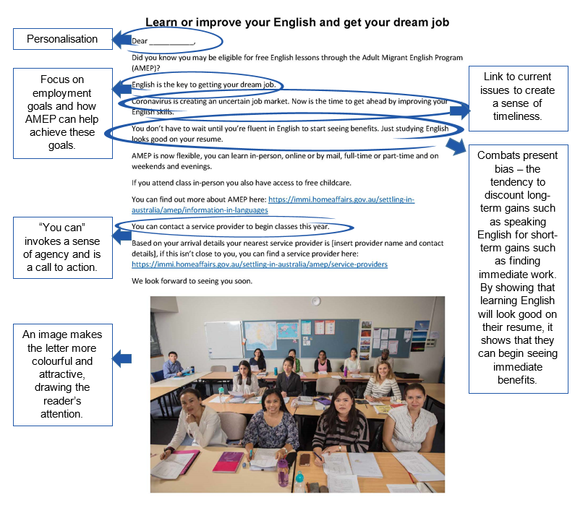
- Social connectedness letter used in the user testing
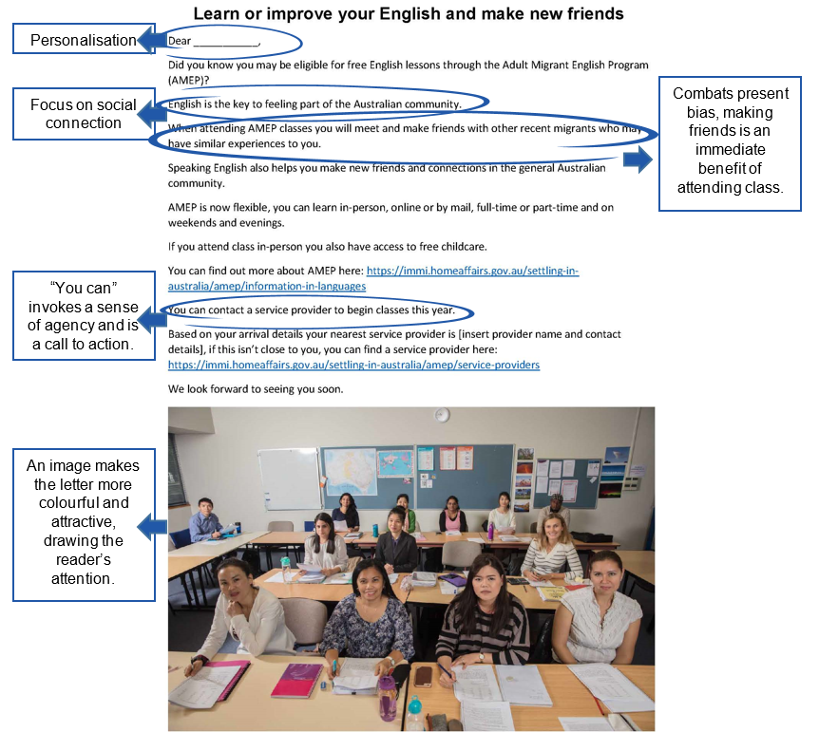

User testing results
Text messages
Focus group participants found the messages easy to understand but expressed mixed opinions about which message would be more encouraging. They suggested combining the texts and placing more emphasis on the importance of English for life in Australia and the flexibility in the program.
Social norms work best when the group you are trying to influence identifies with the group they are being compared with. The social norm message in the texts stated “many students similar to you have restarted classes”. There were mixed responses to this social norm component of the message. Participants in one language group thought it was important and should be moved to the top of the message while a participant in a different language group questioned how the sender would know if students in the same situation had restarted classes, as everyone’s personal situation is different.
Employment-focused letter
Focus group participants liked the employment focus and inclusion of different study modes. They thought finding employment and free childcare would be the key motivators in the letter. However, they thought the letter may not be suitable for some cohorts e.g. stay-at-home parents and older people may not be looking for employment opportunities and that this message would not be effective if potential students are already employed.
Social connection letter
Focus group participants said the letter would make them want to join the AMEP and the messaging would be especially useful for older people who might be lonely, especially as friendships may also be a longer term benefit of attending the AMEP. However, they thought the letter wouldn’t resonate as strongly with younger people who are probably more interested in finding a job than making social connections.
Feedback on the image
Some participants didn’t like the staged nature of the photograph, they thought it was too serious and didn’t capture the lively classroom environment. Participants also commented that most of the people in the photo were women so men may not feel welcome and one older participant couldn’t see themselves represented in all the young faces. One participant suggested replacing the photograph with an image showing all the different benefits the AMEP provides.
Overall feedback on the letters
Participants in all groups suggested combining the two letters and including other benefits of the AMEP besides employment and social connection. These other benefits were learning about Australian culture, learning English as a bridging option to other TAFE or university studies, understanding the AMEP is the beginning of your life or career in Australia, learning about life and laws in Australia, learning about etiquette and how to interact with people from different cultures and access to additional resources which help build confidence in learning English.

Final intervention designs
Based on the user testing feedback, we decided to combine the two messages (employment and social connection) and trial sending them in English (the business as usual approach) and sending them in participants’ home languages. The photograph in the letter was replaced with an image outlining the other benefits of the AMEP. The social norms component was removed from the text message, the increased flexibility was included and the message was shortened. The final versions are shown in Figures 5 and 6.
- Final text message (in English)
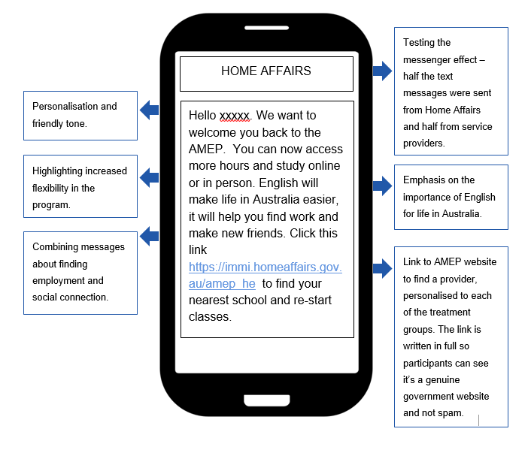

- Final letter/email (in English)

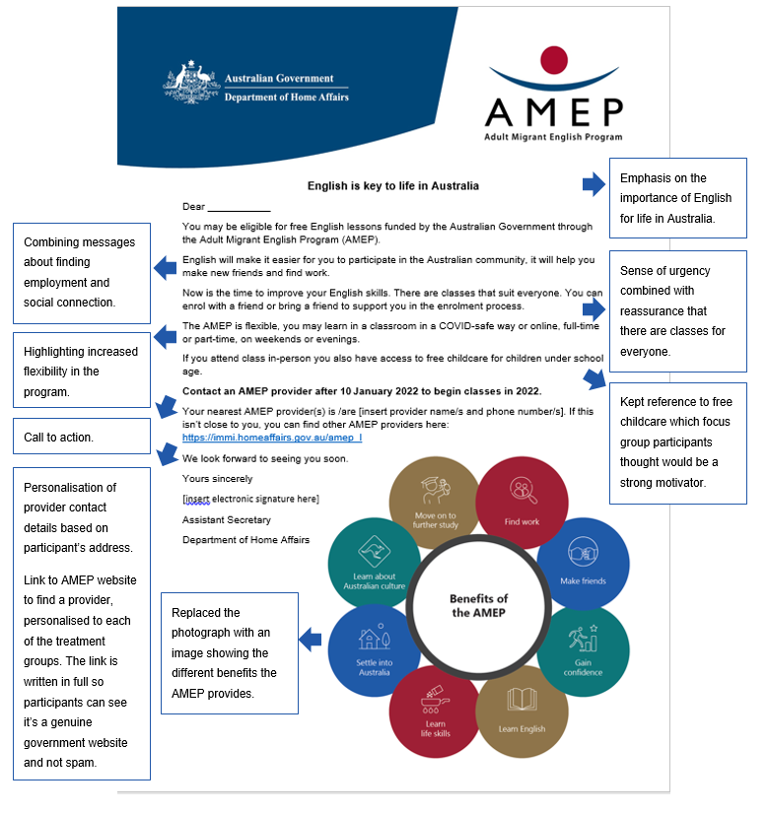

Testing the impact of our interventions
We designed two randomised controlled trials (RCTs) to test the effectiveness of the letters/emails and text messages in English and home languages at increasing participation among potential students and disengaged students, respectively. The Disengaged Students Trial also tested the effect of two different messengers, the Department of Home Affairs and AMEP service providers.
Our research addresses a knowledge gap about the effect of communication in people’s home languages compared with communication in English for migrant communities. There is a dearth of empirical research in this area, we identified only one study which previously investigated this. The study compared the effect of translated letters (sent alone) with translated letters and letters in English (sent together) on breast cancer screening booking rates (Beauchamp et al. 2020). The study found no difference between the two groups although it had a relatively small sample size so was only powered to detect a 10% difference between the intervention and control.

Trial 1: Potential Students Trial
In the Potential Students Trial we sent letters and emails to 16,990 potential AMEP students who speak Arabic, Cantonese, Mandarin, and Vietnamese. These were migrants who arrived in Australia between 1 July 2017 and 1 October 2020 and had never enrolled in the AMEP. Participants were randomly assigned to one of two groups to either receive the letter/email in English (English Group) or in their home language (Home Language Group).
- Potential Students Trial design
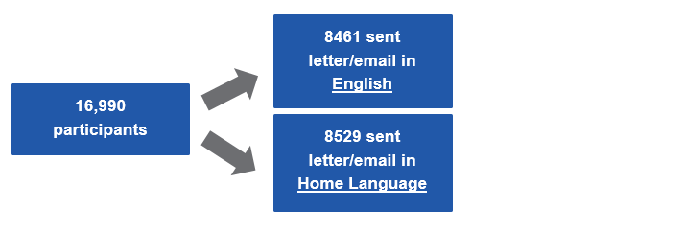We sent participants the letters during the period between Christmas 2021 and New Year 2022 and sent the emails on 7 January 2022. Service providers re-opened for the 2022 education year on 10 January 2022, and Term started in late January/early February. Registrations were collected up to the end of March 2022.
Our primary outcome measure was registrations in the AMEP. We also included a link to the ‘Find an English class’ webpage, unique to whether participants were in the English or Language group, to capture engagement with the communication material.
We hypothesised there would be a higher proportion of registrations among people who receive the letter/email in their home language compared with those who receive it in English.

Trial 2: Disengaged Students Trial
In the Disengaged Students Trial we sent text messages to 26,113 disengaged AMEP students who speak Arabic, Cantonese, Mandarin, and Vietnamese. Participants were randomly assigned to one of four groups to receive the text message in English (English Group) or in their home language (Home Language Group) from either the Department of Home Affairs or their former AMEP service provider.
- Disengaged Students Trial design

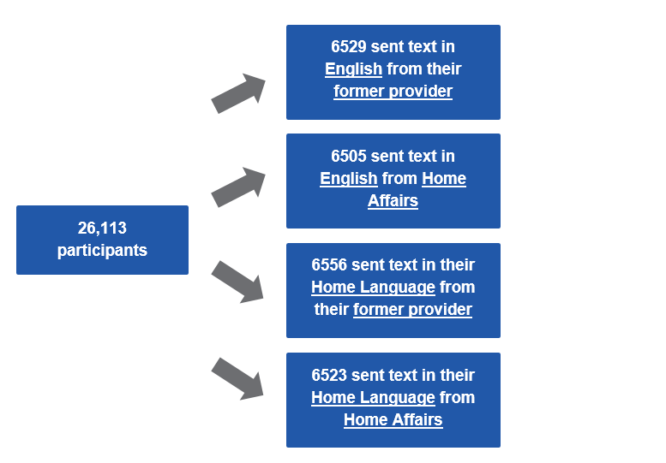
Participants were sent the text message on 10 January 2022, the day service providers reopened ahead of Term 1 starting in late January/early February.
Our primary outcome measure was re-engagement in the AMEP. We also included a link to the ‘Find an English class’ webpage, there were four unique links for the four trial groups.
We hypothesised there would be a higher proportion of re-engagement among people who received a message in their home language compared with those who received a message in English. We also expected to see differences in re-engagement between the Department of Home Affairs messenger group and the AMEP service provider messenger group.

Results
Translating communication material into participants’ home languages did not increase engagement with the AMEP but did increase traffic to the AMEP website

Potential Students Trial
A total of 151 participants registered for the AMEP within the trial period (the first 3 months of 2022), translating to 0.9% of participants. There were 88 registrations in the English Group, 1.0% of participants in this group, and 63 registrations in the Home Language Group, 0.7% of participants in this group. There was no statistically significant difference in enrolment between the two groups.
Registrations in the Potential Students Trial are displayed in Figure 9.

N=16,947. The difference between the English and Home Language groups was 0.3 percentage points. This was not statistically significant.
- Percentage of participants who registered in the Potential Students Trial by language allocation

Disengaged Students Trial
Similar to the Potential Students Trial, there was no difference in re-engagement between those who received the text in English and those who received it in their home language in the Disengaged Students Trial. There was also no significant difference in engagement between the two sender groups, the Department of Home Affairs and AMEP service providers.
A total of 834 participants re-engaged in the AMEP, translating to 3.8% of participants. The breakdown across main effects was:
- 4.0% (439) of participants who received the English text message re-engaged
- 3.6% (395) of participants who received a text message in their home language re-engaged
- 3.7% (405) of participants who received a text message from their former provider re-engaged
- 3.9% (429) of participants who received a text message from Home Affairs re-engaged.
Re-engagement in the Disengaged Students Trial is displayed in Figures 10 and 11.

N=22,150. The difference between the English and Home Language groups was 0.4 percentage points. This was not a statistically significant difference.
- Percentage of participants who engaged in the Disengaged Students Trial by language allocation

N=22150. The difference between the provider and Home Affairs groups was 0.2 percentage points. This was not a statistically significant difference.
- Percentage of participants who engaged in the Disengaged Students Trial by sender
More participants clicked on the link in the text messages (37%, Disengaged Students Trial) than in the emails (10%, Potential Students Trial). This was likely because the email was longer and contained more information than the text message, including the contact details of the provider in their region so people did not need to click the link to find a provider.
There was no statistically significant difference in link clicks between the English and Home Language groups in the Potential Students Trial (9.7% and 10.2% respectively). However, there were statistically significant differences in link clicks between the groups in the Disengaged Students Trial. More people clicked on the links if they received the communication material in their home language than in English and if they received the text message from the Department of Home Affairs rather than their former AMEP service provider.
The percentage of link clicks in the Disengaged Students trials are displayed in Figures 12 and 13.

N=22,150. The difference between the English and Home Language groups was 4.4% percentage points. This was a significant difference.
- Percentage of unique page visits in the Disengaged Students Trial by language allocation

N=22,150. The difference between the provider and Home Affairs groups was 4.4 percentage points. This was a significant difference.
- Percentage of unique page visits in the Disengaged Students Trial by sender

Discussion and conclusion
We found no difference in registration and re-engagement between people sent the English and translated material (both trials), in re-engagement between people who received a text message from the Department of Home Affairs and those who received a text message from AMEP service providers (Disengaged Students Trial) and in clicking embedded links between the translated and English material for participants in the Potential Students Trial.
We did find statistically significant differences in clicking the embedded links between the translated and English material and between texts sent from Home Affairs or service providers in the Disengaged Students Trial. More people clicked the links if they received the text message in their home language (rather than English) with Home Affairs as the sender (rather than their former provider).
These differences suggest sending text messages in people’s home languages coming from the department will increase website traffic although it will not necessarily follow through to behaviour change. This could be useful if the department wishes to provide information to people that does not require them to act.

Possible reason for no differences in engagement
It is relatively easy for people to copy and paste the content of their email or text message into an online translator which may account for the lack of difference in engagement between the two groups. While it may not be necessary to translate short, electronically sent communication as people increasingly have access to accurate, free online translators, our results do show that sending short messages in home languages did result in more people visiting the department’s website.

Possible reasons for low overall engagement

Process between clicking the embedded link and enrolling
Many more participants clicked the links embedded in the messages than ultimately ended up engaging in the AMEP. In the Potential Students Trial, 11.0 times more people (1686) visited the AMEP webpage than eventually registered in the AMEP (151) and in the Disengaged Students Trial, there were 9.8 times as many webpage visits (8177) as re-engagements (834). This may be because the link took people to the ‘Find an English class’ webpage. For participants in the Potential Students Trial, this page provided no new information as the letter/email already contained the contact details of the provider/s in their region. For participants in the Disengaged Students Trial, they may have visited the webpage to see if there was a provider in their region they hadn’t already attended and seeing their wasn’t, may have decided against re-engaging. Alternatively, participants in both trials may have clicked the link out of curiosity or may have intended to engage with the AMEP and not followed through.
There are a number of steps involved between receiving the communication material and starting classes, including contacting a provider, being assessed for eligibility, undertaking a language assessment and intake interview and attending an orientation. Some of the people who clicked on the embedded links may have started the process or contacted a service provider and, after learning of the process, intend to engage at a later date. We sent the communication material 3 weeks prior to the start of Term 1 and collected information on participants who enrolled during Term 1. It is feasible some of the participants who visited the website will engage with the AMEP in Term 2 or beyond. Measuring engagement over subsequent terms was out of the scope of the current trials but it is possible our trials may understate the impact of our interventions over time.

Potential Students - cohort saturation
Overall engagement was low in the Potential Students Trial, 0.9%. However, this is on par with the 0-1% enrolment rate found in 2020 following the mailing of letters to unenrolled migrants (refer to page 16). Those letters went to all language groups, not only Mandarin, Cantonese, Arabic and Vietnamese speakers, so it is likely the trial would have increased enrolment by more than 1% if it went to all language groups.
Participants in the Potential Students Trial previously had to enrol within 6 months of arrival in Australia but had not done so. The legislative change allowed this group a second chance at learning English in the AMEP. The low registration rate of this group suggests if people do not enrol in the AMEP when they first arrive in Australia, they may not intend to ever enrol. This may be due to them having higher levels of English and not needing the AMEP. While there is no way of knowing the English levels of those who did not engage, the majority of participants in the Potential Students Trial were on skilled/other visas (56%), suggesting they already have a high enough level of English to enter the workforce. In contrast the number of participants who do enrol in the AMEP each year on skilled/other visas is closer to 10%. The low registration rate in the trial suggests many of those who received the letters and emails could already speak English and were not in need of the AMEP. Dedicating resources to follow up with these migrants is unlikely to yield much return on investment.

Advertising campaigns during COVID
From 2020-2022, Australian borders were closed to new migrants due to COVID-19 containment measures, which significantly reduced the pool of possible AMEP students. After the change in eligibility came into effect in April 2021, the AMEP and its providers advertised the changes to encourage migrants who were already in the country to enrol in the AMEP for the first time or to re-engage with the AMEP if they had left before reaching vocational English. Approximately 24,000 disengaged and previously unenrolled students engaged between April 2021 and 31 December 2021. This may account for the relatively low engagement rates in the trials. Despite this, capturing an additional 985 people across the two trials is a good outcome.

Omicron outbreak
The communication was sent over late December 2021/early January 2022 which coincided with the first Omicron outbreak of COVID-19 in Australia, particularly in the eastern states. This may have affected participants’ behaviour as COVID case numbers and hospitalisations rose dramatically. The government instructed people to work and study from home where possible, despite providers initially expecting to be open for face-to-face classes from Term 1 2022.
Many AMEP students disengaged during the pandemic, reporting studying from home was hard, especially if they also had caring responsibilities, had no or limited access to technological resources, and no dedicated study space. These students likely chose not to re-engage due to the prospect of further online study.

Recommendations
Our trials found that translating communication into people’s home languages does not make a difference on whether people register or re-engage with the AMEP. Short, electronic communication to migrants about joining the AMEP can be sent in English.
For longer documents, hard copy documents and documents requiring deeper processing and analytical thinking we would still recommend translating them into people’s home languages to ensure they are fully understood. Similarly, if the purpose of the communication is to direct people to a website to provide them with further information, we would recommend translating it, especially if the communication is a short text message.

Appendices

Appendix 1 – sample sizes, trial design and randomisation
Below is more detail on the trial design and method of randomisation

Trial design
We ran two randomised controlled trials. The first, the Potential Students Trial, focused on potential AMEP students who had never previously enrolled in the AMEP. This was a two arm cluster randomised controlled trial. This trial tested the impact of translating letters and emails into the recipients’ home languages. Those in the control group received a letter in English and those in the treatment group received a letter in their home language.
The second trial, the Disengaged Students Trial, focused on students who had previously been enrolled in AMEP. This was a 2² factorial design that tested the impact of translating text messages into home languages and/or varying the messenger of those texts. Thus, there were two independent variables: (A) Language - participants were randomly assigned to receive text messages in either their home language or English and (B) Messenger - participants were randomly assigned to receive text messages from either the Department of Home Affairs or their former AMEP service provider. The following table provides a summary of this trial and the nomenclature used to refer to groups and main effects.
- Main effects, interventions and group nomenclature
Trial groups |  | (A) Language
 |  | (0) English | (1) Home
(B) Messenger | (0) Department | A0B0 | A1B0
 | (1) Service provider | A0B1 | A1B1

Pre-registration and ethics approval
Both of these trials were registered on the AEA RCT registry on 10 December 2021 and on the BETA website on 21 December 2021. This was prior to trial launch.
We lodged a pre-analysis plan for each trial as part of our registration. We deviated slightly from the analysis plan for the Disengaged Students Trial. We planned to include a single baseline covariate: years of education. However, this was not available at baseline and was therefore excluded. There were no deviations from the analysis plan for the Potential Students Trial. We have added additional exploratory analysis focusing on link clicks.

Both trials were approved through BETA’s ethics approval process, with risk assessed by Macquarie University (reference Nos: 10430 and 9377) in accordance with the guidelines outlined in the National Statement on Ethical Conduct in Human Research.

Outcome measures
For both the trials, the primary outcome measure was engagement in the AMEP between 1 January 2022 and 31 March 2022, measured as registration for the Potential Students Trial and re-engagement in the Disengaged Students Trial as captured by ARMS (the AMEP Reporting and Management System). The outcome measure was binary where participants either did (1) or did not (0) engage. From this binary measurement we calculated sample proportions.
As a secondary measure we examined the number of clicks on the link provided in emails, text messages and letters. This was a binary outcome where participants either did (1) or did not (0) visit the provided URL.

Population and sampling
Potential Students Trial
We worked with four service providers based in eastern Australia covering 3 states and one territory. Participants were drawn from government databases. Participants were selected based on their visa status, indicating their potential eligibility, language spoken and their address falling within the four service provider regions. Two of the providers had an overlapping service region, for the potential students living in this region we included the details of both service providers so they could choose which provider to contact. Table 2 shows the breakdown of sample by language and provider region prior to randomisation.
- Sample sizes by home language and provider contract region - Potential Students Trial
Sample sizes by region and language | Provider region 1 | Provider region 2 | Provider region 3 | Provider region 2 &3 | Provider region 4 | Total
Arabic | 60 | 345 | 58 | 356 | 263 | 1082
Cantonese | 223 | 483 | 71 | 30 | 409 | 1216
Mandarin | 1875 | 4744 | 1037 | 220 | 4034 | 11910
Vietnamese | 431 | 659 | 203 | 744 | 745 | 2782
Total | 2589 | 6231 | 1369 | 1350 | 5451 | 16990

Disengaged Students Trial
Participants were students who had disengaged between 1 July 2017 and 30 September 2021 and had identified their home language to be one of the four languages. For participants in the overlapping service region we used the provider they were last enrolled with to be the sender of the text message so an additional region overlap group is not included as it was in the Potential Students Trial. Table 3 shows the breakdown of sample by language and provider region prior to randomisation.
- Sample sizes by home language and provider contract region Disengaged Students Trial
Sample sizes by region and language | Provider region 1 | Provider region 2 | Provider region 3 | Provider region 4 | Total
Arabic | 1175 | 2509 | 4077 | 3100 | 10861
Cantonese | 181 | 656 | 88 | 224 | 1149
Mandarin | 1855 | 4594 | 633 | 3465 | 10547
Vietnamese | 616 | 500 | 1751 | 689 | 3556
Total | 3827 | 8259 | 6549 | 7478 | 26113

Randomisation
Participants in both trials were randomised at the cluster level. Clusters were constructed so people at the same addresses were assigned to the same group in order to prevent individuals in the same households receiving different text message/email/letter content.
Because of errors and formatting differences in recorded addresses, we used a ‘fuzzy’ text matching strategy to match similar addresses into clusters. This yielded clusters largely comprised of individuals at the same individual addresses, but did cluster some similar but discrete addresses together. For example, different units in the same apartment block were clustered together, or houses on the same street.
We stratified clusters by service provider region and language to ensure balance of regions and languages in each experimental group.
Table 4 in the statistical tables appendix shows the number of individuals and clusters assigned to each group for both the potentials and disengaged trials.

Power calculations
The following power calculations were published in our pre-analysis plans:

Potential Students Trial
With an available sample size of approximately 17,000 participants, and an estimate of 1.5 people per cluster, the trial will have around 11,300 clusters with an estimated ICC of 0.4. This will give us 90% power to detect a standardised effect size of d = 0.04 with α = 0.05 using a one-sided test. This is equivalent to approximately 1.5 percentage points difference between groups with the assumption that one per cent of control participants will enrol.

Disengaged Students Trial
With an available sample size of approximately 26,500 participants, approximately 15 people per suburb, the trial will have around 1,740 clusters with an estimated ICC of 0.1. This will give us 80% power to detect a standardised effect size of h = 0.07 with α = 0.05 using a single-sided test. As an example, this is the equivalent of a difference of around one percentage point off a base of one per cent.

Hypotheses
Potential Students Trial
H1: There will be a higher proportion of enrolments among people who receive the letter/email in their home language as compared with those who receive the letter/email in English (Treatment > Control). Assessed with a one sided test.
Disengaged Students Trial
H1: There will be a higher proportion of re-engagement among people who receive a message in their home language as compared with those who received a message in English (A1 > A0). Assessed with a one sided test.
H2: There will be differences in re-engagement between the Department of Home Affairs messenger group and the AMEP service provider messenger group (B1 ≠ B0). Assessed with a two-sided test.

Method of analysis
The principal analysis of the effect of the intervention(s) in both randomised trials was intent-to-treat, consisting of an adjusted comparison of our primary outcome across the two arms. Estimates, confidence intervals and p-values were derived from a linear regression models with the following specifications:
Potential Students Trial
$$Y= α+ β_{1}A+ γ_{1}X+ γ_{2}X*A+v+w$$
Where Y is a binary variable indicating whether the student enrolled. A indicates whether the cluster is allocated to the home language or English language group, X indicates a vector of mean centered block indicators, X * A is the interaction of this vector with the treatment indicator, v is a cluster-level error term and ω is the individual-level error term.
Disengaged Students Trial
$$Y= α+ β_{1}A+ β_{2}B+ γ_{1}X+ γ_{2}X*A+γ_{3}X*B+v+w$$
Where Y is either a binary variable indicating whether the student re-engaged. A indicates whether the suburb is allocated to the home language or English language group, B indicates whether the suburb was allocated to the Department of Home Affairs or provider messenger group, X indicates block indicator, X * A , X * B are the interaction of these covariates with the treatment indicators, v is a suburb-level error term and ω is the individual-level error term.
For both trials, clustering was accounted for in the analysis by use of HC2 cluster robust standard errors coupled to a degrees of freedom correction. We did not perform multiple comparison adjustment for either trial, however, p-values are included in the statistical table section to allow readers to perform such corrections if they choose to.

Appendix 2 – Statistical tables
The final sample size for the Potential Students Trial was 16,947. Forty participants were removed due to both their email bouncing back and their letter being returned undelivered.
The final sample size for the Disengaged Students Trial was 22,150. Participants were removed if the text message was undelivered, this occurred for 3963 participants.
This appendix presents the statistical tables which underlie the results section. It contains detail not included in the main body of the report.
- Number of participants and clusters in each arm across the trials
Group | Number of participants in each group | Number of clusters in each group
Potential Students Trial
English | 8,439 (49.8%) | 6,274 (49.99%)
Home Language | 8,508 (50.2%) | 6,276 (50.01%)
Overall | 16,947 (100%) | 12,550 (100%)
Disengaged Students Trial
English | 11,045 (49.9%) | 7,450 (49.9%)
Home Language | 11,105 (50.1%) | 7,480 (50.1%)
Former provider | 11,046 (49.9%) | 7,453 (49.9%)
Home Affairs | 11,104 (50.1%) | 7,477 (50.1%)
Overall | 22,150 (100%) | 14,930 (100%)
- Participant engagement across the trials
Group | Number and percentage of participants who engaged within each group | Percentage of participants who engaged in overall sample
Potential Students Trial
English | 88 (1.04%) | 0.52%
Home Language | 63 (0.74%) | 0.37%
Overall | 151 | 0.89%
Disengaged Students Trial
English | 439 (3.97%) | 1.98%
Home Language | 395 (3.56%) | 1.78%
Former provider | 405 (3.67%) | 1.83%
Home Affairs | 429 (3.86%) | 1.94%
Overall | 834 | 3.76%
- Link clicks per group for each trial
Group | Number and percentage of unique page visits | Percentage of unique page visits in overall sample
Potential Students Trial
English | 820 (9.72%) | 4.84%
Home Language | 866 (10.18%) | 5.11%
Overall | 1686 | 9.95%
Disengaged Students Trial
English | 3838 (34.75%) | 17.33%
Home Language | 4339 (39.07%) | 19.59%
Former provider | 3837 (34.74%) | 17.32%
Home Affairs | 4340 (39.08%) | 19.59%
Overall | 8177 | 36.92%

- Primary analysis: Potential Students Trial (Ordinary Least Squares regression)
Group | Estimate | Standard error | Statistic | 95% CI | Degrees of freedom | p-value  (one-sided)
(Intercept) | 0.022 | 0.013 | 1.740 | -0.003-0.047 | 107.494 | 0.042
Treatment (Language) | -0.006 | 0.017 | -0.358 | -0.039-0.027 | 221.506 | 0.640
- Primary analysis: Disengaged Students Trial (Ordinary Least Squares regression)
Group | Estimate | Standard error | Statistic | 95% CI | Degrees of freedom | p-value  (one-sided)
(Intercept) | 0.041 | 0.002 | 17.397 | 0.036, 0.045 | 3159.510 | 0.000
Treatment (Language) | -0.004 | 0.003 | -1.609 | -0.009, 0.001 | 7719.855 | 0.946
Treatment (Provider messenger) | -0.002 | 0.003 | -0.764 | -0.007, 0.003 | 7724.934 | 0.778
- Unique page visits: Potential Students Trial (2-sample t-test)
Group | Estimate 1 | Estimate 2 | Statistic | 95% CI | p-value  (two-sided)
Language | 0.097 | 0.102 | 0.958 | -1.000, 0.003 | 0.164
- Unique page visits: Disengaged Students Trial (2-sample t-tests)
Group | Estimate 1 | Estimate 2 | Statistic | 95% CI | p-value  (two-sided)
Language | 0.347 | 0.391 | 44.267 | -1.000, -0.032 | 0.000
Messenger | 0.391 | 0.347 | 44.775 | 0.033,1.000 | 0.000

- Demographics: Potential Students Trial by treatment group
Age | English | Home Language
Under 30 | 2229 (13.15%) | 2262 (13.35%)
30 to under 40 | 4749 (28.02%) | 4863 (28.7%)
40 to under 50 | 982 (5.79%) | 894 (5.28%)
50 to under 60 | 304 (1.79%) | 314 (1.85%)
60 and over | 175 (1.03%) | 175 (1.03%)
Gender* | English | Home Language
Female | 4839 (28.55%) | 4839 (28.55%)
Male | 3599 (21.24%) | 3668 (21.64%)
Home Language | English | Home Language
Arabic | 548 (3.23%) | 533 (3.15%)
Cantonese | 601 (3.55%) | 610 (3.60%)
Mandarin | 5880 (34.7%) | 5999 (35.4%)
Vietnamese | 1410 (8.32%) | 1366 (8.065)
Visa type | English | Home Language
Family | 3504 (20.68%) | 3535 (20.86%)
Humanitarian | 180 (1.06%) | 163 (0.96%)
Skilled/other | 4755 (28.06%) | 4810 (28.38%)
Visa applicant status | English | Home Language
Principal applicant | 6971 (41.13%) | 7056 (41.64%)
Not principal applicant | 1468 (8.66%) | 1452 (8.57%)
Provider region | English | Home Language
Provider 1 | 1287 (7.59%) | 1290 (7.61%)
Provider 2 | 3059 (18.05%) | 3157 (18.63%)
Provider 3 | 666 (3.93%) | 699 (4.12%)
Provider 2&3 | 697 (4.11%) | 652 (3.85%)
Provider 4 | 2730 (16.11%) | 2710 (15.99%)
* A small number of individuals did not have a gender specified. We have not published numbers or percentages due to statistical disclosure concerns but would like to acknowledge the diversity in the data.
- Demographics: Disengaged Students Trial by treatment group
Demographics | English/ provider | English/ Home Affairs | Home Language/ provider | Home Language/ Home Affairs
Age | English/ provider | English/ Home Affairs | Home Language/ provider | Home Language/ Home Affairs
Under 30 | 632 (2.85%) | 678 (3.06%) | 638 (2.88%) | 681 (3.07%)
30 to under 40 | 1554 (7.02%) | 1545 (6.98%) | 1454 (6.56%) | 1564 (7.06%)
40 to under 50 | 1253 (5.66%) | 1249 (5.64%) | 1327 (5.99%) | 1302 (5.88%)
50 to under 60 | 931 (4.2%) | 890 (4.02%) | 946 (4.27%) | 929 (4.19%)
60 and over | 1162 (5.25%) | 1151 (5.2%) | 1149 (5.19%) | 1115 (5.03%)
Gender* | English/ provider | English/ Home Affairs | Home Language/ provider | Home Language/ Home Affairs
Female | 3441 (15.53%) | 3409 (15.39%) | 3431 (15.49%) | 3467 (15.65%)
Male | 2091 (9.44%) | 2104 (9.50%) | 2083 (9.40%) | 2123 (9.58%)
Home Language | English/ provider | English/ Home Affairs | Home Language/ provider | Home Language/ Home Affairs
Arabic | 2461 (11.11%) | 2400 (10.84%) | 2447 (11.05%) | 2480 (11.2%)
Cantonese | 237 (1.07%) | 228 (1.03%) | 233 (1.05%) | 236 (1.07%)
Mandarin | 2081 (9.4%) | 2154 (9.72%) | 2092 (9.44%) | 2100 (9.48%)
Vietnamese | 753 (3.40%) | 731 (3.30%) | 742 (3.35%) | 775 (3.50%)
Visa type | English/ provider | English/ Home Affairs | Home Language/ provider | Home Language/ Home Affairs
Family | 2838 (12.81%) | 2854 (12.88%) | 2853 (12.88%) | 2864 (12.93%)
Humanitarian | 1994 (9.0%) | 1920 (8.67%) | 1982 (8.95%) | 1967 (8.88%)
Skilled/other | 700 (3.16%) | 739 (3.34%) | 679 (3.07%) | 760 (3.43%)
Visa applicant status* | English/ provider | English/ Home Affairs | Home Language/ provider | Home Language/ Home Affairs
Principal applicant | 3590 (16.21%) | 3522 (15.9%) | 3602 (16.26%) | 3563 (16.09%)
Not principal applicant | 1940 (8.76%) | 1990 (8.98%) | 1910 (8.62%) | 2028 (9.16%)
Provider region | English/ provider | English/ Home Affairs | Home Language/ provider | Home Language/ Home Affairs
Provider 1 | 835 (3.77%) | 849 (3.83%) | 775 (3.50%) | 773 (3.49%)
Provider 2 | 1685 (7.61%) | 1727 (7.80%) | 1714 (7.74%) | 1745 (7.88%)
Provider 3 | 1446 (6.53%) | 1381 (6.23%) | 1438 (6.49%) | 1489 (6.72%)
Provider 4 | 1566 (7.07%) | 1556 (7.02%) | 1587 (7.16%) | 1584 (7.15%)
*A small number of individuals did not have a gender or visa applicant status specified. We have not published numbers or percentages due to statistical disclosure concerns but would like to acknowledge the diversity in the data.
- Potential Students Trial: Final sample size in each treatment group
English | Home Language
8439 (49.80%) | 8508 (50.20%)

- Disengaged Students Trial: Final sample size in each treatment group
English/ provider | English/ Home Affairs | Home Language/ provider | Home Language/ Home Affairs
5535 (24.98%) | 5513 (24.89%) | 5514 (24.89%) | 5591 (25.24%)

References
Bandura A (1977) ‘Self-efficacy: toward a unifying theory of behavioral change’, Psychological review, 84(2):191-215, doi: https://doi.org/10.1037/0033-295X.84.2.191.
Bandura A (2018) ‘Toward a psychology of human agency: Pathways and reflections’ Perspectives on Psychological Science, 13(2):130-136, doi: doi.org/10.1177/1745691617699280.
Beauchamp A, Mohebbi M, Cooper A, Pridmore V, Livingston P, Scanlon M, Davis M, O’Hara J and Osborne R (2020) ‘The impact of translated reminder letters and phone calls on mammography screening booking rates: Two randomised controlled trials’, PloS one, 15(1), doi: https://doi.org/10.1371/journal.pone.0226610.
BIT (Behavioural Insights Team) (2014) ‘EAST: Four simple ways to apply behavioural insights’.
De Leon E, Fuentes LW and Cohen JE (2014) ‘Characterizing periodic messaging interventions across health behaviors and media: Systematic Review’, Journal of Medical Internet Research, 16(3):e93, doi: 10.2196/jmir.2837.
Department of Home Affairs (2021) Adult Migrant English Program, Department of Home Affairs website, accessed 24 January 2022.
Dolan P, Hallsworth M, Halpern D, King D and Vlaev I (2010) ‘MINDSPACE: Influencing behaviour through public policy’ Institute for Government.
Hardisty DJ, Appelt KC and Weber EU (2013) ‘Good or bad, we want it now: Fixed-cost present bias for gains and losses explains magnitude asymmetries in intertemporal choice’, Behavioral Decision Making, 26(4):348-361, doi: https://doi.org/10.1002/bdm.1771.
Legros S and Cislaghi B (2020) ‘Mapping the social-norms literature: An overview of reviews’ Perspectives on Psychological Science, 15(1):62-80, doi: https://doi.org/10.1177/1745691619866455.
Macau F and Jie F (17 June 2020) ‘Australia Post can’t turn back. Here’s why’, The Conversation, accessed 22 April 2022.
Muench F Baumel A (2017) ‘More than a text message: Dismantling digital triggers to curate behavior change in patient-centered health interventions’, Journal of Medical Internet Research; 19(5):e147, doi: 10.2196/jmir.7463.
Neimand A, Wright S, Steinman M and Christiano A (6 January 2020) ‘How to build better calls to action’, Stanford Social Innovation Review, accessed 13 May 2022.
O'Donoghue T and Rabin M (2015) ‘Present bias: Lessons learned and to be learned’, American Economic Review, 105(5):273-279, doi: 10.1257/aer.p20151085.
Zeithaml VA (1988) ‘Consumer perceptions of price, quality, and value: a means-end model and synthesis of evidence’, Journal of marketing, 52(3):2-22, doi: https://doi.org/10.1177/002224298805200302.

© Commonwealth of Australia 2020
ISBN 978-1-925365-16-0 To translate or not to translate: Increasing participation in the Adult Migrant English Program (online)

Copyright Notice
With the exception of the Commonwealth Coat of Arms, this work is licensed under a Creative Commons Attribution 4.0 International license (CC BY 4.0) (https://creativecommons.org/licenses/by/4.0/)

Third party copyright
Wherever a third party holds copyright in this material, the copyright remains with that party. Their permission may be required to use the material. Please contact them directly.

Attribution
This publication should be attributed as follows:
© Commonwealth of Australia, Department of the Prime Minister and Cabinet, To translate or not to translate: Increasing participation in the Adult Migrant English Program

Use of the Coat of Arms
The terms under which the Coat of Arms can be used are detailed on the following website: https://pmc.gov.au/cca

Behavioural Economics Team
of the Australian Government
General enquiries beta@pmc.gov.au
Media enquiries media@pmc.gov.au
Find out more www.pmc.gov.au/beta

Entry/Exit language eligibility threshold and is defined as Level 3 in the Australian Core Skills Framework

