Improving Government Forms

Better Practice Guide
pmc.gov.au/beta

Contents
Purpose of this guide 1
WISER form design 3
Before you start: Which form? 5
1. Who 7
2. Introduction, Structure, Expression 8
3. Repeat: Test and iterate 15
Resources 17
Form audit information sheets 19
BETA 24

Purpose of this guide

The complex business of simplifying forms
Forms are everywhere. They are still the most common interaction between Australians and government, and can be a frustrating experience for the agencies and citizens involved. Designing a government form might sound simple, but it is deceptively difficult. Agencies must collect large quantities of information via simple, user-friendly, multi-channel forms while meeting legal and practical constraints. And these forms must work for diverse individuals with complex needs and circumstances. For clients, a poorly-designed form can delay or prevent their access to essential services and payments.
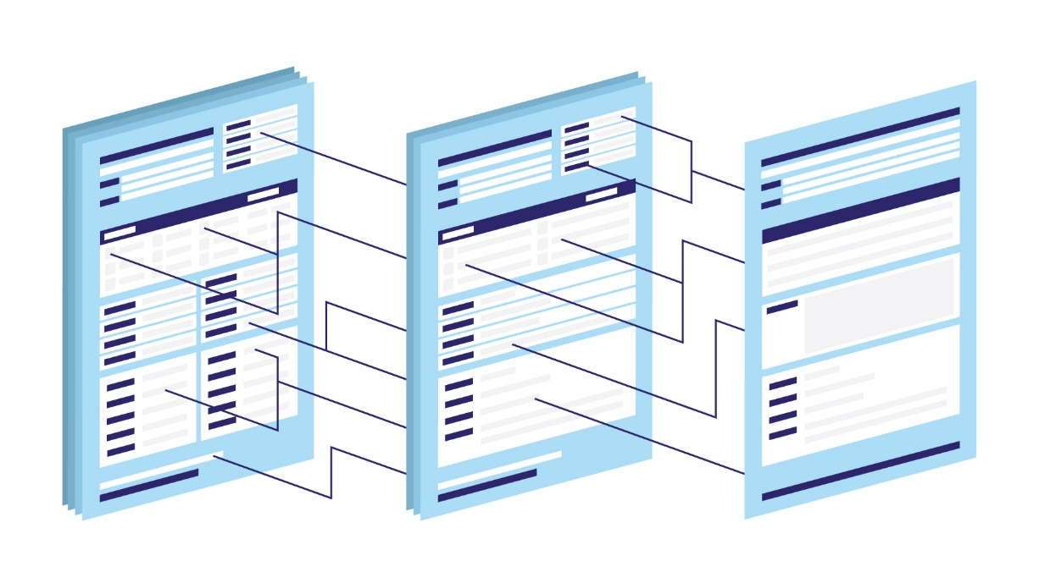

A ‘how to’ guide for applying behavioural insights principles to form design
This guide offers a systematic approach to improving government forms, drawing on behavioural science to make forms easier, simpler and more human. Behavioural insights (BI) offers an understanding of how people make decisions and interpret information, which we can leverage to design forms to go with the grain of human behaviour. We also draw on the practices of user experience design (UX), plain language principles, and better practice in government communications.
We know agencies may not always have the time or resourcing to go through each of the steps laid out in this guide — and not every step will be appropriate for forms with a small audience or minimal error rates. We hope you will focus on the sections which are relevant or feasible for your situation.

Who should use this guide?
This guide is for public servants who want to improve their agency’s forms to simplify processes and deliver better outcomes for their clients. No prior knowledge of BI or UX is necessary.

What’s included? What’s not?
This is not a comprehensive guide to form design. We do not focus on digital form delivery, accessibility, or language standards, as there are already many excellent resources for better practice in these areas. We have provided links to a range of resources, tools and further reading throughout the guide and a summary in the resources section.

What’s next?
We recognise this is a rapidly evolving area. Advancements in automation and data sharing will reduce the burden on citizens to provide information. In the future, better practice in forms may be no forms at all! We anticipate this will be a living document, and we welcome feedback and suggestions for future versions. For feedback on this guide, please contact the BETA team on beta@pmc.gov.au

WISER form design

A framework for improving government forms
In June 2019, BETA hosted Australia’s first ever Form-a-Palooza. It was a one-day festival of forms, designed to share the latest in form design across the public service.
At the event, BETA launched a new framework to guide the design of good forms — the WISER framework. It is based on the latest research, as well as our own experience working with agencies on forms, letters and communications. The full WISER framework is provided on the next page.
- WHO – Understand your clients and the process.
- INTRODUCTION – Offer clear instructions. Highlight key info.
- STRUCTURE – Structure the form simply and guide people through it.
- EXPRESSION – Write for clients, not government. Use plain English.
- REPEAT – Test and iterate.
The framework is underpinned by key behavioural insights principles — look out for explanations and examples of these in pink boxes throughout this guide.

A ‘how-to’ guide to applying the WISER framework
In this better practice guide, we expand on the WISER framework, stepping public servants through the process of improving their agency’s forms by providing practical tips, ideas and examples.
As you work through this guide, look out for:
- Relevant BI concepts
- Tools & templates
- Examples

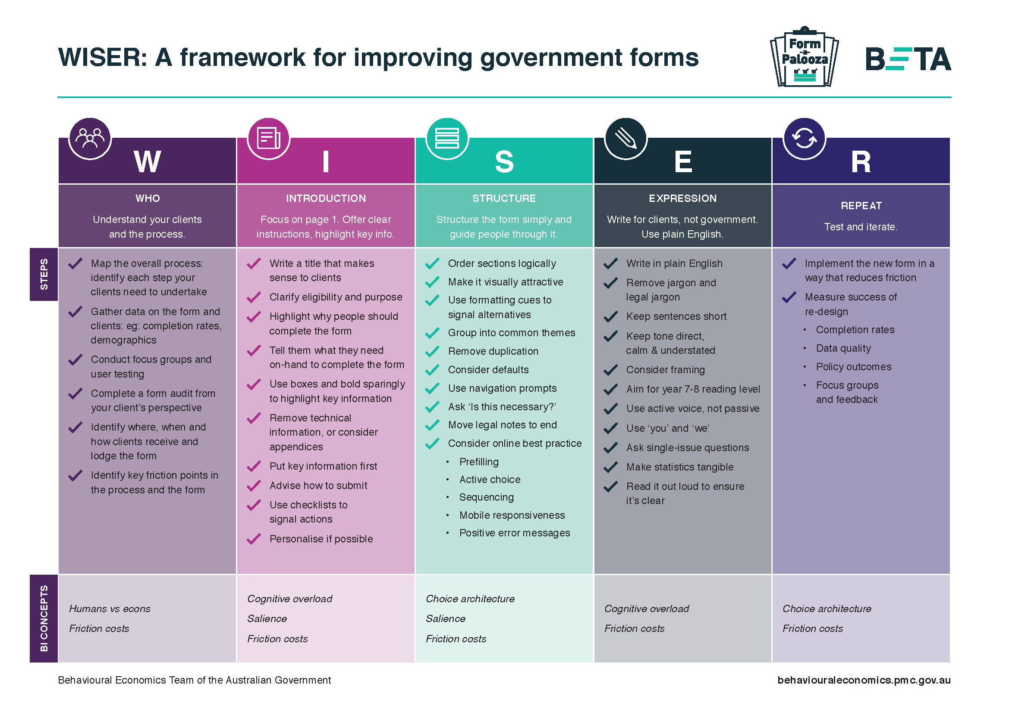

Before you start:
Which form?
Before starting with the WISER framework, the first step is to select a priority form for improvement, identify baseline data for key metrics, and set specific targets for improvement.

Prioritising forms for improvement
In selecting which form to re-design, prioritise based on how often a form is used, and the proportion of clients who have difficulties with it. These difficulties are particularly important if they prevent access to services or benefits, so you should also consider the consequences if clients cannot complete the form.
Once you have identified high-priority forms, you can sequence these by considering the feasibility of changing the form. Start with high-priority forms that can be easily changed. This will build momentum for more challenging forms.
This prioritisation guide can also help you calibrate your work effort. If you are working on a form with relatively few clients or errors, you may not need to go through all the steps in this guide (look for the ‘key’ icon in this guide for the essential steps). Forms with a large number of clients and frequent difficulties warrant a more comprehensive approach.
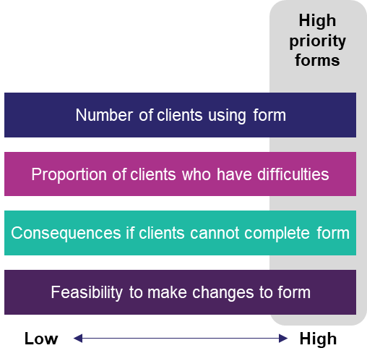

Identifying number of form users and difficulties
Often, we know which forms are problematic through anecdotes and general organisational knowledge. This is useful in knowing which forms to turn your attention to in the first place, but analysing administrative data is important to confirm which forms should be top priority. Consider:
- Number of forms submitted per year, and trends over time;
- Form completion rates (successful first-time completion, form returns, error rate);
- Average time between receiving the form and submitting the completed form; and
- Allocation of staff resources (number of staff hours assisting clients with the form and processing data).

Assessing feasibility
It is necessary to consider feasibility when selecting forms for review and improvement. Among your agency’s high-priority forms, focus your attention first on those which are easier to amend. We have suggested some basic questions to consider in this process, recognising this will be unique to each circumstance.
- What are the policy and/or legislative requirements for information capture? What information must be included? How much freedom is there to make changes to this form?
Speak to policy experts in your team, and review relevant legislation.
- Which constraints are ‘hard’ (e.g. legislative) and which are ‘soft’ (within the discretion of your agency)?
Review the constraints with a critical eye.
- Does the form overlap with other forms, or other methods of information capture?
Explore opportunities to combine forms held by other areas to reduce duplication for clients, and consider opportunities for pre-fill and automation.
- Will making changes to the form have any privacy implications?
Review the Australian Privacy Principles and consider if re-designing the form may change how your clients’ personal information is collected and stored.
- Is the overall program or business area under review?
Seek to embed form improvement into larger programs of work.
- Is the form scheduled to be updated to an online or fillable PDF format?
Take advantage of format changes to also update form design and content.

Resources and further reading
Australian Privacy Principles

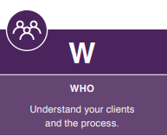
1. Who
The first step in the WISER framework is ‘WHO: Understand your clients and the process’. In this phase, we need to explore who the clients are, understand the process, and uncover barriers to successful form completion. Applying for government services might appear easy, but when you break it apart, it is often a long process with dozens of steps before a client can successfully apply. Form design needs to consider this end-to-end process, including the many steps a client must complete to find, complete and submit the form.
This is known as a ‘form audit’ — an investigation of the form, building a detailed understanding of the clients, process, systems and data. Our friend David Yokum, Director of the Lab @ DC sees this process as ‘similar to an accountant auditing for suspicious financial transactions, you are auditing for steps where you suspect people might get tripped up’.

First, fill in the form!
Start by simply reading your form and the instructions. Fill out the form yourself and see if you get stuck anywhere. Read it aloud to check how the language flows, then mark up the form with notes:
- Are there confusing words, phrases or concepts? Any assumed knowledge?
- Are there duplications? Anything missing?
- Make note of questions requiring clients to source information or documents (essentially any answer they would not be able to pull from memory).

Understand your clients and the process
We recommend drawing on four key sources of data and insight to understand your clients and the process:
- Create a process map
- Analyse administrative data
- Workshop with frontline staff
- Research with end users
We explore how to approach each of these four areas in detail in the ‘Form Audit Information Sheets’ at the end of this guide.

2. Introduction, Structure, Expression

Designing your form
Once you have built an understanding of your clients and the process, you are ready to (re)design your form!
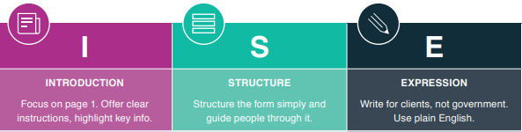This process has three stages: introduction (guidance to the form and instructions on how to complete it), structure (how the content is organised), and expression (how the form is written).

Who you need in the room
Never design alone! It is important to have a range of perspectives in the room when you are designing your form. You may want to consider running a design workshop or Form-a-Palooza style event, but at the very least make sure you gather input from a range of people in your organisation. Consider including:
- Policy experts
- Frontline staff who interact directly with clients and the form
- Data analysts
- ICT staff
- Clients / form users

Introduction
In designing your form’s introduction, your guiding mantra is attack uncertainty.
The ‘Introduction’ is all the information clients will see before they start completing the form. This includes how you direct people to the form (how they navigate your website to find the form) and instructions on how to complete it (on the first page).

Help the right people find the right form
- Write a title that makes sense to clients
- Make sure clients can quickly and easily find the form
- Clarify eligibility and purpose (who should complete the form and why)
A clear and descriptive title for your form is an important first step. Consider the objective your clients have in mind, and title your form to fit with this language. Next, refer back to your process map and review all the ways clients are directed to the form. Check the results for your form on search engines, make sure all links take clients directly to the form, and assess whether you can simplify the pathway to the form on your website.
When clarifying eligibility and purpose, consider using a ‘question and answer’ format, descriptive icons, or a decision tree. A Q&A format is particularly useful if there are common areas of confusion. Clients may be more likely to notice and read instructions if the headings reflect a question they already have in mind. There is also evidence this format increases comprehension of complex information; a study from the Behavioural Insights Team (BIT) found the presentation of terms and conditions in a Q&A format improved understanding by 36 per cent (The Behavioural Insights Team UK, 2019).
Relevant BI concepts
Cognitive Overload: People tend to become overwhelmed by large amounts of information. Cognitive overload can lead people to delay or never take action.
Salience: The quality of being notable; people are more likely to respond to information that is novel, simple and stands out.

Set expectations and requirements
- Tell them what they need on-hand to complete the form
- Use checklists to signal actions
- Advise how to submit, and what will happen afterwards
- Explain the process and timeframes (include a flowchart with key milestones)
Clients are more likely to complete the form quickly and correctly if they are prepared before they start. Provide a list of everything they will need on-hand to complete the form (any information they would not hold in their memory), and any documents they will need to submit along with the form. Where possible, direct clients to where information (such as their reference number) is located. Consider including a flowchart including key milestones and estimated timeframes to offer clients transparency of the process.

Example: Reducing uncertainty with SMS confirmation
BETA conducted a randomised controlled trial with the Department of Human Services (DHS) looking at the effect of SMS confirmation messages sent to parents who had lodged a ‘Change of Assessment’ form. The confirmation SMS reduced the number of parents who called DHS to confirm their form had been received.
The requirement to source documents or information from third parties can be a major barrier to the successful completion of forms. Consider using a ‘planning prompt checklist’, which asks people to make concrete plans about how and when they will complete tasks (see example below). Several trials have shown planning prompts are an effective method of increasing rates of follow-through.
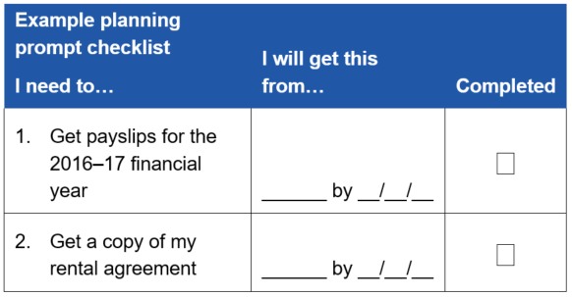
Example of a planning prompt checklist

Make your instructions clear, highlight key information
- Put key information first
- Use boxes and bold sparingly to highlight important information
- Remove technical information, or consider appendices
- Personalise if possible
Any form re-design should ensure instructions are as brief as possible. The eye-tracking example below demonstrates how most people skip over ‘fine print’ entirely (the blue dots indicate where participant’s eyes rested on the form). This highlights why it is crucial to limit your instructions only to the information your clients must know to complete the form successfully.
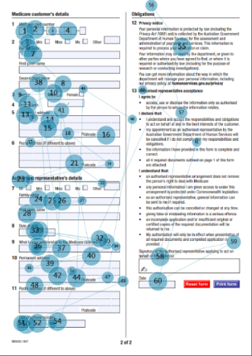
Eye-tracking example — declaration page of government form.
Below are examples of the types of information you should consider removing, or moving to an appendix.
Remove | Move to appendix | Keep
Technical details  Repetitive information  Information not directly relevant to the form | Required legal disclosures  References to legislation  Agency governance | Information on eligibility  Submission requirements  Contact information
Another option is to provide ‘just-in-time’ instructions throughout your form, instead of relying on your clients to read a long introduction. This involves pop-up notifications or call-out boxes to provide information and instructions relevant to each section as clients move through the form.

Resources and further reading
BIT best practice guide: Improving consumer understanding of contractual terms and privacy policies

Better practice examples (clear instructions)
Department of Human Services: Home Care Package Calculation of your cost of care

Structure
When designing your form’s structure, your guiding mantra should be is this necessary?
Every question, every line of text, and every unnecessary design element has a cost in terms of your clients’ attention and comprehension. One of the most impactful things you can do to reduce errors and increase completion rates is to simplify and shorten your form.

Implement a Question Protocol: Do we really need that question?
Removing unnecessary questions is easier said than done. A ‘question protocol’ is a useful tool to help identify which questions are unnecessary, by systematically interrogating how you will use the answers.
- Start by listing all the information/ data points (not the questions) the form captures. Are there any duplicates?
- Check this against the relevant policy and legislation. Is there anything we are not required to ask?
- Review any data already held about the client. Is there any information we could pre-fill or omit from the form?
- Talk to the team(s) who process the data, to find out exactly what happens with each piece of information generated by the form. Are we capturing data that is not used?
- Find out what happens if a client enters unusable or invalid information in a question field. If we can process the form without this information, is it necessary in the first place?
By using this method, each question must ‘prove’ its usefulness to stay. You may be surprised by how many questions you can remove!
Real-world example
In 2017, the Department of Human Services reviewed the claims process for student payments, and were able to reduce the number of questions from 117 to 37 for some clients!

Group and order your questions logically
- Carefully consider the order and grouping of questions (align with how clients naturally process the information)
- Consider defaults and order effects
- Ensure any eligibility questions are upfront
- Avoid duplication of sections for different scenarios (customise the form for the client instead)
Once you have your final list of questions, consider carefully how to structure these to reduce friction and ease comprehension. Imagine your form as a conversation, and consider your clients’ natural train of thought when discussing the topic. For example, questions relating to the clients’ current situation should come before planning or preferences for future services.
Chunking your form down into logical sections will help clients navigate and understand the information required. Ensure your sections all relate to the same topic, and collect ‘core’ information first before optional or supplementary information.
Carefully consider default options and order effects. Pre-selecting (or otherwise highlighting) options in your form is a highly effective way to influence choice. If you do use defaults in your form, ensure you only do so to guide clients towards an optimal choice.
Relevant BI concepts
Choice architecture: The practice of influencing choice through the presentation and framing of options.
Default effect: We tend to stick with the default option.
Order effect: The order in which things are presented to us affects our choices. People are more likely to choose the first option presented to them.

Use formatting and visuals to communicate
- Make your form visually attractive (consider white space, contrast and design)
- Break up large paragraphs with dot points or headings
- Use formatting cues to help clients navigate and understand alternatives
- Use colour, shading and icons to highlight key information and ease navigation
Formatting and visuals are key to ensuring people can easily engage with your form. Visually appealing forms signal to clients the experience will be easy and non-threatening.
A key formatting consideration is the size of the form’s answer boxes. Clients are guided to give shorter or longer responses based on the size of the text box presented to them, even when using an expandable or scrollable box in online forms.

Consider better practice for online forms
Online forms allow for greater responsiveness and customisation than paper or fillable PDF forms. They allow us to guide clients through the process with positive error messages, sequencing, and pop-up windows.
There have been many exciting innovations in online form delivery, which are outside the scope of this guide. Refer to the resources below for better practice standards in this area.
Best practice tools and methods for online forms
Pre-filling
Validation / positive error messaging
Active choice
Sequencing / auto navigation
Mobile responsiveness
Progress bars

Resources and further reading on form structure
Digital Transformation Agency’s standards and templates for online government forms
Victorian government’s digital standards for designing forms
The Question Protocol: How to make sure every form field is necessary

Better practice examples (structure and formatting)
ATO myTax
Australian Government ‘Life Checks’

Expression
When writing your form, your guiding mantra is focus on clarity.
It is important to recognise people have limited ‘mental bandwidth’, and filling out a government form is just one of many things your clients are processing. Simplifying the language in your form reduces cognitive overload, making information easier for people to process. However, simplification alone does not guarantee comprehension. Simple questions can be harder to understand if they do not provide enough context or use unfamiliar terms.
A good test of your form is to ask the questions aloud. Do you find yourself adjusting the language when speaking directly to a real person?

Write simply and clearly
- Write in your clients’ language, avoid government jargon, legalese, and insider terms
- Write in plain English — keep sentences short
- Aim for a Year 7‒8 reading level
- Use consistent terms throughout
These writing standards are not about ‘dumbing down’ your information. Writing in plain English is about delivering your information in the most direct way possible.
Example
The phrase ‘declare your gross income earned, not your net income’ has a good readability score (Year 6, scored by Hemingway Editor app). However ‘net’ and ‘gross’ can be difficult concepts to understand, and can often lead to incorrect income reporting.
There are online tools available to identify complex sentences and words, and provide a ‘readability score’ for your text. Use these with care — a good readability score does not automatically translate to comprehension as it does not account for simple words with complex or dual meanings.
How to: Write simply and clearly
Avoid ambiguous terms
Use this: ‘Do you do this weekly?’
Not this: ‘Do you do this regularly?’
Use your clients’ natural language
Use this: ‘Representative’
Not this: ‘Nominated person’

Use a calm & collaborative tone
- Keep tone direct, calm and understated
- Present options and information using positive framing
- Use first and second person pronouns (I, we, us and you)
Use a calm, positive tone, and speak directly to your reader. Ensure the language you use recognises your clients’ point of view and the challenges they may face.
How to: Use collaborative language
Use positive framing
Use this: ‘Do you agree with this assessment?’
Not this: ‘Do you disagree with this assessment?’
Use first and second pronouns
Use this: ‘Call us if you need more time’
Not this: ‘Contact the department to request an extension of time

Assume nothing
- Provide clarifying information, definitions, and spell out acronyms
- Ask single-issue questions
- Work within the limits of memory and cognition
In removing jargon, be careful you aren’t making assumptions about words and phrases your clients will understand. This is where conducting research with clients is crucial.
Avoid asking about the distant past or overly specific details, or provide suggestions for how clients can source the required information.
How to: Avoid assuming knowledge
Explain terminology
Use this: ‘Name and address of grantor (the person who is selling the property)’
Not this: ‘Name and address of grantor’
Avoid double-barrelled questions
Use this: ‘Do you speak a language other than English? Do you require an interpreter?’
Not this: ‘Do you speak a language other than English and require an interpreter?’
Provide examples
Use this: ‘Attach evidence such as payslips to show you worked during this time period.’
Not this: ‘Attach appropriate evidence.’

Further reading and resources
DTA – Writing Style Digital Guide
DTA – Guide to using inclusive language
Victorian Government - Guide to writing questions in government forms

Better practice example (language and tone)
Consumer Affairs Victoria feedback form

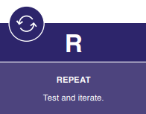
3. Repeat:
Test and iterate

Aim to reduce friction when implementing your new form
When you implement your new form, think about where, when and how you distribute it. Try to minimise the time and effort required of your clients.
Online forms offer a range of benefits, including sequencing, personalisation, and the ability to pre-fill information. If your form is on paper only, think about whether you can deliver the form to clients when and where they are likely to need it. For example, if your form is commonly accessed at a certain life stage or life event (such as the birth or a child, retirement or redundancy), consider if you can proactively send clients the form when they need it.

Measure the success of form re-design
It is important to test if the changes to your form are working. Do they have a measurable impact on your target metrics, such as completion rates, data quality, and policy outcomes? At BETA we often use Randomised Controlled Trials (RCTs) and A/B Testing to rigorously test the impact of a behavioural intervention. However, field trials may not always be feasible, and there are a range of evaluation methods available to measure the success of your form re-design.

Evaluation methods for forms

Randomised Controlled Trial (e.g. A/B Testing)
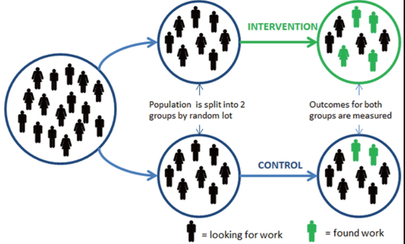
Pre-post evaluation

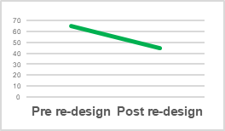
Qualitative evaluation

A/B Testing
A/B testing is a type of randomised controlled trial (RCT) conducted in an online environment. Clients are randomly assigned to see either the existing or re-designed form, and the outcomes for each group are measured and compared. If your form is delivered online, this evaluation method is the gold standard for testing the impact of changes, as it allows you to assess with a high degree of certainty if your changes are working.
Pros:
- Very high ability to measure if the changes to the form have impacted target measures
- Allows for quick iteration and improvements
Cons:
- Can be complex to implement if clients can access the form via multiple channels (suited to online only)
- Involves a trial stage before full implementation
- May require multiple systems for data capture

Pre-post evaluation
If there is a need to implement the re-designed form without a trial stage (for example if it is not possible for systems to capture output data in two formats simultaneously), a pre-post evaluation can offer evidence on whether the new form is an improvement.
Pros:
- Relatively simple evaluation method, does not require trial design and implementation
- Offers some evidence on impact of form re-design, including measurement of any unintended consequences
Cons:
- The outcome measures could be impacted by factors other than the form design (for example, time of year or changes to related systems)

Qualitative evaluation
We recommend using qualitative methods to complement A/B testing or a pre-post evaluation. This can include:
- Feedback from frontline staff
- Research with end users (focus groups, usability and comprehension testing, observational research)

Next steps
There is plenty of opportunity for improvement in government form design. Improving forms will reduce complexity, friction, and unnecessary work from customer-facing processes. This leads to less time fielding complaints and enquiries, reduces job complexity and saves the government time and money, allowing limited resources to be allocated elsewhere.
BETA will continue to develop resources to assist the APS with behaviourally-informed form design, building capacity across the APS for easier and simpler forms. Contact BETA if you want to know more about form re-design, testing and evaluation methods.

Resources and further reading
Developing behavioural interventions for randomised controlled trials
Evaluation Guide

Resources

Examples of better practice government forms
ATO myTax (online simulator to view a range of myTax lodgement scenarios): https://www.ato.gov.au/Calculators-and-tools/ATO-online-services-simulator/
Australian Government ‘Life Checks’: https://www.lifechecks.gov.au
Consumer Affairs Victoria feedback form: https://forms.consumer.vic.gov.au/feedback
Department of Human Services, Home Care Package Calculation: https://www.humanservices.gov.au/individuals/forms/sa456

References
Behavioural Economics Team of Australia (BETA), 2016. Developing behavioural interventions for randomised controlled trials: Nine guiding questions. Available from: https://behaviouraleconomics.pmc.gov.au/sites/default/files/resources/developing-behavioural-interventions-rct.pdf
Behavioural Economics Team of Australia (BETA), 2019. Four Reasons Government Should Improve Forms. Available from: https://behaviouraleconomics.pmc.gov.au/blog/four-reasons-government-should-improve-forms
The Behavioural Insights Team UK, 2019. Improving consumer understanding of contractual terms and privacy policies. Available from: https://www.bi.team/publications/improving-consumer-understanding-of-contractual-terms-and-privacy-policies-evidence-based-actions-for-businesses/.
Creately blog, 2019. The Easy Guide to Process Mapping. Available from: https://creately.com/blog/diagrams/process-mapping-guide/
Department of the Prime Minister and Cabinet, 2016. Data skills and capability in the Australian Public Service. Available from: https://pmc.gov.au/resource-centre/public-data/data-skills-and-capability-australian-public-service
Digital Transformation Agency, 2019. Accessibility and inclusivity. Available from: https://guides.service.gov.au/content-guide/accessibility-inclusivity/
Digital Transformation Agency, 2019. User research. Available from: https://www.dta.gov.au/help-and-advice/build-and-improve-services/user-research
Digital Transformation Agency, 2019. Digital Guide – Writing Style. Available from: https://guides.service.gov.au/content-guide/writing-style/.
Government of Western Australia, 2015. Evaluation Guide. Available from: https://www.treasury.wa.gov.au/uploadedFiles/Treasury/Program_Evaluation/evaluation_guide.pdf
Formulate Information Design, 2008. What makes a good form: The 4 Cs of Good Form Design. Available from: http://www.formulate.com.au/blog/what-makes-a-good-form/
The Hemingway Editor: Online App to test readability of text. Available from: http://hemingwayapp.com/.
Jarrett, C., 2010. The Question Protocol: How to Make Sure Every Form Field Is Necessary. Available from: https://www.uxmatters.com/mt/archives/2010/06/the-question-protocol-how-to-make-sure-every-form-field-is-necessary.php.
MindTools, 2018. Planning a Workshop. Available from: https://www.mindtools.com/pages/article/PlanningAWorkshop.htm
National Health and Medical Research Council, 2007 (updated 2018). National Statement on Ethical Conduct in Human Research. Available from: https://www.nhmrc.gov.au/about-us/publications/national-statement-ethical-conduct-human-research-2007-updated-2018#toc__2102
Nielsen, J., 2011. Blog post on Neilsen Norman Group. ‘Cloze Test for Reading Comprehension’. Available from: https://www.nngroup.com/articles/cloze-test-reading-comprehension/
Roulston, K., 2019. Ethnographic Interviewing. Available from: https://methods.sagepub.com/foundations/ethnographic-interviewing
UK Government Service Manual, 2018. Structuring Forms. Available from: https://www.gov.uk/service-manual/design/form-structure.
UK Government Service Manual, 2018. Designing Good Questions. Available from: https://www.gov.uk/service-manual/design/designing-good-questions.
Victorian Government, 2019. Design forms – Digital Standards. Available from: https://www.vic.gov.au/design-forms.
Web Accessibility Initiative, 2018. Web Content Accessibility Guidelines. Available from: http://www.w3.org/WAI/standards-guidelines/wcag/

Form audit information sheets

1. Create a Process Map
Your goal in creating a process map for your form is to identify (in excruciating detail!) each step your clients need to take and all possible options and methods for completing the form. Then for each step in the process, brainstorm every way a problem can occur.
Behavioural research has found surprisingly large effects from even small barriers to completing a task. In the context of forms, seemingly insignificant factors such as the requirement to print and scan a form can be enough to stop some from completing the task.
Relevant BI concepts
Friction costs: Seemingly small friction points can make a big difference to whether a behaviour takes place, or is deferred indefinitely.
Humans vs Econs: Real-world humans are decision-makers with limited processing capability, often lacking in self-control and with changing preferences. They are quite different from ‘econs’, decision-makers who consider and correctly analyse all available data, and always optimise their own welfare.

Questions to build your process map
- Motivation
- How do clients find out they need to complete the form?
- What are clients trying to achieve by completing it?
- Are there any prerequisites?
- Sourcing
- How do clients find the form? Is there more than one way?
- How do they know which form to fill out? Are there other similar forms, or other methods of accessing the service?
- Completing
- How do clients fill out the form? Are there multiple options? (e.g. paper, fillable PDF, online)
- What kind of information do clients need on-hand to complete the form?
- Submitting
- What is the process for submitting the form? Are there multiple options?
- Do clients need to include any supporting documentation along with the form?
- Resolution
- Do clients receive a confirmation of successful lodgement?
- What happens if more information is required?
- What are all the possible outcomes? How are clients advised of the outcome?

Resources and further reading
Creately blog post: The Easy Guide to Process Mapping

2. Analyse Administrative Data
This stage calls for in-depth administrative data analysis for two purposes: (1) exploratory, to build understanding of the clients and process; and (2) benchmarking, to identify baseline data for key metrics to measure improvement.

Exploratory data analysis
The research questions below are prompts to consider what might be useful to explore. You may not have access to some of this data, and some questions might be irrelevant for your particular form.
- Completion rates

- How many forms are submitted per year? Have these rates changed over time?
- On average, how long do clients take to return a completed form once they receive it?
- What is the average processing time for this form? What kind of factors drive delays?
- What proportion of submitted forms include errors or incomplete information?
- Client profile and demographics

- What is the demographic profile of form users? (e.g. age, gender, location, cultural and linguistic diversity, Aboriginal and Torres Strait Islander status, disability status)
- What is known about the backgrounds and lived experiences of clients? (e.g. education, health, migrant/refugee status, other interactions with government)
- Are vulnerable cohorts more likely to have a need to complete the form?
- Channel

- What proportion of clients are completing the form online? How many submit paper forms?
- How long do clients spend filling out the form online?
- How often do clients ask questions about the form through staff-assisted channels (phone, web chat, in person)? How many staff hours are spent on the form annually?
- Behaviour

- What proportion of clients are using a representative to fill out their form for them?
- Are there any issues with follow-through? What proportion of clients fill out the form but do not access the service after approval?

Benchmarking
Use this data to select performance measures to test the impact of your form re-design. At the start of the process, make sure you collect baseline data and identify targets for each measure. Targets should be specific and measurable — below are some examples.
Examples: Form improvement targets
Use this: Reduce the number of identifiable errors in this form by 25% over the next 12 months
Not this: Improve the clarity of instructions in the form to reduce errors (not specific or measurable)
Use this: Reduce the number of phone calls made about this form by 15% within 6 months
Not this: Make it easier for clients to navigate the process of submitting this form (not specific or measurable)

3. Workshop with frontline staff
Running a small number of workshops with frontline staff is a quick and effective way to identify issues with your form. Staff members working closely with the form and clients are a valuable source of insight — they will have direct knowledge of the most common issues.

Purpose and outcomes
The purpose of these workshops is to identify the source of issues, delays and frustrations. You should not be aiming to re-design your form during these sessions. Instead, focus on developing a comprehensive list of the issues experienced by clients and staff. Consider also taking the opportunity to check the accuracy and completeness of your process map with frontline staff.

Participants & Scope
- Invite staff who interact directly with clients and form data (e.g. customer service staff who answer clients’ questions and staff responsible for processing forms).
- Keep your workshops relatively small (we suggest 5‒8 staff) to ensure everyone has the chance to share their thoughts.
- Aim for peer groups to encourage frank conversations about what is not working. Frontline staff may speak more openly when their managers are not in the room.
- We suggest running at least two workshops to get a range of perspectives.

Example questions to guide discussions
What do you wish our clients knew before they started this form?
When clients are confused (e.g. about their eligibility, the process of submitting the form), how do you go about explaining it to them?
What kind of errors do you consistently see in this form?
Is there anything slowing down how you enter data or process the form?

Resources and further reading
Tips and tools for planning a workshop

4. Research with end users
Once we understand something, we tend to assume others do too. Policymakers and public servants who are experts in their field may find it hard to take the perspective of someone without specialist knowledge, making it hard to identify jargon, assumed knowledge and confusing concepts.
Relevant BI concept
The curse of knowledge: it is hard for specialists to take the perspective of a person with no specialist knowledge.
This is why it is important to conduct research with form users to understand their perspective and challenge assumptions. Talking to clients as they work through your form allows you to understand exactly where they are getting tripped up, how they are interpreting words or phrases and what explanatory information they are really looking for.

Objectives of qualitative research
Qualitative research is particularly useful to uncover the complex set of reasons why a client might find form completion tricky or even impossible.
Qualitative research is not intended to be exhaustive or always representative. Because of small sample sizes, you should not use qualitative research to answer questions like ‘what percentage of clients struggle with the form?’. Take care not to place too much emphasis on individual preferences (such as what people ‘like’ or ‘do not like’). Instead, focus on exploring the factors relevant to your target behaviour, such as language comprehension and ease of form completion.

Methodology
We recommend a combination of two better practice methods for form testing:
Ethnographic interviews
This method (also known as a contextual inquiry) involves interviewing and observing clients in their environment as they are filling out and submitting the form ‘for real’.
Pros:
- Allows for identification of contextual factors.
- Builds a rich understanding of barriers and drivers for form completion.
Cons:
- Time-consuming to conduct and analyse, and can be difficult to recruit suitable participants.
Lab User Testing
This method tests comprehension of the form and process in a controlled environment with research participants who are similar to the form’s users.
Pros:
- Allows for objective research methods such as eye-tracking, website useability and word comprehension tests.
- Relatively quick to recruit and conduct.
Cons:
- The artificial environment and lack of relevant individual context can affect validity of findings.

Ethnographic interviews
Resources required:
Ethnographic-style research requires skilled moderators and careful consideration of research ethics.
Participants:
Include participants who may have difficulty filling out the form. For example, clients who have English as their second language.
Sample & timing:
Varies based on complexity of form and users, 8‒12 interviews of 60‒90 min each is typical.
Recruitment:
Recruit participants by sending a request to clients who have recently made contact about the form.
Quick tips for conducting ethnographic interviews
Ask participants to fill out and submit the form as they normally would, taking note of anything time-consuming
When they have finished, ask them to step you through anything they found difficult or confusing
If they misinterpret a question, do not correct them, instead seek to understand the source of their confusion

Lab User Testing
Resources required:
Lab-based user testing requires trained facilitators, venues and equipment.
Participants:
Ideally a range of participants, broadly matched to the typical form user cohort. Aim to include people with diverse backgrounds.
Sample & timing:
Varies — 12‒20 interviews of 30‒60 mins each is typical.
Recruitment:
Recruitment can be outsourced to an external agency or by directly contacting clients.
Methods to consider for lab-based user testing of forms
Cloze Test / Cloze Deletion Test: empirical method for testing comprehension of text.
Eye-tracking: Goggles or cameras track participants’ eye movements, revealing which parts of the forms attract attention.
Language comprehension tests: facilitators ask participants about their interpretation of key terms and concepts.
Website useability: methods to test ease and speed of navigating website.

Resources and further reading
DTA guide to user research (including guides on recruitment, incentives and consent forms)
Ethical Conduct in Human Research
Ethnographic Interviewing research methods
Cloze Testing for measuring comprehension

BETA

Who are we?
We are the Behavioural Economics Team of the Australian Government, or BETA. We are the Australian Government’s first central unit applying behavioural economics to improve public policy, programs and processes.
We use behavioural economics, science and psychology to improve policy outcomes. Our mission is to advance the wellbeing of Australians through the application and rigorous evaluation of behavioural insights to public policy and administration.

What is behavioural economics?
Economics has traditionally assumed people always make decisions in their best interests. Behavioural economics challenges this view by providing a more realistic model of human behaviour. It recognises we are systematically biased (for example, we tend to satisfy our present self rather than planning for the future) and can make decisions that conflict with our own interests.

What are behavioural insights and how are they useful for policy design?
Behavioural insights (BI) apply behavioural economics concepts to the real world by drawing on empirically-tested results. These new tools can inform the design of government interventions to improve the welfare of citizens.
Rather than expect citizens to be optimal decision makers, drawing on behavioural insights ensures policy makers will design policies that go with the grain of human behaviour. For example, citizens may struggle to make choices in their own best interests, such as saving more money. Policy makers can apply behavioural insights that preserve freedom, but encourage a different choice — by helping citizens to set a plan to save regularly.

© Commonwealth of Australia 2020

978-1-925364-24-8
Improving Government Forms Better Practice Guide

Copyright Notice
With the exception of the Commonwealth Coat of Arms, this work is licensed under a Creative Commons Attribution 4.0 International license (CC BY 4.0) http://creativecommons.org/licensesby/4.0/deed.en
Third party copyright
Wherever a third party holds copyright in this material, the copyright remains with that party.
Their permission may be required to use the material. Please contact them directly.
Attribution
This publication should be attributed as follows: Commonwealth of Australia, Department of the Prime Minister and Cabinet, Improving Government Forms Better Practice Guide.
Use of the Coat of Arms
The terms under which the Coat of Arms can be used are detailed on the following website: https://www.pmc.gov.au/government/commonwealth-coat-arms

Behavioural Economics Team
of the Australian Government

General enquiries beta@pmc.gov.au

Media enquiries media@pmc.gov.au

www.pmc.gov.au/beta

General enquiries beta@pmc.gov.au

Media enquiries media@pmc.gov.au

