BETA
BEHAVIOURAL ECONOMICS TEAM
OF THE AUSTRALIAN GOVERNMENT
Effective use of SMS:
improving government confirmation processes
December,2017
© Commonwealth of Australia 2017
978-1-925363-01-2 Effective use of SMS: improving government confirmation processes (DOCX)
978-1-925363-00-5 Effective use of SMS: improving government confirmation processes (PDF)
Copyright Notice
With the exception of the Commonwealth Coat of Arms, this work is licensed under a Creative Commons Attribution 4.0 International license (CC BY 4.0) (http://creativecommons.org/licenses/by/4.0/deed.en).
Third party copyright
Wherever a third party holds copyright in this material, the copyright remains with that party. Their permission may be required to use the material. Please contact them directly.
Attribution
This publication should be attributed as follows: Commonwealth of Australia, Department of the Prime Minister and Cabinet, Effective use of SMS: improving government confirmation processes.
Use of the Coat of Arms
The terms under which the Coat of Arms can be used are detailed on the following website:
http://www.itsanhonour.gov.au/coat-arms
BETA
BEHAVIOURAL ECONOMICS TEAM
OF THE AUSTRALIAN GOVERNMENT
Effective use of SMS: improving government confirmation processes
Outcomes of a trial conducted by the Behavioural Economics Team of the Australian Government (BETA) in partnership with the Australian Government Department of Human Services
Other uses
Enquiries regarding this license and any other use of this document are welcome at:
Managing Director
Behavioural Economics Team of the Australian Government
Department of the Prime Minister and Cabinet
Barton ACT 2600
Email: beta@pmc.gov.au
The views expressed in this paper are those of the authors and do not necessarily reflect those of the Department of the Prime Minister and Cabinet or the Australian Government.
Research team
Professor Michael J. Hiscox was the principal investigator for this project. Other (current and former) staff who contributed to the report were: Scott Copley; Jacqui Brewer; Andrei Turenko; and
James Wilson.
Acknowledgments
Thank you to the Department of Human Services’ Behavioural Insights Team and Child Support Team for their support and valuable contribution in making this project happen. In particular, special thanks to Pam Spurr, Denise Blayden, Rachel Evans, Kate Sare, Ainsley McGrath, Anthony Leary, Barry Cake, Nicole White, Afroditi Cook and Kim Seagrim for their work on this project.
The trial was pre-registered on the BETA website and the American Economic Association registry:
https://www.pmc.gov.au/domestic-policy/behavioural-economics/improving-government-confirmation-processes-using-sms
https://www.socialscienceregistry.org/trials/2072/history/14770

Contents
Contents 5
Executive summary 6
Why was it important to conduct this study? 7
What we did 8
Results 11
Discussion and Conclusion 15
Appendices 16
References 23

Executive summary
The Child Support Scheme ensures children receive an appropriate level of financial support following the separation of their parents. In 2016-17, the Australian Government Department of Human Services’ Child Support Agency oversaw more than $3.5 billion worth of transfers to support approximately 1.2 million children.
For parents or children facing special circumstances, the amount of child support received or paid may need to be adjusted. Parents can apply to have these special circumstances considered by lodging a ‘Change of Assessment’ form with the Department.
Parents will often follow up with a call to enquire if their form has been received. Usually, the parent is told whether the form has arrived and to expect to be contacted in due time. BETA partnered with Human Services’ Behavioural Insights Team and Child Support Team to simplify the process and contribute to the Department’s objective of streamlining and simplifying ways for Australians to interact with the Government. We used behavioural insights to design a confirmation SMS and then ran a trial to see what the response would be.
We found the confirmation SMS not only reduced the number of parents who called (down by 11.3 percentage points), but if they did call, they would do so later (median time to call increased by 13 days). Based on these results, if everyone who submitted a change of assessment form received a confirmation SMS, there would be approximately 2,100 fewer phone calls made every year.
The outcomes of this trial show how a small change in a traditional submission process could have a substantial impact on the overall experience for all parties involved. The confirmation SMS reduced the number of calls received by the Child Support Team, which in turn reduced call wait times for other Australians interacting with the Department. This was achieved without increasing the administrative burden on parents or the Department. The findings of this trial could be applied across a range of Human Services’ or other government programs where people are waiting for a response or an update.

Why was it important to conduct this study?

Policy context
The Child Support Scheme is delivered by the Department of Human Services. This scheme is designed to ensure children are financially supported where parents have separated (or are in the process of separation). In the 2016-17 financial year, the Department oversaw in excess of $3.5 billion in support transfers between parties, money to support approximately 1.2 million children (Department of Human Services, 2017).
The Child Support Scheme determines the amount of child support based on a number of factors including income, care levels for the children and specific cost tables. If special circumstances exist or arise, parents can apply for a Change of Assessment by lodging an ‘Application to Change your Assessment – Special Circumstances’ form with the Department. In the 2016-17 financial year, almost 19,000 parents submitted this form (Department of Human Services, 2017).

The problem
The parent lodging the form will often call the Child Support area after submitting it, which can generate a high volume of calls. Many of these calls simply enquire about whether the form has been received and the next steps in the process.
Typically these calls do not give much information to either party; the parent is advised
the form has been received and they will be contacted in due time, while the Department receives no additional information to assist with processing the form. These calls also divert service officers from other inbound calls, and could be entirely avoided by redesigning the process.

What we did

The design of SMS messages for this study
Feedback from Department staff indicated the vast majority of calls are due to:
- Parents confirming their sensitive documentation was received and safe. Often parents will need to send a large amount of private information (bank statements, payslips, etc.) via mail. Some parents may call concerned these documents have been lost. Currently, no receipt is provided for mail or fax lodgements.
- Parents making sure there are no outstanding issues and seeking an update. A potential outcome of the process is an altered child support amount. As such, it is important to parents that the form has been received and there are no outstanding issues impeding its processing.
There may be several behavioural factors influencing the reasons for calling to enquire about the form. These are set out in Box 1.

BOX 1: Factors influencing BEHAVIOUR IN UNCERTAIN SITUATIONS
Uncertainty avoidance leads individuals to call the Child Support area to reduce their uncertainty. People’s behaviour is less affected by uncertainty when they have high trust in the other party.
Trust and reciprocity can help ensure positive, functional, effective relationships between citizens and the Government. The act of reciprocity by the Child Support area, in sending an SMS for receipt of a form, could help build trust in the organisation by parents (in reciprocity, we act in-kind to the way we are treated).
Lack of feedback increases uncertainty. Providing timely updates would reduce the need to call the Department.

We delved into behavioural insights literature to help design a possible solution.

Box 2: Prior research on managing wait times
People don’t like to needlessly wait. Long queue times lead consumers to evaluate the service received as poor (Taylor, 1994; Houston, Bettencourt & Wenger, 1998). People
may also experience other types of waiting negatively, such as waiting for a response
from the Government.
We looked at research which examined two possible ways of updating people who are waiting for an outcome (Danziger, Shai & Moran, 2017):
(a) an inquiry system which relies on consumers to find out an outcome (e.g., ‘your form will be ready within 30 days, you must contact us to learn the outcome’), or
(b) a notification system where service providers tell consumers they will be notified (e.g., ‘you will receive a call when your form is ready. You can expect this within 30 days’).
This research found the notification based system achieved better outcomes, based on three features:
- people evaluated their wait experience more favourably than in an inquiry system,
- people did not mind waiting longer when they knew they would be notified,
- they were more positively engaged with the service provider in the long term.
There is evidence suggesting increasing operational transparency, or removing barriers (these may be informational or visual in nature) between people and service providers, leads to greater satisfaction by both (Buell et al., 2016).
To address these factors, a simple, one-off text message was designed. This message informed parents their form had been received by the Department and no further action was required from them for now. It also set the expectation of the Department contacting them “in the coming weeks” to discuss the case. Figure 1 shows the wording of the SMS message used in our trial.

Figure 1: wording of the sms
The SMS confirmation parents received read: “Child Support has received your Change of Assessment form. You do not need to do anything. We will call you in the coming weeks. Do not reply by SMS”.

The trial
To see whether our confirmation SMS could improve the process, we ran a randomised controlled trial (RCT). We wanted to see if receiving an SMS would decrease parents’ uncertainty enough to reduce their need to make a follow-up call to the Department.
Our trial did not impact the time it took for parents to have their form processed. We simply sent a confirmation SMS and observed whether this impacted call volumes to the Department.

BOX 3: WHAT IS A RANDOMISED CONTROLLED TRIAL (RCT)?
A randomised controlled trial (RCT) is the best way of telling if a policy is working.
RCTs work by randomly assigning people (or other units) into different groups – usually one or more ‘treatment’ groups participate in the new intervention, and a ‘control’ group does not.
The differences in outcomes across the groups are then compared. RCTs are considered the ‘gold standard’ for assessing causal impacts because a RCT determines the impact of an intervention or treatment compared to if nothing was changed.
Parents who submitted a form were randomly assigned to receive a confirmation SMS or go without one. We then monitored whether these parents called the Department.

Results

Does receiving an SMS confirmation reduce calls?
Sending a confirmation SMS reduced the call in rate to the Department by 11.3 percentage points from 41.9 to 30.6 per cent. This represents 169 fewer calls in the ‘SMS confirmation’ (treatment) group compared to the ‘no SMS confirmation’ (control) group over the trial period (see Technical Appendix for more details on the statistical analysis). If these SMS confirmation messages were sent to all parents who submitted a change form over the year, we could expect approximately 2,100 fewer phone calls to the Department.

Figure 2: Impact of sending a confirmation SMS on call rates
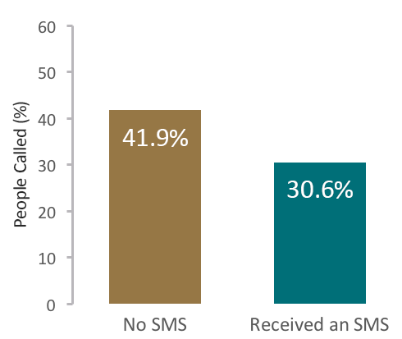
Sending an SMS message confirming receipt of the form reduced call rates by 11.3 percentage points (from 41.9 per cent to 30.6 per cent).

Does receiving a confirmation SMS increase the time before calling?
As well as testing the effect of the SMS message on the total number of calls, we also checked how long people waited before calling the Department. We reasoned that even if the confirmation message did not prevent some individuals from calling, it may still increase the amount of time before those people called.
We compared the median time to call in the two groups. We found sending a confirmation SMS increased the median time to call by 13 days (37 days to 50 days) (Figure 3).

Figure 3: Impact of sending a confirmation SMS on median time to call
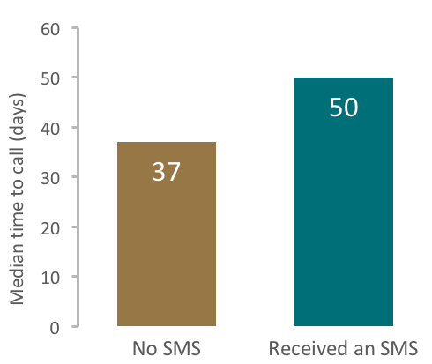
Sending an SMS message confirming receipt of an individual’s form increased the median time to call by 13 days (from 37 days to 50 days).
Figure 4 provides a graphical representation of the delay in call times. The figure shows estimations of the probability of an individual, in either treatment or control group, calling the Department at any point during the trial period. It shows sending a confirmation SMS causes a reduction in the probability of an individual calling across all timepoints.

Figure 4: Impact of sending a confirmation SMS on time to call
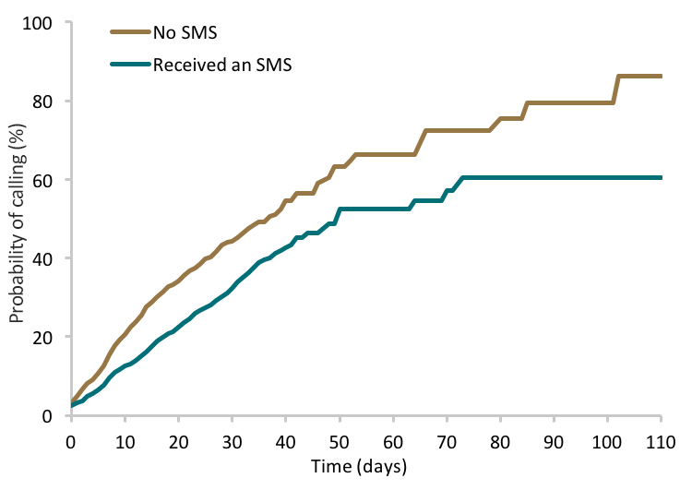
This figure shows the probability of an individual calling the Department as the number of days from trial enrolment increases. Receiving an SMS reduces the probability of an individual calling across all timepoints. See Table A.4 in Technical Appendix for more information.

Does the intervention work across different groups?
This trial was not designed to detect differences in subgroups, so this analysis is exploratory and the findings below should be treated with some caution.
In the group which did not receive an SMS, parents who paid child support were somewhat less likely to call the Department than those receiving payments (37.2 per cent versus 45.9 per cent). We looked at the effect of sending a confirmation SMS to these two groups. While there was evidence the treatment was less effective among those who paid child support, this finding would need to be explored further in future trials before this can be confirmed.
There was, however, a clearly significant and substantial difference in the effect of sending a confirmation SMS to women who submitted a change of assessment form compared with men who had submitted a form. Among women, receiving a confirmation SMS reduced the call-in rate by 14.6 percentage points compared to 6.7 percentage points among men.

Finally, for age, the effectiveness of the SMS confirmation varied across different age groups. A small group of young parents (younger than 25 years old) were most affected by the SMS, as shown in Figure 5. In contrast, the messages had little to no effect among the oldest parents (greater than 54 years old).

Figure 5: Impact of sending a confirmation SMS on call rates by age
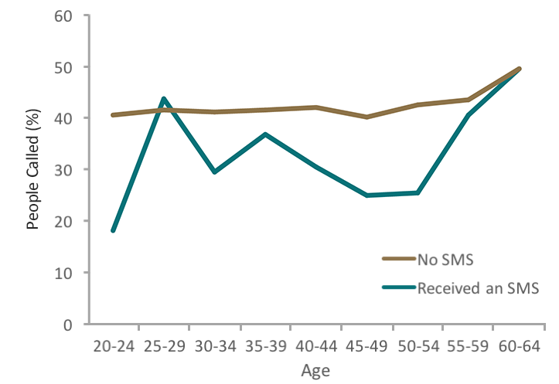
This figure shows the percentage of each age group calling the Department. SMS appears to be less effective for people aged 25-29 and those older than 54 years of age.

Discussion and Conclusion
This trial showed how a single SMS notification improved the experience of parents updating their details with the Child Support scheme and reduced the workload of the Department. Parents who lodged a change of assessment form and then received an SMS were less likely to call the Department overall. If they did call, the median time to place that call was 13 days later than parents who did not receive an SMS. Based on these results, if everyone who submitted a change of assessment form received a confirmation SMS, there would be approximately 2,100 fewer phone calls made every year.

Receiving a confirmation SMS appears to reduce uncertainty for parents, and reduces their need to spend time making a follow-up call. Aside from improving parents’ experience, this also benefits the Department. A decline in overall call volumes frees up resources to attend to other priority matters. This is achieved without increasing the administrative burden on either party.
Our results show a single SMS received at the onset of parent’s wait time reduced the likelihood of them calling over the following weeks, suggesting the message had a long term effect on parents. This is at odds with our previous research into SMS reminders sent to income support recipients (see BETA’s “Effective use of SMS: timely reminders to report on time” publication), where we found an SMS had no persistence over the following weeks. We expect this is due to the different purposes of each SMS –a one-time SMS is likely to have a more enduring effect in cases of providing information to reduce uncertainty and set expectations about timelines, than a reminder message for an ongoing task that occurs at regular short intervals (which may need to be delivered prior to each deadline).
Possible future research could focus on several strategies, including informing people in more precise ways about how long their estimated wait is, or advising them of their number in the ‘queue’ (perhaps by checking online). Knowing their case is progressing to a case manager might divert people from calling in and assure them their form has not been misplaced.
Overall, this trial found SMS communication to be an effective approach for advising parents who lodge a Child Support change of assessment form about the process involved and reducing enquiry calls to the Department. Lessons learned from this trial could be applied to other interactions between the Department and Australians, within and beyond the Child Support Scheme, and also to a wide range of programs administered by the Commonwealth, State and Territory, and local governments.

Appendices

Appendix 1: Technical appendix

Power Calculations
We conducted power analyses to determine how many people we would need to enrol in the trial in order to detect an effect of the SMS intervention on call rates. We calculated that a total sample of approximately 2500 would allow us to detect a 5 per cent reduction in call rates with a significance level of 0.05 at 80 per cent power.

The sample frame
The trial took place over the period 1 March 2017 to 25 August 2017, with SMS sent from 7 March - 6 June 2017 over all States and Territories of Australia. The sample frame consisted of all individuals paying (payer) or receiving (payee) Child Support payments who submitted a Change of Assessment form. Exclusions from the trial consisted of parents (or non-parent guardians) that: were listed as living overseas, were already allocated to a Child Support Payment team member, had a mismatch between their mobile or daytime phone number and what was listed on the change of assessment form, were deceased or had a vulnerability indicator recorded.
There were a total of 43 individuals who were enrolled in the trial multiple times after submitting a second or third change of assessment form. Because these individuals could be in both the treatment and control groups they were excluded from the final analyses. This gave us a total of 2852 units enrolled in the trial (1437 in the control group and 1415 in the treatment group). Five additional exclusions were made when calculating survival curves and median time to call as these units lacked the outcome data to specify censoring times.

Randomisation
Change of assessment forms were received by Human Services and were registered in the administrative system. The Human Services research team were alerted to newly received forms on a daily basis and simple randomisation was used to assign individuals to treatment and control groups. Randomisation was conducted using Microsoft Excel. A random number between 0 and 1 was generated for each individual using the RAND () function. Individuals with a random number greater than 0.5 were assigned to treatment, otherwise individuals were assigned to control. Random numbers were copied and pasted as values to ensure re-randomisation did not occur. Randomisation occurred on weekdays within Human Services and was verified by BETA.

Data
We could not distinguish if the call trial participants made related specifically to their change of assessment form, therefore some calls may have been made for other reasons. Given that individuals were randomised into groups we expect these irrelevant calls to be balanced across groups. The trial continued until all change of assessment applications were assigned to a Child Support decision maker to be progressed.

Analysis
Analysis of the call rate primary outcome was conducted using ordinary least squares regression (OLS). Performing a logistic regression revealed estimates and standard errors identical to those produced with OLS. Time to call was analysed by estimating Kaplan–Meier curves for the treatment and control groups using the Survival package in R. Median time to call was calculated from these curves. Curves were tested for statistical significance using a Mantel–Cox (log-rank) test.

Key statistical tables
This appendix presents the full statistical tables which underlie the results section.

Table A.1: Baseline characteristics of individuals randomised INTO THE TRIAL
 |  | Control | Treatment
 | N (no.) | 1437 | 1415
Sex | Female (%) | 56.4 | 57.3
 | Male (%) | 42.9 | 41.6
Age | Mean (SD) | 42.1  (7.7) | 41.9  (7.4)
Applicant type | Payee (%) | 54.1 | 54.0
 | Payer (%) | 45.9 | 46.0

Table A.2: Summary statistics and regression results for CALLED YES/NO
 | N | Called  % (no.) | Difference from Control  (95% confidence interval) | p-value
No SMS | 1437 | 41.9 (602)
Received an SMS | 1415 | 30.6 (433) | -11.3 (-14.8 to -7.8) | < 0.001
Treatment effects and p-values are from linear models. This analysis was also run as a logistic regression with the same results.

Table A.3: MEDIAN TIME TO CALL
 | N | Number of events | Median time to call  (95% CI)
No SMS | 1434 | 602 | 37 (33 to 42)
Received an SMS | 1413 | 433 | 50 (42 to INF/UNDEFINED)
Median time to call was calculated from a Kaplan–Meier curve. The upper confidence interval for the ‘received an SMS group’ is undefined because of the small number of individuals available beyond 50 days in the ‘received an SMS group’. There was a significant difference in curves between the treatment and control groups (Chi-square = 46.5 on 1 df, p < 0.0001).

Table A.4 – TIME TO CALL ANALYsis
DAYS | 0 | 10 | 20 | 30 | 40 | 50 | 60 | 70 | 80 | 90
CONTROL
Number left in trial | 1434 | 1109 | 773 | 336 | 66 | 26 | 19 | 9 | 9 | 5
Probability of calling (%) | 0 | 20.6 (18.5-22.7) | 34.3  (31.7-36.8) | 44.3 (41.3-47.1) | 54.7 (49.9-58.9) | 63.3 (55.7-69.6) | 66.3 (57.9-73.0) | 72.4 (60.6-80.7) | 75.5 (62.5-83.9) | 79.6 (64.4-88.3)
TREATMENT
Number left in trial | 1413 | 1198 | 915 | 410 | 80 | 42 | 29 | 17 | 3 | 1
Probability of calling (%) | 0 | 12.5 (10.7-14.2) | 22.5 (20.2-24.7) | 32.4 (29.5-35.1) | 42.6 (38.2-46.7) | 52.5 (45.1-58.9) | 52.5 (45.1-58.9) | 57.2 (47.4-65.2) | 60.5 (48.8-69.6) | 60.5 (48.8-69.6)
This table gives the details of the Kaplan–Meier survival curves for the control and treatment groups. The ‘number left in trial’ is the total number of individuals at risk of calling at the start of the time interval. The probability of calling is the probability that an individual calls after the specified time. There was a significant difference in curves between the treatment and control groups (Chi-square = 46.5 on 1 df, p < 0.0001).

Table A.5 – Summary statistics AND REGRESSION RESULTS for CALLED YEs/NO subgroup analyses
Subgroup | Level | On time reporting Control % (n/N) | On time reporting Treatment % (n/N) | Control – Treatment difference  (95% CI) | P-value | Difference across subgroup levels (95% CI) | P-value
Applicant type | Payee | 45.9 (357/778) | 31.9 (244/764) | -13.9 (-18.8 to -9.1) | < 0.0001
 | Payer | 37.2 (245/659) | 29.0 (189/651) | -8.1 (-13.2 to -3.1) | 0.0017 | 5.8 (-1.2 to 12.83) | 0.105
Sex | Female | 45.4 (368/810) | 30.8 (250/811) | -14.6(-19.3 to -9.9) | < 0.0001
 | Male | 37.0 (228/617) | 30.3 (178/588) | -6.7(-12.0 to -1.3) | 0.014 | 7.9 (0.8 to 15.0) | 0.029
Columns 3 & 4 show treatment effects and p-values within each subgroup level. Columns 5 & 6 show the difference in treatment effects between each level of the subgroup. Only sex had significant differences between subgroup levels.

Appendix 2: Accessible graph data

Figure 2: Impact of sending a confirmation SMS on call rates
 | People called (%)
No SMS | 41.9
Received an SMS | 30.6

Figure 3: Impact of sending a confirmation SMS on median time to call
 | Median time to call (Days)
No SMS | 37
Received an SMS | 50

Figure 4: Impact of sending a confirmation SMS on time to call
Time (Days) | Median time to call (Days)
 | No SMS | Received an SMS
0 | 3.2 | 2.5
10 | 20.6 | 12.5
20 | 34.3 | 22.5
30 | 44.3 | 32.4
40 | 54.7 | 42.6
50 | 63.3 | 52.5
60 | 63.5 | 52.5
70 | 72.4 | 57.5
80 | 75.5 | 60.5
90 | 79.6 | 60.5
100 | 79.6 | 60.5
110 | 86.4 | 60.5

Figure 5: Impact of sending a confirmation SMS on call rates by age
Age | People calling (%)
 | No SMS | Received an SMS
20-24 | 40.9 | 18.2
25-29 | 41.9 | 44.1
30-34 | 41.5 | 29.7
35-39 | 41.9 | 37.1
40-44 | 42.4 | 30.7
45-49 | 40.5 | 25.1
50-54 | 42.9 | 25.6
55-59 | 43.9 | 40.9
60-64 | 50.0 | 50.0

References

BUELL, R. W., KIM, T. & TSAY, C.-J. 2016. Creating reciprocal value through operational transparency. Management Science.
DANZINGER, S., & Moran, s. 2017. Don’t Call Us, We’ll Call You: Freeing the Mind in Non-Queue Waits. Working Paper. The Collar School of Management. Tel Aviv University.
DEPARTMENT OF HUMAN SERVICES. 2017. Annual Report 2016-17.
HOUSTON, M. B., BETTENCOURT, L. A. & WENGER, S. 1998. The relationship between waiting in a service queue and evaluations of service quality: A field theory perspective. Psychology & Marketing, 15, 735-753.
TAYLOR, S. A. & BAKER, T. L. 1994. An assessment of the relationship between service quality and customer satisfaction in the formation of consumers' purchase intentions. Journal of retailing, 70, 163-178.

Due to the large number of people involved in the trial, we are confident in the precision of this estimate.
The median time to call represents the timepoint at which the probability of calling reaches 50 per cent. Another way of thinking about this is the time at which half of all individuals in the group would be expected to call.
Table A.4 in the Technical Appendix presents confidence intervals for the curves

