Improving tax compliance: deductions for work-related expenses

August 2018

Other uses
Enquiries regarding this license and any other use of this document are welcome at:
Managing Director
Behavioural Economics Team of the Australian Government
Department of the Prime Minister and Cabinet
Barton ACT 2600
Email: beta@pmc.gov.au
The views expressed in this paper are those of the authors and do not necessarily reflect those of the Department of the Prime Minister and Cabinet or the Australian Government.

Research team
Professor Michael J. Hiscox was the principal investigator for this project. Other (current and former) staff who contributed to the report were: Janine Bialecki; Heather Cotching; Michael Daffey; Harry Greenwell; Su Mon Kyaw-Myint; Kailash Rajah; Robert Slonim; and Bec Weeks.

Acknowledgments
Thank you to the Australian Taxation Office for collaborating with us on the project. In particular, special thanks to Cindy Baker; Karla Bauer; Belinda Gibson; and Jane Mitchell.
The trial was pre-registered on the BETA website and the American Economic Association registry:
https://www.pmc.gov.au/domestic-policy/behavioural-economics/improving-tax-compliance-deductions-work-related-expenses-income-tax-returns-filed-through-tax-agents
https://www.socialscienceregistry.org/trials/2132

Who?

Who are we?
We are the Behavioural Economics Team of the Australian Government, or BETA. We are the Australian Government’s first central unit applying behavioural economics to improve public policy, programs and processes.
We use behavioural economics, science and psychology to improve policy outcomes. Our mission is to advance the wellbeing of Australians through the application and rigorous evaluation of behavioural insights to public policy and administration.

What is behavioural economics?
Economics has traditionally assumed people always make decisions in their best interests. Behavioural economics challenges this view by providing a more realistic model of human behaviour. It recognises we are systematically biased (for example, we tend to satisfy our present self rather than planning for the future) and can make decisions that conflict with our own interests.

What are behavioural insights and how are they useful for policy design?
Behavioural insights apply behavioural economics concepts to the real world by drawing on empirically-tested results. These new tools can inform the design of government interventions to improve the welfare of citizens.
Rather than expect citizens to be optimal decision makers, drawing on behavioural insights ensures policy makers will design policies that go with the grain of human behaviour. For example, citizens may struggle to make choices in their own best interests, such as saving more money. Policy makers can apply behavioural insights that preserve freedom, but encourage a different choice – by helping citizens to set a plan to save regularly.

Contents
Executive summary 4
Why? 5
What we did 7
Results 11
Limitations 16
Discussion and conclusion 17
Appendices 18
Appendix 1 - Interventions 18
Appendix 2 - The technical details 19
Appendix 3 - Key statistical tables 22
References 30

Executive summary
In the Australian Income Tax system, individual taxpayers are entitled to claim deductions for expenses incurred while earning salary and wage income. These deductions are called work related expenses. According to Taxation Statistics, work related expense deductions grew by 15 per cent from 2010-11 to 2015 16. In 2015-16, 8.6 million taxpayers claimed nearly $22 billion in work related expense deductions.
There is evidence that claims for work-related expense deductions can be erroneous and there is a propensity to over claim, including in returns prepared by tax agents. In his National Press Club address on 5 July 2017, the Commissioner of Taxation expressed concern about the accuracy of work-related expense claims related to work, clothing and vehicles in the 2014-15 financial year. While individual amounts over-claimed can be small, the sum and overall revenue impact is significant. The Commissioner estimated the overall revenue impact was in the vicinity of $2.5 billion.
Research by H&R Block in 2016 indicated one in five taxpayers believed misrepresentation of tax return information isn’t so bad, and 71 per cent believed they could claim something they were not entitled to (Lonergan Research 2016). PhD research (Wurth 2013) found tax agents rated their clients’ work-related expense claims as the ‘least compliant’ label on the tax return. Behavioural insights offers a low-cost tool to address these behaviours and underlying attitudes and help taxpayers willingly comply with the tax system.
The Behavioural Economics Team of the Australian Government (BETA) partnered with the Australian Taxation Office (ATO) to examine the extent to which behaviourally-informed communications to tax agents could reduce erroneous work related expense claims. In particular, we tested the effectiveness of a letter sent to tax agents drawing on behavioural insights to address social norms.
We used a randomised controlled trial to test the impact of sending this letter to tax agents whose clients had higher than expected work-related expense claims compared to their peers. The letter specifically identified each agent’s clients who had lodged higher than expected claims (referred to as ‘identified clients’). There were over 2,000 tax agents in the trial, who were randomly assigned to a letter group or a ‘no letter’ control group.
17 per cent of agents in the letter group lodged amendments, compared with 1 per cent of agents in the ‘no letter’ group. On average, identified clients represented by agents in the letter group reduced their work related expense claims by $191, compared with a $2 increase in the ‘no letter’ group. Overall, identified clients reduced their work-related expense claims by a total of $2.2 million. If we had sent the letter to all agents in the trial, including those who did not receive a letter, we expect this simple messaging intervention would have decreased work related expense deductions by about $4.4 million.
The letter led to an increase in the average total tax paid per client of $76, for a total of $0.9 million. If we had sent the letter to all agents in the trial, total tax revenue would have increased by an estimated $1.7 million. We cannot be sure about the contribution of the reduction in work-related expense claims to the increase in tax paid, because amendments to tax return labels other than work-related expenses could have influenced the net tax position.
Overall, these findings indicate low-cost, well-targeted and well-designed communications incorporating behavioural insights are effective in reducing erroneous work-related expense claims although the length of time for which this behavioural change is sustained remains unknown.

Why?
Australia has a relatively generous deductions regime compared to other jurisdictions, particularly for the largest category of deductions, work-related expenses. For example, New Zealand abolished work-related deductions for employees in the late 1980’s and the UK has very stringent rules.
To add to this environment, complexity and cost of compliance are well-recognised characteristics of the personal income tax system. The cost of compliance for individuals is estimated to be $7.3 billion per year, driven primarily by record keeping costs and fees for independent professionals (Australian Treasury 2015).
Complexity and compliance factors are reflected in the high proportion of individual taxpayers who choose to lodge via a tax agent (over 70 per cent), and have led to Australia having the second highest use of tax agents in the OECD, behind Italy. Government reviews have acknowledged these issues and recommendations for change have been put forward.
Recent unpublished ATO research has found many taxpayers think it is wrong to over-claim work-related expenses and intend to do their best to report income and claim deductions correctly. However, in practice it appears some taxpayers think it is okay to over-claim ‘a little.’ Ensuring deductions are claimed accurately is a priority for the Australian Government and the ATO.
Approximately 65 per cent of Australian taxpayers claim work-related expense deductions. In 2015-16, 8.6 million taxpayers claimed nearly $22 billion in work related expense deductions – representing a 15 per cent increase since 2010-11.
Over 70 per cent of Australians lodge their income tax return through a tax agent, so prompting a behaviour change among agents could lead to a larger increase in overall tax compliance.
The ATO uses data analytics to identify agents whose clients’ claims are higher than expected when compared to agents with similar clientele. Agents are then engaged directly to address compliance risks in relation to work-related expense claims in their client base.
In engaging with agents, the ATO uses a range of approaches to encourage compliance, from help and education through to enforcement activities. Unpublished work by the ATO has found the most positive return on investment and sustainable compliance impact results from activities where interaction with agents is tailored (using data analytics) and involves direct dialogue between an ATO officer and agent.
In this trial we tested whether ATO data analytics could be coupled with behaviourally informed written communications to improve the accuracy of work related expense claims in a low cost manner.

What we did

What we did for this study

Behavioural analysis
A number of biases can influence decisions about claiming tax deductions.
Box 1: Common biases in tax behaviour
Social norms - we are heavily influenced by the behaviour considered acceptable in a group or by society. Norms can change according to the environment and over time.
Availability bias - we tend to overestimate the likelihood of events with greater "availability" in memory, which affects perceptions of occurrence.
Priming - when we are exposed to a particular idea or stimulus, it can have an impact on behaviour later on.

Social norms
Among Australian taxpayers, views about socially acceptable behaviour suggest many individuals believe deliberate tax evasion is common - especially if taxpayers cheat ‘just a little’ (Orima 2015, Mazar 2008).
It is possible this type of tax evasion reflects a form of ‘moral licensing’ (Merritt et al., 2010), where people allow themselves to do something slightly bad (such as overstating tax deductions) after doing something good or being reminded they have done something good (such as paying taxes).
Social norms can be used to nudge behaviour towards increased tax compliance by making it clear compliance is actually the norm. The statement “9 out of 10 people pay their tax on time” in letters sent to taxpayers increased payment rates by 15 per cent in the UK (BIT, 2012). The positive effects were stronger when the social norm was localised – “9 out of 10 people in [your county of residence] pay their tax on time.”

Availability bias
Our decisions and expectations tend to be heavily shaped by recent or accessible information (Tversky and Kahneman, 1973). Many individual taxpayers have not been through a tax audit, and while the ATO has increased the use of letters and technology to increase deterrence, research suggests a proportion of the population expect there is a low probability they will ever face an audit.
Simply reminding people of the risk of audit prior to tax lodgement can increase compliance (Slemrod et al., 2001; Appelgren, 2008; Wenzel and Taylor, 2004; Hasseldine et al., 2007; Kleven et al., 2011). This is the case even when information about penalties is not included (Hasseldine et al., 2007). Previous research also shows letters indicating audits will concentrate on high risk entities are more effective in improving tax compliance than letters indicating audits will be random (Appelgren, 2008).

Priming
Agents need to apply the law correctly, and may need to balance their clients’ expectation to maximise their tax refunds. Reminding tax agents of their role as trusted advisers could affect behaviour later on when agents are faced with difficult judgment calls.
In a marketing study, asking people “Do you consider yourself a helpful person?” increased the number of people who agreed to participate in a survey from 29 per cent to 77 per cent (Bolkan and Anderson, 2009). This shows priming an identity can have an impact on future behaviour, as individuals try to conform with their own positive self-image.

Designing the letter sent to tax agents
We designed a letter (at Appendix 1) to send to agents notifying them their clients’ work-related expense claims were higher than expected and prompting them to review those claims.
To utilise social comparisons, agents were ranked against other agents and informed their clients’ collective claims were in a top percentage of “higher risk” claims.
To highlight the potential costs of non-compliance, the letter stated the ATO was employing a targeted, data-driven method for monitoring claims, rather than a random audit process. It also included a list of the agent’s clients with higher than expected claims compared to their peers.
To prime a specific identity, the letter emphasised the agent’s position as a trusted advisor with a special role and responsibility to help clients get things right.
The trial
We used a randomised controlled trial (RCT) to examine the effect of sending the letter to agents.
Box 3: What is a randomised controlled trial?
Well-designed randomised controlled trials (RCTs) provide the best empirical method for determining a policy’s quantifiable impacts. In this respect, RCTs are considered the ‘gold standard’ for impact evaluation. RCTs work by randomly separating people into two or more groups, in a manner similar to flipping a coin. People in a ‘treatment’ group receive an intervention (new policy) while people in the ‘control’ group do not. On average, the difference in outcomes between people in a treatment group and in the control group reflects the causal impact of the new policy.

The ATO created a population of ‘notional peers’ for agents with the same number of clients and similar characteristics. The ATO determined each agent’s level of risk based on their clients’ work-related expense claims. This trial focused on agents considered to have a moderate to high risk of over-claiming. The trial consisted of 2,277 agents. The ATO sent the letters to 1,139 agents on 10 March 2017, leaving 1,138 agents in the ‘no letter’ control group. All agents in the trial were excluded from other ATO activities in relation to work-related expenses.

Amended tax returns
The letter was sent after agents had already lodged a number of tax returns for clients. The letter identified a sample of no more than 20 of the agents’ clients who had lodged higher than expected claims (referred to as ‘identified clients’).
Overall, the 2,277 agents in the trial had a total of 22,776 identified clients, an average of 10 per agent. Of the total 22,776 identified clients, 11,296 clients were attached to agents who received the letter and 11,480 clients were attached to agents who did not receive the letter. We examined whether agents amended claims for their identified clients, up to 12 May 2017. We expected agents in the letter group to reduce work-related expense claims by more and to pay more tax than agents in the ‘no letter’ group.

Figure 1: Trial design for amended tax returns

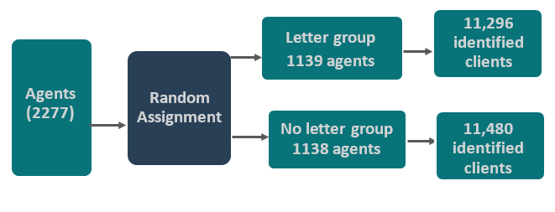

New tax returns
Agents had not lodged tax returns for a number of clients on 10 March 2017, when the letter was sent. Therefore, these clients could not be identified in the letter. We examined the effect of the letter on subsequently lodged tax returns for these (non-identified) clients, up until 11 June 2017. We expected agents in the letter group to lodge lower work-related expense claims and to pay more tax than agents in the ‘no letter’ group.

Results
The letter had a substantial effect on tax agent behaviour compared to the behaviour of agents in the ‘no letter’ group.
This section firstly looks at amendments to tax returns. It then looks at lodgement of new tax returns.

Did the letter result in amended work-related expense claims?

Rate of agents lodging amendments
Agents in the letter group submitted more amendments for work-related expense claims for their identified clients in the 60 days after the letter was sent, than agents in the no-letter group. A total of 193 agents (17 per cent) in the letter group lodged amendments on behalf of 546 clients, compared with only 16 agents (1 per cent) in the ‘no letter’ group on behalf of 16 clients (Figure 2). Most of the amendments were reductions in work-related expense claims but some were increases (Table 3.2, Appendix 3).

Figure 2: Percentage of agents who lodged an amendment
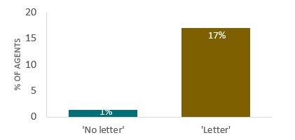
Note: the difference in percentage of amendments lodged (16%) is statistically significant at p<0.001. The total sample size was 2,267 tax agents.

Adjustment value at agent level (for identified clients)
On average, agents in the letter group reduced work-related expense claims for their identified client group by $1,863 (Figure 3). This effect was observed across all work-related expense deduction categories, with the largest average reduction seen for car expenses ($727). On average, agents in the letter group with higher risk scores reduced work-related expense claims by $1,772 more than agents with moderate risk scores (Table 3.5, Appendix 3).
On average, agents in the letter group lodged amendments resulting in $721 more tax paid for their identified clients, compared with only $36 in the ‘no letter’ group (Figure 3). This effect is attributable to the letter, but changes to a number of tax return labels (such as income) may have contributed to the increased tax paid. Therefore, we cannot be sure about the contribution of the reduction in work-related expense claims to the increase in tax paid.

Figure 3: Average change in value of work-related expense claims and tax paid for amended returns – by agent

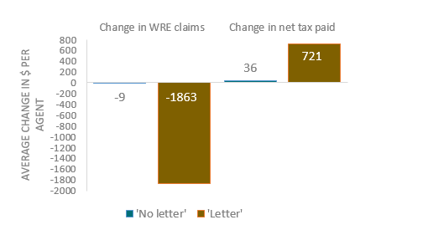
Note: the differences in WRE claims ($1,854) and net tax paid ($685) are both statistically significant at p<0.001. The total sample size was 2,267 tax agents.

Adjustment value by individual identified clients
On average, identified clients represented by agents in the letter group reduced work-related expense claims by $191, compared with a $2 average increase in the ‘no letter’ group (Figure 4). This difference was observed in all categories of work-related expense deductions, with the largest average differences seen for car ($79) and travel ($46) expenses (Table 3.4, Appendix 3).
On average, identified clients in the letter group represented by agents with higher risk scores had their work-related expense claims reduced by $100 more than identified clients represented by agents with moderate risk scores (Table 3.5, Appendix 3).
Identified clients represented by agents in the letter group lodged amendments resulting in $76 more tax paid on average than identified clients represented by agents in the ‘no letter’ group (Figure 4). As noted above, this effect is attributable to the letter, but we cannot be sure about the contribution of the reduction in work-related expense claims to the increase in tax paid.

Figure 4: Average change in value of work-related expense claims and tax paid for amended returns – by individual identified client

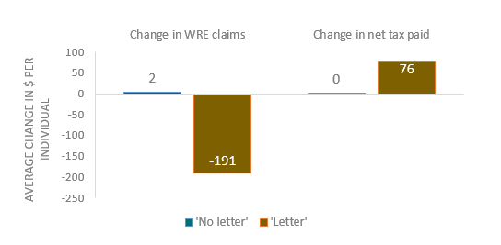
Note: the differences in WRE claims ($193) and net tax paid ($76) are both statistically significant at p<0.001. The total sample size was 22,686 clients.

Did the letter affect work-related expense claims in new tax returns?
Most agents lodged new tax returns in the 90 days after the letter was sent (i.e. for non-identified clients). Agents in the letter group lodged returns for 6,440 fewer clients than agents in the ‘no letter’ group (107,427 compared to 113,867, see Table 3.6 in Appendix 3). The average number of new tax returns was 260 in the letter group (range 1 to 1647) and 279 in the ‘no letter’ group (range 1 to 1437).
On average, individuals represented by agents in the letter group claimed $32 less in work-related expense deductions than individuals represented by agents in the ‘no letter’ group (Figure 5 and Table 3.8, Appendix 3).
Interestingly, individuals represented by agents in the letter group also claimed $399 more in other deductions (non-work related) on average than individuals represented by agents in the no letter group. This increase was driven predominantly by deductions for gifts and donations.
Despite this, on average, individuals represented by agents in the letter group paid $1,999 more tax than individuals represented by agents in the ‘no letter’ group. Again, we note that work-related deductions are not the only factor that can affect the amount of net tax paid.

Figure 5: Average work-related expense claims and tax paid for new returns – by individual

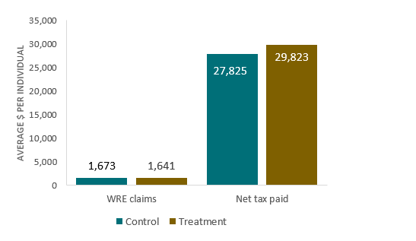
Note: the differences in WRE claims (-$32) and net tax paid ($1,998) are both statistically significant at p=0.043 and p=0.008, respectively. The total sample size was 222,194 clients.

Limitations
For new tax returns, individuals in the letter group paid more tax on average than individuals in the ‘no letter’ group although the former group had higher average deductions overall, including higher deductions for gifts and donations. We cannot fully explain this finding as we only examined income from wages, salary and allowances and did not consider income from other sources. Future research with data on all income sources may explain this finding.
The analysis of new tax returns at the agent level found results varied depending on the type of income variable included in the regression model (e.g. whether we used clients’ median income or clients’ average income). This possibly reflects the wide variation in income of their clients and the fact averages are sensitive to outliers. Hence, the results of the new tax returns analysis at the agent level are only included in Tables 3.8 and 3.9 at Appendix 3 and are not presented in the main body of the report.
Contrary to the analysis plan, we did not analyse data on amended tax returns of non identified clients of agents in the trial. This additional data, as well as historical income tax return data, could be explored in future research to shed light on patterns of deductions, including whether the letter and ‘no letter’ groups differed in their pattern of deductions prior to the trial.
Finally, analysis on the accuracy of either amended or new returns was beyond the scope of this trial. Reductions may have been made to reduce over-claiming, or may have been made to take a more conservative approach to genuine claims. It is therefore difficult to assert the reduction in claims unequivocally reduced non compliant activity. That said, we are working on the reasonable assumption that agents would be unlikely to amend returns if there were no identifiable issues with the initially lodged return.

Discussion and conclusion
The results of the trial demonstrate coupling data analytics with communications incorporating behavioural insight techniques can influence compliance for work-related expense claims.
Identified clients represented by agents in the letter group reduced their work-related expense claims by a total of $2.2 million. On average, identified clients represented by agents in the letter group reduced their work related expense claims by $191, compared with a $2 increase in the ‘no letter’ group.
While acknowledging factors other than work related expense deductions may also be driving the amount of net tax paid, agents in the letter group also increased tax paid by $0.9 million (Table 3.10, Appendix 3) . On average, tax paid increased per client by $76. Given there were as many agents in the ‘no letter’ group as in the letter group, we can estimate if the letter was sent to all agents in the trial, work-related expense claims would have reduced by $4.4 million and tax revenue increased by $1.7 million (Table 3.10, Appendix 3).
On the face of it, this result indicates an effective return on investment when the cost of sending the letters is compared with the additional tax revenue collected as a result of reducing deductions. However, noted alongside this result, unpublished ATO reports suggest other approaches employed within the ATO (as noted on page 4-5 of this report) to influence compliance for work related expense claims are resulting in a greater return on investment. The ATO has previously established that unless follow-up compliance work is conducted after letter campaigns, the effectiveness of future campaigns is decreased. The need for this follow up action reduces the cost effectiveness of a letter based approach.
Our trial shows it is important to test interventions because human behaviour is complex. Our trial showed the letter was effective at reducing work-related expense claims, but work-related expenses are just one part of the overall tax system and tax return process. As changes in deductions claimed in one category may be offset by increases in deductions claimed in other categories, future trials should connect and analyse data across all deduction categories to better identify shifts in behaviour around claiming deductions.

Appendices
- Interventions
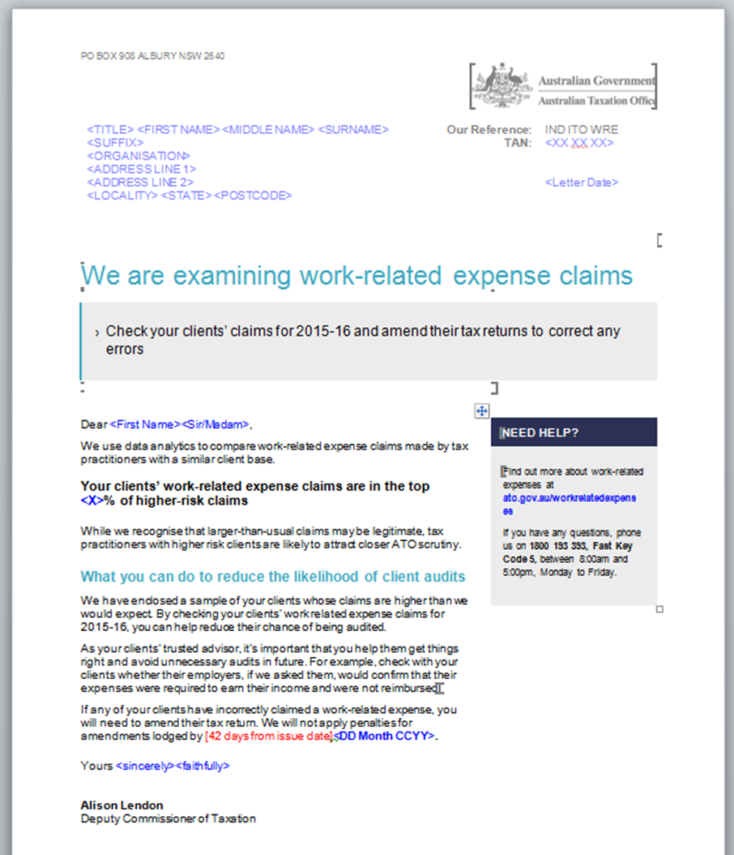

- The technical details

SAMPLE

Power calculations
To determine the appropriate sample size, we conducted power calculations based on average work-related expense claims in 2015 from tax returns prepared by agents included in this trial.
Agents included in this trial had been previously assessed by the ATO to have a moderate to high level of risk in relation to their client’s work-related expense claims. To make this assessment, the ATO uses stratified sampling on tax agent lodged returns to establish industry norms for lodgment behaviour. For each tax agent, the ATO creates a population of ‘notional peers’ with the same number of clients and the same characteristics as the tax agent in focus; and this relative comparison determines the level of work-related expense risk for the tax agent based on their clients’ claims.
We did not include agents that are considered to have the highest risk, because the ATO conducts separate compliance and auditing activities as appropriate for this cohort. We also only included agents with a client base of predominantly individuals because the study was designed to address work-related expense deductions claimed by individuals.
We estimated a sample size of 2,276 was needed for 80 per cent power to detect a difference of $271 (a 9 per cent decrease) in average work-related expense claims at the agent level for amended claims.

Randomisation method
The initial sample was 2,287, which accounts for dropping three agents to ensure balance across the groups. We then randomised by first grouping agents by business size and function. We then pair matched agents based on work-related expense risk score and work-related expense claims over the 2012-13 to 2014-15 years. We designed the grouping and pair matching to ensure the characteristics of agents in the letter group and ‘no letter’ group were as similar as possible.

Final sample sizes

Amended tax returns
The baseline sample was reduced from 2287 to 2267 after exclusions due to ATO compliance activities and resulting adjustments for pair-matching. The size of the treatment and control groups were 1134 and 1133.

New tax returns
From the baseline sample of 2,287 agents, 58 did not lodge a new return. 28 were in the letter group. We excluded matched pairs of these 58 agents if pairs were broken. This left the analysis sample for new returns at 2,174 agents.

ANALYSIS
Agent level analyses were adjusted for pair matching and the following covariates: agent segment (e.g. micro market segment, small and medium market segment, individual and non-business market), agent state, agent risk score, agent number of clients, agent average work-related expense claims (2013, 2014, 2015, 2016 to February 2017), agent average client income and agent lodgements.
Individual level analyses were clustered at the agent and adjusted for pair matching and the same covariates but also individual age, individual gender and individual income. By using individual level covariates we hoped to obtain greater statistical power.
As a robustness check for both existing returns and new returns, we ran analyses without the dummy variable for pair matching and did not exclude broken pairs. The results were very similar but the standard errors were larger in these analyses.
For subgroup analyses at the individual level, we did not adjust for pair matching (as pairs can break up between subgroups) and covariates (due to smaller sample sizes and as covariates added very little to improve standard error even for overall analyses). The models for subgroup analyses at the agent level only included the treatment and outcome variables.
The findings from regression models examining work-related expense claims and tax paid provide an estimate of the average treatment effect by comparing the mean of the outcome variables in the letter and ‘no letter’ groups.

Amended tax returns
We analysed the data of amended tax returns as at 12 May 2017 for identified clients (agents’ top 1 to 20 clients who had high work-related expense claims) only.
The primary outcome measure for individuals is the change in work-related expense claim (original claim minus amended claim). For agents, this measure is the sum of the work-related expenses changes for their identified clients.
The secondary outcome measure for individuals is the difference in tax paid over the financial year. For agents, this measure is the sum of the changes in tax paid for their identified clients.

New tax returns
We analysed the data of new tax returns lodged between 13 March 2017 and 11 June 2017 for all clients of the agents in the trial. This does not include data of identified clients (because these returns had already been initially lodged prior to the letters being circulated on 10 March 2017).
The primary outcome measure for individuals is the work-related expense claimed. For agents, we specified in our pre-analysis plan that we would examine the average work-related expense claim per agent using the average claim amount of their clients as per the analysis plan. However, we did not present these results in the main body of the report because the average of an average outcome measure is hard to interpret and in any case, we are interested in the effect on individual returns. We have included the results of these agent level analyses in Appendix 3.
The secondary outcome measure for individuals is the amount of tax paid over the financial year. For agents, this measure is the average tax paid per client.
The dollar figures in amended returns and new returns are not directly comparable because the outcome variables are different. For amended returns we examined the change in work-related expense claims whereas for new returns we examined the amount of work-related expense claims.

Spillovers
A spillover is an event which occurs in one context because of an event which occurs in an unrelated context. In this trial, spillovers are possible if an agent in the ‘no letter’ group finds out about the letter and changes their behaviour as a result.
For this trial we anticipate the threat of spillovers to be low. We split agents randomly into the letter and ‘no letter’ group based on their Tax Agent Number (TAN). If the TAN is registered by an individual, the letter was addressed to the individual. If the TAN is registered by a company, the letter was addressed to the director or contact person in the ATO’s database. It is common practice that all agents within a company or practice use the same TAN, so generally all agents within a given firm will either fall into the letter group or ‘no letter’ group. We therefore expect that the risk of agents in the letter group speaking with agents in the ‘no letter’ group about the letter is low.

- Key statistical tables
We ran a regression with treatment allocation as the outcome variable and categorical and continuous covariates as dependent variables. There were no significant differences between the letter and ‘no letter’ groups for all variables tested.

Table 3.1 – Baseline characteristics of agents and their identified clients
Characteristics |  | Treatment | Control
Identified clients
N |  | 11,256 | 11,430
Male | n (%) | 8,478 (75.3%) | 8,627 (75.5%)
Age | Mean (SD) | 38.9 yrs (10.7) | 39.0 yrs (10.6)
Income | Mean (SD) | $108,266 (58,982) | $108,151 (57,630)
Agents
N |  | 1,134 | 1,133
Major urban region | n (%) | 981 (86.2) | 1,002 (88.0)
ACT | n (%) | 13 (1.2%) | 7 (0.6%)
NSW | n (%) | 443 (39.1%) | 444 (39.2%)
NT | n (%) | 4 (0.4%) | 4 (0.4%)
QLD | n (%) | 188 (16.6%) | 185 (16.3%)
SA | n (%) | 36 (3.2%) | 39 (3.4%)
TAS | n (%) | 4 (0.4%) | 7 (0.6%)
VIC | n (%) | 383 (33.8%) | 403 (35.6%)
WA | n (%) | 63 (5.6%) | 44 (3.9%)
Agent’s average WRE claim 2013 | Mean (SD) | $2,024 (1,036) | $2,074 (992)
Agent’s average WRE claim 2014 | Mean (SD) | $2204 (940) | $2,208 (921)
Agent’s average WRE claim 2015 | Mean (SD) | $2,408 (788) | $2,400 (764)
Agent’s average WRE claim 2016 (to February 2017) | Mean (SD) | $2,929 (808) | $2,928 (793)
Agent risk score | Mean (SD) | 2.7 (1.4) | 2.7 (1.4)
Higher risk score | n (%) | 369 (32.5%) | 376 (33.2%)
Moderate risk score | n (%) | 765 (67.5%) | 757 (66.8%)

Table 3.2 – Number and per cent of amendments (reduced WRE deductions or increased tax paid) by letter group at the individual and agent level

 | Statistic | Treatment | Control
Individual level
Individuals for whom tax returns were amended | N | 546 | 16
Reduced WRE claims | N (%) | 483 (88.5%) | 1 (6.3%)
Increased net tax paid | N (%) | 487 (89.2%) | 7 (43.8%)
Reduced work-related car deductions | N (%) | 243 (44.5%) | 1 (6.3%)
Reduced work-related travel deductions | N (%) | 175 (32.1%) | 1 (6.3%)
Reduced work-related clothing deductions | N (%) | 99 (18.1%) | 1 (6.3%)
Reduced work-related self-education deductions | N (%) | 43 (7.9%) | 0 (0.0%)
Reduced other work-related deductions | N (%) | 285 (52.2%) | 1 (6.3%)
Agent level
Agents who amended tax returns | N | 193 | 16
Reduced WRE claims | N (%) | 170 (88.1%) | 1 (6.3%)
Increased net tax paid | N (%) | 171 (88.6%) | 7 (43.8%)
Reduced work-related car deductions | N (%) | 112 (58.0%) | 1 (6.3%)
Reduced work-related travel deductions | N (%) | 90 (46.6%) | 1 (6.3%)
Reduced work-related clothing deductions | N (%) | 58 (30.1%) | 1 (6.3%)
Reduced work-related self-education deductions | N (%) | 38 (19.7%) | 0 (0.0%)
Reduced other work-related deductions | N (%) | 126 (65.3%) | 1 (6.3%)

Table 3.3 – Logistic regression results for amended returns for identified clients (number of agents =2,246)

 | Odds ratio | Standard Error | p-value
Treatment | 15.1 | 4.0 | < 0.001
Control | Reference group
Note: Adjusted for agent risk score, agent segment, agent state, agent number of clients, agent’s average WRE claims (2013, 2014, 2015, 2016 to February 2017), agent’s average clients’ income 2015 and agent’s number of lodgements and state but there were no significant differences in the odds of amended tax returns by these variables. Dummy variables for pairs were not included as with logistic regression, many were predicting failure or success perfectly.

Table 3.4 – Linear regression results for amended returns – impact for identified clients

 | Average change in $ per individual in the letter group (compared to control) | Standard Error | p-value- difference between control and treatment | Average change in $ per agent (compared to control) | Standard Error | p-value- difference between control and treatment
 | Individual level | (n= 22,686) |  | Agent level | (n=2,267)
Change in WRE deduction | -193.2 | 16.2 | < 0.001 | -1853.8 | 214.5 | < 0.001
Change in net tax paid | 76.2 | 7.5 | < 0.001 | 684.2 | 96.4 | < 0.001
Other deductions | -1.6 | 1.2 | 0.171 | -11.0 | 12.2 | 0.371
All deductions (WRE + Other) | -194.8 | 16.2 | < 0.001 | -1864.7 | 215 | < 0.001
WRE deduction (cars) | -78.9 | 9.0 | < 0.001 | -727.0 | 112.6 | < 0.001
WRE deduction (travel) | -45.6 | 6.0 | < 0.001 | -484.3 | 97.9 | < 0.001
WRE deduction (clothing) | -4.6 | 0.7 | < 0.001 | -45.0 | 9.3 | < 0.001
WRE deduction (self-education) | -8.5 | 1.8 | < 0.001 | -81.2 | 27.3 | 0.003
WRE deduction (other WRE) | -55.7 | 6.2 | < 0.001 | -516.4 | 77.5 | < 0.001
Note: Other deductions include non-work-related deductions such as deductions for expenses associated with earning interests and dividends, gifts or donations and the cost of managing tax affairs. For individual level analysis, covariates included were individual age, individual gender and individual income and agent level covariates were agent segment, agent region, agent state, agent risk score and agent number of clients, agent average WRE claims (2013, 2014, 2015, 2016 to February 2017), agent's average clients' income and agent lodgements. Agent level analyses include the same covariates except individual gender, age and income.

Table 3.5 – Linear regression results for amended returns by risk score sub groups

 | Average change in $ in the letter group (compared to control) | Standard Error | p-value –difference between treatment and control within each sub group | p-value – difference in treatment effect between sub groups
WRE deduction - Individual level
Higher risk score (n=9,218) | -245.5 | 40.8 | < 0.001 | 0.032
Moderate risk score (n=13,468) | -146.4 | 22.0 | < 0.001
WRE deduction - Agent level
Higher risk score (n=745) | -1276.4 | 258.7 | < 0.001 | < 0.001
Moderate risk score (n=1,522) | -3048.3 | 369.7 | < 0.001
Net tax paid - Individual level
Higher risk score (n=9,218) | 86.2 | 15.4 | < 0.001 | 0.154
Moderate risk score (n=13,468) | 57.9 | 12.4 | < 0.001
Net tax paid - Agent level
Higher risk score (n=745) | 1070.0 | 169.3 | < 0.001 | 0.006
Moderate risk score (n=1,522) | 504.4 | 118.5 | < 0.001
Note: Pairs and covariates were not included in these regression models.

Table 3.6 – Descriptive statistics for new tax returns – analysis sample

Characteristics |  | Treatment | Control
Number of agents in the analysis sample | N | 1087 | 1087
New tax returns lodged | Mean (SD) | 260 (263) | 279 (273)
New tax returns lodged | Median | 180 | 183
New tax returns lodged | Total | 107,427 | 113,867

Table 3.7 – Poisson regression results for new returns (number of agents = 2,174)

 | Incidence rate ratio (IRR) | Standard Error | p-value
Control | 1.1 | 0.005 | < 0.001
Treatment | Reference group
Note: Adjusted for agent segment, agent state, agent number of clients, agent’s average WRE claims (2013, 2014, 2015, 2016 to February 2017), agent’s average clients’ income 2015, agent’s number of lodgements and state. Dummy variables for pairs were included. We also ran this as a linear regression and found similar results.

Table 3.8 – Regression results for new returns – impact on new returns – main results

 | Average $ per individual in the letter group (compared control) |  | Standard Error |  |  | p-value- difference between control and treatment | Average $ per agent in the letter group (compared to control) | Standard Error |  | p-value- difference between control and treatment
 |  | Individual level (n= 222,194) |  |  |  |  | Agent level (n=2,174)
WRE deduction |  | -31.8 |  | 15.7 | 0.043 |  | -82.6 |  | 32.2 |  | 0.011
Net tax paid |  | 1998.7 |  | 749.0 | 0.008 |  | -238.8 |  | 672.9 |  | 0.723
Other deductions |  | 398.9 |  | 115.1 | 0.001 |  | 81.5 |  | 96.1 |  | 0.397
All deductions (WRE + Other) |  | 367.1 |  | 118.7 | 0.002 |  | -1.1 |  | 104.9 |  | 0.992
WRE deduction (cars) |  | -33.1 |  | 9.6 | 0.001 |  | -39.6 |  | 19.6 |  | 0.044
WRE deduction (travel) |  | -2.5 |  | 5.4 | 0.651 |  | -26.3 |  | 11.6 |  | 0.023
WRE deduction (clothing) |  | 1.2 |  | 1.4 | 0.375 |  | 1.5 |  | 2.8 |  | 0.601
WRE deduction (self-education) |  | 2.5 |  | 3.3 | 0.440 |  | -3.1 |  | 6.4 |  | 0.622
WRE deduction (other WRE) |  | 0.0 |  | 10.0 | 0.998 |  | -15.0 |  | 16.5 |  | 0.361
Note: For individual level analysis, covariates included were agent state, agent segment, agent risk score, agent number of clients, agent's average WRE (2013, 2014, 2015, 2016 to February 2017), agent's average income of clients from 2015, agent's number of lodgements, individual gender, individual income (2016) and individual age. For agent level analysis, covariates included were agent segment, agent state, agent risk score, and agent number of clients, agent's average WRE claims (2013, 2014, 2015, 2016 to February 2017), agent's number of lodgements 2015 and median income of agent’s clients for whom new tax returns were lodged. Note for new returns, there are some changes to findings depending on which income variables were included. For this reason, we present Table 3.9 which presents results with alternative covariates.

Table 3.9 – Regression results for new returns – with different covariates

 | Average $ per individual in the letter group (compared control) |  | Standard Error |  | p-value- difference between control and treatment |  | Average $ per agent in the letter group (compared to control) |  | Standard Error |  |  | p-value- difference between control and treatment
 |  | Individual level (n= 222,194) |  |  |  |  |  | Agent level (n=2,174)
WRE deduction |  | -36.7 |  | 16.0 |  | 0.022 |  | -66.1 |  | 35.0 | 0.059
Net tax paid |  | 1821.2 |  | 766.1 |  | 0.018 |  | -10.1 |  | 573.4 | 0.986
Other deductions |  | 395.4 |  | 115.3 |  | 0.001 |  | 83.1 |  | 93.5 | 0.374
All deductions (WRE + Other) |  | 358.7 |  | 119.2 |  | 0.003 |  | 16.9 |  | 102.2 | 0.868
WRE deduction (cars) |  | -34.9 |  | 9.7 |  | <0.001 |  | -34.1 |  | 20.2 | 0.092
WRE deduction (travel) |  | -3.2 |  | 5.4 |  | 0.550 |  | -24.1 |  | 11.6 | 0.039
WRE deduction (clothing) |  | 1.2 |  | 1.4 |  | 0.401 |  | 1.9 |  | 2.8 | 0.486
WRE deduction (self-education) |  | 2.3 |  | 3.3 |  | 0.472 |  | -2.6 |  | 6.4 | 0.684
WRE deduction (other WRE) |  | -2.1 |  | 10.1 |  | 0.832 |  | -7.4 |  | 17.4 | 0.671
Note: This table presents findings undertaken for robust checks with different covariates. For individual level analysis, covariates included were agent state, agent segment, agent risk score, agent number of clients, agent's average WRE (2013, 2014, 2015, 2016 to February 2017), agent's average income of clients, agent's number of lodgements, individual gender, income (2015) and individual age. For agent level analysis, covariates included were agent segment, agent state, agent risk score, and agent number of clients, agent's average WRE claims (2013, 2014, 2015, 2016 to February 2017), agent average income of clients 2015, agent's number of lodgements 2015.

Table 3.10 – Extrapolation on work-related deductions and net tax paid to all identified clients and their agents in this trial

 | Results within trial | Extrapolation- if all agents in the trial received the letter
 | Decrease in work-related deductions | Decrease in work-related deductions
Upper bound estimate | $2.53 million (=$224.91 X 11,256) | $5.13 million (=$224.91 X 22,815)
Mid-point estimate | $2.17 million (=$193.20 X 11,256) | $4.41 million (=$193.20 X 22,815)
Lower bound estimate | $1.82 million (=$161.48 X 11,256) | $3.68 million (=$161.48 X 22,815)
 | Increase in tax paid | Increase in tax paid
Upper bound estimate | $1.02 million (=$90.93 X 11,256) | $2.07 million (=$90.93 X 22,815)
Mid-point estimate | $857,369.52 (=$76.17 X 11,256) | $1.74 million (=$76.17 X 22,815)
Lower bound estimate | $691,230.96 (=$61.41 X 11,256) | $1.40 million (=$61.41 X 22,815)
Note: This table uses estimated deductions and net tax paid from amendments and extrapolates this for all identified clients in the trial regardless of which letter group they were in. The table uses the 95 per cent confidence interval to calculate the upper bound and lower bound estimates. The number of amendments used in these extrapolations are based on the number of identified clients (n=22,815) among eligible agents for the trial. This number is larger than the number of identified clients in the analysis sample (n=22,686) because the analysis sample excluded individuals whose agents had broken pairs from randomisation.

References
Appelgren, L. 2008. The Effect of Audit Strategy Information on Tax Compliance - an Empirical Study. eJournal of Tax Research, 6, 67-81.
Australian Government, The Treasury 2015, Stocktake of Regulation, Final Report, March 2015.
BIT 2012. Applying Behavioral Insights to reduce Fraud, Error and Debt. 38.
Bolkan, S., & Anderson, P. A. 2009. Image induction and social influence: Explication and initial tests. Basic and Applied Social Psychology, 31(4), pp.317-324.
Commonwealth of Australia (House of Representatives Standing Committee on Economics 2017. Report on the inquiry into tax deductibility.
Hasseldine, J., Hite, P., James, S. & Toumi, M. 2007. Persuasive communications: Tax compliance enforcement strategies for sole proprietors. Contemporary Accounting Research, 24, 171-+.
Kleven, H. J., Knudsen, M. B., Kreiner, C. T., Pedersen, S. O. S. O. & Saez, E. 2011. Unwilling or Unable to Cheat? Evidence From a Tax Audit Experiment in Denmark. Econometrica, 79, 651-692.
Lonergan Research 2016. Australian community attitudes towards tax agents and tax obligations (H&R Block).
Mazar, N., Amir, O. & Ariely, D. 2008 The Dishonesty of Honest People: A Theory of Self-Concept Maintenance, Journal of Marketing Research, 45(6), pp. 633-644.
Meritt, A., Effron, D. A & Monin, B. 2010.Moral self-licensing: When being good frees us to be bad. Social and Personality Psychology Compass, 4/5, 344 357.
Orima 2015. ATO Taxpayer Behaviour Research.
Slemrod, J., Blumenthal, M. & Christian, C. 2001. Taxpayer response to an increased probability of audit: Evidence from a controlled experiment in Minnesota. Journal of Public Economics, 79, 455-483.
Tversky, A. & Kahneman, D. 1973. Availability: A Heuristic for Judging Frequency and robability. Cognitive Psychology.
Wurth, E. 2013. A will and a way: An analysis of tax practitioner preparation compliance. A thesis submitted for the degree of Doctor of Philosophy of the Australian National University, https://openresearch-repository.anu.edu.au/bitstream/1885/10355/1/01Front_Wurth.pdf

© Commonwealth of Australia 2018
978-1-925363-49-4 Improving tax compliance: deductions for work-related expenses (DOCX)
978-1-925363-50-0 Improving tax compliance: deductions for work-related expenses (PDF)

Copyright Notice
With the exception of the Commonwealth Coat of Arms, this work is licensed under a Creative Commons Attribution 4.0 International license (CC BY 4.0) http://creativecommons.org/licensesby/4.0/deed.en

Third party copyright
Wherever a third party holds copyright in this material, the copyright remains with that party. Their permission may be required to use the material. Please contact them directly.

Attribution
This publication should be attributed as follows: Commonwealth of Australia, Department of the Prime Minister and Cabinet, Improved tax compliance: deductions for work-related expenses.

Use of the Coat of Arms
The terms under which the Coat of Arms can be used are detailed on the following website: http://www.itsanhonour.gov.au/coat-arms

Behavioural Economics Team
of the Australian Government
General enquiries beta@pmc.gov.au
Media enquiries media@pmc.gov.au
Find out more www.pmc.gov.au/beta

These reviews include: Commonwealth of Australia (chaired by Ken Henry) 2009, Australia’s Future Tax System; Commonwealth of Australia (Commonwealth Treasury) 2015, Re:think – tax discussion paper; and Commonwealth of Australia (House of Representatives Standing Committee on Economics) 2017, Report on the inquiry into tax deductibility.
The majority of results presented in this section are averages. For example, we compared the average deduction (in dollars) among agents who received the letter with the average among agents who did not receive the letter. When we present other statistics (e.g. the percentage who lodged tax amendments), these are clearly noted in text.
The effect was statistically significant at p < 0.001. For statistical details of this finding and other results presented in the Results Section, please refer to Appendix 3. We are aware there is a lively academic debate about the merits of testing for ‘statistical significance’, the appropriateness of conventional thresholds such as p<0.05 (or any thresholds at all), and even the use of p-values generally. See, in particular, ‘The American Statistical Association Statement on Statistical Significance and P-Values’ (Wassertein and Lazar 2016).
Note new tax returns lodged are for an agent’s other clients. They are not new tax returns for identified clients who were attached in the treatment letter.

