Electricity information to fit the bill

December 2018

Other uses
Enquiries regarding this license and any other use of this document are welcome at:
Managing Director
Behavioural Economics Team of the Australian Government
Department of the Prime Minister and Cabinet
Barton ACT 2600
Email: beta@pmc.gov.au
The views expressed in this paper are those of the authors and do not necessarily reflect those of the Department of the Prime Minister and Cabinet or the Australian Government.
Research team
Staff who contributed to the report were: Janine Bialecki, Tim Blomfield, Bradley Carron-Arthur, Lani Perlesz and Heather Cotching.
Acknowledgments
Thank you to the Department of the Environment and Energy for their support and valuable contribution to this project.
The trial was pre-registered with BETA’s Academic Advisory Panel. The pre-analysis plan is published alongside this report.

Who?

Who are we?
We are the Behavioural Economics Team of the Australian Government, or BETA. We are the Australian Government’s first central unit applying behavioural economics to improve public policy, programs and processes.
We use behavioural economics, science and psychology to improve policy outcomes. Our mission is to advance the wellbeing of Australians through the application and rigorous evaluation of behavioural insights to public policy and administration.

What is behavioural economics?
Economics has traditionally assumed people always make decisions in their best interests. Behavioural economics challenges this view by providing a more realistic model of human behaviour. It recognises we are systematically biased (for example, we tend to satisfy our present self rather than planning for the future) and can make decisions that conflict with our own interests.

What are behavioural insights and how are they useful for policy design?
Behavioural insights apply behavioural economics concepts to the real world by drawing on empirically-tested results. These new tools can inform the design of government interventions to improve the welfare of citizens.
Rather than expect citizens to be optimal decision makers, drawing on behavioural insights ensures policy makers will design policies that go with the grain of human behaviour. For example, citizens may struggle to make choices in their own best interests, such as saving more money. Policy makers can apply behavioural insights that preserve freedom, but encourage a different choice – by helping citizens to set a plan to save regularly.

Contents
Executive summary 4
Why? 5
What we did 7
Results 13
Limitations 18
Discussion and conclusion 19
Appendices 20
Appendix A: Designing the electricity bills 20
Appendix B: Focus groups 22
Appendix C: User testing 23
Appendix D: BETA electricity bills 28
Appendix E: Online survey questions 40
Appendix F: Technical details 46
Appendix G: Statistical Tables 52
References 65

Executive summary
Most consumers can choose their electricity retailer. But many consumers are not shopping around for the best offer.
Part of the reason for this is the difficulty in comparing offers, with many consumers reporting they are not confident making choices in the electricity market. The ACCC’s recent Electricity supply and prices inquiry highlights there is unnecessary complexity in the way electricity plans are communicated. The Australian Energy Market Commission’s 2018 Retail Energy Competition Review similarly finds consumers have reached record-low levels of trust in the industry.
In our previous work, BETA found re-designing electricity price fact sheets could increase consumer confidence when it comes to engaging in the electricity market. But a range of behavioural traits still contribute to consumer inertia: the time and effort needed to seek out, compare offers and choose a plan can seem like it’s just not worth the hassle; and many consumers fear something will go wrong if they switch.
Electricity bills are a key way to inform consumers about their plan and usage, but bills are typically confusing and not useful to help consumers navigate the electricity market. Given all electricity consumers receive bills, the bill itself presents a useful vehicle to communicate the information consumers need to engage confidently in the electricity market.
In partnership with the Department of the Environment and Energy, we drew on behavioural insights to design and test six electricity bills. We focussed on simplifying bill design to draw attention to key information, and including a ‘ways to save’ box encouraging consumers to search for and switch to a better plan.
We tested electricity bills with around 4,200 Australians through an online survey experiment focussing on two key outcomes:
- confidence using the electricity bill to help look into finding a better plan; and
- stated intention to look into options for switching plans in the next year.
We found simplified bills with ‘ways to save’ information increased consumers’ confidence by up to 13 per cent. But this did not translate into intention to look for a better offer.
Increasing consumer confidence in a market facing record-low levels of trust is important. For this reason alone, making bills clearer and more accessible for consumers makes sense and should be considered by electricity retailers.

Why?

Policy context
Over the past decade, the price of electricity for Australian consumers has increased by around 56 per cent. High electricity bills have tightened household budgets and placed strain on businesses (ACCC, 2018).
Electricity bills help consumers manage electricity costs by communicating how much electricity is consumed and how much consumers are paying for electricity.
The National Energy Retail Rules require energy retailers to include certain information on customer electricity bills in New South Wales, Queensland, South Australia, Tasmania and the Australian Capital Territory. These include:
- the household’s average daily consumption during the billing period; and
- an energy consumption benchmark, comparing quarterly energy use against similar sized households.
The Australian Government also maintains an energy price comparison website, Energy Made Easy, designed to help consumers find a suitable offer in retail electricity and gas markets.

The problem
The Australian retail electricity market is a complex environment for consumers to navigate. Changes in technology and new product offerings present consumers with more choices, whether it be which electricity plan, how to consume less electricity or how to become electricity generators themselves.
In most States and Territories, consumers can choose their electricity retailer, with around 300 retail plans available for consumers in central Sydney. Although competition exists, there is significant inertia in the electricity market with many consumers failing to shop around for the best plan. In 2017, around 50 per cent of Australian consumers reported they had not switched electricity retailer or plan in the last five years. This is despite the significant cost savings many Australians could make by switching (AEMC, 2017).
Consumers who do engage actively and switch tend to pay less on average for electricity. This means less actively-engaged customers tend to bear retailers’ costs associated with attracting and retaining customers (ACCC, 2018).
A range of behavioural traits contribute to consumer inertia: the time and effort needed to compare and choose a plan can make it seem like it’s just not worth the hassle; and many consumers fear something will go wrong if they switch (ECA, June 2017).
Driving good consumer outcomes is no easy task. As a starting point, electricity information needs to be accessible to consumers. Consumers need to have the skills or assistance to assess information. Finally, consumers need to be motivated to act on information.
The two most common reasons consumers cite as their motivation for switching provider are dissatisfaction with the value for money they are receiving, and finding a better value plan elsewhere even though they weren’t dissatisfied with their current provider (ECA, June 2017). This project is focused on monetary incentives for switching, although we note dissatisfaction with customer service, faults and other reasons are also motivators for a minority of consumers to switch (ECA, June 2017).
Electricity bills are a key tool to inform consumers about their electricity plan and usage. However, bills can be difficult to understand and currently aren’t designed to help consumers search the electricity market (ACCC, 2018). Given all electricity consumers must receive a bill, the bill itself presents a useful vehicle to communicate the information consumers need to engage confidently in the electricity market.

What we did
We conducted a three-stage investigation into consumer behaviour, culminating in new electricity bill designs. We rigorously tested the new designs to see if they supported greater consumer engagement in the electricity market.

Overview
This project was exploratory in nature and aimed at providing insights into whether electricity bills are a useful tool for prompting Australian consumers to engage in the electricity market. Our goal was to design an electricity bill which would increase consumer confidence and stated intention to engage in the market to find the most suitable plan for them.
In partnership with the Department of the Environment and Energy, we conducted a three-stage design process. As shown in Figure 1, we first reviewed existing literature to understand what is already known about how consumers interact with electricity bills. We then talked to consumers in focus groups to understand their experience using existing electricity bills. Finally, we created several different bill design prototypes and sought feedback through user testing interviews with consumers.
To find out what changes to the bills help consumers, we used what we learned from the first three stages to design six bills. We then tested these designs in a framed field experiment.
Figure 1. Project sequence
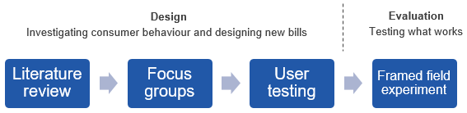

A summary of the method and findings for each of these stages is set out below. The findings of the framed field experiment are detailed in the Results section.

Literature review
Electricity bills are the primary touch point between consumers and their electricity provider. However, the complexity and presentation of information on electricity bills can be hard for consumers to digest, leading them to ignore much of the information (Gigerenzer G et al., 1999; Roberts and Baker, 2003). When consumers face ‘cognitive overload’, they are more likely to make poor choices (Jacoby et al., 1974) or give up on making a decision altogether (Gardner and Nilsson, 2017).
Simplification can increase bill comprehension (BEworks, 2016) and peer comparisons can lead consumers to reduce their electricity use (Andor and Fels, 2018). But there is little evidence on whether electricity bills can work as a vehicle to promote switching to a better plan.
Importantly, if the potential benefits of switching are unclear, uncertain or seem small, consumers are less likely to act. Presenting information in a clear and attractive way can help (Roberts and Baker, 2003), as does standardising the way energy information is presented (Fletcher, 2016; European Commission, 2016).
We also know conversational language with limited jargon is more likely to be well received and understood (BEworks, 2016). This is because certain concepts like ‘kilowatt hours’ (Karjalainen, 2011) and ‘supply charges’ can be difficult to understand.
Even consumers who do learn of a better electricity plan may still stick with their current retailer because of status quo bias and loss aversion – consumers fear something will go wrong if they switch. However, research in the UK and Australia finds while most consumers perceive switching to be difficult and risky, those who did switch found it easier than expected (OFGEM, 2008; Newgate Research, 2016).
Further considerations we took into account from literature during the design process are in Appendix A.

Box 1: Behavioural factors affecting electricity consumers
Cognitive overload is a tendency to become overwhelmed by large amounts of information. Cognitive overload may lead us to forget things and delay decisions.
Loss aversion is encapsulated in the expression ‘losses loom larger than gains’ as the pain of a loss is psychologically about twice as powerful as the pleasure of an equivalent gain. Loss aversion can result in not switching if the losses (such as the time to search) weigh more heavily than the potential financial gains.
- Salience is the quality of being noticeable or prominent. Disclosure documents can make certain products or features more or less salient.
Status quo bias is a tendency to stick with a chosen option or default, even where a better option may be available.

Focus groups
We ran four focus groups in three locations across the country to understand consumers’ experience with existing electricity bills. We asked questions to gauge how consumers interact with their electricity bill and how they engage in the electricity market more broadly. Overall, we found varying levels of comprehension around key energy concepts, but broad consensus electricity bills could be much simpler. There was also a strong emphasis on discounts as a measure for whether a plan was good or not. This is concerning as some retailers “increase discounts to gain customers, and then inflate the underlying tariffs that discounts are taken from” (ACCC, 2018).
Further detail on our focus group work is in Appendix B.

User testing
We used the feedback from focus groups to design a number of bill prototypes for further testing. We used eye-tracking technology to see how consumers interact with electricity bills in various formats – paper, computer-based and on mobile devices. Overall, most participants in the user-testing sessions appreciated simplified bills. They were also drawn to ‘ways to save’ information, with most participants reporting it would motivate them to visit the energy comparison site Energy Made Easy (though this was not corroborated in our framed field experiment. See Results section for further detail). This stage helped us refine our bill designs.
Further detail on our user testing work, including our prototype bills, is in Appendix C.

The six bill designs
We created six bills which were all two pages. Figure 2 outlines the design elements of each of the six bills, which were:
- A control bill, modelled on exemplar bills from retailer websites. This bill served as a benchmark for our trial.
- A control bill with a generic ‘ways to save’ box, encouraging consumers to shop around for a better plan based on average savings.
- A simple bill, which presented key information up front, but did not explicitly encourage consumers to shop around.
- A simple bill with a generic ‘ways to save’ box.
- A simple bill with a personalised ‘ways to save’ box, encouraging consumers to shop around for a better plan based on how much they could personally save.
- A simple bill with a personalised ‘ways to save’ box and unique Energy Made Easy code, providing consumers the option to skip entering their own data into Energy Made Easy and go straight to a personalised comparison page.

Figure 2. Design elements included in each of the six bills

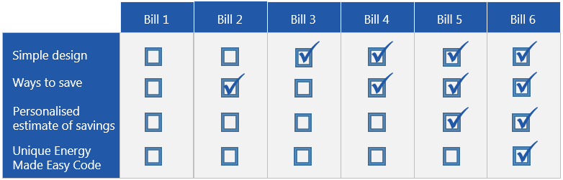

One design element involved simplifying the overall layout of the bill. Four of the six bills used the simplified design (Bills 3-6) and two used a design modelled on exemplar bills sourced from retailer websites (Bills 1-2). An example of how they differed, using the bill summary information, is included in Figure 3.
Figure 3: Bill design
Typical bill design (Bills 1-2)
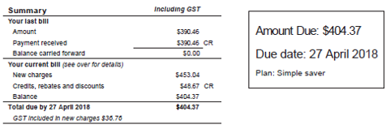

Simplified bill design (Bills 3-6)

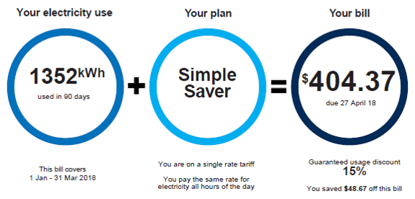

The primary element encouraging consumers to search for and switch to a better plan was the ‘ways to save’ box. This box was on the front page and included a call-to-action to visit the Australian Government energy price comparison website, Energy Made Easy. Existing regulation requires a link to Energy Made Easy to be included on all energy bills, however it is not typically framed as a way to help consumers save money. The different ‘ways to save’ boxes for each of the bill designs is set out in Figure 4, including the unique code in Bill 6.
Figure 4: ‘Ways to Save’ boxes from BETA designed bills
Bill 2 (generic)
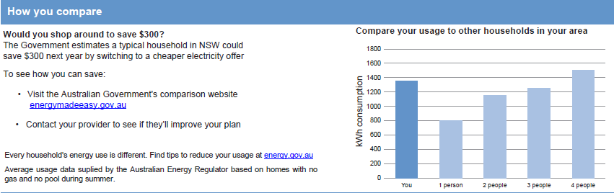
Bill 4 (generic) Bill 5 (personalised)
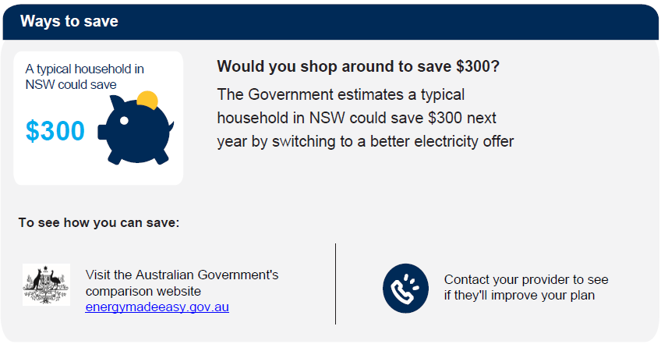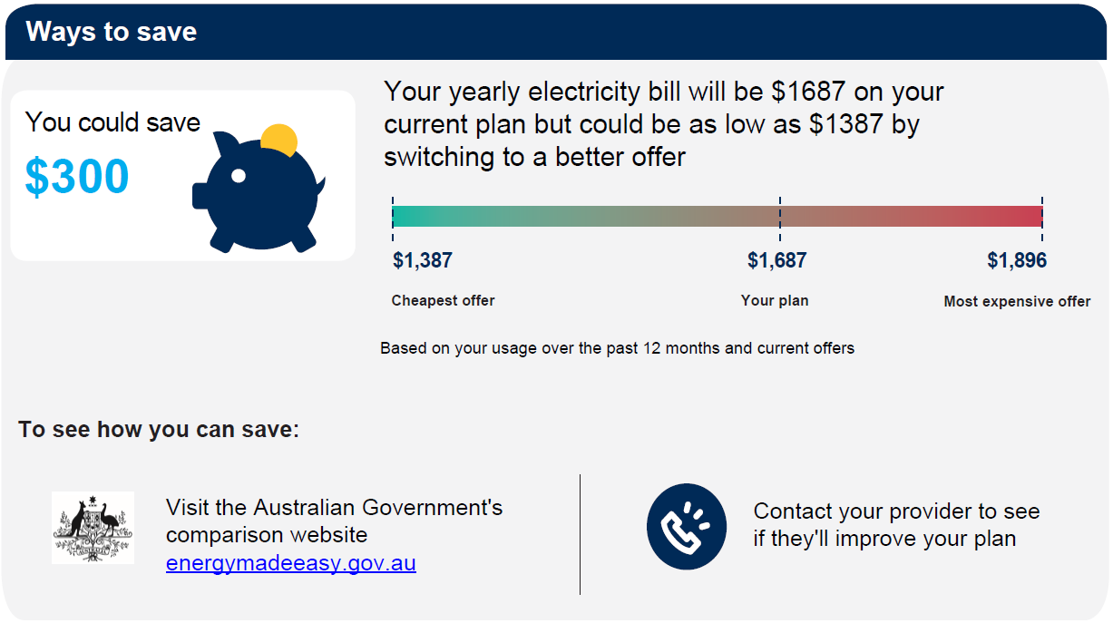
Bill 6 (personalised + unique code)
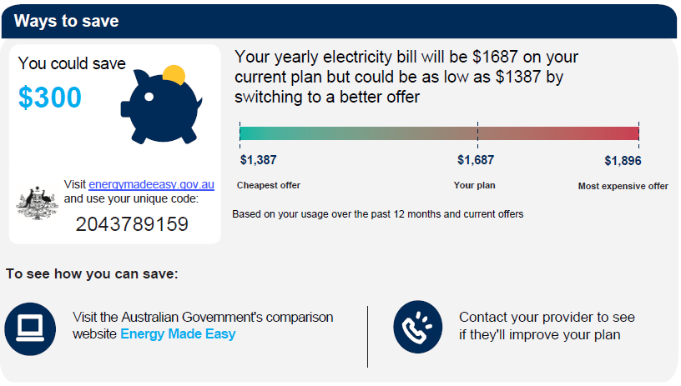
Note: Bills 1 and 3 did not contain a ‘ways to save’ box.
Full versions of all six electricity bill designs are in Appendix D.

Framed field experiment
We conducted a framed field experiment involving 4,224 Australian adults with experience choosing an electricity retailer, who were asked to complete an online survey. Participants in our survey came from deregulated National Electricity Market states (South Australia, New South Wales, South-East Queensland and Victoria), and met demographic quotas for age, gender and geographic location.
Participants were asked to have their most recent electricity bill on hand while completing the survey. In the first part of the survey, participants were asked questions about themselves, their household and their most recent bill. Participants were then randomly split into six subgroups of approximately 700 people and shown just one of the six BETA-designed bills. Participants were asked questions about the bill, such as which parts of the bill were important to them, how clear the information was, and how it affected their confidence and intention to engage in the electricity market. All bills were based on the same hypothetical provider, customer, plan and usage.
Box 2: What is a framed field experiment?
A framed field experiment is a type of randomised control trial conducted with a sample of people drawn from the population of interest (in this case, electricity consumers). Framed field experiments are designed to mimic features of naturally occurring settings in a controlled environment, to better understand how people respond to different types of stimuli. Framed field experiments generally ask participants to make choices in settings which approximate how they make decisions in real life (for example, sitting in front of their own computer in their own office or home).
We identified and tested for two primary outcomes. These were a participant’s:
- confidence using the electricity bill to help look into options for switching to a better plan; and
- stated intention to look into options for switching to a better plan.
We hypothesised each additional component added to the bill would lead to an increase in both primary outcomes.
A copy of the questions asked in the experiment is in Appendix E and more detail on the trial design is in Appendix F.

Results
BETA’s simplified bills increased participants’ confidence. This did not translate into intention to look for a better offer.

Were the changes BETA made to the bills valued by participants?
We asked participants to rate clarity and comprehension of their most recent bill as well as the bill with which they were presented in the survey on a seven-point scale. As shown in Figure 5, we found bills in the survey were rated as being clearer and more comprehensible than participants’ existing bills (0.37 to 0.48 points greater than 5.12). The bills with a simplified design (Bills 3-6) were rated more highly than the bills with the typical design (Bills 1 and 2) (p=0.002).
Figure 5: Clarity and comprehension of the bill designs
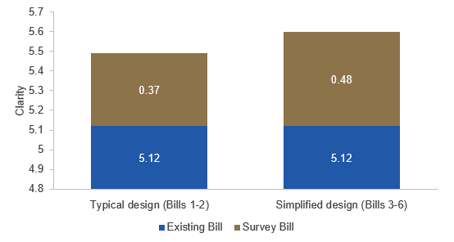
Secondary outcome, n=4,224. The bills in the survey were rated clearer and more comprehensible than participants’ existing bills. Survey bills with the simplified design (Bills 3-6) were rated more highly than survey bills without the simplified design (Bills 1 and 2) (p=0.002).

We also found participants indicated the link to Energy Made Easy was important to them more frequently when a ‘ways to save’ box was included on the bill contextualising the link’s purpose. As illustrated in Figure 6, less than one per cent of the participants selected the Energy Made Easy link as being important to them when shown a bill without the ‘ways to save’ box (Bills 1 and 3). In bills with a ‘ways to save’ box framing the link (Bills 2, 4-6), between 7.0 and 45.8 per cent of participants selected this component as being important to them. Relative to the control bill, these increases were all statistically significant (p<0.001). Participants who viewed the personalised ways to save information were the most likely to endorse this information as important. Only three components of the bill were rated as important by more participants: the amount due and when, the bill breakdown, and bill history.
Figure 6: The importance of Energy Made Easy and ‘ways to save’ information
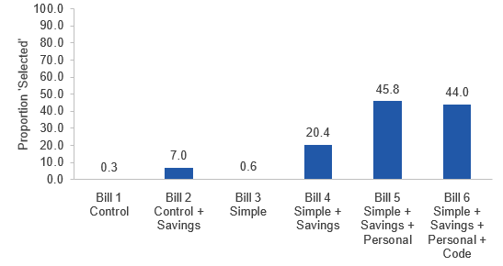
Secondary outcome, n=4,224. Bill with ‘ways to save’ box contextualising the Energy Made Easy link (Bills 2, 4-6) led to a statistically significant increase in the proportion of participants reporting that component of the bill was important to them (p<0.001).

Did the BETA-designed bills increase confidence?
After viewing one of the bill types, we asked participants how the bill affected their confidence to engage in the electricity market to find a better plan. Participants scored their confidence on a seven-point scale, with a score of four indicating the participant felt just as confident using the experimental bill as their existing electricity bill.
Figure 7: Participant confidence in ability to use the bill to look into switching
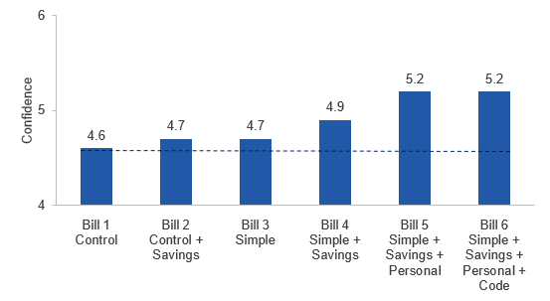
Primary outcome, n=4,224. Increases in confidence, relative to the control bill, were statistically significant. See Appendix G for relevant p-values, confidence intervals and a discussion of the statistical significance of these effects.
As shown in Figure 7, all bills received a higher confidence rating than the participants’ existing bills and all of the re-designed bills led to increased confidence relative to the control bill. The largest improvement was a 13 per cent increase in confidence, which came from the two bills which included a simplified design and personalised savings information (Bills 5 and 6). These differences were both statistically significant (p<0.001). The bill with a simplified design and generic savings information (Bill 4) also led to a statistically significant increase in confidence of six per cent.
We also ran an overall test for the effect of each component we added to the bill (that is, simplified design, ‘ways to save’ information, personalised estimate of savings, or a unique code). We found all components to be statistically significant predictors of increased confidence, with the exception of the unique code. Further detail is provided in Appendix G, which contains full results of analyses undertaken, including effect sizes, p-values and confidence intervals.

Did the alternative bills affect intention to look into switching?
We found no difference in the impact of the different bills on participants’ stated intention to look into their options for switching to a different plan in the next 12 months. Across all six experimental groups, approximately 57-60 per cent of participants stated they were planning to look into their options, as shown in Figure 8. None of these groups differed by a substantial or statistically significant amount from the control.
Figure 8: Intention to look into switching in the next 12 months
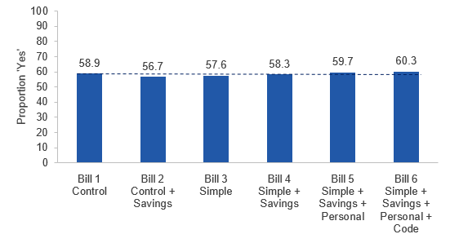
Primary outcome, n=4,224. There was no statistically significant difference between the control bill and any other of the bills in their impact on participants’ intention to look into switching in the next 12 months.

Did the alternative bills affect switching-related behaviour?
At the end of the survey, we drew participants’ attention to the Australian Government energy price comparison website, Energy Made Easy, and provided a noticeable link to the website. We tracked whether participants clicked on the link. We found no statistical difference between the experimental groups in the proportion of people who clicked on the link. This is consistent with the pattern of results regarding stated intention to look into switching. In all groups, only two per cent of participants clicked on the link.

Why didn’t increased confidence lead to changes in intention or behaviour?
Going beyond the bill, we asked participants about their expectations of switching. We found on average, participants expected it would take a little over two hours looking into their options to find a better plan. To make this time spent worthwhile, they wanted to save at least $237 annually.
Given a typical household in New South Wales could save around $300 by switching to the best available market offer (AEMC, 2017) (as was stated in bills with ‘ways to save’ information), it appears there is a gap between what consumers say they would do and what they actually do. In support of this, we found a majority of participants (56 per cent) stated they were at least somewhat concerned switching could lead them to end up on a worse plan. When asked what might prompt them to look into their options, one participant described how an offer exceeding their desired savings could be insufficient to prompt action.
“The plans all seem to be the same or [so] similar that it does not matter. It would have to be a good discount but then I would probably believe that it was too good to be true.”
Other participant feedback similarly highlighted trust issues in the market and the difficulty in trying to compare offers. Some participants suggested ways to overcome these issues. In summary, they pointed towards easy-to-use, trusted and objective comparison tools, with Government having a role to play in their design and delivery.

Limitations
The framed field experiment component of this study measured participants’ intention to switch, rather than whether participants actually switched provider or plan after viewing the electricity bill. Unlike a naturally occurring situation, participants did not actually receive the bill in the mail or online. It is possible participants spent more time examining the bills than they would have in real life and, as a result, responded differently to how they would have in practice.
In addition, there may be limitations in how far we can generalise the findings from this study because the focus groups, user testing sessions and the framed field experiment all involve voluntary participation. We designed each component of the study with demographic quotas to ensure our results could be as representative as possible of the broader population. However, the focus group, user testing and survey participants were incentivised to engage in the research so it is possible the study attracted participation by people who were more motivated by financial incentives. A field experiment conducted among the broader Australian population could help reduce this potential response bias.
We conducted multiple tests on our primary outcomes, which could inflate our risk of false-positive findings (for example, incorrectly concluding the difference between the bills is a real effect and not just a result of chance). We did not adjust our statistical thresholds for multiple testing but we did take this into account when interpreting our results. For further discussion, see Appendix G.

Discussion and conclusion
Clear and accessible information improves consumers’ confidence in making decisions in the electricity market. But complementary measures may be required to prompt action.
This is the second BETA study looking at increasing consumer engagement in the electricity market. The first, which involved redesigning electricity price fact sheets, found very similar results to the current study. That is, simplifying content and product design led to a clear increase in consumer confidence, but had no impact on intentions to engage in the market (BETA, 2017).
Increasing consumer confidence is a necessary step towards promoting engagement in the electricity market. Fact sheets and bills are the most obvious channels through which we could do so. Increasing confidence through these channels is a good start. Even though a one-off viewing was not sufficient to increase intentions to switch, it is possible repeated viewing could be. Over time, familiarity may develop and promote greater confidence. Further research could consider whether repeated exposure to such information included in regular bills would increase switching.
There are currently record-low levels of consumer trust in the retail energy sector (AEMC, 2018). In this context, even small improvements in consumer confidence are worthwhile. BETA notes other steps the Government is taking to improve trust in the electricity market and improve competition. The ACCC’s recent Electricity supply and prices inquiry (2018) highlighted there is unnecessary complexity in the way electricity plans are communicated. The ACCC found retailers have made pricing structures confusing and have developed a practice of discounting which is opaque.
The ACCC recommended making regulatory changes to the way plans could be structured. In particular, the ACCC recommended discounts be quoted with reference to a consistent base rate. The Government has accepted this recommendation. BETA’s work complements the ACCC’s findings by confirming electricity bills and fact sheets form part of reducing market complexity.
Our designs may assist retailers seeking to improve the experience of their customers and give them confidence in their ability to engage in the market. In light of underlying market changes, it is timely that simple changes to electricity bill design be given consideration.

Appendices

Appendix A: Designing the electricity bills
We considered a number of behavioural factors in designing the BETA electricity bills. Using bills to drive switching behaviour takes advantage of consumers being most aware of their electricity use and costs when they have to pay. This makes the bill a natural catalyst to help consumers consider switching (Gourville, J.T. and Soman, D., 1998.)
Key design elements derived from our review of the existing literature are set out below.

Addressing cognitive overload by making electricity bills simpler
To make it easier for consumers to understand their plan and feel confident searching for a better one, our research suggested electricity bills should:
- Be no longer than two pages and include key information (such as bill amount and date due) on the front page. The second page should include more detailed plan information for consumers who seek more detail (SSE, 2016).
- Use conversational language (with limited jargon) as it is more likely to be well received and understood (BEworks, 2016). Certain concepts like ‘kilowatt hours’ (Karjalainen, 2011) and ‘supply charges’ can be difficult to understand, so it can help to put these terms into more everyday language.
- Use a combination of text, diagrams and tables. This is more effective than single-format presentations when providing information on electricity bills (Roberts and Baker, 2003).
- Order information carefully and draw out key facts. Decisions can be influenced by the way information is structured (Simon, 1956). To draw people towards information on getting a better plan, it helps if information stands out on the front page and is visually appealing.
- Present comparisons using simple visuals. For benchmarks or comparisons, bar charts are easy to interpret and provide a quick way for consumers to understand how their electricity use compares (Karjalainen, 2011.)
- Only include one ‘amount due’ figure. Existing discounts are particularly difficult for consumers to navigate, with many participants in our focus groups confused about from where the underlying tariff discounts are taken, and the impact of pay-on-time discounts. To minimise confusion, our bill designs do not include any contingent discounts. Adopting Recommendation 32 from the ACCC’s Retail Electricity Price Inquiry - quoting discounts with reference to a standard reference bill - would also assist consumers, allowing them to ‘compare apples with apples’.

Addressing status quo bias by encouraging consumers to consider switching
To motivate switching behaviour, we considered a number of ways to encourage consumers to think about whether they were on the best plan for them, including:
- Prompting consumers by making it salient there are other plans which could save them money and providing suggestions on how easily to go about initiating the process.
- Making the potential savings personal or making them social, by drawing comparisons with others getting a cheaper plan for the same electricity. Evidence from electricity usage comparisons suggests they can be effective in driving behavioural change (Andor and Fels, 2018).
- Presenting the potential savings over a year-long horizon, so consumers can clearly see the benefits to them over time (Gourville, 2003).

Appendix B: Focus groups

Focus group goals
We ran four focus groups in South Australia, New South Wales and Queensland, each containing between five and eight participants. The focus groups included a cross section of household electricity consumers, with one group specifically targeting regional consumers, and one group targeting low-income consumers. The purpose of our focus groups was to seek views from electricity consumers about their understanding of and engagement with existing electricity bills.

Focus group methodology
The two-hour focus groups compared three existing electricity bills, drawing out views on content, format, comprehension, awareness of alternative plans and barriers to switching.
Each focus group responded to the same set of semi-structured questions intended to guide discussion, including questions designed to gauge participants' current engagement in the electricity market. We collected each group’s set of preferences for the electricity bill design comparisons and articulated areas of agreement and disagreement among participants.
After discussing elements of existing bills participants found most/least easy to understand, participants created their own ‘ideal bill’, informed by guiding questions:
- What layout helps you find the most useful information?
- What information would you include on your bill to help you find the best plan?
- What information would you include on your bill to make it easier to understand?

Focus group results
For their ideal bill, we found:
- All participants prefer bills no longer than two pages.
- Participants generally preferred different information in clearly separated areas, with colour in headings to break up sections of the bill.
- Participants wanted key information up front, including: bill period (date and/or days), due date, amount due and discounts.
- Participants generally wanted extra detail on the back including: contact details, detailed usage information, payment options.
- Many participants found a historical comparison graph helpful for understanding their own electricity use.
- Many participants found discount information attractive, without properly understanding the tariff rate the discount applied to. While some participants understood they couldn’t make direct comparisons between discount numbers, they were still confused by the array of discounts and tariffs.
With regard to engaging in the electricity market, we found mixed views on the challenges of switching. The main barrier was the perceived time required to switch. However, many participants reported they proactively look for better plans based on price, or they could be encouraged to shop around by hearing about discounts or experiencing ‘bill shock’.

Appendix C: User testing

User testing goals
Following our focus groups, we created several prototype electricity bills for further testing. User testing (including eye-tracking) helped us determine which design was most useful for helping consumers understand information on the bills and supporting consumers to make better energy choices. The user testing results informed the final design of the bills we used in the framed field experimental survey.

User testing methodology
Sixteen user testing sessions were conducted, each for 90 minutes with a single participant per session. Eleven one-on-one sessions took place in Sydney and five were conducted in Brisbane. We recruited a variety of participants with the aim of broadly covering a cross-section of household electricity consumers. Participants were recruited via a panel maintained by research partners Farron Research and AccessHQ.
Participants were presented with five bill variations in one of three media: paper; computer; or mobile device. Bills were presented to participants in a random order to minimise bias. Participants were eye-tracked throughout the entire session to allow the research team to gain deeper insights into bill engagement and the areas of the bills where participants focused most.
Each participant was asked the same set of semi-structured questions intended to guide discussion. Participants were first asked general questions about engagement with their existing bills and the electricity market, such as how much information they typically read when they get their electricity bill. They were then asked to find key pieces of information on the new bills such as the bill amount, due date and any discounts. Further discussion focussed on comprehension of specific components of the bill, and how confident and likely participants would be to use the bill to find a better electricity plan.

Figure C1. User testing bill designs and key design differences (front page)
Design A |  | Design B |  | Design C
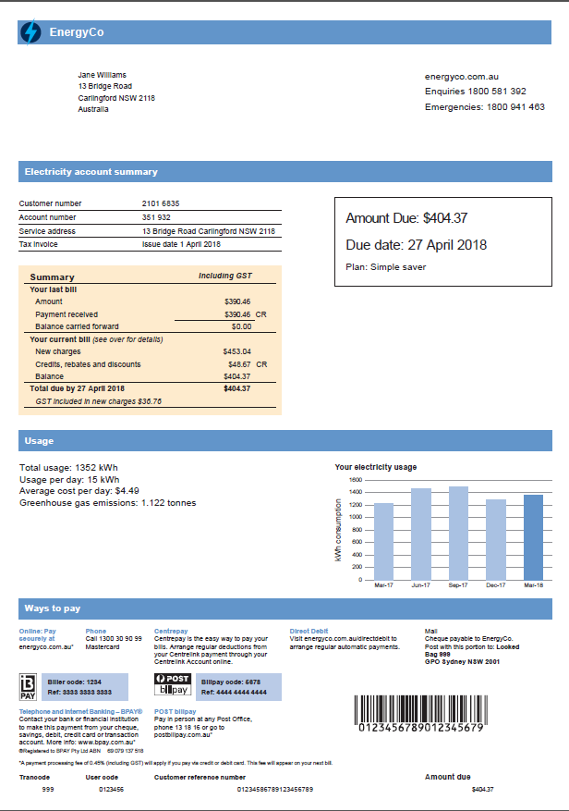 |  | 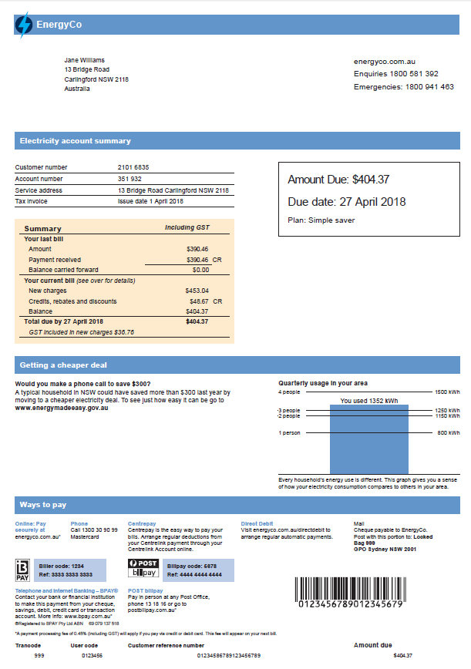 |  | 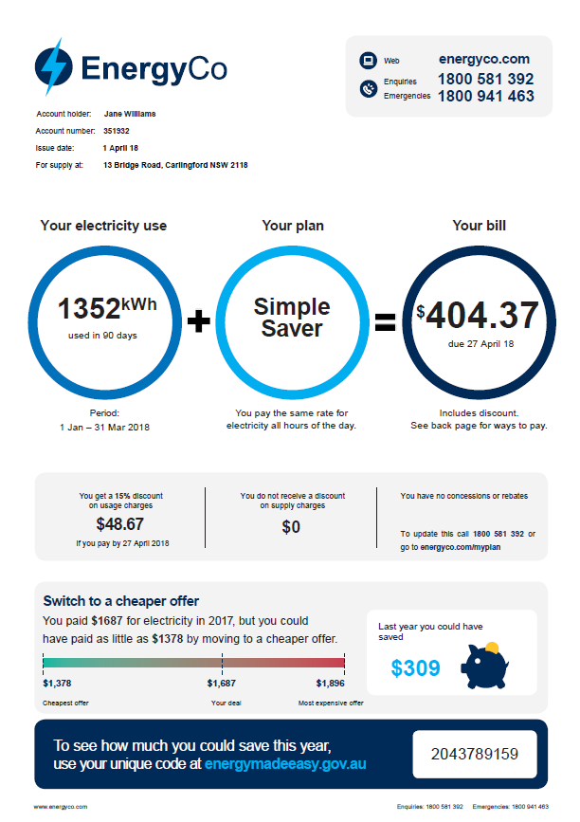
Control without Energy Made Easy module; bill comparison on page 1 |  | Control with Energy Made Easy module; bill comparison on page 2 |  | Horizontal circles with Energy Made Easy module and piggy bank icon
 | Design D |  | Design E
 | 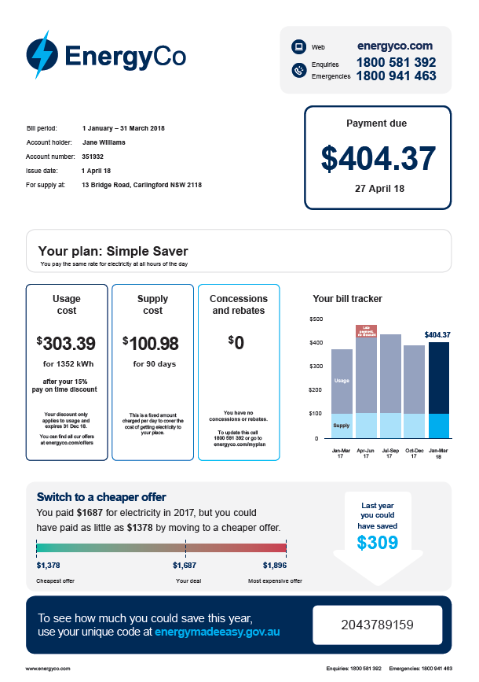 |  | 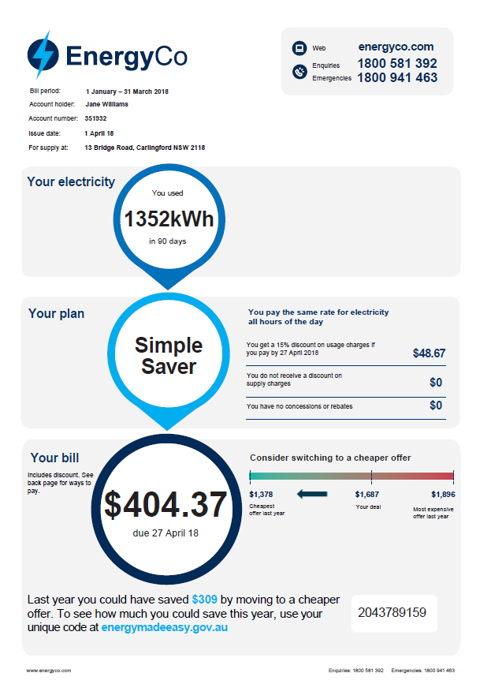
 | Horizontal modules with Energy Made Easy module and arrow icon |  | Vertical circles with Energy Made Easy module

Figure C2. User testing bill designs and key design differences (back page)
Design A | Design B
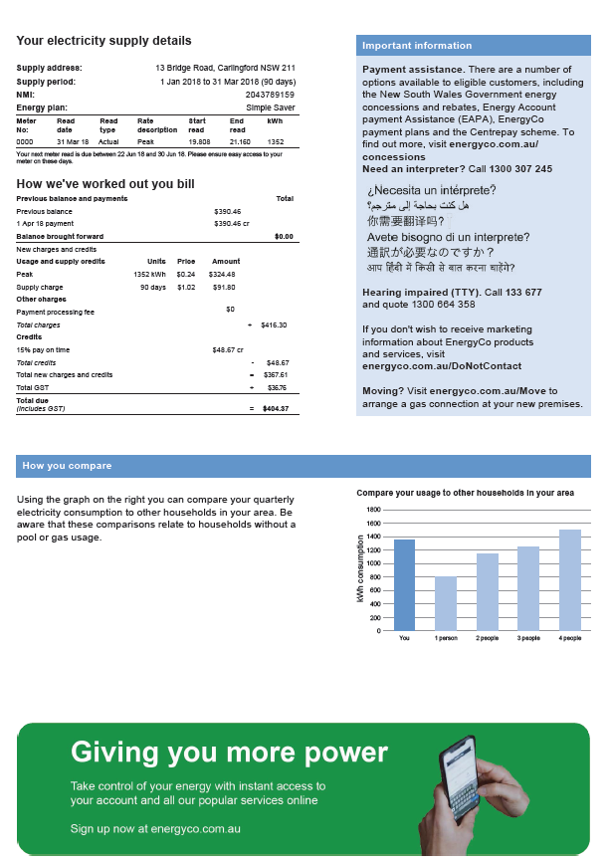 | 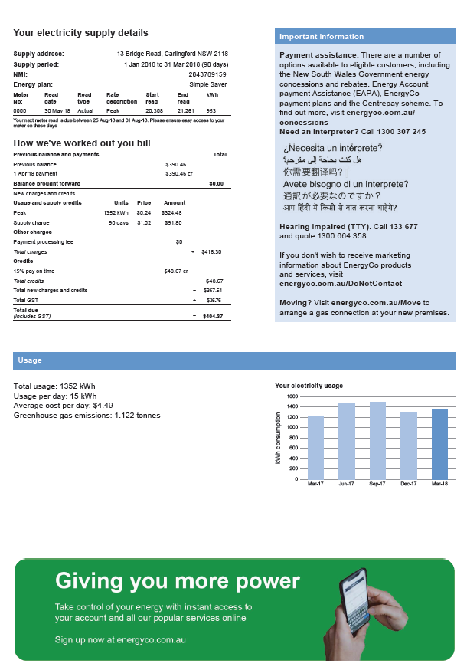
Control with bill comparison on page 1 | Control with bill comparison on page 2
Design C and E | Design D
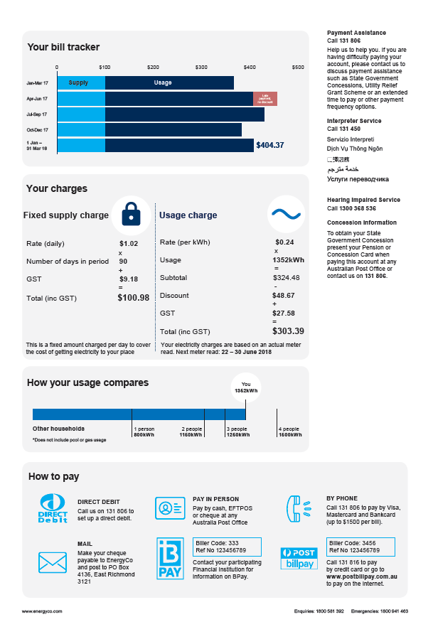 | 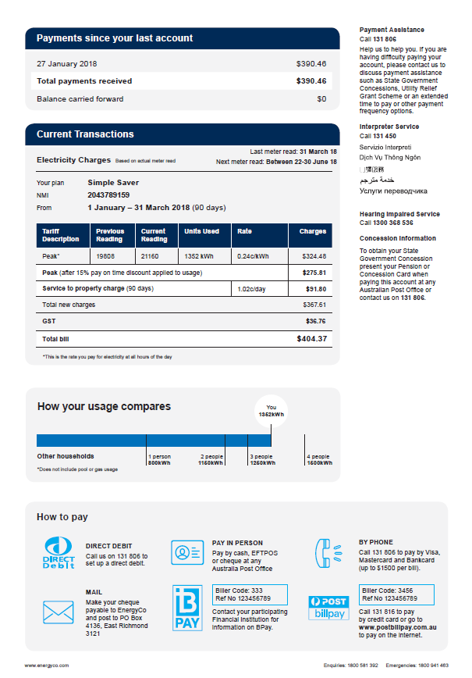
Simplified design with novel ways of presenting breakdown of charges | Simplified design with familiar table presenting breakdown of charges

User testing results
Our qualitative analysis of user testing sessions revealed a number of key findings.
Bill preference
- Bills C, D and E were substantially more engaging and more likely to motivate participants to consider options to save than control bills A and B.
Energy Made Easy
- Overall, participants voluntarily indicated on bills C, D, and E visiting Energy Made Easy would be their ﬁrst step towards seeking energy option alternatives.
- Participants unanimously found control bills A and B to be highly unlikely to motivate them to take any action towards ﬁnding a better plan, let alone visiting the website.
- All participants stated they would trust a government website over any third party comparison website.
- The piggy bank icon helped to capture participants’ attention, and was distinctly preferred over the arrow icon.
- The unique code was appreciated as a nice personal touch, and indicated to participants that clicking on the energymadeeasy.gov.au link would provide a personalised service regarding ﬁnding a cheaper plan.
Switching providers
- Although participants were not immediately inclined to switch, the Energy Made Easy module was highly motivating.
- Many participants stated if they could get a better plan, they would ﬁrst contact their existing provider to see if they would match the better plan to save the effort of switching.
Information presented on back page of bill
- Participants were unanimous in stating they rarely used the detailed information on the bill (typically found on page 2).
- Participants mentioned they would only ever use this information where their bill didn’t align with what they expected each billing cycle.
- For participants who did refer to information on the back page, they preferred it in a familiar table form. Novel ways of presenting usage and supply information was not helpful as participants often struggled with understanding what usage and supply charges are.
Platform considerations
- Key platform differences are outlined in Table C1.

Table C1. Key differences in user testing findings based on testing platform
Printed | Desktop PDF | Mobile PDF
Participants were very familiar with  this process based on prior usage and the key benefit of the printed bill allows for an easy overview of all content and an easy, almost  instinctual desire to turn over to page 2. | The larger screen of the desktop made accessing the bill relatively easy.  However, participants  struggled taking in all  details as a result of having  to scroll to content hidden  from the initial view. However, overall participants were able to make good use of PDF bills on a computer screen. | The ability to access the entire bill is dramatically reduced on a mobile device. This highlights a need to explore future options for mobile specific PDF bills. At present the PDF platform does not allow for designs which respond to device size. Electricity providers may need to provide web based bills rather than PDF based bills. One key thing with mobile PDF consumptions is the natural bias towards content down the left side of the bill as the user scrolls down a narrower screen. From this standpoint, design E performed best due to the vertical orientation of the circles.

Appendix D: BETA electricity bills

Bill 1 – Control (front)
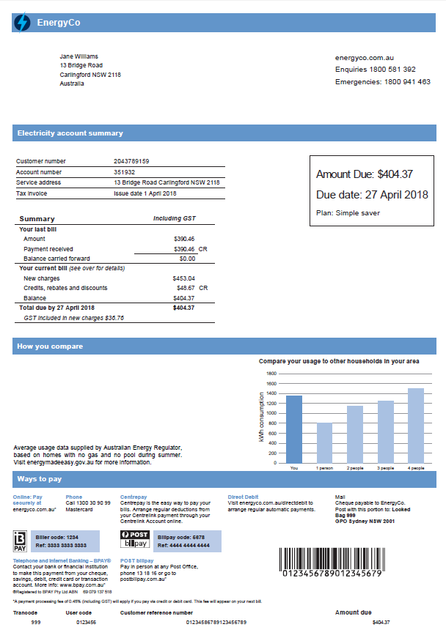

Bill 1 – Control (back)
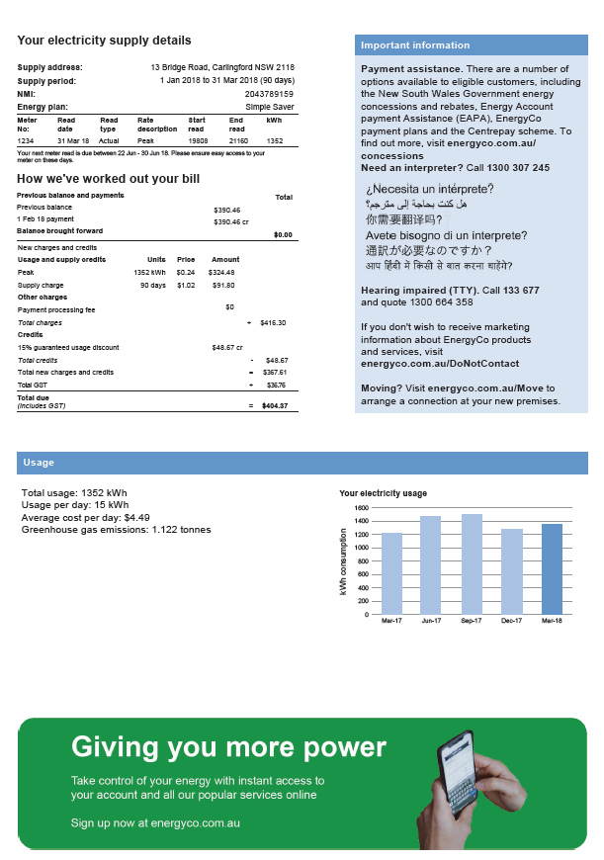
Bill 2 – Control + savings (front)
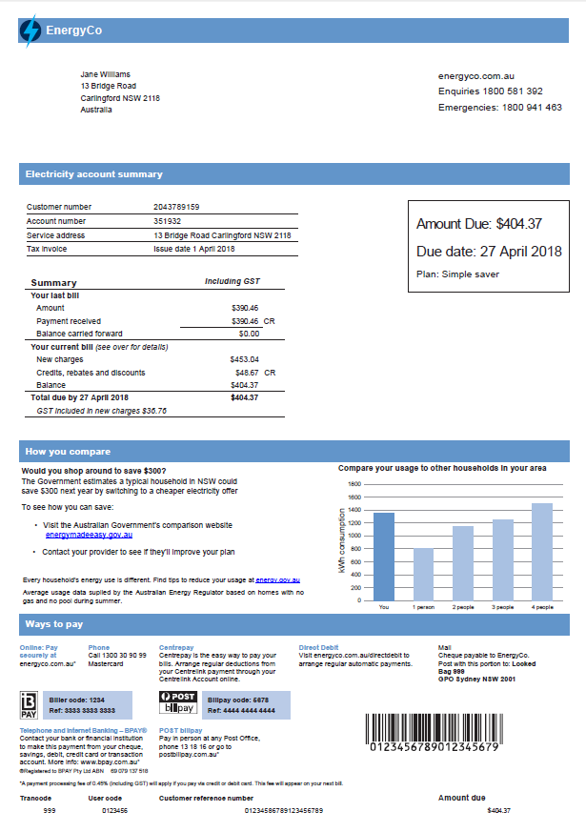

Bill 2 – Control + savings (back)
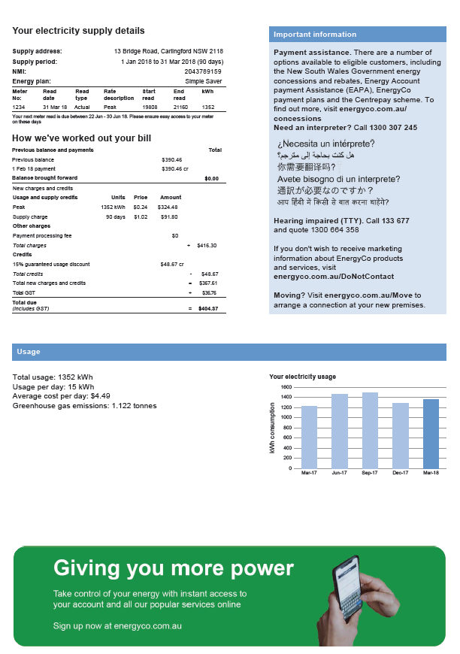

Bill 3 – Simple (front)
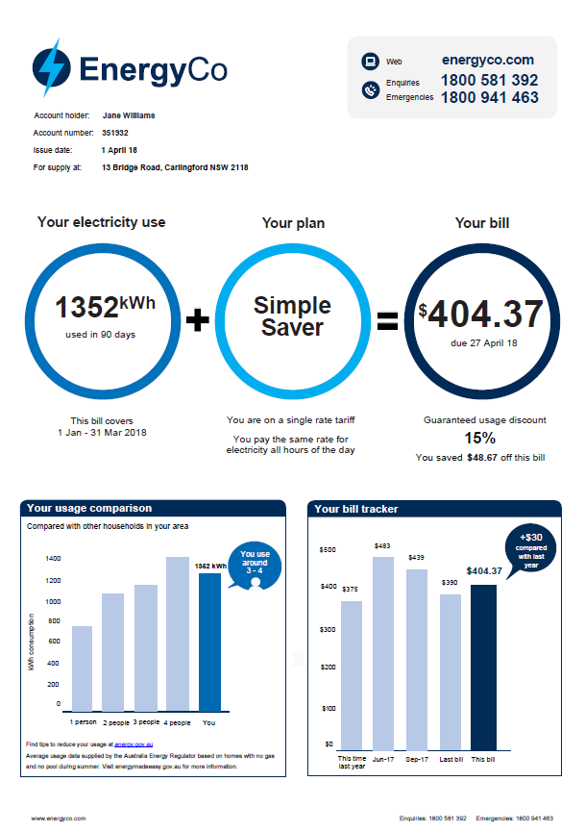
Bill 3 – Simple (back)
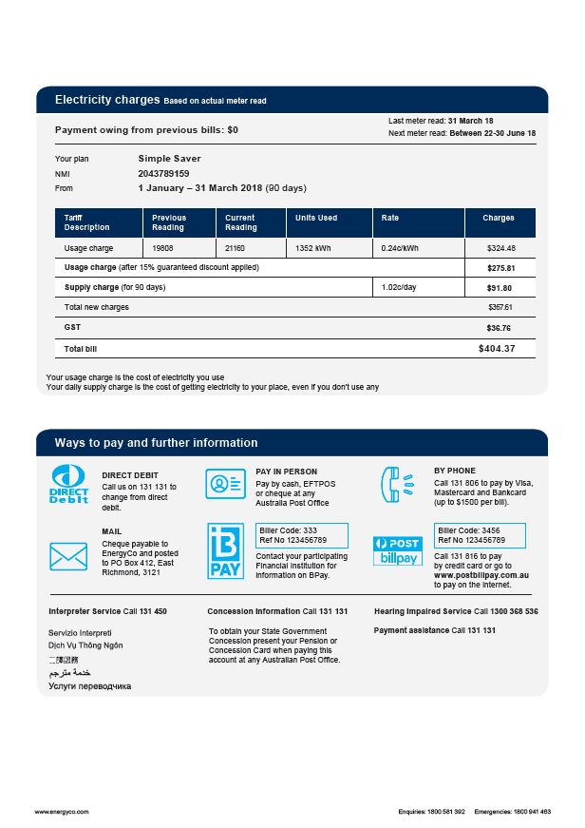
Bill 4 – Simple + savings (front)
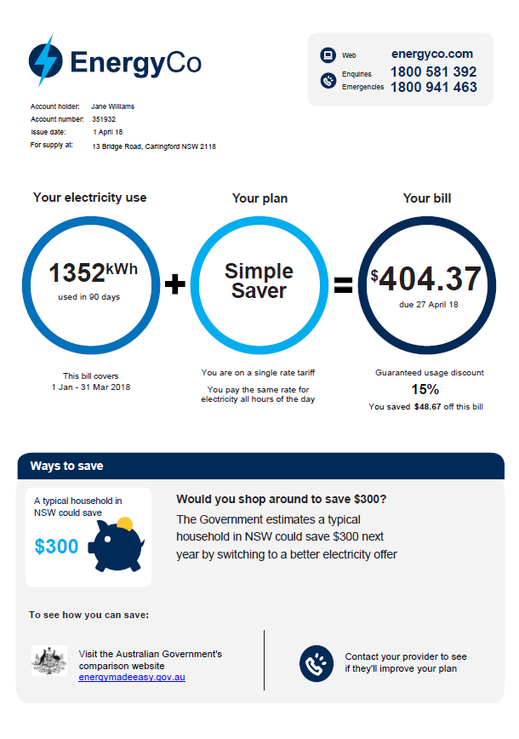
Bill 4 – Simple + savings (back)
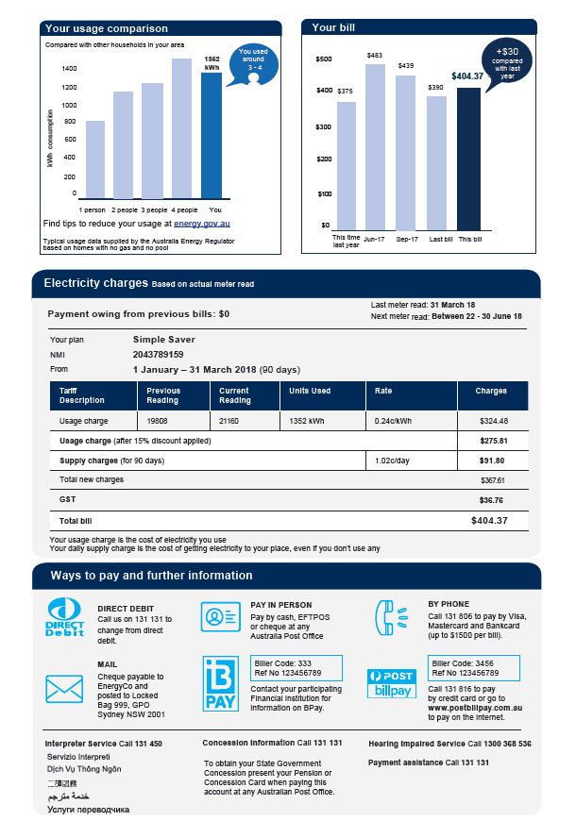
Bill 5 – Simple + personal savings (front)
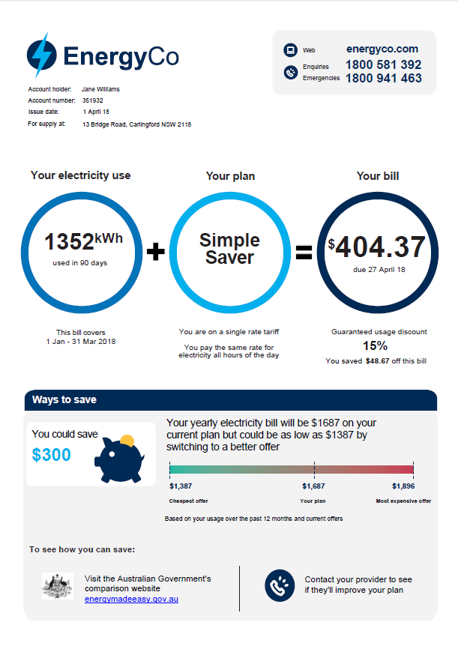
Bill 5 – Simple + personal savings (back)
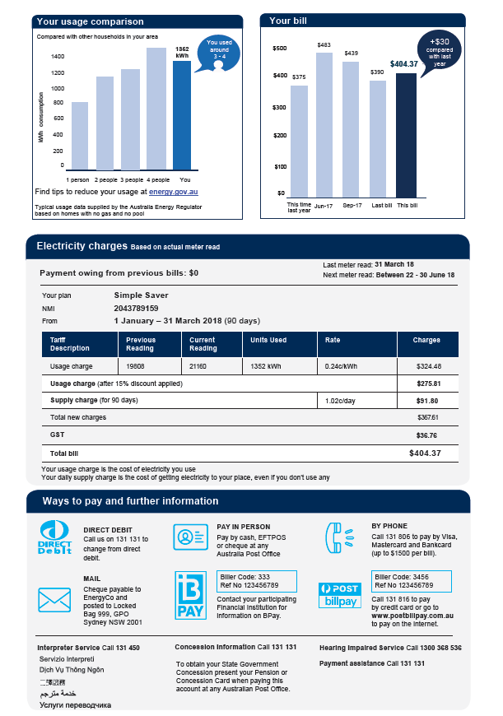
Bill 6 – Simple + personal savings + code (front)
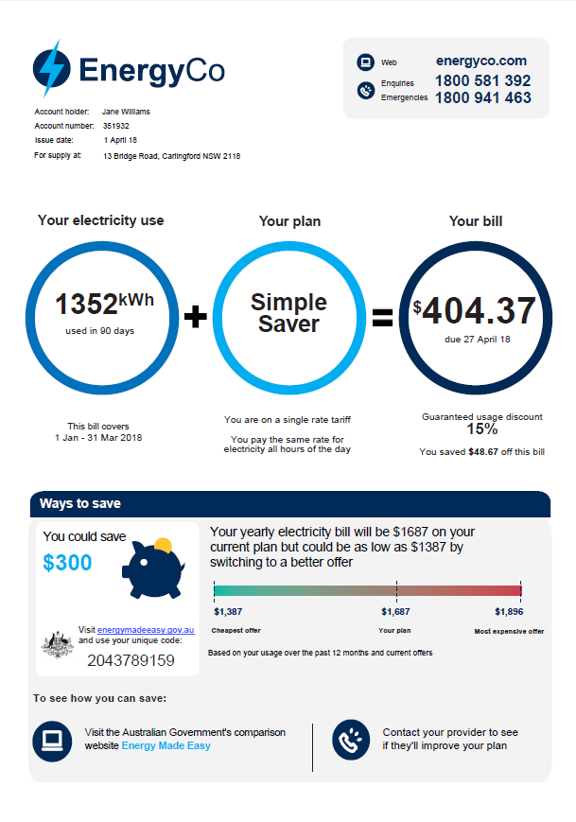
Bill 6 – Simple + personal savings + code (back)
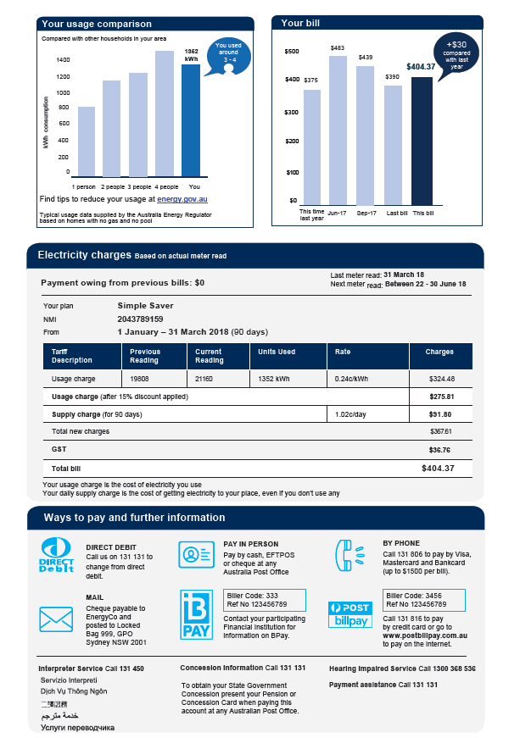

Appendix E: Online survey questions
Note – each of the six survey groups was shown a different bill.

Part 1
The following questions ask about information that can be found on your most recent electricity bill.
Q1 Do you have your most recent bill on hand?
- No
- Yes
If no, then include a follow-up prompt: ‘It’s preferable you have your most recent bill on hand while you conduct this survey as questions will relate to specific details about energy bills.’

Q2 What is your postcode?
- Free text response (Must be a four digit number)

Q3 Which electricity company are you with?
- AGL
- EnergyAustralia
- Origin
- Alinta
- Lumo
- Red
- Momentum
- Simply
- Other – please specify

Q4 How many months does the bill cover?
- 1 month
- 2 months
- 3 months
- Other- please specify

Q5 What is the total cost of the bill (including discounts)?
- Sliding scale

Q6 How much electricity did your household use (total kWh)?
- Free text response (must be a number)

Q7 Do you know what electricity plan you are on? Click here if you want more information on what we mean by ‘plan’. [Include a pop-up box when respondents click on the link with this text: ‘By ‘Plan’ we mean the electricity offer you are on including the usage and supply charges, discounts and other fees and conditions.’]
- No
- Yes

The following questions are about you.
Q8 What is your age?
- Ten year age brackets: 21-30, 31-40, 41-50, 51-60, 61-70, 70+

Q9 What is your gender?
- Female
- Male
- Other
- Prefer not to say

Q10a How many adults (persons aged 18 years and over) live in your household?
- 1
- 2
- 3
- 4 or more

Q10b How many children (persons aged under 18 years) live in your household?
- 0
- 1
- 2
- 3
- 4 or more

Q11 In the last year, have you have you borrowed money to pay a bill on time or not paid on time because you did not have enough money?
- No
- Yes

Q12 Have you looked into or researched your options for switching electricity companies or electricity plans in the last year?
- No
- Yes

Q13 [If answered ‘yes’ to Q12] Did you switch electricity companies or electricity plans?
- No
- Yes

Q14 [If answered ‘yes’ to Q13] Which of the following best explains the reason for switching electricity companies or electricity plans? (Respondents can select multiple responses)
- I was dissatisfied with the value for money I was receiving. It was too expensive.
- I was dissatisfied with the customer service I was receiving (such as billing issues or communication issues)
- I was dissatisfied with the number of faults, interruptions and outages of the energy supply I was experiencing and/or how quickly these problems were resolved
- I was satisfied, but found a better value plan elsewhere
- I was satisfied and there was another reason for changing

Q15 [If answered ‘no’ to Q12 OR Q13] Which of the following statements best describes your reason not to switch or look into switching electricity companies or electricity plan in the last year? (Respondents can select multiple responses)
- Too time consuming to research
- Too difficult to organise (disconnection and reconnection)
- The information available is too complex and difficult to understand
- I’m happy with the plan I have now
- I was concerned I would end up with a worse plan
- No particular reason
- Couldn’t be bothered/ too lazy
- They’re all the same/makes no difference
- There are no other alternatives available as far as I know
- Other (please specify)
- Don’t know

Thinking about your current bill, please answer the following question
Q16 To what extent are the following things clear to you from looking at the bill?
- What makes up the total cost of my bill
- How discounts affect the total cost of my bill
- How the cost of my current bill compares to previous bills
- How your electricity usage compares to other households
- Why each component has been included on the bill
[Scale: very unclear / moderately unclear / slightly unclear / neutral / slightly clear / moderately clear / very clear]

Part 2
On the next screen, you will be given the opportunity to look at an electricity bill. Please look at it as if it was a bill you had to pay. There will be questions about it afterwards.
Q17 Please click on the parts of the bill that are most important to you.

Part 3
Please answer the following questions about the bill you have just seen. If you want to look at the bill again, you can do so by selecting the “View bill” button.
Q18 To what extent do agree/disagree with the following statements?
- The most important information is easy to find.
- The most important information is easy to understand.
- The other information on the bill is easy to understand.
- The other information on the bill is helpful.
[Scale: Strongly disagree / moderately disagree / slightly disagree / neutral / slightly agree / moderately agree / strongly agree]

Q19 To what extent are the following things clear to you from looking at the bill?
- What makes up the total cost of the bill
- How the discounts affect the total cost of the bill
- How the cost of the current bill compares to previous bills
- How your electricity usage compares to other households
- Why each component has been included on the bill
[Scale: very unclear / moderately unclear / slightly unclear / neutral / slightly clear / moderately clear / very clear]

Q20 Imagine if your electricity bill changed to be like this one. It would look similar and have all the same components. But the usage, costs and details would be specific to your household and your electricity plan.
Would this new bill make you feel more or less able to use your bill to:
- Help work out whether your household could be on a cheaper electricity plan?
- Look in to your options for switching to a cheaper electricity plan?
- Look into your options to reduce your energy use?
[Scale: Much less able / moderately less able / slightly less able / about the same / slightly more able / moderately more able / much more able]

Q21a Using this bill, how concerned would you be that by switching plans your household might end up worse off?
- [Scale: Extremely concerned / moderately concerned / somewhat concerned/ slightly concerned / not at all concerned]
- Plus check box option: “Don’t know”

Q21b How much time do you think it would take to look into your options and make a switch you were confident would make you better off?
- [Scale: 0 – 1 hours, 1 – 2 hours, 2 – 3 hours, 3 – 4 hours, 4 – 5 hours, 5 – 6 hours, 7 – 8 hours, 8+ hours]

Q21c How much money would that alternative electricity offer have to save you over a year to make it worth you taking this time?
- Scale: 0 to 1000+ with options in $50 increments]
- Plus check box option: “Don’t know”

Q22 In the next year, do you intend to look into options for switching plans to find a cheaper offer?
- No
- Yes

Q23 [If yes to Q22] How likely is it that you will do each of the following things?
- Visit my electricity company website
- Call my electricity company
- Look at a third party comparison website (e.g. CHOICE, iSelect)
- Speak to a friend, family member or work colleague about what plan they are on
- Look at the government’s comparison website “Energy made easy”
[Scale: Definitely won’t / highly unlikely / somewhat unlikely / 50-50 / somewhat likely/ highly likely / definitely will]

Q24 [If no to Q22] What if anything would prompt you to look into options for switching plans to find a cheaper offer?
- [open ended response]
- Plus check box option: “Nothing would prompt me”

Q25 Like your current bill, this new bill provides a comparison of your energy use to other households in your local area. To what extent do you agree/disagree with the following statements:
- I understand how this comparison is calculated.
- I trust the chart provides accurate information about how my household compares.
- This chart helps my household make a choice about how much energy to use.
- I would know where to find information about ways to reduce energy use.
[Scale: Strongly disagree / moderately disagree / slightly disagree / neutral / slightly agree / moderately agree / strongly agree]

Thank you. You have now completed the survey
If you would like to compare your options for electricity companies or electricity plans, you may find the following website helpful:
https://www.energymadeeasy.gov.au/

Appendix F: Technical details

Pre-registration, pre-analysis plan and ethics
This trial was not publically pre-registered. As a substitute, we supplied pre-registration and pre-analysis plan documentation to BETA’s Academic Advisory Panel prior to completion of the trial and receipt of any data. The pre-analysis plan is published as supplementary materials to this report. All of our analysis was consistent with our pre-analysis plan.
The project was approved through BETA’s ethics approval process, with risk assessed in accordance with the guidelines outlined in the National Statement on Ethical Conduct in Human Research.

Population and sampling
Our population of interest was Australian electricity consumers residing in deregulated National Energy Market states (New South Wales, Victoria, South Australia and South East Queensland). We sought participants who were aged 18+ and identified as being at least jointly responsible for making decisions about household electricity. Participants were asked to have their latest bill in front of them while conducting the survey however we could not enforce this.
Our sample was drawn from the 300,000-person Online Research Unit (ORU) survey panel. ORU recruits a nationally representative sample of the Australian population through online and offline (telephone and post) methods. Our survey included age, gender, and postcode location quotas to help ensure we had a representative sample in each state. Survey participants received a financial incentive of approximately $1.50.
To address the possibility of missing data, participants were replaced if they did not complete the survey. In total, we drew a sample of 4,224 participants.

Randomisation and balance checks
The ORU survey panel randomly allocated participants with a fixed probability of assignment to each of the six experimental groups. Specifically, allocation took place by: 1) selecting the least-filled experimental group, and 2) using a random sequence instrument to allocate among groups of equal least-filled sample sizes. Following this procedure, the sample size of each experimental group comprised 702-705 participants (see Table F1).
We performed a balance check to determine whether the randomisation worked as intended. We did this by conducting a multinomial logistic regression analysis using four variables – gender, age, state and status regarding switching in the last 12 months – as predictors of experimental group allocation. If the groups were randomly allocated, these variables should fail to predict how participants were allocated to experimental groups and, as expected, we found the model was not a better fit than an intercept-only model (p=0.97). Thus, we inferred that the randomisation worked as intended.

Baseline characteristics
Table F1 summarises the baseline characteristics of the sample.
Table F1: Baseline characteristics of participants
 |  | Bill 1 |  | Bill 2 |  | Bill 3 |  | Bill 4 |  | Bill 5 |  | Bill 6
 |  |  | N=705 |  | N=704 |  | N=702 |  | N=705 |  | N=705 |  | N=703
Gender | Female | 344 (48.8%) |  | 354 (50.3%) |  | 355 (50.6%) |  | 344 (48.8%) |  | 356 (50.5%) |  | 381 (54.2%)
 | Male | 361 (51.2%) |  | 350 (49.7%) |  | 347 (49.4%) |  | 361 (51.2%) |  | 349 (49.5%) |  | 322 (45.8%)
Age | 18-30 | 149 (21.1%) |  | 183 (26.0%) |  | 163 (23.2%) |  | 181 (25.7%) |  | 163 (23.1%) |  | 172 (24.5%)
 | 31-40 | 160 (22.7%) |  | 142 (20.2%) |  | 146 (20.8%) |  | 146 (20.7%) |  | 162 (23.0%) |  | 147 (20.9%)
 | 41-50 | 93 (13.2%) |  | 78 (11.1%) |  | 94 (13.4%) |  | 88 (12.5%) |  | 91 (12.9%) |  | 84 (11.9%)
 | 51-60 | 107 (15.2%) |  | 106 (15.1%) |  | 105 (15.0%) |  | 114 (16.2%) |  | 106 (15.0%) |  | 119 (16.9%)
 | 61-70 | 117 (16.6%) |  | 113 (16.1%) |  | 111 (15.8%) |  | 107 (15.2%) |  | 106 (15.0%) |  | 118 (16.8%)
 | 71+ | 79 (11.2%) |  | 82 (11.6%) |  | 83 (11.8%) |  | 69 (9.8%) |  | 77 (10.9%) |  | 63 (9.0%)
Provider | AGL | 195 (27.7%) |  | 197 (28.0%) |  | 177 (25.2%) |  | 188 (26.7%) |  | 207 (29.4%) |  | 185 (26.3%)
 | Energy-Australia | 147 (20.9%) |  | 133 (18.9%) |  | 141 (20.1%) |  | 123 (17.4%) |  | 144 (20.4%) |  | 133 (18.9%)
 | Origin | 156 (22.1%) |  | 165 (23.4%) |  | 173 (24.6%) |  | 186 (26.4%) |  | 151 (21.4%) |  | 177 (25.2%)
 | Alinta | 32 (4.5%) |  | 19 (2.7%) |  | 32 (4.6%) |  | 31 (4.4%) |  | 22 (3.1%) |  | 37 (5.3%)
 | Lumo | 17 (2.4%) |  | 19 (2.7%) |  | 27 (3.8%) |  | 20 (2.8%) |  | 19 (2.7%) |  | 20 (2.8%)
 | Red | 42 (6.0%) |  | 58 (8.2%) |  | 46 (6.6%) |  | 53 (7.5%) |  | 49 (7.0%) |  | 46 (6.5%)
 | Momentum | 15 (2.1%) |  | 11 (1.6%) |  | 12 (1.7%) |  | 6 (0.9%) |  | 7 (1.0%) |  | 17 (2.4%)
 | Simply | 25 (3.5%) |  | 35 (5.0%) |  | 32 (4.6%) |  | 28 (4.0%) |  | 27 (3.8%) |  | 29 (4.1%)
 | Other | 76 (10.8%) |  | 67 (9.5%) |  | 62 (8.8%) |  | 70 (9.9%) |  | 79 (11.2%) |  | 59 (8.4%)
Table F1 continued: Baseline characteristics of participants
 |  | Bill 1 |  | Bill 2 |  | Bill 3 |  | Bill 4 |  | Bill 5 |  | Bill 6
 |  |  | N=705 |  | N=704 |  | N=702 |  | N=705 |  | N=705 |  | N=703
State | NSW | 286 (40.6%) |  | 292 (41.5%) |  | 293 (41.7%) |  | 286 (40.6%) |  | 277 (39.3%) |  | 271 (38.5%)
 | VIC | 231 (32.8%) |  | 214 (30.4%) |  | 234 (33.3%) |  | 225 (31.9%) |  | 236 (33.5%) |  | 221 (31.4%)
 | SE QLD | 123 (17.4%) |  | 133 (18.9%) |  | 117 (16.7%) |  | 128 (18.2%) |  | 132 (18.7%) |  | 134 (19.1%)
 | SA | 65 (9.2%) |  | 65 (9.2%) |  | 58 (8.3%) |  | 66 (9.4%) |  | 60 (8.5%) |  | 77 (11.0%)
Bill period | 1 month | 122 (17.3%) |  | 121 (17.2%) |  | 136 (19.4%) |  | 122 (17.3%) |  | 117 (16.6%) |  | 103 (14.7%)
 | 2 months | 33 (4.7%) |  | 25 (3.6%) |  | 24 (3.4%) |  | 23 (3.3%) |  | 35 (5.0%) |  | 30 (4.3%)
 | 3 months | 524 (74.3%) |  | 528 (75.0%) |  | 520 (74.1%) |  | 531 (75.3%) |  | 522 (74.0%) |  | 531 (75.5%)
 | 4+ months | 26 (3.7%) |  | 30 (4.3%) |  | 22 (3.1%) |  | 29 (4.1%) |  | 31 (4.4%) |  | 39 (5.5%)
Adults | 1 | 164 (23.3%) |  | 136 (19.3%) |  | 158 (22.5%) |  | 162 (23.0%) |  | 143 (20.3%) |  | 140 (19.9%)
 | 2 | 407 (57.7%) |  | 428 (60.8%) |  | 398 (56.7%) |  | 415 (58.9%) |  | 429 (60.9%) |  | 413 (58.7%)
 | 3 | 83 (11.8%) |  | 77 (10.9%) |  | 89 (12.7%) |  | 89 (12.6%) |  | 84 (11.9%) |  | 85 (12.1%)
 | 4+ | 51 (7.2%) |  | 63 (8.9%) |  | 57 (8.1%) |  | 39 (5.5%) |  | 49 (7.0%) |  | 65 (9.2%)
Children | 0 | 531 (75.3%) |  | 546 (77.6%) |  | 535 (76.2%) |  | 526 (74.6%) |  | 533 (75.6%) |  | 525 (74.7%)
 | 1 | 90 (12.8%) |  | 81 (11.5%) |  | 80 (11.4%) |  | 100 (14.2%) |  | 90 (12.8%) |  | 97 (13.8%)
 | 2 | 63 (8.9%) |  | 60 (8.5%) |  | 71 (10.1%) |  | 59 (8.4%) |  | 67 (9.5%) |  | 62 (8.8%)
 | 3 | 18 (2.6%) |  | 12 (1.7%) |  | 13 (1.9%) |  | 18 (2.6%) |  | 10 (1.4%) |  | 18 (2.6%)
 | 4+ | 3 (0.4%) |  | 5 (0.7%) |  | 3 (0.4%) |  | 2 (0.3%) |  | 5 (0.7%) |  | 1 (0.1%)

Table F1 continued: Baseline characteristics of participants
 |  | Bill 1 |  | Bill 2 |  | Bill 3 |  | Bill 4 |  | Bill 5 |  | Bill 6
 |  |  | N=705 |  | N=704 |  | N=702 |  | N=705 |  | N=705 |  | N=703
Know what plan they are on | No | 329 (46.7%) |  | 325 (46.2%) |  | 327 (46.6%) |  | 320 (45.4%) |  | 303 (43.0%) |  | 286 (40.7%)
 | Yes | 376 (53.3%) |  | 379 (53.8%) |  | 375 (53.4%) |  | 385 (54.6%) |  | 402 (57.0%) |  | 417 (59.3%)
Looked to switch in last 12 months | No | 329 (46.7%) |  | 345 (49.0%) |  | 372 (53.0%) |  | 342 (48.5%) |  | 330 (46.8%) |  | 328 (46.7%)
 | Yes | 376 (53.3%) |  | 359 (51.0%) |  | 330 (47.0%) |  | 363 (51.5%) |  | 375 (53.2%) |  | 375 (53.3%)
Switched last 12 months | No | 566 (80.3%) |  | 591 (83.9%) |  | 572 (81.5%) |  | 574 (81.4%) |  | 577 (81.8%) |  | 566 (80.5%)
 | Yes | 139 (19.7%) |  | 113 (16.1%) |  | 130 (18.5%) |  | 131 (18.6%) |  | 128 (18.2%) |  | 137 (19.5%)
Vulnerable (Unable to afford bill) | No | 643 (91.2%) |  | 635 (90.2%) |  | 644 (91.7%) |  | 652 (92.5%) |  | 630 (89.4%) |  | 630 (89.6%)
 | Yes | 62 (8.8%) |  | 69 (9.8%) |  | 58 (8.3%) |  | 53 (7.5%) |  | 75 (10.6%) |  | 73 (10.4%)
Mean bill cost/mth |  | $120 |  | $117 |  | $126 |  | $119 |  | $118 |  | $120
Mean kWh/mth |  | 305  kWh |  | 319 kWh |  | 335 kWh |  | 326 kWh |  | 347 kWh |  | 316 kWh
Note: We have low confidence in the accuracy of the kWh usage per month statistic. It is unclear how many respondents were able to provide reliable information.

Sample size and power calculations
With a planned sample of 4,200, this trial had power to detect a minimum effect size of 0.15 (Cohen’s h) between any two groups, assuming 80 per cent power and 95 per cent confidence. See pre-analysis plan for further details.

Outcome measures
Our primary outcome measures were:
- Confidence in ability to use the bill to look into switching (construction of this variable is described below); and
- Intentions to look in switching in the next 12 months (Binary: Yes/No).

Construction of primary outcome: Confidence
As specified in our pre-analysis plan, the primary outcome ‘confidence’ was constructed by taking the mean response for each participant on two items in the survey. These were:
Would this new bill make you feel more or less able to use your bill to:
- Help work out whether your household could be on a cheaper electricity plan?
- Look into your options for switching to a cheaper electricity plan?
[Scale: 1 = Much less able / 2 = moderately less able / 3 = slightly less able / 4 = about the same / 5 = slightly more able / 6 = moderately more able / 7 = much more able]

Construction of secondary outcome: Clarity and Comprehension
We also constructed a secondary outcome we call ‘clarity and comprehension’ out of five items in the survey asked twice; first in relation to their existing bill and second in relation to the bill they viewed in the survey. These items were:
To what extent are the following things clear to you from looking at the bill?
- What makes up the total cost of the bill.
- How the discounts affect the total cost of the bill.
- How the cost of the current bill compares to previous bills.
- How your electricity usage compares to other households.
- Why each component has been included on the bill.
[Scale: 1 = very unclear / 2 = moderately unclear / 3 = slightly unclear / 4 = neutral / 5 = slightly clear / 6 = moderately clear / 7 = very clear]
For each participant we calculated the mean score across the five items for both their existing bill and the survey bill. We then turned this into a ‘difference score’ by subtracting the existing bill score from the survey bill score. Our inferential analyses were conducted on this difference score.

Hypotheses
In our pre-analysis plan, we specified three hypotheses in relation to our two primary outcomes:
H1: Confidence and stated intentions to switch will be higher among respondents who view a bill with a call-to-action intervention than respondents who view the same style bill without a call to action.
H2: Confidence and stated intentions to switch will be higher among respondents who view the generic call-to-action on the alternative design bill than the typical design bill.
H3: Confidence and stated intentions to switch will increase with the addition of each intervention.
In hindsight, we recognise the first and second hypotheses specify detail which is implied by the third. Moreover, the analyses associated with the first and second hypotheses are redundant with the analyses specified for the third hypotheses. Thus, we only report the analyses for the third hypothesis.

Method of analysis
All survey data processing and analysis was performed using STATA script and involved manual checks at each stage to ensure no errors were introduced. We did not analyse any data until after the survey reached the 4,224-person target.
As stated in our pre-analysis plan, all analyses used ordinary least squares regression with robust standard errors. None of our analyses involved covariate adjustment.
For each of the two primary outcomes (confidence and stated intention to look into switching), we conducted two sets of analyses. First, we conducted pairwise comparisons between the control group bill and each of the other bills. In each of the pairwise comparisons, the only predictor included in the model was the experimental manipulation. Second, we created a model using data from all six groups which isolated the effect of each of the components on the bill (simplified design, generic savings, personalised savings and unique code). We did this by creating a dummy variable representing the presence of each component on each of the bills and entering them simultaneously as predictors of the outcome.
As per our pre-analysis plan, we did not make any adjustments to our statistical significance thresholds due to multiple comparisons. See Appendix G for further discussion.

Appendix G: Statistical Tables
The following statistical tables provide the inferential statistics underpinning the findings presented in the main report, as well as descriptive statistics for responses to other questions in the survey not reported in the main body of the report.

Primary outcome: Confidence
Analyses of the primary outcome ‘confidence’ are presented in Table G1 and Table G2. Table G1 shows the results of pairwise comparisons between the control and each of the other bills.
Table G2 presents the effect contributed by each of the intervention components (simplified design, generic savings, personalised savings, or unique code) across the bills. The intercept coincides with the average confidence rating in the control group (4.6). Thereafter, the coefficient for each intervention represents an estimate for the effect it contributes to increasing confidence. The pattern of findings is consistent with that of the pairwise comparison of groups: confidence increase with the addition of each component, with the exception of the addition of the unique code. Personalised savings contributed the largest effect on confidence, of around 0.3 points or 6.5 per cent (p<0.001).
Table G1: Pairwise comparisons between control and each bill for participant confidence in ability to use the bill to look into switching
 | N | Mean (SD) | Difference from control (95% Confidence interval) | P value
Bill 1 (Control) | 705 | 4.6 (1.2)
Bill 2 | 704 | 4.7 (1.2) | 0.1 (0.00 to 0.24) | 0.06
Bill 3 | 702 | 4.7 (1.2) | 0.1 (0.01 to 0.25) | 0.04
Bill 4 | 705 | 4.9 (1.2) | 0.3 (0.17 to 0.42) | <0.001
Bill 5 | 705 | 5.2 (1.2) | 0.6 (0.47 to 0.71) | <0.001
Bill 6 | 703 | 5.2 (1.3) | 0.6 (0.44 to 0.69) | <0.001
Table G2: Effect of each intervention component on confidence in ability to use the bill to look into switching
 | Coefficient | SE | P value | 95% Confidence Interval
Simplified design  (Bills 3-6) | 0.15 | 0.05 | 0.001 | 0.07 to 0.24
Generic savings  (Bills 2 and 4) | 0.14 | 0.05 | 0.001 | 0.05 to 0.23
Personalised savings (Bills 5 and 6) | 0.30 | 0.06 | <0.001 | 0.19 to 0.42
Unique code (Bill 6) | -0.02 | 0.06 | 0.760 | -0.15 to 0.11
Intercept (Control) | 4.6 | 0.04 | <.001 | 4.5 to 4.7
We note the pairwise comparisons between Bill 1 (Control) and each of Bill 2 and 3 produced p-values which were marginally significant at conventions levels (p=0.05). If we had adjusted our statistical significance threshold to account for conducting multiple tests, these values would not be regarded as statistically significant. However, we did not adjust our significance threshold because we felt that we could account for the multiple comparisons in a different way, by looking for clear and consistent patterns across the various tests that we conducted. This is the approach that we specified in our pre-analysis plan.
Our judgement is the results for consumer confidence follow a pattern that is consistent with our prior expectations. Moreover the results of the model presented in Table G2, which had more power than the pairwise comparisons, are consistent with there being statistically significant effects. That is, both the simplified design and the generic savings information were found to be highly statistically significant when taking into account data from across all the bills. Given the addition of these components were the only differences between Bill 1 and each of Bills 2 and 3, we infer the differences we observed reflect real underlying effects, as opposed to chance findings. However, we note the effect sizes are insubstantial.

Primary outcome: Stated Intention
The analysis of the primary outcome ‘intention to look into switching’ follows the same approach as the analysis of ‘confidence’. Table G3 presents the difference between the control group and each of the groups that viewed one of the other bills for the proportion of participants who indicated they would look into switching. Table G4 presents estimates of the effects of each intervention component.
Table G3: Pairwise comparisons between control and each bill for intention to look into switching in the next 12 months
 | N | Proportion yes % (No.) | Difference from control (95% Confidence interval) | P value
Bill 1 (Control) | 705 | 58.9% (415)
Bill 2 | 704 | 56.7% (399) | -2.2 (-7.4 to 3.0) | 0.41
Bill 3 | 702 | 57.6% (404) | -1.3 (-6.5 to 3.8) | 0.62
Bill 4 | 705 | 58.3% (411) | -0.6 (-5.7 to 4.6) | 0.83
Bill 5 | 705 | 59.7% (421) | 0.9 (-4.3 to 6.0) | 0.75
Bill 6 | 703 | 60.3% (424) | 1.4 (-3.7 to 6.6) | 0.58
Table G4: Effect of each intervention component on intention to look into switching in the next 12 months
 | Coefficient | SE | p | 95% CI
Format | 0.2 | 1.9 | 0.93 | -3.5 to 3.8
Generic savings | -0.7 | 1.9 | 0.70 | -4.4 to 2.9
Personalised savings | 2.2 | 2.5 | 0.38 | -2.7 to 7.0
Unique code | 0.6 | 2.6 | 0.82 | -4.5 to 5.7
Intercept | 58.1 | 1.6 | <.001 | 55.0 to 61.3

Secondary outcomes
Table G5 presents results of tests comparing clarity and comprehension ratings between bills with and without the simplified design. The first two rows are based on a pairwise comparison of Bill 1 (the control) with Bill 3 (the simplified bill). The last two rows are based on pooled results comparing all groups with and without the simplified design. These pooled results correspond with the results presented in the main body of the report.
Table G5: Clarity and comprehension
 | N | Mean (SD) | Difference from control (95% Confidence interval) | P value
Control (Bill 1) | 705 | 0.36 (0.93)
Simplified design (Bill 3) | 702 | 0.50 (1.1) | 0.14 (0.03 to 0.24) | 0.01
Without simplified design (Bills 1-2) | 1,409 | 0.37 (0.93)
With simplified design (Bills 3-6) | 2,815 | 0.48 (1.1) | 0.11 (0.03 to 0.18) | 0.005

Table G6 shows the results of pairwise comparisons between the control and each of the other bills for the proportion of people who selected the Energy Made Easy/ ‘ways to save’ information on the bill as important.
Table G6: The importance of Energy Made Easy and ‘ways to save’ information
 | N | Proportion selected % (No.) | Difference from control (95% Confidence interval) | P value
Bill 1 (Control) | 705 | 0.3% (2)
Bill 2 | 704 | 7.0% (49) | 6.7 (4.8 to 8.6) | <0.001
Bill 3 | 702 | 0.6% (4) | 0.3 (-0.4 to 1.0) | 0.41
Bill 4 | 705 | 20.4% (144) | 20.1 (17.1 to 23.1) | <0.001
Bill 5 | 705 | 45.8% (323) | 45.5 (41.8 to 49.2) | <0.001
Bill 6 | 703 | 44.0% (309) | 43.7 (40.0 to 47.4) | <0.001

Other outcomes
The following tables provide descriptive statistics for responses to questions that have not been presented above.
Table G7: Reasons for switching
Question 14: Which of the following best explains the reason for switching electricity companies or electricity plans?

Participants who looked and switched in the last 12 months
N=778
I was dissatisfied with the value for money I was receiving. It was too expensive | 345 (44.3%)
I was dissatisfied with the customer service I was receiving (such as billing issues or communication issues) | 73 (9.4%)
I was dissatisfied with the number of faults, interruptions and outages of the energy supply I was experiencing and/or how quickly these problems were resolved | 17 (2.2%)
I was satisfied, but found a better value plan elsewhere | 340 (43.7%)
I was satisfied and there was another reason for changing | 95 (12.2%)
Results are presented as the count of people who selected the reason followed by the proportion in parentheses. Respondents were able to select multiple responses.

Table G8: Reasons not to switch
Question 15: Which of the following statements best describes your reason not to switch or look into switching electricity companies or electricity plan in the last year?
 | Participants who looked but didn’t switch  N=2,046 | Participants who neither look nor switched  N=1,400
Too time consuming | 376 (18.4%) | 167 (11.9%)
Too difficult to organise (disconnection and reconnection) | 249 (12.2%) | 145 (10.4%)
The information available is too complex | 293 (14.3%) | 270 (19.3%)
I’m happy with the plan I have now | 810 (39.6%) | 512 (36.6%)
I was concerned I’d end up on a worse plan | 246 (12.0%) | 299 (21.4%)
No particular reason | 168 (8.2%) | 44 (3.1%)
Couldn’t be bothered / too lazy | 294 (14.4%) | 77 (5.5%)
They’re all the same / makes no difference | 371 (18.1%) | 259 (18.5%)
There is no other alternative as far as I know | 78 (3.8%) | 68 (4.9%)
Other | 114 (5.6%) | 225 (16.1%)
Don’t know | 90 (4.4%) | 16 (1.1%)
Results are presented as the count of people who selected the reason followed by the proportion in parentheses. Respondents were able to select multiple responses.

Table G9: Clarity and comprehension of existing bill
Question 16: Thinking about your current bill, please answer the following question. To what extent are the following things clear to you from looking at the bill?
 | Mean (Standard deviation)
What makes up the total cost of my bill | 5.1 (1.6)
How discounts affect the total cost of my bill | 5.2 (1.6)
How the cost of my current bill compares to previous bills | 5.5 (1.5)
How your electricity usage compares to other households | 4.9 (1.8)
Why each component has been included on the bill | 4.8 (1.6)
Results are mean response and standard deviation in parentheses. Responses were given on seven-point scale: 1 = very unclear, 2 = moderately unclear, 3 = slightly unclear, 4 = neutral, 5 = slightly clear, 6 = moderately clear and 7 = very clear. Question 16 was asked in relation to the most bill participants has received.
Table G10: Median amount of time spent viewing bill in survey
Time viewing the bill in the survey
 | Bill 1 | Bill 2 | Bill 3 | Bill 4 | Bill 5 | Bill 6
Median | 31 seconds | 31 seconds | 32 seconds | 32 seconds | 31 seconds | 35 seconds

Table G11: Importance of each component of the bill
Question 17: Please click on the parts of the bill that are most important to you.

 | Bill 1 | Bill 2 | Bill 3 | Bill 4 | Bill 5 | Bill 6
Energy Made Easy/ ‘ways to save’ information | 2 (0.3%) | 49 (7.0%) | 4 (0.6%) | 144 (20.4%) | 323 (45.8%) | 309 (44.0%)
Peer comparison chart | 263 (37.3%) | 257 (36.5%) | 266 (37.9%) | 275 (39.0%) | 248 (35.2%) | 246 (35.0%)
Energy.gov.au | 3 (0.4%) | 7 (1.0%) | 7 (1.0%) | 6 (0.9%) | 3 (0.4%) | 2 (0.3%)
Usage/bill history | 287 (40.7%) | 289 (41.1%) | 360 (51.3%) | 372 (52.8%) | 326 (46.2%) | 316 (45.0%)
Ways to pay | 100 (14.2%) | 125 (17.8%) | 104 (14.8%) | 129 (18.3%) | 119 (16.9%) | 101 (14.4%)
Further information | 5 (0.7%) | 4 (0.6%) | 11 (1.6%) | 11 (1.6%) | 5 (0.7%) | 10 (1.4%)
Customer details | 84 (11.9%) | 83 (11.8%) | 34 (4.8%) | 21 (3.0%) | 27 (3.8%) | 19 (2.7%)
Amount due and when | 553 (78.4%) | 558 (79.3%) | 543 (77.4%) | 528 (74.9%) | 506 (71.8%) | 514 (73.1%)
Usage/ over time period | 128 (18.2%) | 123 (17.5%) | 234 (33.3%) | 235 (33.3%) | 221 (31.3%) | 213 (30.3%)
Your last bill | 188 (26.7%) | 178 (25.3%) | 20 (2.8%) | 17 (2.4%) | 23 (3.3%) | 10 (1.4%)
Plan | 61 (8.7%) | 62 (8.8%) | 139 (19.8%) | 137 (19.4%) | 156 (22.1%) | 139 (19.8%)
Discount | 288 (40.9%) | 278 (39.5%) | 104 (14.8%) | 131 (18.6%) | 101 (14.3%) | 105 (14.9%)
Supply period | 44 (6.2%) | 34 (4.8%) | 64 (9.1%) | 81 (11.5%) | 66 (9.4%) | 50 (7.1%)
NMI | 28 (4.0%) | 22 (3.1%) | 23 (3.3%) | 15 (2.1%) | 19 (2.7%) | 6 (0.9%)
Results are presented as the count of people who indicated the component was important followed by the proportion in parentheses. Components with NA were not included in the simplified bill designs.

Table G11 continued: Importance of each component of the bill
Question 17: Please click on the parts of the bill that are most important to you.

 | Bill 1 | Bill 2 | Bill 3 | Bill 4 | Bill 5 | Bill 6
Next meter read | 18 (2.6%) | 9 (1.3%) | 20 (2.8%) | 22 (3.1%) | 24 (3.4%) | 21 (3.0%)
Back page cost breakdown | 397 (56.3%) | 402 (57.1%) | 388 (55.3%) | 357 (50.6%) | 331 (47.0%) | 328 (46.7%)
Enquiries | 13 (1.8%) | 18 (2.6%) | 26 (3.7%) | 24 (3.4%) | 30 (4.3%) | 22 (3.1%)
Logo | 0 (0.0%) | 2 (0.3%) | 6 (0.9%) | 8 (1.1%) | 10 (1.4%) | 5 (0.7%)
Selected no components | 42 (6.0%) | 44 (6.3%) | 49 (7.0%) | 57 (8.1%) | 57 (8.1%) | 48 (6.8%)
Average cost per day | 126 (17.9%) | 117 (16.6%) | NA | NA | NA | NA
Greenhouse gas | 67 (9.5%) | 61 (8.7%) | NA | NA | NA | NA
App advertisement | 7 (1.0%) | 2 (0.3%) | NA | NA | NA | NA
Results are presented as the count of people who indicated the component was important followed by the proportion in parentheses. Components with NA were not included in the simplified bill designs.

Table G12: Ease and helpfulness
Question 18: To what extent do agree/disagree with the following statements?
 | Bill 1 | Bill 2 | Bill 3 | Bill 4 | Bill 5 | Bill 6
The most important information is easy to find. | 5.7 (1.3) | 5.7 (1.3) | 5.8 (1.2) | 5.8 (1.3) | 5.7 (1.2) | 5.7 (1.2)
The most important information is easy to understand. | 5.6 (1.3) | 5.6 (1.3) | 5.8 (1.2) | 5.7 (1.3) | 5.7 (1.3) | 5.7 (1.2)
The other information on the bill is easy to understand. | 5.3 (1.4) | 5.4 (1.3) | 5.5 (1.3) | 5.5 (1.3) | 5.5 (1.3) | 5.5 (1.3)
The other information on the bill is helpful. | 5.3 (1.3) | 5.4 (1.3) | 5.4 (1.3) | 5.4 (1.3) | 5.4 (1.3) | 5.5 (1.3)
Results are mean response and standard deviation in parentheses. Responses were given on seven-point scale: 1 = strongly disagree, 2 = moderately disagree, 3 = slightly disagree, 4 = neutral, 5 = slightly agree, 6 = moderately agree and 7 = strongly agree. Question 18 was asked in relation to the bill viewed in the survey.

Table G13: Clarity and comprehension of the bill viewed in the survey
Question 19: To what extent are the following things clear to you from looking at the bill?
 | Bill 1 | Bill 2 | Bill 3 | Bill 4 | Bill 5 | Bill 6
What makes up the total cost of the bill | 5.6 (1.4) | 5.6 (1.4) | 5.7 (1.4) | 5.6 (1.3) | 5.6 (1.3) | 5.6 (1.3)
How the discounts affect the total cost of the bill | 5.4 (1.5) | 5.7 (1.3) | 5.5 (1.4) | 5.4 (1.5) | 5.5 (1.4) | 5.5 (1.4)
How the cost of the current bill compares to previous bills | 5.8 (1.3) | 5.7 (1.3) | 5.9 (1.3) | 5.8 (1.3) | 5.8 (1.3) | 5.9 (1.3)
How your electricity usage compares to other households | 5.5 (1.5) | 5.6 (1.4) | 5.6 (1.4) | 5.7 (1.3) | 5.6 (1.3) | 5.6 (1.4)
Why each component has been included on the bill | 5.2 (1.5) | 5.3 (1.5) | 5.3 (1.4) | 5.4 (1.4) | 5.4 (1.3) | 5.4 (1.3)
Results are mean response and standard deviation in parentheses. Responses were given on seven-point scale: 1 = very unclear, 2 = moderately unclear, 3 = slightly unclear, 4 = neutral, 5 = slightly clear, 6 = moderately clear and 7 = very clear. Question 19 was asked in relation to the bill viewed in the survey.

Table G14: Options to reduce energy use
Question 20: Would this new bill make you feel more or less able to use your bill to:
 | Bill 1 | Bill 2 | Bill 3 | Bill 4 | Bill 5 | Bill 6
Look into your options to reduce your energy use? | 4.5 (1.3) | 4.6 (1.2) | 4.7 (1.2) | 4.8 (1.2) | 4.9 (1.2) | 4.9 (1.3)
Results are mean response and standard deviation in parentheses. Responses were given on seven-point scale: 1 = much less able, 2 = moderately less able, 3 = slightly less able, 4 = about the same, 5 = slightly more able, 6 = moderately more able and 7 = much more able. Question 20 was asked in relation to the bill viewed in the survey.
Table G15: Concern over switching
Question 21a: Using this bill, how concerned would you be that by switching plans your household might end up worse off?
 | Bill 1 | Bill 2 | Bill 3 | Bill 4 | Bill 5 | Bill 6
Mean (Standard deviation) | 1.4 (1.2) | 1.4 (1.3) | 1.4 (1.3) | 1.4 (1.3) | 1.3 (1.2) | 1.4 (1.3)
Proportion at least ‘slightly concerned’ | 56% | 56% | 54% | 55% | 58% | 58%
Results are mean response and standard deviation in parentheses. Responses were given on seven-point scale: 0 = not at all concerned, 1 = slightly concerned, 2 = somewhat concerned, 3 = moderately concerned, 4 = extremely concerned. Additionally, the response ‘Don’t know’ was selected by 18% of respondents. Question 21a was asked in relation to the bill viewed in the survey.

Table G16: Expected time commitment required to switch
Question 21b: How much time do you think it would take to look into your options and make a switch you were confident would make you better off?
 | Bill 1 | Bill 2 | Bill 3 | Bill 4 | Bill 5 | Bill 6
Mean (Standard deviation) | 2.3 (2.0) | 2.4 (2.1) | 2.4 (2.1) | 2.5 (2.2) | 2.1 (1.9) | 2.2 (1.9)
Results are mean response and standard deviation in parentheses. Responses were scored as 0.5 hours for response 0-1 hours, 1.5 hours for response 1-2 hours and so on up to 8.5 hours for response 8+ hours. Additionally, the response ‘Don’t know’ was selected by 18% of respondents. Question 21b was asked in relation to the bill viewed in the survey.

Table G17: Desired saving
Question 21c: How much money would that alternative electricity offer have to save you over a year to make it worth you taking this time?
 | Bill 1 | Bill 2 | Bill 3 | Bill 4 | Bill 5 | Bill 6
Mean (Standard deviation) | 227 (200) | 232 (185) | 227 (212) | 238 (200) | 251 (211) | 248 (191)
Results are mean response and standard deviation in parentheses. Responses were scored on a scale between $0 and $1,000+ dollars in $50 increments. Additionally, the response ‘Don’t know’ was selected by 5% of respondents. Question 21c was asked in relation to the bill viewed in the survey.
Table G18: Looking into switching
Question 23: How likely is it that you will do each of the following things?

 | Bill 1 | Bill 2 | Bill 3 | Bill 4 | Bill 5 | Bill 6
Visit my electricity company website | 5.0 (1.4) | 5.0 (1.4) | 5.1 (1.3) | 5.0 (1.3) | 5.2 (1.4) | 5.2 (1.3)
Call my electricity company | 4.5 (1.6) | 4.5 (1.6) | 4.4 (1.5) | 4.5 (1.6) | 4.6 (1.6) | 4.6 (1.6)
Look at a third party comparison website (e.g. CHOICE, iSelect) | 4.9 (1.4) | 4.9 (1.4) | 4.9 (1.4) | 4.9 (1.4) | 4.9 (1.4) | 4.9 (1.4)
Speak to a friend, family member or work colleague about what plan they are on | 4.3 (1.5) | 4.4 (1.5) | 4.2 (1.4) | 4.5 (1.4) | 4.4 (1.4) | 4.4 (1.5)
Look at the government’s comparison website “Energy made easy” | 5.2 (1.3) | 5.3 (1.3) | 5.1 (1.3) | 5.3 (1.3) | 5.3 (1.3) | 5.3 (1.3)
Results are mean response and standard deviation in parentheses. Responses were given on seven-point scale: 1 = definitely won’t, 2 = highly unlikely, 3 = somewhat unlikely, 4 = 50-50, 5 = somewhat likely, 6 = highly likely, 7 = definitely will.

Table G19: Peer comparison
Question 25: Like your current bill, this new bill provides a comparison of your energy use to other households in your local area. To what extent do you agree/disagree with the following statements:
 | Bill 1 | Bill 2 | Bill 3 | Bill 4 | Bill 5 | Bill 6
I understand how this comparison is calculated. | 4.4 (1.5) | 4.4 (1.5) | 4.4 (1.6) | 4.6 (1.4) | 4.6 (1.4) | 4.5 (1.4)
I trust the chart provides accurate information about how my household compares. | 4.7 (1.5) | 4.7 (1.4) | 4.7 (1.5) | 4.8 (1.4) | 4.8 (1.4) | 4.7 (1.4)
This chart helps my household make a choice about how much energy to use. | 4.5 (1.5) | 4.6 (1.5) | 4.5 (1.5) | 4.6 (1.4) | 4.6 (1.4) | 4.7 (1.4)
I would know where to find information about ways to reduce energy use. | 4.8 (1.4) | 4.8 (1.4) | 4.7 (1.5) | 4.9 (1.4) | 4.9 (1.4) | 4.8 (1.4)
Results are mean response and standard deviation in parentheses. Responses were given on seven-point scale: 1 = strongly disagree, 2 = moderately disagree, 3 = slightly disagree, 4 = neutral, 5 = slightly agree, 6 = moderately agree and 7 = strongly agree.
Table G20: Clicked on Energy Made Easy link
Proportion of participants who clicked on the ‘Energy Made Easy’ link at the end of the survey
 | Bill 1  N=705 | Bill 2  N=704 | Bill 3  N=702 | Bill 4  N=705 | Bill 5  N=705 | Bill 6  N=703
Count and proportion who clicked | 13 (1.8%) | 18 (2.6%) | 10 (1.4%) | 10 (1.4%) | 20 (2.8%) | 14 (2.0%)
Results are presented as the count of people who clicked on the link followed by the proportion in parentheses.

References
ACCC 2017. Retail Electricity Pricing Inquiry Final Report, 11 July 2018. Canberra.
AEMC, 2017. Retail Energy Competition Review, Final Report, 25 July 2017. Sydney.
AEMC, 2018. Retail Energy Competition Review, Final Report, 15 June 2018, Sydney
Andor, M.A. and Fels, K.M., 2018. Behavioral Economics and Energy Conservation–A Systematic Review of Non-price Interventions and Their Causal Effects. Ecological Economics, 148, pp.178-210.
BETA, 2017. Saying more with less: Simplifying energy fact sheets. Canberra.
BEWORKS 2016. Introduction to Behavioural Economics for CDM, Applications and Best Practices for Bill Design. Toronto.
ECA 2017. Energy Consumers Sentiment Survey, Key findings for households, December 2017. Sydney.
ECA 2017. Energy Consumers Sentiment Survey, Key findings for households, June 2017. Sydney.
European Commission, 2016. Second consumer market study on the functioning of the retail electricity markets for consumers in the EU Final Report, September 2016, Brussels
Fletcher, A., 2016. The role of demand-side remedies in driving effective competition. A review for Which. Norwhich.
GARDNER, J. & NILSSON, D. 2017. Exploring the drivers and barriers of consumer engagement in the Victorian retail energy market. CSIRO, Australia.
GIGERENZER G, TODD PM & ABC RESEARCH GROUP 1999. Simple heuristics that make us smart. Oxford University Press.
Gourville, J.T., 2003. The effects of monetary magnitude and level of aggregation on the temporal framing of price. Marketing Letters, 14(2), pp.125-135.
GOURVILLE, J. T. & SOMAN, D. 2011. The consumer psychology of mail-in rebates. Journal of Product & Brand Management, 20, 147-157.
JACOBY, J., SPELLER, D. E. & KOHN, C. A. 1974. Brand choice behavior as a function of information load. Journal of Marketing Research, 11, 63-69.
KARJALAINEN, S. 2011. Consumer preferences for feedback on household electricity consumption. Energy and buildings, 43, 458-467.
NEWGATE RESEARCH 2016. AEMC 2016 Retail Competition Review: Understanding Vulnerable Customer Experiences and Needs, Consumer Research Report. Australia.
OFGEM. 2008. Energy Supply Probe – Initial Findings Report, 6 October 2008. London
ROBERTS, S. & BAKER, W. 2003. Towards effective energy information. Improving Consumer Feedback on Energy Consumption, Centre for Sustainable Energy, Bristol, UK.
SIMON, H. A. 1956. Rational choice and the structure of the environment. Psychological review, 63, 129.
SSE, 2016 New SSE bill design aims to end energy bill confusion. [online] Available via the SSE website: http://sse.com/newsandviews/allarticles/2016/02/new-sse-bill-design-aims-to-end-energy-bill-confusion/ [Accessed 10 October 2018].
WASSERSTEIN, R.L. and LAZAR, N.A. (2016). ‘The ASA's Statement on p-Values: Context, Process, and Purpose, The American Statistician, 70(2), pp129-133.

© Commonwealth of Australia 2018
978-1-925363-79-1 Electricity information to fit the bill: Redesigning electricity bills to support consumer engagement (DOCX)
978-1-925363-79-1 Electricity information to fit the bill: Redesigning electricity bills to support consumer engagement (PDF)
Copyright Notice
With the exception of the Commonwealth Coat of Arms, this work is licensed under a Creative Commons Attribution 4.0 International license (CC BY 4.0). For more information, see the creative commons website at http://creativecommons.org/licensesby/4.0/deed.en
Third party copyright
Wherever a third party holds copyright in this material, the copyright remains with that party. Their permission may be required to use the material. Please contact them directly.
Attribution
This publication should be attributed as follows: Commonwealth of Australia, Department of the Prime Minister and Cabinet, Electricity information to fit the bill: Redesigning electricity bills to support consumer engagement.
Use of the Coat of Arms
The terms under which the Coat of Arms can be used are detailed on the following website: http://www.itsanhonour.gov.au/coat-arms

Behavioural Economics Team
of the Australian Government
General enquiries beta@pmc.gov.au
Media enquiries media@pmc.gov.au
Find out more www.pmc.gov.au/beta

In New South Wales, Victoria, South-East Queensland and South Australia energy retailers set their own prices. In the ACT, Tasmania and some parts of Queensland, consumers can ask for a contract with a regulated electricity price which is set by government (see the AER’s website for information on tariff and fees at: https://www.aer.gov.au/consumers/my-energy-bill/tariff-and-fees-explained).
We are aware there is a lively academic debate about the merits of testing for ‘statistical significance’, the appropriateness of conventional thresholds such as p<0.05 (or any thresholds at all), and even the use of p-values generally. See, in particular, the ‘The American Statistical Association Statement on Statistical Significance and P-Values’ (Wasserstein and Lazar, 2016). See Appendix G for further discussion of the statistical significance of these effects.

