Building Persistent Compliance with Labour Law
Evidence from a randomised controlled trial

April 2019

Other uses
Enquiries regarding this license and any other use of this document are welcome at:
Managing Director
Behavioural Economics Team of the Australian Government
Department of the Prime Minister and Cabinet
Barton ACT 2600
Email: beta@pmc.gov.au
The views expressed in this paper are those of the authors and do not necessarily reflect those of the Department of the Prime Minister and Cabinet or the Australian Government.
Research team
As the BETA Research Director, Professor Michael J. Hiscox was the principal investigator for this project until 30 June 2017, at which time Professor Robert Slonim took over the role. Other (current and former) staff who contributed to the report were: Brad Carron-Arthur, Harry Greenwell, Caitlin Cooper, Phil Ames, and James Wilson.

Acknowledgments
Thank you to the Fair Work Ombudsman, the Behavioural Economics and Education Team and the Proactive Compliance Team for their support and valuable contribution in making this project happen. In particular, special thanks to Greg Jennings, Lucy Olsen, Brad Clark, and Eva Koromilas for their work on this project.
The trial was pre-registered on the BETA website and the American Economic Association registry:
http://behaviouraleconomics.pmc.gov.au/projects/building-persistent-compliance-labour-law-evidence-randomised-controlled-trial
https://www.socialscienceregistry.org/trials/1987/

Who?

Who are we?
We are the Behavioural Economics Team of the Australian Government, or BETA. We are the Australian Government’s first central unit applying behavioural economics to improve public policy, programs and processes.
We use behavioural economics, science and psychology to improve policy outcomes. Our mission is to advance the wellbeing of Australians through the application and rigorous evaluation of behavioural insights to public policy and administration.

What is behavioural economics?
Economics has traditionally assumed people always make decisions in their best interests. Behavioural economics challenges this view by providing a more realistic model of human behaviour. It recognises we are systematically biased (for example, we tend to satisfy our present self rather than planning for the future) and can make decisions that conflict with our own interests.

What are behavioural insights and how are they useful for policy design?
Behavioural insights apply behavioural economics concepts to the real world by drawing on empirically-tested results. These new tools can inform the design of government interventions to improve the welfare of citizens.
Rather than expect citizens to be optimal decision makers, drawing on behavioural insights ensures policy makers will design policies that go with the grain of human behaviour. For example, citizens may struggle to make choices in their own best interests, such as saving more money. Policy makers can apply behavioural insights that preserve freedom, but encourage a different choice – by helping citizens to set a plan to save regularly.

Contents

Executive summary 6
Why? 8
What we did 9
Results 14
Limitations 20
Discussion and conclusion 21
Appendices 22
Appendix 1 - Audit designs 22
Appendix 2 - Technical details 27
Appendix 3 - Statistical Tables 31
References 38

Executive summary
All employees working in Australia are entitled to a minimum wage and standards of employment. The underpayment of wages and entitlements is a serious social and economic issue affecting workers, businesses and the community.
Drawing on BETA’s insights from behavioural science and the Fair Work Ombudsman’s (FWO) experience, we partnered to test the impact of audits on around 2,000 small businesses, and to see if small changes to the audit processes could lead to better outcomes for workers, businesses and the community.
Small business owners can feel overwhelmed by competing priorities. Our aim in redesigning audit processes was to support employers to understand and meet their obligations. To help improve compliance further, we simplified communications, drawing on behaviourally informed techniques such as planning prompts, and added a reminder of the annual wage increase. We tested whether this would lead to higher levels of ongoing compliance a year after the audit was undertaken.
We found the FWO’s standard audits improve ongoing rates of compliance with award wage rates. Furthermore, the behaviourally informed changes we made to the audit communications and process (including timely reminders) reduced non-compliance with monetary entitlements by a further 24 per cent (14.6 per cent compared with 19.3 per cent for the standard audit). We estimate this led to employees being $900 per person better off annually, as compared to the standard audit. This was driven by improvements in ongoing compliance. In total, the three audit variations helped prevent underpayments for around 200 employees, representing a drop of about 30 per cent in the number of underpaid employees.
In addition, we found businesses rated the behaviourally informed audit significantly more helpful and informative; as well as less confronting, complex, and confusing. The audits were also faster for employers to complete and to supply records, taking 15 days compared with 23 days for the standard audit.
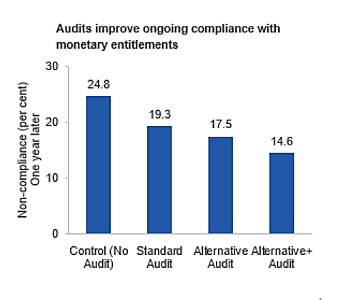
These small changes are cost-effective and easily scalable, both across the FWO’s audits and other services and resources delivered by the FWO. Insights gained from this trial are useful for the FWO and other organisations when designing other communications and compliance-related services. These improvements are a win-win for workers, businesses and the community.

Why?

Policy context
The Fair Work Act 2009 and the Fair Work Regulations 2009 provide a safety net of minimum entitlements, enable flexible working arrangements and fairness at work and prohibit discrimination against employees.
The FWO is an independent statutory agency whose role is to promote harmonious, productive and cooperative workplace relations. It also has responsibility for monitoring, inquiring into, investigating, and enforcing compliance with Commonwealth workplace laws. There is community concern about the exploitation of vulnerable workers by unscrupulous operators.
The FWO aims to promote a culture of compliance by equipping Australian workers and businesses with the information and support they need to make compliant choices in their workplaces.

The problem
The underpayment of wages and entitlements (hereafter referred to as monetary entitlements) is a serious social and economic issue which imposes significant costs on workers, businesses and the community. These behaviours create barriers to workforce participation, weaken the integrity of the workplace relations system, distort the labour market and undermine the principles of fair competition.
The proportion of businesses contravening workplace laws varies across different industries and geographical locations. Left unchecked, such unlawful behaviour can result in a race to the bottom where non-compliance is perceived to be the social norm. The FWO takes a strategic approach to enforcement, reserving the most serious enforcement actions for those who set out to do the wrong thing.
In some instances, underpayment amounts to deliberate and/or severe exploitation. However, some businesses found to be non-compliant are willing to do the right thing but lack motivation and/or a proper understanding of their obligations. The focus of this trial is on better supporting non-compliant businesses who are willing to comply.
To assist these businesses, the FWO delivers a range of free services to employers and employees, including advice, education and support. In addition, the FWO conducts campaigns to check, improve and maintain compliance with Commonwealth workplace laws in a targeted way. The FWO takes a risk-based and proportionate approach to determining which industries, locations and workplace relations issues to focus on.
During a campaign, the FWO communicates with employers and employees about Commonwealth workplace laws. This communication can be through letters, phone calls, visits from Fair Work Inspectors, social media, or through the FWO website. Within these campaigns, the FWO conducts audits by looking at employee time and wage records to check compliance with Commonwealth workplace laws. If employers are found not to be meeting their obligations, the FWO works closely with them to help them fix any errors. FWO regularly looks for ways to improve its campaigns, and making it easier for small businesses to comply is a key priority.
Annually, the FWO conducts around 4,500 audits as a part of its campaigns work. In this trial we sought to improve the long term outcomes of these audits.

What we did
BETA and the FWO partnered to combine our expertise in behavioural science and workplace regulation. We drew on the FWO’s understanding of the factors influencing compliance, as well as the behavioural science literature and practice. We also spoke to employers who had been audited about their experiences. Our goal was to redesign audit processes to help employers comply with their workplace obligations. We then trialled the new processes to assess their effect on ongoing compliance.
We focussed on the retail and hair and beauty industries, which typically offer minimum award wages and conditions, and are significant employers of young workers.

Behavioural biases can contribute to non-compliance
We know people get busy, can become overwhelmed and sometimes fail to fully comply with their legal obligations.
Our research indicated that small business engagement with workplace obligations is relatively low. In addition, some small businesses perceive workplace laws as complex and difficult to keep up to date with.

Box 1: Behavioural biases affecting employers
Cognitive overload is when people become overwhelmed by large amounts of information. Cognitive overload can lead to forgetting things or delaying decisions due to having too many competing tasks.
Present bias is a tendency to delay action on complicated tasks with more distant future rewards/consequences, in favour of less important but more immediately salient and simple tasks (e.g. the day-to-day running of the business).
Social norms are rules and standards that are understood by members of a group which guide or constrain behaviour without the force of laws.
Status quo bias refers to the tendency for people to stick with what they know and be reluctant to change.

The day-to-day demands of running a business can cause cognitive overload, leading employers to forget things, delay decisions, stick with the status quo or otherwise make inferior choices. This is most likely when employers have been presented with a lot of information and/or don’t know where to find the right information. From speaking with employers, we found they frequently rely on heuristics or ‘rules of thumb’ to determine what they should pay their employees. An easy heuristic for wages might be to pay employees what they think other business owners are paying their employees (social norms), or to base wages on personal perceptions of fairness. Employers also sometimes assume they must be doing the right thing and there’s no need to change/update business practices, as they haven’t been advised otherwise.
For employers who had been audited, we heard the audit clarified employers’ obligations in some cases. In others, they found audit letters to be overly complex.
Previous work in the US tested whether simplifying communications and providing reminders to employers can help improve compliance with Occupational Safety and Health regulations. Chojnacki et al. (2017) found it led to a five per cent increase in responsiveness and a proportionate decrease in the number of employers having to be referred for debt collection.

The audit designs (interventions)
The purpose of an audit is tailored to the needs of the business. It acts as any combination of:
- a quick workplace health check-up
- an educational experience and ability to update business practices
- an opportunity to rectify mistakes and back-pay employees
- a deterrent to breaching workplace laws
It may involve the use of appropriate enforcement outcomes and/or further investigation to address non-compliant behaviour.
To help meet the FWO’s goals, we reviewed the audit processes and made a number of behaviourally informed changes. Through this process we created a standardised version of the existing audit communications and two alternative audit communications designs. Key features of these three processes are summarised in Figure 1 and described in detail in Appendix 1.
- Key features of the behaviourally-informed audits
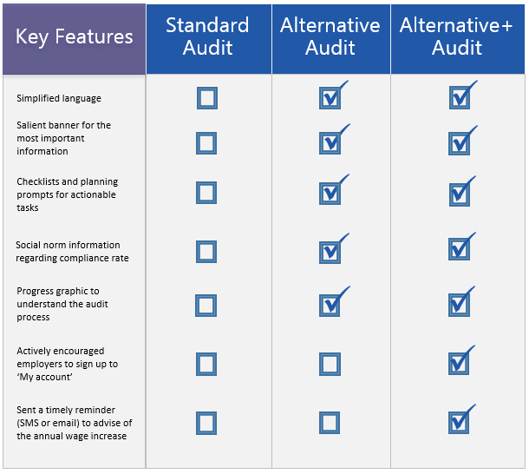

The trial
We conducted a randomised controlled trial (RCT) involving 1,860 small businesses from Victoria, New South Wales and Queensland. Eighty-three per cent of businesses were from the retail industry and 17 per cent were from the hair and beauty industry. The number of employees in each business ranged from 1 to 25 with a median of four. The median age of the businesses was four years.
We used an algorithm that matched together quadruplets of businesses with similar characteristics in terms of age of the business, industry and number of employees. We then randomly assigned each business in a quadruplet to one of four audit groups: ‘Control’, ‘Standard Audit’, ‘Alternative Audit’, and ‘Alternative+ Audit’.
Box 2: What is a randomised controlled trial (RCT)?
Well-designed randomised controlled trials are the best available method for determining whether policies, programs or services have a specific intended impact. In this respect, RCTs are considered the ‘gold standard’ for impact evaluation. RCTs work by separating people into two or more groups randomly, in a manner similar to flipping a coin. People in the ‘treatment’ groups are assigned to receive an intervention (new or existing policy) while people in the ‘control’ group are not. The control group receive either the business-as-usual experience or nothing. On average, the difference in outcomes between people in the groups reflects the effect caused by the intervention.
Businesses in the Standard Audit, Alternative Audit, and Alternative+ Audit groups were audited twice. These businesses were first audited as part of the ‘Intervention Phase’ in the 2016/17 financial year; and then audited again as part of the ‘Compliance Outcome Phase’ in the 2017/18 financial year to measure the impact of the initial audit on ongoing compliance (Figure 2). Businesses in these groups were also asked to complete a voluntary survey after the Intervention Phase audit to assess their experience.
The Control group was audited once in the 2017/18 financial year. This group provided a point of comparison for the other groups regarding the rate of compliance for businesses not previously audited. A full description of the trial design is in Appendix 2.
We hypothesised the audits would increase the proportion of businesses complying with monetary entitlements in the 2017/18 financial year compared with the Control group. We also hypothesised the Alternative Audit and Alternative+ Audit would lead to greater rates of compliance than the Standard Audit.
- Trial overview
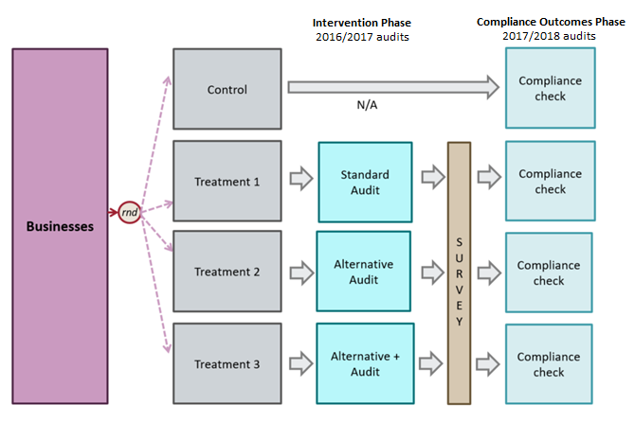

Results
Fair Work Ombudsman audits have a positive impact on the ongoing compliance rates of small businesses. Small changes to the audit processes further increased the compliance rate while also simplifying the audit for employers.
This section begins with our findings for the payment of monetary entitlements and flow-on financial benefits for employees. Next, we present results for compliance with record-keeping obligations. Finally, we report on the employers’ experience of the audits. All findings relate to audits conducted in the Outcomes Phase (2017/18 financial year).

Do audits improve compliance with payment of monetary entitlements?
We found the FWO’s standard audits improve ongoing rates of compliance with monetary entitlements, and the behaviourally informed changes we made reduced non-compliance even further (Figure 3).
- Impact of audit on non-compliance with monetary entitlements
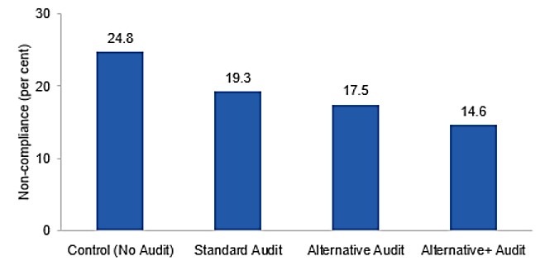
Compared with businesses in the control group (n=480), the rate of non-compliance was 5.5 percentage points lower among businesses which received the Standard Audit (n=450, p=0.05), 7.3 percentage points lower for the Alternative Audit (n=486, p=0.005) and 10.2 percentage points lower for the Alternative+ Audit (n=444, p<0.001).
We introduced changes to the audit process in layers. The Alternative Audit incorporated a range of behaviourally informed additions: checklists, planning prompts, simpler and more salient information, and social norms. In addition, the Alternative+ Audit included an encouragement to sign up to the FWO My account tool, and a timely reminder of award wage increases. Each layer reduced non-compliance with monetary entitlements, over and above the impact of the Standard Audit. The combined effect of these changes reduced non-compliance by 24 per cent, from 19.3 for the Standard Audit to 14.6 per cent for the Alternative+ Audit (p=0.05). This difference is statistically significant. (Statistical tables with full trial results are in Appendix 2.)

What is the ongoing financial impact of the audits for employees?
When we followed up businesses to check monetary compliance in the 2017/18 financial year, we found lower rates of underpayment among businesses that had been previously audited, and even lower rates among businesses receiving one of the alternative audits. By extrapolating the rate of underpayment in the year-to-date over the full financial year, it was possible to estimate the reduction in underpayments for employees in audited businesses.
We estimate the Alternative+ Audit made employees better off by an average of over $900, relative to the Standard Audit, due to improvements in ongoing compliance. Further, the combined effect of all audits helped prevent underpayments for around 200 employees. This represents about 30 per cent of the over 600 employees who we estimate would have been underpaid without the various audits. (See Table 8 in Appendix 3 for details.)

Do audits improve compliance with record-keeping obligations?
Record-keeping and pay slip obligations ensure employees receive correct wages and entitlements. Certain information needs to be kept for each employee. In addition, pay slips have to be given within one working day of pay day. Employers are required to provide details of an employee’s pay for each pay period.
We found audits improved ongoing compliance with record-keeping obligations. For businesses receiving any of the three types of audit, the rate of non-compliance was substantially lower than the Control group, falling by 30 to 42 per cent (Figure 4). Not only are these changes substantial, they are also highly statistically significant.
- Impact of audit on non-compliance with record-keeping obligations
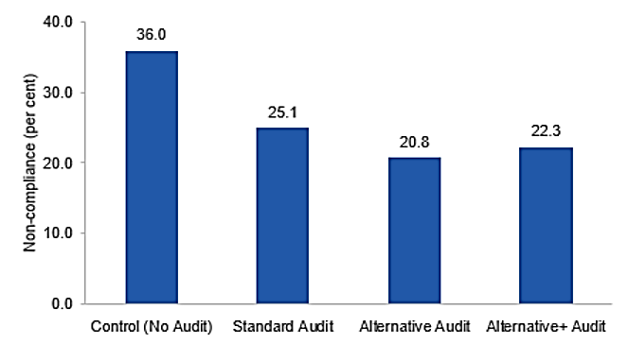
Compared with businesses in the control group (n=480), the rate of non-compliance was found to be 10.9 percentage points lower among businesses which received the Standard Audit (n=450, p<0.001), 15.2 percentage points lower for the Alternative Audit (n=486, p<0.001) and 13.7 percentage points lower for the Alternative+ Audit (n=444, p<0.001).
We found the Standard Audit (25.1 per cent) was outperformed by both the Alternative Audit (17 per cent lower, p=0.09) and by the Alternative+ Audit (11 per cent lower, p=0.25). Although these differences are not statistically significant at the conventional level, we believe they likely reflect real and substantial differences, given the overall pattern of results indicates a positive effect of the alternative audits.

Employer experience
In addition to improving compliance outcomes, we examined whether the changes could enhance the customer experience for businesses. The following sections illustrate three ways in which the audits were found to improve the employers’ experience. They also help explain the impacts we observed.

Audit perception and attitudes to compliance
Based on a survey conducted following the interventions, the Alternative Audits were viewed more favourably by employers. Relative to employers who received the Standard Audit, those who received either of the Alternative Audits rated the process significantly more helpful and informative; as well as less confronting, complex, and confusing. This was supported in feedback provided by employers who received the Alternative Audits. For example, one employer reported it was “quite an easy process and guidelines were set out in an easy to read format”, another “felt like the audit was specifically tailored to [them]”.
The alternative audits also changed employer attitudes, with businesses reporting they were less likely to feel:
- it’s ok to underpay employees if other businesses are, or
- it’s fair to underpay employees if their business is struggling to make money.

Efficiency
On average, the Standard Audit took 23 days to complete from the first point of contact to the date of finalisation, whereas the Alternative Audits took considerably less (Figure 5). Importantly, this efficiency gain was due to the reduced time it took for businesses to supply employment records (four days faster on average) and evidence to the FWO (two days faster on average).
- Mean number of days taken to complete each type of audit
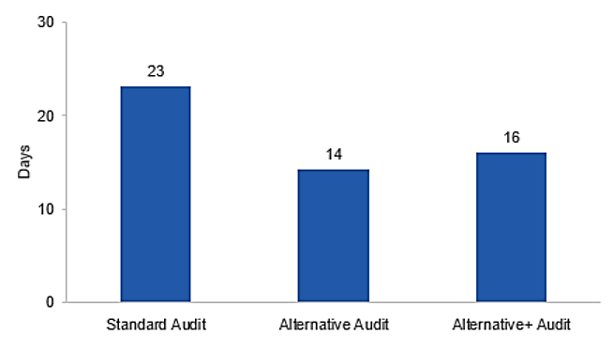
Taken together with the favourable survey ratings, we infer these efficiency gains were due to the Alternative Audits being a genuinely easier process for businesses compared to the Standard Audit. We estimate the efficiency gain for the businesses within the trial could be worth $300,000 in bookkeeper wages or employer time, assuming the underlying gain in time was one day for each business.

Use of the FWO’s educational resources
We gathered data during the Compliance Outcomes Phase (2017/18 financial year) in relation to resources employers used to help them set their employee’s pay rates. We found there were 14 per cent more employers who reported they had used FWO resources across the intervention groups compared with the control group. There was not a substantial difference between the different audited groups.

Limitations
The trial was subject to a limitation inherent to any trial evaluating the impact of an audit: in practice, the means of delivering the intervention (an audit) is the same means by which we measured the outcomes. This meant we could not measure baseline compliance rates for the control group without interfering with their future compliance (the outcome of interest). Consequently, we were not able to apply the same exclusion criteria to businesses in the control group as were applied to businesses in the treatment groups.
We also faced limitations relating to business and employee turnover. We used a list of small businesses to identify our trial population however, early indications showed up to 50 per cent of these businesses were no longer trading or did not have employees when we contacted them. In addition, the ABN of some businesses was inconsistent with the trading/employing entity. In order to reach the intended sample size, we allocated more businesses to the trial and worked through the lists in order. In the Intervention Phase, we audited a higher number of businesses than our intended sample size to accommodate further turnover. In the Compliance Outcomes Phase, we worked consecutively through the lists again to reach the intended sample size.
Associated with this, we found 50 businesses were allocated into the trial twice. We had begun audits on five of these businesses when the issue was uncovered. Also, we could not link the identity of seven businesses between the first and second financial years. We excluded these businesses from the trial.
We conducted balance and robustness checks to determine whether the results were affected by the attrition, exclusions and removal of additional businesses. We found that it did not meaningfully affect the pattern of results. See Appendix 2 for details of these tests.

Discussion and conclusion
Simple changes to the audit process had big, cost-effective impacts. Similar changes, especially reminders, to the broader suite of FWO’s correspondence may also be beneficial.
Underpayments matter greatly to employees. The FWO’s audits improve small business compliance with monetary entitlements. FWO routinely looks for ways to improve its campaigns. By simplifying audit communications and making it easier to comply, businesses are more likely to be compliant in future. This is a win for employees, businesses, the community and government.
If the findings for the best-performing (Alternative+) audit generalise to the approximately 4,500 audits conducted by the FWO each year, we estimate that over 900 extra employees would no longer be underpaid in the following year due to the audit’s impact on persistent compliance. At the same time, simpler audit procedures may reduce the regulatory burden on businesses by up to $1 million. Given the low cost of implementing these changes, this is a tremendous impact.
Potential application to wider audit processes
Our findings build on previous evidence to provide a clear basis for other government agencies to consider similar improvements to their audit communications. In particular, our behavioural interventions targeted businesses who are willing to comply but find it difficult to do so. Thus, we expect the benefits will be greatest in areas of complex regulation and where the target decision makers are dealing with competing priorities and are time poor.
The impact of reminders as part of the audit process is particularly promising. This is now the third trial conducted by BETA in which timely reminders have produced a substantial benefit (BETA, 2017; BETA, 2018). It is plausible that the repetition of the reminder in subsequent periods would continue to have some impact. Such a light-touch intervention is less intrusive to businesses and highly cost-effective.
In the future, it would be worthwhile exploring the potential of the tools and techniques developed in this study for other areas of FWO’s responsibilities. In particular, timely reminders may be similarly effective in other circumstances to encourage businesses to keep up to date with workplace laws.

Appendices
- Audit designs

Standard Audit
The Standard Audit followed a process with up to seven steps.
- The FWO makes initial contact via phone to notify the business/employer of the audit and request records
- The FWO then emails a request for records (employees’ timesheets and pay slips) and information
- The business provides records and information
- The FWO reviews records within 2 business days. Non-compliance involved any record-keeping or monetary contraventions.
- The FWO notifies the business of the audit findings via phone and email
- (If necessary) The business provides evidence of rectification to the FWO
- The FWO provides email confirmation that the audit is finalised.
All email correspondence was entirely text based, structured by paragraphs with the use of dot points only in step 5 to outline the different contraventions identified.
Throughout this process the inspector may have further phone conversations.

Alternative Audit
The Alternative Audits included the same information and processes used in the Standard Audit, but included a number of features in the emails that reframed the way the information was presented.
Drawing on behavioural science literature, we used a number of techniques which have been found to assist people facing the behavioural biases referenced above.
Box 3: Behavioural techniques
Salience is being particularly noticeable, important or prominent and describes the way in which people are more likely to respond to things that are novel, simple and relevant.
Chunking is the grouping together of connected items or words so they can be processed as a single concept.
Defaults make choices easier by removing some of the friction costs involved.
Checklists support our ability to complete tasks by reducing errors due to memory failure.
Planning Prompts and Reminders make it easier to complete a task by planning when we will do it or providing a cue at the right time.
Below we describe a number of changes that were made to the FWO’s audit communications for this project. The FWO routinely looks for ways to improve its campaigns and plans to review the BI techniques trialled for this project to ensure they remain fit for purpose.
To simplify messaging and draw greater attention to the key components in the emails, we drew upon the cognitive psychological principles of salience and chunking (BIT, 2014):
- At the top of the email, we added a banner which outlined the main call-to-action or key message (see Figure 6). At the bottom of the email we added a diagram chunking the audit process into steps with a marker indicating the current step (see Figure 7). Throughout the emails we structured the information with headings, sections and dot points to make the content easier to process (Adams and Hunt, 2013).
- For action items we used checklists (see Figure 8) which broke down the overall request into the individual tasks that needed to be completed. Setting intermediate goals and tracking their progress helps with building momentum, as the perception of progress toward the end goal can itself be motivating (Kivetz et al. 2006). We added planning prompts (empty date fields) which can address present bias and increase the likelihood that a person will undertake the task (Milkman et al., 2011, Nickerson and Rogers, 2010).
- In the finalisation email, we added a traffic light graphic (see Figure 9) which provided social norm information about the business’ compliance. Based on the information provided during the audit, businesses in this trial were categorised as ‘full compliance’ or ‘partial compliance’ (along with a third category of ‘serious non-compliance’, which did not apply to businesses in this trial). Although it’s tempting to see the compliance distinction as black and white (that is, either compliant or non-compliant), employers we spoke with resisted this categorisation because they felt as if they were being ‘treated as criminals’. When given a ‘label’, people tend to behave and perceive themselves consistent with their label (Tybout and Yalch, 1980). For businesses that were not yet fully compliant, we wanted to assure them that they could take practical steps to improve now rather than move towards more conscious non-compliance.
- Alternative Audit feature – salient banner

- Alternative Audit feature – progress graphic
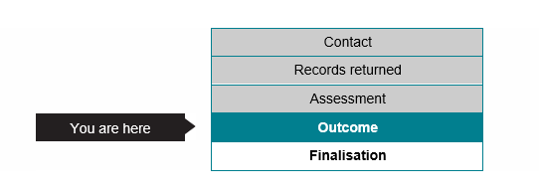
- Alternative Audit feature – planning prompt checklist

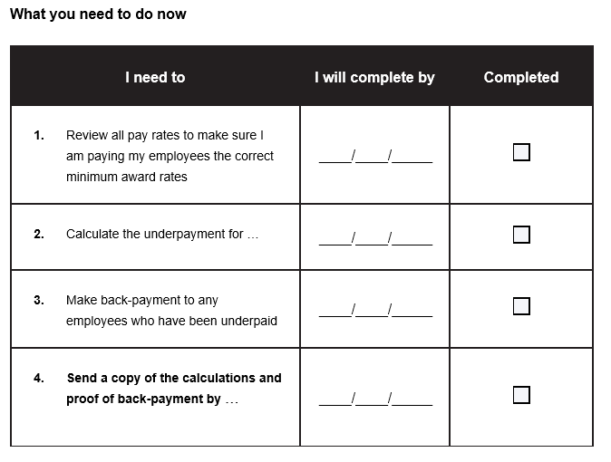
- Alternative audit feature – traffic light
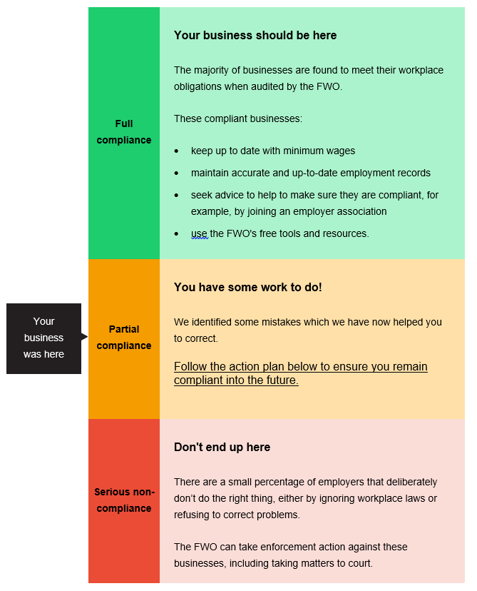

Alternative+ Audit
In addition to the correspondence and features used in the Alternative Audit, the Alternative+ Audit included:
  - Employers were encouraged and assisted to sign up to the FWO My account tool as a default option. This tool allows employers to save and receive tailored information about the entitlements of their employees and their compliance obligations. This tool collates relevant up-to-date information in one place and reduces the friction costs of accessing that information. Friction cost can be a significant barrier to acquiring information (Kling et al., 2012).
  - Employers received a timely reminder (SMS or email) to advise them of the annual wage increase. There is evidence that reminders, if used at the right time, can address cognitive overload and prompt people to take action (Karlan et al., 2010, Cadena and Schoar, 2011). Reminder emails have improved businesses’ compliance with the Deferred Goods and Services Tax (DGST) Scheme (BETA, 2018) and reminder text messages have improved job seekers’ compliance with reporting their income on time (BETA, 2017).

- Technical details

Pre-registration, pre-analysis plan and ethics
We pre-registered this trial on both the American Economic Association RCT Registry and the BETA website prior to the commencement of the trial. This pre-registration specified compliance with monetary entitlements as the primary outcome. Subsequent to this, we developed a pre-analysis plan specifying the method of analysis for the primary outcome and additional secondary measures. The pre-analysis plan was developed after the collection of baseline data and completion of the intervention but prior to collection of Compliance Outcomes Phase data. We made only minor deviations from this pre-analysis plan (described below).
The project was approved through BETA’s ethics approval process, with risk assessed in accordance with the guidelines outlined in the National Statement on Ethical Conduct in Human Research.

Population and sampling
Our population of interest was small businesses. We chose to sample businesses operating in retail and hair and beauty industries in Victoria, New South Wales and Queensland. This selected sample provided a sufficiently large and relatively homogenous group of businesses.
We were seeking to have a final sample of at least 1,600 businesses (400 per trial arm). In order to engage these businesses in the trial, we acquired a list of businesses fitting the following criteria from a list broker:
- Business in industries: Motor vehicle and motor vehicle parts retailing, food retailing, other store-based retailing, and hairdressing and beauty services
- Number of employees between 1 to 25
- Business located in Victoria, New South Wales or Queensland
In total, the list contained 4,484 businesses.

Randomisation and balance checks
Businesses were grouped into quadruplets with a matching algorithm using industry type, number of employees and age of business as matching variables. Each business in a matched-quadruplet was then randomly allocated to one of four experimental conditions. Initially, 2,000 business (500 quadruplets) were allocated. Upon commencing to contact businesses, we found there was an unexpectedly high proportion of businesses that were no longer trading or no longer had employees (approximately 50 per cent). Thus we matched, randomised and allocated an extra 2,484 businesses (621 quadruplets) to the sample. Matching for the additional businesses was based on industry and number of employees (data on age of business was not available). Inspectors worked consecutively down this list drawing businesses to audit until the end of the 2016/17 financial year, with the aim of recruiting at least 440 businesses to each condition, to accommodate 10 per cent attrition rate (i.e. further business/employee turnover) between the Intervention and Compliance Outcome phases.
We performed balance checks by conducting a multinomial logistic regression analysis. This allowed us to assess whether observed covariate imbalances between the four treatment arms were larger than would normally be expected from chance alone. The covariates were the same as those used for matching: industry type, number of employees, and age of business. This test returned a non-statistically significant result (p=0.38) so we inferred that the randomisation was implemented successfully.
The audits were conducted by 29 FWO Inspectors from three different teams. Each inspector was randomly allocated to only one of the three interventions. The randomisation was stratified by team and audit completion rates (categorical: above or below the median audit completion rate).

Sample size and power calculations
Based on data from previous audits conducted in related industries, the baseline rate of non-compliance with award-wage employee entitlements was expected to be around 30 per cent. We aimed to recruit a sample size of 400 businesses in each condition. This meant that the trial was powered to detect a change in the rate of compliance by 8.6 percentage points from 30 per cent to 21.4 per cent, with alpha = 0.05 (two sided), power = 0.80 and a 1:1:1:1 allocation ratio.

Trial criteria, attrition and follow up
Upon contacting businesses, we found up to 50 per cent did not meet our trial criteria. That is, they were no longer trading, did not have employees or had more than 25 employees. In addition, we excluded businesses which had recently been audited or affected by FWO activities. Also, as noted in the Limitations section, we excluded businesses that required additional attention which could have impacted ongoing compliance in a way that was different from the remaining audits. Finally, we excluded duplicate allocations and businesses that could not be re-identified across the two phases.
In the Intervention Phase, there were around 550 to 590 businesses in each of the treatment groups that did not meet the trial criteria for one of the reasons set out in the preceding paragraph (Table 1). Similarly, there were around 480 businesses in the control group that did not meet trial criteria upon contact in the Compliance Outcomes Phase. Between the two phases, there was attrition (businesses no longer trading or no employees) of around 60 businesses in each of the treatment groups.
In the Compliance Outcomes Phase, we checked ongoing compliance by re-auditing businesses in the same order as they had been in the Intervention Phase until we reached the intended sample size, highlighted in green in Table 1. Similarly, we worked through the control group list of businesses in order. Around 25 businesses in each of the treatment groups and 158 businesses in the control group were not checked during the Compliance Outcomes Phase.
Table 1: Breakdown of exclusions and attrition by intervention group
 | Control | Standard Audit | Alternative Audit | Alternative+ Audit | Total
Total sample | 480 | 450 | 486 | 444 | 1,860
Did not meet trial criteria during Intervention phase | NA | 585 | 556 | 593
Did not meet trial criteria during Compliance Outcomes Phase | 483 | 57 | 60 | 60
Not checked | 158 | 29 | 19 | 24
Randomised (initial) sample | 1,121 | 1,121 | 1,121 | 1,121 | 4,484
Note: We checked ongoing compliance during the Compliance Outcomes Phase by re-auditing businesses in the same order as they had been in the Intervention phase until we reached the intended sample size, which is highlighted in green.

Baseline Characteristics
The baseline characteristics of the businesses included in the total sample are displayed in Table 2. There were no substantial imbalances between groups.
Table 2: Baseline characteristics of businesses
 |  | Control | Standard Audit | Alternative Audit | Alternative+ Audit
 | N (no.) | 480 | 450 | 486 | 444
Industry | Retail (%) | 79.6 | 83.6 | 84.8 | 82.9
 | Hair and Beauty (%) | 20.4 | 16.4 | 15.2 | 17.1
Time since registration | Mean years (SD), median | 9.2 (11.5), 5.4 | 8.8 (10.5),  4.5 | 8.5 (10.9),  3.9 | 7.9 (9.7),  3.9
Number of Employees | Mean (SD), median | 5.4 (4.7),  4 | 5.5 (4.8),  4 | 5.2 (4.1),  4 | 5.3 (4.0),  4
State | NSW (%) | 44.8 | 45.6 | 45.1 | 45.5
 | QLD (%) | 22.9 | 21.3 | 22.6 | 18.9
 | VIC (%) | 32.3 | 33.1 | 32.3 | 35.6
Note: Using multinomial logistic regression, we found that a model containing industry type, time since registration, number of employees and state as predictors of treatment group allocation was not a better fit than an intercept-only model (p=0.38). Thus, we inferred that the randomisation was implemented successfully.

Method of analysis
For all outcomes we used ordinary least squares (OLS) regression. We also analysed our binary outcomes (compliance and use of educational resources) using binary logistic regression as robustness check (see Table 7 in Appendix 3). There was no difference in the pattern of results.
Although our randomisation was stratified, we found little difference in our results when adjusting for these blocks in our estimating equations, therefore we did not adjust for them. As specified in the pre-analysis plan, however, we did adjust our estimates of the differences between treatment groups on compliance at follow-up by controlling for Intervention Phase rates of compliance. Specifically, we entered compliance status in the Intervention Phase as a mean-centred covariate and interaction term with the experimental variable as per Lin (2013).

Matched randomisation, missing data and robustness checks
The nature of matched randomisation is such that each matched-quadruplet in our trial comprises its own internally valid randomised controlled trial, albeit with the smallest possible sample size of one business per group. Combining these quadruplets produces a larger sample size which similarly has internal validity, but only as long as there is no outcome data that is missing for systematic (non-random) reasons. As discussed in the Limitations section, there were systematic reasons for missing data. In order to check whether the missing data had a material impact on the results (i.e., produced bias in our estimates), we repeated all the analyses with a smaller sample that only included businesses from internally-valid quadruplets. There was no meaningful difference between the results generated by this robustness check and the results of the analysis on the full sample we present in the report (see Tables 5 and 6 in Appendix 3).

- Statistical Tables
The following statistical tables provide the full set of results underpinning the findings presented in the main body of the report. The tables are provide in the same order the outcomes are presented in the results section of the report, that is:
- Monetary entitlements
- Ongoing financial implications for employees
- Record-keeping
- Audit perception and attitudes to compliance
- Efficiency
- Use of the FWO’s educational resources
Additionally, at the end, we present the findings of a model which isolated the individual effect of each component of the audit (audit, alternative communications and reminder). This model was pre-specified in our analysis plan in addition to the pairwise comparisons of experimental groups.

Monetary entitlements
Analyses of the primary outcome (compliance with monetary entitlements) are presented in two tables. Table 3 shows the effect of each type of audit relative to not being audited on the non-compliance rate. The estimate of the difference ranges from –5.5 percentage points for the Standard Audit to –10.2 percentage points for the Alternative+ Audit. This reflects the raw difference between groups in non-compliance rate. In interpreting the comparison with the Control group, it’s noted that these businesses had not had their sample of records audited in the previous financial year. As a result, these businesses may have had non-compliant practices over an extended period.
At the Intervention Phase, there were small differences in the initial compliance rates for each of the audited groups, ranging from 16 to 18 per cent non-compliance (Table 4). In order to compare the effect of the audits on each of the audited groups, we first adjusted our estimates to take account of these initial differences in compliance rates. The p-values used in the Results section of the report are derived from these adjusted analyses.
The non-compliance rates for the 2016/17 Financial Year audits (16-18 per cent, Table 4) were lower than for the corresponding audits during the 2017/18 Financial Year (25 per cent, Table 3). We suspect this could be due to the effect of the audits being conducted at different times during the financial year (e.g. one round of audits was conducted closer to the wage increase stemming from the annual wage review, which is generally conducted in the second half of the financial year). Regardless, it would be incorrect for readers to infer from Table 4 that, for example, the Standard Audit caused non-compliance to increase from 16 to 19 per cent. The correct causal conclusions should be based on a comparison of the groups at the same point in time (the 2017/18 Financial Year), as set out in Table 3. The same point applies to the interpretation of Tables 5 and 6.

Table 3: Impact of audits on non-compliance with monetary entitlements
Group | N | Non-compliance rate (n) | Difference from control (95% confidence interval) | P-value
Control | 480 | 24.8% (119) | NA
Standard Audit | 450 | 19.3% (87) | -5.5% (-10.8 to -0.1) | 0.045
Alternative Audit | 486 | 17.5% (85) | -7.3% (-12.4 to -2.2) | 0.005
Alternative+ Audit | 444 | 14.6% (65) | -10.2% (-15.3 to -5.0) | <0.001
Any Audit (pooled) | 1,380 | 17.2% (237) | -7.6% (-11.7 to -3.5) | <0.001
Table 4: Relative impact of audits on non-compliance with monetary entitlements
Group | N | 16/17 financial year non-compliance rate (n) | 17/18 financial year non-compliance rate (n) | Adjusted difference from Standard Audit group (95% CI) | p-value | Adjusted difference from Alternative Audit group (95% CI) | p-value
Standard Audit | 450 | 15.8% (71) | 19.3% (87) | NA |  | NA
Alternative Audit | 486 | 16.9% (82) | 17.5% (85) | -1.9%  (-6.9 to 3.0) | 0.44 | NA
Alternative+ Audit | 444 | 18.2% (81) | 14.6% (65) | -4.9%  (-9.8 to 0.0) | 0.05 | -3.0%  (-7.7 to 1.7) | 0.21
Note: these estimates have been adjusted for baseline monetary entitlement compliance status (included as a mean centred covariate and interaction with treatment variable)
In Tables 5 and 6, we present the results of the same analyses as presented in Tables 3 and 4, respectively, but using the restricted sample described in Appendix 2 as a robustness check. The results follow the same pattern of results, albeit with slightly higher p-values in the robustness checks due to the smaller sample size in each group.
Table 5: Impact of audits on non-compliance with monetary entitlements, restricted sample
Group | N | Non-compliance rate (n) | Difference from control (95% confidence interval) | p-value
Control | 443 | 24.8% (110) | NA
Standard Audit | 374 | 19.3% (72) | -5.6% (-11.3 to -0.2) | 0.06
Alternative Audit | 386 | 18.4% (71) | -6.4% (-12.1 to -0.8) | 0.03
Alternative+ Audit | 351 | 14.5% (51) | -10.3% (-15.9 to -4.7) | <0.001
Any Audit (pooled) | 1,111 | 17.5% (194) | -7.4% (-11.7 to -3.0) | 0.001

Table 6: Relative impact of audits on non-compliance with monetary entitlements, restricted sample
Group | N | 16/17 financial year non-compliance rate (n) | 17/18 financial year non-compliance rate (n) | Adjusted difference from Standard Audit group (95% CI) | p-value | Adjusted difference from Alternative Audit group (95% CI) | p-value
Standard Audit | 374 | 16.8% (63) | 19.3% (72) | NA |  | NA
Alternative Audit | 386 | 16.1% (62) | 18.4% (71) | -0.7%  (-6.3 to 4.8) | 0.79 | NA
Alternative+ Audit | 351 | 18.5% (65) | 14.5% (51) | -4.9%  (-10.4 to 0.5) | 0.08 | -4.1%  (-9.5 to 1.2) | 0.13
Note: these estimates have been adjusted for baseline monetary entitlement compliance status (included as a mean centred covariate and interaction with treatment variable)

In Table 7, we present the same analysis as presented in Table 3 (pairwise comparisons of groups for monetary entitlements outcome) with the only difference being we used logistic regression instead of Ordinary Least Squares (OLS) regression. In our pre-analysis plan, we specified we would use logistic regression, but we have since changed our approach because OLS provides more readily interpretable coefficients (percentage point changes rather than odds ratios) and it does not change the underlying pattern of results. We have included these additional results for transparency.
Table 7: Impact of audits on non-compliance with monetary entitlements, logistic regression results
Group | N | Non-compliance rate (n) | Odds ratio control: treatment (95% confidence interval) | p-value
Control | 480 | 24.8% (119) | NA
Standard Audit | 450 | 19.3% (87) | 0.73 (0.53 to 0.99) | 0.046
Alternative Audit | 486 | 17.5% (85) | 0.64 (0.47 to 0.88) | 0.006
Alternative+ Audit | 444 | 14.6% (65) | 0.52 (0.37 to 0.73) | <0.001
Any Audit (pooled) | 1,380 | 17.2% (237) | 0.63 (0.49 to 0.81) | <0.001

Ongoing financial impact for employees
Table 8 shows the number of businesses and employees in each trial group along with an estimate of the extent of underpayment in the 2017/18 financial year. This estimate is calculated by assuming the year-to-date underpayment for each employee would have continued at the same rate for the full financial year.
Table 8: Underpayment observed at the Compliance Outcomes Phase
 |  | Control | Standard Audit | Alternative Audit | Alternative+ Audit
Number of businesses | All | 473 | 449 | 482 | 444
 | Non-compliant | 115 | 87 | 83 | 65
Number of employees | All | 2,548 | 2,277 | 2,441 | 2,340
 | Underpaid | 223 | 166 | 143 | 114
Total underpayment |  | $426,124 | $161,454 | $172,456 | $114,499
This table shows the extent of businesses underpaying employing across the trial groups. The data in this table are drawn from the total sample of businesses (n=1,860), with the exception that businesses that were checked in July 2018 were excluded (n=12). With less than one month of data, we found the estimates for the annual rate of underpayment for these businesses were unreliable and contained outliers.
To compare the level of underpayment in the four experimental arms, we scaled the size of groups to match one another (Table 9). For example, to compare the Alternative+ group with the Standard group, we scaled the number of employees in the latter group (2,277) to match the number in the former (2,340). We then used the scaled numbers to calculate the reduction in the number of underpaid employees (Table 10). For example, the reduction from Control (scaled) to the Alternative+ Audit was 91 employees (205 less 114). This led to our estimates that the combined effect of all audits helped prevent underpayments for 195 employees and that, without the audits, 618 people would have been underpaid. Hence, the audits reduced the number of people underpaid by about 32 per cent.
We also calculated the changes between the Standard and Alternative+ audits: 57 fewer underpaid employees and a reduction in underpayments of $51,400. This implies that the Alternative+ audit made employees better off by $909 each, relative to the effect of the Standard audit.
Table 9: Underpayment observed at the Compliance Outcomes Phase, scaled for comparison
 |  | Control |  |  | Standard Audit
 |  | Scaled to: Standard | Scaled to: Alternative | Scaled to: Alternative+ | Scaled to: Alternative+
Number of employees | All | 2,277 | 2,441 | 2,340 | 2,340
 | Underpaid | 199 | 214 | 205 | 171
Total underpayment |  | $380,802 | $408,229 | $391,338 | $165,921
See notes to Table 8.
Table 10: Reduction in number of underpaid employees
 | Compared to Control: |  |  |  | Compared to Standard:
 | Standard Audit | Alternative Audit | Alternative+ Audit | Total | Alternative+ Audit
Number of underpaid employees | 33 | 71 | 91 | 195 | 57
See notes to Table 8.

Record-keeping
The analysis of record-keeping compliance follows the same approach as the analysis of compliance with monetary entitlements. Table 11 presents the difference in non-compliance rate between businesses which received each type of audit and businesses which did not receive an audit. Table 12 presents estimates of the effects of each audit relative to each other, adjusted for differences between groups in baseline rates on non-compliance.
Table 11: Impact of audits on non-compliance with record-keeping obligations
Group | N | Non-compliance rate (n) | Difference from control (95% confidence interval) | P-value
Control | 480 | 36.0% (173) | NA
Standard Audit | 450 | 25.1% (113) | -10.9% (-16.8 to -5.0) | <0.001
Alternative Audit | 486 | 20.8% (101) | -15.2% (-20.9 to -9.6) | <0.001
Alternative+ Audit | 444 | 22.3% (99) | -13.7% (-19.6 to -7.9) | <0.001
Table 12: Relative impact of audits on non-compliance with record-keeping obligations
Group | N | 16/17 financial year non-compliance rate (n) | 17/18 financial year non-compliance rate (n) | Adjusted difference from Standard Audit group (95% CI) | p-value | Adjusted difference from Alternative Audit group (95% CI) | p-value
Standard Audit | 450 | 31.1% (140) | 25.1% (113) | NA |  | NA
Alternative Audit | 486 | 33.1% (161) | 20.8% (101) | -4.6%  (-10.0 to 0.7) | 0.09 | NA
Alternative+ Audit | 444 | 34.2% (152) | 22.3% (99) | -3.2%  (-8.7 to 2.3) | 0.25 | 1.4%  (-3.9 to 6.7) | 0.60

Attitudes
Table 13 shows the mean score and difference between the standardised audit and alternative audits (pooled) for outcomes measured in the survey following the Intervention Phase audit. All responses were scored on a five-point Likert scale ranging from 1 = ‘Strongly disagree’ to 5 = ‘Strongly Agree’. The survey was non-compulsory. Around one third of audited businesses responded. On each of the items there was between 4-7 per cent missing data which we imputed with the grand mean.
The survey items are presented below and numbered in the same order as in Table 11. We found the difference between groups on all items trended in a direction which reflected a positive outcome. The seven survey items referred to in the main body of the report were among the largest effects. We have marked these with an asterisk.
      - I found the overall audit process to be efficient.
      - I found the overall audit process to be fair.
      - I found the overall audit process to be supporting.
      - I found the overall audit process to be educational.
      - * I found the overall audit process to be confusing.
      - * I found the overall audit process to be complex.
      - I found the overall audit process to be slow.
      - * I found the overall audit process to be confronting.
      - I understood what I was required to do as I moved through the audit process.
      - The timeframes I was required to meet during the audit process were reasonable.
      - * The emails I received throughout the audit process helped me to do what was required.
      - * I was provided with enough information during the audit process to comply with workplace laws in future.
      - Participating in the audit improved my awareness of my obligation in relation to workplace laws.
      - Participating in the audit will result in me taking a more proactive role in ensuring my business is compliant with the Fair Work Act moving forward.
      - Since participating in the audit I have made a plan to address my ongoing compliance with workplace laws (e.g. creating a reminder to check the annual wage increase).
      - Since participating in the audit I understand that most businesses are compliant with their workplace obligations.
      - * If other businesses in an industry are paying below award wages, it’s ok for an individual business to do so.
      - * If a business is struggling to make money, it isn’t fair to expect the business to increase its wages to pay minimum entitlements.
      - It’s up to employees or the Fair Work Ombudsman to inform a business of its obligations in relation to pay and conditions.
      - Every week I’m faced with more important priorities than compliance with workplace laws.
      - I find the award wage system complex and difficult to understand.
      - It is common not to comply with workplace laws in our industry.
Table 13: Attitudes towards the audit and compliance
Survey Item | Standard audit (n=159)  Mean (SD) | Alternative audits (n=366)  Mean (SD) | Difference (95% CI) | p
1 | 4.26 (0.70) | 4.34 (0.64) | 0.08 (-0.04 to 0.21) | 0.19
2 | 4.30 (0.64) | 4.33 (0.65) | 0.03 (-0.09 to 0.15) | 0.62
3 | 4.13 (0.79) | 4.20 (0.77) | 0.07 (-0.07 to 0.22) | 0.31
4 | 4.01 (0.84) | 4.08 (0.83) | 0.08 (-0.08 to 0.23) | 0.34
5* | 1.92 (0.94) | 1.72 (0.83) | -0.20 (-0.03 to -0.36) | 0.02
6* | 1.99 (0.88) | 1.77 (0.83) | -0.22 (-0.06 to -0.38) | 0.007
7 | 1.89 (0.92) | 1.60 (0.71) | -029 (0.15 to 0.44) | <0.001
8* | 2.18 (1.06) | 1.92 (0.94) | -0.26 (-0.08 to -0.45) | 0.005
9 | 4.30 (0.59) | 4.37 (0.57) | 0.07 (-0.03 to 0.18) | 0.18
10 | 3.88 (0.95) | 4.02 (0.89) | 0.14 (-0.03 to 0.31) | 0.11
11* | 4.16 (0.72) | 4.28 (0.66) | 0.12 (-0.003 to 0.25) | 0.06
12* | 4.12 (0.71) | 4.26 (0.66) | 0.15 (0.02 to 0.27) | 0.02
13 | 3.82 (0.96) | 3.93 (0.88) | 0.11 (-0.06 to 0.28) | 0.19
14 | 3.89 (0.92) | 3.93 (0.85) | 0.04 (-0.12 to 0.21) | 0.60
15 | 3.87 (0.88) | 3.96 (0.85) | 0.09 (-0.07 to 0.25) | 0.26
16 | 3.65 (0.77) | 3.86 (0.81) | 0.21 (0.06 to 0.36) | 0.005
17* | 1.51 (0.72) | 1.34 (0.66) | -0.17 (-0.30 to -0.04) | 0.008
18* | 1.97 (0.99) | 1.69 (0.89) | -0.28 (-0.45 to -0.11) | 0.001
19 | 1.94 (0.99) | 1.88 (1.02) | -0.06 (-0.25 to 0.13) | 0.53
20 | 2.05 (0.84) | 1.85 (0.87) | -0.20 (-0.36 to -0.04) | 0.02
21 | 2.56 (1.09) | 2.45 (1.06) | -0.11 (-0.31 to 0.08) | 0.26
22 | 1.97 (0.80) | 1.92 (0.91) | -0.05 (-0.21 to 0.11) | 0.54

Efficiency
We analysed audit efficiency in three ways. The results of these analyses are presented in Tables 14-16. Each table presents the average amount of time taken to complete a task in each of the three treatment groups and the difference between groups. Table 14 presents the overall time taken to complete an audit, Table 15 presents the time taken by employers to supply records to the FWO to be audited, and Table 16 presents the time taken by businesses to supply proof of back-payment to employees. The act of supplying records and supplying proof of back-payment are both tasks contained within the overall time taken to complete an audit. We infer the overall efficiency gain was in part due to the reduction in time taken by employers to complete each of these subtasks.
Table 14: Relative time taken to complete the different audits
Group | N | Mean days (SD) | Difference from Standard Audit group (95% CI) | p-value | Difference from Alternative Audit  group (95% CI) | p-value
Standard Audit | 450 | 23.1 (22.3) | NA |  | NA
Alternative Audit | 486 | 14.2 (13.7) | -8.8  (-11.2 to -6.5) | <0.001 | NA
Alternative+ Audit | 444 | 16.0 (18.1) | -7.1  (-9.7 to -4.4) | <0.001 | 1.8  (-0.3 to 3.8) | 0.09
Table 15: Relative impact of audits on time taken by businesses to supply records
Group | N | Mean days (SD) | Difference from Standard Audit group  (95% CI) | p-value | Difference from Alternative Audit  group  (95% CI) | p-value
Standard Audit | 450 | 11.4 (14.1) | NA |  | NA
Alternative Audit | 486 | 7.6 (7.1) | -3.8  (-5.2 to -2.3) | <0.001 | NA
Alternative+ Audit | 444 | 8.0 (9.3) | -3.4  (-4.9 to -1.8) | <0.001 | 0.4  (-0.7 to 1.4) | 0.48
Note: Three missing values were imputed with the grand mean.
Table 16: Relative impact of audits on time taken by businesses to supply proof of back-payment to employees
Group | N | Mean days (SD) | Difference from Standard Audit group  (95% CI) | p-value | Difference from Alternative Audit  group  (95% CI) | p-value
Standard Audit | 69 | 12.5 (13.1) | NA |  | NA
Alternative Audit | 77 | 10.5 (7.0) | -2.0  (-5.3 to 1.3) | 0.24 | NA
Alternative+ Audit | 76 | 9.8 (11.0) | -2.6  (-6.5 to 1.2) | 0.18 | -0.7  (-3.5 to 2.2) | 0.64
Note: Eleven missing values were imputed with the grand mean.

Use of FWO’s educational resources
Tables 17 and 18 present the proportion of businesses who reported having used a FWO resource to help them meet their compliance obligations, and the difference between groups. Table 17 presents findings from the comparison of businesses that received any of the types of audit to businesses which were not audited. Table 18 presents findings from the comparison of each of the three types of audit to each other.
Table 17: Impact of the audits on use of the FWO’s resources
Group | N | Proportion using FWO Resource (n) | Difference  (95% CI) | p-value
Control | 480 | 42.5% (204) | NA
Any Audit | 1,380 | 49.4% (682) | 6.9%  (1.7 to 12.1) | 0.01
Table 18: Relative impact of the audits on use of the FWO’s resources
Group | N | Proportion using FWO Resource (n) | Difference from Standard Audit group (95% CI) | p-value | Difference from Alternative Audit  group  (95% CI) | p-value
Standard Audit | 450 | 49.1% (221) | NA |  | NA
Alternative Audit | 486 | 49.4% (240) | 0.3%  (-6.2 to 6.7) | 0.93 | NA
Alternative+ Audit | 444 | 49.8% (221) | 0.7%  (-5.9 to 7.2) | 0.84 | 0.4  (-6.1 to 6.8) | 0.91

Modelling the effect of each component of the audits
We analysed the trial primary outcome in two ways. One way, which is presented in the main body of the report, focuses on pairwise comparisons between experimental groups. A second way, which is presented here, focuses on the effect contributed by each component of the audits.
Since our trial involved interventions which were incrementally added across the four trial groups, we were able to analyse the trial in a single model with a dummy variable for each of the interventions. In the comparison of all four experimental groups, these interventions are (i) being audited, (ii) receiving the alternative communications, and (iii) receiving the reminder and encouragement to sign up to My account. The estimate of the effect of each of these interventions is presented in Table 17. The intercept coincides with the non-compliance rate in the control group (24.8 per cent). Thereafter, we have taken the coefficient for each intervention and presented it as an estimate for the effect it contributes to reducing non-compliance, along with the associated p-value and confidence interval. The pattern of findings is consistent with that of the pairwise comparison of groups: that with the addition of each intervention non-compliance was further reduced. We found that audits contributed the largest effect of around a 5.5 percentage point reduction (p=0.04) and that alternative communication and the reminder further contributed. Although not all the p-values are below conventional thresholds, we are reasonably confident these effects reflect real impacts. Given the overall pattern of the results is consistent with our hypothesis and the observed pattern of results is consistent across the different trial groups, we consider it unlikely that, where the conventional threshold was not met, the observed impact occurred by chance.
Consistent with the other analysis of our primary outcome, we also looked at the effect of each intervention taking into account baseline rates of non-compliance. For this we could only investigate the three treatment groups, which meant we could only model the effect of the alternative communications and the reminder. This is presented in Table 18 and is largely consistent with the results without the adjustment for baseline non-compliance.
Table 19: Effect of audit, alternative communications and reminder on monetary entitlements
Group | Estimate of the effect on non-compliance (95% CI) | p-value
Intercept | 24.8%
Audit | -5.5% (-10.5 to -0.4) | 0.04
Alternative communications | -1.8% (-6.9 to 3.2) | 0.47
Reminder | -2.9% (-7.9 to 2.2) | 0.27
Table 20: Effect of alternative communications and reminder on monetary entitlements, controlling for baseline non-compliance
Group | Adjusted estimate of the effect on non-compliance (95% CI) | p-value
Intercept | 17.9%
Alternative communications | -1.9% (-6.8 to 2.9) | 0.43
Reminder | -3.0% (-7.8 to 1.9) | 0.23

References
Adams, P. and Hunt, S., 2013. Encouraging consumers to claim redress: evidence from a field trial.
Wasserstein, R.L. and Lazar, N.A., 2016. The ASA’s statement on p-values: context, process, and purpose. The American Statistician, 70(2), pp.129-133. Available at: http://amstat.tandfonline.com/doi/abs/10.1080/00031305.2016.1154108#.Vt2XIOaE2MN
The Behavioural Insights Team, 2014. EAST: Four Simple Ways to Apply Behavioural Insights. Available at: http://www.behaviouralinsights.co.uk
BETA, 2018. Improved Compliance with the Deferred GST Scheme. Available at: http://behaviouraleconomics.pmc.gov.au/sites/default/files/projects/report-improved-compliance-deferred-gst_0.pdf
BETA, 2017. Effective use of SMS: timely reminders to report on time. Available at: http://behaviouraleconomics.pmc.gov.au/sites/default/files/projects/sms-timely-reminders.pdf
Cadena, X. and A. Schoar (2011). Remembering to pay? Reminders vs. financial incentives for loan payments, National Bureau of Economic Research.
Chojnacki, G., Deutsch, J., Perez-Johnson, I., Amin, S., Darling, M., & Lefkowitz, J. (2016). Pilot OSHA Citation Process Increases Employer Responsiveness. DOL Behavioral Interventions Project Brief, Department of Labor, Washington, DC.
Karlan et al. (2010), Getting to the Top of Mind: How Reminders Increase Saving, NBER Working Paper
Kivetz, R., Urminsky, O. and Zheng, Y., 2006. The goal-gradient hypothesis resurrected: Purchase acceleration, illusionary goal progress, and customer retention. Journal of Marketing Research, 43(1), pp.39-58.
Kling, J.R., Mullainathan, S., Shafir, E., Vermeulen, L.C. and Wrobel, M.V., 2012. Comparison friction: Experimental evidence from Medicare drug plans. The Quarterly Journal of Economics, 127(1), pp.199-235
Lin, W. 2013. Agnostic notes on regression adjustments to experimental data: Reexamining Freedman’s critique. The Annals of Applied Statistics, 7(1), pp. 295-318.
Milkman, K.L., Beshears, J., Choi, J.J., Laibson, D. and Madrian, B.C., 2011. Using implementation intentions prompts to enhance influenza vaccination rates. Proceedings of the National Academy of Sciences, 108(26), pp.10415-10420.
Nickerson, D.W. and Rogers, T., 2010. Do you have a voting plan? Implementation intentions, voter turnout, and organic plan making. Psychological Science, 21(2), pp.194-199.
Payscale (2018) Australia Bookkeeper Salary. Available at: https://www.payscale.com/research/AU/Job=Bookkeeper/Hourly_Rate
Tybout, A.M. and Yalch, R.F., 1980. The effect of experience: A matter of salience?. Journal of Consumer Research, 6(4), pp.406-413.

© Commonwealth of Australia 2018
XXX-X-XXXXXX-XX-X Document name goes here (DOCX)
XXX-X-XXXXXX-XX-X Document name goes here (PDF)
Copyright Notice
With the exception of the Commonwealth Coat of Arms, this work is licensed under a Creative Commons Attribution 4.0 International license (CC BY 4.0) http://creativecommons.org/licensesby/4.0/deed.en
Third party copyright
Wherever a third party holds copyright in this material, the copyright remains with that party. Their permission may be required to use the material. Please contact them directly.
Attribution
This publication should be attributed as follows: Commonwealth of Australia, Department of the Prime Minister and Cabinet.
Use of the Coat of Arms
The terms under which the Coat of Arms can be used are detailed on the following website: http://www.itsanhonour.gov.au/coat-arms

Behavioural Economics Team
of the Australian Government
General enquiries beta@pmc.gov.au
Media enquiries media@pmc.gov.au
Find out more www.pmc.gov.au/beta

In both cases, ‘compliance’ refers to assessed compliance based on the information provided during the audit.
There is ongoing academic debate about how (or whether) to test for statistical significance (Wasserstein and Lazar, 2016). When we state a result is ‘statistically significant’, this means we judge the result to be a real effect, not a chance finding. Our assessment is based on, amongst other things, the ‘p-value’, the effect size, consistency with past evidence and theory, and any deviations from our pre-analysis plan.
Given there was a slightly different number of businesses in each trial group, we scaled the figures so we could make a direct comparison. See Tables 8-10 in Appendix 3 for details.
Assuming the average daily wage of a bookkeeper was $220 for the 1,380 businesses in our sample (Payscale, 2018).
Approximately one per cent of the sample required additional audit activities which could have impacted ongoing compliance in a way that was different from the remaining audits. This resulted in these businesses being excluded from the trial during the Intervention phase. In the case of the control group, we are not able to know which businesses would have been treated similarly and removed from the sample if they had been audited at the same time. Our best estimate comes from the treatment groups and we expect the potential impact of this systematic difference is negligible.

