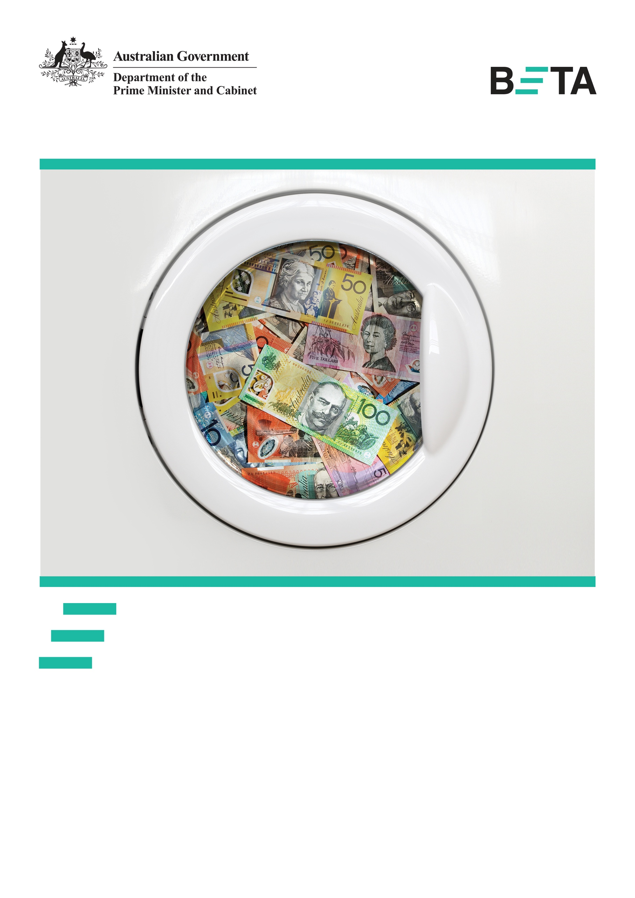

Energy labels
that make cents
Testing energy rating labels
on appliances sold online
March 2018
Who

Who are we?
We are the Behavioural Economics Team of the Australian Government, or BETA. We are the Australian Government’s first central unit applying behavioural economics to improve public policy, programs and processes.
We use behavioural economics, science and psychology to improve policy outcomes. Our mission is to advance the wellbeing of Australians through the application and rigorous evaluation of behavioural insights to public policy and administration.

What is behavioural economics?
Economics has traditionally assumed people always make decisions in their best interests. Behavioural economics challenges this view by providing a more realistic model of human behaviour. It recognises we are systematically biased (for example, we tend to satisfy our present self rather than planning for the future) and can make decisions that conflict with our own interests.

What are behavioural insights and how are they useful for policy design?
Behavioural insights apply behavioural economics concepts to the real world by drawing on empirically-tested results. These new tools can inform the design of government interventions to improve the welfare of citizens.
Rather than expect citizens to be optimal decision makers, drawing on behavioural insights ensures policy makers will design policies that go with the grain of human behaviour. For example, citizens may struggle to make choices in their own best interests, such as saving more money. Policy makers can apply behavioural insights that preserve freedom, but encourage a different choice – by helping citizens to set a plan to save regularly.

Contents
Executive summary 4
Why? 6
What we did 8
Results 12
Limitations 15
Discussion and conclusion 16
Appendices 17
Appendix A – Prior research on energy label effectiveness on consumer purchasing behaviour 17
Appendix B – Trial design and technical details 19
Appendix C – List of experimental appliances 23
Appendix D – Interpretation of results, trial limitations, and additional results 25
References 33

Executive summary
In 2015, Australian households contributed 11.1 per cent of Australia’s carbon emissions (Commonwealth of Australia, 2017), with about 45 per cent of these carbon emissions accounted for by household appliances and equipment (Reidy and Milne, 2017). Lower efficiency appliances contribute greater emissions and cost consumers more to run.
To encourage production of more energy efficient appliances and assist consumers to make more informed choices, the Australian Government requires an Energy Rating Label on appliances sold in stores. This requirement does not extend to appliances sold online.
Energy labels can provide important information on energy consumption and running costs, which consumers may otherwise be unaware of when making decisions about which appliances to buy. Absence of this information could lead them to undervalue more efficient appliances. Higher energy efficient appliances often cost more up-front, but over time can lower household energy bills and reduce overall emissions. The Energy Rating Label aims to help consumers compare the energy efficiency of similar appliances by providing information on average annual energy use in kilowatt-hours (kWh) and assigning a star rating to each appliance.
In partnership with the Department of the Environment and Energy (DoEE) and Appliances Online we conducted a randomised controlled trial (RCT) to test the impact of energy labels on decisions made by Australian consumers shopping for appliances in an online environment. We assessed the impact of the Energy Rating Label and we used behavioural insights to design and test an alternative label.
Growing evidence from behavioural economics shows most people have difficulty making decisions when they have to weigh immediate costs against future benefits accruing slowly over time, and comparing multiple options with multiple attributes. To address this, we designed a simple, more salient label to inform consumers of how much money they could avoid losing by buying a more efficient appliance compared to the lowest rated, one-star appliance of the same size and capacity.
Information on the alternative label was expressed in simple dollar terms rather than the more abstract kWh metric. We expected this form of labelling would make consumers more aware of hip-pocket costs – for example, a person buying a four-star top mount fridge could avoid losing $1,700 in lifetime running costs compared to a one-star top mount fridge.

We found energy labels have positive effects on consumer behaviour compared to no labels. These effects are large enough to warrant consideration by policy makers interested in the twin policy goals of reducing carbon emissions and household energy costs. For example, consumers who viewed the labels were 11 per cent more likely to add higher efficiency appliances to the cart and 20 per cent more likely to purchase higher efficiency appliances than consumers who did not see a label. However, most of our estimates are not ‘statistically significant’ according to conventional tests, so for these and related reasons, we only have moderate statistical confidence in this conclusion.
Our alternative behaviourally-informed label – presenting lifetime running costs as avoided losses – was not found to be any more effective than the Energy Rating Label at encouraging consumer interest in higher efficiency appliances. A possible explanation for this result is the way the information was presented. Framing information about lifetime running costs as ‘avoided losses’ may have confused consumers. In an online environment, consumers may be more familiar with simple calls to action to ‘save’ money rather than to ‘avoid losing’ money.

Box 1: Appliances Online
Established in 2005, Appliances Online is an Australian online retailer of white goods and home appliances. The company is a subsidiary of the family-run Winning Group, encompassing Big Brown Box and Winning Appliances.
Appliances Online’s product range includes fridges, freezers, washers, dryers, dishwashers, ovens and TVs.
The company has more than 300,000 consumers nation-wide.

Why?

Policy context
The National Energy Productivity Plan (NEPP) seeks to deliver a 40 per cent improvement in Australia’s energy productivity by 2030 (COAG Energy Council, 2015). Better energy productivity helps consumers manage energy costs and helps meet Australia’s 2030 greenhouse gas emissions reduction target. One of the ways the NEPP is looking to drive greater energy efficiency is by empowering consumers with information to make better energy consumption choices (COAG Energy Council, 2015). Household appliances and equipment account for approximately one-third of household energy use and about 45 per cent of household greenhouse gas emissions (Reidy and Milne, 2017).
The Australian Government employs a range of strategies to help consumers reduce household energy use and emissions. One of these strategies is to provide information on the energy efficiency of different appliances through the Energy Rating Label.
The Greenhouse and Energy Minimum Standards Act 2012 implements the commitments of the Australian Government and the Council of Australian Governments (COAG) to establish national legislation to regulate energy efficiency and labelling standards for appliances and other products. This legislation allows the Australian Government to set nationally consistent labelling requirements to increase Australians’ awareness of options to improve energy efficiency and reduce energy consumption, energy costs and greenhouse gas emissions.
In Australia it is mandatory for retail stores in every state and territory to display the Energy Rating Label on a range of appliances. The label summarises an appliance’s energy efficiency in two ways. It displays a star rating (out of a possible 10) indicating how energy efficient the appliance is compared with similar models of the same size or capacity. The label also provides an estimate of how much energy (in kilowatt-hours or kWh) the appliance will use over a year.
Energy Rating Labels are displayed as stickers prominently placed on the front of these appliances. It is not mandatory for online retailers to display the label next to such appliances.

The problem
The impact of energy labels on consumer purchasing behaviour is largely unknown. Existing evidence on the effects of energy labels is limited and largely comes from studies conducted in laboratory and hypothetical choice settings (see Appendix A). These studies may not accurately reflect how consumers behave when making real buying decisions, especially in an online environment. Field trials with labels are rare, have to date been conducted only outside Australia, and have yielded mixed results.
A consumer survey conducted by the COAG Energy Council’s Equipment Energy Efficiency (E3) Committee assessed respondent awareness and understanding of the Energy Rating Label on air conditioners. It found label recognition to be high, with approximately 97 per cent of those surveyed saying they recognised the label. In contrast, label understanding and interpretation were considerably lower, at 72 per cent (ACIL Allen Consulting, 2014).
While these results are encouraging, it is important to note survey measures of self-reported awareness and knowledge are notoriously biased upwards and tend to overstate true levels of awareness and knowledge (Bishop et al., 1986). Awareness and knowledge of a label also do not necessarily imply the label is helpful in informing consumer choices.

What we did

What we did for this study
BETA and DoEE developed this trial to test whether energy labels are effective at encouraging consumers to purchase more energy efficient appliances and whether an alternative label, presenting key information in a new way to take into account some common behavioural biases, might be more effective than the Energy Rating Label.

Behavioural analysis
Consumers may under-invest in energy efficient appliances that would save them money over time due to lower operating costs. This is sometimes referred to as the ‘energy-efficiency gap’ (Jaffe and Stavins, 1994). Insights from behavioural economics help explain this gap and how it might be bridged.
In general, the research indicates people have difficulty making rare and infrequent decisions – like decisions about purchasing a large appliance – when it requires analysing a great deal of information, some of it technical and unfamiliar. Difficulties making decisions also arise when comparing multiple options with multiple attributes, and weighing immediate costs – including a higher sticker price – against future benefits accruing slowly over time, such as lower running costs. People often use quick ‘short cuts’ or heuristics to simplify problems and make a quick choice, ignoring critical information; for example, efficiency and what it means for the overall cost of an appliance.
One way to help people overcome this problem is to provide simple information in a salient way. An obvious approach is to modify the Energy Rating Label and provide people with the dollar cost of operating the appliance rather than information on kWh used, as people may struggle to understand and make use of the latter. Another approach we could use here is to frame energy consumption information in terms of the money people would lose in extra running costs if they choose not to buy the more efficient appliance. People tend to worry more about losses than they value gains of the same magnitude (Kahneman and Tversky, 1979; 1984). A label framing the lifetime running costs of alternative appliances in terms of avoided losses, rather than amounts saved, may therefore have a larger impact.

Based on these behavioural insights we designed an alternative label with a modified energy consumption figure. The energy consumption figure in the alternative label shows the avoided financial loss, in terms of lifetime running costs, of purchasing the appliance compared to the lowest rated, one-star appliance of the same size and capacity. This provides a relative measure the consumer can use to identify which appliance will help them reduce spending over the appliance’s life. For example, a person buying a four star top mount fridge could avoid losing $1,700 in lifetime running costs compared to if they bought a one star top mount fridge.
The alternative label was otherwise identical in size, shape, and colour, and, as with the Energy Rating Label, it included the graphical star rating. This was to ensure the only difference between the two labels was the way information about the appliance’s energy consumption was presented. The different label designs are presented in Figure 1.
Figure 1: Energy label designs
Energy Rating Label | Alternative label
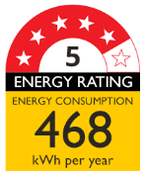

Box 2: Common biases affecting human behaviour
Cognitive overload may lead people to forget things, delay decisions, stick to the default option or otherwise make an inferior choice when presented with too much information.
Inattention to key considerations, as people simplify a complex decision by processing only a limited subset of information.
Loss aversion is encapsulated in the expression ‘losses loom larger than gains’ as the pain of losing is psychologically about twice as powerful as the pleasure of gaining. Loss aversion explains why people tend to prefer avoiding losses to acquiring equivalent gains.
Present bias is when people overweight the immediate implications of their decisions compared with the impacts they have in the future.

The trial
We ran a RCT where just under 40,000 visitors to the Appliances Online website during the trial period (1 to 29 March 2017) were randomly assigned to one of three groups. The control group (13,142 people) always viewed the website in the standard form – with no energy rating labels. Another group (13,199 people) saw the website with the Energy Rating Label positioned next to each experimental appliance. The third group (13,273 people) saw the website with the alternative label positioned next to each experimental appliance.
Box 3: What is a randomised controlled trial?
Well-designed randomised controlled trials (RCTs) provide the best empirical method for determining a policy’s quantifiable impacts. In this respect, RCTs are considered the ‘gold standard’ for impact evaluation. RCTs work by randomly separating people into two or more groups, in a manner similar to flipping a coin. People in a ‘treatment’ group receive an intervention (new policy) while people in the ‘control’ group receive the business-as-usual experience. On average, the difference in outcomes between people in a treatment group and in the control group reflects the causal impact of the new policy.
We displayed label designs on the Appliances Online website next to some, but not all, appliances. The labelled appliances included 34 of their most popular appliances, hereafter referred to as ‘experimental appliances’, in four appliance categories: smart TVs, vented dryers, fridges, and washing machines. Experimental appliances appeared on two types of web pages: the ‘filter page’ for each appliance category; and the ‘appliance page’ associated with each experimental appliance. See Figure 2 and Figure 3 for examples of each web page.
To gauge the impact of the labels on shopping behaviour, we examined three key outcomes:
- Customer engagement: clicks on experimental appliances to view more detailed appliance information.
- Customer intent-to-purchase: clicks to add experimental appliances to the online shopping cart.
- Customer purchases: clicks to complete payment for experimental appliances in the shopping cart.
We classified the experimental appliances as ‘higher efficiency’ or ‘lower efficiency’ (see Appendix B for details). For higher efficiency appliances, we anticipated more people who saw the versions of the web pages with the Energy Rating Label or the alternative label would click on, add to cart and purchase experimental appliances than people who saw no energy label. The information contained on the labels was designed to help consumers understand the value associated with higher energy efficiency appliances compared with lower efficiency appliances, and make them more appealing.
We also anticipated more people shown the alternative label would click to view, add to cart and purchase experimental appliances than those who saw the Energy Rating Label. This is because we expected information on avoided financial losses, in terms of lifetime running costs, would be more powerful than information on energy consumption presented in kWh.
More detail on the trial design is in Appendix B.
Figure 2: Screen shot of experimental filter page
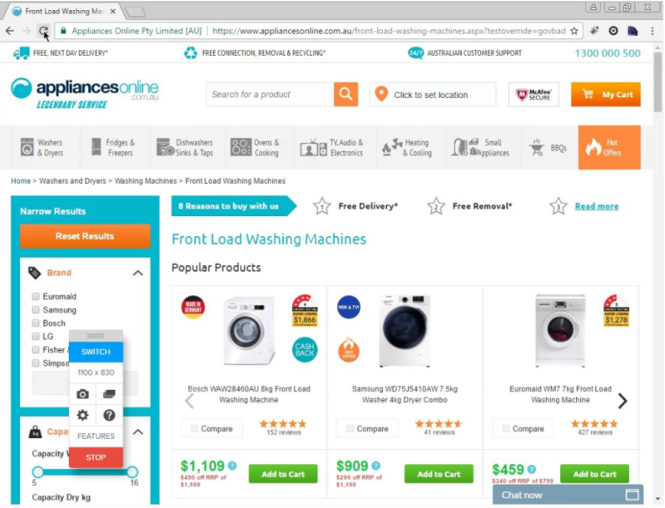

Figure 3: Screen shot of experimental appliance page
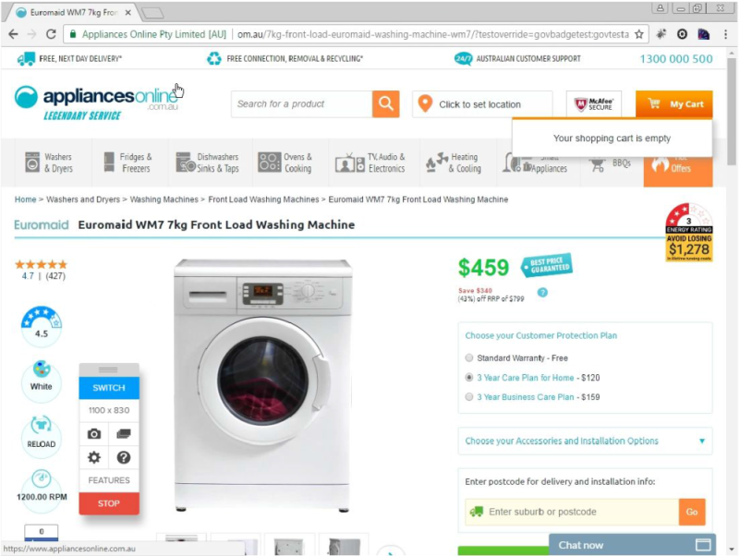

Results
Our best estimate of results is labels have positive effects on consumer behaviour large enough to matter for the twin policy goals of reducing carbon emissions and household energy costs. However, most of our results are not ‘statistically significant’ according to conventional tests so, for this and related reasons, we have only moderate statistical confidence in this conclusion.
The outcomes for higher efficiency experimental appliances were consistently greater for consumers who viewed either of the energy labels than among consumers in the control group who did not see a label (see Figure 4, Table 1 and Table 2). For example, when we compared the no-label control group with the pooled results for the two treatment groups:
- customer engagement (click) increased by 3.7 per cent, from 10.8 per cent for the control group to 11.2 per cent for the combined treatments (p=0.32)
- customer intent-to-purchase (add to cart) increased by 11 per cent, from 3.6 per cent to 4.0 per cent (p=0.04)
- customer purchases (purchase) increased by 20 per cent, from 1.0 per cent to 1.2 per cent (p=0.09).
These results are consistent in their direction, in that they all suggest increased interest in higher efficiency experimental appliances, and the effect of energy labels in increasing experimental appliance add to carts and purchases was large. However, most of the estimates are not ‘statistically significant’ for the conventional threshold of p<0.05, and have wide confidence intervals. These and related grounds for caution are discussed in Appendix D along with additional results and analysis, and further discussion of trial limitations.

Table 1: Outcomes for higher efficiency experimental appliances
 | Control Group (no label) | Energy Rating Label | Alternative Label | Either label (pooled)
Number of consumers | N=13,142 | N=13,199 | N=13,273 | N=26,472
Click | 10.8%  (n=1,424) | 11.2%  (n=1,473) | 11.2%  (n=1,485) | 11.2%  (n=2,958)
Add to cart | 3.57%  (n=469) | 3.99%  (n=527) | 3.97%  (n=527) | 3.98%  (n=1,054)
Purchase | 1.01%  (n=133) | 1.23%  (n=163) | 1.18%  (n=156) | 1.21%  (n=319)
Table 2: Differences in outcomes for higher efficiency experimental appliances
 | Control Group vs Energy Rating Label | Control Group vs Alternative Label | Energy Rating Label vs Alternative Label | Control Group vs Either Label (pooled)
Click | 0.32%  p=0.41  (-0.44, 1.08) | 0.35%  p=0.36  (-0.41, 1.11) | -0.028%  p=0.94  (-0.73, 0.79) | 0.34%  p=0.32  (-0.32, 0.98)
Add to cart | 0.42%  p=0.07  (-0.04, 0.89) | 0.40%  p=0.09  (-0.06, 0.86) | -0.022%  p=0.92  (-0.49, 0.45) | 0.41%  p=0.04  (0.02, 0.81)
Purchase | 0.22%  p=0.09  (-0.03, 0.48) | 0.17%  p=0.20  (-0.09, 0.41) | -0.060%  p=0.66  (-0.32, 0.20) | 0.20%  p=0.09  (-0.02, 0.41)
Note: results are reported as “difference in proportions, p-value (95% confidence interval)”. In some instances, the differences in proportions appear inconsistent with those that can be inferred from Table 1. This is due to rounding.
Figure 4: Increase in outcomes for higher efficiency appliances, labels (Pooled) versus no label (Control), percentage points
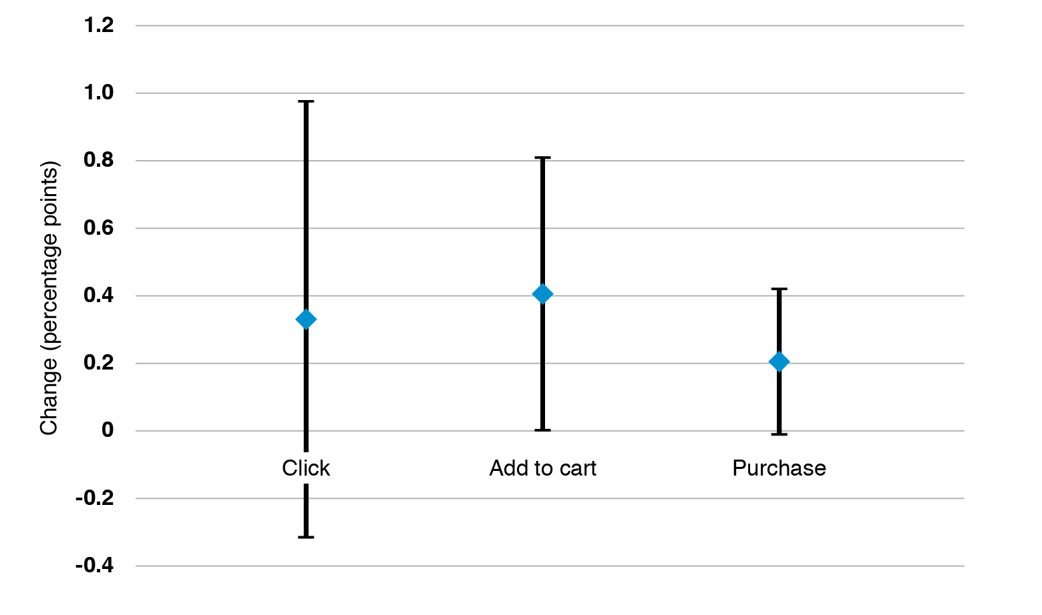
Note: The error bars are 95% confidence intervals.

Did the alternative label have more impact than the Energy Rating Label?
We found no clear difference between the Energy Rating Label and the alternative label we designed for the trial, in terms of experimental appliance clicks, add to carts and purchases. The differences in the proportions of consumers clicking to view, adding to cart, and purchasing experimental appliances among those who saw the Energy Rating Label and those who saw the alternative label (see the third column in Table 2) are close to zero in each case. This means we found no evidence for the alternative label having more or less impact on consumer behaviour than the Energy Rating Label.

Limitations
The principal limitations of this trial relate to variations from our pre-analysis plan. We discuss these variations, and our justification for them, in Appendix D. In brief, these relate to our choice of primary outcome variable (from the three available), our decision to pool the results for the two treatment groups (who viewed either the Energy Rating Label or the alternative label), and our preferred method of analysis, which assessed consumer preferences for higher efficiency experimental appliances.
The sample size for the study was smaller than anticipated. This means our estimates of label effects are less precise than expected. We excluded a sub-sample of trial participants (n=18,734 or 32 per cent of the entire sample) who came to the Appliances Online website via a link (for example, from a search engine) leading them directly to a detailed appliance page, without ever navigating to a filter page where they could have made appliance comparisons. More detail on this and other data exclusions are set out in Appendix B.
About 10 per cent of the trial sample saw an incorrectly rendered label (either the Energy Rating Label or the alternative label) when they visited the website and so we excluded them from the analysis. The trial duration was extended to compensate for this loss of sample.
We also faced trial design restrictions in relation to the number of labelled appliances and the size of the labels and we made a series of choices about the design of the alternative label. Other designs may have had a greater impact.
Finally, we faced some minor technical limitations (see Appendix D).

Discussion and conclusion
Energy labels are widely used and mandated across the world. They provide important information on energy consumption and running costs, of which consumers may otherwise not be aware when making decisions about which appliances to buy. Absence of this information could lead them to undervalue more efficient appliances. As far as we are aware, this is the first time the Energy Rating Label has been tested.
The results of this trial suggest the presence of energy labels in an online environment have a positive impact on customer behaviour when it comes to purchasing higher efficiency appliances.
However, we found no evidence for our alternative behaviourally-informed label – presenting lifetime running costs as avoided losses – being any more effective than the Energy Rating Label at encouraging consumer interest in higher efficiency appliances. This finding does not mean behavioural designs do not work: other label designs may perform better in terms of attracting attention of consumers and encouraging consideration of energy efficiency.
Further research replicating this trial and correcting for limitations would provide increased confidence in the results. In seeking to optimise energy label effectiveness, further research may investigate what labels work best to help people quickly compare appliances and make well-informed choices aligned with their goals, in store settings as well as in online environments.
Running trials to inform policy in government is still fairly new. BETA has been established to demonstrate the value of incorporating rigorous, experimental evidence in policy design and is learning from running trials in its own right. This trial has generated lessons for policy makers, in particular the importance of testing to build an evidence base for what works.
The trial also generated several lessons for BETA and others conducting research in this area. In particular, the importance of reviewing pre-analysis plans before trial implementation, conducting small-scale pilots before launching the trial, understanding the format of the raw output data, and using qualitative data such as interviews and focus groups to inform the trial design.

Appendices
Appendix A – Prior research on energy label effectiveness on consumer purchasing behaviour
Mandatory energy labels are now required by governments in many countries to help inform consumer choices when purchasing household appliances. Labels can present information about the appliance’s energy consumption in physical units for a single use or in typical use over a period of time (for example, kWh per year): the latter is the approach used in the US EnergyGuide and Canadian EnerGuide labels. Labels can also show ratings allowing simple comparisons between similar appliances in terms of energy efficiency. For example, the EU Energy label assigns appliances letter grades from A to G. The Energy Rating Label combines these approaches, providing information on energy consumption for each appliance along with a rating in the form of a number of stars on a 10-star scale.
To date, few studies have attempted to rigorously assess the extent to which energy labels affect real consumer choices. Most studies were laboratory experiments or survey experiments examining how individuals respond to different information on labels when considering hypothetical choices between appliances. These studies tended to investigate whether providing information about consumption in terms of dollar costs rather than in physical units, or providing these measures over shorter or longer periods, makes a difference to (hypothetical) choices. The evidence, while mixed, seems to suggest providing monetary information has a larger impact on stated choices as long as the operating costs are calculated over the appliance’s expected lifetime.
To our knowledge only four field experiments have examined the impacts of energy labels on real purchasing decisions. Results from these studies are mixed, but on balance provide limited evidence for energy labels influencing consumer choices. An early experiment run in Canadian stores tested versions of the Canadian EnerGuide label showing energy consumption in either kWh a month or dollars a year (combined with sales staff pointing out this information to consumers as they shopped) applied to refrigerators (Anderson and Claxton, 1982). A similar type of experiment was conducted more recently in Norway in stores selling fridge-freezers and tumble driers, with labels (displayed in addition to the mandatory EU Energy label) providing information about lifetime running costs (Kallbekken et al., 2013). Both studies report only weak or no impacts from energy labels on the energy efficiency of appliance purchases.
In another study conducted in UK stores, researchers displayed labels showing lifetime running costs information on washing machines, washer-dryers and tumble dryers. Some stores contained labelled appliances where others did not. The researchers also trained staff in these stores in how to communicate lifetime running cost information to consumers. During the trial period, washing machines and tumble dryers sold in the labelled stores were no more energy efficient on average than those sold in the other stores. In contrast, washer dryers sold in the labelled stores were 0.7 per cent more energy efficient on average than those sold in the non-labelled stores. Yet it was not possible to isolate the influence of the label on customer purchasing decisions from staff training influences (Department of Energy and Climate Change, 2014).
In the most recent field trial, Stadelmann and Schubert (2018) examined online purchasing of freezers, tumble driers, and vacuum cleaners in Switzerland and assessed the impact of the EU Energy Label compared with an alternative label showing the lifetime operating costs of each appliance in monetary terms. The results were again mixed: while showing either of the labels on the site increase the sales proportion of the more energy efficient appliances, the labels also induce consumers to purchase large volume freezers, and the monetary-cost label appeared to lead consumers toward purchasing less efficient vacuum cleaners.
Appendix B – Trial design and technical details

Experimental design
Our study tested two different energy labels for 34 experimental appliances sold on the Appliances Online retail website. We chose the experimental appliances from four appliance categories across seven appliance types:
- smart TVs
- vented dryers
- fridges (bottom-mount, top-mount, and multi-door)
- washing machines (front-load and top-load)
All experimental appliances had a star rating of greater than one. This allowed us to compare each appliance to a one-star rated appliance in the same category, helping us calculate the ‘avoided cost’ in lifetime running expenses for each experimental appliance.
We classified the 34 experimental appliances as ‘higher efficiency’, ‘lower efficiency’ or neither by ranking appliances within each of the four appliance categories according to their energy efficiency ratings. We classified all appliances above the median (within an appliance category) as ‘higher efficiency’ while appliances below the median were classified as ‘lower efficiency’. A list of all experimental appliances and their classification within each category is provided in Appendix C.
Experimental appliances appeared on two types of experimental web pages:
- ‘filter pages’ for each of the seven appliance types
- ‘appliance pages’ associated with each experimental appliance
Filter pages featured labels to the right of each experimental appliance. This allowed consumers to make a ready comparison of the energy efficiency of similar appliances. When a consumer clicked on a particular appliance, they were taken to an appliance page where they could see a close-up image of the appliance and additional appliance information. Appliance pages for each experimental appliance displayed a label in the top right-hand corner of the page.

Power calculations
The trial pre-registration reports the power analysis used to determine how many people we would need in the trial to detect an effect of the labels (if indeed they have an effect). Specifically, the pre-registration states that a sample of approximately 48,000 non-unique visitors to the experimental filter pages will provide at least 80 per cent power at a five per cent significance level (with two sided tests) to detect a five per cent increase in ‘customer engagement’ (that is, clicks to view detailed information about labelled appliances). While we expected around 48,000 visitors over the trial period, the eventual number – after data cleaning (described below) – was 39,614.

The sample frame and data
The trial took place between 1 March and 29 March 2017. The eligible participants were all visitors to the Appliances Online website during this period.
We received the raw data from Appliances Online in four data sets (described below). Each of these data sets had separate records for each ‘domain session ID’. A new session commenced: whenever a visitor left the site and returned to it later, or after 15 minutes on the site. Whenever visitors allowed cookies on their web browser, we collated multiple sessions into a single record (‘device ID’). If the visitor did not allow cookies then it was not possible to collate multiple sessions on the site. Each session was treated as a separate record in our cleaned data. Thus, with this exception, we applied our randomisation procedure to each device, not to each session.
The four raw data sets were as follows:
- Filter page views: this captured all visitors to the experimental filter pages and provided the denominator for the outcome variables.
- Filter page events: this captured only those visitors who clicked for more information (or added an appliance to cart directly from the filter page).
- Appliance page events: this captured all visitors who viewed an appliance page and it also captured whether those visitors added the appliance to cart.
- Purchase events: this captured all purchases by visitors who had added an appliance to cart.
We merged these four data sets together based on the ‘device IDs’ derived from the ‘domain session IDs’ in the Filter Page Views dataset. However, some domain session IDs in the other three data sets did not correspond to a device ID (or domain session ID) in the first data set – we dropped these records from the analysis. We were unable to determine why this mismatch occurred however the total number of records dropped was small (less than three per cent of the total) and were evenly distributed between the experimental groups. We believe that it is unlikely that this caused any selection bias.
Finally, we took the combined data set and merged two additional data sets with appliance information for each appliance (for example, kWh, star rating and appliance price). We used these variables in exploratory analysis discussed in Appendix D.

Randomisation
The trial was an individually randomised controlled trial. Appliances Online randomly assigned participants (that is, devices) to the control group and two treatment groups with an even (1:1:1) allocation ratio. Specifically, the randomisation code allocated 13,142 devices to the control group, 13,199 devices to the group who saw the Energy Rating Label and 13,273 devices to the group who saw the alternative label.
Participants were not stratified and we did not conduct balance checks due to the lack of any suitable variables.

Outcome measures
To gauge label effects on shopping behaviour, we examined three key outcomes:
- Customer engagement: clicks on experimental appliances to view more detailed appliance information.
- Customer intent-to-purchase: clicks to add experimental appliances to the online shopping cart.
- Customer purchases: clicks to complete payment for experimental appliances in the shopping cart.
We defined the three outcome measures for each website visitor as binary variables. The definitions are set out in the table below.
Table B1: Outcome variable definitions
Outcome variable | Definition
Customer engagement | 1 = the visitor clicked for more information for at least one higher efficiency appliance  0 = otherwise
Add to cart | 1 = the visitor added at least one higher efficiency appliance to cart  0 = otherwise
Purchase | 1 = the visitor purchased at least one higher efficiency appliance  0 = otherwise

Analysis
For each experimental group, we derived percentages for each outcome variable. For example, we derived the percentage of website visitors who purchased at least one higher efficiency experimental appliance, as a proportion of all visitors.
To account for these percentages, we analysed the results using a z-test to compare proportions across experimental groups (specifically, using the prtesti command in Stata). This method tests whether there is a difference in the proportions for two experimental groups.
The method described above was our preferred method of analysis. We also produced results based on two variations to this preferred method. Both variations altered the definition of the outcome variable but used the same test-of-proportions method. See Appendix D for further discussion and results.
Appendix C – List of experimental appliances
Table C1: List of appliances that formed part of the trial
(‘higher efficiency appliances’ are shaded dark grey)
Product | Type | Model | Star rating
Televisions | Smart TV | 32P1S | 6
 | Smart TV | 55UH652T | 6
 | Smart TV | UA75JU6400 | 5
 | Smart TV | 50E5900US | 5
 | Smart TV | UA40KU6000 | 4
 | Smart TV | UA50KU6000 | 4
 | Smart TV | UA55KU6000 | 4
 | Smart TV | UA60KU6000 | 4
Refrigerators | Bottom mount | SRL458ELS | 4
 | Bottom mount | SRL457MW | 4
 | Bottom mount | WBE5300SARH | 3.5
 | Multi-door | RF522ADUSX5 | 3.5
 | Top mount | SR318LSTC | 3.5
 | Top mount | SR254MW | 3.5
 | Multi-door | WHE5200SA-D | 3
 | Multi-door | EQE6207SD | 3
 | Multi-door | SRF583DLS | 2.5
 | Top mount | HRF224FW | 2.5
Washing Machines | Front load | WAW28460AU | 4
 | Front load | WAE22466AU | 4
 | Front load | WW75J4233GW | 4
 | Front load | WD1200D | 3.5
 | Front load | WD12021D6 | 3.5
 | Front load | WM7 | 3
 | Top load | WA80F5G4DJW | 2.5
 | Top load | WA65F5S2URW | 2
Clothes Dryers | Vented | DE5060M1 | 2
 | Vented | DE4060M1 | 2
 | Vented | EDV6051 | 2
 | Vented | DM4KG | 2
 | Vented | DE6060G1 | 2
 | Vented | MDV07 | 2
 | Vented | 39P400M | 1.5
 | Vented | 39S500M | 1.5

Appendix D – Interpretation of results, trial limitations, and additional results
This Appendix provides further discussion of our interpretation of the results reported in the Results section along with the results of additional analysis. It is structured as follows:
- Section D.1 provides context by discussing the current academic debate about the use of ‘statistical significance’ and ‘p-values’ to interpret results.
- Section D.2 expands on our interpretation of the results and presents our justification for our ‘preferred method of analysis’, along with some notes of caution.
- Section D.3 discusses other trial limitations.
- Section D.4 describes additional analysis of the impact of energy labels on lower efficiency appliances.
- Section D.5 presents the results of alternative methods of analysis for all appliances.

D.1 The debate about statistical significance and p-values
Our findings are based, in part, on the ‘p-values’ associated with our estimates and on the conventional test for a ‘statistically significant’ finding of p<0.05. However, there is a very lively academic debate about the misinterpretation of p-values, the merits of testing for ‘statistical significance’, and how much weight to put on p-values as evidence for or against a hypothesis. Consequently, the American Statistical Association (ASA) took the unusual step of releasing a Statement on Statistical Significance and P-Values (Wasserstein and Lazar, 2016). Two principles from the ASA’s statement are particularly striking:
- Principle 3. Scientific conclusions and business or policy decisions should not be based only on whether a p-value passes a specific threshold. Practices that reduce data analysis or scientific inference to mechanical “bright-line” rules (such as “p < 0.05”) for justifying scientific claims or conclusions can lead to erroneous beliefs and poor decision making. A conclusion does not immediately become “true” on one side of the divide and “false” on the other. Researchers should bring many contextual factors into play to derive scientific inferences, including the design of a study, the quality of the measurements, the external evidence for the phenomenon under study, and the validity of assumptions that underlie the data analysis.
- Principle 6. By itself, a p-value does not provide a good measure of evidence regarding a model or hypothesis. Researchers should recognize that a p-value without context or other evidence provides limited information. For example, a p-value near 0.05 taken by itself offers only weak evidence against the null hypothesis.
An alternative position in the debate on p-values, put forward by 72 co-authors, argued that statistical significance (for ‘new findings’) should require a more stringent threshold of p<0.005 (Benjamin et al., 2017). In response, 84 co-authors argued that a stricter threshold could be counterproductive and proposed instead that researchers ‘should justify their choice of alpha level [that is, their threshold for statistical significance] before collecting the data, instead of adopting a new uniform standard on a case-by-case basis’ (Lakens et al., 2017). Some have gone further and have argued that statistical significance testing should be abandoned (McShane et al., 2017; Amrhein and Greenland, 2018).

D.2 Interpretation of results and grounds for caution
In interpreting our results, we have sought to accommodate the principles of the ASA Statement on Statistical Significance and P-Values to the extent possible while still reporting our results against the conventional thresholds for statistical significance. For example, we are mindful that statistical significance is different from practical significance (ASA Statement, Principle 5). Our estimates for the effect sizes of energy labels on, for example, the purchase of higher efficiency experimental appliances were large. If these estimates reflect a true effect, they are highly material for government policy and so should not be overlooked. But nor should we overlook that there are several reasons to be cautious about these results, which is why we conclude that we only have moderate confidence that these results do, in fact, reflect a true effect of energy rating labels.
One ground for caution relates simply to the p-values themselves. Most of our estimates did not meet the p<0.05 threshold, which is potentially exacerbated by the fact that we ran multiple tests. To address the issue of multiple tests, we specified Customer Engagement as our primary outcome because we expected it would have the most power to detect an effect of the energy labels (see the section of our pre-analysis plan on Sample Size and Statistical Power, pp.10-11).
As it turns out, it yielded the smallest effect size in comparison to the other outcomes and, associated with this, a larger p-value.

We shifted our focus away from Customer Engagement as the primary outcome for two reasons. First, it is the least important outcome from a substantive perspective since our ultimate interest is in how energy labels influence purchases, not clicks for more information. Second, we measured Customer Engagement through a binary variable – ‘yes’ if they clicked on at least one higher efficiency experimental appliance; ‘no’ otherwise – that, on reflection, may only give a weak indication of a customer’s engagement with higher efficiency experimental appliances. Given this, and the greater substantive importance of purchases for our research question, we regard add to cart and purchases as preferable primary outcomes.
A related concern about multiple tests is that we report three sets of results: treatment one (Energy Rating Label) against control; treatment two (alternative label) against control; and the pooled treatments against control. Our hypothesis was the alternative, behaviourally-informed label would have greater impact than the Energy Rating Label. Once we found there was no evidence one label had more impact than the other, we pooled the treatments, which gave us a single test for our hypothesis that the information in the labels would influence consumer behaviour (compared to no labels).
Our preferred approach to interpreting our results is, therefore, to focus on the pooled results for the two treatments and, within those pooled results, to focus on the add to cart and purchase outcome variables. Both of these choices represent variations from our pre-analysis plan because we did not anticipate the need to pool treatments, and because we specified a different primary outcome.
A further ground for caution is that we conducted four separate data analyses, which increases the probability a ‘statistically significant finding’ is just a chance result (Simmons et al., 2011). The different methods we considered are described immediately below.
Method 1 (preferred approach): Our preferred method focused on higher efficiency experimental appliances (appliances that had above-median efficiency within that appliance category: see Appendix B for details). This allowed us to test, for example, whether there were more purchases of higher efficiency experimental appliances by consumers who saw an energy label than those who did not. This is the policy question we sought to answer. It is also consistent with statements in our pre-analysis plan that we expected higher ratings would lead to greater interest (and purchases) among consumers, although our plan could have stated this more clearly.

Method 2 (preferred approach but different ‘base population’): Our initial attempt at our preferred method used a different ‘base population’ for each of the outcome variables. In our preferred method, the base population is constant for all three outcome measures: it is simply the total number of visitors to the experimental pages on the Appliances Online website. In Method 2, the base population changed so the base for the add to cart outcome variable was the number of visitors who clicked on an experimental appliance on the filter page and the base for the purchase outcome variable was the number of visitors who added an experimental appliance to the shopping cart. This method is inferior because, by changing the base population after each navigation stage of the website, we were potentially introducing selection bias into our outcome measures in a similar manner to how systematic bias in attrition can introduce selection bias. That is, in Method 2 we effectively changed our control and treatment groups by excluding visitors who did not click or add to cart and, as a result, the altered control and treatment groups may no longer be ‘statistically identical’.
Method 3 (all appliances, not just higher efficiency appliances): We also assessed the impact of energy labels on the relative demand between treatments and control for all experimental appliances, whereas our preferred method focused on the impact of labels on higher efficiency appliances. Since the experimental appliances all had a rating greater than one star, Method 3 effectively tests whether consumers interpreted the energy labels as conveying positive information, leading to greater interest in purchasing those appliances than if they were unlabelled. This question has less policy relevance since it says nothing about whether energy labels influenced decisions within the set of greater-than-one-star appliances. However, our pre-analysis plan implied this would constitute part of our analysis so we report it for completeness in Section D.5 below.

Method 4 (mixed-effects model): Finally, we undertook a more complex method of analysis that went beyond what we anticipated in our pre-analysis plan and so was only intended to be exploratory in nature. Our preferred method of analysis is consistent with our original research proposal and produces results that are relatively straightforward to interpret. However, more advanced methods have the potential to exploit more of the richness in the data. Our preferred method of analysis did not include experimental appliances’ energy rating as an explanatory variable, which could give us an idea of how much the probability of purchase, add to cart, or click outcomes increases with each additional star rating. Similarly, our preferred method does not include other variables that could influence purchase decisions (‘covariates’) such as the appliance brand, size, or price, which could help improve the precision of our estimates. We therefore used a ‘mixed-effects model’ to include experimental appliances’ energy rating and price in our analysis. We did not, however, find evidence in support of any of our hypotheses. We will publish the results of this analysis in supplementary materials accompanying this report.
In conclusion, while we pursued four lines of analysis, we believe we have justification for opting for our preferred approach. In comparison, Method 2 has the potential to introduce selection bias, Method 3 only provides a partial answer to our underlying research question, and Method 4 is exploratory in nature since it was not anticipated in our pre-analysis plan.

D.3 Other trial limitations
As noted in the Limitations section, about 10 per cent of the trial sample saw an incorrectly rendered energy label when they visited the website. As a result, we excluded them from the analysis and we extended the trial duration to compensate for this loss of sample. This rendering issue only affected visitors with certain browsers and, in particular, those who had older browser versions and had not updated to more recent versions. The error affected similar proportions of visitors in each experimental group. To address this issue, all of the affected observations (visitors to the erroneously labelled sites) were excluded from the analysis.

The Limitations section also referred to some minor technical issues, as follows. We may have counted some consumers several times if they used multiple devices to access experimental website pages, although we expect this would apply to a relatively small number of observations. Similarly, we may have counted consumers several times if they blocked cookies on their browser, in which case we had no choice but to treat each website ‘session’ as a separate user. Conversely, we may have counted several people as one if they all used a single device. Again, we think the numbers involved were relatively small.
Lastly, since only some appliances in each category were labelled in the treatment groups, individuals would not have been able to use the labels to make comparisons (in relation to energy efficiency) between all appliances. It is possible individuals may have behaved differently if all appliances were labelled.

D.4 Additional results: lower efficiency appliances
The energy labels had no apparent effect on shopping choices for lower efficiency experimental appliances. For these appliances, the results are similar across the experimental groups (see Table 3 and Table 4). In other words, for all three outcomes (clicking to view appliance information, adding appliances to the cart, and making purchases) the differences between the control group and the treatment groups are close to zero and not consistently positive or negative in sign.
In the context of an increase in purchases of higher efficiency appliances, we might expect there to be a corresponding decrease in purchases elsewhere, reflecting a substitution of one appliance bought instead of another. For example, purchases of higher efficiency appliances instead of lower efficiency appliances. However, there are other such places from which these purchases could be substituted and it is not clear we should expect a corresponding decrease specifically in the set of lower-efficient labelled appliances to demonstrate this effect. Thus, we do not regard these results as necessarily being inconsistent with a positive effect of the labels.
Table D1: Outcomes for lower efficiency experimental appliances
 | Control Group (no label) | Energy Rating Label | Alternative Label | Either label (pooled)
Number of consumers | N=13,142 | N=13,199 | N=13,273 | N=26,472
Click | 5.26%  (n=691) | 4.97%  (n=656) | 5.40%  (n=717) | 5.19%  (n=1,373)
Add to cart | 1.79%  (n=235) | 1.73%  (n=228) | 1.78%  (n=236) | 1.75%  (n=464)
Purchase | 0.556%  (n=73) | 0.455%  (n=60) | 0.535%  (n=71) | 0.495%  (n=131)
Table D2: Difference in outcomes for lower efficiency experimental appliances
 | Control Group vs Energy Rating Label | Control Group vs Alternative Label | Energy Rating Label vs Alternative Label | Control Group vs Either label (pooled)
Click | -0.29%  p=0.29  (-0.82, 0.24) | 0.14%  p=0.60  (-0.40, 0.69) | 0.43%  p=0.11  (-0.10, 0.97) | -0.071%  p=0.77  (-0.54, 0.40)
Add to cart | -0.061%  p=0.71  (-0.38, 0.26) | -0.010%  p=0.95  (-0.33, 0.31) | 0.051%  p=0.75  (-0.27, 0.37) | -0.035%  p=0.80  (-0.31, 0.24)
Purchase | -0.10%  p=0.25  (-0.27, 0.07) | -0.021%  p=0.82  (-0.20, 0.16) | 0.080%  p=0.35  (-0.09, 0.25) | -0.061%  p=0.43  (-0.21, 0.09)
Note: results are reported as “difference in proportions, p-value (95% confidence interval)”

D.5 Additional results: supplementary analysis
As noted in Section D.2 above regarding Method 3, our pre-analysis plan implied we would analyse the difference between experimental groups for all appliances altogether, not just the higher efficiency appliances, although it was not as relevant to policy as our preferred approach. We report this analysis here for completeness only.

Did labels have an impact compared to no label?
Of the consumers who did not see a label (the control group), only 1.9 per cent purchased an experimental appliance. This increased to 2.0 per cent for consumers who saw the Energy Rating Label and the same for those who saw the alternative label (Table D3). There was a similar pattern of results for appliance add to carts but not for appliance clicks. For consumers who viewed the Energy Rating Label, a lower proportion clicked on an experimental appliance than those who viewed no label or the alternative label.
The differences between the experimental groups are shown in Table D4 along with 95 per cent confidence intervals around these mean differences (the p-values for the statistical tests). All of the confidence intervals span from a negative number to a positive number, including the possibility of no effect at all. If this experiment was repeated multiple times, we could expect the true effect to be included in such intervals 95 per cent of the time.

Did the alternative label have more impact than the Energy Rating Label?
The proportion of consumers who purchased a higher-efficient appliance was very slightly greater (0.02 per cent) among those who viewed the alternative label than those who viewed the Energy Rating Label. Statistically, there was very low confidence in this difference (p=0.91), as shown in Table D4. Thus, we conclude we did not find sufficient evidence the alternative label increased the probability of purchasing a labelled appliance relative to the Energy Rating Label.
Table D3: Outcomes for all experimental appliances
 | Control Group (no label) | Energy  Rating Label |  | Alternative  label | Either label (pooled)
Number of consumers | N=13,142 | N=13,199 | N=13,273 |  | N=26,472
Click | 17.9%  (n=2,348) | 17.6%  (n=2,319) | 17.9%  (n=2,377) |  | 17.7%  (n=4,696)
Add to cart | 6.30%  (n=829) | 6.57%  (n=867) | 6.59%  (n=875) |  | 6.58%  (n=1,742)
Purchase | 1.87%  (n=246) | 1.98%  (n=262) | 2.00%  (n=266) |  | 1.99%  (n=528)
Table D4: Difference in outcomes for all experimental appliances
 | Control Group vs Energy Rating Label | Control Group vs Alternative Label | Energy Rating Label vs Alternative Label | Control Group  vs Either label (pooled)
Click | -0.30%  p=0.53  (-1.22, 0.63) | 0.042%  p=0.93  (-0.88, 0.97) | 0.34%  p=0.47  (-0.58, 1.26) | -0.13%  p=0.76  (-0.93, 0.67)
Add to cart | 0.26%  p=0.39  (-0.33, 0.85) | 0.28%  p=0.35  (-0.31, 0.88) | 0.024%  p=0.94  (-0.57, 0.62) | 0.27%  p=0.30  (-0.24, 0.78)
Purchase | 0.11%  p=0.51  (-0.22, 0.45) | 0.13%  p=0.44  (-0.20, 0.47) | 0.019%  p=0.91  (-0.32, 0.36) | 0.12%  p=0.41  (-0.16, 0.41)
Note: (i) results are reported as “difference in proportions, p-value (95% confidence interval)”

References
ACIL ALLEN CONSULTING 2014. 'Energy rating labels review' report prepared for the Department of Industry (on behalf of the Equipment Energy Efficiency Committee). Canberra.
AMRHEIN, V. & GREENLAND, S. 2018. Remove, rather than redefine, statistical significance.
ANDERSON, C. D. & CLAXTON, J. D. 1982. Barriers to consumer choice of energy efficient products. Journal of Consumer Research, 9, 163-170.
AUSTRALIAN GOVERNMENT 2012. Greenhouse and Energy Minimum Standards Act 2012. In: GOVERNMENT, A. (ed.).
BENJAMIN, D. J., BERGER, J. O., JOHANNESSON, M., NOSEK, B. A., WAGENMAKERS, E.-J., BERK, R., BOLLEN, K. A., BREMBS, B., BROWN, L. & CAMERER, C. 2017. Redefine statistical significance. Nature Human Behaviour, 1.
BISHOP, G. F., TUCHFARBER, A. J. & OLDENDICK, R. W. 1986. Opinions on fictitious issues: The pressure to answer survey questions. Public Opinion Quarterly, 50, 240-250.
BULL, J. 2012. Loads of green washing—can behavioural economics increase willingness-to-pay for efficient washing machines in the UK? Energy policy, 50, 242-252.
COAG ENERGY COUNCIL 2015. National Energy Productivity Plan 2015-2030: Boosting competitiveness, managing costs and reducing emissions.
COMMONWEALTH OF AUSTRALIA 2017. National Inventory by Economic Sector 2015.
DEPARTMENT OF ENERGY AND CLIMATE CHANGE 2014. Evaluation of the DECC/John Lewis energy labelling trial. Department of Energy and Climate Change.
JAFFE, A. B. & STAVINS, R. N. 1994. The energy-efficiency gap What does it mean? Energy policy, 22, 804-810.
KAHNEMAN, D. & TVERSKY, A. 1979. Prospect Theory: an analysis of decision under risk. Econometrica, 47, 263-291.
KAHNEMAN, D. & TVERSKY, A. 1984. Choices, values and frames. American Psychologist, 39, 341-350.
KALLBEKKEN, S., SÆLEN, H. & HERMANSEN, E. A. 2013. Bridging the energy efficiency gap: A field experiment on lifetime energy costs and household appliances. Journal of Consumer Policy, 36, 1-16.
LAKENS, D., ADOLFI, F., ALBERS, C., ANVARI, F., APPS, M., ARGAMON, S. & ZWAAN, R. 2017. Justify your alpha: A response to “Redefine statistical significance”. Retrieved from psyarxiv. com/9s3y6.
MCSHANE, B. B., GAL, D., GELMAN, A., ROBERT, C. & TACKETT, J. L. 2017. Abandon statistical significance. arXiv preprint arXiv:1709.07588.
REIDY, C. & MILNE, G. 2017. YourHome: Australia’s guide to environmentally sustainable homes [Online]. Available: http://www.yourhome.gov.au/energy/appliances
ROHLING, M. & SCHUBERT, R. 2013. Energy labels for household appliances and their disclosure format: A literature review. Institute for Environmental Decisions (IED), ETH Zurich, www.ied.ethz.ch/pub/pdf/IED_WP21_Rohling_Schubert. pdf.
SIMMONS, J. P., NELSON, L. D. & SIMONSOHN, U. 2011. False-positive psychology: Undisclosed flexibility in data collection and analysis allows presenting anything as significant. Psychological science, 22, 1359-1366.
STADELMANN, M. & SCHUBERT, R. 2018. How Do Different Designs of Energy Labels Influence Purchases of Household Appliances? A Field Study in Switzerland. Ecological Economics, 144, 112-123.
WASSERSTEIN, R. & LAZAR. N. 2016. The ASA's Statement on p-Values: Context, Process, and Purpose. The American Statistician, 70, 129-133.

© Commonwealth of Australia 2018
978-1-925363-16-6 Energy labels that make cents: Testing energy rating labels on appliances sold online (DOCX)
978-1-925363-17-3 Energy labels that make cents: Testing energy rating labels on appliances sold online (PDF)

Copyright Notice
With the exception of the Commonwealth Coat of Arms, this work is licensed under a Creative Commons Attribution 4.0 International license (CC BY 4.0) http://creativecommons.org/licensesby/4.0/deed.en

Third party copyright
Wherever a third party holds copyright in this material, the copyright remains with that party. Their permission may be required to use the material. Please contact them directly.

Attribution
This publication should be attributed as follows: Commonwealth of Australia, Department of the Prime Minister and Cabinet, Energy labels that make cents: testing energy rating labels on appliances sold online.

Use of the Coat of Arms
The terms under which the Coat of Arms can be used are detailed on the following website: http://www.itsanhonour.gov.au/coat-arms

Other uses
Enquiries regarding this license and any other use of this document are welcome at:
Managing Director
Behavioural Economics Team of the Australian Government
Department of the Prime Minister and Cabinet
Barton ACT 2600
Email: beta@pmc.gov.au
The views expressed in this paper are those of the authors and do not necessarily reflect those of the Department of the Prime Minister and Cabinet or the Australian Government.

Research team
Professor Michael J. Hiscox was the principal investigator for this project. Other (current and former) staff who contributed to the report were: Lilia Arcos-Holzinger; Brad Carron-Arthur; Michael Corliss; Harry Greenwell; Catherine Marks; Lani Perlesz; and Professor Robert Slonim.

Acknowledgments
Thank you to Appliances Online and the Department of Environment and Energy for collaborating with us on the project. In particular, special thanks to Katharina Kuehn, Tim Griffin and Felipe Ramirez Lastrico from Appliances Online, and to Renee Robinson, Dayne Thompson, Richard Miles, Trish Lavery, Angela McGregor and Melissa Hogan from the Department of Environment and Energy.
Special thanks to Dr Elizabeth Hobman for providing advice on research design.
The trial was pre-registered on the BETA website and the American Economic Association registry:
https://www.pmc.gov.au/domestic-policy/behavioural-economics/energy-labels-make-cents-randomised-controlled-trial-test-effect-appliance-energy-rating-labels
https://www.socialscienceregistry.org/trials/2052

Behavioural Economics Team
of the Australian Government
General enquiries beta@pmc.gov.au
Media enquiries media@pmc.gov.au
Find out more www.pmc.gov.au/beta

- Mandatory labelled appliances include: air conditioners (single phase, non-ducted); clothes washers; clothes dryers; dishwashers; televisions; refrigerators; freezers; and computer monitors.
- The Energy Rating Label used in this trial is for online use. Online use of this label is not regulated under the Greenhouse and Energy Minimum Standards (GEMS) Act 2012 but is based on the in-store regulated label under the Act.
- For a similar approach see Bull (2012).
- Where an appliance model has six stars or less, the star rating will be displayed on the label out of a possible six stars. Highly-efficient models of seven of 10 stars have additional stars displayed in a band above the regular six star label. All appliances in this trial were six stars or less.
- We are aware that there is a lively academic debate about the merits of testing for ‘statistical significance’, the appropriateness of conventional thresholds such as p<0.05 (or any thresholds at all), and even the use of p-values generally. See, in particular, the ‘The American Statistical Association Statement on Statistical Significance and P-Values’ (Wasserstein and Lazar, 2016). For further discussion, see Appendix D.
- For summaries see Rohling and Schubert, 2013 ; Schubert and Stadelmann, 2015.
- References to the pre-analysis plan include both the public trial pre-registration documentation and a research proposal, published along with this report, which elaborates on the information in the pre-registration. Although the research proposal was not pre-registered, we have held ourselves to it as if it were. Hereafter, references to pre-analysis plan refer to both documents.
- An alternative approach to address multiple tests is to adjust the statistical significance threshold. However, adjustments such as the Bonferroni correction are appropriate for multiple independent tests whereas the three outcomes in this trial are correlated with one another. This means that a Bonferroni correction is unsuitable.
- There may also be grounds to treat the results for purchases with further caution since the estimates are close to zero (for example, 1.0 per cent for the control; 1.2 per cent for the pooled treatments), which may lead to unreliable standard errors.
- For example, for the control group, there were 13,142 visitors. Of these, 1,424 clicked for more information, 469 added an appliance to cart and 133 who finally made a purchase. In our preferred method, we calculated our outcomes as: 10.8 per cent clicked, 3.6 per cent added to cart and 1.0 per cent purchased. In the earlier variation, our calculations were: 10.8 per cent clicked, 32.9 per cent added to cart (of those who clicked) and 28.4 per cent purchased (of those who added to cart).
- Specifically, our pre-analysis plan (p3) stated that: “Overall, we hypothesise that consumers shown the alternative label are more likely to engage with, indicate an intent to purchase, and actually purchase higher energy-efficient appliances when compared to consumers shown the Energy Rating Label or no label at all. [Footnote 8: ‘Higher energy-efficient appliances’ refers to those appliances that have a higher than one star energy rating.]” In other places in the plan, we make clear that our intended analysis was broader than this and consistent with our preferred approach.
- Specifically, we used a mixed-effects logistic regression with the following ‘fixed factor’ explanatory variables: experimental group, appliance price, star rating, and an interaction term (experimental-group-by-star-rating). We added a random intercept term for each customer. The reason for using this more complex methodology is that a purchase probability, for example, depends on each individual appliance that each customer either did or did not purchase. When the data is aggregated into a single outcome per customer (as we did in our preferred method) we cannot attribute specific energy ratings or prices to the outcome. In particular, we cannot attribute appliance energy ratings or prices for consumers who did not make a purchase.

